

STA365

Mathematical Statistics

Dr. Muhammad Junaid Mughal
Professor

VCOMSATS
Learning Management System

Preface
This handout is an extract from the course text books, “Probability and Statistics for Engineers and Scientists by Ronald E. Walpole, Raymond H. Myers, Sharon L. Myers, Keying Ye Walpole”, Advanced Engineering Mathematics” by E Kreyszig, and. Schaums Easy Outline of Probability and Statistics

Statistics
“Statistics is the study of the collection, organization, analysis, interpretation and presentation of data. It deals with all aspects of data including the planning of data collection in terms of the design of surveys and experiments”. [Wikipedia]

Analyses of Data in all fields
Data analysis is required in all fields of life, e.g.,
Sciences (Natural, Social and Management)
E.g., estimating the average number of electrons generated from a solar cell when a known intensity of light falls on it
If a company wants to hire a mathematician, he would need some data about the average salary a mathematician would demand
Engineering, Manufacturing and Industry
E.g., it would be beneficial for the car industry to know how many car will be needed to fulfill the demand in 2014
Estimating the number of defective parts in manufacturing
Governance (for surveys, planning and prediction)
E.g, if the government is able to gather data of the current population and the growth rate, then they would be able to estimate the population in 2020 and can plan how many schools would be required for the children
Traffic light timing adjustment
There is always uncertainty is present in Data. For example in population survey we can never be sure that every single citizen is counted and moreover there are no errors in the data entry. There can also variation in the data, e.g. number of car at an intersection change during the day. The data collected is used for “Inferences” and this information is used to improve the quality.

Statistical Methods

Data:
Data are values of qualitative or quantitative variable belonging to a set of items (Wikipedia).

Data Collection
Data is collected by Simple Random Sampling. Data collected in this process is called Raw Data
Experimental Design
E.g., How many people need public transport to go to cities from villages and how often they need to go?
Problem Definition and issues to be addressed
Demarcation of population of interest
Sampling
Definition of Experimental Design

Data Analyses
Data collected is analyzed and Statistical Inference is made.

Data Representation
Data collected can be represented in many ways
Numerically
Numbers
For example the age of 10 students in a M.Sc Mathematics class can be represented as
{20, 21, 20, 22, 23, 19, 23, 19, 20, 22}
Grouped Data
A raw dataset can be organized by constructing a table showing the frequency distribution of the variable
As in the above example we can group the data and represent it as

Age years | Number of students
19 | 2
20 | 3
21 | 1
22 | 2
23 | 2

Tables
A table is a means of arranging data in rows and columns
e.g. age of people
Name | Age (years)
Faisal | 25
Amir | 29
Waqar | 39
Waseem | 40
Kamran | 28

Graphically
Data can also be represented graphically as
Curves
In this representation a graph is plotted which represents the data
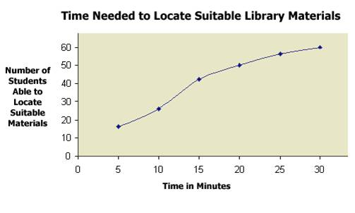
Pie Chart
A pie chart (or a circle graph) is a circular chart divided into sectors, illustrating numerical proportion.
E.g., a survey of all the sportsmen in a certain country show
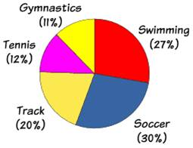

Stem and Leaf plot
Stem-and-leaf plots are a method for showing the frequency with which certain classes of values occur.
For instance, suppose you have the following list of values:
12, 13, 21, 27, 33, 34, 35, 37, 40, 40, 41.
We can represent it as
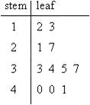
Bar Chart / Histogram
A bar chart or bar graph is a chart with rectangular bars with lengths proportional to the values that they represent. The bars can be plotted vertically or horizontally. A vertical bar chart is sometimes called a column bar chart.

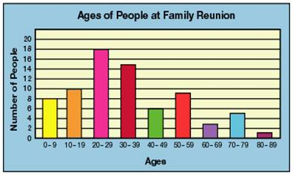
Example
Given the following data, represent it as bar chart
89 84 87 81 89 86 91 90 78 89 87 99 83 89
Sorting this data we get
78 81 83 84 86 87 87 89 89 89 89 90 91 99
We make five groups of the data as
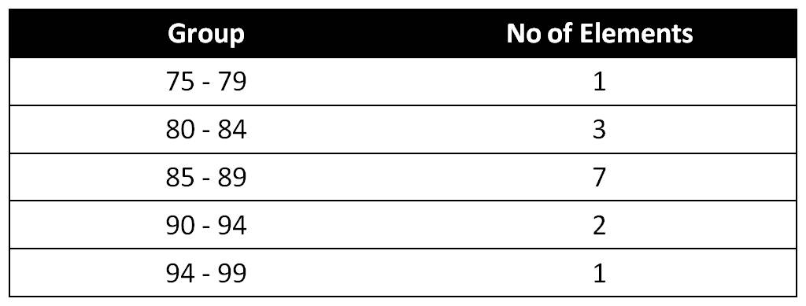
We can represent the data as Bar chart shown below
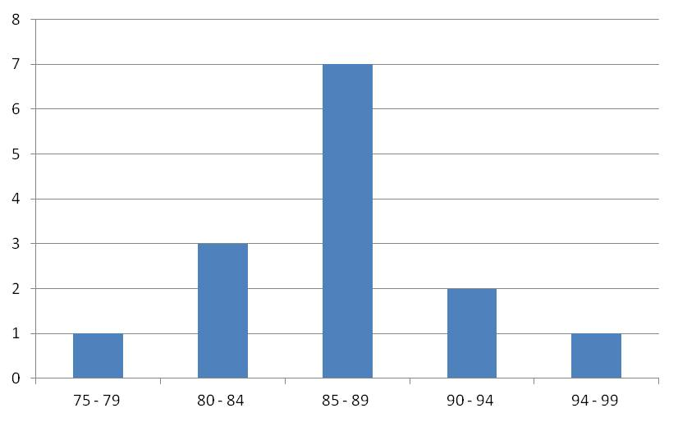
Now representing the same data in stem and leaf plot. Counting how many leaves a certain stem has, we write that number in the left most column, and call it absolute frequency
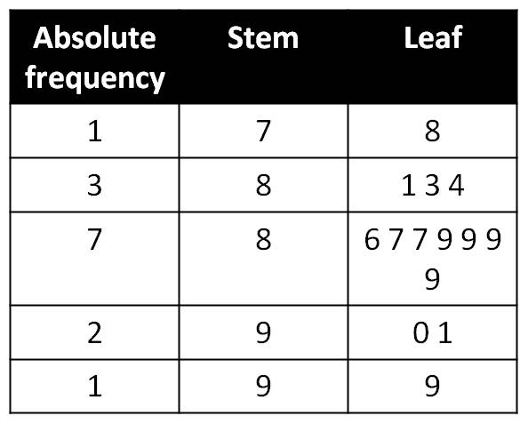

To find the cumulative absolute frequency, we add up the absolute frequencies up to the line of the leaf as shown below
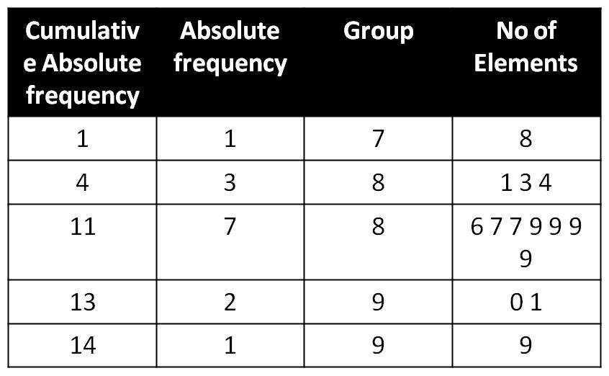

Cumulative Absolute Frequency CAS
Individual entries of left most column in stem and leaf plot are called Cumulative Absolute Frequency CAS, i. e. the sum of the absolute frequencies of values up to the line of the leaf.
For example, 11 shows that there are 11 values in the data not exceeding 89.

Relative class Frequency
Dividing the absolute frequency by n (total number of entries in the data) gives Relative class Frequency. In the present example there are total 14 entries, therefore, relative frequency is calculated as Relative frequency
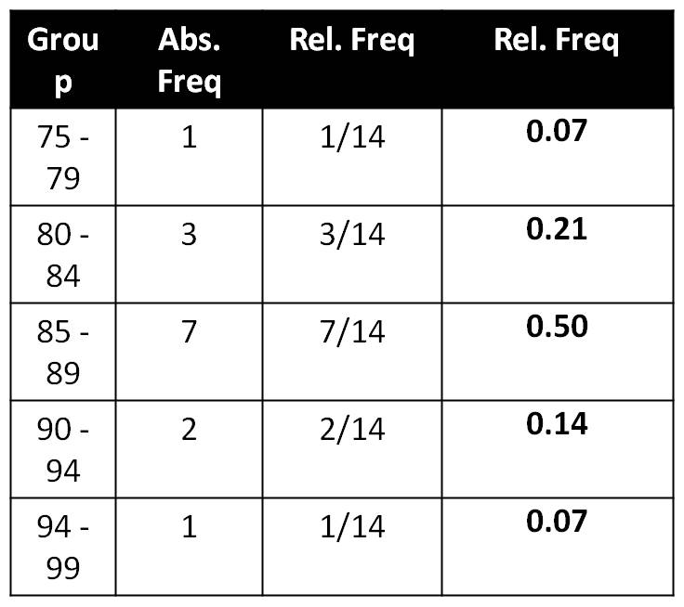

Next we plot the relative frequency as histogram where areas of the rectangles are proportional to the relative frequency.
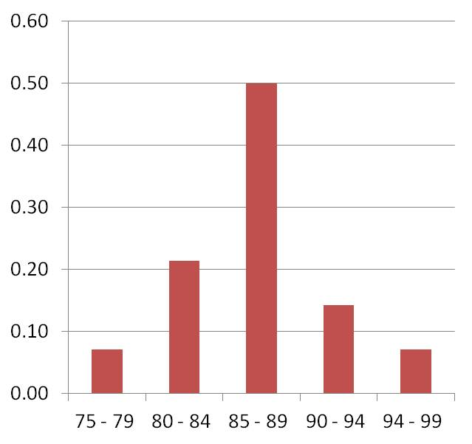
Consider that we have data and we want to analyze it,
We take the previous data
89 84 87 81 89 86 91 90 78 89 87 99 83 89
Sorting this data we get
78 81 83 84 86 87 87 89 89 89 89 90 91 99

Center and Spread of Data
As a center of the location of data values we can take a median.
78 81 83 84 86 87 87 89 89 89 89 90 91 99
There are total 14 values
As in the present data set we have even number of values so there is no center value
But we have 87 and 89 as middle values (7th and 8th) so we take the median as (87+89)/2
=88. Therefore, the median is 88. Remember that the median may not be present in the data.
Taking another example
51 54 55 55 57 62 63 63 69
There are total 9 values As in the present data set we have ODD number of values so there is a center value which is 57. Therefore, the median is 57. Notice in this example Median is present in the data.
Take another example
51 54 55 55 56 57 62 63 63 69
There are total 10 values. As in the present data set we have even number of values so there is no center value, but we have 56 and 57 as middle values (5th and 6th) so we take the median as (56+57)/2 =56.5. Remember Median may have decimal places.

Spread of Data
Spread of data can be measured by the range
Spread is also called variability.
Spread = maximum value – minimum value
Example data
78 81 83 84 86 87 87 89 89 89 89 90 91 99
In this case spread is 99 – 78 = 21.
Example data
51 54 55 55 57 62 63 63 69
In this case spread is 69 – 51 = 18.

Consider another example
3, 13, 7, 5, 21, 23, 39, 23, 40, 23, 14, 12, 56, 23, 29
putting data in order
3, 5, 7, 12, 13, 14, 21, 23, 23, 23, 23, 29, 39, 40, 56
Total value are 15, 8th value is in the middle. The median value turns out to 23
The spread 56 – 3 = 53

Example
3, 13, 7, 5, 21, 23, 23, 40, 23, 14, 12, 56, 23, 29
Here we have even number of elements in data. Putting this data in order
3, 5, 7, 12, 13, 14, 21, 23, 23, 23, 23, 29, 40, 56
n = 14
3, 5, 7, 12, 13, 14, 21, 23, 23, 23, 23, 29, 40, 56
Median is found by (21 + 23)/2 = 22 i.e. by taking mean value of two middle values.
The spread 56 – 3 = 53
Median separates the data in two equal halves.

Quartiles
With Quartiles data is divided in 4 groups in the same manner as we do for median.
There are three quartiles in data called
Lower Quartile q_{l} (median of the lower half of the data)
Middle Quartile q_{m}(median of the data)
Upper Quartile q_{u} (median of the upper half of the data)
Interquartile Range IQR can be found by
IQR = q_{u} - q_{l}
Example²
78 81 83 84 86 87 87 89 89 89 89 90 91 99
Lower half of data is
78 81 83 84 86 87 87
Lower Quartile is 84
Upper half of data is
89 89 89 89 90 91 99
Lower Quartile is 89
Middle Quartile (same as median) is 88
IQR (interquartile range) = 89 – 84 = 5

Box and Whisker Plot
Also called Box Plot. Box plot is obtained by 5 values of data.
Minimum value of the data
Three quartiles
Maximum value of the data
Example²
78 81 83 84 86 87 87 89 89 89 89 90 91 99
Middle Quartile is 88
Lower half of data is
78 81 83 84 86 87 87
Lower Quartile is 84
Upper half of data is
89 89 89 89 90 91 99
Upper Quartile is 89
IQR = 89 – 84 = 5

Outliers
Lets say an experiment was performed in which time was noted for a toy parachute to land on the ground from a fixed height. The experiment was repeated 10 times, under similar conditions
The data was recorded as
14 13 15 16 5 27 16 11 12 22
Sorting this data
5 11 12 13 14 15 16 16 22 27
Remember we said that the same experiment is repeated 10 times under the same conditions, then the time take should be same in all the cases and we should have the same number 10 times,
However due to unavoidable delay in the response of the human in clicking the stop watch, we have varied data, but some of the data is completely out of sink with the rest of the data. The data which is not representative of the rest of the data is called OUTLIERS. An outlier is a value that appears to be uniquely different from the rest of the data set. It might indicate that something went wrong with the data collection process. The outlier is normally defined as a value more than a distance of 1.5 IQR, from either end of the box.
Coming back to the sorted data
7 11 12 13 14 15 16 16 22 23
Middle quartile = 14.5
Lower quartile = 12
Upper quartile = 16
Spread = 23-7 = 16
IQR = 16-12 = 4
1.5xIRQ = 1.5x4 = 6
Therefore all values above upper quartile +6
16+6 = 22, are outliers as is 23
And all values below (lower quartile -6)
12-6 = 6, will be outliers

Mean, Average or Expected Value
A person may take different time to reach his office on different days, depending on the traffic conditions on a particular day,
E.g., in a certain week he may take
30 35 45 25 55 (minutes)
Re-ordering the data in ascending order
25 30 35 45 55
Here the median is 35. However this does not give complete information, if we look in total how much time he spent in the entire week, it comes out to be 190 minutes in total. In 5 days of the week he on the average spent 190/5 = 38 minutes. Which is different from the median and more representative of the time spent in travelling. The term used in statistics for such an average is mean, and is defined as
Mean = (Σ X_{j})/n
Mean, Average or Expected Value
Mean = (Σ X_{j})/n
example
89 84 87 81 89 86 91 90 78 89 87 99 83 89
Σ X_{j} = 1222
Mean = 1222/14 = 87.3

Consider
40 45 50 55 60
The Mean = (40+45+50+55+60)/5 = 50
Consider another data
0 25 50 75 100
The Mean = (0+25+50+75+100)/5 = 50
In both cases the mean is same, however the data is completely different. How to measure the spread in the data???

Variance
Spread and variability of the data values can be measure in a more refined way by standard deviation and variance. Variance is defined as mean of the squared deviations from the mean.

Standard Deviation
Standard Deviation measures variation of the scores about the mean. Mathematically, it is calculated by taking square root of the variance.


To calculate Variance, we need to
Step 1. Calculate the mean.
Step 2. From each data subtract the mean and then square.
Step 3. Add all these values.
Step 4. Divide this sum by number of data in the set.
Step 5. Standard deviation is obtained by taking the square root of the variance.

Consider the same data
40 45 50 55 60
The Mean = (40+45+50+55+60)/5 = 50
Standard Deviation = 7.9
Consider another data
0 25 50 75 100
The Mean = (0+25+50+75+100)/5 = 50
Standard Deviation = 39.5

Randomness
There are certain situations in which there is a certain amount of uncertainty, e.g, tossing of coin, rolling of a dice and drawing card from deck. A process is random if its individual outcome is uncertain but in large repetition of a regular pattern will be exist.

Experiments, Outcomes and Events
Experiment is a process of measurement or observation in a lab, factory, on the street, in nature or wherever. Experiment is used in a rather general sense. An experiment to be random must yield at least two possible outcomes. A trial is a single performance of the experiment. Result of a trail is called outcome or sample point. n trials then give a sample of size n consisting n – samples. A sample space S of an experiment is the set of all possible outcomes. Subsets of S are called events and outcomes Simple events
Examples
Rolling a dice can result in getting any number of dots out of {1, 2, 3, 4, 5, 6}
Experiment is rolling the dice. As the dice was rolled once so this experiment has one trial
Getting the number e.g 5, is called outcome or sample point. {1, 2, 3, 4, 5, 6} in the sample space S. Subsets of S are called events and outcomes.

Union, Intersection, Complement of Events
The Union AUB consists of all points in A or B or both.
The intersection A ∩ B consists of all points that are in both A and B.
If A and B have nothing in common then A ∩ B = Φ where Φ is called empty set.
If A ∩ B = Φ then the events A and B are called Mutually Excusive or Disjoint
A Complement of set A denoted by A^{c} or A’ consists of all points of S not in A. Thus A ∩ A’ Φ and A U A’ = S

Probability
If there are n equally likely possibilities of which one must occur and s are regarded as favorable or success, then the probability of success is given by s/n; Classical approach
If n repetitions of an experiment (n very large), an event is observed to occur in h of these, then probability of the event is then h/n. This also called Empirical Probability; Frequency Approach.

Sample Space
The set of all possible outcomes of a statistical experiment is called the sample space and is represented by the symbol S.
Each outcome in a sample space is called an element or a member of the sample space, or simply a sample point. If the sample space has a finite number of elements, we may list the members separated by commas and enclosed in braces. Thus the sample space S, of possible outcomes when a coin is tossed, may be written
S={H,T),
Where, H and T correspond to "heads" and "tails," respectively.
Next consider the experiment of tossing a die. If we are interested in the number that shows on the top face, the sample space would be
S₁ = {1,2,3,4,5,6}.
But, if we are interested only in whether the number is even or odd, the sample space is simply
S₂ = {even, odd}.
Note: more than one sample space can be used to describe the outcomes of an experiment.
In the above two example, which representation of the sample space is better ? In this case S₁ provides more information than S₂. If we know which element in S₁ occurs, we can tell which outcome in S₂ occurs. However, a knowledge of what happens in S₂ is of little help in determining which element in S₁ occurs. Therefore, in general, it is desirable to use a sample space that gives the most information concerning the outcomes of the experiment.
Sample Space- Tree Diagram
In some experiments it is helpful to list the elements of the sample space systematically by means of a tree diagram. For example consider the experiment of flipping a coin and then flipping it a second time if a head occurs. If a tail occurs on the first, flip, then a die is tossed once. To list the elements of the sample space providing the most information, we construct the tree diagram. To understand the problem better we break it up as
- an experiment consists of flipping a coin
- and then flipping it a second time if a head occurs.
- If a tail occurs on the first, flip, then a die is tossed once.
We draw its tree diagram by considering i) an experiment consists of flipping a coin, we start from a point and as the experiment has two outcomes, so we draw two branches and label the outcomes as H (head) and T (Tail) as below

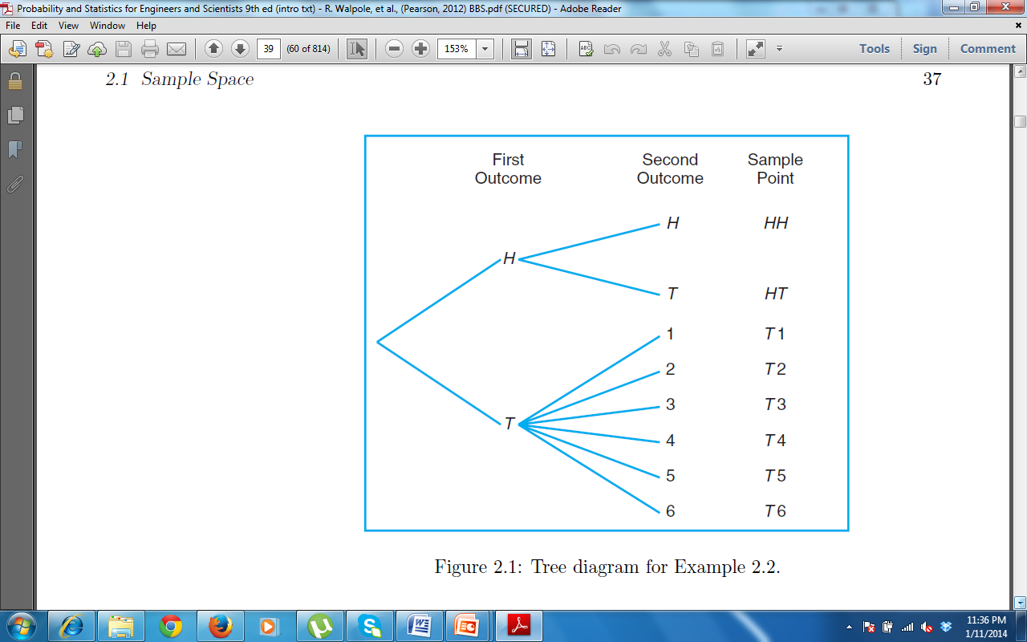
Figure 4.1. Tree diagram for an experiment consists of flipping a coin.[Walpole 2012]

Now considering the second part of the problem, which states, ii) and then flipping it a second time if a head occurs. In the tree diagram we start from H, in the figure above and as this experiment also has two possible outcomes therefore we again draw two branches and label the outcomes as H and T. And then the third part iii) If a tail occurs on the first, flip, then a die is tossed once. As rolling a die has 6 possible outcomes therefore, we draw 6 branches out of the starting point T, in the above diagram. In both cases we label the outcomes against each branch, as given in the Figure 4.2. Using the tree diagram we can write the sample space by, writing the outcomes, to the right of each branch. We start from the left and keep adding the outcomes of each branch till we reach the right end of the last branch. As the first outcome on the first branch is H, we write H and then the outcome of the second branch is again H, so on the right most top branch we write HH. Following the same procedure we write HT on the outcome of the second branch and so on till the last branch as T6.
Figure 4.2. Tree diagram for an experiment consists of flipping a coin and then flipping it a second time if a head occurs. If a tail occurs on the first, flip, then a die is tossed once.[Walpole 2012]
The sample space can be written from the tree diagram as
S= {HH, HT, T1, T2, T3, T4, T5, T6}.
Example 2
Suppose that three items are selected at random from a manufacturing process. Each item is inspected and classified defective, D, or non-defective, N. To list the elements of the sample space providing the most information, we construct the tree diagram as given in Figure 4.3. The sample space can be written from the tree diagram as
S = {DDD, DDN, DND, DNN, NDD, NDN, NND, NNN}.

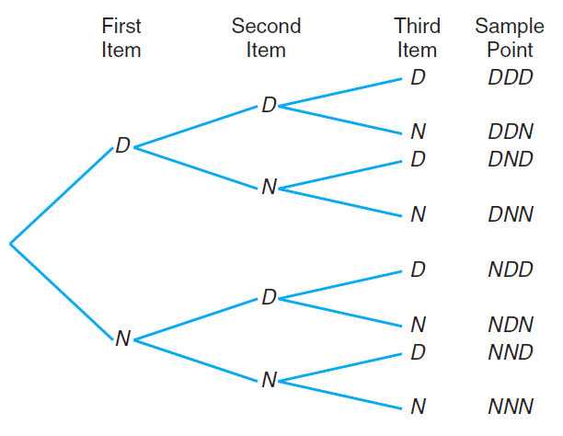
Figure 4.3. Tree diagram for the case where three items are selected at random from a manufacturing process. Each item is inspected and classified defective, D, or non-defective N.[Walpole 2012]

Event
An event is a subset of a sample space. For any given experiment we may be interested in the occurrence of certain events rather than in the outcome of a specific element in the sample space. For instance, we may be interested in the event A that the outcome when a die is tossed is divisible by 3. The sample space for tossing a dice will have all possible outcome,
S₁ = {1,2,3,4,5,6}.
In this sample space we find those elements which are divisible by 3. which are,
A = {3,6}
Next consider the example in which three items were selected at random from a manufacturing process. Each item was inspected and classified defective, D, or non-defective N. Now we may be interested in the event B that the number of defective parts is greater than 1: The sample space was written from the tree diagram as
S = {DDD, DDN, DND, DNN, NDD, NDN, NND, NNN}.
We note down all the elements which have more than 1 defective part, that is there are two or more D’s in the elements, we get our desired event as
B = {DDN, DND,NDD,DDD}

Next we consider the sample space
S = {t | t > 0},
where t is the life in years of a certain electronic component, then the event A that the component fails before the end of the fifth year is the subset
A = {t | 0 < t < 5}.
It is conceivable that an event may be a subset that includes the entire sample space S, or a subset of S called the null set and denoted by the symbol φ, Which contains no elements at all.

Complement of event
Definition : The complement of an event A with respect to S is the subset of all elements of S that are not in A.
We denote the complement, of A by the symbol A'.
Example
Consider the sample space
S = {book, catalyst, cigarette:, precipitate, engineer, rivet}.
And let the event A be given as
A = {catalyst, rivet, book, cigarette}.
Then the complement of A is
A' = {precipitate, engineer}.
Let R be the event that a red card is selected from an ordinary deck of 52 playing cards, and let S be the entire deck. Then R' is the event that the card selected from the deck is not a red but a black card.

Operations with Event
We now consider certain operations with events that will result in the formation of new events. These new events will be subsets of the same sample space as the given events.

Intersection of Events
Intersection of two events is defined as all elements which are present in both the events.
For example, in the tossing of a die we might let A be the event that an even number occurs and B the event that a number greater than 3 shows.
Then the subsets A — {2,4,6} and B = {4, 5,6} are subsets of the same sample space
S= {1,2,3,4,5,6}.
If on a given toss 4 or 6 comes that is event C={4,6}, then we can say that both A and B have occurred, which is just, the intersection of A and B, which is defined as all the elements which are present in both A and B. Intersection of A and B, is represented as A∩B.
Let C be the event that a person selected at random in an Internet cafe is a college student, and let M be the event that the person is a male. Then C ∩ M is the event of all male college students in the Internet cafe.

Mutually Exclusive events
Definition : Two events A and B are mutually exclusive, or disjoint, if A n B = φ, that is A and B have no elements in common.
Now consider events M = {a,e,i,o,u} and N = {r, s,t}. Then M ∩ N = φ, that is, M and N have no elements in common and, therefore, cannot both occur simultaneously.
For certain statistical experiments it is by no means unusual to define two events, A and B, that cannot both occur simultaneously. The events A and B are then said to be mutually exclusive.

Union of Events
Definition : The union of the two events A and B, denoted by the symbol AU B, is the event containing all the elements that belong to A or B or both.
Example: Let A = {a,b,c} and B = {b,c,d,e}; then
AU B = {a,b,c,d,e}
If M = {x | 3 < x < 9} and N = {y | 5 < y < 12}, then M U N = {z | 3 < z < 12}.

Venn Diagram
The relationship between events and the corresponding sample space can be illustrated graphically by means of Venn diagrams.
In a Venn diagram we let the sample space be a rectangle and represent events by circles drawn inside the rectangle. Then we can represent the events and operation with events by shading the respective areas. Consider the Figure below, where three events are Shown as A, B and C.

A
B
C

Different areas labeled 1 to 7 are shown below

A
B
C
1
2
3
4
5
6
7
Then different operations with events A, B, and C, can be represented as,
A∩B = region 1 and 2
A∩C = region 1 and 4
AUB = region 1, 2, 3, 4, 6 and 7
A∩B’ = region 7 and 4
A∩B∩C = region 1

Probability
If there are n equally likely possibilities of which one must occur and s are regarded as favorable or success, then the probability of success is given by s/n. This is the Classical approach to probability.
If n repetitions of an experiment (n very large), an event is observed to occur in h of these, then probability of the event is then h/n. This also called Empirical Probability and is the frequency approach to probability, which is the frequency of occurrence of the desired output in n trials.

Counting Problems
In order to evaluate probability, we must know how many elements are there in sample space. The sample space can be finite and infinite sample space or it can be continuous or discrete sample space.
In the experiment consisting of flipping a coin and then flipping it a second time if a head occurs. If a tail occurs on the first, flip, then a die is tossed once. The sample space can be written as
S= {HH, HT, T1, T2, T3, T4, T5, T6}.
Similarly, suppose that three items are selected at random from a manufacturing process. Each item is inspected and classified defective, D, or non-defective, N. The sample space can be written from the tree diagram as
S = {DDD, DDN, DND, DNN, NDD, NDN, NND, NNN}.
In these examples the number of outcomes are finite and can easily be written from the tree diagram. Now consider the experiment in which two dies are rolled and we are only interested in the sum of the dies which is equal to 7. Writing down all the elements in the sample space will be cumbersome in such an experiment. However if we only know how many all possible elements are in the sample space, that may be enough to solve the problem. Which may require us to calculate the probability of the desired event only and the knowledge about all the elements of the sample space is not required.

Counting Sample Points
In many cases we shall be able to solve a probability problem by counting the number of points in the sample space without actually listing each element. The fundamental principle of counting, is often referred to as the multiplication rule.

Counting Problem (Multiplication Theorem)
Theorem:
If an operation can be performed in n₁ ways, and if for each of these ways a second operation can be performed in n₂ way, then the two operations can be performed together in n₁n₂ ways
OR
Theorem:
If sets A and B contain respectively m and n elements, there are m*n ways of choosing an element from A then an element from B.
For example, how many sample points are: there: in the sample: space when a pair of dice is thrown once? The first die has 6 different possible outcomes and for the second die also has 6 different possible outcomes, therefore, the sample space will have 6x6=36, elements.

Counting Problem (Multiplication Theorem)
Theorem:
If an operation can be performed in n₁ ways, and if for each of these a second operation can be performed in n₂ ways, and for each of the first two a third operation can be performed in n₃ ways, and so forth, then the sequence of k operations can be performed in n₁n₂n₃…n_{k} ways.

Permutation
Definition:
A permutation is an arrangement of all or part of a set of objects.
Consider the three letters a, b, and c. The possible permutations are abc, acb, bac, bca, cab, and cba. Thus we see that there are 6 distinct arrangements. Using multiplication Theorem we could arrive at the answer 6 without actually listing the different orders.
There are
n₁ = 3 choices for the first position,
n₂ = 2 for the second position and,
n₃ = 1 choice for the last position,
giving a total of
n₁n₂n₃= (3)(2)(1) = 6 permutations.
In general, n distinct objects can be arranged in
n(n - l)(n - 2) • • • (3)(2)(1) ways.
We represent this product by the symbol n! which is read as "n factorial."
Three objects can be arranged in
3! = (3)(2)(1) = 6 ways.
By definition,
1! = 1
0! = 1

Theorem:
The number of permutations of n objects is n!.
The number of permutations of the four letters a, b, c, and d will be 4! = 24.
Now consider the number of permutations that are possible by taking two letters at a time from four letter a,b,c and d..
These would be
{ab, ac, ad, ba, be, bd, ca, cb, cd, da, db, dc}
In this particular example we have two positions to fill with 4 alphabets {a,b,c,d}, we have
n₁ = 4 choices for the first position
n₂ = 3 choices for the second position
Now using the multiplication theorem we
n₁ x n₂ = (4) (3) = 12 permutations.
Which can be written as
4 x (4-1) = 12
Permutations
Using Multiplication Theorem, we have three positions to fill with 6 alphabets {a,b,c,d,e,f}
We have
n₁ = 6 choices for the first position
n₂ = 5 choices for the second position
n₃ = 4 choices for the third position
Now using the multiplication theorem we
n₁ x n₂ x n₃ = (6) (5) (4) = 120 permutations.
Which can be written as
6 x (6-1) x (6-2) = 120
Lets say we have n objects and r places to fill then considering the previous two examples we can write
For n = 4, r = 2 we got
4 x (4-1) = 12
Which can be written as
n x (n – r + 1)= 12
Similary
And for n = 6, r = 3 we got
6 x 5 x 4 = 120
n x (n-1) x (n – r + 1) = 120

Definition
In general, n distinct objects taken r at a time can be arranged in
n(n- l ) ( n - 2 ) - - - ( n - r + 1)
ways. We represent this product by the symbol
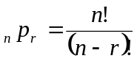

As a result we have the theorem that follows.

Theorem
The number of permutation of n distinct objects taken r at a time is

So far we have considered permutations of distinct objects. That is, all the objects were completely different or distinguishable. If the letters b and c are both equal to x, then the 6 permutations of the letters a, b, and c become
{axx, axx, xax, xax, xxa, xxa}
of which only 3 are distinct.
Therefore, with 3 letters, 2 being the same, we have
3!/2! = 3 distinct permutations.
With 4 different letters a, b, c, and d, we have 24 distinct permutations.
If we let a = b = x and c = d = y, we can list only the following distinct permutations:
{xxyy, xyxy, yxxy, yyxx, xyyx, yxyx}
Thus we have
4!/(2! 2!) = 6 distinct permutations.

Theorem
The number of ways of partitioning a set of n objects into r cells with n₁ elements in the first cell, n₂ elements in the second, and so forth, is
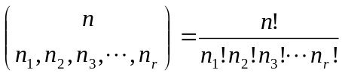
Where,
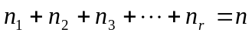
To understand this theorem better consider the example. In how many ways can 7 students be assigned to one triple and two double hotel rooms during a conference? Using the rule given above we write,
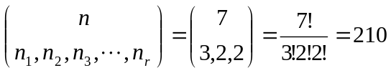

Combinations
Suppose that you have 3 fruits, Apple (A), Banana (B) and a citrus fruit (C). If you have to use all the 3 fruits, how many different juices can you make? Your answer would be “Only one”. When you are drinking the juice would you know in which order the fruits have been put into the juicer? Your answer would be “No”.
Thus, if we have n objects, and we would like to combine all of them, then there is only one combination that we can have. In combination the order does not matter. This is a major difference between permutation and combination.
Suppose that we decide to use only two fruits out of the three (A, B, C) to prepare a juice. How many different juices can you make?
You can use
A and B or
A and C or
B and C.
Therefore, we can make “Three” different juices.
Consider next the number of permutations of the four letters a, b, c, and d. The total number of permutations will be 4! = 24. Now consider the number of permutations that are possible by taking two letters at a time from four.
These would be
{ab, ac, ad, ba, bc, bd, ca, cb, cd, da, db, dc}
The number of permutations can be calculated by the following formulae, with n = 4 and r = 2.
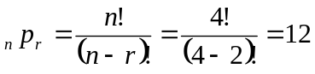
Lets check which same alphabets are used to make groups, that is the order does not matter
{ab, ac, ad, ba, bc, bd, ca, cb, cd, da, db, dc}
{(ab,ba),(ac,ca),(ad,da),(bc,cb),(bd,db),(cd,dc)}
We have grouped the permutations with same alphabets, if the order was not important then the permutations in the parenthesis would be counted as one, as they use the same letters. We know that r objects can be arranged in r! order, (2! =2), therefore we have two groups of same alphabets but different permutation. Therefore, we divide all the possible permutations of n objects taken r at a time by r !, to get the combinations

Combinations

Definition:
When we have n different objects, and we want to have combinations containing r objects, then we will have _{n}C_{r} such combinations. (where, r is less than n).
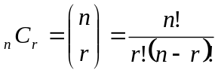

Probability
If there are n equally likely possibilities of which one must occur and s are regarded as favorable or success, then the probability of success is given by s/n
If an event can occur in h different possible ways, all of which are equally likely, the probability of the event is h/n: Classical Approach
If n repetitions of an experiment, n is very large, an event is observed to occur in h of these, the probability of the event is h/n: Frequency Approach or Empirical Probability.
Once we know the number of elements in the sample space (n) and also know the number of favorable outcomes (s), then the probability of success can be calculated as s/n. It should be noted that whatever method is used in assigning probability to events, this probability should satisfy certain axioms, else it can’t be considered probability. The axioms of probability are:

Axioms of Probability
To each event A_{i}, we associate a real number P(A_{i}). Then P is called the probability function, and P(A_{i}) the probability of event A_{i} if the following axioms are satisfied
- for every event A : P(Ai) ≥ 0
- For the certain event S: P(S) = 1
- For any number of mutually exclusive events A₁, A₂ ,…, A_{n} :
P(A₁U A₂ U…..U A_{n}) = P(A₁) + P(A₂) + … + P(A_{n})
Note: Two events A and B are mutually exclusive or disjoint if A ∩ B = Φ
Next we consider some theorems on probability,

Theorem
For A or B two events,
P(A U B) = P(A) + P(B) – P(A ∩ B)
For mutually exclusive events we know P(A ∩ B) = φ, therefore,
P(A U B) = P(A) + P(B)
This theorem can be extended to any number of events, as given in the next theorem

Theorem
If events A₁, A₂, …., A_{n} are partitions of a sample space then
P(A₁U A₂ U…..U A_{n}) = P(A₁) + P(A₂) + … + P(A_{n})
We should remember that events which are partition of sample space are disjoint.

Theorem
If A and A’ are complementary events then
P(A) + P(A’) = 1
The above theorem can be proved by considering AUA’=S, that is the union of A and compliment of A, is the entire sample space, which is a certain event; hence its probability is always 1, which is also given in the axioms.

Conditional Probability

Consider there are 2 blue and 3 red marbles in a bag. What are the chances of getting a blue marble?
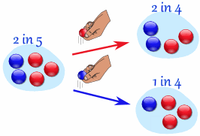
The chance is 2 in 5, But after taking one out you change the chances! So the next time: if you got a red marble before, then the chance of a blue marble next is 2 in 4 if you got a blue marble before, then the chance of a blue marble next is 1 in 4. So if we know what happened before, then the probability is changed.
Now lets say I flip a fair coin twice, and we define an event that two heads occur, i.e.,
A = two heads = {HH}
and the sample space is
S = {HH,HT,TH,TT}
We get the probability of A as P(A) = ¼
Now, suppose I tell you that the outcome was the same for both flips, that is, either HH or TT occurred, that is the event
B = {HH, TT} has ALREADY occurred
Will this extra information change the probability?
Now, how would you assess the probability of A given that B has ALREADY occurred?
Since we know that B has occurred, our sample space has been reduced sample space is now B = {TT, HH} and thus
P(A given B has occurred)=(1out of 2) = ½
In general: P(A GIVEN B) = P(A | B) can be calculated as
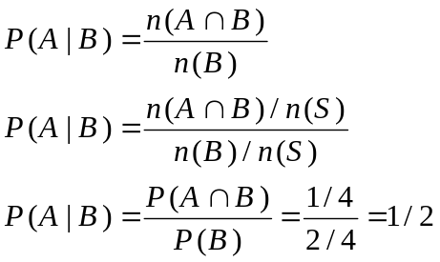

Conditional Probability
Let A and B be two events such that
P(B) > 0.

Denoted by P(A|B) the probability of A given that B has occurred is given by
P(A|B) = P(B∩A)/P(B)
P(A|B) is called the conditional probability of A given B has occurred
For any two events A and B:
P(A∩B) = P(A)P(B | A)
And
P(B∩A) = P(B)P(A | B)

Theorem

For any events A₁, A₂, …, A_{k}, we have
P(A₁∩A₂∩ … ∩A_{k}) = P(A₁)P(A₂| A₁)P(A₃|A₁∩A₂)…P(A_{k}|A₁∩A₂∩A₃…∩A_{k-1} )
If the events A₁, A₂, . . . , A_{n}, are independent
P(A₁∩ A₂∩ … ∩A_{k}) = P(A₁)P(A₂)P(A₃)…P(A_{k})

Theorem
The events A₁, A₂, . . . , A_{n}, are called mutually exclusive then the probability of the event B can be calculated as
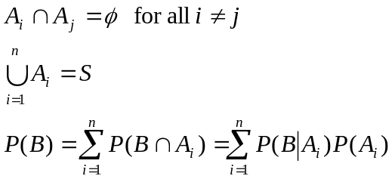

Independent Events
Two events A and B are independent
if and only if
P(B|A) = P(B) or P(A|B) = P(A)
That is the probability of event B does not depend on the probability of A, and vice versa.

Bayes’ Rule
If the events B₁, B₂,.. ,B_{k} constitute a partition of the sample space S such that P(B_{i}) ≠ 0 for i = 1,2,...,k, then for any event A in S such that P(A) ≠ 0

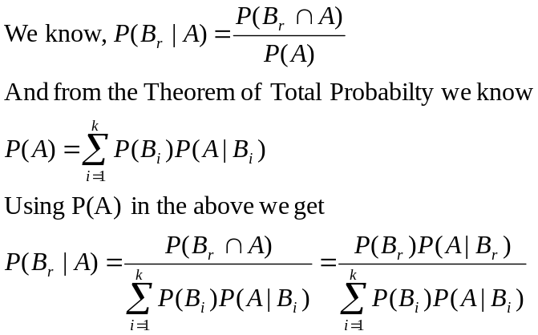

Bayes Theorem (Alternate form)

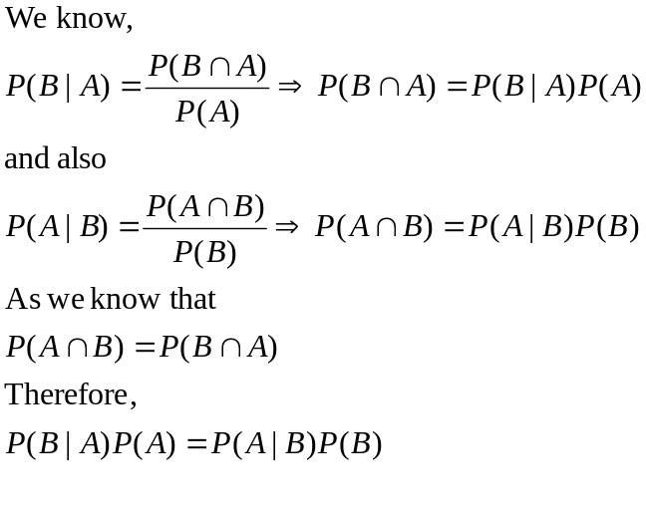

Random Variables
A random variable is a function that associates a real number with each element in the sample space. Capital letter is used to represent the random variable as X and small letter is used to represent the value as x. For example, the number of people visiting an ATM in one day can be represented by Random variable N. The pressure of gas at different CNG stations can be represented as a random variable P.

Discrete and Continuous Sample Space
If a sample space contains a finite number of possibilities or an unending sequence with as many elements as there are whole numbers, it is called a discrete sample space. If a sample space contains an infinite number of possibilities equal to the number of points on a line segment, it is called a continuous sample space.

Discrete and Continuous Random Variables
A Discrete Random Variable is the one that has a countable set of outcomes. When a random variable takes on values on continuous scale, the variable is regarded as continuous random variable.

Examples of Discrete Random Variables
- Number of tosses of a fair coin until a head comes.
X={1,2,3,4,5,……..}
- Number of people visiting an ATM machine in a day.
Y = {1,2,3,…….}

Example of Continuous Random Variables
- Interest centers around the proportion of people who respond to a certain mail order solicitation. Let X be that proportion. X is a random variable that takes on all values x for which 0 < x < 1.
- Let X be the random variable defined by the: waiting time, in hours, between successive speeders spotted by a radar unit. The random variable X takes on all values x for which t > 0.

Discrete Probability Distribution
The set of ordered pairs (x, f(x)) is a probability function , probability mass function or probability distribution of discrete random variable x, if for each possible outcome x
f(x) ≥ 0
Σf(x) = 1
P(X = x) = f(x)

Cumulative Distribution
The cumulative distribution function F(x) of a discrete random variable X with probability distribution f(x) is

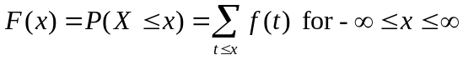

Continuous Probability Distribution
Continuous probability distribution cannot be written in tabular form but it can be stated as a formula. Such a formula would necessarily be a function of the numerical values of the continuous random variable X and as such will be represented by the functional notation f(x). The function f(x) usually called probability density function or density function of X.
The function f(x) is the probability density function for a continuous random variable X, defined over set of real numbers, if
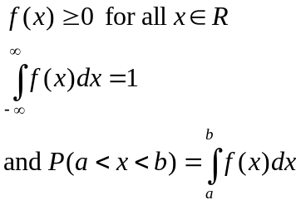

Continuous Cumulative Distribution
The cumulative distribution function F(x) of a continuous random variable X with probability density function f(x) is

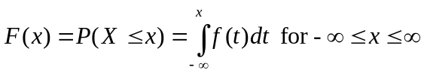
Using the above definition we can find the probability
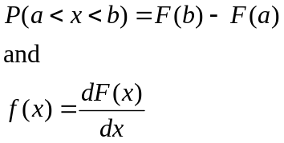

Discrete Joint Probability Distribution
The function f(x,y) is a joint probability, or joint probability mass function of the discrete random variables x and y, if for each possible outcome x and y
f(x,y) ≥ 0
ΣΣf(x,y) = 1
P(X = x,Y=y) = f(x,y)

Joint Probability Density Function
The function f(x,y) is joint probability density function of continuous random variables X and Y if
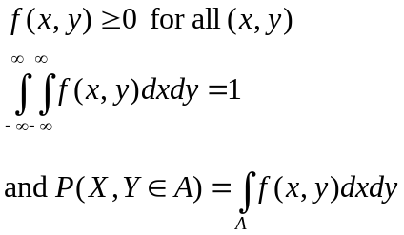

Marginal Distribution
The marginal distribution of X alone and of Y alone for the discrete random variable X and Y is defined as
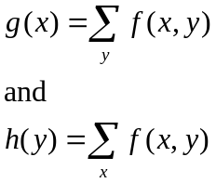
And for the continuous random variables X and Y is defined as,
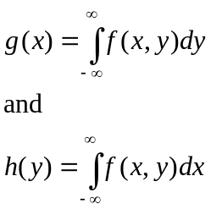

The fact that the marginal distributions g(x) and h(y) are indeed the probability distributions of the individual variables X and Y alone can be verified by showing that the conditions of definitions of probability function are satisfied.

Conditional Distribution
Let X and Y be two random variables, discrete or continuous. The conditional distribution of the random variable Y given that X=x is
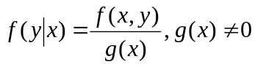
Similarly the conditional distribution of the random variable X given Y= y is
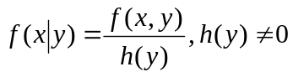

Statistical Independence

Let X and Y be two random variable, discrete or continuous, with joint probability distribution f(x,y) and marginal distributions g(x) and h(y), respectively. The random variables X and Y are said to be statistically independent if and only if,
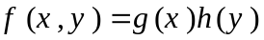
For all (x,y) within their range.

Mean of a distribution
Let X be a random variable with probability distribution f(x). The mean or expected value of X is
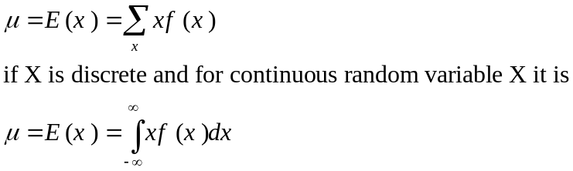

Variance
Let X be a random variable with probability distribution f(x) and mean µ the variance of x is
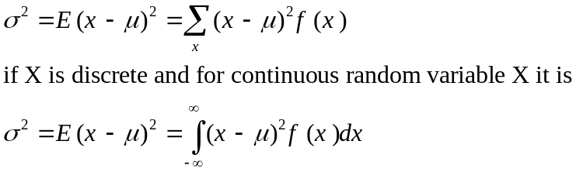

Standard Deviation
Positive square root of variance is called Standard Deviation.

Theorem
The variance of a random variable X is
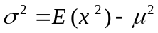

Mean of a function of random variable
Let X be a random variable with probability distribution f(x). The expected value of the random variable g(x) is
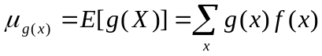
If X is discrete, and
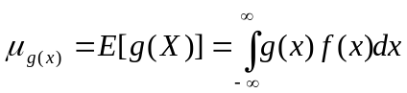
If X is continuous random variable.

Mean of a function of random variables
Let X and Y be random variables with joint probability distribution f(x,y). The expected value of the random variable g(x,y) is
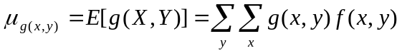
If X and Y are discrete, and
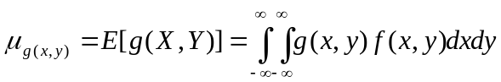
If X and Y are continuous random variable.

Covariance
Let X and Y be random variables with joint probability distribution f(x,y). The covariance of X and Y is
If X and Y are discrete, and
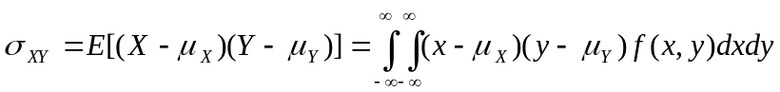
If X and Y are continuous random variable.
The covariance between two random variables is a measurement of the nature of the association between the two. If large values of X often result in large values of Y or small values of X result in small values of Y. Then positive (x — µ_{x}) will often result in positive (y — µ_{y}), and negative (x — µ_{x}) will often result in negative (y — µ_{y}). Thus (x — µ_{x})(y — µ_{y}) will tend to be positive.
On the other hand, if large X values often result in small Y values, the product (x — µ_{x})(y — µ_{y}) will tend to be negative. Thus the sign of the covariance indicates whether the relationship between two dependent random variables is positive or negative.
When X and Y are statistically independent, the covariance is zero, because some of the values of (x — µ_{x})(y — µ_{y}) will be positive and some will be negative, resulting in the sum to be zero. The converse, however, is not generally true. Two variables may have zero covariance and still not be statistically independent.
Remember that the covariance only describes the linear relationship between two random variables. Therefore, if a covariance between X and Y is zero, X and Y may have a nonlinear relationship, which means that they are not necessarily independent.

Theorem
The covariance of two random variables X and Y with means µ_{x} and µ_{y} respectively is given by
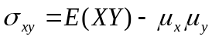
Although the covariance between two random variables does provide information regarding the nature of the relationship, the magnitude of σ_{xy} does not indicate anything regarding the strength, of the relationship, since σ_{xy} is not scale-free. Its magnitude will depend on the units measured for both X and Y. There is a scale-free version of the covariance called the correlation coefficient that is used widely in statistics.

Correlation Coefficient
Let X and Y be random variables with covariance σ_{xy} and standard deviations σ_{x} and σ_{y} respectively. The correlation coefficient of X and Y is
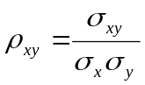
It should be noted that ρ_{XY} is free of the units of X and Y. The correlation coefficient satisfies the inequality - 1 < ρ_{XY} < 1. It assumes a value of zero when σ_{XY} = 0. Where there is an exact linear dependency, say Y = a + bX,
ρ_{XY} = 1 if b > 0 and ρ_{XY} = -1 if b < 0.

Theorem
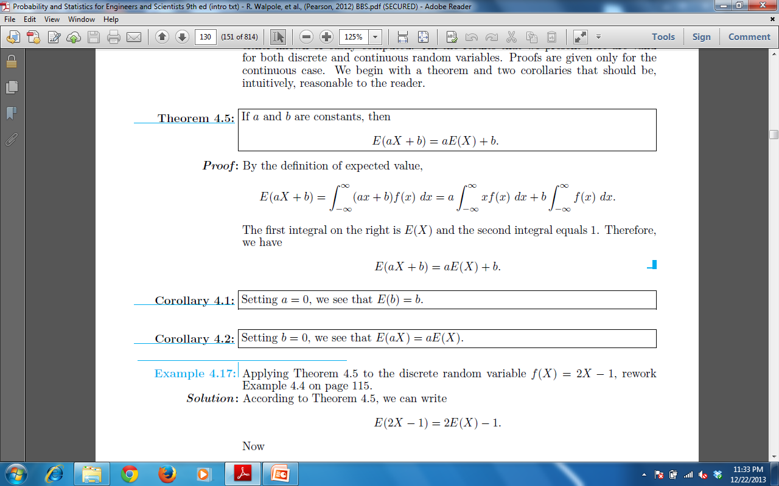

Corollary

Corollary

Theorem
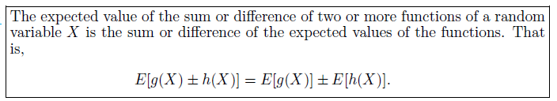

Theorem
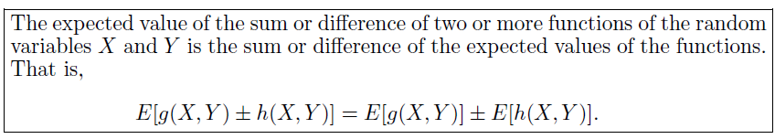

Theorem
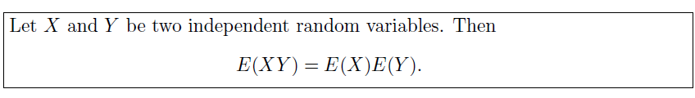

Corollary
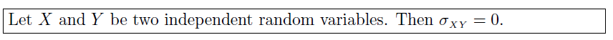

Theorem
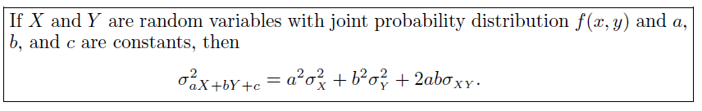

Corollary
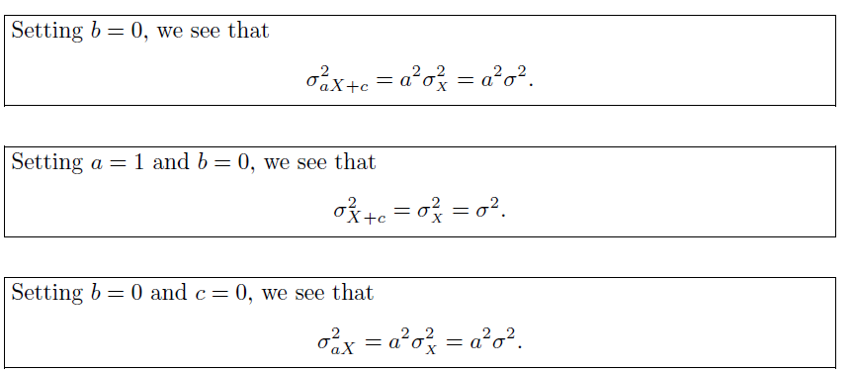

Corollary
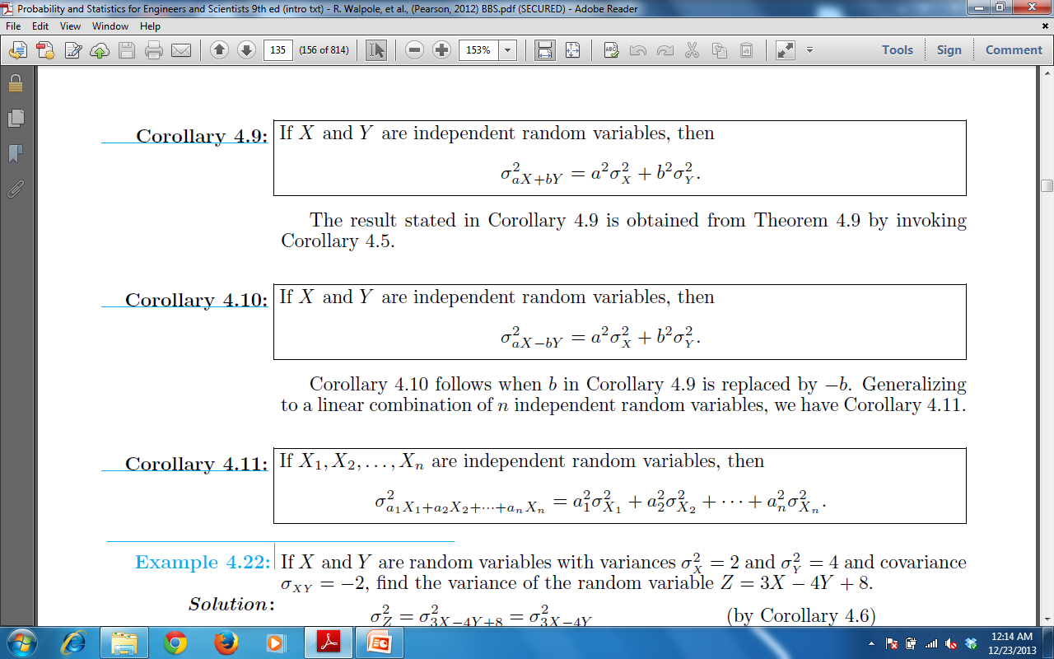

Corollary

Chebyshev’s Theorem
The variance of a random variable tells us about the variability of the observations about the mean. If a random variable has a small variance or standard deviation, we would expect most of the values to be grouped around the mean. Therefore, the probability' that a random variable assumes a value within a certain interval about the mean is greater than for a similar random variable with a larger standard deviation. If we think of probability in terms of area, we would expect a continuous distribution with a large value of σ to indicate a greater variability, and therefore we should expect the area to be more spread out, as in Figure (a). However, a small standard deviation should have most of its area close to µ, as in Figure (b).
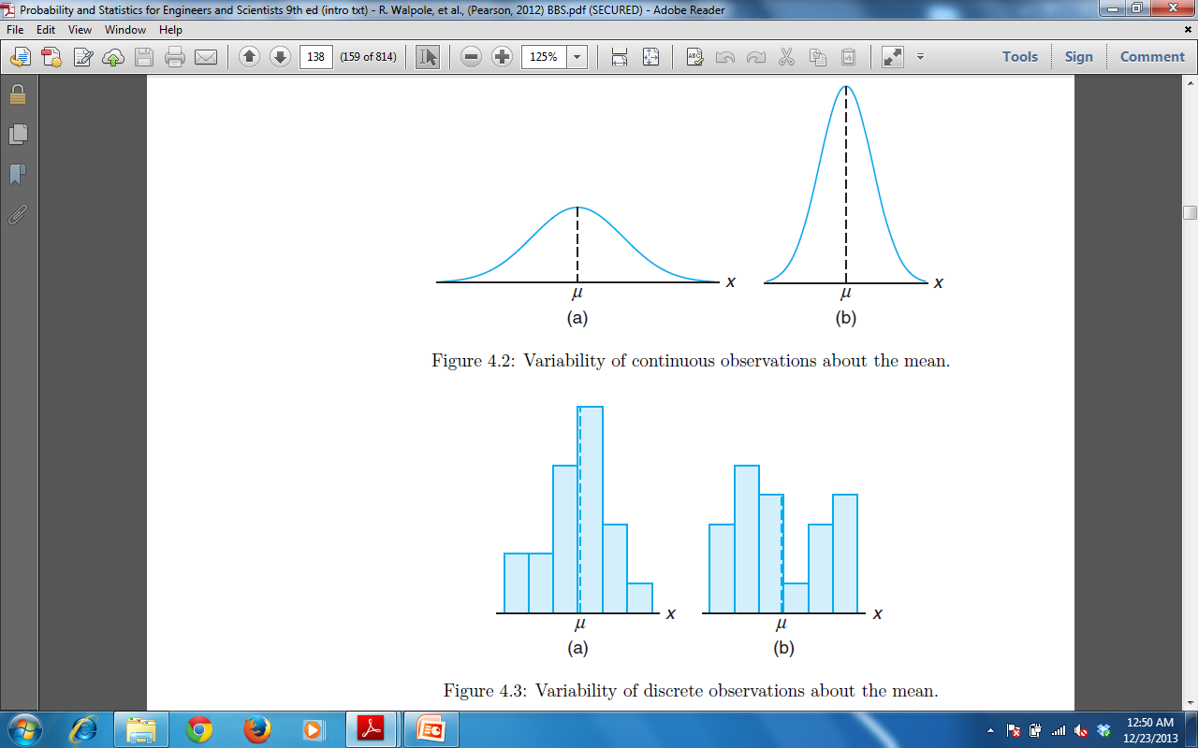
We can argue the same way for a discrete distribution. The area in the probability histogram in Figure (b) is spread out much more than that Figure (a) indicating a more variable distribution of measurements or outcomes.

The Russian mathematician P. L. Chebyshev (1821-1894) discovered that the fraction of the area between any two values symmetric about the mean is related to the standard deviation. Since the area under a probability distribution curve or in a probability histogram adds to 1, the area between any two numbers is the probability of the random variable assuming a value between these numbers.
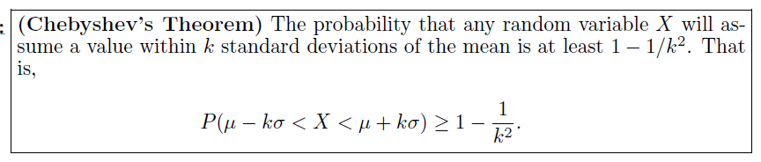

Probability Distributions
Next we will discuss probability distribution functions for the discrete and continuous random variables. For the discrete case we have,

Uniform Distribution
If the random variable X assumes the values x₁, x_{2,} x_{3,…,} x_{n} with equal probabilities, then the discrete uniform distribution is given by
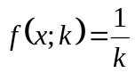

Theorem
The mean and variance of uniform PDF f(x;k) is
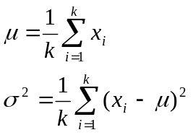

Bournoulli’s Process / Trail
The Bournoulli’s process possesses the following properties
- The experiments consists of repeated trails
- The probability of success is same in each trail
- There are n trails and n is constant
- The n – trails are independent.

Binomial Distribution
A Bernoulli trial can result in a success with probability p and a failure with probability q=1-p. Then the probability distribution of the binomial random variable X, the number of successes in n independent trials, is
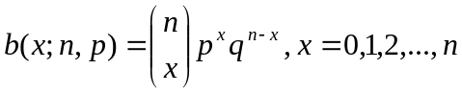

Theorem
The mean and variance of the binomial distribution b(x;n,p) are
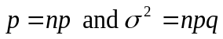
If the random variable X assumes the values x₁, x_{2,} x_{3,…,} x_{n} with equal probabilities, then the

Poisson’s Experiment and Process
Experiments yielding numerical values of a random variable X, the number of outcomes occurring during a given time interval or in a specified region, are called Poisson experiments. The given time interval may be of any length, such as a minute, a day, a week, a month, or even a year. Hence a Poisson experiment can generate observations for the random variable X, which may represent
- the number of telephone calls per hour received by an office,
- the number of days school is closed due to snow during the winter,
- or the number of postponed games due to rain during a baseball season.
The specified region could be a line segment, an area, a volume, or perhaps a piece of material.
In such instances X might represent
- the number of field mice per acre,
- the number of bacteria in a given culture,
- or the number of typing errors per page.
Poisson Experiment is derived from the Poisson’s Process. A process is called a Poisson Process if
- the process has no memory
- The probability that a single outcome will occur during a very short time interval or in a small region is proportional to the length of the time interval or the size of the region and does not depend on the number of outcomes occurring outside this time interval or region.
- The probability that more than one outcome will occur in such a short time interval or fall in such a small region is negligible.
The number X of outcomes occurring during a Poisson experiment is called a Poisson random variable, and its probability distribution is called the Poisson distribution.

Poisson distribution
The probability distribution of the Poisson random variable X, representing the number of outcomes occurring in a given time interval or specified region denoted by t, is
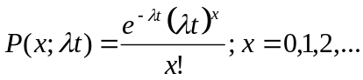
where, λ is the average number of outcomes per unit time, per unit distance or per unit area.

Theorem:
Both the mean and variance of the Poisson distribution p(x; λt) are λt.

Poisson distribution as a limiting case of Binomial distribution
It should be evident from the three principles of the Poisson process that the Poisson distribution relates to the binomial distribution. Although the Poisson usually finds applications in space and time problems but it can be viewed as a limiting form of the binomial distribution. In the case of the binomial, if n is quite large and p is small, the conditions begin to simulate the continuous space or time region implications of the Poisson process. The independence among Bernoulli trials in the binomial case is consistent with property 2 of the Poisson process. Allowing the parameter p to be close to zero relates to property 3 of the Poisson process. Indeed, if n is large and p is close to 0, the Poisson distribution can be used, with p = np, to approximate binomial probabilities. If p is close to 1, we can still use the Poisson distribution to approximate binomial probabilities by interchanging what we have defined to be a success and a failure, thereby changing p to a value close to 0.
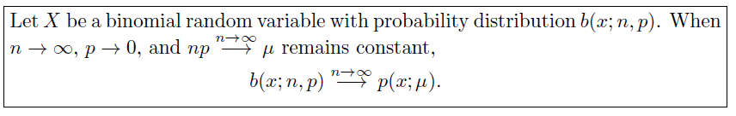

Continuous Distributions
So far we have discussed the probability distribution for discrete random variables, next we will discuss some probability distribution for continuous random variables.

Uniform Distribution
One of the simplest continuous distributions in all of statistics is the continuous uniform distribution. This distribution is characterized by a density function that is "flat," and thus the probability is uniform in a closed interval, say [A, B].
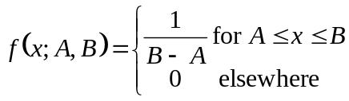
Uniform Distribution is also called rectangular distribution.
The mean and variance of uniform random variable is given as
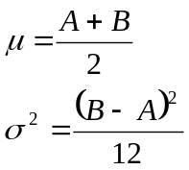

Normal Distribution
The most important, continuous probability distribution in the entire field of statistics is the normal distribution. Its graph, called the normal curve, is the bell shaped curve.
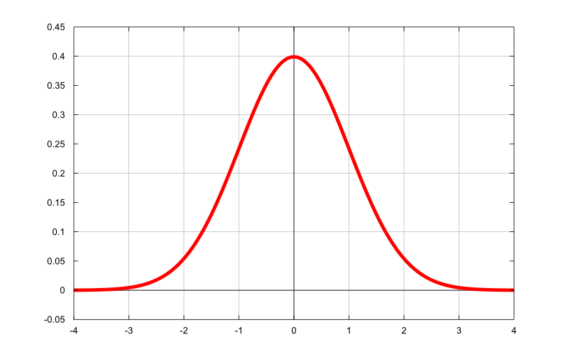
Normal distribution describes approximately many phenomena that occur in
- nature,
- industry,
- and research

Physical measurements in areas such as
- meteorological experiments,
- rainfall studies,
- measurements of manufactured parts
- errors in scientific measurements
- are often more than adequately explained with a normal distribution.
In 1733, Abraham DeMoivre developed the mathematical equation of the normal curve. Which provided a basis for which much of the theory of inductive statistics is founded.
The normal distribution is often referred to as the Gaussian distribution, in honor of Karl Fricdrich Gauss (1777-1855), who also derived its equation from a study of errors in repeated measurements of the same quantity.

Normal Distribution
A continuous random variable X having the bell-shaped distribution is called a normal random variable. The probability density of random variable X with mean µ and variance σ² is denoted by n(x,µ,σ) and is given by
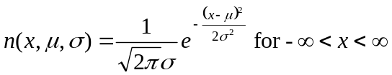

Properties of Normal Distribution

- The mode, which is the point on the horizontal axis where the curve is a maximum, occurs at x = μ.
- The curve is symmetric about a vertical axis through the mean μ .
- The curve has its points of inflection at x = µ ± σ, is concave downward if µ — σ < X < µ + σ, and is concave upward otherwise.
- The normal curve approaches the horizontal axis asymptotically as we proceed in either direction away from the mean.
- The total area under the curve and above the horizontal axis is equal to 1.

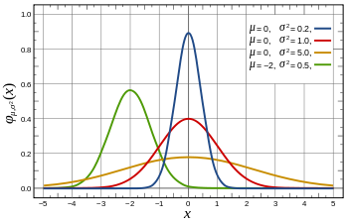Figure: Normal curves for various values of mean and variance.

Beauty of Normal Distribution
No matter what μ and σ are, the area between μ-σ and μ+σ is about 68%; the area between μ-2σ and μ+2σ is about 95%; and the area between μ-3σ and μ+3σ is about 99.7%. Almost all values fall within 3 standard deviations.
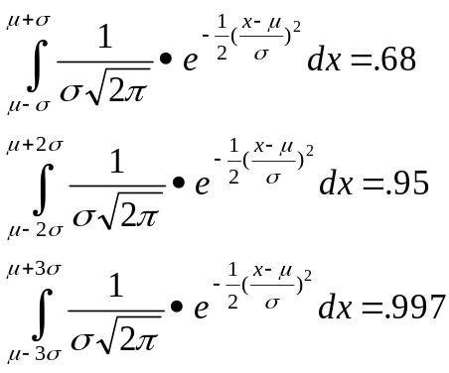

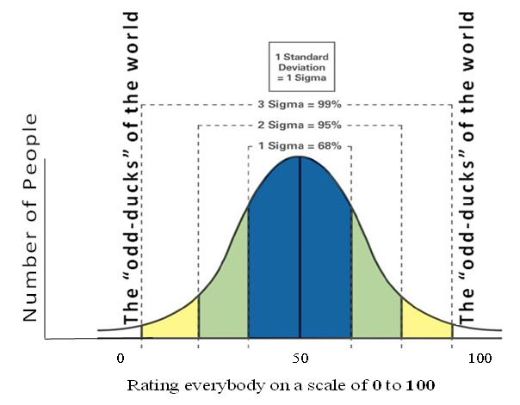
Figure: Area under the normal distribution in different limits.

Standard Normal Distribution
The distribution of a normal random variable with mean 0 and variance 1 is called a standard normal distribution.
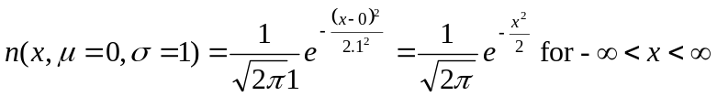
All normal distributions can be converted into the standard normal curve by subtracting the mean and dividing by the standard deviation:
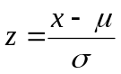
Somebody calculated all the integrals for the standard normal and put them in a table! These tables are in the appendix. So we never have to integrate!

Approximation to Binomial Distribution
It turns out that as n gets larger, the Binomial distribution looks increasingly like the Normal distribution. Consider the following Binomial histograms, Binomial distribution with p = 0.1
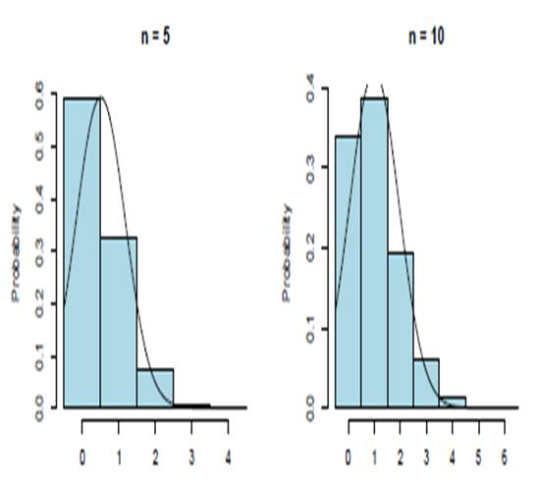
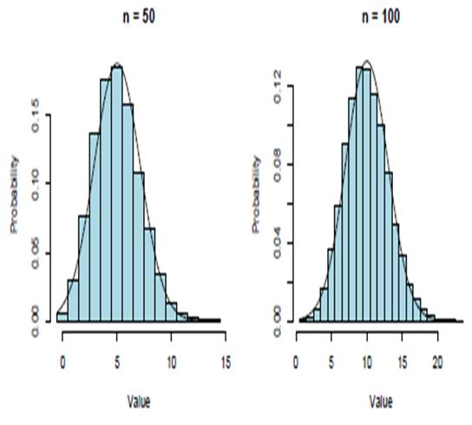
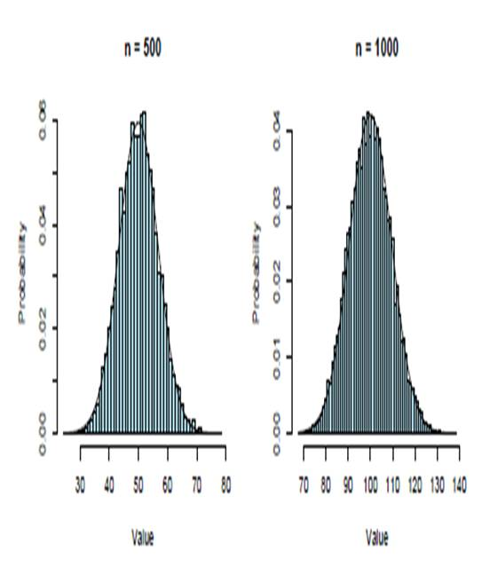

Parameters of the Approximating Distribution
The approximating Normal distribution has the same mean and standard deviation as the underlying Binomial distribution. Thus, if X ~ B(n; p), having mean E[X] = np and standard deviation SD(X) = √np(1 - p) = sqrt(npq),
It can be approximated by Normal distribution with
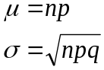
When is the approximation appropriate?
The farther p is from 0.5 , the larger n needs to be for the approximation to work.
Thus, as a rule of thumb, only use the approximation if
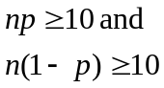

Calculations with the Normal Approximation
The continuity correction is intended to refine the approximation by accounting for the fact that the Binomial distribution is discrete while the Normal distribution is continuous.
In general, we make the following adjustments:
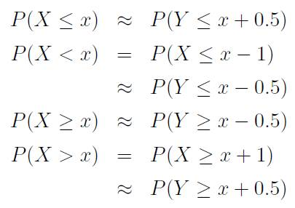

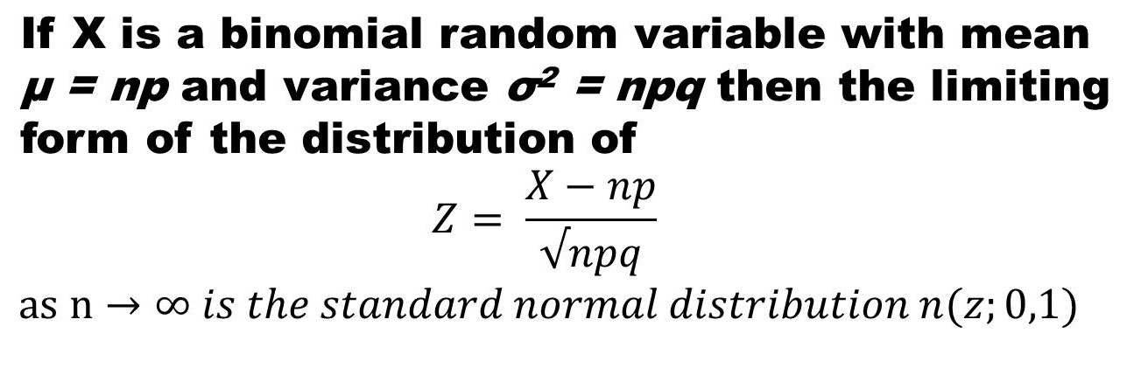

Next we discuss some more distributions, for that we first define the Gamma Function

Gamma Function
A Gamma function is defined by
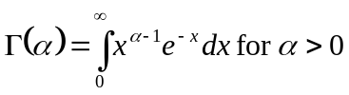
Integrating by parts and manipulating the results we get
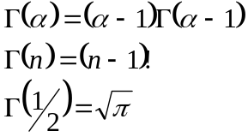

Gamma distribution
The continuous random variable X has a gamma distribution, with parameters α and β, if its density function is given by
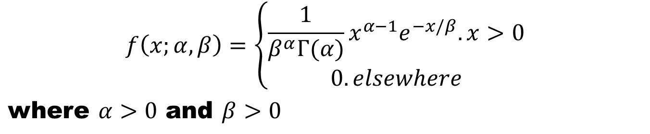
The mean and variance of Gamma distribution are
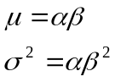

Exponential distribution
A special case of gamma distribution is when α=1, the continuous random variable X has an exponential distribution, with parameter β, if its density function is given by
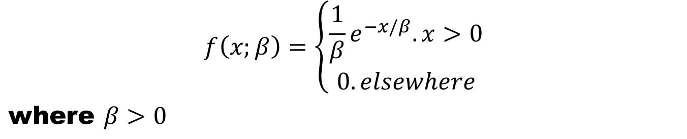
The mean and variance of Gamma distribution are
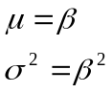

Relationship of Exponential Distribution to the Poisson Process
The most important applications of the exponential distribution are situations where the Poisson process applies. Recall that the Poisson process allows for the use of the discrete distribution called the Poisson distribution. The Poisson distribution is used to compute the probability of specific numbers of "events" during a particular period of time or space. In many applications, the time period or span of space is the random variable. For example, a trafic engineer may be interested in modeling the time T between arrivals at a congested intersection during rush hour in a large city. An arrival represents the Poisson event.
The relationship between the exponential distribution (often called the negative exponential) and the Poisson process is quite simple. Poisson distribution was developed as a single-parameter distribution with parameter λ, where λ may be interpreted as the mean number of events per unit "time."
Consider now the random variable described by the time required for the first event to occur. Using the Poisson distribution, we find that the probability of no events occurring in the span up to time t is given by
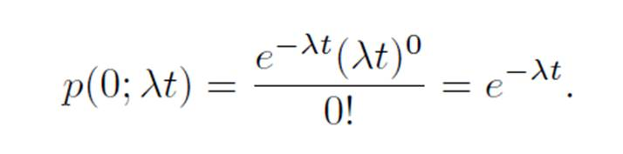
Consider now the random variable described by the time required for the first event to occur. Using the Poisson distribution, we find that the probability of no events occurring in the span up to time t is given by

We can now make use of the above and let X be the time to the first Poisson event. The probability that the length of time until the first event will exceed x is the same as the probability that no Poisson events will occur in x. Thus the cumulative distribution function for X is given by
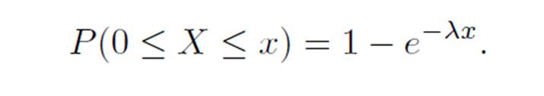
Now, in order that we recognize the presence of the exponential distribution, we may differentiate the cumulative distribution function above to obtain the density function
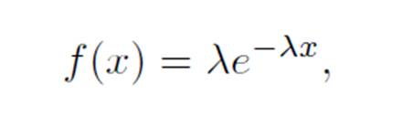
which is the density function of the exponential distribution with λ = 1/β.

Sample and Population
“In statistics and quantitative research methodology, a data sample is a set of data collected and/or selected from a statistical population by a defined procedure”. [Wikipedia]

Estimation of Parameters
A point estimate of a parameter is a number (point on the real line), which is computed from a given sample and serves as an approximation of the unknown exact value of the parameter of the population.
An interval estimate is an interval (“confidence interval”) obtained from a sample.
Mean of a population can be estimated from the mean of the corresponding sample
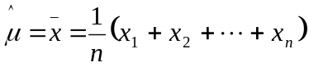
Where n is the sample size, similarly variance is estimated as
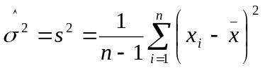

Maximum-likelihood estimation (MLE)
Wikipedia “In statistics, maximum-likelihood estimation (MLE) is a method of estimating the parameters of a statistical model. When applied to a data set and given a statistical model, maximum-likelihood estimation provides estimates for the model's parameters. In general, for a fixed set of data and underlying statistical model, the method of maximum likelihood selects the set of values of the model parameters that maximizes the likelihood function. Intuitively, this maximizes the "agreement" of the selected model with the observed data, and for discrete random variables it indeed maximizes the probability of the observed data under the resulting distribution. Maximum-likelihood estimation gives a unified approach to estimation, which is well-defined in the case of the normal distribution and many other problems. However, in some complicated problems, difficulties do occur: in such problems, maximum-likelihood estimators are unsuitable or do not exist”.
Let us consider a discrete (or continuous) random variable X whose probability function (or density) depends on a single parameter θ. We take a corresponding sample of n independent values x₁, x₂, ..., x_{n.} Then in the discrete case the probability that a sample of size n consist precisely of those n values is
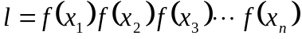
And in the continuous case
Since f(x_{i}) depends on θ, the function l depends on x₁, x₂, ..., x_{n} and θ. Let the random variables x_{i} be fixed, which is true once the sample data has been fixed, then the likelihood function only remains the function of θ. We then find the value of θ for which the function is maximum. For this we differentiate the natural log of l with respect to θ and then equate it equal to zero. By solving this equation we find that value of θ, for which the function l is maximum.
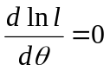
The solution of the above equation is called the maximum likelihood estimate for θ.

Confidence Interval
Confidence intervals for an unknown parameter θ of some distribution are intervals θ₁≤ θ≤ θ₂ that contain θ not with certainty but with a high probability γ which we can choose, 95% and 99% are popular. The procedure to find the confidence interval for normal distribution is given below in tabular form [Ervin Kryzik]
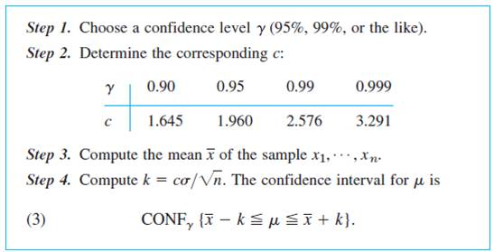

Central Limit Theorem
Let X₁,…., X_{n},… be independent random variables that have same distribution function and therefore the same mean µ and the same variance σ². Let Y_{n}= X₁+….+ X_{n}. The the random variable
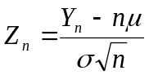
Is asymptotically normal with mean 0 and variance 1.

Regression Analysis
In regression analysis one of the two variables, call it x, can be regarded as an ordinary variable because we can measure it without substantial error or we can even give it values we want. x is called the independent variable, or sometimes the controlled variable because we can control it.
The other variable, Y, is a random variable, and we are interested in the dependence of Y on x.

Least Squares Principle
The straight line should be fitted through the given points so that the sum of the squares of the distances of those points from the straight line is minimum, where the distance is measured in the vertical direction.

Estimators
The equations of the estimator are given as
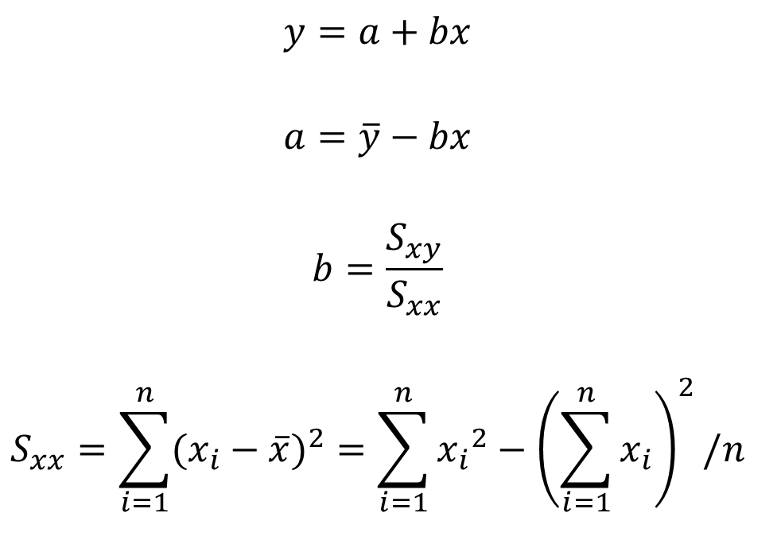

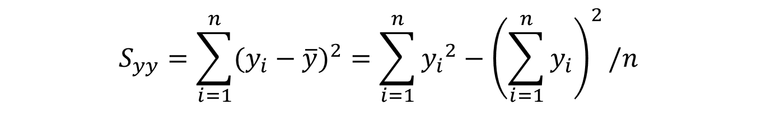

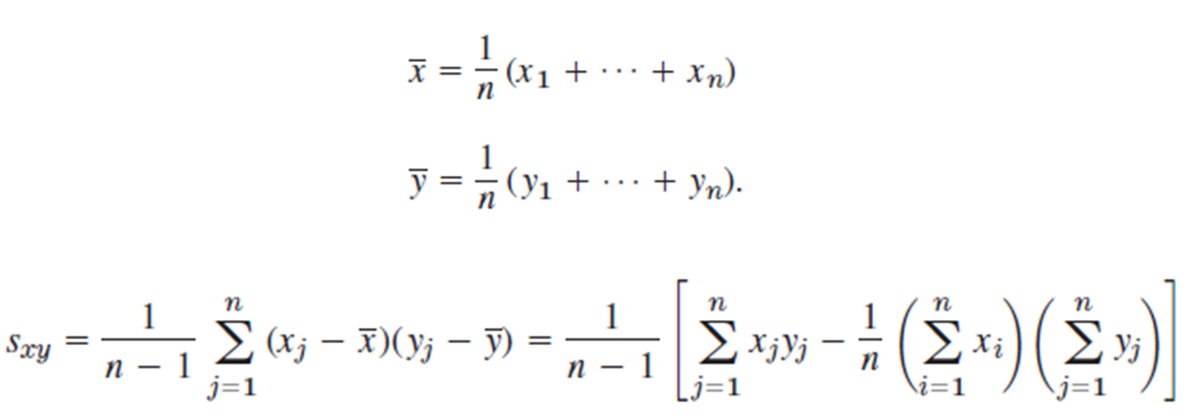

Correlation Coefficient
Let f(x) and g(x) be two continuous functions, of x. The correlation coefficient is defined by
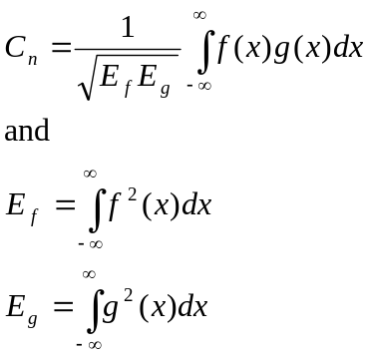

The values of correlation coefficient tell us how similar the two functions are.

References:
Probability and Statistics for Engineers and Scientists .Ninth Edition, Ronald E Walpole, Raymond H Myers, Sharon L Myers and Keying Ye. Prentice Hall Inc. 2012
Schaum’s Outline of Theory and Problems of Probability, Random Variables, and Random Processes, Hwei Hsu, McGraw Hill 1997
Advanced Engineering Mathematics, Erwin Kreyszig, John Wiley and Sons Inc. Tenth Edition, 2011.

