

MTH352: Differential Geometry
Module Handbook
Credit Hours: 3(3,0)

For

Master of Mathematics

By

Dr. SOHAIL IQBAL
Assistant Professor
Department of Mathematics,
CIIT Islamabad, Pakistan.

The following lecture notes are designed for the course of
MTH-352
Differential Geometry
The notes are not intended to be an independent script and are designed to go together with the videos and the recommended book.

Chapter 1

Calculus On Euclidean Space

Lecture # 1

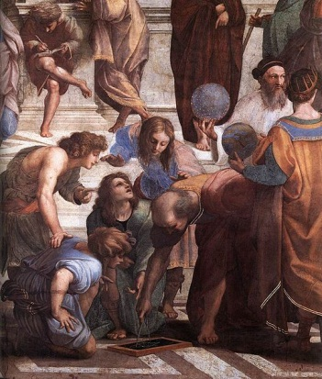
History
From the very beginning of the evolution human beings started observing geometry of objects around.
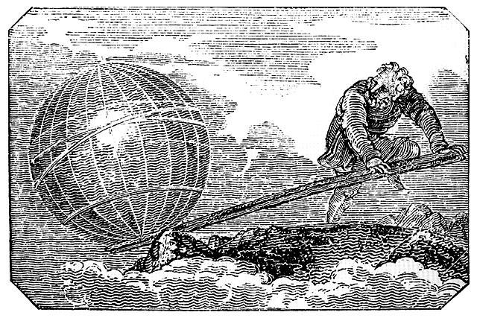
The first written work is by Euclid. He compiled of his and others work into volume form known as Euclid's Elements. His work is one of the most influential works in the history of mathematics. The “Elements” have been serving as the main textbook for teaching geometry from the 300 B.C. until the 20th century. For his contributions he is often referred as “Father of geometry”.
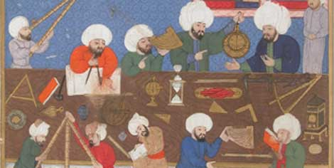
The next name we came across in the history of geometry is Archimedes. He understood the geometry of different objects about him, for example, he calculated the area and volumes of different objects, and the techniques were later formulated in calculus. He understood geometry to such an extent that once he said give me a place to stand on and I will move the Earth.
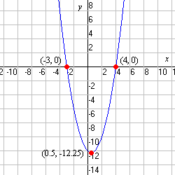
The next major development in geometry was done in Muslim Era. The need to predict the phases of the Moon for Ramadan and other religious festivals led to great steps forward in geometry of celestial objects (astronomy).
Introduction of “Cartesian coordinates” marked a new stage for geometry, since geometric figures, could now be represented analytically, that is, with functions and equations. It is said that Cartesian coordinates were invented by René Descartes and Pierre de Fermat independently. In Cartesian coordinates we can associate a point in plane with an ordered pair. In a coordinate plane we can associate a curve starting from an equation. Hence the Cartesian coordinates built a bridge between algebra and geometry. The following example reminds us the procedure.
Example: Graph of equation $y=x^{2}$ in Euclidean plane. We can sketch the graph by first finding the images of different values of $x$ under the equation $y=x^{2}$. Then we can sketch the ordered pair in Cartesian plane to get the graph of the equation $y=x^{2}$.

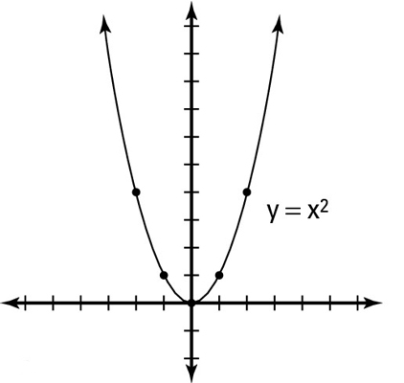
X | 0 | 1 | -1 | 2 | -2
Y | 0 | 1 | 1 | 4 | 4
5

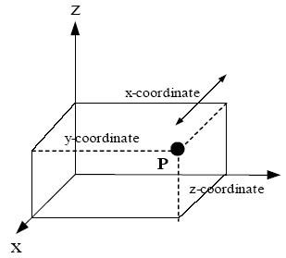
On the same lines we can have Cartesian coordinates in three dimensional space. On the same lines we can associate a point in space with an ordered triple. Using these coordinates we can associate curves and surfaces in space with an equation.

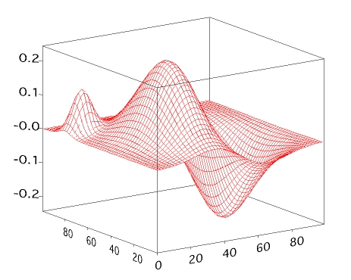
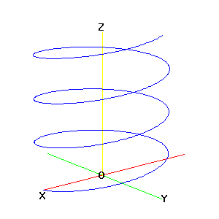

There is a particular emphasis on surfaces in geometry. Mainly because there are many examples of surfaces around us, for example, surface of earth and the geometry of space due to some heavy object.

Aim of the course:
In this course we are mainly interested in doing calculus on surfaces. For this we aim at doing the followings.
- Review of differential calculus.
- Develop tools to study curves and surfaces in space.
- Proper definition of surface. How to do calculus on surface.
- A detailed study of geometry of surface.
Let us start the course with some review of basics.

Some definitions
Set
A set S is a collection of objects that are called the elements of S.
Example1: S = {1,2,3,4,…} is a set of natural numbers.
Example2: S = { x : x is an integer ^ x is divisible by 2} = Set of even integers.
Subset
A set A is a subset of S provided each element of A is also an element of S.
Example1: A = {1,2,3} is a subset of S = {1,2,3,4,…}.
Example2: A = { x : x is an integer ^ x is divisible by 2 } is a subset of integers.
Function
A function from set $D$ to set $R$, written as $f :D → R$, is a rule that assigns each element element of $D$ to a unique element of $R$
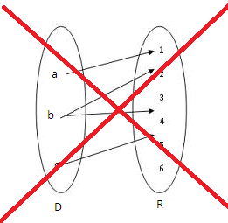
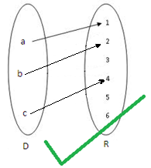

Example1: Let $D=\left\{a,b,c\right\}, R=\left\{1,2,3,4,5,6\right\}$
Domain
$D$ is called domain of $f$.
Range
$R$ is called range of $f$.
Image
For $x∈D, f(x)$ is called image of $x$ under $f$. In above example $f\left(a\right)=1$. Image of the function $f$ is the set $\{f\left(x\right):x∈D\}$. In above example image of $f$ is $\{1,2,4\}$.
Example: $f:R→R,f\left(x\right)=1+x$, Image of $f=R$.
Composite Function
Let $f:D→R$ and $g:E→S$ such that g$\left(E\right)⊂D$ then $f∘g\left(x\right)=f(g(x))$.
Example: $f\left(x\right)=1+x$, $g\left(x\right)=x^{2}$, then
$f∘g\left(x\right)=f\left(g\left(x\right)\right)=f\left(x^{2}\right)=1+x^{2}$.
One-to-one
$f:D→R$, $f\left(x\right)=f(y)$ )$x=y$.
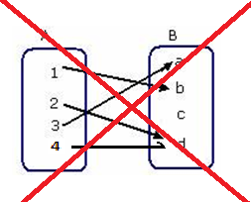
Example: $f:A→B$, for $A=\left\{1,2,3,4\right\}, B=\{a,b,c,d\}$.
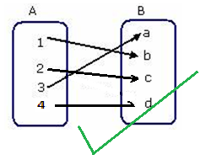

Example: $f\left(x\right)=1+x$.

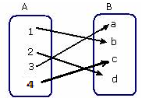
Onto functions
A function $f:A→B$, is onto if $f\left(A\right)=B$.
Example: $f:A→B$, for $A=\left\{1,2,3,4\right\}, B=\{a,b,c,d\}$
Inverse
$f:D→R$is one-to-one and onto, then $f$ has inverse $f^{-1}:R→D,$ such that $y→x$where $y=f(x)$.
Or
$g$ is inverse of $f$ if $f∘g=g∘f=I$.
Example: $f\left(x\right)=1+x$, has inverse $g\left(x\right)=x-1$.

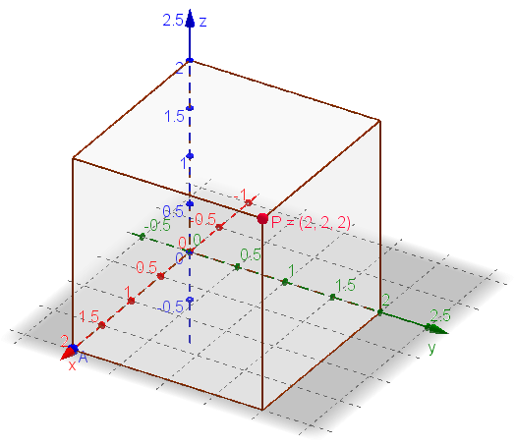
Euclidean 3-Space
Euclidean 3-space $R$ is the set of all ordered triples of real numbers. Such a triple $p=(p_{1},p_{2},p_{3})$ is called a point of $R^{3}.$
For $p=(p_{1},p_{2},p_{3})$, $q=(q_{1},q_{2},q_{3})$ then
$$p+q=\left(p_{1}+q_{1},p_{2}+q_{2}, p_{3}+q_{3}\right)$$
For $p=(p_{1},p_{2},p_{3})$, and $α$ a scalar then
$$αp=(αp_{1},αp_{2},αp_{3})$$
$R^{3}$ is a vector space .
The point $O=(0,0,0)$ is called the origin of $R^{3}$.

Review of Fields and vector spaces
Field
A Field is a set $F$ such that for any $α, β,γ$ in $F$ the following holds:
- Closure of $F$ under addition and multiplication:
$α+β∈F$, and $α.β∈F$
- Associativity of addition and multiplication:
$α+\left(β+γ\right)=\left(α+β\right)+γ$ and $α.\left(β.γ\right)=\left(α.β\right).γ$
- Commutativity of addition and multiplication:
$α+β=β+α$and $α.β=β.α$
- Existence of additive and multiplicative identity elements:
$α+0=0+α=α$, $α.1=α$
- Existence of additive inverses and multiplicative inverses:
$-α∈F$, $α+\left(-α\right)=\left(-α\right)+α=0$
for $α≠0$, there exists an element $α^{-1}∈F$, such that $α.α^{-1}=1$
- Distributivity of multiplication over addition:
$$α.\left(β+γ\right)=α.β+αγ$$
Example: Set of real numbers and set of rational numbers are examples of field.
Vector Space
A vector space over a field is a set $V$ such that: for any $α, β∈F$ and $v, w∈V$, the following hold.
- Closed under addition and scalar multiplication | $u+v∈V$ , $αv∈V$
- Associativity of addition | $$u+\left(v+w\right)=\left(u+v\right)+w$$
- Commutativity of addition | $$u+v=v+u$$
- Identity element of addition | $0∈V$ such that $v+0=0+v=v$
- Inverse elements of addition | For every $v∈V$ there exist $-v∈V$ such that $v+\left(-v\right)=\left(-v\right)+v=0$
- Distributivity of scalar multiplication with respect to vector addition | $$α\left(u+v\right)=αu+αv$$
- Distributivity of scalar multiplication with respect to field addition | $$\left(α+β\right)v=αv+βv$$
- Compatibility of scalar multiplication with field multiplication | $$α\left(βv\right)=\left(αβ\right)v$$
- Identity element of scalar multiplication | $1v=v$, where $1$ is the multiplicative identity in $F$.
Example: The Euclidean 3-space $R^{3}$ is a vector space.
Coordinate functions
Let $x,y$, and $z$ be real-valued functions on $R^{3}$ such the for each point $p=(p_{1},p_{2},p_{3})$ we have
$$x\left(p\right)=p_{1},y\left(p\right)=p_{2}, z\left(p\right)=p_{3}$$
We can use
$$x_{1}=x, x_{2}=y, x_{3}=z$$
$$p=\left(p_{1},p_{2},p_{3}\right)=(x_{1}\left(p\right),x_{2}\left(p\right),x_{3}\left(p\right))$$
Differentiable OR $C^{∞}$ functions
A real-valued function $f$ on $R^{3}$ is differentiable (or infinitely differentiable, or smooth, or of class $C^{∞}$) provided all partial derivatives of $f,$ of all orders, exist and are continuous.
Example: Consider a function $f:R^{2}→R$, defined as $f\left(x,y\right)=x^{2}y$. Is $f$ a smooth function?
Solution: Since $f$ is a polynomial function, hence $f$ is differentiable. Now the first partial derivatives of $f$ are :
$$\frac{∂f}{∂x}=2xy, \frac{∂f}{∂y}=x^{2}.$$
Which are continuous. Now the second partial derivatives are:
$$\frac{∂^{2}f}{∂x^{2}}=2y, \frac{∂^{2}f}{∂y^{2}}=0, \frac{∂^{2}f}{∂x∂y}=2x.$$
Which are continuous again. Similarly we can see that all the partial derivatives of $f(x,y)$ are continuous so $f\left(x,y\right)$ is a smooth function.
Arithmetic of differentiable functions
Differentiable real-valued functions $f$ and $g$ may be added and multiplied in the following way
- $(f+g)\left(p\right)=f\left(p\right)+g(p)$,
- $\left(fg\right)\left(p\right)=f\left(p\right)g(p)$

Q1(a) (Exercise 1.1):
If $f=x^{2}y$ and $g=y sin z$ then find $fg^{2}$.
Solution: Here $fg^{2}$ represents the point wise multiplication. So
$$fg^{2}=\left(x^{2}y\right)\left(y\sin{z}\right)=x^{2}yz\sin{z} .$$
Chain rule
If g is differentiable at x and f is differentiable at g(x) then the composition $f∘g$ is differentiable at x. Moreover, if
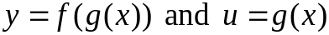

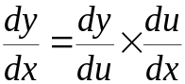
Then $y=f(u)$ and

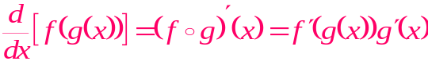
Alternatively

Derivative of outside function
Derivative of inside function

Example:
Find $\frac{dy}{dx}$ if $y=cos (x^{3})$.
Solution: Let
$$u=x^{3}$$
Then
$$y=\cos{u }.$$
Now
$$\frac{dy}{du}=-\sin{u}.$$

And
$$\frac{du}{dx}=3x^{2}$$
So by using chain rule
Rates of change multiply
$$\frac{dy}{dx}=\frac{dy}{du}×\frac{du}{dx}$$
$$\frac{dy}{dx}=(-\sin{u})(3x^{2})$$
$$\frac{dy}{dx}=-3x^{2}\sin{x^{3}}$$

Q1(d) (Exercise 1.1):
Find $\frac{∂}{∂y}(\sin{f})$ where $f=x^{2}y$.
Solution: Using chain rule
$$\frac{∂}{∂y}\sin{f}=\left(\frac{∂}{∂f}\sin{f} \right)\left(\frac{∂f}{∂y}\right).$$
$$\frac{∂}{∂y}\sin{f}=\left(\cos{f} \right)\left(x^{2}\right).$$

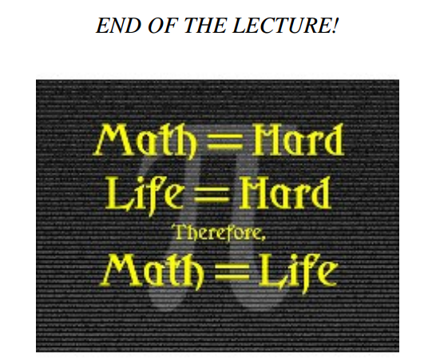

Lecture # 2

The lecture contents
- Vectors in $R^{3}$
- Tangent vectors
- Vector field
- Natural frame field on $R^{3}$
- Differentiable vector fields
- Some questions from Exercise 1.2
Vectors in $R^{3}$
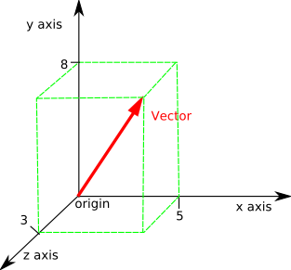
Intuitively a vector in $R^{3}$ is an oriented line segment or “arrow”. Vectors are used to describe vector quantities such as force, velocities, angular momenta etc.

For practical purposes there is a problem with this definition and needs to be improved. According to above definition two translated vectors are same, but in real life two vectors can have different effect if there initial points are different (see picture below). So we need to incorporate the initial point in the definition of vector.
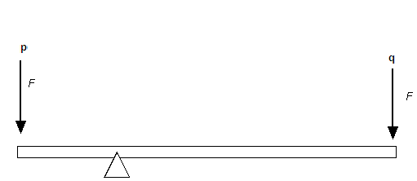
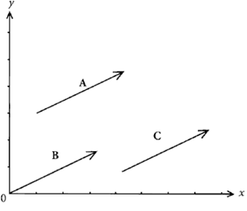

To define a vector $v$ precisely we mention the starting point $p$of the vector as well.
Definition: A vector in $R^{3}$ is $p+v$, where $p$ is initial point of vector $v$.
Strictly speaking $v$ is a point in $R^{3}$.
Tangent vectors
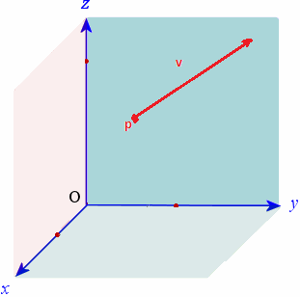
Definition: A tangent vector $v_{p}$ to $R^{3}$ consists of two points of $R^{3}$; its vector part $v$ and its point of application $p$.

A tangent vector $v_{p}$ is drawn as an arrow from the point $p$ to the point $p+v$.

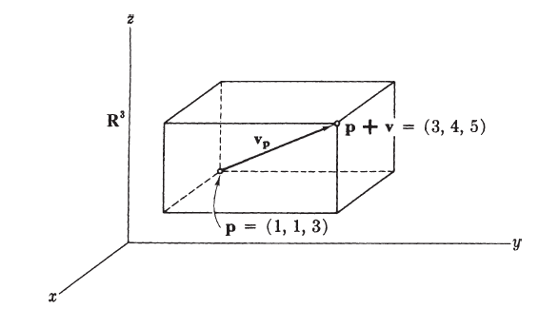
Example: If $v=\left(2,3,2\right)$, and $p=(1,1,3)$ then the tangent vector
$$v_{p}={\left(2,3,2\right)}_{(1,1,3)}$$
Starts in $\left(1,1,3\right)$ and ends in $(3,4,5)$.
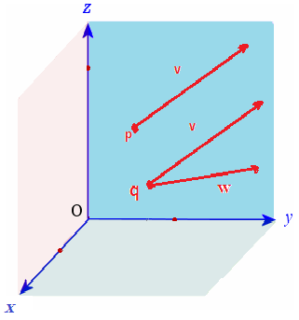
Equality of tangent vectors
- Two tangent vectors $v_{p}$ and $w_{q}$ are parallel if and only in $v=w$.
- Two tangent vectors $v_{p}$ and $w_{q}$ are equal if and only in $v=w$ and $p=q$.
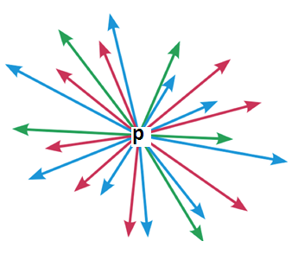
- $v_{p}$ and $v_{q}$ are different tangent vectors if $p≠q$.
Definition: Let $p$ be a point of $R^{3}$. The set $T_{p}(R^{3})$ consisting of all tangent vectors that have $p$ as point of application is called the tangent space of $R^{3}$ at $p$.
Note: Each point of $R^{3}$ has its own tangent space. They are all different from each other.

Here we give a recall of the method of parallelogram law, scalar multiple of a vector, linear transformation, and isomorphism of vector spaces.
- Given two vectors $V$ and $W$ in $R^{3}$ we add them by parallelogram law.
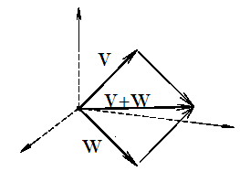
- Let $c$ be scalar, then for vector $A$, $cA$ stretches or shrinks $A$ by the factor $c$, and reverse the direction if $c<0$.
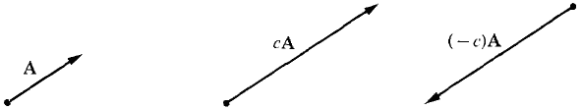

For $v_{p},w_{p}∈T_{p}(R^{3})$ then we can define:
$$v_{p}+w_{p}={\left(v+w\right)}_{p}$$
And for any scalar $c∈R$ we define
$${cv}_{p}={\left(cv\right)}_{p}$$
Fact : $T_{p}{(R}^{3})$ is vector space under the above addition and scalar multiplication.
Linear Transformation: A linear transformation $L:V→W$ from a vector space $V$ to vector space $W$ is a function that satisfy the following conditions: for any vectors $v,w∈V$ and any scalar $c$
$$L\left(v+w\right)=L\left(v\right)+L\left(w\right)$$
$$L\left(cv\right)=cL\left(v\right).$$
Isomorphism: Two vector spaces $V$ and $W$ are isomorphic if there exist a bijective linear transformation between them $L:V→W.$ A bijective linear transformation $L$ is also called an isomorphism.
Fact: $T_{p}(R^{3})$ is isomorphic to $R^{3}$. The isomorphism $L:T_{p}\left(R^{3}\right)→R^{3}$ between them such that for $v_{p}∈T_{p}\left(R^{3}\right)$
Using above definition we can conclude that the map $L:T_{p}\left(R^{3}\right)→R^{3}$ defined as
$$L\left(v_{p}\right)=v.$$
is an isomorphism.
Vector field
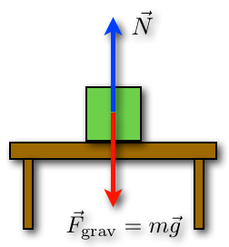
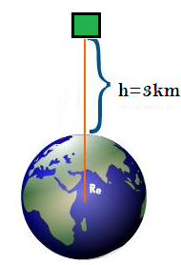
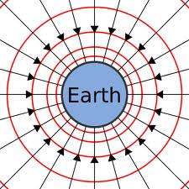
There are many examples of vector field around us, for example, the gravitational field etc. In such vector fields each point of the domain space represents a vector, for example, in case of gravitation vector field each point of the space represents a vector, directed towards the center of the earth and the magnitude representing the amount of force with which earth attracts the object towards itself. As the force of attraction of earth reduced as the object moves away from the center of earth so there will be vectors of different length in the gravitational vector field.

Hence we define a vector field as.
Definition: A vector field $V$ on $R^{3}$ is a function that assigns to each point $p$ of $R^{3}$ a tangent vector $V(p)$ to $R^{3}$ at $p$.

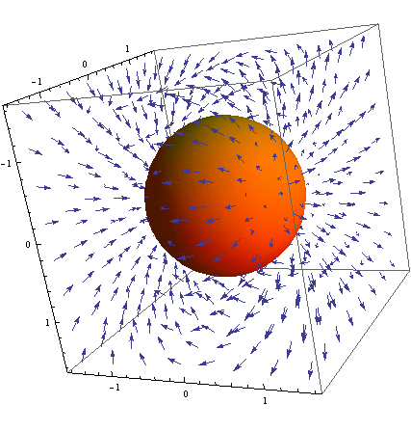
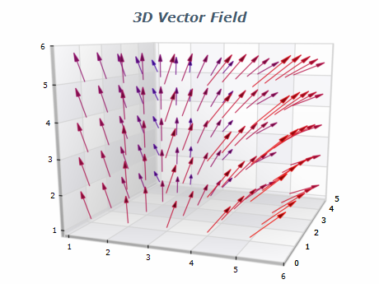

Since a vector field is a function so we can add two vector fields just like we add functions. So if $V$ and $W$ are two vector fields on $R^{3}$ then
$$\left(V+W\right)\left(p\right)=V\left(p\right)+W\left(p\right).$$
For any real-valued function $f:R^{3}→R$ we define
$$\left(fV\right)\left(p\right)=f\left(p\right)V\left(p\right).$$
Natural frame field on $R^{3}$
To investigate vector fields on $R^{3}$ we introduce a set of basic vector fields on $R^{3}$.
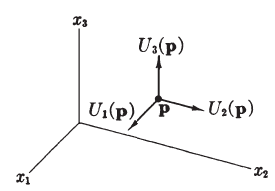
Definition: Let $U_{1} , U_{2}, U_{3}$ be the vector fields on $R^{3}$ such that
$$U_{1}\left(p\right)={\left(1,0,0\right)}_{p}$$
$$U_{2}\left(p\right)={\left(0,1,0\right)}_{p}$$
$$U_{3}\left(p\right)={\left(0,0,1\right)}_{p}$$
For each point $p$of $R^{3}$. We call $U_{1} , U_{2}, U_{3}$ -collectively-the natural frame field on $R^{3}$.
The following result shows how to factorize given vector field into combination of natural frame:
Lemma: If $V$ is a vector field on $R^{3}$, there are three uniquely determined real-valued functions, $v_{1},v_{2},v_{3}$ on $R^{3}$ such that
$$V=v_{1}U_{1}+v_{2}U_{2}+v_{3}U_{3}$$
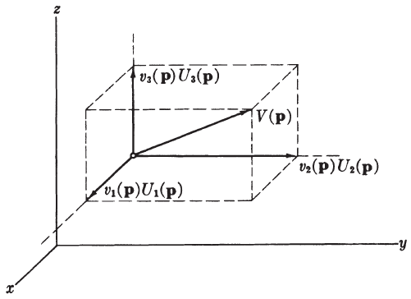
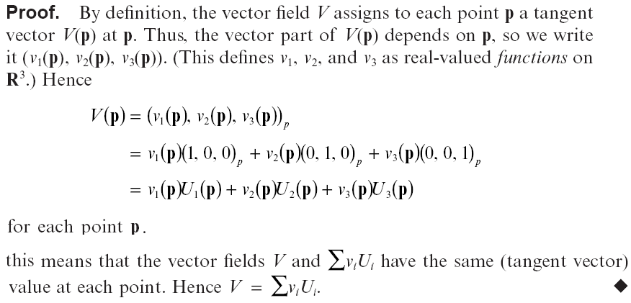
The functions $v_{1},v_{2},v_{3}$ are called the Euclidean coordinate functions of $V$.

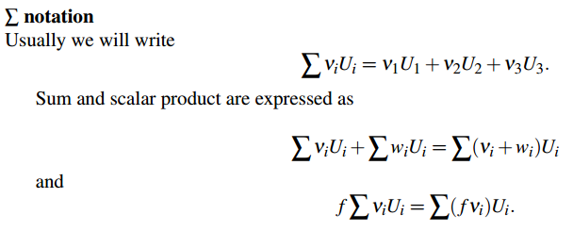

Differentiable vector field
Definition: A vector field $V$ is differentiable if each of its three Euclidean coordinate function $v_{1},v_{2},v_{3},$ is differentiable function (smooth, of class $C^{∞}$).
We always assume vector fields are differentiable. So from now on vector field means
differentiable vector field

End of the lecture


Lecture # 3

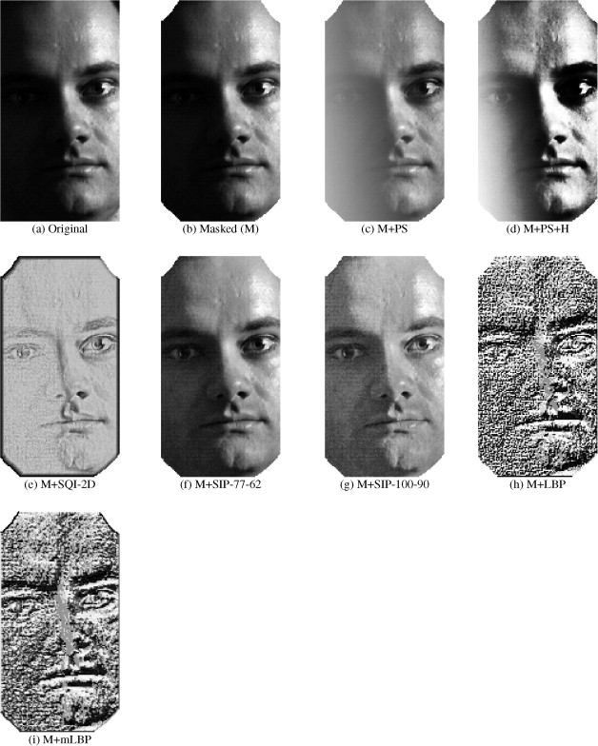
Contents:
- Directional derivatives
- How to differentiate composite functions (Chain rule)
- How to compute directional derivatives more efficiently
- The main properties of directional derivatives
- Operation of a vector field
- Basic properties of operations of vector fields
The main of the lecture is to discuss directional derivative of real-valued functions on $R^{3}$. Recall that a real-valued function on $R^{3}$, written as $f:R^{3}→R$, has domain $R^{3}$ and range $R$. Graph of such a function is a surface, for example, the graph in the following is a graph of a real-valued function on $R^{3}$.
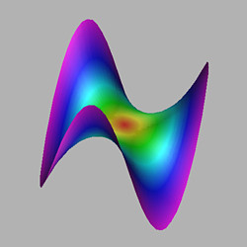

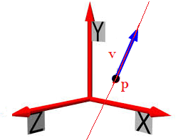
To define directional derivative we first need the following.
Associated with each tangent vector $v_{p}$ to $R^{3}$ is the straight line
$$t→p+tv$$
The line is parallel to vector $v$ and passes through point $p$.

Definition: Let $f$ be a differentiable real-valued function on $R^{3}$, and let $v_{p}$ be a tangent vector to $R^{3}$. Then the number
$$v_{p}\left[f\right]=\frac{d}{dt}\left(f\left(p+tv\right)\right){\left.​\right|}_{t=0}$$
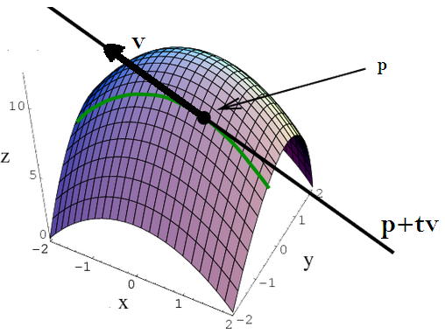
Is called the derivative of $f$with respect to $v_{p}$.
From the picture shows the geometrically interpretation of the directional derivative. The surface is the graph of the function $f:R^{3}→R$. The directional derivative of $f$ corresponding to the tangent vector is calculated in the following mannar:
- First calculate the line corresponding to the tangent vector $v_{p}$.
- The line corresponds to a curve on the surface.
- The directional derivative $v_{p}[f]$ is then the derivative of the curve at point $p$.
Here the derivative of the curve means the same thing as we did in calculus of one variable (In fact the green curve in above graph is contained in a plane which is not shown in the graph).
The following are worth noting:
- The number $v_{p}[f]$ is called the derivative of $f$with respect to $v_{p}$
- We also say that $v_{p}[f]$ is a directional derivative.
- The directional derivative $v_{p}[f]$ informs us about the change in the value of $f$ as we move away from $p$ in the direction $v_{p}$.
Example: Compute $v_{p}[f]$ for the function $f=x^{2}yz$, with $p=(1,1,0)$ and $v=(1,0,-3)$.
Solution: First we compute the line defined by $p$ and $v$
$$p+tv=\left(1,1,0\right)+t\left(1,0,-3\right)=(1+t,1,-3t)$$
Now evaluating $f$ along the line.
$$f\left(p+tv\right)=f\left(1+t,1,-3t\right)={\left(1+t\right)}^{2}\left(1\right)\left(-3t\right)=-3t-6t^{2}-3t^{3}$$
Now
$$\frac{d}{dt}\left(f\left(p+tv\right)\right)=\frac{d}{dt}\left(-3t-6t^{2}-3t^{3}\right)=-3-12t-9t^{2}$$
Now applying definition of$v_{p}\left[f\right]$ we get
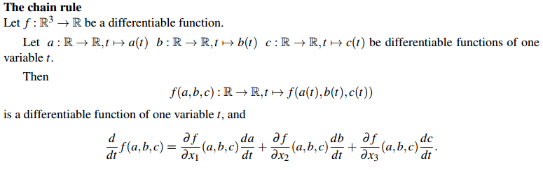
$v_{p}\left[f\right]=\frac{d}{dt}\left(f\left(p+tv\right)\right){\left.​\right|}_{t=0}=\left(-3-12t-9t^{2}\right){\left.​\right|}_{t=0}=-3.$
For next discussion we need to recall the following.

The following results can be used to calculate directional derivatives more efficiently.
Lemma: If $v_{p}=\left(v_{1},v_{2},v_{3}\right)$ is a tangent vector to $R^{3}$, then
$$v_{p}\left[f\right]={∑v}_{i}\frac{∂f}{∂x_{i}}(p)$$
Proof: Let $p=(p_{1},p_{2},p_{3})$; then
$$p+tv=(p_{1}+tv_{1},p_{2}+tv_{2},p_{3}+tv_{3})$$
Now
$$f\left(p+tv\right)=f\left(\left(p_{1}+tv_{1},p_{2}+tv_{2},p_{3}+tv_{3}\right)\right)$$
Since
$$\frac{d}{dt}\left(p_{i}+tv_{i}\right)=v_{i}$$
By using chain rule, we get
$$v_{p}\left[f\right]=\frac{d}{dt}f\left(p+tv \right){\left.​\right|}_{t=0}=∑\frac{∂f}{∂x_{i}} \frac{d}{dt}\left(p_{i}+tv_{i}\right){\left.​\right|}_{t=0}={∑v}_{i}\frac{∂f}{∂x_{i}}\left(p\right)$$
The same example as before:
Example: Compute $v_{p}[f]$ for the function $f=x^{2}yz$, with $p=(1,1,0)$ and $v=(1,0,-3)$.
Solution: We know that
If $v_{p}=\left(v_{1},v_{2},v_{3}\right)$ is a tangent vector to $R^{3}$, then
$$v_{p}\left[f\right]={∑v}_{i}\frac{∂f}{∂x_{i}}\left(p\right).$$
So we calculate
$$\frac{∂f}{∂x}=2xyz, \frac{∂f}{∂y}=x^{2}z, \frac{∂f}{∂z}=x^{2}y$$
Thus at point $p=(1,1,0)$
$$\frac{∂f}{∂x}=0, \frac{∂f}{∂y}=0, \frac{∂f}{∂z}=1$$
So
$$v_{p}\left[f\right]={∑v}_{i}\frac{∂f}{∂x_{i}}\left(p\right)=1\left(0\right)+0\left(0\right)-3\left(1\right)=-3$$
Theorem: Let $f$ and $g$ be functions on $R^{3}$, $v_{p}$ and $w_{p}$ tangent vectors, $a$ and $b$ numbers. Then
1)- $\left(av_{p}+bw_{p}\right)\left[f\right]=av_{p}\left[f\right]+bw_{p}[f]$.
2)- $v_{p}\left[af+bg\right]=av_{p}\left[f\right]+bv_{p}[g].$
3)- $v_{p}\left[fg\right]=v_{p}\left[f\right].g\left(p\right)+f\left(p\right).v_{p}[g]$
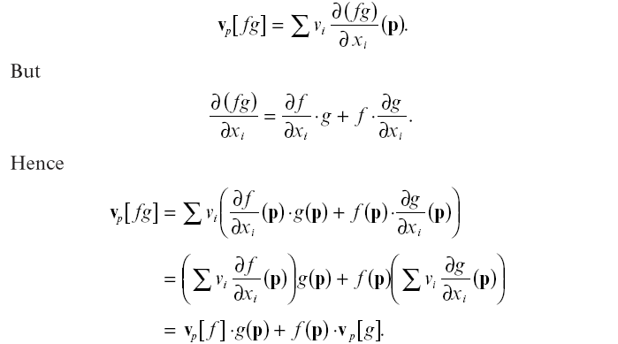
Proof (3):

Operation of a vector field
Operation of a vector field $V$on a function $f$ is defined as follows:
Definition: Let $V$ be a vector field, and let $f:R^{3}→R$be a function. Then $V[f]$ be the function defined by
$V\left[f\right]:R^{3}→R$, $V\left[f\right]\left(p\right)=V\left(p\right)[f]$
So $V[f]$ is a function which to each point $p$ in $R^{3}$ gives us the derivative of $f$ with respect to the tangent vector $V(p)$.
Example: For the natural fame field $U_{1},U_{2},U_{3},$ we get
$$U_{1}\left[f\right]\left(p\right)=U_{1}\left(p\right)\left[f\right]={\left(1,0,0\right)}_{p}[f]$$

Lemma: If $v_{p}=\left(v_{1},v_{2},v_{3}\right)$ is a tangent vector to $R^{3}$, then
$$v_{p}\left[f\right]={∑v}_{i}\frac{∂f}{∂x_{i}}(p)$$
So we get
$$U_{1}\left[f\right]\left(p\right)=U_{1}\left(p\right)\left[f\right]={\left(1,0,0\right)}_{p}\left[f\right]=1\frac{∂f}{∂x}\left(p\right)+0.\frac{∂f}{∂y}\left(p\right)+0\frac{∂f}{∂x}\left(p\right)=\frac{∂f}{∂x}\left(p\right).$$
Basic properties of operations of vector fields
Corollary: Let $V$ and $W$ be vector fields on $R^{3}$ and $f,g$ and $h$ are real-valued function, then
(1)- $\left(fV+gW\right)\left[h\right]=fV\left[h\right]+gW\left[h\right]$
(2)- $V\left[af+bg\right]=aV\left[f\right]+bV[g]$
(3)- $V\left[fg\right]=V\left[f\right].g+fV[g]$
Proof (2): $V\left[af+bg\right]=aV\left[f\right]+bV[g]$
For the proof we need to recall the following:
1)- $\left(av_{p}+bw_{p}\right)\left[f\right]=av_{p}\left[f\right]+bw_{p}[f]$.
2)- $v_{p}\left[af+bg\right]=av_{p}\left[f\right]+bv_{p}[g].$
3)- $v_{p}\left[fg\right]=v_{p}\left[f\right].g\left(p\right)+f\left(p\right).v_{p}[g]$

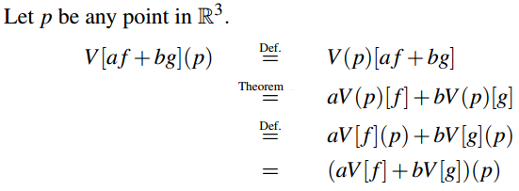

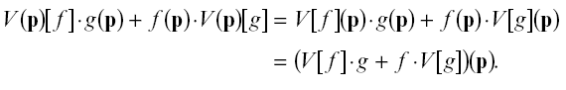
Proof (3): $V\left[fg\right]=V\left[f\right].g+fV[g]$

Example: Let $V$ be a vector field $V=x^{2}U_{1}+yU_{3}$ and let $f$be the function $f=x^{2}y-y^{2}z$. Calculate $V[f]$.
Solution:
$$V\left[f\right]=(x^{2}U_{1}+yU_{3}){(x}^{2}y-y^{2}z)$$
Using the following two properties:
1)- $\left(fV+gW\right)\left[h\right]=fV\left[h\right]+gW\left[h\right]$
2)- $V\left[af+bg\right]=aV\left[f\right]+bV[g]$
We get
$${V\left[f\right]=(x}^{2}U_{1}+yU_{3}){(x}^{2}y-y^{2}z)$$
$$={ (x}^{2}U_{1}+yU_{3})x^{2}y-{ (x}^{2}U_{1}+yU_{3})y^{2}z$$
$${ =x}^{2}U_{1}\left[x^{2}y\right]+yU_{3}\left[x^{2}y\right]{-x}^{2}U_{1}\left[y^{2}z\right]-yU_{3}[y^{2}z]$$
$$=x^{2}\left(2xy\right)+y.0-x^{2}.0-y\left(y^{2}\right)$$
$=2x^{3}y-y^{3}$.

End of the lecture

Lecture # 4

Contents:
- Curves in $R^{3}$
- Velocity Vectors
- Reparametrization of Curves in $R^{3}$
- Derivative with respect to Velocity
- Properties of Curves
- Conclusion
Curves in $R^{3}$
Open intervals in $R$
An open interval in $R$ is a set $I$ of real numbers of one of the four forms
- $\left\{t\right| a<t<b\}$
- $\left\{t\right| b<t\}$
- $\{t|t<a\}$
- $R$
Where $a$ and $b$ are real numbers.
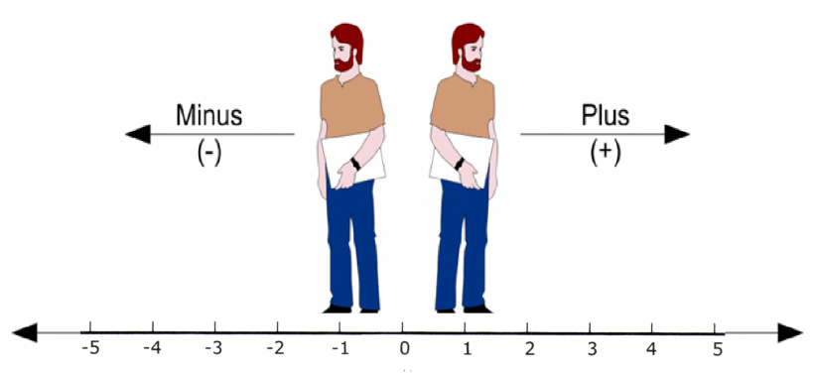

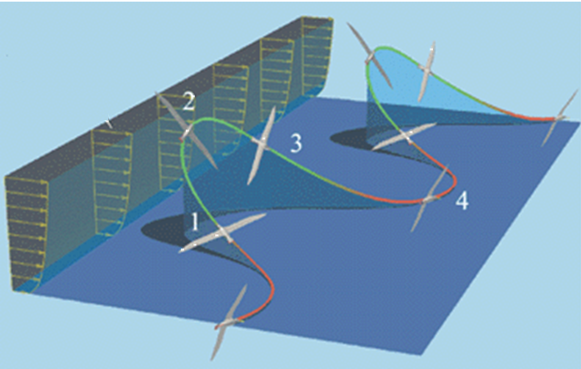
What is a curve in space intuitively?
The path followed by the bird in $R^{3}$ gives a trajectory in space.
Let for time $t$ the bird is located at
$α\left(t\right)=\left(α_{1}\left(t\right),α_{2}\left(t\right),α_{3}\left(t\right)\right)$,
in $R^{3}$ for $t∈(0,8)$.
This path together with some extra conditions gives us a curve.
In rigorous terms:
$α$ is a function from $I$ to $R^{3}$,
where $I$ is an open interval. Thus we
write
$$α\left(t\right)=\left(α_{1}\left(t\right),α_{2}\left(t\right),α_{2}\left(t\right)\right) for all t in I.$$
The real-valued functions $α_{1}(t)$, $α_{2}(t)$, and $α_{3}(t)$ are called Euclidean coordinate functions.
Differentiable functions: We define the function $α$ to be differentiable provided its coordinate functions $α_{1}(t)$, $α_{2}(t)$, and $α_{3}(t)$ are differentiable.
Definition: A curve in $R^{3}$ is a differentiable function $α:I→R^{3}$ from an open interval $I$ to $R^{3}$.
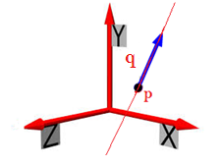
Example 1: Straight line
A line through point $p$ and in the direction $q$ is a curve
$$α:R→R^{3}$$
defined as
$$α\left(t\right)=p+tq=\left(p_{1}+tq_{1},p_{2}+tq_{2},p_{3}+tq_{3}\right).$$

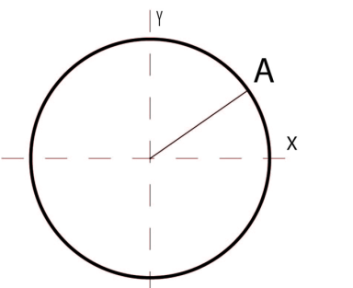
Circle:
The curve $t→(\operatorname{acos}{t, asint, 0})$ travels around a circle of radius a > 0 in the $xy$-plane of $R^{3}$.

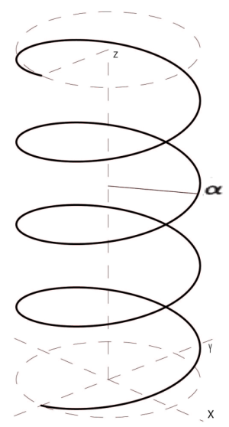
Helix:
If we allow this curve to rise (or fall) at a constant rate, we obtain a helix
$$α:R→R^{3}$$
defined as
$$α\left(t\right)=(a\cos{t},\operatorname{asin}{t , bt})$$
where $a>0, b≠0$.

Example: The curve $α:R→R^{3}$defined by
$$α\left(t\right)=\left(1+\cos{t},\sin{t} ,2\sin{\frac{t}{2}}\right)$$
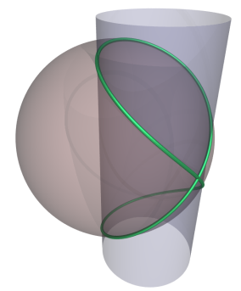
is a curve. The green line in the figure shows the curve.

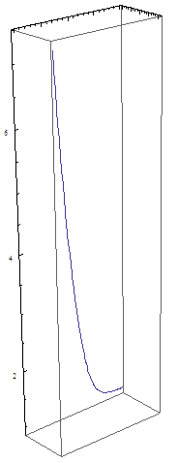
Example:
The curve $α:R→R^{3}$ defined as
$$α\left(t\right)=\left(e^{t},e^{-t},\sqrt{2} t \right)$$
is shown in the picture.

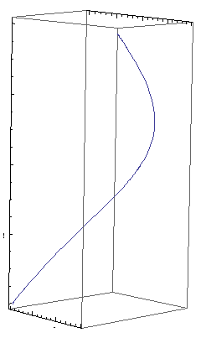

Example:
The curve $α:R→R^{3}$ defined by
$$α\left(t\right)=(3t-t^{3},3t^{2},3t+t^{3})$$
is shown in the figure.
This particular curve is called 3-curve.

Velocity vector
Definition: Let $α:I→R^{3}$ be a curve in $R^{3}$ with $α=(α_{1},α_{2},α_{3})$. For each number $t$ in $I$, the velocity vector of $α$ at $t$ is the tangent vector
$$α^{'}\left(t\right)={\left(\frac{dα_{1}}{dt}\left(t\right),\frac{dα_{2}}{dt}\left(t\right),\frac{dα_{3}}{dt}\left(t\right)\right)}_{α(t)}$$
at the point $α(t)$ in $R^{3}$.
Example: Let $α:R→R^{3}$ is defined by
$$α\left(t\right)=\left(3t-t^{3},3t^{2},3t+t^{3}\right).$$
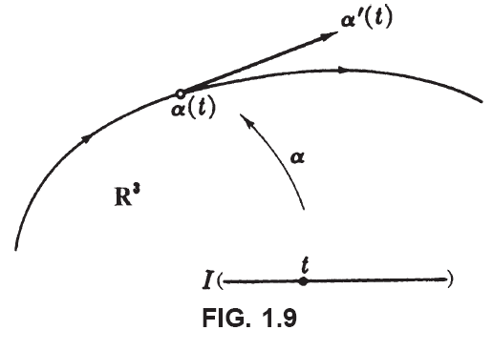
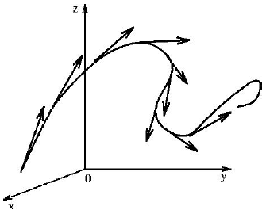

Geometric interpretation:
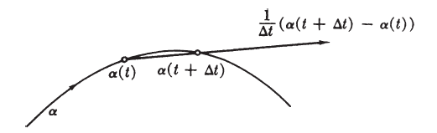

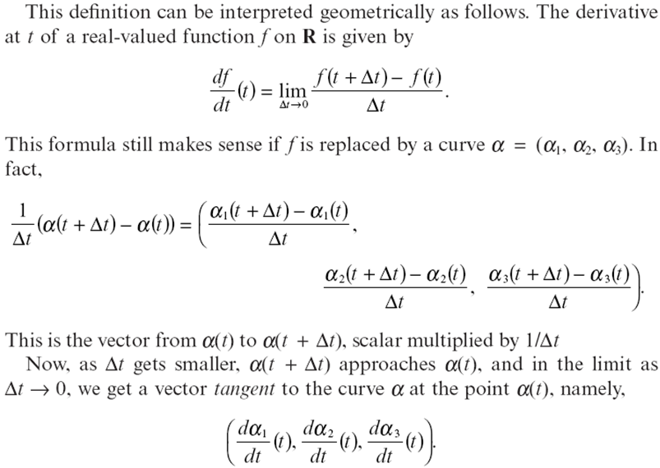

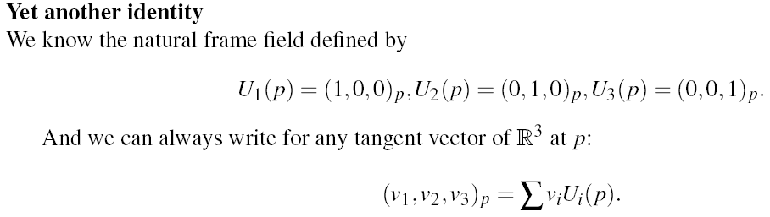

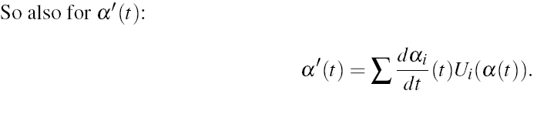

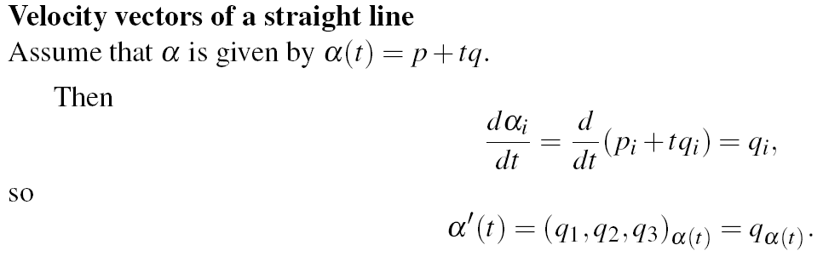
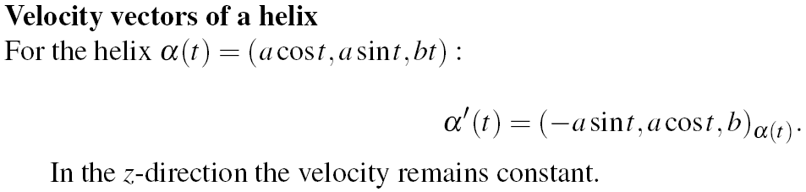
Q1 (Exercise 1.4): Compute the velocity vector of the curve in Example 4.2(3) for arbitrary $t$ and for $t=0$, $t=\frac{π}{4}$, $t=\frac{π}{2}$ visualizing these on figure 1.8.
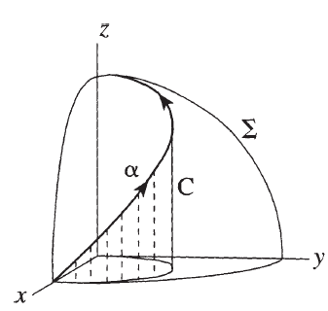
Solution: Here $α:R→R^{3} is given as$
$α\left(t\right)=\left(1+\cos{t},\sin{t} ,2\sin{\frac{t}{2}}\right)$.
Now by definition
$α^{'}\left(t\right)={\left(\frac{dα_{1}}{dt}\left(t\right),\frac{dα_{2}}{dt}\left(t\right),\frac{dα_{3}}{dt}\left(t\right)\right)}_{α(t)}$
which in this case is
$α^{'}\left(t\right)={\left(-\sin{t,\cos{t}},\cos{\frac{t}{2}}\right)}_{α\left(t\right)}$
Now at $t=0$
$α\left(0\right)=\left(2,0 ,0 \right)$.
and hence
$α^{'}\left(0\right)={\left(0,1,1 \right)}_{\left(2,0 ,0 \right)}$ .
Now at $t=\frac{π}{4}$
$α\left(\frac{π}{4}\right)=\left(\frac{1+\sqrt{2}}{2} ,\frac{1}{\sqrt{2}} ,0.76537\right)$.
and hence
$α^{'}\left(\frac{π}{4}\right)={\left(-\frac{1}{\sqrt{2}},\frac{1}{\sqrt{2}},0.92388 \right)}_{\left(\frac{1+\sqrt{2}}{2} ,\frac{1}{\sqrt{2}} ,0.76537\right)}$ .
Now at $t=\frac{π}{2}$
$α\left(\frac{π}{2}\right)=\left(1 ,1 ,√2 \right)$
and hence
$α^{'}\left(\frac{π}{2}\right)={\left(-1,0,\frac{1}{\sqrt{2}} \right)}_{\left(1 ,1 ,√2 \right)}$ .
Reparametrization of Curves in $R^{3}$
Definition: Let $α:I→R^{3}$ be a curve. If $h:J→I$ is a differentiable function on an open interval $J$, then the composite function
$β=α\left(h\right):J→R^{3}$
Is a curve called a reparametrization of $α$ by $h$.
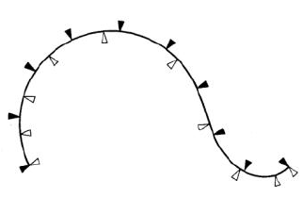
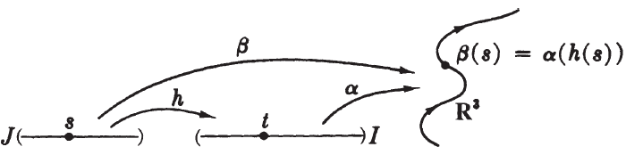

Example: Let the curve $α$ is defined as
$$α\left(t\right)=\left(\sqrt{t},t\sqrt{t},1-t\right) on I=\left(0,4\right)$$
If $h:J→I$ be the function given as $h\left(s\right)=s^{2}$, where $J=(0,2)$. Then the reparametrization is
$$β\left(s\right)=α\left(h\left(s\right)\right)=α\left(s^{2}\right)=(s,s^{3},1-s^{2})$$

Lemma: If $β$ is the reparametrization of $α$ by $h$, then
$$β^{'}\left(s\right)=\frac{dh}{ds}\left(s\right)α^{'}\left(h\left(s\right)\right).$$
Proof: If $α=(α_{1},α_{2},α_{3})$, then
$$β\left(s\right)=α\left(h\left(s\right)\right)=\left(α_{1}\left(h\left(s\right)\right),α_{2}\left(h\left(s\right)\right),α_{3}\left(h\left(s\right)\right)\right).$$
Now
$$β'\left(s\right)=α'\left(h\left(s\right)\right)=\left(α_{1}\left(h\left(s\right)\right)',α_{2}\left(h\left(s\right)\right)',α_{3}\left(h\left(s\right)\right)'\right).$$
By applying chain rule on $α_{i}'\left(h\left(s\right)\right)$, for $i=1,2,3$ we get
$$α_{i}^{}{\left(h\left(s\right)\right)}^{'}=α_{i}^{'}\left(h\left(s\right)\right)h^{'}\left(s\right) for i=1,2,3.$$
Which yields
$$β'\left(t\right)=α'\left( h\left(s\right)\right)=\left(α_{1}^{'}\left(h\left(s\right)\right)h^{'}\left(s\right),α_{2}^{'}\left(h\left(s\right)\right)h^{'}\left(s\right),α_{3}^{'}\left(h\left(s\right)\right)h^{'}\left(s\right)\right)$$
$=h^{'}\left(s\right)\left(α_{1}^{'}\left(h\left(s\right)\right),α_{2}^{'}\left(h\left(s\right)\right), α_{3}^{'}\left(h\left(s\right)\right)\right)$
${=h}^{'}\left(s\right)α^{'}(s)$ .

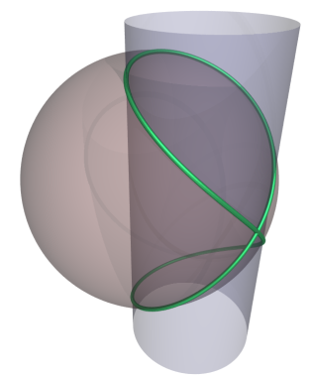
Q3 (Exercise 1.4): Find the coordinate function of the curve $β=α(h)$, where $α$ is the curve in example 4.2(3) and $h\left(s\right)=\cos^{-1}\left(s\right)$ on $J:0<s<1$.
Solution: The curve $α$ from 4.2(3) is given by:
$$α\left(t\right)=\left(1+\cos{t},\sin{t} ,2\sin{\frac{t}{2}}\right).$$

Lemma: Let $α$ be a curve in $R^{3}$ and let $f$ be a differentiable function on $R^{3}$. Then
$$α^{'}\left(t\right)\left[f\right]=\frac{d\left(f\left(α\right)\right)}{dt}\left(t\right)$$
Proof:
In this case
$$α^{'}=\left(\frac{dα_{1}}{dt},\frac{dα_{2}}{dt},\frac{dα_{3}}{dt}\right)$$
So
$$α^{'}\left(t\right)\left[f\right]=\sum{\frac{∂f}{∂x_{i}}}\left(α\left(t\right)\right)\frac{dα_{i}}{dt}(t)$$
But by chain rule.
$$α^{'}\left(t\right)\left[f\right]=\frac{d\left(f\left(α\right)\right)}{dt}\left(t\right).$$
Properties of Curves
One-to-one curves: The function $α:I→R^{3}$ is one-to one if
$$α\left(t_{1}\right)≠α\left(t_{2}\right)for t_{1}≠t_{2}$$
If $α$ is one-to-one then the curve does not intersect itself, or stay in the same point without moving on, or repeat itself over after some time.
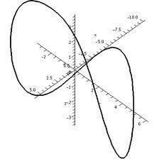
Periodic curves:
A curve $α:R→R^{3}$ is called periodic if there is a positive number $p$ such that
$$α\left(t+p\right)=α\left(t\right) for all t∈R$$
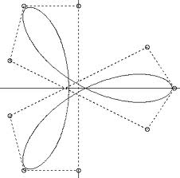
The smallest such number $p$ is the period of $α$.

Regular curves: A curve $α:I→R^{3}$ is called regular if
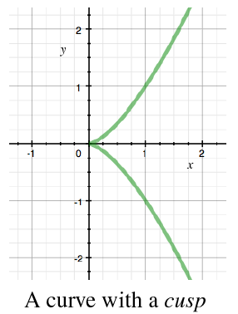
$α^{'}\left(t\right)≠{\left(0,0,0\right)}_{α\left(t\right)} for all t∈I$
Example: The curve $α:R→R^{3}$ given as $α\left(t\right)=(t^{2},t^{3},0)$ is not regular.

End of the lecture

Lecture # 5

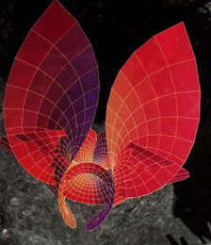
Contents:
- $1$-forms
- Differentials
- Properties of differentials

Classical differentials:
If $f$ is a real-valued function on $R^{3}$ , then in elementary calculus the differential of $f$ is usually defined as
$$df=\frac{∂f}{∂x} dx+\frac{∂f}{∂y} dy+\frac{∂f}{∂z} dz.$$
$df$ here calculates the small change in the value of $f$ when there is small change $(dx,dy,dz)$ in $x$, $y$ and $z$.
What does $df=\frac{∂f}{∂x} dx+\frac{∂f}{∂y} dy+\frac{∂f}{∂z} dz$ means?
We will see the meaning of this expression using the notion of $1$-forms.
Definition:
A $1-$form $ϕ$ on $R^{3}$ is a real-valued function on the set of all tangent vectors to $R^{3}$ such that $ϕ$ is linear at each point, that is,
$$ϕ\left(av+bw\right)=a ϕ\left(v\right)+bϕ(w)$$
For any numbers $a$, $b$ and tangent vectors $v$ $w$ at the same point of $R^{3}$.
Sometimes we write $v_{p}$ instead of $v$ for tangent vector to $R^{3}$ at $p$.

Fact:
For fix point p in $R^{3}$ the resulting fucntion $ϕ_{p}:T_{p}\left(R^{3}\right)→R$ is linear.
Sum of two $1$-forms:
Let $ϕ$ and $ψ$ be two $1-$forms then their sum is defined as:
$$\left(ϕ+ψ\right)\left(v\right)=ϕ\left(v\right)+ψ (v)$$
for all tangent vectors $v$.
Product of a $1$-form with a function $f:R^{3}→R$
Let $f:R^{3}→R$ be a real valued function and $ϕ$ be a one form. Then for any tangent vector $v_{p}$ to $R^{3}$ we define:
$$\left(fϕ\right)\left(v_{p}\right)=f\left(p\right)ϕ(v_{p})$$
Evaluating a $1$-form on a vector form
Let $V$ be a vector field, then for any point $∈R^{3}$ , $V(p)$ is a tangent vector to $R^{3}$ at point $p$.
So we can evaluate a $1$-form $ϕ$ on a vector field $V$ in the following way
At each point $p∈R^{3}$ the value of $ϕ(V)$ is the number $ϕ(V(p))$.

Differentiable $1$-form
A $1$-form $ϕ$ is differentiable if $ϕ(V)$ is differentiable whenever $V$ is differentiable then $ϕ$ is differentiable .
Properties of $ϕ\left(V\right)$
The linearity of $ϕ$ and vector field properties imply that:
$$ϕ\left(fV+gW\right)=fϕ\left(V\right)+gϕ(W)$$
and
$$\left(fϕ+gψ\right)\left(V\right)=fϕ\left(V\right)+gψ\left(V\right).$$
Where $f$ and $g$ are functions from $R^{3}$ to $R$.

Definition:
If $f$ is a differentiable real-valued function on $R^{3}$, the differential $df$of $f$ is the
$1$-form such that
$$df\left(v_{p}\right)=v_{p}[f]$$
For all tangent vectors $v_{p}$.

The $1$-form $df$ satisfies all the conditions of $1$-form:
- $df$ maps every tangent vector to a real number.
- $df$ is linear because of the properties of directional derivative.

Fact:
For any real-valued function $f$ on $R^{3}$ the differential of $f$ knows directional derivative of $f$ in every direction $v_{p}$.
Let us consider some examples of $1$-forms on $R^{3}$
Example 1 ( Differential of Natural coordinate functions )
Natural coordinate functions: Natural coordinate functions $x_{1}, x_{2}$ and $x_{3}$ are functions from $R^{3}$ to $R$ are defined as:
$$x_{1}\left(p_{1},p_{2},p_{3}\right)=p_{1}$$
$$x_{2}\left(p_{1},p_{2},p_{3}\right)=p_{2}$$
$$x_{3}\left(p_{1},p_{2},p_{3}\right)=p_{3}.$$
Now we calculate differentials of these natural coordinate functions. Using definition of $df$ we get, for any tangent vector $v_{p}$:
$$dx_{i}\left(v_{p}\right)=v_{p}\left[x_{i}\right]=\sum_{j}{\frac{∂x_{i}}{∂x_{j}}\left(p\right)v_{j}}=\sum{δ_{ij}v_{j}}=v_{i}$$
Where $δ_{ij}$ is Kronecker delta defined as:
$$δ_{ij}=\left\{\begin{aligned}1 when i=j \\ 0, when i≠j \end{aligned}\right.$$
Thus $dx_{i}$ only depends on $v$ and not on the point of application $p$.
Example 2 (Linear combination of $1$-forms)
Let $f_{1}$, $f_{2}$, $f_{3} :R^{3}→R$ be three functions. Let
$$ψ=f_{1}dx_{1}+f_{2}dx_{2}+f_{3}dx_{3}$$
Then $ψ$ is a $1$-form, and for any vector $v_{p}$ we have
$$ψ\left(v_{p}\right)=f_{1}\left(p\right) dx_{1}\left(v\right)+f_{2}\left(p\right) dx_{2}\left(v\right)+f_{3}\left(p\right) dx_{3}(v)$$
$$=f_{1}\left(p\right) v_{1}+f_{2}\left(p\right) v_{2}+f_{3}\left(p\right) v_{3}$$
$$=\sum_{i}{f_{i}\left(p\right)v_{i} }$$
Next: we show that in fact each $1$-form can be written in the form of $ψ$ above.
Euclidean coordinate functions of a $1$-form
Lemma: If $ϕ$ is a $1$-form on $R^{3}$ , then $ϕ=\sum{f_{i}dx_{i} }$, where $f_{i}=ϕ(U_{i})$.
These functions $f_{1}$, $f_{2}$, and $f_{3}$ are called the Euclidean coordinate functions of $ϕ.$
Proof:
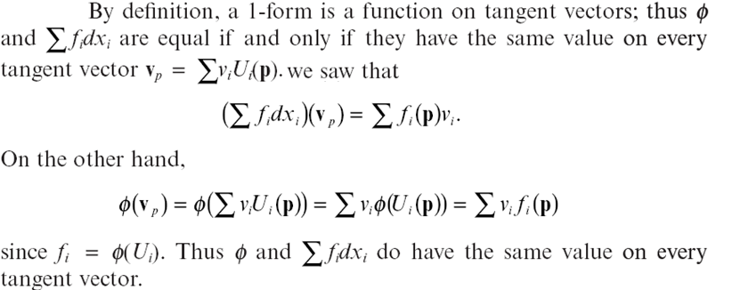

The classical differentials:
Corollary: Let $f:R^{3}→R$ be a differentiable function. Then
$$df=\frac{∂f}{∂x} dx+\frac{∂f}{∂y} dy+\frac{∂f}{∂z} dz.$$
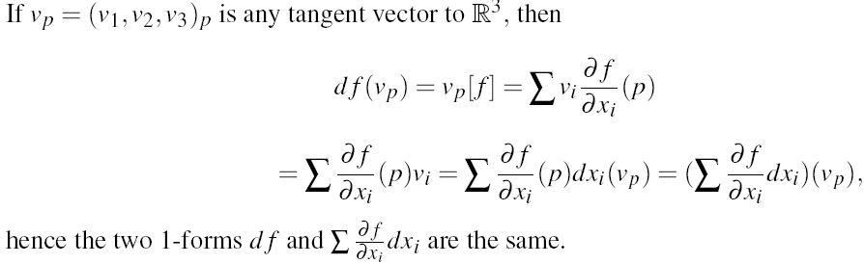
Proof:

Product rule:
Lemma: Let $fg$ be the product of differentiable functions $f$ and $g$ on $R^{3}$. Then
$$d\left(fg\right)=gdf+fdg$$
Proof:
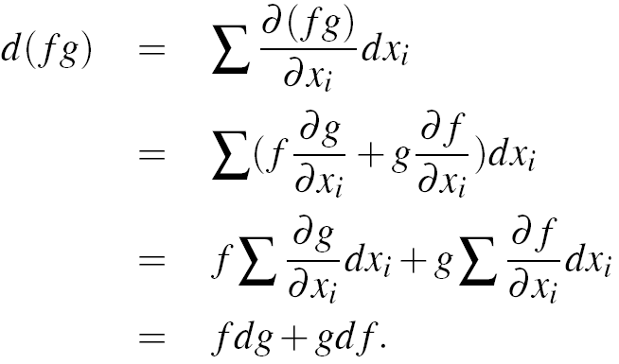

Chain rule:
Lemma: Let $f:R^{3}→R$ and $h:R→R$ be differentiable functions, so the composite function $h\left(f\right):R^{3}→R$ is also differentiable. Then
$$d\left(h\left(f\right)\right)=h^{'}\left(f\right)df.$$
Proof: We know that chain rule for $h(f)$ is

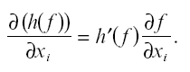
Now
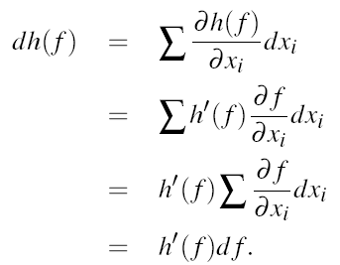

Example: Calculate $df$, where $f=\left(x^{2}-1\right)y+\left(y^{2}+2\right)z$.
Solution:
$$df=\left(2xdx\right)y+\left(x^{2}-1\right)dy+\left(2ydy\right)z+\left(y^{2}+2\right)dz$$
$$=2xy dx+\left(x^{2}-1+2yz\right)dy+\left(y^{2}+2\right)dz$$
Now we evaluate $df$ on the tangent vector $v_{p}$ where $p=(p_{1},p_{2},p_{3})$ and $v=\left(v_{1},v_{2},v_{3}\right).$
$$df\left(v_{p}\right)=v_{p}\left[f\right]=2p_{1}p_{2} v_{1}+\left(p_{1}^{2}-1+2p_{2}p_{3}\right)v_{2}+\left(p_{2}^{2}+2 \right)v_{3}$$

End of the lecture


Lecture # 6

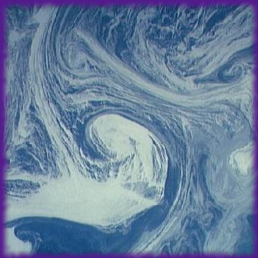
Contents
- Differential Forms
- $p$-forms
- Exterior derivatives
- Conclusion

Differential Forms
- $1-$forms (we discussed in last lecture) are part of a larger system called differential forms.
- Will discuss some properties of differential forms rather than full description.
To construct a differential form we follow the following procedure:
- Take real-valued functions $f_{1},f_{2},f_{3},…,f_{n}:R^{3}→R$
- Take differential $1$-forms of the coordinate functions $dx, dy, dz$.
- Take sum and product of above.
Examples:
1)- $x^{2}dxdy+xydydz+\left(xz+y^{2}\right)dzdy$
2)- $xyz dx+\left(x^{2}z^{2}+y\right)dy+xyzdz$
3)- $x^{2}y^{2}dxdydz$ .

- The multiplication of forms $dx dy$ is not the usual multiplication and is not commutative. In fact
$$dx dy=-dy dx.$$
called the alternation rule.
This is a special kind of multiplication called “Wedge product”, we denote it by $"∧"$ (called wedge). Hence the above expression becomes:
$$dx∧dy=-dy∧dx.$$
Other properties of wedge product are as follows. For differential forms $α$, $β$ and $γ$ we have:
- $α∧\left(β∧γ\right)=\left(α∧β\right)∧γ$
- $α∧\left(β+γ\right)=α∧β+α∧γ$
We will ignore the $"∧"$ sign where ever it is clear that what kind of multiplication we are considering.
An important consequence of the wedge product is that “repeats are zero”, due to “alternation rule”. Which means
$$dx∧dx=0.$$
Similarly
$dy∧dy=0$ and $dz∧dz=0$.
In fact
$$dx∧dx=-dx∧dx⇒2 dx∧dx=0⇒ dx∧dx=0$$
Similarly we can show
$dy∧dy=0$ and $dz∧dz=0$.

Exercise: Calculate ${(x}^{2}dxdy+xy dydz)∧\left(xz dx+{(z}^{2}+y\right)dxdy)$.
$p$-forms: A $p$-form, for $p$ one of $0,1,2,3$, is defined as:
- A $0$-form is just a differentiable function $f$.
- A $1$-form is an expression $x+gdy+hdz$ .
- A $2$-form is an expression $fdx∧dy+gdx∧dz+hdy∧dz$
(or simply $fdxdy+gdxdz+hdydz$) .
- A $3$-form is an expression $fdx∧dy∧dz$( or simply $fdx∧dy∧dz$).
Notice that on $R^{3}$ , where we have three coordinates namely $x,y,z$ the $4$-forms and higher $p$-forms are zero due to the “alternation rule”. For instance
$$dx∧dy∧dz∧dy=0.$$

“Product of a $p$-form and a $q$-form is a $(p+q)$-form”.
Lemma: If $ϕ$ and $ψ$ are 1-forms, then
$$ϕ∧ψ=-ψ∧ϕ.$$
Proof: Write
$$ϕ=\sum{f_{i}dx_{i}}$$
and
$$ψ=\sum{g_{i}dx_{i}}.$$
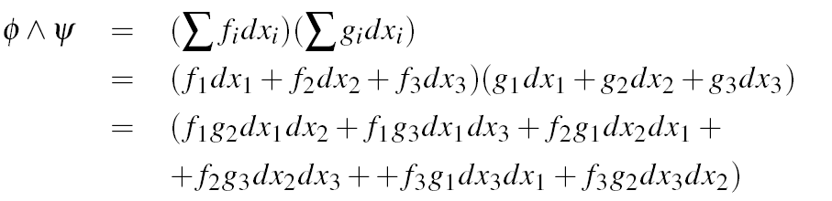
Then

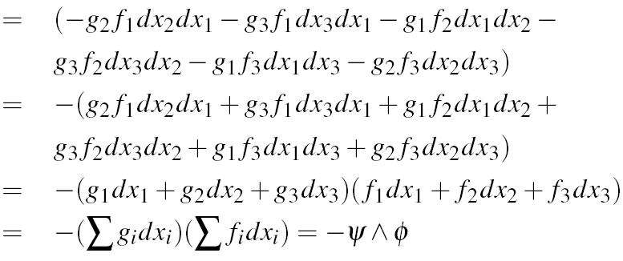

Exterior derivative
Recall:
Definition:
If $f$ is a differentiable real-valued function on $R^{3}$, the differential $df$of $f$ is the $1$-form such that
$$df\left(v_{p}\right)=v_{p}[f]$$
For all tangent vectors $v_{p}$.
We can generalize this concept to define an apply it on a $p$-form and get a $(p+1)$-form.
For example for $p=1$ we define
Definition: If $ϕ=\sum{f_{i}dx_{i}}$is a 1-form on $R^{3}$, the exterior derivative of $ϕ$ is the 2-form $dϕ=\sum{df_{i}∧dx_{i}}$.
We know that:
Corollary: Let $f:R^{3}→R$ be a differentiable function. Then
$$df=\frac{∂f}{∂x} dx+\frac{∂f}{∂y} dy+\frac{∂f}{∂z} dz.$$
So if we expand $dϕ=\sum{df_{i}∧dx_{i}}$ using above then using:
$$df_{1}=\frac{∂f_{1}}{∂x_{1}} dx_{1}+\frac{∂f_{1}}{∂x_{2}} dx_{2}+\frac{∂f_{1}}{∂x_{3}} dx_{3}.$$
$$df_{2}=\frac{∂f_{2}}{∂x_{1}} dx_{1}+\frac{∂f_{2}}{∂x_{2}} dx_{2}+\frac{∂f_{2}}{∂x_{3}} dx_{3}.$$
$$df_{3}=\frac{∂f_{3}}{∂x_{1}} dx_{1}+\frac{∂f_{3}}{∂x_{2}} dx_{2}+\frac{∂f_{3}}{∂x_{3}} dx_{3}.$$
$dϕ=\sum{df_{i}∧dx_{i}}$ using above then using:
$$df_{1}=\frac{∂f_{1}}{∂x_{1}} dx_{1}+\frac{∂f_{1}}{∂x_{2}} dx_{2}+\frac{∂f_{1}}{∂x_{3}} dx_{3}.$$
$$df_{2}=\frac{∂f_{2}}{∂x_{1}} dx_{1}+\frac{∂f_{2}}{∂x_{2}} dx_{2}+\frac{∂f_{2}}{∂x_{3}} dx_{3}.$$
$$df_{3}=\frac{∂f_{3}}{∂x_{1}} dx_{1}+\frac{∂f_{3}}{∂x_{2}} dx_{2}+\frac{∂f_{3}}{∂x_{3}} dx_{3}.$$

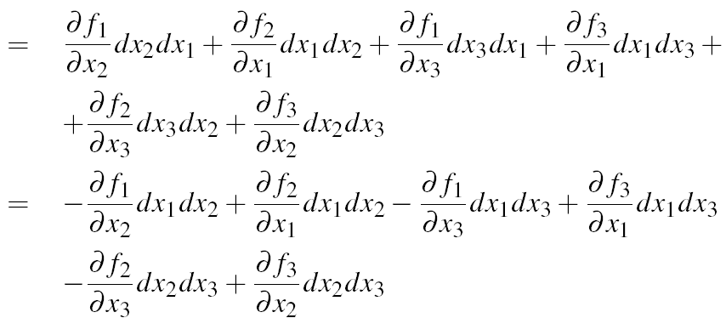

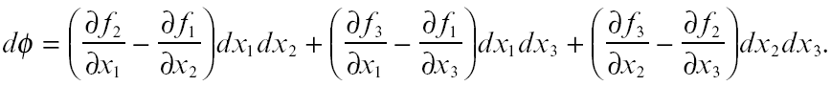

Definition: Let $ψ=fdxdy+gdxdz+hdydz$ be a 2-form. Then the exterior derivative of $ψ$ is the 3-form
$$dψ=df∧dxdy+dg∧dxdz+dh∧dydz.$$

It is easy to check the following
$$d \left(aϕ+bψ\right)=adϕ+bdψ.$$
Where $ϕ$ and $ψ$ are arbitrary forms and a and b are numbers.
Theorem: Let $f$ and $g$ be functions, $ϕ$ and $ψ$ be 1-forms. Then
- $d\left(fg\right)=df g+fdg$
- $d\left(fϕ\right)=df∧ϕ+f dϕ$
- $d\left(ϕ∧ψ\right)=dϕ∧ψ-ϕ∧dψ$
Proof (1): $d\left(fg\right)=df g+fdg$

Proof (3):$d\left(ϕ∧ψ\right)=dϕ∧ψ-ϕ∧dψ$
Lets first consider the case where
$ϕ=f dx$ and $ψ=g dy$then:
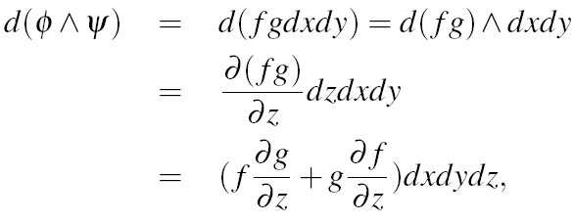

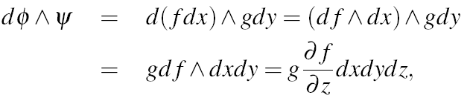
and

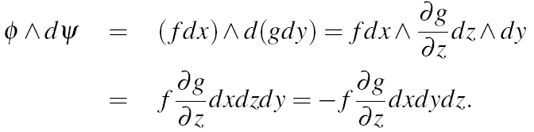
and

Lets first consider now
$$ϕ=\sum{f_{i}dx_{i}}$$
and
$$ψ=\sum{g_{i}dx_{i}}.$$
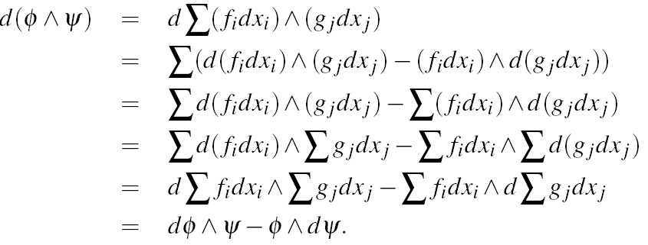

End of the lecture

Lecture # 7
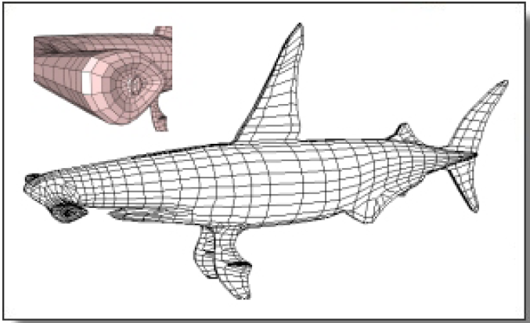
Contents:
- Introduction to Mappings
- Tangent Maps

Introduction to Mappings
Our aim:
To understand the mappings
$$f:R^{m}→R^{n}$$
for different values of $m$ and $n$.
In particular we are interested in the following cases
$f:R^{2}→R^{2}$ , $f:R^{2}→R^{3}$, $f:R^{3}→R^{3}$

Definition: Given a function $F:R^{n}→R^{m}$, let $f_{1},f_{2},…,f_{m}$ denote the real-valued functions on $R^{n}$ such that
$$F\left(p\right)=(f_{1}\left(p\right),f_{2}\left(p\right),…,f_{m}(p))$$
for all points $p$ in $R^{n}$ .
These function are called the Euclidean coordinate functions of $F$, and we write $F=(f_{1},f_{2},…,f_{m})$.

Mappings: A function $F:R^{n}→R^{m}$ is differentiable if all its Euclidean coordinate functions are differentiable. A differentiable function from $R^{n}$ to $R^{m}$is called a mapping.
Example: Consider $F:R^{3}→R^{3}$ defined by
$$F\left(x,y,z\right)=(x^{2},yz,xy)$$
is differentiable and hence a mapping.

Definition: If $α:I→R^{n}$ is a curve in $R^{n}$ and $F:R^{n}→R^{m}$ is a mapping then the composite function $β=F\left(α\right):I→R^{m}$ is a curve in $R^{m}$ called the image of $α$ under $F$.
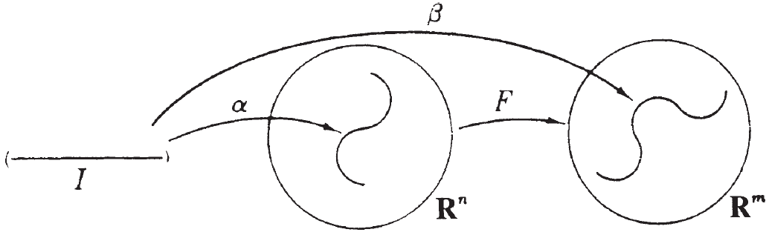

Example: Consider the mapping $F:R^{2}→R^{2}$ define by:
$$F\left(u,v\right)=(u^{2}-v^{2},2uv)$$
To see the effect of this mapping we consider images of a special curve $α$ in $R^{2}$ under this mapping, namely circle of radius r, given as
$α\left(t\right)=(r\cos{t},r\sin{t})$ where $0≤t≤2π$
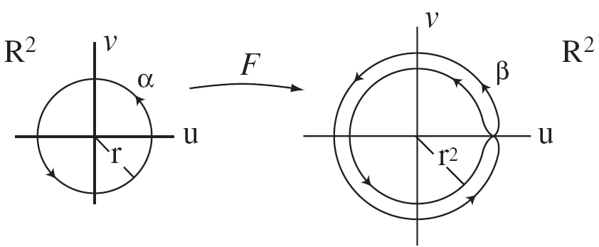

Example: Consider the mapping $F:R^{3}→R^{3}$ such that
$$F\left(x,y,z\right)=(x-y,x+y,2z)$$
Observe that $F$ is a linear transformation.
Tangent Maps
Our next goal is to find analogous linear approximation for the mapping $F:R^{n}→R^{m}$ near a point $p∈R^{n}$.
For this we once again used special curves in $R^{n}$, namely lines associated to tangent vectors $v_{p}$. We approximate $F$ near $p$ by the map $F_{*}$.
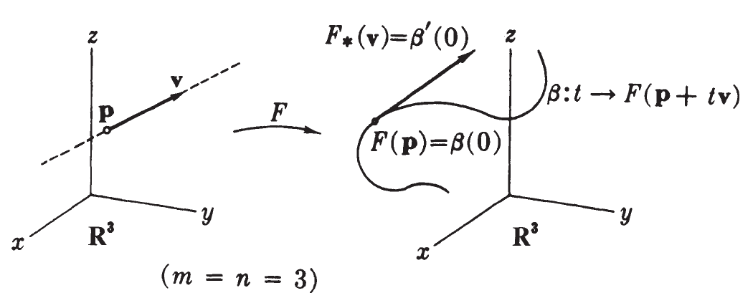

Definition: Let $F:R^{n}→R^{m}$be a mapping. If $v$ is a tangent vector to $R^{n}$ at $p,$ let $F_{*}(v)$ be the initial velocity vector of the curve $t→F(p+tv)$. The resulting function $F_{*}$ sends tangent vectors to $R^{n}$ to tangent vectors to $R^{m}$, and is called the tangent map of $F$.

How to calculate tangent maps:
Proposition: Let $F=(f_{1},f_{2},…,f_{m})$ be a mapping from $R^{n}$ to $R^{m}.$ If $v$ is a tangent vector to $R^{n}$ at $p$, then
$F_{*}\left(v\right)=\left(v\left[f_{1}\right],v[f_{2}\right],…,{v[f}_{m}])$ at $F(p)$
See book for proof.

Tangent map of a mapping at a point $p$
The tangent map $F_{*}$ sends tangent vectors at $p$ to tangent vectors at $F(p)$. Thus for each $p$ in $R^{n}$, the map $F_{*}$ give rise to a function
$$F_{*}:T_{p}\left(R^{n}\right)→T_{F\left(p\right)}(R^{m})$$
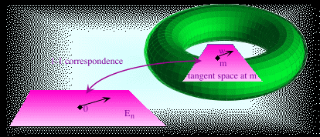
Called the tangent map of $F$ at $p$.

Tangent maps at a point are linear
An important property of tangent maps which is a consequence of proposition is:
Corollary: If $F:R^{n}→R^{m}$ is a mapping, then at each point $p$ of $R^{3}$ the tangent map $F_{*}:T_{p}\left(R^{n}\right)→T_{F\left(p\right)}(R^{m})$ is a linear transformation.
See book for proof.

The velocity of an image curve
Another important consequence of the proposition is that mappings preserved velocities.
Corollary: Let $F:R^{n}→R^{m}$ be a mapping. If $β=F(α)$ is the image of a curve $α$ in $R^{n}$, then $β^{'}=F_{*}(α')$.
Proof: We take $m=3$

By proposition above we have:
we have
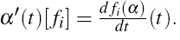

Tangent maps on vector fields
Let $\left\{U_{j}\right\}$ $\left(1≤j≤n\right)$ and ${\{\overline{U}}_{i}\} (1≤i≤m)$ be the natural frame fields of $R^{n}$ and $R^{m}$ respectively. Then:
Corollary: If $F=(f_{1},f_{2},…,f_{m})$ is a mapping from $R^{n}$ to $R^{m}$, then
$$F_{*}\left(U_{j}\left(p\right)\right)=\sum_{i=1}^{m}{\frac{∂f_{i}}{∂x_{j}}\left(p\right) \overline{U_{i}}(p)}$$
for $1≤j≤n$.
See book for proof.

The matrix appearing in the preceding formula,
$${\left(\frac{∂f_{i}}{∂f_{j}}\left(p\right)\right)}_{1≤j≤n,1≤i≤m}$$
Is called the Jacobian matrix of $F$ at point $p$.
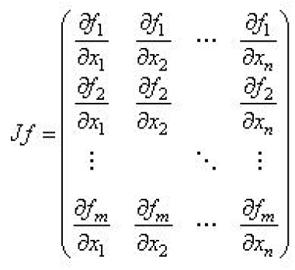
In expanded form it is given as:

We study mappings $F$ using the tangent map.
Definition: A mapping $F:R^{n}→R^{m}$ is regular provided that at every point $p$ of $R^{n}$ the tangent map $F_{*_{p}}$ is one-to-one.
For $p∈R^{n}$ the following are equivalent:
- ${F_{*}}_{p}$ is one-to-one
- $F_{*_{p}}\left(v_{p}\right)=0$ implies $v_{p}=0$
- The rank of the Jacobian matrix of $F$ at $p$ is $n$.
Diffeomorphism
Definition: if $F:R^{n}→R^{m}$ has an inverse mapping, then $F$ is called diffeomorphism.
Inverse function theorem.
Theorem: Let $F:R^{n}→R^{m}$ be a mapping. If $F_{*_{p}}$ is one-to-one at $p$, then there is a restriction of $F$ to an open set containing $p$ which is a diffeomorphism.
End of the Lecture

Chapter 2
Lecture #8

Contents:
- The Dot Product
- Frames

The Dot Product

We study distances and angles in geometry. We will see that geometry of Euclidean spaces can be derived from dot product.
Definition: Let
$p=(p_{1},p_{2}, p_{3})$ and $q=(q_{1},q_{2}, q_{3})$
be two points in $R^{3}$. The dot product of $p$ and $q$ is the real number
$$p∙q=p_{1}q_{1}+p_{2}q_{2}+p_{3}q_{3}$$

Dot product has the following properties
If $p, q$ and $r$ are points in $R^{3}$ and $a,b$ are real numbers, then
- Bilinearity:
$$\left(ap+bq\right).r=a\left(p.r\right)+b(q.r)$$
$$r.\left(ap+bq\right)=a\left(r.p\right)+b(r.q)$$
- Symmetry:
$$p.q=q.p$$
- Positive definiteness
$$p.p≥0$$
and
$$p.p=0 \overset{⇒}{} p=0$$
The norm of a point
The norm of a point $p=(p_{1},p_{2},p_{3})$ is the number
$${‖p‖=\left(p∙p\right)}^{\frac{1}{2}}=\sqrt{p_{1}^{2}+p_{2}^{2}+p_{3}^{2}}$$
The norm is a real-valued function on $R^{3}$. It has the following properties
- $\left\|p+q\right\|≤‖p‖+‖q‖$
- $‖ap‖=|a|‖p‖$
for vectors $p$ and $q$ of $R^{3}$ and real number $a$.

Distances in $R^{3}$
If $p$ and $q$ are two points of $R^{3}$, the Euclidean distance from $p$ to $q$ is the number
$$d\left(p,q\right)=‖p-q‖$$
So we calculate
$$d\left(p,q\right)=\sqrt{{\left(p_{1}-q_{1}\right)}^{2}+{\left(p_{2}-q_{2}\right)}^{2}+{\left(p_{3}-q_{3}\right)}^{2}}$$

Open sets
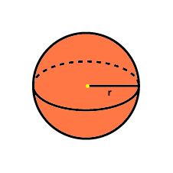
The distance formula can be used to give a precise definition of open sets.
Definition: If $p$ is a point in $R^{3}$and $ϵ$ is a positive real number, then the $ϵ-$neighborhood N$_{ϵ}(p)$of $p$ in $R^{3}$ is the set of all points $q$ in $R^{3}$ such that $d\left(p,q\right)<ϵ$:
$$N _{ϵ}\left(p\right)=\{q∈R^{3}:d\left(p,q\right)<ϵ\}$$
Definition: A subset O of $R^{3}$ is open if every point of O has some $ϵ-$neighborhood that is completely contained in O :
$$∀p∈O ∃ ϵ >0: N _{ϵ}\left(p\right)⊂O$$
This definition of open set can be used on any $R^{n}$.
We can also replace $d$ with some other distance function.

Dot product on tangent vectors
We know that tangent space at any point of $R^{3}$ , that is, $T_{p}(R^{3})$ is isomorphic to $R^{3}$. We can use this relation to define dot product on any tangent space $T_{p}(R^{3})$.
Definition: The dot product of tangent vectors $v_{p}$ and $w_{p}$ at the same point of $R^{3}$ is the number $v_{p}.w_{p}=v. w$.

Similarly we can define norm of any tangent vector in the following way.
Definition: The norm, or length, of a tangent vector $v_{p}$ is the norm of its vector part, that is,
$$\left\|v_{p}\right\|=\left\|v\right\|$$

Schwarz inequality:
A fundamental result of linear algebra is Schwarz inequality given by
$$\left|v.w\right|≤‖v‖‖w‖$$
This permits us to define the cosine of the angel between two vectors as:
Definition: To any non-zero vectors $v$ and $w$ define the cosine of the angle between $v$ and $w$ by
$$v.w=\left\|v\right\|\left\|w\right\|\cos{θ}$$

Definition: Two vectors are orthogonal if $v.w=0$.
Definition: A vector of length 1 is called a unit vector.
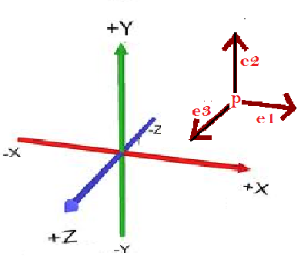
Frames
Definition: A set $e_{1},e_{2},e_{3}$ of three mutually orthogonal unit vectors tangent to $R^{3}$at point $p$ is called a frame at the point $p$.

We can say that a set of three tangent vectors $e_{1},e_{2},e_{3}$ in $T_{p}(R^{3})$ is a frame at $p$ if the vectors satisfy
$$e_{1}.e_{2}=e_{1}.e_{3}=e_{2}.e_{3}=0$$
$$e_{1}.e_{1}=e_{2}.e_{2}=e_{3}.e_{3}=1$$
We can write down the same definition using notion of Kronecker delta function $δ_{ij}$ defined as
$$δ_{ij}=\left\{\begin{aligned}0, if i≠j \\ 1, if i=j\end{aligned}\right.$$
So the alternate definition becomes:
Definition: The set of tangent vectors $e_{1},e_{2},e_{3}$ to $R^{3}$ at $p$ is a frame at $p$ if and only if
$e_{i}.e_{j}=δ_{ij}$ for all $i,j∈\{1,2,3\}$
Theorem: Let $e_{1},e_{2},e_{3}$be a frame at a point $p$ of $R^{3}$. If $v$ is any tangent vector to $R^{3}$ at $p, then$
$$v=\left(v.e_{1}\right)e_{1}+\left(v.e_{2}\right)e_{2}+\left(v.e_{3}\right)e_{3}$$
See book for proof.
Now we know that the tangent space $T_{p}(R^{3})$ is isomorphic to $R^{3}.$ So three linearly independent vectors form a basis of $T_{p}(R^{3})$.

End of the lecture


Lecture # 9

Contents:
- The Attitude Matrix
- Cross Product

The Attitude Matrix
The Attitude Matrix Of A Frame
Let $\{e_{1},e_{2},e_{3}\}$ be a frame at point $p$ in $R^{3}$
If
$$e_{1}=(a_{11}, a_{12}, a_{13})$$
$$e_{2}=(a_{21},a_{22},a_{23})$$
$$e_{3}=(a_{31},a_{32},a_{33})$$
Then
$$A=\left(\begin{matrix}a_{11} & a_{12} & a_{13} \\ a_{21} & a_{22} & a_{23} \\ a_{31} & a_{32} & a_{33}\end{matrix}\right)$$
is called the attitude matrix of the frame $\{e_{1},e_{2},e_{3}\}$.
Definition:
If the rows of a square matrix are orthonormal, then the matrix is called orthogonal.
Hence the attitude matrix of any frame is an orthogonal matrix.

Definition:
The transpose of $3×3$ matrix is defined by
$$A=\left(\begin{matrix}a_{11} & a_{12} & a_{13} \\ a_{21} & a_{22} & a_{23} \\ a_{31} & a_{32} & a_{33}\end{matrix}\right) \overset{⇒}{}tA=\left(\begin{matrix}a_{11} & a_{21} & a_{31} \\ a_{12} & a_{22} & a_{32} \\ a_{13} & a_{23} & a_{33}\end{matrix}\right)$$

Property of orthogonal matrices
If $A$ is a $3×3$ orthogonal matrix, then the matrix product of $A$ with $A^{t}$ is equal to
$$AA^{t}=\left(\begin{matrix}1 & 0 & 0 \\ 0 & 1 & 0 \\ 0 & 0 & 1\end{matrix}\right)$$
So $A^{t}$ is inverse of $A$.
Cross Product
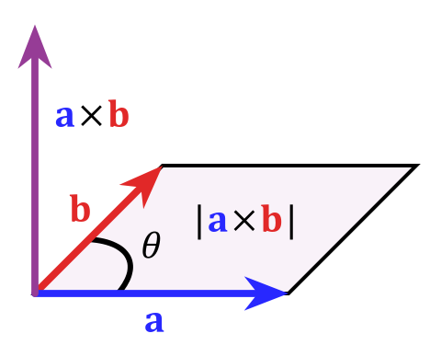
Cross Product:
Let $v$ and $w$ be tangent vectors to $R^{3}$at a point $p$. The cross product of $v$ and $w$ is the determinant
$$v×w=\left|\begin{matrix}U_{1}(p) & U_{2}(p) & U_{3}(p) \\ v_{1} & v_{2} & v_{3} \\ w_{1} & w_{2} & w_{3}\end{matrix}\right|$$
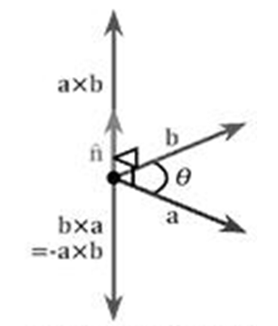
Which is also element of $T_{p}(R^{3})$.
Properties Of Cross Product
Linearity: Let $u, v$ and $w$ be tangent vectors to $R^{3}$ at the same point $p$, and let $a,b$ be real numbers. Then
$$\left(au+bv\right)×w=a\left(u×w\right)+b(v×w)$$
and
$$u×\left(av+bw\right)=a\left(u×v\right)+b(u×w)$$

Properties Of Cross Product
Alternation Rule:
If $v,w$ are tangent vectors to $R^{3}$ at a point $p,$then
$$v×w=-w×v$$
It is also easy to see that $v×v=(0,0,0)$.
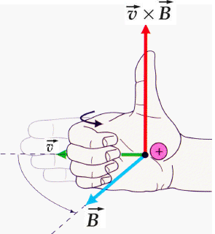
Direction of the Cross Product
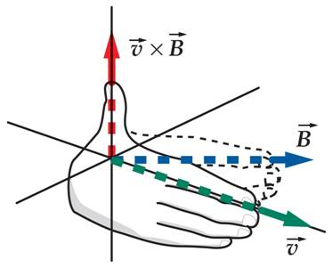

Lemma: The cross product of $v$ and $w$ is orthogonal to both $v$ and $w$.
See book for the proof.
The length of the cross product:
The cross product of $v$ and $w$ has length such that
$${\left\|v×w\right\|}^{2}=(v.v)\left(w.w\right)-{\left(v.w\right)}^{2}$$

See book for the proof.
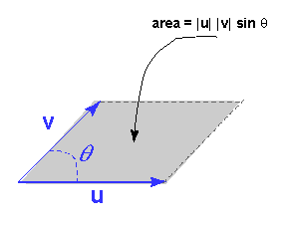

A more intuitive description of the length of a cross product is
$$\left\|v×w\right\|=\left\|v\right\|\left\|w\right\|\sin{θ}$$

Triple Scalar Product
Let $u,v,w$ be three vectors. The triple scalar product of $u,v,w$ is the number
$$u.v×w$$
We can also write the above as
$$u.v×w=\left|\begin{matrix}u_{1} & u_{2} & u_{3} \\ v_{1} & v_{2} & v_{3} \\ w_{1} & w_{2} & w_{3}\end{matrix}\right|$$

End of the lecture

Lecture # 10

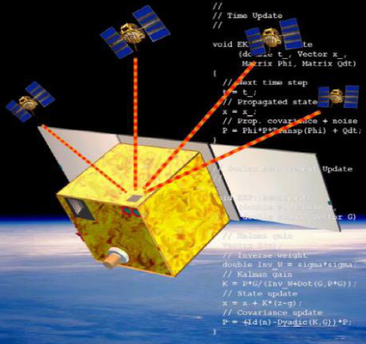
Contents:
- Speed Of A Curve
- Vector Fields On Curves
- Differentiation of Vector Fields

Speed Of A Curve
Speed
Let a car moves between Islamabad and Quetta and follow the path
$$α=\left(α_{1},α_{2} \right):I→R^{2}$$
given by
$$α\left(t\right)=(t^{2},t^{3})$$
What is the speed of the car after 3 hours. To answer such questions we need the following.
Definition: Let
$$α=\left(α_{1},α_{2},α_{3}\right):I→R^{3}$$
be a curve
The speed of $α$ is defined as the length of the velocity of :
$$v=\left\|α^{'}\right\|=\sqrt{{\left(\frac{dα_{1}}{dt}\right)}^{2}+{\left(\frac{dα_{2}}{dt}\right)}^{2}+{\left(\frac{dα_{3}}{dt}\right)}^{2}}$$

Arc length
Let a car moves between Islamabad and Quetta and follow the path
$$α=\left(α_{1},α_{2},α_{3}\right):I→R^{2}$$
given by
$$α\left(t\right)=(2t,t^{2})$$
Question: What is the distance travelled in 3 hours?
To answer such questions we need the following.
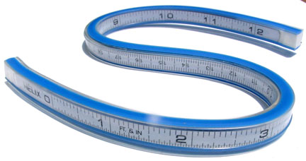
Definition:
The arc length of $α$ from $t=a$ to $t=b$ is equal to
$$\int_{a}^{b}{‖α'‖dt}=\int_{a}^{b}{v\left(t\right)dt}$$

Definition: The restriction of a curve $α:I→R^{3}$ to a closed interval $[a,b]$ is called a curve segment.
If $σ$ is a curve segment of $α$,
$$σ:\left[a,b\right]→R^{3}$$
then the length of $σ$ is written as $L(σ)$.
Definition: A curve $β$ has unit speed if its speed is 1 at every point, that is,
$$\left\|β^{'}\right\|=1.$$
Example: Let $β:I→R^{3}$ be defined by
$$β\left(t\right)=\left(\cos{t,\sin{t},}t\right)$$
Arc-Length parameterization
Theorem: Let $α:I→R^{3}$ be a regular curve. Then there exist a reparameterization $β$ of $α$ such that
$$‖β^{'}‖=1.$$
See book for proof.
Orientation of a reparameterization
A reparameterization of a curve $α$ given by
$$β\left(t\right)=α(h(s))$$
Is orientation preserving if
$$h^{'}\left(s\right)≥0$$
It is orientation reversing if
$$h^{'}\left(s\right)≤0$$
FACT: Unit speed reparameterization is always orientation preserving.
Let $α:I→R^{3}$ be a curve. We define:
Definition: A vector field $Y$ on curve $α$ is a function that assigns to each number $t$ in $I$ a tangent vector $Y(t)$ to $R^{3}$ at the point $α(t)$.

Vector Fields On Curves

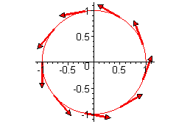
Example:
For curve $α$ the velocity $α'$ satisfies the definition of vector field on a curve.

Properties of vector fields on curves
Definition:
If $Y$ is a vector field on $α:I→R^{3}$, then for each $t$ in $I$ we can write
$$Y\left(t\right)={\left(y_{1}\left(t\right),y_{2}\left(t\right),y_{3}\left(t\right)\right)}_{α(t)}=\sum{y_{i}\left(t\right)U_{i}(α(t))}.$$
The real-valued function $y_{1},y_{2}y_{3}:R→R$ are called Euclidean coordinate functions.

Addition of vector fields
Let $Y\left(t\right)=y_{1}U_{1}+y_{2}U_{2}+y_{3}U_{3}$ and $Y\left(t\right)=z_{1}U_{1}+z_{2}U_{2}+z_{3}U_{3}$ be two vector valued functions on $α:I→R^{3}$. Then the addition of $Y(t)$ and $Z(t)$ is defined as:

Scalar Multiplication
Let $Y\left(t\right)=y_{1}U_{1}+y_{2}U_{2}+y_{3}U_{3}$ be a vector field on $α:I→R^{3}$ and $f(t)$ be a real valued functions. Then we define $fY$
Dot product of two vector fields
Let $Y\left(t\right)=y_{1}U_{1}+y_{2}U_{2}+y_{3}U_{3}$ and $Y\left(t\right)=z_{1}U_{1}+z_{2}U_{2}+z_{3}U_{3}$ be two vector valued functions on $α:I→R^{3}$. Then the dot product of of $Y(t)$ and $Z(t)$ is defined as:
Cross product of two vector fields
Let $Y\left(t\right)=y_{1}U_{1}+y_{2}U_{2}+y_{3}U_{3}$ and $Y\left(t\right)=z_{1}U_{1}+z_{2}U_{2}+z_{3}U_{3}$ be two vector valued functions on $α:I→R^{3}$. Then the cross product of of $Y(t)$ and $Z(t)$ is defined as:
Differentiation of a vector field on a curve
Definition: Let $Y(t)$ be a vector field on a curve , with $Y\left(t\right)=\sum{y_{i}U_{i}}$.
Then the new vector filed on $α$
$$Y^{'}\left(t\right)=\sum{\frac{dy_{i}}{dt}U_{i}}$$
is the derivative of $Y(t)$.

Definition: Let $α:I→R^{3}$ be a curve with coordinates $α\left(t\right)=(α_{1}\left(t\right),α_{2}\left(t\right),α_{3}(t))$ then the acceleration of $α$ is defined as
$$α^{''}=\left(\frac{d^{2}α_{1}}{dt^{2}},\frac{d^{2}α_{2}}{dt^{2}},\frac{d^{2}α_{3}}{dt^{2}}\right)$$
Properties of differentiation
Let $Y\left(t\right)=y_{1}U_{1}+y_{2}U_{2}+y_{3}U_{3}$ and $Y\left(t\right)=z_{1}U_{1}+z_{2}U_{2}+z_{3}U_{3}$ be two vector valued functions on $α:I→R^{3}$. Let $f:R→R$ be a real-valued function. Let $a$ and $b$ be two real numbers then

Linearity:
$${\left(aY+bZ\right)}^{'}=aY^{'}+bZ^{'}$$
Leibnizian properties
$${\left(Y.Z\right)}^{'}=Y^{'}.Z+Y.Z^{'}$$
$$\left(fY\right)=f^{'}Y+fY^{'}$$
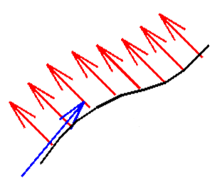
Parallel vector fields
A vector field on a curve is parallel if all its values are parallel tangent vectors.
That is
$$Y\left(t\right)={\left(c_{1},c_{2},c_{3}\right)}_{α\left(t\right)}=\sum{c_{i}U_{i}(α(t))}$$

Vanishing derivatives:
Lemma: Let $α:I→R^{3}$ be a curve then:
- $α$ is constant if and only if $α^{'}=0$.
- If $α$ is not constant, then $α$ is a straight line if and only if $α^{''}=0$.
- A vector field $Y$ on a curve $α$ is parallel if and only if $Y^{'}=0$.
See book for proof.

End of the lecture

Lecture #11

Contents:
- Curvature
- Frenet Frame Field
- Frenet Formulas
- Unit-Speed Helix

Aim of today’s lecture is to understand the geometry of the curves. In daily life we can understand the geometry of the curve by looking at them, for example, in the following figure there are three curves given. We can easily see that which curves have more curvature and which curve is turning very fast.
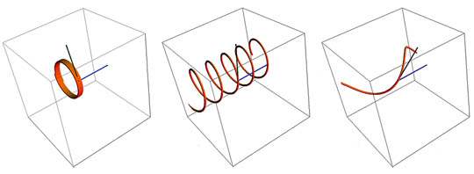

Today we will define these properties mathematically.
Curvature
Definition: The rate of change of tangent, that is,
$$T^{'}=β^{''}$$
is called the curvature vector filed of $β$.

Since we have that
$$\left\|T\right\|=1$$
So
$$T.T=1$$
And this gives us
$$T^{'}.T=0$$
Definition: A vector field $V$ on $β$ is called normal to $β$ if $V. β^{'}=0$.
We can see that curvature vector field is normal to $β$.
Definition (Curvature): The function $κ:I→R$ defined by
$$κ\left(t\right)=‖T^{'}(t)‖$$
Is called the curvature function of $β$.
The curvature function satisfies $κ\left(t\right)≥0$ for all $s∈I$.
Note:
- When $κ$ is small then the curve is close to straight.
- When $κ$ is large then the turn in the curve is sharp.

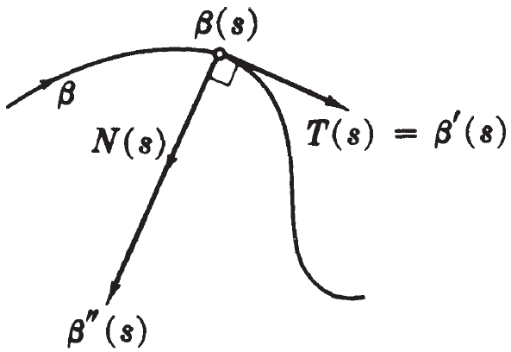
Principal normal
Let $β$ be a curve. Let $>0$ , that is, curve is never straight. We define principal normal vector $N$ as:
$$N=\frac{T^{'}}{κ}$$
We can see that $\left\|N\right\|=1$, hence a unit vector.
The principal normal vector tells us the direction in which the curve turns.

Binormal vector field
The vector field on curve $β$
$$B=T×N$$
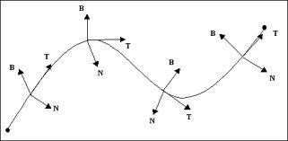
is called the binormal vector field of $β$.

Lemma: If $β$ is a unit-speed curve in $R^{3}$ with $κ>0$. Then the three vector fields $T, N, B$ on $β$ are unit vectors that are mutually orthogonal at each point.
Proof: See book.

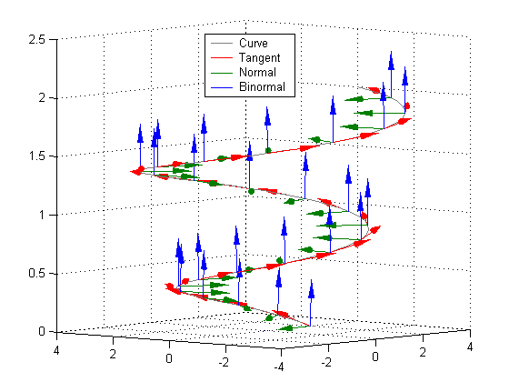
Definition (Frenet Frame )
The triplet $(T,B,N)$ is called the Frenet frame field on $β$.

The derivatives of a Frenet field
We can express derivatives of $T, N, B$ in terms of $T,N, B$.
The derivative of $T$
We defined
$$N=\frac{T^{'}}{κ}$$
So
$$T^{'}=κN$$
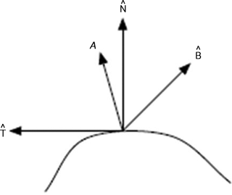
The derivatives of a Frenet field
We can express derivatives of $T, N, B$ in terms of $T,N, B$.
The derivative of B
We can write $B'$ in the following form
$$B^{'}=\left(B^{'}.T\right)T+\left(B^{'}.N\right)N+\left(B^{'}.B\right)B$$
The torsion of a curve
The function $τ:I→R$ such that
$$B=-τN$$
is called the torsion of the curve.
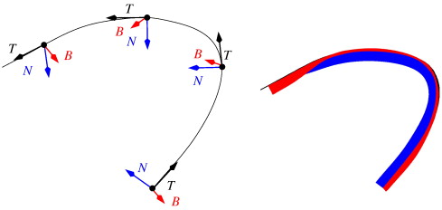

The Frenet Formulas
Theorem: If $β$ is a unit speed curve with curvature $κ$ and torsion $τ$ then
$$T^{'}= κN$$
$$N^{'}=-κT +τB$$
$$B^{'}= -τN$$
Proof: see book.

End of the lecture


Lecture # 12

Contents:
- Frenet Approximation
- Plane Curves
- Planes
In this lecture we are mainly interested in approximating the curve using Frenet Frame and Frenet formulas. So we want to approximate the curve using the geometric information, for example, using curvature, torsion, normal, etc.
First we recall definition of a plane in $R^{3}$.
A plane through $p$ and orthogonal to $q≠0$ consists of all points $r$ such that
$$\left(r-p\right).q=0$$
forms a plane.
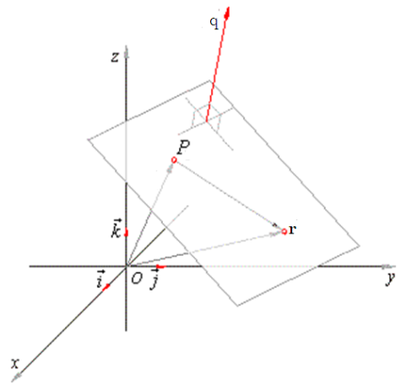
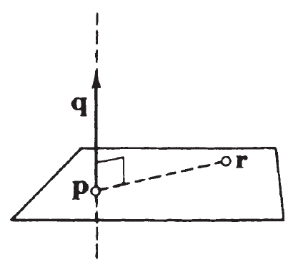

Next we are going to recall Taylor series.

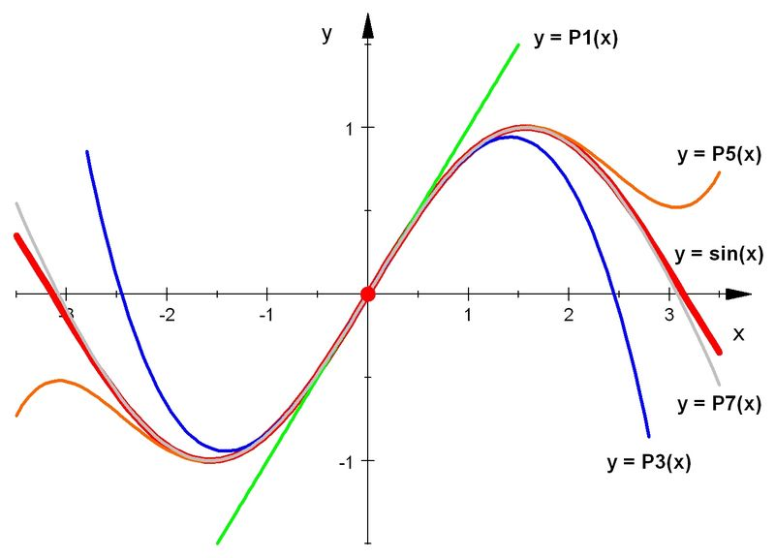
Taylor Series
Let $f(x)$ be a function from $R$ to $R$. If $f(x)$ is infinitely differentiable near $0$. Then the functional values of $f(x)$ near $x=0$ are given by the Taylor series.
$$f\left(x\right)=f\left(0\right)+\frac{df}{dx}\left(0\right) x+\frac{d^{2}f}{dx^{2}}\left(0\right) \frac{x^{2}}{2}+\frac{d^{3}f}{dx^{3}}\left(0\right) \frac{x^{3}}{3!}+…$$

To approximate a curve near an arbitrary point on the curve. We are going to achieve this by using Taylor series and Frenet Frame at a point.
Frenet Approximation
Approximation of Euclidean Coordinate Functions
The Taylor series around origin is given.
Taylor series around point $x=0$
$$f(x)=f\left(0\right)+\frac{df}{ds}\left(0\right) s+\frac{d^{2}f}{ds^{2}}\left(0\right)\frac{s^{2}}{2}+\frac{d^{3}f}{ds^{3}}\left(0\right)\frac{s^{3}}{3!}+…$$
Where $x$ is any point near $x=0$.
Now let $β=(β_{1},β_{2},β_{3})$ be a unit speed curve. We can approximate each of the functions $β_{i}$, for $i=1,2,3$ in the following way:
$$β_{i} \sim β_{i}\left(0\right)+\frac{dβ_{i}}{ds}\left(0\right) s+\frac{d^{2}β}{ds^{2}}\left(0\right)\frac{s^{2}}{2}+\frac{d^{3}β}{ds^{3}}\left(0\right)\frac{s^{3}}{3!}$$
In coordinate form we can write.
$$β\left(s\right)=\left(β_{1}\left(s\right),β_{2}\left(s\right),β_{3}\left(s\right)\right) \sim β\left(0\right)+s β'(0)+\frac{s^{2}}{2}β^{''}\left(0\right)+\frac{s^{3}}{3!} β^{'''}(0)$$
Now the above is an approximation to the curve. Now we want to see what kind of geometrical properties can be obtained from this geometrical approximation of the curve. For this we apply Frenet formulas.
Applying Frenet Formulas
We know that $T\left(s\right)=β'(s)$ so this gives us
$$β^{'}\left(0\right)=T\left(0\right)=T_{0}$$
We also know that
$$T^{'}\left(s\right)=κ\left(s\right)N\left(s\right) \overset{⇒}{} β^{''}\left(s\right)=κ\left(s\right)N\left(s\right)$$
$\overset{⇒}{} β^{''}\left(0\right)=κ\left(0\right) N\left(0\right) \overset{⇒}{} β_{0}^{''}=κ_{0}N_{0}$
To calculate $β^{'''}\left(0\right)$ we use Leibniz rule
$$β^{'''}=\frac{d\left(κ N\right)}{ds}=\frac{dκ}{ds} N+κ \frac{dN}{ds}$$
Frenet formulas imply that
$$N^{'}\left(s\right)=-κ T+τ B$$
Using this in above expression we get
$$β^{'''}=\frac{dκ}{ds} N-κ^{2} T+τκ B$$
So we get
$${β_{0}^{'''}=β}^{'''}\left(0\right)=\frac{dκ}{ds} \left(0\right) N_{0}-κ_{0}^{2} T_{0}+τ_{0}κ_{0} B_{0}$$
Definition: Let $β$ be a unit speed curve then
$$\hat{β}\left(s\right)=β\left(0\right)+sT_{0}+κ_{0}\frac{s^{2}}{2} N_{0}+τ_{0} κ_{0}\frac{s^{3}}{6} B_{0}$$
is called Frenet approximation of $β$ near $s=0$.
Next question: Can we do the same process for a point $s_{0}$ other than $s=0$.
The Frenet approximation at point $s_{0}$
For this we use Taylor series around point $s=s_{0}$.
Taylor series around point $x=s_{0}$
$$f(x)=f\left(s_{0}\right)+\frac{df}{ds}\left(s_{0}\right) (s-s_{0})+\frac{d^{2}f}{ds^{2}}\left(s_{0}\right)\frac{{(s-s_{0})}^{2}}{2}+\frac{d^{3}f}{ds^{3}}\left(s_{0}\right)\frac{{\left(s-s_{0}\right)}^{3}}{3!}+…$$
Where $x$ is any point near $x=s_{0}$.
Using above and Frenet Formulas we can show that for a general point $s_{0}$ on the curve the approximation is given by
$${\hat{β}}_{s_{0}}\left(s\right)=β\left(s_{0}\right)+\left(s-s_{0}\right)T_{s_{0}}+κ_{s_{0}}\frac{{\left(s-s_{0}\right)}^{2}}{2} N_{s_{0}}+κ_{s_{0}} τ_{s_{0}}\frac{{\left(s-s_{0}\right)}^{3}}{3!} B_{s_{0}}$$

Important: We have triplet $(T,B,N)$ at each and every point of the curve.
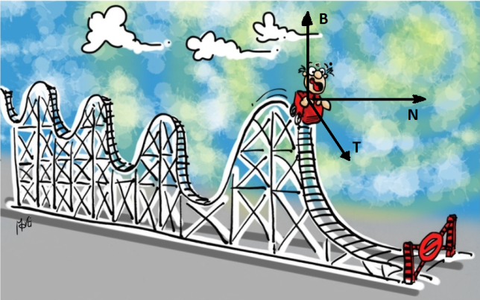

So we have at each point of curve
$$\hat{β}\left(s\right)=β\left(0\right)+sT_{0}+κ_{0}\frac{s^{2}}{2} N_{0}+τ_{0} κ_{0}\frac{s^{3}}{6} B_{0}$$
Now we discuss the terms of approximation one by one.
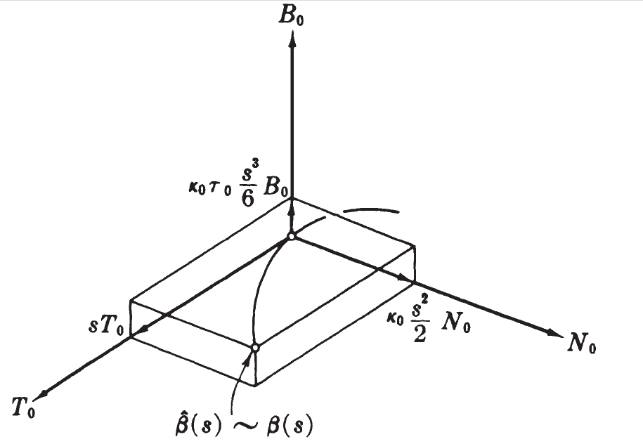
The curve defined by $s→β\left(0\right)+sT_{0}$ is the tangent line to $β$ at $s=0$. It is the best linear approximation to $β$ near $β(0)$.

The approximation $β\left(0\right)+sT_{0}+κ_{0}\frac{s^{2}}{2} N_{0}$ is in fact a quadric function in $s$ and in particular defines a parabola. The parabola lies in the plane with axis $T_{0}$ and $N_{0}$. This plane is called Osculating plane.

The approximation
$$β\left(0\right)+sT_{0}+κ_{0}\frac{s^{2}}{2} N_{0}+τ_{0} κ_{0}\frac{s^{3}}{6} B_{0}$$
is curve which is moving the parabola in the third dimension of $B_{0}$.
Lets recall what is a planar curve.
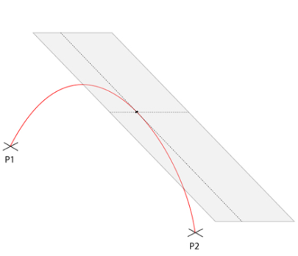
Planar curve
A plane curve in $R^{3}$ is the set of all point which lie in the same plane in $R^{3}$.
See figure below for a geometrical idea.

Torsion Free Curves
Let $β$ be a curve in $R^{3}$ with positive curvature $κ>0$. Then $β$ is a plane curve if and only if $τ=0$.

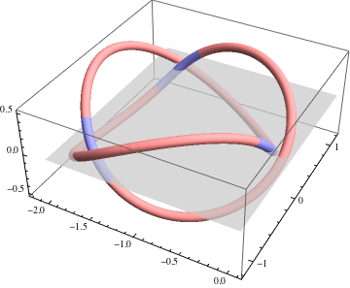
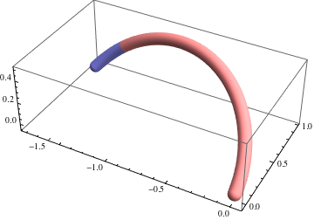

Theorem: Let $β$ be a curve in $R^{3}$ with positive curvature $κ>0$. Then $β$ is a plane curve if and only if $τ=0$.
See book for proof.


End of the lecture

Lecture #13

Contents:
- Frenet Approximation
- Conclusion
- Frenet Frame For Arbitrary Speed Curves
- Velocity And Acceleration

Curvature Of Circle
Consider the following circle
$$β\left(s\right)=\left(\operatorname{acos}{\frac{s}{a}},a\sin{\frac{s}{a}} \right)$$
Then it is a unit speed curve. And its curvature is $\frac{1}{a}$.
Now the question is: every curve with torsion zero (contained in plane) and constant curvature is a circle?
Lemma: If $β$ is a unit speed curve with constant curvature $κ$ and torsion zero, then $β$is part of a circle of radius $\frac{1}{κ}$.
See book for proof.
Arbitrary Speed Curves
We use the following result.
Theorem: Let $α:I→R^{3}$ be a regular curve. Then there exist a reparameterization $β$ of $α$ such that
$$‖β^{'}‖=1.$$

Arc length parameter
Let $α:I→R$ be a regular curve. We can find arc-length parameter $s$ in the following way
$$s=\int_{a}^{t}{‖α'(u)‖du}$$
Let $\overline{α}$ be the arc-length reparametrization of $α$ such that
$$α\left(t\right)=α\left(s\left(t\right)\right) t∈I$$
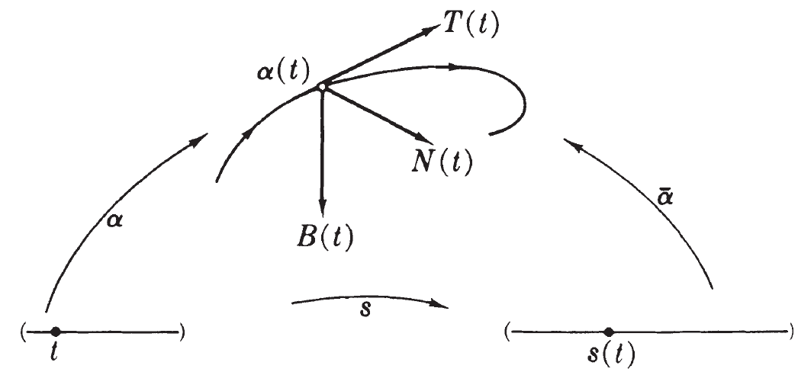

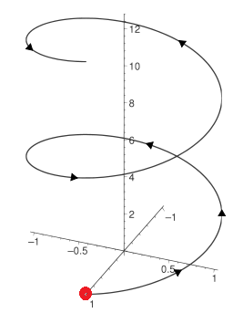
Example: Consider a helix $α:R→R$ defined by
$$α\left(t\right)=(a\cos{t ,a\sin{t, bt}})$$

Now $\overline{α}$ is a unit speed curve. If $\overline{κ}>0$then we can define the following
$$\overline{κ}, \overline{τ}, \overline{T},\overline{N}, \overline{B}$$

The Frenet Frame of $α$
Definition: Let $α$ be a regular curve and let $\overline{α}$ be its arc-length parametrization. Then we define
The curvature function of : $κ=\overline{κ}(s)$
The torsion function of : $τ=\overline{τ}(s)$
Unit tangent vector field of $α$: $T=\overline{T}(s)$
Principal normal vector field of : $N=\overline{N}(s)$
Binormal vector field of : $B=\overline{B}(s)$

For arbitrary speed curve $α$ the speed$v\left(t\right)=‖α'(t)‖$ is an important factor in the Frenet formulas for arbitrary speed curves.
Lemma: If $α$ is a regular curve in $R^{3 }$with $κ>0$, then
$$T^{'}= κvN$$
$$N^{'}=-κvT +τvB$$
$$B^{'}= -τN$$
If a object (e.g. bird, airplane, etc ) is moving on a constant speed then velocity and acceleration are perpendicular. If the object follow the path $α:I→R^{3}$. Since $α$ has constant speed so
$$‖α'‖=c$$
Definition: Let $α:I→R^{3}$ be a curve with coordinates $α\left(t\right)=(α_{1}\left(t\right),α_{2}\left(t\right),α_{3}(t))$ then the acceleration of $α$ is defined as
$$α^{''}=\left(\frac{d^{2}α_{1}}{dt^{2}},\frac{d^{2}α_{2}}{dt^{2}},\frac{d^{2}α_{3}}{dt^{2}}\right)$$
So
$$α.^{'}α^{'}=c^{2}$$
$$α^{'}. α^{''}=0$$
So velocity and acceleration are perpendicular.
We can analyze the situation by expressing velocity and acceleration in terms of Frenet Frame field.
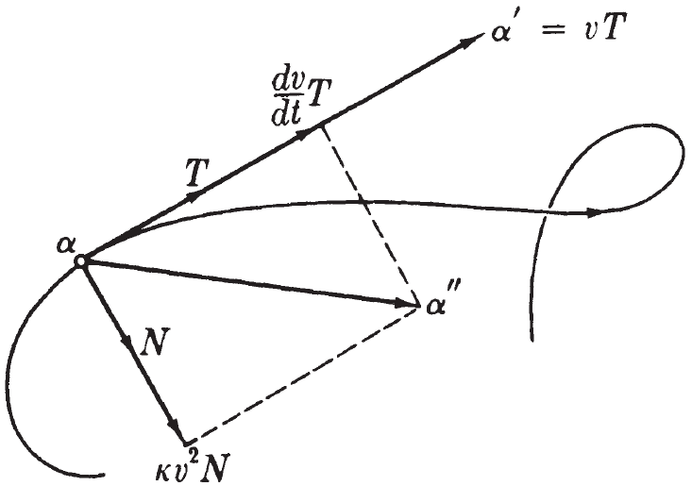
Lemma: If $α$ is a regular curve with speed function $v,$ then its velocity and acceleration are expressed by
$α^{'}=vT$, $α^{''}=\frac{dv}{dt}T+κv^{2}N$

Definition: The term $\frac{dv}{dt} T$ is called the tangential component of acceleration.
Definition: The term $κv^{2}N$ is called normal component of $α''$.

End of the lecture


Lecture # 14

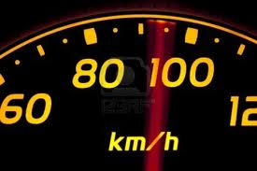
Contents:
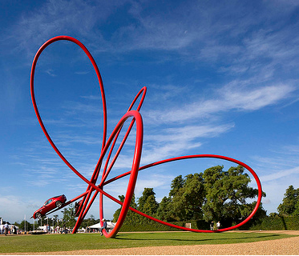
- Frenet Apparatus For A Regular Curve
- Computing Frenet Frame
- The Spherical Image
- Cylindrical Helix
- Conclusion

In this lecture we will learn to calculate the Frenet Frame for arbitrary speed curves. For this purpose the following result is useful.
Theorem: Let $α$ be a curve in $R^{3}.$ Then
$$T=\frac{α}{\left\|α^{'}\right\|},$$
$$N=B×T$$
$$B=\frac{{α'×α}^{''}}{\left\|α^{'}×α^{''}\right\|},$$
$$κ=\frac{\left\|α^{'}×α^{''}\right\|}{{\left\|α^{'}\right\|}^{3}}$$
$$τ=\frac{\left(α^{'}×α^{''}\right). α^{'''}}{‖{\left.​α^{'}×α^{''}\right\|}^{2}}$$
See lecture video of the book for the proof of this.

Exercise: Consider $α$ a curve in $R^{3}$ given by
$$α\left(t\right)=(3t-t^{3},3t^{2}.3t+t^{3})$$
Find the Frenet apparatus for $α.$
Applications Of Frenet Formulas
Given a curve $β$ we construct a new curve $\hat{β}$. Such that $\hat{β}$ has some properties of $β$ and helps us to understand those properties in a better way.
Spherical Image:
Let $β:I→R^{3}$ be a unit speed curve. The spherical image $β$ is the curve $σ≈T.$ That is
$$σ:I→R^{3}$$
is given by
$$σ\left(t\right)=(v_{1}\left(t\right),v_{2}\left(t\right),v_{3}(t))$$
where
$${\left(v_{1}\left(t\right),v_{2}\left(t\right),v_{3}\left(t\right)\right)}_{β(t)}$$
is tangent at point $β(t)$ of the curve.
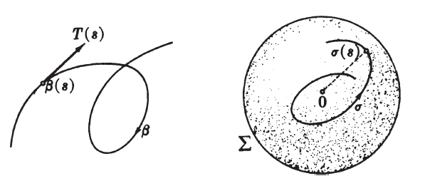

Example: The unit helix is given by
$$β\left(t\right)=(a cos\frac{s}{t}, a sin\frac{s}{t},\frac{bs}{c})$$
where $c=\sqrt{a^{2}+b^{2}}$. Then the spherical image $σ$ of $β$ is given by:
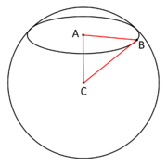
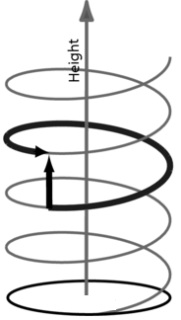

Curvature Of The Spherical Image
Let $σ$ be the spherical image of the unit speed curve $β$. Let us calculate the curvature of $σ$.

End of the lecture


Lecture # 15

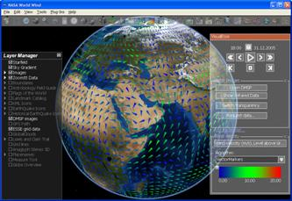
Contents:
- Cylindrical Helix
- Covariant Derivatives
- Euclidean Coordinate Representation
- Properties Of The Covariant Derivative
- The Vector Field Of Covariant Derivatives

Cylindrical Helix
Sometimes the geometrical information like torsion and curvature are enough to tell what the curve is exactly going to be. Cylindrical is one of those examples where, by just looking at the torsion and curvature, you can tell with exactness. In fact the ration $\frac{τ}{κ}$ is some times very decisive in the case of some curves. We start with the definition of the cylindrical helix.
Definition: A regular curve $α$ in $R^{3}$ is a cylindrical helix provided the unit tangent $T$ of $α$ has constant angle $θ$ with some fixed unit vector $u$; that is, $T\left(t\right).u=cos θ$.
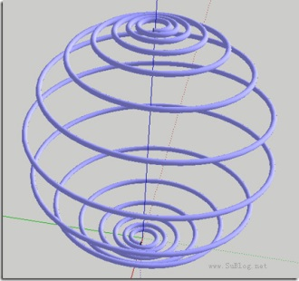
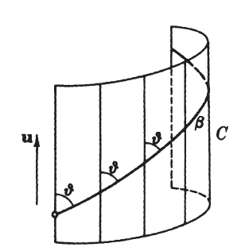
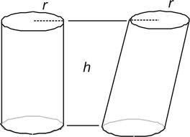

Movement of a cylindrical helix
Assume that $β$ is a unit-speed curve which is a cylindrical helix, that is, $T.u=\cos{θ}$, for some fixed unit vector $u$. Lets consider the following function:
$$h\left(s\right)=\left(β\left(s\right)-β\left(0\right)\right).u$$
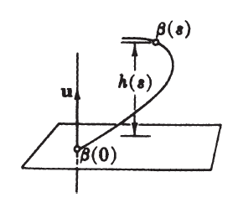

Theorem: A regular curve $α$ with $κ>0$ is a cylindrical helix if and only if the ration $\frac{τ}{κ}$ is constant.
See book for proof.
In summary we have the following information directly about the curve by just looking at the Frenet apparatus.
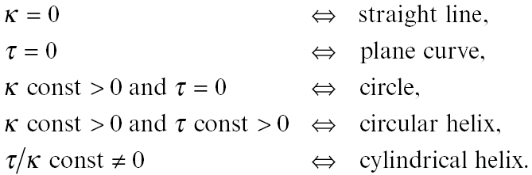

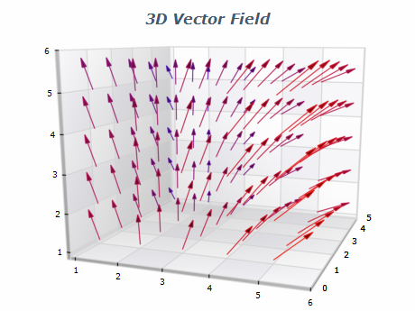
Covariant Derivative
We have seen the definition of vector field. For an example of a vector field see the diagram.
As we can see that the arrows are different at each and every point. Our next aim is understand the rate of change of vector field at any point. For this we define covariant derivative.

Definition:
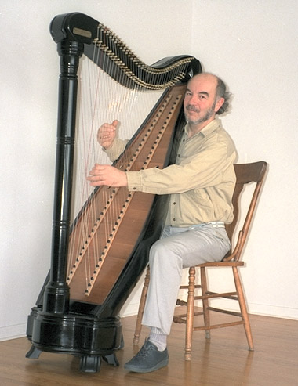
Let $W$ be a vector field on $R^{3}$. Let $v_{p}$ be a tangent vector to $R^{3}$at point $p.$ The covriant derivative of $W$ with respect to $v_{p}$ is the tangent vector
$$∇_{v}W=W{\left(p+tv\right)}^{'}(0)$$
at the point $p$.
The symbol $∇$ is called nabla.

In fact $∇_{v}W$ measures the initial rate of change of $W(p)$ as $p$ moves in the direction of $v$.

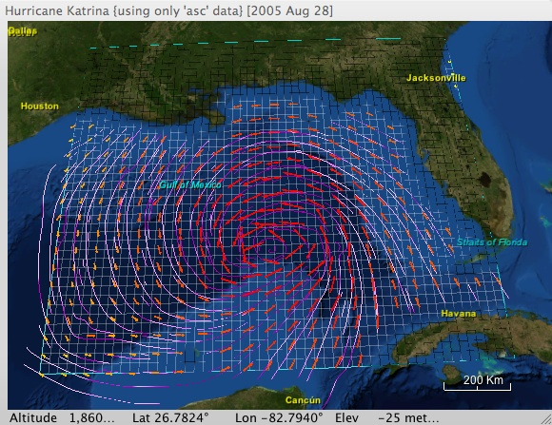
Example: Wind Vector field
One of the practical examples of a vector fields are wind vector field, which tells us the direction and magnitude of the wind at any point.
Calculating the rate of change of this vector field is a crucial part of weather prediction. We use covariant derivative to calculate such quantities.

Now lets see how to calculate the covariant derivative.
Exercise: Consider a vector field
$$W=x^{2}U_{1}+yzU_{2}$$
and
$$v=\left(-1,0,2\right), at p=\left(2,1,0\right).$$
Lemma: If $W=\sum{w_{i}U_{i} }$ is a vector field on $R^{3}$, and $v$ is a tangent vector at $p,$ then
$$∇_{v}W=\sum{v\left[w_{i}\right]U_{i}\left(p\right)}$$
See book for proof.
From the properties of directional derivative we can drive
Theorem: Let $v$ and $w$ be tangent vectors to $R^{3}$ at $p$, and let $Y$ and $Z$ be vector fields on $R^{3}.$ Then for numbers $a, b$ and functions $f$.
$\left(1\right) ∇_{av+bw} Y=a∇_{v}Y+b ∇_{w} Y$
$\left(2\right) ∇_{v}\left(aY+bZ\right)=a ∇_{v}Y+b ∇_{v}Z$
${\left(3\right) ∇}_{v}\left(f∇\right)=v\left[f\right]Y\left(p\right)+f\left(p\right)∇_{v}Y$
$\left(4\right) v\left[Y.Z\right]=∇_{v}Y.Z \left(p\right)+Y\left(p\right). ∇_{v}\left(Z\right)$
The vector field of covariant derivatives
Definition: Let $V$ and $W$ be vector fields on $R^{3}$.
The covariant derivative $∇_{V}W$ of $W$ with respect to $V$ is a vector field defined by
$${(∇}_{V}W)\left(p\right)=∇_{V(p)}W$$
Corollary: If $=\sum{w_{i}U_{i}}$ , then
$$∇_{V}W=\sum{V\left[w_{i}\right]U_{i}}$$
Example: We always use $∇_{V}W=\sum{V\left[w_{i}\right]U_{i}}$ and $U_{i}\left[f\right]=\frac{∂f}{∂x_{i}}:$
If $W=xyU_{1}-e^{z} U_{3}$and $V=zU_{1}+\left(x-y\right)U_{2}$ , then
$$V\left[xy\right]=zU_{1}\left[xy\right]+\left(x-y\right)U_{2}\left[xy\right]=yz+x\left(x-y\right)$$
$$V\left[e^{z}\right]=zU_{1}\left[e^{z}\right]+\left(x-y\right)U_{2}\left[e^{z}\right]=0$$
and therefore
$$∇_{V}W=\left(yz+x\left(x-y\right)\right)U_{1}$$
Corollary: Let $V, W, Y$ and $Z$ be vector fields on $R^{3}$. Then
$\left(1\right) ∇_{fV+gW} Y=f∇_{v} Y+g ∇_{W} Y$ for all functions $f$ and $g$
$\left(2\right) ∇_{V}\left(aY+bZ\right)=a∇_{V}Y+b ∇_{V}Z$ for all numbers $a$ and $b$
$\left(3\right) ∇_{V}\left(fY\right)=V\left[f\right]Y+f ∇_{V}Y$ for all functions $f$
$\left(4\right) V\left[Y.Z\right]=∇_{V}Y.Z+Y. ∇_{V}Z$
See book for proof.

End of the lecture

Lecture #16

Contents:
- From Curves to Space
- Frame Fields
- Coordinate Functions
From Curves To Space

In 1847 Frenet formulas were discovered by Jean Frédéric Frenet (7 February 1816 – 12 June 1900) in 1847.
In 1851 Joseph Alfred Serret (August 30, 1819 - March 2, 1885) discovered the same formulas independently.
So we can call them Frenet—Serret Formulas.
$$\left(\begin{matrix}T' \\ N' \\ B'\end{matrix}\right)=\left(\begin{matrix}0 & κv & 0 \\ -κv & 0 & τv \\ 0 & -τv & 0\end{matrix}\right)\left(\begin{matrix}T \\ N \\ B\end{matrix}\right)$$

From Curves to Surfaces
So far we have discussed the geometry of curves in $R^{3}$. We mainly use the Frenet frame $T, N ,B$. Then we calculated the rate of change $T^{'}, N^{'},B^{'}$ using Frenet formulas.
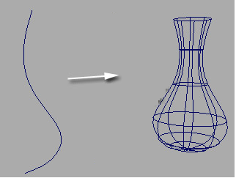

Now to go from curves to surfaces we use the same idea, that is,
Assign a frame to each point of the surface
And then we calculate the changes in the frame in terms of the frame itself.
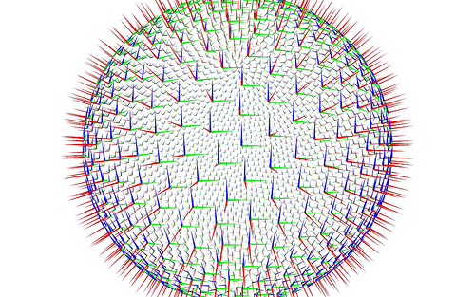

The following theorem helps
Theorem: Let $e_{1},e_{2},e_{3}$be a frame at a point $p$ of $R^{3}$. If $v$ is any tangent vector to $R^{3}$ at $p, then$
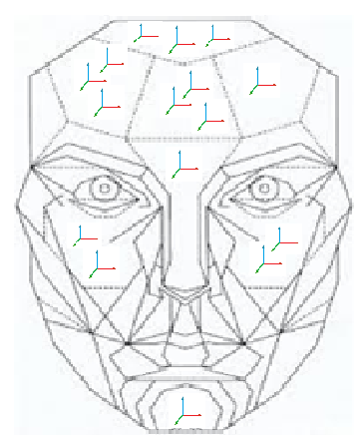
$v=\left(v.e_{1}\right)e_{1}+\left(v.e_{2}\right)e_{2}+\left(v.e_{3}\right)e_{3} .$

Instead of defining frame field on the geometrical object, like sphere, we carry on this idea for the Euclidean space $R^{3}.$ Then the restriction of the idea to geometries in $R^{3}$ is simple.

Frame Fields
We can extend the idea of point wise operation to define the following terms for vector fields.
Definition: Let $V$ and $W$ be vector fields in $R^{3}$, then we can define their dot product $V.W$as follows:
$$V.W \left(p\right)=V\left(p\right).W(p)$$
Similarly we can define the following:

Definition: Let $V$ be a vector field then we define $‖V‖$ to be a real valued function on $R^{3}$
$$\left\|V\right\|:R^{3}→R$$
given by
$$\left\|V(p)\right\|=\sqrt{V\left(p\right).V(p)}$$
The norm $‖V‖$ is not defined around $0$.
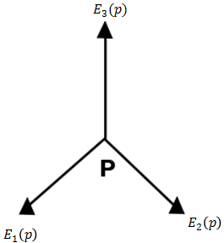
Definition: Three vector fields $E_{1}, E_{2}, E_{3}$ on $R^{3}$ forms a frame field on $R^{3}$ if they satisfy
$E_{i}.E_{j}=δ_{ij}$ for $1≤i,j≤3$
Thus at each point $p$ the vectors $E_{1}\left(p\right), E_{2}\left(p\right), E_{3}(p)$ do in fact form a frame since they have unit length and are mutually orthogonal.

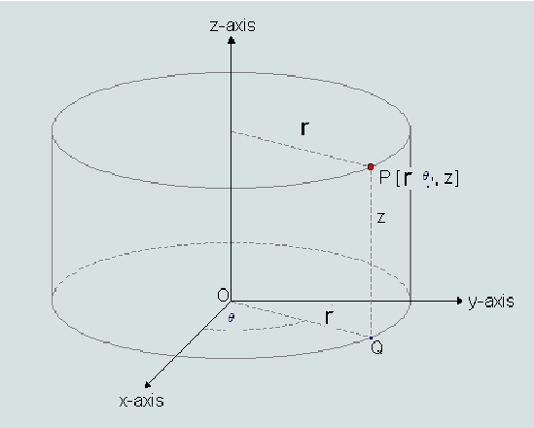
Example ( Cylindrical Frame Field)
Before defining the cylindrical frame we recall what are cylindrical coordinates.
Cylindrical Coordinates: Let $r$, $θ$, $z$ be the cylindrical coordinate functions of $R^{3}$.

We pick unit vector field in the direction in which each coordinate increases
$$E_{1}=\cos{θ} U_{1}+\sin{θ} U_{2}$$
$$E_{2}=\cos\left(θ+\frac{π}{2}\right) U_{1}+\sin\left(θ+\frac{π}{2}\right)$$
$$=-\sin{θ U_{1}+\cos{θ U_{2}}}$$
$$E_{3}=U_{3}$$
It is easy to check that
$$E_{i}.E_{j}=δ_{ij}$$
So
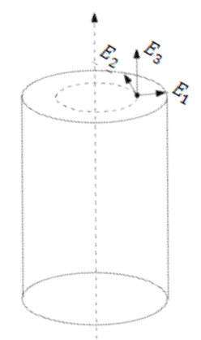
$\left(E_{1},E_{2},E_{3}\right)=(\cos{θ} U_{1}+\sin{θ} U_{2},-\sin{θ U_{1}+\cos{θ U_{2}}},U_{3})$
forms a frame field on $R^{3}$ called cylindrical frame field.
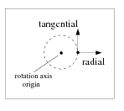
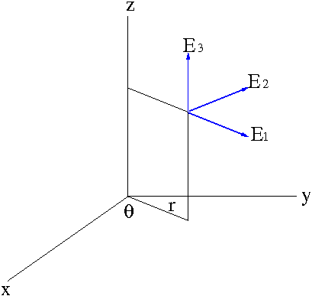

Now the question is are there points where the cylindrical frame is not defined?
Yes, the points on $z-$axis does not have a cylindrical frame defined on them. Cylindrical coordinates are useful in many practical situations, like, designing of a robotic arm etc.

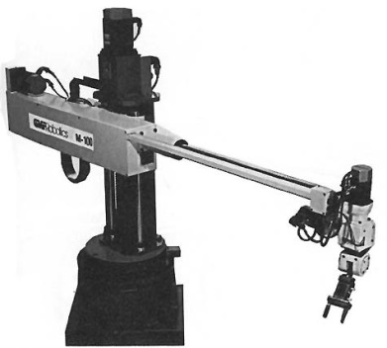
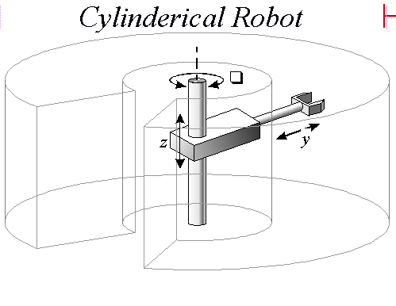

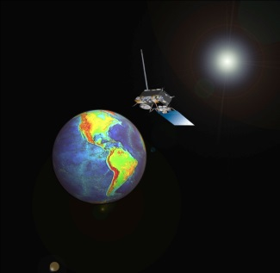
Spherical Coordinates:
Why spherical coordinates?
Just like cylindrical coordinates, there are situations in real like that
Could be dealt in a good way if we use the spherical coordiantes.
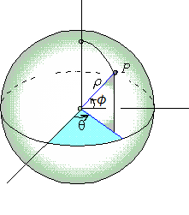

From Cylindrical Frame to Spherical Frame
$F_{2}=E_{2}$
$F_{1}=\cos{ϕ E_{1}}+\sin{ϕ} E_{3}$
$F_{3}=\cos\left(ϕ+\frac{π}{2}\right)E_{1}+\sin{ \left(ϕ+\frac{π}{2}\right) }E_{3}$
$=-\sin{ϕ} E_{1}+\cos{ϕ} E_{3}$
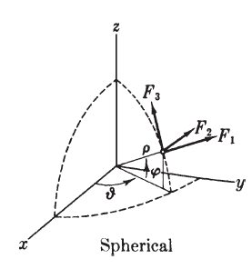
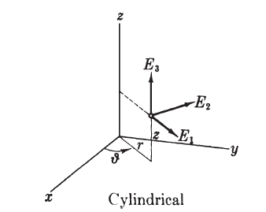

So we have
$F_{2}=E_{2}$
$F_{1}=\cos{ϕ E_{1}}+\sin{ϕ} E_{3}$
$F_{3}=-\sin{ϕ} E_{1}+\cos{ϕ} E_{3}$
Lemma: Let $E_{1},E_{2},E_{3}$ be a frame field on $R^{3}$.
- Let $V$ be a vector field, then $V=\sum{f_{i}E_{i}}$. Where the functions $f_{i}$ are called the coordinate functions of $V$ with respect to $E_{1}, E_{2}, E_{3}$.
- If $V=\sum{f_{i}E_{i}}$ and $W=\sum{g_{i}E_{i}}$ then
$$V.W=\sum{f_{i}g_{i}}$$
And
$$\left\|V\right\|={\left(V.V\right)}^{\frac{1}{2}}={\left(\sum{f_{i}^{2}}\right)}^{\frac{1}{2}}$$
See book for proof.

So far we have seen many frame fields.
But for a given problem we would like to choose a frame field that is especially easy to work with. The calculations could be very easy with the right selection of frame field.
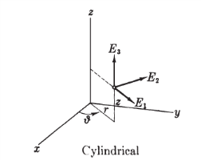
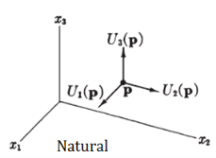


End of the lecture

Lecture # 17

Contents:
- Connection Form
- Connection Equations
- How To Calculate Connection Forms

Connection Form
Covariant derivative of a frame field
Let $\{E_{1},E_{2},E_{3}\}$ be a frame field on $R^{3}$. Let $v$ be an arbitrary tangent vector at point $p$ of $R^{3}$. Then we can write
$$∇_{v} E_{1}=c_{11} E_{1}+c_{12}E_{2}+c_{13}E_{3}$$
$$∇_{v} E_{2}=c_{21} E_{1}+c_{22}E_{2}+c_{23}E_{3}$$
$$∇_{v} E_{3}=c_{31} E_{1}+c_{32}E_{2}+c_{33}E_{3}$$

We can use orthonormal expansion:
Theorem: Let $e_{1},e_{2},e_{3}$be a frame at a point $p$ of $R^{3}$. If $v$ is any tangent vector to $R^{3}$ at $p, then$
$$v=\left(v.e_{1}\right)e_{1}+\left(v.e_{2}\right)e_{2}+\left(v.e_{3}\right)e_{3} .$$
To express each coefficient $c_{ij}$ as
$c_{ij}=∇_{v}E_{i}.E_{j}\left(p\right)$ for $1≤i, j≤3$
Note that the coefficients $c_{ij}$ depend only the vector $v$, so we can write them
$c_{ij}\left(v\right)=ω_{ij}\left(v\right)=∇_{v}E_{i}.E_{j}\left(p\right)$ for $1≤i,j≤3$
The function $ω_{ij}(v)$ given by
$ω_{ij}\left(v\right)=∇_{v}E_{i}.E_{j}\left(p\right)$ for $1≤i,j≤3$
is a function of tangents vectors on $R^{3}$, and the output is a real number.
Have we met any function that satisfy this property?
Yes, we have.
Definition:
A $1-$form $ϕ$ on $R^{3}$ is a real-valued function on the set of all tangent vectors to $R^{3}$ such that $ϕ$ is linear at each point, that is,
$$ϕ\left(av+bw\right)=a ϕ\left(v\right)+bϕ(w)$$
For any numbers $a$, $b$ and tangent vectors $v$ , $w$ at the same point of $R^{3}$.

Lemma: Let $E_{1},E_{2},E_{3}$ be a frame field on $R^{3}$. For each tangent vector $v$ to $R^{3}$ at point $p$, let
$ω_{ij}\left(v\right)=∇_{v}E_{i}.E_{j}\left(p\right)$ for $1≤i,j≤3$
Then each $ω_{ij}$ is a one form, and $ω_{ij}=-ω_{ji}$.
See book for proof.
Theorem: Let $ω_{ij}$ be the connection forms of the frame field $E_{1},E_{2},E_{3}$ on $R^{3}$.
Then for any vector field $V$ on $R^{3},$
$$∇_{V}E_{i}=\sum{ω_{ij}\left(V\right)E_{j}}$$
We call the equations
$$∇_{V}E_{i}=\sum{ω_{ij}\left(V\right)E_{j}}$$
Connection equations.

The matrix of connection forms
We can write the connection forms $ω_{ij}$ in matrix form
$$ω=\left(\begin{matrix}ω_{11} & ω_{12} & ω_{13} \\ ω_{21} & ω_{22} & ω_{13} \\ ω_{31} & ω_{32} & ω_{33}\end{matrix}\right)$$
But since $ω_{ij}=-ω_{ji}$ , so for $i=j$ we have $ω_{ii}=-ω_{ii}$. Hence we have
$ω_{ii}=0$ for $1≤i≤3$.
Hence the matrix of connection forms becomes
$$ω=\left(\begin{matrix}0 & ω_{12} & ω_{13} \\ ω_{21} & 0 & ω_{13} \\ ω_{31} & ω_{32} & 0\end{matrix}\right)$$
Hence we can write connection equations as
$$∇_{V} E_{1}= +ω_{12}{\left(V\right)E}_{2}+ω_{13}(V)E_{3}$$
$$∇_{V} E_{2}=ω_{21}\left(V\right)E_{1} +ω_{23}(V)E_{3}$$
$$∇_{V} E_{3}=ω_{31}\left(V\right)E_{1}+ω_{32}\left(V\right){ E}_{2}$$

How To Calculate Connection Forms
Let ${\{E}_{1},E_{2},E_{3}\}$ be an arbitrary frame field and let ${\{U}_{1},U_{2},U_{3}\}$ be natural frame field. We can write
$$E_{1}=a_{11}U_{1}+a_{12}U_{2}+a_{13}U_{3}$$
$$E_{2}=a_{21}U_{1}+a_{22}U_{2}+a_{23}U_{3}$$
$$E_{3}=a_{31}U_{1}+a_{32}U_{2}+a_{33}U_{3}$$
here the coefficients can be calculated using orthonormal expansion
$$a_{ij}=E_{i}.U_{j}$$
Here $a_{ij}$ are real valued functions on $R^{3}$.
From here we can define the attitude matrix of the frame.
$$A=\left(\begin{matrix}a_{11} & a_{12} & a_{13} \\ a_{21} & a_{22} & a_{23} \\ a_{31} & a_{32} & a_{33}\end{matrix}\right)$$
Now we define differential of $A=(a_{ij})$ to be $dA=(da_{ij})$. So $dA$ is a matrix whose entries are $1$-forms.
We can calculate the connection forms in terms the attitude matrix as follows:
Theorem: If $A=(a_{ij})$ is an attitude matrix of a frame field $\left\{E_{1},E_{2},E_{3}\right\}$. Let
$ω_{ij}$ be the connection forms of this frame field, then
$$ω_{ij}=dA tA$$
Or equivalently
$$ω_{ij}=\sum{da_{ik} a_{kj} }$$
See book for proof.
Connection forms for the cylindrical frame
We know that
So the attitude matrix of the cylindrical frame is
$$A=\left(\begin{matrix}\cos{θ} & \sin{θ} & 0 \\ -\sin{θ} & \cos{θ} & 0 \\ 0 & 0 & 1\end{matrix}\right)$$
Hence
$$ω=\left(\begin{matrix}0 & d θ & 0 \\ -d θ & 0 & 0 \\ 0 & 0 & 0\end{matrix}\right)$$
Now the connection forms for cylindrical frame are
$$ω=\left(\begin{matrix}0 & d θ & 0 \\ -d θ & 0 & 0 \\ 0 & 0 & 0\end{matrix}\right)$$
Hence the connection equations become
$$∇_{V}E_{1}=dθ U_{2}$$
$$∇_{V}E_{2}=-d θ U_{1}$$
$$∇_{V}E_{3}=0$$
Since $θ$ is a real valued function on $R^{3}$. So
$$dθ(V)=V[θ]$$
Hence the equations
$$∇_{V}E_{1}=dθ U_{2}$$
$$∇_{V}E_{2}=-d θ U_{1}$$
$$∇_{V}E_{3}=0$$
Becomes
$$∇_{V}E_{1}=V[θ] U_{2}$$
$$∇_{V}E_{2}=-V[θ] U_{1}$$
$$∇_{V}E_{3}=0$$

End of the lecture



Lecture # 18
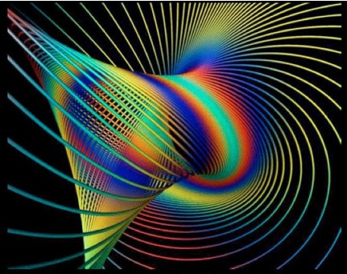

Contents:
- Dual Forms
- Cartan Structural Equations
- Structural Equations For Spherical Frame

Dual Forms
The dual forms of a frame field
Any frame field can be described in terms of 1-forms.
Definition: If $E_{1}, E_{2},E_{3}$ is a frame field on $R^{3}$, then the dual 1-forms $θ_{1},θ_{2}, θ_{3}$ of the frame field are the 1-forms such that
$$θ_{i}\left(v\right)=v.E_{i}(p)$$
For each tangent vector $v$to $R^{3}$ at point $p$.
Here $θ_{i}$ are 1-forms since
1)- $θ_{i}$ takes vectors to real numbers
2)- $θ_{i}$ are linear

Another property of $θ_{i}$
$θ_{i}\left(E_{j}\right)=δ_{ij}$ for $1≤i, j≤3$
here $δ_{ij}$ is Kronecker delta function.
Orthonormal expansion formula for vector field
Let $V$ be a vector field then we can write in terms of frame field $\{E_{1},E_{2}, E_{3}\}$
$$V=\sum{f_{i}E_{i}}$$
In terms of dual 1-forms the orthonormal expansion can be written as
$$V=\sum{θ_{i}\left(V\right)E_{i}}$$
Expressing 1-forms in terms of dual forms
In case of natural frame field $U_{1},U_{2}, U_{3}$ the dual 1-forms are $dx_{1}, dx_{2}, dx_{3}$. We also know that any 1-form $ϕ$ can be written as
$$ϕ=\sum{ϕ\left(U_{i}\right) dx_{i}}$$
Question: Is it true in general?
Answer: Yes, by the following result.
Theorem: Let $θ_{1}, θ_{2}, θ_{3}$ be the dual 1-forms of a frame field $E_{1},E_{2},E_{3}$. Then any 1-form $ϕ$ on $R^{3}$ has a unique expression
$$ϕ=\sum{ϕ\left(E_{i}\right)θ_{i}}$$

Formula for $θ_{i}$
We know that any frame field $\{E_{1}, E_{2}, E_{3}\}$ can be written in terms of natural frame field,
$$E_{i}=\sum{a_{ij}U_{j}} for 1≤i, j≤3$$
We have the following result for dual 1-forms $θ_{1}, θ_{2}, θ_{3}$ of $E_{1}, E_{2}, E_{3}$ as:
Fact:
$$θ_{i}=\sum{a_{ij}dx_{j}} for 1≤i, j≤3$$

Cartan Structural Equations
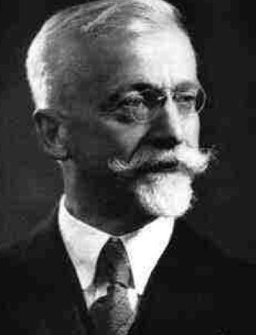
Exterior derivatives
Exterior derivatives of 1-forms and connection forms were given by Cartan.
Theorem (Cartan Structural Equations)
Let $E_{1}, E_{2}, E_{3}$ be a frame field on $R^{3}$ with dual forms $θ_{1}, θ_{2}, θ_{3}$ and connection forms
$$ω_{ij} \left(1≤i, j≤3\right).$$
The exterior derivatives of these forms satisfy:
- The first structural equations:
$$dθ_{i}=\sum{ω_{ij}∧θ_{j}}.$$
(2) The second structural equation:
$$d ω_{ij}=\sum{ω_{ik}∧ω_{kj}}.$$
Proof is not included.
Matrix notation
We define some notations and remarks to make these structural equations more easy to understand. We define
$$ω=\left(\begin{matrix}ω_{11} & ω_{12} & ω_{13} \\ ω_{21} & ω_{22} & ω_{23} \\ ω_{31} & ω_{32} & ω_{33}\end{matrix}\right)$$
and we also know the attitude matrix
$$A=\left(\begin{matrix}a_{11} & a_{12} & a_{13} \\ a_{21} & a_{22} & a_{23} \\ a_{31} & a_{32} & a_{33}\end{matrix}\right)$$
And we can write the dual forms $θ_{1}, θ_{2}, θ_{3}$ in matrix form as
$$θ=\left(\begin{matrix}θ_{1} \\ θ_{2} \\ θ_{3}\end{matrix}\right)$$
And the dual of natural frame fields as:
$$dξ=\left(\begin{matrix}d x_{1} \\ d x_{2} \\ d x_{3}\end{matrix}\right)$$

Using these notations we can write the following fact
Fact:
$$θ_{i}=\sum{a_{ij}dx_{j}} for 1≤i, j≤3$$
In the following form:
$$\left(\begin{matrix}θ_{1} \\ θ_{2} \\ θ_{3}\end{matrix}\right)=\left(\begin{matrix}a_{11} & a_{12} & a_{13} \\ a_{21} & a_{22} & a_{23} \\ a_{31} & a_{32} & a_{33}\end{matrix}\right)\left(\begin{matrix}d x_{1} \\ d x_{2} \\ d x_{3}\end{matrix}\right)$$
In short form it becomes:
$$θ=A d ξ$$

So we can write the Cartan structural equations as
First structural equation
$$dθ_{i}=\sum{ω_{ij}∧θ_{j}}$$
can be written as
$$\left(\begin{matrix}d θ_{1} \\ d θ_{2} \\ d θ_{3}\end{matrix}\right)=d θ=\sum{ω_{ij}∧θ_{i}}=\left(\begin{matrix}ω_{11} & ω_{12} & ω_{13} \\ ω_{21} & ω_{22} & ω_{23} \\ ω_{31} & ω_{32} & ω_{33}\end{matrix}\right)\left(\begin{matrix}θ_{1} \\ θ_{2} \\ θ_{3}\end{matrix}\right)$$
Similarly
The second structural equation
$$d ω_{ij}=\sum{ω_{ik}∧ω_{kj}}.$$
can be written as
$$d ω=ω ω$$

Example: The Spherical Frame Field
The spherical Frame field is given by
$$F_{1}=\cos{θ\cos{ϕ U_{1}+\sin{θ\sin{ϕ U_{2}+\sin{ϕ U_{3}}}}}}$$
$$F_{2}=-\sin{θ U_{1}+\cos{θ U_{2} }}$$
$$F_{3}=-\cos{θ\sin{ϕ U_{1}-\sin{θ\sin{ϕ }U_{2}+\cos{ϕ U_{3}}}}}$$
So the attitude matrix is
$$A=\left(\begin{matrix}\cos{θ\cos{ϕ}} & \sin{θ\sin{ϕ}} & \sin{ϕ} \\ -\sin{θ} & \cos{θ} & 0 \\ -\cos{θ\sin{ϕ }} & -\sin{θ\sin{ϕ }} & \cos{ϕ }\end{matrix}\right)$$
Now if $θ_{1}, θ_{2}, θ_{3}$ are dual 1-forms of the spherical frame field then:
$$θ=A dξ$$
Calculation of $θ$
Now to calculate $dx_{1}, dx_{2},dx_{3}$ we consider
$$x_{1}=ρ\cos{ϕ\cos{θ }}$$
$$x_{2}=ρ\cos{ϕ\sin{θ }}$$
$$x_{3}=\sin{ϕ }$$
We calculate $dx_{1} dx_{2}, dx_{3}$ use the following to get $θ$.
$$df=\frac{∂f}{∂x_{1}} dx_{1}+\frac{∂f}{∂x_{2}} dx_{2}+\frac{∂f}{∂x_{3}} dx_{3}$$
Calculation of $ω$
Now we will
$$A=\left(\begin{matrix}\cos{θ\cos{ϕ}} & \sin{θ\sin{ϕ}} & \sin{ϕ} \\ -\sin{θ} & \cos{θ} & 0 \\ -\cos{θ\sin{ϕ }} & -\sin{θ\sin{ϕ }} & \cos{ϕ }\end{matrix}\right)$$
Now we after calculating $dA$, the matrix of $ω$ is given by
$$ω=\left(\begin{matrix}0 & \cos{ϕ dθ} & d ϕ \\ & 0 & \sin{ϕ}dθ \\ & & 0\end{matrix}\right)$$
First Structural Equation for Spherical Frame
So we have
- The first structural equations:
$$dθ_{i}=\sum{ω_{ij}∧θ_{j}}.$$
(2) The second structural equation:
$$d ω_{ij}=\sum{ω_{ik}∧ω_{kj}}.$$
Where
$$θ=\left(\begin{matrix}dr \\ r\cos{ϕ} \\ r dϕ\end{matrix}\right) and ω=\left(\begin{matrix}0 & \cos{ϕ dθ} & d ϕ \\ & 0 & \sin{ϕ}dθ \\ & & 0\end{matrix}\right)$$
Recipe for dealing with geometrical problems in $R^{3}$
Procedure
- Select a frame field
- Find its dual 1-forms
- Calculate connection forms
- Apply structural equations
- Interpret the results

End of the lecture


Lecture # 19

Contents:
- Surfaces in $R^{3}$
- The Sphere
- Construction Of A Surface

Surfaces in $R^{3}$
Coordinate patches
A coordinate patch
$$x :D→R^{3}$$
is a
- Mapping
- one-to-one
- regular
of an open set $D$ of $R^{2}$ into $R^{3}$.
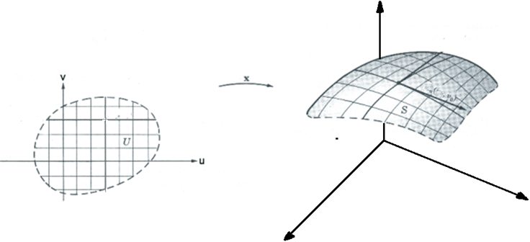

Proper Patches
A coordinate patch $x:D→R^{3}$ is called proper if its inverse function
$$x^{-1}:x\left(D\right)→R^{2}$$
is continuous.
What is a surface roughly?
Every small region of surface looks like a region in $R^{2}$, or image of patch.
Definition: Let $x:D→R^{3}$ be a patch with $x\left(D\right)⊂M$ is a patch in $M$.
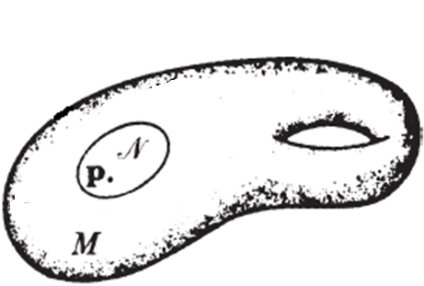
Definition:
A neighborhood in $M⊂R^{3}$ of a point $p$ is the subset of all points in $M$ at distance less that $ϵ$, for some real number $ϵ>0$.

Surface
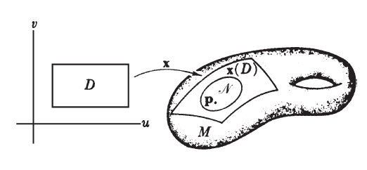
A surface in $R^{3}$ is a subset $M$ of $R^{3}$ such that for each point $p$ of $M$ there exist a proper patch in $M$ whose image contains a neighborhood of $p$ in $M$.

Sphere:
A sphere $Σ$ is the set of all point in $R^{3}$ whose distance from origin is 1, that is all points $p$ such that
$$\left\|p\right\|={\left(p_{1}^{2}+p_{2}^{2}+p_{3}^{2}\right)}^{\frac{1}{2}}=1$$
Patch containing north pole
Consider the point $(0,0,1)$ on sphere, known as North pole.
Let
$$D=\{\left(u,v\right):u^{2}+v^{2}<1\}$$
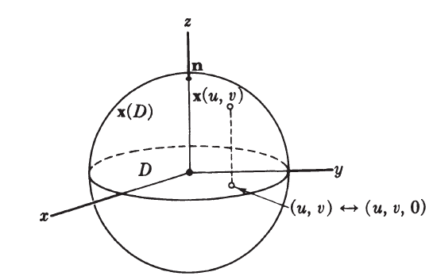
Define
$$x:D→Σ such that x\left(u,v\right)=(u,v, \sqrt{1-u^{2}-v^{2}})$$
Lets see if $x$ is a patch or not. For this check the following:
- Mapping: since the coordinate functions are differentiable
- One to one
To check if the patch $x$ is regular we need to calculate the Jacobian of this map:

Similarly we can define the patch for the south pole, that is, the point $(0,0,-1)$.

From the sphere example we can guess the following
The map
$$x:D→R^{3}$$
given by
$$x\left(u,v\right)=(u,v,f(u,v))$$
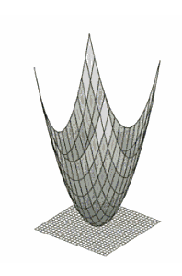
for any differentiable function $f(u,v)$ is a patch. These kind of patches are called the Monge patches.
Simple Surface
Let $x:D→R^{3}$ be patch. Then the image $x(D)$ satisfies definition of a surface. This type of surface is called simple surface.
Example:
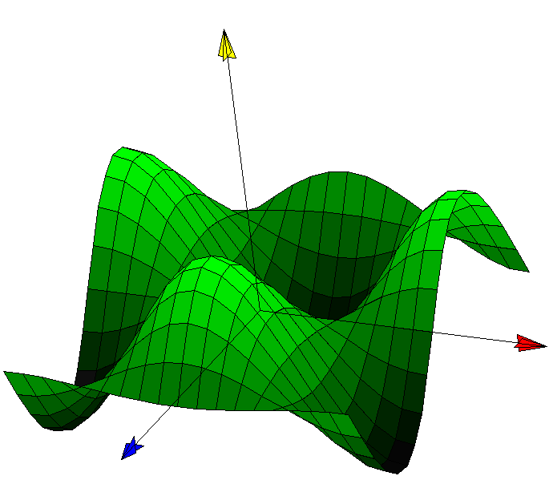
Let $f(u,v)$ be a real valued differentiable function from $R^{2}$ to $R^{3}$. The graph of $z=f(u,v)$ is the set of all points in $R^{3}$ satisfying $z-f\left(u,v\right)=0$.
In fact $M$ is the image of the Monge patch.
So $M$ is a simple surface.

End of the lecture

Lecture 20

Contents:
- Implicitly Defined Surfaces
- Surfaces of Revolution
- Properties Of Patches

Implicitly Defined Surfaces
Let $g$ be a real valued function from $R^{3}$to $R$. For any real number $c$, the equation
$$g\left(x,y,z\right)=c$$
defines the set of all points $p$ of $R^{3}$ such that
$$g\left(p\right)=c$$
Example:
Let $g\left(x,y,z\right)=x^{2}+y^{2}+z^{2}$ and let $c=1$ then the set of all points $p$ such that
$$g\left(p\right)=1$$
forms a sphere of radius $1$.
Example:
Let $g\left(x,y,z\right)=z$ and $c=1$ then the set of all points $p$ in $R^{3}$ such that
$$g\left(p\right)=1$$
is
$$z=1$$
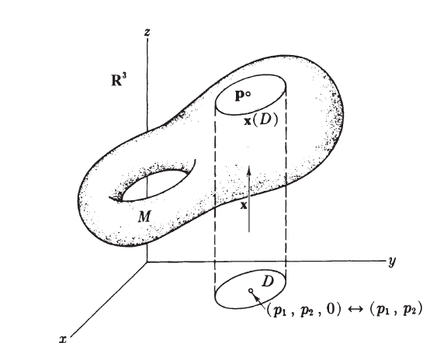
forms a plane parallel to $xy-$plane.
An Implicit Construction
Theorem: Let $g:R^{3}→R$ be a differentiable real valued function on $R^{3}$, let $c$ be a number. The subset $M:g\left(x,y,z\right)=c$ of $R^{3}$ is a surface if the differential $dg$ is not zero at any point of $M$.
See book for proof.

Monge Patches:
The map
$$x:D→R^{3}$$
given by
$$x\left(u,v\right)=(u,v,f(u,v))$$
for any differentiable function $f(u,v)$ is a patch. These kind of patches are called the Monge patches.
Sphere is a surface
A sphere $Σ$ with center $c=(c_{1},c_{2},c_{3})$ and radius r is the set of all point in $R^{3}$ whose distance from $c$ is $r$, that is all points $p=(x,y,z)$ such that
$$\left\|p-c\right\|={\left({\left(x-c_{1}\right)}^{2}+{\left(y-c_{2}\right)}^{2}+{\left(z-c_{3}\right)}^{2}\right)}^{\frac{1}{2}}=r^{2}$$

Let $g\left(x,y,z\right)={\left(x-c_{1}\right)}^{2}+{\left(y-c_{2}\right)}^{2}+{\left(z-c_{3}\right)}^{2}$
Then $g\left(x,y,z\right)=r^{2}$ defines sphere with center $c$ and radius $r$.
We apply the previous theorem to shwo if this sphere is a surface or not.
Surfaces of Revolution
If $C$ is defined by $f\left(x,y\right)=c$, where $f{:R}^{2}→R$ is a differentiable function. Also $C$ is regular curve.
Then the surface of revolution is defined by
$$g\left(x,y,z\right)=f\left(x,\sqrt{y^{2}+z^{2}}\right)=c$$
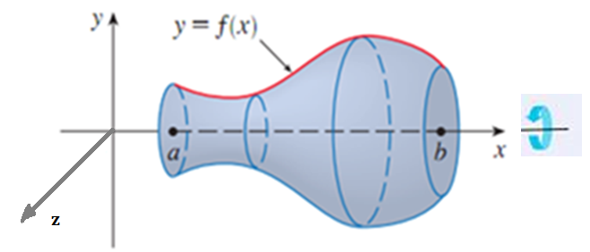

More surfaces of revolution
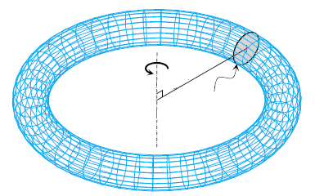
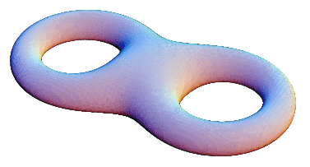
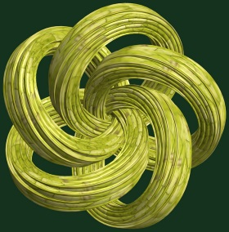
We can generate a torus using the idea of surface of revolution.

Lets see why we need properness in defining surface patches.
Example: Let
$$D=\left\{\left(u,v\right):-π<u<-π, <0v<1\right\}$$
and
$$x:D→R^{3} defined by x\left(u,v\right)=(\sin{u,\sin{2u}, v})$$
Here $x$ is a patch.
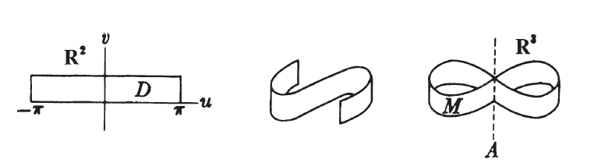
But the image is not a surface.

End of the lecture

Lecture 21

Contents:
- Parameter Curves on Surfaces
- Parametrizations
- Torus
- Ruled Surface

Parameter Curves on Surfaces
Parameter Curves
Let $x:D→R^{3}$ be a coordinate patch. For each point $(u_{0},v_{0})$ in $D$ the curve
$$u→x(u,v_{0})$$
is called the $u-$parameter curve, $v=v_{0}$, of $x$.
Similarly the curve
$$v→x(u_{0},v)$$
Is called $v-$parameter curve, $u=u_{0}$, of $x$.
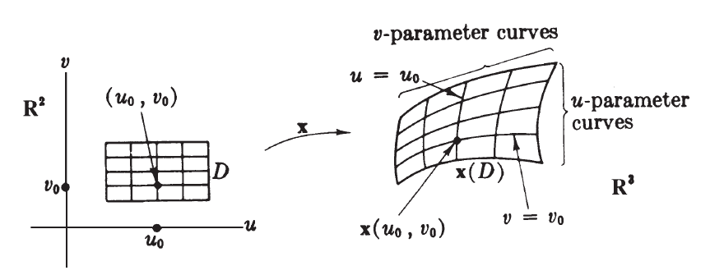

- The image $x(D)$ of $D$ is the union of all such curves.
- Each point of $x(D)$ lies on exactly one curve of each type.
Partial Velocities
If $x:D→R^{3}$ is a patch, for each point $(u_{0},v_{0})$ in $D$.
- The velocity vector at $u_{0}$ of the $u-$parameter curve, $v=v_{0}$, is denoted by $x_{u}(u_{o},v_{0})$.
- The velocity vector at $v_{0}$ of the $v-$parameter curve, $u=u_{0}$, is denoted by $x_{v}(u_{o},v_{0})$.
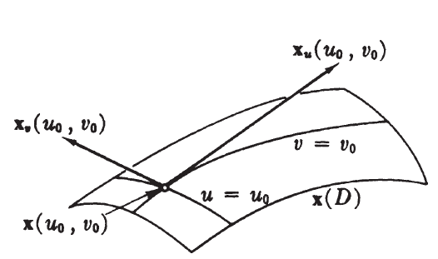
The vectors $x_{u}(u_{0},v_{0})$ and $x_{v}(u_{0},v_{0})$ are called the partial velocities of $x$ at $(u_{0},v_{0})$.

Calculation of partial velocities
Given a coordinate patch $x:D→R^{3}$
$$x\left(u,v\right)=(x_{1}\left(u,v\right),x_{2}\left(u,v\right),x_{3}(u,v))$$
Then the partial velocities functions are
$$x_{u}={\left(\frac{∂x_{1}}{∂u} ,\frac{∂x_{2}}{∂u} ,\frac{∂x_{3}}{∂u} \right)}_{(u_{0},v_{0})}$$
$$x_{v}={\left(\frac{∂x_{1}}{∂v} ,\frac{∂x_{2}}{∂v} ,\frac{∂x_{3}}{∂v} \right)}_{(u_{0},v_{0})}$$
Where $(u_{0},v_{0})$ is point of application and can be omitted.

Geographical patch in a sphere
Let $Σ$be a sphere of radius $r$ and center $\left(0,0,0\right)$ in $R^{3}$. Let $x$ be a mapping defined on
$$D=\{\left(u,v\right):-π<u<π, -\frac{π}{2}<v<\frac{π}{2}\}$$
Defined by
$$x\left(u,v\right)=(r\cos{v\cos{u,} r\cos{v\sin{u}, r\sin{v}}})$$
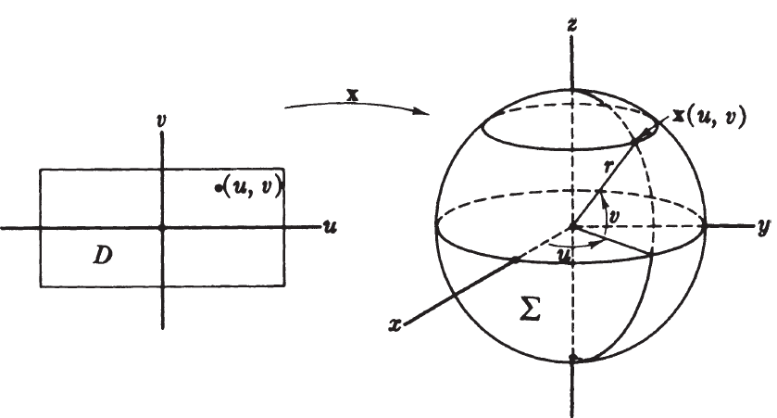

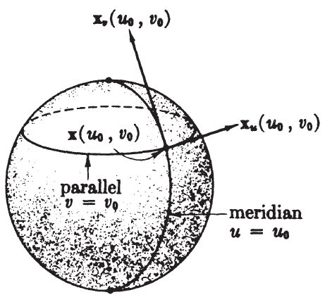
Parametric Curves on the sphere
- The $u-$parameter curve, $v=v_{0}$, is a circle with constant value of $z$. It is the parallel at latitude $v_{0}$.
- The $v-$parameter curve, $u=u_{0}$, is a half circle. It is the meridian of longitude $u_{0}$.

Parametrizations

Definition:
A regular mapping $x:D→M$ whose image lies in a surface $M$ is called a parametrization of the region $x(D)$ in $M$.
Properties of parametrization
- A 1-1 parametrization is a patch
- In parametrization of a curve mean a surjective map onto the whole curve. But in case of surface parametrization it might be only the region $x(D)$ of $M$.

When a mapping is a parametrization?
Given a mapping $x:D→R^{3}$. To check whether it is a parametrization of a surface $M⊂R^{3}$ we check the following:
- $x\left(D\right)⊂M ?$
First determine that $x\left(D\right)⊂M$ or not. For example if surface is defined by $M:g=c$. Then
$"x\left(D\right)$ is contained in $M$ if and only if $g\left(x\left(D\right)\right)=c$.”
- $x$ is regular?
The map $x:D→M$ is regular if
$$x_{u}×x_{v}=\left|\begin{matrix}U_{1} & U_{2} & U_{3} \\ \frac{∂x_{1}}{∂u} & \frac{∂x_{2}}{∂u} & \frac{∂x_{3}}{∂u} \\ \frac{∂x_{1}}{∂v} & \frac{∂x_{2}}{∂v} & \frac{∂x_{3}}{∂v}\end{matrix}\right|$$
is non zero.
Parametrization for sphere
Given mapping
$$x\left(u,v\right)=(r\cos{v\cos{u,} r\cos{v\sin{u}, r\sin{v}}})$$
Question: Is it parametrization of sphere $Σ$ of radius $r$ and center $(0,0,0)$?
Lets check the two conditions to see.
- $x\left(D\right)⊂Σ ?$
The equation of sphere is
$$g\left(x,y,z\right)=x^{2}+y^{2}+z^{2}=r^{2}$$
Then $x\left(D\right)⊂M$ if and only if $\left(g\left(x\right)\right)=r^{2}$.
- $x$ is regular?
Here $D=\{\left(u,v\right):-π<u<π, -\frac{π}{2}<v<\frac{π}{2}\}$
To check if $x$ is a patch we need to only check if $x$ is 1-1 or not.

Surface of revolution
Let the curve $C$ has parametrization
$$α\left(u\right)=(g\left(u\right),h\left(u\right),0)$$
here $h>0$.
As the point on the curve is rotated then it reaches the point
$$x\left(u,v\right)=(g\left(u\right),h\left(u\right)\cos{v},h\left(u\right)\sin{v})$$
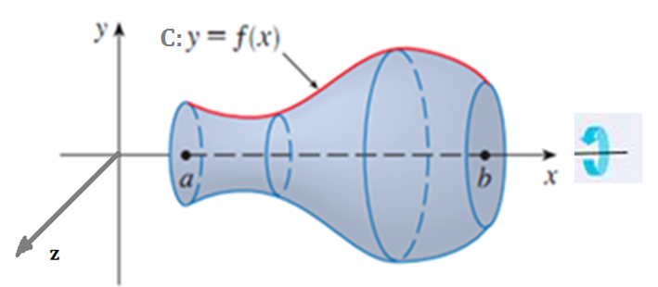
Question: Is it a parametrization of the surface of revolution?
Answer: check the following two.
- $x\left(D\right)⊂M?$
- $x$ is regular?

Torus
Definition:
A torus of revolution $T$ is the surface of revolution of a circle $C$.
Example:
Suppose that $C$ is the circle in the $xz-$plane with radius $r>0$ and center $(R,0,0)$.
We rotate the circle around $z-$axis here $R>r$.
Here parametrization of $C$ is
$$α\left(u\right)=(R+r\cos{u}, r\sin{u})$$
This yields the parametrization
$$x\left(u,v\right)=(\left(R+r\cos{u} \right)\cos{v },\left(R+r\cos{u} \right)\sin{v }, r\sin{u})$$
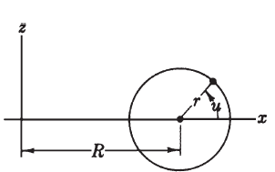

Definition:
A ruled surface is a surface swept out by a straight line $L$ moving along a curve $β$.
The various positions of the ruling line $L$ are called the rulings of the surface.
Such a surface always has a ruled parametrization
$$x\left(u,v\right)=β\left(u\right)+vδ(u)$$
here $β$ is base curve and $δ$ is the director curve.
We put conditions on $β$ and $δ$ to make $x$ a parametrization.
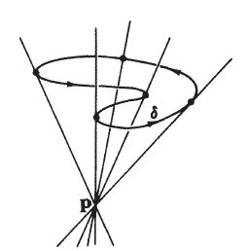
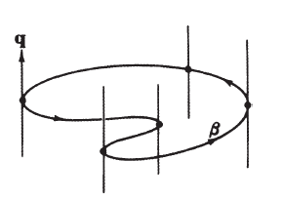

End of the lecture

Lecture # 22

Contents:
- Coordinate Expressions
- Curves on a Surface
- Differentiable Functions

Definition:
A regular mapping $x:D→M$ whose image lies in a surface $M$ is called a parametrization of the region $x(D)$ in $M$.
In parametrization of a curve mean a surjective map onto the whole curve. But in case of surface parametrization it might be only the region $x(D)$ of $M$.
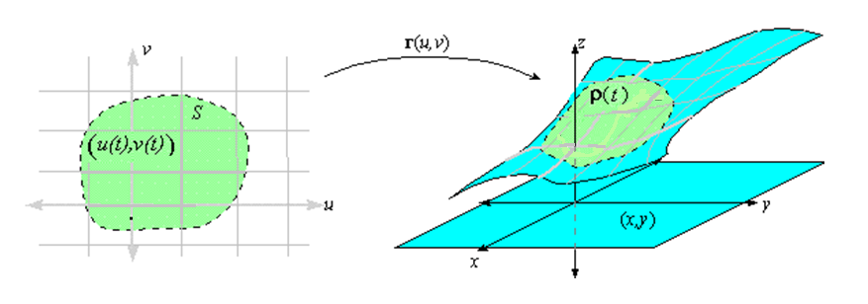

Coordinate Expressions
Suppose that $f$ is a real valued function on a surface $M$.
If
$$x:D→M$$
is a coordinate patch of $M$ then the composite function $f(x)$ is called the coordinate expression for $f$.
The coordinate expression $f$ is just a real-valued function
$$f(x):D→R$$
The function $f$ is differentiable provided all its coordinate expressions
are differentiable.

For a function
$$F:R^{n}→M$$
each patch of $M$
$$x:D→M$$
gives a coordinate expression of $F$, given by
$$x^{-1}\left(F\right):O→D$$
here $O$ is an open set containing points from the set
$$\{p∈R^{n}:F\left(p\right)∈x(D)\}$$
The function $F$ is differentiable if every coordinate expression for $F$ is differentiable. Every set $O$ is open set.
Definition:
A curve on a surface $M$ is a differentiable function
$$α:I→M$$
from open interval $I$ to $M$.
Coordinate functions of a curve
Lemma: If $α$ is a curve $α:I→M$ whose route lies in the image $x(D)$ of a single patch $x$, then there exist unique differentiable functions $a_{1}, a_{2}$ on $I$ such that
$$α\left(t\right)=x\left(a_{1}\left(t\right),a_{2}\left(t\right)\right) for all t$$
Or $α=x(a_{1},a_{2})$.
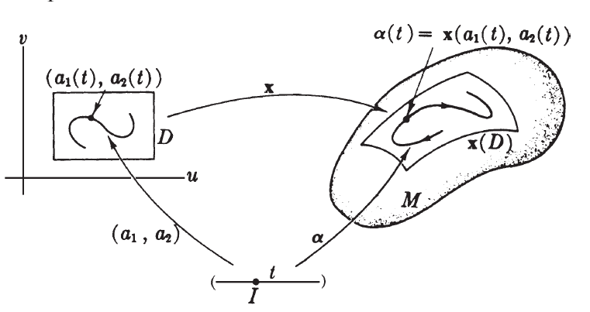
See book for proof

Map of the region
Let $x:D→M$ be a patch in $M$.
We take the domain $D$ as the map of the region $x(D)$.

The functions $x$ and $x^{-1}$ establish a one-to-one correspondence between objects in D and the objects in $x(D)$.
Too many patches
To check the differentiability of functions $F:R^{n}→M$ we need to check differentiability at each and every patch. The following theorem simplify the situation.
Theorem: Let $M$ be a surface in $R^{3}$.
If $F:R^{n}→R^{3}$ is a (differentiable) mapping whose image lies in $M$,
then considered as a function $F:R^{n}→M$ into $M$, $F$ is differentiable.

Overlapping patches
Corollary: Let $x:D→M$ and $y:E→M$ be patches in $M,$ where $M⊂R^{3}$. Assume that images of $x$ and $y$ overlap, that is, $x\left(D\right)\bigcap{y\left(E\right)≠ϕ}$. Then each of $x^{-1}y$ and $y^{-1}x$ is a differentiable mapping defined on an open set in $R^{2}$.
Here the mapping $x^{-1}y$ is defined on the set $x^{-1}(x(D)\bigcap{y(E)})$.
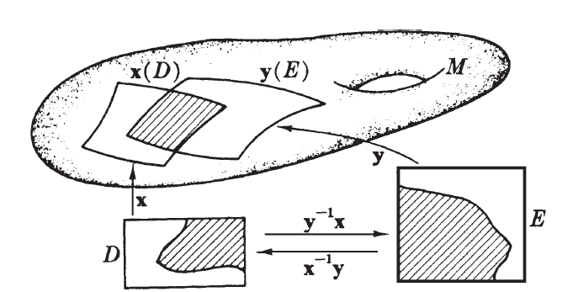
Similarly the mapping $y^{-1}x$ is defined on the set$y^{-1}(x\left(D\right)\bigcap{y\left(E\right)})$.

How to show that $f:M→R$ is differentiable
By definition $f:M→R$ is differentiable if $f(x)$ is differentiable for all patches $x:D→M$.
Assume that we show that $f(x)$ is differentiable for a patch $x$. Let $y$ be another patch. Then $f(x)$ is differentiable and $x^{-1}y$ is also differentiable. Therefore the composition $fxx^{-1}y$ is differentiable. The function $fxx^{-1}y$ is the restriction of $f(y)$ to only a small region of $M$, where $x$ and $y$ overlap.
But $M$ is covered by such regions, therefore $f(y)$ is differentiable in an open region around every point of $M$

End of the lecture

Lecture #23

Contents:
- Tangents
- Tangent Vector Fields
- Gradient Vector Field

Tangents
Tangents to a surface
Definition: Given an surface $M.$ Let $p$ is a point of $M$. Then a tangent vector to $R^{3}$ at $p$is tangent vector to $M$ if $v$ is velocity of some curve in $M$.
The set of all tangent vectors to $M$ at $p$ is called the tangent plane of $M$ at point $p$ and is denoted by $T_{p}(M)$.
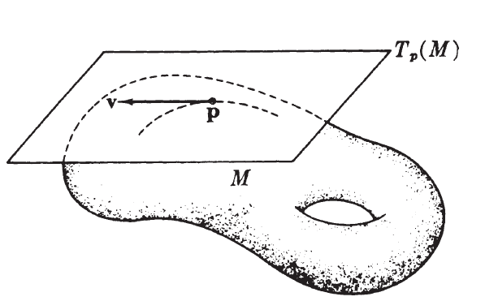
Fact: At each point the tangent plane $T_{p}(M)$ is actually a 2-dimensional vector subspace of the tangent space $T_{p}(R^{3})$.

Lemma:
Let $M$ be a surface in $R^{3}$ and $p$ be a point on $M$. Let $x$ be a patch of $M$ such that $x\left(u_{0},v_{0}\right)=p$. A tangent vector to $R^{3}$ is a tangent vector to $M$ at point $p$ if and only if $v$ can be written as a linear combination of $x_{u}(u_{0},v_{0})$ and $x_{v}(u_{0},v_{0})$.
See book for proof.
Tangent plane as approximation to $M$ at point $p$
We can think $T_{p}(M)$ is linear approximation of surface near point $p$.
Euclidean and tangent vector fields
Definition:
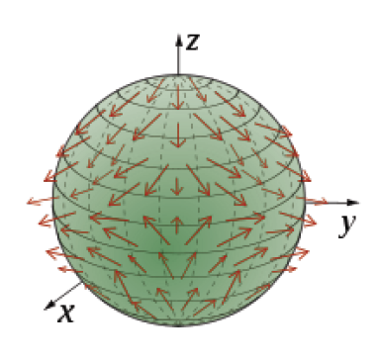
A Euclidean vector field on $M$ is a function $Z$ that maps every point $p$ of $M$ to a tangent vector $Z(p)$ to $R^{3}$ at point $p$.
Definition: A tangent vector field on $M$ is a Euclidean vector field $V$ on $M$ that maps every point $p$ of $M$ to a tangent vector $V(p)$ at $M$.
Most of the time a Euclidean vector field are defined only
on a small region of $M.$

Normal vector field
A tangent vector $z$ to $R^{3}$ at point $p$ is normal to $M$ if $z$ is orthogonal to the tangent plane $T_{p}(R^{3})$.
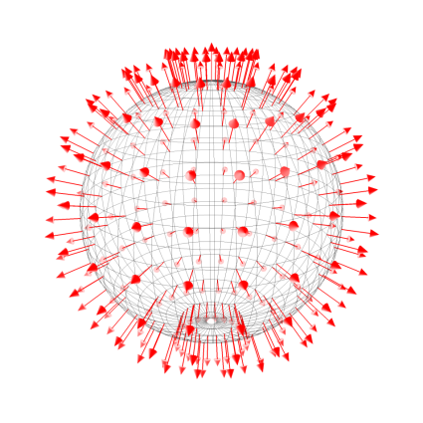
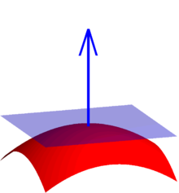
A Euclidean vector field $Z$ is normal vector field on $M$ if $Z(p)$ is normal to $M$ for every point $p$ of $M$.

It is easy to deal with tangent and normal vector fields for surfaces given in implicit form. To see this we define:
Gradient Vector Field
Gradient vector field
Let $M$be a surface given in implicit form $M:g=c$. The gradient vector field is the Euclidean vector field $∇_{g}$ that maps every point $p$ of $M$ to
$$∇_{g}\left(p\right)=\sum{\frac{∂g}{∂x_{i}}\left(p\right) U_{i}\left(p\right) }$$
Question: What does the gradient vector field look like?
Answer is given by the following Lemma.
Lemma: Let $M:g=c$ be a surface in implicit form. Then the gradient vector field has the following properties:
- A normal vector field on $M.$
- Nonzero at every point of $M$.

Directional derivatives
- Let $p∈M$ be a point on surface and $v∈T_{p}(M)$ be a tangent vector. Let $f:M→R$ be a real valued function on $M$.
- The directional derivative of $f$ with respect to $v$, written as $v[f]$, is defined as
- $v\left[f\right]=\frac{df\left(α\right)}{dt}\left(0\right)$
- for any curve $α$ in $M$ with $α\left(0\right)=p$ and $α^{'}\left(0\right)=v.$
- Directional derivative has the same properties as we studied for $R^{3}$.

End of the lecture

Lecture # 24

Contents:
- Differential Forms
- Exterior Derivatives
- Differential Forms On The Euclidean Plane
- Closed And Exact Forms

Differential Forms
Let $M$ be a surface in $R^{3}$
- A $0-$form on $M$ is a function $f:M→R$
- A $1-$form on $M$ is a real-valued function $ϕ$ on the tangent vectors on $M$, such that $ϕ$ is linear on $T_{p}(M)$ for every $p∈M$.
We defined 2-form and 3-form on $R^{3}$ in the following way.
But we did’t define them properly.
Intuitively what is a 2-form.
Definition
A $2-$form $η$ on a surface $M$ is a real-valued function on all ordered pairs of tangent vectors $v, w$ to $M$ such that
- $η\left(v,w\right)$ is linear in $v$ and in $w$
- $η\left(v,w\right)=-η(w,v)$
Definition: A $d-$form is a form of degree $d$.
Fact: Since surface is two dimensional hence all $p-$forms with $p>2$ are zero.
Properties of forms
- Two $p-$forms, for $p=0,1,2$, can be added.
- A $1-$form can be evaluated on a vector field $V$.
- Similarly a $2-$form can be added evaluated on pair of vector fields $V, W$.
- Second axiom of the definition of the $2-$form implies that
$$η\left(v,v\right)=0.$$
$2-$forms and determinants
Let $η$ be a $2-$form on surface $M$. Let $v, w$ be two linearly independent tangent vectors at some point of $M$. Then
$$η\left(av+bw, cv+dw\right)=\left|\begin{matrix}a & b \\ c & d\end{matrix}\right|.$$
See book for proof.
Wedge product
- Product of a $p-$form and a $q-$form is a $\left(p+q\right)-$form.
- The product of a $0-$form and a $1-$form and $2-$form is usual multiplication.
- On surface the wedge product is zero if $p+q>2$. So we need only the following definition:
Definition: If $ϕ$ and $ψ$ are $1-$forms on a surface $M$, the wedge product $ϕ∧ψ$ is a $2-$form on $M$ such that
$$\left(ϕ∧ψ\right)\left(v,w\right)=ϕ\left(v\right)ψ\left(w\right)-ϕ\left(w\right)ψ(v)$$
for all pairs $v,w$ of tangent vectors to $M$.
Question : Why $ϕ∧ψ$ is a $2-$form?
Rule for interchanging the factors in a wedge product
If $ξ$ is a $d_{1}-$form and $η$ is a $d_{2}-$form, then
$$ξ∧η={\left(-1\right)}^{\left(p+q\right)} η∧ξ$$
In case of surfaces sign changes only occur in case of multiplication of two $1-$forms.
In particular for $1-$form $ϕ$ we have
$$ϕ∧ϕ=0.$$
Exterior Derivatives
The differential calculus of forms is based on the exterior derivatives $d$.
- For $0-$form, that is a real-valued function $f$ , the exterior $df$ is defined as
$$df=v\left[f\right].$$
- The exterior derivative of a $p-$form is a $\left(p+1\right)-$form.
- For surface we need the following:
Definition: Let $ϕ$ be a $1-$form on a surface $M$. Then the exterior derivative $d ϕ$ of $ϕ$ is a $2-$form such that for each patch $x:D→M$,
$$d ϕ\left(x_{u},x_{v}\right)=\frac{∂}{∂u}\left(ϕ\left(x_{v}\right)\right)-\frac{∂}{∂v}\left(ϕ\left(x_{u}\right)\right).$$
Definition: Let $ϕ$ be a $1-$form on a surface $M$. Then the exterior derivative $d ϕ$ of $ϕ$ is a $2-$form such that for each patch $x:D→M$,
$$d ϕ\left(x_{u},x_{v}\right)=\frac{∂}{∂u}\left(ϕ\left(x_{v}\right)\right)-\frac{∂}{∂v}\left(ϕ\left(x_{u}\right)\right).$$

Lemma: Let $ϕ$ be a $1-$form on $M$. If $x$ and $y$ are patches in $M$. If $x$ and $y$ are patches in $M$, then $d_{x}ϕ=d_{y}ϕ$on the overlap of $x\left(D\right)$ and $y(E)$.
Differentiation Rule
Let $M$ be a surface in $R^{3}$. Let $f:M→R$ and $g:R→R$be a function.
Then
$$d\left(g\left(f\right)\right)=g^{'}\left(f\right) df$$
Differentiation of wedge product
Let $f,g, h$ be three functions on $M$ and $ϕ$ is a $1-$form. Then
- $d\left(fgh\right)=gh df+fh dg+fg dh$
- $d\left(f ϕ\right)=f dϕ-ϕ∧df$
- $\left(df∧ dg\right)\left(v,w\right)=v\left[f\right] w\left[g\right]-v\left[g\right] w\left[f\right]$
Theoerem: If $f$ is a real valued function on $M$, then $d\left(d \left(f\right)\right)=0$.
How to show that the forms are equal
Two criteria
Let $x:D→M$ be a patch in $M$. Then
- Two $1-$forms, $ϕ, ψ$ are equal on $x(D)$ if and only if
$$ϕ\left(x_{u}\right)=ψ\left(x_{u}\right) and ϕ\left(x_{v}\right)=ψ(x_{v})$$
- Two $2-$forms $ν, μ$ are equal on $x(D)$ if and only if
$$μ\left(x_{u},x_{v}\right)=ν\left(x_{u},x_{v}\right).$$
Closed and exact forms
Let $ϕ$ be a differential form.
If the exterior derivative of $ϕ$ is zero, $dϕ=0$, then $ϕ$ is closed.
If $ϕ$ is the exterior derivative of some form $ξ$, so that $ϕ$ can be written as $ϕ=d ξ$, then $ϕ$ is exact.

End of the lecture

Lecture # 25

Contents:
- Mappings of Surfaces
- Tangent Maps of Mappings
- Diffeomorphism

Mappings of Surfaces
Differential functions
Let $M$ and $N$ be two surfaces in $R^{3}$. Let $F:M→N$ be a function. Then $F$ is differentiable if the following condition is satisfied
For each patch $x:D→M$ in $M$ and $y:E→N$ in $N$ the composite function $y^{-1}Fx$ is Euclidean differentiable (defined on an open subset of $R^{2}$).
$F$ is then called a mapping.
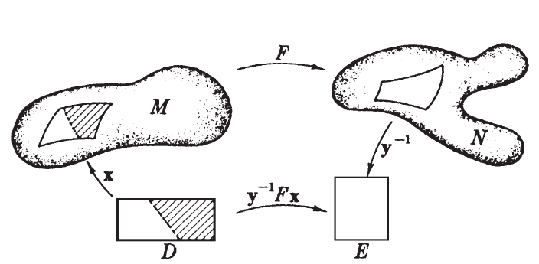

The function $y^{-1}Fx$ is defined at all points $(u,v)$ of $D$ such that $F(u,v)$ lies in the image of $y$.
FACT: It suffices to check enough patches to cover both $M$ and $N$.
Cylindrical Projection
Let $Σ$be a unit sphere in $R^{3}$ with center at origin with north and south poles removed, that is,
$$Σ=\left\{p∈R^{3}:d\left(p,0\right)=1\backslash \{\left(0,0,1\right),\left(0,0,-1\right)\} \right\}.$$
Let $C$ be the cylinder bases on the unit circle in the $xy$ plane. So $C$ is in contact with the sphere along the equator, that is $C$ is given by
$$C=\left\{p∈R^{3}:p_{1}^{2}+p_{2}^{2}=1\right\}$$
Cylindrical projection
Define $F:Σ→C$ as follows.
Start from a point $p=\left(p_{1},p_{2},p_{3}\right)∈Σ$.
Draw the line $L$ through $\left(0,0,p_{3}\right)$ and $=(p_{1},p_{2},p_{3})$ .
Let $F(p)$ be the intersection of $L$ with $C$ as seen in the figure.
Question: Is $F$ a mapping?
Consider the following patch $x:D→Σ$of the sphere which we discussed earlier
$$x\left(u,v\right)=(r\cos{v\cos{u,} r\cos{v\sin{u}, r\sin{v}}})$$
where
$$D=\left\{\left(u,v\right):-π<u<π, -\frac{π}{2}<v<\frac{π}{2}\right\}.$$
Now consider a patch $y:E→C$ of the cylinder given by
$$y\left(u,v\right)=\left(\cos{u},\sin{u}, v\right)$$
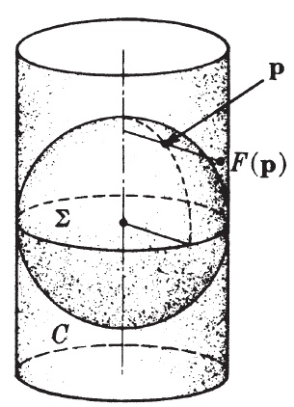
where
$$E=\left\{\left(u,v\right): π<u<-π, -1<v<1\right\}.$$
Now from the definition of $F$ we get
$$F\left(x\left(u,v\right)\right)=\left(\cos{u,\sin{u},\sin{v}}\right).$$
But
$$y\left(u,\sin{v}\right)=\left(\cos{u,\sin{u},\sin{v}}\right).$$
Hence
$$F\left(x\left(u,v\right)\right)=y\left(u,\sin{v}\right).$$
Applying $F^{-1}$ we get
$$y^{-1}Fx\left(u,v\right)=\left(u,\sin{v}\right).$$

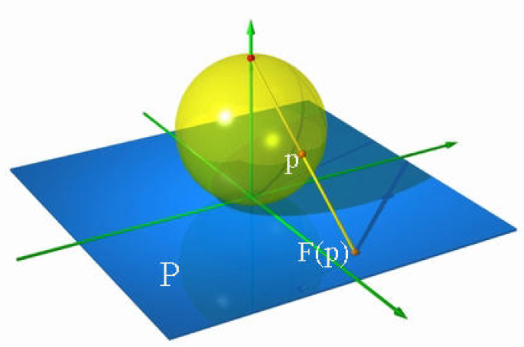
Hence $F:Σ→C$ is a mapping.
Stereographic projection
Let $Σ$ be a unit sphere with center $\left(0,0,1\right)$. Delete the north pole from $Σ$, that is, consider
$$Σ=\left\{p=\left(p_{1},p_{2},p_{3}\right)∈R^{3}:d\left(p,\left(0,0,1\right)\right)=1\right\}\backslash \{\left(0,0,2\right)\}.$$
Let us identify $xy$-plane with $R^{2}$, that is,
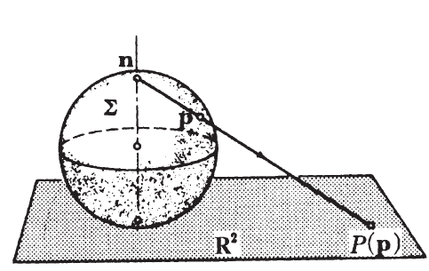
$R^{2}=\left\{\left(p_{1},p_{2},0\right):p_{1},p_{2}∈R\right\}.$

The function $F$ is given by
$$F\left(p_{1},p_{2},p_{3}\right)=\left(\frac{Rp_{1}}{r},\frac{Rp_{2}}{r}\right)$$
where $r$ and $R$ are shown in the figure below.
Using the similar triangles in the figure below (left), we get,
$$\frac{R}{2}=\frac{r}{2-p_{3}}$$
So
$$F\left(p_{1},p_{2},p_{3}\right)=\left(\frac{2p_{1}}{2-p_{3}},\frac{2p_{2}}{2-p_{3}}\right).$$
The function
$$F\left(p_{1},p_{2},p_{3}\right)=\left(\frac{2p_{1}}{2-p_{3}},\frac{2p_{2}}{2-p_{3}}\right).$$
is differentiable.
For any patch $x:D→Σ$ in $Σ$ the function $F(x)$ is differentiable.
Let $y:R^{2}→R^{3}$ given by
$$y\left(p_{1},p_{2}\right)=\left(p_{1},p_{2},p_{3}\right)$$
be the patch for the $xy-$ plane, then $y^{-1}$ is differentiable. Hence $y^{-1}Fx$ is differentiable, making $F$ a mapping.
Definition
Let $F:M→N$ be a mapping of surfaces. Let $v$ be a tangent vector to $M$ such that there exist a curve $α$ in $M$ and $v=α^{'}(0)$. Then $F(α)$ is a curve in $N$.
We define the tangent map $F_{*}$ of $F$ as
$$F_{*}\left(v\right)=F{\left(α\right)}^{'}(0)$$
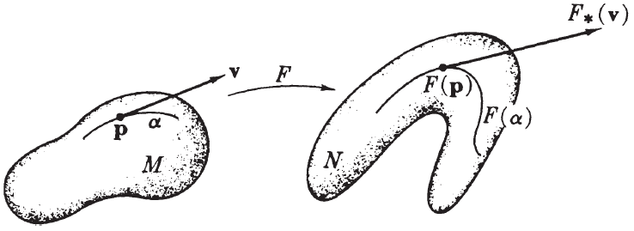
that takes tangent vectors of $M$ to the tangent vectors of $N$.

Fact1: The tangent map $F_{*}$ is a linear map from $T_{p}(M)$ to $T_{T\left(p\right)}\left(N\right)$.
Fact 2: Let $F:M→N$ and $G:N→P$ be mappings of surfaces. Then $G\left(F\right):M→P$ is a mapping of surfaces and
$${\left(G\left(F\right)\right)}_{*}=G_{*}\left(F_{*}\right).$$
Computation of tangent map
Let $F:M→N$ be a mapping.
Let $x:D→M$ be a parameterization in $M$. Let $y=F\left(x\right):D→N$.
Diffeomorphisms
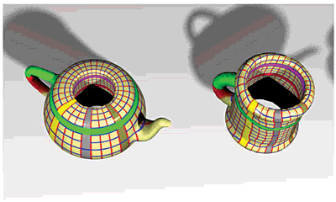
Definition: Let $F:M→N$ be a mapping of surfaces. If $F$ has an inverse $F^{-1}:N→M$ which is also a mapping of surfaces then $F$ is a diffeomorphism.

Inverse function theorem
Let $F:M→N$ be a mapping of the surface. Let $p∈M$ be a point. Assume that
$$F_{*}:T_{p}\left(M\right)→T_{T\left(p\right)}(N)$$
is an isomorphism. Then there are neighborhoods $U⊂M$ of $p$ and $V⊂N$ of $F(p)$ such that
$$F{\left.​\right|}_{U}:U→V$$
is a diffeomorphism.
Corollary: If $F$ is regular and bijective, then $F$ is a diffeomorphism.
Definition: Two surfaces are diffeomorphic if there is a diffeomorphism between them.

End of the lecture

Lecture # 26

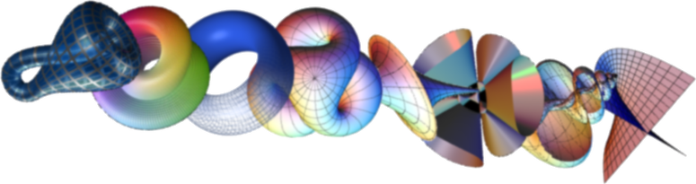
Contents:
- Diffeomorphic Surfaces
- Mapping of Differential Forms

Diffeomorphic Surfaces
Examples of diffeomorphic surfaces
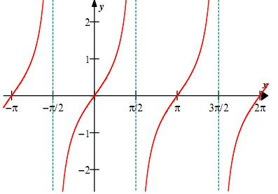
Example1: An open rectangle in $R^{2}$ is isomorphic to the entire plane $R^{2}$
Let $R$ be an open set given as
$$R=\left\{\left(u,v\right):u<-\frac{π}{2}<u<\frac{π}{2},-\frac{π}{2}<v<\frac{π}{2}\right\}.$$
Then the function $F:R →R^{2}$ defines as
$$F\left(u,v\right)=\left(\tan{u,\tan{v}}\right)$$
is a mapping of $R$ into $R^{2}$. The inverse $F^{-1}$ is given by
$$F^{-1}\left(u,v\right)=\left(\tan^{-1}{u,}\tan^{-1}{v}\right).$$
So $F$ is a diffeomorphism.
Similarly every open rectangle in $R^{2}$ is
diffeomorphic to $R^{2}$.

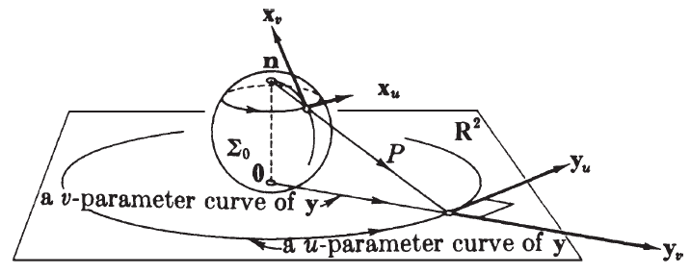
Example2: The sphere minus one point to $R^{2}$
Let $Σ_{0}$ be a sphere minus one point, namely the north pole. A parametrization of $Σ_{0}$ is given by:
$$x\left(u,v\right)=\left(\cos{v}\cos{u},\cos{v}\sin{u }, 1+\sin{v}\right).$$
where
$$\left(u,v\right)∈R×(-\frac{3π}{2},\frac{π}{2})$$

Let $F$from $Σ_{0}$ to $R^{2}$ be the projection map, so a point $\left(p_{1},p_{2},p_{3}\right)$ of $Σ_{0}$ has image:
$$F\left(p_{1},p_{2},p_{3}\right)=\left(\frac{2p_{1}}{2-p_{3}},\frac{2p_{2}}{2-p_{3}},0\right).$$
So
$$y\left(u,v\right)=F\left(x\left(u,v\right)\right)=\frac{2\cos{v}}{1-\sin{v}}\left(\cos{u},\sin{u},0\right).$$

Example 3: A cylinder and $R^{2}$ minus a point
Let $C:x^{2}+y^{2}=1$ be a cylinder in $R^{3}$. Define $F:C→R^{2}$ by
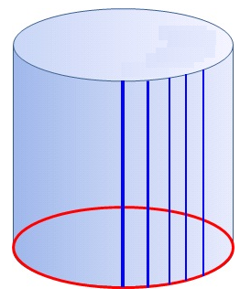
$F\left(x,y,z\right)=e^{z}\left(x,y\right)$
Then $F$ maps objectively $C$ to $R^{2}\backslash (0,0).$
The inverse of $F$ is gives as:
$$F^{-1}\left(u,v\right)=\left(\frac{u}{\sqrt{u^{2}+v^{2}}},\frac{v}{\sqrt{u^{2}+v^{2}}},\ln{\sqrt{u^{2}+v^{2}}}\right).$$
This is again a mapping, therefore $F$is a diffeomorphism.

Mappings of Differential Forms

Mapping of a $0-$form
Let $F:M→N$ be a mapping of surface.
Question: If $g:M→R$ is a function then how to move $g$ to a function defined on $N?$
This is not possible in general, but we take functions $f:N→R$ to functions on $M$.
For functions $f:N→R$ we define:
$$f\left(F\right):M→R , p→f\left(F\left(p\right)\right).$$
We call $f(F)$ the pull back of $f$.

Pull-back of $1-$forms and $2-$forms
Definition: Let $F:M→N$ be a mapping of surfaces.
- Let $ϕ$ be a $1-$form on $N$, the pull-back of $ϕ$, written as $F^{*}(ϕ)$ is defined as:
For every tangent vector $v$ to $M$ define
$${(F}^{*}ϕ)\left(v\right)=ϕ\left(F_{*}v\right).$$
- Let $η$ be a $2-$form on $N$. The pull-back of $η$, denoted by $F^{*}(η)$, is defined as:
For every pair of tangent vectors $u,v$ to $M$
$$F^{*}η\left(u,v\right)=η\left(F_{*}u, F_{*}v\right).$$
The essential operations on forms are sum, wedge product, and exterior derivative, are all preserved by mapping.
Theorem:
Let $F:M→N$ be a mapping of surfaces, and let $ξ$ and $η$ be forms on $N$. Then
- $F^{*}\left(ξ+η\right)=F^{*}ξ+F^{*}η$.
- $F^{*}\left(ξ∧η\right)=F^{*}ξ∧F^{*}η$.
- $F^{*}\left(dξ\right)=d (F^{*}ξ)$.
End of the lecture

Lecture # 27
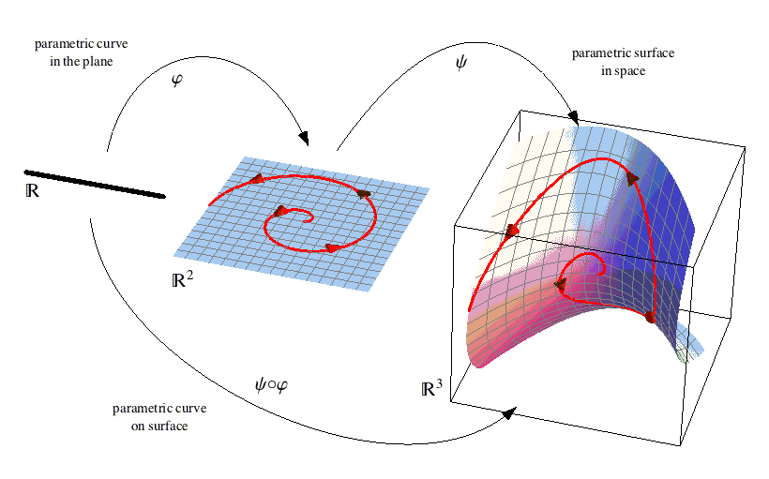

Contents:
- Line Integrals
- Integration of $2-$forms
- Integral Over a Boundary

Line Integrals
Pull-back of $1-$form on a curve
Let
$$α:\left[a,b\right]→M$$
be a closed curve segment on surface $M$.
Let $ϕ$ be a $1-$form on $M$. The pull-back of $ϕ$ is a $1-$form on $[a,b]$ is of the form
$f\left(t\right) dt$ where
$$f\left(t\right)=\left(α^{*}ϕ\right)\left(U_{1}\left(t\right)\right)=ϕ\left(α_{*}\left(U_{1}\left(t\right)\right)\right)=ϕ\left(α^{'}\left(t\right)\right).$$
Definition: Let $ϕ$ be a $1-$form on $M$.
Let $α:\left[a,b\right]→M$ be a curve segment. Then the integral of $ϕ$ over $α$ is equal to
$$\int_{α}{ϕ}=\int_{[a,b]}{α^{*}ϕ}=\int_{a}^{b}{ϕ\left(α^{'}\left(t\right)\right) dt} .$$
Another name is the integral of $ϕ$ over $α$.
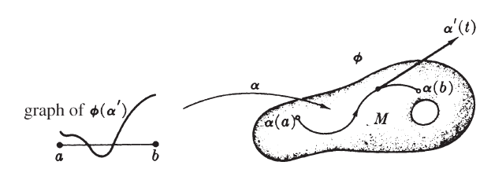

Force field: Particle moving in a force field
Example: Let $V$ be a vector field on a surface $M$. We assume that $V$ is a force field.
Assume that a particle moves on a curve $α:\left[a,b\right]→M.$ We want to know how much work is done by the force field on the particle as it moves between points $α\left(a\right)$ and $α(b)$.

Work is done on the particle only by the component of force tangent to $α$, that is,
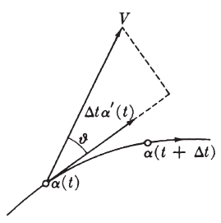
$V\left(α\right).\frac{α^{'}}{\left\|α^{'}\right\|}=\left\|V\left(α\right)\right\|\cos{θ}$
The work done by the force during time $Δt$ is approximately given as
$$\left(V\left(α\right).\frac{α^{'}}{\left\|α^{'}\right\|}\right) \left\|α^{'}(t)\right\|Δt .$$
Adding these on the whole time interval $[a,b]$ we get
$$W=\int_{a}^{b}{V\left(α\left(t\right)\right). α^{'}\left(t\right) dt } .$$

To express the following more easily
$$W=\int_{a}^{b}{V\left(α\left(t\right)\right). α^{'}\left(t\right) dt }$$
we introduce the following
Definition: The dual to the vector field $V$ on $M$ is the $1-$ form $ϕ$ defined by
$$ϕ\left(w_{p}\right)=w.V(p)$$
for every $p∈M$ and every $w_{p}∈T_{p}(M)$.

The total work done by the particle
becomes
$$W=\int_{α}{ϕ}$$
where $ϕ$ is the dual $1-$form of $V$.

The integral of a differential
Theorem: Let $f:M→R$ be a function on $M$. Let $α:\left[a,b\right]→M$be a curve segment on $M$, where $α\left(a\right)=p$ and $α\left(b\right)=q$. Then
$$\int_{α}{df}=f\left(q\right)-f\left(p\right).$$
See the book for proof.

Theorem: Let $f:M→R$ be a function on $M$. Let $α:\left[a,b\right]→M$be a curve segment on $M$, where $α\left(a\right)=p$ and $α\left(b\right)=q$. Then
$$\int_{α}{df}=f\left(q\right)-f\left(p\right).$$
The above can also be restated as:
Let the “boundary” of the curve be $q-p$, where $p$ is the starting point and $q$ is the end point. Then the integral of $df$ over $α$ equals the “integral” of $f$ over the boundary of $α$, namely $f\left(q\right)-f(p)$.
Extending to surface maps
Definition:
Let
$$R=\left[a,b\right]×\left[c,d\right]=\left\{\left(u,v\right):a≤u≤b and c≤v≤d\right\} .$$
be a closed rectangle in $R^{2}$.
A $2-$segment is a function $x:R→M$ which is differentiable, that is, there exist an open set $D⊂R^{2}$ such that $R⊂D$, and $x:D→M$ is differentiable.
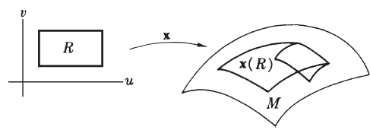

Note:
We do not assume that a $2-$segment $x$ is regular or injective.
The partial velocities $x_{u}$ and $x_{v}$ are defined as usual.
But they may behave in some strange way if $x$ is not regular.

Pull-back of a $2-$form
Let $x:R→M$ be a $2-$segment on a surface $M$. Let $η$ be a $2-$form on $M$. Then the pull-back by $x$ of $η$ has the form
$$h du dv$$
Where
$$h={(x}^{*}η)\left(U_{1}, U_{2}\right)=η\left(x_{*}U_{1},x_{*}U_{2}\right)=η\left(x_{u},x_{v}\right).$$

Definition: The integral of $η$ over $x$ is
$$\iint_{x}{η}=\iint_{R}{x^{*}η}=\int_{a}^{b}{\int_{c}^{d}{η\left(x_{u},x_{v}\right) du dv }}.$$

Definition: Let $=\left[a,b\right]×\left[c,d\right]$ . Let $x:R→M$ be a $2-$segment in $M$.
Let $α, β, γ, δ$ be the curve segments such that
$$α\left(u\right)=x\left(u,c\right), β\left(v\right)=x\left(b,v\right), γ\left(u\right)=\left(u,d \right), δ\left(v\right)=\left(a, v \right) .$$

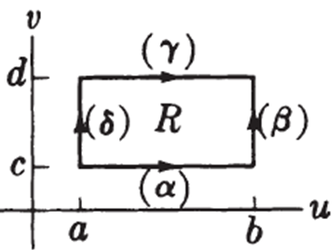
The boundary of $x$ is a formal expression
$$∂x=α+β-γ-δ$$
Let $ϕ$ be a $1-$form on $M$ then the integral of $ϕ$ on $∂x$ is defined as
$$\int_{∂x}{ϕ}=\int_{α}{ϕ}+\int_{β}{ϕ}-\int_{γ}{ϕ}-\int_{δ}{ϕ} .$$

End of the lecture

Lecture # 28

Contents:
- Stokes Theorem
- Reparametrization

Stokes Theorem

Theorem: Let $ϕ$ be a $1-$form on $M$. Let $R$ be a closed rectangle $R=\left[a,b\right]×\left[c,d\right]$. Let $x:R→M$ be a $2-$segment in $M$. Then
$$\int{ }\int_{x}{d ϕ}=\int_{∂x}{ϕ} .$$

Proof:
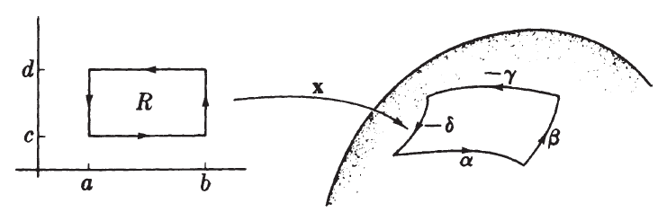
Idea of the proof: We will start from the double integral and show that it turns into the integral over the boundary of $x$.
We have
$$\int{ }\int_{x}{d ϕ}=\int_{a}^{b}{\int_{c}^{d}{dϕ\left(x_{u},x_{v}\right)du dv}}$$

By definition of exterior derivative:
$$\int_{a}^{b}{\int_{c}^{d}{dϕ\left(x_{u},x_{v}\right)du dv}}=\int_{a}^{b}{\int_{c}^{d}{\left(\frac{∂}{∂u}ϕ\left(x_{v}\right)-\frac{∂}{∂u}ϕ\left(x_{u}\right)\right) du dv}}$$
So
$$\int{ }\int_{x}{d ϕ}=\int_{a}^{b}{\int_{c}^{d}{\left(\frac{∂}{∂u}ϕ\left(x_{v}\right)-\frac{∂}{∂u}ϕ\left(x_{u}\right)\right) du dv}} .$$
Let $f=ϕ\left(x_{u}\right):R→R$ and $g=ϕ\left(x_{v}\right):R→R$. . So
$$\int_{a}^{b}{\int_{c}^{d}{\left(\frac{∂}{∂u}ϕ\left(x_{v}\right)-\frac{∂}{∂u}ϕ\left(x_{u}\right)\right) du dv}}=\int_{a}^{b}{\int_{c}^{d}{\left(\frac{∂g}{∂u}-\frac{∂f}{∂u}\right) du dv}}$$
$$=\int_{a}^{b}{\int_{c}^{d}{\left(\frac{∂g}{∂u}\right) du dv}}-\int_{a}^{b}{\int_{c}^{d}{\left(\frac{∂f}{∂u}\right) du dv}}$$
Now we will calculate:
$$\int_{a}^{b}{\int_{c}^{d}{\left(\frac{∂g}{∂u}\right) du dv}} and \int_{a}^{b}{\int_{c}^{d}{\left(\frac{∂f}{∂u}\right) du dv}}$$

Now we will calculate:
$$\int_{c}^{d}{\int_{a}^{b}{\left(\frac{∂g}{∂u}\right) du dv}} and \int_{c}^{d}{\int_{a}^{b}{\left(\frac{∂f}{∂u}\right) du dv}}$$
Consider
$$\int_{c}^{d}{\int_{a}^{b}{\left(\frac{∂g}{∂u}\right) du dv}}= \int_{c}^{d}{\left(\int_{a}^{b}{\left(\frac{∂g}{∂u}\right) du}\right) dv}=\int_{c}^{d}{\left(I\right) dv}$$
Where
$$I=\int_{a}^{b}{\left(\frac{∂g}{∂u}\right) du}$$
By fundamental theorem of calculus:
$$I=\int_{a}^{b}{\frac{∂g(u,v)}{∂u}du}=g\left(b,v\right)-g\left(a,v\right).$$
If $β\left(v\right)=x(b,v)$ and $δ\left(v\right)=x(a,v)$ then
$$\int_{c}^{d}{g\left(b,v\right) dv}=\int_{c}^{d}{ϕ\left(x_{v}\left(b,v\right)\right) dv}=\int_{c}^{d}{ϕ\left(\frac{∂}{∂v} x\left(b,v\right)\right) dv}=\int_{c}^{d}{ϕ\left(β^{'}\left(v\right)\right) dv}=\int_{β}{ϕ}$$
Now
$$\int{ }\int_{x}{d ϕ}=\left(\int_{c}^{d}{ϕ\left(β^{'}\left(v\right)\right) dv}-\int_{c}^{d}{ϕ\left(δ^{'}\left(v\right)\right) dv} \right)-\left(\int_{c}^{d}{ϕ\left(γ^{'}\left(v\right)\right) dv}-\int_{c}^{d}{ϕ\left(α^{'}\left(v\right)\right) dv} \right)$$
$$\int{ }\int_{x}{d ϕ}=\left(\int_{β}{ϕ}-\int_{δ}{ϕ} \right)-\left(\int_{γ}{ϕ}-\int_{α}{ϕ} \right)$$
$$=\int_{∂x}{ϕ }$$
Reparametrization
Line integrals of reparametrized curves
Let $α\left(h\right):\left[a,b\right]→M$be a reparametrization of a curve segment $α:\left[c,d\right]→M$ by $h:\left[a,b\right]→[c,d]$. Then for any $1-$form on $M$
- If $h$ is orientation preserving that is $h\left(a\right)=c$ and $h\left(b\right)=d$ then
$$\int_{a\left(h\right)}{ϕ}=\int_{α}{ϕ}$$
- $h$ is orientation reversing that is $h\left(a\right)=d$ and $h\left(b\right)=c$ then
$$\int_{α\left(h\right)}{ϕ}=-\int_{α}{ϕ}$$
See the book for proof.
Integral of the boundary without the minus sign
Now if $ξ:\left[t_{1},t_{2}\right]→M$be any curve segment, define
$$-ξ:\left[t_{1},t_{2}\right]→M$$
by
$$-ξ\left(t\right)=ξ(t_{1}+t_{2}-t)$$
Then $ξ$ is orientation reversing reparametrization of $ξ$
So by previous result
$$\int_{-ξ}{ϕ}=-\int_{ξ}{ϕ}$$

We have seen that
$$\int{ }\int_{x}{d ϕ}=\int_{∂x}{ϕ}=\left(\int_{β}{ϕ}-\int_{δ}{ϕ} \right)-\left(\int_{γ}{ϕ}-\int_{α}{ϕ} \right)$$
So we can write
$$\int{ }\int_{x}{d ϕ}=\int_{∂x}{ϕ}=\int_{α}{ϕ}+\int_{β}{ϕ}+\int_{-δ}{ϕ}+\int_{-γ}{ϕ}$$

End of the lecture

Lecture # 29

Contents:
- Connectedness
- Compactness
- Orientability

Connectedness
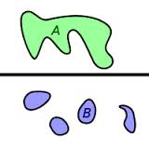
Definition:
Let $M$ be a surface. The surface $M$ is connected if for any two points $p$ and $q$ of $M$ there exists a curve segment in $M$ from $p$ to $q$.

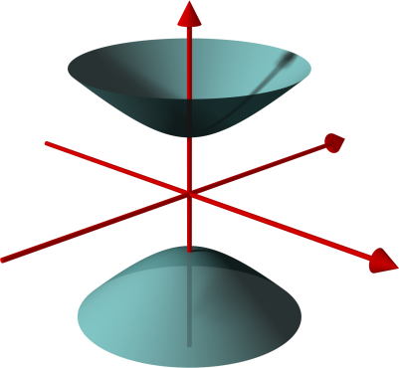
Example: Let $M$ be implicitly defined surface
$$M:z^{2}=x^{2}+y^{2}+1$$
Then $M$ is disconnected.
There are no curves in $M$ between points with $z>0$ and points with $Z<0$.

Compactness
Definition: Let $A$ be a set in a topological space. If for every covering of $A$ by open sets
$$A=\bigcup_{α∈J}{U_{α}} ,$$
there exists $k∈N$ and there exist $α_{1}, α_{2}, …,α_{k}∈J$ such that
$$A⊂\bigcup_{j=1}^{k}{U_{α_{j}}} ,$$
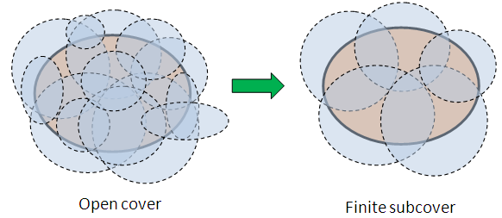
then $A$ is compact.

Examples:
- Closed and bounded intervals $\left[a,b\right]⊂R$.
- Rectangles $\left[a,b\right]×\left[c,d\right]⊂R^{2}$.
- Closed and bounded subsets of $R^{n}$ .

Compactness of surfaces
Lemma: A surface $M$ is compact if and only if there exist a $k∈N$ and $2-$segments
$$x_{i}:R_{j}→M for j=1,2,…,k$$
such that
$$M=\bigcup_{j=1}^{k}{x_{j}(R_{j})}$$
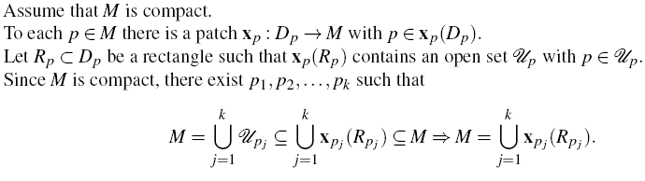
Proof:

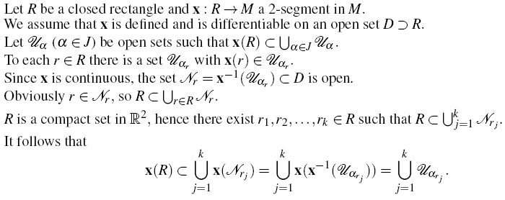

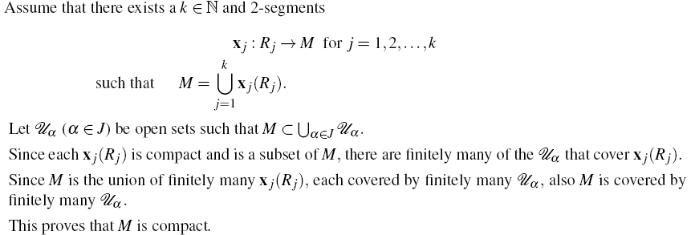

Compact regions on surfaces
If follows from the previous result that
“A region $R$ in $M$ in compact if it is composed of the images of finitely many $2-$segments in $M$”.
Examples:
- A sphere is compact.
- A torus is compact.
- Surface of revolution whose profile curve is closed.
How to check compactness
A continuous real valued function on a closed rectangle $R$ in the plane takes a maximum at some point of $R$.
Lemma:
A continuous function $f$ on a compact region in a surface $M$ takes on a maximum at some point of $M$.
See the book for proof.
Examples of non-compact surfaces
- A cylinder is not compact.
- The disk in $R^{2}$is not compact.

Orientability
Definition:
A surface $M$ is orientable if there exists a continuous $2-$form on $M$ that is non-zero at every point of $M$.
Example:
- The plane $R^{2}$is a surface.
The product $du∧dv$ is a $2-$form on $R^{2}$ that is non-zero at every point of $R^{2}$.
Therefore $R^{2}$ is an orientable surface.

Unit normal
A unit normal $U$ on $M$ is a differentiable Euclidean vector field on $M$ that has unit length and is everywhere normal to $M$.
Proposition:
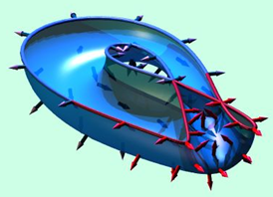
A surface $M⊂R^{3}$ is orientable if and only if there exists a unit normal vector field on $M$.

Examples of orientable surfaces
- Spheres
- Cylinder
- Surface of revolution
- Implicitly defined surfaces.

End of the lecture

Lecture # 30

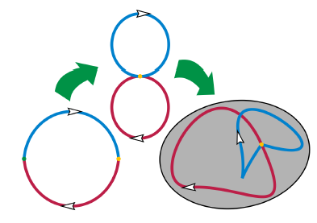
Contents:
- Homotopy
- Simply Connectd Surfaces
- Poincare Lemma
- Conditions of Orientability

Homotopy
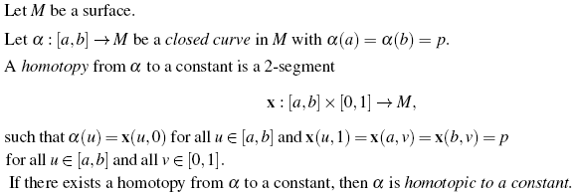

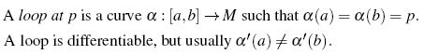
Definition:

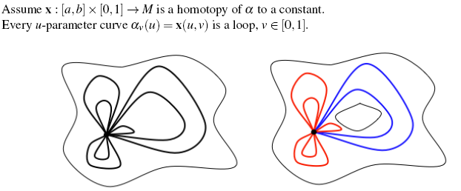

Simply Connected Surfaces
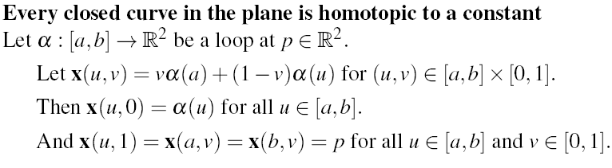

Definition:
A surface $M$ is simply connected provided it is connected and every loop in $M$ in homotopic to a constant.
Example:
The plane $R^{2}$ is simply connected. In general every Euclidean space is simply connected.
Example: A Sphere is simply connected
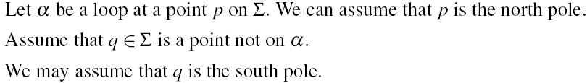
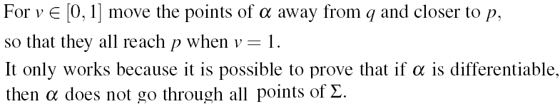

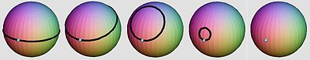

Not simply connected surfaces
Definition: If $ϕ$ is any differential form, then $ϕ$ is called closed if $d ϕ=0$.
Lemma: Let $M$ be a surface and $ϕ$ a closed $1-$form on $M$. Let $α$ be a loop in $M$. If $α$ is homotopic to a constant then
$$\int_{α}{ϕ}=0.$$
Proof:
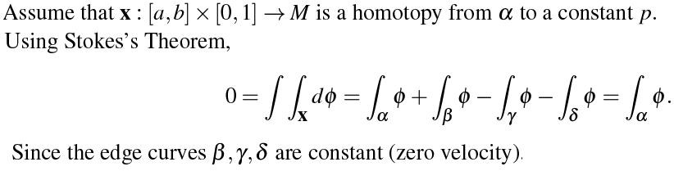
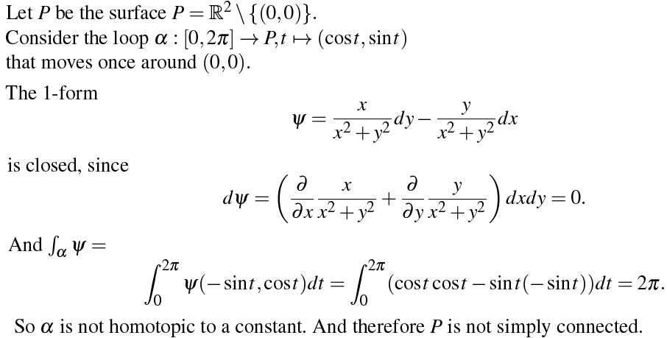
Example: $R^{2}$ minus a point is not simply connected

Definition: A differential form is exact if it is exterior derivative of another form.
Lemma: Every closed $1-$form on a simply connected space is exact.
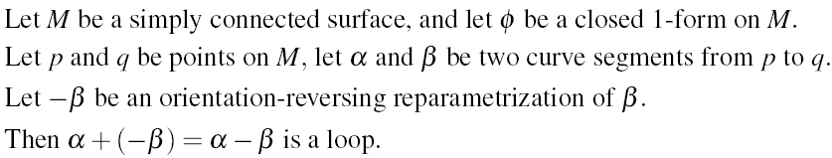
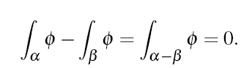

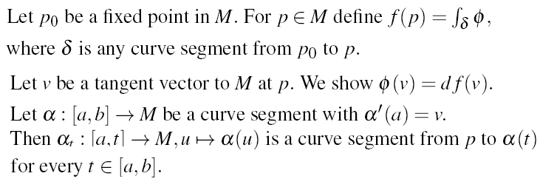

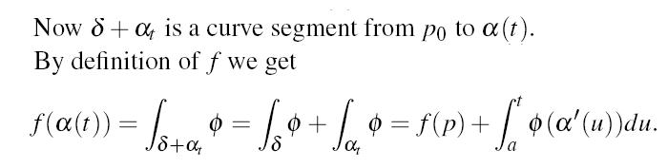

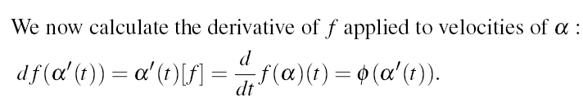

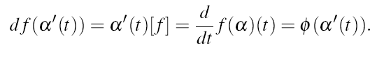

Compactness and orientability
Theorem: Every compact surface in $R^{3}$ is orientable.
The theorem is a consequence of the following result.

Jordan-Brouwe-Separation theorem
A compact surface in $R^{3}$ separates $R^{3}$ into two non-empty sets, an exterior and an interior.

Connectedness and orientability
Theorem: Every simply connected surface in $R^{3}$ is orientable.

End of the lecture

Lecture # 31

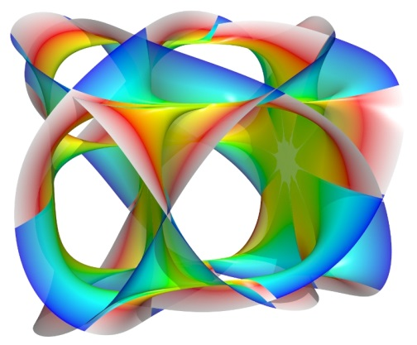
Contents:
- Abstract Surfaces
- Manifolds

Abstract Surfaces
Abstract patch
Let $M$ be any set.
An abstract patch in $M$ is a function
$$x:D→M$$
that satisfies the following
- $x$ is injective.
- $D$ is an open set in $R^{2}$.
Definition
An abstract surface is a pair $(M, P)$ such that $P$ is a set of abstract patches in $M$, and such that the following three axioms are satisfied:
- The covering axiom: The union of the images of the patches in $P$ is equal to $M$.
- The smooth overlap axiom: If $x, y$ are elements of $P,$ then $y^{-1}(x)$ and $x^{-1}(y)$ are differentiable functions from open sets in $R^{2}$ into $R^{2}$.
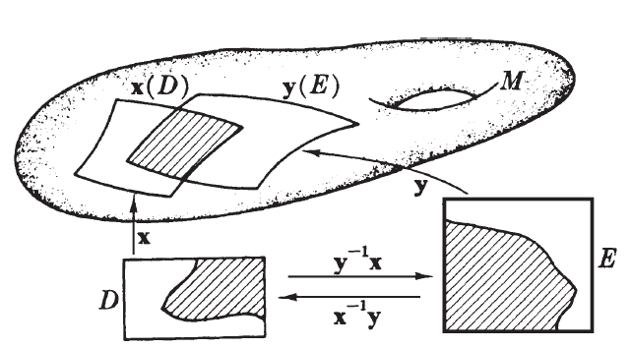
- The Hausdorff axiom: If $p$ and $q$ are different points in $M$ then there are disjoint patches $x,y∈P$ such that $p$ is in the image of $x$ and $q$ is in the image of $y$.

Open sets of a surface
Let $(M,P)$ be an abstract surface.
An open set of $M$ is any union of sets $x(U)$ such that $x∈P$ and $U$ is open subset of the domain of $x$.

The projective plane
Let $x:D→Σ$ be a patch in $Σ$.
Call $x$ a small patch if $x(D)$ is contained in a hemisphere of $Σ$. So $\left\{p,-p\right\}$ is not subset of $x(D)$ for all $p∈Σ$.
If $x$ is small, then $F\left(x\right):D→P$ is injective. Therefore $F(x)$ is an abstract patch in $P$.
$\left(S,P\right)$is an abstract surface
It is clear that $(S,P)$ satisfies the covering axiom (1).
Is also satisfies the Hausdorff axiom (3).
This is easy to show, because the domain $D$ of every patch has the Hausdorff property: for any two given distinct points there are disjoint open sets around them.
What about the smooth overlap axiom?
$(S,P)$ satisfies the smooth overlap axiom
Assume that $F\left(x\right), F\left(y\right)∈P$ and there is a point $\{p,-p\}$ which is in the image of both $F\left(x\right)$ and $F(y)$. Then either the images of $x$ and $y$ in $Σ$ both contain $p$ or $-p$ or one contains $p$ and the other contains $-p$.
If $x$ and $y$ overlap in $Σ$, then
$$F{\left(y\right)}^{-1}\left(F\left(x\right)\right)=y^{-1}x$$
and we know that $y^{-1}x$ is differentiable.
If $x$ and $y$ do not overlap, then $x$ and $A(y)$ overlap instead.
$${\left(F\left(y\right)\right)}^{-1}\left(F\left(x\right)\right)={\left(F\left(A\left(y\right)\right)\right)}^{-1} \left(F\left(x\right)\right)=y^{-1}x$$
which proves that $F(x)$ and $F(y)$ satisfies the smooth overlap
condition.
Surfaces in $R^{3}$
A surface in $R^{3}$ is an example of an abstract surface, if we explain $S$ as the set of patches that is used to construct $M$.
By definition $\left(M,P_{1}\right)$ and $\left(M,P_{2}\right)$ are different surfaces if $P_{1}≠P_{2}$.
We will assume that the set $P$ of patches in an abstract surface $(M,P)$ is as large as possible.
So all patches in $M$ that satisfies the overlap condition with all elements of $P$ also have to be in $P$.
Sometimes we only speak of the surface $M$ when we mean the abstract surface $(M,P)$.
Curves in abstract surface
Let $M$ be an abstract surface. A curve in $M$ is a function
$$α:I→M$$
Such that $α$ has a velocity vector $α^{'}\left(t\right)$ for every $t∈I$.
Definition:
A velocity vector of a function $α:I→M$ is a function $α^{'}(t)$ such that for every differentiable function $f:M→R$
$$α^{'}\left(t\right)\left(f\right)=α^{'}\left(t\right)\left[f\right]=\frac{df\left(α\right)}{dt} \left(t\right) for all t∈I .$$
We notice that differential forms and integration on surfaces can all be explained in terms of velocity of curves.

Manifold
An $n-$dimensional manifold is a pair $(M,P)$, where $M$ is a set of points, and $P$ is a set of abstract patches $x:D→M$ injective, with $D⊂R^{n}$ an open set, satisfying:
- The covering axiom: The union of the images of the patches in $P$ is equal to $M$.
- The smooth overlap axiom: If $x, y$ are elements of $P,$ then $y^{-1}(x)$ and $x^{-1}(y)$ are differentiable functions from open sets in $R^{2}$ into $R^{2}$.
- The Hausdorff axiom: If $p$ and $q$ are different points in $M$ then there are disjoint patches $x,y∈P$ such that $p$ is in the image of $x$ and $q$ is in the image of $y$.
Example:
- An abstract surface is precisely the same as a $2-$dimensional manifold.
- $R^{n}$ is an example of an $n-$dimensional manifold.
Tangent bundle of a surface
Let $M$ be a surface in $R^{3}$ (or abstract surface, or $2-$dimensional manifold).
Let $T(M)$ be the set of all tangent vectors to $M$ at all points.
Then $T(M)$ is the tangent bundle of $M$.
Example:
An element of $T(M)$ corresponds to a pair $\left(p,v\right)∈M×T_{p}(M)$. Since $M$ and $T_{p}(M)$ each has dimension $2$. We expect that $T(M)$ has dimension $4$.
Let $x:D→M$ be any patch in $M$.
Let $\check{D}=\left\{\left(p_{1},p_{2},p_{3},p_{4}\right):\left(p_{1},p_{2}\right)∈D\right\}=D×R^{2}$
Let $\tilde{x}:\check{D}→T(M)$ be defined as
$$\left(p_{1},p_{2},p_{3},p_{4}\right)→p_{3}x_{u}\left(p_{1},p_{2}\right)+p_{4}x_{v}\left(p_{1},p_{2}\right).$$
Then$\tilde{x}$ is injective, and if $P$ is the set of all derived patches$\tilde{x}$ of patches in $M$, then $(T\left(M\right),P)$ satisfies the definition of a manifold.
If follows that $T(M)$ is a $4-$dimensional manifold.

End of the lecture

Lecture # 32

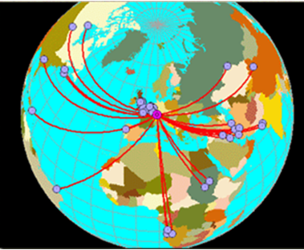
Contents:
- Geodesic Curves
- Examples

Geodesic Curves

Definition:
Let $M$ be a surface in $M$. The $α$ is a geodesic of $M$ if $α''$ is normal to $M$.
Remark: Geodesics is a curve that does not turn right or left on $M$. It only moves up and down to stay on $M$ itself.
Properties of geodesics
- A geodesic has constant speed $‖α^{'}‖$
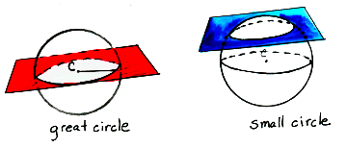
- Every straight line is a geodesic

Geodesics on spheres
- Let $Σ$ be a sphere with center $(0,0,0)$ in $R^{3}$. Let $P$ be a plane in $R^{3}$ through $(0,0,0)$. Then $P∩Σ$ is a great circle.

Great circles are geodesics
Assume that $α$ is a parametrization of a great circle on $Σ$.
We know that $α^{''}$ at every point of $α$ points towards the $(0,0,0)$ of the circle.
This implies that $α^{''}$ is normal to $Σ$.
It follows that $α$ is a geodesic.

Geodesics on cylinders
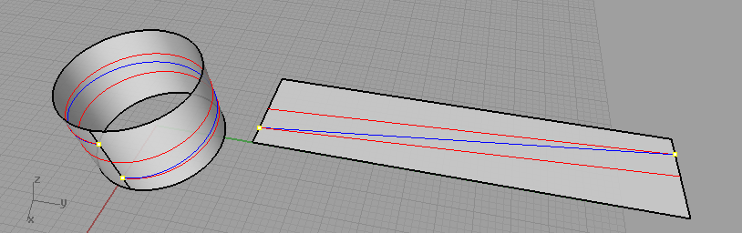
Geodesics are helices on cylinders

Assume that $M$ is a circular cylinder $M:x^{2}+y^{2}=r^{2}$ in $R^{3}$.
Let $α\left(t\right)=(r\cos{θ(t)}, r\sin{θ(t)}, h(t))$ be any curve in $M$.
For every $p∈M$ we have $\left(0,0,1\right)∈T_{p}(M)$.
So if $α^{''}$ is normal to $M$, then $h^{''}\left(t\right)=0$. This implies
$h\left(t\right)=ct+d$
For constants $c,d∈R$. The speed of $α$ is $\sqrt{r^{2}θ^{'}+c^{2}}$.
The speed is constant if and only if $θ^{'}$is constant $a$.
Thus if and only in
$θ\left(t\right)=at+b$.
It follows that a geodesic is a curve of the form
$α\left(t\right)=(r\cos{ \left(at+b\right)}, r\sin{ \left(at+b\right)}, ct+d)$
If $a$ and $c$ are non-zero then this is a helix.
If $c=0$ and $a≠0$ then $α$ is a circle around the $z-$axis.

Closed geodesics
Assume that $α:\left[a,b\right]→M$ is a segment of a geodesic.
If $α\left(a\right)=α(b)$ and $α^{'}\left(a\right)=α^{'}(b)$ then $α$ is a closed geodesic.
Example:
Every geodesic on a sphere is closed.
Example:
A geodesic on a cylinder is closed only if it is a circle around
the $z$-axis.

Geodesics in orthogonal planes
Theorem: Assume that $α$ is a unit speed curve in $M$. Let there exist a plane $P$ such that
$$α⊂P∩M .$$
If $P$ is orthogonal to $T(M)$ at every point of $α$, then $α$ is a geodesic.
Proof:
Let $α$ has a constant speed. This implies that $α^{'}. α^{''}=0 .$
We know that
$$α^{'}∈P∩T(M)$$
And $α^{''}∈P$. Since $P$ is orthogonal to $T(M)$, this implies that $α^{''}$ is orthogonal to $T(M)$.
So $α$ is a geodesic.

Surface of revolution
If $M$ is a surface of revolution, then every meridian in $M$ is a geodesic.
Proof:
Every meridian is the intersection of $M$ with a plane $P$ that contains the rotation axis.
Such a plane is orthogonal to $M$ at every point.
It follows from the previous result that a meridian is a geodesic.

End of the lecture

