HANDOUTS
MTH 161: Introduction to Statistics

Lecture 01
Lecture Outline
- Statistics and its importance
- Basic Definitions:
- Types of statistics
  - Descriptive Statistics
  - Inferential Statistics
- Types of Variables
- Qualitative and Quantitative variables
- Level of measurement of a variable

History of Statistics
Statistics is derived from: Latin Word ‘Status’ means a Political State. In the past, the statistics was used by rulers and kings. They needed information about lands, agriculture, commerce, population of their states to assess their military potential, their wealth, taxation and other aspects of government. So the application of statistics was very limited in the past.
What is Statistics?
The study of the principles and the methods used in: Collecting, Presenting, Analyzing and Interpreting numerical data.
Importance in Daily Life
Every day we are bombarded with different types of data and claims. If you cannot distinguish good from faulty reasoning, then you are vulnerable to manipulation and to decisions that are not in your best interest. Statistics provides tools that you need in order to react intelligently to information you hear or read. In this sense, statistics is one of the most important things that you can study.
Quote from H.G. Wells (a famous writer) about a century ago: “Statistical thinking will one day be as necessary for efficient citizenship as the ability to read and write”.

Applications of Statistics in Other Fields
Statistics has a number of applications in: Engineering, Economics, Business and Finance, Environment, Physics, Chemistry, Biology, Astronomy, Psychology, Medical and so on…
Some Basic Concepts
Before going on, some basic concepts are required:
  - Population
  - Sample
  - Parameter
  - Statistic
Population
A set of all items or individuals of interest.
Examples:
- All students studying at COMSATS
- All the registered voters in Pakistan
- All parts produced today
Finite Population (Countable Population):
If it is possible to count all items of population.
Examples:
- The number of vehicles crossing a bridge every day
- The number of births per years in a particular hospital
- The number of words in a book
- All the registered voters in Pakistan (large finite population)
Size of finite Population: Total number of individuals/units in a finite population (N).
Infinite Population (un-countable population):
If it is NOT possible to count all items of a population.
Examples:
- The number of germs in the body of a patient of malaria is perhaps something which is uncountable
- Total number of stars in the sky
Sample
A Sample is a subset of the population
Examples:
- 1000 voters selected at random for interview
- A few parts selected for destructive testing
- Only Students of Management Sciences Department
Sample Size: Total number of individuals/units in sample (n).
Note: A good sample is representative of the population.
Parameter: A numerical value summarizing all the data of an entire population. e.g. Population Mean, population variance etc.
Statistic: A numerical value summarizing the sample data. e.g. Sample Mean, sample variance etc.
Example:
- Average income of all faculty members working at COMSATS is a parameter.
- Average income of faculty members of Management Sciences Department at COMSATS is a statistic.
An Example
A statistics student is interested in finding out something about the average value (in Rupees) of cars owned by the faculty members working at COMSATS.
Question: Identify Population, Sample, parameter and statistic.
Answer:
- The population is the collection of all cars owned by faculty members of all departments at COMSATS.
- A sample can include the cars owned by faculty members of the Management Sciences Department.
- The parameter about is the “average” value of all cars in the population.
- The statistic is the “average” value of the cars in the sample.
- Parameter and Statistic
Note: Parameters are fixed in value But Statistics vary in value.
Example: If we take a second sample, considering faculty members of English department.
Then the average value of these faculty members will be different from the average value of cars obtained for faculty members of Management Sciences Dept.
Lesson:
- Statistic vary from sample to sample.
- But the average value for “all faculty-owned cars”, i.e. parameter will not change.

Branches of Statistics
Statistics is divided into TWO main branches
- Descriptive Statistics
- Inferential Statistics
- Descriptive Statistics
It includes tools for collecting, presenting and describing data
  - Data Collection
(e.g. Surveys, Observations or experiments)
  - Data Presentation
(e.g. via Graphs and Tables etc.)
  - Data Description
(e.g. finding average etc.)
- Inferential Statistics
Drawing conclusions and/or making decisions concerning a population based only on sample data
Variable
A characteristic that changes or varies over time and/or for different individuals or objects under consideration.
Examples:
- Hair color
- white blood cell count
- time to failure of a computer component.
- Data
- An experimental unit is the individual or object on which a variable is measured.
- A measurement results when a variable is actually measured on an experimental unit.
- A set of measurements, called data, can be either a sample or a population.
Example 1
- Variable
Hair color
- Experimental unit:
Person
- Typical Measurements
Brown, black, blonde, etc.
Example 2
- Variable
Time until a light bulb burns out
- Experimental unit
Light bulb
- Typical Measurements
1500 hours, 1535.5 hours, etc.
- How many variables have you measured?

Univariate data:
One variable is measured on a single experimental unit (individual or object).
Bivariate data:
Two variables are measured on a single experimental unit (individual or object).
Multivariate data:
More than two variables are measured on a single experimental unit (individual or object).

Types of Variables
Two Main types of variables:
- Qualitative variables
- Quantitative variables
Qualitative variables
Whose range consists of qualities or attributes of objects under study.
Examples:
  - Hair color (black, brown, white)
  - Make of car (Suzuki, Honda, etc.)
  - Gender (male, female)
  - Province of birth (Punjab, Sindh, KPK, Balochistan, Gilgit & Baltistan)
  - Grades: (A, B, C, D, F)
  - Level of satisfaction: (Very satisfied, satisfied, somewhat satisfied)
  - Model of transportation: (Car, University Bus, Bike, Cycle etc.)
Quantitative variables
whose range consists of a numerical measurement characteristics of objects under study.
Examples:
  - Number of cars owned by faculty of CIIT
  - Marks of students of Statistics class in Quiz 1
  - Ages of students
  - Salaries of faculty members
  - Types of Qualitative variables
There are TWO main types.
- Nominal variable
- Ordinal variable
Nominal Variable
A qualitative variable that characterizes (or describes, or names) an element of a population.
Examples:
  - Hair color (black, brown, white)
  - Make of car (Suzuki, Honda, etc.)
  - Gender (male, female)
  - Province of birth (Punjab, Sindh, KPK, Balochistan, Gilgit & Baltistan)
Note: Order of variables Doesn’t matter.
Ordinal Variable
A qualitative variable that incorporates an ordered position, or ranking.
Examples:
- Grades: (A, B, C, D, F)
- Level of satisfaction: (Very satisfied, satisfied, somewhat satisfied)

Types of Quantitative variables
There are TWO types.
- Discrete variable
- Continuous variable
Discrete Variable
A quantitative variable that can assume a countable number of values.
Examples:
- number of courses for which you are currently registered
- Total number of students in a class
- Number of TV sets sold by a company
We can’t say there is a half student or half tv set.
Continuous Variable
A quantitative variable that can assume an uncountable number of values.
Examples:
- weight of books and supplies you are carrying as you attend class today
- Height of the students
- Amount of rain fall

Measurement Scales
The values for variables can themselves be classified by the level of measurement, or measurement scale.
Four Scales of Measurement:
- Nominal Scale
- Ordinal Scale
- Interval Scale
- Ratio Scale

Nominal Scale
Classifies data into distinct categories where no ranking is implied. All we can say is that one is different from the other.
Examples:
- Religion
- Your favorite soft drink
- Your political party affiliation
- Mode of transportation
Note: Weakest form of measurement. Average is meaning less here. [Question: What is the average RELIGION?]
Ordinal Scale
Classifies values into distinct categories in which ranking is implied.
Examples:
- Rating a soft drink into: “excellent”, “very good”, “fair” and “poor.”
- Students Grades: A, B, C, D, F
- Faculty Ranks: Professor, Associate Professor, Assistant Professor, Lecturer
Note:
It is stronger form of measurement than nominal scaling.
It does not account for the amount of the differences between the categories. i.e. ordering implies only which category is “greater,” “better,” or “more preferred”—not by how much.
Interval Scale
A measurement scale possessing a constant interval size (distance) but not a true zero point– the complete absence of the characteristic you are measuring.
Example: Temperature measured on either the Celsius or the Fahrenheit scale:
Same difference exists between 20º C (68º F) and 30º C (86º F) as between 5º C (41º F) and 15º C (59º F)
Note: You cannot speak about ratios.
We can’t say that temperature of 30⁰ C is twice as hot as a temperature of 15⁰C.
The arithmetic operation of addition, subtraction, etc. are meaningful.
Ratio Scale
An interval scale where the sale of measurement has a true zero point as its origin– zero point is meaningful.
Examples: height, weight, length, units sold
Note: All scales, whether they measure weight in kilograms or pounds, start at 0. The 0 means something and is not arbitrary.
- 100 lbs. is double 50 lbs. (same for kilograms)
- $100 is half as much as $200

Lecture 02
Lecture Outline
Methods of Data Presentations
- Classification of Data
- Tabulation of Data
- Table of frequency distributions
- Frequency Distribution
- Relative frequency distribution
- Cumulative frequency distribution

Organizing Data
After collecting data, the first task for a researcher is to organize and simplify the data so that it is possible to get a general overview of the results.

Raw Data: Data which is not organized is called raw data.

Un-Grouped Data: Data in its original form is called Un-Grouped Data.
Note: Raw data is also called ungrouped data.

Different Ways of Organizing Data
To get an understanding of the data, it is organized and arranged into a meaningful form.
This is done by the following methods:

Classification
- Tabulation (e.g. simple tables, frequency tables, stem and leaf plots etc.)
- Graphs (Bar Graph, Pie chart, Histogram, Frequency Ogive etc.)

Classification of Data
The process of arranging data into homogenous group or classes according to some common characteristics present in the data is called classification.
Example:
The process of sorting letters in a post office, the letters are classified according to the cities and further arranged according to streets.

Bases of Classification
There are four important bases of classification:
- Qualitative Base
- Quantitative Base
- Geographical Base
- Chronological or Temporal Base
Qualitative Base:
When the data are classified according to some quality or attributes such as sex, religion, etc.
Quantitative Base:
When the data are classified by quantitative characteristics like heights, weights, ages, income etc.
Geographical Base:
When the data are classified by geographical regions or location, like states, provinces, cities, countries etc.
Chronological or Temporal Base:
When the data are classified or arranged by their time of occurrence, such as years, months, weeks, days etc. (e.g. Time series data).

Types of Classification
There are Three main types of classifications:
- One -way Classification
- Two-way Classification
- Multi-way Classification

One -way Classification
If we classify observed data keeping in view single characteristic, this type of classification is known as one-way classification.
Example:
The population of world may be classified by religion as Muslim, Christian etc.

Two-way Classification
If we consider two characteristics at a time in order to classify the observed data then we are doing two way classifications.
Example:
The population of world may be classified by Religion and Sex.

Multi-way Classification
If we consider more than two characteristics at a time in order to classify the observed data then we are doing multi-way classification.
Example:
The population of world may be classified by Religion, Sex and Literacy.

Tabulation of Data
The process of placing classified data into tabular form is known as tabulation. A table is a symmetric arrangement of statistical data in rows and columns. Rows are horizontal arrangements whereas columns are vertical arrangements.

Types of Tabulation
There are three types of tabulation:
- Simple or One-way Table
- Double or Two-way Table
- Complex or Multi-way Table
- Simple or One-way Table
When the data are tabulated to one characteristic, it is said to be simple tabulation or one-way tabulation.
Example:
Tabulation of data on population of world classified by one characteristic like Religion, is an example of simple tabulation.
- Double or Two-way Table
When the data are tabulated according to two characteristics at a time. It is said to be double tabulation or two-way tabulation.
Example:
Tabulation of data on population of world classified by two characteristics like Religion and Sex, is an example of double tabulation.
- Complex or Multi-way Table
When the data are tabulated according to many characteristics (generally more than two), it is said to be complex tabulation.
Example:
Tabulation of data on population of world classified by three characteristics like Religion, Sex and Literacy etc.

Construction of Statistical Table
A statistical table has at least four major parts and some other minor parts.
- The Title
- The Box Head (column captions)
- The Stub (row captions)
- The Body
- Prefatory Notes
- Foot Notes
- Source Notes

General Rules of Tabulation
- A table should be simple and attractive. A complex table may be broken into relatively simple tables.
- Headings for columns and rows should be proper and clear.
- Suitable approximation may be adopted and figures may be rounded off. But this should be mentioned in the prefatory note or in the foot note.
- The unit of measurement and nature of data should be well defined.
- Organizing Data via Frequency Tables

One method for simplifying and organizing data is to construct a frequency distribution.

Frequency Distribution: The organization of a set of data in a table showing the distribution of the data into classes or groups together with the number of observations in each class or group is called a Frequency Distribution.
Class Frequency: The number of observations falling in a particular class is called class frequency or simply frequency, denoted by ‘f’.
Grouped Data: Data presented in the form of a frequency distribution is called grouped data.
- Why Use Frequency Distributions?
- A frequency distribution is a way to summarize data.
- A frequency distribution condenses the raw data into a more meaningful form.
- A frequency distribution allows for a quick visual interpretation of the data.
Frequency Distributions can be drawn for qualitative data as well as quantitative data.

Grouped Frequency Distribution
- Sometimes, when the data is continuous or covers a wide range of values, it becomes very burdensome to make a list of all values as in that case the list will be too long.
- To remedy this situation, a grouped frequency distribution table is used.

Steps in Constructing Grouped Frequency Distribution
Sort raw data from low to high:
Find range:
Range=maximum value – minimum value=58 - 12 = 46
Select number of classes: 5 (usually between 5 and 20)
Compute class width:
Class width=Range/no of class=46/5=9.2 ~ 10
Determine class limits
Count the number of values in each class

Relative Frequency Distribution

Relative Frequency is the ratio of the frequency to the total number of observations.
Relative frequency = Frequency/Number of observations

Cumulative Frequency Distribution
Cumulative Frequency:
The total frequency of a variable from its one end to a certain values (usually upper class boundary in grouped data), called the base, is known as cumulative frequency less than or more than the base of the variable.

Stem and Leaf Plot
Disadvantage of Frequency Table:
An obvious disadvantage of using frequency table is that the identity of individual observation is lost in the grouping process.
Stem and Leaf plot provides the solution by offering a quick and clear way of sorting and displaying data simultaneously.
- Stem and Leaf Plot
METHOD:
- Sort the data series
- Separate the sorted data series into leading digits (the stem) and the trailing digits (the leaves)
- List all stems in a column from low to high
- For each stem, list all associated leaves

Lecture 03
Lecture Outline
- Graphical Methods of Data Presentations
- Graphs for quantitative data
  - Histograms
  - Frequency Polygon
  - Cumulative Frequency Polygon (Frequency Ogive)

Graphs For Quantitative Data
Common methods for graphing quantitative data are:
- Histogram
- Frequency Polygon
- Frequency Ogive

Histograms For Quantitative Data
A histogram is a graph that consists of a set of adjacent bars with heights proportional to the frequencies (or relative frequencies or percentages) and bars are marked off by class boundaries (NOT class limits). It displays the classes on the horizontal axis and the frequencies (or relative frequencies or percentages) of the classes on the vertical axis. The frequency of each class is represented by a vertical bar whose height is equal to the frequency of the class. It is similar to a bar graph. However, a histogram utilizes classes or intervals and frequencies while a bar graph utilizes categories and frequencies.

Example: Construct a Histogram for ages of telephone operators.
Age (years) | No of Operators
11-15 | 10
16-20 | 5
21-25 | 7
26-30 | 12
31-35 | 6
Total | 40

Method:
First construct Class Boundaries (CB).
Age (years) | Class Boundaries | No of Operators
11-15 | 10.5-15.5 | 10
16-20 | 15.5-20.5 | 5
21-25 | 20.5-25.5 | 7
26-30 | 25.5-30.5 | 12
31-35 | 30.5-35.5 | 6
Total |  | 40

Construct Histogram by taking CB along X-axis and frequencies along Y-axis.

Frequency Polygon For Quantitative Data
Graph of frequencies of each class against its mid point (also called class marks, denoted by X).
Class Mark (X) or Mid point: It is calculated by taking average of lower and upper class limits.

Method:
Take Mid Points along X-axis and Frequency along Y-axis.
Construct Bars with height proportional to the corresponding freq.
Join Mid points to get Frequency Polygon.
Cumulative Frequency Polygon (called Ogive) For Quantitative Data
Ogive is pronounced as O’Jive (rhymes with alive).
Cumulative Frequency Polygon is a graph obtained by plotting the cumulative frequencies against the upper or lower class boundaries depending upon whether the cumulative is of ‘less than’ or ‘more than’ type.
Less than Cumulative Frequency
Method:
Take Upper Class Boundaries along X-axis and Cumulative Frequency along Y-axis.
Join less than Class Boundaries with corresponding Cumulative Frequencies.

Distribution of a Data Set
A table, a graph, or a formula that provides the values of the observations and how often they occur. An important aspect of the distribution of a quantitative data is its shape. The shape of a distribution frequently plays a role in determining the appropriate method of statistical analysis. To identify the shape of a distribution, the best approach usually is to use a smooth curve that approximates the overall shape.
Advantage of smooth curves:
It skips minor differences in shape and concentrate on overall patterns.

Frequency Distributions in Practice
Common Type of Frequency Distribution:
- Symmetric Distribution
  - Normal Distribution (or Bell Shaped)
  - Triangular Distribution
  - Uniform Distribution (or Rectangular)
- Asymmetric or skewed Distribution
  - Right Skewed Distribution
  - Left Skewed Distribution
  - Reverse J-Shaped (or Extremely Right Skewed)
  - J-Shaped (or Extremely Left Skewed)
  - Frequency Distributions in Practice
- Bi-Modal Distribution
- Multimodal Distribution
- U-Shaped Distribution
Lecture 04 & 05
Lecture Outline
- Introduction to MS-Excel
- Creating Charts in MS-Excel

See video lecture for demonstration

Lecture 06
Lecture Outline
- Creating Charts in MS-Excel
- Graphs for Qualitative Data
  - Bar Chart
  - Pie Chart
- Graphs for Quantitative Data
  - Histogram

Simple Bar Chart for Qualitative Data
Party Affiliation Example:
Consider party affiliation data
Party | Frequency (f)
PTI | 10
N | 9
Q | 6
P | 5
Total | 30
The bar chart of the above data is provided below:

Relative Frequency Distribution
Party | Frequency (f) | Relative Frequency
PTI | 10 | 0.3333
N | 9 | 0.30
Q | 6 | 0.20
P | 5 | 0.1667
Total | 30 | 1

We can interchange x and y axis to get horizontal bar chart, as shown below:

Multiple Bar Chart
Multiple Bar Chart shows two or more characteristics corresponding to values of a common variable in the form of a grouped bars, whose lengths are proportional to the values of the characteristics.
Example: Draw multiple bar charts to show the area and production of cotton in Punjab for the following data:
Year | Area (000 acres) | Production (000 bales)
1965-66 | 2866 | 1588
1970-71 | 3233 | 2229
1975-76 | 3420 | 1937

Component Bar Chart (subdivided bars)
A bar is divided into two or more sections, proportional in size to the component parts of a total displayed by each bar.
Example: Draw component bar chart of the students’ enrollment data:
Classes | Total | Male | Female
BBA | 65 | 33 | 32
MBA | 60 | 32 | 28
MS/PHD | 40 | 21 | 19

Pie Charts for Qualitative Data
A Pie-Chart (also called sector diagram), is a graph consisting of a circle divided into sectors whose areas are proportional to the various parts into which whole quantity is divided.
Example: Represent the expenditures on various items of a family by a pie chart.
Items | Expenditure (in 100 rupees)
Food | 50
Clothing | 30
Rent | 20
Fuel | 15
Misc. | 35
Total | 150

Items | Expenditure (in 100 rupees) | Angles of sector (in Degrees)
Food | 50 | 120⁰
Clothing | 30 | 72⁰
Rent | 20 | 48⁰
Fuel | 15 | 36⁰
Misc. | 35 | 84⁰
Total | 150 | 360⁰

Scatter Plot
Example: The local ice cream shop keeps track of how much ice cream they sell versus the temperature on that day. Here are their figures for the last 12 days.
Temperature (°C) | Ice Cream Sales ($)
14.2 | 215
16.4 | 325
11.9 | 185
15.2 | 332
18.5 | 406
22.1 | 522
19.4 | 412
25.1 | 614
23.4 | 544
18.1 | 421
22.6 | 445
17.2 | 408

Construct a Scatter Diagram for this data.
Method: To make a scatter plot, take temperature along X-axis and Ice Cream Sales along Y-axis and make a plot. Scatter plot is shown below:

Histograms For Quantitative Data
Example: Construct a Histogram for temperature data.
24
35
17
21
24
37
26
46
58
30
32
13
12
38
41
43
44
27
53
27

Solution:
Min= | 12
Max= | 58
Range= | 46
No of classes= | 5
width= | 9.2

Class Limits | Class Boundaries | Freq
10-20 | 9.5-20.5 | 3
21-30 | 20.5-30.5 | 7
31-40 | 30.5-40.5 | 4
41-50 | 40.5-50.5 | 4
51-60 | 50.5-60.5 | 2

Excel Add-ins
An Add-in is a software program that extends the capabilities of larger programs. There are many Excel add-ins designed to complement the basic functionality offered by Excel. Common Add-in for performing basic statistical functions in Excel is: ‘Analysis Tool Pack’. Before using, we have to activate the add-in (if it is not already active).

Lecture 07
Lecture Outline
- Graphs for Quantitative Data
  - Scatter plot
  - Histogram

Measures of Central Tendency
  - Data, in nature, has a tendency to cluster around a central value.
  - That central value condenses the large mass of data into a single representative figure.
  - The central value can be obtained from sample values (called statistic) and population observations (called parameter).

Definition: Average is an attempt to find a single figure to describe a group of figures. (Clark, A famous Statistician)

Objectives for the study of measures of central tendency
Two main objectives:
- To get one single value that represents the entire data.
- To facilitate comparison among different data sets.

Characteristics of a Good Average
According to the statisticians Yule and Kendall, an average will be termed good or efficient if it possesses the following characteristics:
- Should be easily understandable.
- Should be rigidly defined.
It means that the definition should be so clear that the interpretation of the definition does not differ from person to person.
- Should be mathematically expressed
- Should be easy to calculate.
- Should be based on all the values of the variable.
This means that in the formula for average all the values of the variable should be incorporated.
- Characteristics of a Good Average
- The value of average should not change significantly along with the change in sample.
This means that the values of the averages of different samples of the same size drawn from the same population should have small variations. In other words, an average should possess sampling stability.
- Should be suitable for further mathematical treatment.
- The average should be unduly affected by extreme values.
This means that the formula for average should be such, that it does not show large due to the presence of one or two very large or very small values of the variable.
Different Measures of Central Tendency or Averages
  - Mathematical Averages
    - Arithmetic Mean or simply Mean or average
    - Geometric Mean
    - Harmonic Mean
  - Positional Averages
    - Median
    - Mode
In this lecture we will focus only on the first measures of central tendency which is called Arithmetic Mean.

Arithmetic Mean (or Simply Mean)
  - It is the most popular and well known measure of central tendency.
  - It can be used with both discrete and continuous data.

Calculation: The mean is equal to the sum of all the values in the data set divided by the number of values in the data set.
Example: Calculate Arithmetic Mean of five numbers: 2, 5, 7, 10, 6
Arithmetic Mean=(2+5+7+10+6)/5=30/5=6
Notation:
Sample Mean ($\overline{x}$)
Population Mean ($μ$)

Arithmetic Mean for Ungrouped Data

General Formulae For Un-Grouped Data:
For ‘n’ observations, $x_{1},x_{2},…,x_{n}$.
$$Sample Mean=\overline{x}=\frac{x_{1}+x_{2}+…+x_{n}}{n}=\frac{\sum_{i=1}^{n}{x_{i}}}{n}=\frac{\sum{x}}{n}$$
$$Population Mean=μ=\frac{x_{1}+x_{2}+…+x_{n}}{n}=\frac{\sum_{i=1}^{n}{x_{i}}}{n}=\frac{\sum{x}}{n}$$
Example: Marks obtained by 5 students, 20, 15, 5, 20, 10
$$\overline{x}=\frac{\sum{x}}{n}=\frac{20+15+5+25+10}{5}=\frac{75}{5}=15$$
Arithmetic Mean for Grouped Data
General Formulae for Grouped Data:
$$Sample Mean=\overline{x}=\frac{\sum_{i=1}^{n}{f_{i}x_{i}}}{\sum_{i=1}^{n}{f_{i}}}=\frac{\sum{fx}}{\sum{f}}$$
$$Population Mean=μ=\frac{\sum_{i=1}^{n}{f_{i}x_{i}}}{\sum_{i=1}^{n}{f_{i}}}=\frac{\sum{fx}}{\sum{f}}$$
Where, $f_{i}$ is the frequency of the i-th class
$x_{i}$ is the mid point of the i-thclass
Example: Calculate Arithmetic Mean for the following frequency distribution of temperature data:
Classes | Frequency (f)
11-20 | 3
21-30 | 6
31-40 | 5
41-50 | 4
51-60 | 2

Solution: Note that we have Arithmetic Mean for Grouped Data$=\overline{x}=\frac{\sum{fx}}{\sum{f}}$
Step 1: Calculate Midpoint (x) of each class.
Step 2: Calculate the product of frequency (f) and Midpoint (x) of each class.i.e. calculate fx.
Step 3: Calculate $\sum{f}$ and $\sum{fx}$.
Classes | Frequency (f) | Mid Point (x) | fx
11-20 | 3 | (11+20)/2=15.5 | 46.5
21-30 | 6 | 25.5 | 153
31-40 | 5 | 35.5 | 177.5
41-50 | 4 | 45.5 | 182
51-60 | 2 | 55.5 | 111
Total | $\sum{f}$=20 |  | $\sum{fx}$=670

Step 4: Calculate Arithmetic mean using formula.$\overline{x}=\frac{\sum{fx}}{\sum{f}}=\frac{670}{20}=33.5$
Lecture 08

Combined Arithmetic Mean
For ‘k’ subgroups of data consisting of ‘n₁, n₂, …, n_{k}’ observations (with $\sum_{i=1}^{k}{n_{i}=n}$), having respective means, ${\overline{x}}_{1}$, ${\overline{x}}_{2}$, …, ${\overline{x}}_{k}$.
Then combined mean (mean of the all ‘k’ means) is given by:

$${\overline{x}}_{c}=\frac{n_{1}{\overline{x}}_{1}+n_{2}{\overline{x}}_{2}+…+n_{k}{\overline{x}}_{k}}{n_{1}+n_{2}+…+n_{k}}=\frac{\sum_{i=1}^{k}{n_{i}{\overline{x}}_{i}}}{\sum_{i=1}^{k}{n_{i}}}=\frac{\sum_{i=1}^{k}{n_{i}{\overline{x}}_{i}}}{n}$$
Example: The mean heights and the number of students in three sections of a statistics class are given below:

Calculate overall (or combined) mean height of the students.
Solution: Note that we have, n₁=40, n₂=37, n₃=43 and ${\overline{x}}_{1}$=62, ${\overline{x}}_{2}$=58 and ${\overline{x}}_{3}$=61. So, combined mean is:${\overline{x}}_{c}=\frac{n_{1}{\overline{x}}_{1}+n_{2}{\overline{x}}_{2}+n_{3}{\overline{x}}_{3}}{n_{1}+n_{2}+n_{3}}=60.4$ inches

Merits and De-Merits of Arithmetic Mean

Merits of Arithmetic Mean are:
- Easy to calculate and understand.
- Based on all observations.
- Can be expressed by a mathematical formula.

De-Merits of Arithmetic Mean are:
- It is greatly affected by extreme values.
Example: Mean of 1, 2, 3, 4 and 5 is 3. If we change last number 5 to 20 then mean is 6.
Note that 6 is not a representative number as most of the data in this case is below the average (i.e. 6).
- Works well only in case of symmetric distributions and performs poorly in case of skewed distributions.
- Bipolar case misrepresented (e.g. 50% of the students in a class got full marks and remaining 50% got zero marks).
- If the grouped data has ‘open-end’ classes, then mean can not be calculated without assuming the limits.
- High growth + Increasing Poverty (e.g. if have 10 individuals and nine of them are poor with income Rs. 10,000 each and one is very rich with income Rs. 100,000. So the average income is Rs. 19000. Now if we double the income of rich individual and reduce the income of poor by half. Then average income of ten individuals will be Rs. 24500.

Example 1: Marks obtained by 5 students, 20, 15, 5, 25, 10
Solution:
- Arrange the data in ascending order. 3, 10, 15, 20, 25
- Compute an index i=(n/2)
where n=5 is the number of observations.
i=(n/2)=5/2=2.5
Since i=2/5 is not an integer, so the next integer greater than 2.5 is 3, which gives the position of the Median. At third position, we have number 15.
Hence Median=13

Example 2: Run made by a cricket player in 4 matches: 30, 70, 10, 20
Solution:
- Arrange the data in ascending order. 10, 20, 30, 70
- Compute an index i=(n/2)
where n=4 is the number of observations.
i=(4/2)=2
Since i=2 is an integer,
so Median is the average of the values in positions i and i+1.
i.e. Median is the average of the values in positions 2 and 3.
At position 2, we have number 20.
At position 3, we have number 30.
Hence Median=average of 20 and 30= (20+30)/2=50/2=25

Median for Grouped Data
Formulae for calculating Median in case of Grouped data is: $Median=l+\frac{h}{f}\left(\frac{n}{2}-C\right)$
Where, $l$=lower class boundary of the Median Class
$f$=Frequency of the Median Class
$n=\sum{f}$=Total Frequency
$C=Cumulative Frequency preceding the Median Class$
$h$=Width of class interval

Example: Calculate Median for the distribution of examination marks provided below:
Marks | No of Students (f)
30-39 | 8
40-49 | 87
50-59 | 190
60-69 | 304
70-79 | 211
80-89 | 85
90-99 | 20
Solution:
Step 1: Calculate Class Boundaries
Step 2: Calculate Cumulative Frequency (cf)
Step 3: Find Median Class. This can be done by calculating Median using formula,
Median=Marks obtained by (n/2)^{th} student=905/2=452.5th student
Locate 452.5 in the Cumulative Freq. column. Hence 59.5-69.5 is the Median Class.
Step 4: Find$l, h, f and C$. Note that h=10
Marks | Class Boundaries | No of Students (f) | Cumulative Freq (cf)
30-39 | 29.5-39.5 | 8 | 8
40-49 | 39.5-49.5 | 87 | 95
50-59 | 49.5-59.5 | 190 | 285=C
60-69 | l=59.5-69.5 | 304=f | 589
70-79 | 69.5-79.5 | 211 | 800
80-89 | 79.5-89.5 | 85 | 885
90-99 | 89.5-99.5 | 20 | 905

Step 5: Calculate Median using following formula
$Median=l+\frac{h}{f}\left(\frac{n}{2}-C\right)$
$Median=59.5+\frac{10}{304}\left(\frac{905}{2}-589\right)=$ $=59.5+\frac{10}{304}\left(452.5-589\right)=$65 Marks

Merits of Median
Merits of Median are:
- Easy to calculate and understand.
- Median works well in case of Symmetric as well as in skewed distributions as opposed to Mean which works well only in case of Symmetric Distributions.
- It is NOT affected by extreme values.
Example: Median of 1, 2, 3, 4, 5 is 3. If we change last number 5 to 20, i.e. 20 is an extreme value compared to 1, 2, 3 and 4 then Median will still be 3. Hence Median is not affected by extreme values.

De-Merits of Median
De-Merits of Median are:
- It requires the data to be arranged in some order which can be time consuming and tedious, though now-a-days we can sort the data via computer very easily.

Lecture 09

Mode
- Mode is a value which occurs most frequently in a data.
- Mode is a French word meaning ‘fashion’, adopted for most frequent value.

Calculation: The mode is the value in a dataset which occurs most often or maximum number of times.

Mode for Ungrouped Data
Example 1: Marks: 10, 5, 3, 6, 10 Mode=10
Example 2: Runs: 5, 2, 3, 6, 2 , 11, 7 Mode=2

Often, there is no mode in a data.
Example: marks: 10, 5, 3, 6, 7 No Mode

Sometimes we may have several modes in a data.
Example: marks: 10, 5, 3, 6, 10, 5, 4, 2, 1, 9 Two modes (5 and 10)

Mode for Qualitative Data
Mode is mostly used for qualitative data.
Mode is PTI

Mode for Grouped Data
Formulae for calculating Mode in case of Grouped data is: $Mode=l+\frac{f_{m}-f_{1}}{\left(f_{m}-f_{1}\right)+{(f}_{m}-f_{2})}×h$
Where,
$l$=lower class boundary of the modal class
$f_{m}$=Frequency of the modal class
$f_{1}$=Frequency of the class preceding the modal class
$f_{2}=Frequency of the class following the modal class$
$h$=Width of class interval
Note: There is an alternative formula for calculating mode but the formula given above provides more accurate results.

Example: Calculate Mode for the distribution of examination marks provided below:
Marks | No of Students (f)
30-39 | 8
40-49 | 87
50-59 | 190
60-69 | 304
70-79 | 211
80-89 | 85
90-99 | 20

Solution:
- Calculate Class Boundaries
- Find Modal Class (class with the highest frequency)
- Find ${l, f}_{m},f_{1}, f_{2} and h$. Note that h=10

Marks | Class Boundaries | No of Students (f)
30-39 | 29.5-39.5 | 8
40-49 | 39.5-49.5 | 87
50-59 | 49.5-59.5 | 190=f₁
60-69 | $l$=59.5-69.6 | 304=f_{m}
70-79 | 69.5-79.5 | 211=f₂
80-89 | 79.5-89.5 | 85
90-99 | 89.5-99.5 | 20

- Calculate Mode using the formula, $Mode=l+\frac{f_{m}-f_{1}}{\left(f_{m}-f_{1}\right)+{(f}_{m}-f_{2})}×h$
$Mode=59.5+\frac{(304-190)}{\left(304-190\right)+(304-211)}×10$=65.3 Marks

Merits of Mode
Merits of Mode are:
- Easy to calculate and understand. In many cases, it is extremely easy to locate it.
- It works well even in case of extreme values.
- It can be determined for qualitative as well as quantitative data.

De-Merits of Mode
De-Merits of Mode are:
- It is not based on all observations.
- When the data contains small number of observations, the mode may not exist.

Geometric Mean
When you want to measure the rate of change of a variable over time, you need to use the geometric mean instead of the arithmetic mean.

Calculation: The geometric mean is the nth root of the product of n values.

Geometric Mean for Ungrouped Data

General Formulae for Un-Grouped Data:

For ‘n’ observations, $x_{1},x_{2},…,x_{n}$. The geometric mean is the nth root of the product of n values. $Geometric Mean={\overline{x}}_{G}=\sqrt[n]{(x_{1}×x_{2}×…×x_{n})}$

When ‘n’ is very large, then it is difficult to compute Geometric Mean using above formula.

This is simplified by considering alternative form of the above formula.
$$Geometric Mean={\overline{x}}_{G}=\sqrt[n]{(x_{1}×x_{2}×…×x_{n})}$$
Taking Logarithm on both sides, we have
$$\log\left({\overline{x}}_{G}\right)=log\left[ \sqrt[n]{\left(x_{1}×x_{2}×…×x_{n}\right)} \right]$$
$$\log\left({\overline{x}}_{G}\right)=log\left[ {\left(x_{1}×x_{2}×…×x_{n}\right)}^{1/n} \right]$$
$$\log\left({\overline{x}}_{G}\right)=\frac{1}{n}[ log\left(x_{1}×x_{2}×…×x_{n}\right) ]$$
$$\log\left({\overline{x}}_{G}\right)=\frac{1}{n}[ log\left(x_{1}\right)+log\left(x_{2}\right)+…+log\left(x_{n}\right)]$$
$\log\left({\overline{x}}_{G}\right)=\frac{1}{n}\sum_{i-1}^{n}{log\left(x_{i}\right)}$
$${\overline{x}}_{G}=Antilog [ \frac{1}{n}\sum_{i=1}^{n}{log\left(x_{i}\right)} ]$$

Example 1: Marks obtained by 5 students, 2, 8, 4
$$Geometric Mean={\overline{x}}_{G}=\sqrt[3]{(x_{1}×x_{2}×x_{3})}$$
$=\sqrt[3]{(2×8×4)}$
$=\sqrt[3]{(64)}$
$=\sqrt[3]{\left(4^{3}\right)}$
$={\left(4^{3}\right)}^{1/3}$
$=$4

Example 1(Alternative Method): Marks obtained by 5 students, 2, 8, 4
Solution:
Marks (x) | Log(x)
2 | Log(2)=0.30103
8 | 0.90309
4 | 0.60206
Total | $\sum_{i=1}^{n}{log\left(x_{i}\right)}$=1.80618

$Geometric Mean={\overline{x}}_{G}=Antilog [ \frac{1}{n}\sum_{i=1}^{n}{log\left(x_{i}\right)} ]$
$=Antilog \left[ \frac{1}{3}\left(1.80618\right)\right]$
$=Antilog \left[0.60206\right]$
$=$1.825876

Geometric Mean for Grouped Data
General Formulae for Grouped Data:
$$Geometric Mean={\overline{x}}_{G}=\sqrt[n]{({x_{1}}^{f_{1}}×{x_{2}}^{f_{2}}×…×{x_{n}}^{f_{n}})}$$
This can be written as:
$$Geometric Mean={\overline{x}}_{G}=Antilog \left[\frac{1}{n}\sum_{i=1}^{n}{f_{i} log\left(x_{i}\right)}\right]$$
Where, fi’s are the frequencies of each class
Xi’s are mid-points or class marks of each class
$n=\sum{f=Total Frequency}$

Example 1: Given the frequency distribution of weights of 60 students, calculate Geometric Mean.
Weights (grams) | Frequency (f)
65-84 | 9
85-104 | 10
105-124 | 17
125-144 | 10
145-164 | 5
165-184 | 4
185-204 | 5

Solution: Formula for Geometric Mean is: ${\overline{x}}_{G}=Antilog \left[\frac{1}{n}\sum_{i=1}^{n}{f_{i} log\left(x_{i}\right)}\right]$
- Calculate Mid-point or class mark (x).
- Calculate log(x).
- Calculate the product of f and log(x), i.e. f log(x).
- Calculate $\sum_{i=1}^{n}{f_{i} log\left(x_{i}\right)}$ and n=$\sum{f}$

Weights (grams) | Frequency (f) | Midpoint (x) | Log(x) | f log(x)
65-84 | 9 | 74.5 | 1.872156 | 16.8494
85-104 | 10 | 94.5 | 1.975432 | 19.75432
105-124 | 17 | 114.5 | 2.058805 | 34.99969
125-144 | 10 | 134.5 | 2.128722 | 21.28722
145-164 | 5 | 154.5 | 2.188928 | 10.94464
165-184 | 4 | 174.5 | 2.241795 | 8.96718
185-204 | 5 | 194.5 | 2.28892 | 11.4446
Total= | 60 |  |  | 124.247

- Calculate Geometric Mean,
${\overline{x}}_{G}=Antilog \left[\frac{1}{n}\sum_{i=1}^{n}{f_{i} log\left(x_{i}\right)}\right]$=antilog[124.247/60]=7.93104 grams

Merits of Geometric Mean
Merits of Geometric Mean are:
- Based on all observations.
- Rigorously defined by a mathematical formula.
- It gives equal weight to all observations.
- It is not much affected by sampling variability.

De-Merits of using Geometric Mean
De-Merits of Geometric Mean are:
- It is neither easy to calculate nor understand.
- It vanishes if any of the observations is zero.
- In case of negative values, it can’t be calculated. (As log of negative number is undefined).

Lecture 10

Harmonic Mean
Harmonic Mean is used in averaging certain types of ratios or rate of change. For example,
Suppose a car is running at the rate of 15km/hr during the first 30km, at 20km/hr during the second 30km, and at 25km/hr during the third 30km. Note that the distance covered is constant but the time is changing. To find the average speed of the car, Harmonic Mean is the suitable average.

Harmonic Mean for Ungrouped Data
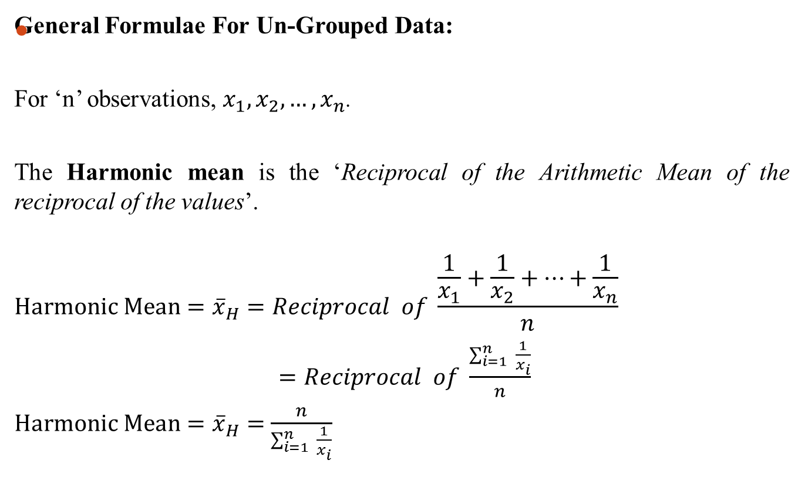
Example: suppose a car is running at the rate of 15km/hr during the first 30km, at 20km/hr during the second 30km, and at 25km/hr during the third 30km. Calculate Average Speed of the car.
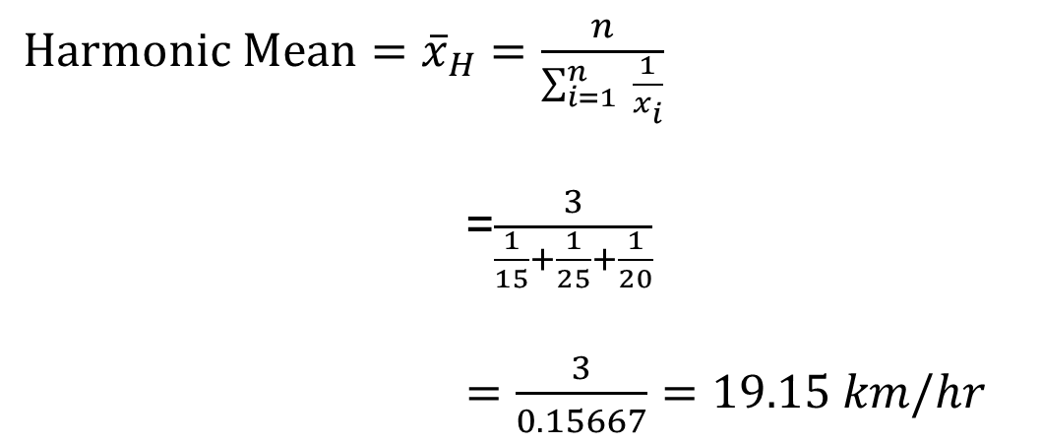

Harmonic Mean for Grouped Data
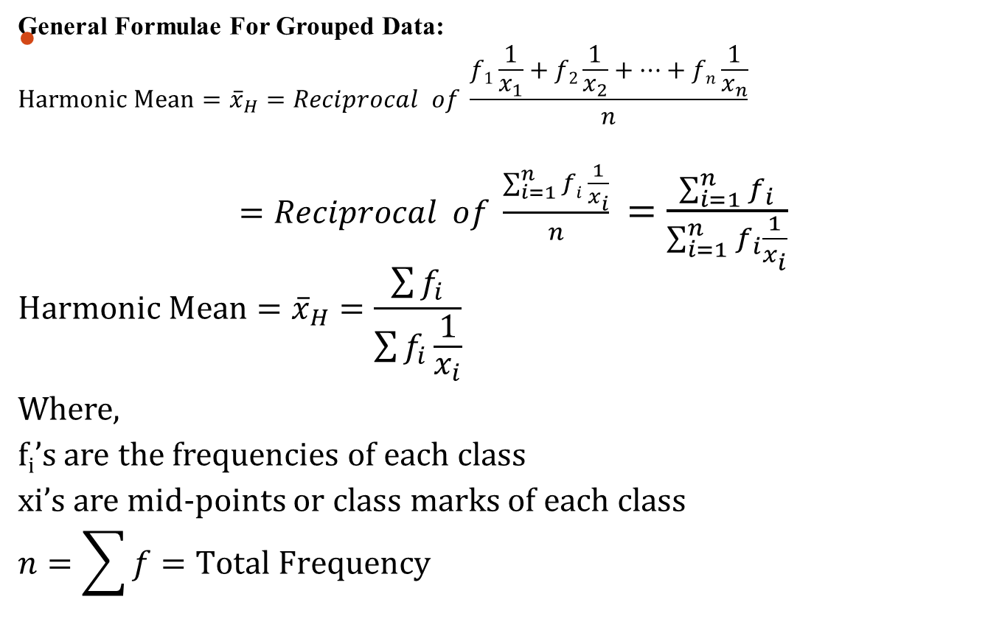

Example: Given the frequency distribution of weights of 60 students, calculate Geometric Mean.
Weights (grams) | Frequency (f)
65-84 | 9
85-104 | 10
105-124 | 17
125-144 | 10
145-164 | 5
165-184 | 4
185-204 | 5
Solution: Formula for finding harmonic mean is
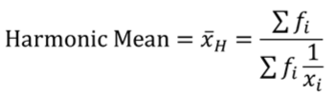
Follow the following steps to calculate Harmonic mean:
- Calculate midpoint or class mark (x)
- Calculate reciprocal of x, i.e. 1/x
- Calculate the product of f and 1/x , i.e. f(1/x)
- Calculate 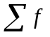and 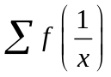
- Calculate Harmonic Mean using formula, 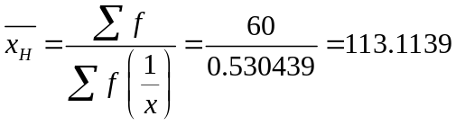 Grams

Merits of Harmonic Mean
Merits of Harmonic Mean are:
- Rigorously defined by a mathematical formula.
- Based on all observations.
- It is amenable to mathematical treatment.
- It is not much affected by sampling variability.

De-Merits of Harmonic Mean
De-Merits of Harmonic Mean are:
- It is neither easy to calculate nor understand.
- It can’t be calculated if any of the observations is zero.
- It gives too much weightage to the smaller observations.
(e.g. 1/0.00001 is 100000)

Lecture 11

Empirical Relationship between the Mean, Median and Mode

In case of symmetrical distributions:
Mean=Median=Mode
When the distribution is not symmetric then it is called asymmetric or skewed.
- If it is positively skewed:
Mean > Median > Mode
- If it is negatively skewed:
Mean < Median < Mode

According to Karl Pearson (a famous statistician):
In cases of moderately skew (or moderately asymmetrical) distributions the value of the mean, median and mode have the following empirical relationship:
Mode= 3Median-2Mean

According to Karl Pearson (a famous statistician):
In cases of moderately skew (or moderately asymmetrical) distributions the value of the mean, median and mode have the following empirical relationship:
Mode= 3Median-2Mean
Mode= 3Median-3Mean+Mean
3Mean-3Median=Mean-Mode
3(Mean-Median)=Mean-Mode
OR Mode= Mean-3(Mean-Median)
From this relationship, we can derive
Mean-Mode=3(Mean-Median)
Mean-Median=1/3(Mean-Mode)

Example: Given median = 20.6 and mode = 26, Find mean.
Solution: As Mode= 3Median-2Mean
We can write it as:
2Mean=3Median-Mode
Mean=1/2*[3Median-Mode]
Mean=1/2*[3(20.6)-26]
Mean=1/2*[61.8-26]
Mean=1/2*[35.8]=17.9

Example: In a moderately skewed distribution, if the value of the mean is 5 and the median is 6, determine the value of the mode.
Solution: Given that Mean = 5, Median = 6.
Formula for mode is, Mode=3Median–2Mean
Mode=3(6)–2(5)
Mode=18–10=8
Hence, Mode = 8

Does the relation Mode= 3Median-2Mean always holds?
Example: 1, 2, 2, 3, 4, 7, 9
Mean=28/7=4, Median=3, Mode=2
RHS=3Median-2Mean=3*3-2*4=1 which is different from 2.
Two main reasons for wrong result:
Firstly, this formula is approximate. Therefore, real results may differ from the results obtained using this formula.
Secondly, this formula is valid only for moderately skewed distribution in which the peak is only slightly oriented towards the right or left. If the distribution is highly skewed, this formula is not valid.

Percentiles
- A percentile provides information about how the data are spread over the interval from the smallest value to the largest value.
- The pth percentile is a value such that at least p percent of the observations are less than or equal to this value and at least (100-p) percent of the observations are greater than or equal to this value.
Note: Median is the value below which 50% of the observations lie and above which remaining 50% of the observations lie, so we can say that median is the same as 50th percentile.

Importance of Percentiles
Colleges and universities frequently report admission test scores in terms of percentiles. For instance, suppose an applicant obtains a raw score of 54 on the verbal portion of an admission test. How this student performed in relation to other students taking the same test may not be readily apparent. However, if the raw score of 54 corresponds to the 70th percentile, we know that approximately 70% of the students scored lower than this individual and approximately 30% of the students scored higher than this individual.

Percentiles for Ungrouped Data
Computation:
- Arrange the data in ascending order (smallest value to largest value).
- Compute an index i=(p/100) n
Where, p is the percentile of interest and
n is the number of observations.
  - If i is not an integer, round up. The next integer greater than i denotes the position of the pth percentile.
  - If i is an integer, then pth percentile is the average of the values in positions i and i+1.
Example: Suppose we have data on Monthly starting salaries for a sample of 12 business school graduates:
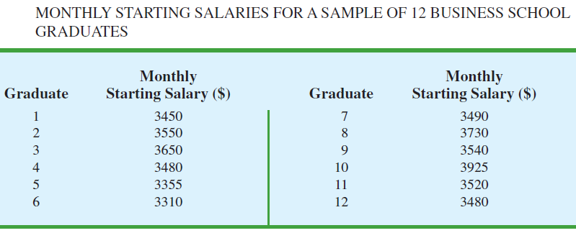

Calculate 85th percentile and Median (i.e. 50th percentile).

Solution: (85th percentile)
- Arrange the data in ascending order.
- Compute the index
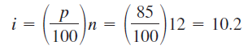
Because i is not an integer, round up.
The position of the 85th percentile is the next integer greater than 10.2, the 11th position.
Returning to the data, we see that the 85th percentile is the data value in the 11th position, or 3730.

Solution: (50th percentile)
- Arrange the data in ascending order.
- Compute the index
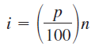 , 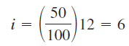
Because i =6 is an integer, so 50th percentile is the average of the values in positions i and i+1.
i.e. 50th percentile (Median) is the average of the values in positions 6 and 7.
At position 6, we have number 3490.
At position 7, we have number 3520.
Hence 50th percentile=Median=average of 3490 and 3520
= (3490+3520)/2=3505

Quartiles
- It is often desirable to divide data into four parts, with each part containing approximately one-fourth, or 25% of the observations.
- The division points are referred to as the quartiles and are defined as:
  - Q1 first quartile, or 25th percentile
  - Q2 second quartile, or 50th percentile (also the median)
  - Q3 third quartile, or 75th percentile.
Note: Quartiles are just specific percentiles;
thus, the steps for computing percentiles can be applied directly in the computation of quartiles.

Quartiles for Ungrouped Data
Computation:
- Arrange the data in ascending order (smallest value to largest value).
- Compute an index, i such that:
For First Quartile (Q₁), compute i=(25/100) n
For Second Quartile (Q₂), compute i=(50/100) n
For Third Quartile (Q₃), compute i=(75/100) n
Where, n is the number of observations.
  - If i is not an integer, round up. The next integer greater than i denotes the position of the pth percentile.
  - If i is an integer, then pth percentile is the average of the values in positions i and i+1.
Example:
Arrange the monthly starting salary data in ascending order.
For Q₁, Compute the index,
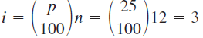
Because i =3 is an integer, so 25th percentile is the average of the values in positions i =3and i+1=4.
At position 3, we have number 3450.
At position 4, we have number 3480.
Hence Q₁=25th percentile= (3450+3480)/2=3465

For Q₃, Compute the index,
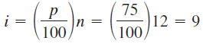
Because i =9 is an integer, so 75th percentile is the average of the values in positions i =9 and i+1=10.
Hence Q₃=75th percentile= (3550+3650)/2=3600

Note: Q₂=Median has already been calculated=3505

Note that, the quartiles divide the starting salary data into four parts, with each part containing 25% of the observations.
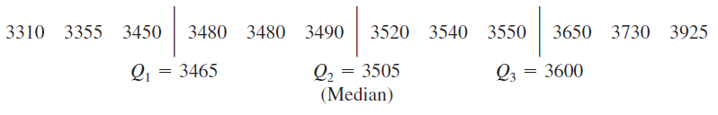
Deciles
It is often desirable to divide data into ten parts instead of four, with each part containing approximately one-tenth, or 10% of the observations. The division points are referred to as the Deciles, denoted by: D1, D2, …, D9 and defined as:
  - D₁ first decile, or 10th percentile
  - D₂ second decile, or 20th percentile
  - D₃ third decile, or 30th percentile
  - D₄ fourth decile, or 40th percentile
  - D₅ fifth decile, or 50th percentile (or Median)
  - D₆ sixth decile, or 60th percentile
  - D₇ seventh decile, or 70th percentile
  - D₈ eighth decile, or 80th percentile
  - D₉ ninth decile, or 90th percentile
Note: Deciles, like Quartiles are just specific percentiles;
thus, the steps for computing percentiles can be applied directly in the computation of quartiles.

Deciles for Ungrouped Data
Computation:
- Arrange the data in ascending order (smallest value to largest value).
- Compute an index, i such that:
For First Decile (D₁), compute i=(10/100) n=(1/10)n
For Second Decile (D₂), compute i=(20/100) n=(2/10)n
And so on
For Ninth Decile (D₉), compute i=(90/100) n=(9/10)n
where, n is the number of observations.
  - If i is not an integer, round up. The next integer greater than i denotes the position of the corresponding Decile.
  - If i is an integer, then corresponding Decile is the average of the values in positions i and i+1.

Percentiles for Grouped Data
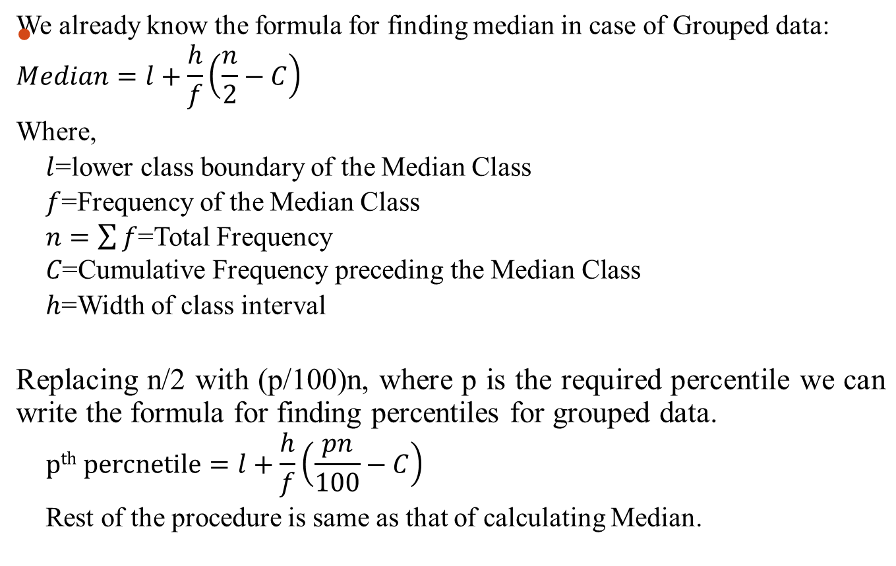
Example: Calculate 10th Percentile (p₁₀) for the distribution of examination marks provided below:
Marks | No of Students (f)
30-39 | 8
40-49 | 87
50-59 | 190
60-69 | 304
70-79 | 211
80-89 | 85
90-99 | 20
Solution:
- Calculate Class Boundaries
- Calculate Cumulative Frequency (cf)
- Find 10th Percentile Class:
- 10th Percentile=Marks obtained by [(10/100)n]^{th} student=905/10=90.5th student. Locate 90.5 in the Cumulative Freq. column. Hence 59.5-69.5 is the Median Class.
- Find l, h, f and c. Note that h=10

Marks | Class Boundaries | No of Students (f) | Cumulative Freq (cf)
30-39 | 29.5-39.5 | 8 | C=8
40-49 | l=39.5-49.5 | f=87 | 95
50-59 | 49.5-59.5 | 190 | 285
60-69 | 59.5-69.6 | 304 | 589
70-79 | 69.5-79.5 | 211 | 800
80-89 | 79.5-89.5 | 85 | 885
90-99 | 89.5-99.5 | 20 | 905
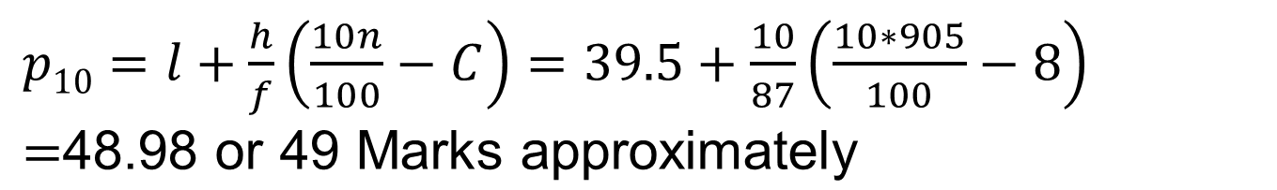

Quartiles for Grouped Data
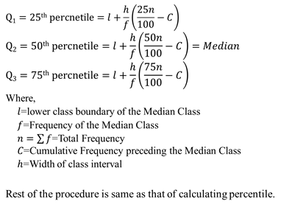
Deciles for Grouped Data
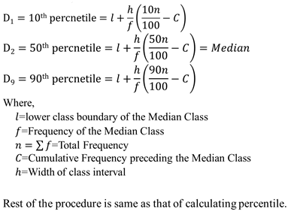
Quantiles
Note: Quartiles, Deciles, percentiles are called Quantiles.

Lecture 12

Using MS Excel to calculate:
- Mean
- Median
- Mode
- Geometric Mean
- Harmonic Mean
- Percentiles, Quartiles
Excel commands are:
For Arithmetic Mean, the command is:
=AVERAGE(A1:A10), where A1:A10 contains the data points of which we want to calculate the arithmetic mean
See lecture video for details.

Lecture 13
Lecture Outline
- Measures of Dispersion
- Characteristics of a suitable measure of dispersion
- Types of measures of dispersion
- Main measures of dispersion
  - The Range
    - Coefficient of Dispersion
  - Semi-Interquartile Range or Quartile Deviation
    - Coefficient of Quartile Deviation
  - Mean (or Average) Deviation
    - Coefficient of Mean Deviation

Measures of Dispersion
A value of Central Tendency doesn’t adequately describe the data. For example: In comparing two data sets, we can have same average (mean, median or mode) but their individual observations may differ considerable from average. Thus we need additional information concerning with how the data are dispersed around the average. This is done by measuring the dispersion (i.e. spread of observations around the average value). A quantity that measures this characteristic is called a measure of dispersion, scatter or variability.

Characteristics of a Suitable Measure of Dispersion
A Measure of Dispersion should be:
- In the same units as the observations.
- Zero when all the observations are same.
- Independent of origin.
- Multiplied or divided by the constant when each observation is multiplied or divided by a constant.
In addition, it is also desirable that it should satisfy the conditions similar to those laid down for average (or measure of central tendency (discussed earlier). (i.e. should be defined by a mathematical formula, amenable to further mathematical treatment, shouldn’t be affected by extreme values, should be based on all observations etc.)

Types of Measure of Dispersion
Two Main types of Measure of Dispersion:
- Absolute Measure of Dispersion
- Relative Measure of Dispersion

Absolute Measure of Dispersion
It measures the dispersion in terms of the same units or in the square of units, as the units of the data. For example: If the units of the data are rupees, meters , kilograms etc. then unit of measure of dispersion should also be rupees, meters , kilograms etc.

Relative Measure of Dispersion
It measures the dispersion in the form of a ratio or percentages and hence is independent of the unit of measurement. It is useful to compare data of different nature.
Note: A measure of central tendency together with the measure of dispersion gives an adequate description of the data.

Main Measures of Dispersion
Main measures of dispersion are:
- The Range
- The Semi-Interquartile Range or the Quartile Deviation
- The Mean Deviation or the Average Deviation
- The Variance and the Standard Deviation
Note: In this lecture, we will discuss Range, The Semi-Interquartile Range and Mean Deviation.
The discussion of variance and standard deviation will be covered in next lecture.

The Range
The Range (R) is defined as the difference between the largest and the smallest observations in a set of data. Symbolically, Range=R=x_{m}-x₀
Where, x_{m} is the largest observation
x₀ is the smallest observation

In case of Grouped Data:
Range is the difference between the upper boundary of the highest class and the lower boundary of the lowest class.

Note: Range can’t be computed if there are any open-end classes in the frequency distribution.

Range is simple to measure and easy to understand but it has two serious disadvantages.
First: It ignores all the observations available from the intermediate observations.
Second: Since it is based only on two extreme observations, so it might give misleading picture of the spread of the data.
However it is used in statistical quality control charts of manufactured products, daily temperature, stock prices etc.
This is an absolute measure of dispersion.

Coefficient of Dispersion
Its relative measure known as the coefficient of dispersion
Coefficient of Dispersion=(x_{m}-x₀)/(x_{m}+x₀)
This is a dimensionless number and thus has no unit and it is used for purpose of comparison.

Example: The marks obtained by 9 students are given below:
45, 32, 37, 46, 39, 36, 41, 48, 36
Find the Range and the coefficient of dispersion.

Solution: Highest marks=x_{m}=48, Lowest marks=x₀=32
Range= x_{m}-x₀ =48-32=16 Marks
Coefficient of dispersion=(x_{m}-x₀)/(x_{m}+x₀)
=(48-32)/(48+32)
=16/80=1/5=0.2

Semi-Interquartile Range or Quartile Deviation
Interquartile range is a measure of dispersion, defined by the difference between the third and first quartiles.
Interquartile Range=IQR=Q₃-Q₁
Where Q₁= First Quartile, Q₃=Third Quartile

Semi-Interquartile Range (SIQR) or quartile deviation (Q.D) is the half of Interquartile range.
Q.D=(Q₃-Q₁)/2

Coefficient of Quartile Deviation
Q.D is also an absolute measure of dispersion like Range.
Its relative measure is called Coefficient of Quartile Deviation or of Semi-Interquartile Range.
Coefficient of Q.D=(Q₃-Q₁)/(Q₃+Q₁)
It is dimensionless and is used for comparing the variation in two or more data sets.

Example: The marks obtained by 9 students are given below:
45, 32, 37, 46, 39, 36, 41, 48, 36
Find IQR, Q.D and Coefficient of Q.D of the marks obtained by 9 students:

Solution: Using MS-Excel or analytical methods discussed in earlier lecture, we have:
Q1=36, Q3=45
Interquartile Range=IQR=Q₃-Q₁=45-36=9 Marks
Q.D=(Q₃-Q₁)/2=9/2=4.5 Marks
Coefficient of Q.D=(Q₃-Q₁)/(Q₃+Q₁)=(45-36)/(45+36)=9/81=1/9=0.11

Mean (or Average) Deviation
The Mean Deviation (M.D) of a set of data is defined as the arithmetic mean of the absolute deviations measured either from the mean or from the median.

Computation of M.D from Mean for Un-Grouped data:
For Sample Data: $M.D=\frac{\sum_{i=1}^{n}{\left|x_{i}-\overline{x}\right|}}{n}$
For Population Data: $M.D=\frac{\sum_{i=1}^{n}{\left|x_{i}-μ\right|}}{N}$

Computation of M.D from Median for Un-Grouped data:
For Sample Data: $M.D=\frac{\sum_{i=1}^{n}{\left|x_{i}-Median\right|}}{n}$
For Population Data: $M.D=\frac{\sum_{i=1}^{n}{\left|x_{i}-Median\right|}}{N}$

Computation of M.D from Mean for Grouped data:
For Sample Data: $M.D=\frac{\sum_{i=1}^{n}{f_{i}\left|x_{i}-\overline{x}\right|}}{\sum_{i=1}^{n}{f_{i}}}$
For Population Data: $M.D=\frac{\sum_{i=1}^{n}{f_{i}\left|x_{i}-μ\right|}}{\sum_{i=1}^{n}{f_{i}}}$

Computation of M.D from Median for Grouped data:
For Sample Data: $M.D=\frac{\sum_{i=1}^{n}{f_{i}\left|x_{i}-Median\right|}}{\sum_{i=1}^{n}{f_{i}}}$
For Population Data: $M.D=\frac{\sum_{i=1}^{n}{f_{i}\left|x_{i}-Median\right|}}{\sum_{i=1}^{n}{f_{i}}}$
Where, x_{i}’s are mid points or class marks
f_{i}’s are class frequencies.

Coefficient of Mean Deviation
Mean Deviation is an absolute measure of dispersion. Its relative measure of is Coefficient of Mean Deviation defined as:
Coefficient of M.D=M.D/Mean
Coefficient of M.D=M.D/Median

Example: The marks obtained by 9 students are given below:
45, 32, 37, 46, 39, 36, 41, 48, 36
Calculate:
a). Mean Deviation from Mean and coefficient of Mean Deviation
b). Mean Deviation from Median and coefficient of Mean Deviation

Solution: Note that, Mean=Xbar=360/9=40, Median= 39
 |  | X | X-Xbar | |x-xbar| | x-median | |x-median|
 |  | 45 | 5 | 5 | 6 | 6
 |  | 32 | -8 | 8 | -7 | 7
 |  | 37 | -3 | 3 | -2 | 2
 |  | 46 | 6 | 6 | 7 | 7
 |  | 39 | -1 | 1 | 0 | 0
 |  | 36 | -4 | 4 | -3 | 3
 |  | 41 | 1 | 1 | 2 | 2
 |  | 48 | 8 | 8 | 9 | 9
 |  | 36 | -4 | 4 | -3 | 3
Total |  | 360 | 0 | 40 |  | 39

M.D from Mean, $M.D=\frac{\sum_{i=1}^{n}{\left|x_{i}-\overline{x}\right|}}{n}=\frac{40}{9}=4.4 Marks$
M.D from Median, $M.D=\frac{\sum_{i=1}^{n}{\left|x_{i}-Median\right|}}{n}=\frac{39}{9}=4.3 Marks$
Coefficient of M.D from Mean=M.D/Mean =4.4/40=0.11
Coefficient of M.D from median=M.D/Med=4.3/39=0.11

Example: Calculate M.D of the following frequency distribution:

Weights (grams) | Frequency (f)
65-84 | 9
85-104 | 10
105-124 | 17
125-144 | 10
145-164 | 5
165-184 | 4
185-204 | 5

Solution: Note that formula for Mean Deviation is: $M.D=\frac{\sum_{i=1}^{n}{f_{i}\left|x_{i}-\overline{x}\right|}}{\sum_{i=1}^{n}{f_{i}}}$
- First calculate Arithmetic Mean, i.e. xbar. We can calculate mean for this grouped data by finding first midpoint (x) and then the product of frequency (f) and midpoint (x), i.e. f*x.
- The calculated value of mean is Mean=7350/60=122.5 grams
- Once mean is calculated, calculate x-xbar
- Then calculate f*|x-xbar|

Weights (grams) | Frequency (f) | Midpoint (x) | f*x | x-xbar | f*|x-xbar|
65-84 | 9 | 74.5 | 670.5 | -48 | 432
85-104 | 10 | 94.5 | 945 | -28 | 280
105-124 | 17 | 114.5 | 1946.5 | -8 | 136
125-144 | 10 | 134.5 | 1345 | 12 | 120
145-164 | 5 | 154.5 | 772.5 | 32 | 160
165-184 | 4 | 174.5 | 698 | 52 | 208
185-204 | 5 | 194.5 | 972.5 | 72 | 360
Total | 60 |  | 7350 |  | 1696

- Calculate Mean Deviation using formula,
$M.D=\frac{\sum_{i=1}^{n}{f_{i}\left|x_{i}-\overline{x}\right|}}{\sum_{i=1}^{n}{f_{i}}}=\frac{1696}{60}=28.27 Grams$
Lecture 14
Lecture Outline
- Variance
- Standard Deviation
- Chebyshev’s Rule
- Coefficient of Variation
- Properties of Variance
- Properties of Standard Deviation

Variance
The variance of a set of observations is defined as the mean of the squares of the deviations of all observations from their mean. It is denoted by Greek lower case $σ^{2}$ sigma square.
Computation of Variance for Un-Grouped data:
For Sample Data: $S^{2}=\frac{\sum_{i=1}^{n}{{\left(x_{i}-\overline{x}\right)}^{2}}}{n}$
For Population Data: $σ^{2}=\frac{\sum_{i=1}^{n}{{\left(x_{i}-μ\right)}^{2}}}{N}$
Computation of Variance for Grouped data:
For Sample Data: $S^{2}=\frac{\sum_{i=1}^{n}{{f_{i}\left(x_{i}-\overline{x}\right)}^{2}}}{\sum_{i=1}^{n}{f_{i}}}$
For Population Data: $σ^{2}=\frac{\sum_{i=1}^{n}{{f_{i}\left(x_{i}-μ\right)}^{2}}}{\sum_{i=1}^{n}{f_{i}}}$
Note: Variance is in square of units in which the observations are expressed.
Because of some nice mathematical properties, variance assumes an extremely important role in statistics. But Mean deviation due to absolute value of the deviations doesn’t have nice mathematical properties and hence its use is limited.

Standard Deviation
The positive square root of variance is called standard deviation. It is denoted by Greek lower case $σ$sigma (without square).
Computation of Standard Deviation for Un-Grouped data:
For Sample Data: S$=\sqrt{\frac{\sum_{i=1}^{n}{{\left(x_{i}-\overline{x}\right)}^{2}}}{n}}$
For Population Data: $σ=\sqrt{\frac{\sum_{i=1}^{n}{{\left(x_{i}-μ\right)}^{2}}}{N}}$
Computation of Standard Deviation for Grouped data:
For Sample Data: $S=\sqrt{\frac{\sum_{i=1}^{n}{{f_{i}\left(x_{i}-\overline{x}\right)}^{2}}}{\sum_{i=1}^{n}{f_{i}}}}$
For Population Data: $σ=\sqrt{\frac{\sum_{i=1}^{n}{{f_{i}\left(x_{i}-μ\right)}^{2}}}{\sum_{i=1}^{n}{f_{i}}}}$
Note: Standard Deviation has the same units in which the original observations are expressed and it is measure of average spread of the observations around their mean. Sometimes, we use an unbiased version of sample variance, which is given by: $s^{2}=\frac{\sum_{i=1}^{n}{{\left(x_{i}-\overline{x}\right)}^{2}}}{n-1}$, where, n is replaced by n-1 on the basis of the argument that the knowledge of any n-1 deviations automatically determines the remaining deviation because the sum of deviations must be zero. When sample size is small then $s^{2}=\frac{\sum_{i=1}^{n}{{\left(x_{i}-\overline{x}\right)}^{2}}}{n}$under estimates the population variance ($σ^{2}$). But when sample size is large then dividing by n or by n-1 are practically lead to same result.

Alternative Formulas

Computation of variance for Un-Grouped data:
For Sample Data: $S^{2}=\frac{\sum{x^{2}}}{n}-{\left(\frac{\sum{x}}{n}\right)}^{2}$
For Population Data: $σ^{2}=\frac{\sum{x^{2}}}{N}-{\left(\frac{\sum{x}}{N}\right)}^{2}$
Computation of standard deviation for Un-Grouped data:
For Sample Data: S$=\sqrt{\frac{\sum{x^{2}}}{n}-{\left(\frac{\sum{x}}{n}\right)}^{2}}$
For Population Data: $σ =\sqrt{\frac{\sum{x^{2}}}{N}-{\left(\frac{\sum{x}}{N}\right)}^{2}}$

Computation of variance for Grouped data:
For Sample Data: $S^{2}=\frac{\sum{fx^{2}}}{\sum{f}}-{\left(\frac{\sum{fx}}{\sum{f}}\right)}^{2}$
For Population Data: $σ^{2}=\frac{\sum{fx^{2}}}{\sum{f}}-{\left(\frac{\sum{fx}}{\sum{f}}\right)}^{2}$
Computation of standard deviation for Grouped data:
For Sample Data: $S=\sqrt{\frac{\sum{fx^{2}}}{\sum{fx}}-{\left(\frac{\sum{fx}}{\sum{f}}\right)}^{2}}$
For Population Data: $σ =\sqrt{\frac{\sum{fx^{2}}}{\sum{f}}-{\left(\frac{\sum{fx}}{\sum{f}}\right)}^{2}}$

Examples (Variance & SD):

Example: The marks obtained by 9 students are given below:
45, 32, 37, 46, 39, 36, 41, 48, 36
Calculate:
a). Variance
b). Standard Deviation
Solution: Note that the formula for variance is: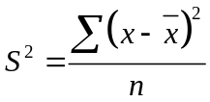
The necessary calculations are:
 | X | X-Xbar | (x-xbar)^2
 | 45 | 5 | 25
 | 32 | -8 | 64
 | 37 | -3 | 9
 | 46 | 6 | 36
 | 39 | -1 | 1
 | 36 | -4 | 16
 | 41 | 1 | 1
 | 48 | 8 | 64
 | 36 | -4 | 16
Total | 360 | 0 | 232

First calculate Arithmetic Mean or simply Mean, Mean=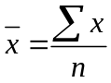=360/9=40
Then subtract mean from each of x values to get, 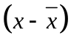. Square each value to obtain, 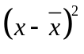. In the end take summation, 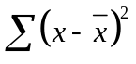
Hence the variance is:=232/9=25.77
Taking square root of variance to get SD, SD=5.0764

Example: Calculate: a). Variance b). Standard Deviation for the following frequency distribution:
Weights (grams) | Frequency (f)
65-84 | 9
85-104 | 10
105-124 | 17
125-144 | 10
145-164 | 5
165-184 | 4
185-204 | 5

Solution: Note the formula for variance is: 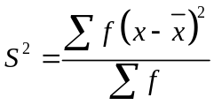. Note that first we have to calculate mean () and for this we need to calculate midpoint (x) and the product (f*x). once mean is calculated, we have to subtract mean from x to get then square it to get , and then calculate 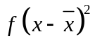. In the end take sum of it to get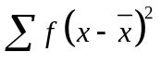.
The necessary calculation is provided below:
Weights (grams) | Frequency (f) | Midpoint (x) | f*x
65-84 | 9 | 74.5 | 670.5 | -48 | 2304 | 20736
85-104 | 10 | 94.5 | 945 | -28 | 784 | 7840
105-124 | 17 | 114.5 | 1946.5 | -8 | 64 | 1088
125-144 | 10 | 134.5 | 1345 | 12 | 144 | 1440
145-164 | 5 | 154.5 | 772.5 | 32 | 1024 | 5120
165-184 | 4 | 174.5 | 698 | 52 | 2704 | 10816
185-204 | 5 | 194.5 | 972.5 | 72 | 5184 | 25920
Total | 60 |  | 7350 |  |  | 72960

Mean ()=7350/60=122.5 grams

Variance= 72960/60=1216
Taking square root of variance to get SD, SD=34.87

Examples: using alternative formula
Example: Calculate: a). Variance b). Standard Deviation for the following data of marks using Alternative formula:
X
45
32
37
46
39
36
41
48
36
Solution: The necessary calculations are provided below:
X | X^2
45 | 2025
32 | 1024
37 | 1369
46 | 2116
39 | 1521
36 | 1296
41 | 1681
48 | 2304
36 | 1296
Total:360 | Total:14632

Variance is given by: 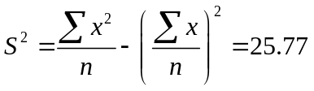
In order to calculate SD, just take square root of variance, so we have, SD=5.076

Example: Calculate: a). Variance b). Standard Deviation for the following frequency distribution of weights (using Alternative formula):
Weights (grams) | Frequency (f)
65-84 | 9
85-104 | 10
105-124 | 17
125-144 | 10
145-164 | 5
165-184 | 4
185-204 | 5
Total | 60

Solution: The formulas for the variance and SD are:
$$S^{2}=\frac{\sum{fx^{2}}}{\sum{fx}}-{\left(\frac{\sum{fx}}{\sum{f}}\right)}^{2}$$
$$S=\sqrt{\frac{\sum{fx^{2}}}{\sum{fx}}-{\left(\frac{\sum{fx}}{\sum{f}}\right)}^{2}}$$
So in order to calculate S and S2, we need to calculate first the midpoint (x), then the product (f*x) and then f*x². Once we have these in hand then simply summing these entries to get variances and SD. The necessary calculations are provided below.

Weights (grams) | Frequency (f) | Midpoint (x) | f*x | x^2 | f*x^2
65-84 | 9 | 74.5 | 670.5 | 5550.25 | 49952.25
85-104 | 10 | 94.5 | 945 | 8930.25 | 89302.5
105-124 | 17 | 114.5 | 1946.5 | 13110.25 | 222874.3
125-144 | 10 | 134.5 | 1345 | 18090.25 | 180902.5
145-164 | 5 | 154.5 | 772.5 | 23870.25 | 119351.3
165-184 | 4 | 174.5 | 698 | 30450.25 | 121801
185-204 | 5 | 194.5 | 972.5 | 37830.25 | 189151.3
Total | 60 |  | 7350 |  | 973335

$S^{2}=\frac{\sum{fx^{2}}}{\sum{fx}}-{\left(\frac{\sum{fx}}{\sum{f}}\right)}^{2}=1216$
$S=\sqrt{\frac{\sum{fx^{2}}}{\sum{fx}}-{\left(\frac{\sum{fx}}{\sum{f}}\right)}^{2}}=\sqrt{1216}=34.87$

Chebyshev’s Rule
A link between the Standard Deviation and fraction of data included in intervals constructed around mean is suggested by a Russian Mathematican P. L. Chebyshev, (known as Chebyshev’s (pronounced as chi - bih – SHOFF) Rule):

“For any data set,
The interval $\left[\overline{x}-ks , \overline{x}+ks\right]$ contains at-least the fraction $\left(1-\frac{1}{k^{2}}\right)$ of data, where, k is any number greater than 1 and $\overline{x}$ & s are mean and SD respectively”.

Examples:
The interval $\left[\overline{x}-2s , \overline{x}+2s\right]$ contains at-least the fraction $\left(1-\frac{1}{2^{2}}\right)$ of data. i.e. ¾ of data.
The interval $\left[\overline{x}-3s , \overline{x}+3s\right]$ contains at-least the fraction $\left(1-\frac{1}{3^{2}}\right)$ of data. i.e. 8/9 of data.

Note: This rule can be applied to any distribution (population and Sample).

Coefficient of Variation
The variability of two or more than two data sets cannot be compared unless we have a relative measure of dispersion. For this purpose, Karl Pearson introduced a relative measure of variation, known as Coefficient of Variation (CV), defined as:
$\begin{matrix}\begin{aligned}C.V=\frac{S}{\overline{x}}×100, for Sample data \\ \end{aligned} \\ C.V=\frac{σ}{μ}×100, for Population data\end{matrix}$
Note that C.V is a pure number and hence it has no unit.
A large value of C.V indicates larger variability while a small value of C.V is an evidence of less variability. We can use Coefficient of variation to compare the performance of two individuals (candidates, players etc.) in various situations (exams, games etc.). The smaller the C.V is the more consistent the player or individual is.
Note: When mean is very small then C.V is UNRELIABLE.

Example: Data on goals scored by two teams (A & B) is given below:
Team A: 27, 9, 8, 5, 4
Team B: 17, 9, 6, 5, 3
By calculating C.V., find which team is more consistent.
Solution: Note that you can calculate Mean and SD using formulas for the ungrouped data. Once Mean and SD are in hand, then you can use formula for Coefficient of Variation (C.V),
$C.V=\frac{S}{\overline{x}}×100$
to calculate C.V for both teams.

 | Team A | Team B
 | 27 | 17
 | 9 | 9
 | 8 | 6
 | 5 | 5
 | 4 | 3
Mean | 10.6 | 8
SD | 8.404761 | 4.898979
CV | 79.30% | 61.20%

Note that C.V of Team A is larger than C.V of Team B, Hence team B is more consistent than Team A.

Properties of variance
Some useful properties of variance are:

- The variance of a constant is equal to zero.
Symbolically, Var(a)=0, where a is any constant.
- The variance is independent of the origin, i.e. it remains unchanged when a constant is added to or subtracted from each observation of the variable X.
Symbolically, Var(X+a)=Var(X) or Var(X-a)=Var(X) where a is any constant.
- The variance is multiplied or divided by the square of the constant when each observation of the variable X is either multiplied or divided by a constant.
Symbolically, Var(aX)=a²Var(X) and Var(X/a)=1/a² Var(X)
- The variance of the sum or difference of two independent variables (X and Y) is equal to sum of their respective variances.
Mathematically,
Var(X+Y)=Var(X)+Var(Y)
Var(X-Y)=Var(X)+Var(Y)
But if X and Y are not independent then
Var(X+Y)=Var(X)+Var(Y)+2Cov(X,Y)
Var(X-Y)=Var(X)+Var(Y)-2Cov(X,Y)
Where Cov(X,Y) is the covariance between X and Y. We will study about Covariance in detail later.

Properties of SD
Since SD is the positive square root of variance, so all properties of variance are valid for SD as well.
- SD(a)=0, where a is any constant.
- SD(X+a)=SD(X) or SD(X-a)=SD(X) where a is any constant.
- SD(aX)=|a| SD(X), since SD can’t be negative.
- SD(X/a)=|1/a| SD(X) , since SD can’t be negative.
- $SD\left(X±Y\right)=\sqrt{Var\left(X\right)+Var\left(Y\right)}$

Lecture 15
Lecture Outline
- Moments
  - Central (or Mean) Moments
  - Moments about (arbitrary) Origin
  - Moments about zero

Moments
A moment is a quantitative measure of the shape of a set of points. The first moment is called the mean which describes the center of the distribution. The second moment is the variance which describes the spread of the observations around the center. Other moments describe other aspects of a distribution such as how the distribution is skewed from its mean or peaked.
A moment designates the power to which deviations are raised before averaging them.

Central (or Mean) Moments
In mean moments, the deviations are taken from the mean.

Formula for Ungrouped Data:
$$\begin{matrix}First Population Moment about Mean=μ_{1}=\frac{\sum{\left(x_{i}-μ\right)}}{N} \\ Second Population Momentabout Mean=μ_{2}=\frac{{\sum{\left(x_{i}-μ\right)}}^{2}}{N} \\ First Sample Momentabout Mean=m_{1}=\frac{\sum{\left(x_{i}-\overline{x}\right)}}{n} \\ Second Sample Momentabout Mean=m_{2}=\frac{{\sum{\left(x_{i}-\overline{x}\right)}}^{2}}{n}\end{matrix}$$

In General,
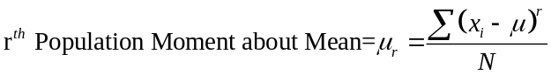
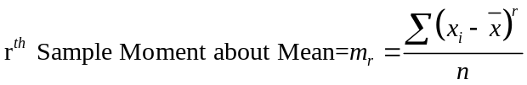

Formula for Grouped Data:
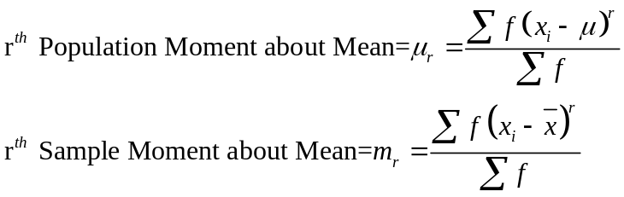

Example: Calculate first four moments about the mean for the following set of examination marks:
X
45
32
37
46
39
36
41
48
36

Solution: For solution, move to MS-Excel.

Moments about (arbitrary) Origin
If the deviations are taken from some arbitrary number (‘a’ called origin), then moments are called moments about arbitrary origin ‘a’.

Formula for Ungrouped Data:
$$\begin{matrix}r^{th} Population Moment about Origin 'a'=μ_{r}^{'}=\frac{{\sum{\left(x_{i}-a\right)}}^{r}}{N} \\ r^{th} Sample Moment about Origin 'a'=m_{r}^{'}=\frac{{\sum{\left(x_{i}-a\right)}}^{r}}{n}\end{matrix}$$

Formula for Grouped Data:
$\begin{matrix}r^{th} Population Moment about Origin 'a'=μ_{r}^{'}=\frac{{\sum{f\left(x_{i}-a\right)}}^{r}}{\sum{f}} \\ r^{th} Sample Moment about Origin 'a'=m_{r}^{'}=\frac{{\sum{f\left(x_{i}-a\right)}}^{r}}{\sum{f}}\end{matrix}$

Moments about zero
If origin is taken as zero. i.e. a=0, moments are called moments about zero.

Formula for Ungrouped Data:
$$\begin{matrix}r^{th} Population Moment about Zero=μ_{r}^{'}=\frac{{\sum{\left(x_{i}-0\right)}}^{r}}{N}=\frac{{\sum{\left(x_{i}\right)}}^{r}}{N} \\ r^{th} Sample Moment about Zero=m_{r}^{'}=\frac{{\sum{\left(x_{i}-0\right)}}^{r}}{n}=\frac{{\sum{\left(x_{i}\right)}}^{r}}{n}\end{matrix}$$

Formula for Grouped Data:
$\begin{matrix}r^{th} Population Moment about Zero=μ_{r}^{'}=\frac{{\sum{f\left(x_{i}-0\right)}}^{r}}{\sum{f}}=\frac{{\sum{f\left(x_{i}\right)}}^{r}}{\sum{f}} \\ r^{th} Sample Moment about Zero=m_{r}^{'}=\frac{{\sum{f\left(x_{i}-0\right)}}^{r}}{\sum{f}}=\frac{{\sum{f\left(x_{i}\right)}}^{r}}{\sum{f}}\end{matrix}$
Example: Calculate first four moments about zero (origin) for the following set of examination marks:
Weights (grams) | Frequency (f)
65-84 | 9
85-104 | 10
105-124 | 17
125-144 | 10
145-164 | 5
165-184 | 4
185-204 | 5
Total | 60

Solution: For solution, move to MS-Excel.

Lecture 16
Lecture Outline
- Conversion from Moments about Mean to Moments about Origion
- Moment Ratios
  - Skewness
  - Kurtosis
  - Excess Kurtosis
- Standardized Variable
- Describing a Frequency Distribution

Conversion from Moments about Mean to Moments about Origion

Sample Moments about Mean in terms of Moments about Origion.
$$\begin{matrix}m_{1}=m_{1}^{'}-m_{1}^{'}=0 \\ m_{2}=m_{2}^{'}-{\left(m_{1}^{'}\right)}^{2} \\ m_{3}=m_{3}^{'}-3m_{2}^{'}m_{1}^{'}+2{\left(m_{1}^{'}\right)}^{3} \\ m_{4}=m_{4}^{'}-4m_{3}^{'}m_{1}^{'}+6m_{2}^{'}{\left(m_{1}^{'}\right)}^{2}-3{\left(m_{1}^{'}\right)}^{2}\end{matrix}$$
Population Moments about Mean in terms of Moments about Origion.
$$\begin{matrix}μ_{1}=μ_{1}^{'}-μ_{1}^{'}=0 \\ μ_{2}=μ_{2}^{'}-{\left(μ_{1}^{'}\right)}^{2} \\ μ_{3}=μ_{3}^{'}-3μ_{2}^{'}μ_{1}^{'}+2{\left(μ_{1}^{'}\right)}^{3} \\ μ_{4}=μ_{4}^{'}-4μ_{3}^{'}μ_{1}^{'}+6μ_{2}^{'}{\left(μ_{1}^{'}\right)}^{2}-3{\left(μ_{1}^{'}\right)}^{2}\end{matrix}$$

Moment Ratios
Ratios involving moments are called moment-ratios.
Most common moment ratios are defined as:
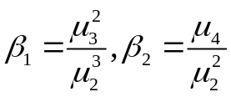
Since these are ratios and hence have no unit.

For symmetric distributions, $β_{1}$is equal to zero. So it is used as a measure of skewness.

$β_{2}$is used to explain the shape of the curve and it is a measure of peakedness.

For normal distribution (Bell-Shaped Curve), $β_{2}=3$.
For sample data, moment ratios can be similarly defined as:
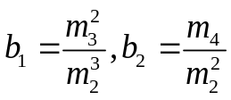

Standardized Variable

It is often convenient to work with variables where the mean is zero and the standard deviation is one.

If X is a random variable with mean μ and standard deviation σ, we can define a second random variable Z such that Z will have a mean of zero and a standard deviation of one. $z=\frac{x-μ}{σ}$

We say that X has been standardized, or that Z is a standard random variable.

In practice, if we have a data set and we want to standardize it, we first compute the sample mean and the standard deviation. Then, for each data point, we subtract the mean and divide by the standard deviation.

We can express moment ratios in terms of standardized variable as well.

Consider first moment ratio ($β_{1}$),

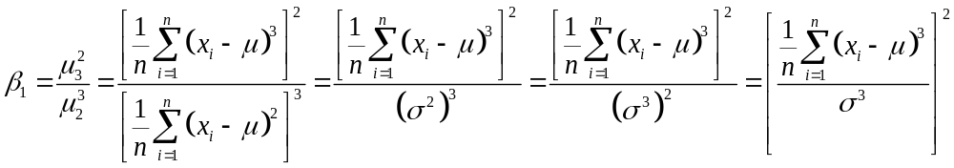

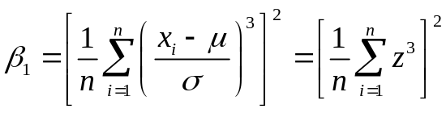

Hence $β_{1}$ is the square of the third population moment expressed in standard units.

Now consider second moment ratio ($β_{2}$),

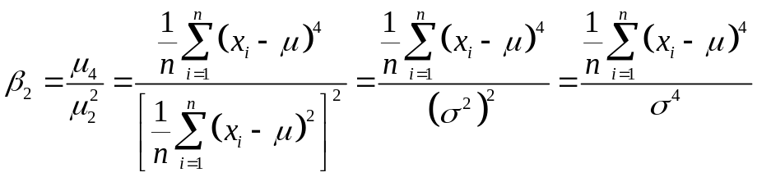

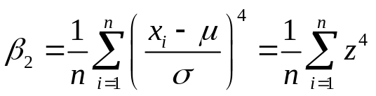

Hence $β_{2}$is the fourth population moment expressed in standard units.

Skewness
A distribution where the values equidistant from the mean have equal frequencies and is called Symmetric Distribution.
Any departure from symmetry is called skewness.

In a perfectly symmetric distribution, Mean=Median=Mode and the two tails of the distribution are equal in length from the mean. These values are pulled apart when the distribution departs from symmetry and consequently one tail become longer than the other.
- If right tail is longer than the left tail then the distribution is said to have positive skewness. In this case, Mean>Median>Mode
- If left tail is longer than the right tail then the distribution is said to have negative skewness. In this case, Mean<Median<Mode
- When the distribution is symmetric, the value of skewness should be zero.

Coefficient of skewness
Karl Pearson defined coefficient of Skewness as:
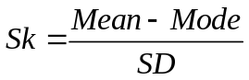
Since in some cases, Mode doesn’t exist, so using empirical relation, 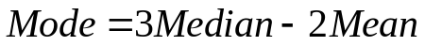
We can write,
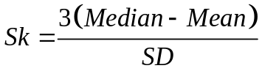
(it ranges b/w -3 to +3)

According to Bowley (a British Statistician), coefficient of skewness (also called Quartile skewness coefficient) is:
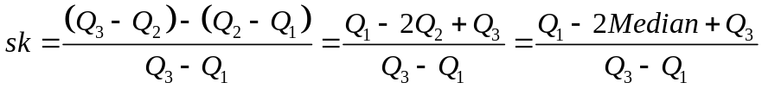

Example: Calculate Skewness, when median is 49.21, while the two quartiles are Q₁=37.15 and Q₃=61.27.
Using above formula, we have, sk=0 (because numerator is zero)

Another measure of skewness mostly used is by using moment ratio (denoted by $\sqrt{β_{1}}$):
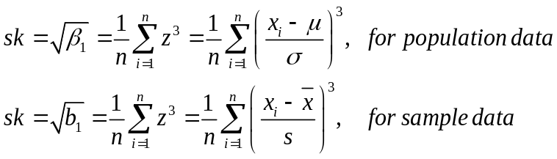

Alternative equivalent formula for Skewness is:
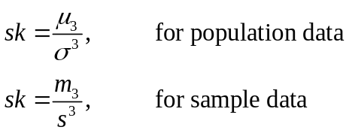
For symmetric distributions, it is zero and has positive value for positively skewed distribution and takes negative value for negatively skewed distributions.

Kurtosis
Karl Pearson introduced the term Kurtosis (literally the amount of hump) for the degree of peakedness or flatness of a unimodal frequency curve.

When the peak of a curve becomes relatively high then that curve is called Leptokurtic.
When the curve is flat-topped, then it is called Platykurtic.
Since normal curve is neither very peaked nor very flat topped, so it is taken as a basis for comparison and it is called Mesokurtic.
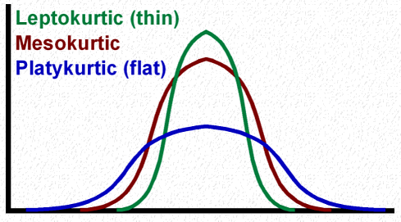
Kurtosis is usually measured by the moment ratio ($β_{2}$).
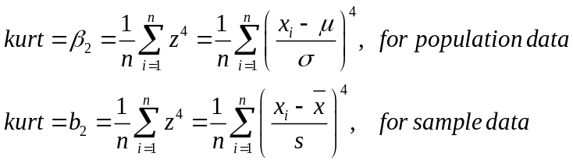

Alternative equivalent formula for Kurtosis is:
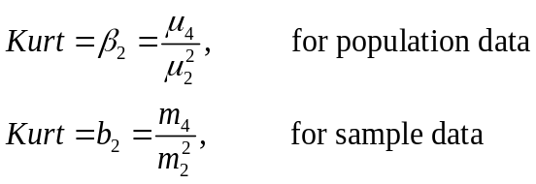
- For normal distribution Kurtosis is equal to 3.
- When is greater than 3, the curve is more sharply peaked and has narrower tails than the normal curve and is said to be leptokurtic.
- When it is less than 3, the curve has a flatter top and relatively wider tails than the normal curve and is said to be platykurtic.

Excess Kurtosis (EK): It is defined as: EK=Kurtosis-3
Since Kurtosis=3 for Normal Distribution so Excess Kurtosis=EK=0 in case of normal distribution. Hence we have three cases:

- When EK>0, then the curve is said to be Leptokurtic.
- When EK=0, then the curve is said to be Mesokurtic.
- When EK<0, then the curve is said to be Platykurtic.
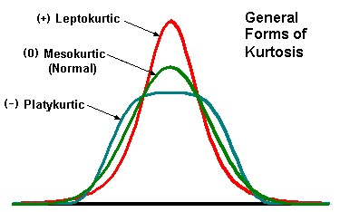

Another measure of Kurtosis, known as Percentile coefficient of kurtosis is:
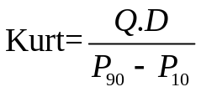
Where,
Q.D is semi-interquartile range=Q.D=(Q₃-Q₁)/2
P₉₀=90th percentile
P₁₀=10th percentile

Describing a Frequency Distribution
To describe the major characteristics of a frequency distribution, we need to calculate the following five quantities:
- The total number of observations in the data.
- A measure of central tendency (e.g. mean, median etc.) that provides the information about the center or average value.
- A measure of dispersion (e.g. variance, SD etc.) that indicates the spread of the data.
- A measure of skewness that shows lack of symmetry in frequency distribution.
- A measure of kurtosis that gives information about its peakedness.
- Describing a Frequency Distribution
It is interesting to note that all these quantities can be derived from the first four moments.
For example,
- The first moment about zero is the arithmetic mean
- The second moment about mean is the variance.
- The third standardized moment is a measure of skewness.
- The fourth standardized moment is used to measure kurtosis.
Thus first four moments play a key role in describing frequency distributions.

Lecture 17
Lecture Outline
- Probability: Basic Idea
- Sets
  - Basic concepts of sets
  - Laws of Sets
  - Cartesian Product of sets
- Venn-Diagram
- Random Experiment
  - Sample space
  - Events and their types
- Counting Sample Points
  - Rule of multiplication
  - Rule of Permutation
  - Rule of Combination
- Probability examples

Probability
Probability (or likelihood) is a measure or estimation of how likely it is that something will happen or that a statement is true.

For example, it is very likely to rain today or I have a fair chance of passing annual examination or A will probably win a prize etc.
In each of these statements the natural state of likelihood is expressed.

Probabilities are given a value between 0 (0% chance or will not happen) and 1 (100% chance or will happen). The higher the degree of probability, the more likely the event is to happen, or, in a longer series of samples, the greater the number of times such event is expected to happen.

Probability is used widely in different fields such as: mathematics, statistics, economics, management, finance, operation research, sociology, psychology, astronomy, physics, engineering, gambling and artificial intelligence/machine learning to, for example, draw inferences about the expected frequency of events.

Probability theory is best understood through the application of the modern set theory. So first we are presenting some basic concepts, notations and operations of set theory that are relevant to probability.

Sets
A set is a well-defined collection of or list of distinct objects. For example:
- A group of students
- Number of books in a library
- Integers between 1and 100
- The objects that are in a set are called members or elements on that set.

Sets are usually denoted by capital letters such as A, B, C, Z etc, while their elements are represented by small letters such as a, b, c and z etc. Elements are enclosed by braces to represent a set, e.g.
A={a,b,c,z} or B={1,2,3,4,5}
If x is an element of a set A, we write, $x∈A$, which is read as ‘x belongs to A’ or ‘x is in A’.
If x is not an element of a set A, we write,$x∉A$, which is read as ‘x belongs to A’ or ‘x is in A’.

Null or Empty Set: A set containing no elements, denoted by Ф.
Note: {0} is not an empty set instead it has an element ‘0’.

Singleton or Unit Set: A set containing only one element. e.g. A={1}, B={7} etc.

Representation of a Set:
A={x| x is an odd number and x<12}
B={x| x is a month of the year}
C={1,2,3,4…,10}

Subsets: A set ‘A’ is called subset of set ‘B’ if every element of set A is also an element of set B, we write A $⊂$ B or B$⊃$A.

Example: A={1,2,3} and B={1,2,3,4,5}, so we can see that A $⊂$ B

Equal sets: Two sets A and B are said to be equal (A=B), if A $⊂$ B and B $⊂$ A.

Universal Set or Space: A large set of which all the sets we talk about are subsets, denoted by S or Ω.
The universal set thus contains all possible elements under consideration.

Venn-Diagram
Venn-Diagrams are used to represent sets and subsets in a pictorial way and to verify the relationship among sets and subsets. In venn-diagram, a rectangle is used to represent the universal set or space S, whereas the sets are represented by circular regions.
Example:

A simple venn-diagram
S
A
B
Operations on Sets
AUB
A$∩$B
A’
A-B or A difference B

Laws of Sets

Let A, B and C be any subsets of the universal set S.

Commutative Law
AUB=BUA A$∩$B= B$∩A$

Associative Law
AU(BUC)=(AUB)UC A$∩$(B $∩$C)=(A $∩$B) $∩$C

Distributive Law
AU(B $∩$C)=(AUB) $∩$(AUC) A $∩$(BUC)=(A $∩$B) $U$(A $∩$C)

Idempotent Laws
AUA=A A $∩$A=A

Identity Laws
AUS=S A $∩$S=A AU Ф =A A $∩$ Ф =Ф

Complementation Laws

De-Morgan’s Laws
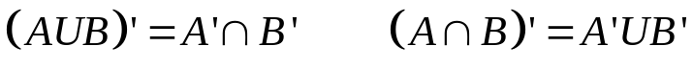

Class of Sets: A set of sets. E.g. A={ {1}, {2}, {3} }

Power Set: A set of all subsets of A is called power set of set A.
Example: Let A={H,T} then P(A)={Ф, {H}, {T}, {H,T} }

Cartesian Product of sets: The Cartesian product of sets A and B, denoted by AxB is a set that contains all ordered pairs (x,y) where x belongs to A and y belongs to B.
Symbolically, we write, AxB={ (x,y)| x A and y B}
Example: Let A={H,T}, B={1,2,3,4,5,6}
AxB={(H,1), (H,2), (H,3), (H,4), (H,5), (H,6), (T,1), (T,2), (T,3), (T,4), (T,5), (T,6) }

Experiment: Experiment means a planned activity or process whose results yield a set of data.

Trial: A single performance of an experiment is called a trial.

Outcome: The result obtained from an experiment or a trial is called an outcome.

Random Experiment: An experiment which produces different results even though it is repeated a large number of times under essentially similar conditions, is called a random experiment.
Examples:
- The tossing of a fair coin
- The throwing of a balanced die
- Drawing a card from a well shuffled deck of 52 playing cards etc.

Sample Space: A set consisting of all possible outcomes that can result from a random experiment is called sample space, denoted by S.
Sample Points: Each possible outcome is a member of the sample space and is called sample point in that space.

For instance, the experiment of tossing a coin results in either of the two possible outcomes: a head (H) or a tail (T), rolling on its edge is not considered.

The sample space is: S={H,T}

Sample space for tossing two coins once (or tossing a coin twice) is : S={HH,HT,TH,TT}

Sample Space for tossing a die is: S={1,2,3,4,5,6}

Sample space for tossing two dice or (tossing a die twice) is:
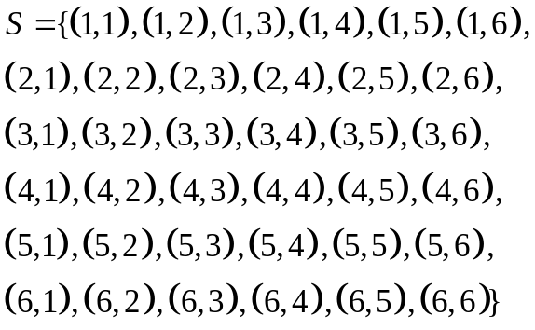

Event: An event is an individual outcome or any number of outcomes of a random experiment.
In set terminology, any subset of a sample space S of the experiment is called an event.
Example: Let S={H,T}, then Head (H) is an event, tail (T) is another event, {H,T} is also an event.

Mutually Exclusive Events: Two events A and B of a single experiment are said to be mutually exclusive iff they can’t occur at the same time. i.e. they have no points in common.

Example1: Let S={H,T}
Let A={H}, B={T}, then A and B are mutually exclusive events

Example2: Let S={1,2,3,4,5,6}
Let A={2,4,6}, B={4,6}, here A and B are not mutually exclusive events.

Exhaustive Events: Events are said to be collectively exhaustive when union of mutually exclusive events is the entire sample space S.

Example: In tossing a fair coin, S={H,T} and two events, A={H} and B={T} are mutually exclusive and also their union AUB is sample space S.

Equally likely events: Two sets are said to be equally likely when one event is as likely to occur as the other.

Example: In tossing of a fair coin, the two events Head and Tail are equally likely.

Counting Sample Points
When the number of sample points in a sample space S is very large, it becomes very inconvenient and difficult to list them all and to count the number of points in the sample space and in the subsets of S.
We then need some methods or rules which help us to count the number of all sample points without actually listing them.
A few of the basic rules frequently used are:
- Rule of multiplication
- Rule of Permutation
- Rule of Combination

Rule of multiplication
If a compound experiment consists of two experiments such that the first experiment has exactly m distinct outcomes and if corresponding to each outcome of the first experiment there can be n distinct outcomes of the second experiment, then the compound experiment has exactly m*n outcomes.
Example: Compound experiment of tossing a coin and throwing a die together consists of two experiments: Coin tossing with two distinct outcomes (H, T) and the die throwing with six distinct outcomes (1,2,3,4,5,6).
The total number of possible distinct outcomes of the compound experiment is 2x6=12.
See the Cartesian product:
Let A={H,T}, B={1,2,3,4,5,6}
AxB={(H,1), (H,2), (H,3), (H,4), (H,5), (H,6), (T,1), (T,2), (T,3), (T,4), (T,5), (T,6) }, n(AxB)=12

Rule of Permutation
A permutation is any ordered subset from a set of n distinct objects.
The number of permutations of r objects selected in a definite order from n distinct objects is denoted by ^{n}P_{r} and is given by:
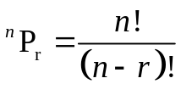
Example: A club consists of four members. How many sample points are in the sample space when three officers: president, secretary and treasurer, are to be chosen?
Solution: Note that order in which three officers are to be chosen is of importance. Thus there are four choices for the first officer, 3 choices for the second officer and 2 choices for the third officer. Hence total number of sample points are 4x3x2x1=24.
The number of permutations is:
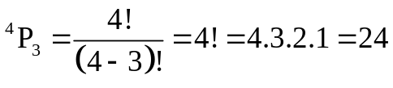
Rule of Combination
A combination is any subset of r objects, selected without regard to their order, from a set of n distinct objects.
The total number of such combinations is denoted by
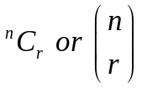
and is given by:
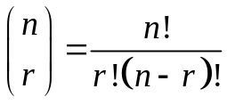
Example: A three person committee is to be formed from a list of four persons. How many sample points are associated with the experiment?
Solution: Since order doesn’t matter here, so total number of combinations are:
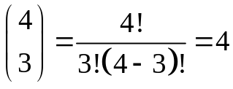

Lecture 18
Lecture Outline
- Definition of Probability and its properties
- Some basic questions related to probability
- Laws of probability
- More examples of probability

Probability
Probability of an event A:
Let S be a sample space and A be an event in the sample space. Then the probability of occurrence of event A is defined as:
P(A)=Number of sample points in A/ Total number of sample points
Symbolically, P(A)=n(A)/n(S)

Properties of Probability of an event:
- P(S)=1 for the sure event S
- For any event A,
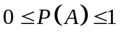
- If A and B are mutually exclusive events, then P(AUB)=P(A)+P(B)

Probability: Examples
Example: A fair coin is tossed once; Find the probabilities of the following events:
- An head occurs
- A tail occurs

Solution: Here S={H,T}, so, n(S)=2
Let A be an event representing the occurrence of an Head, i.e. A={H}, n(A)=1
P(A)=n(A)/n(S)=1/2=0.5 or 50%
Let B be an event representing the occurrence of a Tail, i.e. B={T}, n(B)=1
P(B)=n(B)/n(S)=1/2=0.5 or 50%.

Example: A fair die is rolled once, Find the probabilities of the following events:
- An even number occurs
- A number greater than 4 occurs
- A number greater than 6 occurs
Solution: Here S={1,2,3,4,5,6}, n(S)=6
a). An even number occurs
Let A=An even number occurs={2,4,6}, n(A)=3
P(A)=n(A)/n(S)=3/6=1/2=0.5 or 50%
b). A number greater than 4 occurs
Let B=A number greater than 4 occurs={5,6}, n(B)=2
P(B)=n(B)/n(S)=2/6=1/3=0.3333 or 33.33%
c). A number greater than 6 occurs
Let C=A number greater than 6 occurs={}, n(C )=0
P(C)=n(C)/n(S)=0/6=0 or 0%

Example: If two fair dice are thrown, what is the probability of getting (i) a double six? (ii). A sum of 11 or more dots?
Solution: Here
So, n(S)=36
Let A=a double six={(6,6)}, n(A)=1, P(A)=1/36
Let B= a sum of 11 or more dots
B={(5,6), (6,5), (6,6)}, n(B)=3, P(B)=3/36

Example: A fair coin is tossed three times. What is the probability that:
- At-least one head appears
- More heads than tails appear
- Exactly two tails appear

Solution: Here S={HHH, HHT, HTH, THH, HTT, THT, TTH, TTT}, n(S)=8
a). At-least one head appears
Let A=At-least one head appears={HHH, HHT, HTH, THH, HTT, THT, TTH}, n(A)=7
P(A)=n(A)/n(S)=7/8
b). More heads than tails appear
Let B= More heads than tails appear ={HHH, HHT, HTH, THH}, n(B)=4
P(B)=n(B)/n(S)=4/8=1/2=0.5 or 50%
c). Exactly two tails appear
Let C=Exactly two tails appear={HTT, THT, TTH}, n(C )=3
P(C)=n(C)/n(S)=3/8

Example: An employer wishes to hire three people from a group of 15 applicants, 8 men and 3 women, all of whom are equally qualified to fill the position. If he selects three people at random. What is the probability that:
- All three will be men
- At-least one will be a women
Solution: Total number of ways in which three people can be selected out of 15 are:$\left(\begin{matrix}15 \\ 3\end{matrix}\right)=455$. so n(S)=455
a). All three will be men
Let A= All three will be men, so
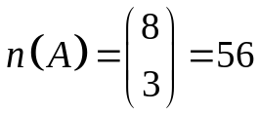
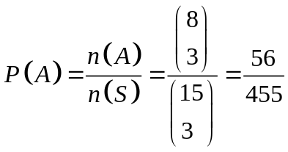
b). At-least one will be a women
Let B= At-least one will be a women=one or two or three women
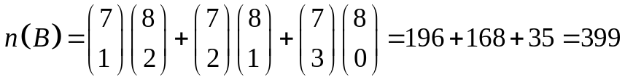
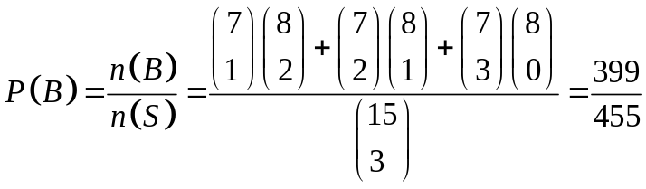

Example: Six white balls and four black balls, which are indistinguishable apart from color, are placed in a bag. If six balls are taken from the bag, find the probability of getting three white and three black balls?

Solution: Total number of possible equally likely outcomes are:
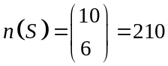
Let A=three white and three black balls
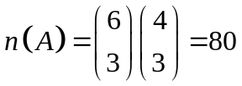
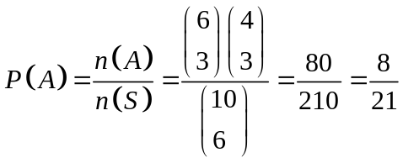
Laws of Probability
- If A is an impossible event then P(A)=0
- If A’ is complement of an event A relative to Sample space S then P(A’)=1-P(A)
S A’
A

Addition Law:
If A and B are any two events defined in a sample space S then:
P(AUB)=P(A)+P(B)-P(A$∩$B)

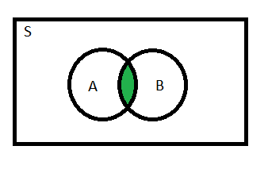
If A and B are two Mutually Exclusive events defined in a sample space S then:
P(AUB)=P(A)+P(B)
S
A
B

If A, B and C are any three events defined in a sample space S then:
P(AUB)=P(A)+P(B)+P(C)-P(A$∩$B) -P(B$∩$C) -P(C$∩$A) +P(A$∩$B$∩$C)

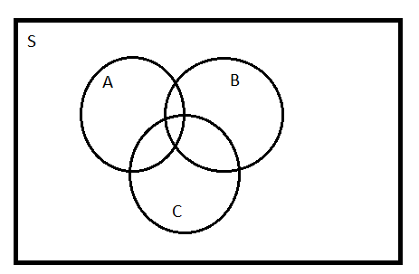

If A and B are two Mutually Exclusive events defined in a sample space S then:
P(AUBUC)=P(A)+P(B)+P(C)

Structure of a Deck of Playing Cards
Total Cards in an ordinary deck: 52
Total Suits: 4 Spades (♠), Hearts (♥), Diamonds (♦), Clubs (♣)
Cards in each suit: 13
Face values of 13 cards in each suit are:
Ace, 2, 3, 4, 5, 6, 7, 8, 9, 10, Jack, Queen and King
Clubs (♣)
Spades (♠)
Hearts (♥)
Diamonds (♦)
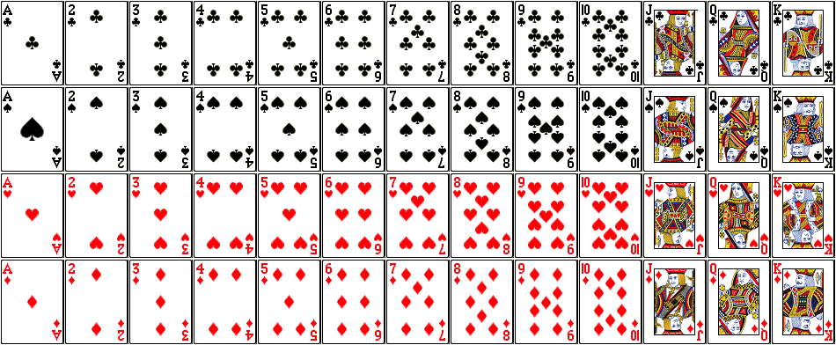
Honor Cards are: Ace, 10, Jack, Queen and King
Face Cards are: Jack, Queen, King
Popular Games of Cards are: Bridge and Poker

Example: If a card is drawn from an ordinary deck of 52 playing cards, find the probability that: a. It is a red card b. Card is a diamond c. Card is a 10 d. Card is a king e. A face card

Solution: Since total playing cards are 52, So, n(S)=52
a). A red Card
Let A=A red card, n(A)=26, P(A)=n(A)/n(S)=26/52=1/2
b). Card is a diamond
Let B= Card is a diamond, n(B)=13, P(B)=n(B)/n(S)=13/52=1/4
c). Card is a ten
Let C=Card is a ten, n(C )=3, P(C)=n(C)/n(S)=4/52=1/13
d). Card is a King
Let D=Card is a King, n(D )=4, P(D)=n(D)/n(S)=4/52=1/13
e). A face card
Let E=A face card, n(E )=12, P(E)=n(E)/n(S)=12/52=3/13

Example: If a card is drawn from an ordinary deck of 52 playing cards, what is the probability that the card is a club or a face card?

Solution: Since total playing cards are 52, So, n(S)=52
Let A=Card is a club, and let B=A face card
P(A or B)=P(AUB)=?
By addition, law, we have, P(AUB)=P(A)+P(B)-P(A$∩$B)
Note, P(A$∩$B)=n(A$∩$B)/n(S)=3/52 (As we have three face cards in the club suit)
n(A)=13, P(A)=13/52 n(B )=12, P(B)=12/52
So, P(AUB)=P(A)+P(B)-P(A$∩$B)=13/52+12/52-3/52=22/52

Example: An integer is chosen at random from the first 10 positive integers. What is the probability that the integer chosen is divisible by 2 or 3?

Solution: Since there are a total of 10 integers, So, n(S)=10
Let A=Integer is divisible by 2={2,4,6,8,10}, n(A)=5, P(A)=5/10
Let B=Integer is divisible by 3={3,6,9}, n(B)=3, P(B)=3/10
By addition, law, we have, P(A or B)=P(AUB)=P(A)+P(B)-P(A$∩$B)
(A$∩$B)={6}, n(A$∩$B)=1, P(A$∩$B)=n(A$∩$B)/n(S)=1/10
So, P(AUB)=P(A)+P(B)-P(A$∩$B)=5/10+3/10-1/10=7/10=0.7 or 70%

Example: A pair of dice is thrown, what is the probability of getting a total of either 5 or 11?

Solution: Here sample space is:
Note that n(S)=36
Let A=a total of 5 occurs={(1,4), (2,3), (3,2), (4,1)}, n(A)=4, P(A)=4/36
Let B= a total of 11 occurs={(5,6), (6,5)}, n(B)=2, P(B)=2/36
Note that A & B are mutually exclusive events,
So P(AUB)=P(A)+P(B)=4/36+2/36=6/36=1/6

Example: Three horses A, B and C are in a race; A is twice as likely to win as B and B is as likely to win as C what is the probability that A or B wins?

Solution: Let P(C)=p then P(B)=2P(C)=2p and P(A)=2P(B)=2(2p)=4p
Since A, B and C are mutually exclusive and collectively exhaustive events,
So P(A)+P(B)+P(C)=1
p+2p+4p=1, 7p=1, or p=1/7
So, P(C)=p=1/7, P(B)=2p=2/7, P(A)=4p=4/7
P(A or B wins)= P(AUB)=P(A)+P(B)=4/7+2/7=6/7

Lecture 19
Lecture Outline
- Conditional probability
- Independent and Dependent Events
- Related Examples

Conditional Probability
The sample space for an experiment must often be changed when some additional information related to the outcome of the experiment is received.
The effect of such additional information is to reduce the sample space by excluding some outcomes as being impossible which before receiving the information were believed possible.
The probabilities associated with such a reduced sample space are called conditional probabilities.

Example: Let us consider the die throwing experiment with sample space=S={1,2,3,4,5,6}
Suppose we wish to know the probability of the outcome that the die shows 6, say event A. So, P(A)=1/6=0.166
If before seeing the outcome, we are told that the die shows an even number of dots, say event B. Then this additional information that the die shows an even number excludes the outcomes 1,3 and 5 and thereby reduces the original sample space to only three numbers {2,4,6}. So P(6)=1/3=0.333
We call 1/3 or 0.333 as the conditional probability of event A because it is computed under the condition that the die has shown even number of dots.
P(Die shows 6/die shows even numbers)=P(A/B)=1/3=0.333
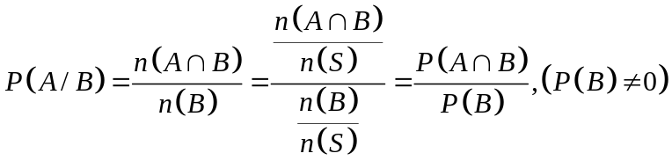

Example: Two coins are tossed. What the probability that two heads result, given that there is at-least one head?

Solution: S={HH,HT,TH,TT} , n(S)=4
Let A=Two Heads appear={HH}
Let B=at-least one head={HH,HT,TH}
P(A/B)=?
We have, P(A/B)=P(A$∩$B)/P(B)
P(A)=1/4, P(B)=3/4
(A$∩$B)={HH}, P(A$∩$B)=1/4
P(A/B)=P(A$∩$B)/P(B)=(1/4)/(3/4)=1/3=0.33

Example: Three coins are tossed. What the probability that two tails result, given that there is at-least one head?

Solution: S={HHH,HHT,HTH, THH, HTT, THT, TTH, TTT} , n(S)=8
Let A=Two tails appear={HTT, THT, TTH }
Let B=at-least one head={HHH,HHT,HTH, THH, HTT, THT, TTH}
P(A/B)=?
We have, P(A/B)=P(A$∩$B)/P(B)
P(A)=3/8, P(B)=7/8
(A$∩$B)={HTT, THT, TTH }, P(A$∩$B)=3/8
P(A/B)=P(A$∩$B)/P(B)=(3/8)/(7/8)=21/64

Example: A pair of dice is thrown, what is the probability that the sum of two dice will be 4, given that (i). The two dice has the same outcome.
Solution: Here
n(S)=36
Let A=Sum is 4={(1,3), (2,2), (3,1)}
Let B=same outcome on both dice={(1,1), (2,2) , (3,3) , (4,4) , (5,5) , (6,6)}
P(A/B)=?
We have, P(A/B)=P(A$∩$B)/P(B)
(A$∩$B)={(2,2)}, P(A$∩$B)=1/36
P(B)=6/36
P(A/B)=P(A$∩$B)/P(B)=(1/36)/(6/36)=1/6

Example: A pair of dice is thrown, what is the probability that the sum of two dice will be 7, given that (i). The sum is greater than 6?
Solution: Here n(S)=36
Let A=Sum is 7
Let B=Sum is greater than 6
P(A/B)=?
We have, P(A/B)=P(A$∩$B)/P(B)
P(A$∩$B)=6/36=1/6
P(B)=21/36=7/12
P(A/B)=P(A$∩$B)/P(B)=(1/6)/(7/12)=7/72

Multiplication Law
If A and B are any two events defined in a sample space S, then:
- P(A and B)=P(A$∩$B)=P(A/B)/P(B) , provided P(B) $≠$0
- P(A and B)=P(A$∩$B)=P(B/A)/P(A) , provided P(A) $≠$0

Independent Events: Two events A and B defined in a sample space S are said to be independent if the probability that one event occurs, is not affected by whether the other event has or has not occurred,
P(A/B)=P(A) and P(B/A)=P(B)
So, the above laws simplifies to:

- P(A and B)=P(A$∩$B)=P(A/B)/P(B)=P(A).P(B)
Similarly, in case of three events, A,B and C, we have:
P(A and B and C)=P(A$∩$B$∩$C)=P(A).P(B).P(C)
Note: Two events A and B defined in a sample space S are said to be dependent if: P(A$∩$B) $≠$P(A).P(B)

Multiplication Law: Examples

Example: A box contains 15 items, 4 of which are defective and 11 are good. Two items are selected. What is the probability that the first is good and the second is defective?

Solution: Let A=First item is good and B=Second item is defective
P(First is good and second is defective)=P(A and B)=P(A$∩$B)=?
We have, P(A$∩$B)=P(B/A)/P(A)
P(A)=11/15, P(Second is defective/fist is good)=P(B/A)=4/14
So, P(A$∩$B)=P(B/A)/P(A)=(4/14)/(11/15)=44/210=0.16

Example: Two cards are drawn from a well-shuffled ordinary deck of 52 cards. Find the probability that they are both aces if the first card is (i) replaced, (ii) not replaced.

Solution: Let A=an Ace on first card and B=an Ace on second card
P(Both are Aces)=P(Ace on first and Ace on second)=P(A and B)=P(A$∩B)=?$

i). In case of replacement, events A and B are independent
So, P(A$∩$B)=P(A).P(B)=4/52. 4/52=1/13. 1/13=1/169

ii). If the first card is not replaced, then, events A and B are dependent
P(both are Aces)=P(Ace on first and Ace on second given that first card is an Ace)=P(A$∩$B)=P(A).P(B/A)=4/52. 3/51=1/13. 1/17=1/221
So, P(A$∩$B)=P(B/A)/P(A)=(4/14)/(11/15)=44/210=0.16

Example: The probability that a man will be alive in 25 years is 3/5 and the probability that his wife will be alive in 25 years is 2/3. find the probability that (i) both will be alive, (ii) only the man will be alive, (iii) only the wife will be alive, (iv) at-least one will be alive and (v) neither will be alive in 25 years.
Solution:
Let A= Man will be alive in 25 years and B=His wife will be alive in 25 years
P(A)=3/5, P(B)=2/3
P(Man will not be alive)=P(A’)=1-P(A)=1-3/5=2/5
P(His wife will not be alive)=P(B’)=1-P(B)=1-2/3=1/3

(i). P(Both will be alive)=P(A and B)=P(A$∩$B)=P(A).P(B)=3/5.2/3=2/5
(ii). P(only man will be alive)=P(man will be alive and his wife will not be alive)
=P(A and B’)=P(A$∩$B’)=P(A).P(B’)=3/5.1/3=1/5

(iii). P(only wife will be alive)=P(his wife will be alive and man will not be alive)=P(A’ and B)=P(A’$∩$B)=P(A’).P(B)=2/5.2/3=4/15

(iv). P(at-least one will be alive)=P(AUB)=P(A)+P(B)-P(A$∩$B)
Since A & B are independent events, so P(A$∩$B)=P(A).P(B)
=3/5+2/3-(3/5).(2/3)=13/15

(v). P(neither will be alive in 25 years)=P(A’$∩$B’)=P(A’).P(B’)
=2/5. 1/3=2/15

Example: A card is chosen at random from a deck of 52 playing cards. It is then replaced and a second card is chosen. What is the probability of choosing a jack and then an eight?
Solution:
Let A=First card is a Jack
Let B=Second card is an eight
P(A)=4/52, P(B)=4/52
P(First card is a Jack and Second card is an eight)=P(A and B)=P(A$∩$B)=?
Since A and B are independent events, so,
P(A$∩$B)=P(A).P(B) =(4/52). (4/52)=(1/13).(1/13)=1/169

Example: A jar contains 3 red, 5 green, 2 blue and 6 yellow marbles. A marble is chosen at random from the jar. After replacing it, a second marble is chosen. What is the probability of choosing a green and then a yellow marble?
Solution:
Total marbles=16
Let A=Green marble
Let B=Yellow marble
P(A)=5/16, P(B)=6/16
P(A Green and then a yellow marble)=P(A and B)=P(A$∩$B)=?
Since A and B are independent events, so,
P(A$∩$B)=P(A).P(B) =(5/16). (6/16)=30/256=15/128

Example: A nationwide survey found that 50% of the young people in Pakistan like pizza. If 3 people are selected at random, what is the probability that all three like pizza?
Solution:
Let A=First person likes pizza
Let B=Second person likes pizza
Let C=Third person likes pizza
P(all three like pizza)=P(A$∩$B$∩$C)=?
Since A, B and C are independent events, so,
P(all three like pizza)=P(A$∩$B$∩$C)=P(A).P(B) .P(C)=(0.5)(0.5)(0.5)=0.125

Example: If P(A)=0.5, P(B)=0.4, and P(A$∩$B)=0.3, Calculate P(A|B)?
- Are A and B independent?
Solution:
P(A/B)=P(A$∩$B)/P(B)=0.3/0.4=3/4
If A and B are independent then P(A$∩$B)=P(A).P(B)
LHS=P(A$∩$B)=0.3
RHS= P(A).P(B)=(0.5)*(0.4)=0.2
Note that LHS$≠$RHS
This implies, P(A$∩$B) $≠$P(A).P(B)
Hence A and B are not independent.

Lecture 20
Lecture Outline
- Introduction to Random variables
- Distribution Function
- Discrete Random Variables
- Continuous Random Variables

Random Variable
The outcome of an experiment need not be a number, for example, the outcome when a coin is tossed can be 'heads' or 'tails'. However, we often want to represent outcomes as numbers.

A random variable is a function that associates a unique numerical value with every outcome of an experiment. The value of the random variable will vary from trial to trial as the experiment is repeated.

Examples
- A coin is tossed ten times. The random variable X is the number of tails that are noted. X can only take the values 0, 1, ..., 10.
- A light bulb is burned until it burns out. The random variable Y is its lifetime in hours. Y can take any positive real value.

A random variable is also called a chance variable, a stochastic variable or simply a variate and is abbreviated as r.v. The random variables are usually denoted by capital letters such as X, Y, Z; while the values taken by them are represented by the corresponding small letters such as x, y, z.

It should be noted that more than one r.v. can be defined on the same sample space.

Types of Random Variable
There are two types of r.v’s:
- Discrete Random Variable
- Continuous Random Variable

Discrete Random Variable
A random variable X is said to be discrete if it can assume values which are finite or countably infinite.
When X takes on a finite number of values, they may be listed as x1, x2, …, xn, but in the countably infinite case, the values may be listed as x1, x2, …, xn, …..
Examples
- The number of heads obtained in coin tossing experiments
- The number of defective items observed in a consignment
- The number of fatal accidents
- Probability Distribution of a Discrete Random Variable
- The probability distribution of a discrete random variable is a list of probabilities associated with each of its possible values.

Probability Distribution of a Discrete Random Variable
Let X be a discrete r.v. taking on distinct values x1, x2, …., xn, …., then probability density function (pdf) of the r.v. X, denoted by p(x) or f(x), defined as:
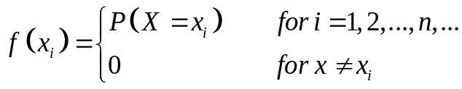
Note: The probability distribution is also called the probability function or the probability mass function.

Properties:
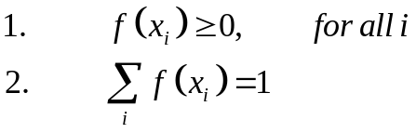
Distribution Function or Cumulative Distribution Function (CDF)
It is a function giving the probability that the random variable X is less than or equal to x, for every value x.
More formally, the distribution function of a random variable X taking value x, denoted by F(x) is defined as: F(X=x)=P(X$≤$x).
The distribution function is abbreviated as d.f. and is also called Cumulative Distribution Function (c.d.f.) as it is the cumulative probability function of the X from the smallest up to specific value of x.
Since F(x) is a probability, so
$$F\left(-∞\right)=F\left(ϕ\right)=0 and F\left(+∞\right)=F\left(S\right)=1$$
If a and b are any two real numbers such that a<b.
Then P(a$≤$X$≤$b)=P(X$≤$b)-P(X$≤$a)=F(b)-F(a)

Properties of Cumulative Distribution Function (CDF)
- $F\left(-∞\right)=0 and F\left(+∞\right)=1$
- F(x) is a non-decreasing function of x, i.e. F(x₁) $≤$F(x₂) if x₁ $≤$x₂
Note: All random variables (discrete and continuous) have a cumulative distribution function.

Cumulative Distribution Function of a Discrete Random Variable
Cumulative Distribution Function of a Discrete Random Variable is:
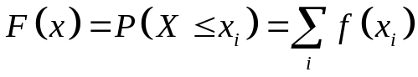
Example: Find the probability distribution and distribution function for the number of heads when 3 balanced coins are tossed.
Construct a probability histogram and a graph of the CDF.
Solution: Here S={HHH, HHT, HTH, THH, HTT, THT, TTH, TTT}
Let X= number of heads then x=0,1,2,3
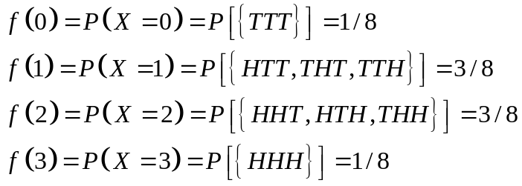

The Probability distribution for the number of heads is given by:
No of heads (xi) | Probability P(xi) or f(xi)
0 | 1/8
1 | 3/8
2 | 3/8
3 | 1/8
Total | 1
The probability Histogram is given by:
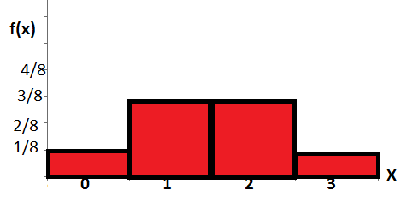
CDF of X is given by:
(xi) | f(xi) | Distribution Function F(xi)=P(X<=xi)
0 | 1/8 | P(X<=0)=1/8
1 | 3/8 | P(X<=1)=P(X=0)+P(X=1)=1/8+3/8=4/8
2 | 3/8 | P(X<=2)=P(X=0)+P(X=1) +P(X=2)=1/8+3/8+3/8=7/8
3 | 1/8 | P(X<=3)=P(X=0)+P(X=1)+P(X=2) +P(X=3)=1/8+3/8+3/8+1/8=8/8=1
The graph of CDF of X is given by:

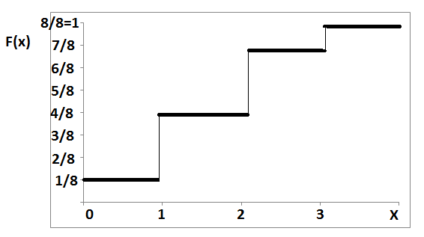

Example: Find the probability distribution and distribution function for the sum of dots when two fair dice are thrown. Using probability distribution find: (a). Sum of 8 or 11, (b). Sum is greater than 8, (c). Sum is greater than 5 but less than or equal to 10.

Solution: Sample space is
Note that n(S)=36
Let X= Sum of dots, then x=2, 3, 4, …, 11, 12
x_{i} | f(x_{i}) | F(x_{i})=P(X<=x_{i})
2 | 1/36 | 1/36
3 | 2/36 | 3/36
4 | 3/36 | 6/36
5 | 4/36 | 10/36
6 | 5/36 | 15/36
7 | 6/36 | 21/36
8 | 5/36 | 26/36
9 | 4/36 | 30/36
10 | 3/36 | 33/36
11 | 2/36 | 35/36
12 | 1/36 | 36/36=1

P(Sum is 8 or 11)=P(X=8)+P(X=11)=5/36+2/36=7/36

P(Sum is greater than 8)=P(X>8)=P(X=9) +P(X=10)+P(X=11) +P(X=12)
=4/36+3/36+2/36+1/36=10/36=5/18
P(Sum is greater than 5 but less than or equal to 10)=P(X>5 and X<=10)
=P(5<X<=10)
=P(X=6)+P(X=7)+P(X=8)+P(X=9) +P(X=10)
=23/36

Continuous Random Variable
A random variable X is said to be continuous if it can assume every possible value in an interval [a, b], a<b.
Examples
- The height of a person
- The temperature at a place
- The amount of rainfall
- Time to failure for an electronic system

Probability Density Function of a Continuous Random Variable
The probability density function of a continuous random variable is a function which can be integrated to obtain the probability that the random variable takes a value in a given interval.
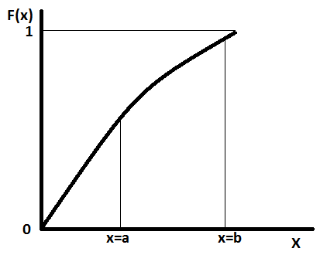
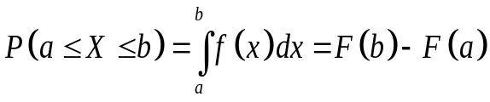
More formally, the probability density function, f(x), of a continuous random variable X is the derivative of the cumulative distribution function F(x), i.e.
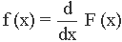
Where,
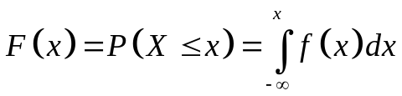
Properties:
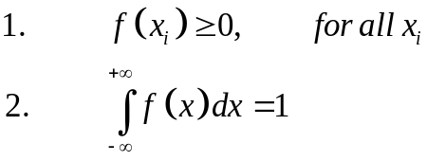
Note: The probability of a continuous r.v. X taking any particular value ‘k’ is always zero.
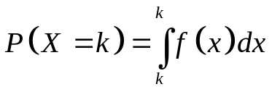
That is why probability for a continuous r.v. is measurable only over a given interval.
Further, since for a continuous r.v. X, P(X=x)=0, for every x, the four probabilities are regarded the same.

Example: Find the value of k so that the function f(x) defined as follows, may be a density function.
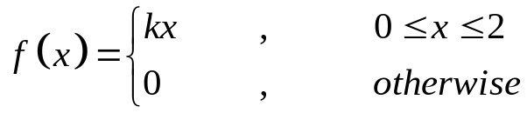
Solution: Since we have,
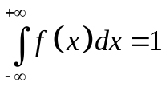
So,
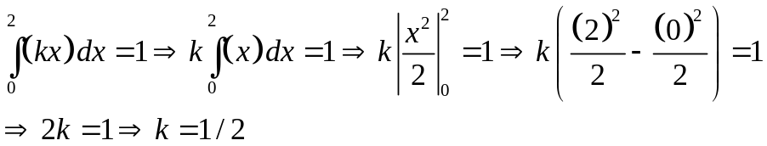

Hence the density function becomes,
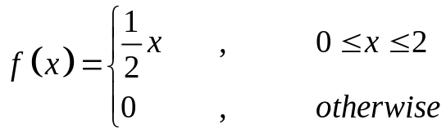
Example: Find the distribution function of the following probability density function.
Solution: The distribution function is:
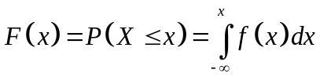
So,
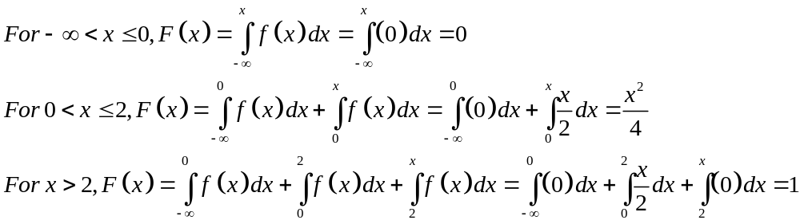
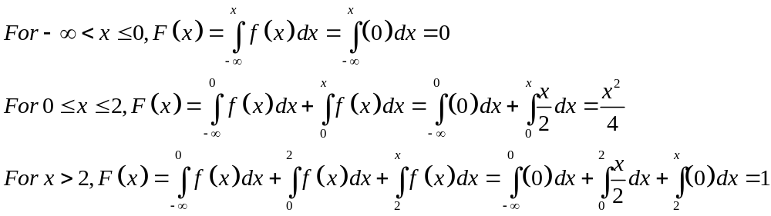
So the distribution function is:
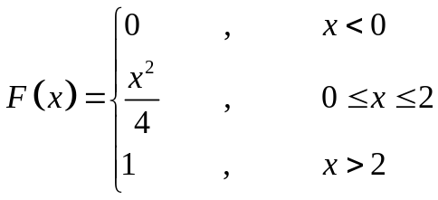

Example: A r.v. X is of continuous type with p.d.f.
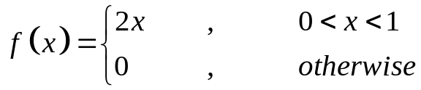
Calculate:
- P(X=1/2)
- P(X<=1/2)
- P(X>1/4)
- P(1/4<=X<=1/2)
- P(X<=1/2 | 1/3<=X<=2/3)
For solution, see video lecture.

Lecture 21
Lecture Outline
- Mathematical Expectation of a random variable
- Law of large numbers
- Related examples

Mathematical Expectation of a Discrete Random Variable
Let a discrete r.v. X have possible values, x1, x2, …, xn, … with corresponding probabilities f(x1), f(x2), …, f(xn), …. Such that $\sum{f\left(x\right)=1}$

Then the mathematical expectation or the expectation or the expected value of X, denoted by E(X), is defined as:
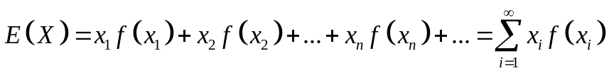
Provided the sum converges absolutely, i.e. $\sum_{i=1}^{∞}{|x_{i}|f\left(x_{i}\right)}$ is finite.

Mathematical Expectation of a continuous Random Variable
Mathematical Expectation of a continuous r..v. X is defined as:
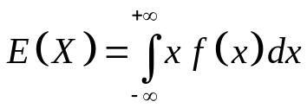
Provided the integral converges absolutely, i.e. $\int_{-∞}^{+∞}{|x| f\left(x\right)dx}$ is finite.

Properties of Mathematical Expectation
Properties of mathematical Expectation of a random variable are:
- E(a)=a, where ‘a’ is any constant.
- E(aX+b)=a E(X)+b , where a and b both are constants
- E(X+Y)=E(X)+E(Y)
- E(X-Y)=E(X)-E(Y)
- If X and Y are independent r.v’s then
E(XY)=E(X). E(Y)

Mathematical Expectation: Examples
Example: What is the mathematical expectation of the number of heads when 3 fair coins are tossed?

Solution: Here S={HHH, HHT, HTH, THH, HTT, THT, TTH, TTT}
Let X= number of heads then x=0,1,2,3
Then X has the following p.d.f:
(xi) | f(xi)
0 | 1/8
1 | 3/8
2 | 3/8
3 | 1/8

Note that formula for Expected Value is:$E\left(X\right)=\sum{xf(x)}$

So,
(xi) | f(xi) | x*f(x)
0 | 1/8 | 0
1 | 3/8 | 3/8
2 | 3/8 | 6/8=3/4
3 | 1/8 | 3/8
Total |  | 12/8

Hence $E\left(X\right)=\sum{xf\left(x\right)=\frac{12}{8}=\frac{3}{2}=1.5}$,

Note: Since E(X)=1.5 which is not an integer, so we can say that When coin is tossed a large no of time then on average we would get 1.5 heads

Example: If it rains, an umbrella salesman can earn $30 per day. If it is fair, he can lose $6 per day. What is his expectation if the probability of rain is 0.3? Solution: Here, P(rain)=0.3, then P(no rain)=0.7
Let X= number of dollars the salesman earns.
Then X can take values, 30 and -6 with corresponding probabilities 0.3 and 0.7 respectively. Then X has the following p.d.f:
(xi) | f(xi) | x*f(x)
30 | 0.3 | 9
-6 | 0.7 | -4.2
Total |  | 4.8

$E\left(X\right)=\sum{xf\left(x\right)=4.8=\$4.8 per day}$

Expectation of a Function of Random Variable
Let H(X) be a function of the r.v. X. Then H(X) is also a r.v. and also has an expected value (as any function of a r.v. is also a r.v.).

If X is a discrete r.v. with p.d f(x) then

If X is a continuous r.v. with p.d.f. f(x) then
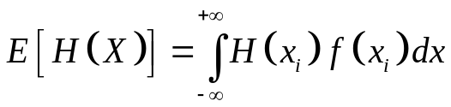
If H(X)=X², then
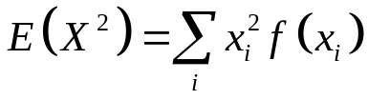
We have
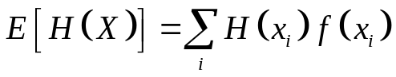
- If H(X)=X², then
- If H(X)=X^{k}, then
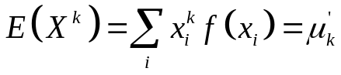
This is called ‘k-th moment about origin of the r.v. X.
If
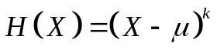 ,
Then
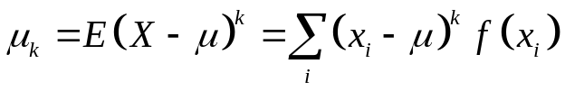
This is called ‘k-th moment about Mean of the r.v. X

Variance
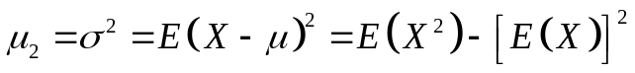

Example: Let X be a r.v. with probability distribution:
x | f(x)
-1 | 0.125
0 | 0.5
1 | 0.2
2 | 0.05
3 | 0.125

Calculate E(X), E(X²) and Var(X)
Solution: Consider
x | f(x) | x*f(x) | x²*f(x)
-1 | 0.125 | -0.125 | 0.125
0 | 0.5 | 0 | 0
1 | 0.2 | 0.2 | 0.2
2 | 0.05 | 0.1 | 0.2
3 | 0.125 | 0.375 | 1.125
Total= |  | 0.55 | 1.65
So we have,

$E\left(X\right)=\sum{xf\left(x\right)=0.55}$
$E\left(X2\right)=\sum{x2f\left(x\right)=1.65}$
Var(X)=E(X²)-[E(X)]²=1.65-[0.55]²=1.3475

Lecture 22
Lecture Outline
- Law of large numbers
- Probability distribution of a discrete random variable
- Binomial Distribution
- Related examples

Law of Large Numbers (LLN):
When the number of trials increases, the observed probability approaches true probability.
Explanation: Consider tossing of a fair coin example, S={H,T}
P(H)=1/2=0.5
P(T)=1/2=0.5
But when we actually throw a coin, say, 10 times, we may get 4 times heads and 6 times tails, i.e. P(H)=4/10=0.4 which is different from 0.5 and similarly, P(T)=6/10=0.6 which is also different from 0.5.
Question is why this is the case?
Answer:
Actually we are considering two different scenarios:
First: Before the coin tossing, we have in mind that if the coin is fair and has two possibilities (H and T) then probability of both will be same, i.e. P(H)=P(T)=1/2=0.5
These are called true probabilities:
True probability of head=P(H)=1/2=0.5
True probability of tail=P(T)=1/2=0.5
THEORETICAL/TRUE PROBABILITIES
P(HEAD)= | 0.5
P(TAIL)= | 0.5

Second: After the coin has been tossed, then the probability of head and tails is called observed or empirical probability, which may be different from the true probability.
But when the number of trials becomes very large (i.e. coin is tossed a very large number of times, say 1000 or more), then observed probability will approach the true probability. This is called law of large numbers.
EMIRICAL/OBSERVED PROBABILITES
NO OF DRAWS/SAMPLE SIZE | P(HEAD) | P(TAIL)
5 | 0.6 | 0.4
25 | 0.64 | 0.36
50 | 0.54 | 0.46
100 | 0.55 | 0.45
250 | 0.524 | 0.476
500 | 0.518 | 0.482
1000 | 0.501 | 0.499
2000 | 0.50 | 0.50

Note from the above table that
“As the number of draws increases, the observed probabilities converge to theoretical probabilities”. This is due to Law of Large Numbers (LLN).

Your Turn: Verify Law of Large Numbers for the case of a die roll.

Discrete Probability Distributions

Some important discrete probability distributions are:
- Bernoulli Distribution
- Binomial Distribution
- Poisson Distribution
- Hypergeometric Distribution
- Multinomial Distribution
- Negative Binomial Distribution

Bernoulli Distribution
Many experiments consist of repeated independent trials, each trial having only two possible complementary outcomes. For example, the two possible outcomes of a trial may be head and tail, success and failure, right and wrong, alive and dead, good and defective, infected or not infected and so forth.

If the probability of each outcome remains the same throughout the trials then such trials are called Bernoulli trials.

Binomial Experiment
The experiment having n Bernoulli trials is called Binomial experiment. In other words, an experiment is called a binomial probability experiment if it possesses the following four properties:

- The outcome of each trial may be classified into one of two categories, conventionally called Success (S) and Failure (F). Usually the outcome of interest is called a success and the other, a failure.
- The probability of success, denoted by p, remains constant for all trials.
- The successive trials are all independent.
- The experiment is repeated a fixed number of times, say n.
Binomial Probability Distribution
When X denotes the number of successes in n trials of a binomial probability experiment, then it is called a binomial random variable.
The probability distribution of a binomial random variable is called the Binomial Probability Distribution.
The random variable X can obviously take on anyone of the (n+1) integer values: 0, 1, 2, …, n.
When the binomial r.v. X assumes a value x, the binomial p.d. is given by:
$$P\left(X=x\right)=\left(\begin{matrix}n \\ x\end{matrix}\right)p^{x}q^{n-x},x=0,1,2,...,n$$
Where, q=1-p, is the probability of failure on each trial.
Binomial probability distribution has two parameters: n and p
It is general denoted by: b(x; n, p).
We can also denote it by
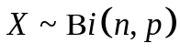
This is read as “Random variable X has binomial distribution with parameters ‘n’ and ‘p’.

Cumulative Binomial Probability Distribution:
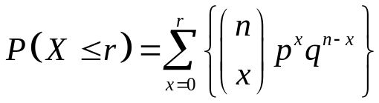

Binomial Distribution: Examples
Binomial probability distribution is widely used distribution in two outcomes situations.

Example: A coin is tossed 5 times. Find the probabilities of obtaining various number of heads.

Solution: Lets regard the tossing of a coin as an experiment. Then we observe that:
- Each toss of a coin (i.e. each trial) has two possible outcomes, heads (success) and tails (failure);
- The probability of a head (success) is p=1/2 (which remains same for all trials);
- The successive tosses of the coin are independent;
- The coin is tossed a fixed number of times (i.e. 5);
So, the random variable X which denotes the number of heads (successes) has a binomial probability distribution with p=1/2 and n=5.
The possible values of X are: 0,1,2,3,4 and 5.
$$\begin{matrix}P\left(X=0\right)=\left(\begin{matrix}5 \\ 0\end{matrix}\right){\left(\frac{1}{2}\right)}^{0}{\left(\frac{1}{2}\right)}^{5-0}={\left(\frac{1}{2}\right)}^{5}=\frac{1}{32} \\ P\left(X=1\right)=\left(\begin{matrix}5 \\ 1\end{matrix}\right){\left(\frac{1}{2}\right)}^{1}{\left(\frac{1}{2}\right)}^{5-1}=\frac{5}{32} \\ P\left(X=2\right)=\left(\begin{matrix}5 \\ 2\end{matrix}\right){\left(\frac{1}{2}\right)}^{2}{\left(\frac{1}{2}\right)}^{5-2}=\frac{10}{32} \\ P\left(X=3\right)=\left(\begin{matrix}5 \\ 3\end{matrix}\right){\left(\frac{1}{2}\right)}^{3}{\left(\frac{1}{2}\right)}^{5-3}=\frac{10}{32} \\ P\left(X=4\right)=\left(\begin{matrix}5 \\ 4\end{matrix}\right){\left(\frac{1}{2}\right)}^{4}{\left(\frac{1}{2}\right)}^{5-4}=\frac{5}{32} \\ P\left(X=5\right)=\left(\begin{matrix}5 \\ 5\end{matrix}\right){\left(\frac{1}{2}\right)}^{5}{\left(\frac{1}{2}\right)}^{5-5}=\frac{1}{32}\end{matrix}$$
Example: Let X be a r.v. having binomial distribution with n=4 and p=1/3.
Find P(X=1), P(X=3/2), P(X<=2)

Solution: The binomial probability distribution for n=4 ad p=1/3 is:
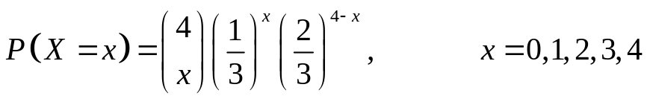
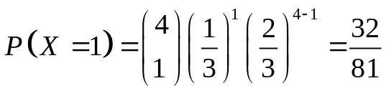
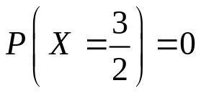
(b/c, a r.v. X with a binomial distribution takes only one of the integer values; 0,1,2,…,n)
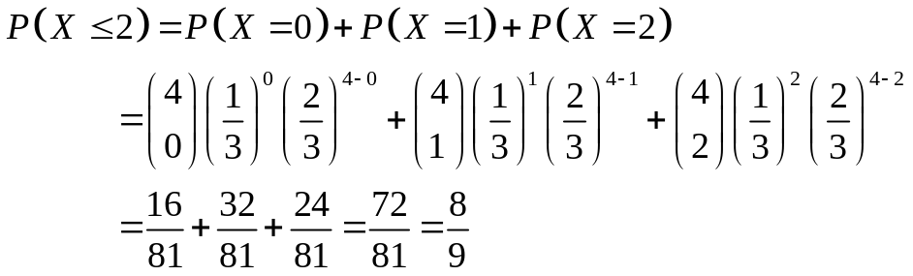

Example: Let X be a r.v. having binomial distribution with n=4 and p=1/3.
Find P(X=1), P(X=3/2), P(X<=2)
Solution: The binomial probability distribution for n=4 ad p=1/3 is:

Properties of Binomial Distribution
Let X be a r.v. with the binomial distribution b(x; n,p).
Then
- Mean of X is: $μ=np$
- Variance of X is:$σ^{2}=npq$
- When p>0.5, the distribution is negatively skewed.
- When p<0.5, the distribution is positively skewed.
- When n becomes very large then binomial distribution is symmetrical and Mesokurtic (i.e. it becomes Normal distribution, the bell shaped curve).

Lecture 23
Lecture Outline
- Poisson Probability Distribution
- Related examples
- Hypergeometric Distribution
- Multinomial Distribution
- Negative Binomial Distribution

Poisson Distribution
In many practical situations we are interested in measuring how many times a certain event occurs in a specific time interval or in a specific length or area.
For instance:
- The number of phone calls received at an exchange in an hour;
- The number of customers arriving at a toll booth per day;
- The number of flaws on a length of cable;
- The number of cars passing over a certain bridge during a day;
The Poisson distribution plays a key role in modelling such problems.

Suppose we are given an interval (this could be time, length, area or volume) and we are interested in the finding the number of “successes" in that interval. Assume that the interval can be divided into very small subintervals such that:
- The probability of more than one success in any subinterval is zero;
- The probability of one success in a subinterval is constant for all subintervals and is proportional to its length;
- Subintervals are independent of each other.

We assume the following.
- The random variable X denotes the number of successes in the whole interval.
- λ is the mean number of successes in the interval.
Then r.v. X has a Poisson Distribution with parameter λ, which is given by:
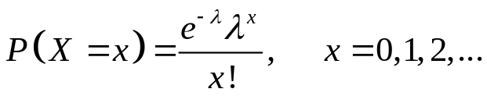
Where, e is a constant and approximately equal to 2.71828.
Notation:
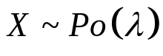
It is read as “X is a random variable which follows Poisson distribution with parameter λ”.

Poisson Distribution: Examples

Example:
If the r.v. X follows a Poisson distribution with mean 3.4, i.e. X~Po(3.4), Find P(X=6).
Solution:
Note that we have:
Replacing x by 6 and $λ$ by 3.4, we get:
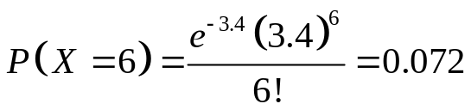

Example: The number of industrial injuries per working week in a particular factory is known to follow a Poisson distribution with mean 0.5. Find the probability that in a particular week there will be:
(i). Less than 2 accidents; (ii). More than 2 accidents;

Solution:
(i). Less than 2 accidents
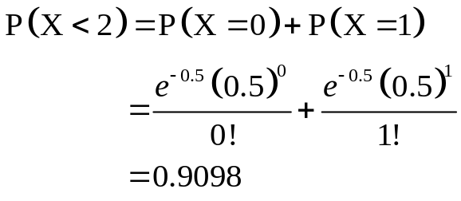
(ii). More than 2 accidents
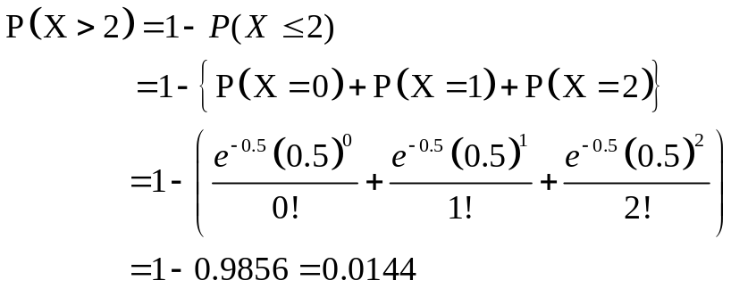
Properties of Poisson Distribution
- The mean and variance of a Poisson random variable X with parameter λ are same and both are equal to λ :
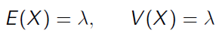
Example:
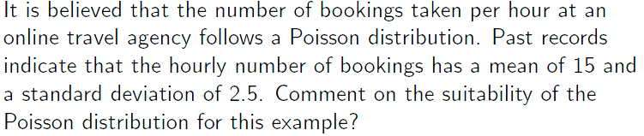
Solution:
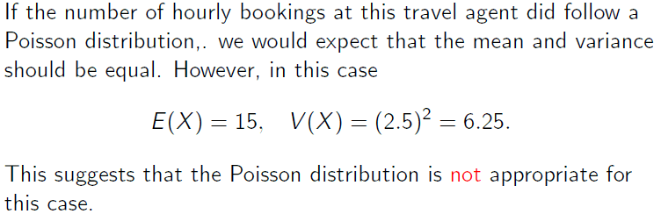
Poisson Approximation to Binomial Distribution
Poisson probabilities can be used to approximate binomial probabilities when n is large and p is small
Suppose
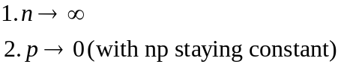

Then, writing λ=np, it can be shown that the binomial distribution b(x; n, p) tends to the Poisson distribution.

Rule of Thumb for Poisson approximation to Binomial:
- n$≥$20 and p$≤$0.05
- If n$≥$100 and np$≤$10, (For an excellent approximation).

Example: A factory produces nails and packs them in boxes of 200. If the probability that a nail is substandard is 0.006, find the probability that a box selected at random contains at most two nails which are substandard.

Solution: Let X= number of substandard nails in a box of 200.
Then X~Bi(200, 0.006), [ Here n=200 and p=0.006]
Since n is large and p is small, so Poisson approximation can be used.
λ=np=(200)*(0.006)=1.2
So, X~Po(1.2)
P(at most two nails are substandard)=?
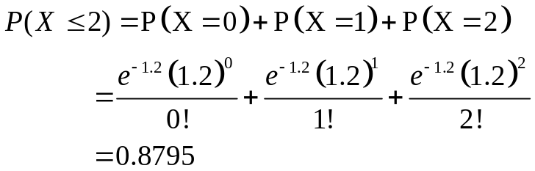

Example: It is known that 3% of the circuit boards from a production line are defective. If a random sample of 120 circuit boards is taken from this production line, use the Poisson approximation to estimate the probability that the sample contains:
(i) Exactly 2 defective boards.
(ii) At least 2 defective boards.
Solution:
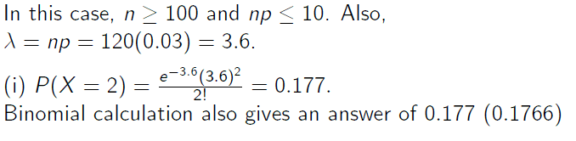
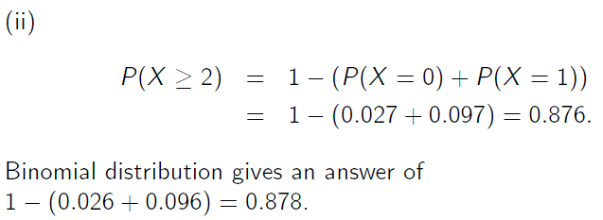

Hypergeometric Distribution
There are many experiments in which the condition of independence is violated and the probability of success does not remain constant for all trials. Such experiments are called hypergeometric experiments.

Properties of a Hypergeometric Experiment:
- The outcomes of each trial may be classified into one of two categories, success and failure.
- The probability of success changes on each trial.
- The successive trials are dependent.
- The experiment is repeated a fixed number of times.
The number of successes, X in a hypergeometric experiment is called a hypergeometric random variable and its probability distribution is called Hypergeometric Distribution.

Negative Binomial Distribution
In the binomial experiments, the number of success varies and the number of trials is fixed. But there are experiments in which the number of successes is fixed and number of trials varies to produce the fixed number of successes. Such experiments are called negative binomial experiments.

Properties of a Negative Binomial Experiment:
- The outcome of each trial may be classified into one of the two categories, success and failure.
- The probability of success (p) remains constant for all trials.
- The successive trials are all independent.
- The experiment is repeated a variable number of times to obtain a fixed number of success.
When X denotes the number of trials to produce a certain number of successes in a negative binomial experiment, it is called a negative binomial r.v. and its p.d. is called negative binomial distribution.

Multinomial Distribution
A binomial experiment becomes a Multinomial experiment when there are more than two possible outcomes of each trial. For example: Manufactured items may be classified as good, average or inferior; or a road accident may results in no injury, minor injury, severe injuries or fatal injuries.

Properties of a Multinomial Experiment:
- The outcomes of each trial may be classified into one of ‘k’ mutually exclusive categories C1, C2,…, Ck.
- The probability of i^{th} outcome is p_{i}, which remain constant and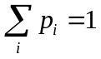.
- The successive trials are all independent.
- The experiment is repeated a fixed number of times.

Lecture 24
Lecture Outline
- Probability distributions of a Continuous random variable
- Uniform Distribution
- Related examples

Probability distributions of a Continuous Probability Distributions
Some important Continuous Probability Distributions are:
- Uniform or Rectangular Distribution
- Normal Distribution
- t-Distribution
- Exponential Distribution
- Chi-square Distribution
- Beta Distribution
- Gamma Distribution

Uniform Distribution
A uniform distribution is a type of continuous random variable such that each possible value of X has exactly the same probability of occurring.
As a result the graph of the function is a horizontal line and forms a rectangle with the X axis. Hence, its secondary name the rectangular distribution.
In common with all continuous random variables the area under the function between all the possible values of X is equal to 1 and as a result it is possible to work out the probability density function of X, for all uniform distributions using a simple formula.

Definition: Given that a continuous random variable X has possible values from a ≤ X ≤ b such that all possible values are equally likely, it is said to be uniformly distributed. i.e. X~U(a,b).
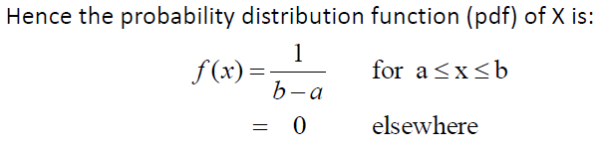

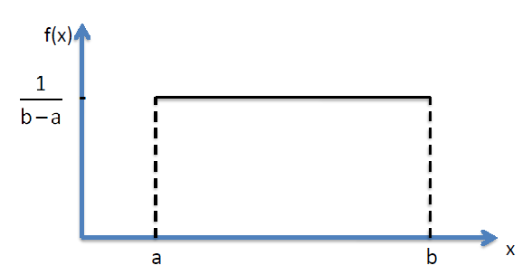
Note: Uniform Distribution has TWO parameters: ‘a’ and ‘b’.

Properties of Uniform Distribution
Let X~U(a,b):
- Mean of X is: (a+b)/2
- Variance of X is: (b-a)²/12

Standard Uniform Distribution
- If X~U(a,b) then
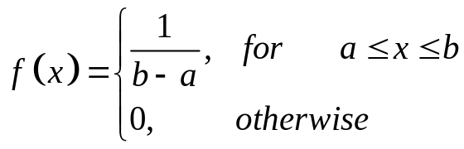

Standard Uniform Distribution
When a=0 and b=1, i.e. X~U(0,1) then the Uniform distribution is called Standard Uniform Distribution and its probability density function is given by:
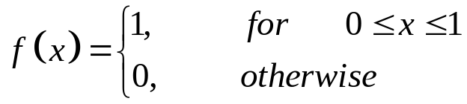

Cumulative Distribution Function of a Uniform R.V
The cumulative distribution function of a uniform random variable X is:
F(x)=(x−a)/(b−a) for two constants a and b such that a < x < b.

Graphically,

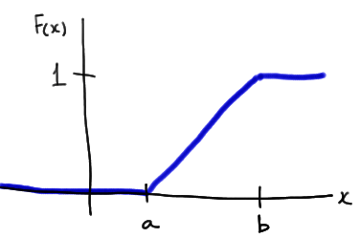
From fig:
- F(x) = 0 when x is less than the lower endpoint of the support (a, in this case).
- F(x) = 1 when x is greater than the upper endpoint of the support (b, in this case).
- The slope of the line between a and b is, 1/(b−a).
So the cumulative distribution function of a uniform r.v. X is given by:

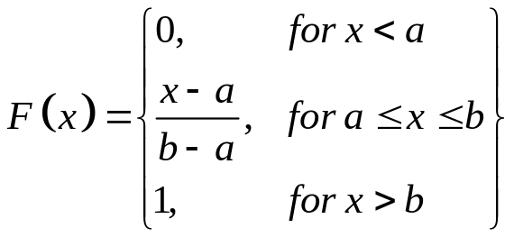

Uniform Applications
Perhaps not surprisingly, the uniform distribution is not particularly useful in describing much of the randomness we see in the natural world. Its claim to fame is instead its usefulness in random number generation. That is, approximate values of the U(0,1) distribution can be simulated on most computers using a random number generator. The generated numbers can then be used to randomly assign people to treatments in experimental studies, or to randomly select individuals for participation in a survey.
Before we explore the above-mentioned applications of the U(0,1) distribution, it should be noted that the random numbers generated from a computer are not technically truly random, because they are generated from some starting value (called the seed). If the same seed is used again and again, the same sequence of random numbers will be generated. It is for this reason that such random number generation is sometimes referred to as pseudo-random number generation. Yet, despite a sequence of random numbers being pre-determined by a seed number, the numbers do behave as if they are truly randomly generated, and are therefore very useful in the above-mentioned applications. They would probably not be particularly useful in the applications of internet security, however!

Generating Random Numbers in MS-Excel
Generate uniform Random numbers between 0 and 1, using Excel built-in function: ‘=Rand()’
Generate uniform Random numbers between A and B, using Excel command: ‘=A+Rand()*(B-A)’
For example, to generate random numbers b/w 10 and 20, replace A by 10 and B by 20 in the above formula.

Generating Random numbers using ‘Analysis Tool Pack’.
- Activate Data analysis tool pack (if it is not already active).
- Open Data Analysis tool Pack from ‘Data’ Tab.
- Select Random Numbers Generation.
- Select appropriate options from the dialogue box.

Example: Consider the data on 55 smiling times in seconds of an eight week old baby.
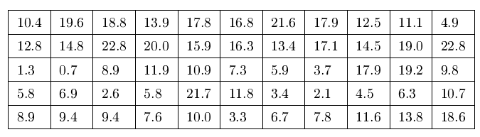

We assume that smiling times, in seconds, follow a uniform distribution between 0 and 23 seconds, inclusive. This means that any smiling time from 0 to and including 23 seconds is equally likely.
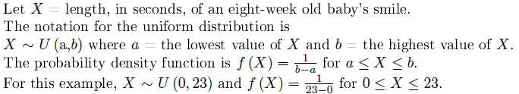
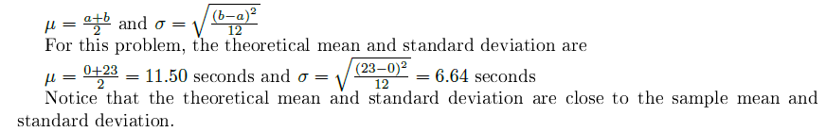

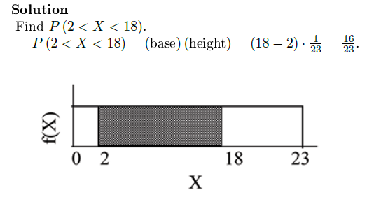
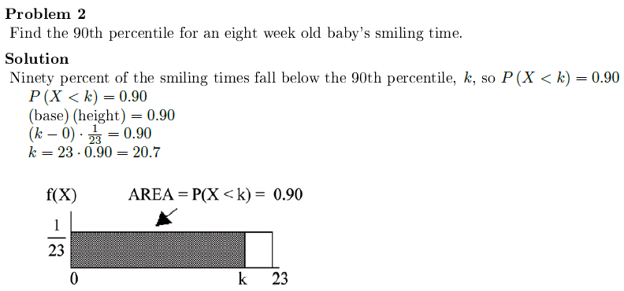

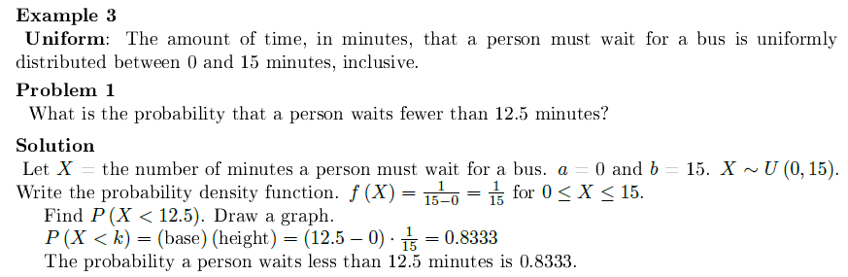
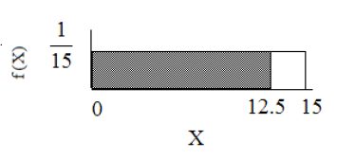

Lecture 25
Lecture Outline
- Normal Distribution
  - Probability Density Function of Normal Distribution
  - Properties of Normal Distribution
  - Related examples

The Normal Distribution
Normal Distribution is considered as the cornerstone of the modern Statistical Theory. It is also called Gaussian in the honor of great German Mathematician Carl F. Gauss (1777-1855). Karl Pearson called it Normal Distribution and it is best known by this name.

Importance of Normal Distribution
Normal Distribution is useful because:
- Many things actually are normally distributed, or very close to it. For example: Height and intelligence are approximately normally distributed, measurement errors also often have a normal distribution.
- The normal distribution is easy to work with mathematically.
- Computations of probabilities are direct and elegant.
- The normal probability distribution has led to good business decisions for a number of applications
- In many practical cases, the methods developed using normal theory work quite well even when the distribution is not normal.
- There is a very strong connection between the size of a sample N and the extent to which a sampling distribution approaches the normal form.
Many sampling distributions based on large N can be approximated by the normal distribution even though the population distribution itself is not normal.
Hence we can say that “The normal distribution closely approximates the probability distributions of a wide range of random variables”.
- The Normal Distribution
- ‘Bell Shaped
- Symmetrical
- Mean, Median and Mode
are Equal
Location is determined by the mean, μ
Spread is determined by the standard deviation, σ
The random variable has an infinite theoretical range:
+ ∞ to − ∞

The Normal Probability Density Function
The formula for the normal probability density function is
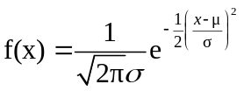
Where e = the mathematical constant approximated by 2.71828
π = the mathematical constant approximated by 3.14159
μ = the population mean
σ = the population standard deviation
x = any value of the continuous variable, −∞ < x < ∞
X is r.v. which follows Normal Distribution with mean ‘μ’ and variance ‘σ² ’, we use the notation: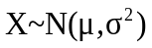

Plotting Normal Probability Density Function in MS-Excel
Working Steps in MS-Excel:
- Take Mean and SD (any values)
- Take any X values from -5 to +5 with a step size of 1
- Calculate normal probabilities using the probability density function formula with corresponding to each value of x.
- Construct a Scatter plot of X against f(x) to get Bell-Shaped Curve.

Note: By varying the parameters μ and σ, we obtain different normal distributions
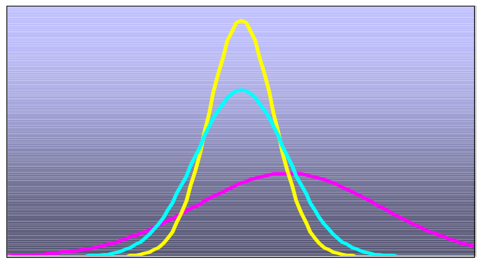

Properties of Normal Distribution
- The function f(x) defining the normal distribution is a proper p.d.f. i.e.
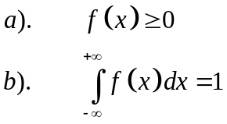
- Mean and variance of Normal Distribution are μ and σ² respectively.
- The Median and the Mode of the Normal Distribution are each equal to the Mean of the distribution. i.e. Mean=Median=Mode
- The Mean Deviation (M.D) of the Normal Distribution is approximately 4/5 of its standard deviation. i.e.
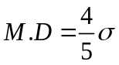
- The Normal Distribution has points of inflection which are equidistant from the mean. i.e. μ – σ and μ + σ.
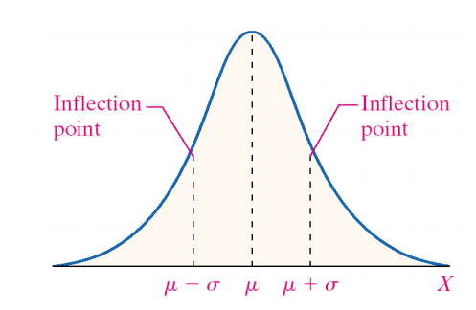
Definition: Point of Inflection: A point at which the concavity of the function changes.

- For the Normal Distribution, all odd order moments about mean are Zero. i.e.
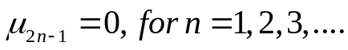
- For the Normal Distribution, even order moments about mean are given by:
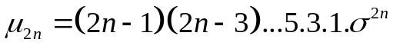
- If 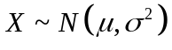and if Y=a+bX then 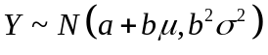

- The sum of independent Normal variables is a normal variable. i.e.
$$\begin{matrix}X_{1}\sim N\left(μ_{1},σ_{1}^{2}\right) and X_{2}\sim N\left(μ_{2},σ_{2}^{2}\right) \\ then \\ X_{1}+X_{2}\sim N\left(μ_{1}+μ_{2},σ_{1}^{2}+σ_{2}^{2}\right)\end{matrix}$$
- The Quartile Deviation (Q.D) is 0.6745 times $σ$, i.e. Q.D=0.6745$σ$
Similarly,
$$\begin{matrix}Q_{1}=μ-0.6745σ \\ Q_{3}=μ+0.6745σ\end{matrix}$$
- The Normal curve is asymptotic to the horizontal axis as 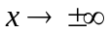i.e. Normal Curve approaches but never really touches the horizontal axis on either sides of the mean towards plus and minus infinity.

Empirical Rule:
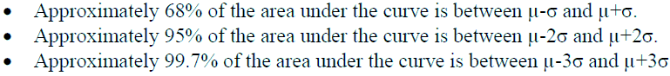

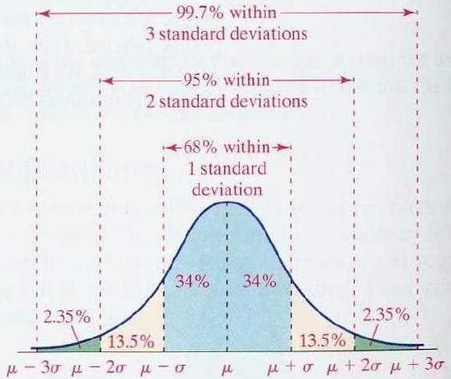

Lecture 26
Lecture Outline
- Finding Area under the Normal Distribution
- Related examples

Empirical Rule:

Cumulative Normal Distribution
- For a normal random variable X with mean μ and variance σ² , i.e., X~N(μ, σ²), the cumulative distribution function is
- Finding Normal Probabilities
- The Standardized Normal
- Any normal distribution (with any mean and variance combination) can be transformed into the standardized normal distribution (Z), with mean 0 and variance 1.
- Need to transform X units into Z units by subtracting the mean of X and dividing by its standard deviation
- Example
- If X is distributed normally with mean of 100 and standard deviation of 50, the Z value for X = 200 is
- This says that X = 200 is two standard deviations (2 increments of 50 units) above the mean of 100.
- Comparing X and Z units
- The Standardized Normal Probability
Density Function
- The formula for the Standardized Normal Probability Density Function can be obtained by replacing μ=0 and σ=1

OR
    - Finding Normal Probabilities
- Probability as Area Under the Curve

Standardized Normal Area Table
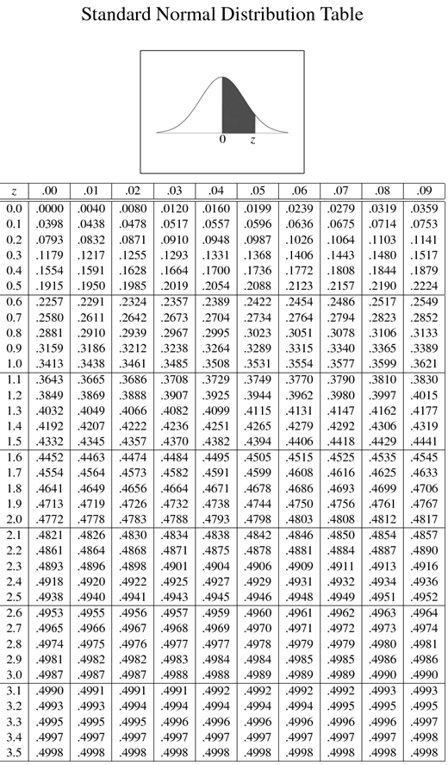
It gives the probability from 0 to Z, i.e. P(0<Z<2)=0.4772
Since the distribution is symmetric, so P(-2<Z<0)=0.4772
P(Z>2)=?
P(Z>2)=0.5-P(0<Z<2)
=0.5-0.4772
=0.0228
P(Z<-2)=?
P(Z<-2)=0.5-P(-2<Z<0)
=0.5-0.4772
=0.0228

P(-2<Z<+2)=?
P(-2<Z<+2)
= P(-2<Z<0)+ P(0<Z<+2)
= 0.4772 + 0.4772=0.9544
P(+1<Z<+2)=?
P(+1<Z<+2)
= P(0<Z<+2) - P(0<Z<+1)
= 0.4772 - 0.3413=0.1359

P(-2<Z<-1)=?
P(-2<Z<-1)
= P(-2<Z<0) - P(-1<Z<0)
= 0.4772 - 0.3413=0.1359

P(Z>+1.96)=?
P(Z>+1.96)
= 0.5 - P(0<Z<+1.96)
= 0.5 – 0.4750=0.025

P(<Z<-2.15)=?
P(Z<-2.15)
= 0.5 - P(-2.15<Z<0)
= 0.5 - 0.4842=0.0158

General Procedure for Finding Probabilities
- Draw the normal curve for the problem in terms of X
- Translate X-values to Z-values
- Use the Normal Table to find probabilities
- Suppose X is normal with mean 8.0 and standard deviation 5.0. Find P(X < 8.6)
Suppose X is normal with mean 8 and standard deviation 5. Find P(7.4<X < 8.6)
P(7.4<X < 8.6)= P(-0.12<Z < +0.12)
= P(-0.12<Z<0)+ P(0<Z<+0.12)
=0.0478+ 0.0478
=0.0956

Lecture 27
Lecture Outline
- Central Limit Theorem (CLT)
- Related Examples

Central Limit Theorem: CLT
The central limit theorem says that sums of random variables tend to be approximately normal if you add large numbers of them together.
Let X₁, X₂, … X_{n} be random draws from any population. Let S = X₁ + X₂ + … + X_{n}. Then the standardization of S will have an approximately standard normal distribution if n is large.
Note:
- Independence is required, but slight dependence is OK.
- Each term in the sum should be small in relation to the SUM.
CLT: An Example
We illustrate graphically the convergence of Binomial to a Normal distribution.
Consider the distribution of X ∼ Bi(10,0.25)
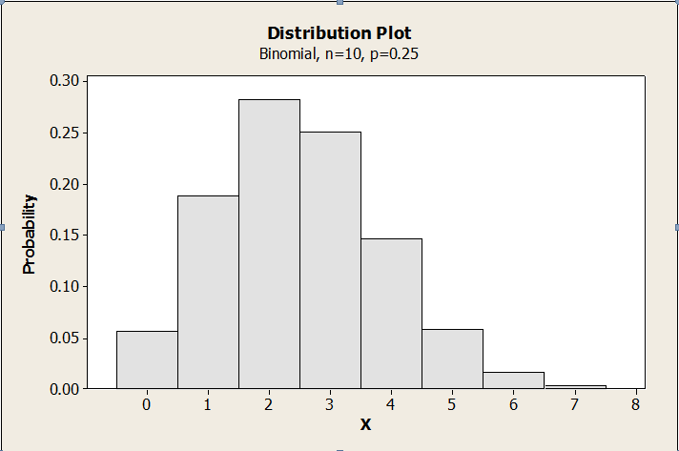
Note: It does not look very normal.
Next: Consider the distribution of X1+X2 ∼ Bi(20,0.25)
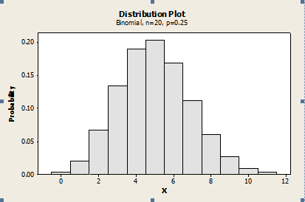
Note: It looks more close to normal.
Next: Consider the distribution of X1+X2+X3+X4 ∼ Bi(40,0.25)
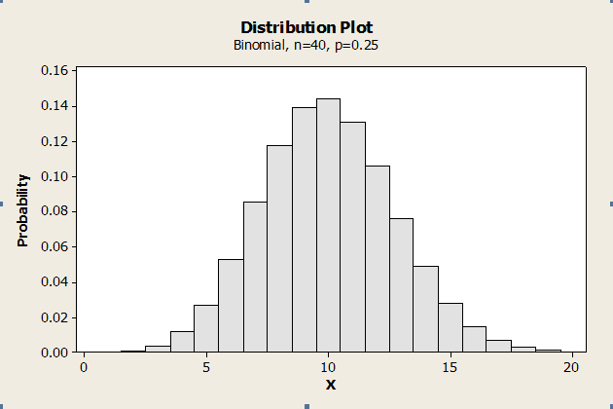
Note: It looks even more closer to normal.
This just illustrates the Central Limit Theorem. As we add random variables, the distribution of the sum begins to look closer and closer to a normal distribution. If we standardize, then it looks like a standard normal.
Note: As we add random variables, the distribution of the sum begins to look closer and closer to a normal distribution.
If we standardize, then it looks like a standard normal.

Lecture 28
Lecture Outline
- Joint Distributions
- Moment Generating Functions
- Covariance
- Related Examples

Joint Distributions
The distribution of two or more random variables which are observed simultaneously when an experiment is performed is called their joint distribution.
It is customary to call the distribution of a single r.v. as univariate.
Likewise, a distribution involving two, three or many random variables is called bivariate, trivariate or multivariate.
Let X and Y be two random variables defined on the same sample space S. Then the probability that a random point (X,Y) falls in the interval (x₁$≤$X$≤$x₂: y₁$≤$Y$≤$y₂) is shown graphically as:
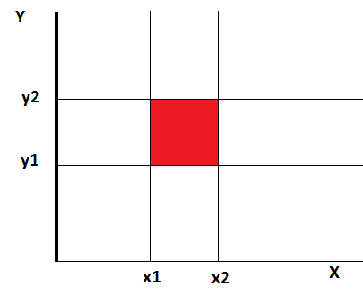
Types of Joint Distribution:
- Discrete
- Continuous
- Mixed
A bivariate distribution may be discrete when the possible values of (X,Y) are finite or countably infinite. It is continuous if (X,Y) can assume all values in some non-countable set of plane. It is said to be mixed if one r.v. is discrete and other is continuous.

Discrete Joint Distributions
Let X and Y be two discrete r.v’s defined on the same sample space S, X taking values x₁,x₂,…,x_{m} and Y taking values y₁,y₂,…,y_{n}.
Then the probability that X takes on the value x_{i} and at the same time, Y takes on the value y_{j}, denoted by f(x_{i},y_{j}) or p_{ij} is defined to be Joint Probability Function or simply the Joint Distribution of X and Y.
Thus the Joint Probability Function also called Bivariate Probability Function f(x,y) is a function whose value at the point (xi,yi) is given by:
$$f\left(x_{i},y_{i}\right)=P\left(X=x_{i} and Y=y_{j}\right)i=1,2,...,m \& j=1,2,...,n$$
The joint or bivariate probability distribution consisting of all parts of values (x_{i},y_{j}) and their associated probabilities f(x_{i},y_{j}), i.e. The set of tripples [x_{i}, y_{j}, f(x_{i},y_{j}) ] can be shown in a two-way table or by means of a formula for f(x,y).
X\Y | y₁ | y₂ | … | y_{n} | P(X=x_{j})
x₁ | f(x₁,y₁) | f(x₁,y₂) | … | f(x₁,y_{n}) | g(x₁)
x₂ | f(x₂,y₁) | f(x₂,y₂) | … | f(x₂,y_{n}) | g(x₂)
… | … | … | … | … | …
x_{m} | f(x_{m},y₁) | f(x_{m},y₂) | … | f(x_{m},y_{n}) | g(x₃)
P(Y=y_{j}) | h(y₁) | h(y₂) | … | h(y_{n}) | 1

Note: Joint Probability Function also called Bivariate Probability Function

Marginal Probability Functions:

Marginal Distribution of X
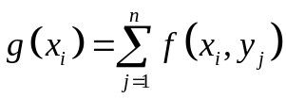
Marginal Distribution of Y
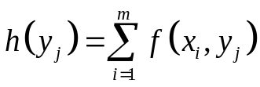

Conditional Probability Functions:
Conditional Probability of X/Y
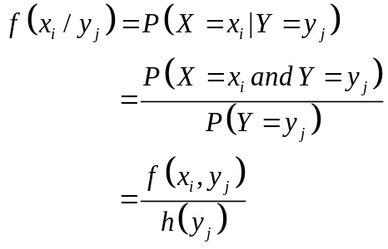
Conditional Probability of Y/X
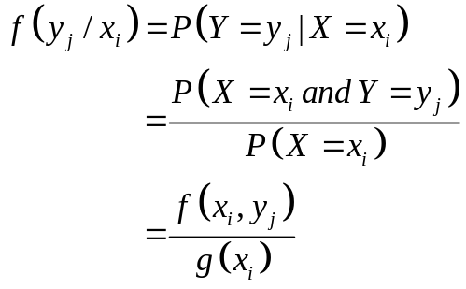

Independence: Two r.v.s X and Y are said to be independent iff for all possible pairs of values (x_{i}, y_{j}), the joint probability function f(x,y) can be expressed as the product of the two marginal probability functions.
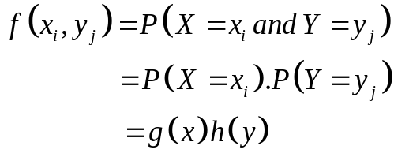
Example:
Example: An urn contains 3 black, 2 red and 3 green balls and 2 balls are selected at random from it. If X is the number of black balls and Y is the number of red balls selected, then find the joint probability distribution of X and Y.
Solution: Total Balls=3black+2red+3green=8 balls
Possible values of both X & Y are={0,1,2}
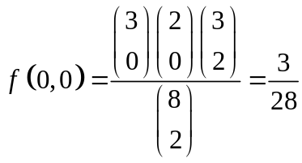
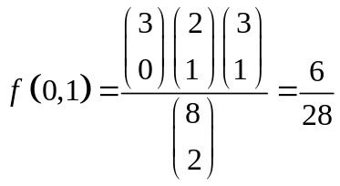

X\Y | 0 | 1 | 2 | g(x)
0 | 3/28 | 6/28 | 1/28 | 10/28
1 | 9/28 | 6/28 | 0 | 15/28
2 | 3/28 | 0 | 0 | 3/28
H(y) | 15/28 | 12/28 | 1/28 | 1

P(X+Y<=1)=?
P(X+Y<=1)=f(0,0)+f(0,1)+f(1,0)
=3/28+6/28+9/28=18/28

P(X=0 |Y=1)=?
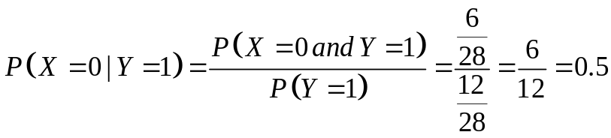
Covariance
Covariance between two r.v.’s X and Y is a numerical measure of the extent to which their values tend to increase or decrease together. It is denoted by Cov(X,Y) or $σ_{XY}$ and is defined as:
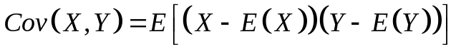
This simplifies to:
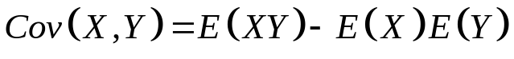

Sample Covariance can be written as:
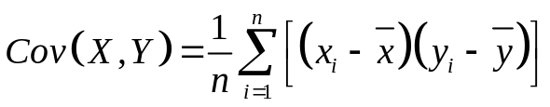

Covariance ranges between minus infinity to plus infinity.
The covariance is positive if the deviations of the two variables from their respective means tend to have the same sign and negative if the deviations tend to have opposite signs.
- A positive covariance indicates a positive association between the two variables.
- A negative covariance indicates a negative association between the two variables.
- A zero covariance indicates neither positive nor negative association between the two variables.

NOTE 1: Covariance of r.v. X with itself is Variance of X.
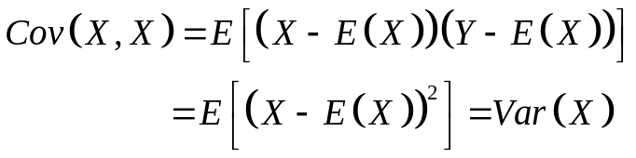

NOTE 2: If X and Y are INDEPENDENT, then E(XY)=E(X) E(Y) Hence Cov(X,Y)=0

NOTE 3: Converse of above results DOESN’T Hold, i.e. if Cov(X,Y)=0 then it doesn’t mean X and Y are independent. e.g. Let X be Normal r.v with mean zero and Y=X² then obviously X and Y are NOT independent.
Now Cov(X,Y)=Cov( X, X²)=E(X³)-E(X²)E(X)
=E(X³)-E(X²)*(0) [since E(X)=0]
=E(X³)
=0 [Since Normal is symmetric]
Hence, Zero Covariance doesn’t imply Independence.

Variance of Sum or Difference of r.v.’s
Let X and Y be two r.v.’s, then:

Moment Generating Function
The moment-generating function of a random variable is an alternative specification of its probability distribution. Thus, it provides the basis of an alternative route to analytical results compared with working directly with probability density functions or cumulative distribution functions. In addition to univariate distributions, moment-generating functions can be multivariate distributions, and can even be extended to more general cases.
There are relations between the behavior of the moment-generating function of a distribution and properties of the distribution.
Moment Generating Function of a r.v. X is defined as:
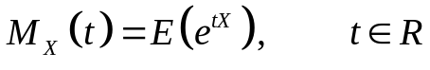
But,
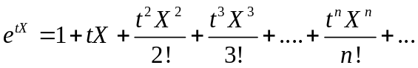
So,
$$\begin{matrix}M_{X}\left(t\right)=E\left(e^{tX}\right)=E\left(1+tX+\frac{t^{2}X^{2}}{2!}+\frac{t^{3}X^{3}}{3!}+....+\frac{t^{n}X^{n}}{n!}+...\right) \\ =1+tE\left(X\right)+\frac{t^{2}E\left(X^{2}\right)}{2!}+\frac{t^{3}E\left(X^{3}\right)}{3!}+....+\frac{t^{n}E\left(X^{n}\right)}{n!}+... \\ =1+tm_{1}+\frac{t^{2}m_{2}}{2!}+\frac{t^{3}m_{3}}{3!}+....+\frac{t^{n}m_{n}}{n!}+...\end{matrix}$$
Where, m_{n} is the n-th moment.

If X is a Bernoulli r.v. with parameter p:
If X is a Binomial r.v. with parameters n and p:
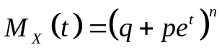
If X is a Poisson r.v. with parameters λ:
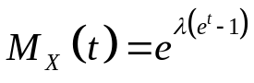
If X is a Normal r.v. with parameters μ and σ²:
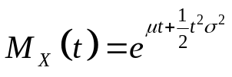
Characteristic Function
The M.G.F. doesn’t exist for many probability distributions. We then use another function, called characteristic function (c.f.).
The characteristic function of a r.v. is defined as:
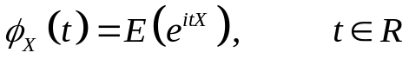

Lecture 29
Lecture Outline
- Describing Bivariate Data
- Scatter Plot
- Concept of Correlation
- Properties of Correlation
- Related examples

Describing Bivariate Data
Sometimes, our interest lies in finding the “relationship”, or “association”, between two variables.
This can be done by the following methods:
- Scatter Plot
- Correlation
- Regression Analysis

Scatter Plot
A first step in finding whether or not a relationship between two variables exists, is to plot each pair of independent-dependent observations {(Xi, Yi)}, i=1,2,..,n as a point on a graph paper. Such a diagram is called a Scatter Diagram or Scatter Plot. Usually, independent variable is taken along X-axis and dependent variable is taken along Y-axis.
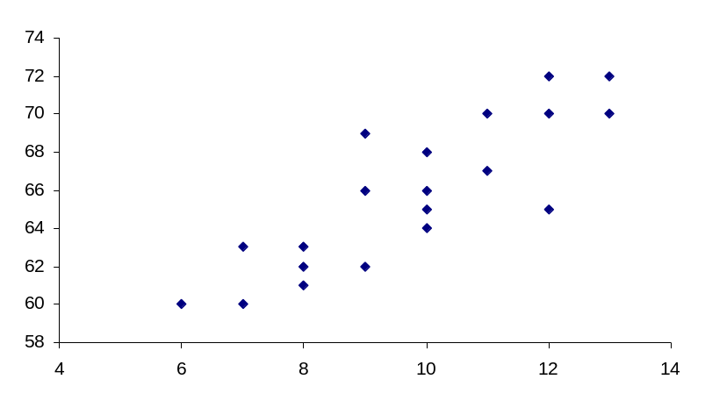

Correlation
Correlation measures the direction and strength of the linear relationship between two random variables. In other words, two variables are said to be correlated if they tend to vary in some direction simultaneously.
If both variables tend to increase (or decrease) together, the correlation is said to be direct or positive. E.g. The length of an iron bar will increase as the temperature increases.
If one variable tends to increase as the other variable decreases, the correlation is said to be inverse or negative. E.g. If time spent on watching TV increases, then Grades of students decrease.
If a variable neither increases nor decreases in response to an increase or decrease in other variable then the correlation is said to be Zero. E.g. The correlation between the shoe price and time spent on exercise is zero.
Notations:
  - For population data, it is denoted by the Greek letter (ρ)
  - For sample data it is denoted by the roman letter r or r_{xy}.
Range:
Correlation always lies between -1 and 1 inclusive.
  - -1 means perfect negative linear association
  - 0 means No linear association
  - +1 means perfect positive linear association
Note:
- In correlation analysis, both the variables are random and hence treated symmetrically, i.e. there is NO distinction between dependent and independent variables.
- In regression analysis (to be discussed in forthcoming lectures), we are interested in determining the dependence of one variable (that is random) upon the other variable that is non-random or fixed and in addition, we are interested in predicting the average value of the dependent variable by using the known values of other variable (called independent variable).
- There is no assumption of causality
The fact that correlation exists between two variables does not imply any Cause and Effect relationship but it describes only the linear association.
- Correlation is a necessary, but not a sufficient condition for determining causality.
Example: Two unrelated variables such as ‘sale of bananas’ and ‘the death rate from cancer’ in a city, may produce a high positive correlation which may be due to a third unknown variable (called confounding variable, namely, the city population). The larger the city, the more consumption of bananas and the higher will be the death rate from cancer. Clearly, this is a false of merely incidental correlation which is the result of a third variable, the city size. Such a false correlation between two unconnected variables is called Spurious or non-sense correlation. Therefore one should be very careful in interpreting the correlation coefficient as a measure of relationship or interdependence between two variables.

Correlation: Computation
Pearson Product Moment Correlation Coefficient
It is a numerical measure of strength in the linear relationship between any two variables, sometimes called coefficient of simple correlation or total correlation or simply the correlation coefficient.
The population correlation coefficient for a bivariate distribution is:
$$ρ=\frac{Cov\left(X,Y\right)}{\sqrt{Var\left(X\right) Var\left(Y\right)}}$$
The Sample correlation coefficient for a bivariate distribution is:
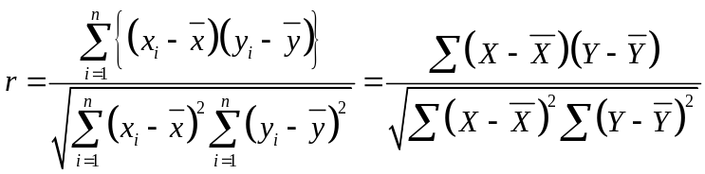

Computationally easier version is:
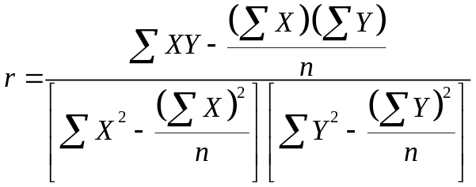
OR
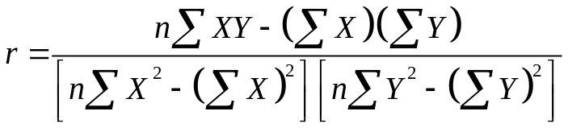
Note: r is a pure number and hence is unit less.

Example: Consider a hypothetical data on two variables X and Y.
X | Y
1 | 2
2 | 5
3 | 3
4 | 8
5 | 7

Calculate product moment coefficient of correlation between X and Y.
Solution:
 | X | Y | (X-Xbar) | (X-Xbar)² | (Y-Ybar) | (Y-Ybar)² | (X-Xbar)* (Y-Ybar)
 | 1 | 2 | -2 | 4 | -3 | 9 | 6
 | 2 | 5 | -1 | 1 | 0 | 0 | 0
 | 3 | 3 | 0 | 0 | -2 | 4 | 0
 | 4 | 8 | 1 | 1 | 3 | 9 | 3
 | 5 | 7 | 2 | 4 | 2 | 4 | 4
Total= | 15 | 25 | 0 | 10 | 0 | 26 | 13

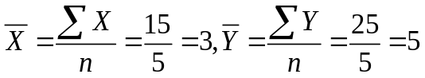
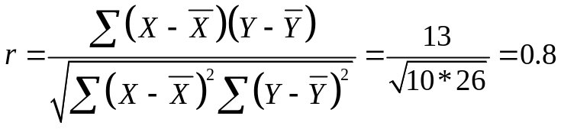

Alternative Method:
 | X | Y | X² | Y² | XY
 | 1 | 2 | 1 | 4 | 2
 | 2 | 5 | 4 | 25 | 10
 | 3 | 3 | 9 | 9 | 9
 | 4 | 8 | 16 | 64 | 32
 | 5 | 7 | 25 | 49 | 35
Total= | 15 | 25 | 55 | 151 | 88

Putting values in the formula, we get;
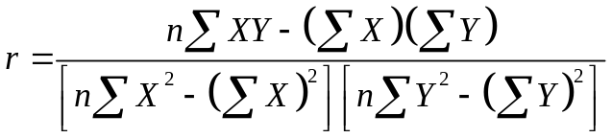
Replacing values and simplifying, we get, r=0.8

Properties
- Correlation only measures the strength of a linear relationship. There are other kinds of relationships besides linear.
- Correlation is symmetrical with respect to the variables X and Y, i.e. r_{xy}=r_{yx}
- Correlation coefficient ranges from -1 to +1.
- Correlation is not affected by change of origin and scale. i.e. correlation does not change if the you multiply, divide, add, or subtract a value to/from all the x-values or y-values.
- Assumes a linear association between two variables.
Lecture 30-32
Lecture Outline
- Common misconceptions about correlation
- Related Examples
- Introduction to Regression Analysis
- Regression versus Correlation
- Simple and Multiple Regression Model

Common Confusion about Correlation
There are many situations in which correlation is misleading.
- Correlation is defined only when both variables (X and Y) are Jointly Normal.
- Non-Linearity
- Outliers
- Ecological Correlations
- Trends
Non-Linearity: Consider the data set on X and Y=X².
X | Y
-10 | 100
-9 | 81
-8 | 64
-7 | 49
-6 | 36
-5 | 25
-4 | 16
-3 | 9
-2 | 4
-1 | 1
0 | 0
1 | 1
2 | 4
3 | 9
4 | 16
5 | 25
6 | 36
7 | 49
8 | 64
9 | 81
10 | 100

Scatter plot of above data is shown below:

Note: Scatter plot shows very strong (perfect) relationship b/w X and Y. But Correl(X,Y) is approx. zero.
The correlation coefficient only measures the strength of the linear relationship. Hence it is essential to plot the data prior to doing statistical analysis. If the data does not fit a standard joint normal pattern (or close) then the standard analysis can be quite misleading.
Outliers: Outliers present in a data can mislead.
Consider a data set:
x | y
10 | 7.46
8 | 6.77
13 | 12.7
9 | 7.11
11 | 7.81
14 | 8.84
6 | 6.08
4 | 5.39
12 | 8.15
7 | 6.42
5 | 5.73

Scatter plot of above data is shown below:

Note: A perfect linear relationship b/w X and Y is spoiled by one outlier. Calculated Correlation is 0.82.
LESSON: One outlier, or a small group of outliers, can distort a strong correlation and make it appear as a zero or even negative correlation.
Ecological Correlations:
When a correlation is measured at a group level, and then conclusions drawn for individuals within groups, this is called an “ecological correlation”.
Example: Suppose we look at country data on total number of cigarettes consumed and total number of lung cancer cases, and find a strong correlation. From this, we might be tempted to conclude that smoking causes cancer. However, countries do not smoke, individuals do. So this is an ecological correlation. It is easily possible to make up data such that despite a strong ecological correlation, there is no relation between smoking and cancer at the individual level. For example suppose that there is a sequence of countries with increasing populations: 10, 100, 200, 500 etc. Suppose all males in each country smoke, but none of them get lung cancer, while none of the females smoke, but all females get lung cancer. If we look at individual data on smoking and cancer (at the level of persons), we will find a perfect correlation of -100%. No one who smokes gets cancer, and no one who gets cancer smokes. However if we look at the ecological correlation at the group level, we will find that there is a perfect +100% correlation between smoking and cancer – the larger the number of smokers, the large the number of lung cancer cases in each country. There will be a perfect linear relations between the two at the level of the country. This example shows that group level correlations cannot necessarily be reduced to the level of individuals.
Trends:
One of the most damaging and least understood phenomenon is that of spurious correlation. Correlation reveals the relationship between two stationary variables, and does not work to reveal any relationship between nonstationary and trending variables. The most important such case is when the two variables in question have increasing (or decreasing) trends.
Example: Consider data on GNP per capita for Bhutan and El Salvador.
Year | .Bhutan | ElSalvador
1979 | 1478.424 | 4171.818
1980 | 1583.599 | 3693.96
1981 | 1626.714 | 3434.062
1982 | 1722.021 | 3466.129
1983 | 1800.135 | 3490.863
1984 | 1807.344 | 3484.543
1985 | 1924.189 | 3455.915
1986 | 2203.557 | 3500.369
1987 | 2156.315 | 3516.656
1988 | 2197.854 | 3495.197
1989 | 2344.948 | 3601.444
1990 | 2393.125 | 3660.578
1991 | 2527.632 | 3857.446
1992 | 2651.113 | 4054.301
1993 | 2820.177 | 4207.451
1994 | 3020.178 | 4381.249
1995 | 3194.396 | 4362.509
1996 | 3312.917 | 4453.65
1997 | 3417.545 | 4526.712
1998 | 3590.644 | 4589.47
1999 | 3684.819 | 4596.743
2000 | 3840.869 | 4586.245
2001 | 4105.917 | 4606.568
2002 | 4295.516 | 4627.453
2003 | 4471.634 | 4629.312
2004 | 4658.292 | 4674.763
2005 | 4929.535 | 4775.517

In practical terms, we could easily consider these to be “independent” series – these two small economies are remote from each other geographically, and have no linkages to speak of. Hence correlation is expected to Zero. But calculated value of correlation is found to be 0.90. This is due to the fact that both series have trends. This 90% does not measure any real association between the two series. Before we measure correlation, it is necessary to transform the series to stationary ones. One way to do this is by taking rates of growth for each economy. Differencing the series is another method that is commonly used. It is also possible to subtract a trend from the series to eliminate the trend. There is substantial literature on the best method to make a series stationary (same across time) before applied standard statistical techniques to it. Correlation of both series after differencing is found to be only 0.26 which is much less than 0.90.
LESSON: Trends can mislead the real correlation.
Note: For El Salvador and Bhutan, it is easy to see on intuitive grounds that the two series have no relation with each other. This makes it easy to dismiss the statistical correlation of 90% as being spurious or nonsensical – these two words have been used in the literature on this subject. However when we expect to see a relation between the two series, then this same problem becomes much more serious. Someone does a correlation between GNP and Money Stock for Pakistan. The result will be a very large number. Now he could argue for a very strong relationship between the two. Because we expect that there is some real relationship between these two variables, the fact that the correlation here is nonsensical does not seem quite so obvious.
General Lesson:
We have considered many cases where correlation can mislead us. Quoting a decisive number to a lay audience will sound very definite and authoritative and in addition, it will help win arguments. As a statistics student, you should be well aware of all these misconceptions and should not get trapped in the false interpretations.
Regression
Regression analysis is almost certainly the most important tool at the statistician’s and econometrician’s disposal. Regression is concerned with describing and evaluating the relationship between a given variable and one or more other variables. More specifically, regression is an attempt to explain movements in a variable by reference to movements in one or more other variables.
To make the idea more concrete, denote the variable whose movements the regression seeks to explain by y and the variables which are used to explain those variations by x₁, x₂, . . . , x_{k} .
Hence, in this relatively simple setup, it would be said that variations in k variables (the xs) cause changes in some other variable, y.
There are various completely interchangeable names for y and the xs.
Regression Versus Correlation
Regression and correlation have some fundamental differences.
In regression analysis there is an asymmetry in the way the dependent and explanatory variables are treated. The dependent variable is assumed to be statistical, random, or stochastic, that is, to have a probability distribution. The explanatory variables, on the other hand, are assumed to have fixed values.
In correlation analysis, on the other hand, we treat any (two) variables symmetrically; there is no distinction between the dependent and explanatory variables. After all, the correlation between two variables scores on mathematics and statistics examinations is the same as that between scores on statistics and mathematics examinations. Moreover, both variables are assumed to be random.
Simple vs Multiple Regression Models
If is believed that y (dependent variable) depends on only one x (explanatory or independent) variable. Then the regression model is said to be simple.
Example:
- Wage depends on education
- Consumption depends on income
If is believed that y (dependent variable) depends on two or more than two (explanatory) variables (x₁, x₂, …, x_{k}). Then the regression model is said to be a Multiple.
Example:
- Wage depends on education and experience etc.
NOTE: For details of lecture 31 and 32, please see the video lecture

