Decision Making in Non Profit Sector (NPO)-Lecture 1

HISTORY
Voluntary and Philanthropic initiatives and practices date back in the history in the region now Pakistan before recorded history and are mentioned in regional folklore. In recent times, these activities were manifested through the creation of trusts to supplement the state’s provision in the fields of
 Education
 Health
 Social Welfare
 Cultural Activities
Following independence, in 1947: The role of nonprofit organizations gained momentum.
○ Initially, the state was unable to provide emergency relief to the large influx of refugees that resulted from Pakistan’s Creation.
○ So nonprofit sector stepped in to fill the gap.
○ Most recently, as a result of the erosion of good governance practices and lack of confidence in the governmental capabilities and capacity, International Donor organizations, Multilateral, Bilateral and Private Philanthropists have resorted to funding non-government organizations directly (SPDC, 1998)
○ Government of Pakistan itself is committed: To deliver a substantial part of Social Action Program(SAP) and the programs under poverty reduction strategy through Non-government organizations. Thus, Rapid growth is witnessed in nonprofit organizations involved in social service delivery.
○ In addition to the individual voluntary activities, there have been significant organized efforts of Pakistan’s “Nonprofit sector”.
○ Most NGOs and Community base organizations are supported by:
 Community Donors,
 Local and International Donors
 Government Funds
○ In recent years, nonprofit organizations (NPOs) have become increasingly involved in community based initiatives for social and economic development in order to improve quality of life and help Alleviate poverty.
○ The spirit of voluntarism and philanthropy in the people of Pakistan stems from religious impulses.
○ The system of “Zakat” and other mechanisms outlined in Islamic teachings to help the poor by devoting resources to them.
○ In the year (2000), Agha khan Development network recorded that people of Pakistan contributed 41 billion rupees(1.5% of GDP) in 1998 and volunteered 1.6 billion hours of time to philanthropic activities in 1998.
○ History of philanthropy and voluntary activities goes back to the early-recorded history with the geographical boundaries now called “Pakistan”.
○ Religion has been the foremost driving force behind this phenomenon.
○ Hinduism
○ Buddhist
○ Islam
○ Christianity
○ Sikhism
○ Social cultural practices, such as joint family system and community living have been condusive to philanthropic activities.
○ Some early examples of philanthropic organizations Pre-dominentely religious institution such as ;
✓ Shipas
✓ Temples
✓ Monasteries
✓ Ashram
✓ Khanqahs
✓ Gurdwaras
○ In 711 A.D, Muslims established their rule in the region & institution such as,
✓ Madrasahs (Islamic religious schools)
✓ Mosques
✓ Began their role to play in community development and social welfare activities
○ In the 15th century, large numbers of Christian minorities came to sub-continent.
○ These missionaries introduced western education system and provided health care facilities to the peoples.

Colonial Period (1947)
○ Colonial period was categorized by the institutionalization of philanthropic and voluntary activates in the south Asia.
○ Activates were based “on service delivery “
○ In Pre-colonial period the philanthropic and voluntary sector was categorized mostly by the initiatives of individual philanthropists E.g.; Raja Ramohan Roy.

BrahmoSabha (1830)
○ The first association of its kind worked on Social reform (NGO RC,1999)
○ British rule initiated institutionalization of voluntary organization
○ Various laws were introduced
○ Societies registration act (1860)
○ Religious endowment act(1863)
○ Trust act (1882)
○ In recognition of philanthropic nature in South Asia.

Organization Started Emerged
Following were formed to provide education to masses on modern secular lines:
○ Anyiuman-i-Himayat Islam
○ National Muhammadan association
○ Dayal Singh Trust
○ Nadershah Eduligee Dinshawajee established the NED engineering college through Parsi funding has now become NED University of engineering and technology.
○ Some medical hospitals and college were established by Ganga Ram trust.

Edhi Trust (1951)
○ Biggest ambulance system (non-profit ambulance system).
○ Edhi foundation emerged as legendary social welfare organization,
✓ Health care
✓ Destitute Homes
✓ Graveyard services
✓ Prisoner aid and refuge sciences

1956 to 1999
○ 1956: National council for social welfare has been formed to finance /fund non-profit organization.
○ 1961:Voluntary social welfare agencies registration and control ordinance was passed.
○ 1970:Democratic years(1970s) witnessed conflicting development regarding the scope and prospect of non-profit sector in Pakistan.
○ According to NGO resource center in 1999,trade unions emerged in 1970.
○ Many others advocacy organization also appeared on scene.
○ AKRSP (Agha khan rural support program) working on rural development in northern areas of Pakistan.
○ Organization pilot project (water and sanitation facility in urban slums of Karachi).
○ Following the model of AKRSP,government established rural support program and provided endowment fund to these programs through small networks and community based organization .
○ After the Afghanistan war, many NGO setups headquarters in Pakistan (NGORC,1999),
✓ Human right commission of Pakistan
✓ Women action forum
✓ Pakistan institute of labor, education and research
In 1990’s,
○ Social action program .
○ Establishment of trust for voluntary organization.
○ Poverty alleviation fund.

NPO activities /objectives are diversified
○ Social welfare.
○ Rehabilitation.
○ Social service provision.
○ Social Development.

Lecture—3
Decision making in npo

  - NPO-An Overview

AGENDA
○ Preview of Last Lecture
○ NPO-Over View
○ Laws Governing NPOs
○ Conclusion

NPO-An Overview
○ Political theorists sometimes divide society into three components: the state, private enterprise and civil society.
○ This tripartite division is embodied by ‘the prince’, ‘the merchant’, and ‘the citizen’.
○ The prince symbolizes governmental power; the merchant represents economic power; and the citizen embodies the power of the peoples. Civil society can also be identified as the public space between individual citizens and the state, in which their activities occur collectively and in an organized form (Stewart, 1997)
○ Nonprofit Organizations (NPOs) are an important part of civil society and are distinct from both the state and private enterprises.
○ Their unique position outside the market and the state, comparatively smaller scale, connection with citizens, their flexibility and capacity to tap private initiative in support of public purpose have positioned.
○ NPOs as strategically important participants in the search of a ‘middle way’ between sole reliance on the market and the state. (Salamon, 1999)
○ NPOs have mushroomed across the world in recent years, in large due part to widespread “crises of the state” that have been underway for two decades in virtually every region of the world. Despite their growth in number and size, NPOs remain dimly understood.
○ A gross lack of basic information about NPOs makes it difficult to determine what their role and capabilities really are and to highlight the difficulties they face in scaling up.
What exactly are NPOs?
○ The many existing definitions of ‘nonprofit’ add to the confusion, as do the activities undertaken by these organizations. Known variously as the ‘non-governmental’, ‘voluntary’, ‘community based’, ‘charitable’, ‘welfare societies’, this set of institutions include within it a sometimes bewildering array of entities – schools, hospitals, dispensaries, human rights organizations, sports clubs, madarsa (schools primarily providing religious education), residents welfare associations, organizations involved in material assistance to the needy, community based organizations involved in lobbying for civic amenities, and many more.

Common Features in all NPOS
○ They have an institutional presence and structure
○ They are institutionally separate from the state
○ They do not return profits to their members, managers or directors
○ They are fundamentally in control of their own affairs
○ They attract some level of voluntary contribution of time or money and also membership in them is not legally required.

Legal Status of NPO
○ The legal framework governing the nonprofit sector in Pakistan is both archaic and confusing.
○ There does not appear to be a legal definition of the term ‘nonprofit organization’ under any law that gives legal status to these types of organizations.
○ A significant number of organizations are registered under four laws: the Voluntary Social Welfare Agencies (Registration and Control Ordinance), 1961; the Society Registration Act, 1860; the Companies Ordinance, 1984; and The Trust Act II, 1882.
○ Voluntary Social Welfare Agencies (Registration and Control Ordinance), 1961
○ A voluntary social agency is an organization, association, undertaking established by persons of their own free will for the purpose of rendering welfare services and depending for its resources on public subscription, donation or government aid (NGO Resource Centre, 1991).
○ These agencies can carry out their function in one or more fields such as child welfare, youth welfare, women’s welfare, welfare of physically and mentally handicapped, welfare of beggars, recreational programs, social education, family planning etc.

Societies Registration ACT, 1860
The society is an organization, association or undertaking established by persons of their own free will. These societies may be established for the promotion of science; literature; the fine arts; instructions; the diffusion of useful knowledge; political education; charitable services; the foundation and maintenance of libraries/reading rooms; painting galleries; collection of natural history; mechanical and philosophical inventions; religious and educational services.

Companies Ordinance (Section 42), 1984
Associations, formed for promoting commerce, arts, science, religion, sports, social services, charitable or any other useful purposes may be registered as nonprofit companies, provided that they apply or intend to apply their profits, if any, or other income in promoting their objectives and prohibit the payment of dividends to their members. In most cases, registered nonprofit companies are organizations engaged in research with donor funding, clubs and very large organizations engaged in delivering social and welfare services.

The Trust Act, 1882
A trust is an obligation annexed to the ownership of property. It is a ‘gift’ of property to a person or institution providing benefit to both parties. For the creation of a trust it is necessary that there should be a creator or author of the trust, a person in whom the confidence is reposed i.e. the trustee, and a person for whose benefit the trust is created i.e. the beneficiary (Janjua, 2000). A trust may be created for any lawful purpose, which can be revoked. The Trust Act, with a component for Public Trusts, provides legal cover for private acts of public charity, and allows the creators of the trust tremendous flexibility in their operations.

Data Collection Strategy
Specifically, the purpose of the data collection exercise was to estimate;
○ The size of the nonprofit sector in terms of paid and voluntary employment, operating and development expenditure, number of organizations and number of memberships;
○ The sectorial composition according to the characteristic activities of organizations in the sector and according the International Classification of Non Profit Organizations (ICNPO)
○ Nonprofit sector revenue by sources

Information
Available information: Why there was a Need for Primary Survey
○ The estimates of some parameters of our interest are available from government publications as well as previous national level organizations surveys. However, these estimates indicate great variation among the parameters.
○ For example, a significant variation exists between the estimates from the surveys conducted by the Federal Bureau of Statistics, Government of Pakistan. The estimates of employment in nonprofit social sector, based on Labour Force Survey (1996-97) indicate an employment level of 604,000, while the estimated level of employment in the nonprofit institution as generated from the data of Household Integrated Economic Survey (1996-97) is about 180,000.
○ On the other hand, various organizations have conducted sample surveys of other registered organizations. For instance, a sample survey sponsored by United Nation Development Program reports employment in the nonprofit sector, at the national level as 234,255 during 1991. Unfortunately, the raw data of these surveys is not accessible, and, therefore, it is difficult to estimate the parameters of our interest at the ICNPO disaggregated level. Another problem in using these estimates is the issue of wide variation. For instance, one study reports that the percentage of revenues from membership fees is 41 percent (Trust for Voluntary Organizations, 1993), while the another study reports the same to be at 3 percent (Government of Pakistan, 1990) only.

Drawbacks of survey
○ Perhaps, the most important drawback of these organizational surveys is that all of them have ignored the unregistered component of the nonprofit sector.
○ This clearly reveals the problem of underestimating the sector’s parameters.

Survey Locations
○ Twelve districts, which represent heterogeneity with respect to income, ethnicity, social norms and languages, have been selected. Most of these districts contain cities having population of more than one million.
○ These cities are termed as Self- Representing Cities (SRC) by the Federal Bureau of Statistics (FBS). The FBS also considers these districts as a separate stratum in the stratification plan for the urban domain in conducting nationwide surveys.

Applying Survey Weights
○ For both the survey of registered organizations and population-based survey, standard survey weights were applied to arrive at national and provincial estimates.
○ The sample organizations were weighted/adjusted using the following formula:
○ Registration-Based Survey
(Total Organizations in the Act * Proportion of Estimated Active Organizations / Number of Sample Organizations)
○ Population-Based Survey - Urban
(Total Urban Population (Province) / Sample Population Surveyed)
○ Population-Based Survey - Rural
(Total Rural Population (Sample Districts) / Sample Population
Surveyed)
○ Perhaps the most important pattern of nonprofit activity is the dominance of education. This sector retains 71 percent of the total estimated nonprofit
employment.
○ Organizations that provide primary education alone have a share of 25 percent of total employment in the nonprofit sector.
○ The share of organizations providing religious education is about 17 percent, while organizations providing secondary and higher education employ nearly 28 percent of the NPS employed force.
○ Majority of the organizations providing non–religious education is registered under the Societies Act, 1860. Nonetheless, there are concerns about the organizations registered under this Act. By the charter of the law, these organizations are nongovernmental and nonprofit distributing organizations, however, public concern is directed at the managers or directors of these organizations, who draw attractive salaries for their services or lease their property at exorbitant prices.
○ The second largest sector in terms of paid employment is health, which provides about 11 percent of NPS employment. The majority of these organizations are registered under the Social Welfare Ordinance, 1961 or under The Trust Act, 1882.
○ It is evident from the data that the domination of education and health activities in employment, most of their revenues come from fees and user charges.
○ The fee component alone has a share of 34 percent in the total NPS cash revenue.
○ The study illustrates a story that is quite different from general public perception in Pakistan. It is generally believed that the share of foreign resources is quite high in nonprofit activities. This is based on the observation that nonprofit organizations grew rapidly in size and number after the Afghan war in 1980.
○ The myth of a ‘foreign driven’ nonprofit sector model is not supported by this study, since the share of direct foreign philanthropy is only 6 percent while public sector payments including bilateral and multi-lateral foreign aid is only 7 percent.
○ Therefore, with 87 percent of the revenue coming from indigenous private philanthropy, fees and user charges, the nonprofit sector poses a substantially different picture.
○ Nonprofit institutions are vital as they give expression to citizen concerns, they hold governments accountable, promote community, address unmet needs, and strive for improving the quality of life. The findings of this study suggest the existence of a vibrant and sizable nonprofit sector on both, social and economic fronts in Pakistan.
○ The emphasis on education and health as well as sizable campaigning or lobbying Organizations.

Conclusion
○ Pakistan’s nonprofit sector presents a good and a balanced prospect.
○ Despite its limitations relating to low geographical coverage and little or no social exposure of nonprofit institutions, the study is the first scientific and systematic approach to document the key dimensions of the nonprofit sector in Pakistan and as such is a significant milestone in social science research on the NPS in Pakistan.

Lecture—4
Decision making in npo

AGENDA
○ Preview of Last Lecture
○ Strategy
○ SWOT and PEST Analysis
○ Strategy Formulation
○ Strategy Implementation
○ Strategy Evaluation

LECTURE-3
○ Strategic Management Perspective-1
○ Strategy(Why it is Important)
○ Role of Strategy in NPO Sector

SWOT
○ Internal Environment
○ External Environment
○ SWOT Analysis

Articulating Vision and Mission
○ One thing that most people don’t know about organizational planning is that strategic planning is neither the first nor the most important step in the planning process. The highest step in the planning process is establishing a clear mission, articulating a vision of the future, followed by creating strategic plans to fulfill the mission and vision.

Strategy Formulation
○ Vision
- Guiding Philosophy
- Intangible Image
-World Vision:
For every child, life in all its fullness; our prayer for every heart, the will to make it so

Vision Examples
○ Amnesty International: To undertake research and action focused on preventing and ending grave abuses of these rights.
○ Save the Children: Our vision is a world in which every child attains the right to survival, protection, development and participation.
○ WWF: We seek to save a planet, a world of life. Reconciling the needs of human beings and the needs of others that share the Earth…
○ Special Olympics: To transform communities by inspiring people throughout the world to open their minds, accept and include people with intellectual disabilities an thereby anyone who is perceived as different.
○ Make-A-Wish: We grant the wishes of children with life-threatening medical conditions to enrich the human experience with hope, strength and joy.
○ Oxfam: A just world without poverty.

Edhi’s Vision
○ Edhi's vision is to create an institution that will carry on his life's work and survive for a long time to come.
○ His dream is that of a Pakistan as a modern welfare state, which provides a safety net for the poor and needy while providing basic health and education with vocational skills.
○ A welfare state Edhi feels is the only way to tackle Pakistan’s myriad social problems. He hopes that one day; Pakistan will be a model for other developing countries.

PAKISTAN SOCIETY FOR THE REHABILIATION OF THE DISABLED – PSRD

Difference between Vision and Mission
○ Mission is the purpose for which the organization exists. A mission statement tends to be a paragraph or less, and is frequently broadly cast, and not compelling. A typical mission statement of an association of traffic light painters might be, “To promote the art and science of traffic light painting, and improve the safety and welfare of motorists and maintenance workers on public roadways.”
○ Vision is an inspiring, long-term view of where the organization is headed.
○ A vision statement includes a brief articulation of (1) core values, (2) core purpose, (3) a huge goal, and (4) a vivid description of what it will be like to achieve the goal. Any interested person looking at the vision statement, which should be less than one page in length, should immediately be able to identify with it, and know whether they want to be part of it or not. Vision remains fixed for decades at a time; it does not change with environment or circumstances.
○ Virtually every organization has a mission statement, and the majority of organizations have strategic plans. Most organizations do not have a clearly articulated vision.
○ Yet, strategic planning without a vision is like building flying machine without a clear picture of what the machine must do, or what it will look like. The organization drifts, frequently changes course, and may be consumed by personal agendas and petty political squabbles. Under such circumstances, the machine will never fly (achieve greatness) without major divine intervention.

VISION
○ Vision and Mission both should be based on concept of rationality.
○ E.g., If we say we will finish poverty from the face of earth, then it is emotionally charged vision and kind of impossible.
○ Yes, if we say we will finish poverty from one village or tehsil then it looks rational vision.
○ President J. F Kennedy

OBJECTIVES
○ Specific
○ Measurable
○ Attainable
○ Reliable
○ Time-bound

Sectors of the Country
○ Majorly, two sectors exist in the country; Development sector and Commercial.
○ Development sector invests for the betterment of the Society.
○ Commercial sector invests for the sake of earning profits or revenue.

Strategy

“The future just doesn’t happen. It’s shaped by decisions.”

Paul Tafliabue, former commissioner

National Football League

Formulation of Strategy
○ Vision: DELTA( Development, Economic, Legislative, Training Advocates) want to make 30 Cardiac hospitals in All over Pakistan by 2040.
○ Formulation of Strategy
○ Phase 1- 2013-2020(10 Cardiac Hospitals)
○ Phase 2-2020-2030(10 Cardiac Hospitals)
○ Phase 3- 2030-2040(10 Cardiac Hospitals)

Policies
○ Field Staff Policies
○ Administrative Policies

History of HR Manual
○ O ye who believe! When ye deal with each other, in transactions involving future obligations in a fixed period of time, reduce them to writing Let a scribe write down faithfully as between the parties: let not the scribe refuse to write: as Allah Has taught him, so let him write. Let him who incurs the liability dictate, but let him fear His Lord Allah, and not diminish aught of what he owes Al Quran [ Surah-Al-Baqarah ] Chapter No 2, Verse No 282

At-will employment statement policy
○ Employment Relationship can be terminated at any time with or without notice
○ Critical in defending against claims of wrongful termination

Right to revise statement
○ This Statement makes your employee handbook a legal document
○ Gives flexibility when your employee handbook needs to be changed

Equal employment opportunity
○ Federal and state laws require employers to communicate with employees about commitment to equal opportunity to every one
○ EEO ensures that all applicants and employees receive equal treatment without regard to race, color, religion, sex, age, disability, martial status etc.
○ Policy should also state that it prohibits harassment

Harassment Policy
○ Policy should state how to identify harassment & the company complaint process
○ A well written policy and follow through will help avoid these potential costs

Employment Benefit policy
○ Communicate the federal and state mandate benefits: worker’s compensation insurance, social security, state disability, unemployment insurance etc.

○ Communicate company sponsored benefits: Vacation/sick plans, holidays, health, insurance.

Employee conduct policy
○ Informs the employee what behavior is appropriate and the potential consequences for breaking company rules
○ Employee conduct policy may include: conflicts of interest, personal appearance, attendance and punctuality, drug and alcohol abuse, etc.
○ Helps protect employer against claims of unlawful disciplinary actions or discrimination

Employee Acknowledgement of receipt form
○ Acknowledges that employee understands everything in the employee handbook
○ Holds the employee accountable
○ Have employee sign and date and put in their personal file .

Common Contents of HR Manual
○ 1. Recruitment Policy
○ 2. Promotion Policy
○ 3. Salary Policy
○ 4. Job description, specification and Evaluation Policy
○ 5.Leave Policy
○ 6. Promotion Policy
○ 7. Training Policy
○ 8. Welfare Policy
○ 9. Communication Policy
○ 10. Environment Policy
○ 11. Health And Safety Policy
○ 12.Anti HarassmentOr Abuse Policy

Recruitment Policy
○ How Recruitment will be done ?
○ What will be the criteria ?
○ How much time will be given for the recruitment procedure
○ What type of recruitment will it be ?( Internal or External )

Health And Safety Policy
○ What health and safety standards will be followed in the organization
○ Emergency Evacuation procedure in case of emergency
○ What standard operating procedure will be followed in filed and in office

Environment Policy
○ What are the environmental aspects
○ Legal and other requirement
○ Environmental management program ( EMP )

Communication Policy
○ What will be the reporting method
○ The hierarchal design
○ Language of communication
○ Method of communication

Welfare Policy
○ Will the policy be based on Religion ?
○ Will the policy be based on Area ?

Leave Policy/Salary Policy
○ Grading / Pay Scales (Position, Skills, Experience, Education, Market Competitive )
○ Basic Salary
○ Allowances (Communication Allowances, Medical, Transportation etc
○ Increments
○ Bonuses
○ Gratuity
○ End of Service/ Terminal benefits

Job Description, Specification
○ Job Description is about the Job (Environment etc.)
○ Requirements
○ Eligibility
○ Authority

Sexual Harassment Policy
○ Gender Harassment Includes any unwanted sexual advance, requests for sexual favors or other verbal or physical conduct of a sexual nature, causing interference with work performance, which is made a condition of employment.

Training Policy
○ Indoctrination
○ On Job Training
○ Internal / External
○ Job Enrichment
○ Class Room Training

Promotion Policy
○ Experience
○ Target
○ Performance
○ Appraisal
○ Opportunity

Operational Policy
○ Safety and Security of Field office and Staff
○ Security Meetings of NPOs

Conclusion
○ Vision without Actions is a day dream and actions without Vision is a nightmare. (Japanese Proverb)

Lecture—5
Decision making in npo
  - STRATEGIC PLANNING
AND
NEED ASSESSMENT
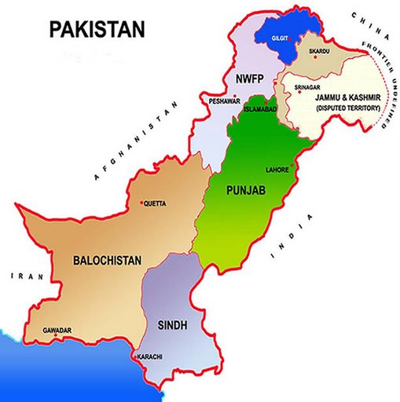

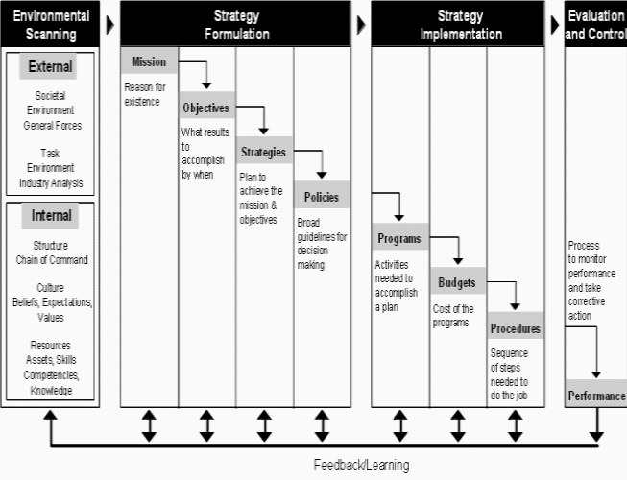

Sectors of the Country
○ Majorly, two sectors exist in the country; Development sector and Commercial.
○ Development sector invests for the betterment of the Society.
○ Commercial sector invests for the sake of earning profits or revenue.

Project
○ Temporary endeavors undertaken to create product, service or result.

Why Project Management

Every social organization – whether working on service delivery or process issue, undertakes projects. Projects come in many forms and can range from the very simple to the very complex. Every project is unique and presents unique challenges. Project Management is essential to manage projects.

Examples of Project Oriented Industries
○ NASA and DOD (Department of Defense)
○ Construction, architecture, new product development
○ NGOs
○ Financial/Service Institutions
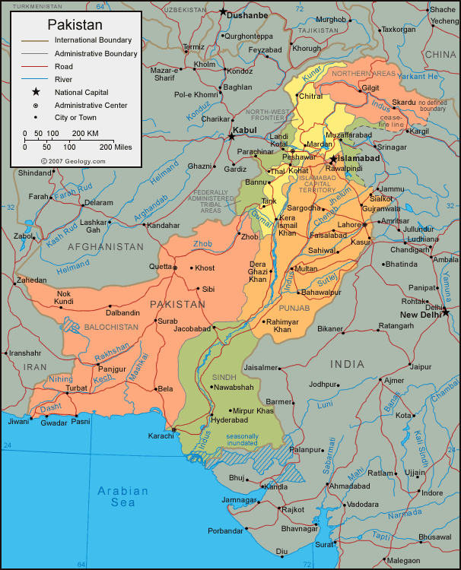
○ Banks, Insurance, Telecommunication
○ Manufacturing Units and Plants’ operation

Examples of Major Projects in Pakistan
○ Tarbela Dam
○ Mangla Dam
○ Ghazi-Barotha
○ HUBCO
○ Jinnah International Airport
○ AllamaIqbal International Airport
○ Muslim Commercial Bank
○ National Stadium Karachi
○ Shah Faisal Mosque
○ ShaukatKhanum Memorial Hospital
○ JF-17 Sino-Pakistan Combat Aircraft
Examples of Social Sector Projects in Pakistan
○ Voter Education Project
○ Constituency Relations Group
○ Tobacco Free Initiative
○ Polio Eradication Program
○ Family Planning Project
○ Governance Monitoring
○ Khuda Ki Basti
○ Orangi Pilot Project
○ Clean Drinking Water Project
○ Awaz
○ Youth Parliament
○ Diya
○ Iodine Use

What is a Project?
QUALITY
Need/Scope / Requirement
Budget / Cost
Time / Schedule

Project Management
○ Application of knowledge, skills, tool and techniques to the project environment to satisfy the stakeholder needs of expectations.

What Projects Are Not?
Projects must not be confused with an organization‘s on-going and recurring operations.
For example:
- Routine procurement, administration adn other operations
- Routine meetings of governing bodies of organizations
- Ongoing industrial manufacturing
- Airline flights
- Bank and stock operations
- Routine hospital services and operations
- War
-are not projects even though they may exhibit project characteristics (goal, time-frame, cost).

What is a Program?
○ Program
 More than one project that aims to contribute to a common goal consistent with vision and mission statement of the implementers
 A group of projects managed in a coordinated way to obtain benefits not available from managing them individually
 A project results in the creation of a set of results that outlive the project life although the project stands closed at a defined point in time.
 A program must integrate and maintain the operationally of expected result for a specified period of time.

Project A
Project B
Project C
Program
X
Project D
Project E
Project F

Project Structure
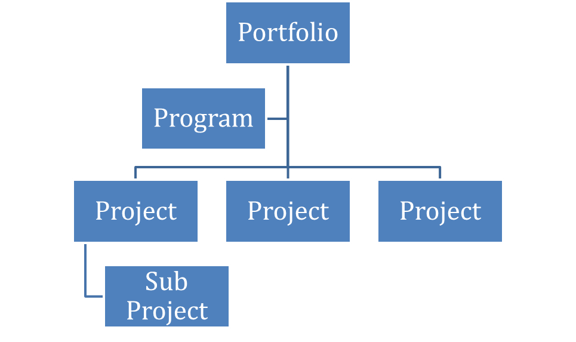

Project Output & Outcome: Example

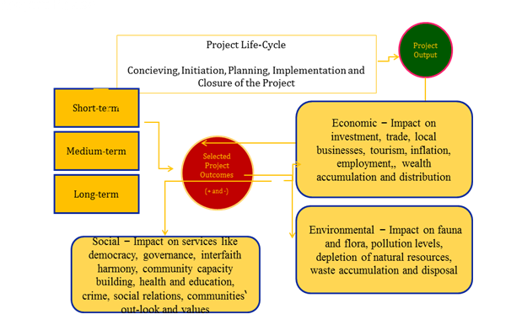

Project consist of Process groups and knowledge areas and their relationship

○ Five Process Groups
○ Initiating
○ Planning
○ Executing
○ Monitoring and control
○ Closing

9 Knowledge Areas
○ Project Integration Management
○ Project Scope Management
○ Project Time Management
○ Project Cost Management
○ Project Quality Management
○ Project Human Resource Management
○ Project Communication Management
○ Project Risk Management
○ Project Procurement Management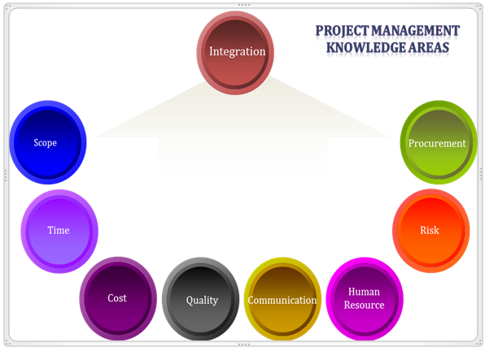
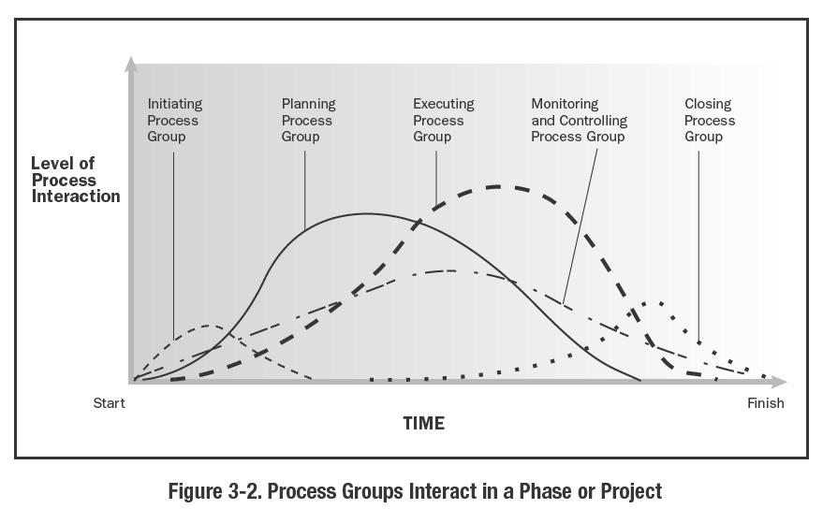

Collect Requirements
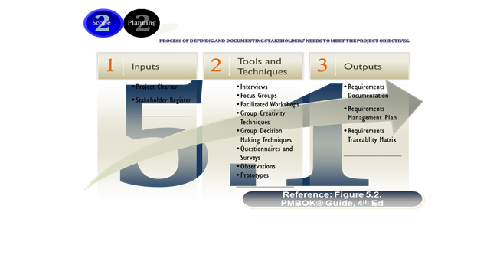

Define Scope
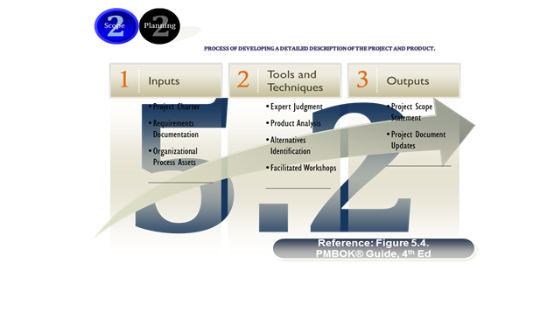

Create WBS

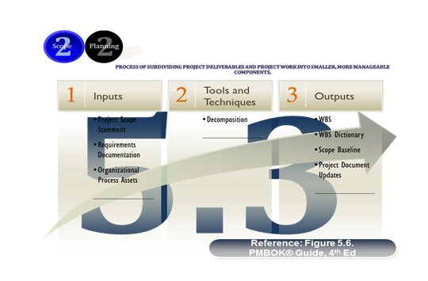

Community Need Assessment
○ The goal of need assessment is to identify the assets of the community and determine potential concerns that it faces. The Straight forward way to estimate the needs of a community is to simply ask residents their opinions about the development of services within the community. Their satisfaction with services and what particular
○ Services are needed.
Planning and organizing phase
○ Information gathering
○ Learn About Organization and Programme
○ Identify goals and objectives for the need assessment.

Need Assessment Methodology
○ Getting ready
○ Developing a need assessment Survey
○ Creating a need assessment Survey

The Need Assessment Survey Data Collection

○ Obtaining the representation of the community.
○ Providing incentives.
○ Flyers, Advertising the public forums.
○ Getting ready to conduct the survey.
○ Administering the door to door survey.

Summarizing and Distributing the Need Assessment Results

○ Summarizing the data on the public forums.
○ Writing the final report.

Community Need Assessment Guide

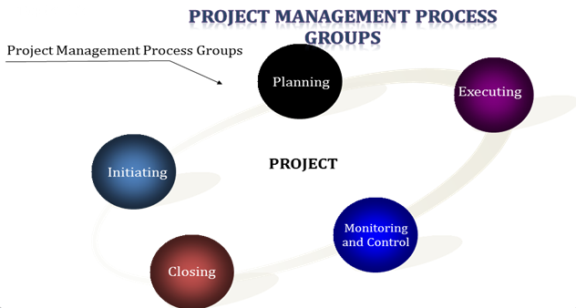

Conclusion
In Development Sector Projects are designed keeping in view results of need assessment.
In order to develop community and fulfill the gaps identified after a need assessment. Projects and Programs are initiated

Lecture—6
Decision making in NPO

AGENDA
○ Preview
○ Dimensions of Non Profit sector in Pakistan
○ Common Features and Major Features
○ Legal Status of Non Profit Organizations
○ Services
○ Composition
○ Employment, Voluntarism and Membership
○ Expenditure Pattern
○ Revenue Structure
○ Results
○ Conclusion

DIMENSIONS OF THE NONPROFIT SECTOR IN PAKISTAN
Political theorists sometimes divide society into three components: the state, private enterprise and civil society. This tripartite division is embodied by ‘the prince’, ‘the merchant’, and ‘the citizen’. The prince symbolizes governmental power; the merchant represents economic power; and the citizen embodies the power of the peoples. Civil society can also be identified as the public space between individual citizens and the state, in which their activities occur collectively and in an organized form (Stewart, 1997).

DIMENSIONS OF THE NONPROFIT SECTOR IN PAKISTAN
Nonprofit Organizations (NPOs) are an important part of civil society and are distinct from both the state and private enterprises. Their unique position outside the market and the state, comparatively smaller scale, connection with citizens, their flexibility and capacity to tap private initiative in support of public purpose have positioned NPOs as strategically important participants in the search of a ‘middle way’ between sole reliance on the market and the state. (Salamon, 1999)

DIMENSIONS OF THE NONPROFIT SECTOR IN PAKISTAN

NPOs have mushroomed across the world in recent years, in large due part to widespread “crises of the state” that have been underway for two decades in virtually every region of the world.

DIMENSIONS OF THE NONPROFIT SECTOR IN PAKISTAN
Despite their growth in number and size, NPOs remain dimly understood. A gross lack of basic information about NPOs makes it difficult to determine what their role and capabilities really are and to highlight the difficulties they face in scaling up.

DIMENSIONS OF THE NONPROFIT SECTOR IN PAKISTAN
The Johns Hopkins Comparative Nonprofit Sector (CNP) Project1 facilitates to make the sector visible to most policymakers, business leaders, the media, and even to many people within the sector itself.

What exactly are NPOs?
The many existing definitions of ‘nonprofit’ add to the confusion, as do the activities undertaken by these organizations. Known variously as the ‘non-governmental’, ‘voluntary’, ‘community based’, ‘charitable’, ‘welfare societies’, this set of institutions include within it a sometimes bewildering array of entities – schools, hospitals, dispensaries, human rights organizations, sports clubs, madarsa(schools primarily providing religious education), residents welfare associations, organizations involved in material assistance to the needy, community based organizations involved in lobbying for civic amenities, and many more.

Common Features in NPOs
- They have an institutional presence and structure;
- They are institutionally separate from the state;
- They do not return profits to their members, managers or directors
- They are fundamentally in control of their own affairs;
- They attract some level of voluntary contribution of time or money and also membership in them is not legally required.

More Features
- Namely
- Organized
- Private
- Self-governing
- Nonprofit distributing
- voluntary

LEGAL STATUS OF NONPROFIT ORGANIZATIONS
- A significant number of organizations are registered under four laws:
- Voluntary Social Welfare Agencies (Registration and Control Ordinance), 1961.
- Societies Registration Act, 1860;
- Companies Ordinance, 1984
- Trust Act II, 1882.

Voluntary Social Welfare Agencies (Registration and Control Ordinance), 1961
A voluntary social agency is an organization, association, undertaking established by persons of their own free will for the purpose of rendering welfare services and depending for its resources on public subscription, donation or government aid (NGO Resource Centre, 1991).

Voluntary Social Welfare Agencies (Registration and Control Ordinance), 1961
These agencies can carry out their function in one or more fields such as child welfare, youth welfare, women’s welfare, welfare of physically and mentally handicapped, welfare of beggars, recreational programs, social education, family planning etc.

Societies Registration ACT, 1860
The society is an organization, association or undertaking established by persons of their own free will. These societies may be established for the promotion of science; literature; the fine arts; instructions; the diffusion of useful knowledge; political education; charitable services; the foundation and maintenance of libraries/reading rooms; painting galleries; collection of natural history; mechanical and philosophical inventions; religious and educational services.

Companies Ordinance (Section 42), 1984
Associations, formed for promoting commerce, arts, science, religion, sports, social services, charitable or any other useful purposes may be registered as nonprofit companies, provided that they apply or intend to apply their profits, if any, or other income in promoting their objectives and prohibit the payment of dividends to their members. In most cases, registered nonprofit companies are organizations engaged in research with donor funding, clubs and very large organizations engaged indelivering social and welfare services

The Trust Act, 1882
A trust is an obligation annexed to the ownership of property. It is a ‘gift’ of property to a person or institution providing benefit to both parties. For the creation of a trust it is necessary that there should be a creator or author of the trust, a person in whom the confidence is reposed i.e. the trustee, and a person for whose benefit the trust is created i.e. the beneficiary (Janjua, 2000).

The Trust Act, 1882
A trust may be created for any lawful purpose, which can be revoked. The Trust Act, with a component for Public Trusts, provides legal cover for private acts of public charity, and allows the creators of the trust tremendous flexibility in their operations.

Services or Activities

Estimation in Pakistan
About 45,000 organizations are estimated in Pakistan according to the definition discussed above, i.e., focus entities were Private, Not profit distributing, Self- governing and Voluntary organizations.
According to one study, the highest percentage (46%) of organizations reported Education as their main activity. The second largest component in the nonprofit sector consists of organizations engaged in advocacy (18%). Organizations providing social services are at 8%, while 5% organizations reported religious activities as their main service. Organizations working in health sector are relatively few (6%).

Composition of NPOs in Pakistan

Religious Education

Lobbying for Civic Amenities

Primary Education

Religion

Secondary Education

Resident Welfare Associations

Material Assistance To The Needy

Health Treatment, Primarily Outpatient

Sports

Shopkeepers/Traders Associations

Vocational / Technical /Special Education

Community And Neighborhood Improvement

Civil Rights Promotion

Income Support And Maintenance

Hospital Care – Inpatient

Burial and Funeral Services

Other Organizations (With less than one percent share)

Employment, Voluntarism and Membership
According to the estimates of the study, the NPS employs about 265,000 people on a paid basis, while more than 212,000 people volunteer their time. Paid employment in the NPS is equivalent to 0.36% of the adult population and 1.9% of non-agricultural employment; the number of FTE volunteers is equivalent to 0.29% of the adult population and 1.5% of non-agricultural employment

Employment, Voluntarism and Membership
The estimated number of members in nonprofit organizations is about 6,000,000.
The highest membership share goes to ‘Civil Rights and Advocacy’ (34.6%) followed by ‘Business and Professional Association’ (26.8%). This is not surprising since these organizations tend to be membership based associations.
About 16 of the percent membership share goes to the ‘Education’ sector, which also absorbs the highest percentage of employees and volunteers. About 5 percent membership each is reported in organizations mainly working in ‘Health’ and ‘Social Services’ sectors.

Expenditure Pattern
Operating expenditure is defined as the costs incurred in the general operation of an organization. These include salaries, fringe benefits, and other personal costs; purchases of non-capital goods, supplies, and services; fees & other charges paid. However, operating expenditure excludes; costs incurred in land acquisition, building construction, and purchases of major equipment and vehicles, since these are typically paid for over a period of time.

Expenditure Pattern
The share of ‘Education’ group in total NPS operating expenditure is about 42 percent, while this group employs about 71 percent of the total paid persons. Similarly the health sector, with 11 percent of the employment share, expends about 28 percent of theNPS operating expenditure.

Expenditure Pattern
60 percent cash expenditure of NPS are incurred in Punjab province, while its share in voluntary time is about 47 percent. Annual wage bill is estimated at 40 percent of the total operating, expenditure amounting to Rs. 5 billion, while the value of volunteer time is imputed as 3.7 billion, which is about 28 percent of annual operating expenditure. The distribution of imputed value of volunteer time is more or less consistent with the distribution of FTE volunteer distribution. The dissimilarities, are mainly due to wage rate differentials across various sectors.

Revenue Structure of Nonprofit Organizations
Revenue is defined as inflow of spend-able resources received by the organizations during the year. In-kind revenues were distinguished from cash revenues.
Fees and Charges, which include membership charges, service charges paid directly by the client in exchange for services; investment income; and income from business activities (e.g., sale of goods and services) that are not directly related to the primary activity of the organization.
Public Sector Payments, which refer to revenues coming from all levels of the government (federal, provincial, district) as well as quasi-governmental entities such as Pakistan Poverty Alleviation Fund, Trust of Voluntary Organizations etc.
Public sector revenues also include grants and contracts in support of specific organizationalactivities or services and thirdpart payment, i.e. indirect government payments for reimbursement to another organizations for services rendered to clients.
Philanthropy, or Private Giving, which includes revenues received from, individual contributions; private foundation grants, and corporate donations including those from corporate foundations.
About 16400 million annual cash revenue and 135 million in-kind revenues are estimated in just 1999.

Results from Johns Hopkins CNP Project
- Perhaps the most important pattern of nonprofit activity is the dominance of education.
- This sector retains 71 percent of the total estimated nonprofit employment.
- Organizations that provide primary education alone have a share of 25 percent of total employment in the nonprofit sector.
- The share of organizations providing religious education is about 17 percent, while organizations providing secondary and higher education employ nearly 28 percent of the NPS employed force.

Results
Majority of the organizations providing non–religious education is registered under the Societies Act, 1860. Nonetheless, there are concerns about the organizations registered under this Act. By the charter of the law, these organizations are nongovernmental and nonprofit distributing organizations, however, public concern is directed at the managers or directors of these organizations, who draw attractive salaries for their services or lease their property at exorbitant prices.
The second largest sector in terms of paid employment is health, which provides about 11 percent of NPS employment. The majority of these organizations are registered under the Social Welfare Ordinance, 1961 or under The Trust Act, 1882.
The fee component alone has a share of 34 percent in the total NPS cash revenue.

Conclusion
Nonprofit institutions are vital as they give expression to citizen concerns, they hold governments accountable, promote community, address unmet needs, and strive for improving the quality of life.

References
DIMENSIONS OF THE NONPROFIT SECTOR IN PAKISTAN By Dr. Aisha Ghaus-Pasha, HaroonJamal and Muhammad AsifIqbal

Prepared by:

Social Policy and Development CentreIn collaboration withAga Khan Foundation (Pakistan) andCenter for Civil Society, Johns Hopkins University, USA

Lecture—7
Decision making in NPO

AGENDA ON BOARD

- Current Trends and Challenges.
- Where are we now? Situational Analysis.
- Where do we want to go? Vision, Mission and Goals.
- How do we get there? Planning, Budgeting and Financing.

CURRENT TRENDS
Three Broader categories or Generations of NGOs:
a) Welfare and Charity-Oriented (1st Generation)
b) Community Development –Oriented (2nd Generation)
c) Sustainable Development and Advocacy-Focused (3rd Generation)

SCOPE OF THEIR WOR

1). (First Generation) Welfare, Charity Based NGOs:
- Mostly Alleviative.
- Largest Number of NGOs.
- Immense Credibility.
- Receive large donations.
- Conscious Policy

2). (Second Generation) Community Development NGOs:
- Bit of both 1st and 3rd category of NGOs.
- Providing a range of development services
- Number a Few Thousand.
- National and Local NGO Networks.
- With Innovative Models for Development (e.g. AKRSP & OPP
- Aimed towards poverty eradication.
- Providing small grants to registered CBOs/NGOs.
- Responding to the absence of effective local government.
- Education and skill enhancement programs.

3). (Third Generation) Sustainable Development and Advocacy NGOs:
- Transformative in Nature.
- Third and youngest generation.
- Overtly engaged in equitable development.
- Community empowerment and transformation.
- Advocacy campaigns for social and economic change.
- Smallest in number.
- Annual Budgets.
- More risky to function.
- Better access to indigenous and government grants.
- Mostly dependent on foreign fund.

CURRENT CHALLENGES FACED BY THE NGO SECTOR OF PAKISTAN

1). Horizontal and Vertical Linkages

Horizontal Linkages:
Horizontal linkages include ties with labor unions, journalists associations, nurses associations, teachers associations and lawyers associations.

Vertical Linkages:

Vertical linkages of civil society include inter-ministerial and state linkage with the civil society within the national context.

2). SECURITY ISSUES
- Unless the arm conflicts are not resolved.
- Intervene into such conditions without any care.
- Possibility to restrict there activities to those regions.
- Monitoring work and gather facts via contacts with local people

3). ISOLATION FROM MILITARY HUMANITARIAN INTERVENTION
- Counter-insurgency or other military objectives has blurred the line between military and humanitarian actors.
- They may be perceived as party to the conflict as a result.

4). CULTURAL SENSITIVITY AND UNDERSTANDING
- Traditional aid and development organizations are very slow in adapting to a multi-cultural environment.
- The melting pot of people and cultures in Pakistan and South-Asia at large creates challenging environment for civic expressions in general.
- On-going migration of people from the other regions is leading to multiple changes in Pakistani society, including the inevitable clashes of, culture and economic interest.

5). RIGHT AND ADVOCACY BASED NGO & THEIR FUNDING CONSTRAINTS
- International and domestic donors agencies are skeptical and reluctant to extend the fund facilities.
- Structure of these type of NGOs demands vertical linkages with its stakeholder (e.g. Government and inter-ministerial).
- Certain rights of the citizens are withheld by the state

6). ANTI-WEST/US SENTIMENTS
- US and European policies toward Pakistan since 2001.
- In turn it is hindering efforts to stabilize the country by involvement of NGO.
- Must urge their host country.

7). CONCENTRATION IN OPERATIONS
- NGO sector consumes about 80 per cent of their funds for flood-relief workand rehabilitation.
- Compromising at growth component in this country.
- Growth is the ultimate power that elevates the society at its strong footings.
- Dependent on the sound infrastructure, skilled human capital, vocational training and expertise in line with the paradigm

8). TRENDS IN SOCIETY ‘AN ISLAMIST OR SECULAR ONE’
- People in Pakistan are more conservative and attached to their Islamist ideology and believe in state to be Islamic state.
- On the other hand, secularization debate in Pakistan is not new under the sun of this country.
- Mixed picture of the structure of the state ideology complicating and making the policies of the NGO sector more abstruse.
- People at large, charged the certain NGOs under the allegation that theseNGOs are dominant by the secular society of the west must be carrying some ulterior pernicious motives against Islam.

B). WHERE ARE WE NOW? SITUATIONAL ANALYSIS
- NGO different sector
- Agricultural extension,
- Water and sanitation,
- Housing construction.

NGO Sector at Socio Economic Front

Poverty and NGO
- 72.1% extremely poor females are from agricultural class.
- 27.9% are from non-agricultural sector

Health/Sanitation Facilities & Ngo Sector
- Pakistan Economic Survey, 2004-05)
- low level of development of health sector
- Females.
- Sanitation facilities 46%, thus indicating that Pakistan is set to miss the MTDF and MDG targets of sanitation.

Safe Drinking water and NGO Sector
- 2001-02 was 69%,
- Declined to 66% in 2005-06

Education & NGO Sector
- South Asia.
- Gender disparities
- Lack of adequate infrastructure,
- Poor quality of teaching and teaching materials
- More than 50 percent
- TCF
Relief and Rehabilitation &The NGO Sector:
- The 2010 floods
- Approximately 20 million people were affected.
- More than one million homes,
- 24,000 kilometers of road were damaged,
- NGO sector consumed about 80 %.

MATERNAL AND CHILD MORTALITY RATE
The maternal mortality rate is high, with 320 out of 100,000 mothers dying during childbirth and only 39 per cent of births attended by skilled medical personnel. Child health and nutrition are a particular concern, with two out of every five children malnourished and one in ten children dying before reaching the age of five.
Ngo Sector in Response to Climate Change
- Natural disasters
- Global warming
- Earth quake
- Floods
MICRO FINANCE CREDIT & NGO SECTOR

WHERE WE WANT TO GO?

Vision
Maximum outreach for the benefit andsocial uplift of the people without discriminating them on the basis of there, sex, class, creed, sect, religion and ideology with our utmost impartiality.

Mission
Purely serve to drive and to bring ultimate social change via providing the basic social services to the poor and distressed that are deprived of, and marginalizedat the expense of the state.

Goals
Our goals are not to achieve the tangible benefits but intangiblebenefits in guise of balanced society where people are given equalrights and economic opportunities and society free of fundamental inequity
1)Diversification vis-à-vis Anticipative Approach
2) Natural Disasters & Pro-activism/Social Protection Scenario
3) Capacity Building and Partnership
4) Professionalization
5) Documentation and Registration
6) Upholding the Fundamental Humanitarian Principles, Neutrality, Impartiality and Independence:
7) Stop Appropriation of Humanitarian aid for Non-Humanitarian Purposes
8) Ensure Accountability and Transparency

HOW DO WE GET THERE?
Planning
- Past, Present and future Analysis
- Identification of the Core Issues:
- Setting the Priorities:
- Timeframe and Plan Execution:

BUDGETING AND FINANCING
- The art of budgeting is all about the ‘revenues and expenditures’.
- Revenues:
  - Revenues are the funding granted to them by the certain national and international donor agencies
- Expenditures:
- Comprise of the spending of the funds on certain project e.g. relief work in floods and rehabilitation.

MAJOR SOURCES OF FINANCING
- Private donations
- Institutional funding
- Corporate funding

BUDGETARY AND FINANCING CONSTRAINTS AND PROCESS OF RATIONALIZATION
- Economic perspective.
- Budget is s tool to balance.
- Budgetary and financial allocations should be balance in nature.
- That is not the case:
  - 80% of the total funding amount spent on relief and rehabilitation.
  - Imbalance approach in the humanitarian sector causes other imbalances at socio-economic front.
  - Humanitarian sector compromised on the growth by avoiding major funding to the Sustainable development NGOs.
  - 50% of the total budgetary allocations for humanitarian sector must go to the sustainable development based NGOs in Pakistan.
  - Must be responsible for setting up a good infrastructure, providing vocational and technical training, develop the social safety nets for poor and distressed, must dispense the quality education.
  - Must notice the economic impact of such activities in place quarterly, annually and semi-annually.
  - Finances can be accordingly both annually and semi-annually in an un-intermittent manner on the basis of prioritizing the projects.

Conclusion

“We must remember that one determined person can make a significant difference, and that a small group of determined people can change the course of history.” Sonia Johnson

Lecture—8
Decision making in NPO

AGENDA
- Preview of Last Lecture
- Assignment
- Legal Frame work of NPOs
- Legal Regime
- Type A1 Laws
- Type A2 Laws
- Type A3 Laws
- Type A4 Laws
- Type B Laws
- Type C Laws
- Type D Laws
- Conclusion

ASSIGNMENT
Do the comprehensive analysis of two non-profit sector organizations in your region according to the strategic management model taught in the lectures?
Design one nonprofit sector organization under the law taught in the class and also identify the projects and their working?
Write a detail note on the history of philanthropic initiatives in the world?

Introduction
The origins of charity and philanthropy are probably based on religious underpinnings - the gift to the gods for an act of largesse to benefit the community as a whole such as a good harvest or relief from a natural disaster or in thanksgiving for such munificence.

Charity and Philanthropy
Charity is used for the relief of an immediate need or a lack of something.
Philanthropy, on the other hand, has a wider context “for the public benefit”.
Both involve giving.

Islamic Context
The concepts of, one, Zakat, a mandatory tax on wealth, to be used for providing relief to the indigent, the widow and the orphan; of, two, Ushr, a mandatory tax on the gross produce from agriculture; three, Fitra, a voluntary contribution on the occasion of Eid-ulFitr (the festival immediately after Ramadan) as a contribution to ensure that the poor and indigent also enjoy the occasion; four, Khairat, the voluntary giving of charity for charity’s sake; and of, five, Sadaqa, the voluntary giving of charity in expiation of sins or to ward off evil, are all enshrined in the Holy Quran

Charity
Charity is aimed at providing immediate relief to some lack or need. This commonly occurs in the shape of welfare disbursements, where people ‘in need’’ are typically provided with food, shelter or money (Qureshi, 2000).

Philanthropy
Philanthropy has the broader and longer-term
connotation of ‘social investing’ – actions that move beyond charity towards building human and social capital.” (Qureshi, 2000).

In Pakistan
In Pakistan, as elsewhere in most developing countries, the role of the non-profit sector has been growing and has evolved over the years from the limited sphere of charitable and philanthropic organizations to the wider public welfare-oriented and development roles to complement the state’s effort.
Over the years not for profit organizations (NPOs) have become more involved in community-based initiatives to improve the quality of life, or to help alleviate poverty, or advocate for access to basic rights. Community contributions, local donors, and government funds support most of these organizations.
In recent years, direct support from the international donor community has increased.

Categories under law
The sector organizations can be categorized into four categories: one, internationally funded policy research and advocacy.
Two, well endowed umbrella organizations at the national level which are catalytic and leaders in nature.
Three, the Rural Support Programmes as contractors for government and international donors helping support poverty reduction, thrift and savings associations, community development and micro-enterprise development.
Four, the foot soldiers – the small community based organization which implement and operate projects and schemes.

Plethora of Laws
The plethora of laws which impact, or at the very least, marginally impinge on philanthropic organizations consist of a total of 18 federal acts some of which are derivative of laws enacted in the United Kingdom in the first half of the nineteenth century.

First Law
In 1860, the British government passed the Societies Registration Act (initially only in Madras, Bombay and Calcutta) in an attempt to control voluntary associations, especially the cultural societies that it blamed for the insurrection of the sepoys in 1857.

Following societies registration act
Followed by a series of acts (until the middle of the twentieth century) governing Trusts, Religious Endowments and Auqaf to recognize the philanthropic and charity in the Sub-continent.

Post Partition Laws
The post partition laws were draconian laws used primarily either to intimidate philanthropic organizations or pursue a vendetta against those which were critical of the government of the day and were dependent on either government largesse or collected donations through bazaars, melas (fêtes) and other socio-cultural gatherings (Hasan and Junejo 1996; Ismail 2002).

Law of charity
If an organization is involved in a public fund -raising activity, it requires to seek permission from the office of the Local Deputy Commissioner, under the Charitable Fund (Regulations of Collection) Act, 1953, and then apply for a waiver of Entertainment Duty on the sale of tickets from the provincial Excise Department.

TYPE A1
I The Societies Registration Act, 1860
II The Trusts Act, 1882
III The Voluntary Social Welfare Agencies (Registration and Control Ordinance), 1961
IV The Companies Ordinance, 1984

Type A2
I Religious Endowment Act, 1863
II The Charitable Endowments Act, 1890
III TheMussalmanWakf Validating Act, 1913
IV The MussalmanWakf Act, 1923
V The MussalmanWakf Validating Act, 1930

TYPE A3
I The Charitable and Religious Trusts Act, 1920

TYPE A4
I The Income Tax Ordinance, 1979
II The Income Tax Ordinance, 2001

TYPE B
I The Cooperative Societies Act, 1925
II The Industrial Relations (Trade Unions) Ordinance, 1969

TYPE C
I The Registration Act, 1908

TYPE D
I The Charitable Funds (Registration of Collection) Act, 1953
II Minimum Wages Ordinance, 1961
III Employees’ Social Security Ordinance, 1965
IV The West Pakistan Industrial and Commercial Employment (Standing Orders) Ordinance, 1968
V The West Pakistan Shops and Establishment Ordinance, 1969
VI Employees’ Old Age Benefits Act, 1976

The Societies Registration Act, 1860
- The Societies Registration Act, 1860
- This is the oldest of the four registration laws, and was promulgated by the British in pre-partition India.
- This was created largely to regulate professional, scientific and fine arts activities and was extended later on to encompass charitable and social organizations as well.
- Registration under this law is also open to organizations for mutual benefit, such as clubs and residents’ association.

The Societies Registration Act, 1860
Once the NPO receives its certificate of registration under the Societies Registration Act, 1860, its legal status is that of a registered society and as an artificial juridical person, which means it can enforce its rules against its members, sue and be sued in its own name, own property and keep accounts in the bank in the name of the society.

Judgment
In addition, if any judgment is passed against a person on behalf of the society, the judgment can only be enforced against the property of the society, not against the person.
One major benefit of registration that is available only to registered societies in the province of Sindh is that they may apply for ‘amenity plots’ at half of the rate for residential plots, from the Karachi Development Authority (NGORC 1991).

Refute and Reporting
The only way to refute it being a society would be if there were any evidence of its members making private gains by setting up the society.
The reporting requirements are limited to the list of the governing body members being filed with the Registrar. Basic accounting records of receipts, assets and expenditure are to be maintained and audited by a qualified auditor.
These with a statement of its affairs must be presented to the members in an annual general meeting.

The Religious Endowment Act, 1863
The Act was created to relieve the Boards of Revenue from managing religious trusts and buildings and reverting authority to the Trustees and Boards of Governors.
The Act only recognizes the existence of such Trusts, provides for how they are to be managed and regulates their activities.

The Trusts Act, 1882
The Trusts Act provides legal cover for private acts of public charity, and allows the creators of the trust tremendous flexibility in their operations.
The procedure for the creation of the trust is very simple.
A mere declaration on a stamp paper will ensure creation.

The Trusts Act, 1882
Registration is optional and not mandatory. The Act has also been used to establish public trusts and this has been vindicated through case law.

The Charitable Endowments Act, 1890
The Act grants authority to the Government to appoint a Treasurer for better financial management of Trusts, thus ensuring that the property of any Trust, which is in financial difficulty, is ensured.

The Charitable and Religious Trusts Act, 1920
The Act is yet another one, which governs the operations of both charitable and religious, Trusts.
The Act permits any person claiming to have an interest in the benefits accruing from the Trust to file a suit for redress or for access to information, subject to the applicant first proving such interest.
The Court (District Judge) in its judgment can specify the manner in which the future operations of the Trust will be conducted.
This, therefore, ensures the accountability.

The MussalmanWakf Validating Acts, 1913 and 1930 and the MussalmanWakf Act, 1923
- The former two Acts confer recognition on Waqfs created by Muslims for their personal benefit, or for the benefit of the descendants and eventually or specifically for charitable purposes.
- The 1913 Act is pro-active and the 1930 Act retroactive.
- The Act of 1923 governs the financial management of Waqfs.
- It requires that annual accounts be audited by a licensed auditor (as provided in the Companies Ordinance, 1984) and submitted for scrutiny to the District Judge.

The Voluntary Social Welfare Agencies (Registration and Control)
Ordinance, 1961
- The Ordinance was conceived for controlling the grass roots level
- organizations providing welfare services to those in need.
- The registration authority lies with the Directorate of Social Welfare, who may be approached either directly or through a lawyer.
- This ordinance is based on the premise that the “poor and destitute” in society need institutional, rather than only charitable, support.
- The Ordinance requires that all organisations engaged in social welfare or charitable works must be registered with the Social Welfare Departments (SWDs) of the provincial governments.

The Voluntary Social Welfare Agencies (Registration and Control)
Ordinance, 1961
- Registration is mandatory for organizations working in, and seeking funds from the government for any one of the twelve specified areas.
- The government has the discretionary right to dissolve an agency through due process or replace the governing body arbitrarily.
- The reporting requirements are stringent and require that even small organizations submit annual reports, audited accounts, statement of receipts and list of members.

The Voluntary Social Welfare Agencies (Registration and Control)
Ordinance, 1961
- Section 42 permits the registration of a Company for promoting commerce, art, science, religion, sports, social services, charity or other useful object.
- The procedure is cumbersome, as it requires a two-stage mechanism, one centered in Islamabad for the licence, and the second, the actual registration, at the regional offices located in the provinces.
- Registration confers on organisations the status of a non-profit company and the right to drop the use of the suffix ‘Limited’, ‘(Private) Limited’ or ‘(Guarantee) Limited’.

Status and Registration Laws
- Societies, associations and clubs under the Societies Registration Act of 1860 which also grant the organization the status of aartificial juridical persona.
- Religious societies under the Religious Societies Act of 1880.
- Public Charitable Trusts and Private Trusts under the Trusts Act of 1882.

Status and Registration Laws
- Charitable Endowment Trusts under the Charitable Endowments Act of 1890.
- Waqfs(Trusts) under the MussalmanWakf Act of 1923 and the MussalmanWakf Validating Acts of 1913 and 1930 (the former applicable to those created from 1913 onwards and the latter granting ex-post recognition to those created before 1913).

Status and Registration Laws
- Voluntary Social Welfare Agencies under the Voluntary Social Welfare Agencies (Registration and Control) Ordinance, 1961.
- Public Companies limited by guarantee under section 42 of the Companies Ordinance of 1984 which also grants the organization the status of aartificial juridical persona.

Status and Registration Laws
Tax Exempt Charitable Organization under sections 14 and 47 and the rules framed as part of the Income Tax Ordinance, 1979 and after 30 June 2002, under clause 36 of section 2, section 53 and section 80 and the rules framed as part of the Income Tax Ordinance, 2001.

Status and Registration Laws
- Under most forms of registration, the NPO hassome basic obligations with regard to the registration authority.
- Each type of registration also offers some benefits.
- Redress for grievance against any trust is through the Charitable and Religious Trusts Act, 1920 irrespective of which act they have been created through.

Why Have a Lawful NPOs?
- Personal Benefit
- For Business Purposes
- Funding Restrictions
- Financial Accountability
- Political Activities

Conclusion
- A telling testimony to the cumbersome and inhibiting environment for registration has been recorded by Ghaus -Pasha, Jamal and Iqbal [2002] when they conclude that of the nearly 45,000 estimated number of organizations (excluding those involved in trade union and political activities) working in the non-profit sector more than 34 percent have preferred not to register themselves, even under the VSAW Ordinance of 1961 where this is mandatory.
- The Act of 1860 is largely benign and supportive of civil society organizations but has suffered on account of the amendments of 1976 that have placed the power to suspend the governing body of the society in the hands of the government without any judicial process.
- Public trust can come into existence both through the dedication of property by an individual, a family or a small group as well as through the contribution of assets to a fund by the community in general.
- At present property dedicated as public trust can be vested as the property of a society under the Act of 1860, a charitable company under Section 42 of the Companies Ordinance, 1984 or a public trust with one or more trustees not expressly regulated by any law except the threat of action under Section 92 of the Civil Procedure Code, 1908. A sub-set of public trusts are also subject to the Charitable Endowments Act of 1890 or the Official Trustee Act of 1864.
- Charitable Companies under section 42 of the Companies Ordinance, 1984 remain an important subset of public benefit organizations and are likely to remain so as regards the larger nonprofit institutions.
- Agencies under the VSAW Ordinance of 1961 are a numerically preponderant group, 40.5 percent of the universe of non-profit organizations Ghaus-Pasha, Jamal and Iqbal, 2002).
- Given the plethora of legislation and functionaries impacting on the sector organizations, it could be beneficial and create a supportive environment for the growth of the sector if a new law is enacted for the registration, facilitation and monitoring of sector organization such as that currently being considered by the Government [PCP, 2002].

Reference

THE LEGAL FRAMEWORK OF THE NONPROFIT SECTOR IN PAKISTAN

Zafar H. Ismail

Lecture—9
Decision making in NPO

AGENDA
- Preview of the Last Lecture
- Pakistan Civil Society: Past and Present
- Pakistan NGO Legal Regulations
- Registration
- Types of Registered Organizations
- Structure of Society
- Structure of Trusts
- Waqf (Muslim Trusts)
- Steps involved to Register a Non Profit Company
- Example of Sustainable Development Society
- Income tax
- Conclusion

Pakistan Civil Society: Past and Present
- Philanthropy and charity are codified in the doctrines of the Islamic faith.
- Just as critically, however, the political and social developments of the country have directly impacted the growth of non-governmental organizations (NGOs).
- Pakistan’s lack of democracy, poverty, and underdevelopment make it difficult for civil society to flourish.
- Since Pakistan’s independence in 1947, NGOs have been filling gaps in the delivery of social services, such as healthcare and education, that the government of the day was able or unwilling to provide.
- In the late 1980s, when the government began recognizing the use of NGOs to deliver government programs, the number of NGOs increased and the types of services expanded from healthcare and education to advocacy and development.

In Pakistan
According to researchers, the “contribution of [the NGO sector] to the economy of Pakistan is substantial.”
This important role, however, has not resulted in a harmonious relationship with the state or wide spread support for NGOs among the people of Pakistan.
As in most non-democratic countries, while the Pakistan government does not actively discourage NGOs that provide education, healthcare, and welfare services, it attempts to obstruct NGOs that engage in social and political advocacy.

Further fueling the appearance
In the latter role, NGOs are seen as competition for the government in “funds and influence.”
Further fuelling the appearance that NGOs are engaging in anti-state activities is the presence of foreign-funding.

Pakistan NGO Legal Regulations
- There is no single body of law that governs NGOs in Pakistan.
- The Constitution guarantees citizens the right to assembly “subject to any reasonable restrictions imposed by law in the interest of Public order.”
- In addition, depending on the source, there are between 10 to 18 different laws in Pakistan that may govern an NGO.
- Several of these laws are based on British laws enacted by colonial rulers in the mid- to late 1800s before Pakistan was partitioned from India.

Kinds of Laws That Govern NGO
The kinds of laws that govern NGOs fall into two categories: registration laws that define internal governance and the reporting relationship between the state and the NGO, and second is taxation laws.

Why most of the NGOs unregistered
- Many NGOs in Pakistan are unregistered. According to a 2000 study, unregistered NGOs comprised 38% of all NGOs.
- Reasons for this high rate vary, but may include high registration fees and the discretionary and inconsistent implementation of the registration laws by the governing authority.

For Those NGOs That Do Choose To Register
For those NGOs that do choose to register, the benefits, although not necessarily enjoyed by every registered NGO, include:
- the ability to enforce by-laws;
- statutory requirements that force an NGO to become organized;
- legal status “at the official level and among donors;”
- the ability to open a bank account;
- the ability to sign contracts;
- the ability to indemnify employees; and
- the ability to qualify for financial assistance and tax exemption.

Registration laws
There are four main registration laws:
- the Societies Registration Act of 1860,
- the Trusts Act, 1882,
- The Voluntary Social Welfare Agencies (Registration and Control) (VSWA) Ordinance, 1961, and
- The Companies Ordinance, 1984.

Estimates
- Except under the VSWA Ordinance, registration is optional.
- According to the 2000 study, 40.5% of all registered NGOs are societies, 15% are agencies registered under the VSWA Ordinance, and 6% are trusts.

Similarities under the law
Similarities can be found between and among the laws.
For example, none of the registration laws proscribe a time period by which the government must accept or reject the application.
Each law requires a “statement of objects and purposes,” which is a legal constraint on an NGO’s activities.
Each registration act also requires that accounts be maintained in specific form and manner.
However, only the VSWA and The Companies Ordinances require audits be performed on accounts.

VSWA Important Ordinance
- Furthermore, except under the VSWA Ordinance, registered NGOs may engage in political activity.
- Each law also has particular benefits, disadvantages, and regulatory schemes, and its own registration authority.

LAWS
The most comprehensive of the laws, the VSWA Ordinance, has several unique characteristics.
The provincial Social Welfare Departments (SWD) that oversee NGOs registered under the VSWA Ordinance provide more guidance in operating and managing an agency than the registration offices for societies and companies, which only seem to get involved when there is a dispute or if called upon by a court.

Social Welfare Department and Agency
- Further, the SWD has developed a training institute for agencies; however, it is not automatically available for every registered agency.
- Additionally, an agency may be eligible for funds from the SWD not available to other types of NGOs.

Types of Registered Organizations: Societies
- NGOs can be registered under the Societies Registration Act of 1860 for any literary, scientific or charitable purpose.
- The Societies Registration Act is the oldest NGO registration act and societies are the most common and convenient form.

Societies registration act
- Societies that may be registered under this Act include:
- Charitable Societies
- Societies established for the promotion of science, literature, or the fine arts, for instruction, the diffusion of useful knowledge, the diffusion of political education the foundation or maintenance of libraries or reading-rooms for general use among the members or open to the public, or public museums and galleries of paintings and other works of art, collections of natural history, mechanical and philosophical inventions, instruments or designs.

Basic Requirements to establish a society
- Basic Requirements to Establish a Society
- At least seven founders,
- A signed Memorandum of Association,
- A copy of the society’s rules and regulations,
- A fee of 50 Pakistan rupees, and
- An application submitted to the Registrar of Joint Stock Companies in the province in which the NGO is located.

Memorandum of Association
- The Memorandum of Association must include:
- the name of the NGO;
- the province in which it is located;
- the objects for which it is established;
- names, addresses, and descriptions of the members of the governing body; and
- the signatures of those members.

Rules and Regulations
- The rules and regulations must contain:
- membership requirements,
- the makeup of the governing body,
- meeting and quorum requirements,
- meeting notice requirements,
- procedures for the election and removal of officers, and
- accounting and audit procedures

Once Registered
- Upon the filing of the Memorandum of Association, the registrar certifies that the society is registered.
- Registration can take as little as two weeks and there are no compliance costs.
- Once registered, a society is considered a legal person, which can enter into a contract, sue and be sued, have judgments enforced against it, sue its members, maintain bank accounts and own property.

Structure of society
- Societies are composed of a governing body and members.
- The governing body is the groups of governors, council, directors, commission trustees, or other body entrusted with the management of the affairs of the society and must consist of at least three members.
- The property of the society, if not vested in trustees, vests in the governing body.
- Its duties include filing all required documents on an annual basis and holding annual meetings in compliance with the rules and regulations. Meeting and Reporting Requirements

AGMs
- The governing body is also responsible for holding annual general meetings (AGMs) of the members.
- A quorum, consisting of a “major part of the members,” is required for the meeting.
- The accounting records of receipts, assets and expenditures audited by a qualified auditor must be submitted to the members at the AGM along with a statement of the organization’s affairs.

After AGM
- By the 14th day following the AGM or if there is no AGM, within the month of January, the society must file with the registrar a list of the names, addresses, and occupations of the governing body.
- There are no other reporting requirements. Suspension/Dissolution

Takeover
The provincial government may take over management of the society from the governing body for up to one year if it determines that the governing body:
- is unable to discharge its duties;
- is unable to administer the society’s affairs or meet its financial obligations; or
- “acts in a manner contrary to the public interest or the interests of the members of the society.”
At the end of the period, the society is reconstituted in accordance with the Memorandum of Association and its rules and regulations.

Once Dissolved
- A society may be dissolved by a three-fifths vote of its members or the members can ask a court to order dissolution.
- However, if the government is a “member of, a contributor to, or otherwise interested in [the] society,” the society needs the consent of the provincial government to dissolve.
- Upon dissolution no member of the society may obtain any of the profit.
- The property of the dissolved society must go to another society agreed to by three-fifths of the members or ordered by the court.

Trust
- A trust is a “’gift’ of property to a person or institution providing benefit to both parties,” and may be either a public trust, which benefits the public at large, or a private trust, which benefits individuals.
- Private trusts for public charity are governed by the Trusts Act, 1882.
- There is no law specifically governing public charitable trusts.
- However, a public charitable trust may register under one of the other registration acts.

Advantages to Register A Trust
The advantages to registering as a trust under the Trusts Act include:
- A high level of control over the administration and management of the NGO - there is a succession in place and there are no members;
- little to no interference from the outside;
- A simple registration procedure;
- Irrevocability; and
- Eligibility for income tax exemption.

Trust
- There are also no meeting or account maintenance requirements for a trust.
- A trust may be created for any lawful purpose and “is created when the author of the trust indicates with reasonable certainty by words or acts
- an intention … to create … a trust,
- the purpose of the trust,
- the beneficiary,
- the trust property and … transfers the property to the trustee.”

When is trust registered?
A trust is registered when the trustees (any number) file the trust deed or other instrument with the registration authority that then stamps the document.

Trustee is bind to:
- A trustee is bound to fulfill the purpose of the trust and to obey the directives of the author of the trust.
- A trustee is also bound to deal with the trust property as carefully as a man of “ordinary prudence.”

Accounts of Trust and Beneficiary
- A trustee must keep clear and accurate accounts of the trust property and furnish the beneficiary with full and accurate information.
- The beneficiary has the right to inspect and take copies of the trust instrument and other trust documents.

A Trustee May Be Discharged
A trustee may be discharged
- upon extinction of the trust
- completion of his duties
- according to the trust instrument
- upon appointment of a new trustee
- by consent of the trustee and beneficiary
- by order of the court.
- A new trustee may be appointed according to the trust instrument or by the author of the trust.

Dissolution
Under the Trusts Act, a trust is extinguished if:
- the purpose for which it was created is completed;
- the purpose becomes unlawful;
- the fulfillment of the purpose becomes impossible
- the trust is revoked.

Waqfs (Muslim Trusts)
- Another type of trust that may serve as an NGO is a waqf.
- Waqfs (also spelled wakf) are Muslim trusts initially created for personal benefit or the benefit of one’s descendants, but eventually expand to benefit the public.
- Waqfs may be created for “any purpose recognized by Islam as religious, pious or charitable.” Waqfs are “created for the ultimate benefit of mankind,” thus, Waqf property vests in God.

MussalmanWaqf Act, 1923
The MussalmanWaqf Act, 1923 and the Provincial Waqf Property Ordinances, 1979, govern the management and administration of a waqf.

MussalmanWaqf Act, 1923
The MussalmanWaqf Act, 1923, requires that within six months of creation, the mutawalli (trustee) of every waqf must submit a statement of particulars to the local court which include:
1. a description of the waqf property.
2. gross annual income.
3. gross amount of income since creation of the waqf;
4. amount of government revenues, taxes, and rents annually paid
5. an estimate of annual expenditures
6. an accounting of the amounts for salary and allowance.
7. “Any other particulars.”

Implications of Waqt act-1923
- The statement must be accompanied by the deed or other creation instrument.
- Additionally, the mutawalli must annually file with the court an audited statement of accounts of funds received and expended.
- In contrast to other types of NGOs, waqfs cannot be modified or terminated.
- Further, the property of a waqf may not be confiscated by the government, although in certain circumstances the government may assume the administration of the property, such as when the founder dies.

Implications of Waqt act-1923
The government may also dispose of the property and invest the proceeds in accordance with the Waqf’s directives.

Agencies
NGOs may register under The Voluntary Social Welfare Agencies (Registration and Control) (VSWA) Ordinance, 1961.
A voluntary social welfare agency (agency) is “an organization, association or undertaking established by persons of their own free will for the purpose of rendering welfare services in any one or more of [the proscribed] fields and depending for its resources on public subscription, donations or Government aid.”

Fields Include
- The proscribed fields are:
- child welfare
- welfare and rehabilitation of released prisoners,
- youth welfare
- welfare of juvenile delinquents
- women’s welfare
- welfare of the beggars and destitute
- training in social work
- welfare and rehabilitation of patients
- family planning
- welfare of aged and infirm
- recreational programs
- welfare of the physically and mentally handicapped
- Coordination of social welfare agencies

Registration
- Registration under this Ordinance is mandatory for any NGO which performs in one of these fields.
- Agency founders must submit an application to the Director of Social Welfare along with the constitution of the agency and a receipt for 25 Pakistan rupees paid to the provincial Social Welfare Department (SWD).

Application
The application must state:
1. the name
2. the address
3. the aims and objectives
4. the area of operation;
5. how the agency will be financed
6. the names, occupations, and addresses of the founding members
7. the name of the agency’s bank.

Constitution
The constitution must include:
1. the name, address, area of operation, and aims of the agency;
2. the requirements for membership, such as eligibility, categories, administrative procedures, rights and privileges, procedure for suspension or cancellation, and procedure for restoring membership;
3. the location of any agency branches;
4. the organizational structure;
5. the procedure for calling and noticing meetings and the constitution of a quorum;
6. financial administration, such as the procedure for withdrawing funds and appointing an auditor;
7. the procedure for amending the constitution.
- If the application is rejected, the founders may appeal the decision within 30 days.
- The agency may start functioning three months from the date of certification and must inform the registrar of its start within 15 days.
- Government Involvement and Reporting Requirements

Suspension
The registrar may suspend the governing body of an agency if there is an irregularity in the funds, maladministration in the conduct of affairs, or failure to comply with the Ordinance.
The registrar will then appoint a caretaker governing body of not more than five persons who have the authority and power of the governing body under the constitution.

When Termination
Thereafter, the provincial government may reinstate the original governing body, dissolve the agency, or reconstitute the governing body as it thinks fit.
The agency may appeal within 30 days of the suspension.

Provincial government
The provincial government may also dissolve an agency, after giving it an opportunity to be heard, if the registrar finds that the NGO is “acting in contravention of its constitution” or the Ordinance and its rules, “or in a manner prejudicial to the interests of the public.”
Once agency is desolved
- Additionally, the governing body or its members cannot dissolve the agency on their own; however, three-fifths of the members may apply to the provincial government to dissolve it.
- Once an agency is dissolved, the provincial government may appoint a competent person to wind up its affairs and order the remaining assets, after satisfaction of the NGO’s debts, to be transferred to another agency with a similar purpose.

Penalty
- Unlike the other registration acts, the VSWA Ordinance contains a penalty provision for noncompliance.
- Any person involved with an agency that contravenes the provisions of the VSWA Ordinance or makes false statements can be punished with up to six months in jail and a fine of 2,000 Pakistan rupees.
- Every director or officer of the agency “unless he proves that the offense was committed without his knowledge or consent [is] deemed to be guilty of such offense.

Memorandum- Voluntary social welfare ordinance- memorandum
- Name
- Registered office
- Character of society
- Objectives of the society
- Income and Property of Society for promotion of its objectives.
- Memorandum of society
- Liability Limited
- Interpretation
- Honorary Members
- Members to further interest and influence
- Exclusion from Membership
- Restrictions of Rights on honorary members
- Terms of Honorary members
- Meeting of the society
- Quorum
- Chairman of Meeting

Memorandum
- Procedure of Poll
- Board of Directors
- President and Members of the Board of Directors
- Chief Executive
- Power and Duties of BODs
- Special Power given to BODs
- Secretary and Treasurer
- BODs to Comply with the provision of ordinance

Income Tax
- NGOs may be eligible for income tax exemption under the Income Tax Ordinance.
- The Ordinance provides for a relatively complicated and confusing system.
- Only registered NGOs may apply for an income tax exemption to the Central Board of Revenue (CBR), the federal tax authority in Pakistan.

Categories under CBR
The CBR recognizes three categories of charity: informal, trusts and other legal obligations, which include waqfs, societies, agencies and non-profit companies, and organizations approved by the Commissioner of Income Tax or the CBR.

Tax Exemption
Any income of a trust, welfare institute, or non-profit organization from donations, contributions, subscriptions, property, investments in securities, and “income from business” is exempt from tax if the income was spent towards the objectives of the organization.

TAX
In addition, income from investments, grants received from the federal or provincial government or property held under trust or other legal obligations for religious or charitable purposes is exempt.
Income received by a religious or charitable institution from voluntary contributions which apply solely to the religious or charitable purposes of the organization is exempt
The income of non-profit educational institutes established solely for educational purposes is also exempt if the income is applied to its educational purposes and not given to any of its members.

Income Tax-Application Process
NGO must submit an application that provides:
1. the name of the NGO;
2. the address of the NGO;
3. the date registered;
4. its aims and objects;
5. the law under which the NGO was registered, its registration number, and the date of registration;
6. whether the NGO’s registration documents conform to this Ordinance;
7. details of the intended beneficiaries;
8. the number of members;
9. the start and end date of the NGO’s fiscal year; and 10. that books of accounts are regularly maintained.

TAX EXEMPTION
- Tax exempt status is granted an NGO must annually submit to the Commissioner: 1. a statement of the audited accounts; 2. a statement of income and donations received or paid; 3. a list of donors, beneficiaries and their addresses; and 4. a statement showing the amount of unutilized funds and the reasons for setting the funds aside.

- Government of Pakistan Central Board of Revenue http://www.cbr.gov.pk
- Government of Pakistan Ministry of Law, Justice & Human Rights http://www.pakistan.gov.pk/law-division
- Government of Pakistan Ministry of Social Welfare and Special Education, NGO Electronic Database http://www.ngosinfo.gov.pk/user/main.asp
- National Council of Social Welfare http://www.ncsw1.gov.pk
- Other
- Aga Khan Foundation http://www.akdn.org/agency/akf.html
- The Asia Foundation http://www.asiafoundation.org/Locations/pakistan.html
- Asian Development Bank – Pakistan http://www.adb.org/Pakistan/default.asp
- NCL-Pakistan (NGO’s Computer Literacy Shelter Welfare RWP) http://www.geocities.com/nclpakistan/?20073
- Net-NGO.com, Guide to NGOs in Pakistan http://www.net-ngo.com
- Pakistan Development Gateway http://pdg.org.pk/national/Hrd.asp
- Pakistan Virtual Library Cultural Associations and NGOs http://www.southasianist.info/pakistan/culassoc.html
- Social Policy and Development Centre http://www.spdc-pak.com
- Transparency International – Pakistan http://www.transparency.org/pk/

REFERENCES
Aisha Ghaus-Pasha and Muhammad AsifIqbal.“Defining the Nonprofit Sector: Pakistan.”The John Hopkins Comparative Nonprofit Sector Project, 2003.
Dr. Aisha Ghaus-Pasha, Haroon Jamal, and Muhammad AsifIqbal. “Dimensions of The Nonprofit Sector in Pakistan.” The John Hopkins Comparative Nonprofit Sector Project, 2002.
Ebrahim, Zofeen. “NGOs Balk at Government Prescribed Code of Conduct.” Inter Press Service News Agency, March 2, 2007.
Ismail, Zafar H. “The Income Tax Regime and the Non-Profit Sector: The Case of Pakistan.” The John Hopkins Comparative Nonprofit Sector Project, June 2003.
Razvi, Nasira. “Country Note: Pakistan,” International Journal for Civil Society Law, 3 (July 2005) 1-15.
White, Andrew. “The Role of the Islamic Waqf in Strengthening South Asian Civil Society: Pakistan as Case Study.” International Journal of Civil Society Law, 4 (April 2006) 7-36.
ZafarHameed Ismail and QadeerBaig.“Philanthropy and Law in Pakistan” in Philanthropy in South Asia, ed. Mark Sidel and IftekharZaman.Asia Pacific Philanthropy Consortium, 2004.
STATUTES
Pakistan Constitution of 1973 http://www.nrb.gov.pk/constitutional_and_legal/constitution/

Conclusion
“It takes years to build a good reputation, and only seconds to destroy it.”

Lecture—10
Decision making in NPO

  - THE ROLE OF NGOS

How do you describe an NGO? One survey found 48 different terms and acronyms. Here is a sample:

BINGOs Big International NGOs  BONGOs Business Organized NGOs  CBOs Community Based Organizations  CSOs Civil Society Organizations  ENGOs Environmental NGOs  GONGOs Government Organized NGOs | IPOs Indigenous Peoples Organizations  GROs Grassroots organization  GSCOs Global Social Change Organizations  NPOs Nonprofit Organizations  VOs Voluntary Organizations

In short, there is no agreed terminology for describing the NGO sector.
In some ways, it is easier to describe what NGOs are not, rather than what they are. It is generally agreed that NGOs are not:
- part of government, or
- Organized primarily for private profit.

Defining NGOS: What the Un Says
From the UN Department of Public Information:
- NGO refers to a non-profit citizens’ voluntary entity organized nationally or internationally. Thus, professional associations, foundations, trade unions, religious organizations, women’s and youth groups, cooperative associations, development and human rights associations, environmental protection groups, research institutes dealing with international affairs and associations of parliamentarians are considered NGOs.

From the Report of the Panel of Eminent Persons on United Nations–Civil Society Relations:
- Non-governmental organization (NGO). All organizations of relevance to the United Nations that are not central Governments and were not created by intergovernmental decision, including associations of businesses, parliamentarians and local authorities. There is considerable confusion surrounding this term in United Nations circles.
- Elsewhere, NGO has become shorthand for public-benefit NGOs — a type of civil society organization that is formally constituted to provide a benefit to the general public or the world at large through the provision of advocacy or services.
- They include organizations devoted to environment, development, human rights and peace and their international networks. They may or may not be membership-based. The Charter of the United Nations provides for consultations with NGOs.

NGOS, CIVIL SOCIETY, OR MAJOR GROUPS?
The Panel described civil society in the following way:
- The associations of citizens (outside their families, friends and businesses) entered into voluntarily to advance their interests, ideas and ideologies. The term does not include profit-making activity (the private sector) or governing (the public sector). Of particular relevance to the United Nations are mass organizations (such as organizations of peasants, women or retired people), trade unions, professional associations, social movements, indigenous people’s organizations, religious and spiritual organizations, academe and public benefit non-governmental organizations.

NGOS, CIVIL SOCIETY, OR MAJOR GROUPS?
“Major Groups” is a term that was introduced in Agenda 21, agreed by governments at the Rio Earth Summit. It describes nine sectors of society identified as having a significant role in sustainable development:
- women
- children and youth
- indigenous people
- NGOs
- Local authorities
- Workers and trade unions
- business and industry
- the scientific and technical community
- farmers

STAKEHOLDERS: YET ANOTHER TERM!

Stakeholders:
Those who have an interest in a particular decision, either as individuals or representatives of a group. This includes people who influence a decision, or can influence it, as well as those affected by it.

NGOs at The UN

“Ten years ago there was little talk of civil society in the corridors of power, but now the walls reverberate with at least the rhetoric of partnership, participation, and the role of citizens’ groups in promoting sustainable development”

- The number of NGOs who are active at the UN has grown rapidly, especially since the 1990s.

NGOS IN INTERGOVERNMENTAL PROCESSES

4 important functions:
- Setting agendas
- Negotiating outcomes
- Conferring legitimacy
- Implementing solutions

ROLE of NGOS in MEAS
- Enhancing the knowledge base
- Advocacy and lobbying
- Membership in national delegations
- Contribution to compliance review and enforcement as well as dispute settlement procedures
- Ensuring transparency
- Supporting international secretariats
- Broader functions of NGOs in international environmental governance

UNEP’S APPROACH TO CS

Service-delivery

Organizationsthat develop, monitor and implement projects/programmes or services; these CSOs are often based at the grassroots level or work closely with community-based organizations (CBOs).

Representation
Organizations that aggregate citizen voices; these include CSO umbrella and network organizations and indigenous peoples’ groups.

Advocacy and policy inputs
Organizations that provide expertise and lobby on particular issues; these include think tanks, research-oriented institutions and “watchdog” institutions.

Capacity building
Organizations that provide support to other CSOs, including funding, training and raising awareness; these institutions include foundations and major NGOs.

Social functions
Organizations that foster collective social activities, including religious groups.

CONSIDERINGTHE ROLE OF NGOS
[B] social movements take an unlikely idea, make it seem feasible, and then put it into practice.
[C] …civil society is not just a resting place for social movements on their way to the state. It is meaningful and sometimes crucial as a site of political action in its own right.
[D] the rise of the global idiots … any group with a fax machine and a modem has the potential to distort public debate .

The following quotes suggest some different opinions of the role of NGOs. What do you think?

ANTI-SLAVERY MOVEMENT
The anti-slavery movement, founded in England in the late 18th century, gave rise to many organizations and eventually led to the World Anti-Slavery Convention (1840), a milestone gathering to coordinate the work of citizen organizations on an international basis. The World Alliance of YMCAs was founded soon after, in 1855, and the International Committee for the Red Cross came into being in 1863.

IN SUMMARY
- Terminology around NGOs varies. They are defined by the UN as ‘non-profit citizens’ voluntary entities organized nationally or internationally.’
- A range of other terms are used almost interchangeably, particularly ‘stakeholders’, ‘civil society’ and ‘major groups’.
- NGOs have been involved in the UN since its inception; the rate of involvement has grown exponentially. Different agencies of the UN have their own accreditation arrangements (see Module Seven).
- NGOs bring knowledge and information, new issues and expert advice to intergovernmental negotiations and can play different roles, including:

- NGOs usually seem to take an increasingly important role in political life, some critics are concerned that NGOs speak in many different and conflicting voices that can fragment and weaken political action.
- Many respected NGOs work hard to overcome this narrowness by operating in close partnership with others.
- Some NGOs themselves specialize in coalition building.

- NGOs are often seen as synonymous with non-profits, but a distinction between the two is useful.
- Non-profits include a very wide range of organizations, including museums, universities, and hospitals, that focus on services and rarely (if ever) engage in advocacy.
- By contrast, NGOs always have an important advocacy mission.

- Pakistan is in a deep civil and economic crisis. During the past decade, the standard of living has deteriorated, poverty has increased, public institutions have decayed causing inadequate provision of essential services of any quality, and political and legal institutions lack the public's trust due to corruption and cycles of political crisis

- Reversing this trend and returning Pakistan to the path toward democratic and economic reform are in the U.S. Government's interest.
- Since independence, Pakistan has shifted among various forms of parliamentary, military, and presidential governments in pursuit of political stability.

- Civil society in Pakistan is generally weak, and has only recently begun to address macro political issues.
- Nonetheless, there are some potentially promising results that are beginning to emerge from the efforts of coalitions and networks of NGOs and community-based organizations (CBOs) to educate citizens about the meanings of democracy, representation, and the role of voters

- A time came when in third world countries including Pakistan people realized that the services being provided by government or its various departments either do not exist or of an inferior quality.
- Eventually people realized to work on self-help basis by establishing local groups, initially at Mohalla (street) and then at the National level.

- Most of the development work they carried out, was with the orientation of welfare and through indigenous available human, natural and financial resources.
- However, thanks to foreign aid for development which came through various channels and was helpful for these groups to grown up and to bank upon.
- The available funds that initially were siphoned through the government now shared by another, the non-governmental organizations (NGOs).

LAWS GOVERNING NPOS
- The Societies Registration Act (XXI),1860.
- The Trust Act,1882.
- The Charitable Endowment Act,1890.
- The Cooperative Societies Act,1925.
- The Voluntary Social Welfare Agencies (Registration and Control) Ordinance, 1961 (XLVI of 1961)
- The Companies Ordinance under Section 42 of 1984.

NGO BILL-1996
In 1994, Government of Pakistan (GOP) has decided to introduce a new act for the registration of NGOs.
It was introduced in the Senate of Pakistan as Social Welfare Agencies (Registration and Regulation) Act, 1996 on January 25, 1996.

PRIME PURPOSE OF NGO BILL
- The prime purpose of this bill was to unified various existing rules and regulation.
- One of the reasons perhaps was whenever any registration authority visits to an NGO, it refuses to cooperate with them on the basis that the organization is not registered with that particular department.

NGO BILL DISCUSSION
- The NGOs in Pakistan held a number of meetings throughout the country to discuss the issue of NGO-bill.
- A series of meetings was also held between NGOs representatives and the concerned minister and government officials.
- These meetings developed a basic understanding between the two concerns.
- However, any concrete result has not been come out as the Bill is still under consideration in the upper house.

DONORS TO NGOS
- The democracy and governance activity-which will operate independently of the Government of Pakistan (GOP)-and the basic education activity are being coordinated with other major donors such as the Asian Development Bank, the World Bank, the United Nations Children's Fund, Canada, and the European Union.
- All donor programs focus on Pakistan's priority needs as defined in its World Bank-supported national Social Action Plan, which encourages NGO and private sector participation in the delivery of social services.

NGOS….AS A PLATFORM
We are living in that type of critical situation where civil society is facing numerous challenges and threats from various quarters, there is a need to have a strong platform of NGOs to effectively address these issues and convey civil society's voice and concerns to policy makers and planners for this a region where people are always been crying HELP HELP........!!
WHY TRUSTING NGOS?
- The World Bank considers Pakistan a low-income country, due to its per capita gross domestic product (GDP) of about $470. Life expectancy is about 62 years.
- The population, currently about 150 million, is growing at about 2.4%, very close to the GDP growth rate.
- Relatively few government resources have been devoted to socioeconomic development.

NGOS THE ONLY SOLUTION
- Inadequate provision of social services and high population growth contribute to persistent poverty and unequal income distribution.
- So this all needs a platform to be overcome to which NGOs are the only solution.

FAILURE OF NGOS
- The failure of non-governmental organizations and misappropriation of funds by them is not a new phenomenon in Pakistan.
- But another debate started within people and through print media about the way NGOs work and advantages they take from funds available to them.
- Corruption and dishonesty has lunged in all sectors of Pakistan .....so as with these organizations.

NGOS FROM CRITICAL POINT OF VIEW

According to one of these critics:"Most of these NGOs are headed by influential, politician, bureaucrats and rich people/elite. These are the people who plunder in the name of "NGOs" and deprive the deserving people of their rights. There are NGO people who were riding on bicycles in the past, now own more than one vehicle such as Honda Accord and Pajero/Land Cruiser at their home. Those had pennies in their pocket until yesterday now having accounts in millions of dollar, what tosay accounts in rupees. The ill-mannered people now have their meals in five star hotels."

Another statement given by a government official that published says: "The deserving people get a very small amount after a thorough probe. While on the other hand, NGOs get huge amounts on the recommendations of Ministers or influential. The proverb for such NGOs is "gold attracts the gold."

CRITIC EYE
These are not the ordinary women rather, the wives of rich or elite. The question is, what is the purpose of these NGOs? And, what is the use of funds being received by these NGOs? If these NGOs had implemented the programmes according to their constitutions then unlike today, condition of the poor women was different. The poor women's condition was not so miserable. The society might not be desperate.
- Academy for Educational Development
- Action Aid
- Adventist Development and Relief Agency Pakistan
- AFS Intercultural Exchanges
- Himalaya Foundation
- Arab-Pakistani Fund
- Asian Human Rights Development Organization
- Association for the Development of Pakistan
- Aurat Foundation

- Bedari
- Braille Without Borders
- Bremen Overseas Research and Development Association
- CARE Pakistan
- Caritas Pakistan
- Carter Center
- Childreach International
- Chiltan Adventurers Association Balochistan
- William J. Clinton Foundation
- CMKP Pakistan
- Conservation International
- Consumer Rights Commission of Pakistan
- DarulSukun
- David and Lucile Packard Foundation
- Edhi Foundation
- Environmental Defense
- Environmental Investigation Agency
- Faiz Foundation for Pakistan
- Family Health International
- Fatima Jinnah Trust
- Fatma Welfare Foundation
- Fauna and Flora International
- Ford Foundation
- Friedrich Ebert Stiftung
- Friends of Pakistan
- Friends of the Earth Pakistan
- HabibJalib Institute for Social Development
- Habitat for Humanity International
- Health Unlimited
- Heart to Heart International
- Heifer Project International
- Heinrich Böll Foundation
- Hope International
- Humanity First
- iDonate Pakistan
- Idara-e-Amn-o-Insaf
- Institute for Sustainable Communities
- International Committee of the Red Cross
- International Development Enterprises
- International Federation of Red Cross and Red Crescent
- International Fund for Animal Welfare
- International Organization for Sustainable Development
- International Republican Institute
- Islamic Relief
- Marie Adelaide Leprosy Centre
- Mennonite Central Committee
- MKR Foundation
- Muslim Charity
- Muslim Hands
- Muslim World League
- Médecins du Monde
- Médecins Sans Frontières
- Minhaj Welfare Foundation
- National Democratic Institute for International Affairs
- Natural Resources Defense Council
- New Life Psychiatric Rehabilitation Association
- NRDF National Research and Development Foundation

Lecture—11
Decision making in NPO

AGENDA
- Preview of last Lecture
- The Role of NGOs, Charitable Organizations, Trust.
- Example 1: Edhi Foundation
- Example 2: Sustainable Development Policy Institute
- Example 3: An Overview of Basic Education under the Social Action Plan in Pakistan(1999) Shahrukh Rafi Khan
- Example 4: Sustainable Development Society.
- Conclusion

Dr. Abdul SattarEdhi
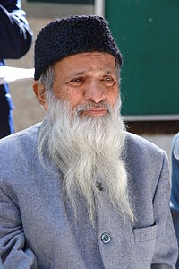

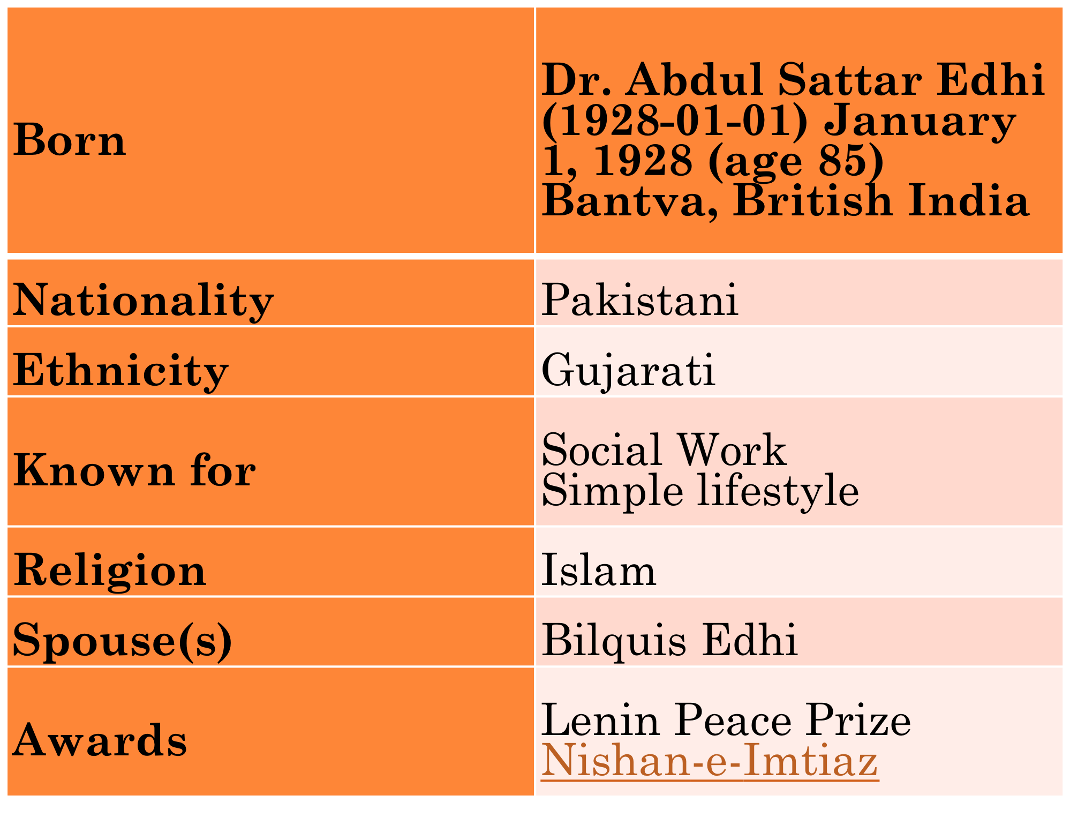
○ Dr. Abdul SattarEdhi or MaulanaEdhi, is a prominent Pakistani philanthropist, social activist and humanitarian.
○ He is the founder and head of the Edhi Foundation, a non-profit social welfare organization in Pakistan.
○ Together with his wife, BilquisEdhi, he received the 1986 Ramon Magsaysay Award for Public Service. He is also the recipient of the Lenin Peace Prize and the Balzan Prize.
○ In 2006, Institute of Business Administration Pakistan conferred an honoriscausa degree of Doctor of Social Service Management for his services.
○ In September 2010, Edhi was also awarded an honorary degree of Doctorate by the University of Bedfordshire.
○ In 1985 Edhi received the Nishan-e-Imtiaz from the Government of Pakistan.
○ He was born in 1928, in the city of Bantva in what is now western India.
○ Edhi's first interaction with human suffering occurred at the age of eleven, when his mother was physically paralyzed and later suffered from mental illness.
○ Edhi spent his waking hours caring for her, and her worsening health and eventual death left a lasting impact on his life.
○ Edhi resolved to dedicate his life to aiding the poor, and over the last sixty years, he has single handedly changed the face of welfare in Pakistan.
○ Edhi founded the Edhi Foundation, with an initial sum of a mere five thousand rupees.
○ Regarded as a guardian for the poor, Edhi began receiving numerous donations, which allowed him to expand his services.
○ To this day, the Edhi Foundation continues to grow in both size and service, and is currently the largest welfare organization in Pakistan.
Since Its Inception
○ Since its inception, the Edhi Foundation has rescued over 20,000 abandoned infants, rehabilitated over 50,000 orphans and has trained over 40,000 nurses.
○ It also runs over three hundred and thirty welfare centers in rural and urban Pakistan which operate as food kitchens, rehabilitation homes, shelters for abandoned women and children and clinics for the mentally handicapped.

○ Edhi has remained a simple and humble man. To this day, he owns two pairs of clothes, has never taken a salary from his organization and lives in a small two bedroom apartment over his clinic in Karachi.
○ He has been recommended for a Nobel Peace prize by the Prime Minister of Pakistan.
○ On June 25, 2013 Edhi’s kidneys failed and it was announced that he will be on dialysis for the rest of his life, unless he finds a kidney donor.
○ Edhi Foundation runs the world's largest ambulance service and operates free nursing homes, orphanages, clinics, women's shelters, and rehab centers for drug addicts and mentally ill individuals.
○ It has run relief operations in Africa, Middle East, the Caucasus region, eastern Europe and US where it provided aid following the New Orleans hurricane of 2005.

International Awards
○ Ramon Magsaysay Award for Public Service (1986)
○ Lenin Peace Prize (1988)
○ Paul Harris Fellow from Rotatory International Foundation, (1993)
○ Peace Prize from (USSR former) for services in the Armenian earthquake disaster, (1998)
○ Largest Voluntary Ambulance Organization of the World - Guinness Book of World Records (2000)
○ Hamdan Award for volunteers in Humanitarian Medical Services (2000) UAE
○ International Balzan Prize (2000) for Humanity, Peace and Brotherhood, Italy
○ Peace and Harmony Award (Delhi), 2001
○ Peace Award (Mumbai), 2004
○ Peace Award (Hyderabad Deccan), 2005
○ Wolf of Bhogio Peace Award (Italy), 2005
○ Gandhi Peace Award (Delhi),2007
○ UNESCO Madanjeet sing Peace Award (Paris),2007
○ Peace Award Seoul (South Korea), 2008
○ Honorary Doctorate degree from the Institute of Business Administration Karachi (2006).
○ UNESCO-Madanjeet Singh Prize (2009)
○ Peace Award (London), 2011

National Awards
○ Silver Jubilee Shield by College of Physicians and Surgeons, Pakistan, (1962–1987)
○ The Social Worker of Sub-Continent by Government of Sind, Pakistan, (1989)
○ Nishan-e-Imtiaz, civil decoration from Government of Pakistan (1989)
○ Recognition of meritorious services to oppressed humanity during eighties by Ministry of Health and Social Welfare, Government of Pakistan, (1989)
○ Pakistan Civic Award from the Pakistan Civic Society (1992)
○ Shield of Honor by Pakistan Army (E & C)
○ Khidmat Award by Pakistan Academy of Medical Sciences
○ Human Rights Award by Pakistan Human Rights Society

Sustainable Development Policy Institute(SDPI)
○ The end of 2012 marks the 20 years of SDPI operations in the field of research, policy advocacy and capacity building.
○ Today SDPI has in its credit hundreds of research initiatives, studies, policy briefs and policy papers in various disciplines including economy, climate change, water and energy, governance, food security, poverty alleviation, health and education, gender, peace and conflict etc.
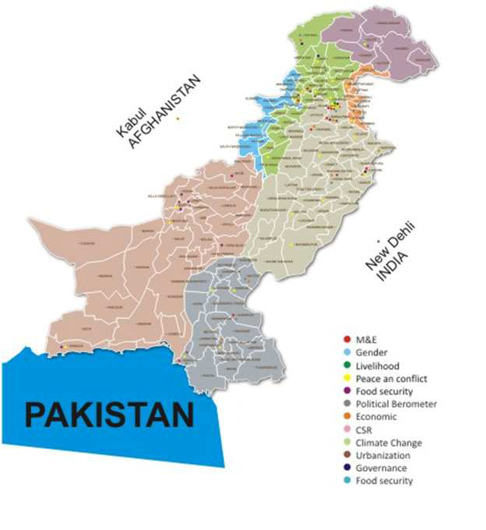

SDPI
○ The year ending 2012 has proved highly fruitful for SDPI owing to the untiring efforts and unflinching dedication of its staff and their allegiance to the organization’s vision and mission.
○ During the year, dozens of research studies were conducted in different areas showing fruitful results.
○ A large number of advocacy as well as capacity building workshops were arranged to modify the design and implementation of SDPI model.
○ Worth mentioning is the holding of 5th South Asia Economic Summit and the 15th Sustainable Development Conference.

AAWAZ
○ AAWAZ is aUKAid funded Voice and Accountability Programme in Pakistan to strengthen civil society.
○ Theprogramme focuses on strengthening democratic process to make it more open, inclusive and accountability-oriented. SDPI is leading the “Policy, advocacy, research and results” component of Aawaz.

IDRC-SDPI Fellowships
○ International Development Research Centre (IDRC) in collaboration with the Sustainable Development
○ Policy Institute has launched Fellowships in Governance, Security and Justice in South Asia.
○ SDPI has granted fellowships to the students of South Asian countries for their M. Sc and Ph. D programs.

Internal e-Newsletter
○ In an attempt to strengthen internal communication and promote the culture of transparency and openness, an internal e-Newsletter is being produces every month.

Revival of PaidarTarraqi and Dharti
○ SDPI’s Urdu Journals, PaidarTarraqi and Dhart, have been revived after five years. The Urdu unit was closed due to financial constraints resulting in closure of PaidarTarraqi and Dharti.
○ SDPI firmly believe on research based information and policy recommendations should reach the common man, as majority of our literate population can read urdu or native languages.

RESEARCH AT SDPI
○ Cost of Economic Non-cooperation to Consumers in South Asia–Phase II
○ The main objective of the study is to generate better political buy-in for enhanced and improved intraregional trade in South Asia by conducting some research based advocacy on customs-related and other procedural non-tariff barriers.
○ Policy recommendations derived from phase –I of this project are being disseminated to key stakeholder groups in this phase.

India-Pakistan Trade Normalization

○ The research initiative aims to support the track-I initiatives through developing B2B India-Pakistan Trade and Marketing web as well as revisiting and updating sector-specific NTBs faced by India and Pakistan.

Illegal Economy in Pakistan
○ The findings of this research study indicate that currently the most lucrative type of business for organized criminals is drug and precursors trafficking followed by migrant smuggling and human trafficking, arms trafficking, the illegal timber trade and then kidnapping for ransom.
○ Estimating Size & Operations of Public Sector & its Impact on Wheat Market in Pakistan
○ The study focuses on various government institutions involved in governance of agriculture (wheat) sector at
○ national or sub-national level.

FDI in India: Prospects for Pakistan
○ The study seeks to explore investment opportunities in India and concerns of Pakistani investors, who are interested in making investment there after India has allowed Foreign Direct Investment (FDI) from Pakistan in August 2012.

POVERTY ALLEVIATION
○ Poverty & Social Impact Analysis of Extended Program on Immunization
○ After a detailed review of literature on the subject the study points out the few gaps in Extended Program on
○ Immunization (EPI) and suggests some measures for possible redressal. The study shows that impact of
○ climate change induced disasters and conflict on EPI progress has not been quantitatively investigated.

POVERTY ALLEVIATION
○ Social Assessment of Pakistan Poverty Alleviation Fund (PPAF)
○ The overarching aim of the two social assessment studies was to analyze social issues, and institutional viability of organizations working at grass roots level to undertake socially responsible development in line with PPAF core values of inclusion, accountability, good governance, transparency and environmental awareness.

POVERTY ALLEVIATION
○ Poverty & Social Impact Analysis of Workers Welfare Fund (WWF)
○ The project focuses on the policy impact questions regarding employment, socio-economic, and poverty impact of WWF and how the government can improve its effectiveness?

POVERTY ALLEVIATION
○ 'Pakistan: Progress and Bottlenecks towards achieving MDGs'
○ The study discusses the reasons for Pakistan’s poor performance on MGDs and particularly suggests that the strengthening of institutional framework for MGDs particularly policy planning, implementation and coordination between various tiers of the government will be crucial to close the gaps towards the achievement of MGDs.

POVERTY ALLEVIATION
○ Clustered Deprivations: District Level Analysis of Multidimensional Poverty in Pakistan
○ SDPI researchers believe that poverty is not merely the economic poverty. After employing the Multidimensional Poverty Index (MPI) methodology over the Pakistan Standard of Living Measurement (PSLM) data 2008-09, the study provides the estimates of multidimensional poverty on indicators pertaining to four dimensions of poverty i.e; education, health, asset ownership and living conditions. The study ranks districts of Pakistan on the basis of their poverty.

GENDER

Review of Gender Justice Protection (GJP) Program
The Review of Gender Justice Protection (GJP) Program aims at assessing the extent to which the Ukaidfunded program has achieved the overall purpose and outputs and contributed to goals as set out in the logical framework.

Gender and Environmental Migration
The Gender and Environmental Migration (GEM) project aims at collecting gender disaggregated data on local perceptions of climate change and variability and on adaptation strategies to climate change impact in Karakoram region of Gilgit-Baltistan as well as in Indus River Delta (Sindh).

LIVELIHOOD
○ Secure Livelihoods Research Consortium (SLRC)
○ SLRC’s Pakistan research program aims to address the knowledge gaps, generating robust and usable evidence that will help inform livelihoods policy and programs in Khyber Pakhtunkhwa (KP), and perhaps further a field.

PEACE AND CONFLICT

Perception Survey on Reconciliation in Malakand Division
○ The survey carried out in six districts of Malakand division aims at providing evidence base, impact and perception about reconciliation among the indigenous population of Malakand division.

Peace in Pakistan – EU
○ The main objective of the research is to explore local perceptions (at community and household level) about private sector (business) as ‘agents of peace’ and conduct analysis of economic drivers of conflict and an assessment of the policy environment for inclusive economic reforms.

PEACE AND CONFLICT

Civil-military imbalance and its policy implications
○ The evidence base being gathered through panel discussion seeks to address the broader issue of civil-military
○ imbalance, its impact on policy-making and a prognosis for the future.
Effects of Militancy and Impact Trend of Rehabilitation Activities in Malakand Division
○ The focus of the study is to empirically determine the effects of militancy on the socio-economic conditions
○ and to determine the impact trends of ongoing rehabilitation activities in Malakand Division against the
○ baseline provided by DNA report.

POLITICAL ECONOMY OF RESEARCH/REFUGEES
○ Mapping policy relevant research and understanding political economy of research in Pakistan
○ The study aims to understand the policy related research and evaluation landscape in Pakistan.
○ Mapping policy relevant research institutions will be an important step to allow policy makers and donor agencies to identify who the major players are, what the major research priorities are and what research is currently being conducted in the country. Using this mapping as an entry point the study aims to enhance understanding of political economy of research in Pakistan.

GOVERNANCE
○ Political Barometers
○ SDPI is currently conducting nation-wide surveys across Pakistan to understand pre-election voter perceptions on political trends and politics.
○ Primary data is being collected from all provinces of Pakistan.
○ The study would lead to production of a flagship report in the run-up to elections
Sustainable development society
○ Registered office of the society is in Baluchistan(Province).
○ The society is a non-governmental, non-profit ,non sectarian body for physical and social development and research and research based that will operate within all legal frameworks governing such organizations in Pakistan.

Objectives
○ To mobilize, motivate and organize human resource especially among people of rural areas(Male and Female).
○ To establish infrastructure by tapping indigenous local resources, thereby cutting down dependence of local population over external resources.
○ To promote and undertake male and female education and to manage any education institution by targeting rural people.
○ To eradicate harmful drugs from the society.
○ To establish, erect , construct, organize run and manage townships .
○ To train people of rural communities.
○ To serve as a support group to government aid and other non-governmental allies.

Achievements
○ Establishment of Plant Nursery
○ KilliRaiggiKarezat District Pishin
○ Duration: Two years
○ Financer: WWF Quetta

Objectives
 To create awareness about the benefits of forests and plantation.
 To introduce the different drought resistance species.

Achievements of the project
○ About 5000 people were aware about the benefits of forests and plantation.
○ About 60000 different drought species, tress were distributed to the local CBOs, NGOs and local activist of the province.
○ 2000 trees were planted in project’s jurisdiction.

Project: Establishment of non formal school
○ Project Location: KilliRaiggi and Killi Jan Muhammad Karezat District Pishin.
○ Project Duration: Two Years
○ Financer: Non Formal Basic Education Government.

Objectives
 To enroll out of school children’s of the area.
 To provide basic education(Primary Education).

Achievements
○ 2 Non formal schools were established.
○ 100 out of schools children’s were enrolled.
○ 60 students have received primary education.

References
○ A Mirror to the Blind, a biography of Abdul SattarEdhi
○ Half of Two Paisas: The Extraordinary Mission of Abdul SattarEdhi and BilquisEdhi
○ Sustainable Development policy Institute, Annual report, 2012.
○ Mr. Imran Jogezai, Memorandum of SDS, 2013.

Lecture—12
Decision making in NPO

AGENDA
- Preview of the last lecture
- United Nations and NPOs
- UNICEF
- UNMOG
- Conclusion

United Nations and NPOs
• BINGOs Big International NGOs
• BONGOs Business Organized NGOs
• CBOs Community Based Organizations
• CSOs Civil Society Organizations
• ENGOs Environmental NGOs
• GONGOs Government Organized NGOs
• IPOs Indigenous Peoples Organizations
• GROs Grassroots Organizations
• GSCOs Global Social Change Organizations
• NPOs Nonprofit Organizations
• VOs Voluntary Organizations
In short, there is no agreed terminology for describing the NGO sector.
In some ways, it is easier to describe what NGOs are not, rather than what they are. It is generally agreed that NGOs are not: an art of government, or organized primarily for private profit.

Donor-UNICEF
• UNICEF is going to do everything it can, not just during this emergency but as Pakistan works its way out of this emergency as well,” Mr. Lake
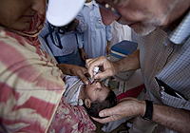
Boys play a board game in a UNICEF-supported child-friendly space at the Prang Government Primary School in Charsadda district, Khyber-Pakhtunkhwa, Pakistan. The school is being used as a relief camp for flood-affected families.
• This is one of the last areas in the world where there is polio, so the whole world will be watching to see how well we can do in preventing another outbreak, not just with measles, not just with diarrhoea, but with polio,” said Mr. Lake.
• The camps in Charsadda are a small oasis of safety in a country that has been devastated by its largest disaster in living memory. Nearly 8.6 million children have been affected by the floods throughout Pakistan, and about 3.5 million are at risk of contracting waterborne diseases. UNICEF is gravely concerned that further disaster will follow unless more aid becomes available immediately.
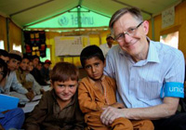
• UNICEF Representative in Pakistan Dan Rohrmann said, “With 280,000 people having moved from the Khyber Agency to Nowshera District, of which over 50,000 are residing in Jalozai camp, we really have a critical emergency that is not drawing enough attention.”
• The new IDPs are being housed in Jalozai, ToghSerai and New Durrani camps and many more reside with host communities in Peshawar and Nowshera districts.
• UNICEF has issued a request for US$37.2 million to meet the needs of this complex emergency. Funding of only US$11.9 million has been received so far.
• 12 UNICEF-established primary schools in the camp.
• Nearly 4,483 students are enrolled in the ‘child-friendly schools’, which offer important health and hygiene lessons as well as recreation
• psychosocial support and other features that engage the children and their communities.

Essential services
• UNICEF has also established 21 Protective Learning and Community Emergency Services (PLaCES) centres in the camp to provide a protective environment for women and children. There, psychosocial support is provided in addition to educational and recreational activities.
• “Families from tribal areas, especially females, do not stay in the camp for long. At times, they are here and at other times they move back to their villages.
• Because of this back-and-forth, they face some psychological problems. Psychosocial support that we provide in these centers benefits them a lot,” said Saiqa Gigyani, a child protection monitor at one of the Places.

Jalozai Camp-UNICEF
• In Jalozai camp, UNICEF and partners are providing safe water to more than 58,000 people and are maintaining 4,000 latrines, 1,800 washrooms, 1,000 washing pads and 200 solid waste collection points. Thousands of families have received hygiene kits, buckets and jerry cans.
• UNICEF is providing critical services to the new IDPs. Immunization is one of them because many of the children have not been vaccinated for years. Secondly, nutritional services are critical because many children who come here are severely malnourished. Provision of clean water and sanitation helps prevent outbreak of waterborne diseases, and of course education provides a possibility to re-connect with a learning opportunity that has been dearly missed.
Ten-year-old Reshma walks in front of her destroyed house in Jacobabad district, Sindh. Nearly 460,000 houses have been swept away or badly damaged by flooding. Children are disproportionately affected in the aftermath of such emergencies.

Disproportionate risk for children
• Rain fell continuously for several days in early September, inundating many areas of southern Punjab, northern Sindh and northern Balochistan.
• The National Disaster Management Authority puts the number of affected people at 5.06 million – with satellite imagery showing that large areas of 15 districts were flooded.
• More than 1.12 million acres of crops have been affected, and nearly 460,000 houses have been swept away or badly damaged.
• Reports from the field indicate that the families affected this year are even worse off than those affected by the previous floods, with higher standing water and more devastation across a smaller area. There are dire needs for shelter, food, water, sanitation, healthcare, malaria prevention and education.
• In the aftermath of flood emergencies such as this one, children become disproportionately susceptible to diseases and malnutrition, and many are unable to attend school.

Disrupted lives
• Reshma hasn’t been able to attend school for weeks.
• The two-room school building quickly filled with household items as village residents rushed to save whatever they could from the rising water.
• The downpours also deluged what had looked like a bountiful rice crop, just before harvest. Weeks later, the land is still inundated with the floodwaters.
• The rice itself will be useless, although the grassy stems can be chopped off to use as fodder for livestock.
• Reshma spends her days waiting for the water to recede so she can go back to school and also help her family build a new home. Until then, her desires are modest. “We need food and water,” she says. “Right now, we live in others’ homes; I will be content once I go back to my own.”

Providing water, education and protective spaces
• In response to the flood emergency, UNICEF and partners are providing safe drinking water to 267,900 flood-affected people in Balochistan, Punjab and Sindh.
• If funding permits, UNICEF, government and cluster partners plan to provide emergency education services to more than 21,000 children by establishing 1,147 temporary learning centres, which aim to provide safe and secure learning environments that promote the protection and well-being of students.
• Fifteen are already up and running, benefitting more than 2,100 children. Children in these centres will be mainstreamed back into regular schools, as either continuing or new students.

Child Protection-Sub Cluster
• The child protection sub-cluster, including UNICEF, Save the Children and Action Aid, has established 16 protective spaces in Sindh, benefitting more than 1,658 children, of whom 46 per cent are girls. In addition, 379 children (49 per cent girls) and 73 women have received or are receiving psychosocial support and have access to recreational activities through the child protection sub-cluster response.

Preparing for the future
• “The impact of devastating flooding in Pakistan over the past three years has been particularly severe for millions of children,” says Emergency Coordinator for UNICEF Pakistan Oscar Butragueño. “Recurrent natural disasters affect Pakistan’s ability to achieve development goals.
• This is why UNICEF not only reaches out to flood-affected children and their families in the country’s most disadvantaged areas, but we are committed to mitigating the impact of disasters on children and increasing community resilience by integrating disaster risk reduction into all of our work.”

UNICEF REQUIREMENT
• To continue life-saving activities in response to the 2012 monsoon floods, UNICEF urgently needs US$15.4 million to provide flood-affected communities with timely and adequate assistance through the next three months.

Pakistan’s Hunger Facts

The monsoon floods in August hit a country already grappling with high levels of malnutrition, high food prices and a humanitarian crisis along its border with Afghanistan.

Facts Behind Hunger

20 million affected by the floods
The Pakistan floods this summer impacted the lives and livelihoods of some 20 million people, around 10 million of whom required emergency food assistance.

Nearly one in two Pakistanis at risk
Pakistan suffered from widespread hunger even before the monsoon floods, with an estimated 82.6 million people – a little less than half the population – estimated to be food insecure.

Widespread poverty
An estimated 36 percent of Pakistanis live below the poverty line and almost half are illiterate. Poorer households typically spend over 60 percent of their income on food.

Poor sanitation
50 percent of all Pakistanis have little or no access to clean toilets and drinking water, a condition that renders them vulnerable to infectious diseases.

Child mortality
The biggest killers of children under five in Pakistan are diarrhea and acute respiratory infections. Undernourishment is an underlying cause in 38 percent of those cases.

Violent conflict
Conflict along Pakistan’s northwestern border with Afghanistan has forced millions of people to flee their homes. Since 2008, WFP has provided over 2.6 million of them with food assistance.

Rising hunger
Volatile food prices over the past seven years have pushed the number of people who depend on food assistance in Pakistan from 38 percent of the population in 2003 to 49 percent in 2009.

Wheat dependent
Wheat is Pakistan’s main staple crop and most important source of calories. As a result of the flooding, which submerged around 16 percent of all arable land in Pakistan, the upcoming wheat harvest is expected to be around 15 percent smaller than usual.
• Two months into the flooding, its economic loss and social impact on Pakistan is though to size up, millions of hungry affectees are awaiting emergency relief.
• In the midst of such an unparalleled disaster, the United Nations World Food Program (WFP) said it is actively engaged in tackling the worst food crisis in Pakistan's history, with a shorter-run plan and a longer-term program.
• In an exclusive interview with Xinhua, WFP Pakistan Country Director Wolfgang Herbinger said the aid agency, teamed up with the government of Pakistan, is leading a pilot UN development program to help the country for better disaster management and to improve the handling of food insecurity.
• "WFP has a leading role working closely with the government at national, provincial, and district level to improve their own capacity to handle the disasters," Herbinger said.
• Pakistan has been on a good track of development but since 2003 the food insecurity has deteriorated due to natural calamities, global food price hiking and militancy conflicts, he said, so WFP set a program for next two years, until the end of 2012, which would improve household food security particularly in the border area and the hardest-hit areas by the flood.
• The WFP representative said the flooding is the biggest disaster ever in the history of natural or man-made disasters in Pakistan, affecting over 21 million. He said an assessment shows luckily that only half of them need urgent assistance.

Steps Taken by WFP
• WFP is taking practical steps to stabilise and improve the nutritional and food security levels of the most affected and vulnerable population in the country.
• Locally produced products called ‘Wawa Mum’ and ‘Acha Mum’ are being used in the community based management of acute malnutrition (CMAM) programme, in key districts across the country.
• WFP has currently helped treat nearly half a million malnourished children under this programme, which has seen high recovery rates.

Six Million People
• As Pakistan continues to reel from a disastrous wave of monsoon flooding, WFP’s operation to bring emergency food aid to six million people a month is being extended in time and expanded so as to help long-term recovery. Further assistance from donors is needed.

Growing needs
• WFP has been streaming emergency humanitarian assistance into Pakistan since the beginning of August and has so far received US$103 million.
• The budget required for the new emergency food relief operation through to July 2011 is now USD $600 million.

WFP
WFP aims to provide emergency food assistance to an average of 6 million people each month while transitioning towards recovery activities, such as programmes that provide people with cash and food in return for work on projects to rebuild their communities.
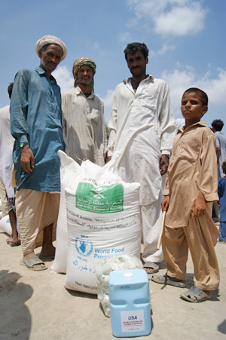
WFP estimates that more than 10 million people need immediate food assistance. WFP will aim to reach the majority of those affected, while the Pakistan government and NGOs are also providing food assistance.
In addition to providing food to families, WFP is also setting up a specialised feeding programme targeting small children, and pregnant and nursing mothers—who are particularly vulnerable to the effects of hunger and malnutrition.
Conclusion
- United Nations play a significant role in the humanitarian efforts.
- Floods have recently devastated lots of communities thus marginalized community is provided necessary assistance from UNICEF and WFP.

Lecture—13
Decision making in NPO

AGENDA
○ Preview of Last Lecture
○ United Nations Perspective 2
○ What are Human Rights
○ What is United Nations
○ Main Aim of UN
○ History of UN
○ Purpose of UN
○ Bodies of UN
○ Sanctions
○ UN Peace Keepers
○ Major Missions
○ International Court of Justice(ICJ)
○ UN Human Rights Bodies
○ Where Do Human Rights Begin?
○ UNICEF And Humanitarian Action In the World
○ Conclusion
○ Reference

HUMAN RIGHTS are the rights that all people have by virtue of being human beings.
The United Nations

Main Aims:

Tolerance and friendship among all nations, racial or religious groups.
Maintenance of peace

What is the UN?
- an international organization designed to make the enforcement of international law, security, human rights, economic and social progress easier for countries around the world
- 192 member countries
- headquarters in New York City

History of the UN
- the League of Nations was the predecessor to the UN, it was founded in1919 and was responsible for ensuring peace and cooperation between world nations
- the term ‘’United Nations’’ was coined in 1942 by Winston Churchill and Franklin D. Roosevelt
- the UN was founded on October 24, 1945, when the Charter of the UN was drafted at the UN Conference on International Organization in San Francisco
- the conference was attended by 50 nations and several non governmental organizations
- main principles: save future generations from war, reaffirm human rights, and establish equal rights for all nations
- United Nations day is celebrated on October 24

Organization of the UN
- purposes of the UN:
- maintaining international peace and security
- developing friendly international relations among world nations
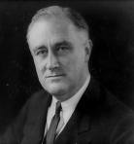
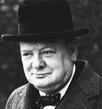
- solving international problems of any nature (economic, cultural, social, humanitarian…)
- principal organs of the UN:
- the General Assembly
- the Secretariat
- the Security Council
- the International Court of Justice
- the Economic and Social Council
- the Trusteeship Council

Parts of the United Nations
1. The General Assembly – the ‘town meeting’ of the world.
2. UN Security Council – maintains world peace (most powerful branch)
3. Economic and Social Council - works with the UN’s economic, cultural, health and educational activities.
4. Trusteeship Council - territories
5. ICJ – International Court of Justice
6. The Secretariat – administrative duties and can bring any topic before the SC.

The General Assembly
- main function: assessing member countries and deciding on the budget
- the only organ where every member state is represented

The General Assembly inside UN Headquarters
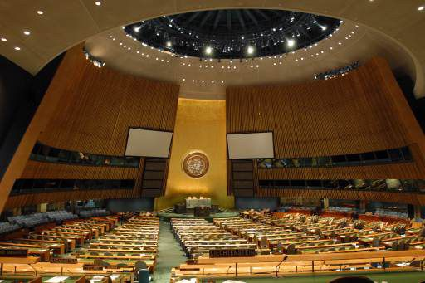

The Secretariat
- includes the Secretary General and the Secretariat staff
- primarily has an administrative function
-the Secretary General holds office for five years per term
The first ever Secretary General was Trygve Lie, the office is currently held by Ban Ki-moon

The Security Council
- UN’s most powerful organ
- deals with threats to international peace and security

UN Security Council
○ Made up of 15 countries:
 The “Permanent Five” countries
 10 non-permanent countries (elected every two years)
○ The strong-arm of the UN
○ Maintains international peace
○ How does it do this:
 Recommends peaceful negotiations (peace talks)
 Can use Economic Sanctions
 Can use Military Sanctions

The UN Security Council Inside World Headquarters
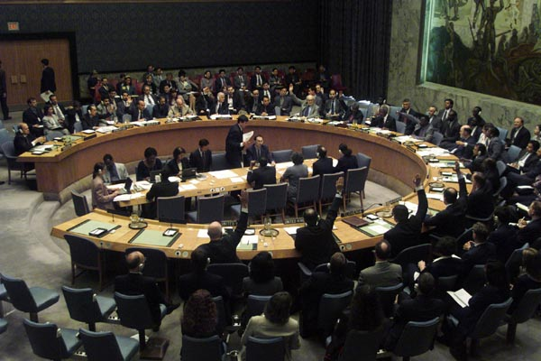

Sanctions
○ Sanctions are used to punish a country for violating international law. They can be used to force a country to follow a law.
○ In order for sanctions to be used by the UN Security Council, ALL FIVE permanent members must have a unanimous vote.

Types of Sanctions
○ Diplomatic Sanctions – removal of all political ties (like embassies)
○ Economic Sanctions – ban on all trade with a country (except food)
○ Military Sanctions – using a military to force compliance.

Military Sanctions
○ UN Peacekeepers – a group of armed soldiers sent to a hostile area to promote peace. They ARE NOT COMBAT TROOPS.
○ These soldiers maintain peace.
○ They don’t go on combat missions.
○ They are not an ‘army’
○ UN Military Force – an army made up of soldiers from more than one UN country that can serve as combat troops.
 They are not very effective and are not used very often.

UN Peacekeepers
They always wear blue berets or blue helmets to identify themselves.

Major UN Missions
○ East Timor (Asia) – the UN supervised the independence of this country
○ Iraq (Middle East) – UN tried to cut all trade with Iraq after it failed to comply with international law, but some nations continued to trade with them.
○ Somalia (Africa) – UN humanitarian mission to get food and supplies to people in need
○ Haiti (Caribbean) – UN helped strengthen government, army, and hold elections
○ Congo
○ Bosnia Herzegovina

The ICJ
- the principal judicial organ of the UN
- based in the Hague, Netherlands
- consists of 15 judges elected by the General Assembly and Security Council
- applies international law
- not bound by precedents
- no appeals can be made by parties to its judgment

International Court of Justice The Hague, Netherlands
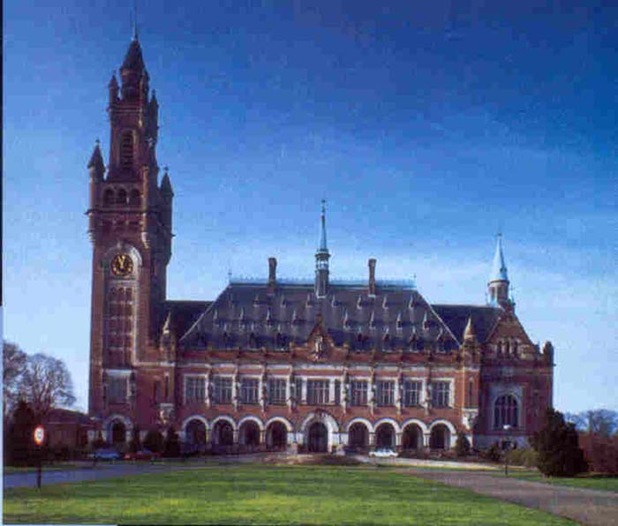

The Charter of the UN
○ The United Nations Charter is the treaty that forms and establishes the international organization called the United Nations.

History
○ It was signed at the South Dakota Civic Center of the San Francisco War Memorial and Performing Arts Center (part of the Civic center) in San Francisco, United States, on June 26, 1945, by 50 of the 51 original member countries (Poland, the other original member, which was not represented at the conference, signed it later).
○ It entered into force on October 24, 1945, after being ratified by the five permanent members of the Security Council (China, France, The Union of Soviet Socialist Republics, The United Kingdom and the United States) and a majority of other signatories

Preamble
○ "We the peoples of the United Nations determined: to save succeeding generations from the scourge of war, which twice in our lifetime has brought untold sorrow to mankind, and to reaffirm faith in fundamental human rights, in the dignity and worth of the human person, in the equal rights of men and women and of nations large and small, and to establish conditions under which justice and respect for the obligations arising from treaties and other sources of international law can be maintained, and to promote social progress and better standards of life in larger freedom…”

Chapter I
○ Chapter I sets forth the purposes and principles of the United Nations, including provisions of the maintenance of international peace and security

Purposes of the UN
○ To maintain international peace and security
○ To develop friendly relations among nations
○ To achieve international co-operation in solving international problems of an economic, social, cultural or humanitarian character
○ To be a centre for harmonizing the actions of nations in the attainment of these common ends

What does the UN do?
○ The UN aims to ensure that people don’t suffer from hunger and homelessness.
○ It has a special section called Unicef that tries to help children.
○ The UN has a convention on children's rights. They would like it to be followed by all countries, as a set of rules about the treatment of children.

Why is it important to have an organisation that is bigger than any one country?
○ Stops governments mistreating people
○ Helps stop wars between countries
○ Looks after all the world's young people

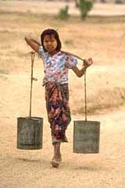
Why might the UN have problems getting all countries to treat children fairly?
○ Some countries use children in their armies
○ Many children work in factories
○ Poor countries can't afford to provide schools

UN Human Rights Bodies
○ Security Council
○ General Assembly
○ Economic and Social Council
○ Commission on Human Rights
○ Subcommission on the Promotion and Protection of Human Rights
○ Commission on the Status of Women

UN Human Rights Bodies
○ Commission on Crime Prevention and Criminal Justice
○ International Court of Justice
○ International Criminal Court
○ Office of the High Commissioner for Human Rights (created by the General Assembly in 1993)

UN Human Rights Bodies
○ Treaty Monitoring Bodies
 Human Rights Committee
 Committee on the Elimination of All Forms of Racial Discrimination
 Committee on the Elimination of Discrimination Against Women
 Committee Against Torture
 Committee on the Rights of the Child
 Committee on Economic Social and Cultural Rights

Local Non-Governmental Organizations
○ Minnesota Advocates for Human Rights
○ American Refugee Committee
○ Center for Victims of Torture
○ Institute on Agricultural and Trade Policy
○ University of Minnesota Human Rights Center

NGO Activities
○ Monitor elections and political trials
○ Investigate human rights and conditions
 Analyze human rights practices in closed countries – Albania, North Korea, Saudi Arabia
 Identify and analyze conflicts in Chiapas and Kosovo
 Child slavery in Haiti; child health in Mexico, Uganda and the United States
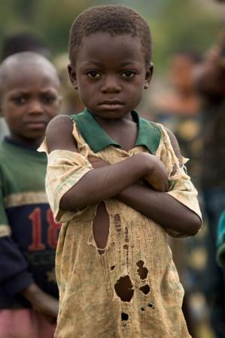
○ Lobby United Nations
○ Draft model statutes
 Inquest procedures
 Forensic techniques
 Domestic violence laws
○ Represent political asylum seekers
○ Promote ratification of human rights treaties

Humanitarian Action is Central to UNICEF’s Work

UNICEF’s Core Commitments for Children

Vision of UNICEF’s Humanitarian Action
• Children and women are the most affected by humanitarian situations
• UNICEF is on the ground before, during and after emergencies.
• The Convention on the Rights of the Child and its optional protocols guide UNICEF’s work on child protection and children in armed conflict.
• Humanitarian action is central to UNICEF’s equity refocus.
• UNICEF supports countries to respond to over 250 humanitarian situations per year on average.

The Humanitarian Situation in 2012 & Response

Results in 2012
•Save lives and protect rights
•Address underlying causes of vulnerability and conflict

The Humanitarian Situation in 2012 & Response
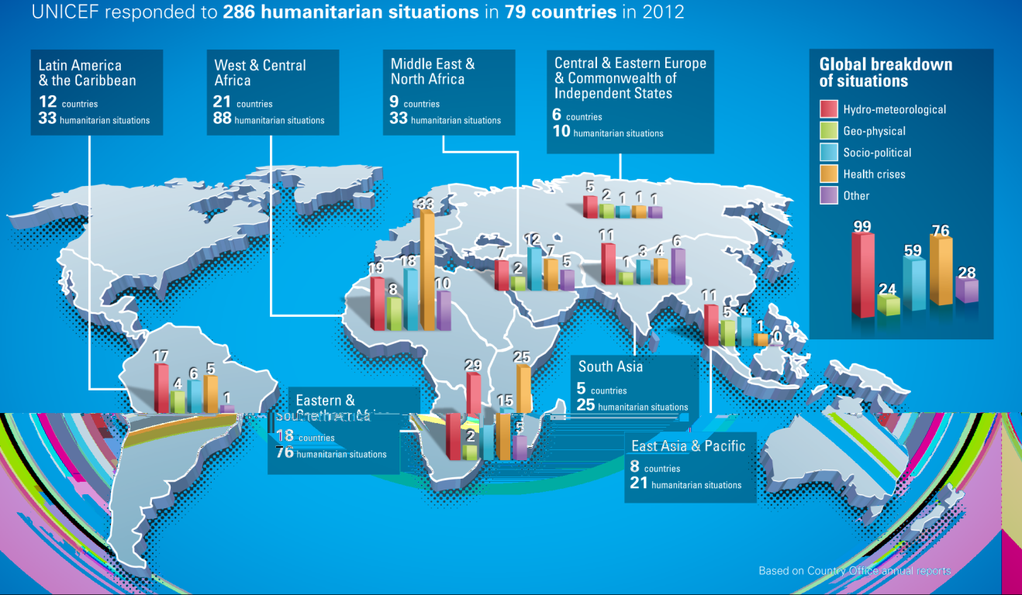

Results in 2012
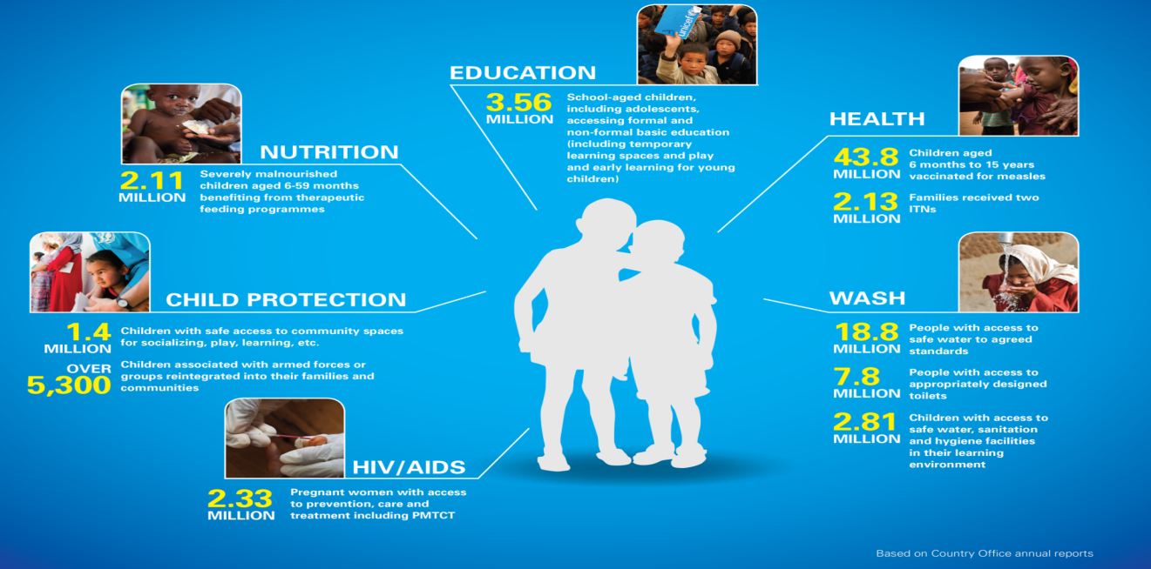

Global Operation Mechanism
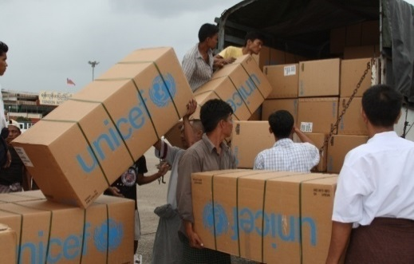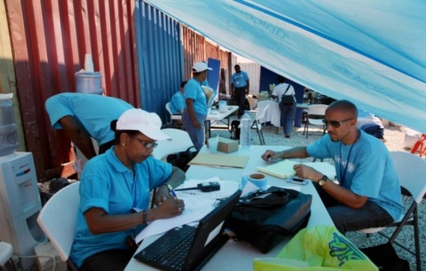

UNICEF

PANAMA SUPPLY HUB
PANAMA SUPPLY HUB

Regional Offices (7 locations)
- Guidance and direct support

Regional Offices (7 locations)
- Guidance and direct support

Emergency Preparedness

UNICEF works with governments and partners to support preparedness, in addition to response, recovery and risk reduction.
Target of our efforts:
•Strengthening the preparedness capacity of national systems and communities (based on analysis of the threats facing children)
•Internally, supporting UNICEF staff at all levels
•Externally, supporting partners through cluster leadership
Tools of the trade:
•Early warning/risk monitoring
•Standard operating procedures for response
•Contingency planning
•Emergency training
•Drills and simulations

Building Systems to Strengthen Resilience
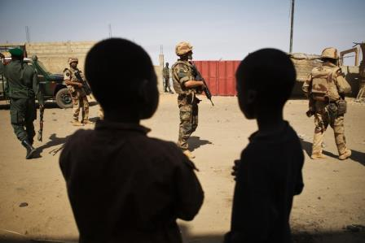
- Community empowerment, strengthening social service delivery and capacity development
- Brazil, Ethiopia, Kenya, Niger, Pakistan and Zimbabwe
- Risk-informed programming, including disaster risk reduction and situation analysis
- Peacebuilding, with focus on education in 13 countries

Addressing Grave Violations Against Children in Armed Conflict

Recent Reforms and Successes

In complex emergencies, children are particularly vulnerable to grave violations. State and non-state actors must protect children and other civilians.

•SCR 1612 on Children and Armed Conflict established a compliance mechanism to end grave violations.

•SCR 2068 called for strengthened measures to bring persistent perpetrators into compliance with international child rights standards.
•UNICEF supports the implementation of the monitoring and reporting mechanism for grave violations against children in 14 countries.
•Four new Action Plans negotiated in 2012 (two in Somalia, one in DRC, one in Myanmar)
•Programmes in place to assist survivors of grave violations

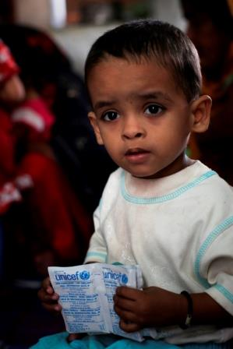
Recent Reforms and Successes
In response to the mega-emergencies of 2010, UNICEF took bold steps:
•Human Resources (HR) in emergencies unit established and HR fast track adopted, which improved surge deployment
•Level 2 & 3 Simplified Standard Operating Procedures (SSOP) finalized, which led to a more predictable and efficient response
•Resources invested in strengthening monitoring for results in humanitarian action (e.g. Mali, Syria, etc.)
•Supported the IASC Transformative Agenda

Strengthened collaboration / Coordination

Operations
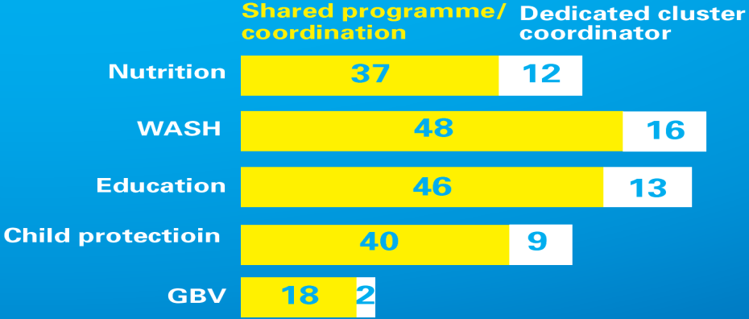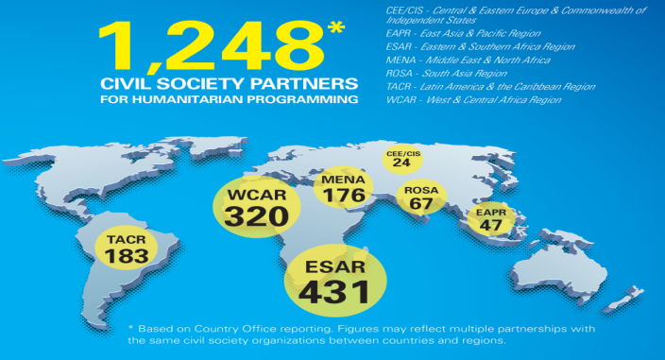Operations

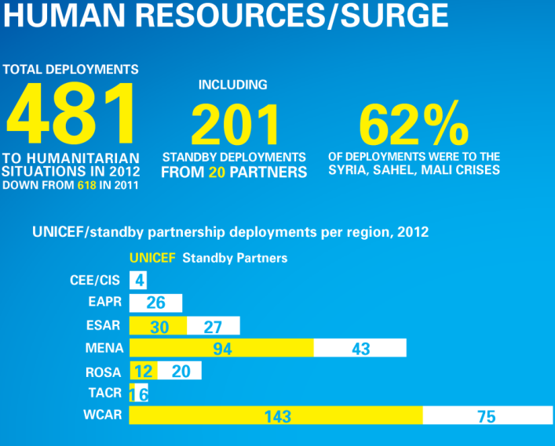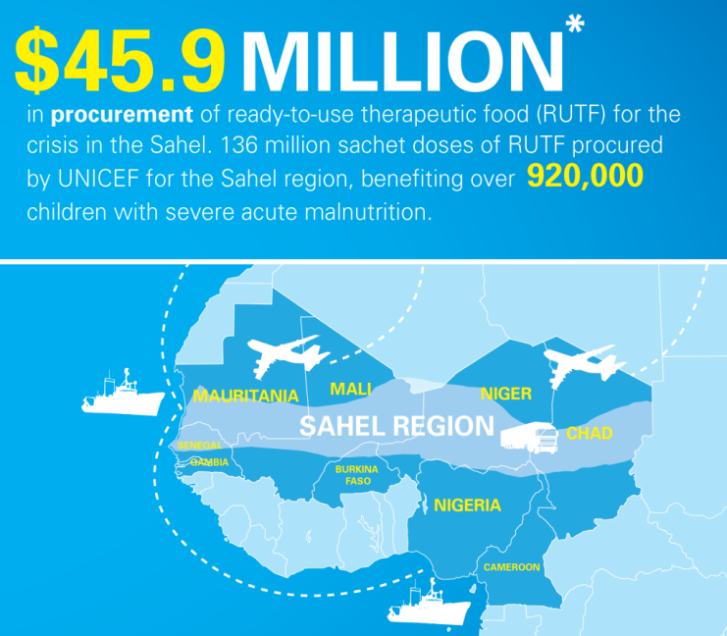

Syria: Example of a Major Response
A children’s crisis: Of the 9.3 million people affected by the crisis in Syria, nearly half are children.

Major Challenges to Response:
• Attacks against humanitarian workers
• Intensive armed conflict and presence of extremist groups hampering aid delivery
• Limited partner movements and humanitarian access
• Protection of civilians, in particular children
In 2013, UNICEF reached 11.3 million people in the region in the sectors of Health, WASH, Child Protection and Education.
In Syria in 2013:
• 1.1 million children vaccinated
• 10 million people provided with access to safe drinking water
• 400,000 children provided with remedial classes, psychosocial support and recreational activities
In the sub-region in 2013:
• 1.3 million people reached with combination of access to drinking and domestic water, immunization against measles, learning programmes and access to psychosocial support

Humanitarian Income
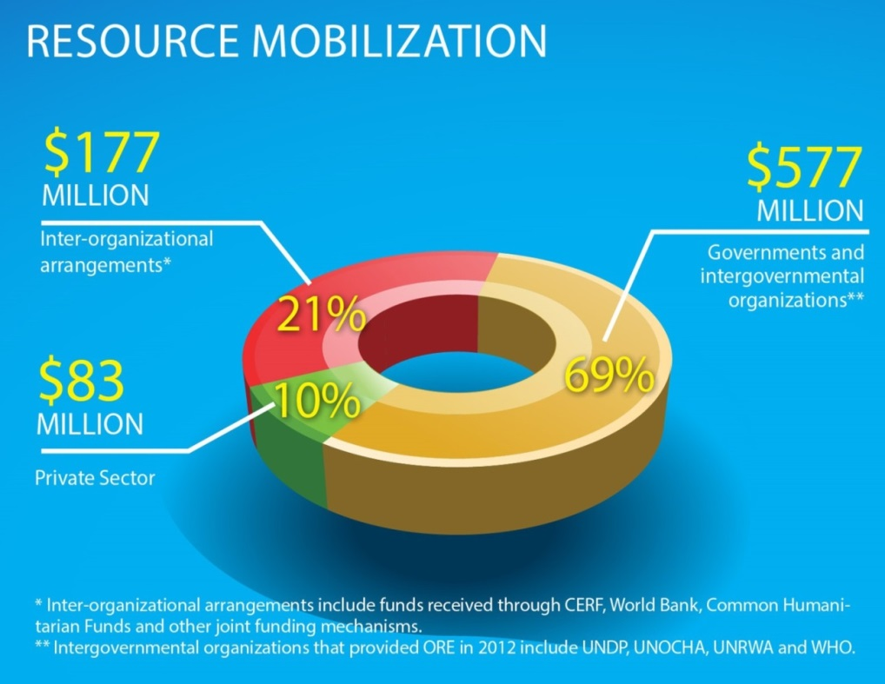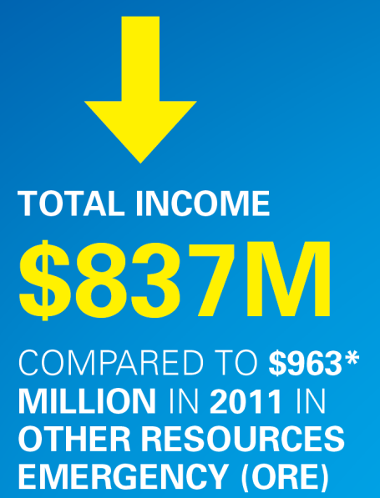

2013 Funding Gaps
Country | Funding Gap
Afghanistan | 9%
CAR | 65%
DRC | 44%
DPRK | 50%
Mali (+Burkina Faso, Mauritania, Niger, WCARO) | 62%
Pakistan | 29%
South Sudan | 56%
Sudan | 49%
Syria (+Lebanon, Jordan, Iraq, Turkey, Egypt) | 21%
Yemen | 48%

Humanitarian Action for Children:
www.unicef.org/appeals

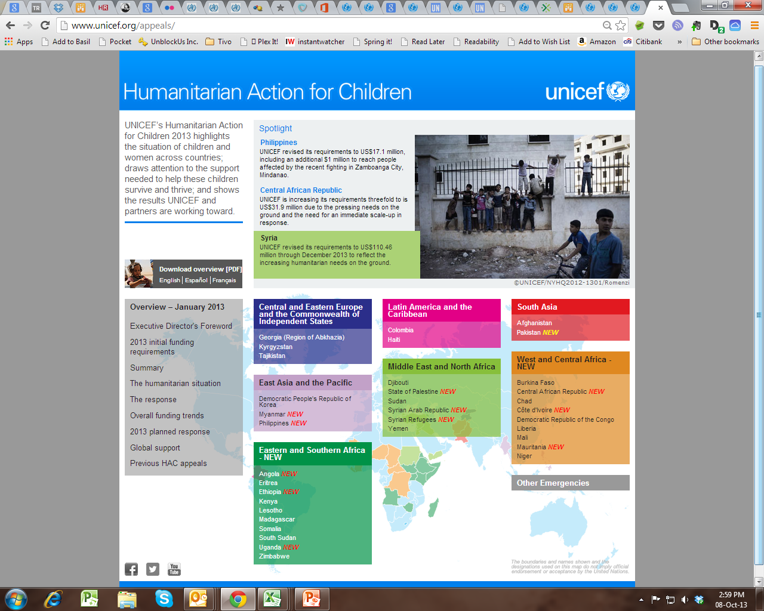

Looking ahead
○ Strategic Plan and post-2015 agenda: new opportunities for resilience
○ Further simplification
○ Helping to improve inter-agency response to non-Level 3 emergencies
○ A practical and inclusive humanitarian partnership system (regional and South-South)

Conclusion
○ Great leaders often inspire their followers to high levels of achievement by showing them how their work contributes to worthwhile ends. It is an emotional appeal to some of the most fundamental of human needs-the need to be important, to make a difference, to feel useful, to be a part of a successful and worthwhile enterprise.
Warren Bennis, PhD, founding chairman of the leadership Institute at the University of Southern California.

Reference
*Source: “International Human Rights: Law, Policy and Process,” David Weissbrodt, Joan Fitzpatrick and Frank Newman (3d ed. 2001)

Lecture—14
Decision making in NPO
Agenda
- Preview of the Last Lecture
- Perceptions of Pakistan Earth Quake Response(Part-1)
- Feinstein International Centre
- Humanitarian agenda 2015
- Introduction
- Overview of Pakistan Earthquake response
- The Universality of Humanitarianism
- Conclusion

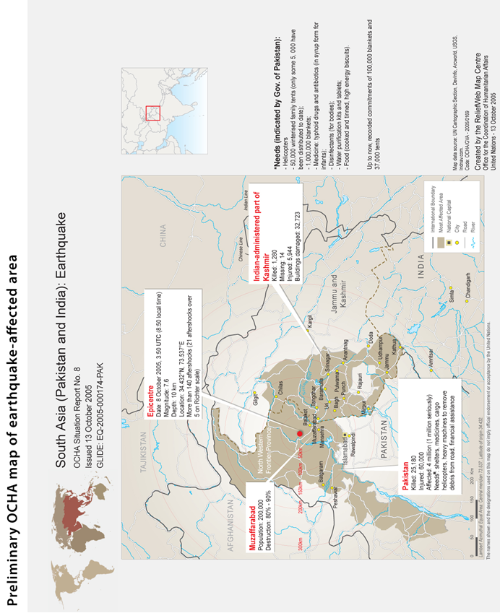

Introduction
At 8:50 a.m. on October 8, 2005, a devastating earthquake measuring 7.6 on the Richter scale struck northern Pakistan and the disputed territory of Kashmir, which is divided into Pakistan-Administered Kashmir (PaK) and Indian-Administered Kashmir (IaK).
The earthquake killed approximately 75,000 people, injured another 70,000, and left an estimated 3.5 million people homeless. A massive humanitarian rescue and relief operation followed that was led by the Pakistan Army.
The response included thousands of private citizens who were in most cases the first to respond, Islamic militant groups based in the region, search and rescue teams from several countries, US and NATO military forces, UN agencies, and more than one hundred national and international NGOs.
The response created some compelling images of the universality of humanitarian action, with erstwhile enemies – including militant jihadi groups, US and NATO military forces, and 2,500 Cuban doctors and nurses – working alongside each other to save lives and respond to the needs of earthquake survivors.
Despite daunting challenges, including the difficult mountainous terrain and the race against time to provide basic shelter to the homeless prior to the arrival of the Himalayan winter, the humanitarian response to the earthquake was perceived by many to be “one of the largest and most effective responses to a natural disaster to date.”

Objective
○ The purpose of this case study was not to conduct an evaluation of the earthquake response.
○ The objective was to learn from the perceptions of those affected by the Pakistan earthquake, as well as those involved in relief and reconstruction efforts, to better understand some of the key challenges facing humanitarian action and humanitarian assistance organizations.

Feinstein International Center
○ This study is part of a broader study undertaken by the Feinstein International Center at Tufts University entitled, “The Humanitarian Agenda 2015: Principles, Politics and Perceptions” (HA2015), which aims to help equip the humanitarian enterprise to better address emerging challenges during the coming decade. In particular, the study is looking at four interrelated issues that are likely to shape the humanitarian agenda.

Universality
○ The universality of humanitarianism – is there anything truly universal about what we call humanitarian action or are the principles and apparatus of humanitarian action perceived to be primarily Western and Northern?

Terrorism and Counter Terrorism
○ The implications of terrorism and counter-terrorism for humanitarian action – to what extent is the humanitarian enterprise perceived to be part of the security agenda of the US and its allies, and if so what are the implications for humanitarian action?

Coherence
○ The search for greater coherence and integration between humanitarian and political/security agendas – does the cost of more integrated approaches exceed the benefits?

Security
○ The security of humanitarian personnel and the beneficiaries of humanitarian action.
○ Case studies examining these four issues have been conducted in 12 countries where humanitarian action is being undertaken.
○ The Pakistan case study differs from the others in several important respects.
○ First, it is the only one where local conflict was not an important dimension to the humanitarian response.
○ Second, the Pakistan case study is the only one looking exclusively at the humanitarian response to a rapid onset natural disaster, in contrast to the other case studies examining humanitarian action in situations of armed conflict.
○ Finally, a notable difference in the case of the Pakistan earthquake response was the central role played by the Pakistan Army in leading relief and reconstruction efforts.

Methodology
○ The field research for this case study was conducted in March 2007, 1.5 years after the earthquake struck northern Pakistan and Kashmir.
○ While the focus of the research was on perceptions of the humanitarian response during the initial six months of rescue and relief efforts, respondents inevitably also communicated their perceptions – usually much more negative – of the subsequent reconstruction phase since April 2006.
○ The study therefore includes analysis of the contrasting perceptions of the relief and reconstruction phases.
○ The field research was conducted over a three-week period in Islamabad, and in the three districts most badly affected by the earthquake – Mansehra and Battagram districts in the Northwest Frontier Province (NWFP), and Muzaffarabad district in Pakistan-administered Kashmir (PaK).

Sources of Information
○ 55 key informant interviews with government officials, staff from NGO, UN, RedCross/Crescent, and donor agencies, and with politicians, religious leaders, journalists and academics.
○ 30 focus group discussions using a semi-structured interview format with 262 community members affected by the earthquake, including internally displaced persons (IDPs), local politicians, professionals, and one with NGO national staff.
○ Eight detailed questionnaires completed by international aid workers working for NGO, UN and donor agencies.
○ These included 19 male focus group discussions with162 participants, seven female focus group discussions with 54 participants, and four mixed focus group discussions with 46 male and female participants.
○ The author conducted seven focus group discussions, and the rest were conducted by three Pakistani researchers.

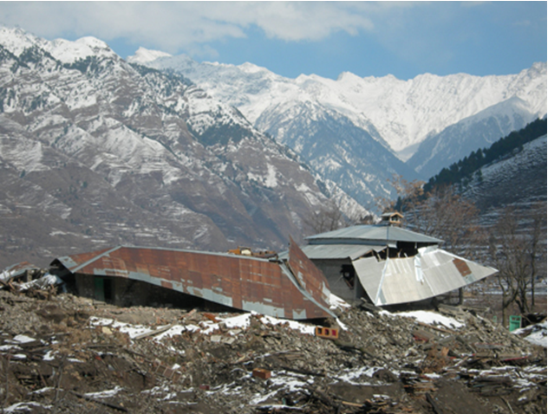

Overview of Pakistan Earthquake
○ In the space of a minute on the morning of October 8, 2005, the powerful earthquake that struck northern Pakistan and the disputed territory of Kashmir leveled towns and villages, killed or injured 145,000 people, and destroyed or seriously damaged 600,000 homes and most of the area’s education, health, and transportation infrastructure.
○ The map below identifies the areas affected by the earthquake – a 30,000 square kilometer area approximately the size of Belgium.
Table1:KeyEarthquakeStatistics
Killed | 73,338 (including an estimated 18,000 children killed when  schools collapsed) (plus 1,309 in India)
Injured | 69,412 (plus 6,622 in India)
Population Affected | 3.5 million
Affected Area | 30,000 square kilometers
Houses severely  damaged/destroyed | 600,000 (76% of the entire housing stock)
Health facilities severely  damaged/destroyed | 796 (80% of primary level facilities severely damaged/destroyed)
Education facilities severely  damaged/destroyed | 6,298 destroyed or severely damaged, and education work forcereduced by 60-70% through death, injury or migration
Roads damaged | 6,440 kilometers
International Humanitarian  & Reconstruction Aid | US$ 1.4 billion in humanitarian aid, US$ 6.2 billion pledged in  grants and loans at November 2005 Donor Conference

Overview
○ The earthquake measured 7.6 on the Richter scale, considerably less than the 9.2 magnitude Indian Ocean earthquake that resulted in the December 2004 tsunami that killed 225,000 people.
○ However, several interviewees for this study emphasized that in many ways the Pakistan earthquake rescue, relief, and reconstruction challenges were much greater.

Un Official Interview
○ One UN official noted that the greater number of dead in the tsunami “is a false measure because dead people don’t need help.
○ In the earthquake there were 3.5 million homeless compared to 1.5 million displaced by the tsunami, and more injured than in the tsunami.” Geographical and climatic differences were also highlighted, including the often remote and inaccessible mountainous terrain in northern Pakistan and Kashmir and the bitterly cold Himalayan winters.

One Aid Official View
○ As one aid official noted, “People can live one month without food, one week without water, but only one night without shelter under these climatic conditions.”
○ Finally, while the burden of responding to the tsunami was spread among several countries, the burden of responding to the earthquake fell primarily on Pakistan.

Rescue And Relief Phase
○ By all accounts the first on the scene to aid in rescue efforts and to provide relief goods were individual Pakistani citizens.
○ In an unprecedented outpouring of public sympathy, private citizens throughout the country donated relief supplies and thousands of volunteers flocked to the earthquake-affected areas to assist in rescue and relief operations.
○ As one government official exclaimed: “The Pakistani nation responded – children sent their pocket money from Karachi to the Khyber.”
○ While the public response was generous and enthusiastic, it was not well-organized.
○ Soon there were traffic jams of well-intentioned volunteers transporting relief supplies for earthquake victims, often blocking the only roads leading into the earthquake zone.
○ Much of what was donated was extremely useful but lots was not, and within a few days
○ of the earthquake there were reports of piles of inappropriate second-hand clothes littering the streets or being burned as fuel.
○ Despite these problems, the work of these individual volunteers played a critically important role in the rescue and relief operations during the first few days following the earthquake.
○ Individual volunteers were soon joined by workers from a wide range of national and international organizations.
○ The first organizations to respond were reportedly the Islamic militant or “jihadi” groups already based in the area at camps used to train anti-Indian Kashmiri militant groups
○ Within the first day or two the staff of national and international NGO and UN agencies that were already working in Pakistan, and in some cases already working in the earthquake areas, were actively involved in rescue and relief efforts.
○ Less than 24 hours after the earthquake the first international search and rescue team deployed by the Turkish Red Crescent Society arrived in Islamabad.
○ It was soon followed by many other search and rescue teams, over 100 national and international NGOs, several private sector organizations, and international military forces.
○ Within 24 hours of the earthquake the UN Disaster Assessment and Coordination (UNDAC) team flew into Islamabad and worked with the Government of Pakistan (GoP), donors, UN agencies, and NGOs to establish coordination structures.
○ Within three days it had prepared and issued a Flash Appeal for $312 million to support a six-month emergency response, which two weeks later was increased to $550 million.
○ During these initial days an important decision was also made to adopt and pilot the “Cluster Approach”, the framework for humanitarian coordination devised by the Inter-Agency Standing Committee (IASC).
○ Based on this decision, different UN agencies were appointed to lead different sectoral and thematic coordination clusters that operated in Islamabad as well as in the four “humanitarian hubs” – in the towns of Mansehra, Battagram, Muzaffarabad, and Bagh – within the earthquake zone.
○ The Pakistan government was ill-prepared for a disaster of this magnitude, despite the knowledge that this region of northern Pakistan and Kashmir is highly earthquake prone as it is the meeting place of two tectonic plates that have created the Himalayan Mountain range.
○ No disaster response organization existed to respond to major natural disasters, and it was therefore not surprising that the country’s most powerful, best organized and best resourced institution, the army, took charge of relief operations.
○ On the day after the earthquake President Musharraf appointed a serving military officer, Major General Farooq Ahmad, to establish and lead a Federal Relief Commission (FRC). The FRC was intended to be a “one-window operation” to coordinate and integrate all relief efforts including the work of both civilian and military actors.
○ Perceptions of the central role played by the army in leading the earthquake response (discussed in more detail later in the paper) have been mixed.
○ It was initially severely criticized in the press for doing little to rescue civilians during the first few days following the earthquake, and for instead focusing on rescuing only military personnel and re-supplying and deploying new troops to man the Line of Control (LoC) separating Pakistan- and Indian-administered Kashmir.
○ It has also been criticized for prolonging its central role into the reconstruction phase where it has been blamed for many of the perceived problems with reconstruction programs.
○ However, nearly all the interviewees for this study were full of praise for the effective leadership the army provided during the six month relief phase following the earthquake.

Usaid Official Reported
○ One report quoted a USAID official with 20 years of experience responding to Asian disasters as saying: “In terms of a host government, this was the best response – the most competent I have ever seen.”
○ One of the noteworthy features of the Pakistan earthquake response was the important role of international military forces in the earthquake rescue and relief phase.

US AND NATO
○ Factors contributing to the significant involvement of US and NATO forces in the response included Pakistan’s geostrategic importance in the US-led “War on Terror” (WoT), and the proximity of US and other NATO forces and equipment in neighboring Afghanistan.
○ Within 48 hours of the earthquake the first of 24 US helicopters arrived in Islamabad from Afghanistan.

MASH
○ Soon approximately 1,200 US military personnel had arrived in Pakistan to assist with relief efforts, which included a medical team to run a US Army Mobile Army Surgical Hospital (MASH) in Muzaffarabad, and a 125-person Naval Mobile Construction Battalion to clear roads and debris, assist in setting up IDP camps, and rebuild infrastructure.

○ In addition to US military forces, the NATO Response Force also deployed approximately 1,200 specialist personnel including engineers and medical staff from 17 NATO countries to participate in NATO’s first purely humanitarian mission.
○ NATO forces also operated two “air-bridges” to fly relief supplies to Pakistan from bases in Germany and Turkey.
○ One of the major successes of the earthquake response, and one of the best examples ever of effective civil- military collaboration in a humanitarian relief operation, was the helicopter operation that ended up being the largest helicopter airlift of aid in history.
○ In much of the remote and mountainous terrain of the earthquake zone – where the few roads that had existed prior to the earthquake were blocked by landslides and destroyed bridges or had simply slipped down the mountainside – helicopters were the only effective way to rapidly transport relief supplies.
○ Although there were reports of considerable confusion during the critical first two weeks after the earthquake, the subsequent operation was described by one interviewee as “seamless.”
○ The Pakistan Army, US Navy, and the UN Humanitarian Air Service managed a highly effective Air Operations Cell (AOC) that at its peak coordinated over 100 helicopters that delivered 100 tons of food to the earthquake zone, transported injured to medical facilities outside the earthquake zone, and transported aid workers to and from the earthquake zone.
○ According to one report, “Never before had a home military, foreign allied support, and the United Nations worked so well in the delivery of air support.”
○ Most aid workers interviewed for this study believed that despite numerous shortcomings and frustrations, the earthquake relief effort was a tremendous success.
○ Many pointed to the fact that after the earthquake very few people died in the “second wave of deaths” which often follows disasters due to lack of shelter or capacity to treat injuries.
○ There was also not a “third wave of deaths” caused by outbreaks of disease.
○ According to a WHO official, fewer Pakistanis died in the earthquake zone after the earthquake than die in an average winter season in that region.

Low Mortality Reason
○ An important reason that was given for the low mortality rates was the success of “Operation Winter Race,” which was literally a race to provide adequate shelter to the estimated 3.5 million homeless prior to the onset of the normally harsh Himalayan winter.

Distribution
○ More than 500,000 tents, five million corrugated galvanized iron (CGI) sheets, six million blankets and 2.2 million tarpaulins and plastic sheeting were distributed.
○ Nevertheless, there was still a major shortage of winterized tents that would keep those living at higher altitudes warm enough throughout the winter.

Strategy
○ To address this critical problem a strategy was adopted of constructing “one warm room” using the rubble from destroyed homes and corrugated iron roofing sheets, which played an important role in contributing to the success of Operation Winter Race.
○ Nature was also kind – perhaps the most important contributing factor to the success of Winter Race was the fact that the 2005-2006 winter was uncharacteristically mild.

Conclusion
○ In this first part, we found out the evidences related to relief effort done after the disaster by various organizations. In the nutshell, all organizations especially Pakistan Armed Forces, NATO and US Army led the rescue operations followed by the distribution of relief items from various organizations.

Lecture—15
Decision making in NPO

AGENDA
○ Preview of the Last Lecture
○ Perceptions of Pakistan Earth Quake Response(Part-2)
○ Transition from Relief to Reconstruction
○ Humanitarian Coordination: Perceptions of “Clusters Approach”.
○ The Universality of Humanitarianism
○ Perceptions of Human Actors
○ Culture Insensitivity
○ “Insiders” and “Outsiders” & “Locals within Locals”
○ Conclusion

TRANSITION FROM RELIEF TO RECONSTRUCTION
○ In April 2006, six months after the earthquake, the relief phase transitioned into the reconstruction phase.
○ This was symbolized by the FRC being phased out as an independent entity and its responsibilities taken over by the Earthquake Reconstruction and Rehabilitation Authority (ERRA).
○ Like the FRC, ERRA was technically a civilian institution, but it was still very much run by military officers. ERRA and the IASC jointly developed an Early Recovery Plan (ERP) that outlined a set of programs designed “to minimize the gap between relief and reconstruction.”
○ The goal of the ERP was to avoid a loss of momentum and a gap, and “to support the longer-term road to reconstruction by bridging the end of the relief phase and the start of full-scale reconstruction.”
○ The focus of the reconstruction phase shifted from saving lives to rebuilding the lives and livelihoods of the affected populations using the slogan “Build Back Better.”

According to one UN official
○ ‘Build Back Better’ is a nice slogan but should we interpret this as build back a better society, or build back better infrastructure? We haven’t been able to define this. We lost a common goal at some point – I’m not sure when. In the rescue/relief phase we had a common goal. In the reconstruction phase we’re very far apart without a common vision. The Early Recovery Plan is a tool that provides a common framework but it doesn’t provide a common vision. We should have invested more time in having Pakistani policy- makers and the humanitarian community agree on a common vision.
○ Two other explanations given in interviews and focus group discussions for the growing public discontent in the earthquake areas included the public’s frustration with the perceived slow pace of reconstruction, and the resentment of local politicians and civilian administrators who felt bypassed by the army and NGO-led relief and reconstruction programs.
○ The most common cause cited for the discontent, however, was the ERRA housing policy. Respondents complained that its financial assistance packages were inadequate and that technical standards were slow to be developed, poorly communicated, and initially too inflexible.

○ Much of the growing public discontent with reconstruction efforts was directed at the Pakistan Army which was still perceived to be running the show, albeit from behind the thin civilian façade of ERRA.
○ While the army’s role was understood and welcomed during the rescue and relief phase, there was a lot less acceptance of the army’s continued leadership role during the earthquake reconstruction phase.
○ As with national politics in general, there were growing demands for the military to put in place an exit strategy to turn responsibility for earthquake reconstruction back to civilian administrators and local government officials.

Humanitarian Coordination – Perceptions of the “Cluster Approach”
○ One of the important decisions made shortly after the earthquake was to use the UN-led “Cluster Approach” for coordination despite the fact that, although endorsed by the heads of the IASC member agencies, it had not been approved for implementation until 2006.
○ The Cluster Approach was based on a recommendation made in the 2005 Humanitarian Response Review (HRR) commissioned by the UN Emergency Relief Coordinator to assign global “cluster leads” to address assistance gaps in humanitarian relief operations.
○ In September 2005 the IASC endorsed a proposal to assign different UN agencies to lead (an initial nine) sectoral or thematic clusters that would be responsible for identifying and filling assistance gaps in humanitarian response operations, as well as for being the “provider of last resort.”
○ On October 9th – the day after the earthquake – the UNDAC team in Islamabad issued its first situation report (sitrep) using a format based on the HRR-proposed clusters.
○ This was followed a few days later by a Flash Appeal for funding that was also organized into the HRR clusters.
○ According to one first-hand account, these initial ad hoc decisions had major ramifications on the subsequent earthquake response:
○ Firstly, a new and experimental approach would be used for what was quickly becoming a larger and more complex humanitarian response…. Lead agencies had neither trained their cluster coordinators nor budgeted for the positions. Agencies had little institutional knowledge of the structures, and basic tools, such as terms of reference and guidelines, simply did not exist. Clusters created first for the sitrep and then for the Flash Appeal now made a permanent mark on the relief operation. The clusters were formalized, leaders appointed, and coordination structures and mechanisms were put in place.
○ Shortly after the adoption of the Cluster Approach in Islamabad, clusters were established in the four “humanitarian hubs”.
○ These field-based clusters soon became the center for operational coordination in the earthquake-affected areas.
○ While there were a number of criticisms of how the Cluster Approach functioned that are discussed below, it is important to note that overall it was generally perceived to have worked better than previous humanitarian emergency coordination mechanisms.
○ Most of the criticisms of the Cluster Approach that were mentioned in interviews for this study were also noted in the IASC real-time evaluation of the Cluster Approach conducted in February 2006, and an Action Aid assessment of the Cluster Approach conducted in February and March 2006.
○ The nine clusters were: Health, Food and Nutrition, Water and Sanitation, Logistics, Camp Management, Emergency Shelter, Emergency Telecommunications, Protection of Vulnerable Groups, and Early Recovery.
○ In the Pakistan earthquake response a tenth cluster, Education, was added.

Lack of clarity about the cluster
○ Confusion and Lack of Clarity About the Cluster Approach - Given that the Cluster Approach was not intended to be implemented until 2006, and that it was pilot tested in an extremely complex and large-scale humanitarian response to a devastating natural disaster, it is not surprising that it generated considerable confusion and raised many questions.
○ No terms of reference existed initially so there was a lack of clarity about the role of the clusters and the responsibilities of the cluster leads.
○ The IASC evaluation noted that “few people were able to differentiate between the Cluster Approach and the traditional sector approach,” and was described by some as simply “old wine in new bottles.”
○ The IASC evaluation also noted that the “raison d’être” of the Cluster Approach to fill gaps was not well understood, and that as a result “some clusters were established where no gap existed” and that other gaps – notably assisting IDPs in spontaneous camps – remained unfilled.

Failure to Prioritize Cross-Cutting Issues
○ A finding of the cluster evaluations that was reiterated by interviewees for this study was that cross-cutting issues of gender, environment and human rights had “fallen between the cracks.”

Weak Information Management and “Gap Analysis”
○ The weakness of information management and “gap analysis” has been a common finding of most assessments of the earthquake response.
○ According to the IASC evaluation, “Overall the information management in this crisis response received low marks.
○ The apparent disconnect between the field-hubs and Islamabad was exemplified by a lack of standardized, inter- operable and verifiable data.”

Weak Donor Participation and Support
○ Donor participation in the clusters was reported to be weak.
○ The IASC evaluation also noted “the lack of clarity on how the clusters linked to donor groups like “G7” and International Financial Institutions.”

UN Official and us official views
○ Another UN official felt that “the USG formally endorses the cluster approach but informally it is anti- cluster.”
○ A US official believed that the negative attitude of many colleagues was because “US groups have an immediate prejudice against the UN.

Another Layer of Bureaucracy
○ Several respondents, especially from NGOs, were concerned that the Cluster Approach had created a thick layer of additional bureaucracy whose benefits were often not clear.
○ In particular, they complained, about the large number of cluster meetings which were often poorly chaired and had few tangible outputs.
○ An INGO director referred to the large number of cluster meetings as “coordination run rampant,” while the IASC report quoted a respondent’s concern that, unchecked, the Cluster Approach risked becoming a “cluster monster.”

Weak Cluster Leadership
○ Concerns were raised about the capability and capacity of some agencies as well as individuals to lead clusters.
○ One donor emphasized the need to ensure flexibility in assigning cluster lead agencies based on the relative strengths and capacities of agencies in each specific context: “The main issue was who should run the clusters. They could have made some better decisions. For example, IOM was not the right agency to run the shelter cluster.”

Cluster Lead Confusion Between Agency Role and Cluster Role
○ Several of the UN cluster leads reportedly had trouble “stepping out of their institutional hats.”
○ In some cases this was because cluster leads had the difficult and confusing task of simultaneously fulfilling both agency responsibilities as well as their cluster responsibilities.

Views from INGO director
○ According to one INGO director, “UN lead agencies couldn’t distinguish between their agency role and their head of cluster role. This led to confusion both internally and externally. Cluster leadership needs to be neutral and not promoting agency agendas.”

UN Official views
○ A UN official described how “UNICEF was the lead [of the protection cluster] but for the first three months was only interested in child protection so many NGOs quit in frustration.”

High Turnover of Cluster Leads and Members
○ Many respondents, especially government officials, cited the high turnover of cluster members in general, and cluster leads in particular, as an important factor undermining the effectiveness of the clusters.

High turnover rate
○ According to the ActionAid study published only five months after the earthquake: “In Manshehra there were 4 changes to OCHA cluster heads, 8 to the head of the Security cluster and 5 to the UNICEF cluster lead.

Problematic Transition from UN-led Cluster Approach to GoP-led Coordination
○ A problem with the Cluster Approach identified in several interviews was the inadequate preparation for developing a sectoral/thematic coordination system to replace the clusters when they were phased out between April to June 2006.

According to one senior UN official
○ The cluster system was dissolved without being replaced with anything else. This was a disaster. This is when lots of the ERRA policies started popping up unchecked and un-discussed. In May-July we saw lots of nonsense, in part because there was no cluster system to vet policies and no mechanism to say “no” to ERRA.

Inadequate capacity of era
○ Some identified the problem as inadequate ERRA capacity to lead sectoral/thematic coordination following the phasing out of the clusters.
○ However, a more fundamental problem identified by one UN official as to why ERRA could not effectively replace the UN-led clusters was “due to lack of trust between the GoP/Army and civil society in Pakistan – a political reality/complication mostly overlooked by the international humanitarian community.”

The Universality of humanitarianism
○ The perceived universality of humanitarian principles and action was greater in the Pakistan earthquake response than in most of the other HA2015 case studies where the humanitarian enterprise was perceived to be “fundamentally northern in values, appearance, and behavior.”

After the earthquake
○ In the immediate aftermath of the earthquake Pakistani citizens were the first to respond, with thousands of volunteers rushing to rescue and assist survivors in the earthquake affected areas of NWFP and PaK, as well as from a collapsed high-rise apartment building in Islamabad.

Relief effort
○ Truck load after truck load of relief supplies donated by Pakistanis throughout the country soon started arriving in the areas devastated by the earthquake.

First organization reported
○ The first organizations to respond in the immediate aftermath of the earthquake were also mostly national and not international, further strengthening the perception that the humanitarian response to the earthquake was not a Western or Northern led enterprise.
○ These included Islamist organizations (including some militant jihadi groups on UN and US State Department and Treasury lists of banned terrorist organizations), local community-based organizations and NGOs, and the Pakistan Army, who were joined by the few international NGOs already working in the area at the time of the earthquake.
○ Even following the arrival of numerous international civilian and military rescue and relief teams and international aid agencies, the nearly unanimous perception communicated in focus groups was that these civilian and military organizations were there to assist in rescue and relief efforts rather than to promote hidden agendas.

As one senior international aid official noted
“The principle of relief is universal but motivations differ from the militantly religious to the militantly secular… In a place like Kohistan [district of NWFP] the people don’t distinguish between a Christian organization perceived to be pushing a religious agenda and a secular organization pushing a women’s rights agenda. A radical Islamic group’s agenda would be more accepted in Kohistan than a secular agenda.”

Views about from several interviewees
○ Several interviewees also pointed out that the more the earthquake response shifted from the immediate life-saving rescue and relief efforts to the medium- to longer-term reconstruction programs the more the consensus around the universality of humanitarian action broke down.

An aid official described this process as follows
○ Issues and differences get highlighted more as time goes on. In the immediacy of the earthquake people took help from anyone… The humanitarian impulse came first, but then other factors including political ones played a role.

Perceptions of Humanitarian Action and Actors
○ A very striking characteristic of the focus group discussions with earthquake survivors was the extent to which they perceived the international aid agencies during the initial rescue and relief phase to be there for humanitarian reasons rather than to promote political, religious or other hidden agendas.

Focus group discussion
○ A focus group member in the devastated town of Balakot said, “Foreign agencies remained completely neutral and impartial. They just came to aid humanity. They didn’t engage in religion, politics or ethnicity.”

Resident of muzaffarabad
○ According to one resident of the earthquake-devastated city of Muzaffarabad, “The international military response was perceived as humanitarian. People said farewell to the US Army with flowers. They had no political agenda.”

Interview with one Molana in mansehra
○ The reputation of foreigners in this area is much better after the earthquake. Foreign agencies… were not at all involved in promoting political or religious agendas. Nearly everyone thinks that whatever NGOs did, whether lots or little, was done for humanitarian reasons.
○ No foreigners were involved in other activities. Of the 30,000 people here you won’t find one who tried to convert. People will criticize how the distribution was done – that some got more than others – but they don’t criticize that they had agendas.

INGO member responded
○ According to one INGO manager, “Relations between the government and NGOs have improved dramatically after the earthquake. There is now a much better understanding of NGOs.
○ This has led to a general change of attitude that is not just earthquake specific.”

Positive perception
○ The positive perception that national and international aid agencies were motivated by humanitarian objectives rather than hidden agendas does not mean that there were no criticisms of these agencies.
○ Many focus group members criticized the relief money being wasted on expensive four-wheel drive vehicles, high rents, and high staff salaries, and that “they are making lots of money off of us.”

According to one INGO director
○ We’re hearing more about people getting upset over NGOs in the reconstruction phase. We’re seeing it in the increase in security incidents…. As NGOs move from relief distributions to the softer side of development, their reputation will fade and problems will increase.

Comments from Pakistan NGO official
○ Most INGOs had a good reputation because they did relief. Now they’re gone and we’re left to do development, so people are less happy with us. People start their conversations with “what will you give us?” People still want relief.

Negative perceptions
○ If negative perceptions of reconstruction efforts continue to replace the positive perceptions of aid agencies created during the rescue/relief phase, it is likely that the significant improvement in the reputation of aid agencies in the earthquake area will prove to have been relatively short-lived.

Cultural Sensitivity
○ Closely related to the issue of the perception of aid agencies is the perception of the cultural sensitivity of aid workers. With a few notable exceptions, international aid workers were given high marks for cultural sensitivity in focus group discussions in earthquake-affected communities.

Religious leaders in NWFP
○ According to one religious leader in a conservative area of the NWFP:
○ Most foreigners tried to adapt to our local culture. Many of the international women dress more modestly than the Pakistani girls…. The world is a global village and everyone watches television. The dress of foreigners is now less of an issue – it no longer looks so shocking.

A Pakistani NGO worker commented
○ I visited an INGO in June – three expat women were wrapped in scarf, dupatta [head covering] and shawl despite it being very hot. They were being more local than the locals.

According to an Islamic organization official
○ All NGOs were very sensitive to local culture except the Cubans. The Cubans were very carefree but people didn’t pay any attention to what they were wearing. They played badminton but no one said a word. When the Cubans closed their camps a large percentage of Muzaffarabad came to say goodbye
○ Another INGO manager described the challenge of formulating policies that balanced individual and organizational rights and interests:
○ We had several problems with interactions between male and female staff. It’s hard for us to come up with a policy that males and females on our compound can’t interact.

Insiders” and “Outsiders” & “Locals within Locals”
○ “One of the interesting findings to emerge from the interviews and focus group discussions conducted for this study was the extent to which Pakistani respondents in particular, but also many international respondents, believed that the major cultural sensitivity issues resulted from the behavior of national staff rather than international staff.
○ According to an INGO manager working in the conservative NWFP district of Battagram:
○ Mullahs have fewer problems with expat women. They are much more worried about Pakistani women not dressing properly and interacting with local women and showing how liberal they are.

An INGO manager cited the following example
○ We hired some Pakistani nurses who in the evenings were dancing in [their living quarters in] the IDP camp – we had to terminate them. It was difficult for us to tell them to cover their heads – they resisted. They felt that they were Pakistanis in Pakistan and could do what they wanted.
○ One Pakistani director described the problem he faced when he requested his national staff, especially the women, to be more culturally sensitive in the conservative earthquake areas where they were working:
○ We cracked down on our Mansehra office but our strong female leadership was opposed. They said we were reinforcing conservativism, and that their behavior was not about promoting a western agenda – it is about Pakistani rights.

One INGO manager described his problem of having to manage “locals within locals:”
○ Ninety-eight percent of our staff are from other areas of Pakistan. Our national staff are not viewed by locals as “local staff,” and the national staff distinguish themselves from what they refer to as the “local staff.” Most national staff don’t speak Pashto – it’s a case of having locals within locals.
According to another NGO manager
○ Pakistani staff assume and say that we are all the same, whereas Kashmiris view themselves as different. Many Pakistani staff were not aware of these tensions and sentiments. We need to educate both national staff and not just expats about these issues.
According to one NGO worker
○ Staff from NWFP cause a lot of problems in AJK. They bring in their conservatism. Two of our female staff wore veils which made local female staff think they had to wear veils. Kashmiri culture is very different from NWFP culture. NGOs have failed to adequately recognize this.
According to one INGO director
○ We’re using Punjabis and Pathans and treat them as locals in AJK – but they’re not. AJK staff view themselves as different than Pakistani staff – they’re not all the same. Already in AJK there has been a huge influx of outsiders when you could hire Kashmiri staff.

Conclusion
○ Despite the growing recognition that many of the problems related to perceived cultural insensitivity resulted from the behavior of “national staff,” who in most cases were not “local staff,” most international aid agencies still treated the problem of cultural sensitivity primarily as an expatriate staff issue.

Lecture—16
Decision making in NPO

Agenda
○ Preview of Last Lectures
○ Perceptions of Pakistan Post Earth Quake Study (Relief And Reconstruction Phases)
○ The Impact of War on Terror
○ A Perceived Minimal Impact
○ Winning Heart and Minds
○ The Controversial role of Jihadi Groups
○ Coherence and Role of Pakistan Army
○ A Highly Criticized Rescue Effort
○ A Highly Praise Relief Role
○ A Controversial Role of Reconstruction
○ The need for an exit Strategy
○ Conclusion

PREVIEW OF LAST LECTURE
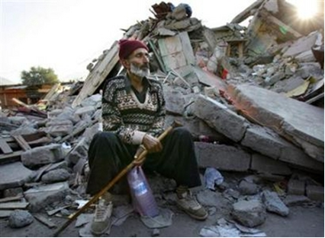

Earthquake Response
○ Rescue and Relief Phase
○ Transition from Relief to Reconstruction
○ Humanitarian Coordination – Perceptions of the “Cluster Approach”

The Universality of Humanitarianism
○ Perceptions of Humanitarian Action and Actors
○ Cultural Sensitivity
○ “Insiders” and “Outsiders” & “Locals within Locals”
○ Differing Perceptions of Human Rights – Especially Women’s Rights
○ Protection of IDPs “The Weakest Link”

The impact of WOT

○ The HA2015 country studies have sought to understand how terrorism and counter-terrorism efforts in the post-9/11 world have influenced the concept and conduct of humanitarian action.
○ The earlier studies have focused for the most part on conflict situations, especially Iraq and Afghanistan, where the impact of the ‘War on Terror’ (WoT) on humanitarian action has been particularly strong.

The impact of War on Terror
○ The Pakistan earthquake response provides an interesting opportunity to look at an issue that has received a lot less attention – the impact of the WoT on humanitarian action in the context of a natural disaster.

A Perceived Minimal Impact
○ Aid workers interviewed for this study felt that globally and at the national level in Pakistan the WoT has had a negative impact on humanitarian action, but that the impact on the earthquake response was minimal.

US Official FEELING
○ At the global level a US official felt that the Bush Administration’s WoT language of “being with us or against us” had “created a wall [between the US and most others], even for those of us who don’t want it to be there.”

Un OFFICIAL
○ In Pakistan a UN official felt that one of the very negative humanitarian impacts of the WoT was “the license given to intelligence agencies which is horrifically misused against political activists, journalists, and others – many of whom have disappeared.
○ Several interviewees felt that the WoT had created a lot more suspicion in Pakistan about the work of aid agencies in general, and US agencies in particular.

US INGO Worker Views
○ We were wandering through a neighborhood when a laborer we passed said… “I’m not a terrorist.” He thought we were there to catch terrorists. We’re increasingly living in a bubble, and fail to realize that top of their mind is recent news and a perception that we’re there to look for terrorists.

WOT
○ Humanitarian rescue and relief operations following sudden onset natural disasters are less likely to be as highly politicized or heavily influenced by external political or security agendas as humanitarian action in situations of protracted conflict.

Comments From USAID Worker
○ My experience with USAID in Pakistan is directly related to 9/11. Before that they weren’t here. All US assistance here is very political and linked to the WoT. ESRA [a USAID-funded education program] was directly talked about as “stemming the madrassah phenomenon, and stopping the production of Taliban.” As a public health official I want to do public health for the sake of public health. I’m very glad I’m now involved in the earthquake response – it’s much less politicized.
○ The overwhelming majority of focus group participants in the earthquake zone also perceived the response of the US and other international donors, including the deployment of US and NATO military forces, as being driven by humanitarian rather than political considerations.
○ Pakistan’s geostrategic location as a “front-line” state in the US’s global WoT, for which it has been richly rewarded with billions of dollars of US foreign aid since 2001, has ensured that WoT considerations still played a role in the earthquake response.
○ In earthquake-affected areas, however, few people were giving much attention to conspiracy theories or objecting to the presence of foreign military forces. As one national NGO worker in Muzaffarabad noted:
People in the earthquake areas didn’t care who gave aid – they were happy with anyone. Elsewhere there were perceptions and conspiracy theories but not in the earthquake area.

Government Minister From Pakistan Views
○ There were some rumors that they have hidden agendas, and that the US created the earthquake to take over, but after a couple of weeks the majority were completely satisfied. When they left everyone was sad that they were leaving.
○ While most government officials and UN and NGO aid workers felt that the US’s initial response was primarily driven by humanitarian considerations, a few interviewees and some secondary sources did identify two important ways in which the earthquake response was affected by the WoT: 1) a much more generous US response as part of a conscious effort to use the earthquake response to “win hearts and minds”; and 2) controversy over the role of Islamist organizations and militant ‘jihadi’ groups in the response.

Winning Hearts and Minds
○ Probably the greatest impact of the WoT on the US’s earthquake response was the very conscious effort on the part of US policy-makers to reward a strategic WoT ally, and to use it as an opportunity to “win hearts and minds”and boost the US’s sagging popularity in this front-line state.

Wall Street Journal Editorial
○ A Wall Street Journal editorial called the earthquake response “…one of America’s most significant hearts-and-minds successes so far in the Muslim world.”

US Congressional Research Service Report
○ A US Congressional Research Service Report written two months after the earthquake was very explicit about the potential benefit of US earthquake assistance to the WoT:
The degree to which the United States receives positive press for its contribution to the earthquake relief effort may make it easier for Musharraf to support anti-terror activity in the region.”
○ In the case of a country like Pakistan, viewed as “strategic” and an “ally,” it seems likely that the WoT agenda had the positive result of increasing the speed and the scale of the US response.

The Controversial Role of “Jihadi” Groups
○ Interviews for this study confirmed observations made by others that in many cases the first to arrive on the scene to assist in rescue and relief efforts following the earthquake were members of Islamist groups, including militant jihadi organizations.
Jihadis and Muslim Brotherhood
○ Respondents were generally very positive about the speedy assistance provided by these groups, who they often referred to in interviews as “our Muslim brothers.”
According to one national NGO worker
○ Jihadi groups were very effective. They were the first to respond. They were much more organized than civil society groups… They had horses and carried supplies on their backs. They were the first to deliver food. We had hundreds of volunteers on our door dressed in jeans and t-shirts, but we didn’t know how to use them. The jihadi organizations were much better organized.

Main Islamic Political Parties
○ Pakistan’s main Islamic political parties like Jamaat-i-Islami (JI) and the Jamiat Ulema-i-Islam (JUI) were active in rescue and relief efforts, along with their respective welfare wings, the Al-Khidmat Foundation and the Al-Khair Trust, and their affiliated militant organizations, the Hizbul Mujahidin and Jamiat-al- Ansar (formerly Harkatul Mujahidin).

According to one NGO worker in Muzaffarabad
○ Cluster meetings hardly saw any Islamic organizations participating…. There was a reluctance to invite them. I asked why we weren’t inviting them. All Islamic organizations aren’t jihadis, but it’s hard for many people to differentiate.

Coherence and the Role of the Pakistan Army
○ The Coherence Agenda
○ An important objective of the HA2015 study has been to critically examine the impact of attempts to promote greater coherence and integration in conflict and post-conflict environments between humanitarian efforts and political, military and/or peace-building efforts.

Findings of HA2015
○ The main finding of the first round of HA2015 case studies regarding the push for greater coherence and integration was that the political-humanitarian relationship in integrated missions “is far from a collaboration among equals,” and that there is “a recurrent danger that humanitarian and human rights priorities will be made subservient to political objectives.”

Pakistan Army Official View
○ According to a Pakistani Lt. General and senior UN official who both played central roles in the response:
The humanitarian operations and military operations were so interlinked that at the strategic level there could no longer be any meaningful division between the military operation and the humanitarian operation. It was one.
○ The earthquake response is also perceived by most donors and aid agencies to have been one of the most effective large-scale humanitarian responses – much more so than other recent responses to natural disasters, including the 2004 Indian Ocean tsunami and Hurricane Katrina.

Interesting Findings of this Study
○ One of the interesting findings of this perceptions study was the extent to which key informants directly involved in earthquake relief efforts attributed this success to the central role in relief efforts of national and international military forces in general, and the Pakistan Army in particular.

Deployed Troops
○ In the days following the earthquake the Federal Relief Commission (FRC) was established headed by a serving army general to coordinate the overall earthquake response, and 60,000 troops were deployed to assist in relief efforts.
○ While the army was strongly criticized for responding slowly in the immediate aftermath of the earthquake, and heavily criticized for its role in the longer-term reconstruction phase, the vast majority of aid workers as well as aid recipients who were interviewed were full of praise for the army’s role in leading the relief phase.
○ It is important to note that the Pakistan Army does not have a constitutional mandate to respond to natural disasters.
○ Prior to 2001 this was the responsibility of provincial civil administrations, and after the Local Government Ordinance of 2001 it became the responsibility of local governments at the district level.
○ They can choose to involve the military if required, but in the case of the earthquake this process was not followed.
○ The FRC and ERRA were established by Presidential Ordinances and were never authorized by parliament, despite requests by parliamentarians for this to be done.
○ Several donor and aid agency officials emphasized that while in principle it would have been better to have a civilian-led response to the earthquake, in reality there was really no alternative to the army leading relief efforts.

Pakistan’s Official View
○ In principle the army should withdraw, but if they did who would step in? INGOs aren’t here for the long- term. Local NGOs don’t have the capacity. The civilian government doesn’t have the capacity.

As a senior USAID official noted
○ “The only organization that can handle a disaster of this magnitude is the army.” Of course, the fact that Pakistan has no other strong institutions that could have led the response is to a considerable extent the result of a long history of deliberate actions taken by the Pakistan military to weaken all other potential rivals for power.

As one Pakistani researcher noted
○ “The army has to do it because no other institutions exist – the army has destroyed them all.”

A Highly Criticized Rescue Effort
○ The Pakistan government, and in particular the army, were heavily criticized for the slow initial response to the earthquake, especially in the local media.

Leading journalist’s Observation
○ One of Pakistan’s leading journalists who was attempting to reach Muzaffarabad the day of the earthquake observed, “I could not help but notice the absence of government and army rescue teams. Instead, the void was filled by members of the ‘religious’ parties.”
○ While there may have been good reasons for the army’s delayed response, there was, nevertheless, a strong public perception that the army responded slowly during the rescue phase. Several explanations have been given for this slow initial response.

Lt General Nadeem Ahmed (ERRA)
○ The first, as explained in an interview with Lt. General Nadeem Ahmed of ERRA, was simply that “Pakistan was not prepared for this level of disaster.”
○ At the time of the earthquake Pakistan had no disaster response organizations other than a small Emergency Relief Cell in the Cabinet Division which maintains a few relief supplies for small-scale emergencies, and a Crisis Management Group in the Ministry of Interior to respond to contingencies like hijackings.

Pakistan Military Responded
○ While the Pakistan military has responded to many previous natural disasters such as floods and earthquakes, other than the 1970 cyclone in East Pakistan (now Bangladesh) that killed an estimated 300,000 people, none were even close to the scale of the 2005 earthquake.
○ Another factor that delayed the army’s response was that it clearly prioritized institutional and strategic considerations over adherence to humanitarian principles of impartiality.
○ As a result, the army’s top priority during the first few days following the earthquake was to rescue the large number of military personnel who were injured in the earthquake, and to restore its defenses along the disputed Line of Control separating Indian- and Pakistan-administered Kashmir.

Director Of an INGO
○ According to the director of an INGO working in PaK at the time of the earthquake, “Initially the Pakistani military were more interested in rescuing their own military men so we were able to focus on the civilian side.”

Views From Retired Brigadier
○ “The quake exposed the military to an unprecedented predicament as the country’s forward positions at several places were rendered unmanned. This caused panic and a rush to move in reinforcements because India could have easily occupied strategically important peaks that had been left undefended.”

Pakistan NGO Worker’s Views
○ On October 11th lots of soldiers were sitting around doing nothing. They had their weapons so it didn’t look like they were there for rescuing – they were being deployed to the front line. The army’s first response was to replace their dead and injured…. Once they had replaced their forces then they did a good job in relief – we need to give the devil his due.

Pakistan Journalist Views
○ A senior Pakistani journalist interviewed for this study noted that “the press was very critical and very confrontational” in the initial weeks following the earthquake. He
acknowledged that in retrospect, “we were all criticizing but they did a good job…. Without the army, the relief operation couldn’t have succeeded.”

A Highly Praised Role in Relief Phase
○ In sharp contrast to the negative perceptions of the military role during the first week following the earthquake was the very positive perception of the army’s central role in coordinating the relief phase.

International Aid Agency Official Views
○ The Pakistani Army were open, listened, learned and then came up with better solutions. They kept in control. This is what’s made it work. I’ve stayed on because they’re a pleasure to work with. (international aid agency official) (female earthquake IDP from PaK)
○ The Pakistan Army provided all the assistance in our area. Nobody else came to our area to help us.

According to General Farooq, the former FRC Commissioner
The Pakistan military has had lots of interaction with the international community through peacekeeping operations, international training courses, field maneuvers abroad and in Pakistan. Pakistani peace- keeping operations are often the biggest.

A Controversial Role in the Reconstruction Phase
○ The perception of the army’s role in the earthquake response, which went from very negative during the rescue phase to very positive during much of the relief phase, again became increasingly controversial and unpopular during the reconstruction phase.

Focus group member in NWFP
○ The army played a key role in the rescue phase which we appreciate. We saw military forces at midnight carrying food and tents up the hill to earthquake victims. However, in the relief phase we’re not happy with the army. They didn’t listen to us and there are lots of irregularities.

Pakistani researcher
The army played a very constructive role in the relief phase, but we felt that at the reconstruction phase coordination and leadership should go back to civilian pre-earthquake structures. (INGO representative) Yes, the military did a good job and now it’s time for them to leave. We need to work more through local government – this is the only sustainable option. Ultimately elected governments have to handle the response.
○ This case study has examined the perceptions of a wide range of aid recipients and providers regarding the humanitarian response to the devastating earthquake that struck northern Pakistan and the disputed territory of Kashmir in October 2005.

An Important Lesson
○ Another important lesson from the Pakistan study (as well as the Afghanistan, Nepal, and Sri Lanka studies) was that the benefits of coherence seem to obey a law of diminishing returns. As the less contentious life-saving humanitarian phase transitions into a more politicized reconstruction and recovery phase, the role of military forces is likely to become more politicized and disputed.

Interview with Lt. General Nadeem Ahmed, Deputy Chairman, ERRA
○ A willingness to learn – On day one we acknowledged we didn’t have knowledge and capacity, and we were more than willing to learn from humanitarian organizations.
○ Opening up to the international humanitarian world, which was remarkable for such a closed institution. We became a good facilitator for humanitarian organizations. There was an initial reluctance but then they preferred to operate with the military and found it easier to interact with us than civilian officials.

Interview with Lt. General Nadeem Ahmed, Deputy Chairman, ERRA
○ Developing Coordination Mechanisms – We provided a platform for all humanitarian organizations – at Federal, State and district levels…. Every evening a coordination meeting was convened and participated in by all sectors which provided an overarching view while the UN Cluster system provided sectoral views.

Interview with Lt. General Nadeem Ahmed, Deputy Chairman, ERRA
○ Personal relationships are critical – Once we got to know and trust each other we could talk frankly among friends. This spirit would then trickle down. We used strong leadership to push teamwork down the system.

Conclusion
○ The objective of the study has been to learn from these perceptions in order to better understand, and more effectively address, some of the key challenges currently facing humanitarian action.

Reference
○ Perceptions of the Pakistan Earthquake Response Humanitarian Agenda 2015-Pakistan Country Study By Andrew Wilder February 2008

Lecture—17
Decision making in NPO

Agenda
○ Preview of Last Lectures
○ Leadership in Non Profit World (Part 1)
○ Eight Broad Missions of IRS
○ Balance between mission and passion
○ Resources-The Boon and the Bane
○ Financial Resources
○ Staff Leadership
○ Volunteer Leadership
○ Leadership Tool Box
○ Context
○ Preparation
○ Persuasion
○ Conclusion

LEADERSHIP IN A NON FOR PROFIT WORLD (A MIXED TOOL BOX)
○ Great leaders often inspire their followers to high levels of achievement by showing them how their work contributes to worthwhile ends. It is an emotional appeal to some of the most fundamental of human needs-the need to be important, to make a difference, to feel useful, to be a part of a successful and worthwhile enterprise.”
○ Warren Bennis, Ph.D., Founding Chairman of the leadership Institute at the University of Southern California.
○ “Non Profits have to start acting like for-profit organizations.”
○ “They need to be more business like”
○ “Non Profits need to operate efficiently”
○ Experts in for-profit and non profit industries and businesses proclaim these mantras, and non profits today are paying attention.
○ Environmental organizations, cultural institutions, civic organizations, health care advocacy non profits, animal rights groups, senior centers:
○ The non-for-profit mission is usually pursued with passion and zeal.

(IRS) Recognition About NPOs
○ A non-for-profit organization recognized by the Internal Revenue Service(IRS) must have a clearly defined mission and financial controls.

IRS Eight broad missions
○ According to 501© Section of the tax code:
○ Religious
○ Educational
○ Charitable
○ Scientific
○ Literary
○ Testing for public safety
○ Fostering certain nation or international amateur sports competition
○ Prevention to cruelty to children or animals

IRS
○ IRS more states that if an organization wants to be tax exempt, it has to serve the purpose or mission to advance public welfare instead of a profit motive.

Effective Non Profit Leader
○ Effective non profit leaders know that there are many sides to running a successful organization.
○ Firstly, there should be clarity regarding the mission itself.
○ Then there are pressures to become more professionally managed, and to articulate and to achieve those bottom-line performance objectives.

Why this is done both ways?
○ Because of a shift in context of demand for services, changing operating environments and frequent financial pressures.

Need
○ Non profit leaders recognize the need of strategic management perspective for translating their missions into objectives, developing plan and programs to accomplish their objectives and implementing those plans or programs.

Balance between Mission and Passion
○ There should be a balance between the mission and passion that drive non profit sector organizations and the effective and efficient management and operations may be the single most important factor for success.

Strong Leadership
○ Achieving the delicate balance between the efficiency and effectiveness requires strong leadership.
○ Professional Leaders (i.e., paid chief executive officers(CEOs), executive directors, vice president, deputy directors, etc.)
○ Volunteer Leaders(i.e., board of trustees or directors, event and committee chairs)
○ They believe that more business like approach is require in and plus the balance between the mission and passion to work.

Non Profit World
○ Today’s non profit world environment requires a good return on investment.
○ Donors demand it.
○ The challenges, changes, and qualities of non profit leaders reveal a number of opportunities and lessons for success.

Resources-The Boon and The Bane
○ The challenge of creating opportunities, enriching lives and communities, and creating fundamental change drives many leaders in to the non profit sector.
○ Those who get in the non profit world carry an obligation to implement programs and procedures, provide services, and manage many institutions effectively against the backdrop of challenging issues.

In author’s view
○ “We need to stand on the shoulders of those who came before us for 90 years, yet we still look forward. We need to stick to our mission, yet be adaptive to stay relevant in order to deliver on it. The messages have to expressed differently to make sense to the community. We need to stay in the cutting edge and use our resources fully”(Interview of an author)

Leader’s Example
○ Nelliw Hayse has been the executive director of the Colonial Coast Conference Girls Scouts of America since its inception in 1981. She knows how important its is to stay relevant, especially to the nearly 17,000 member nonprofit organizations across a 25,000 square mile area in the south eastern Virginia and northeastern North California.

Financial Resources
○ Non profits range in size from the Teachers Insurance and Annuity Association to your neighborhood block part planning committee.
○ Social investors and non profit stakeholders look for a return on their investment of donations to the more thaqn 1.4 million charities in the United States, including religious organizations.
○ In the year 2002, total charitable giving reached a record of nearly $241 billion, representing an estimated 2.3% of the US gross domestic product.

Chronicle of Philanthropy
○ Total giving to the nation’s 400 largest charities fell in 2002, for the first time in a dozen years, after serveral; years of double digit growth.

USA 2003, Charity Report
○ Religious organizations (35%)
○ Educational Institutions (13.1%)
○ Foundations (9.1%)
○ Health(7.8%)
○ Human Services(7.7%)

Staff Leadership
○ Over the nearly 1.4 million registered npo organizations, less than two-thirds ever file annual IRS Forms and have gross income receipt of less than $25,000.
○ “We donot pay our staff members enough” (Head, Girls scout)
○ Most non profit organizations are blessed with dedicated staff and volunteers. Rarely a Staff members paid their worth.

Biggest Issue
○ “The biggest issue is to find a competent leadership when the pay is not high”(personal interview).

President of Norfolk Foundation , Virginia
○ Angelica Light, president of norfolk foundation amongst the largest community foundations in the country established in 1950 says-”It’s critical to lead with the heart. Non profit leaders must possess a keen respect for staff and be reflective in their decision-making”.

Problem
○ Problem is that non profit leaders are not following their mission and not translating it through programs, procedures with zeal and understanding.

Serve
○ Effective leaders in non profit organizations know how to serve multiple stakeholders, balance competing demands, satisfy customers and employees, cut cost and grow on more projects.
○ They are credible, genuine, and have the habits, values and behaviors to engender trust and commitment.
○ They serve a role model inside and outside the organization.
○ The best are tireless, innovative, inventive, observant, risk taking and consistent supporters and enablers of management and leadership teams.
○ It is pretty demanding package.

Changing from non profit to profit
○ In an era when non profit organizations have to fight harder for contributions and use their resources with greater care, many have turned to the business sector for management, and increasingly it is witnessed that more business executives are becoming directors of non profit sector organizations.

Non Profits Like Businesses
○ Non profits, like businesses, “must identify their markets, establish goals and objectives and devise strategic plans”.

Competition
○ In Non profits today, there is the added challenge of increasingly competitive environments, competition for patrons and support, competition of good employees, competition for volunteers, awareness and time.

WHRO CEO Widoff
○ WHRO CEO Widoff agrees, “ Leaders who are subject matter specialists in the arena cannot always adapt to the business side of non profits. Originally in WHRO, the leaders are PhD educators. Today it may be problematic”.

Volunteer Leadership
○ Every non profit organization look for three key factors for executives
 Work
 Wisdom
 Wealth
○ Volunteer Leaders should provide a combination of work, wisdom and wealth.
○ Work, Wisdom often comes together in volunteer leadership.
○ They may give generously of their time, talents and energy but not always of their wealth.

Qualities
○ Effective boards and volunteer leadership teams or committees depend on the combined qualities and characteristics of the individual members.

Leadership Tool Box

Context
○ Balance the focus on mission with efficient operations.
○ Strive for continuous improvement in professional leadership.
○ Clearly define roles and responsibilities.
○ Lead inclusive change initiatives with board and staff.
○ Play to strengths of staff and board leaders.
○ Ensure financial stability for non profit’s future.

Nonprofit Leadership Tool box

Preparation
○ Invest in people
○ Spend more time in strategic planning
○ Ensure financial stability for non profit’s future
○ Regularly evaluate plans, people, and performance
○ Share best practices
○ Groom tomorrow’s staff and volunteer Leaders
○ Create a culture that encourages innovation and accountability
○ Pay attention to governance.

Non Profit Leadership Tool Box

Persuasion
○ Acquire the art of persuasion
○ Persuade stakeholders of value of non profit mission and work.
○ Be a vocal ambassador to bring awareness and support.

Conclusion
“The first responsibility of a leader is to define reality. The last is to say thank you. In between, the leader is a servant “Max DePree

Lecture—18
Decision making in NPO

HOW TO DEVELOP, BUILD AND LEAD TEAMS









What Is A Group? 


What Do You Think?


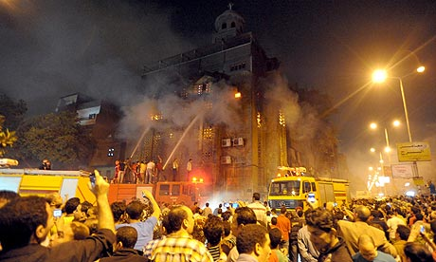

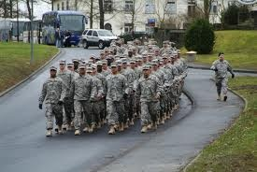

Lecture—25
Decision making in NPO

Leading The Team

Leadership

What Is Leadership?

Types Of Leaders
○ Leader by the position achieved
○ Leader by personality, charisma
○ Leader by moral example
○ Leader by power held
○ Intellectual leader
○ Leader because of ability to accomplish things

MANAGERS VS. LEADERS
Managers  Focus on things  Do things right  Plan  Organize  Direct  Control  Follows the rules | Leaders  Focus on people  Do the right things  Inspire  Influence  Motivate  Build  Shape entities

COMMON ACTIVITIES

○ Planning
○ Organizing
○ Directing
○ Controlling

PLANNING


Manager
○ Planning
○ Budgeting
○ Sets targets
○ Establishes detailed steps
○ Allocates resources

Leader
○ Strategy
○ Sets direction
○ Creates vision

Organizing
Manager  Creates structure  Job descriptions  Staffing  Hierarchy  Delegates  Training | Leader  Gets people on board for strategy  Communication  Networks

Directing Work
Manager  Solves problems    Negotiates  Brings to consensus | Leader  Empowers people  Cheerleader

Controlling
Manager  Implements control systems  Performance measures | Leader  Motivate  Inspire  Gives sense of accomplishment

Leadership Traits
Intelligence  More intelligent than non-leaders  Scholarship  Knowledge  Being able to get things done | Physical  Doesn’t see to be correlated | Personality  Verbal facility  Honesty  Initiative  Aggressive  Self-confident  Ambitious  Originality  Sociability  Adaptability

Management Styles
Autocratic  Make all decisions  Quick/efficient  One way communication | Persuasive  Make all decisions but explains to subordinates  Staff more willing  Subordinates not committed to decisions | Participative  Confers subordinates  More involvement  Time consuming  Limited viewpoint | Democratic  Consensus decision  High commitment  Authority undermined  Long process  No clear cut decisions

New Leaders Take Note
General Advice  Take advantage of the transition period  Get advice and counsel  Show empathy to predecessor  Learn leadership | Challenges  Need knowledge quickly  Establish new relationships  Expectations  Personal equilibrium

New Leader Traps

○ Not learning quickly
○ Isolation
○ Keeping existing team
○ Taking on too much
○ Captured by wrong people
○ Successor syndrome

CORE TASKS

○ Create Momentum
○ Master technologies of learning, visioning, and coalition building
○ Manage oneself

CREATE MOMENTUM
○ Learn and know about organization
○ Securing early wins
 First set short term goals
 When achieved make a big deal
 Should fit long term strategy
○ Foundation for change
 Vision of how the organization will look
 Build political base to support change
 Modify culture to fit vision

Create Momentum

○ Build credibility
 Demanding but can be satisfied
 Accessible but not too familiar
 Focused but flexible
 Active
 Can make tough calls but humane

Master Technologies
○ Learn from internal and external sources
○ Visioning - develop strategy
 Push vs. pull tools
 What behaviors are needed?
○ Communicate the vision
 Simple text - Best channels
 Clear meaning - Do it yourself

Enabling Technologies

○ Coalition building
 Don’t ignore politics
 Technical change not enough
 Political management isn’t same as being political

Manage Oneself
○ Be self-aware
○ Define your leadership style
○ Get advice and counsel
 Advice is from expert to leader
 Counsel is insight
○ Types of help
 Technical
 Political
 Personal
○ Advisor traits
 Competent
 Trustworthy
 Enhance your status

Confidence On Leader
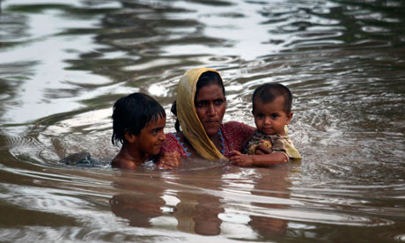

Effective Negotiation Skills



Contents
- Components of Negotiation
- What is Negotiation?
- Features of Negotiation
- Why Negotiation
- Where do We use this Skill
- Phases of Negotiation
- Bargaining Zone Model
- Issues in Negotiation
- Negotiation behaviour
- How to achieve an effective negotiation?
- Negotiation Strategies and tips

Components of Negotiation


What Is A Group?

Attitude
Behaviour
Discussion
Give-n-Take
Needs
Preferences

Process
Management


What Is Negotiation?

- “The process to arrive at an agreement between different parties, each with their Own interests and preferences”.
- “The process we use to satisfy our needs when someone else controls what we want”.
- “The act of discussing an issue Between two or more parties with Competing interests with an aim of coming to an agreement”

Theoretical Framework (way in)

Arrangement
Settlement
Differences
Limit Variation
Issue
Interest

Perception experience
Individuality
Effect of political, Psychological, Spiritual, Social needs
Sharing
Exchanging
Ideas
interests
Process
Influence
Difference
in
opinion
Leads toward

Theoretical Framework (way out)
Conflict
Yes/No
(Conditioned)
Solution
Changing Mind

Human mind
NEGOTIATION

Proposal
Discussion
Preparation
Changing Mind
Bargaining
Settlement
Review/ Evaluation

Issue judgement, both Party’s Interests,
Rapport building, Empathy, sympathy, Trust, Comm.
Planning, Objectives, Language
Friendly relationship
Decide Agenda, Share interest
Be positive, Concentration
Agreement
Expressing interests
Options, Position
Deal Stress & Conflict
Compromise


Features of Negotiation

- Minimum two parties
- Predetermine goals
- Expecting an out come
- Resolution and consensus
- Parties willing to modify their positions
- Parties should understand the purpose of negotiation

Where do we use this Skill


Every thing is Negotiated

- Family & Personal
“Where should we go for Dinner”?
“Can I borrow the Car”?
- Academic Research
“Fund my project”.
“Publish my paper”.
- NGOs
“community interaction”.
“Donor”
“acquire or Implement a project in to the society”.

Why do we NEGOTIATE?

- To reach an agreement
- To beet the opposition
- To compromise
- To settle an argument
- To make a point

Phases of Negotiation
There are basically two phases of Negotiation

Phases of Negotiation
Follow-up, Out-come

Pre-Negotiation
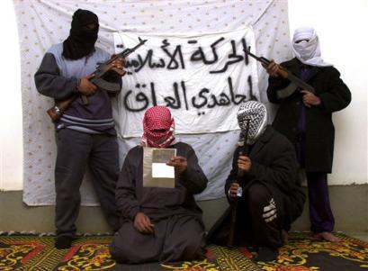
Conflict- Difference- Problem
Satisfaction & Future plan
Success

Negotiation

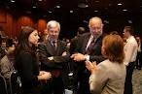
Failure
Pre-Negotiation Negotiation Post-Negotiation
1- Process
Planning & Preparation
Establishing Rapport

Post-Negotiation

Objectives and Goals
Discussion

Phases of Negotiation

Post-negotiation ( Review Evaluation )
- Review : Check the level of
    - Success
    - Satisfaction
    - Performance
    - Future plan
- Evaluate Negotiating & Improve Skills

    - Reason for failure
    - Skills needed for success
    - Checklist for Activities
    - Psychological Management
    - Reaching a life balance

How We Change What Others Think, Feel, Believe And Do?


Phases of Negotiation

Approaches/ techniques/ Skills

Tools in the process of Negotiation
1.Body Language (non-verbal communication)
2.Developing a Win/Win philosophy
3.Culture
4.Diplomatic Language
5.Handling problems

Tools for Using Creativity in Negotiation

- Role playing
- Psychodrama
- Conferences
- Brainstorming
- Homework
- Language

Controlling Negotiation Conflict by Controlling the impression
- Courage to change

Bargaining Zone Model
Proposals
Bargaining
Agreement
Compromise
Review
Evaluation
Your initial point
Your Target point
Opponent’s target point
Opponent’s initial point
Opponent’s Resistance point

NEGOTIATION BEHAVIOR
Gevin Kennedy describes three types of behaviour that we can display and encounter when in a negotiation situation.
Your resistance point

Area of potential agreement
Area of potential agreement

RED behavior
- Manipulation
- Aggressive
- Exploitation
- Always seeking the best for you
- Taking
- No concern for person you are negotiation with

BLUE behavior
- Win-win approach
- Cooperation
- Trusting
- Relational
- Giving

GREEN behavior
- Give me some of what I want (RED)
- I will give you some of what you want (Blue)
- Good intentions
- Two way exchange
- Green behaviour incites green behaviour
- Open
- People know where they stand

NEGOTIATION Tips
- Do not underestimate your power.
- Do not assume that other party knows your weaknesses.
- It is a mistake to assume you know what the other party wants.
- Never accept the 1st offer.
- Don’t fear to negotiate.

Non-verbal Communication
“Body language is an important part of communication which can constitute 60% or more of what we are communicating” (Barry, 2004).

A successful Negotiator


SKILLS FOR EFFECTIVE NEGOTIATION
- Preparation and Planning Skills
- Knowledge of the subjects
- Ability to think clearly and rapidly
- Ability to express
- Listening Skills
- General problem-solving and analytical skills


Common Negotiation Mistakes/ barriers
- Preparation and listening are key!
- Weak knowledge of key motivators
- Poor handling of Alternatives
- Failure to fully acknowledge the concerns of others
- Impatience/ Poor timing
- Poor close
- Self Control
- Where possible, conduct yourself with impartiality
- Try to maintain emotional distance
- Do you know how to defuse tension?
- Know your Hot Buttons….



Negotiation Resources

Books
- “Human Resources Skills for the Project Manager” Barry, 2004.
- “Principles of Project Management” John R Adams
- “The Power of Nice” Ronald Shapiro
- “Swim with the Sharks Without Being Eaten Alive” Harvey Mackay
- “Getting Ready to Negotiate: The Getting to Yes Workbook” Roger Fisher and Danny Ertel
- “Negotiating Skills for Dummies” Michael and Mimi Donaldson

Web Sites
http://www.maxwidman.com/papers/negotiating
http://www.gantthead.com/Gantthead/JPACE/justifypages/1,1457,61,00.html

NEGOTIATION STRATEGY Model

RED
BLUE
GREEN

BARGAINING
EMOTIONS
COMPROMISE
LOGICALLY
By: Kenneth Berrin

Lecture—26
Decision making in NPO

WHAT IS A CONFLICT
- A battle, contest or opposing forces existing between primitive desires and moral, religious or ethical ideas ( Webster’s Dictionary).

- A state of incompatibility of ideas between two or more parties or individuals

Conflict management is the practice of identifying and handling conflict in a sensible, fair and efficient manner.

… So conflict is a
‘clash of interests, values, actions, views or directions’
Conflicts Arise Due To
People disagree
(a) They see things differently because of differences in understanding and viewpoint.
(b) People have different styles, principles, values, beliefs and slogans which determine their choices and objectives.
(c) People have different ideological and philosophical outlooks.
(d) Conflict situations can arise because people have different status.
(f) People are supposed to disagree under particular circumstances.
People are concerned with fear, force, fairness or funds:
(a) Force is a necessary ingredient of any conflict situation. Force may be ethical or emotional.
(b) Fear relates to imaginary concern about something which might happen in the future.
(c) Fairness refers to an individual's sense of what is right and what is not right, a fundamental factor learnt in early childhood.
(d) Funds or costs can cause conflict, but can also force a conclusion through acceptable to the conflicting parties.

Conflicts In Organization
- A party is required to engage in an activity that doesnot meet with his or her needs or interests.
- A party holds behavioral preferences, the satisfaction of which does not meet with another person's preferences.
- A party wants some mutually desirable resource that is in short supply, such that the wants of all parties involved may not be satisfied fully.
- A party possesses attitudes, values, skills, and goals that direct his or her behavior but are perceived to be exclusive of the attitudes, values, skills, and goals held by the other(s).
- Two parties are interdependent in the performance of functions or activities.

Types Of Conflicts
Functional & Dysfunctional Conflicts

Functional conflicts are
constructive, support your
company's goals, and
improve performance.
It generally involves
people who are genuinely
interested in solving a
problem and are willing to listen to one another.
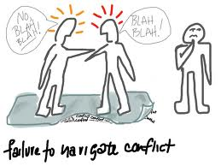

Dysfunctional conflicts on the other hand, consist of disputes and disagreements that hinder your company's performance. This generally involves people who are unwilling to work together to solve a problem and is often personal.

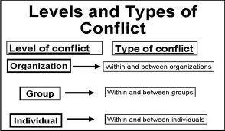
Within an organization,
a conflict can be at five
levels:

○ Inter-personal
○ Intra-personal
○ Inter-group
○ Intra-group
○ Intra-organization

First Level Of Conflict

Intrapersonal

Intrapersonal conflict

Conflict that arises within a person.
For example, when you’re uncertain about what is expected or wanted, or you have a sense of being inadequate to perform a task, you are experiencing intrapersonal conflict.

Intrapersonal conflict can arise because of differences in roles.
For example, Role conflict, may arise if you’re the head of one team but also a member of another team.

Inter-Personal Conflict
A type of conflict between two people. is among individuals such as coworkers, a manager and an employee, or CEOs and their staff.

Intra-Group Conflicts
Intra-group conflicts occur within the group and they are mostly a tug of war towards decision making and involve a great deal of interpersonal and intrapersonal conflicts as well. A group member may act intimidating towards others and that can lead to a conflicting situation.

Inter-Group Conflicts
Conflict that takes place among different groups, such as different departments or divisions in a company, or between union and management, or between companies, such as companies who supply the same customer is conflict that takes place among different groups.

Intra-Organization Conflicts
Intra organizational conflict is a conflict that takes place among different groups or departments of an organization.
Departments may conflict over achieving goals, failures or cross functional responsibilities characterizing their functions and operations.

Conflict Resolution Vs. Conflict Management
Conflict resolution:  Conflict resolution involves the reduction, elimination, or termination of all forms and types of conflict. | Conflict Management  Conflict management involves implementing strategies to limit the negative aspects of conflict and to increase the positive aspects of conflict at a level equal to or higher than where the conflict is taking place.

CONFLICT RESOLUTION

Conflict Resolution Vs Management

The Bottom Line
Businesses can benefit from appropriate types and levels of conflict. That is the aim of conflict management, and not the aim of conflict resolution.

Concluding Remarks
• The task of this part was
◉ to introduce and define conflict in an organization;
◉ its causes,
◉ Its types,
◉ its different levels, and
◉ how it differs from conflict resolution.

All these factors are crucial for understanding of the concept of conflicts in formal organizations and its functions and advantages.
…conflicts can be used as motivators for healthy change.

When Faced With A Conflict
○ They can react in either:

FIGHT
High

Fighting To Resolve Conflict
Fighting as a way of resolving a conflict can only be useful in courtroom situations, where winning and losing becomes a by-product of the judicial process.

Negotiation
Negotiations take place within the prevailing situation and do not involve problem solving or designing.
Negotiations To Solve Conflicts
Third-party roles are very important in bringing the conflicting parties together on some common ground for negotiations.

Problem Solve
Problem solve involves identifying and removing the cause of the conflict so as to make the situation normal again.
It is also possible that the situation may not become normal even after removing the identified cause, because of its influence on the situation.

Design
Design, which is an attempt towards making the conflict situation normal. It considers conflicts as situations rather than problems.
Designing is not confined to what is already there, but attempts to reach what might be created given a proper understanding of the views and situations. It is creating a system to deal with a particular type of conflict.

Conflict Handling Behaviour
Two intentions determining the type of conflict-handling behaviour are:
○ Assertion : assertion refers to an attempt to confront the other party;
○ Cooperation: cooperation refers to an attempt to find an agreeable solution.
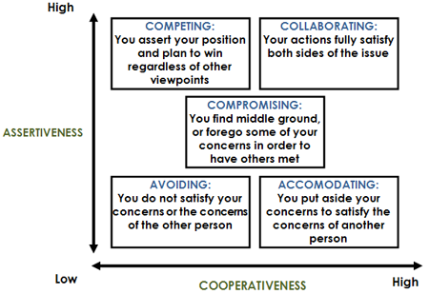

Competition
○ Fundamental premise: Associates "winning" a conflict with competition
○ Strategic philosophy: When goals are extremely important, one must sometimes use power to win
○ When to use:
 When you know you are right
 When time is short and a quick decision is needed
 When a strong personality is trying to steamroller you and you don't want to be taken advantage of
 When you need to stand up for your rights

○ Drawbacks
 Can escalate conflict
 Losers may retaliate

Collaboration
 Fundamental premise: Teamwork and cooperation help everyone achieve their goals while also maintaining relationships.
 Strategic philosophy: The process of working through differences will lead to creative solutions that will satisfy both parties' concerns.
 When to use:
○ When there is a high level of trust
○ When you don't want to have full responsibility
○ When you want others to also have "ownership" of solutions
○ When the people involved are willing to change their thinking as more information is found and new options are suggested
○ When you need to work through animosity and hard feelings
 Drawbacks
○ The process takes lots of time and energy
○ Some may take advantage of other people's trust and openness

Compromise
 Fundamental premise: Winning something while losing a little is OK.
 Strategic philosophy: Both ends are placed against the middle in an attempt to serve the "common good" while ensuring each person can maintain something of their original position.
 When to use
○ When people of equal status are equally committed to goals.
○ When time can be saved by reaching intermediate settlements on individual parts of complex issues.
○ When goals are moderately important.
 Drawbacks
○ Important values and long-term objectives can be derailed in the process.
○ May not work if initial demands are too great.
○ Can spawn cynicism, especially if there's no commitment to honor the compromise solutions.

Avoidance
○ Fundamental premise: This isn't the right time or place to address this issue.
○ Strategic philosophy: Avoids conflict by withdrawing, sidestepping, or postponing.
○ When to use:
○ When the conflict is small and relationships are at stake
○ When you're counting to ten to cool off
○ When more important issues are pressing and you feel you don't have time to deal with this particular one
○ When you have no power and you see no chance of getting your concerns met
○ When you are too emotionally involved and others around you can solve the conflict more successfully
○ When more information is needed
○ Drawbacks
 Important decisions may be made by default
 Postponing may make matters worse

Accommodative
○ Fundamental premise: Working toward a common purpose is more important than any of the peripheral concerns; the trauma of confronting differences may damage weak relationships.
○ Strategic philosophy: Satisfy others by downplaying conflict, thus protecting the relationship.
○ When to use:
○ When an issue is not as important to you as it is to the other person
○ When you realize you are wrong and know you cant win
○ When you are willing to let others learn by mistake
○ When it is not the right time and you would prefer to simply build credit for the future. When peace is extremely important
○ When what the parties have in common is a good deal more important than their differences
○ Drawbacks
 One's own ideas don't get attention
 Credibility and influence can be lost

THE BOTTOM LINE
Conflicts are inevitable in any organization. A modest level of conflict can be useful in generating better ideas and methods, inspiring concern and ingenuity, and stimulating the emergence of long-suppressed problems.

Lecture—27
Decision making in NPO

Agenda
○ Preview of Last Lecture
○ What data NPO Use?
○ financial and internal Operations Data
○ marketing, Communications, and fundraising Data
○ Programs and Outcomes Data
○ External Data
○ Internal Factors
○ Data Collection
○ Prioritization and Time
○ Expertise
○ Technology
○ Money
○ Conclusion

What data NPO use?
○ Too often barriers keep nonprofits from collecting and integrating important data into their daily work.

What data NPO Use?
The barriers are familiar to those who work in and with nonprofits: not enough staff or time
to collect or analyze this data; not knowing what data to collect or how to make use of it; competing demands or conflicting reporting requirements; money or technology limitations.
○ Most nonprofits are tracking financial and operations data and using it to make decisions about budgeting or programs.
Data offers nonprofits a means of measuring their progress toward their missions, but also a way of improving that progress.

What Data and How?
And when their missions are collectively effecting change in the world, their progress is important. Without data, it is impossible to measure financial and operational health, identify problems and measure organizational impact. What data metrics are nonprofits collecting and tracking, and how are they using that data to make decisions?

○ A well-functioning nonprofit data decision-making process provides numerous possibilities for nonprofits to optimize their programs and grow.
○ Even small organizations can use data such as feedback, surveys and self- assessments to measure their impact and determine what is working well and what needs to be addressed

What Data Are nonprofits Using?

• Nearly all nonprofits track some sort of metrics.
•A much lower percentage use the data they collect to make strategy or program decisions.
•The vast majority of nonprofits track finance and operations data while only about two- thirds track marketing, communications and program data.

Financial and Internal operations Data
○ Data tracked by respondents includes such typical financial metrics as expenses, income and cash-on-hand, as well as operations metrics such as volunteer hours and staff training.
○ Consultants in our focus group were quick to point out the different things financial and operations data can show organizations. for example, it can help them take actions that minimize overhead or show the effectiveness of management or the composition and health of an organization’s board of directors.
○ it can also help management make staffing decisions by measuring turnover, technical expertise of staff, as well as staff, volunteer and partner resources.
○ for example, one focus group participant from a youth services nonprofit noted that his organization uses equipment utilization and member retention data to help measure operational efficiency.
○ An executive director at a domestic violence prevention organization reported that her nonprofit monitors volunteer hours to understand how many hours they can expect at different times of the year.
“I rely heavily on the data so i can produce reports that show the value of each office,” said another executive director, helping her organization make decisions as to the viability of an office when a lease is up, for example, as well as to judge whether or not to invest more resources into a service or community.

marketing, Communications and Fundraising Data
○ While many nonprofits are tracking various type of marketing, communications and fundraising data—what we refer to as “outreach” data—our survey indicated a surprisingly low number are actually using that data to make decisions.

○ fundraisers and marketers have the most specific use for this data. They use data to measure which constituents respond to particular channels of communication and then adjust their tactics to maximize response; some track the costs of acquisition mailings against revenue raised from those mailings to determine whether a campaign is cost-effective.
○ One nonprofit fundraiser gave the example that her organization had a very good response to its mailed newsletter one year, and is using that data to decide whether to do more newsletters or to redesign a different document to try to achieve a similar result
○ yet one foundation officer we spoke with noted that most of the nonprofits she deals with don’t have systems in place to understand the key metrics that could help them understand the effectiveness of their fundraising strategy, such as donor retention, average gift and cost per donor.

Tracking Programs and outcomes
○ Tracking program and outcome-related data should be the bread-and-butter for nonprofits because it’s one of the best ways to articulate what they are delivering and the extent to which they are delivering on their mission.
○ however, data collection does not necessarily translate into strategic decision-making. Another organization in our focus group noted that they collect a certain amount of data related to goals and objectives in their strategic plan, and different data every month in aggregate to send to the state Department of Education
○ They would like to determine more strategically which pieces of data are needed to make certain decisions— not only to identify the problems, but to make sure they have the right things in place to solve them.
○ Not surprisingly, organizations that prioritize measuring program success are more likely to be collecting this data.
○ how nonprofits are currently using data does not necessarily reflect how they would like to use it. individuals who participated in our focus groups indicated that they want to move beyond collecting data and start using those metrics to make strategic decisions.

ONE NPO Consultant Views
○ “We have tons of anecdotal information about how we change lives,” explained a focus group participant. “Now we’re asking how we measure our effectiveness.” She and her board are looking for the types of data they need to measure in order to demonstrate how they are making change in their community and having an impact on the people they serve.
○ for some nonprofits, this is a natural evolution. They go from reporting what is required of them (whether by the government or funders) to identifying and tracking metrics that support strategic planning to determining from the outset what data will support potential new

External Data
○ Certain types of organizations were more likely to track external data, particularly employment, environmental and housing nonprofits.
○ most examples of external data we heard in our focus group were used in tracking program outcomes.
○ for instance, a staffer at one Texas-based nonprofit noted that her organization imported state data about her clients into its own database to help measure how effectively it was keeping clients out of nursing homes, and to triage eligible individuals to see who was in greatest need of services.
There’s not always within the organization a desire to evaluate the capabilities of evaluation,” one consultant told us, “but the biggest piece can be getting the data that’s outside of the organization to determine your effectiveness in terms of outcomes and outputs…to know if the services you’re providing are actually fixing what you’re trying to fix.”
○ Some nonprofits have worked out arrangements where they can receive data about their participants in aggregate—one of the organizations in our focus group had worked out a partnership with a local university that already had data-sharing agreements in place to help skirt some of the privacy and legal issues nonprofits face in trying to get personal data.
○ however, it may not be immediately obvious with whom an organization can partner in order to get this data.

How Does this Differ by Type of organization?

• Organizations with the largest budgets are more likely to be tracking and using data for strategic purposes.
•human services and health organization are more likely to have a plan for measuring success.
○ Among the different issue areas, human services and health organizations were more likely to have defined plans for how data would be used to measure the success of their programs.
○ Some of this is partly driven by state government reporting or data-collection requirements, but could also be related to the fact that the delivery of these programs and services is more measurement-oriented than the work of an arts and culture organization, for example.

What Are the Internal Factors?

• The ability to collect and understand data and the time it takes for these activities are the biggest internal barriers to nonprofit organizations’ use of data for strategic decision making.
•money and technology were cited less often as primary barriers, but still play roles.

○ The fact remains that a lot of organizations are not tracking data or using it to make strategic decisions. in many cases, this is not because they don’t want to be data-driven, but rather because of a variety of internal barriers that make tracking and using data a challenge they find difficult to surmount.

Data Collection

○ The ability to collect and work with data is a barrier reported by many nonprofits. in the course of the survey, we asked specific questions about organizations’ abilities to collect data on programs and on marketing and communications. While slightly more than half of survey respondents felt confident in their ability to collect program data, nearly two-thirds of people surveyed find it difficult to collect data about marketing and communications.

Prioritization and Time
○ A number of the difficulties organizations experienced in collecting and interpreting data may be related to the ability of staff to prioritize and make time for measurement.
○ for nonprofits with fewer staff and smaller budgets, there are many priorities and only so many hours in the day. if there’s no clear delineation of measurement duties in people’s job responsibilities, one nonprofit staffer said, figuring out who’s going to carve the time out of which job description to do this is a real challenge. Some nonprofits spread the responsibilities across multiple staffers, a solution with its own set of challenges.
○ for some nonprofits, this is not as easy as it sounds. Nonprofit staffers tend to have a natural inclination that aligns them more toward working with people than working with numbers. During more pragmatic data planning, like a build-the-database meeting

Expertise
○ There is a perception that you need specialized staff to do data analysis, but as we discussed previously, some nonprofits are distributing the duties across the organization. Staff that aren’t as comfortable with data analysis also have problems knowing where to start, and as such, get overwhelmed by the amount of data it’s possible to collect and measure.

○ This is not to say that everyone on staff is able to play the role of data analyst. in fact, as one consultant pointed out, your best staff members might not be the best measurers.

○ Organizations that lack expertise in working with data have very real concerns about the quality of data and analysis they do get, primarily around the issues of consistency in data quality among individuals with varying levels of expertise.

○ The fear runs a little deeper than that at some organizations—a participant working for a human services nonprofit brought up that she thinks there is resistance to what the numbers will show because people think they will get into trouble if the numbers don’t come out the way they think they should come out. As she points out, that is a barrier to getting people to dive into more difficult questions.

○ Time is particularly challenging.
○ Once an organization has a dashboard, whatever those metrics are, and they start measuring whether it’s annually, or daily, or monthly…people forget about the time that needs to be dedicated toward analyzing data or interpreting the data, or toward making decisions, or toward communication
○ There is a perception that you need specialized staff to do data analysis, but as we discussed previously, some nonprofits are distributing the duties across the organization. Staff that aren’t as comfortable with data analysis also have problems knowing where to start, and as such, get overwhelmed by the amount of data it’s possible to collect and measure.

Technology
○ Often, the same organizations that under-invest in planning for the strategic metrics that could help the organization also under- invest in the technologies that could help them track them.both are seen, in the words of a foundation executive, “as taking away from program delivery rather than being part of it. it’s stealing the money away from the doing of the program.”
○ This perception is a shame, because technology can in fact be a substantial help in integrating data collection into the everyday staff process.
○ Understanding the process of front-line staff and then designing data systems that help them gather data in a natural way that helps them with the data they need can be a critical step in creating a data-based decision making culture.

money

○ No discussion of nonprofit barriers would be complete without delving into the role that money—or the lack of it—play.
○ “A big problem for me is the cost of good data systems,” explained an administrator of early childhood education programs.

In the light of one consultant
○ “Clearly, money provides time in the form of more people to do the work.”

○ A blast of money from a funder isn’t necessarily a help in the long run—not only is it hard to get funding for things like evaluation and technology, as they’re not always perceived as directly applicable to services, but it also needs to be sustainable over the long term to support the ongoing effort.

Conclusion
○ Data small or large is utilized to devise information and knowledge out of it, which non profit sector organizations are well enough to do it and take sound decisions to have the outputs, outcomes.

Lecture—28
Decision making in NPO
Agenda
○ Preview of Last Lecture
○ How do funders fit in?
○ Funder Support
○ Funder reporter requirements
○ The challenges for foundation
○ Recommendations with respect to data
○ Conclusion

How Do Funders Fit In?
Nonprofits often find compliance with the number and diverse range of funder reporting requirements overwhelming.

These reporting requirements can be very beneficial, in that they also are often the impetus that spurs a nonprofit to begin tracking and analyzing data in the first place.
○ However, this “data regime” imposed on nonprofits takes away ownership and, often, their ability to see the big picture of what they are measuring.

○ internal barriers are not the only factors that weigh on a nonprofit’s ability to track and analyze data— organizations are also subject to external demands and stakeholders, including foundations, local, state and federal governments, donors, clients and community groups.

Funder Support

○ funders and government agencies are the biggest external forces that affect data collection and analysis.
○ In recent years, many of these organizations have devoted more attention to specific metrics and outcomes measures, creating a positive force to encourage data-based decision-making.
○ A number of the nonprofits in our focus groups were spurred to develop a data collection and analysis strategy based on funder requirements, but have since found it very useful for their own purposes. “grants and contracts were requiring some of that data and that was our initial impetus [for measurement],”

Funder reporting requirements
○ The reporting demands placed on nonprofits related to financial support and government regulations can be overwhelming, however.
○ One focus group participant whose organization administers education programs for low income children said they collect data on “basically everything,” using several different databases. in addition, they collect data on program information reports for the federal government—all required data.
○ in addition to the pressures resulting from reporting requirement for multiple funders, foundations often ask for a number of things—a request often driven by concerns about the validity and reliability of data nonprofits provide them.
○ A program officer at a foundation pointed out that organizations of all sizes have real challenges articulating the changes they want to make and showing the progress that they’re making.
○ Nonprofits supported by multiple funders are often subject to separate reporting requirements spanning a variety of databases and tools.
○ In a focus group, a specialist for a poverty relief foundation pointed out that it’s easier for smaller agencies because the larger the group, and the more diverse the funders, the more difficult to report back.
○ Nonprofits were also frustrated by the “one size fits all” reporting approach taken by some funders and government agencies who require the same broad swath of data reporting to a variety of different program efforts
○ in addition, many government agencies and foundations require grantees and program participants to use their proprietary tools for data collection, which often don’t match up with the tools the nonprofits are using.
○ When many funders impose what one consultant referred to as a “data regime” on organizations from the outside in, there’s a danger of taking away the organization’s ownership over the data they need for their own purposes. because funder reporting

requirements sometimes have the effect of encouraging
○ Nonprofits to think short-term and focus on responding to specific requests, it can remove them a step from the strategic knowledge they need to run their own programs better.
○ In some cases, as one executive director pointed out, organizations try to ensure the data will show their programs as effective, to put them in the best possible position for future funding
○ This further muddies the waters when it comes to making decisions with the data – both the funder and the organization themselves may believe a program is effective simply because the metrics tracked were designed to show it as effective, regardless
of the actual outcome.

The Challenges for Foundations
foundations acknowledge that reporting is time-consuming and expensive, that the design of research requires skill, and that data
collection is time-consuming and difficult however, they often have their own set of stakeholders that want clear metrics as to the impact of the provided funding.
○ funders and government agencies want to understand impact, to see a clear and quantifiable strategic plan, and how an organization plans to measure its success, but they find that nonprofits are often not able to provide that information.
○ While program officers often find a narrative a more useful summary of the actual result than a set of metrics, the format makes it difficult to extract useful data to analyze outcomes across grantees.

Recommendations
○ With all these internal barriers and external forces, how can nonprofits be both better at data collection and more strategic in their analysis? it takes a village to build this type of success

Connect your goals to your mission to your metrics
○ Data is most useful when it encompasses metrics that measure whether or not you are succeeding as an organization.
○ In order to do this, you need to come up with quantifiable goals related to what you’re trying to do and determine the best way to measure whether or not you are meeting them.
○ One foundation officer suggests starting by asking what success looks like, and how you will know it when you see it.
○ Once you’ve defined success and how to measure it, you can hypothesize about ways to move toward it.
○ The data will tell you whether you’re moving in the right direction. however, it’s critical in this model to ensure that your goals are strategic in and of themselves.
○ As one consultant pointed out, you often get what you measure—if you’re measuring outputs that don’t actually relate substantially to organizational success, it’s easy to expend a lot of time trying to improve a metric without actually strengthening your mission or organization.
○ One example of a good way to connect your goals to your metrics is if you have a goal of increasing volunteer involvement, setting a benchmark that you would like to meet such as the number of volunteers you need to recruit to serve a particular community.
○ you can then hypothesize about different ways to recruit volunteers, and use data to tell you if that method worked.
○ funders and government agencies can help with this as well by working with grantees to develop measurement plans that relate to the specific goals of their programs or grants, rather than requiring reporting on a broad swath of data that may or may not be useful.

A small investment in refining reporting
requirements can have a big impact on grantees’ ability to use funder requested data for their own purposes, and ensure time spent in gathering data for reports is valuable as opposed to simply administrative time that can’t be spent on programs.

Don’t start by obsessing about outcomes
○ When asked about methods for measuring organizational health and success, many of the organizations involved in the focus groups immediately jumped to methods for tracking program outcomes—ways to quantify the impact their organizations are having in the world
○ however, there are many different types of data that can be useful to nonprofits, and outcomes are often some of the most difficult. it may make sense to start your data strategy with other metrics that are easier to pin down, like financial, fundraising or program status.
○ Defining an evaluation strategy to gather clear outcome metrics may well be more complicated, as you often need to first think critically about what is possible to measure and what’s practical to expect from your staff.
○ if you’re a funder, think critically about what you can expect nonprofits to be able to produce. it’s reasonable to ask them to measure their own activities, but measuring their impact on a community might well be a research project that would run into the hundreds of thousands even for a trained evaluation firm.

Learn from others.
There’s a tendency among nonprofits to think that their circumstances are unique, but there are commonalities among many different metrics—especially for organizational health and program process. understanding what other nonprofits do can provide valuable insight into what can work for your own organization.

Change your culture to value data
○ buy-in from the top-down is critical to creating a data-driven organization. Start with your board members, one funder counseled, and convince them of the importance of asking questions like “where are we under-investing” rather than “where are we overspending.”

Train staff
○ your staff members are the front line of data collection and analysis.
○ Perhaps the most valuable thing you can do to build a culture that values data is to make sure your staff knows how to use your database, understands what data you are collecting, and feels like data-based decision-making can help them do their jobs.
○ Evaluate the existing ability of your staff for data collection and evaluation and decide if training can increase their comfort with data.
○ Nonprofit staffers are more likely to have a stronger affinity for people or programs than for numbers, so it can be very useful to actively cultivate an appreciation, through training, for what data is good for, and how to interpret the data appropriately to understand nuances and gain insight.
○ Obviously, training is easier if the processes you’re asking people to take on are easier to being with—make sure your systems and workflow are easy to use and integrated into the day-to-day performance of people’s jobs.
○ foundations can help support these efforts by developing educational programs on evaluation topics and providing funding support for capacity building in this area make an investment.
○ In general, funders are reluctant to provide money for things not directly related to services, but technology and evaluation are critical to getting funding for future projects.
○ As one officer at a small foundation said, funders are realizing that technology and evaluation aren’t optional line items— they’re part of an organization’s capacity building.
○ Organizations also need to make investments in time. in order to use data to make decisions, nonprofits need to test hypotheses, which takes time.
○ As one consultant noted, data strategies often fall short because nonprofits don’t actually take the time needed to collect and analyze it.
○ Tracking the right data in the right ways can help your nonprofit measure your progress toward your mission.
○ While there are still barriers to overcome, the moment you begin to track and measure, you’re already over the first one.

Lecture—29
Decision making in NPO

Agenda
➢ Preview of Last Lecture
➢ Learning Organizations
➢ Non-Governmental Organizations (NGOs)
➢ NGOs and Results-Based Management (RBM)
➢ RBM
➢ Results
➢ Results Chain
➢ Measuring Results
➢ Indicators
➢ Examples of Indicators
➢ RBM Framework
➢ Conclusion

Learning Organizations
○ The learning organization is one which is “continuously expanding its capacity to create its future” (Peter Senge, The Fifth Discipline)
○ Good learning tests an organization’s management, its strategies and its values.

Non-Governmental Organizations (NGOs)
○ NGOs claim to be ‘learning organizations’
○ They rely on both formal and informal processes to:
 generate new learning,
 reflect on past experience and
 experiment with new approaches.

NGOs and Results-Based Management (RBM)
○ RBM is a relatively new (1990’s) formal approach being ‘learned’ by NGOs
○ Donor agencies have played a vital role in the adoption of RBM by NGOs.
○ NGOs are adopting RBM to improve, for example:
 governance
 accountability
• capacity development

Important of RBM and Evaluation
○ Growing pressures in developing countries to improve the performance of their public sectors.
○ One strategy to address this need is to design and construct results based monitoring and evaluation(M&E) systems.
○ These strategies track the results produced(or not produced) by governments and other entities.

Results based M&E System
○ Conducting a readiness assessment
○ Agreeing an outcomes to monitor and evaluate
○ Selecting key indicators to monitor outcomes
○ Baseline data on indicators-Where are we today?
○ Planning for improvement selecting realistic targets.
○ Monitoring for results
○ The role of evaluations
○ Reporting findings
○ Using findings
○ Sustaining the M&E systems within the organizations.

The power of measuring results monitoring
○ If you donot measure results, you cannot tell success.
○ If you cannot see success, you cannot reward it.
○ If you cannot reward success. You are probably rewarding failure.
○ If you cannot see success, you cannot learn from it.
○ If you cannot recognize failure, you cannot correct it.
○ If you can demonstrate results, you can win public support

Results Based Monitoring
○ Results based monitoring is a continuous process of measuring progress toward explicit short, intermediate, and long term results.
○ It can provide feedback on progress(or lack of progress) to staff and decision-makers who can use the information in various ways to improve performance.
Results based monitoring
○ Results based monitoring(What we call “monitoring”) is a continuous process of collecting and analyzing information, and comparing actual results to expected results in order to measure how well a projects, program or policy is being implemented.
Results based evaluation
○ Results based evaluation is an assessment of a planned, ongoing, or completed intervention to determine its relevance, efficiency, effectiveness, impact, and sustainability.

Difference between RBM&RBE
○ Evaluation takes a broader view of an intervention, asking if the progress towards the target or explicit results is caused by the intervention or if there is some other explanation for the changes showing up in the monitoring systems.
○ Whether the goals were relevant and worthwhile in the first place?
○ How effectively and efficiently they are being achieved?
○ What other unanticipated effects have been caused by the intervention?
○ Whether the intervention as a package represents the most cost-effective and sustainable strategy for addressing a particular set of identified needs?

Traditional Vr Results Based M&E
○ Traditional M&E focuses on the monitoring and evaluation of inputs, activities, and outputs (i.e. on project or program implementation.
○ Results based M&E combines the traditional approach of monitoring implementation with the assessment of results.

What is RBM (History)?

○ It developed as a result of globalization, competition and the entrepreneurial culture.
○ In the late 1990s, the UN system adopted RBM in its major agencies.

What is RBM?
○ Logframe Matrix/Project Matrix/RBM, is a chart used to organize the expected results from a programme or project.
○ It is a broad management strategy aimed at changing the way institutions operate, by improving performance, programmatic focus and delivery.
○ It is a participatory and team-based approach to programme planning
○ It focuses on achieving defined and measurable results and impact.
○ It serves as a “blueprint” for managers
○ It is a life-cycle approach since a programme under RBM focuses on results from planning and implementation to monitoring, evaluation and reporting.

The RBM life cycle approach

What is a Result?
○ According to Peter Drucker (1990), a non-for-profit institution has had no results until the end “user” becomes a “doer” or is a changed human being.
○ It is a positive change happening in the life of people (in the community, in society) as a consequence of a project.
○ It is a describable or measurable development change resulting from a cause and effect relationship.

3 Levels of Results in RBM
○ The 3 levels of results in RBM are based on the nature of the results involved and the timeframe over which they appear.

3 Levels of Results in RBM

Types of Results
Type of Result | Phase
Expected | Planning
Achieved/Attained | Evaluation and Reporting
Unexpected | Monitoring and Evaluation

Results Chain
○ A series of expected achievements linked by causality
○ Each link in the chain is characterized by:
– Increased importance of achievement with respect the program goal.
– Decreased control, accountability, and attribution.

Low
High
Low
INFLUENCE
INTITUTION
(ability to modify others)

Ten steps to build a RBM M&E System
• Conducting a readiness assessment.
• Agreeing on performance outcomes to monitor and evaluate.
• Selecting key indicators to monitor outcomes
• Baseline data on indicators. Where are we today?
• Planning for improvement-setting realistic targets.
• Monitoring for results
• The role for evaluations
• Reporting findings
• Using findings
• Sustaining the M&E System within the organization.
Step one: conducting a readiness assessment
○ Readiness assessment is a way of determining the capacity and willingness of a government, or an organization and its development partners to construct a results-based M&E systems.
○ This assessment address such issues as the presence and absence of incentives, roles and responsibilities, organizational capacity, and barriers to getting started.
○ Incentives: The first part of the readiness assessment involves understanding what incentives exist for moving forward to construct this M&E System and conversely, what disincentives will hinder positive progress.

Step 2: Agreeing on performance outcomes to monitor and evaluate
○ It is important to generate an interest in assessing the outcomes and impacts the organization or government is trying to achieve, rather than simple focusing on implementation issues(inputs, activities, and outputs).
○ Strategic outcomes and impacts focus and drive the resource allocation and activities of the organization and its partners. These impact should be derived from the strategic priorities of an organization.

Step three: developing key indicators to monitor outcomes
○ CREAM
• CLEAR(Precise and unambiguous)
• RELEVANT(appropriate to the subject in hand)
• ECONOMIC(available at reasonable cost)
• ADEQUATE(able to provide sufficient basis to assess performance)
• MONITORABLE(amenable to independent validation)

Step four: gathering base line data
○ WRITTEN RECORDS(PAPER AND ELECTRONIC)
○ INDIVIDUALS INVOLVED WITH THE INTERVENTION
○ THE GENERAL PUBLIC
○ TRAINED OBSERVERS
○ MECHANICAL MEASUREMENTS AND TESTS
○ GEOGRAPHICAL INFORMATION SYSTEM

STEP FIVE: PLANNING FOR IMPROVEMENTS-SETTING REALISTIC TARGETS

Step six: monitoring for results
○ Impacts +outcomes=Performance monitoring
○ Outputs+activity+input=implementation monitoring.

Step seven: the role of evaluations
○ Any time there is an unexpected result that requires further investigation.
○ When resource or budget allocations are being made across projects, programs, or policies.
○ When a decision is being made whether or not to expand a pilot.
○ Whether there is a long period with no improvement and its is not clear what the reasons for this are
○ When similar policies or programs are reporting divergent outcomes(or when indicators for the same outcome are showing divergent trends)

Step eight: reporting findings
○ Analyzing and reporting finings

Step nine: Using indicators
○ Development partners and civil society have important roles in using the information to strengthen accountability, transparency, and resource allocation procedures.

Step ten: sustaining the m&e system within the organization
○ Six crucial components of sustainable system
• Demand
• Clear roles and responsibilities
• Trust worthy and credible information
• Accountability
• Capacity
• Incentives.
Each of this component requires continued attention over time to ensure the viability of the system.

Measuring Results
○ Instruments used to measure results in RBM, are called indicators.
○ Indicators are the evidence/proof needed to show progress towards outputs, outcomes and finally impact.

Indicators

A Good Indicator is
○ Valid
○ Reliable
○ Sensitive
○ Simple
○ Utilitarian
○ Feasible
○ Affordable

Characteristics of indicators
○ Quality means
▪ Complete in accordance with specifications
▪ No faults, errors, omissions
▪ Never assume an output is complete or fault free

Typical quality indicators
○ Percentage of errors
○ Percentage of rejections
○ Hours spent on re-work
○ Number of amendments or corrections
○ Number of community complaints on quality

Timeliness means
○ Time it takes for the customer to receive the service.
○ Time it takes to use the service
○ Time it takes for the service to be fully delivered.
○ Elapsed time from one point to another (in minutes, hours, days or work days.

Access
○ Availability of the service to the customer.
○ Convenience of getting to the service.
○ Practicality of using the service.
○ Affordability of buying the service.
○ Access can be limited by terrain, weather, location, public transport, security, culture, illness, gender, reading and writing literacy, computer access or literacy.

Unit cost
○ Unit cost means
Cost per patient bed night
Number of vaccinations per one nurse day
Number of resource hours to process any activity
Cost per bus kilometer
Construction cost per road lane kilometer
Cost per emptied bin
Cost per seat kilometer
Customer satisfaction
○ We satisfy the community expectations
○ Community do not complain

RBM Framework
START:  END: | PRIORITY(IES) | RESULT(S): | COUNTRY(IES):
Budget total / Total Budget: |  | OBJECTIVES: | GOAL(S):
ACTIVITIES | OUTPUTS | OUTCOMES | IMPACT(S)
 | PERFORMANCE INDICATORS
 | REACH
RISKS & ASSUMPTIONS

Results- Based Budgeting
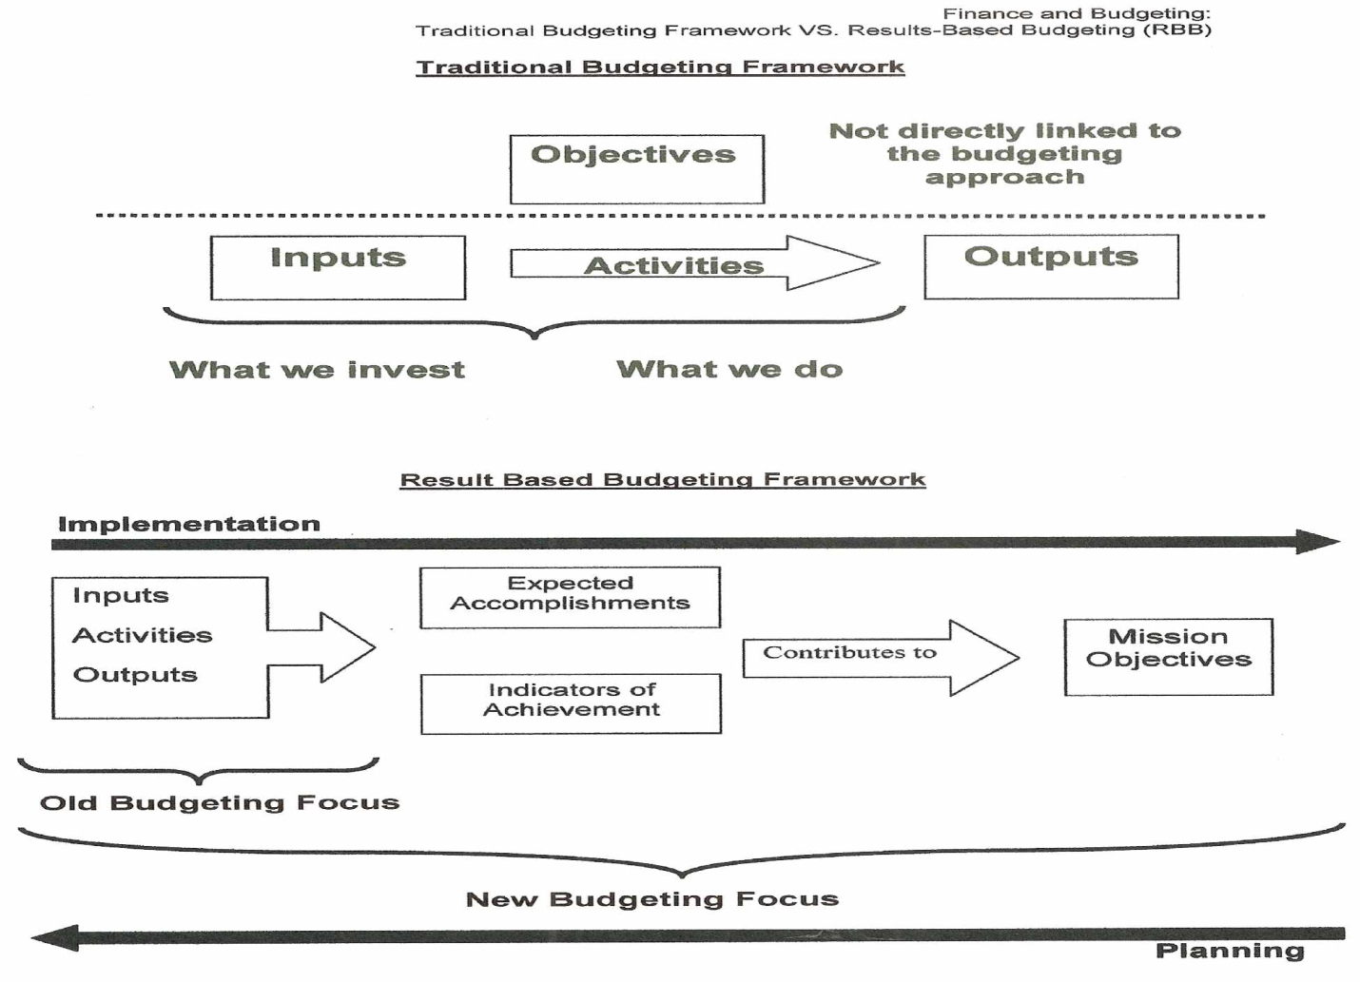

RBM ..
○ Allows the project holder, implementer, coordinator to manage a project more effectively when used properly
○ Offers the benefits that come with any real system: rigor, depth and effectiveness
○ Allows NGOs to better communicate about the impacts of their work on people and societies.
○ Is a means to an end. Not an end!
○ Is not a “technical marvel” of development.

Bibliography
• Smille, I & Hailey, J 2001, Managing for Change: Leadership, Strategy & Management in Asian NGOS, Earthscan Publications Ltd, London.
• World Bank 2004, Ten steps to a results-based monitoring and evaluation system : a handbook for development practitioners, Washington.
• Doyle, N & Nolan D ,RBM (Results-Based Management) Booklet, VSO Indonesia - SPARK Livelihoods Programme, Indonesia.
• Murtaza, N 2011, ‘Putting the Lasts First: The Case for Community- Focused and Peer-Managed NGO Accountability Mechanisms’, Springerlink.com, DOI 10.1007/s11266-011-9181-9
• Soakell Ho, M & Myers, MD 2011, ‘Knowledge management challenges for nongovernment organizations :Health and Disability Sector in NEW Zealand’, VINE: The journal of information and knowledge management systems, Vol 41, No.2 , pp. 212-228.
• Tips Publishing Service 2010, Performance Monitoring & Evaluation Building A Results Framework, 2ndedn, TIPS
• Lavergne, R 2002, Results-Based Management and Accountability for Enhanced Aid Effectiveness, Canadian International Development Agency, Canada.
• United Nations Development Group Publication 2010, Results-Based Management Handbook.
• Kumar, NS, Result- Based Budgeting, Ministry of Finance, India, viewed 25 November 2011,<http://www.cga.nic.in/pdf/ResultBasedBudgeting1.pdf>.
• Based on the UNESCO publication 2008, Results-Based Management (RBM) Guiding Principles ,UNESCO, Paris.

Lecture—30
Decision making in NPO

Agenda
○ Preview of last lecture
○ Resource
○ Benefits
○ Resource mobilization
○ Sociological theory (1970)
○ Need for resources
○ Characteristics of civil society organizations
○ Why don’t just depend on foreign funding?
○ Being business like in non profit organizations.
○ Issues of non profit distributing
○ Entrepreneurial thinking
○ Social entrepreneurship
○ Foundations
○ Grass Root organizations
○ Self Reliance
○ Endowments

Resource
○ A resource is a source or supply for which benefits are produced.
○ In Economics (Resources are scarce)

Benefits
○ Resources are transformed to produce benefits.
○ Benefits such as:
○ Increasing wealth
○ Meeting needs and wants
○ Proper functioning of a system
○ Enhanced well being

Resources
○ Human resources
○ Financial resources
○ Technological resources
Best bet is to mobilize them

Sociological theory (1970)
○ Resource acquire
○ Mobilize people

Need for resources
○ Resources are needed by all types of organizations and so as for the civil society organizations(CSOs).
○ The resources should be effective as well as should be able to inculcate sustainability in the overall systems.
○ While forming strategies at/by any level of the management resource considerations are always given due importance.
Funding requirements
○ However, it is obvious that funding requirement which are available in pakistan from the North america and europe based funding agencies have some underlying requirements which time to time surface out.

○ The result is to find out alternative sources of funds and the pressure on management is mounting day by day.

○ The recent global economic downturn and geo-political events have also made the environment for CSOs more dynamic than ever as some of these traditional funding sources are drying out.

○ The availability of these traditional funding sources may not be guaranteed in coming years.

Social change
○ If we talk about any process, the end result is to come up with the social change in the society.

Resource Mobilization
○ Three integrated concepts
○ Relationship Building
○ Communication and prospecting
○ Organizational management and development

Social relationship
○ “People don’t give money to cause, they give to people with cause”

Grass root organizations
○ Grass root organizations are also known as community based organizations formed at the community level to support a community level initiatives.

Characteristics of GROs
○ Ability to leverage
○ Issue identification
○ Problem identification
○ Team
○ NGO

Friend Raising
○ Form of fund raising
○ Involves be friendly with an organization or individual for the purpose of fund raising.
○ 1992-Ken Burnett
○ Charitable organizations move towards dealing with donor then look the donor from “individual perspective” as we look at the individual history.
○ Communication:
• Communication leads to image building
• Image building leads to brand
• Sometimes we or donor get carried away.
○ Prospecting
○ Major Donor
○ Repeat Donor
○ Donor(potential donors such as general public)

Why nations people provide resources?
○ International framework
○ Political
○ Regional
○ Social
○ Ideological
○ Personal Reasons

What donors look for?
○ Legitimacy
○ Transparency
○ Accountability

Resource Mobilization Action Plan
○ Step1: Organizational Situational Analysis
○ Step2: Resource mobilization environment
○ Step3: Constructing your statement of funding needs.
○ Step4: Prospecting and communicating with potential donors and contributors.
○ Step5:Monitoring and evaluation your Resource mobilization efforts.

Step 1: Organizational situational analysis
○ Team
○ Role clarity
○ Lead / Focal Person
○ SWOT Analysis

SWOT analysis
○ Strengths
 Good team
 Good governance
 Good reputation
 Network
 Presence
 Contacts
 Past performance
 Relationship with donors / stakeholders
 Celebrities
 Working group

Weaknesses
○ Lack of skill/training
○ Less expertise
○ Lack of will
○ Poor scheduling

Opportunities
○ Awareness
○ Increasing trend
○ Incidence
○ Support from government
○ Segment of untapped stakeholders
○ Demand

Threats
○ Economic downturn
○ Political
○ Social
○ Stakeholder’s perception
○ Competition
○ Demographics
○ Young earners

Step 2: Resource Mobilization: Environment research and donor mapping
○ International donor (RFPs)
○ Local Donors
○ Individual donors

Trends are highlighted on the basis of research
○ Gender
○ Women experience
○ Education
○ Poverty reduction
○ Child care
○ Agricultural economics
○ Energy
○ AIDS Eradication
○ Baseline surveys
○ Impact/Assessment slides
○ Funds delivery

Donor research and mapping
○ Web search
○ Broad category
○ Sub category

Fund flow pattern
○ State to state
○ State to people
○ People to people
○ People to state

Resource mobilization plan
○ By this time
 Clear targets
 How much we need to raise
 When
 From whom
 Time line define
○ In which year
○ In which quater

Step 3: constructing the statement of funding needs
○ Actual statement
○ Targeted amount
○ Resource timeline
○ Current situation
○ Target amount (when required).

Step 4: Prospecting and communicating with international donors
○ Brief summary of one or two pages about:
 Organization
 Team
 Mission
 Plans

Donors Map

Who could be / who should be approached
○ Statement of funding needs
 What needed and when needed.

Selecting the Right Mix
Objectives

Strategy
○ Acquisition strategy
○ Nurturing Strategy
○ Email/ Boucher
○ Little / No contact
○ Friends
○ Supporters

○ Acquisition Strategy
○ To bring in front first time donors / contributors raising awareness about your organization
Volunteers

Nurturing / Cultivating Strategy
○ To maintain or promote the existing donors/contributors to the next level of the pyramid.
○ Grant competition
○ Invitation to visit your organization
○ News/ Letter
○ Member card.

Developing a case statement

The need
- Manageable
- Quantifiable
- Supporting a evidence
- Surveys
- Statistics
- Your quantification
Why this fund you and why not others.

Benefits for you
○ Tangible results/targets
○ What is in for you?
○ What is in for them?

Negative impact
If not done now what will happen in future
Meeting the donor
Prior Research
 Name
 Designation
 Area of responsibility
 Supporting material
 Business Card
 Plans/Donors details/Map
 Proposal

Before Meeting
○ Team Structure
○ Team Leader
○ Spokesperson
○ Specialists

During meeting
○ Present the card
○ State the purpose clearly
○ Introduce the team members
○ Build rapport
○ Proposal with material
○ Listen
○ Build with more material
○ Close future action
○ Remember friendship leads to funds

After meeting
○ Send a thanking letter /email
○ Donot immediately bombarded
○ Later send a letter with a news letter
○ Observe and act

Step 5:Monitor and Evaluation
○ What to monitor
○ When to monitor
○ How and who will monitor
○ Feedback

Performance indicators
○ Return on investment
○ Acquisition cost
○ Response Time
○ Average Donation
○ Attrition rate

Donor relations audit
○ Documentation Review
○ Observation
○ Survey
○ Interview
○ Focus group discussion

Reserve Fund
○ Special funds
○ Developed and maintained by the CSOs in which the earnings or extra amounts are deposited for future funding needs.
○ These funds can be generated from any activity which can be the extra amounts from some completed projects or can be the money received as part of some alternative financial activity such as investments.
○ There has been reported increase in services demand of non profit organizations and decline in the contributions/donations world wide.
○ As all NPOs are required to prepare surplus fund.
 Flat sum of money
 Fixed portion of annual revenue
 Percentage of annual budget
 Based on expense consideration.

Endowments
○ A fund that is made up of gifts and bequests that are subject to a requirement that the principal be maintained intact and invested to create a source of income for an organization
Source About.com

Three distinct phases of Endowment Fund
○ Creation
○ Growth
○ Use
The first phase is tapping funds related.
The second phase marked by investments
The last stage is the usage of income.

______________________________________________________________________________

