Lecture 29
Special Accounting Problems related to Leases

Special Accounting Problems

1. Leases have certain characteristics that create unique accounting problems. The next paragraphs review these characteristics.

Residual Value

2. The residual value of a leased asset is the estimated fair value of the asset at the end of the lease term. The residual value may be guaranteed or unguaranteed by the lessee. A guaranteed residual value is said to exist when the lessee agrees to make up any deficiency below a stated amount in the value of the asset at the end of the lease term. A guaranteed residual value affects the lessee’s computation of the minimum lease payments and, therefore, the amounts capitalized as a leased asset and a lease obligation. The lessor assumes the residual value will be realized at the end of the lease term whether guaranteed or unguaranteed.

3. To understand the accounting implications of a guaranteed residual value, assume a lessee guarantees the residual value of an asset will be $8,000. If, at the end of the lease, the fair market value of the residual value is less than $8,000, the lessee will have to record a loss for the difference. For example, if the lessee depreciated the asset down to its residual value of $8,000 but the fair market value of the residual value was $4,000, the lessee would have to record a loss of $4,000. If the fair market value of the asset exceeds the $8,000, a gain may be recognized. Gains on guaranteed residual values may be apportioned to the lessor and lessee in whatever ratio the parties initially agree.

Bargain Purchase Options

4. A bargain purchase option is a provision allowing the lessee, at his or her option, to purchase the leased property at a price that is sufficiently lower than the expected fair value of the property at the date the option becomes exercisable. When a bargain purchase option exists, the lessee must increase the present value of the minimum lease payments by the present value of the option price. The only difference between accounting for a bargain purchase option and a guaranteed residual value of identical amounts is in the computation of the annual depreciation. In the case of a guaranteed residual value, the lessee depreciates the asset over the lease life. When a bargain purchase option is present, the lessee uses the economic life of the asset in computing depreciation.

Disclosure

5 . The disclosure requirements for lessors and lessees vary depending upon the type of lease. The required disclosures provide investors with the following information:

a. General description of the nature of the lease,

b. The nature, timing and amount of cash inflows and outflows, including payments to be paid or received for each of the five succeeding years,

c. The amount of lease revenue and expense reported in the income statement each period,

d. Description and amounts of leased assets by major balance sheet classification and related liabilities, and

e. Amounts receivable and unearned revenues under lease agreements.

ILLUSTRATION
LESSEE’S CAPITALIZATION CRITERIA

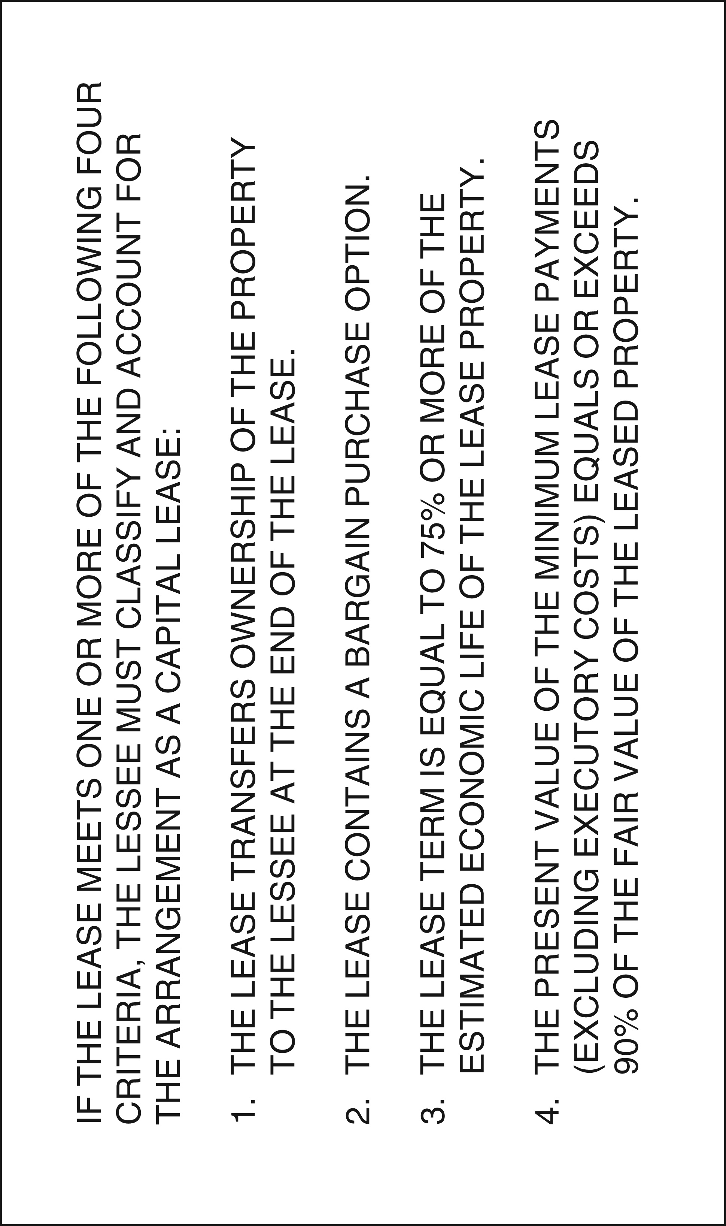
ILLUSTRATION
FLOWCHART FOR LESSEES

