Lecture 26
Statement of Cash Flows Revisited

LECTURE OUTLINE

- Introduction to the Statement of Cash Flows.
- Corporate investors and potential investors seek information about the financial position, results of operations, and cash flow.
- Prior to the issuance of FASB No. 95, “Statement of Cash Flows,” investors were limited to the information about cash flows that they could extract from the balance sheet, income statement, and statement of changes in financial position.
- The information in these statements was based on accrual accounting and an analysis of working capital which was somewhat removed from the underlying cash flows of the enterprise.
- With the required presentation of the statement of cash flows, financial statement users were provided with information about the major sources and uses of cash during the fiscal period.

- Purposes and Uses of Statement of Cash Flows.

1. Purposes of the statement.

a. To provide information about the cash receipts and cash payments of an entity during a period.
b. To summarize the operating, investing, and financing activities of the business.

2. Uses of the statement.

a. Assessing the entity’s ability to generate positive future cash flows.

b. Assessing the entity’s ability to pay dividends and meet obligations.

c. Reconciling the difference between net income and net cash flow from operating activities.

d. Assessing the cash and noncash investing and financing transactions during the period.

- Classification of Cash Flows and Format of Statement of Cash Flows.

1. Operating activities: transactions related to the calculation of net income.

2. Investing activities: transactions related to long-term assets.

3. Financing activities: transactions related to liabilities and stockholders’ equity.

4. Format of the statement.

a. The typical cash receipts and cash payments of a business entity classified according to operating, investing, and financing activities are shown below.

b. Operating Activities
Cash inflows
From sale of goods or services.
From returns on loans (interest) and on equity securities (dividends).
Cash outflows
To suppliers for inventory.
To employees for services.
To government for taxes.
To lenders for interest.
To others for expenses.
c. Investing Activities
Cash inflows
From sale of property, plant, and equipment.
From sale of debt or equity securities of other entities.
From collection of principal on loans to other entities.
Cash outflows
To purchase property, plant, and equipment.
To purchase debt or equity securities of other entities.
To make loans to other entities.

d. Financing Activities
Cash inflows
From sale of equity securities.
From issuance of debt (bonds and notes).
Cash outflows
To shareholders as dividends.
To redeem long-term debt or reacquire capital stock.

e. operating activities involve income determination items,
f. investing activities involve cash flows generally resulting from changes in long-term asset items

g. financing activities involve cash flows generally resulting from changes in long-term liability and stockholders’ equity items.

h. Some cash flows relating to investing or financing activities are classified as operating activities.

- receipts of investment income (interest and dividends) and payments of interest to lenders

- some cash flows relating to operating activities are classified as investing or financing activities.

(a) cash received from the sale of property, plant, and equipment at a gain, although reported in the income statement,

(b) the effect of the related gain would not be included in net cash flow from operating activities.

(c) a gain or loss on the payment of debt would generally be part of the cash outflow related to the repayment of the amount borrowed and, therefore, is a financing activity.

FORMAT OF STATEMENT OF CASH FLOWS (Indirect Method)

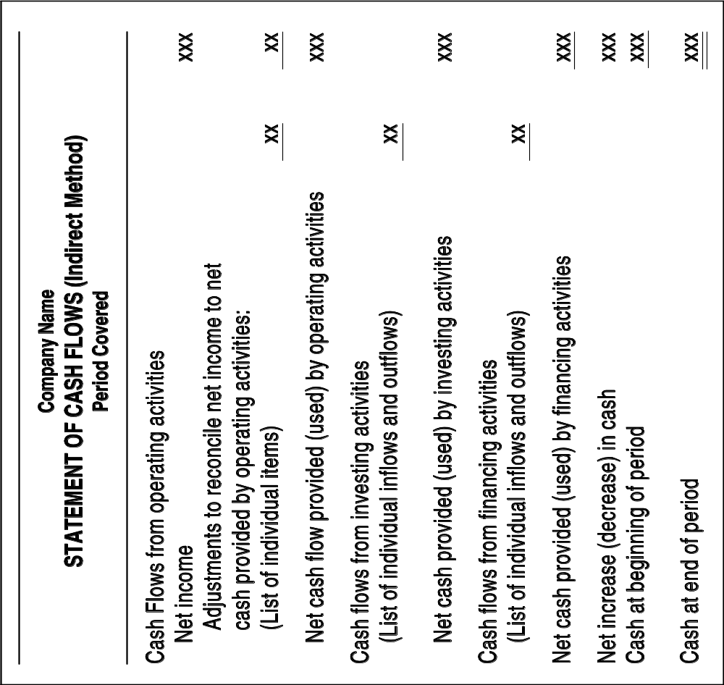

D. Preparation of the Statement of Cash Flows.

1. Sources of information.

a. Comparative balance sheets.

b. Current income statement.

c. Selected transaction data.

2. Steps.

- Determine the change in cash (the difference between the beginning and ending cash balance on the comparative balance sheets).

- Determine the net cash flow from operating activities. (analyze the current year’s income statement , comparative balance sheets and selected transaction data.

- Determine cash flows from investing and financing activities. (all other changes in the balance sheet accounts must be analyzed to determine their effect on cash).

- Difference between Net Income and Net Cash Flows from Operating Activities.

1. Net cash flow from operating activities is equal to difference between revenues and expenses determined on a cash basis.

2. Convert accrual basis net income to a cash basis by eliminating those transactions that do not affect cash.

F. Calculating the Net Cash Flow from Operating Activities.

1. Direct method or income statement method.

a. Net cash flow from operating activities = cash receipts – cash disbursements.

b. Net cash provided by operating activities is equivalent to cash basis net income.

(1) Exists when cash receipts exceed cash disbursements from operating activities.

c. Net cash used by operating activities is equivalent to cash basis net loss.

(1) Exists when cash receipts are less than cash disbursements from operating activities.

