Lecture 19
Investments

Fair Value Option

1. Companies have the option to report most financial assets and liabilities at fair value, with gains and losses reported in net income. The fair value option is only available at the acquisition date or date incurred, and applies on a security-by-security basis. When the fair value option in selected, it must be used for the life of the instrument.

2. When the fair value option is used for
a. Available-for-sale securities, gains and losses related to changes in fair value are reported in net income (rather than as part of comprehensive income).
b. Equity method investments, the investor does not report it share of the investee income or loss, rather, changes in the fair value of the investment are reported in net income. Likewise, the receipt of dividends would be recorded as dividend revenue rather than as a reduction of the investment account.
c. Financial liabilities, a company revalues its own liabilities, with gains and losses reported in net income. That is, when the market price of a company’s bonds declines, the company will reduce the liability and record a gain in the income statement.

Impaired Investments

3. Each period every investment must be evaluated to determine if it has suffered
a loss in value that is other than temporary (an impairment). If an investment is deemed impaired, the cost basis of the individual security is written down to a new cost basis. The amount of the writedown is accounted for as a realized loss and, therefore, included in net income.

Reclassification Adjustments

4. As indicated, unrealized holding gains and losses related to available-for-sale securities are reported as part of other comprehensive income. The reporting of changes in unrealized gains or losses in comprehensive income is straightforward unless securities are sold during the year—then a reclassification adjustment is necessary to ensure that gains and losses are not counted twice.

Transfers Between Categories

5. Transfers between any of the investment categories are accounted for at fair value. The text gives an illustration of measurement basis and how Stockholders’ Equity and Net Income are impacted upon a transfer between investment categories.
ILLUSTRATION 17-1
ACCOUNTING FOR DEBT SECURITIES BY CATEGORY

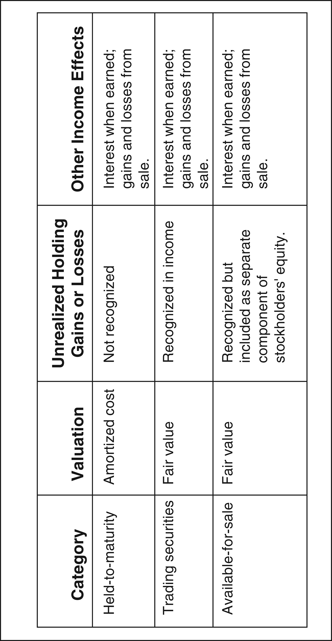
ILLUSTRATION 17-2
SCHEDULE OF INTEREST REVENUE AND BOND DISCOUNT
AMORTIZATION—EFFECTIVE INTEREST METHOD

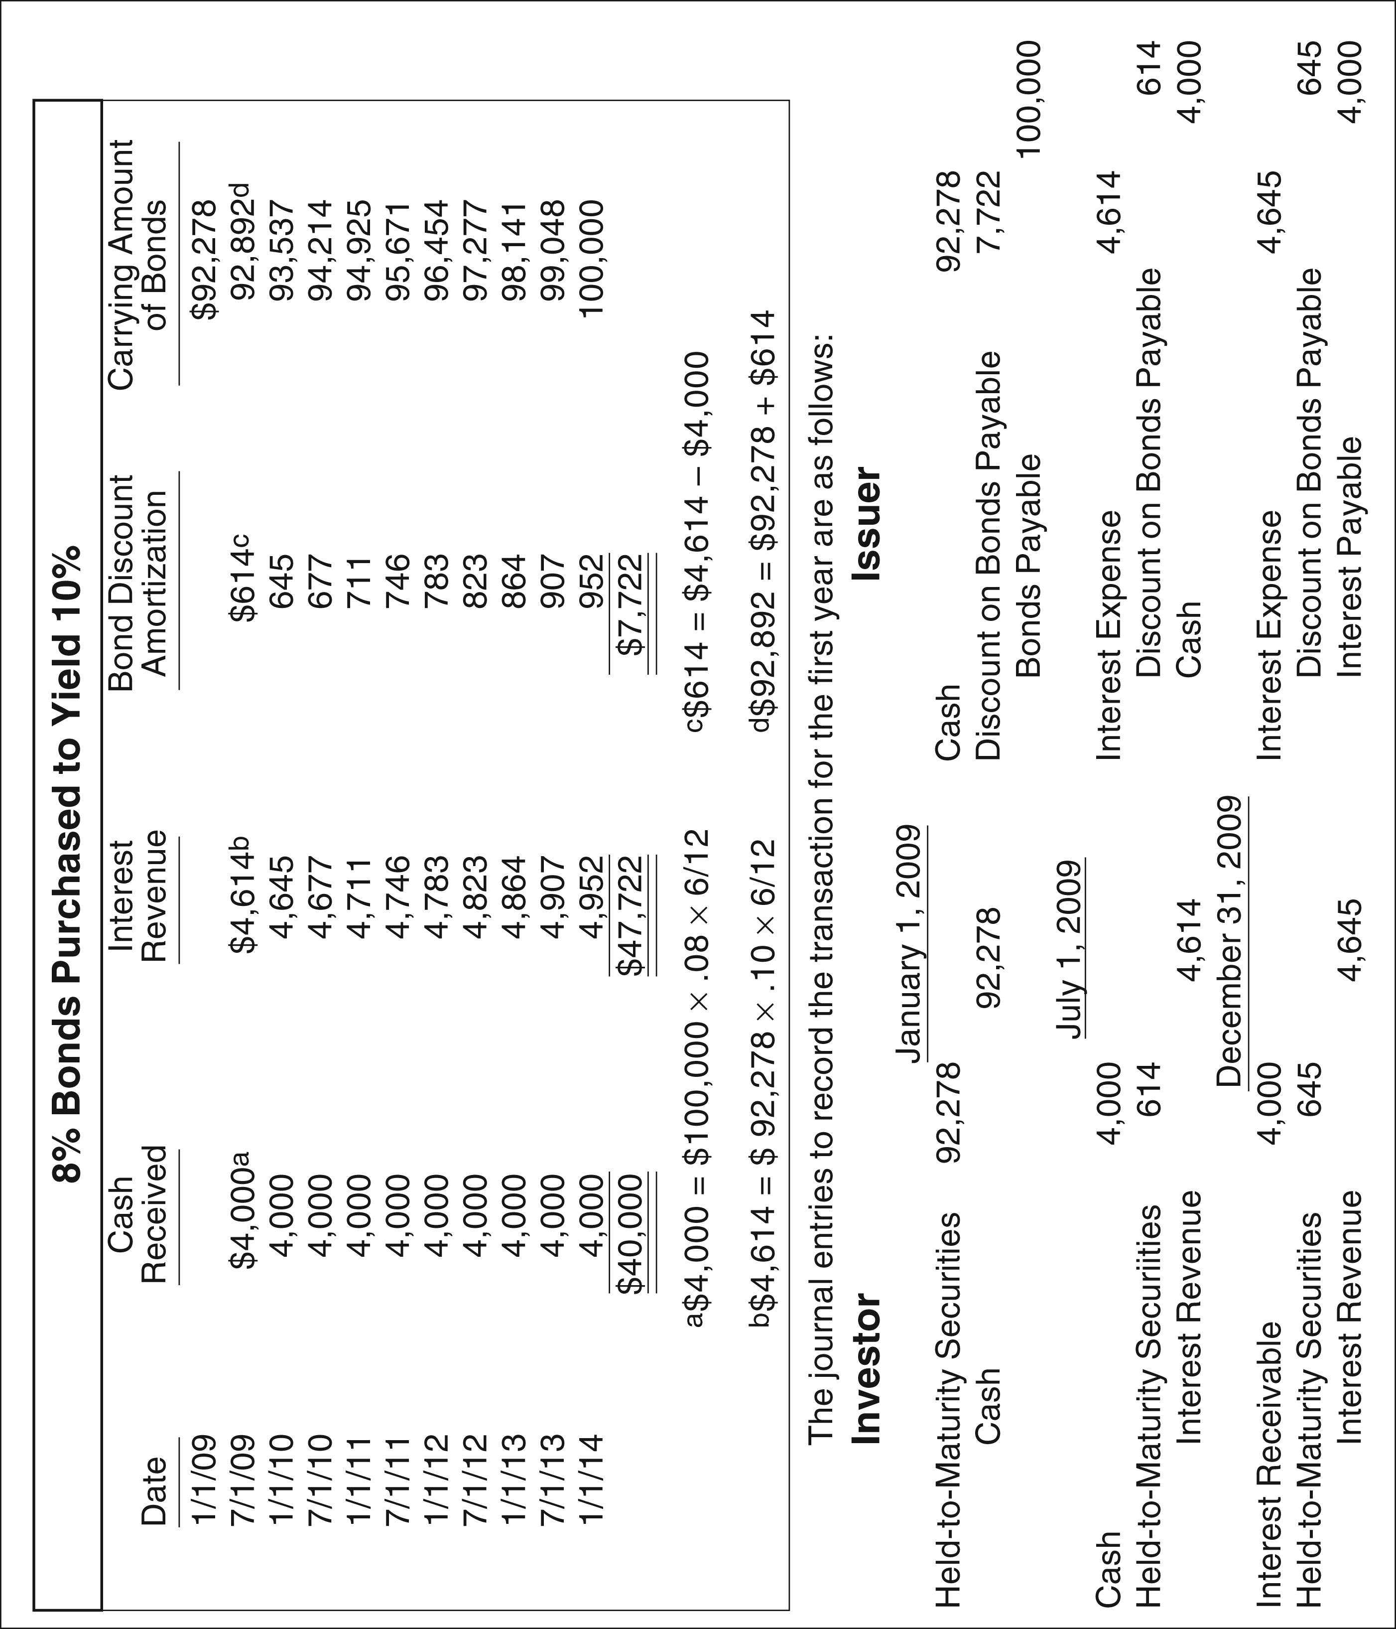
ILLUSTRATION 17-3
ACCOUNTING AND REPORTING FOR EQUITY
SECURITIES BY CATEGORY

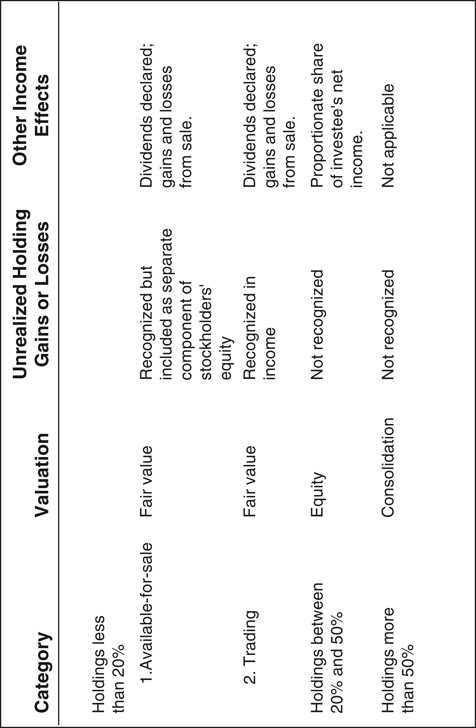
ILLUSTRATION 17-4
ACCOUNTING FOR TRANSFERS

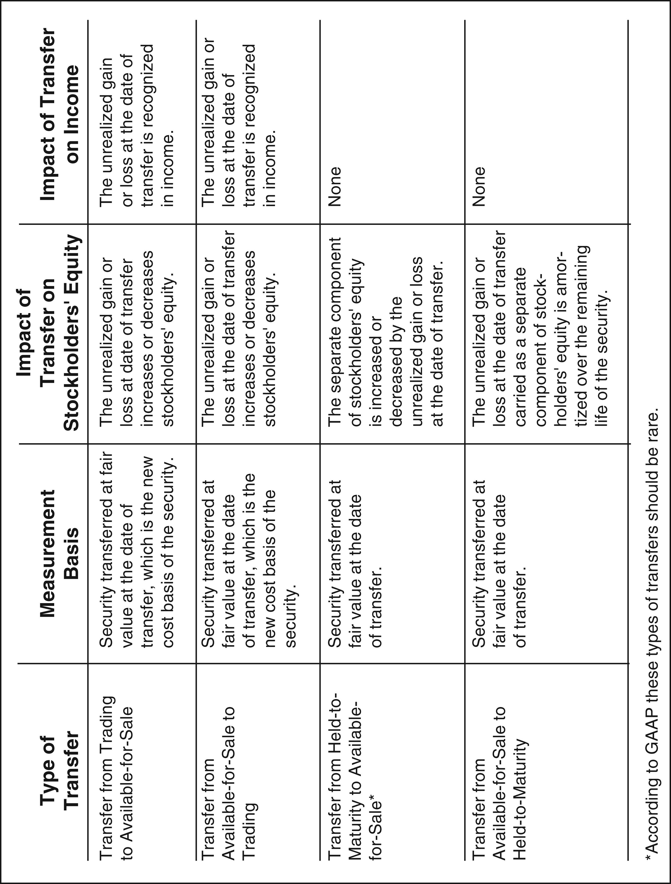
ILLUSTRATION 17-5
SUMMARY OF TREATMENT OF MAJOR DEBT
AND EQUITY SECURITIES

