Handbook for Course:
Managing People and Organizations- MGT 492

Course Description & Objectives
Introductory course about the management of organizations.
It provides instructions on principles of management that have
–general applicability to all types of enterprises;
–basic management philosophy and decision making;
–principles involved in planning, organizing, leading, and controlling; and
–recent concepts in management.
The course encourages students to explore & inquire the applicability of western management principles and theories in local settings.
Learning Outcomes
At the conclusion of this course, the student should be able to:
–Understand the relevance of the western management principles and theories for local settings.
–Apply course concepts and theory in a practical context.
–Integrate several of the disciplines studied
–Demonstrate empirical investigative skills by producing an in-depth analysis of a management situation, resulting in recommendations for a program of action.
–Recognize the need to take a holistic approach to performance improvement rather than a narrowly functional approach.
Course Requirements
Text Book: Management Fundamentals: Concepts, Applications, Skill Development, by Robert N. Loussier, 5th Edition
Reference Books:
1. Bartol, K. M. & Martin, D. C. “Management, McGraw-Hill Higher Education, 1998
2. Mary Coulter & Robbins, Management, International ed.
3. Babcock, D. L. and Morse, L. C., Managing Engineering & Technology, 5th ed., Prentice hall
Lecture 1
CHAPTER 1: MANAGING
Chapter Overview: Learning Outcomes
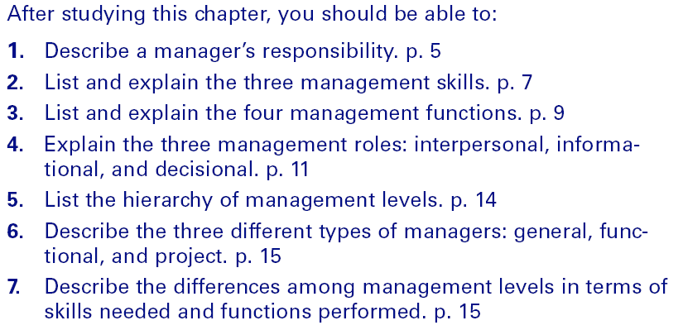

What Is Management?
Manager
–The individual responsible for achieving organizational objectives through efficient and effective utilization of resources.
The Manager’s Resources
–Human, financial, physical, and informational
Performance
–Means of evaluating how effectively and efficiently managers use resource to achieve objectives.
What it takes to be a Successful Manager
Management Qualities
–Integrity, industriousness, and the ability to get along with people

Management Skills
–Technical
Technical skills involve the ability to use methods and techniques to perform a task. Technical skills are also call business skills, and they are the easiest of the three management skills to develop. When managers are working on budgets, e.g., they may need computer skills in order to use spreadsheet software such as Microsoft Excel.
–Human and communication
Interpersonal skills involve the ability to understand, communicate, and work well with individuals and groups through developing effective relationships. Interpersonal skills are based on several other skills, including:
Communication skills
Team skills
Diversity skills
Power, political, negotiation, and networking skills
Motivation skills
Conflict management skills
Ethics skills
–Conceptual and decision-making
The ability to conceptualize situations and select alternatives to solve problems and take advantage of opportunities
The Ghiselli study
–Initiative, self-assurance, decisiveness, intelligence, needfor achievement, and supervisory ability
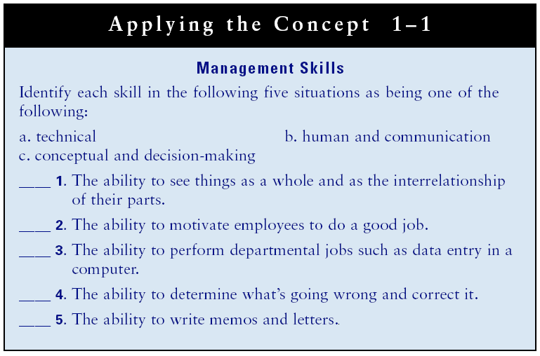

Lecture 2
What Do Managers Do?
Management Functions
–Planning
Setting objectives and determining in advance exactly how the objectives will be met.
–Organizing
Organization is the process of delegating and coordinating tasks and allocating resources to achieve objectives. An important part of coordinating human resources is to assign people to various jobs and tasks. An important part of organizing, sometimes listed as a separate function, is staffing. Staffing is a process of selecting, training, and evaluating employees.
–Leading
Influencing employees to work toward achieving objectives.
–Controlling
Establishing and implementing mechanisms to ensure that objectives are achieved.
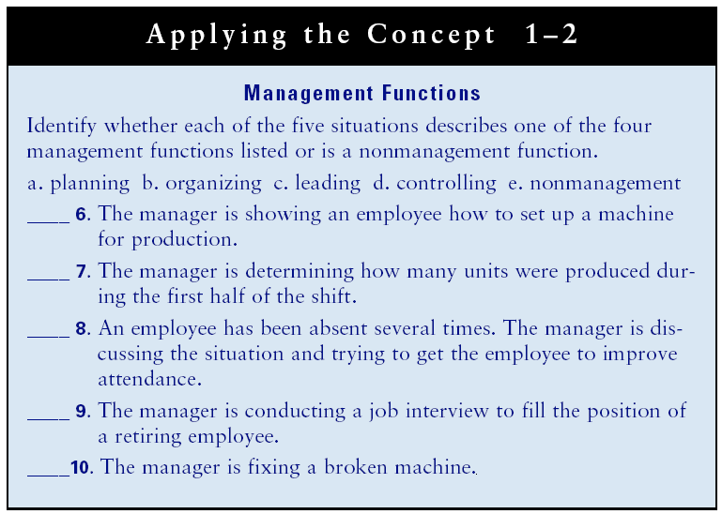

Management Skills and Functions
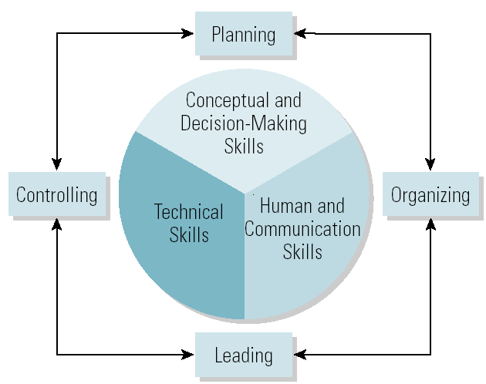

Management Roles
Management Role Categories (Mintzberg)
–Interpersonal
•Figurehead, leader, liaison
–Informational
•Monitor, disseminator, spokesperson
–Decisional
•Entrepreneur, disturbance handler, resource allocator, negotiator

Ten Roles Managers Play

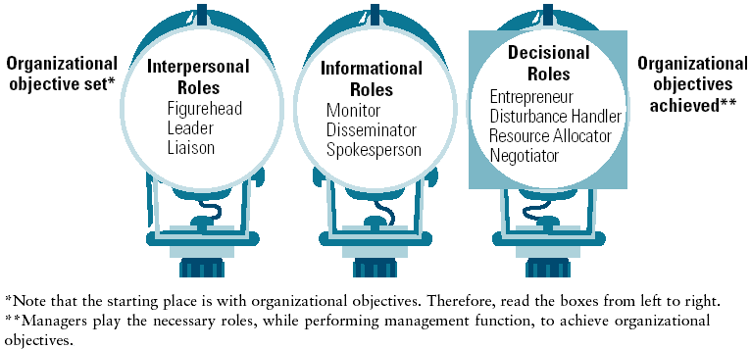

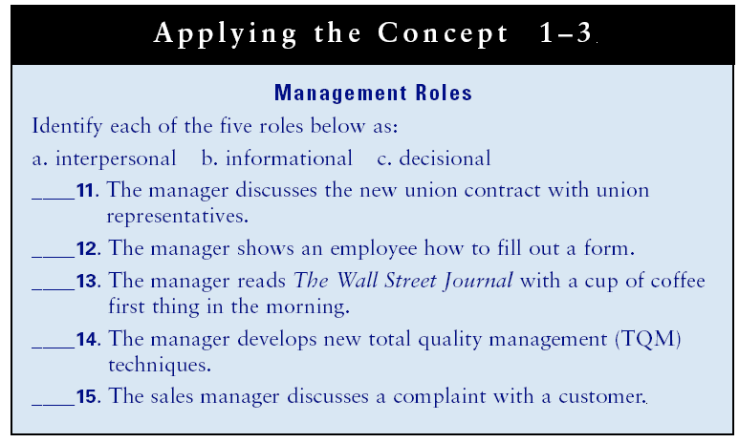

Differences among Managers
The Three Levels of Management
–Top managers
•Chair of the board, CEO, president, vice president
–Middle managers
•Sales manager, branch manager, department head
–First-line managers
•Crew leader, supervisor, head nurse, and office manager
–Non-management operative employees
•Workers in the organization who are supervised by first-line managers.

Management Levels and Functional Areas

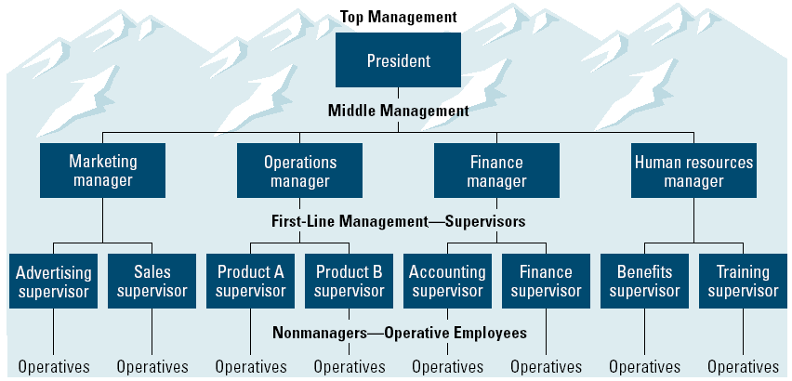

Types of Managers
•General Managers
–Supervise the activities of several departments.
•Functional Managers
–Supervise the activities of related tasks.
Common functional areas:
•Marketing
• Operations/production
•Finance/accounting
• Human resources management
•Project Manager
–Coordinates employees across several functional departments to accomplish a specific task.
Management Skills and Functions
Differences among management levels in skill needed and the functions performed:

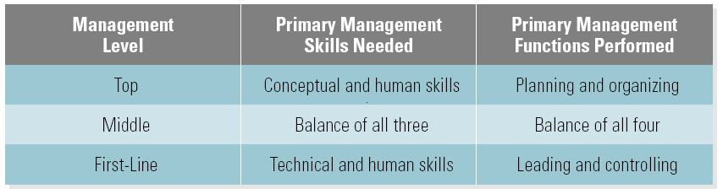

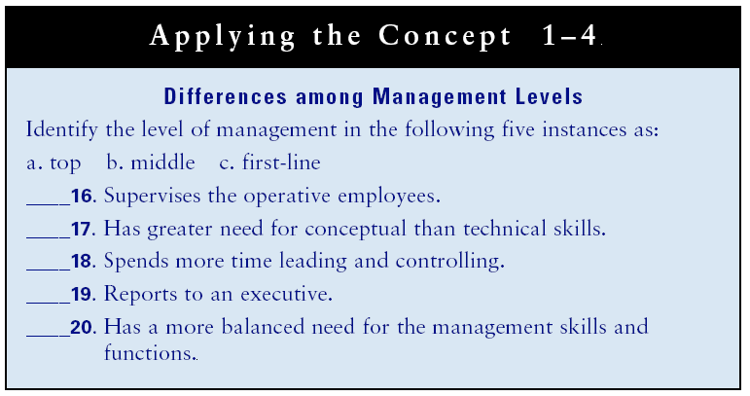

Lecture 3
Large versus Small Business Managers
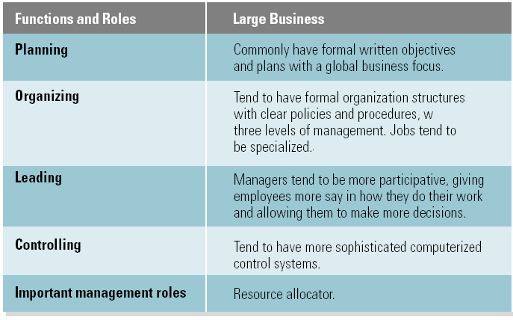
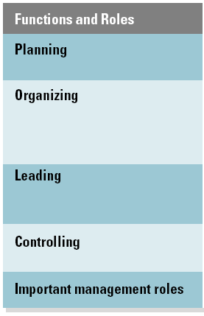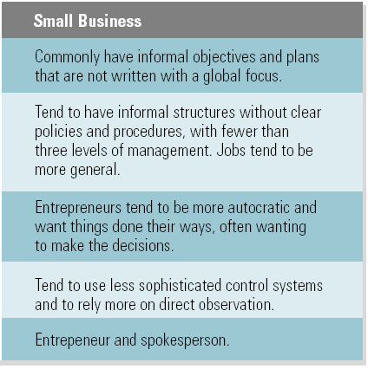
Differences among For-Profit and Non-Profit Organizations
• For Profit
–Primary purpose is bottom-line profit
–Revenues: generated through sales
–Staffing: primarily all paid employees
• Not-for-Profit
–Non-governmental Organizations
- Mission-driven
- Profits are the objective
- No individual owners
- Revenues: raised through donations, grants, memberships and investments as well as sales or fees
- Staffing: volunteer or paid workers
- Governmental Organizations: mission driven
- Profits are not the goal
- Ownership is an entity of a function of government
- Revenues: raised through taxes, fees and sales
- Staffing: primarily all paid employees, with some entities relying on volunteers
Entrepreneurship:
Creating new products or processes, entering new markets, or creating new business ventures and organizations.
Intrapreneurship :
Intrapreneurs commonly start a new line of business with in a large organization. Intrapreneurs are also called corporate entrepreneurs. In essence, Intrapreneurs commonly start and run a small business with in a large organization, often as a separate business unit.

A Competitive Advantage:
Specifies how an organization offers unique customer value. It answers the questions like: What makes u s different from the competition? Why should a person buy our product rather than the product of our competitors?

A business plan:
Is a written description of a new venture – its objectives and the steps to achieve them. Writing a business plan forces you to crystallize your thinking about what you must do to start your new venture before investing time and money in it.
Knowledge Management
Involving everyone in an organization in sharing knowledge and applying it continuously to improve products and processes.
Managing in a Global Environment
•Characteristics of Global Competition
–Downsizing/rightsizing
–Empowerment
–High involvement (management to leadership)
–Information technology (Internet)
–Speed (time-based competition)
–Quality (continuous improvement)
–Electronic commerce (e-business and b2b)
–Learning and knowledge management
–Global diversity of employees

Situation Management Model

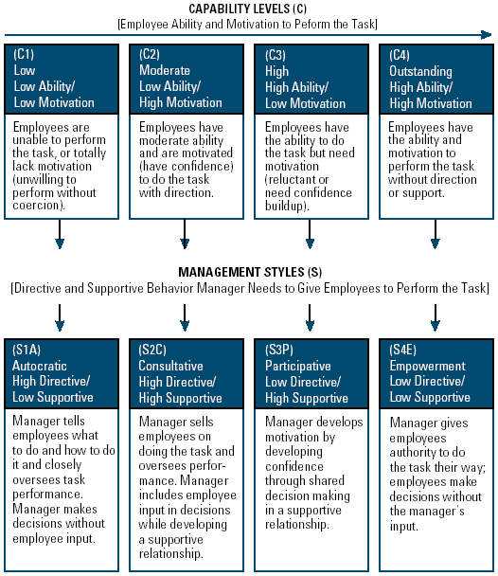

Chapter 2: Environment: Culture, Ethics, And Social Responsibility
Learning Outcomes
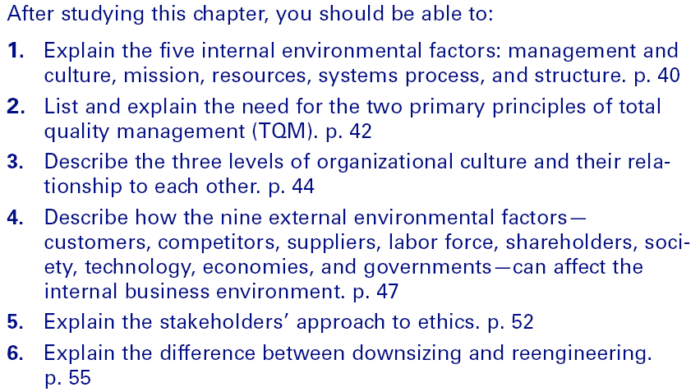

The Internal Environment
• Management and Culture
–Organizational culture
- The shared values, beliefs, and assumptions of how its members should behave.
• Mission
–An organization’s purpose or reason for being
- Top management’s responsibility to develop a mission with clear measurable objectives.
- States the unique advantage the firm offers to customers that differentiates it from its competitors.
- Is relevant to all stakeholders’ interests.
Federal Express Mission Statement 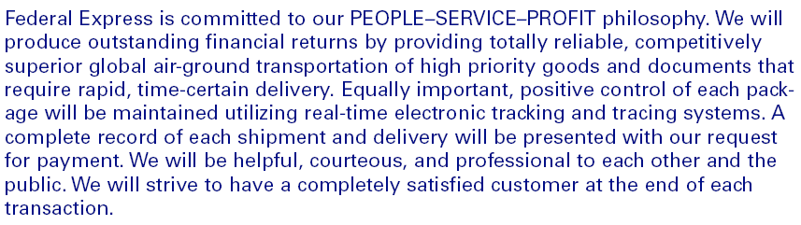
Internal Environment Means and Ends
• Ends
• Mission
• Means (how mission is attained)
• Management and culture
• Resources
• Systems process
–Inputs, transformation, output, feedback
• Quality
–Total quality management
• Structure
• Resources
–Human resources
–Physical resources
–Financial resources
–Informational resources
• Systems Process
–The method used to transform inputs into outputs.
–Process components
- Inputs • Transformation • Outputs • Feedback

The Systems Process

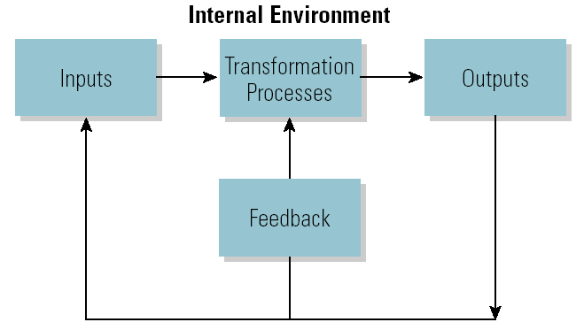
• Quality
–Comparing actual use to requirements to determine value.
• Customer value
–The purchasing benefits used by customers to determine whether or not to buy a product.
• Total Quality Management (TQM)
–Focusing the organization on the customer to continually improve product value.
• Structure
–The way in which resources are grouped to effectively achieve the organization’s mission.

Internal Environment Components
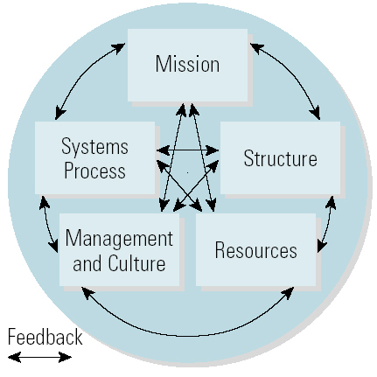

Lecture 4

Organizational Culture
• Learning the Organization’s Culture
–Heroes – Stories –Slogans –Symbols –Ceremonies
• Three Levels of Culture
–Level 1: Behavior is the visible level of cultural influence.
–Level 2: Values and beliefs are evident in actions.
–Level 3: Assumptions are values and beliefs that are deeply ingrained.

Three Levels of Culture
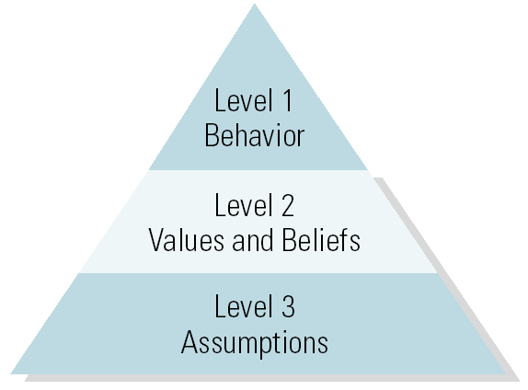

• Strong Cultures
–Have employees who unconsciously know the shared assumptions; consciously know the values and beliefs and agree with them.
- Benefit from easier communications and cooperation; unity of direction and consensus.
- Danger is becoming stagnated.
• Weak Cultures
–Have employees who do not behave as expected and do not agree with the shared values.
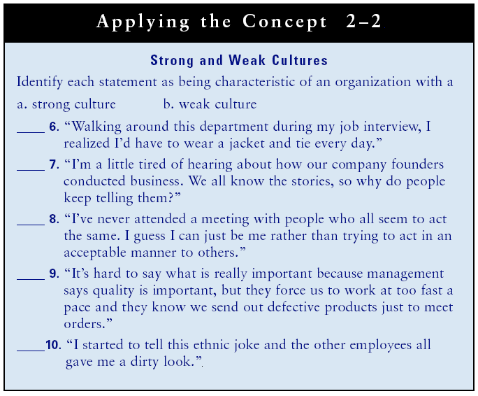
• Managing, Changing, and Merging Cultures
–Symbolic Leaders
- Leaders who articulate a vision for the organization and reinforce the culture through slogans, symbols, and ceremonies.
• Learning Organizations
–Organizations with cultures that value sharing knowledge to adapt to the changing environment and continuously improve.
- Strong adaptive cultures are created through leadership and open sharing of knowledge and information.

The External Environment
• Customers
–Their needs decide what products businesses offer.
• Competition
–Competitors’ business practices often have to be duplicated to maintain customer value.
• Suppliers
–Poor quality suppliers mean poor quality products.
• Labor Force
–Quality labor is needed to produce quality products.
• Shareholders
–The board of directors monitors management and provide direction for the organization.
• Society
–Businesses are pressured by societal forces to behave in an acceptable manner.
• Technology
–Firms must stay current on technology to stay competitive and provide customer value.
• Economy
–Economic activity has both short and long-term effects on an organization’s ability to provide customer value.
• Government
–Policies, rules and regulations affect what, how much, and how business is conducted.

The Organizational Environment

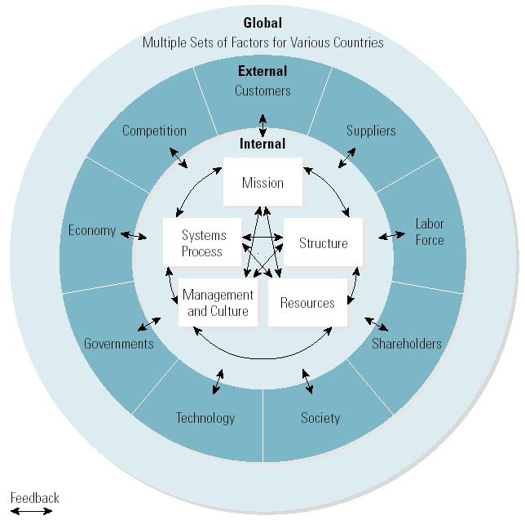

Business Ethics
• Simple Guides to Ethical Behavior
–Golden Rule
- “Do unto others as you would want them to do unto you.”
–Four-Way Test
- Is it the truth? • Is it fair to all concerned?
- Will it build goodwill and better friendship?
- Will it be beneficial to all concerned?
–Stakeholders’ Approach to Ethics
- Creating a win-win situation for all stakeholders so that everyone benefits from the decision.
• Managing Ethics
–Codes of ethics
• State the importance of conducting business in an ethical manner and provide guidelines for ethical behavior.
–Top management support and example
• The responsibility of top management to develop codes of ethics, train employees, and lead by example.
–Enforcing ethical behavior
- Whistle-blowers should not suffer negative consequences.

Summary Code of Ethics of Exxon Company, USA
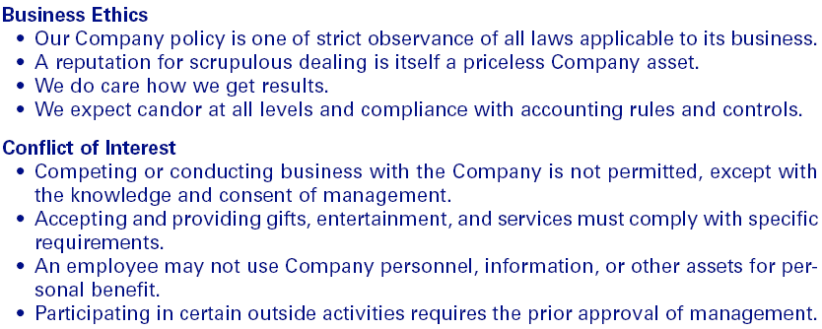
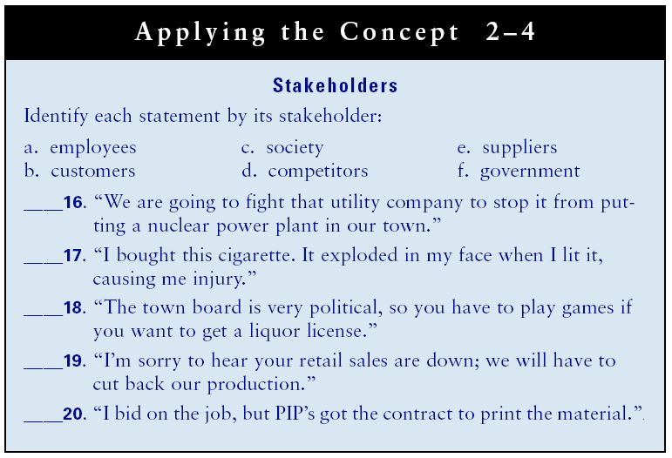
Social Responsibility
is the conscious effort to operate in a manner that creates a win-win situation for all stake holders. It is often called corporate social responsibility as CRS in an umbrella term for exploring the responsibilities of business and its role in society.
Reorganization
• Downsizing
–The process of cutting organizational resources (e.g., human resources) to get more done with less as a means of increasing productivity.
• Reengineering
–The radical redesign of work in a systematic manner to combine fragmented tasks into streamlined processes that save time and money by requiring fewer workers and far fewer managers.
Sustainability
Meeting the needs of the present world without compromising the ability of the future generations to need their own needs.
Lecture 5
Chapter 3: The Global Environment and Entrepreneurship
Learning Outcomes for Chapter
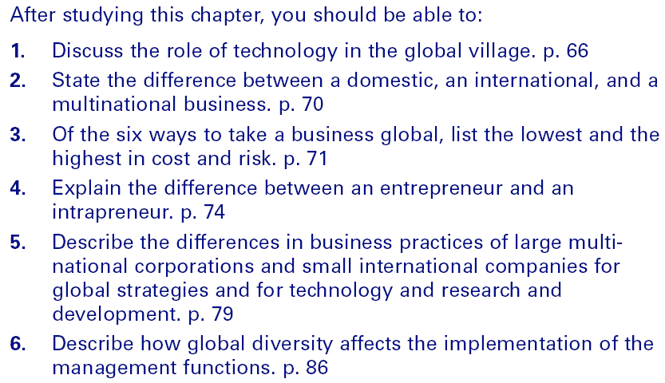

The Global Borderless Environment
• Ethnocentrism
–Regarding one’s own group or culture as superior to others (e.g., “Buy American”). - Parochialism means having a narrow focus, or seeing things solely from one’s own prospective.
• The Global Village
–Companies conducting business worldwide without boundaries
–E-Commerce/E-Business
- Any transaction that occurs when data are processed and transmitted over the Internet as in a business-to-business (b2b) approach.
–Wireless communication
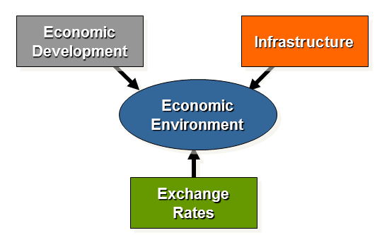

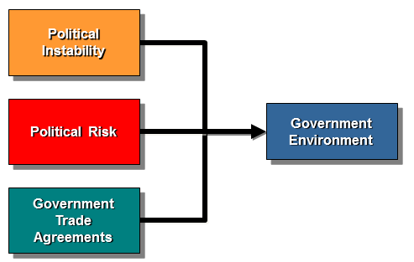

Trading Blocs
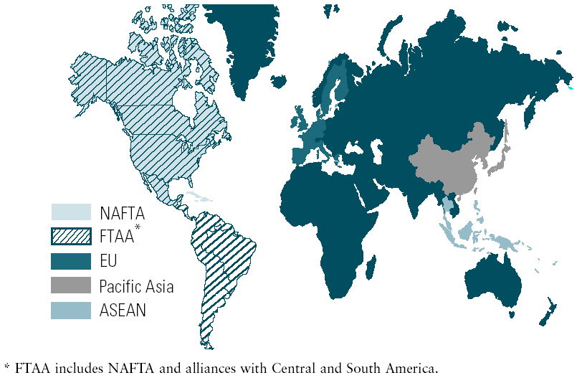
Taking a Business Global
•Global Trade Agreements
–General Agreement on Tariffs and Trade (GATT)
–North American Free Trade Agreement
- United States, Canada, and Mexico
–Association of Southeast Asian Nations (ASEAN)
• Trade Alliances
–European Union (EU)
- A single market without national barriers to travel, employment, investment, and trade
- Euro (€): single currency for the EU.
Classifying Global Village Businesses
• Global Sourcing
–The use of worldwide resources (outsourcing).
• Importing
–Domestic firm buys products from foreign firms and sells them in its home market.
• Exporting
–Domestic firm sells its locally-made products to foreign buyers in overseas markets.
• Licensing
–One company allows another company to use its assets (intellectual property) for a fee.
- Brand name, trademark, technology, patent, and copyright
–Franchising
- For a fee, a franchiser provides the franchisee with the assets and support to conduct a business using the franchiser’s business model for its operations.
• Contracting
–A company has a foreign firm manufacture the goods while retaining the marketing process.
• Joint Venture
–A enterprise that is created when firms agree to share in its ownership.
• Direct Investment
–Investment that occurs when a company builds or purchases operating facilities (subsidiaries) in a foreign country.

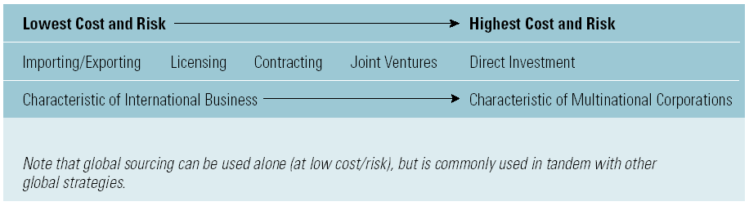

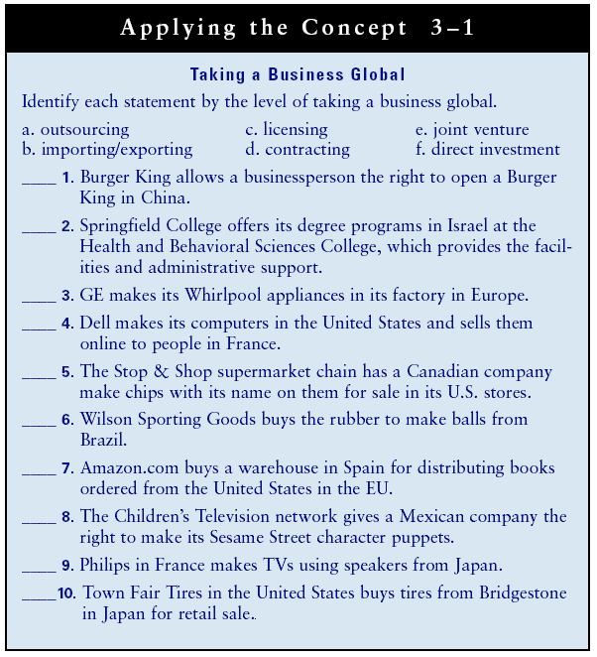

Lecture 6
Entrepreneurship
• New Venture Creation
–The process of starting and operating a new business or new line of business.
• Entrepreneur
–One who starts a new small business?
•Intrapreneur
–One who starts a new line of business within a large organization?

• Small Business Defined
–A business that is independently owned and operated, is not dominant in its field, and has annual receipts not in excess of $500,000.
- Of the 600 million businesses in the U.S., 99% are small businesses and 80% are family businesses.

Contributions of Entrepreneurs
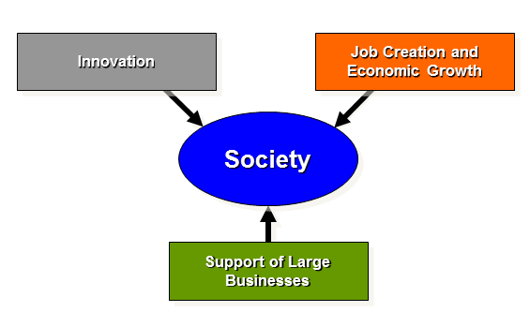

Selecting the New Venture
• Factors in Selecting a New Venture
–Good growth potential and profit opportunities
–Previous work experience
–Observing others’ mistakes and successes
–Finding an overlooked market segment or niche
–Systematic search or hobby

• Competitive Advantage
–Specifies how the organization offers unique customer value.
- First-mover advantage involves offering a unique customer value before competitors do.
– Selecting the New Venture
• Five Most Commonly Used Entrepreneurial Strategies
–Create a competitive advantage.
–Maintain innovation.
–Lower the costs of developing/maintaining one’s venture.
–Defend product/service as it is now.
–Create a first-mover advantage.
The Business Plan
The well prepared business plan answers the following questions:
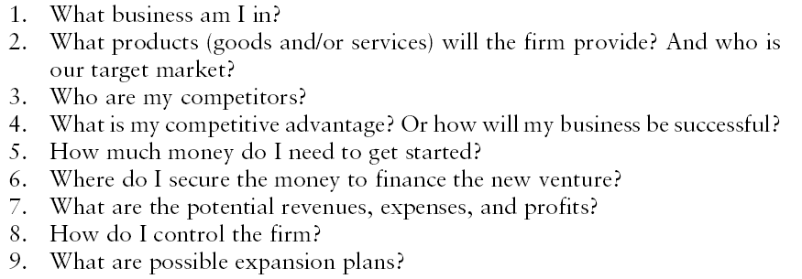

Sections In a Business Plan
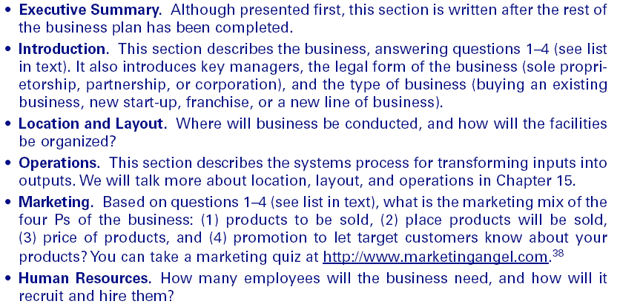
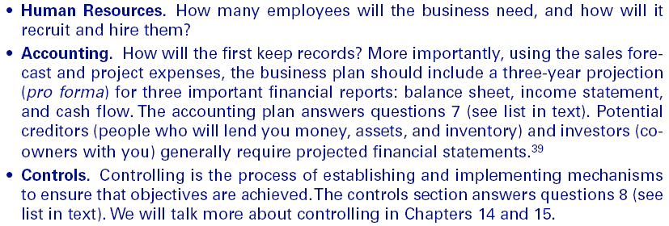
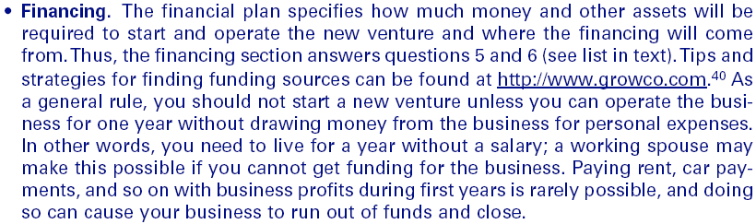

Practices of Global Companies
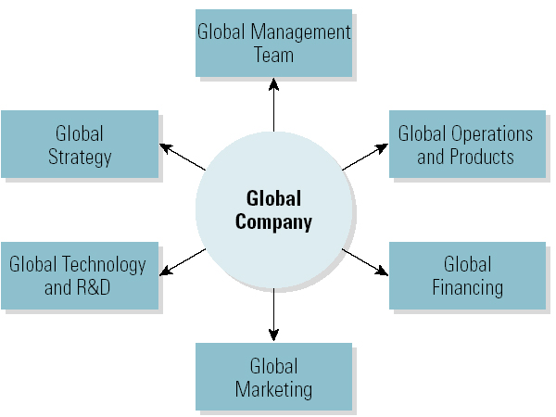

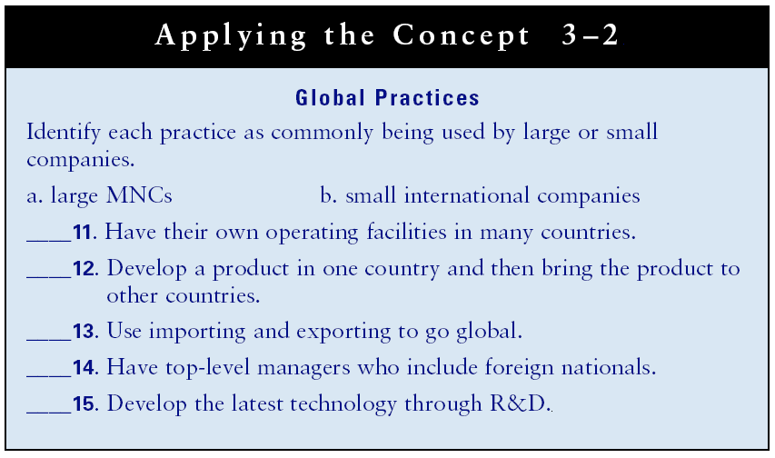

Global Diversities
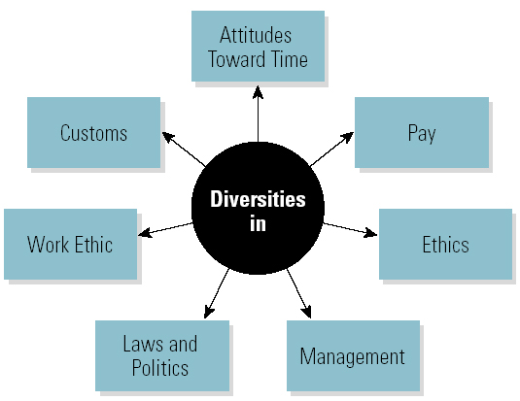

Global Diversity
• Diversity in Work-Related Values
–Geert Hofstede’s Dimensions of National Value Systems
- Individualism and Collectivism
- High and Low Power Distance
- High and Low Uncertainty Avoidance
- Quantity and Quality of Life
• Diversity in Management Functions
–Management practices that work well in one country may not work in another country.
–Managers must base their actions on the characteristics and work-related values of the country in which they are operating.
• The Global Learning Organizations
–Successful multinational organizations value sharing knowledge to adapt to their diverse and changing environments.
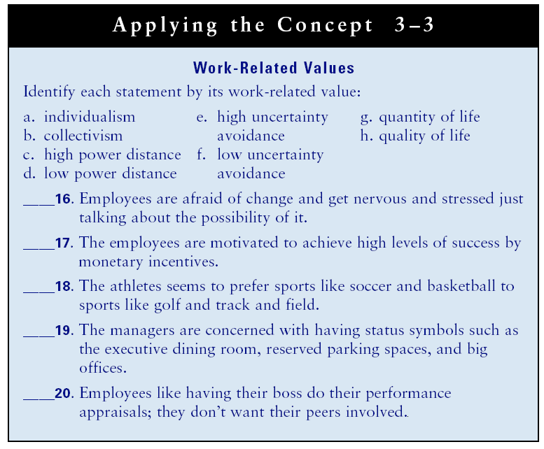

Lecture 7
Chapter 4: Creative Problem Solving and Decision Making
Learning Outcomes
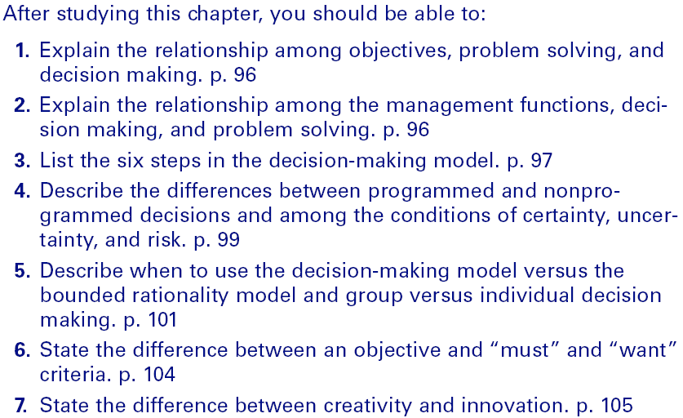

Problem Solving and Decision Making
• Problem
–A situation that exists when objectives are not being met.
• Problem Solving
–The process of taking corrective action to meet objectives.
• Decision Making
–The process of selecting an alternative course of action that will solve a problem.
- Managers need to make proficient decisions while performing the functions of management.
• Management, Decision Making, and Problem Solving
- The Relationship among Management Functions, Decision Making, and Problem Solving
- Managers need to make proficient decisions while performing the functions of management.

The Decision-Making Model
• A six-step model that when properly utilized increases chances of success in decision making and problem solving.
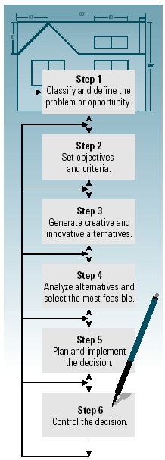

Decision-Making Styles
• Reflexive Style
–Makes quick decisions without taking the time to get all the information that may be needed and without considering all the alternatives.
• Reflective Style
–Takes plenty of time to make decision, gathering considerable information and analyzing several alternatives.
• Consistent
–Tends to make decisions without rushing or wasting time.
Types of Decisions
• Programmed Decisions
–Recurring or routine situations in which the decision maker should use decision rules or organizational policies and procedures to make the decision.
• Non-programmed Decisions
–Significant and nonrecurring and non-routine situations in which the decision maker should use the decision-making model.

Decision-Making Structure
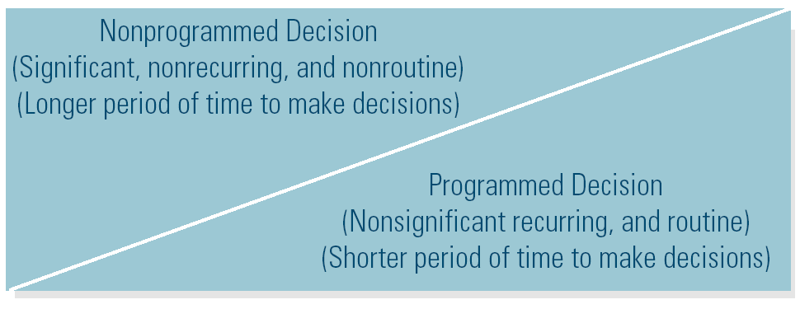

Decision-Making Models
• Rational Model (Classical Model)
–The decision maker attempts to use optimizing, selecting the best possible alternative.
• The Bounded Rationality Model
–The decision maker uses satisficing, selecting the first alternative that meets the minimal criteria for solving the problem.

Which Decision Model to Use
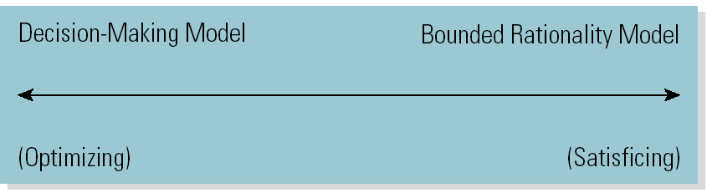
Decision-Making Conditions
• Certainty
–Each alternative’s outcome is known in advance.
• Risk
–Probabilities can be assigned to each alternative.
• Uncertainty
–Lack of information or knowledge makes the each alternative unpredictable such that no probabilities can be determined.

Decision-Making Conditions Continuum
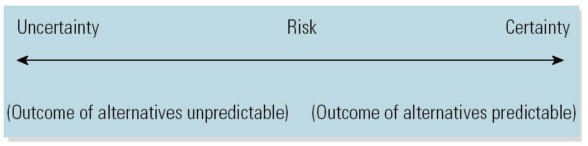

Potential Advantages and Disadvantages of Using Group Decision Making
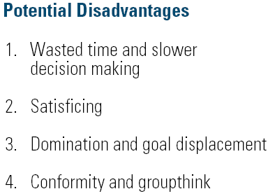
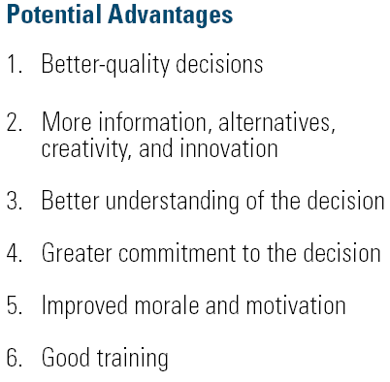

Lecture 8
When to Use Group or Individual Decision Making
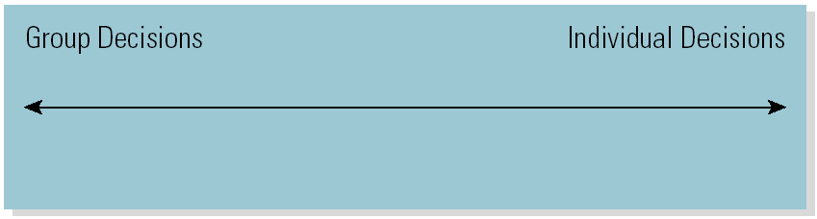
Define the Problem or Opportunity
• Distinguish Symptoms from the Cause of the Problem
–List the observable and describable occurrences (symptoms) that indicate a problem exists.
–Determine the cause of the problem.
–Removing the cause should cause the symptoms to disappear or cease.
- Symptom: Customer dissatisfaction
- Cause: Poorly trained employees
- Solution: Implement customer relations training program for employees
Set Objectives and Criteria
• Setting Objectives
–Involves establishing clear objectives that will make for better decisions.
–Objectives state what the decisions should accomplish in solving a problem or taking advantage of an opportunity.
• Setting Criteria
–Involves setting standards that an alternative must meet to be selected as the decision that will accomplish the objective.

Generate Creative Alternatives
• Innovation
–The implementation of a new idea
- Product innovation (new things)
- Process innovation (new way of doing things)
• Creativity
–A way of thinking that generates new ideas
• The Creative Process
–Preparation
–Incubation and illumination
–Evaluation

Stages in the Creative Process

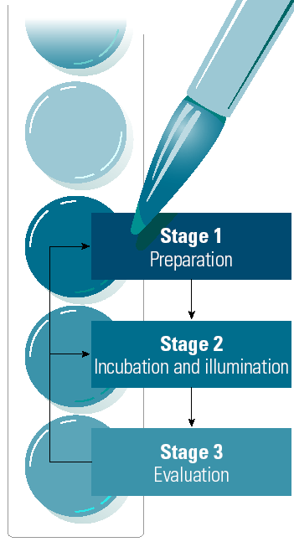
Become familiar with the problem; generate as many alternatives as possible.
Take some time before working on the problem again to gain additional insight.
Before implementing the solution, evaluate the alternative to be sure it is practical.

Characteristics of Useful Information
• Timeliness
• Quality (Accuracy)
• Completeness (Amount)
• Relevance

Group Decision-Making Techniques That Foster Creativity
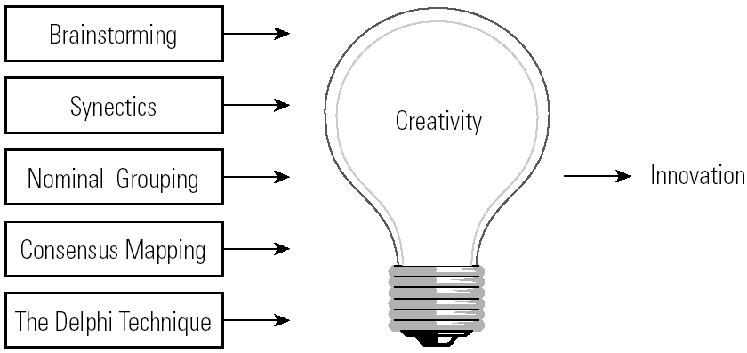

Generating Creative Alternatives
• Brainstorming
–The process of suggesting many possible alternatives without evaluation.
• Synectics
–The process of generating novel alternatives through role playing and fantasizing.
• Nominal Grouping
–The process of generating and evaluating alternatives using a structured voting method that includes listing, recording, clarification, ranking, discussion, and voting to select an alternative.
• Consensus Mapping (Ringi)
–The process of developing group agreement on a solution to a problem.
• Delphi Technique
–The process of using a series of confidential questionnaires posed to experts to refine a solution.

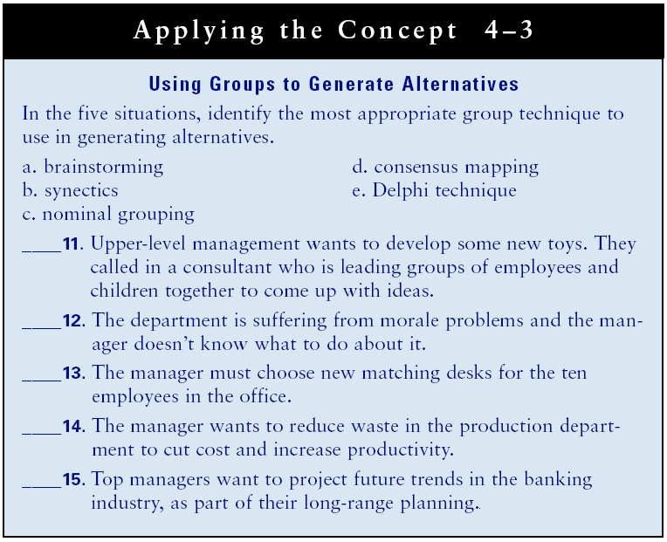

Lecture 9
Responses That Kill Creativity
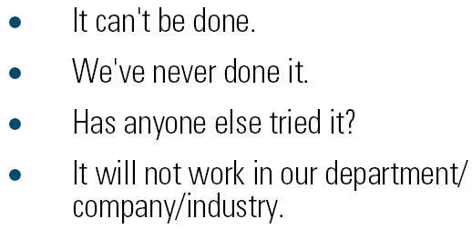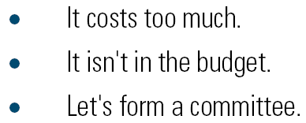

Analyzing the Feasibility of Alternatives
• Quantitative Techniques
–Break-even analysis
–Capital budgeting
- Payback
- Discounted cash flow
–Linear programming
–Queuing theory
–Probability theory
• Break-Even analysis
–Allows calculation of the volume of sales or revenue that will result in a profit.
–Involves forecasting the volume of sales and cost of production.
–No profit or loss results
• Capital budgeting
–Analyze alternative investments in assets, and the make/buy and rent/lease-or-buy decision.
–Payback
–Discounted cash flow
• Linear programming
–Used for programmed decisions under conditions of certainty or low risk, but LP is also widely applied to product mix decisions, such as minimizing transportation cost for truck fleets
• Queuing theory
–Focuses on waiting time.
–Used at reducing time for serving customers per employee
• Probability theory
–Users assign probability of success or failure to each alternative. The user then calculates the expected value, which is the payoff or profit from each combination of alternatives and outcomes.

Read the TEXT
QUANTITATIVE TECHNIQUES
As you read in the Appendix to Chapter 1, one of the five approaches to management is management science, which uses math to aid in problem solving and decision making. Quantitative techniques use math in the objective analysis of alter- native solutions.
The discussion that follows will make you aware of five quantitative techniques.
Managers may not be expected to compute the math for all types of quantitative
techniques. However, if you know when to use these techniques, you can seek help
from specialists within or outside the organization. If you are interested in the
actual calculations, you should take courses in quantitative analysis.
Break-Even Analysis
Break-even analysis allows calculation of the volume of sales or revenue that will result in a profit. It involves forecasting the volume of sales and the cost of production.
The break-even point occurs at the level where no profit or loss results. For example,
if a Home Depot store buys a carpet cleaner for $500 and rents it for $25 a day, how
many times does it have to rent out the carpet cleaner in order to break even?
Capital Budgeting
This technique is used to analyze alternative investments in assets, such as machines
and the make-or-buy and rent/lease-or-buy decision. The payback approach allows
the calculation of the number of years it will take to recover the initial cash invested.
Another approach computes the average rate of return. It is appropriate when the
yearly returns differ. A more sophisticated approach, discounted cash flow, takes
into account the time value of money. It assumes that a dollar today is worth more
than a dollar in the future. Organizations including AMF Bowling Centers, Kellogg,
Procter & Gamble, and 3M use discounted cash flow analysis.
linear Programming
Optimum allocation of resources is determined using linear programming (LP). The
resources that managers typically allocate are time, money, space, material, equipment, and employees. Companies primarily use LP for programmed decisions under
conditions of certainty or low risk, but LP is also widely applied to product-mix
decisions. Lear Siegler, Inc. uses LP when determining work flow to optimize the use
of its equipment. Bendix Corporation uses LP to minimize transportation (shipping)
costs for its truck fleet.
Queuing Theory
Queuing theory focuses on waiting time. An organization can have any number of
employees providing service to customers. If the organization has too many employees working at one time. not all of them will be waiting on customers and money
paid to them is lost. If the organization has too few employees working at one time,
it can lose customers who don't want to wait for service, which results in lost revenue. Queuing theory, which helps the organization balance these two costs, is used
by retail stores to determine the optimum number of checkout clerks, by airports
to determine the optimum number of takeoffs and landings on runways. and by
production departments to schedule preventive maintenance on equipment. Kaiser
Permanente uses queuing theory to help doctors' offices reduce waiting times for patients.

Probability Theory
Probability theory enables the user to make decisions that take into consideration
conditions of risk. The user assigns a probability of success or failure to each alternative. The user then calculates the expected value, which is the payoff or profit from each combination of alternatives and outcomes. The calculations are usually done on a payoff matrix by multiplying the probability of the outcome by the benefit or cost. Probability theory is used to determine whether to expand facilities to what size, to select the most profitable investment portfolio, and to determine the amount of inventory to stock. You could use it to choose a job. Using probability theory, hedge fund investors are providing movie financing to major film studios
such as Walt Disney Company and Sony Corporation's Sony Pictures Entertainment
and are using computer-driven investment simulations to pick movies with the right
characteristics to make money.
THE KEPNER- TREGOE METHOD
The Kepner-Tregoe method combines the objective quantitative approach with some subjectivity. The subjectivity comes from determining "must" and "want" criteria and assigning weighted values to them. As you read earlier in the chapter, "must" criteria are those attributes that an alternative solution must have if it is to be considered. "Want" criteria are attributes that make an alternative solution more attractive; they are desirable but not essential. Absence of certain "want" criteria does not cause an alternative to be eliminated.

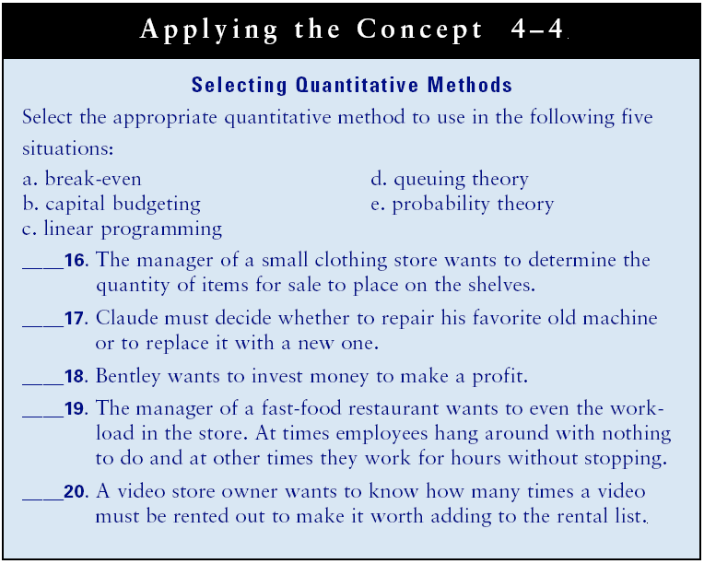
The Kepner-Tregoe Method
1. Compare each alternative to the “must” alternative.
2. Rate each “want” criterion on a scale of 1 to 10 (10 being the most important).
3. Assign a value of 1 to 10 (10 being the highest) to how well each alternative meets the “want” criteria.
4. Compute the weighted score (WS) for each alternative.
5. Select the alternative with the highest total WS.

The Kepner-Tregoe Method for Analyzing Alternatives
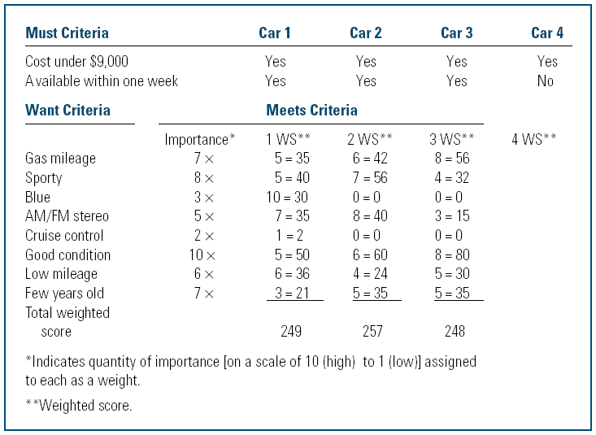

Cost-Benefit (Pros and Cons) Analysis
• Cost-Benefit Analysis
–A technique for comparing the cost and benefit of each alternative course of action using subjective intuition and judgment along with math.

• The Alternative Analysis Techniques
Continuum:
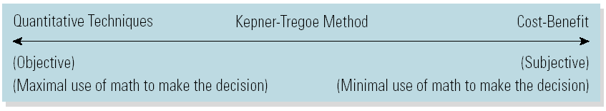
Plan, Implement, and Control
• Plan
–Develop a plan of action and a schedule of implementation.
• Implement the Plan
–Communicate and delegate for direct action.
• Control
–Use checkpoints to determine whether the alternative is solving the problem.
–Avoid escalation of commitment to a bad alternative.

Decision Tree
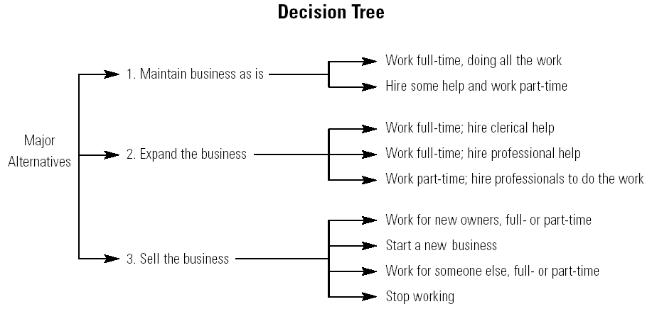

Situational Management: Decision Making
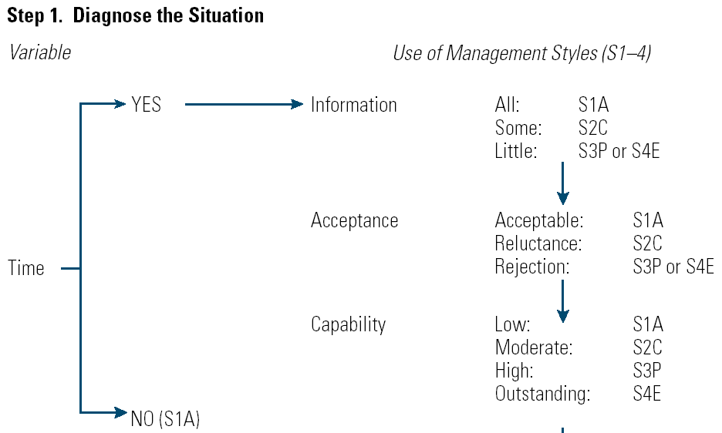

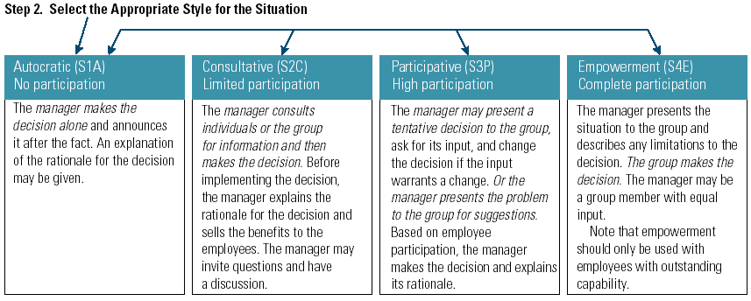

Lecture 10
Chapter 5: The Strategic and Operational Planning Process
Learning Outcomes
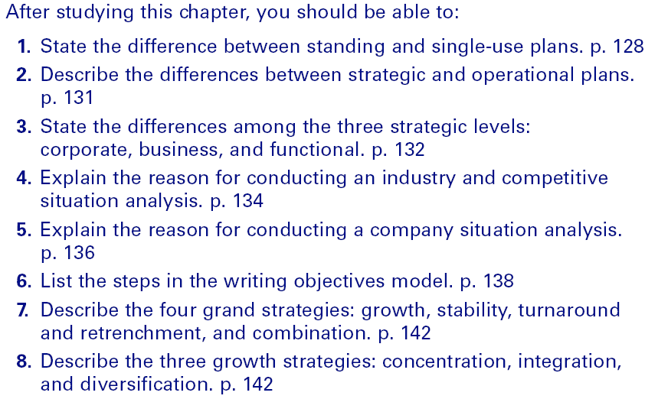

Planning
• Planning Dimensions
–The level of management developing the plan –The type of plan (strategic or operational)
–The scope of the plan (broad or narrow)
–The time horizon of the plan (short- or long-term)
–The plan’s repetitiveness (standing or single-use)
Planning Dimensions
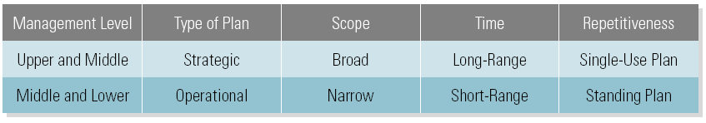
Types of Plans
• Standing Plans
–Policies, procedures, and rules developed for handling repetitive situations.
–Policies
- General guidelines to be followed when making decisions.
–Procedures
- A sequence of actions to be followed in order to achieve an objective.
–Rules
- A statement of exactly what should or should not be done.
• Single-Use Plans
–Programs and budgets developed for handling non-repetitive situations.
–Program
- A set of activities designed to accomplish an objective over a specified period of time.
–Program development
- Set project objectives.
- Break the project down into a sequence of steps.
- Assign responsibility for each step.
- Establish starting and ending times.
- Determine the resources needed for each step.

• Single-Use Plans
–Budget
- Represents the funds allocated to operate a unit for a fixed period of time.
- Is a planning tool initially and becomes a control tool after implementation of the plan.

Standing versus Single-Use Plans
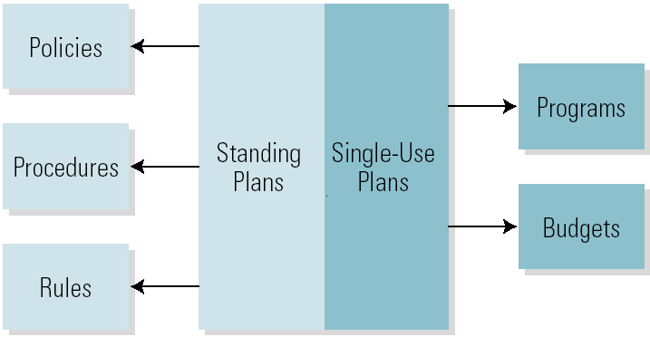

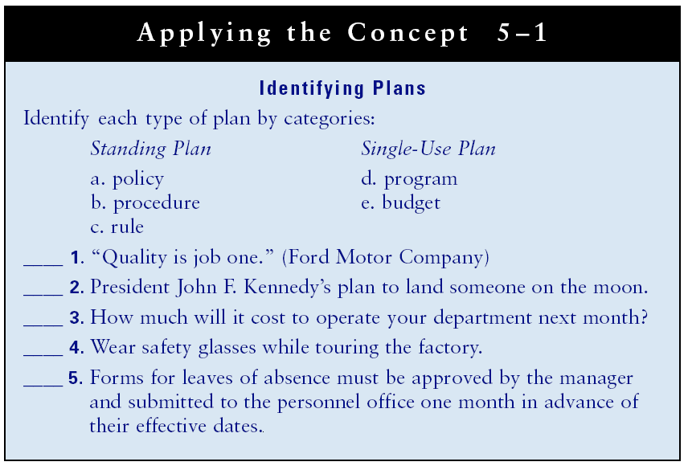
Contingency Plans
–Alternative plans to be implemented if uncontrollable events occur.
–Developing a contingency plan
- What might go wrong in my department?
- How can I prevent it from happening?
- If it does occur, what can I do to minimize its effect?
• Why Managers Don’t Plan
–Claimed lack of time
–Tendency toward action
Strategic and Operational Planning
• Strategic Planning
–The process of developing a mission and long-range objectives and determining in advance how they will be accomplished.
• Operational Planning
–The process of setting short-range objectives and determining in advance how they will be accomplished.
• Strategy
– A plan for pursuing the mission and achieving objectives.
The Strategic Process
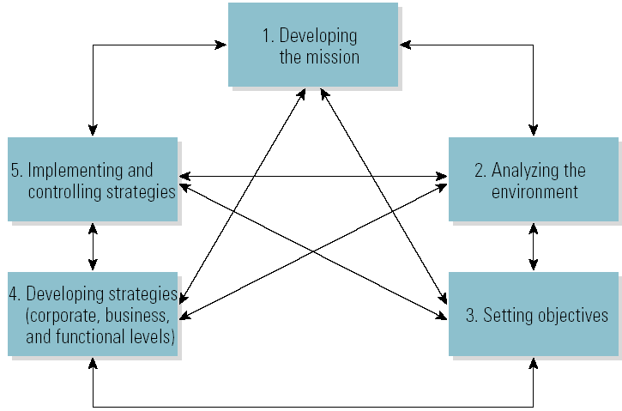
Strategic Planning
• Corporate-Level Strategy
–The plan for managing multiple lines of businesses
• Business-Level Strategy
–The plan for managing one line of business
• Functional-Level Strategy
–The plan for managing one area of the business
Strategic and Operational Levels
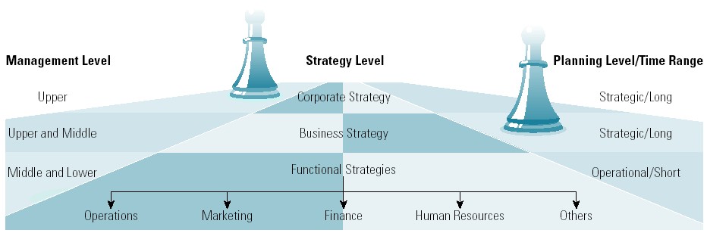

Lecture 11
Industry and Competitive Situation Analysis
• Situation Analysis
–Draws out those features in a company’s environment that most directly frame its strategic window of options and opportunities.
• Five Competitive Forces (Porter)
–Rivalry among competing sellers in the industry
–Threat of substitute products and services
–Potential new entrants
–Power of suppliers
–Power of buyers

Starbuck’s Five-Force Competitive Analysis
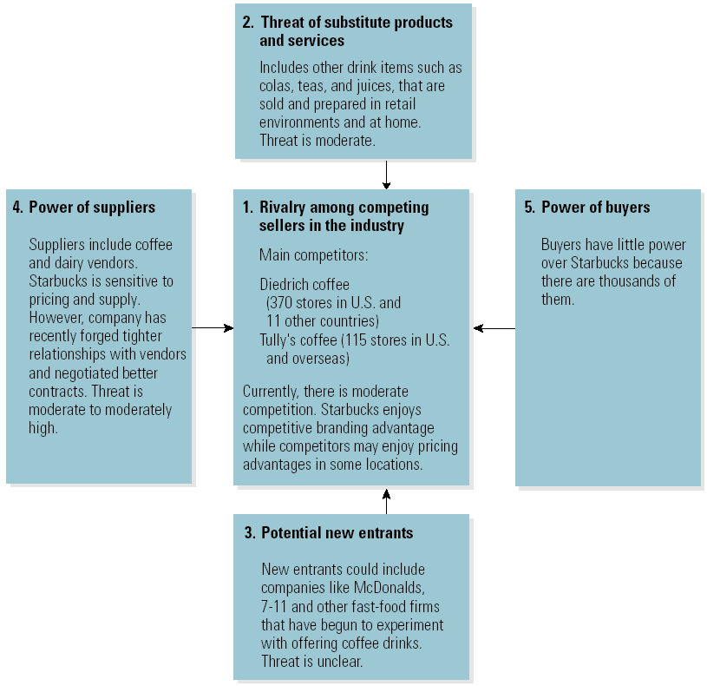

Company Situation Analysis Steps
1. Assessment of the present strategy based on performance.
2. SWOT analysis.
3. Competitive Strength Assessment (competitive advantage).
4. Conclusions concerning competitive position.
5. Determination of the strategic issues and problems that need to be addressed through strategic processes.
SWOT Analysis for Starbucks Coffee

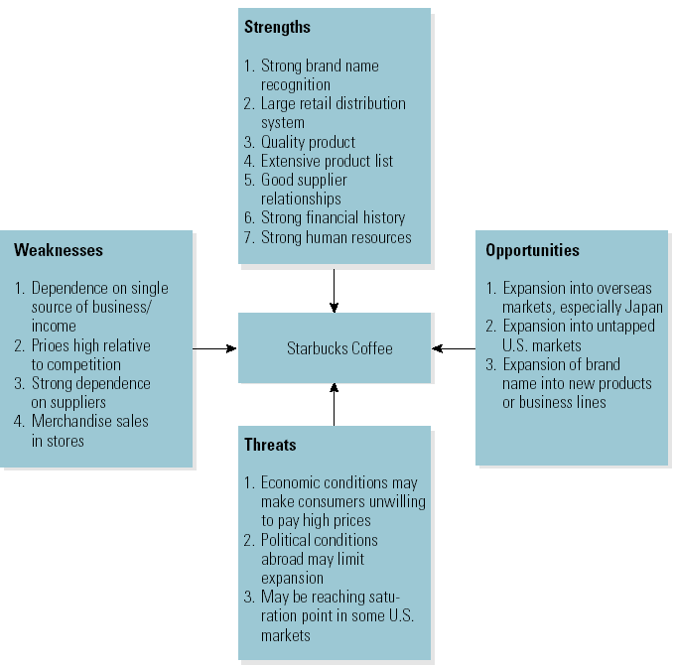

Competitive Strength Assessment for Starbucks Coffee
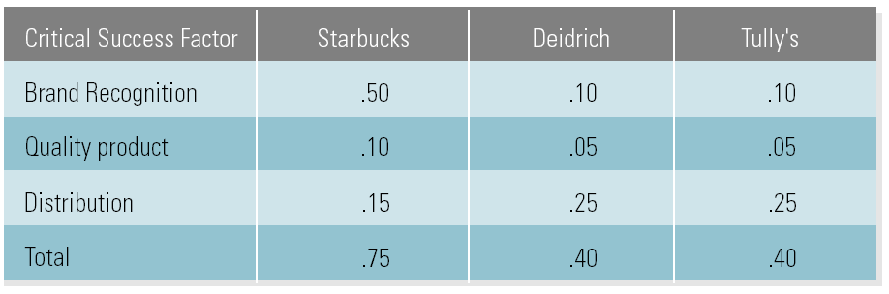
Competitive Advantage
• Core Competency
–A functional capability (strength) that the firm does well and one that creates a competitive advantage for the firm.
• Benchmarking
–The process of comparing an organization’s products or services and processes with those of other companies.
• Environmental Scanning
–Searching the external environment for opportunities and threats.
Setting Objectives
• Objectives
–State what is to be accomplished in singular, specific, and measurable terms with a target date?
• Goals
–Are general targets to be accomplished that are translated into actionable objectives?

Writing Objective Model
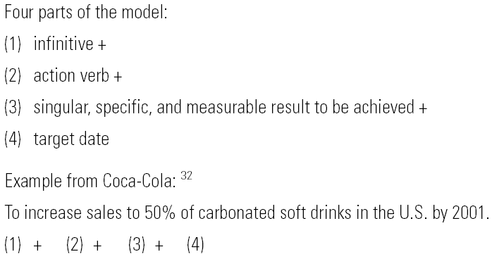

Criteria That Objectives Should Meet
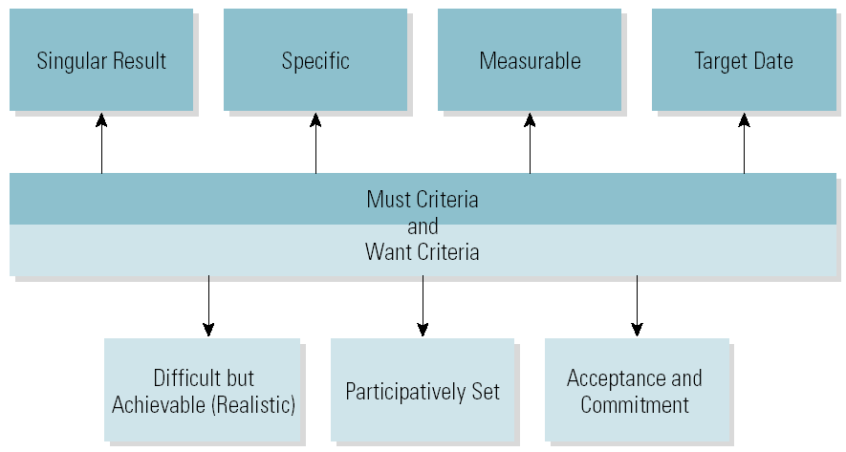

Management by Objective (MBO)
• Management by Objectives
Step 1. Set individual objectives with plans jointly with employees.
Step 2. Give feedback and evaluate.
Step 3. Reward performance according to results.
• Sources of MBO Failures
–Lack of top management commitment and follow-through on MBO.
–Employees’ negative beliefs about management’s sincerity in its efforts to include them in the decision-making process.
Corporate-Level Strategy
• Grand Strategies
–Growth
–Stability
–Turnaround and retrenchment
–Combination
-A spin off is a type of retrenchment in which a corporate sets up one or more of its business units as a separate company rather than selling it.

• Growth Strategies
–Concentration
–Backward and forward integration
–Related and Unrelated diversification

Notes for Study
GRAND STRATEGY
Grand strategy is an overall corporate strategy for growth, stability, or turnaround
and retrenchment, or for some combination of these. Each grand strategy aligns
with different objectives. Let's discuss each separately.
Growth
With a growth strategy, the company makes aggressive attempts to increase its size
through increased sales. ADM is pursuing a growth strategy?
Stability
With a stability strategy, the company attempts to hold and maintain its present size or to grow slowly. Rather than increasing its size aggressively as with a
growth strategy, the company attempts to balance growth and profits.!' Many
companies are satisfied with the status quo. For example, the WD-40 Company
produces WD-40, a well-known petroleum-based lubricant that has more than
2,000 uses. The company pursues a strategy of stability as it has "slowly" added
products, including a hand cleaner and a WD-40 pen, over the course of many
years.
Turnaround and Retrenchment
A turnaround strategy is an attempt to reverse a declining business as quickly as
possible. A retrenchment strategy is the divestiture or liquidation of assets. These
strategies are listed together because most turnarounds include retrenchment. Turn-
around strategies generally attempt to improve cash flow by increasing revenues,
decreasing costs, reducing assets, or combining these strategies. Dell is struggling
to stage a turnaround amid tough competition from Acer and Hewlett-Packard. P
GM, which was forced to declare bankruptcy in 2009, has lost billions of dollars
and is aggressively retrenching itself while producing fewer vehicles and trimming
its workforce.
A spinoff is a form of retrenchment in which a corporation sets up one or more
of its business units as a separate company rather than selling it. British company
Cadbury Schweppes plc split itself into companies-one selling candy and the other
soda (including 7UP and Dr Pepper In 2010, digital-entertainment company
Real Networks and media giant Viacom said they plan to spin off their Rhapsody
music joint venture into a new corporation that will operate independently of the two.
Combination
A corporation may pursue growth, stability, and turnaround and retrenchment
for its different lines of business or areas of operations. For example, GE is continually buying and selling lines of business. PepsiCo sold its KFC, Pizza Hut, and Taco Bell restaurants to Yum! Brands, but it also acquired Quaker Oats and Gatorade. Although GM is retrenching in the United States by selling, discounting, or scaling back most of its brands, closing 13 of its plants and almost 10,000 of its dealerships, and trimming its workforce by 20,000 employees, it is expanding operations in China, where its sales are about 25 percent higher than in the United States.'?

GROWTH STRATEGIES
A company that wants to grow has three major options. These growth strategies
are concentration, backward and forward integration, and related and unrelated
diversification.
Concentration
With a concentration strategy, the organization grows aggressively in its existing
line(s) of business. Wal-Mart, Subway, and McDonald's continue to open new stores.
Integration
With an integration strategy, the organization enters a new line or lines of business
related to its existing one(s). Forward integration occurs when the organization enters a line of business closer to the final customer. For example, Apple has engaged
in forward integration by opening stores, thus bypassing traditional retailers and
selling its products directly to the customer. Backward integration occurs when the
organization enters a line of business farther away from the final customer. Arcelor
Mittal is pursuing a backward integration strategy with its purchases of iron-ore
d coal mines to help lower the cost of producing steel.
Diversification
With a diversification strategy, the organization goes into a related or unrelated line of
products. Nike used related (concentric) diversification when it diversified from sports shoes to sports clothing and then to sports equipment. The Virgin Group has pursued an unrelated (conglomerate) diversification since its existence, owning companies that specialize in everything from travel and tourism to beverage to finance and money.
Common Methods for Pursuing a Growth Strategy
Companies can pursue a growth strategy by means of mergers, acquisitions, joint
ventures, or strategic alliances? Companies engage in mergers and acquisitions to
decrease competition, to compete more effectively with larger companies, to realize
economies of size, to consolidate expenses, and to achieve access to markets, products, technology, resources, and management talent.

A merger occurs when two companies form one corporation. In 2008, Anheuser-Busch and ImBev merged to create Anheuser-Busch ImBev, creating the leading global beer brewer and one of the top five consumer products companies in the world Although mergers are quite common in the business world, their odds of success are quite low. During the past two decades, there have been quite a few notable failed mergers including Alcatel and Lucent, AOL and Time Warm Hewlett-Packard and Compaq, and Daimler-Benz and Chrysler."

An acquisition occurs when one business buys all or part of another business:
One business becomes a part of an existing business. In 2010, Italy's Fiat and U.
car maker Chrysler inked a merger deal to create a global auto giant.
A joint venture is created when firms share ownership of a new enterprise, while a strategic alliance is an agreement to share resources that does not necessarily involve shared leadership. For example, in 2009 the Nielson Company and Face book announced a multiyear strategic alliance to help marketers better use the Internet to develop and market new products. The alliance combines Facebook's global consumer reach with Nielsen's market research expertise to provide better insight and information to marketers around the world.
BUSINESS STRATEGIES
Each line of business must develop its own mission, analyze its own environment,
set its own objectives, and develop its own strategies. For the organization with
a single line of products, corporate and business strategies are the same. For the
organization involved in multiple lines of business, linking corporate strategy with
operations at the business unit level determines success. In this section, we'll
discuss adaptive and competitive strategies and how to change strategies during the
product life cycle.
ADAPTIVE STRATEGIES
Adaptive strategies emphasize adapting to changes in the external environment and
entering new markets as means of increasing sales" The adaptive strategies are
prospecting, defending, and analyzing. Each adaptive strategy reflects a different objective. Exhibit 4-12 indicates the different rates of environmental change, potential growth rates, and corresponding grand strategy for each adaptive strategy.
Prospecting
The prospecting strategy calls for aggressively offering new products and services
and/or entering new markets. Nissan was a prospector when it unveiled the LEAF,
the world's first battery-powered car, in late 2010.⁴⁹ Wal-Mart continues to open
new stores to enter new markets. However, for a line of business, this growth strategy has to be concentration or related diversification. If it's integration or unrelated diversification, new lines of business will be acquired, and there will no longer be a single line of business. The prospecting strategy resembles the grand strategy of growth.
Defending
The defending strategy calls for staying with the present product line and markets
and maintaining or increasing customers. Wilson Sporting Goods Company has
successfully defended its position as the top seller of sporting and athletic goods for
years. Defending resembles the stability grand strategy.

Analyzing
The analyzing strategy calls for a midrange approach between prospecting and de-
fending. Analyzing involves moving into new market areas at a cautious, deliberate pace and/or offering a core product group and seeking new opportunities.
Analyzers commonly match rivals' prospecting actions or use benchmarking.
Based on Apple's iPod and iTunes success, Microsoft came out with Zune, a digital
media player, and Zune Marketplace, an online music store that integrates with the
device. Microsoft also used the analyzing strategy when it came out with its Xbox
after Sony's PlayStation. Analyzing resembles the combination grand strategy.
COMPETITIVE STRATEGIES
Michael Porter identified three effective business competitive strategies: differentiation, cost leadership, and focus.
Differentiation
With a differentiation strategy, a company stresses its advantage over its competitors. Nike, Ralph Lauren, Calvin Klein, and others place their names on the outside of their products to differentiate them from those of the competition. Differentiation strategy somewhat resembles the prospecting strategy. According to Coca-Cola, the three keys to selling consumer products are differentiation, differentiation, differentiation, which it achieves with its scripted name logo and contour bottle.
Cost leadership
With a cost leadership strategy, the company stresses lower prices to attract customers. To keep its prices down, it must have tight cost control and an efficient
systems process. Growth demands high volume and high volume demands low
prices. Wal-Mart and Target have had success with this strategy. Apple has never
been known for stressing a cost leadership strategy. However, when Microsoft
offered its Zune music player for $290, Apple slashed the price of one of its iPod
models from $400 to $280. Cost leadership somewhat resembles the defending
strategy.
Focus
With a focus strategy, the company targets a specific regional market, product line,
or buyer group. Within a particular target segment, or market niche, the firm may
use a differentiation or cost leadership strategy. Focus strategies are commonplace

Lecture 12

Corporate Grand and Growth Strategies

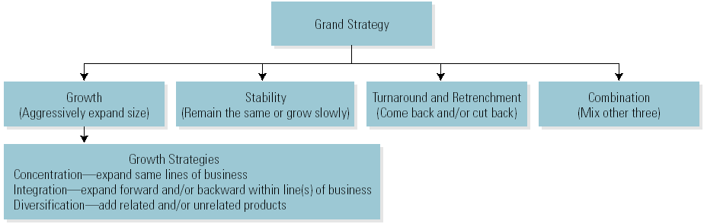

Portfolio Analysis: BCG Matrix
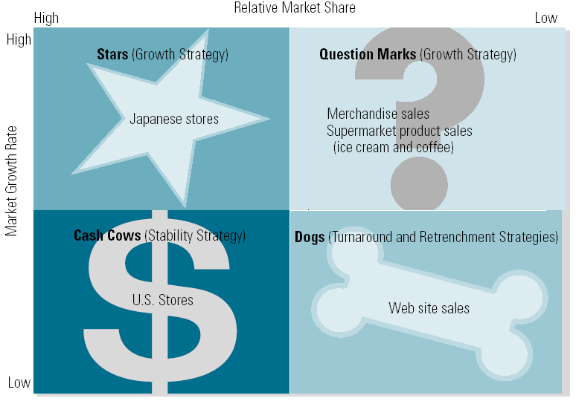
The Entrepreneurial Strategy Matrix
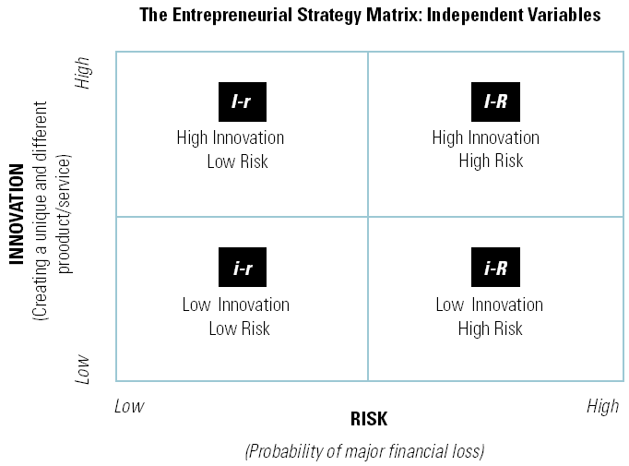

The Entrepreneurial Strategy Matrix: Appropriate Strategies
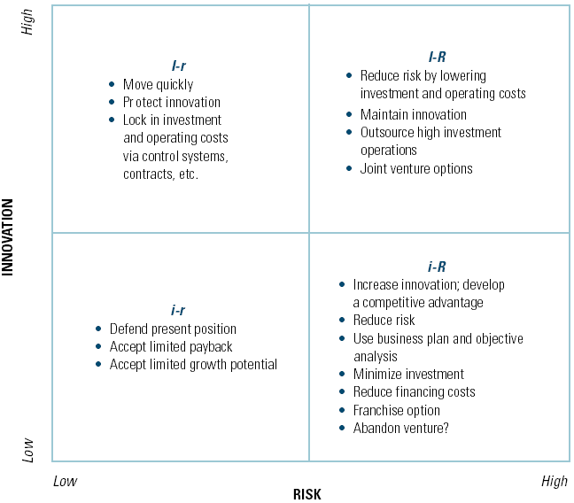

Business-Level Strategies
• Adaptive Strategies
–Prospecting
- Aggressively offering new products and/or entering new markets.
–Defending
- Staying with the present product line and markets, and maintaining or increasing customers.
–Analyzing
- A midrange approach between prospecting and defending, moving cautiously into new markets.

Selecting Adaptive Strategies
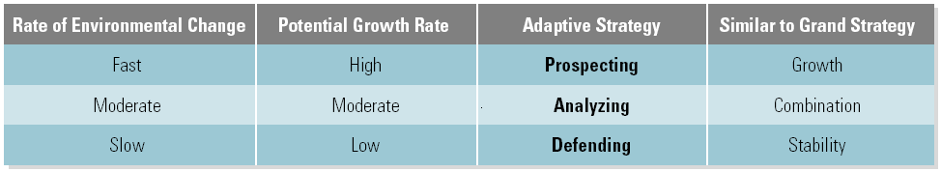
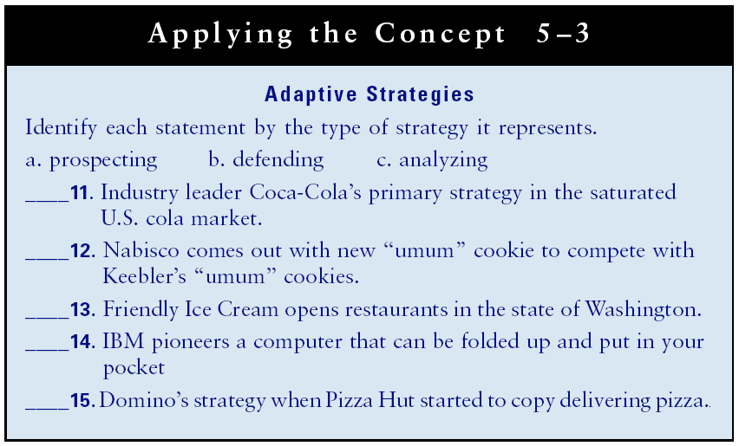

Competitive Strategies
• Differentiation
–Competing on the basis of features that distinguish one firm’s products or services from those of another.
• Cost Leadership
–The firm with the lowest total overall costs has a competitive advantage in price-sensitive markets.
• Focus
–Concentrating competitive efforts on a particular market segment, product line, or buyer group.

Product Life Cycle: Starbucks
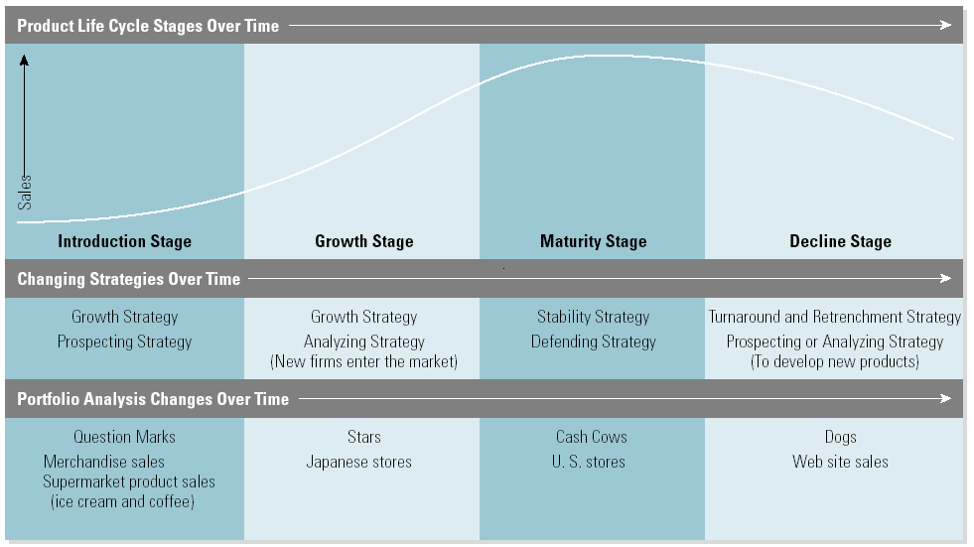
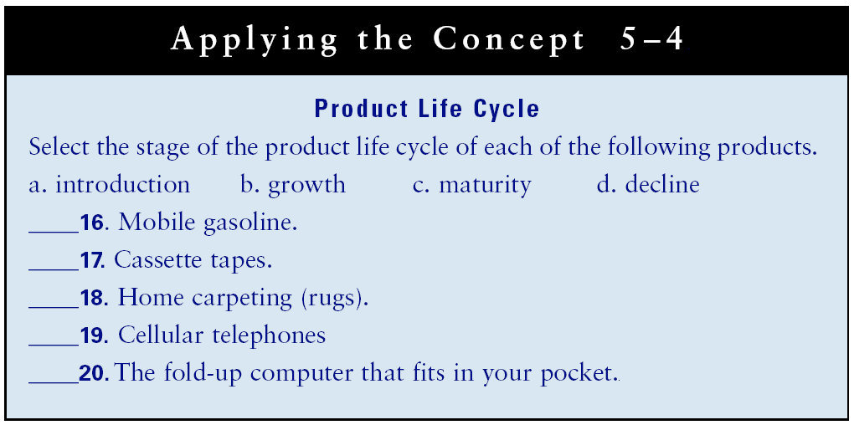

Functional-Level Operational Strategies
• Marketing
–Which products to produce; how will they be packaged, advertised, distributed, and priced?
• Operations
–Which processing systems to use to convert inputs into outputs with quality and efficiency?
• Human Resources
–How to recruit, select, train, evaluate, and compensate the workforce?
• Finance
–How to acquire the necessary equity or debt capital, meet the investment returns expectations of investors and shareholders; maintain an accounting system that optimizes the use of financial resources.
• Other Functional Strategies
–Research and development (R&D) is important to remaining competitive.

Lecture 13
Chapter 6: Organizing and delegating work
Learning Outcomes
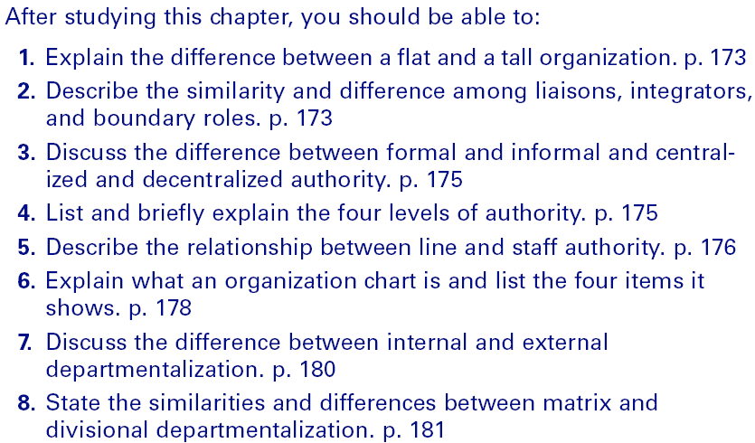

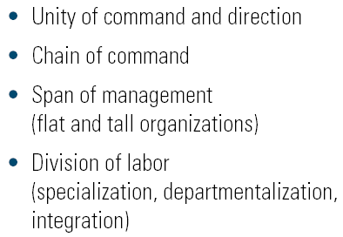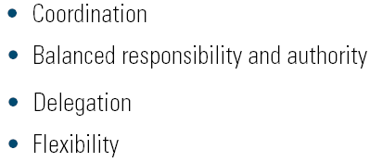Principles of Organizations

Read the TEXT
UNITY OF COMMAND AND DIRECTION
The principle of unity of command requires that each employee report to only one
boss. Former GE CEO Jack Welch stated that having two top executive roles encourages dysfunctional "decision shopping," wherein managers go to the leader
who's most likely to support their initiatives. A lack of unity of command also
contributes to a lack of clarity in organizations. When there are two bosses, you can
often get two conflicting messages.

The principle of unity of direction requires that all activities be directed toward
the same objectives. At Samsung, employees in different divisions were competing
against each other for the same customers, resulting in angry customers and lost
sales. To rectify the situation, Samsung underwent a divisional reorganization to
provide a realignment of strategies and more unity of direction.
CHAIN OF COMMAND
Chain of command, also known as the Scalar Principle, is the clear line of authority from the top to the bottom of an organization. The chain of command forms
a hierarchy, which is illustrated in the organization chart. All members of the firm
should know whom they report to and who, if anyone, reports to them. Efforts to
contain BP's Gulf of Mexico oil spill were stymied by confusion over who was in
charge of the work. Team members were unprepared to handle such a disaster and
thus struggled to determine who should do what. This confusion did little to stop
the oil spill.
SPAN OF MANAGEMENT
The span of management (or span of control) refers to the number of employees
reporting to a manager. The fewer employees supervised, the smaller or narrower
the span of management. The more employees supervised, the greater or wider the
span.

The span of management in an organization is related to the number of its organizational levels, which determines its organizational height. In a tall organization,
there are many levels with narrow spans of management. In a flat organization, there
are few levels with wide spans of management. In recent years, many organizations,
including Procter & Gamble and Johnson & Johnson, have cut management levels
and have restructured so as to have flatter management hierarchies.
DIVISION OF LABOR
With division of labor, employees have specialized jobs. Related functions are
grouped together under a single boss. Employees generally have specialized jobs in a
functional area such as accounting, production, or sales.
Paul Lawrence and Jay Lorsch coined the terms differentiation and integration.
Differentiation refers to the need to break the organization into departments, and
integration refers to the need to coordinate the departmental activities.

COORDINATION
Coordination ensures that all departments and individuals within an organization
work together to accomplish strategic and operational objectives.!" Coordination is
the process of integrating tasks and resources to meet objectives. IS It is important
that organization resources be coordinated through collaborative relationships.

All of the organizational principles discussed above are used as coordination
techniques. In addition, there are other means of coordination:
Through direct contact between people within and among departments
Through liaisons, who work in one department and coordinate information and
activities with one or more other departments
Through committees made up of people from different departments
Through integrators, such as product or project managers, who do not work for
any department but coordinate departmental activities to reach an objective
Through employees in boundary roles, including employees in sales, customer
service, purchasing, and public relations, who coordinate efforts with people in
the external environment
BALANCED RESPONSIBILITY AND AUTHORITY
With balanced responsibility and authority, the responsibilities of each individual in
the organization are clearly defined. Each individual is also given the authority necessary to meet these responsibilities and is held accountable for meeting them. When you delegate, you do not give responsibility and authority away; you share them.
Responsibility is the obligation to achieve objectives by performing required
activities. When strategic and operational objectives are set, the people responsible
for achieving them should be clearly identified. Managers are responsible for the
performance of their units.
Authority is the right to make decisions, issue orders, and use resources. As a
manager, you will be given responsibility for achieving unit objectives. You must
also have the authority to get the job done. Authority is delegated. The CEO is
responsible for the results of the entire organization and delegates authority down
the chain of command to the lower-level managers, who are responsible for meeting
operational objectives.
Accountability is the evaluation of how well individuals meet their responsibilities. All members of an organization should be evaluated periodically and held
accountable for achieving their objectives.
Managers are accountable for everything that happens in their departments.
As a manager, you delegate responsibility and authority to perform tasks, but you
should realize that you can never delegate your accountability.
DELEGATION
Delegation is the process of assigning responsibility and authority for accomplishing
objectives. Responsibility and authority are delegated down the chain of command.'
FLEXIBILITY
Flexibility in employees is vital, because there will always be exceptions to the rule.
Many employees focus on company rules rather than on creating customer satisfaction; they fear getting into trouble for breaking or bending the rules. Today's successful
organizations realize that flexibility is important to employees and to customer satisfaction." For example, suppose a rule is "No sales slip with returned merchandise, no cash refund." This rule helps to protect the store from people who steal merchandise and then return it for cash. What happens when a well-known, excellent customer comes into the store and demands a cash refund without a sales slip? In analyzing the situation, the employee realizes that the store could lose a good customer. Should the employee follow the rules and lose a good customer, or be flexible and keep the good customer?

-----------------------------------------------------------------
Balanced Responsibility and Authority
• Responsibility
–The obligation to achieve objectives by performing required activities.
• Authority
–The right to make decisions, issue orders, and use resources.
• Accountability
–The evaluation of how well individuals meet their responsibility.
• Delegation
–The process of assigning responsibility and authority for accomplishing objectives.
• Flexibility
–The ability to adapt to exceptions to the rules, policies, and procedures of the organization.

Authority
• Formal Authority (or Structure)
–The organizationally-sanctioned way of getting the job done.
–Organizational charts illustrate formal lines of authority in firms.
• Informal Authority
–The patterns of relationships and communication that develops in an organization that is not sanctioned by the organization.
• Scope of Authority
–The degree of authority assigned to a position in an organization; scope broadens at higher organizational levels. The scope of authority is a hierarchy that narrows as it flows down the organization.

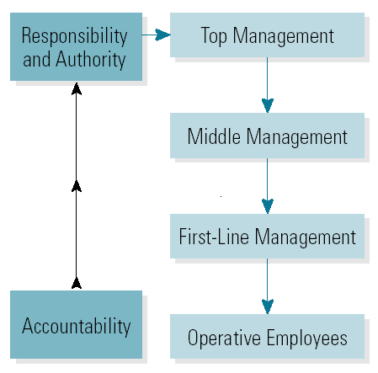

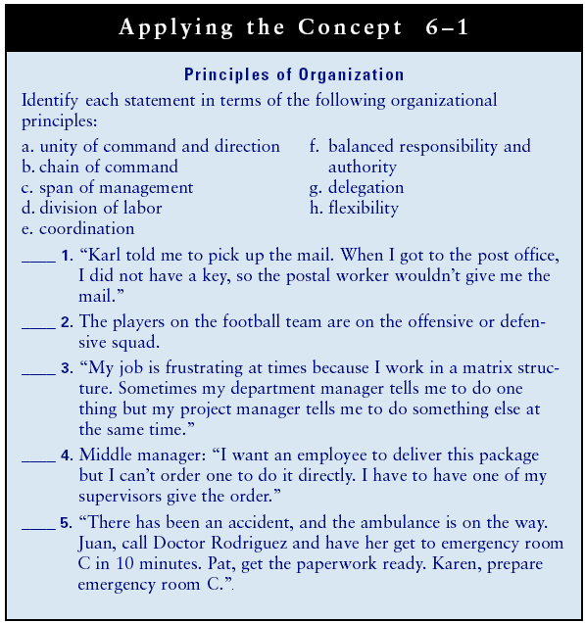
Levels of Authority
• Inform Authority
–Inform a superior of action alternatives and the superior makes the decision.
• Recommend Authority
–List alternatives/actions and recommend one action; superior makes action decision.
• Report Authority
–Select and implement a course of action, reporting action to superior.
• Full Authority
–Acting independently without supervision.
Line and Staff Authority
• Line Authority
–The responsibility to make decisions and issue orders down the chain of command.
• Staff Authority
–The responsibility to advise and assist line and other personnel.
–Functional authority
- The right of staff personnel to require compliance by line personnel with organizational policies and procedures.
–Dual line and staff authority
- Staff personnel exercise line authority within their own departments.
Micromanagement
Is a management style generally used as a negative term where manager closely observes or controls the work of his/her employees. Rather than giving instructions on smaller tasks and then devoting his/her time to supervising larger concerns, micromanagers monitors and accesses every step of business process and avoid delegation of decisions. Because micromanagement suggests to employees that a manager do not trust their work, it is often a source of employee dissatisfaction and disengagement.
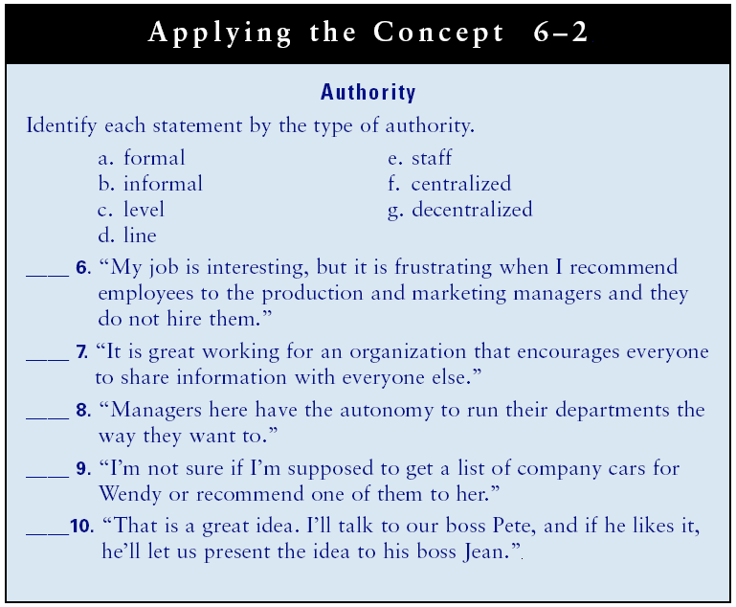

Authority
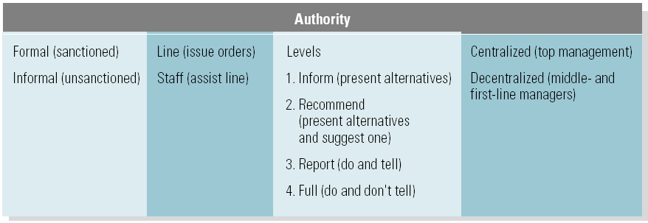

Organization Design
• Contingency Factors Affecting Structure
–Environment (mechanistic versus organic)
–Production technology
–Strategy (“structure follows strategy”)
–Size of the organization (larger = more formal)
• Organization Chart
–A graphic illustration of the organization’s management hierarchy and departments and their working relationships.
- Management level, chain of command, division and type of work, and departmentalization.

Organization Chart
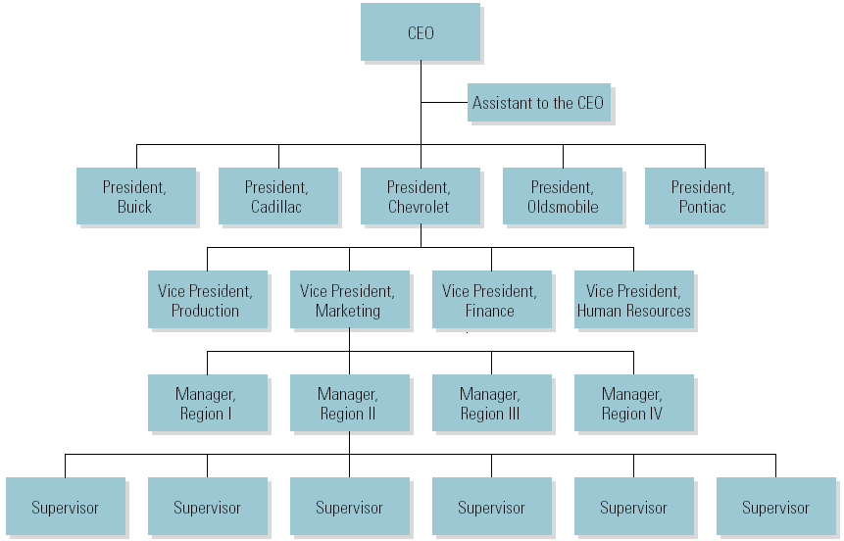

Departmentalization
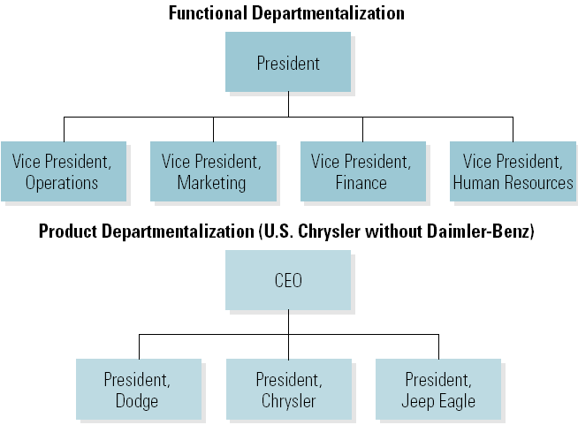

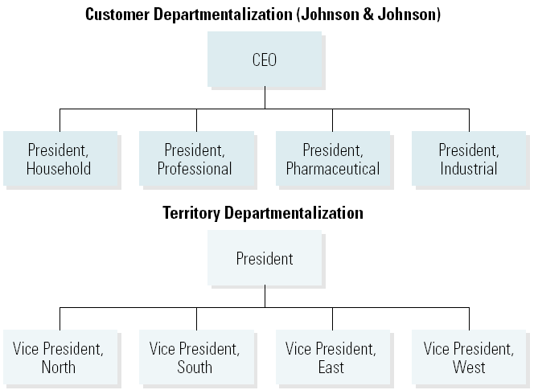
Matrix Departmentalization
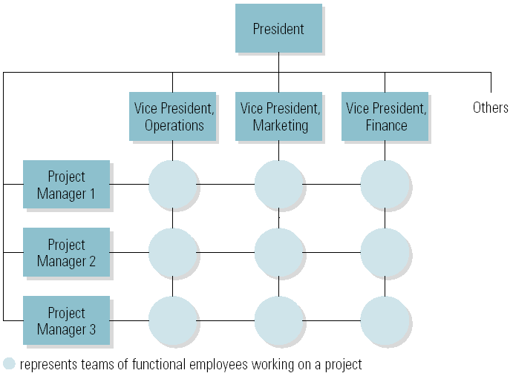

Lecture 14
New Approaches to Departmentalization
• Horizontal Team Organization
–Has an all-directional focus to increase speed of response, individual accountability, flexibility, knowledge sharing, and coordination.
–New Venture Units
- A group of employees who volunteer to develop new products or ventures for employees. A virtual organization is a continually evolving group of companies that unite temporarily to exploit specific opportunities or attain strategic advantages and then disband when objectives are met.
–High-involvement organization (Greenfields)
- A team approach to setting up a new facility with a flat organizational structure.
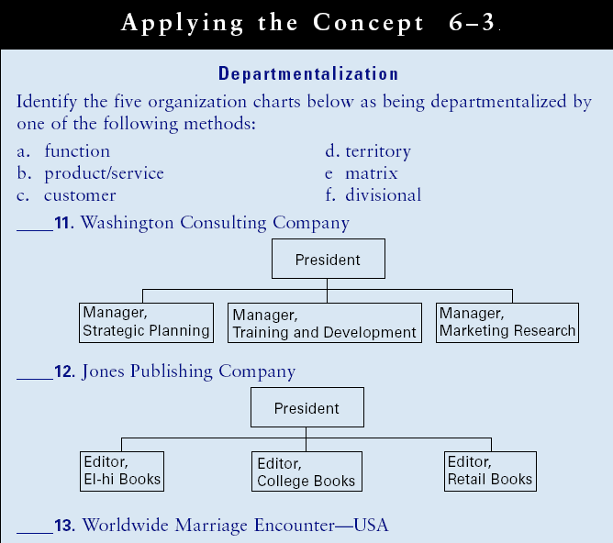

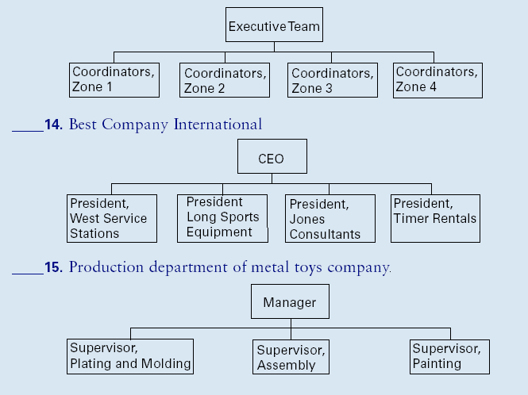

Job Design
• Job Design
–The process of combining task that each employee is responsible for completing.
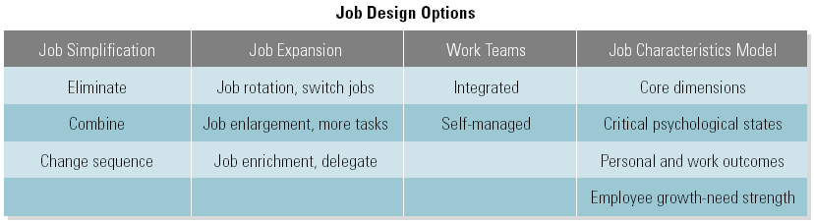

The Job Characteristics Model
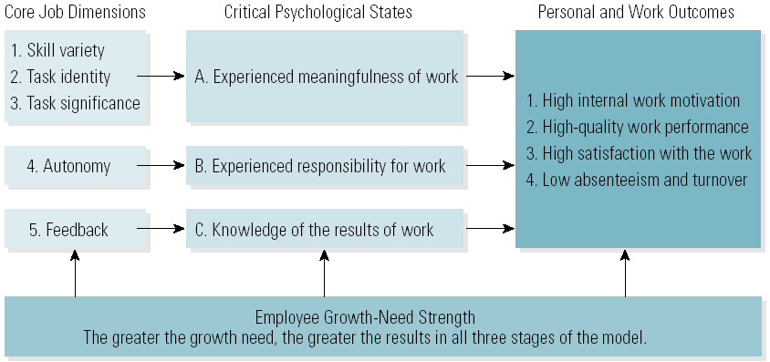

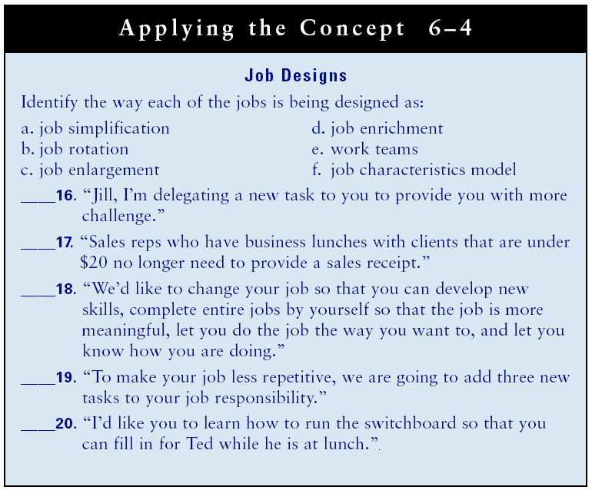
Priority Determination Questions
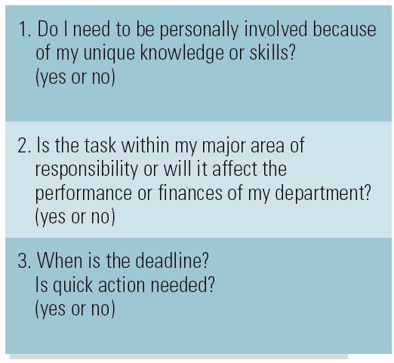

Prioritized To-Do List
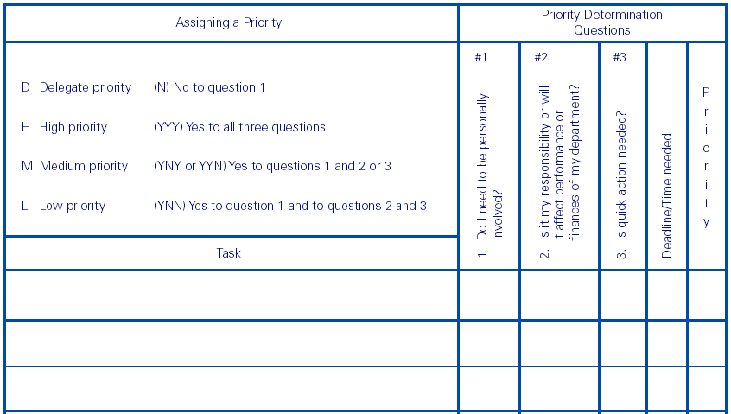
Delegation and Managers
• Benefits
–More time for other high-priority tasks.
–Trains employees and improves their self-esteem.
–Enriches jobs and improves personal and work outcomes.
• Obstacles
–Reluctance to stop doing tasks personally.
–Fear of employee’s failure to accomplish task.
–Threatened by employee’s success.
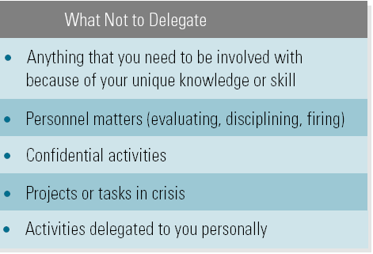
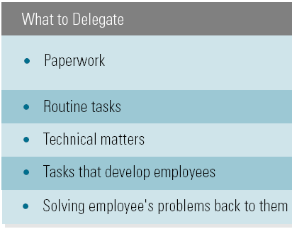
What and What Not to Delegate

Steps in the Delegation Model
1. Explain the need for delegating and the reasons for selecting the employee.
2. Set objectives that define responsibility, the level of authority, and the deadline.
3. Develop a plan.
4. Establish control checkpoints and hold employees accountable.
Organization Chart for Cisco’s Product Development Group
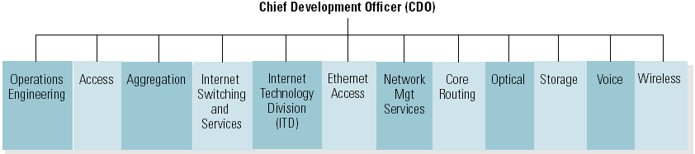

Chapter 7: Managing Change and Innovation
Learning Outcomes
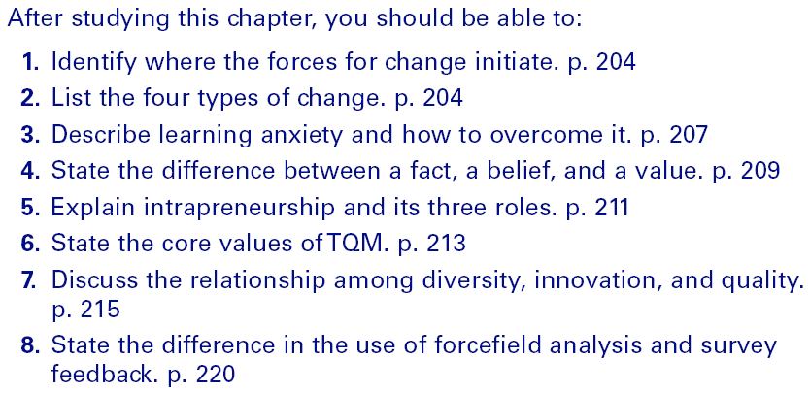

Types of Organizational Change
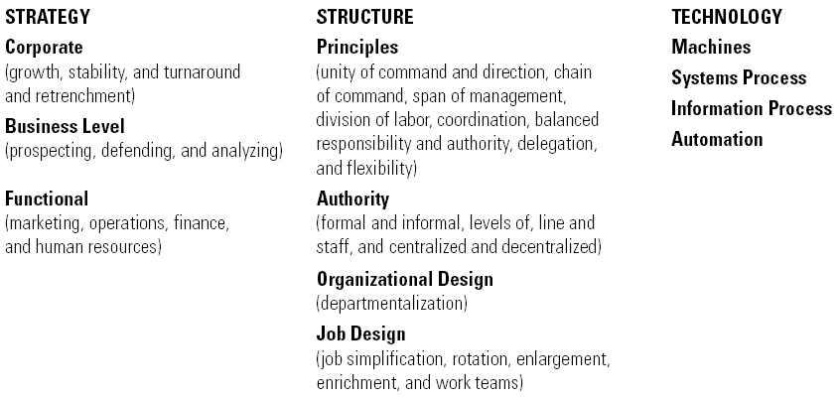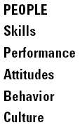

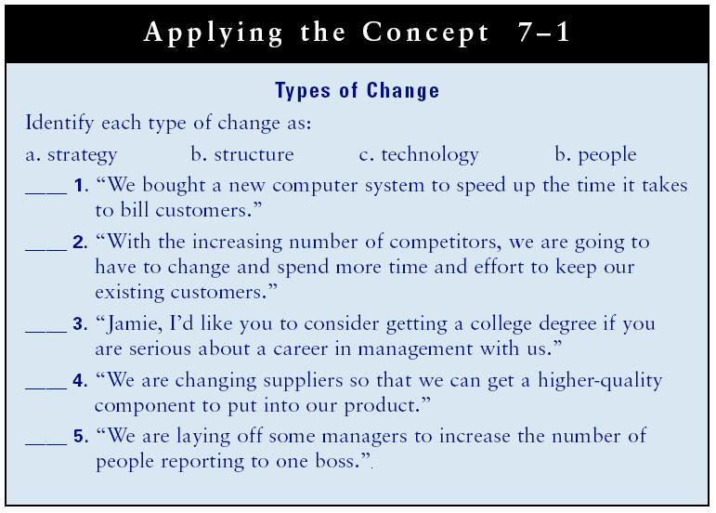

Stages in the Change Process
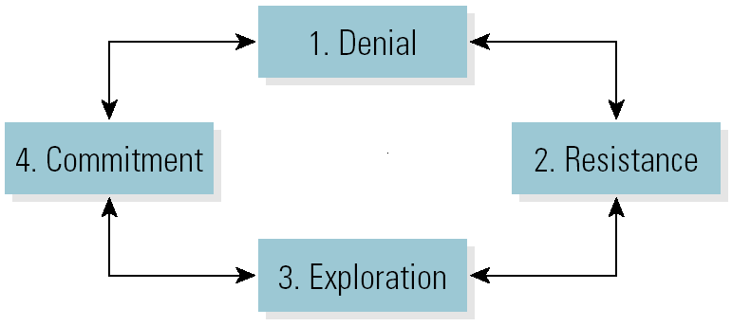

Resistance to Change and Ways to Overcome Resistance

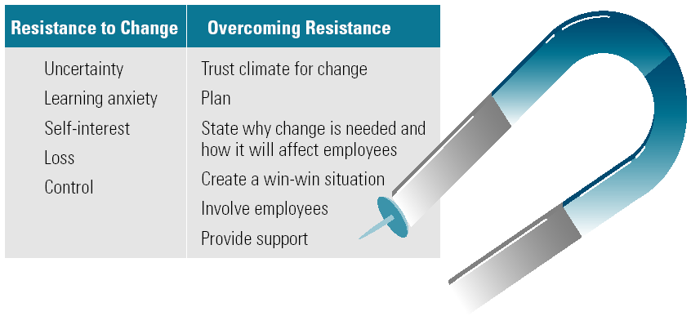

Read the TEXT
RESISTANCE TO CHANGE

As shown in Exhibit 6-3, employees resist change for six major reasons.

- Uncertainty. Fear of the unknown outcome of change is common. People often
get anxious and nervous and resist change in order to cope with these feelings.
Learning anxiety. For many people, the prospect of learning something new
produces anxiety-learning anxiety. We realize that new learning may make
us temporarily incompetent and may expose us to rejection by valued groups.
Learning anxiety makes us react defensively and allows us to rationalize that we
do not really need to change after all.
- Self-interest. People resist change that threatens self-interest. Employees are more
concerned about their interests than the interests of the organization. IS

- Fear of loss. With change, jobs may possibly be lost. Change may involve an economic loss as a result of a pay cut. A change in work assignments or schedules
may create a loss of social relationships.

- Fear of loss of control. Change can also result in an actual or perceived loss of
power, status, security, and especially control. People may resent the feeling that
their destiny is being controlled by someone else.
- Successful habits. When people are successful, they think change is not needed.
- We often lose sight of the need for continuous improvement. Even when we do
change, we tend to fall back into old habits that have worked in the past.

HOW TO OVERCOME RESISTANCE TO CHANGE
Seven major steps you can take to overcome resistance to change are discussed
below.
- Develop a positive trust climate for change. Develop and maintain good human
relations. Make employees realize you have their best interests in mind and develop mutual trust. Constantly look for better ways to do things. Encouraging employees to suggest changes and implementing their ideas are important parts of continuous improvement.
- Plan. Implementing changes successfully requires good planning. You need to identify the possible resistance to change and plan how to overcome it. View change from the employees' position. Set clear objectives so employees know exactly what the change is and how it affects them.!? The next four steps should be part of your plan.
- Clearly state why the change is needed and how it will affect employees. Communication is the key to change. Employees want and need to know why the
change is necessary and how it will affect them, both positively and negatively.
Be open and honest with employees. Giving employees the facts as far in advance as possible helps them to overcome fear of the unknown. If the grapevine starts to spread incorrect information, correct it as quickly as possible.
- Create a win-win situation. The goal of human relations is to meet employee needs while achieving departmental and organizational objectives. To overcome resistance to change, be sure to answer the other parties' unasked question. "What's in it for me?" When people can see how they benefit, they are more willing to change. If the organization is going to benefit by the change, so should the employees.
- Involve employees. To create a win-win situation, involve employees. A commitment to change is usually critical to its successful implementation. Employees who participate in developing changes are more committed to them than employees who have changes dictated to them.'?
- Provide support and evaluation. To overcome resistance to change, employees need to know that managers are there to help them cope with the changes. Managers need to make the learning process as painless as possible by providing training and other support. Managers must also provide feedback and evaluation during the learning process to increase the employees' efficiency and effectiveness in implementing the change.
Create urgency. Many people procrastinate making changes. A feeling of urgency is the primary driver toward taking action. If something is perceived as urgent, it is given a high priority and is usually done immediately.

---------------------------------------------------------------------------------------

Lecture 15
Resistance to Change
• Sources of Resistance to Change
–Facts
- Provable statements that identify reality.
–Beliefs
- Subjective opinions that cannot be proven.
–Values
- What people believe are important and worth pursuing or doing.
• Focuses of Resistance to Change
–Self
- The reaction of individuals who feel their self-interests are threatened by change.
–Others
- The consideration given to how others will be affected by change.
–Work environment
- Change in the working environment threatens individuals’ control of the environment.
Resistance Matrix Focus of Resistance: Self
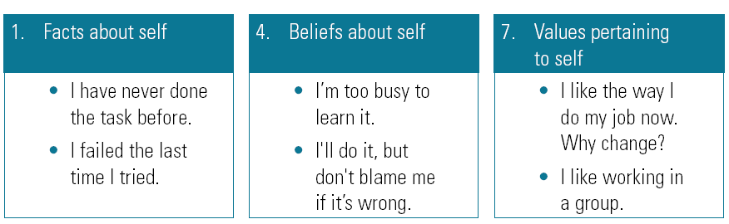

Resistance Matrix Focus of Resistance: Others
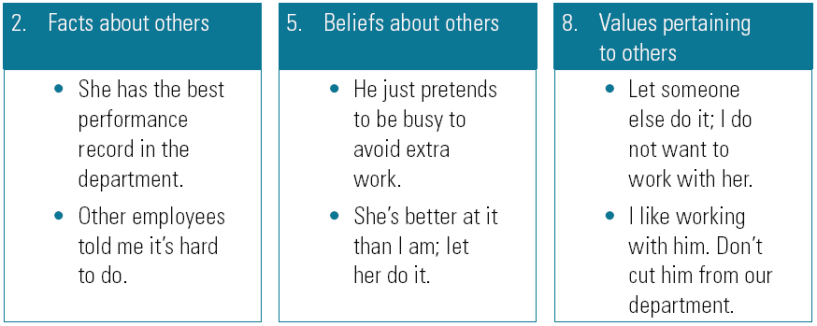

Resistance Matrix Focus of Resistance: Work Environment
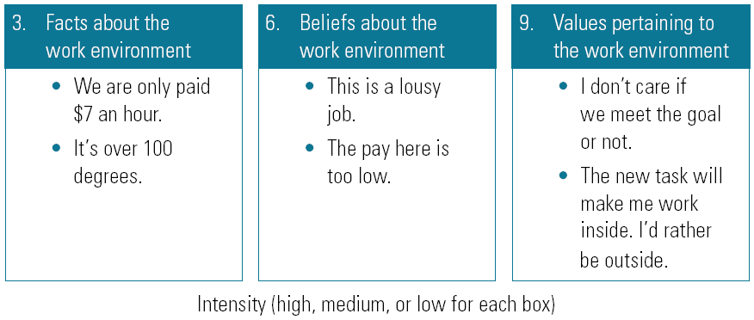

Innovation
• Innovative Organizational Structures
–Flat organizations with limited bureaucracy
–Generalist division of labor
–Coordinate with cross functional teams
–Informal with decentralized authority
–Create separate systems for innovative groups
–Attract and retain creative employees
–Reward innovation and creativity
• Innovative Organizational Cultures
–Encourage creativity and innovation
–Develop structures to match their creative culture
–Encourage risk-taking
–Foster Intrapreneurship
–Have open systems
–Focus on ends rather than means
–Accept ambiguous and impractical ideas
–Tolerate conflict

3M’s Rules for an Innovative Culture
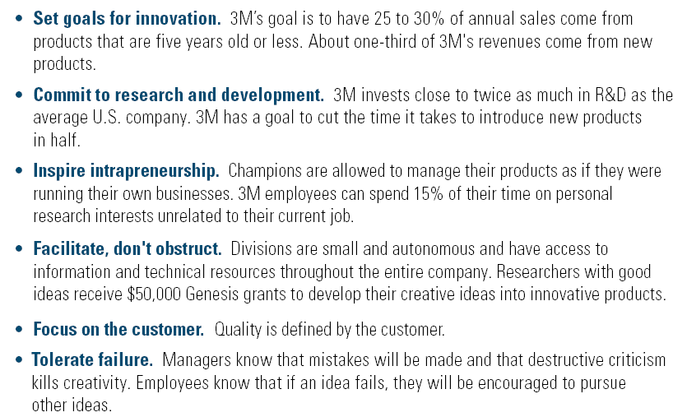
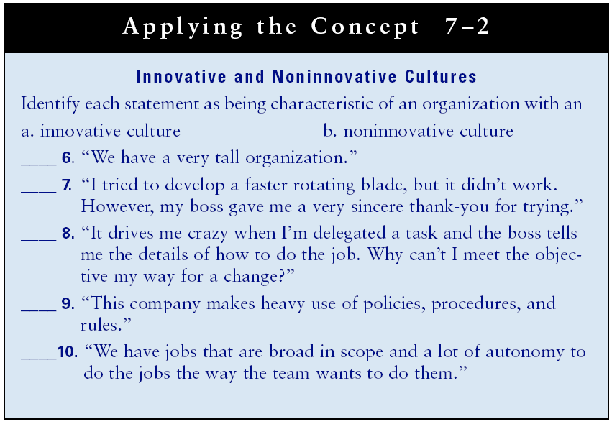

Quality
• Core Values of Total Quality Management (TQM)
–To focus everyone in the organization on delivering customer value.
–To continuously improve the system and its processes.
• The Continuous Improvement Culture
–Successful implementation of TQM requires incorporation of TQM values into the organizational culture.
Diversity
• Diversity
–The degree of differences among members of a group or an organization.
- Race/ethnicity, religion, gender, age, ability
- Diversity in all forms is increasing in the general population and the workforce.
–Incorporating diversity opens up a larger labor pool of skilled workers from which to recruit.
–Diversity is a legal requirement, an ethical obligation, and a competitive advantage.
• Valuing Diversity
–Emphasizing training employees of different races and ethnicity, religions, genders, ages, and abilities and with other differences to function together effectively.
• Managing Diversity
–Emphasizes fully utilizing human resources through organizational actions that meet all employees’ needs.

Managing Diversity

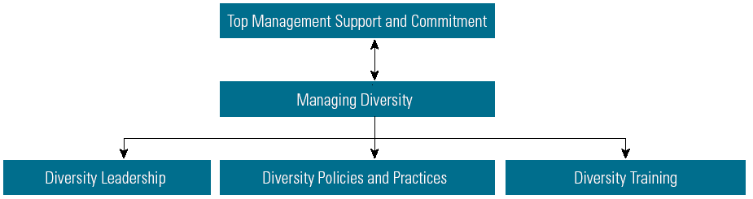

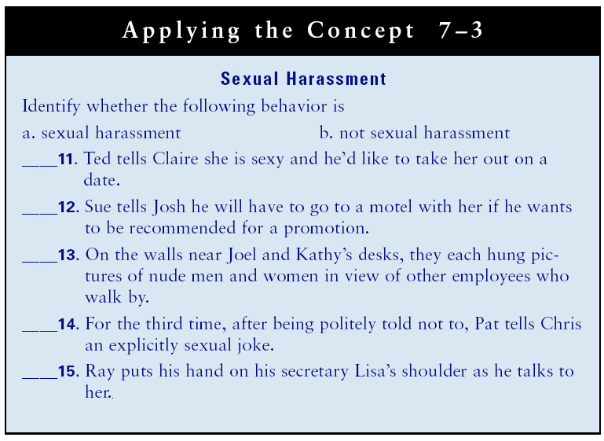

Organizational Development
• Organizational Development (OD)
–The ongoing planned process of change used as a means of improving performance through interventions.
• OD Interventions
–Specific actions taken to implement specific changes.
• Change Agent
–The person selected by human resources management to be responsible for the OD program.

Change Models
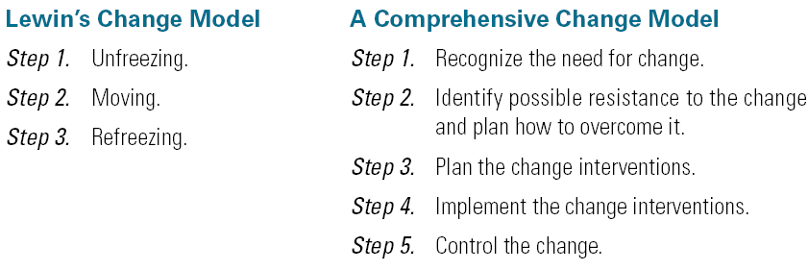

OD Interventions
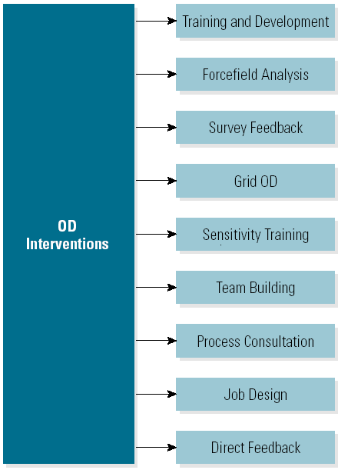

• Force field Analysis
–An OD intervention that diagrams the current level of performance, the hindering forces toward change, and the driving force toward change.

• Survey Feedback
–An OD intervention that uses a questionnaire together data to use as the basis for change.
Large Group intervention
-Is an OD technique that brings together participants from all parts of the organization, and often key outside stakeholders, to solve problems or take advantage of opportunities.
Force field Analysis

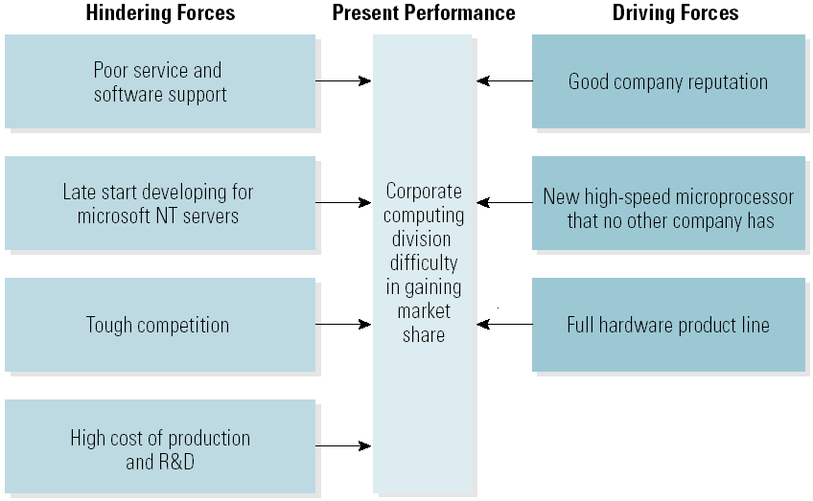
• Team Building
–An OD intervention designed to help work groups increase structural and team dynamics performance to get the job done.
• Process Consultation
–An OD intervention designed to improve team dynamics by focusing on how people interact as they get the job done.

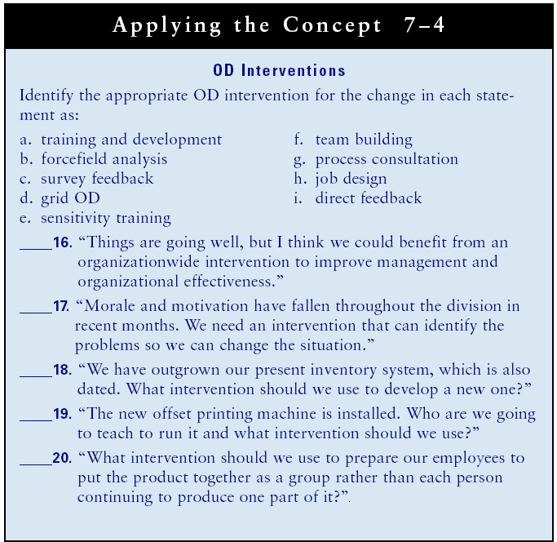

Lecture 16
Chapter 8: Human Resource Management: Staffing
Learning Outcomes
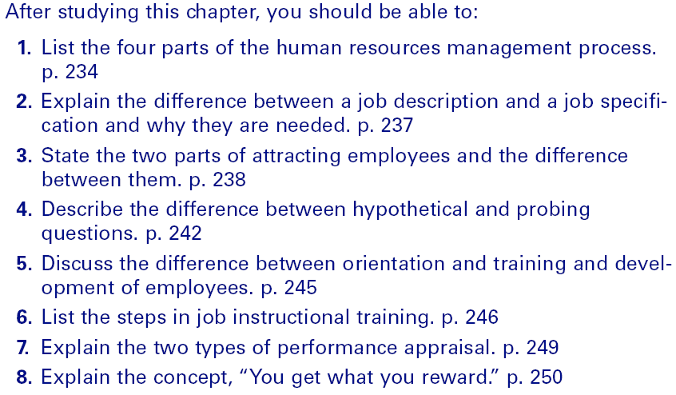
The Human Resources Management Process
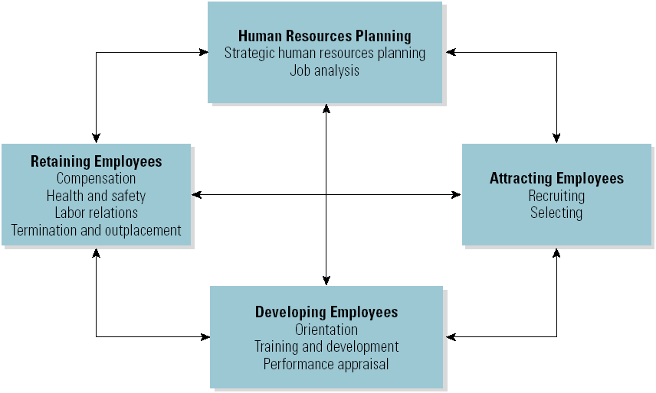
The Legal Environment
• Equal Opportunity Employment (1972)
–Civil Rights Act of 1964 amended
–Executive Orders
–Prohibits employment discrimination on the basis of sex, religion, race or color, or national origin.
–Applies to private and public organizations that employ 15 or more persons.
–Protected classes of minorities:
- Hispanics, Asians, African-Americans, Native Americans, and Alaskan natives.
- Disabled individuals and persons over 40
Pre-employment Inquires
• To avoid asking discriminatory questions:
–All questions asked applicants must be job-related.
–Any general question you ask should be asked of all candidates.
• Bona Fide Occupational Qualification
–A characteristic that an individual must possess that is directly related to performing the essential functions of the job or is a business necessity.
- Casting only females for the leading actress’s part in a play.
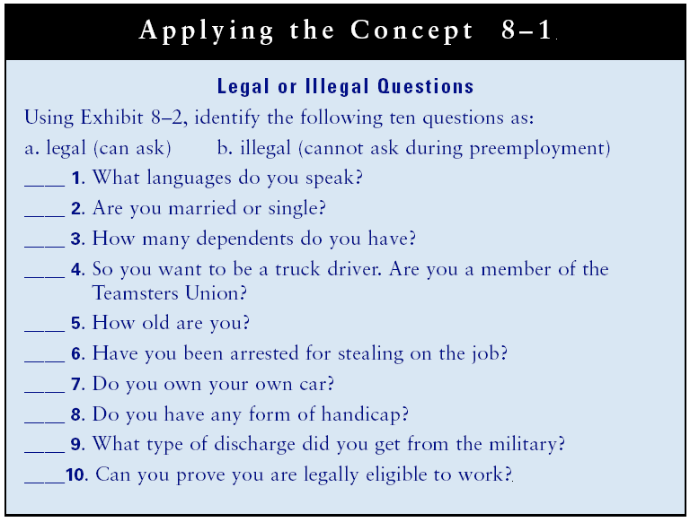
Human Resources Planning
• Strategic Human Resources Planning
–The process of staffing the organization with the number of people and skills needed to meet its objectives.
• Job Analysis
–The process of determining what a job entails and the qualifications need to fill the position.
–Job description: identifies the tasks and responsibilities of a position
–Job specification: identifies the qualifications of the individual needed to staff the position
Attracting Employees: Recruiting Sources
Recruiting is the process of attracting qualified candidates to apply for job openings.
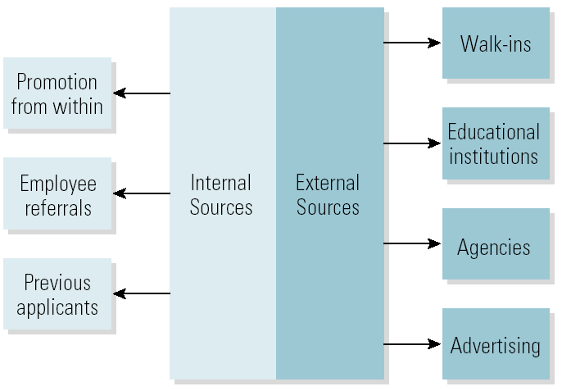

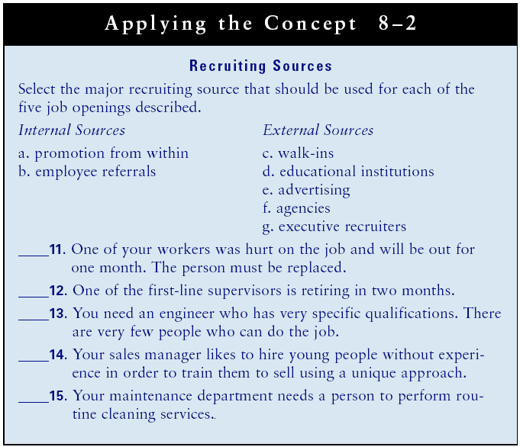
The Selection Process
1. Application form.
2. Screening interviews.
3. Testing.
4. Background and reference checks.
5. Interviewing.
6. Hiring.

Types of Interviews and Questions
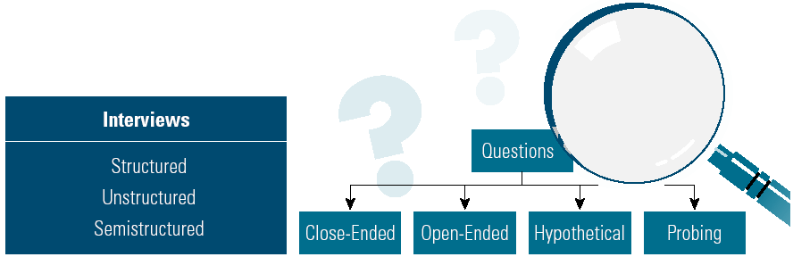

Interview Preparation Steps
1. Review the job description and specifications.
2. Plan your realistic job interview.
3. Plan the type of interview.
4. Develop questions for all candidates.
5. Develop a form.
6. Develop questions for each candidate.
Interviewing Steps
1. Open the interview.
2. Give your realistic job preview.
3. Ask your question.
4. Introduce top candidates to coworkers.
5. Close the interview.

Selecting the Candidate
• Problems to Avoid
–Rushing
–“Like me” syndrome
–Halo and horn effect
–Premature selection

Lecture 17

Developing Employees
• Orientation
–The process of introducing employees to the organization and their jobs.
• Orientation Programs:
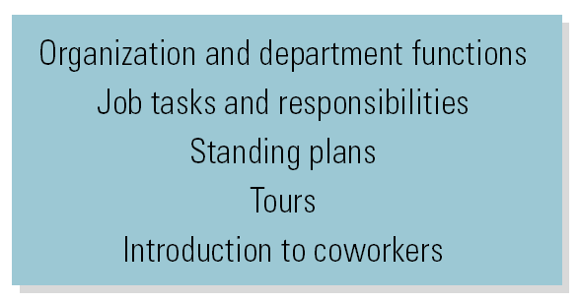
• Training
–The process of acquiring the skills necessary to do the job.
• Development
–Ongoing education to improve skills for present and future jobs.
• Off-the-Job Training
–Vestibule training develops skills in a simulated setting.
• On-the-Job Training
–Training done at the work site with the resources the employee uses to perform the job.
Job Instructional Training Steps
1. Preparation of the trainee.
2. Presentation of the task.
3. Performance of the task by the trainee.
4. Follow-up.
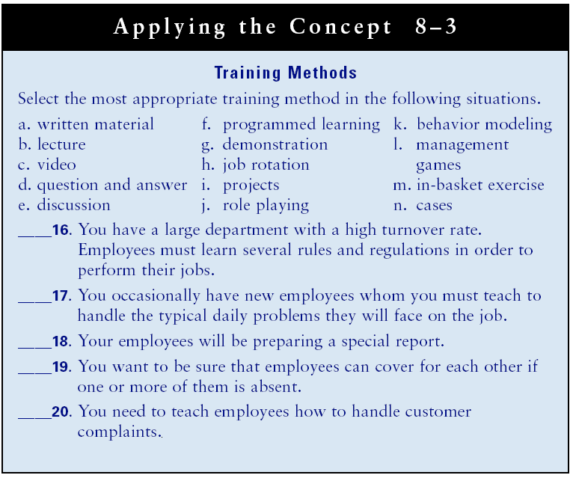

The Performance Appraisal Process
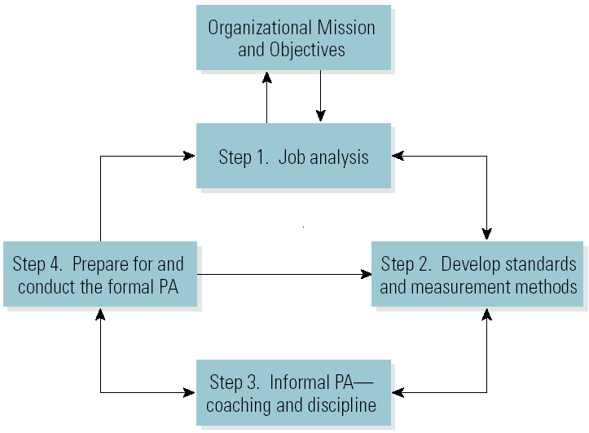
Performance Appraisal Measurement Methods

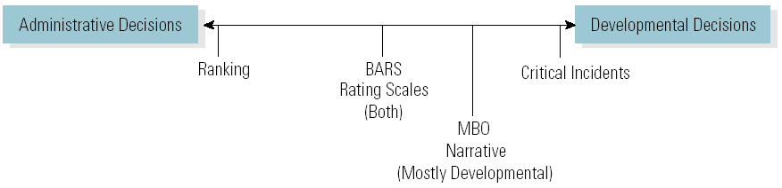

Read the TEXT
The Critical Incidents File is a performance appraisal method in which a manager keeps a written record of positive and negative performance of employees throughout the performance period.
Management by Objectives (MBO) is a process in which managers and employees jointly set objectives for the employees, periodically evaluate performance, and reward according to the results.
The Narrative Method requires a manager to write a statement about the employee's performance. The system can vary.
Managers may be allowed to write whatever they want, or they may be required to answer questions about the employee's performance. The narrative method is often combined with another method.
Behaviorally Anchored Rating Scale (BARS) is a performance appraisal method combining the rating scale and the critical incidents file. It is more objective and accurate than either method used separately. Rather than having ratings of excellent, good, average, and so forth, the form has several statements that describe the employee's performance, from which the manager selects the best one. Standards are clear when a good BARS is developed.
The Rating Scale is a performance appraisal checklist on which a manager simply rates the employee's quantity of work, quality of work, dependability, judgment, attitude, cooperation, and initiative.
Ranking is a performance appraisal method that is used to evaluate employee performance from best to worst. Under the ranking method, the manager compares an employee to other employees, rather than to a standard measurement. An offshoot of ranking is the forced distribution method, which is similar to grading on a curve. Predetermined percentages of employees are placed in various performance categories, for example: excellent, 5%; above average, 15%; average, 60~o; below average
15%; and poor, 5%.

-----------------------------------------------------------------------------------------------------

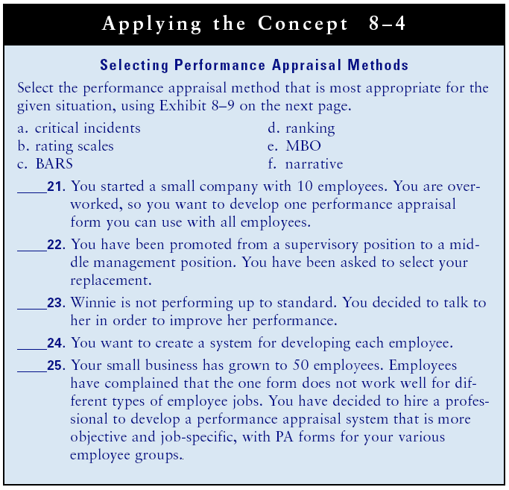

The Evaluative Performance Appraisal
Preparation for the PA Steps
1. Make an appointment.
2. Have employee perform a self-assessment.
3. Assess performance.
4. Identify strengths and areas for improvement.
5. Predict employee reactions and plan how to handle them.

The Evaluative Performance Appraisal
Conducting the PA Steps
1. Open the interview.
2. Go over the PA form.
3. Agree on strengths and areas for improvement.
4. Close the interview.
The Evaluative Performance Appraisal
is used to make administrative decisions about issues such as pay raise, transfers and promotions and demotions and terminations.
Preparation for the PA Steps
1. Make an appointment.
2. Have the employee develop objectives and plans for improving performance.
3. Develop objectives and plans for improving employee performance.

The Developmental Performance Appraisal
360 degree assessment is a term meaning that all of the people who have working relationships with the person being evaluate complete an assessment.
Conducting the PA Steps
1. Open the interview.
2. Agree on objectives.
3. Develop plans for meeting the objectives.
4. Make a follow-up appointment.
5. Close the interview.

Lecture 18
Retaining Employees
• Compensation
–The total cost of pay and benefits to employees
–Pay systems
- Wages: paid on an hourly basis.
- Salary: based on time period regardless of hours.
- Incentives: paid for performance as piece rates for production, commissions on sales, merit raises bonuses for exceeding goals, and profit sharing.
• Compensation
–Pay determination
- Externally market valuing the job on a pay level decision.
- Job evaluation is used internally to establish the relative worth of each job to other jobs in the organization.
Comparable worth is a principle that jobs that jobs that are distinctively different but then entail similar levels of ability, responsibility, skills, working conditions, and so on are capable of equal value and should have the same pay.
–Benefits
- Legally required benefits (e.g., Social security)
- Optional benefits (e.g., life insurance)

Labor Relations
• Labor Relations
–The interactions between management and unionized employees.
• Collective Bargaining
–The negotiation process resulting in a contract that covers compensation, hours, and working conditions and other issues both sides agree to.

Mediator
- A mediator is a neutral party who helps management and labor settle their disagreements. In case where management and employees are not willing to compromise but do not want to call a strike or a lockout, they may call in an arbitrator. An arbitrator is different from a mediator in that the arbitrator makes a binding decision, one to which management and labor must adhere.

• National Labor Relations Act (Wagner Act)
–Oversees the labor relations process through the National Labor Relations Board.

The Union-Organizing Process
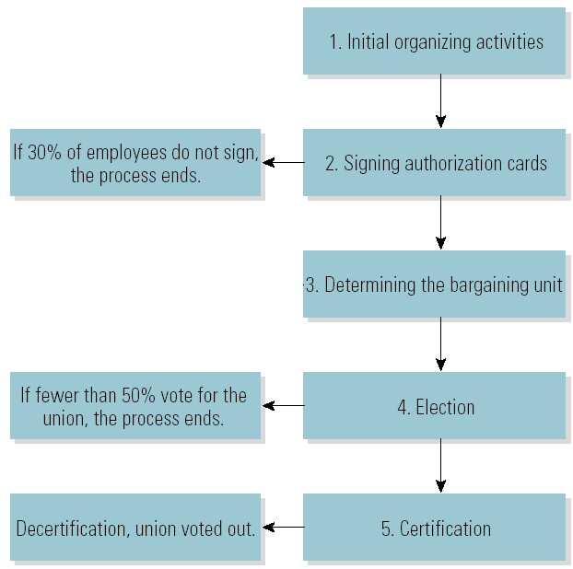

Chapter 9: Organizational Behavior: Power, Politics, Conflict, and Stress
Learning Outcomes
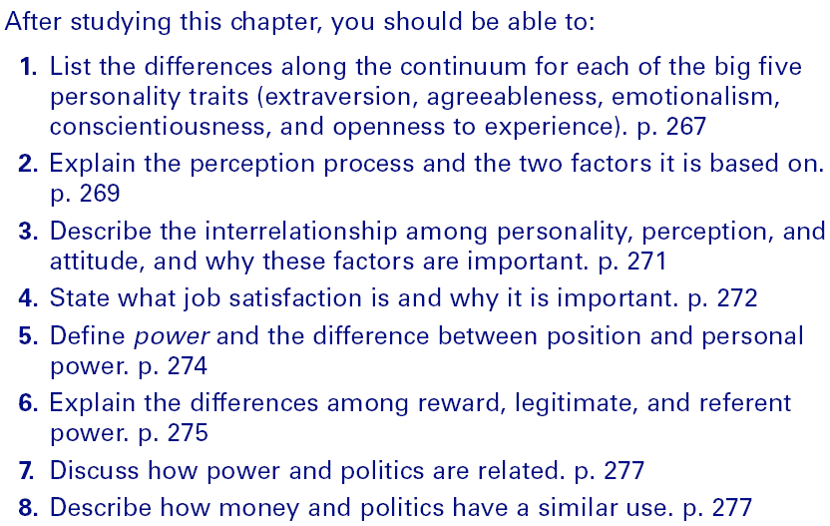

Organizational Behavior
•Organizational Behavior (OB)
–The study of actions that affect performance in the workplace.
–The goal of OB is to explain and predict actions and how they will affect performance.
–OB focuses on three levels: individual, group, and organizational.
•Win-win Situation
–A situation in which both parties get what they want.

Personality
•Personality
–A combination of traits that classifies individuals.
–Developed based on genetics and environmental factors.
–Affects the long-term performance of individuals.
Single Traits of Personality
•Locus of control
Is a trait that lies on a continuum between believing that controls over one’s destiny is external and believing that it is internal.
–External: outside forces are in control.
–Internal: individual is in control.
•Optimism versus Pessimism
- Also lies on a continuum whose opposite end is pessimism.
•Risk Propensity
–From risk taking to risk avoidance.
•Machiavellianism
–The degree to which people believe that ends justify the means and use power to get what they want. High Machs are generally considered effective in situations in which bargaining and winning is important, such as jobs involving negotiations. However, high Machs tend to be more concerned about meeting their own needs than helping the organization.
Perception
•Perception
–The process of selecting, organizing, and interpreting environmental information.
–Based on internal factors (e.g., personality) and external factors (e.g., accuracy of information).
–Self-esteem describes how individuals perceive themselves.

Big Five Personality Traits

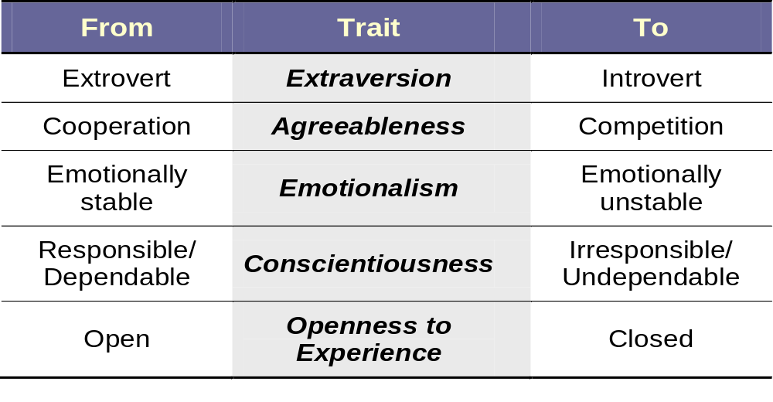

Read the TEXT
THE BIG FIVE PERSONALITY DIMENSIONS
The use of the big five personality dimensions, or traits, is the most widely accepted way to study personality. The big five are extraversion, agreeableness, emotionalism, conscientiousness, and openness to experience. Before reading about the big five, complete the Self-Assessment Personality Profile to better understand your own personality.
Extroversion
Extroversion is measured along a continuum between extrovert and introvert.
Extroverts tend to be enthusiastic, enjoy being with people, and are often perceived
as full of energy. Extroverts do well in sales and often in management. Introverts
tend to be more reserved, less outgoing, and less sociable.
Agreeableness
Agreeableness lies on a continuum between cooperative and competitive. People
who score high on this dimension are empathetic, considerate, friendly, generous,
and helpful. They also tend to be optimistic. People scoring low on agreeableness
place self-interest above getting along with others. They are usually more cautious
about other's agendas. Organizations with work teams whose members cooper-
ate with each other and compete with external organizations generally have higher
levels of performance than companies whose employees compete internally.
Emotionalism
Emotionalism lies on a continuum between stability and instability. Someone who
is emotionally stable is calm, secure, and positive, whereas an unstable person is
nervous, insecure, and negative. Stable people accept responsibility for their actions.
They don't blame others or make excuses. Workers with positive attitudes generally
perform better.
Conscientiousness
Conscientiousness lies on a continuum between responsible/dependable and irresponsible/undependable. Conscientiousness includes such elements as self-discipline, carefulness, thoroughness, organization, and deliberation (the tendency to think before acting). Employees who are high in conscientiousness tend to be hard working and more reliable than those who score low in conscientiousness.
Openness to Experience
Openness to experience lies on a continuum between being willing to try new things
and not being willing to do so. People who are open to experience tend to be intellectually curious, more creative, and more tolerant of diversity when compared to
people who are closed to experience. With today's fast rate of change, employees
who are open to experience are more valuable to an organization.

PERCEPTION
Why do some employees view a decision made by a manager as fair while others
do not? The answer often lies in perception. Perception refers to a person's interpretation of reality. It is important to realize that perceptions, right or wrong,
affect behavior and performance because behavior is the product of, or is based
on, perception. Perception is also linked to organizational politics, attitudes,
and employee turnover. 27 In this section, we discuss the perception process and
perception bias.
THE PERCEPTION PROCESS
Perception is the process of selecting, organizing, and interpreting environmental information. No two people ever perceive-and thus ever experience-anything exactly the same way. One factor that determines how you select, organize, and interpret information is your own internal environment, including your personality, self-
esteem, attitudes, intelligence, needs, values, and so on. Self-esteem, or self-concept,
is your perception of yourself. Self-esteem is a personality trait; it lies on a continuum between positive and negative or between high and low. A related concept, sel]- efficacy, is the belief in your own capability to perform in a specific situation.
A second factor that influences the perception process is the information avail-
able from the external environment. The more accurate the information that is
received, the more closely the perception may be to reality.
The Attribution Process
One factor that affects people's attitudes and expectations is their attributions.
Attribution is the process of determining the reason for someone's behavior and
whether that behavior is situational or intentional. Situational behavior is either
accidental or out of the control of the individual. A manager's response to someone
else's behavior will be determined in part by whether the manager attributes the
behavior to situational factors or intentional factors. The attribution process is
illustrated in Exhibit 8-l.
For example, suppose that Eduardo, a manager, observes an employee, Pat,
coming back to work late after lunch. If Eduardo has observed that Pat is often
late returning from lunch and that she is the only person in his department who is
late, he might conclude that Pat's lateness is intentional and that she doesn't care
about being on time. In that case, Eduardo would probably decide to discipline Pat.
However, if Pat is late only once, Eduardo might determine that her lateness was
situational-the result of car problems, traffic, or the like-and take no action.
BIAS IN PERCEPTION
Different people may perceive the same behavior differently because of perception
biases;" including selectivity, frame of reference, stereotypes, and expectations.
Selectivity
Selectivity refers to people's tendency to screen information in favor of the desired
outcome. People will sometimes make great efforts to find information that sup-
ports their point of view and ignore information that does not. In other words,
people only see and hear what they want to. This process is often referred to as
confirmation bias.
Frame of Reference
Frame of reference refers to seeing things from your own point of view. Employees
often view management decisions differently than managers do. Managers and
employees commonly use the same data during contract negotiations; however, managers perceive that employees want more pay and are not willing to increase
productivity, whereas employees perceive managers as greedy and not willing to
share the wealth that employees create. Remember that it is not your perception but
others' perceptions that will influence their behavior and performance. Try to see
things from others' perspective and create a win-win situation so that all parties get
what they want, based on their perceptions.
Stereotypes
Stereotyping is the process of making generalizations about the behavior of a group
and then applying the generalities to one individual. People form stereotypes about
race/nationality, religion, sex, age, and so forth. Stereotyping a person can lead to
perception errors, because not all individuals from a particular group possess the
same traits or exhibit the same behaviors. Negatively stereotyping an individual
can also affect that person's self-perception in a negative way.36 As a manager, try
not to negatively stereotype employees; get to know them as individuals.
Expectations
Read the phrase below:

Bird in the
the Hand
Did you read the word the twice? Or, like most people, did you read what you
expected, only one the? Many people, especially those who know each other well,
often do not really listen to each other. They simply hear what they expect to hear.

Another type of expectation is the "like me" assumption-that others perceive
things as you do because they are similar to you. Remember to value diversity. Don't
expect others to behave as you do, and don't judge others' behavior as wrong just
because it is different from yours.
How closely do you think your self-perceptions would match those of your
coworkers and family? Would you be interested in being coached so that you could
change your behavior? As suggested in the Self-Assessment Personality Profile, have
others give you their perception of your personality traits.

ATTITUDES
Attitudes are positive or negative evaluations of people, things, and situations. They are judgments and are based on perceptions. Most attitudes are the result of either
direct experience or observational learning from the environment. In this section,
we discuss how attitudes are formed and affect behavior and performance.
ATTITUDE FORMATION
Family, friends, teachers, coworkers, the mass media, and so on affect your attitude
formation. Before you signed up for this course, you may have read the course description, talked to students who completed it to find out more about the course, and
thought about your interest in the course. Based on what you read and heard and your interest in the subject, you may have started this course with a particular attitude, People generally find what they are looking for, so if VOLI had a positive attitude
coming into the course, you probably like it-and vice versa, However, attitudes can
be changed, Ha your attitude toward this course become more positive or negative?
What were the primary factors that formed your present attitude toward this course?
ATTITUDES AND BEHAVIOR
Attitudes often affect behavior. People with opposite attitudes toward a person, job,
course, event, or situation often behave differently. People’s attitudes toward you
may affect your behavior. Do you behave differently with people who like you than
with those who don't?
ATTITUDES AND PERFORMANCE
Attitude is a major factor in determining performance. 1M Both employees' attitudes
and their managers' attitudes toward them have an impact on job performance.
How Employees' Attitudes Affect Performance
Because effectiveness is based on employees' attitudes, organizations hire based on
attitude. Employers recruit employees with good attitudes because employees with
a good work attitude care about what they do. They are more goal-driven, competitive, focused, and reliable. J. W. Marriott, Jr., president of Marriott International,
stated, "We have found that our success depends more upon employee success than
any other single factor."

Nor only can employees' attitudes have an effect on their own performance, but
they can also have an effect on the performance on their coworkers, Since employees
may have to cooperate with each other, other employees may pick up on negative attitudes of coworkers and adopt them as their own. Therefore, having a positive attitude is an important determinant of both individual and organizational performance.
How Managers' Attitudes Affect Performance
The Pygmalion effect is the theory that managers' attitudes toward and expectations
and treatment of employees largely determine their performance, Various studies have
supported this theory. The basic premise of the theory is that people fulfill expectations about themselves. Thus, if managers expect employees to be productive and successful, and treat them accordingly, employees react by being productive. Conversely, if managers expect employees to be unproductive and unsuccessful, and treat them accordingly, the employees generally fulfill the expectation by not working to their potential.
Unfortunately, some managers negatively stereotype their employees as having
low ability or willingness to work. This negative attitude leads to low expectations
and not treating employees with respect. Their employees see and do as their man-
agers expect. These managers' expectations lead to the self-fulfilling prophecy of
low-performing employees. As a manager, if you create win-win situations by expecting high performance and treating employees as capable, you will get the best
performance from them.
ATTITUDES AND JOB SATISFACTION
Job satisfaction is a person's attitude toward the job, and it is generally measured
along a continuum from satisfied/ positive/high to dissatisfied/negative/low. Job satisfaction can be measured through an organizational development survey.
Job satisfaction is important because it affects employee absenteeism and turnover.
Employees with the personality traits of optimism and positive self-esteem tend to have
greater job satisfaction. Although there has long been a debate over the expression
that a happy worker is a productive worker, there is support for the idea of a positive relationship between job satisfaction and citizenship behavior-employee efforts
that go above and beyond the call of duty.43 Also, job satisfaction can affect satisfaction off the job, as people tend to take their jobs home with them, which affects their behavior."

---------------------------------------------------------------------------------
The Attribution Process
•Attribution
–The process of determining the reason for an individual’s behavior.
–Situational: out of the control of the individual.
–Intentional: individual is consciously behaving.
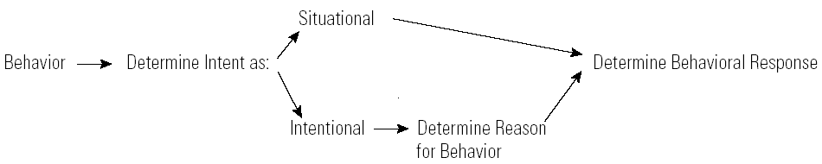

Bias in Perception
•Selectivity
–Screening information in favor of the desired outcome.
•Frame of Reference
–Seeing things from your point of view rather than another’s.
•Stereotypes
–The process of generalizing the behavior of a group to one individual.
•Expectations
–Perceiving what is expected to be perceived.
Attitudes
•Attitudes
–Persistent positive or negative evaluations of people, things, and situations.
•Attitude Formation
–Attitudes are based on perceptions.
•Attitudes and Behavior
–Attitudes reflect feelings and affect behavior.
•Pygmalion Effect
–Managers’ attitudes and expectations of employees and how they treat them largely determine employee performance.
•Attitudes and Job Satisfaction
–Job satisfaction is a person’s attitude toward his or her job.
•Job Satisfaction and Performance –Affects absenteeism and turnover.
–Doesn’t guarantee performance.
–Affects off-the-job behaviors.
•Determinants of Job Satisfaction
–Personality, the work itself, compensation, growth and upward mobility, coworkers, management

Organizational Politics
•Politics
–The process of gaining and using power.
•Political Behavior
–Networking
•The process of developing relationships for the purpose of socializing and politicking.
–Reciprocity
•Is the mutual exchange of favors and privileges to accomplish objectives.
•Involves creating obligations and developing alliances and using them to accomplish objectives.
–Coalition
•A network of alliances that will help a manager to achieve an objective.

Political Behaviors and Guidelines for Developing Political Skills
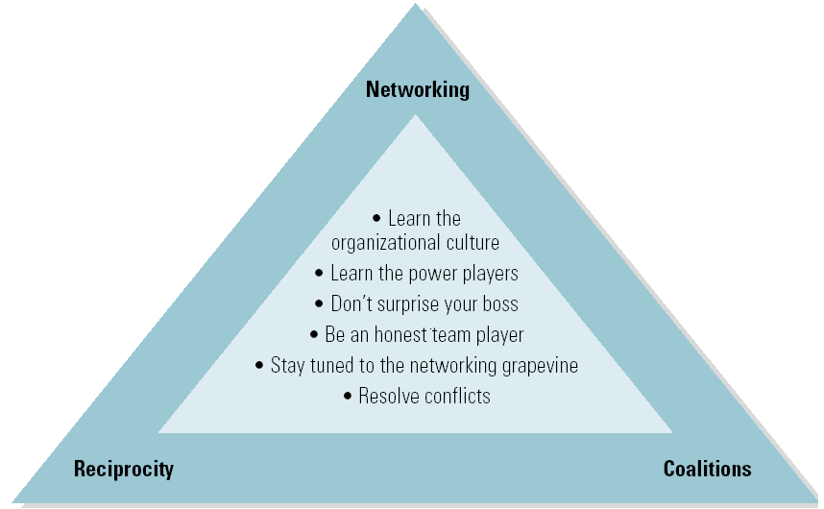

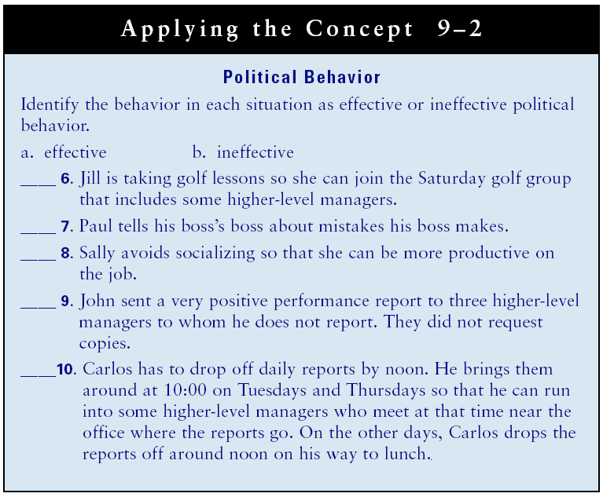

Lecture 19
Power
•Power
–The ability to influence others’ behavior.
•Position power
–Derived from top management and is delegated down the chain of command.
•Personal power
–Derived from the follower based on the individual’s behavior.
Sources and Bases of Power
•Coercive Power
–Involves threats and/or punishment to influence compliance.
•Connection Power
–Based on the user’s relationship with influential people.
•Reward Power
–Based on the user’s ability to influence others with something of value to them.
•Legitimate Power
–Based on the user’s position power given by the organization.
•Referent Power
–Based on the user’s personal power relationship with others.
•Information Power
–Based on data desired by others.
•Expert Power
–Based on the user’s skills and knowledge.
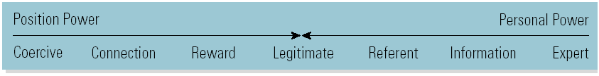

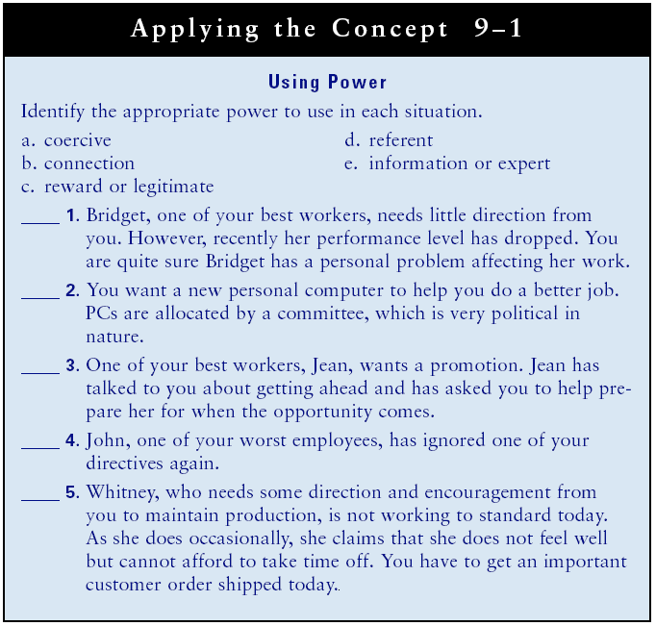

Negotiating
Negotiating is a process in which two or more parties in conflict attempt to come to an agreement.
Managing Conflict
•Conflict
–Exists whenever people are in disagreement and opposition.
•Psychological Contract
- Is composed of the implicit expectations of each party. At work, you have a set of expectations about what you will contribute to the organization and what it will provide to you.
•Functional Conflict
–Exists when disagreement and opposition support the achievement of organizational goals.
•Dysfunctional Conflict
–Exists when conflict prevents the achievement of organizational goals.
–Complacency and confrontation are both dysfunctional forms of conflict.
Conflict Management Styles
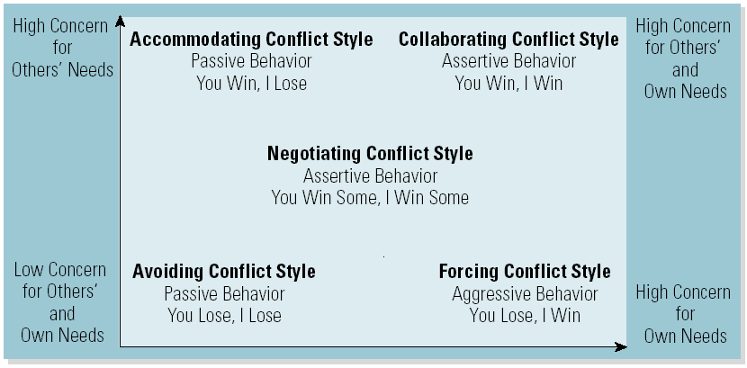

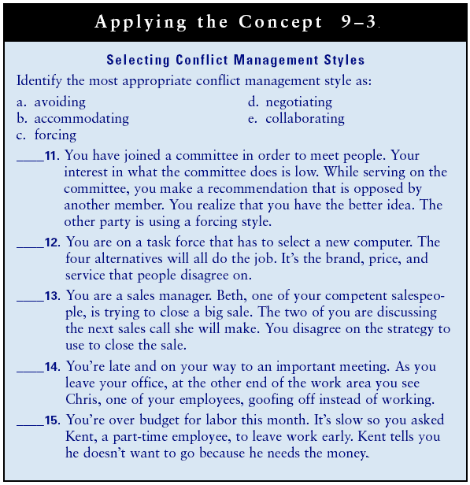

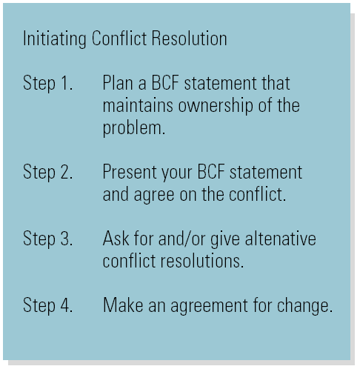
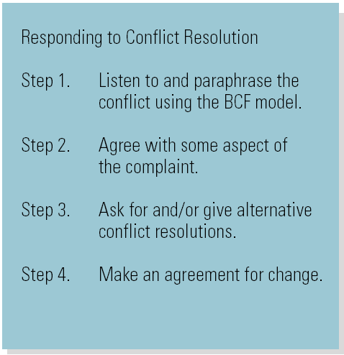
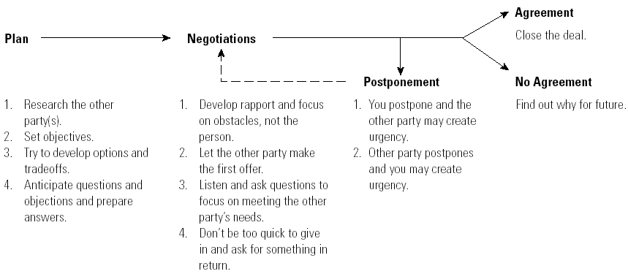
The Negotiation Process
The Negotiation Process
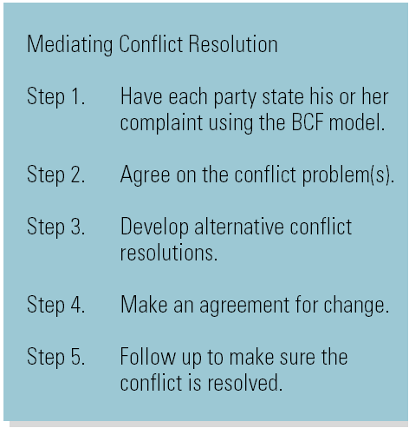

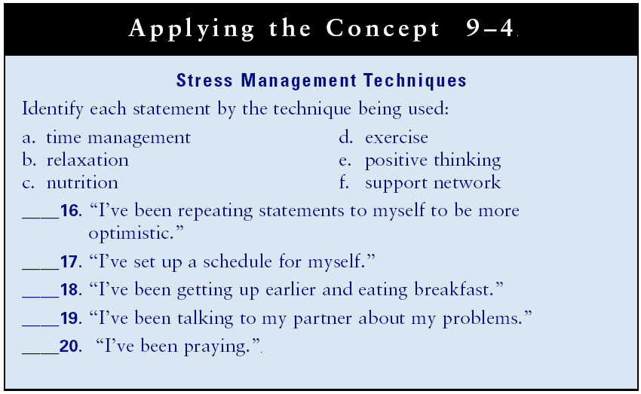
The Stress Tug-of-War
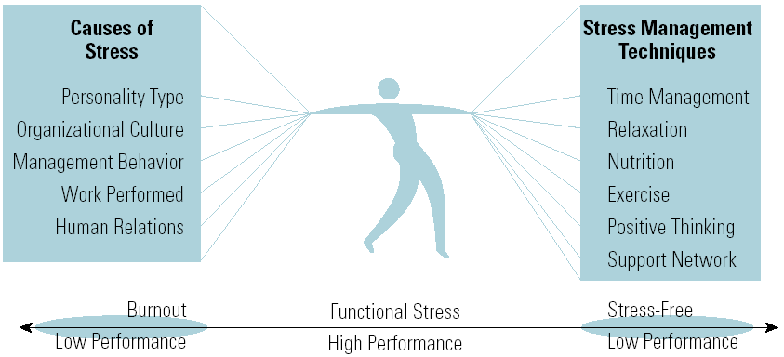

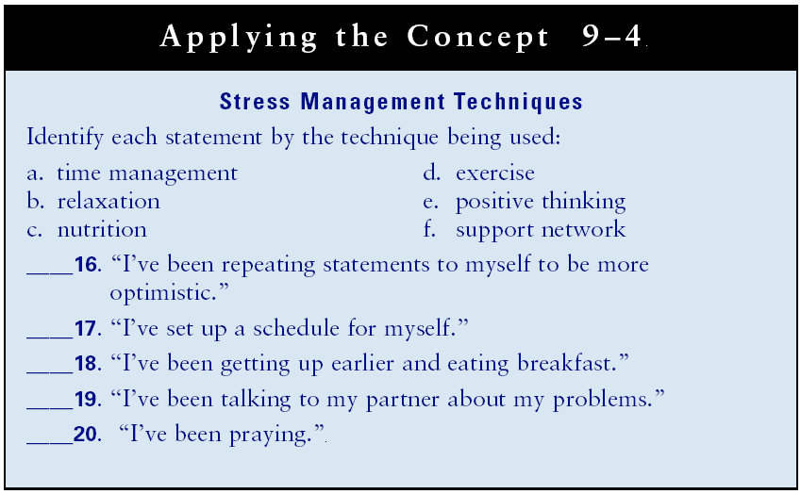

Lecture 20
Chapter 10: Team Leadership
Learning Outcomes
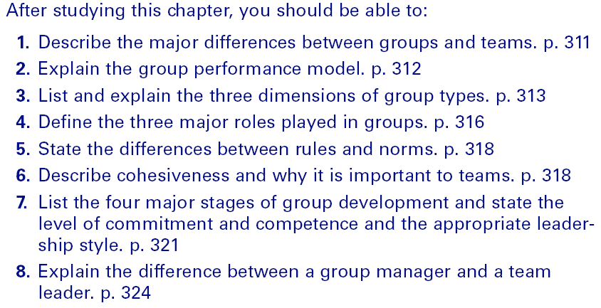
Group versus Team
•Group
–Two or more members with a clear leader who perform independent jobs with individual accountability, evaluation, and rewards.
•Team
–A small number of members with shared leadership who perform interdependent jobs with individual and group accountability, evaluation, and rewards.

Groups versus Teams
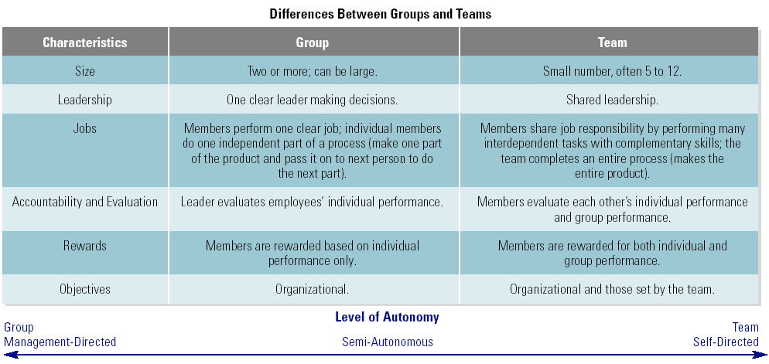

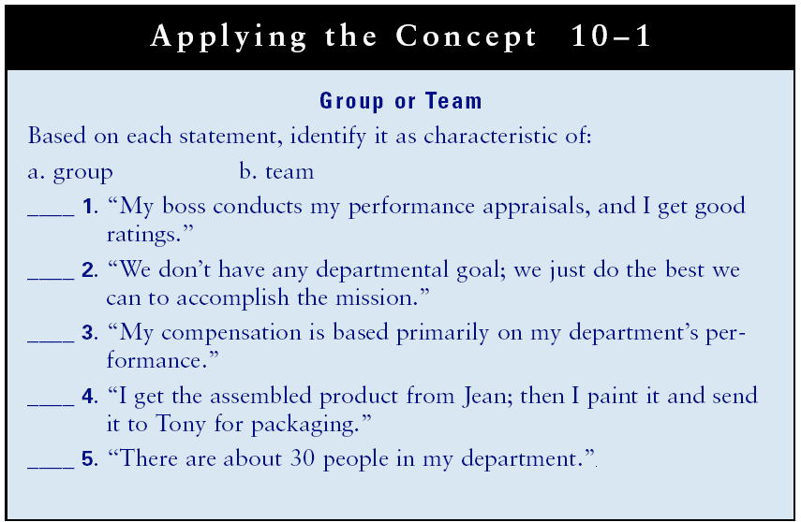

Group Performance Model
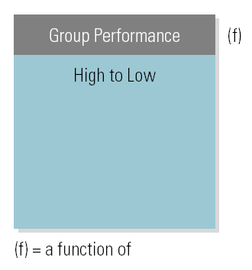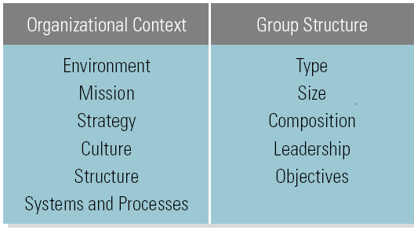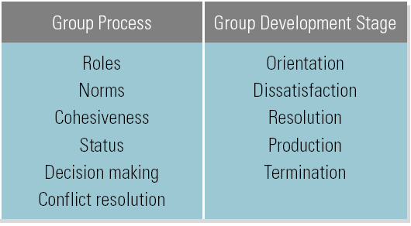

=

Group Types
•Formal
–Recognized (and established) by the organization.
•Informal
–Self-formed, not officially recognized by the organization.
•Functional Groups
–Members from a limited organizational area.
•Cross-Functional Groups
–Members from different organizational areas and/or levels.
•Command
–Consists of managers and their employees.
•Task Groups
–Consists of employees selected to work on a specific objective.
•Task Force
–Temporary group formed for a specific purpose.
•Standing Committee
–A permanent group that works on continuing organizational issues.

Functional and Cross-Functional Groups

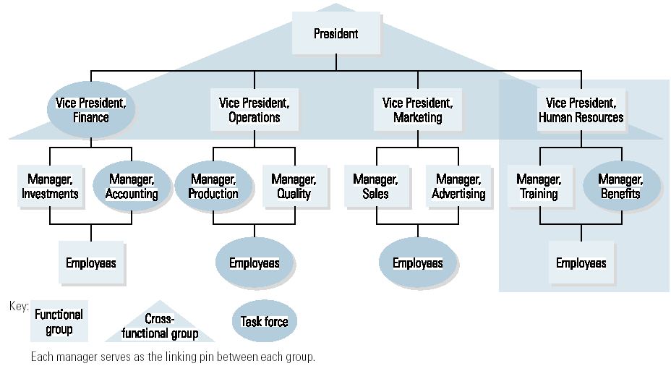

Group Structure Dimensions
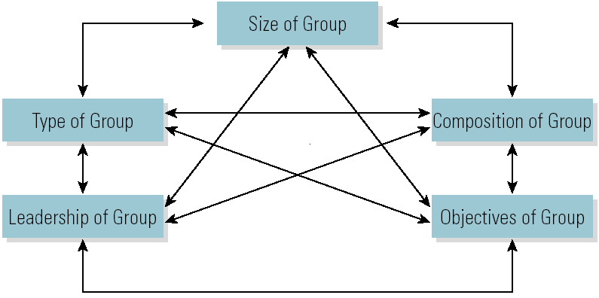
The arrows indicate the effect (or systems interrelationship) each dimension has on the others.
Group Process
•Group Process
–Refers to the patterns of interaction that emerge as members perform their jobs.
•Group Process Dimensions
–Include roles, norms, cohesiveness, status, decision making, and conflict resolution.
•Group Roles
–Task roles
•Do and say things that directly aid the accomplishment of the group’s objectives.
–Maintenance roles
•Do and say things to develop and sustain the group process.
–Self-interest roles
•Do and say things to hurt the group and help the individual.

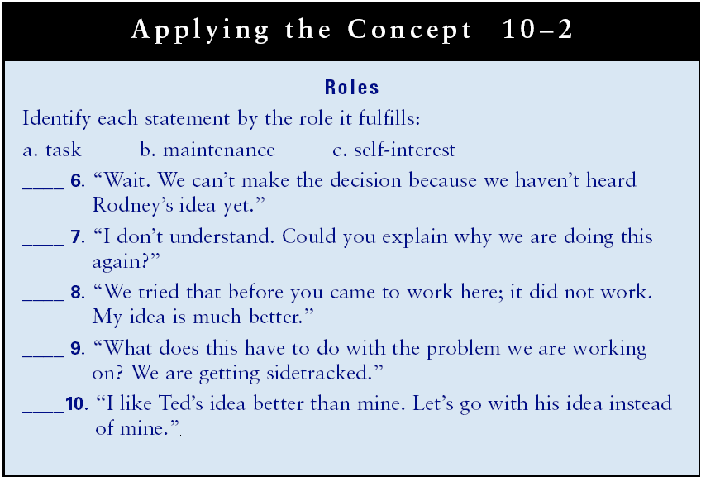

•Group Norms
–The group’s shared expectations of its members’ behavior.
–Norms develop spontaneously through the interactions of group members.
–Compliance with norms is enforced by the group.
–Leaders should work toward maintaining and developing positive norms.
•Group Cohesiveness
–The extent to which members stick together.
–Factors positively influencing cohesiveness:
  - Agreement with and commitment to objectives
  - Small size
  - Homogeneity among group members
  - Equal member participation
  - Focus on external competition
  - A successful group
-- Status within the Group
–Status is the perceived ranking of one member relative to other members in the group.
•Based on performance, job title, wage or salary, seniority, knowledge or expertise, interpersonal skills.
–High status members have a strong influence on the group and its performance.
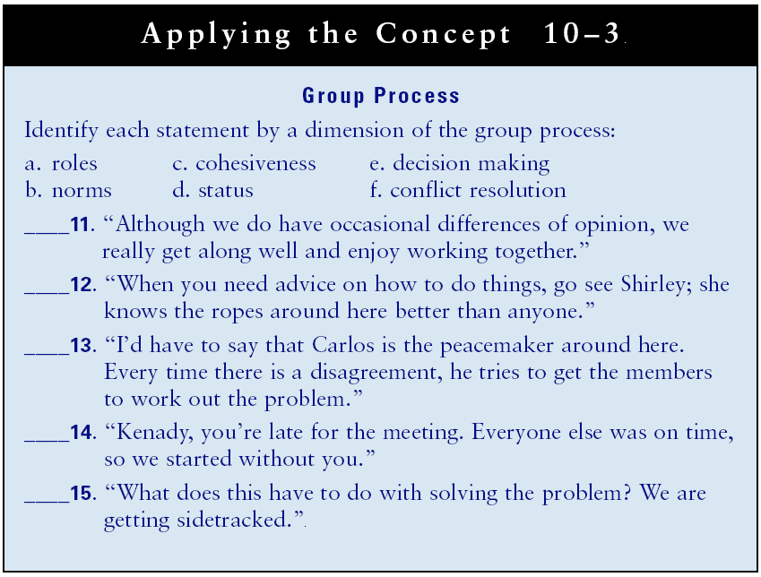

Lecture 21

Group Process Dimensions
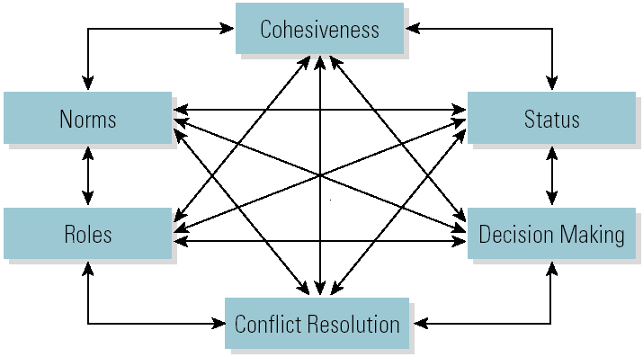
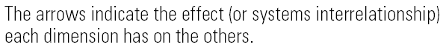

Group Development Stages and Leadership
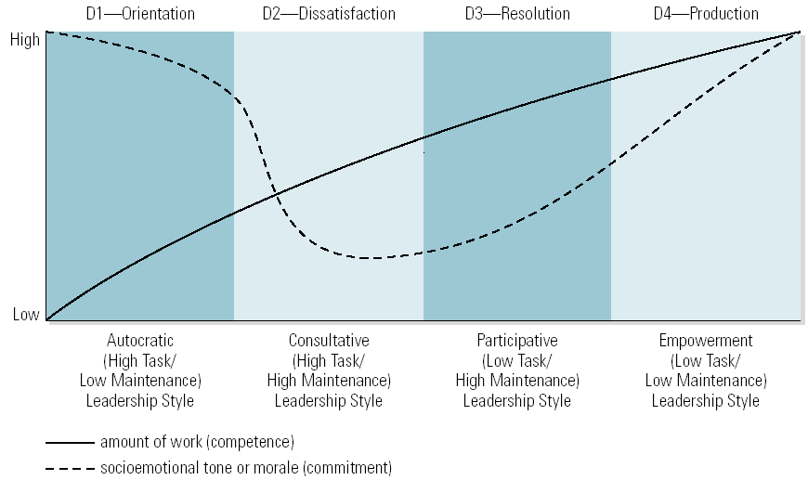

Meeting Leadership Skills
•Planning Meetings
–Objectives
–Participants and Assignments
–Agenda
–Date, Place and Time
–Leadership
–Technology

•Conducting Meetings
–Three Parts of Meetings
•Identify Objectives
•Cover agenda items
•Summarize and review assignments
Meeting Leadership Skills
•Handling Problem Members
–Silent
–Talker
–Wanderer
–Bored
–Arguer
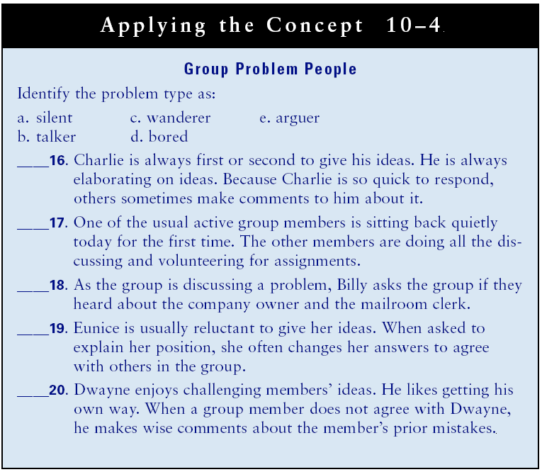

Chapter 11: Communicating for Results
Learning Outcomes
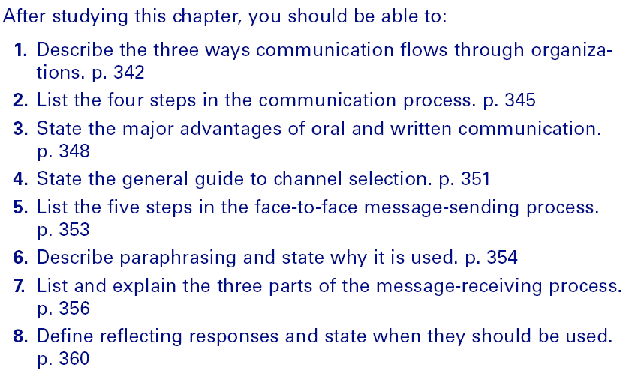

Organizational Communication
Vertical Communication
--The flow of information both downward and upward through the organizational chain of command.
Horizontal Communication
--The flow of information between colleagues and peers.
Grapevine
--The flow of information in any direction throughout the organization.

Organizational Communication: Formal Communication
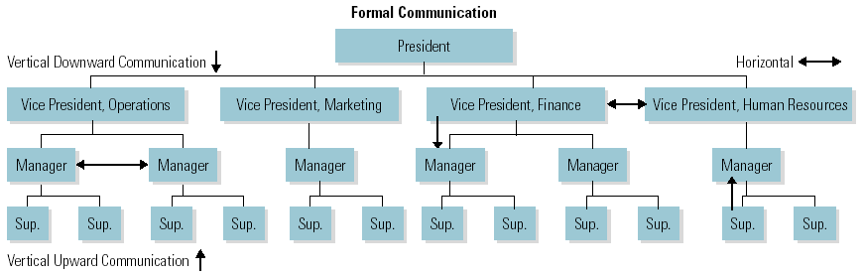

Organizational Communication: Informal Communication

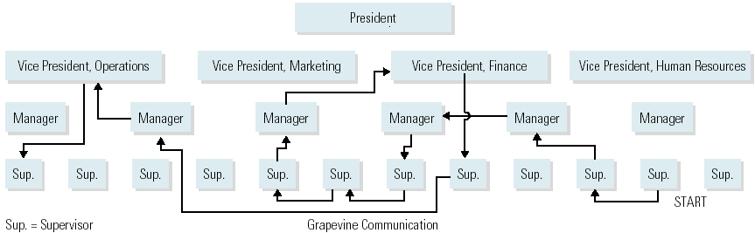

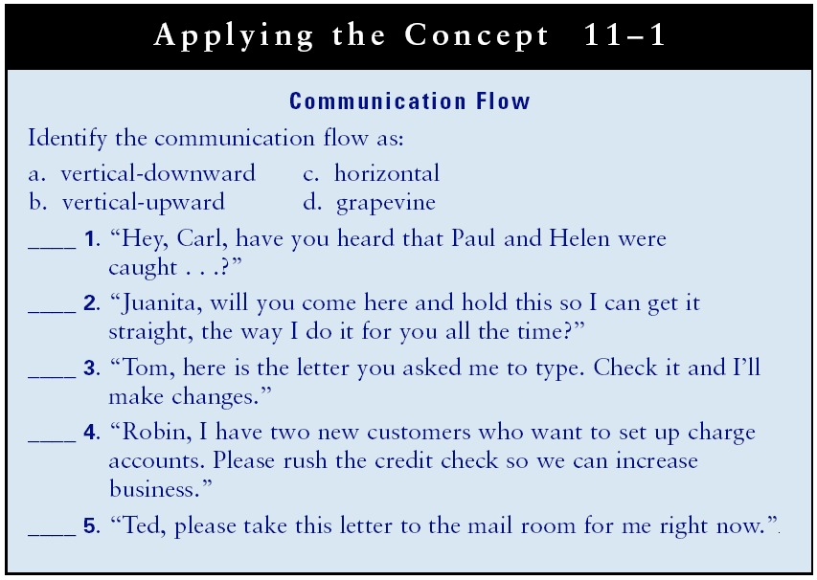

The Communication Process
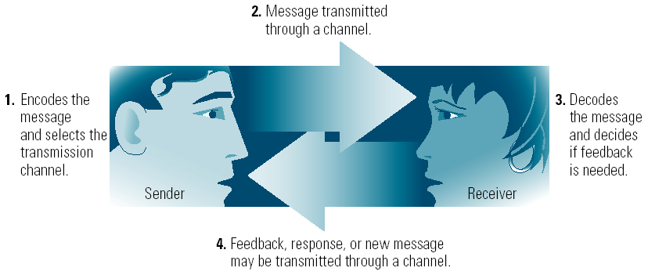
Encoding
--The sender’s process of putting the message into a form that the receiver will understand.
Communication Channels
--The three primary channels are oral, nonverbal, and written.
Decoding
--The receiver’s process of translating the message into a meaningful form.

Lecture 22
Major Communication Barriers

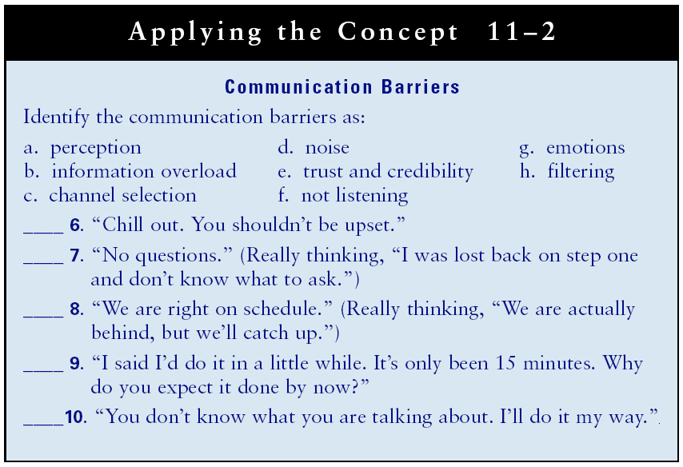

Message Transmission Channels
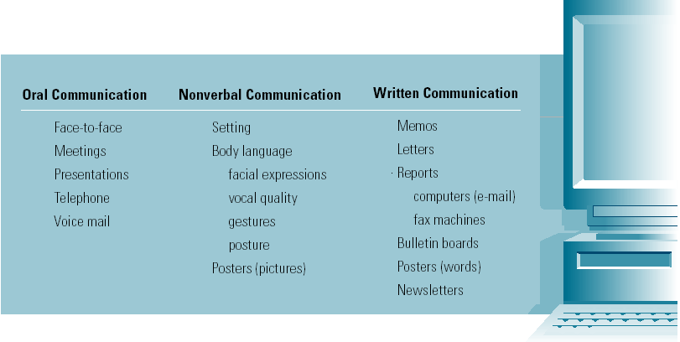
Oral Communications
Advantages
- Easier
- Faster
- Encourages feedback
Disadvantages
- Less accurate
- Leaves no permanent record
Nonverbal Communication
- Includes messages sent without words.
- Setting (physical surroundings)
- Body language
  - Facial expressions
  - Vocal quality (how said, not what said)
  - Gestures
  - Posture
Disadvantage
- Can be misinterpreted by receiver.

Written Communications
Advantages
- More accurate
- Provides a permanent record
Disadvantages
- Takes longer
- Hinders feedback

Selecting the Message Transmission Channel
Media Richness
- The amount of information and meaning conveyed through a channel.
  - Oral channels (e.g., face-to-face) are the richest channels, useful for sending difficult and unusual messages.
  - Written channels are less rich, useful for simple and routine messages.
  - Combined channels are best used for important messages that must be attended to.
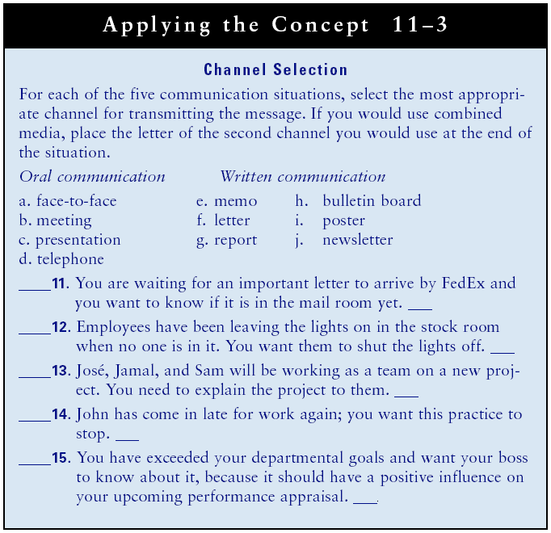

Sending Messages
- Planning the Message
- What is the goal of the message?
- Who should receive the message?
- How should the message be sent?
- When should the message be sent?
- Where should the message be sent?

The Face-to-Face Message-Sending Process
- Develop rapport.
- State your communication objective
- Transmit your message.
- Check receiver’s understanding.
- Get a commitment and follow up.

Checking Understanding: Feedback
Feedback
- The process of verifying messages.
Paraphrasing
- The process of having the receiver restate the message in his or her own words.
Feedback Problems
- Receivers feel ignorant.
- Receivers are ignorant.
- Receivers are reluctant to point out sender’s ignorance.
How to Get Feedback
- Be open to feedback
    - There are no dumb questions.
- Be aware of nonverbal communication
    - Make sure your nonverbal communication encourages feedback.
- Ask questions
    - Don’t take action before checking on message.
- Use paraphrasing
    - Check the receiver’s interpretation of your message.

The Message-Receiving Process
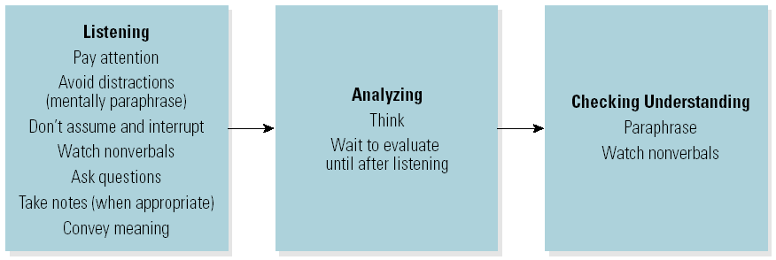

Response Styles
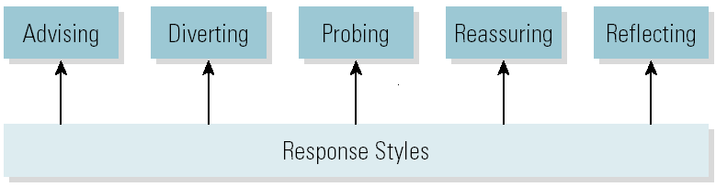
Advising
- Providing evaluation, personal opinion, direction, or instructions.
Diverting
- Switching the focus of the communication.
Probing
- Asking the sender for more information.
Reassuring
- Responding to reduce the intensity of emotions.
Reflecting
- Paraphrasing the message to indicate acceptance and understanding.
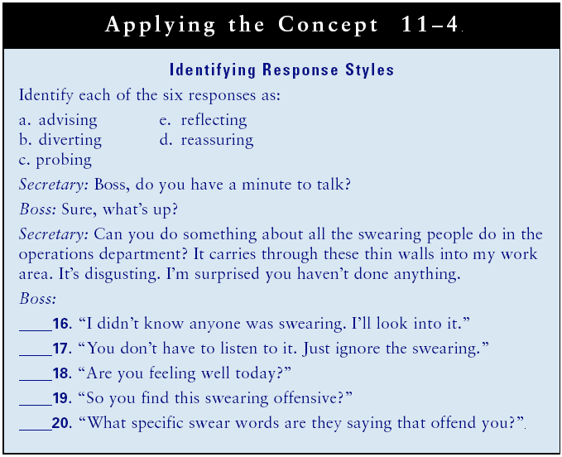

Calming an Emotional Person
Empathic Listening
- The ability to understand and relate to another’s situation and feelings.
Dealing with Emotional People
- Don’t make statements putting the person down.
- Do make reflective empathic responses.
- Paraphrase feelings.

Lecture 23

Chapter 12: Motivating for High Performance
Learning Outcomes
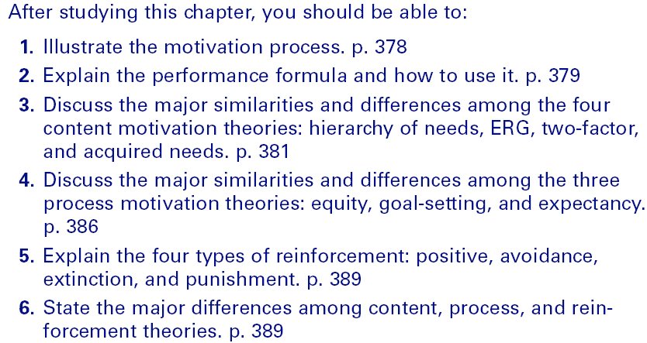

Motivation and Performance

Motivation
-The willingness to achieve organizational objectives.
Motivation Process
-Employees go from need to motive to behavior to consequence to satisfaction or dissatisfaction.

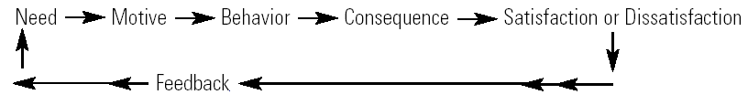

How Motivation Affects Performance
- Expectations, Motivation, and Performance
  - Self-fulfilling prophecy
    - “If you believe you can, or if you believe you can’t, then you are right”—Henry Ford
    - If you think you will be successful, then you will be.
- The Performance Formula
  - Performance = Ability x Motivation x Resources
    - For maximum performance levels, all three factors must be high.

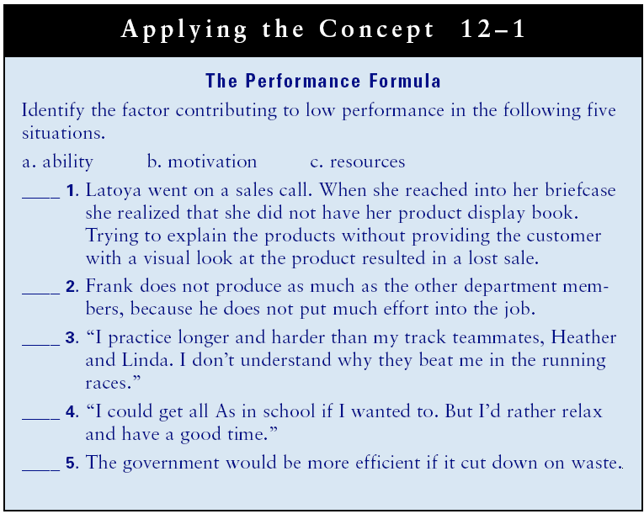

Motivation: Content Theories

Content Motivation Theories
-Focus on identifying and understanding employees’ needs.
- Hierarchy of needs theory
- ERG theory
- Two-factor theory
- Acquired needs theory

Major Motivation Theories

Maslow’s Hierarchy of Needs Theory
- Hierarchy of Needs
  - Only unmet needs motivate.
  - People’s needs are arranged in order of importance for basic to complex.
    - Satisfaction of lower level needs precedes satisfaction of higher levels needs.
- There are five classifications of needs:
- Physiological
- Safety
- Social
- Esteem
- Self-actualization
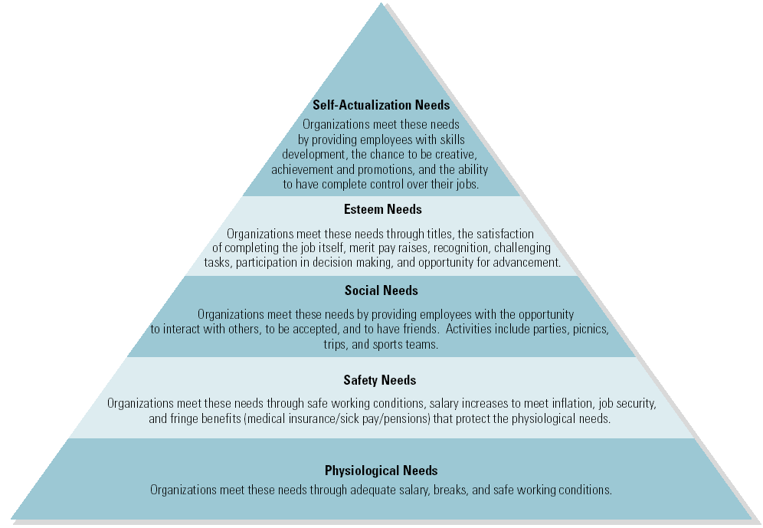

Alderfer’s ERG Theory
- ERG theory
  - Proposes that employees are motivated by three needs:
- Existence: physiological and safety needs.
- Relatedness: social needs.
- Growth: esteem and actualization.

  - Needs can be active on more than one level at the same time.
    - Starving actor: being hungry and wanting fame and fortune.

Herzberg’s Two-Factor Theory
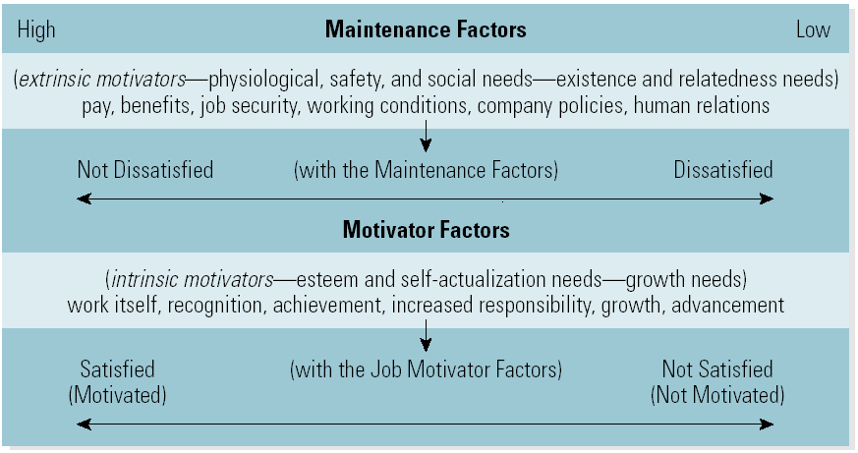

Lecture 24

McClelland’s Acquired Needs Theory
- Acquired Needs Theory
  - Proposes that employees are motivated by their need for achievement, power, and affiliation.
- Need for Achievement (n Ach): the desire for responsibility and accomplishment.
- Need for Power (n Ach): the desire to control the situation and influence others.
- Need for Affiliation (n Aff): the tendency to be liked and to seek close relationship with others.

Motivation: Process Theories
Process Motivation Theories
- Focus on understanding how employees choose behavior to fulfill their needs.
- Equity theory
- Goal-setting theory
- Expectancy theory

Adams’s Equity Theory
- Equity Theory
- Proposes that employees are motivated when their perceived inputs equal outputs.
- People compare their inputs (contributions to the organization) and outputs (rewards) to that of relevant others and conclude that they are:
- Under rewarded
- Over rewarded
- Equitably rewarded
Goal-Setting Theory
- Proposes that achievable but difficult goals motivate employees, leading to higher levels of motivation and performance.
- Goals provide an attractive challenge to high-performing individuals who have a strong need for achievement.
- Goals provide a sense of purpose—why we are working to accomplish a given task.
- Goals require action plans to achieve goals and measure progress.
Vroom’s Expectancy Theory
- Expectancy Theory
- Proposes that employees are motivated when they believe they can accomplish the task and the rewards for doing so are worth the effort.
- Motivation = expectancy x valence
  - Expectancy: the person’s perception of his or her ability to accomplish an objective.
  - Valence: the value the person places on the outcome or reward for his or her performance.
Reinforcement Theory
- Reinforcement Theory
  - Proposes that through the consequences for behavior employees will be motivated to behave in predetermined ways.

Types of Reinforcement
- Positive Reinforcement
  - Encouraging continued behavior by offering attractive consequences (rewards) for desirable performance.
- Avoidance Reinforcement (Negative Reinforcement)
  - Encouraging continued desirable behavior to avoid a negative consequence.
- Extinction
  - Discouraging undesirable behavior by withholding reinforcement when the behavior occurs.
- Punishment
  - Providing an undesirable consequence for the undesirable behavior.

Schedules of Reinforcement
- Continuous Reinforcement
  - Each and every desirable behavior is reinforced.
- Intermittent Reinforcement Schedules
  - Time-based
    - Fixed interval
    - Variable interval
  - Output-based
    - Fixed ratio
    - Variable ratio
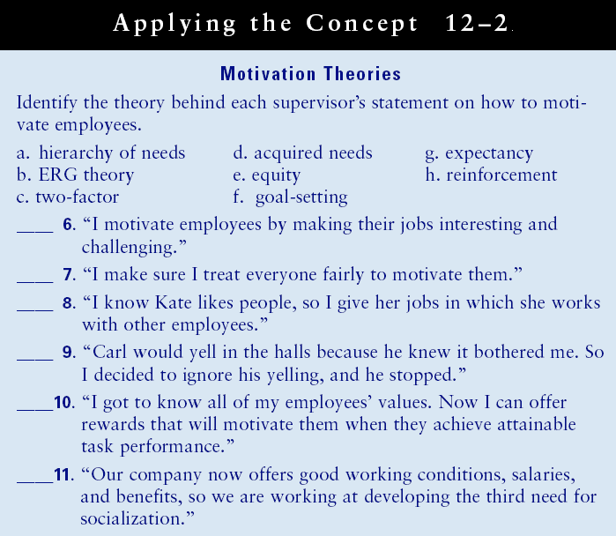

Giving Praise
1. Tell the employee exactly what was done correctly.
2. Tell the employee why the behavior was important.
3. Stop for a moment of silence.
4. Encourage repeat performance.
The Motivation Process with the Motivation Theories
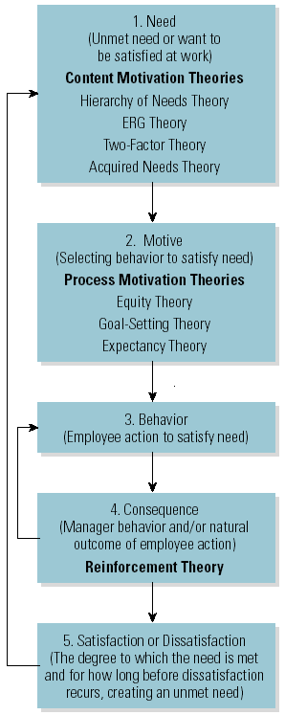
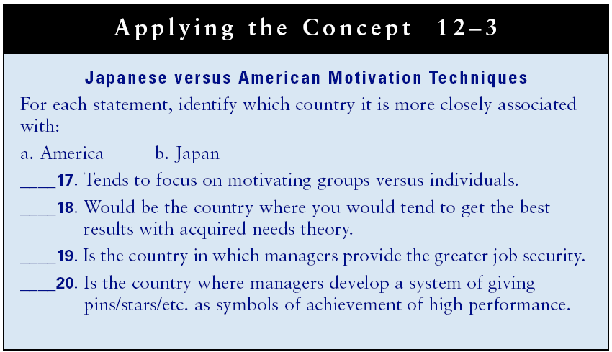
Lecture 25
Chapter 13: Leading with Influence
Learning Outcomes
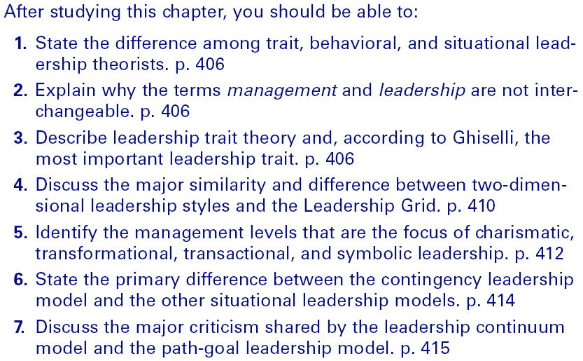

Leadership and Trait Theory
Leadership
- The process of influencing employees to work toward the achievement of organizational objectives.
Leadership versus Management
- Leadership is a functional activity incorporated with the broader scope of management activities.
- Managers lacking the ability to influence others are not true leaders.
Leadership Trait Theorists
- Attempt to determine a list of distinctive characteristics accounting for leadership effectiveness.
- Have been unsuccessful in identifying a universal set of traits that all leaders possess.
Ghiselli Study
- Concluded that certain traits are important to effective leadership; supervisory ability (getting work done through others) being the most important.
Behavioral Leadership Theorists
- Early researchers attempted to identify the “best leadership style” for all situations.
  - Attempted to determine distinctive styles used by effective leaders.
  - Eventually focused on the relationship between leaders and followers.
Leadership Style
- The combination of traits, skills, and behaviors managers use to interact with employees.
Basic Leadership Styles
Autocratic Leader
- One who makes all the decisions, tells employees what to do, and closely supervises employees.
  - Considered a Theory X-type leader.
Democratic Leader
- One who encourages employee participation in decisions, works with employees to determine what to do, and does not closely supervise employees.
  - Considered a Theory Y-type leader.
Laissez-Faire Leader
- One who takes a leave-the-employees-alone approach, allowing them to make the decisions and decide what to do.
Two-Dimensional Leadership Styles
- Based on job structure and employee consideration, which result in four possible leadership styles.
  - Structuring (of the job) and consideration (for the employee) styles (Ohio State University)
  - Job-centered (focusing on the task) and employee centered styles (University of Michigan)

The Ohio State University and University of Michigan Two-Dimensional Leadership Styles
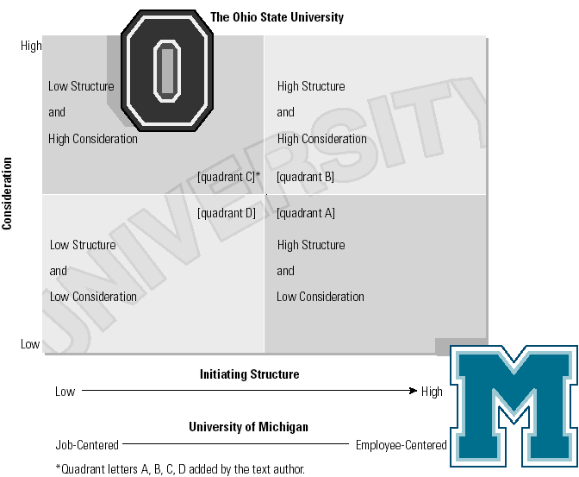

The Leadership Grid©
The Leadership Grid Model
- Identifies the ideal leadership style as having a high concern for both production and people.
Leadership Styles
- The impoverished leader (1,1)
- The authority-compliance leader (9,1)
- The country-club leader (1,9)
- The middle of the road leader (5,5)
- The team leader (9,9)

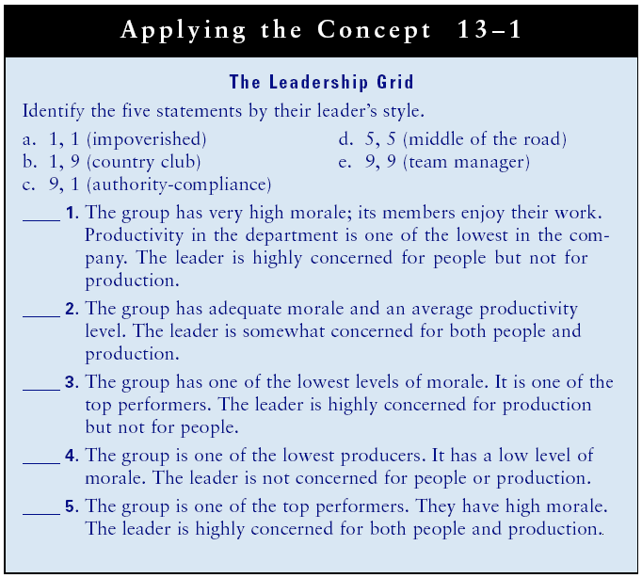

Lecture 26
Contemporary Perspectives
Charismatic Leadership
- A leadership style that inspires loyalty, enthusiasm, and high levels of performance.
Transformational Leadership
- A leadership style that brings about continuous learning, innovation, and change.
Transactional Leadership
- Based on leadership style and exchange.
Symbolic Leadership
- Based on establishing and maintaining a strong organizational culture.

Situational Leadership Theories
- Attempt to determine the appropriate leadership style for various situations.
  - Contingency leadership theory
  - Leadership continuum
  - Path-goal theory
  - Normative leadership theory
  - Situational leadership theory
  - Leadership substitutes and neutralizers
- “Should the leader change style or should the situation be changed to fit the leader’s style?”

Contingency Leadership Model (Fiedler)
Contingency Leadership
- Used to determine if one’s leadership style is task- or relationship-oriented and if the situation matches the leader’s style.
- Leadership style
  - The Least Preferred Coworker (LPC) scales measure a leader’s task (job) or relationship (employee) orientation.
- Situational favorableness
  - Leader member relations (good or poor?)
  - Task structure (structured or unstructured?)
  - Position power (strong or weak?)

Contingency Leadership Model
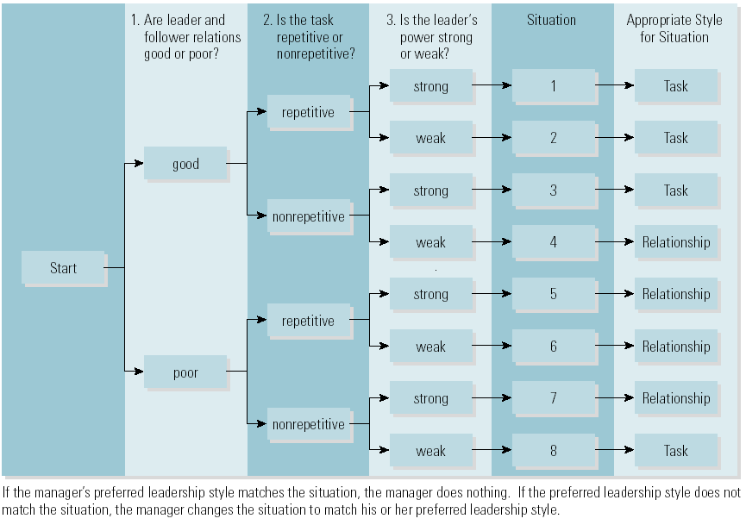

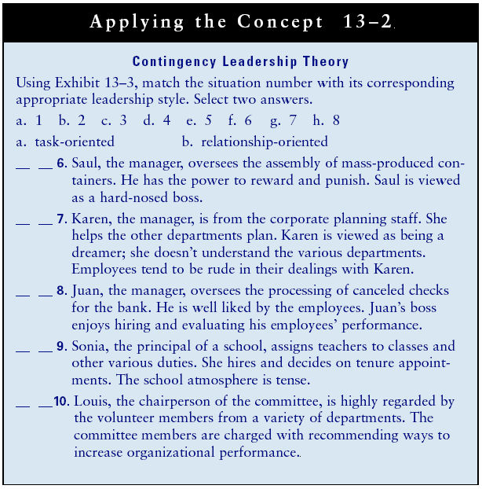
The Leadership Continuum Model (Tannenbaum and Schmidt)
- Used to determine which of seven styles to select based on one’s use of boss-centered versus employee-centered leadership.
- Factors determining selection of style:
  - The manager’s preferred leadership style
  - The subordinates’ preference for participation
  - The situation: organization’s size, structure, climate, goals, technology, and higher-level management leadership style

Leadership Continuum Model
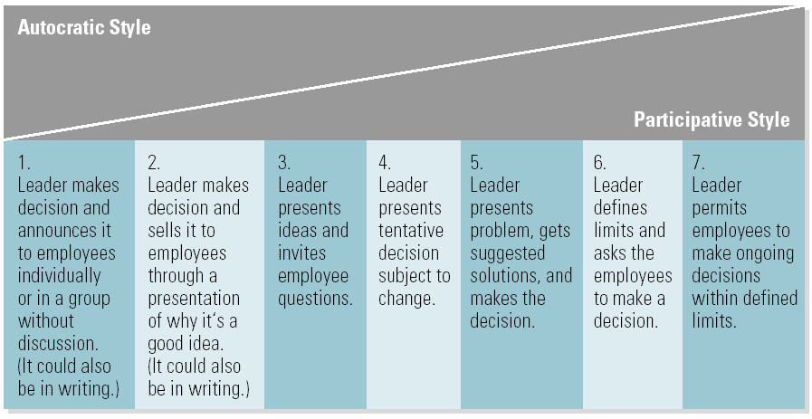
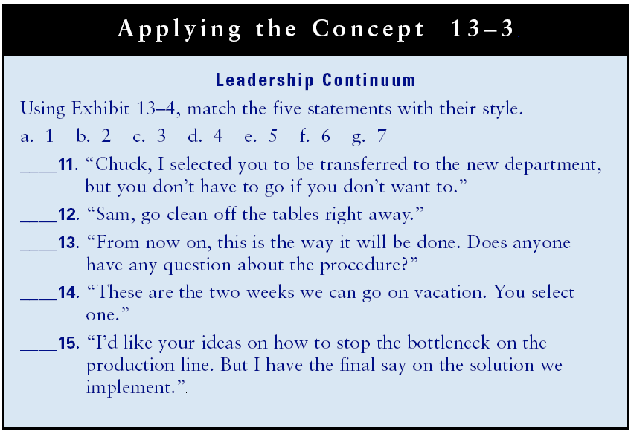

Path-Goal Model (House)
- Used to determine employee objectives and to clarify how to achieve them using one of four styles.
  - Considers subordinate factors and environmental factors in determining the appropriate leadership style that promotes goal achievement through employee performance and satisfaction.
Leadership styles
- Directive: leader provides high structure. Is appropriate when sub-ordinates want authoritarian leadership, have an external locus of control and low ability.
- Supportive: leader provides high consideration.
- Participative: employees participate in decisions.

Path-Goal Leadership Model
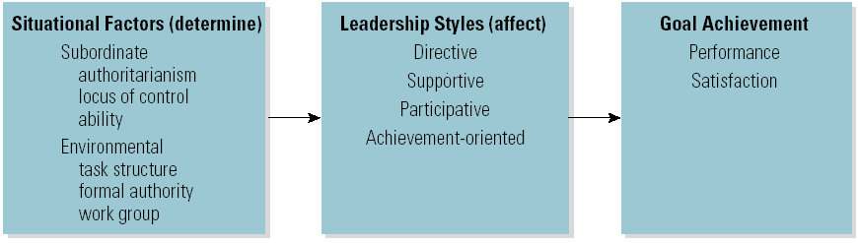

Normative Leadership Model
Normative Leadership Model (Vroom and Jago)
- A decision tree that enables the user to select one of the five leadership styles appropriate for the situation.
- Determination of leadership style is based on two factors:
- The importance of individual versus group decisions (input and participation).
- The importance of time-driven versus development-driven decisions (time-pressure and quality of decision).
Situational Leadership Model
Situational Leadership Model (Hersey and Blanchard)
- Used to select one of four leadership styles that match the employees’ maturity level in a given situation.
- Telling: high structure, low consideration (used when employee maturity is low)
- Selling: high structure, high consideration (used when employee maturity is moderate to low)
- Participating: high consideration, low structure(used when employee maturity is moderate to high)
- Delegating: low consideration, low structure(used when employee maturity is high)

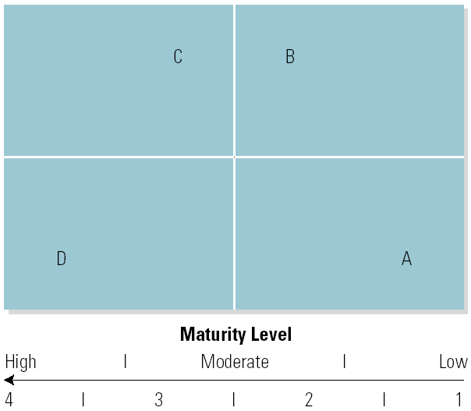

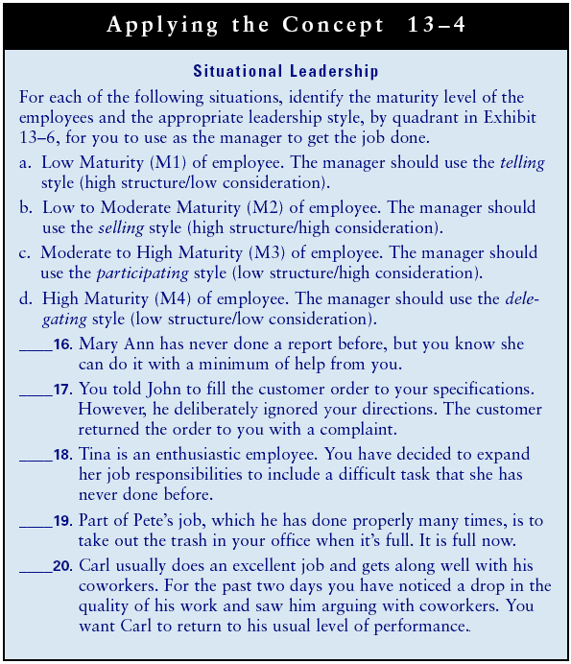
Lecture 27
Leadership Substitutes Theory
- Substitutes for Leadership
  - Characteristics of the task, subordinates, or the organization that replace the need for a leader.
  - Subordinates
    - Ability, knowledge, experience, training, independence, professional orientation, indifference to rewards
  - Task
    - Clarity and routine, methodology, feedback, intrinsic satisfaction
  - Organization
    - Formalization, flexibility, support, cohesiveness

Putting the Leadership Theories Together
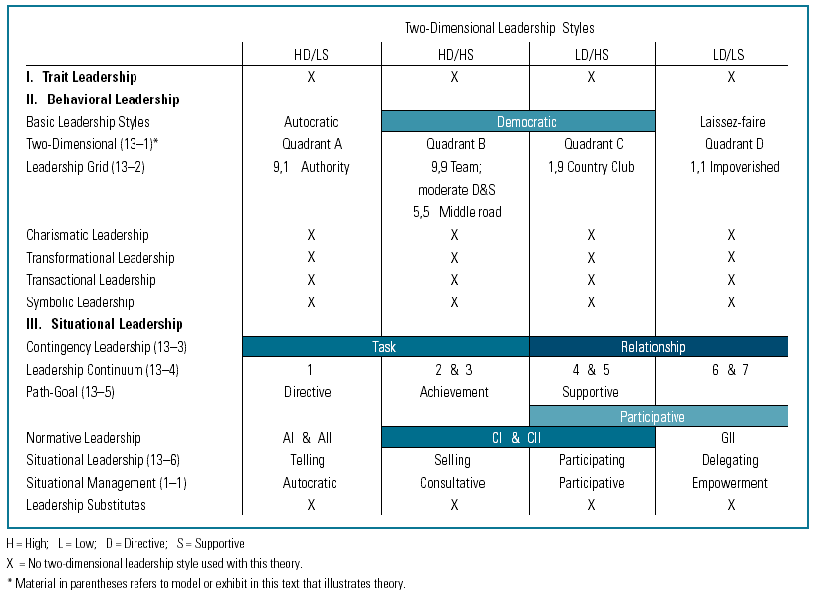

The Employee Complaint Model

The Customer Complaint Model

Chapter 14: Control Systems, Financial and Human
Learning Outcomes
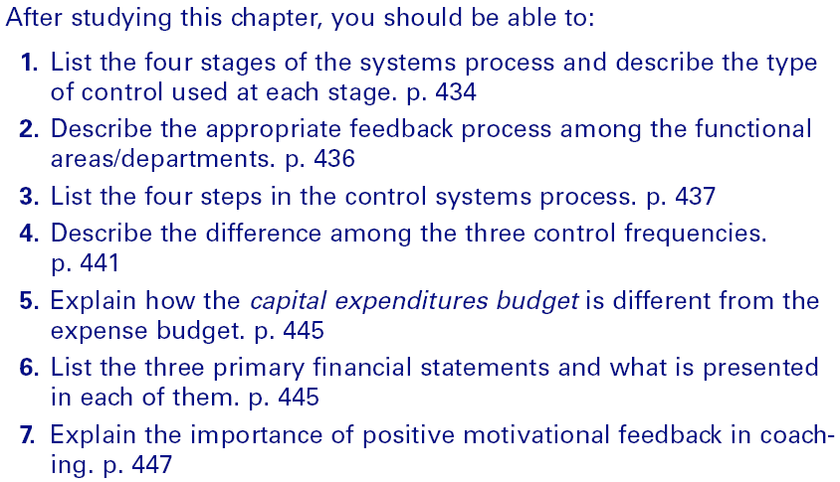

Organizational Systems Controls
Controlling
- The process of establishing and implementing mechanisms to ensure that objectives are achieved.
Preliminary Controls (Feed forward Controls)
- Controls designed to anticipate and prevent possible problems.
- Planning and organizing are important control functions.
  - Standing plans
  - Contingency plans
Concurrent Controls
- Action taken as inputs are transformed into outputs to ensure that standards are met.
Rework Controls
- Action taken to fix an output.
Damage Controls
- Action taken to minimize negative impacts on customers/stakeholders due to faulty outputs.
Feedback
- Information about outputs from customers and stakeholders.

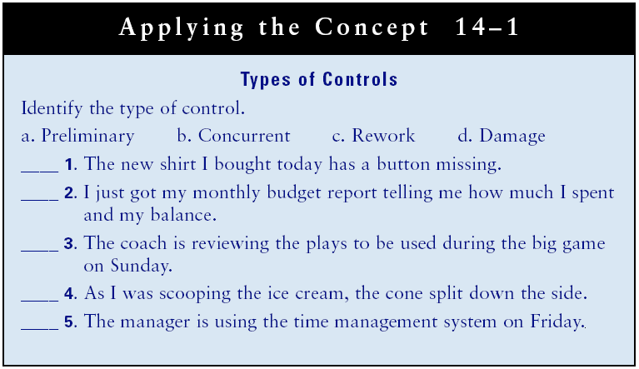

Systems Processes for Functional Controls
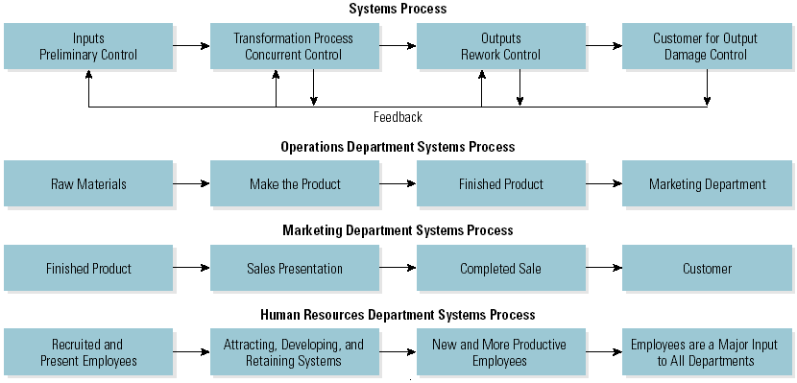

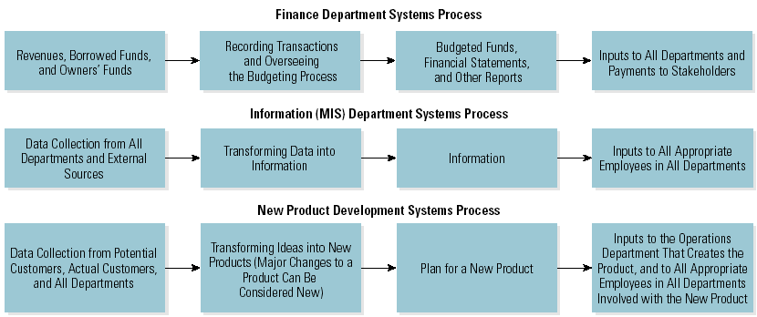

The Feedback Process Among Functional Areas/Departments

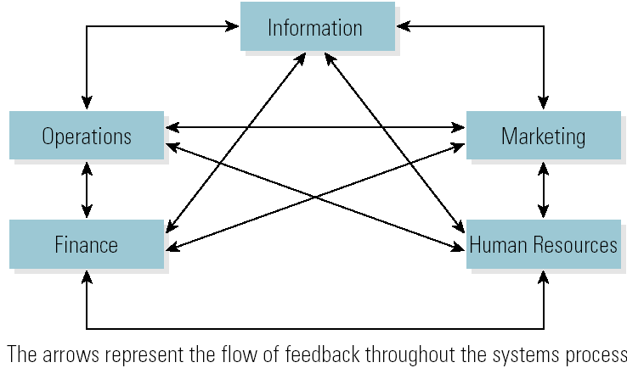

Lecture 28
The Control Systems Process

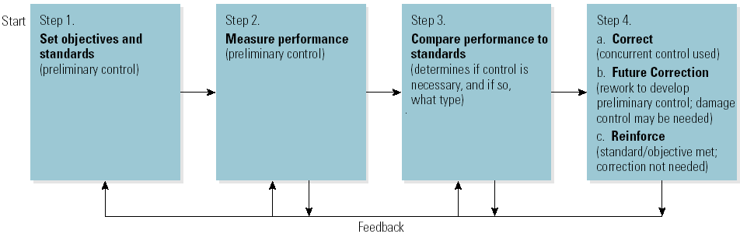

Operations Performance Report
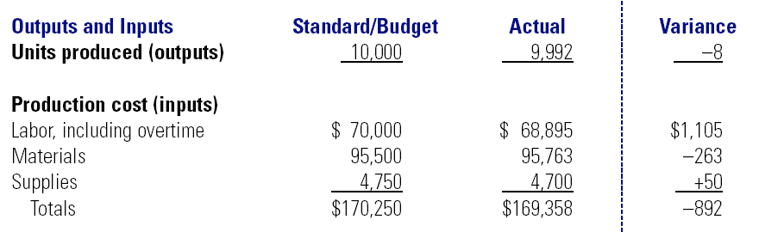
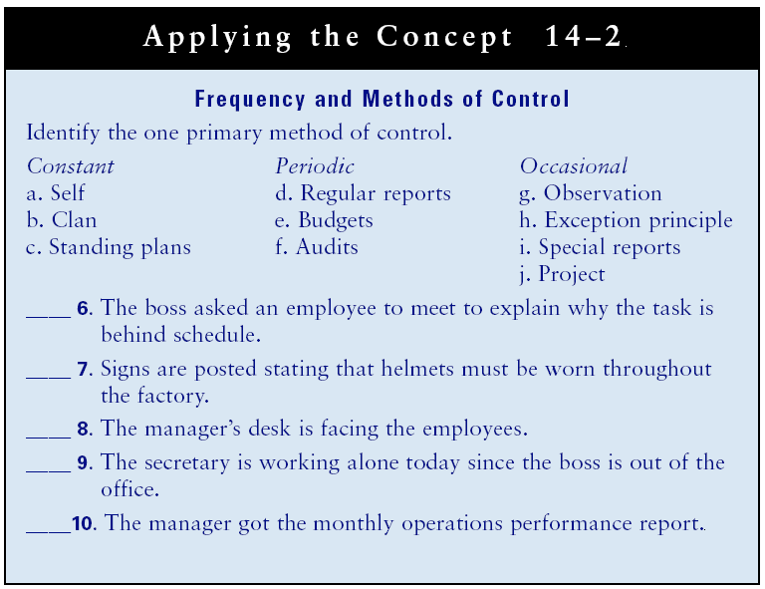
Types and Frequency and Methods of Control
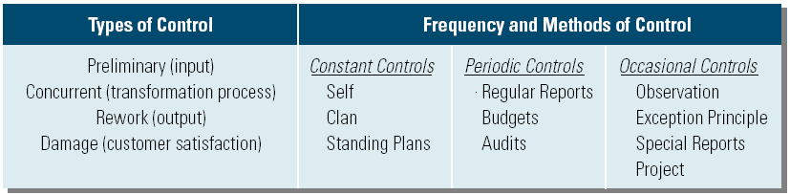
Read the TEXT
Controls are needed to accomplish organizational objectives.?" There are ten
specific methods you can use to measure and control performance. These ten
methods fall into three categories of control frequency : constant. periodic, and
occasional.

Constant Controls

Constant controls, which are in continuous use, include self-control, clan control,
and standing plans.

- Self-control. If managers are not watching or somehow monitoring' performance,
will employees do the job? The real issue is the degree of self-control employees
are given versus control imposed by managers (such as standing plans). Too much
or too little imposed control can cause problems."

- Clan control. Clan, or group, control is a form of human resources control in
which the organization relies heavily on its culture and norms to ensure specific
behaviors through peer pressure. Organizations that use teams tend to rely on
clan control" Self- and clan control are used in all phases of the systems process,
with preliminary, concurrent, rework, and damage control.

- Standing plans. Policies, procedures, and rules are developed to influence
employees' behavior in recurring, predictable situations (Chapter 3).29 Standards
are similar to standing plans that are in constant use. When standing plans and
standards are developed, they are preliminary controls. When standing plans
and standards are implemented, they become concurrent, rework, or damage
controls.

Periodic Controls

Periodic controls are used on a regular, fixed basis, such as once per hour or day,
every week, or at the end of the month, quarter, or year. Periodic controls include
regular meetings and reports, budgets, and audits.

- Regular meetings and reports. Regular reports can be oral or written. Regularly scheduled meetings with one or more employees to discuss progress and any problems are common in all organizations. These meetings may be scheduled daily, weekly, or monthly. Regular reports are designed as preliminary control. But the report itself is used as concurrent, rework, or damage control, depending on the situation.
Budgets. Budgets are one of the most widely used control tools: We discuss budgeting details in the next section of this chapter. The preparation of a new budget is a preliminary control. As the year progresses, the budget becomes a concurrent control. At year end, it is reworked for the next year. A budget may require damage control if significant changes, such as overspending, take place for some reason, such as an increase in final cost.
- Audits. There are two major types of audits: accounting and management. Part of the accounting function is to maintain records of the organization's transactions and assets. Most large organizations have an internal auditing person or department that checks periodically to make sure assets are reported accurately and to keep theft at a minimum."! In addition to performing internal audits, many organizations hire a certified public accounting (CPA) firm to verify the organization’s financial statements through an external accounting audit. The management audit analyzes the organization's planning, organizing, leading, and controlling functions to look for improvements. The analysis focuses on the past, present, and future. The management audit can be conducted both internally and externally.

Audits may also serve as occasional controls when used sporadically; for example, auditors may make unannounced visits at irregular intervals. The audit is designed as a preliminary control, but it is used to ensure accurate record keeping and to control theft.

The audit control system is used to ensure that accurate records are kept of
financial transactions, to protect employees, stockholders, and the public. Unfortunately, at Enron the internal audit did not stop Enron employees from overstating income and understating expenses.
Queuing Theory
Queuing theory focuses on waiting time. An organization can have any number of
employees providing service to customers. If the organization has too many employees working at one time. not all of them will be waiting on customers and money
paid to them is lost. If the organization has too few employees working at one time,
it can lose customers who don't want to wait for service, which results in lost revenue. Queuing theory, which helps the organization balance these two costs, is used
by retail stores to determine the optimum number of checkout clerks, by airports
to determine the optimum number of takeoffs and landings on runways. and by
production departments to schedule preventive maintenance on equipment. Kaiser
Permanente uses queuing theory to help doctors' offices reduce waiting times for
patients.

Probability Theory
Probability theory enables the user to make decisions that take into consideration
conditions of risk. The user assigns a probability of success or failure to each alternative. The user then calculates the expected value, which is the payoff or profit from each combination of alternatives and outcomes. The calculations are usually done on a payoff matrix by multiplying the probability of the outcome by the benefit or cost. Probability theory is used to determine whether to expand facilities and to what size, to select the most profitable investment portfolio, and to determine the amount of inventory to stock. You could use it to choose a job. Using probability theory, hedge fund investors are providing movie financing to major film studios such as Walt Disney Company and Sony Corporation's Sony Pictures Entertainment and are using computer-driven investment simulations to pick movies with the right characteristics to make money.

THE KEPNER- TREGOE METHOD

The Kepner-Tregoe method combines the objective quantitative approach with some
subjectivity. The subjectivity comes from determining "must" and "want" criteria
and assigning weighted values to them. As you read earlier in the chapter, "must"
criteria are those attributes that an alternative solution must have if it is to be considered. "Want" criteria are attributes that make an alternative solution more attractive; they are desirable but not essential. Absence of certain "want" criteria does not cause an alternative to be eliminated.

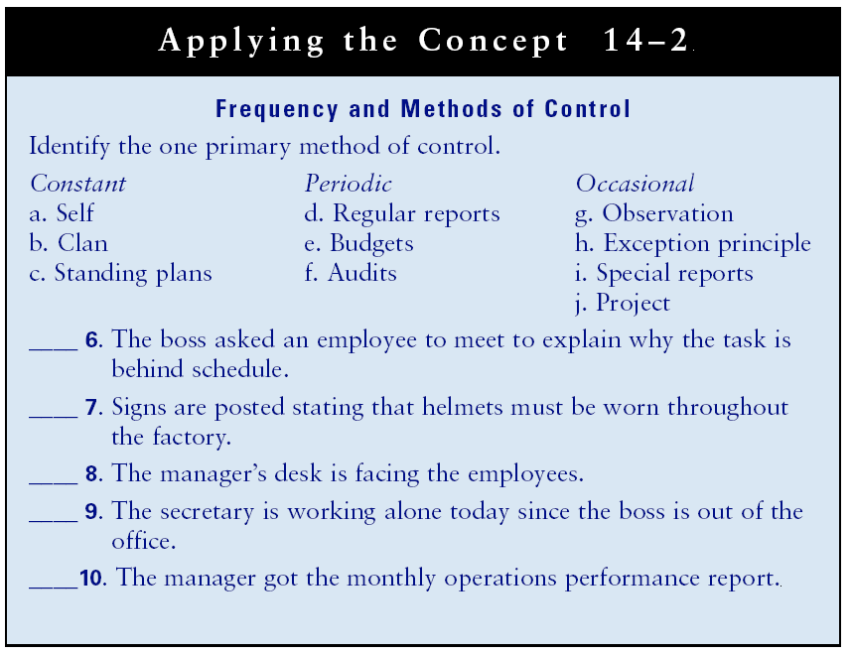

The Master Budgeting Process
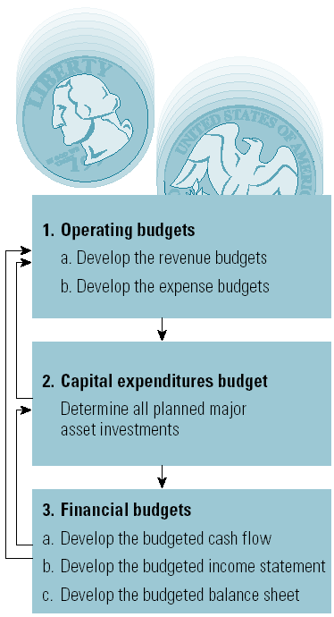

Budgeting
Budget
- A planned quantitative allocation of resources for specific activities.
Operating Budget
- Revenue budget
  - Forecast of total income for the year.
- Expense budget
  - Forecast of total operating spending for the year.
Capital Expenditure Budget
- All planned expenditures for major asset investments.

Financial Statements
Income Statement
- Presents revenues and expenses and the profit or loss for the stated period of time.
The Balance Sheet
- Presents the assets and liabilities and owners’ equity for the stated period of time.
Cash Flow Statement
- Presents the cash receipts and payments for the stated time period.

Financial Statement
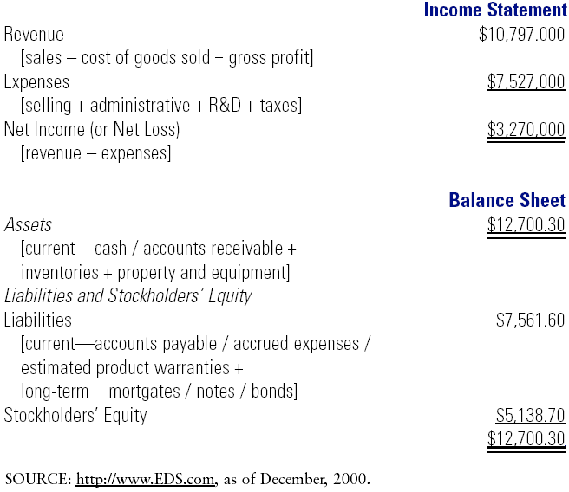
Lecture 29
Human Controls
Coaching
- The process of giving motivational feedback to maintain and improve performance.
Management by Walking Around (MBWA)
- Listening rather than talking
- Teaching rather than telling
- Facilitating rather than ordering
Counseling
- Dealing with problem employees by attempting to help solve the problem.
Management Counseling
- Giving employees feedback so they realize that a problem is affecting their job performance.
- Referring employees with problems to employee assistance programs.
Employee Assistance Program (EAP)
- A staff of people who help employees get professional assistance solving their problems.

Coaching Model

Disciplining
Discipline: Corrective action to get employees to meet standards and standing plans.
- To change ineffective employee behavior.
- To let employees know that action will be taken when standing plans or performance requirements are not met.
- To maintain authority when challenged.
Progressive discipline steps
- Oral warning, written warning, suspension, and dismissal.
- Documentation must be maintained.

Problem Employees
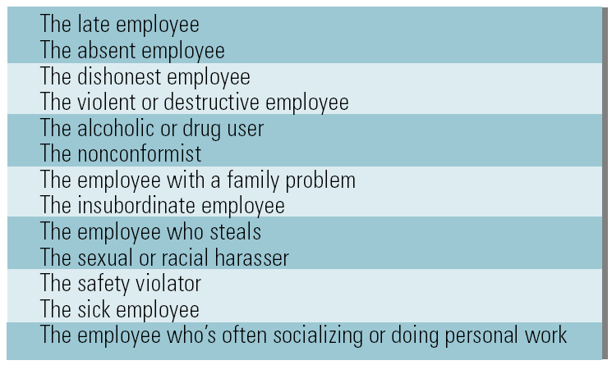

The Discipline Model

Guidelines for Effective Discipline
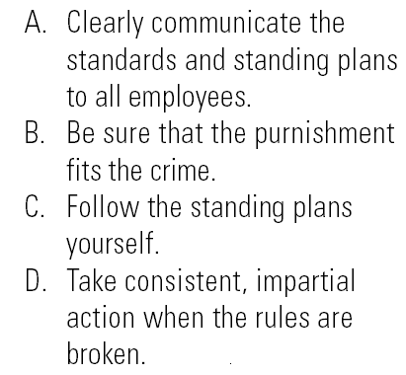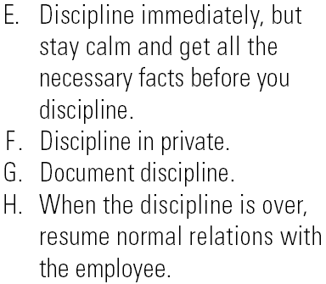

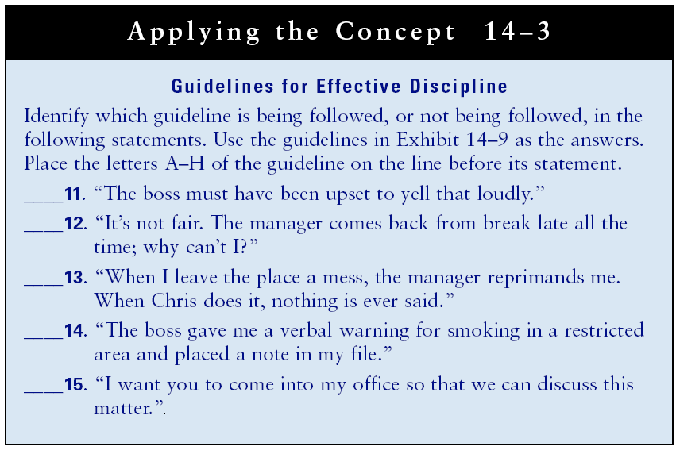

Productivity
Productivity: A performance measure relating outputs to inputs.
- Units produced, labor hours per unit, workers per total output, cost of labor, cost of material, machine hours
Calculating Productivity
- Select a base time period.
- Determine output for time period.
- Select all inputs or a single input factor.
- Divide the output by the input factor to determine the productivity rate.
Calculating Productivity Percentage Change
- Determine productivity rate for the base period.
- Determine productivity rate for the current period.
- Subtract the base rate from the current rate.
  - If the difference is positive, productivity has increased; if negative, productivity has decreased.
- Divide the difference by the current rate to calculate the percentage of change.
Production versus Productivity
- Production can rise and productivity can fall due to increased operational costs for higher output.
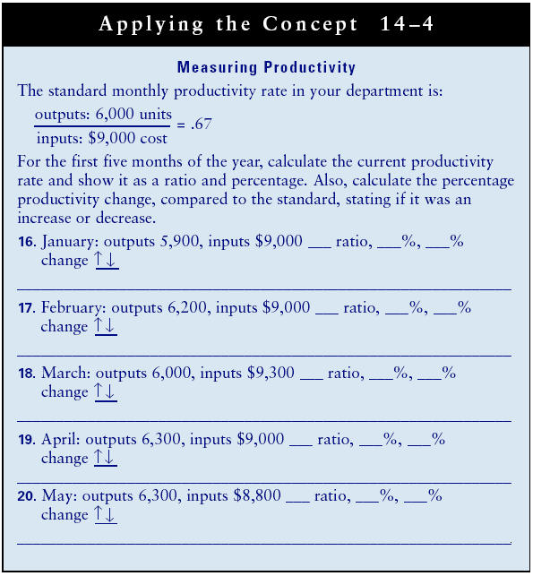

Functional Area Ratios
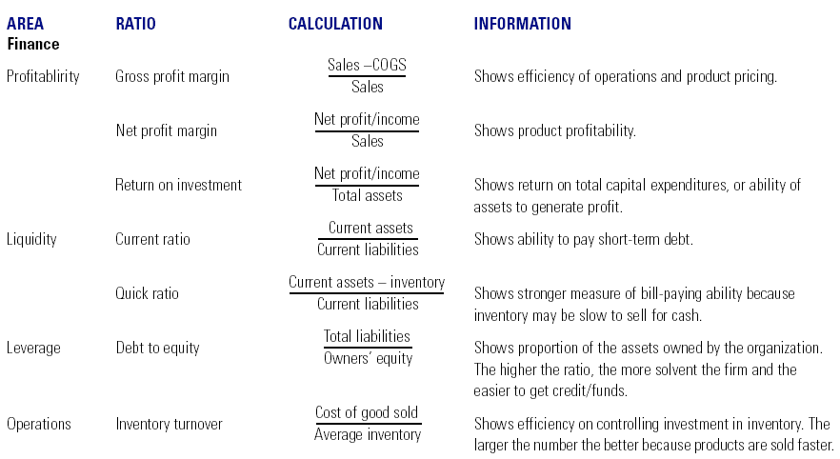

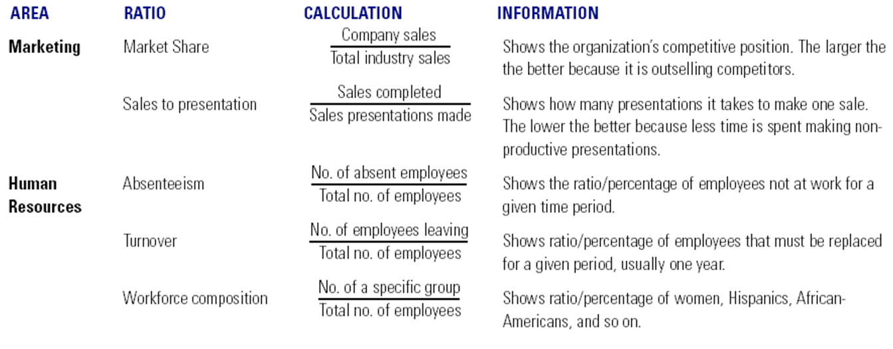

Lecture 30
Chapter 15: Operations, Quality, Technology and Information Systems
Learning Outcomes
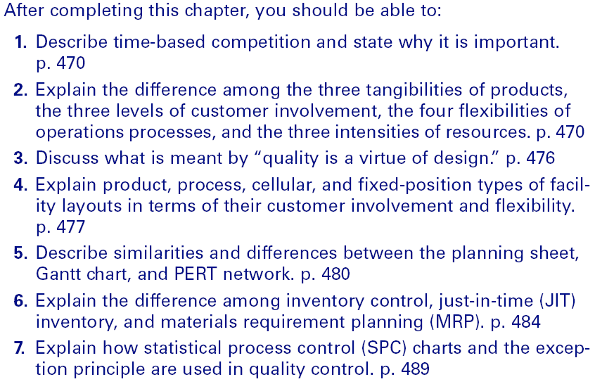

Operations
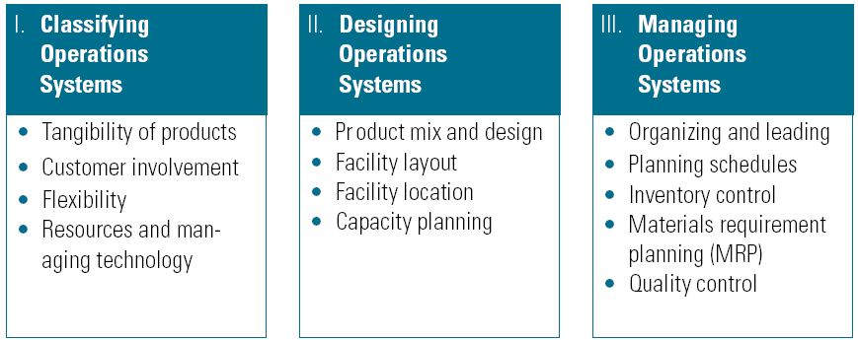

Classifying Operations Systems
Tangibility of Products
- Tangible: goods (computers)
- Intangible: services (house cleaning)
- Mixed: goods and services (airlines).
Customer Involvement
- Make-to-stock (MTS)
  - Producing products in anticipation of demand with a common design and price; low customer involvement.
- Make-to-order (MTO)
  - Producing products after receipt of an order; high customer involvement.
- Assemble-to-order (ATO)
  - Producing a standard product with some customized features; moderate customer involvement

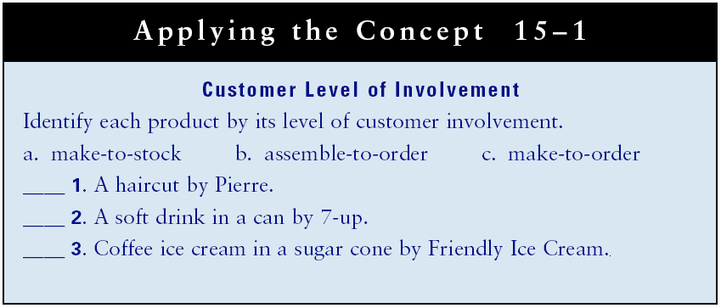
Flexibility
Operations Flexibility
- Products are produced continuously, repetitively, in batches, or individually in different volumes (amounts) and varieties (types).
- Continuous process operations (CPO)
  - Produce outputs that are not discrete units.
- Repetitive process operations (RPO)
  - Produce outputs in an assembly-line-type structure.
- Batch process operations (BPO)
  - Produce different outputs with the same resources.
- Operations Flexibility
  - Individual process operations (IPO)
    - Produce output to customer specifications.
- Project process operations
  - Produce low-volume outputs that take relatively long time to complete.

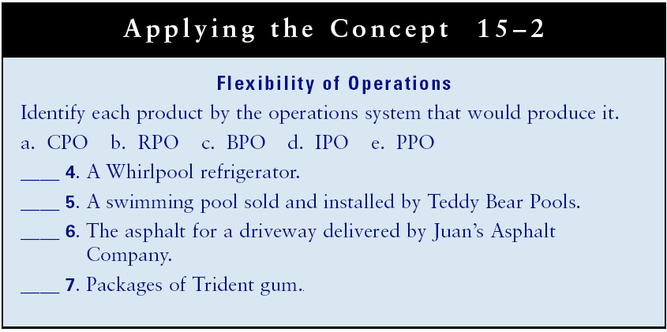

Classifying Operations Systems
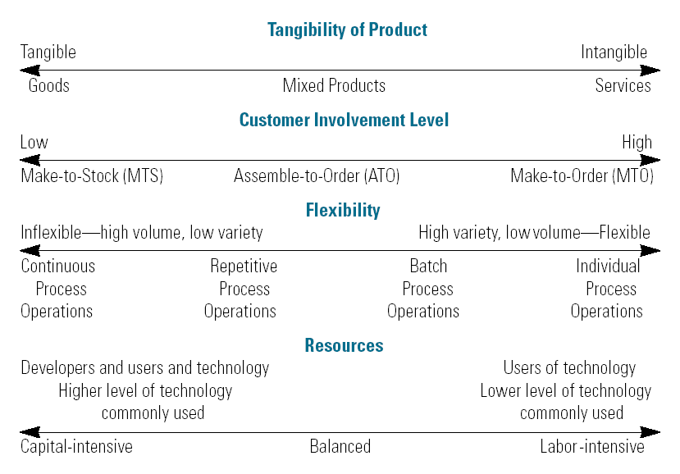

Designing Operations Systems
Product Mix
- The number of product lines, number of products in each line, and the mixture of goods and services within each line.
Product Design
- New or improved product development.
Quality As a Virtue of Design
- Products designed with cross-functional team input have fewer operations (manufacturing) problems.

Facility Layout
Layout
- The spatial arrangement of operations units relative to each other.
Facility Layout
- The arrangement of operations by:
  - Product
  - Process
  - Cellular
  - Fixed position
Facility Location
Location: The physical geographic site of facilities
Location Factors
- Cost
- Near inputs, customers, and/or competitors
- Transportation
- Access to Human Resources
- Community interest
- Quality of life issues
- Number of facilities
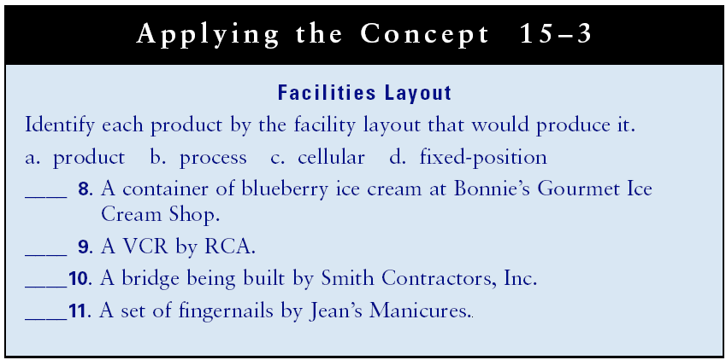

Lecture 31
Managing Operations Systems
Organizing and Leading
- Planning schedules
  - Scheduling and routing
- Priority Scheduling
  - First come-first served
  - Earliest due date
  - Shortest operating time
  - Combination
Planning Sheet
- State an objective and list the sequence and timing of each activity and who will carry it out.
Gantt Chart
- Uses bars to illustrate a schedule and progress toward the objective over a period of time.
- Is useful as both a planning and a control tool.
Performance Evaluation and Review (PERT)
- A network schedule that illustrates the dependence of activities.

Planning Sheet
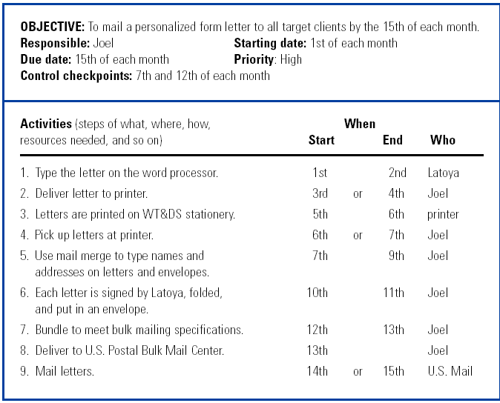
Gantt Chart (Order by Week)
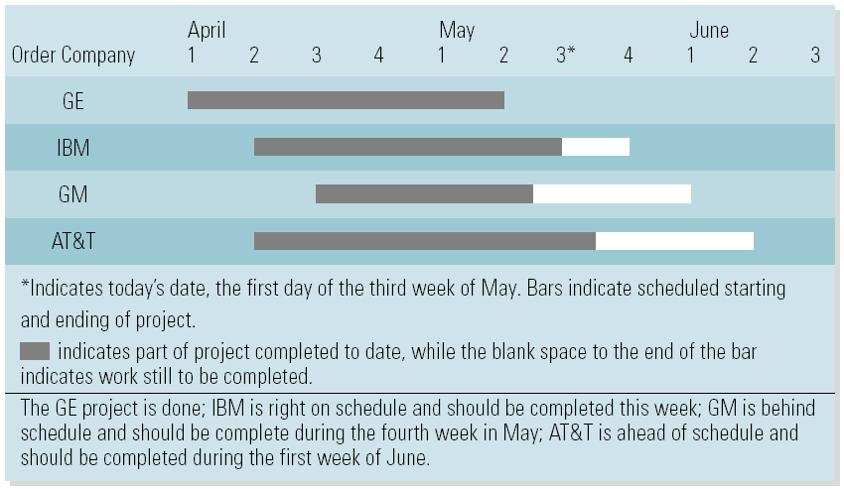

Developing a PERT Network

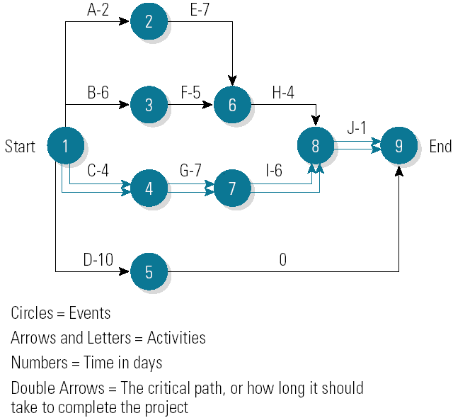
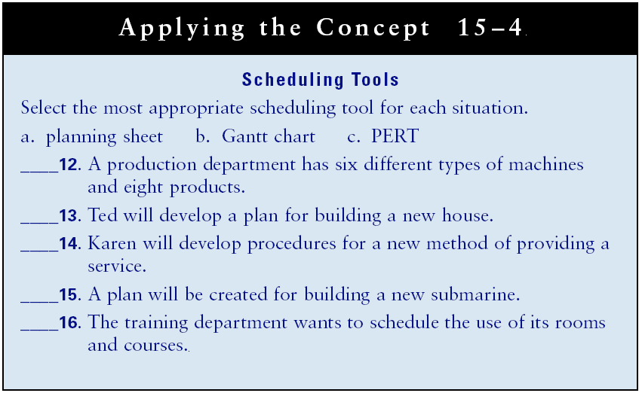

Inventory Control within the Systems Process

Materials Requirements Planning
Materials Requirements Planning (MRP)
- A system that integrates operations and inventory control with complex ordering and scheduling.
Enterprise Resource Planning (ERP)
- Collects information from the entire organization and manages all systems related systems.
Economic Order Quantity
- A mathematical model that determines the optimal quantity to order when placing a reorder by optimizing inventory holding and ordering costs.

Quality Control
Quality Control
- The process of ensuring that all four types of inventory meet standards.
Quality Assurance
- Means building in quality; not attempting to “inspect it in.”
International Standards Organization (ISO)
- Certifies organizations that meet set quality standards.
Six Sigma
- Higher levels of quality at lower costs.

Six Rules of Customer Human Relations
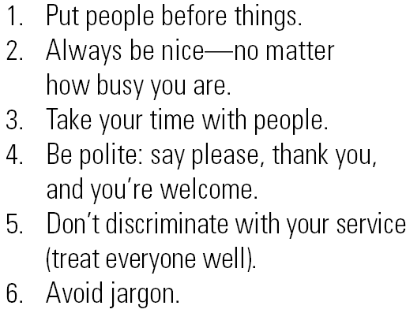
Lecture 32
Statistical Quality Control (SPC)
- A concurrent process control method that uses statistical tests of probability in determining if product quality is within the acceptable range.

Statistical Quality Control Steps

Statistical Process Control Chart by Ounces and Time of Day
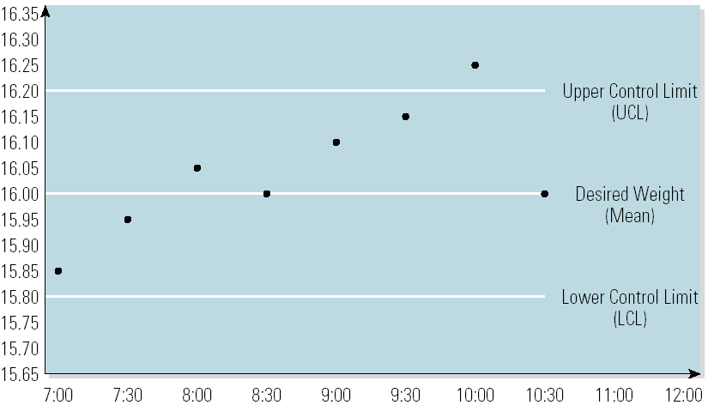

The Information Systems Process
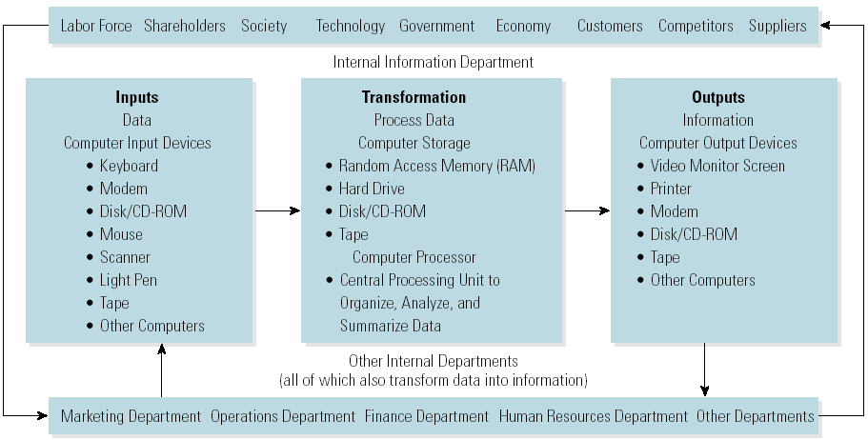

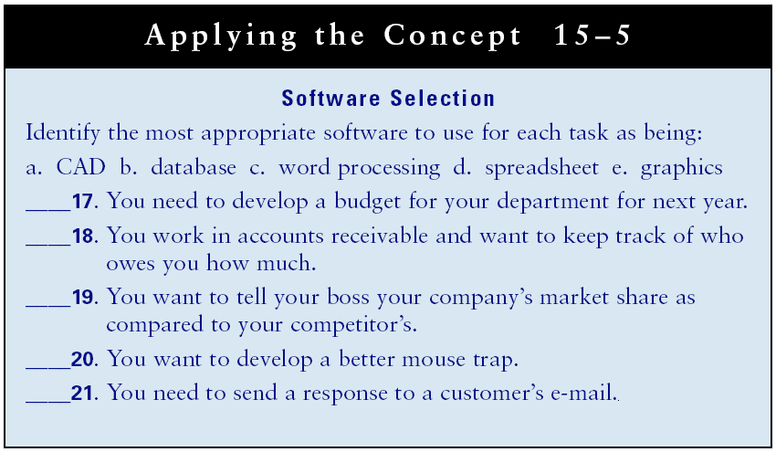

Types of Information Systems
Transaction Processing Systems (TPS)
- Used to handle routine and recurring business matters (e.g. accounting transactions).
Management Information Systems (MIS)
- Used to transform data into information that managers need from the database to do their work.
Decision Support Systems (DSS)
- Use a manager’s insights in an interactive computer-based process to assist in making non-routine decisions.
Artificial Intelligence (AI)
- An attempt to create computers that simulate the human decision process.
Expert Systems
- Imitate the thought processes of a human being.

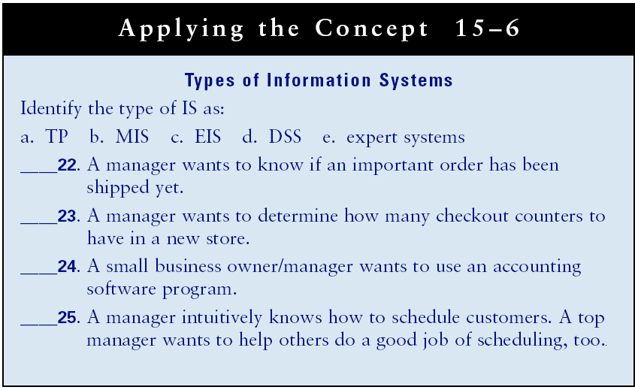
Information Networks and Technology
Computer Networks
- Connect independent computers so that they can function in interrelated ways.
Information Networks
- Connect all employees from headquarters and remote facilities to each other, to suppliers and customers, and into databases.
Types of Networks
- Local-area networks (LAN)
- Wide-area networks (WAN)
- Firewalls, intranets, and peer-to-peer

Information Network
