Lecture 22
Exporting, Importing and Countertrade
- Large and small firms export
- Exporting is on the rise thanks to the decline in trade barriers under the WTO and regional economic agreements such as the EU and NAFTA
Exporting firms need to
- identify market opportunities
- deal with foreign exchange risk
- navigate import and export financing
- understand the challenges of doing business in a foreign market
- Exporting is a way to increase market size--the rest of the world is usually much larger market than the domestic market.
- Large firms often proactively seek new export opportunities.
- Many smaller firms are reactive and wait for the world to come to them .
- Many firms fail to realize the potential of the export market.
- Smaller firms are often intimidated by the complexities of exporting and initially run into problems.
The Promise and Pitfalls Of Exporting
Common pitfalls include:
- poor market analysis
- poor understanding of competitive conditions
- a lack of customization for local markets
- a poor distribution program
- poorly executed promotional campaigns
- problems securing financing
- a general underestimation of the differences and expertise required for foreign market penetration
- an underestimation of the amount of paperwork and formalities involved
- Improving Export Performance
- There are various ways to gain information about foreign market opportunities and avoid the pitfalls associated with exporting
- Some countries provide direct assistance to exporters
- Export management companies can also help with the export process
An International Comparison
- A big impediment to exporting is the simple lack of knowledge of the opportunities available.
- To overcome ignorance firms need to collect information.
- Both Germany and Japan have developed extensive institutional structures for promoting exports.
- Japanese exporters can also take advantage of the knowledge and contacts of sogo shosha, the country’s great trading houses.
- In contrast, American firms have far fewer resources available
Information Sources
- The U.S. Department of Commerce is the most comprehensive source of export information for U.S. firms.
- The International Trade Administration and the United States and Foreign Commercial Service Agency can provide “best prospects” lists for firms.
- The Department of Commerce also organizes various trade events to help firms make foreign contacts and explore export opportunities.
- The Small Business Administration is also a source of assistance.
- Local and state governments can also provide export support
- Utilizing Export Management Companies
- Export management companies (EMCs) are export specialists that act as the export marketing department or international department for client firms.
EMCs normally accept two types of export assignments:
- They start exporting operations for a firm with the understanding that the firm will take over operations after they are well established.
- they start services with the understanding that the EMC will have continuing responsibility for selling the firm’s products
Utilizing Export Management Companies
- Good EMCs will help the neophyte exporter identify opportunities and avoid common pitfalls.
- However, not all EMCs are equal—some do a better job than others.
- Firms that rely on an EMC may not develop their own export capabilities
Export Strategy
To reduce the risks of exporting, firms should
- Hire an EMC or export consultant, to help identify opportunities and navigate through the tangled web of paperwork and regulations so often involved in exporting.
- Focus on one, or a few, markets at first.
- Enter a foreign market on a fairly small scale in order to reduce the costs of any subsequent failures.
- Recognize the time and managerial commitment involved.
- Develop a good relationship with local distributors and customers.
- Hire locals to help establish a presence in the market.
- Be proactive.
- consider local production
- Export And Import Financing
- Over time, various mechanisms for financing exports and imports have evolved in response to a problem that can be particularly acute in international trade: the lack of trust that exists when one must put faith in a stranger
Lack Of Trust
- Many international transactions are facilitated by a third party (normally a reputable bank).
- By including the third party, an element of trust is added to the relationship
Letter Of Credit
- A letter of credit is issued by a bank at the request of an importer and states the bank will pay a specified sum of money to a beneficiary, normally the exporter, on presentation of particular, specified documents. The main advantage of the letter of credit is that both parties to the transaction are likely to trust a reputable bank even if they do not trust each other
Draft
- A draft, also called a bill of exchange, is the instrument normally used in international commerce for payment. A draft is simply an order written by an exporter instructing an importer, or an importer's agent, to pay a specified amount of money at a specified time. A sight draft is payable on presentation to the drawee while a time draft allows for a delay in payment - normally 30, 60, 90, or 120 days
Bill Of Lading
- The bill of lading is issued to the exporter by the common carrier transporting the merchandise
It serves three purposes:
- it is a receipt
- it is a contract
- it is a document of title

Lecture 23
A Typical International Trade Transaction
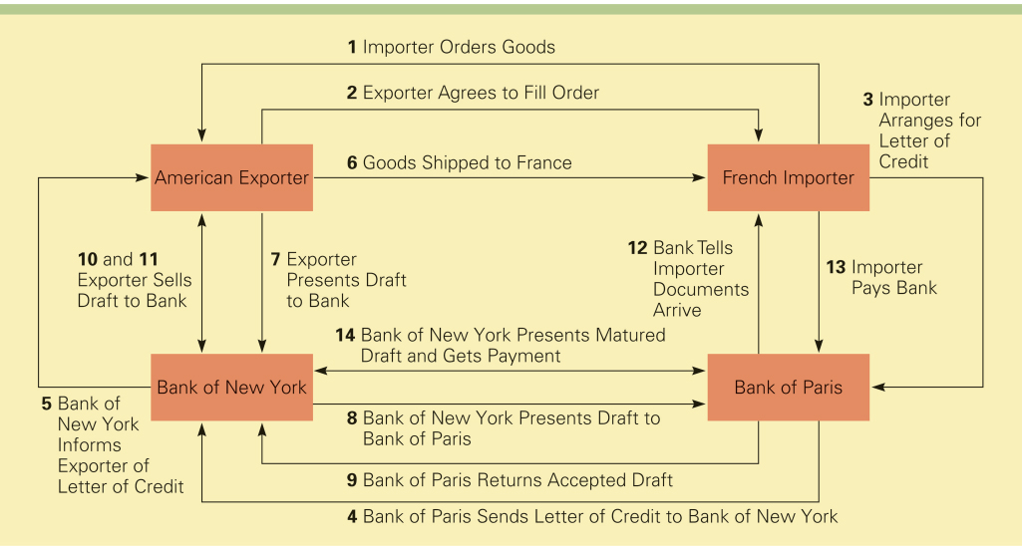

Export Assistance
- There are two forms of government-backed assistance available to exporters:
- Financing aid is available from the Export-Import Bank.
2. Export credit insurance is available from the Foreign Credit Insurance Association
Export-Import Bank
- The Export-Import Bank (Eximbank) is an independent agency of the U.S. government.
- It provides financing aid to facilitate exports, imports, and the exchange of commodities between the U.S. and other countries.
- Unibank achieves its goals though various loan and loan guarantee programs
Export Credit Insurance
- Export credit insurance protects exporters against the risk that the importer will default on payment
- In the U.S., export credit insurance is provided by the Foreign Credit Insurance Association (FICA)
- FICA provides coverage against commercial risks and political risks
Countertrade
- When conventional means of payment are difficult, costly, or nonexistent, some firms may turn to countertrade.
- Countertrade refers to a range of barter-like agreements that facilitate the trade of goods and services for other goods and services when they cannot be traded for money
- The Incidence Of Countertrade
- During the1960s, when the Soviet Union and the Communist states of Eastern Europe had nonconvertible currencies, countertrade emerged as a means purchasing imports.
- During the 1980s, the technique grew in popularity among many developing nations that lacked the foreign exchange reserves required to purchase necessary imports.
- There was a notable increase in the volume of countertrade after the Asian financial crisis of 1997
The Incidence Of Countertrade
There are five distinct versions of countertrade:
1. barter
- Barter is a direct exchange of goods and/or services between two parties without a cash transaction. Barter is the most restrictive countertrade arrangement. It is used primarily for one-time-only deals in transactions with trading partners who are not creditworthy or trustworthy
- counter purchase
It occurs when a firm agrees to purchase a certain amount of materials back from a country to which a sale is made. Counter purchase is a reciprocal buying agreement.
- offset
Offset is similar to counter purchase insofar as one party agrees to purchase goods and services with a specified percentage of the proceeds from the original sale. The difference is that this party can fulfill the obligation with any firm in the country to which the sale is being made

- compensation or buyback
A buyback occurs when a firm builds a plant in a country—or supplies technology, equipment, training, or other services to the country—and agrees to take a certain percentage of the plant’s output as a partial payment for the contract
5. Switch trading
Switch trading refers to the use of a specialized third-party trading house in a countertrade arrangement. When a firm enters a counter-purchase or offset agreement with a country, it often ends up with what are called counter-purchase credits, which can be used to purchase goods from that country. Switch trading occurs when a third-party trading house buys the firm’s counter-purchase credits and sells them to another firm that can better use them
The Pros and Cons Of Countertrade
- Countertrade is attractive because it gives a firm a way to finance an export deal when other means are not available
- If a firm is unwilling to enter a countertrade agreement, it may lose an export opportunity to a competitor that is willing to make a countertrade agreement
- In some cases, a countertrade arrangement may be required by the government of a country to which a firm is exporting goods or services
- The Pros And Cons Of Countertrade
- Countertrade is unattractive because it may involve the exchange of unusable or poor-quality goods that the firm cannot dispose of profitably.
- It requires the firm to establish an in-house trading department to handle countertrade deals.
- Countertrade is most attractive to large, diverse multinational enterprises that can use their worldwide network of contacts to dispose of goods acquired in countertrade deals.

