Lecture 20
Entry Strategy and Strategic Alliances
Introduction
Firms expanding internationally must decide:
- which markets to enter
- when to enter them and on what scale
- which entry mode to use
Entry modes include:
- exporting
- licensing or franchising to a company in the host nation
- establishing a joint venture with a local company
- establishing a new wholly owned subsidiary
- acquiring an established enterprise
- Introduction
Several factors affect the choice of entry mode including:
- transport costs
- trade barriers
- political risks
- economic risks
- costs
- firm strategy
- The optimal mode varies by situation – what makes sense for one company might not make sense for another
- Basic Entry Decisions

Firms entering foreign markets make three basic decisions:
1. Which markets to enter
2. When to enter those markets
3. on what scale to enter those markets
Which Foreign Markets?
The choice of foreign markets will depend on their long run profit potential. Favorable markets are politically stable developed and developing nations with free market systems and relatively low inflation rates and private sector debt. Less desirable markets are politically unstable developing nations with mixed or command economies, or developing nations with excessive levels of borrowing. Markets are also more attractive when the product in question is not widely available and satisfies an unmet need
Timing of Entry
Once attractive markets are identified, the firm must consider the timing of entry. Entry is early when the firm enters a foreign market before other foreign firms. Entry is late when the firm enters the market after firms have already established themselves in the market. First mover advantages are the advantages associated with entering a market early
First mover advantages include:
- the ability to pre-empt rivals and capture demand by establishing a strong brand name
- the ability to build up sales volume in that country and ride down the experience curve ahead of rivals and gain a cost advantage over later entrants
- the ability to create switching costs that tie customers into products or services making it difficult for later entrants to win business
- First mover disadvantages are disadvantages associated with entering a foreign market before other international businesses
First mover disadvantages include:
- pioneering costs - arise when the foreign business system is so different from that in a firm’s home market that the firm must devote considerable time, effort and expense to learning the rules of the game

Pioneering costs include:
- the costs of business failure if the firm, due to its ignorance of the foreign environment, makes some major mistakes
- the costs of promoting and establishing a product offering, including the cost of educating customers
Scale of Entry and Strategic Commitments
- After choosing which market to enter and the timing of entry, firms need to decide on the scale of market entry
- Entering a foreign market on a significant scale is a major strategic commitment that changes the competitive playing field
- Firms that enter a market on a significant scale make a strategic commitment to the market (the decision has a long term impact and is difficult to reverse)
- Small-scale entry has the advantage of allowing a firm to learn about a foreign market while simultaneously limiting the firm’s exposure to that market
Summary
There are no “right” decisions when deciding which markets to enter, and the timing and scale of entry, just decisions that are associated with different levels of risk and reward
Entry Modes
These are six different ways to enter a foreign market:
1. Exporting
2. Turnkey projects
3. Licensing
4. Franchising
5. Establishing joint ventures with a host country firm
6. Setting up a new wholly owned subsidiary in the host country
Managers need to consider the advantages and disadvantages of each entry mode

Exporting
- Exporting is a common first step in the international expansion process for many manufacturing firms
- Later, many firms switch to another mode to serve the foreign market
Exporting is attractive because:
- it avoids the costs of establishing local manufacturing operations
- it helps the firm achieve experience curve and location economies
Exporting is unattractive because:
- there may be lower-cost manufacturing locations
- high transport costs and tariffs can make it uneconomical
- agents in a foreign country may not act in exporter’s best interest
Turnkey Projects
- In a turnkey project, the contractor agrees to handle every detail of the project for a foreign client, including the training of operating personnel
- At completion of the contract, the foreign client is handed the "key" to a plant that is ready for full operation
- Turnkey projects are common in the chemical, pharmaceutical, petroleum refining, and metal refining industries
Turnkey projects are attractive because:
- they are a way of earning economic returns from the know-how required to assemble and run a technologically complex process
- they can be less risky than conventional FDI
Turnkey projects are unattractive because:
- the firm that enters into a turnkey deal will have no long-term interest in the foreign country
- the firm that enters into a turnkey project may create a competitor
- if the firm's process technology is a source of competitive advantage, then selling this technology through a turnkey project is also selling competitive advantage to potential and/or actual competitors
Licensing
- A licensing agreement is an arrangement whereby a licensor grants the rights to intangible property to another entity (the licensee) for a specified time period, and in return, the licensor receives a royalty fee from the licensee
- Intangible property includes patents, inventions, formulas, processes, designs, copyrights, and trademarks
Licensing is attractive because:
- the firm does not have to bear the development costs and risks associated with opening a foreign market
- the firm avoids barriers to investment
- firms with intangible property that might have business applications can capitalize on market opportunities without developing those applications itself
Licensing is unattractive because:
- the firm doesn’t have the tight control over manufacturing, marketing, and strategy required for realizing experience curve and location economies
- it limits a firm’s ability to coordinate strategic moves across countries by using profits earned in one country to support competitive attacks in another
- proprietary (or intangible) assets could be lost
- One way of reducing this risk is through the use of cross-licensing agreements where a firm might license intangible property to a foreign partner, but requests that the foreign partner license some of its valuable know-how to the firm in addition to a royalty payment
Franchising
- Franchising is basically a specialized form of licensing in which the franchisor not only sells intangible property to the franchisee, but also insists that the franchisee agree to abide by strict rules as to how it does business
- Franchising is used primarily by service firms
Franchising is attractive because:
- Firms avoid many costs and risks of opening up a foreign market
- Firms can quickly build a global presence
Franchising is unattractive because:
- It may inhibit the firm's ability to take profits out of one country to support competitive attacks in another
- the geographic distance of the firm from its foreign franchisees can make poor quality difficult for the franchisor to detect
Joint Ventures
- A joint venture is the establishment of a firm that is jointly owned by two or more otherwise independent firms
- Most joint ventures are 50:50 partnerships
Joint ventures are attractive because:
- they allow the firm to benefit from a local partner's knowledge of the host country's competitive conditions, culture, language, political systems, and business systems
- the costs and risks of opening a foreign market are shared with the partner
- When political considerations make joint ventures the only feasible entry mode
Joint ventures are unattractive because:
- the firm risks giving control of its technology to its partner
- the firm may not have the tight control over subsidiaries need to realize experience curve or location economies
- shared ownership can lead to conflicts and battles for control if goals and objectives differ or change over time
Wholly Owned Subsidiaries
- In a wholly owned subsidiary, the firm owns 100 percent of the stock
- Firms can establish a wholly owned subsidiary in a foreign market:
- setting up a new operation in the host country
- acquiring an established firm in the host country
- Wholly Owned Subsidiaries
Wholly owned subsidiaries are attractive because:
- they reduce the risk of losing control over core competencies
- they give a firm the tight control over operations in different countries that is necessary for engaging in global strategic coordination
- they may be required in order to realize location and experience curve economies
Wholly owned subsidiaries are unattractive because:
- the firm bears the full cost and risk of setting up overseas operations

Lecture 21
Selecting an Entry Mode
- All entry modes have advantages and disadvantages
- The optimal choice of entry mode involves trade-offs
Table 14.1:
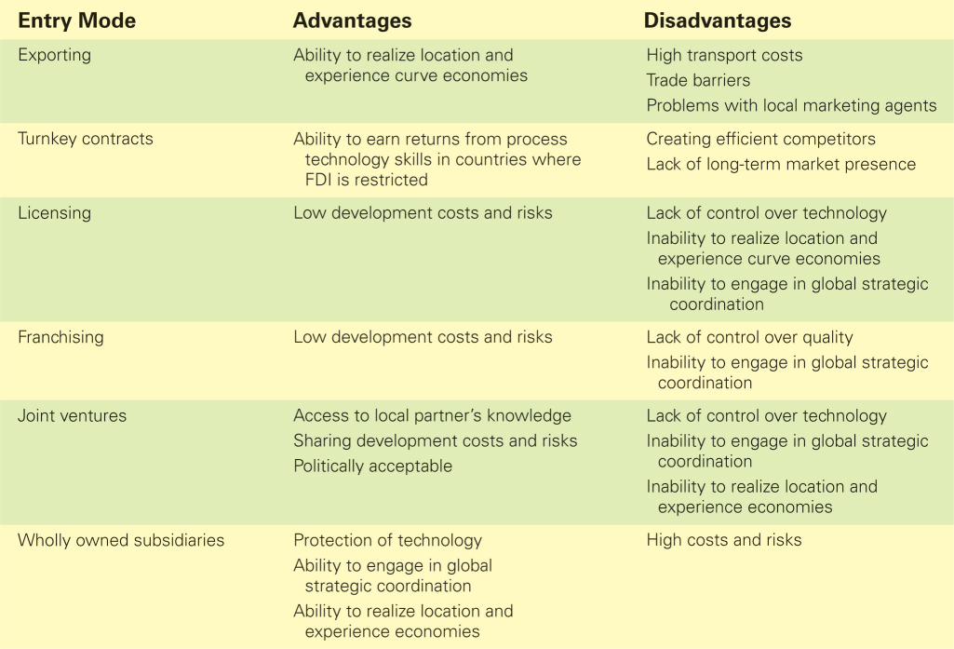

Core Competencies and Entry Mode
- The optimal entry mode depends to some degree on the nature of a firm’s core competencies
- When a firm’s competitive advantage is based on proprietary technological know-how, the firm should avoid licensing and joint venture arrangements unless it believes its technological advantage is only transitory, or that it can establish its technology as the dominant design in the industry
- When a firm’s competitive advantage is based on management know-how, the risk of losing control over the management skills is not high, and the benefits from getting greater use of brand names is significant
Pressures for Cost Reductions and Entry Mode
- When pressure for cost reductions is high, firms are more likely to pursue some combination of exporting and wholly owned subsidiaries
- This will allow the firm to achieve location and scale economies as well as retain some degree of control over its worldwide product manufacturing and distribution
- So, firms pursuing global standardization or transnational strategies prefer wholly owned subsidiaries
Greenfield Ventures or Acquisitions
Firms can establish a wholly owned subsidiary in a country by:
- Using a Greenfield strategy - building a subsidiary from the ground up
Acquisitions are attractive because:
- they are quick to execute
- they enable firms to preempt their competitors
- acquisitions may be less risky than Greenfield ventures
Acquisitions can fail when:
- the acquiring firm overpays for the acquired firm
- the cultures of the acquiring and acquired firm clash
- attempts to realize synergies run into roadblocks and take much longer than forecast
- there is inadequate pre-acquisition screening
To avoid these problems, firms should:
- carefully screening the firm to be acquired
- move rapidly once the firm is acquired to implement an integration plan
Pros And Cons Of Greenfield Ventures
- The main advantage of a Greenfield venture is that it gives the firm a greater ability to build the kind of subsidiary company that it wants. However, Greenfield ventures are slower to establish
- Greenfield ventures are also risky
Greenfield or Acquisition?
- The choice between a Greenfield investment and an acquisition depends on the situation confronting the firm
- Acquisition may be better when the market already has well-established competitors or when global competitors are interested in building a market presence
- A Greenfield venture may be better when the firm needs to transfer organizationally embedded competencies, skills, routines, and culture
Strategic Alliances
- Strategic alliances refer to cooperative agreements between potential or actual competitors
- Strategic alliances range from formal joint ventures to short-term contractual agreements
- The number of strategic alliances has exploded in recent decades
The Advantages of Strategic Alliances
- facilitate entry into a foreign market
- allow firms to share the fixed costs (and associated risks) of developing new products or processes
- bring together complementary skills and assets that neither partner could easily develop on its own
- can help a firm establish technological standards for the industry that will benefit the firm
The Disadvantages Of Strategic Alliances
- Strategic alliances can give competitors low-cost routes to new technology and markets, but unless a firm is careful, it can give away more than it receives
Making Alliances Work
The success of an alliance is a function of:
- partner selection
- alliance structure
- the manner in which the alliance is managed
- Making Alliances Work
A good partner:
- helps the firm achieve its strategic goals and has the capabilities the firm lacks and that it values
- shares the firm’s vision for the purpose of the alliance
- is unlikely to try to opportunistically exploit the alliance for its own ends: that it, to expropriate the firm’s technological know-how while giving away little in return
Once a partner has been selected, the alliance should be structured:
- to make it difficult to transfer technology not meant to be transferred
- with contractual safeguards written into the alliance agreement to guard against the risk of opportunism by a partner
- to allow for skills and technology swaps with equitable gains
- to minimize the risk of opportunism by an alliance partner
- After selecting the partner and structuring the alliance, the alliance must be managed
- Successfully managing an alliance requires managers from both companies to build interpersonal relationships
- A major determinant of how much a company gains from an alliance is its ability to learn from its alliance partners

