Lecture 8
Foreign Direct Investment
Introduction
Foreign direct investment (FDI) occurs when a firm invests directly in new facilities to produce and/or market in a foreign country.
Once a firm undertakes FDI it becomes a multinational enterprise
FDI can be:
Greenfield investments - the establishment of a wholly new operation in a foreign country.
acquisitions or mergers with existing firms in the foreign country
Motives for DFI
DFI can improve profitability and enhance shareholder wealth, either by boosting revenues or reducing costs.
Revenue-Related Motives
- Attract new sources of demand, especially when the potential for growth in the home country is limited.
- Exploit monopolistic advantages, especially for firms that possess resources or skills not available to competing firms.
- React to trade restrictions.
Cost-Related Motives
- Fully benefit from economies of scale, especially for firms that utilize much machinery.
- Use cheaper foreign factors of production.
- Use foreign raw materials, especially if the MNC plans to sell the finished product back to the consumers in that country.
- React to exchange rate movements, such as when the foreign currency appears to be undervalued. DFI can also help reduce the MNC’s exposure to exchange rate fluctuations.
- Diversify sales/production internationally.
The optimal method for a firm to penetrate a foreign market is partially dependent on the characteristics of the market. For example, if the consumers are used to buying domestic products, then licensing arrangements or joint ventures may be more appropriate. Before investing in a foreign country, the potential benefits must be weighed against the costs and risks.
As conditions change over time, some countries may become more attractive targets for DFI, while other countries become less attractive.
Benefits of International Diversification
The key to international diversification is to select foreign projects whose performance levels are not highly correlated over time. An MNC may not be insulated from a global crisis, since many countries will be adversely affected.
However, as can be seen from the 1997-98 Asian crisis, an MNC that had diversified among the Asian countries might have fared better than if it had focused on one country. Even better would be diversification among the continents.
- As more projects are added to a portfolio, the portfolio variance should decrease on average, up to a certain point.
- However, the degree of risk reduction is greater for a global portfolio than for a domestic portfolio, due to the lower correlations among the returns of projects implemented in different economies.
Decisions Subsequent to DFI
Some periodic decisions are necessary.
Should further expansion take place?
Should the earnings be remitted to the parent, or used by the subsidiary?
Foreign Direct Investment in the World Economy
The flow of FDI refers to the amount of FDI undertaken over a given time period.
The stock of FDI refers to the total accumulated value of foreign-owned assets at a given time.
Outflows of FDI are the flows of FDI out of a country.
Inflows of FDI are the flows of FDI into a country

Lecture 09
Trends in FDI
There has been a marked increase in both the flow and stock of FDI in the world economy over the last 30 years
FDI has grown more rapidly than world trade and world output because:
- Firms still fear the threat of protectionism.
- The general shift toward democratic political institutions and free market economies has encouraged FDI.
- The globalization of the world economy is having a positive impact on the volume of FDI as firms undertake FDI to ensure they have a significant presence in many regions of the world
- Trends In FDI
Figure 7.1: FDI Outflows 1982-2006 ($ billions)
The Direction Of FDI
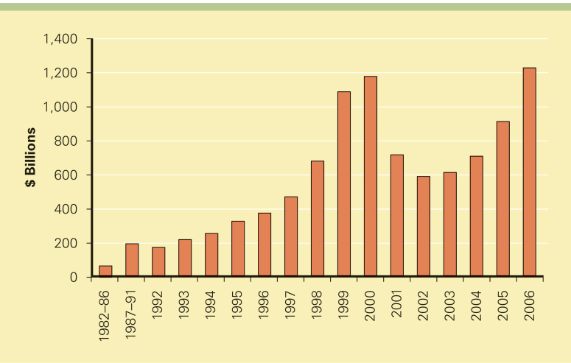

- Most FDI has historically been directed at the developed nations of the world, with the United States being a favorite target.
- FDI inflows have remained high during the early 2000s for the United States, and also for the European Union.
- South, East, and Southeast Asia, and particularly China, are now seeing an increase of FDI inflows.
- Latin America is also emerging as an important region for FDI
The Direction Of FDI
Figure 7.2: FDI Inflows by Region ($ billion), 1995-2006
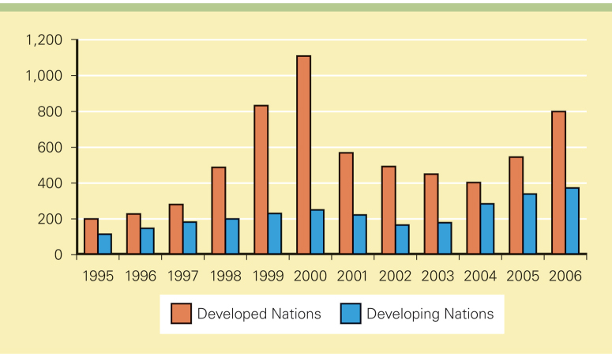
- Gross fixed capital formation summarizes the total amount of capital invested in factories, stores, office buildings, and the like.
- All else being equal, the greater the capital investment in an economy, the more favorable its future prospects are likely to be.
- So, FDI can be seen as an important source of capital investment and a determinant of the future growth rate of an economy
Figure 7.3: Inward FDI as a % of Gross Fixed Capital Formation 1992-2005

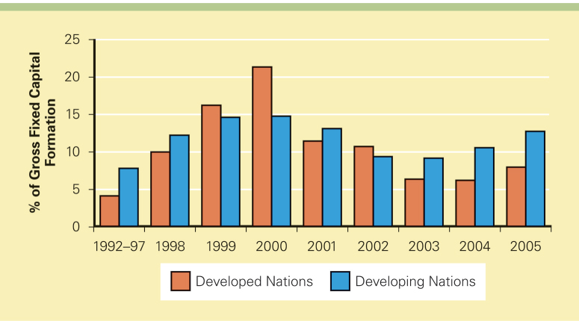
The Source Of FDI
- Since World War II, the U.S. has been the largest source country for FDI.
- The United Kingdom, the Netherlands, France, Germany, and Japan are other important source countries
- The Source Of FDI
Figure 7.4: Cumulative FDI Outflows ($ billions), 1998-2005
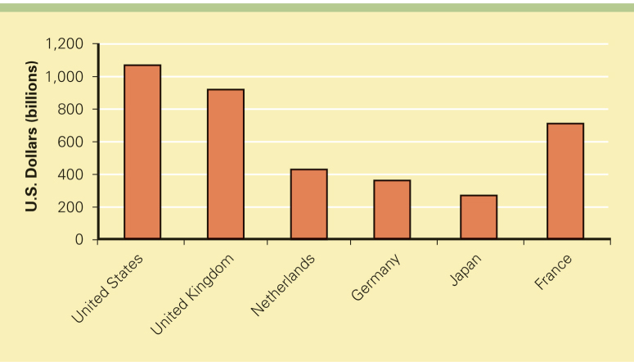

- The Form Of FDI: Acquisitions Versus Greenfield Investments
- Most cross-border investment is in the form of mergers and acquisitions rather than greenfield investments
Firms prefer to acquire existing assets because:
- Mergers and acquisitions are quicker to execute than greenfield investments.
- It is easier and perhaps less risky for a firm to acquire desired assets than build them from the ground up.
- Firms believe that they can increase the efficiency of an acquired unit by transferring capital, technology, or management skills
- The Shift To Services
- FDI is shifting away from extractive industries and manufacturing, and towards services

The shift to services is being driven by:
- The general move in many developed countries toward services.
- The fact that many services need to be produced where they are consumed.
- A liberalization of policies governing FDI in services.
- The rise of Internet-based global telecommunications networks
- Theories Of Foreign Direct Investment
- Why do firms invest rather than use exporting or licensing to enter foreign markets?
- Why do firms from the same industry undertake FDI at the same time?
- How can the pattern of foreign direct investment flows be explained?
- Why Foreign Direct Investment?
Why do firms choose FDI instead of:
- Exporting - producing goods at home and then shipping them to the receiving country for sale or.
- Licensing - granting a foreign entity the right to produce and sell the firm’s product in return for a royalty fee on every unit that the foreign entity sells
- Why Foreign Direct Investment?
- An export strategy can be constrained by transportation costs and trade barriers.
- Foreign direct investment may be undertaken as a response to actual or threatened trade barriers such as import tariffs or quotas
Why Foreign Direct Investment?
Internalization theory (also known as market imperfections theory) suggests that licensing has three major drawbacks:
- licensing may result in a firm’s giving away valuable technological know-how to a potential foreign competitor
- licensing does not give a firm the tight control over manufacturing, marketing, and strategy in a foreign country that may be required to maximize its profitability
- a problem arises with licensing when the firm’s competitive advantage is based not so much on its products as on the management, marketing, and manufacturing capabilities that produce those products
Types Foreign Direct Investment?
- Horizontal FDI
  - Horizontal FDI is investment in the same industry abroad as a firm operates in at home.
- Vertical FD
  - Vertical FDI is investment in different but supporting industry.
    - 1. Backward Vertical FDI- is an investment in an industry abroad that provide inputs for a firm’s domestic production processes e.g. oil extraction
    - 2. Forward Vertical FDI- in which an industry abroad sells the outputs of a firm’s domestic production processes e.g. finding distribution for specific markets,

Lecture 10
Political Ideology and Foreign Direct Investment
- Ideology toward FDI ranges from a radical stance that is hostile to all FDI to the non-interventionist principle of free market economies. Between these two extremes is an approach that might be called pragmatic nationalism
The Radical View
- The radical view traces its roots to Marxist political and economic theory. It argues that the MNE is an instrument of imperialist domination and a tool for exploiting host countries to the exclusive benefit of their capitalist-imperialist home countries
The Free Market View
- According to the free market view, international production should be distributed among countries according to the theory of comparative advantage. The free market view has been embraced by a number of advanced and developing nations, including the United States, Britain, Chile, and Hong Kong
Pragmatic Nationalism
- Pragmatic nationalism suggests that FDI has both benefits, such as inflows of capital, technology, skills and jobs, and costs, such as repatriation of profits to the home country and a negative balance of payments effect. According to this view, FDI should be allowed only if the benefits prevail over the costs
Shifting Ideology
Recently, there has been a strong shift toward the free
Market stance creating:
- a flow in FDI worldwide
- an increase in the volume of FDI in countries with newly liberalized regimes
Benefits And Costs Of FDI
- Government policy is often shaped by a consideration of the costs and benefits of FDI
Host-Country Benefits

There are four main benefits of inward FDI for a host country:
1. resource transfer effects - FDI can make a positive contribution to a host economy by supplying capital, technology, and management resources that would otherwise not be available
2. employment effects - FDI can bring jobs to a host country that would otherwise not be created there
3. balance of payments effects - a country’s balance-of-payments account is a record of a country’s payments to and receipts from other countries.
- The current account is a record of a country’s export and import of goods and services
- Governments typically prefer to see a current account surplus than a deficit
- FDI can help a country to achieve a current account surplus if the FDI is a substitute for imports of goods and services, and if the MNE uses a foreign subsidiary to export goods and services to other countries
4. effects on competition and economic growth - FDI in the form of greenfield investment increases the level of competition in a market, driving down prices and improving the welfare of consumers
- Increased competition can lead to increased productivity growth, product and process innovation, and greater economic growth
Host-Country Costs
Inward FDI has three main costs:
1. the possible adverse effects of FDI on competition within the host nation
- subsidiaries of foreign MNEs may have greater economic power than indigenous competitors because they may be part of a larger international organization
2. adverse effects on the balance of payments
- with the initial capital inflows that come with FDI must be the subsequent outflow of capital as the foreign subsidiary send home earnings to its parent country
- when a foreign subsidiary imports a substantial number of its inputs from abroad, there is a debit on the current account of the host country’s balance of payments
3. the perceived loss of national sovereignty and autonomy
- key decisions that can affect the host country’s economy will be made by a foreign parent that has no real commitment to the host country, and over which the host country’s government has no real control
Home-Country Benefits
The benefits of FDI for the home country include:
- the effect on the capital account of the home country’s balance of payments from the inward flow of foreign earnings
- the employment effects that arise from outward FDI
- the gains from learning valuable skills from foreign markets that can subsequently be transferred back to the home country
The home country’s balance of payments can suffer:
- from the initial capital outflow required to finance the FDI
- if the purpose of the FDI is to serve the home market from a low cost labor location
- if the FDI is a substitute for direct exports
- Employment may also be negatively affected if the FDI is a substitute for domestic production
Government Policy Instruments and FDI
- Home countries and host countries use various policies to regulate FDI
- Home-Country Policies
Governments can encourage and restrict FDI:
- To encourage outward FDI, many nations now have government-backed insurance programs to cover major types of foreign investment risk
- To restrict outward FDI, most countries, including the United States, limit capital outflows, manipulate tax rules, or outright prohibit FDI
Governments can encourage or restrict inward FDI
- To encourage inward FDI, governments offer incentives to foreign firms to invest in their countries
- Incentives are motivated by a desire to gain from the resource-transfer and employment effects of FDI, and to capture FDI away from other potential host countries
- To restrict inward FDI, governments use ownership restraints and performance requirements
International Institutions and The Liberalization Of FDI
- Until the 1990s, there was no consistent involvement by multinational institutions in the governing of FDI
- Today, the World Trade Organization is changing this by trying to establish a universal set of rules designed to promote the liberalization of FDI
- Implications For Managers
- What are the implications of foreign direct investment for managers?
- Managers need to consider what trade theory implies, and the link between government policy and FDI
- The Theory Of FDI
- The direction of FDI can be explained through the location-specific advantages argument associated with John Dunning
- However, it does not explain why FDI is preferable to exporting or licensing
- A host government’s attitude toward FDI is an important variable in decisions about where to locate foreign production facilities and where to make a foreign direct investment

