Part 2
Globalization
Lecture 04
What Is Globalization?
- The world is moving away from self-contained national economies toward an interdependent, integrated global economic system. Globalization refers to the shift toward a more integrated and interdependent world economy
Globalization has two facets:
1) The globalization of markets
2) The globalization of production
- The Globalization Of Markets
The globalization of markets refers to the merging of historically distinct and separate national markets into one huge global marketplace. In many industries, it is no longer meaningful to talk about the “German market” or the “American market”. Instead, there is only the global market. Falling trade barriers make it easier to sell internationally. The tastes and preferences of consumers are converging on some global norm. Firms help create the global market by offering the same basic products worldwide
- The Globalization Of Production
The globalization of production refers to the sourcing of goods and services from locations around the globe to take advantage of national differences in the cost and quality of factors of production like land, labor, and capital. Companies compete more effectively by lowering their overall cost structure or improving the quality or functionality of their product offering.
- Boeing jet 777 airliner ( Japan, Singapore, Italy)
- IBM (Design in US)
( Case, Keyboard, Hard drive in Thailand)
(Display Screen, memory in S.Korea)
( Wirelesscard in Malaysia)
(Micro Processor in US)
Lecture 05
The Emergence of Global Institutions
Institutions are needed to:
- help manage, regulate, and police the global marketplace
- promote the establishment of multinational treaties to govern the global business system
Institutions created over the past half century include:
- the General Agreement on Tariffs and Trade (GATT)
- the World Trade Organization (WTO)- (153 members by July 2008)
- the International Monetary Fund (IMF)- lender of the last resort - HO in Geneva
- the World Bank-HO Washington DC, USA
- the United Nations (UN)-(1945)
The Emergence Of Global Institutions
- The World Trade Organization (like its predecessor GATT) is primarily responsible for policing the world trading system and making sure that nation-states adhere to the rules laid down in trade treaties signed by WTO members. In 2007, the 150 nations that accounted for 97% of world trade were WTO members. The WTO promotes lower barriers to trade and investment
- The International Monetary Fund and the World Bank were created in 1944
- The IMF was established to maintain order in the international monetary system
- The World Bank was established to promote economic development
The United Nations was established in 1945 to:
- maintain international peace and security
- develop friendly relations among nations
- cooperate in solving international problems
- and in promoting respect for human rights

Drivers of Globalization
Two macro factors underlie the trend toward greater globalization:
- The decline in barriers to the free flow of goods, services, and capital that has occurred since the end of World War II
- technological change
Declining Trade and Investment Barriers
- International trade occurs when a firm exports goods or services to consumers in another country
- Foreign direct investment (FDI) occurs when a firm invests resources in business activities outside its home country
- After World War II, advanced countries made a commitment to lower barriers to trade and investment
- Since 1950, average tariffs have fallen significantly and are now at about 4%
- Countries have also been opening markets to FDI
Table 1.1: Average Tariff Rates on Manufactured Products as Percent of Value
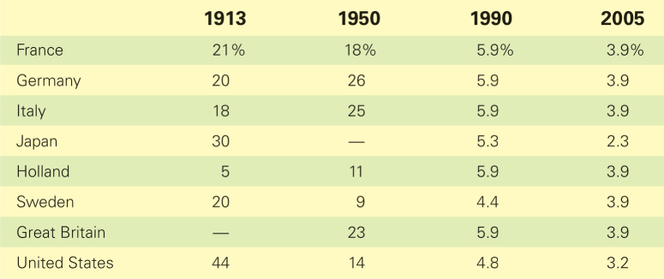
Lower barriers to trade and investment mean:
- that firms can view the world, rather than a single country, as their market
- that firms can base production in the optimal location for that activity
Lecture 06
The Role of Technological Change
- Technological change has made the globalization of markets a reality
Important advances have occurred in:
- microprocessors and telecommunications (Optical fibre, wireless technology)
e.g. examples of phone calls in past and now in PK, comparing PK and UK telecommunication Cost.
- the Internet and World Wide Web
- 1990- less than 1 million
- 1995- 50 million users
- 2004- 945 million users
- 2007- 1.5 billion users ( 25th % of world population)
- It’s easy to get almost all information through internet.
- The Web makes it easier for buyers and sellers to find each other e.g. ebay, buying shares of any company and many more.
- transportation technology
- reducing the time needed
- PK is now closer to NY than it was to Iran in the Colonial times.
- Containerization and railroad cost has been reduced
Implications of technological change for the globalization of production include:
- lower transportation costs that enable firms to disperse production to economical, geographically separate locations
- lower information processing and communication costs that enable firms to create and manage globally dispersed production systems
Implications of technological change for the globalization of markets include:
- low cost global communications networks help create electronic global marketplace
- low-cost transportation help create global markets
- global communication networks and global media are creating a worldwide culture, and a global market for consumer products
The Changing Demographics of the Global Economy
- There has been a drastic change in the demographics of the world economy in the last 30 years
Four trends are important:
- the Changing World Output and World Trade Picture
- the Changing Foreign Direct Investment Picture
- the Changing Nature of the Multinational Enterprise
- the Changing World Order
The Changing World Output and World Trade Picture
- In 1960, the United States accounted for over 40% of world economic activity
- By 2006, the United States accounted for less than 20% of world economic activity
- A similar trend occurred in other developed countries
- The share of world output accounted for by developing nations is rising and is expected to account for more than 60% of world economic activity by 2020
- The World Bank has estimated that with the current prevailing situation, the Chinese economy could be larger than the US by 2020 while the economy of India will approach to that of Germany.

Table 1.2: The Changing Demographics of World GDP and Trade
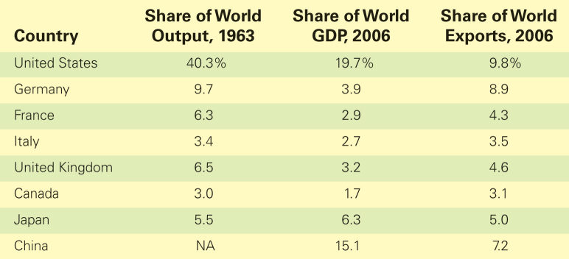
- The Changing Foreign Direct Investment Picture
- In the 1960s, U.S. firms accounted for about two-thirds of worldwide FDI flows
- Today, the United States accounts for less than one-fifth of worldwide FDI flows
- Other developed countries have followed a similar pattern
- In contrast, the share of FDI accounted for by developing countries has risen from less than 2% in 1980 to almost 12% in 2005
- Developing countries, especially China, have also become popular destinations for FDI
Figure 1.2: Percentage Share of Total FDI Stock 1980-2005
- The Changing Foreign Direct Investment Picture
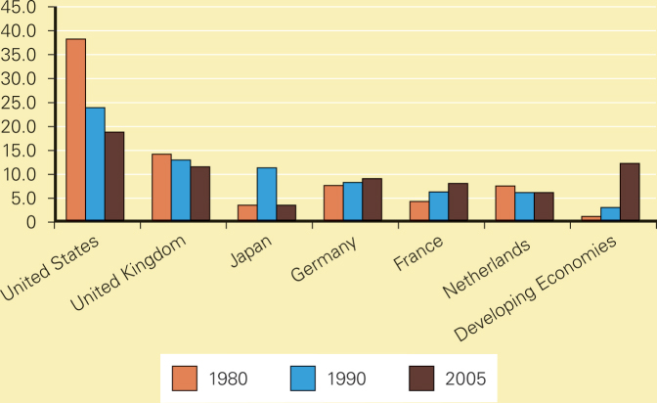
Figure 1.3: FDI Inflows 1988-2006
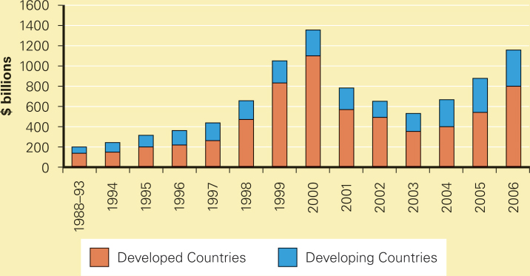
- The Changing Nature Of The Multinational Enterprise
- A multinational enterprise (MNE) is any business that has productive activities in two or more countries
- Since the 1960s,
- There has been a rise in non-U.S. multinationals,
- And a growth of mini-multinationals
- According to UN data, 100 largest are still in the hands of developed economies
- Except three from developing economies
- Hutchison Whampoa from Hong Kong, China (16th)
- Singtel of Singapore (70th )
- CEMEX of Mexico (87th)
The Changing World Order
- Many former Communist nations in Europe and Asia are now committed to democratic politics and free market economies and so, create new opportunities for international businesses
- China and Latin America are also moving toward greater free market reforms

Lecture 07
The Global Economy of the Twenty-first Century
- The world is moving toward a more global economic system, but globalization is not inevitable
- Globalization also brings risks like the financial crisis that swept through South East Asia in the late 1990s. 2007 till running.
- The Globalization Debate
Is the shift toward a more integrated and interdependent global economy a good thing?
- Supporters believe that increased trade and cross-border investment mean lower prices for goods and services, greater economic growth, higher consumer income, and more jobs
- Critics worry that globalization will cause job losses, environmental degradation, and the cultural imperialism of global media and MNEs
Anti-Globalization Protests
- More than 40,000 anti-globalization protesters took to the street at the WTO meeting in Seattle in 1999
- Protesters now regularly show up at most major meetings of global institutions
Globalization, Jobs, and Income
- Globalization critics argue that falling barriers to trade are destroying manufacturing jobs in advanced countries
- Supporters of globalization contend that the benefits of this trend outweigh the costs—that countries will specialize in what they do most efficiently and trade for other goods—and all countries will benefit
Globalization, Labor Policies, and the Environment
- Globalization critics argue that firms avoid costly efforts to adhere to labor and environmental regulations by moving production to countries where such regulations do not exist, or are not enforced
- Globalization supporters claim that tougher environmental and labor standards are associated with economic progress, so as countries get richer from free trade, they get tougher environmental and labor regulations
Globalization and National Sovereignty
- Critics of globalization worry that today’s interdependent global economy is shifting economic power away from national governments toward supranational organizations like the WTO, the EU, and the UN
- Supporters of globalization contend that the power of these organizations is limited to what nation-states agree to grant, and that the power of the organizations lies in their ability to get countries to agree to follow certain actions
Globalization and the World’s Poor
- Critics of globalization argue that the gap between rich nations and poor nations is getting wider
- Supporters of globalization claim that the best way for the poor nations to improve their situation is to reduce barriers to trade and investment and implement economic policies based on free market economies, and to receive debt forgiveness for debts incurred under totalitarian regimes
Managing In the Global Marketplace
Managing an international business differs from managing a domestic business because:
- countries are different
- the range of problems confronted in an international business is wider and the problems more complex than those in a domestic business
- firms have to find ways to work within the limits imposed by government intervention in the international trade and investment system
- international transactions involve converting money into different currencies

