Lecture 29
The Strategy of International Business
Introduction
- What actions can managers take to compete more effectively as an international business?
- How can firms increase profits through international expansion?
- What international strategy should firms pursue?
Strategy and The Firm
- A firm’s strategy refers to the actions that managers take to attain the goals of the firm
- Profitability can be defined as the rate of return the firm makes on its invested capital
- Profit growth is the percentage increase in net profits over time
- Expanding internationally can boost profitability and profit growth
Determinants of Enterprise Value
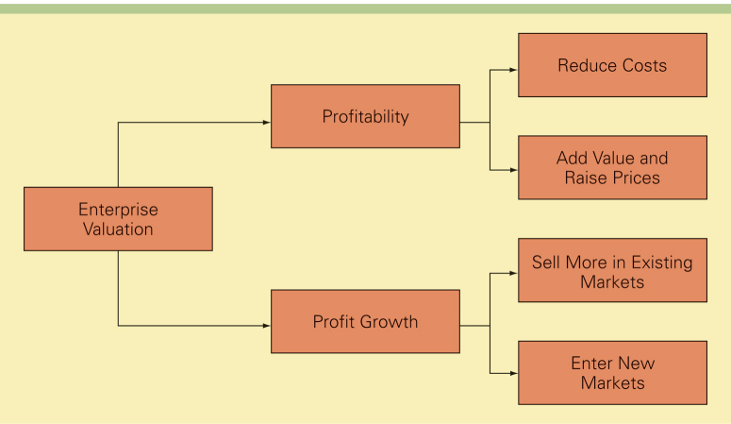

Value Creation
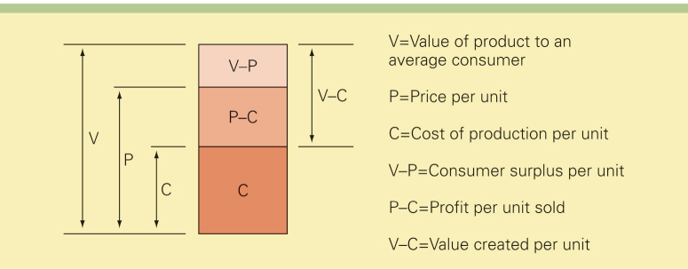
- The value created by a firm is measured by the difference between V (the value of a product to the average consumer) and C (the costs of producing that product)
- In general, the higher the value customers place on a firm’s products, the higher the price the firm can charge for those products, and the greater the profitability of the firm
- However, the price that the firm can charge for that product is typically less than the value that the consumer places on the good due to competitive pressures)
Profits can be increased by:
- adding value to a product so that customers are willing to pay more for it – a differentiation strategy
- lowering costs – a low cost strategy
- Michael Porter argues that superior profitability goes to firms that create superior value by lowering the cost structure of the business and/or differentiating the product so that a premium price can be charged

Strategic Positioning
- Michael Porter argues that firms need to choose either differentiation or low cost, and then configure internal operations to support the choice
To maximize long run return on invested capital, firms must:
- pick a viable position on the efficiency frontier
- configure internal operations to support that position
- have the right organization structure in place to execute the strategy

Lecture 30
Operations: The Firm as a Value Chain
- A firm’s operations can be thought of a value chain composed of a series of distinct value creation activities, including production, marketing, materials management, R&D, human resources, information systems, and the firm infrastructure. Value creation activities can be categorized as primary activities (R&D, production, marketing and sales, customer service) and support activities (information systems, logistics, human resources)
- Operations: The Firm As A Value Chain
The Value Chain
Global Expansion, Profitability, and Profit Growth
International firms can:
- expand the market for their domestic product offerings by selling those products in international markets.
- realize location economies by dispersing individual value creation activities to locations around the globe where they can be performed most efficiently and effectively.
- realize greater cost economies from experience effects by serving an expanded global market from a central location, thereby reducing the costs of value creation.
- earn a greater return by leveraging any valuable skills developed in foreign operations and transferring them to other entities within the firm’s global network of operations
Expanding The Market: Leveraging Products And Competencies
- Firms can increase growth by selling goods or services developed at home internationally.
- The success of firms that expand internationally depends on the goods or services they sell, and on their core competencies (skills within the firm that competitors cannot easily match or imitate).
- Core competencies enable the firm to reduce the costs of value creation and/or to create perceived value in such a way that premium pricing is possible
Location Economies
- When firms base each value creation activity at that location where economic, political, and cultural conditions, including relative factor costs, are most conducive to the performance of that activity, they realize location economies (the economies that arise from performing a value creation activity in the optimal location for that activity, wherever in the world that might be)
- By achieving location economies, firms can:
  - lower the costs of value creation and achieve a low cost position
  - differentiate their product offering
- Firms that take advantage of location economies in different parts of the world, create a global web of value creation activities
- Under this strategy, different stages of the value chain are dispersed to those locations around the globe where perceived value is maximized or where the costs of value creation are minimized
A caveat:
- transportation costs, trade barriers, and political risks complicate this picture
- The experience curve refers to the systematic reductions in production costs that have been observed to occur over the life of a product
- Learning effects are cost savings that come from learning by doing
- So, when labor productivity increases, individuals learn the most efficient ways to perform particular tasks, and management learns how to manage the new operation more efficiently

Experience Effects

The Experience Curve

- Economies of scale refer to the reductions in unit cost achieved by producing a large volume of a product
Sources of economies of scale include:
- spreading fixed costs over a large volume
- utilizing production facilities more intensively
- increasing bargaining power with suppliers
- By moving down the experience curve, firms reduce the cost of creating value
- To get down the experience curve quickly, firms can use a single plant to serve global markets
- Leveraging Subsidiary Skills
It is important for managers to:
- recognize that valuable skills that could be applied elsewhere in the firm can arise anywhere within the firm’s global network (not just at the corporate center)
- establish an incentive system that encourages local employees to acquire new skills
- have a process for identifying when valuable new skills have been created in a subsidiary
Summary
- Managers need to keep in mind the complex relationship between profitability and profit growth when making strategic decisions about pricing
- In some cases, it may be worthwhile to price products low relative to their perceived value in order to gain market share
Cost Pressures And Pressures For Local Responsiveness
Firms that compete in the global marketplace typically face two types of competitive pressures:
- pressures for cost reductions
- pressures to be locally responsive
- These pressures place conflicting demands on the firm
- Pressures for cost reductions force the firm to lower unit costs, but pressure for local responsiveness require the firm to adapt its product to meet local demands in each market—a strategy that raises costs

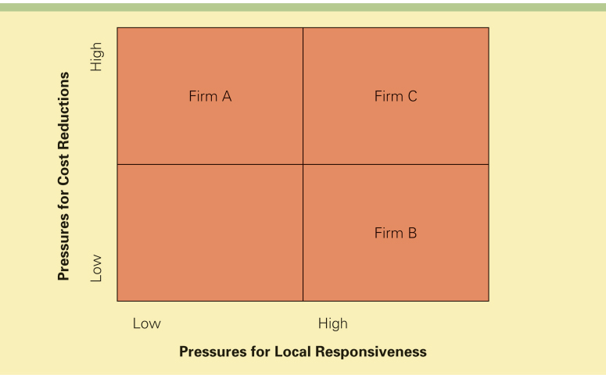
Pressures for Cost Reductions and Local Responsiveness

Pressures for cost reductions are greatest:
- in industries producing commodity type products that fill universal needs (needs that exist when the tastes and preferences of consumers in different nations are similar if not identical) where price is the main competitive weapon
- when major competitors are based in low cost locations
- where there is persistent excess capacity
- where consumers are powerful and face low switching costs
- Pressures For Local Responsiveness
Pressures for local responsiveness arise from:
- differences in consumer tastes and preferences - strong pressures for local responsiveness emerge when consumer tastes and preferences differ significantly between countries
- differences in traditional practices and infrastructure - pressures for local responsiveness emerge when there are differences in infrastructure and/or traditional practices between countries
- differences in distribution channels - a firm's marketing strategies needs to be responsive to differences in distribution channels between countries
- host government demands - economic and political demands imposed by host country governments may necessitate a degree of local responsiveness
Choosing A Strategy
There are four basic strategies to compete in the international environment:
- global standardization
- localization
- transnational
- International
- The appropriateness of each strategy depends on the pressures for cost reduction and local responsivness in the industry

Four Basic Strategies
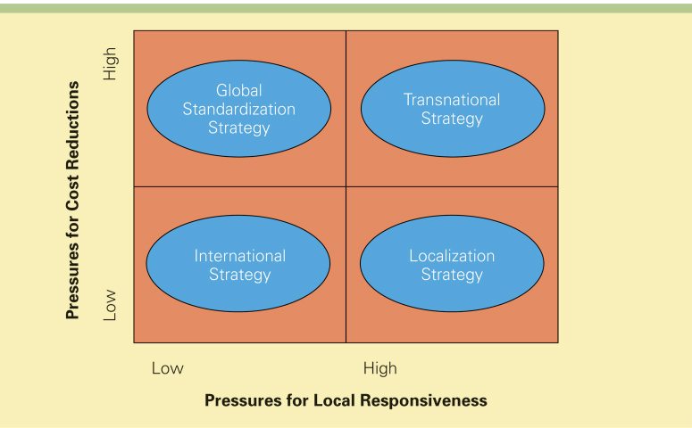

Global Standardization Strategy
- The global standardization strategy focuses on increasing profitability and profit growth by reaping the cost reductions that come from economies of scale, learning effects, and location economies
- The strategic goal is to pursue a low-cost strategy on a global scale
The global standardization strategy makes sense when:
- there are strong pressures for cost reductions
- demands for local responsiveness are minimal
Localization Strategy
- The localization strategy focuses on increasing profitability by customizing the firm’s goods or services so that they provide a good match to tastes and preferences in different national markets
The localization strategy makes sense when:
- there are substantial differences across nations with regard to consumer tastes and preferences
- where cost pressures are not too intense
Transnational Strategy
The transnational strategy tries to simultaneously:
- achieve low costs through location economies, economies of scale, and learning effects
- differentiate the product offering across geographic markets to account for local differences
- foster a multidirectional flow of skills between different subsidiaries in the firm’s global network of operations
The transnational strategy makes sense when:
- cost pressures are intense
- pressures for local responsiveness are intense
International Strategy
- The international strategy involves taking products first produced for the domestic market and then selling them internationally with only minimal local customization
The international strategy makes sense when
- there are low cost pressures
- low pressures for local responsiveness
- Classroom Performance System
Which strategy tries to simultaneously achieve low costs through location economies, economies of scale, and learning effects, and differentiate the product offering across geographic markets to account for local differences?
a) Internationalization
b) Localization
c) Global standardization
d) Transnational

The Evolution of Strategy
- An international strategy may not be viable in the long term
- To survive, firms may need to shift to a global standardization strategy or a transnational strategy in advance of competitors
- Similarly, localization may give a firm a competitive edge, but if the firm is simultaneously facing aggressive competitors, the company will also have to reduce its cost structures, and the only way to do that may be to shift toward a transnational strategy

Changes in Strategy over Time
