Financial Management in the International Business
Lecture 26
Introduction
Financial management involves three sets of decisions
1. Investment decisions – decisions about what to finance
2. Financing decisions – decisions about how to finance those decisions
3. Money management decisions – decisions about how to manage the firm’s financial resources most efficiently
- These decisions are more complex in international business because of the different currencies, tax regimes, regulations on capital flows, economic and political risk, and so on between countries
- Good financial management can be a source of competitive advantage
- Firms with good financial management can reduce the costs of creating value and add value by improving customer service
Investment Decisions
- Financial managers must quantify the benefits, costs, and risks associated with an investment in a foreign country
- To do this, managers use capital budgeting
Capital Budgeting
- Capital budgeting quantifies the benefits, costs, and risks of an investment. This involves estimating the cash flows associated with the project over time, and then discounting them to determine their net present value. If the net present value of the discounted cash flows is greater than zero, the firm should go ahead with the project. Capital budgeting is complicated in international business:
- because a distinction must be made between cash flows to the project and cash flows to the parent company
- by political and economic risk
- because the connection between cash flows to the parent and the source of financing must be recognized
Project and Parent Cash Flows
- Cash flows to the project and cash flows to the parent company are not necessarily the same. Cash flows to the parent may be lower for various reasons including host country limits on the repatriation of profits, host country local reinvestment requirements, and so on. For the parent company, the key figure is the cash flows it will receive, not the cash flows the project generates because received cash flows are the basis for dividends, other investments, repayment of debt, and so on
Adjusting For Political and Economic Risk
- The analysis of a foreign investment opportunity includes an assessment of political and economic risk. Political risk is the likelihood that political forces will cause drastic changes in a country’s business environment that hurt the profit and other goals of a business. Political risk is higher in countries with social unrest or disorder, or where the nature of the society increases the chance for social unrest. Political change can result in the expropriation of a firm’s assets, or complete economic collapse that renders a firm’s assets worthless. Economic risk is the likelihood that economic mismanagement will cause drastic changes in a country’s business environment that hurt the profit and other goals of a business. Typically, the biggest economic risk is inflation. Price inflation is reflected in falling currency values and lower project cash flows.
Firms analyzing foreign investment opportunities can treat risk:
- by raising the discount rate in countries where political and economic risk is high
Or
- by lowering future cash flow estimates to account for adverse political or economic changes that could occur in the future
Financing Decisions
Firms must consider two factors when considering financing options:
- how the foreign investment will be financed
- how the financial structure of the foreign affiliate should be configured
Source of Financing
- Firms using external funding may want to borrow from the lowest cost source. However, some governments prevent this by requiring local debt or equity financing. Firms that anticipate a depreciation of the local currency, may prefer local debt financing
Financial Structure
- The financial structure (debt versus equity) of firms varies by country. In Japan, for example, debt financing is more common than in the U.S. Firms need to decide whether to adopt local capital structure norms or maintain the structure used in the home country. Most experts suggest that firms adopt the structure that minimizes the cost of capital, whatever that may be.
Global Money Management
- Money management decisions attempt to manage global cash resources efficiently.
- Firms need to minimize cash balances and reduce transaction costs
- Minimizing Cash Balances
- Firms need cash balances on hand for notes payable and unexpected demands
- To keep cash accessible cash reserves are usually invested in money market accounts that offer low rates of interest
- If firms could invest for a longer time frame, they could earn higher rates of interest
- So, firms face a dilemma - when they invest in money market accounts they have unlimited liquidity, but low interest rates, and when they invest in long-term instruments they have higher interest rates, but low liquidity
- Reducing Transaction Costs
- Transaction costs are the cost of exchange
- Every time a firm changes cash from one currency to another, they face transaction costs
- Most banks also charge a transfer fee for moving cash from one location to another
- Multilateral netting can reduce the number of transactions between subsidiaries and the number of transaction costs

Lecture 27
Global Money Management:
The Tax Objective
- Tax regimes vary by country
- Many countries tax the foreign-earned income of companies based in the country
- Double taxation occurs when the income of a foreign subsidiary is taxed by the host-country government and by the home-country government
- Many countries maintain various policies like tax credits, tax treaties, and tax deferrals to minimize double taxation
Corporate Income Tax Rates, 2006
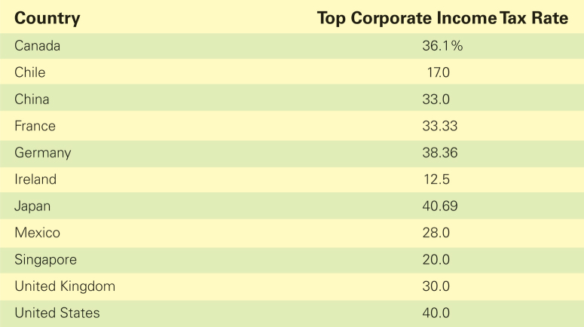

- A tax credit allows an entity to reduce the taxes paid to the home government by the amount of taxes paid to the foreign government
- A tax treaty between two countries is an agreement specifying what items of income will be taxed by the authorities of the country where the income is earned
- A deferral principle specifies that parent companies are not taxed on foreign source income until they actually receive a dividend
- A tax haven is a country with a very low, or no, income tax – firms can avoid income taxes by establishing a wholly-owned, non-operating subsidiary in the country
Lecture 28
Moving Money across Borders: Attaining Efficiencies and Reducing Taxes
Firms can transfer liquid funds across border via:
- dividend remittances
- royalty payments and fees
- transfer prices
- fronting loans
Firms that use more than one of these techniques is using a practice called unbundling
Dividend Remittances
- The most common method of transferring funds from subsidiaries to the parent is through dividends
The relative attractiveness of dividends varies according to:
- tax regulations – high tax rates make this less attractive
- foreign exchange risk – dividends might speed up in risky countries
- the age of the subsidiary – older subsidiaries remit a higher proportion of their earning in dividends
- the extent of local equity participation – local owners’ demands for dividends come into play
Royalty Payments and Fees
- Royalties represent the remuneration paid to the owners of technology, patents, or trade names for the use of that technology or the right to manufacture and/or sell products under those patents or trade names
- Most parent companies charge subsidiaries royalties for the technology, patents or trade names transferred to them
- Royalties can be levied as a fixed amount per unit or as a percentage of gross revenues
- A fee is compensation for professional services or expertise supplied to a foreign subsidiary by the parent company or another subsidiary
- Royalties and fees are often tax-deductible locally
Transfer Prices
- The price at which goods and services are transferred between entities within the firm is the transfer price
- Transfer prices can be manipulated to
1. reduce tax liabilities by shifting earnings from high-tax countries to low-tax countries
2. move funds out of a country where a significant currency devaluation is expected
3. move funds from a subsidiary to the parent when dividends are restricted by the host government
4. reduce import duties when an ad valorem tariffs is in effect
Transfer pricing can be problematic because:
1. governments think they are being cheated out of legitimate income
2. governments believe firms are breaking the spirit of the law when transfer prices are used to circumvent restrictions of capital flows
3. it complicates management incentives and performance evaluation
Fronting Loans
- Fronting loans are loans between a parent and its subsidiary channeled through a financial intermediary, usually a large international bank
Firms use fronting loans:
- to circumvent host-country restrictions on the remittance of funds from a foreign subsidiary to the parent company
- to gain tax advantages
Techniques For Global Money Management
Two techniques used by firms to manage their global cash resources are:
- centralized depositories
- multilateral netting
- Centralized Depositories
- All firms must maintain easily accessible cash balances
- Firms must decide whether to hold cash balances at each subsidiary or at a centralized depository
- Most firms prefer the latter for three reasons:
1. by pooling cash reserves centrally, firms can deposit larger amounts, and therefore earn higher rates of interest
2. when centralized depositories are located in major financial centers, the firm has access to a greater variety of investment opportunities than a subsidiary would have
3. by pooling cash reserves, firms can reduce the total size of the readily accessible cash pool, and invest larger amounts in longer-term, less liquid accounts that have higher interest rates
Centralized Depositories
- Sometimes, government restrictions on cross-border capital flows limit the use of centralized depositories
- Firms must also be aware of the transaction costs involved in moving money in and out of a centralized depository
- The use of centralized depositories is expected to increase thanks to the globalization of capital markets and the removal of barriers to the free flow of capital across borders
Multilateral Netting
- Firms using multilateral netting can reduce the transaction costs associated with many transactions between subsidiaries
- Multilateral netting is an extension of bilateral netting
- Under bilateral netting, if a French subsidiary owes a Mexican subsidiary $6 million, and the Mexican subsidiary simultaneously owes the French subsidiary $4 million, a bilateral settlement will be made with a single payment of $2 million
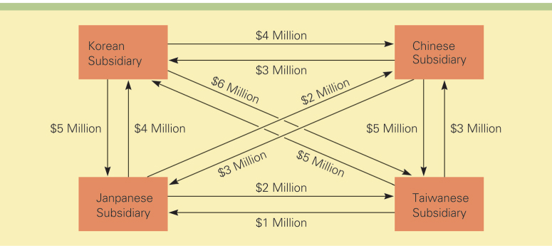
- Under multilateral netting, the concept is extended to multiple subsidiaries within an international business
