Lecture 18
Chapter5
Systems Design: Activity-Based Costing
Assigning Overhead Costs to Products
Plantwide Overhead Rate
A single overhead rate used throughout an entire factory. A simple method, but one that can distort unit product costs. Direct labor has often used as the allocation base for overhead. Today, direct labor may no longer be a satisfactory base for allocation of overhead.
- Direct labor may no longer be highly correlated with overhead costs.
- No single allocation basis may be able to adequately reflect the demands that products place on overhead.
Departmental Overhead Rates
The allocation bases depend on the nature of the work performed in each department. In the machining department, overhead may be based on machine-hours, but in the assembly department overhead is based on labor-hours. Unfortunately, even departmental rates will not correctly assign overhead in situations where a company has a range of products and complex overhead costs.
Activity-Based Costing (ABC)
A number of allocation bases are used for assigning costs to products. Activity Cost Pool a “cost bucket in which costs related to a particular activity are accumulated. Each activity has its own activity rate that is used to apply overhead costs.
Designing an ABC System
Steps for Implementing ABC
- Identify and define activities and activity pools and develop an activity dictionary.
- Trace or assign costs to activities and cost objects.
- Calculate activity rates.
- Assign costs to cost objects.
- Prepare necessary reports.

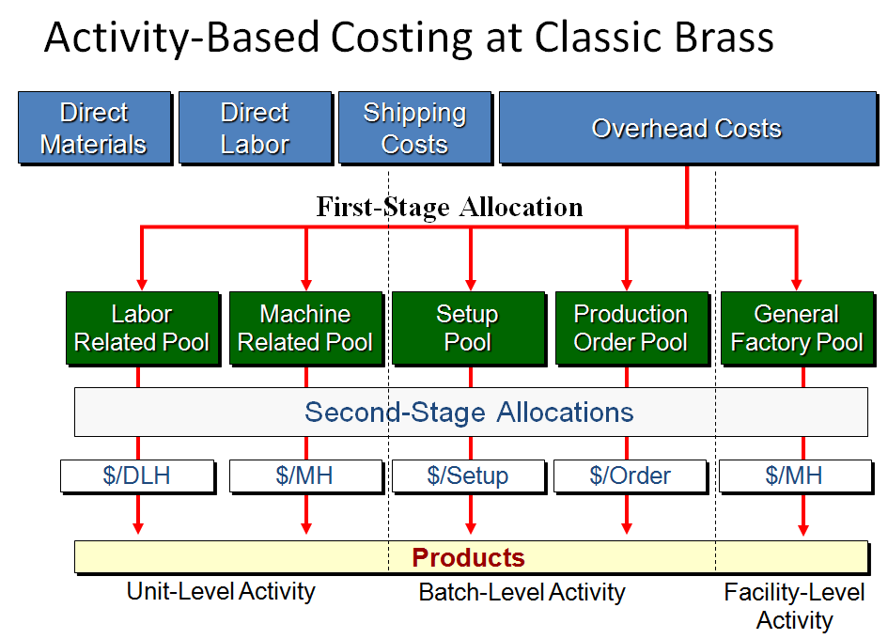

Using Activity-Based Costing
Sony, Inc. makes two products, a radio with a built-in tape player and one with a built-in compact disc player. For the current year, Sony has budgets sales of 50,000 CD units and 200,000 tape units.
  - Both products require two direct labor-hours to complete.
  - The company plans to work 500,000 hours to meet the budgeted production.
  - All production is sold to auto manufacturers for installation in new cars and trucks.
  - Direct materials cost $90 per unit for the CD unit and $50 for the Tape unit.
  - Direct labor costs at $10 per hour are $20 for both the CD and Tape unit.
Direct Labor-Hours as a Base
Total manufacturing overhead costs for the current year are estimated to be $10,000,000. The company develops the following overhead rate based upon labor-hours:
Computing Activity Rates
The ABC project team at Sony has developed the following basic information.
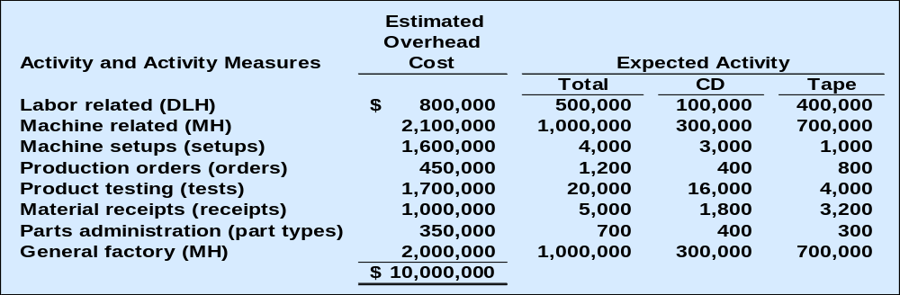

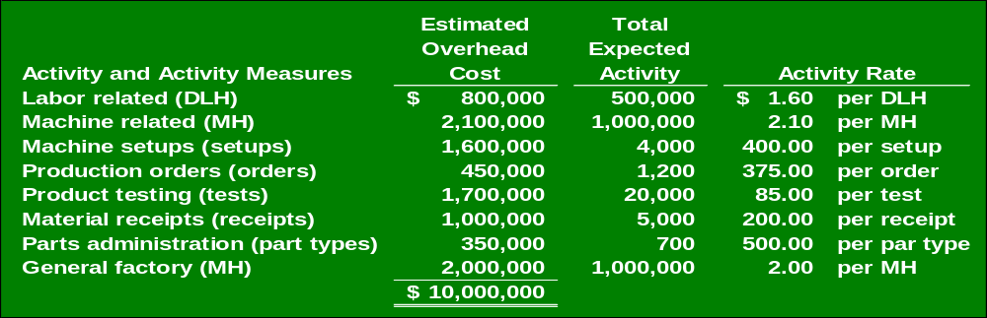Using the basic information, we can calculate the following activity rates:

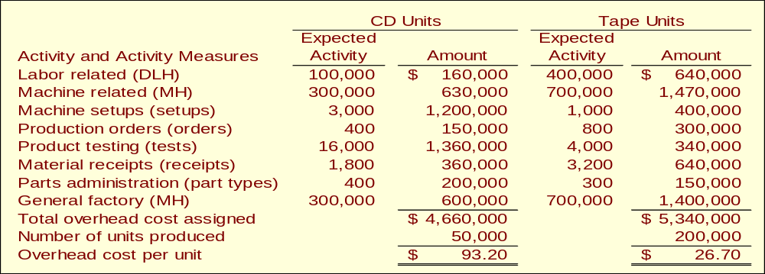

Comparing activity based costing and traditional volume based costing

When a company implements activity-based costing, overhead cost often shifts from high-volume to low-volume products with a higher unit product cost resulting for the low-volume products.

End of Lecture 18

Lecture 19
Targeting Process Improvements
Activity-Based Management
involves focusing on activities to eliminate waste, decrease processing time, and reduce defects.
Benchmarking
is a systematic approach to identifying the activities with the greatest room for improvement. It is based on comparing the performance in an organization with the performance of other, similar organizations known for their outstanding performance.
Evaluation of Activity-Based Costing
Benefits of ABC
  - Improves the accuracy of product costs.
  - Activity cost pools are more homogeneous than departmental cost pools.
  - Allocates overhead on the basis of activities that cause overhead costs.
Limitations of ABC
  - Cost of implementation may exceed benefits.
  - Products costs are not always relevant when making decisions.
ABC and Service Industries
Activity-based costing has been implemented in a wide variety of service industries including railroads, hospitals, banks, and data service companies.
Cost Flows in an ABC System
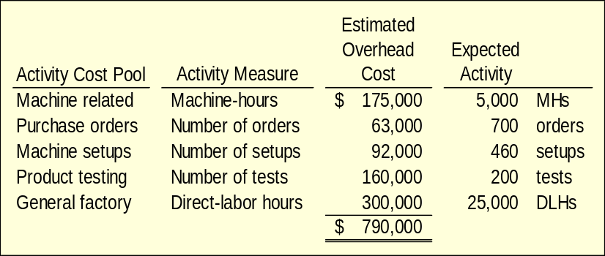Sarvik Company uses activity-based costing. The company has five cost pools shown below.

At the beginning of the year, the company had inventory balance as follows.
Raw materials | $3,000
Work in process | 4,000
Finished goods | - 0 -
Transaction recorded by the company:
- Raw materials purchased on account, $915,000.
- Raw materials used in production, $900,000 ($810,000 direct and $90,000 indirect).
- Factory labor costs, $370,000 ($95,000 direct and $275,000 indirect).
- Depreciation of factory assets, $180,000.
- Miscellaneous manufacturing overhead costs, $230,000.
- Goods costing $1,650,000 manufactured.
Manufacturing overhead cost was applied to production. Actual activity during the year was as follows:
- Machine related 4,600 machine-hours.
- Purchase orders, 800 orders.
- Machine setups, 500 setups.
- Product testing, 190 tests.
- General factory, 23,000 direct-labor hours.
The following journal entries would be used to record transactions (a) through (c).
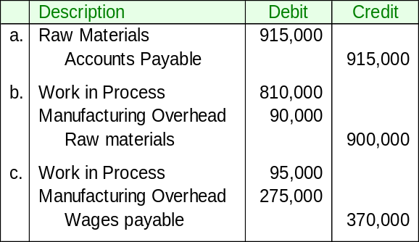

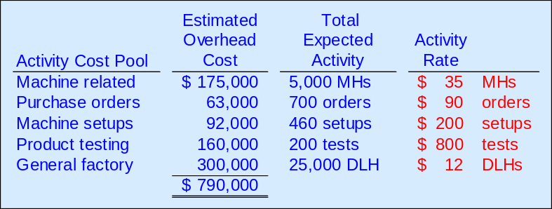Predetermined overhead rates are determined as follows:

Overhead is applied on the basis of actual activities during the year.
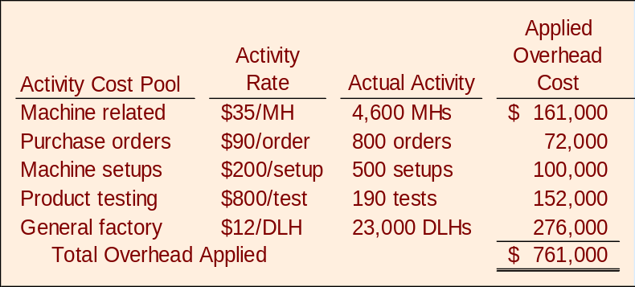

The following journal entry is made to record applied overhead.
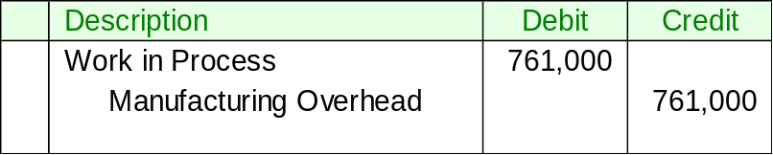

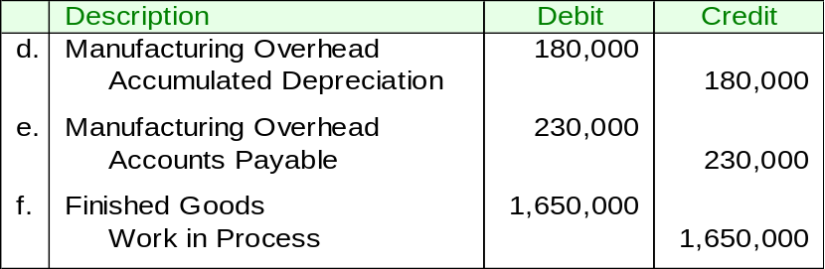The following journal entries would be used to record transactions (d) through (f).

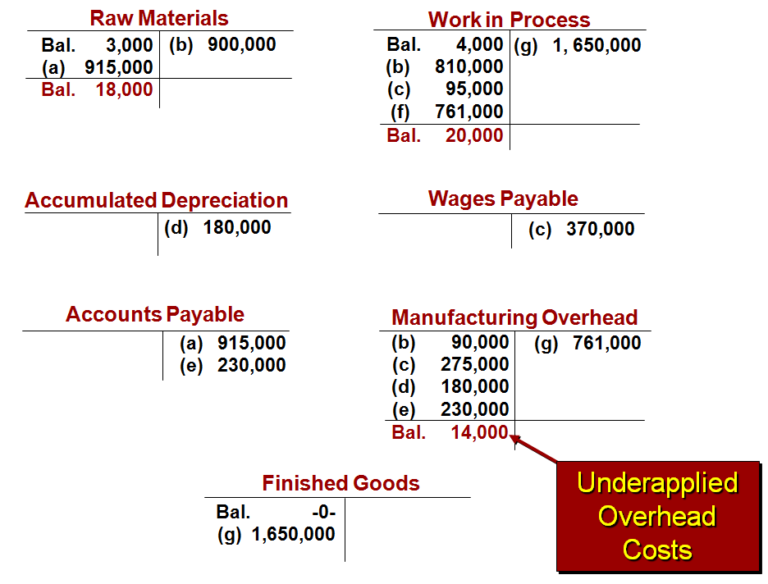
T Accounts Used to show the record of journal entries

End of Lecture 19

Lecture 20
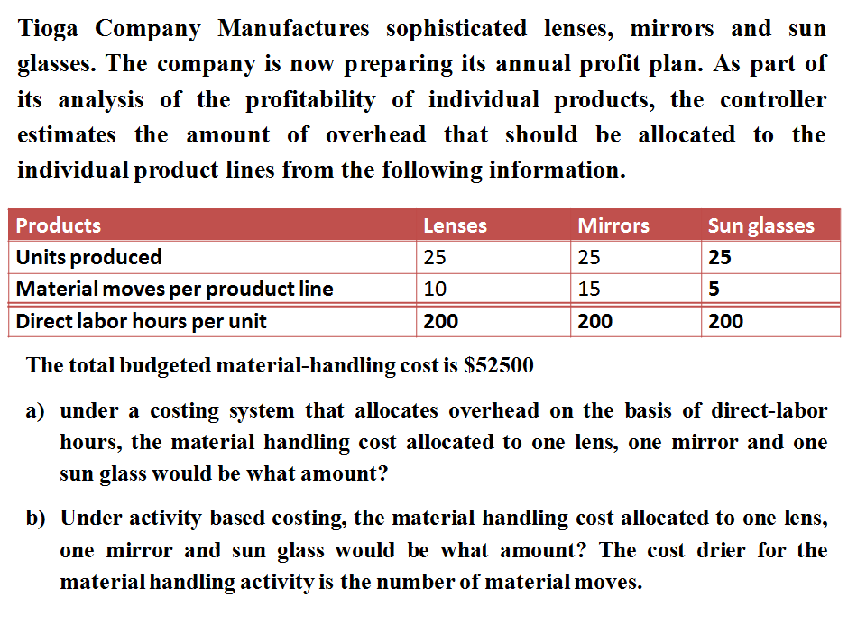
Exercise Questions
Q No. 1

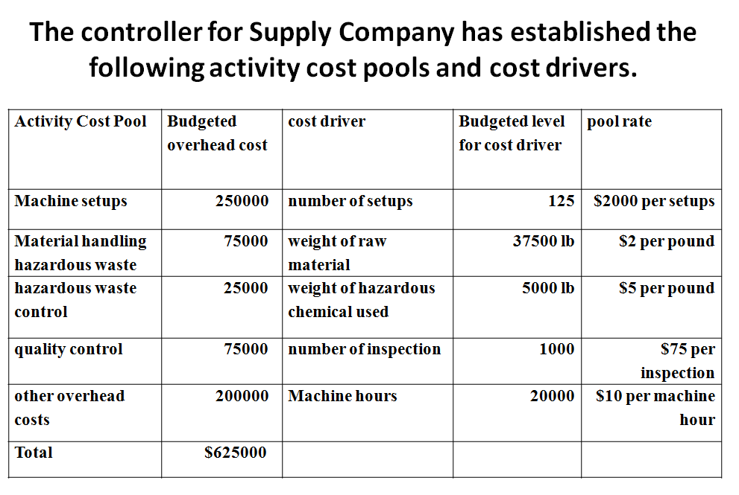
Q No. 2

Machine setups | 5 setups
Raw Material | 10000 pounds
Hazardous materials | 2000 pounds
Inspections | 10 inspections
Machine Hours | 500 machine hours
An order for 1000 boxes of film development chemical has the following production requirements.

Requirements
- Computer total FOH that should be assigned to the development chemical order
- What is the overhead cost per box of chemical
- Suppose supply company were to use a single predetermined FOH based on machine hours, compute the rate per hour
- Under the approach in requirement (3) how much overhead would be assigned to the development chemical order?
  - In total.
  - Per box of chemicals
- Explain why these two products costing systems result in such widely differing cost.

End of Lecture 20

Lecture 21
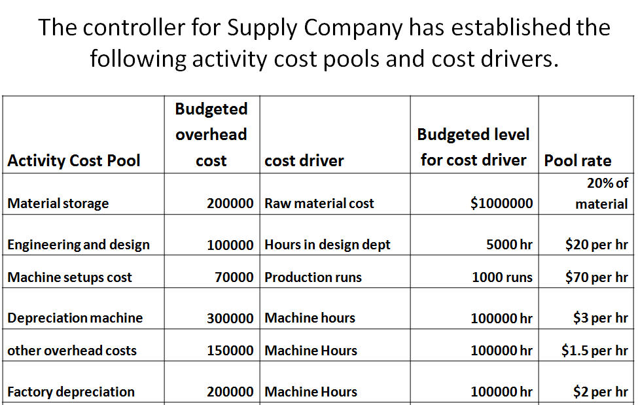
Exercise question

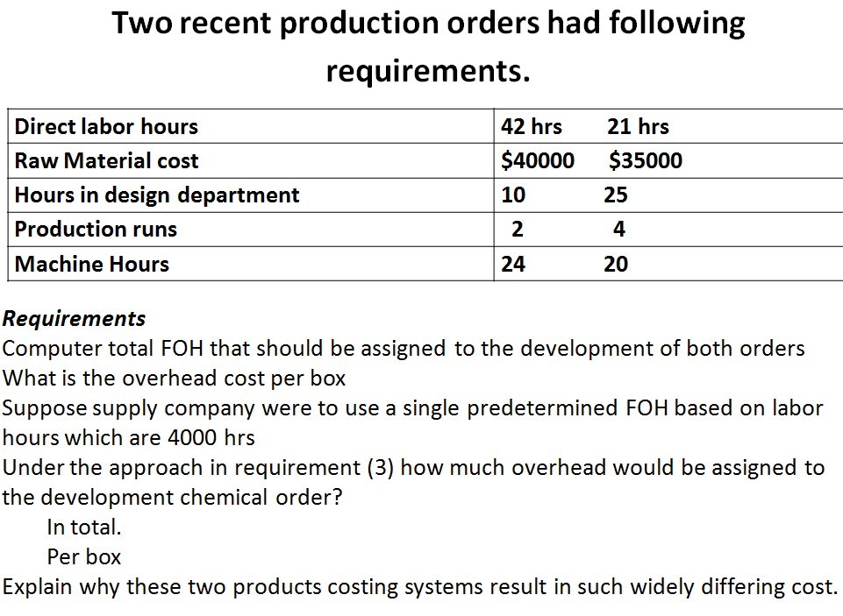

End of Lecture 21

