Lecture 26
Cost Allocation: Joint Products and By-products
Main Products and Byproducts
- Main products are products which constitute the major portion of the total sales value
- Byproducts are products with low sales values compared to the main products
- Scrap are outputs with minimal sales values
- These classifications can change over time especially when market prices change dramatically from year to year
- When allocating joint costs to byproducts either
  - recognize at the time production is completed
  - recognize at the time of sale
Joint Cost Terminology
- Main Product – output of a joint production process that yields one product with a high sales value compared to the sales values of the other outputs
- Joint Products – outputs of a joint production process that yields two or more products with a high sales value compared to the sales values of any other outputs
- Byproducts – outputs of a joint production process that have low sales values compare to the sales values of the other outputs
By-Product Costs
- By-product resulting from scrap, trimmings, and so forth, of the main products in essentially nonjoint-product types of undertakings (e.g., fabric trimmings from clothing pieces).
- Scrap and other residue from essentially joint-product types of processes (e.g., fat trimmed from beef carcasses).
- A minor joint product situation (fruit skins and trimmings used as animal feed).
By-products revenue allocation
- By-product revenue as additional sales revenue
- By product revenue as a deduction from the cost of goods sold
- By product revenue deducted from production cost
Joint Production Process
Joint products are two or more products produced simultaneously by the same process up to a “split-off” point.
The split-off point is the point at which the joint products become separate and identifiable.
Separable costs are easily traced to individual products and offer no particular problem.
By-Products
The distinction between joint and by-products rests solely on the relative importance of their sales value.
A by-product is a secondary product recovered in the course of manufacturing a primary product.
Joint Cost Allocation Methods
- Market-Based – allocate using market-derived data (dollars):
  - Sales value at splitoff
  - Net Realizable Value (NRV)
  - Constant Gross-Margin percentage NRV
- Physical Measures – allocate using tangible attributes of the products, such as pounds, gallons, barrels, etc
- The average unit cost method
- The weighted average method
Criteria of cost allocation-issues
- This “joint cost” problem arises when companies inescapably produce two or more products simultaneously out of the same process.
- How do they allocate costs to jointly-produced products.
- How are the resulting allocations useful?

Joint-Cost Basics
- Joint costs are the costs of a single production process that yields multiple products simultaneously.
- Industries abound in which a single production process simultaneously yields two or more products.

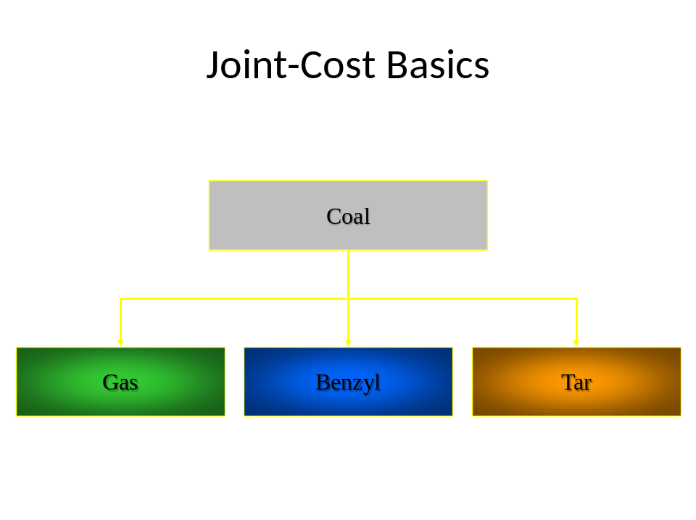

Lecture 27
Splitoff Point
- The splitoff point is the juncture in the production process where one or more products in a joint-cost setting become separately identifiable.
- 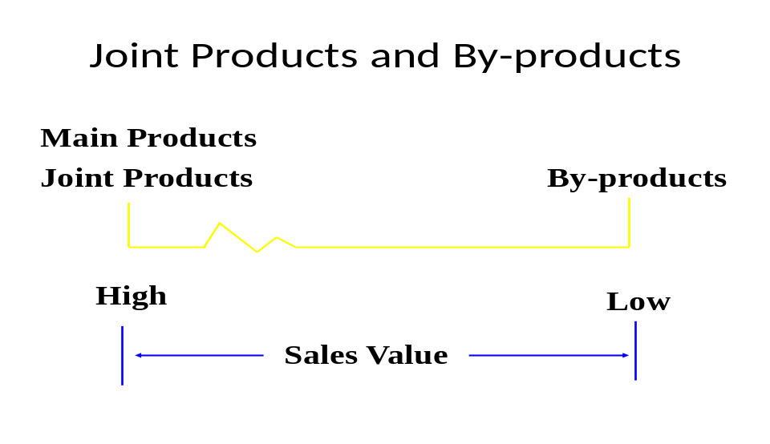Separable costs are all costs (manufacturing, marketing, distribution, etc.) incurred beyond the splitoff point that are assignable to one or more individual products.

Why Allocate Joint Products?
The purposes for allocating joint costs to products include:
- Inventory costing
  - Important for financial accounting purposes, reports to income tax authorities, and internal reporting purposes.
- Cost reimbursement contracts
  - Cost allocation is required for cost reimbursement purposes under contracts when only a portion of a business’ products or services is sold or delivered to a single customer.

- Insurance settlements
    - Require cost allocation when damage claims made by businesses with joint products, main products, or by-products are based on cost information.
- Rate regulation
    - The allocation of joint costs is required if one or more of the jointly produced products or services are subject to price regulation.
- Litigation
    - Joint cost allocation is important in litigation involving one or more joint products.
Allocating Joint Costs
- Company incurred $200,000 of joint costs to produce the following:
- Product A: 10,000 units, 20,000 pounds
- Product B: 10,500 units, 48,000 pounds
- Product C: 11,500 units, 12,000 pounds
Sales Value at Splitoff Method
- Allocates joint costs to joint products on the basis of the relative total sales value at the splitoff point.
  - All outputs must have sales values at this point to use the method.
Assume the following sales values per unit: A: $10.00, B: $30.00, and C: $20.00
- What is the total sales value at splitoff point?
  - Product A: 10,000 × $10.00 = $100,000
  - Product B: 10,500 × $30.00 = 315,000
  - Product C: 11,500 × $20.00 = 230,000
- Total $645,000
How much joint costs are allocated to each product?
  - A: $100,000/$645,000 × $200,000 = $ 31,008
  - B: $315,000/$645,000 × $200,000 = 97,674
  - C: $230,000/$645,000 × $200,000 = 71,318
Total $200,000
What are the joint production costs per unit?
- Product A: $31,008 ÷ 10,000 = $3.10
- Product B: $97,674 ÷ 10,500 = $9.30
- Product C: $71,318 ÷ 11,500 = $6.20
Assume all of the units produced of B and C were sold (no further processing).
- 2,500 units of A (25%) remain in inventory.
- What is the gross margin percentage of each product?
Product A
- Revenues: 7,500 units × $10.00 $75,000
- Cost of goods sold:
  - Joint product costs $31,008
  - Less ending inventory 7,752* 23,256
    - *$31,008 × 25%
- Gross margin $51,744

- Prod. A: $75,000 – $ 23,256 = $51,744; $51,744 ÷ $75,000 = 69%
- Prod. B: ($315,000 – $97,674) ÷ $315,000 = 69%
- Prod. C: ($230,000 – $71,318) ÷ $230,000 = 69%
The sales value at split off method produces an identical gross margin percentage for each product.
End of Lecture 27

Lecture 28
Exercise Question
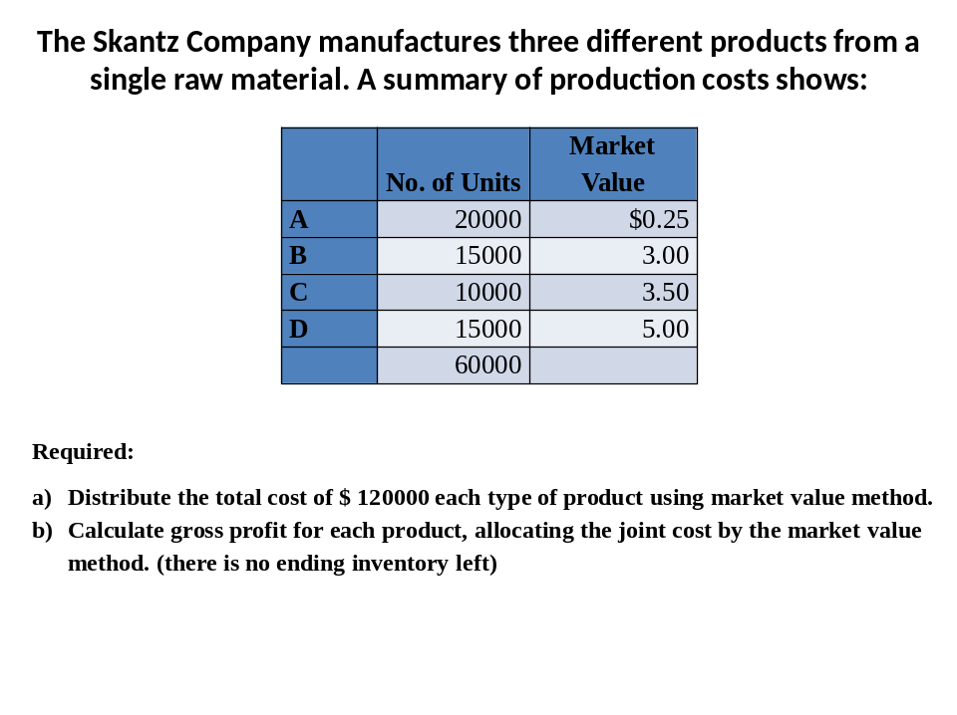

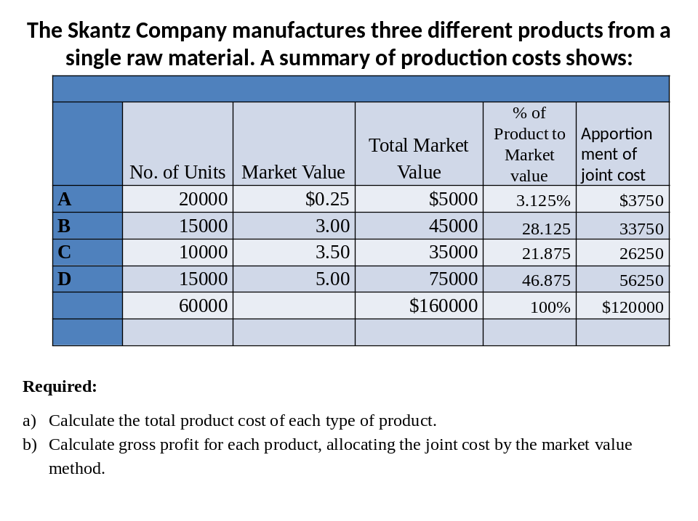

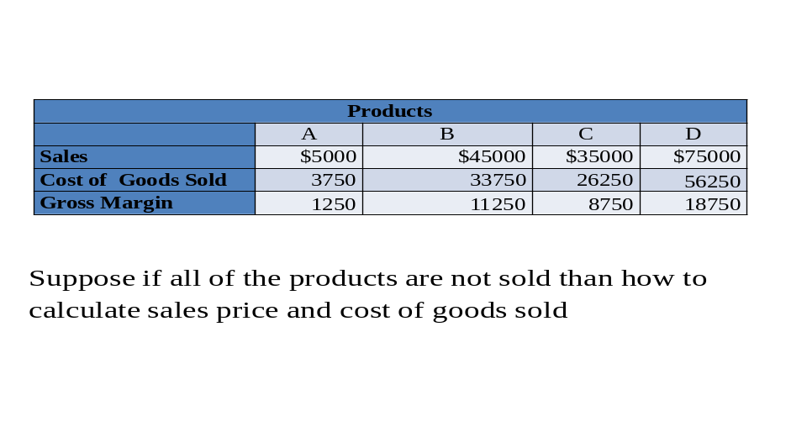Gross Margin Calculation when all the items are sold

Gross Margin Calculation when there is ending inventory left
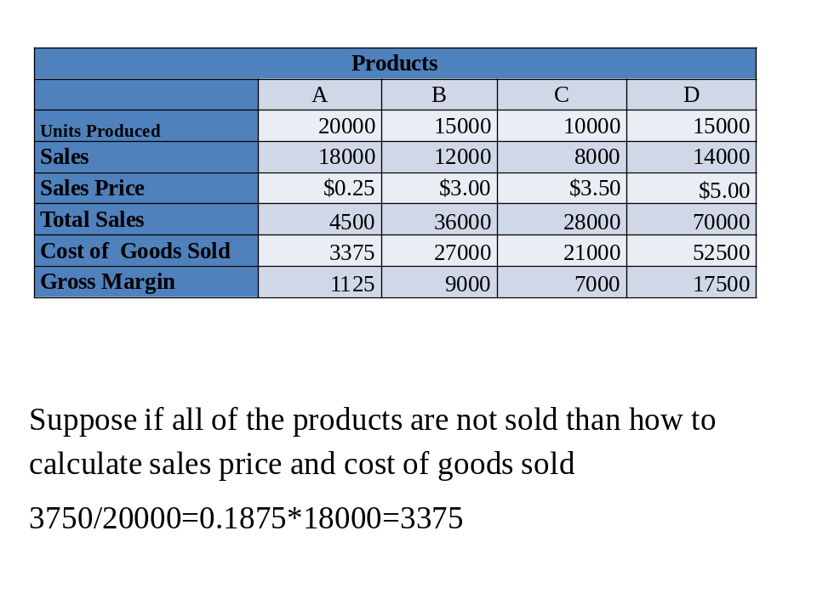

End of Lecture 28

Lecture 29
Estimated Net Realizable Value (NRV) Method
Often products are processed further beyond the splitoff point to make them marketable or increase their value.
The estimated NRV method allocates joint costs to joint products on the basis of the relative estimated NRV.
NRV = (expected final sales value in the ordinary course of business) – (expected separable costs of the total production of these products)
Assume that Company can process products A, B, and C further into A1, B1, and C1.
The new sales values after further processing are:
- A1: 10,000 × $12.00 = $120,000
- B1: 10,500 × $33.00 = $346,500
- C1: 11,500 × $21.00 = $241,500
Additional processing (separable) costs are as follows:
- A1: $35,000; B1: $46,500; and C1: $51,500
What is the estimated net realizable value of each product at the splitoff point?
- Product A1: $120,000 – $35,000 = $85,000 estimated net realizable value
- Product B1: $346,500 – $46,500 = $300,000 estimated net realizable value
- Product C1: $241,500 – $51,500 = $190,000 estimated net realizable value
How much of the joint cost is allocated to each product?
Estimated NRV Proportion
Product A1 $ 85,000 85/575
Product B1 300,000 300/575
Product C1 190,000 190/575
Total $575,000

- Product A1: 85/575 × $200,000 = $ 29,565
- Product B1: 300/575 × $200,000 = 104,348
- Product C1: 190/575 × $200,000 = 66,087
Total $200,000

What is the production cost per unit?
- Product A1: $64,565 ÷ 10,000 = $6.46
- Product B1: $150,848 ÷ 10,500 = $14.37
- Product C1: $117,587 ÷ 11,500 = $10.22

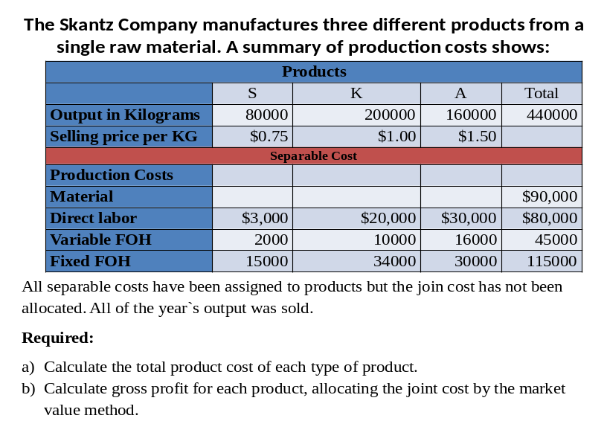Practice Question

End of Lecture 29
Lecture 30
Physical Measure Method
It allocates joint costs to joint products on the basis of the relative weight, volume, or other physical measure at the splitoff point.
Recall that Company incurred $200,00 of joint costs to produce A, B, and C products.
- Product A: 10,000 units, 20,000 pounds
- Product B: 10,500 units, 48,000 pounds
- Product C: 11,500 units, 12,000 pounds
Allocation using the number of pounds produced as the physical measure:
- Product A: 20,000/80,000 × $200,000 = $50,000
- Product B: 48,000/80,000 × $200,000 = $120,000
- Product C: 12,000/80,000 × $200,000 = $30,000
What is the cost per pound for each product?
- Product A: $50,000 ÷ 20,000 = $2.50
- Product B: $120,000 ÷ 48,000 = $2.50
- Product C: $30,000 ÷ 12,000 = $2.50
It is possible to obtain the cost per pound ($200,000 ÷ 80,000 = $2.50) and use this amount to distribute the joint costs.
Under the benefits-received criterion, the physical measure method is less preferred than the sales value at splitoff method.
- Why?
- Because it has no relationship to the revenue-producing power of the individual products.
Comparison of Methods
- Which method of allocating joint costs should be chosen?
- The sales value at splitoff method is widely used where market prices exist at splitoff.
- Sales value at splitoff method:
- Objective
- Does not anticipate subsequent management decisions on further processing.
- Uses a meaningful common denominator.
- Simple
- Not available if not all products salable at splitoff
- The purpose of the joint-cost allocation is important in choosing the allocation method.
- The physical measure method is a more appropriate method to use in rate regulation.
Absolute Irrelevance of Joint Costs for Decision Making
- Joint costs incurred up to the splitoff point are past (sunk) costs irrelevant to the decision to sell a joint (or main) product at the splitoff point or to process it further.
- Assume that products A, B, and C can be sold at the splitoff point (at price1) or processed further into A1, B1, and C1 and sold at price2.
Units price1 price2 Add’l costs
10,000 A: $10 A1: $12 $35,000
10,500 B: $30 B1: $33 $46,500
11,500 C: $20 C1: $21 $51,500

Should A, B, or C be sold at the splitoff -point or processed further?
- Product A: Incremental revenue $20,000 – Incremental cost $35,000 = ($15,000)
- Product B: Incremental revenue $31,500 – Incremental cost $46,500 = ($15,000)
- Product C: Incremental revenue $11,500 – Incremental cost $51,500 = ($40,000)

Physical or Quantitative unit method
- This method attempts to distribute the total joint cost on the basis of some units of measurement, such as pounds, gallons, tons etc.
- For instance, in manufacture of coke, products such as coke, coal tar, benzol, sulfate of ammonia, and gas are measure in different units.
- The yield of these recovered units is measured on the basis of quantity of products extracted per ton of coal.
Products | Yield in lbs of recovered products | Distribution of waste to recovered products | Revised weight of recovered products | Materials cost of each product
Coke | 1320.0 | 69.474 | 1389.474 | 13.895
Coal tar | 120.0 | 6.316 | 126.316 | 1.265
Benzol | 21.9 | 1.153 | 23.053 | 0.230
Sulfate of ammonia | 26.0 | 1.368 | 27.368 | 0.275
Gas | 412.1 | 21.689 | 433.789 | 4.335
Waste | 100.0
Total | 2000.0lbs | 100.000lbs | 2000.000 | $20.000

Average Unit Method
- This method distributes the joint cost on the basis of units produced.
- This method is used when the market value of all types of products are identical
- Average unit method is obtained by dividing the total number of units produced into the total joint production cost.

Weighted Average Unit Method
- In many industries, the previously described methods do not give a satisfactory answer to the joint cost apportionment.
- Weight factors are assigned to each unit, based upon size of unit, difficulty of manufacture, time consumed in making the unit, difference in type of labor employed, amount of materials used, etc.
- Finished Goods of every kind is multiplied by weight factors to apportion the total joint cost to individual units.

End of Lecture 30

