Lecture 14
Chapter 4
Systems Design: Process costing
Types of Costing Systems Used to Determine Product Costs
Process Costing
- Many units of a single, homogeneous product
flow evenly through a continuous production
process.
- One unit of product is indistinguishable from any
other unit of product..
- Each unit of product is assigned the same
average cost.
Typical process cost applications:
  - Petrochemical refinery
  - Paint manufacturer
  - Paper mill
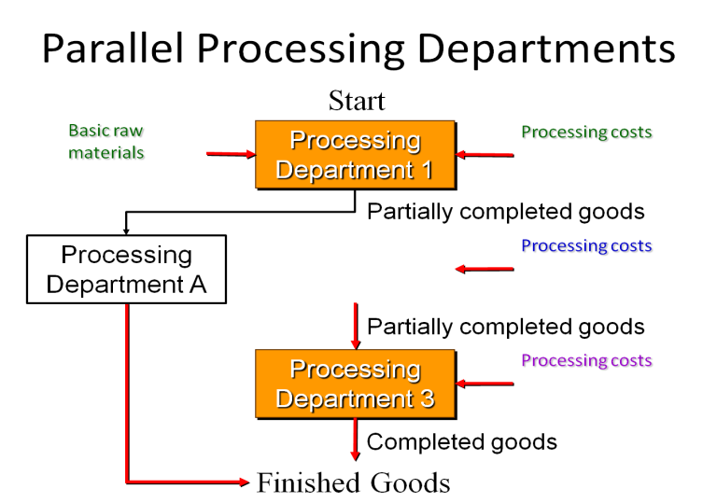

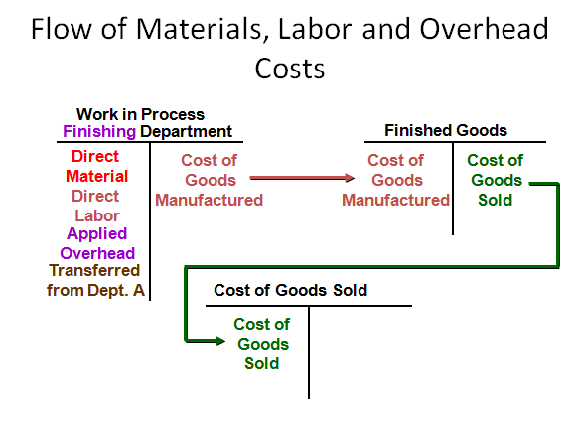

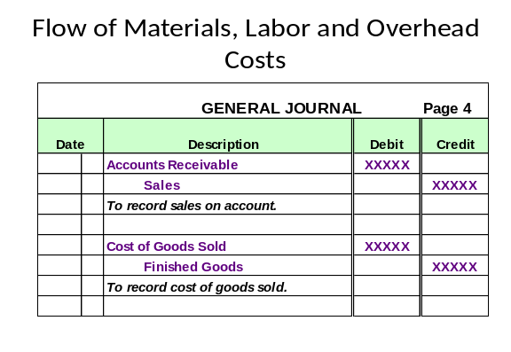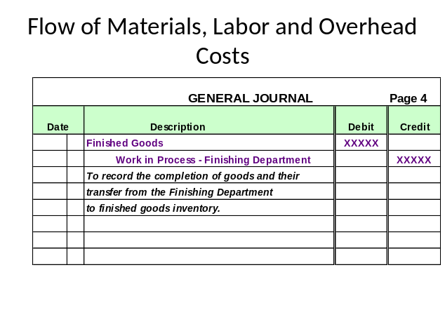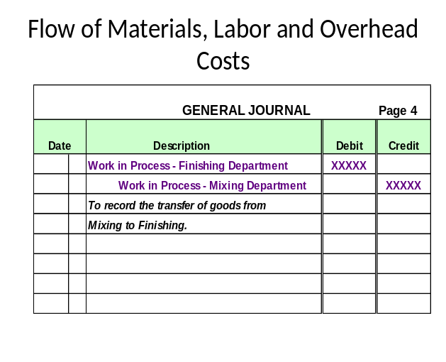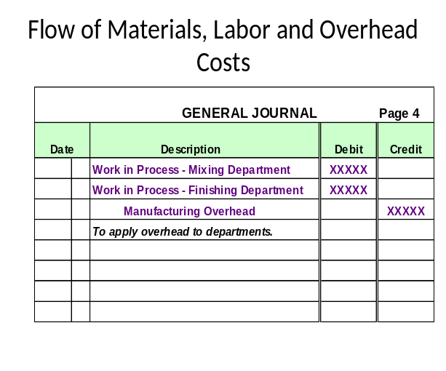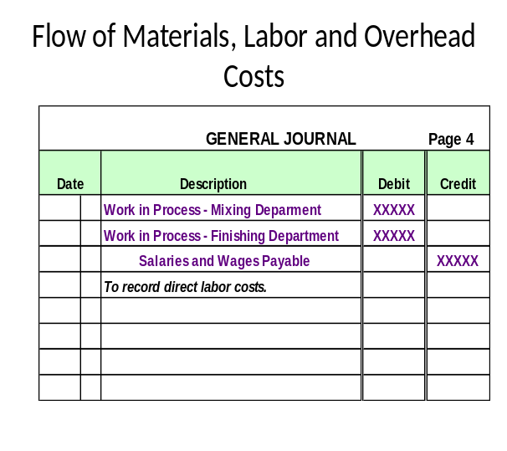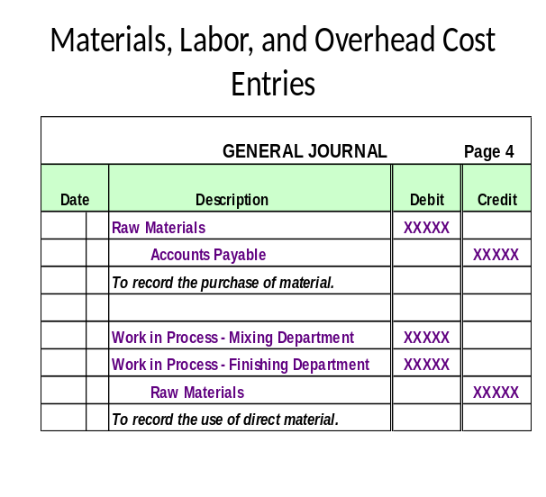

Lecture 15
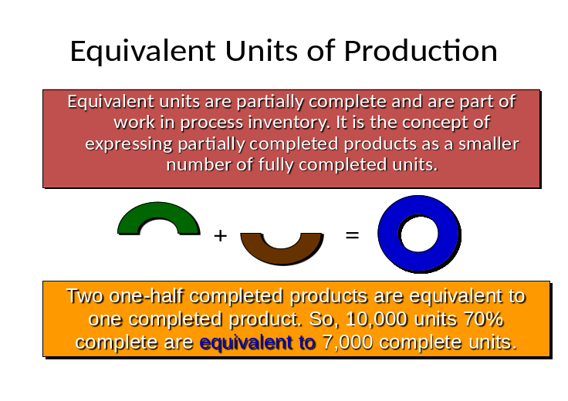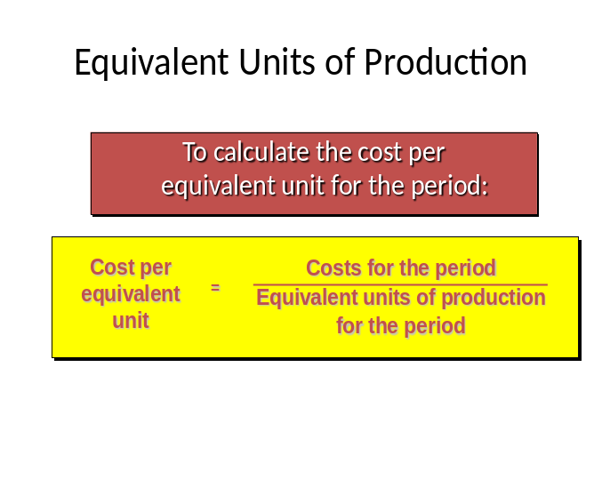Equivalent Unit
Weighted Average Method
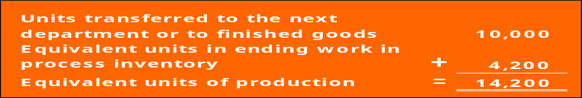Under the weighted-average method equivalent units will always be calculated as follows:

Matrix, Inc. reported the following activity in Mixing Department for the month of June:
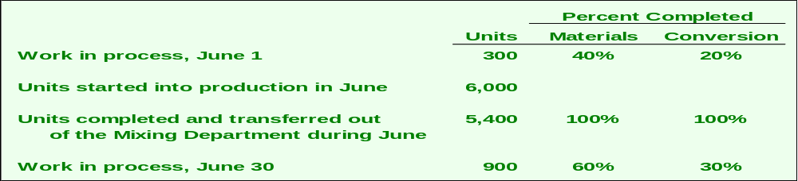

Equivalent units of production always equals:
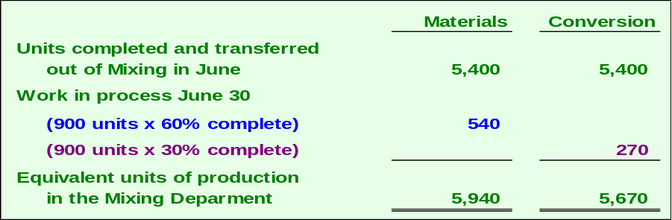Units completed and transferred + Equivalent units remaining in work in process

Production Report
Section: Compute cost per equivalent unit

Production Report
Section : Cost Reconciliation

End of Lecture 15

Lecture 16
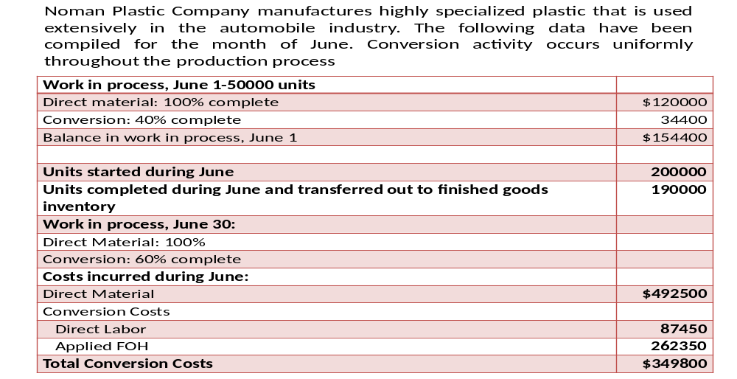Exercise Problems
Q No. 1

Requirements:
Prepare schedules to accomplish each of the following process-costing steps for the month of June. Use the weighted average method of process costing.
- Analysis of physical flow of the units
- Calculation of equivalent units
- Computation of units costs.
- Analysis of total costs

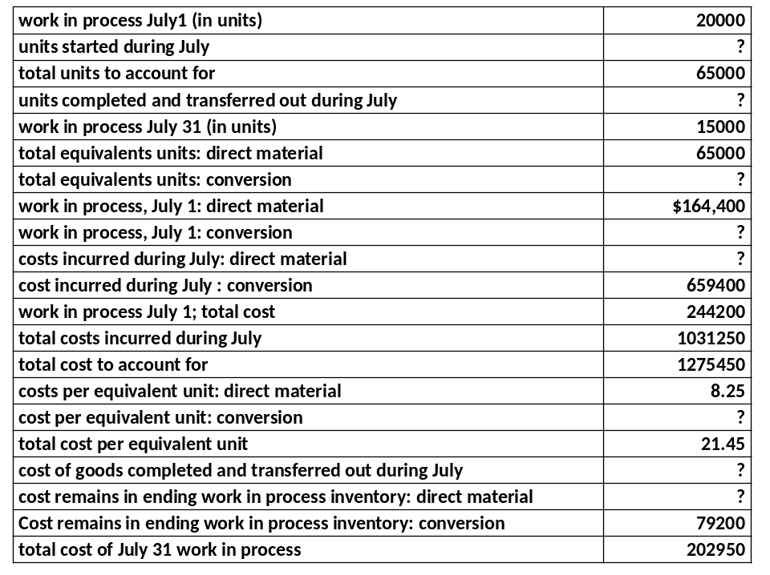Q No. 2

Q No. 3

End of Lecture 16

Lecture 17

Operations Costing

Compare and contrast operation costing with job costing and process costing.
- Operation costing is a hybrid of job and process costing.
- It is used in manufacturing goods that have some common characteristics plus some individual characteristics.

Q No. 1

 | Professional Ball | Scholastic Balls
Direct Material  Batch P25 ($42000/2000)  Batch S33 ($45000/4000) | $21.00 | $11.25
Conversion: Preparation Department | 7.50 | 7.50
Conversion: Finishing Department | 6.00 | 6.00
*Conversion: Packaging Department | 0.50
Total | $35.00 | $24.75
*the two production departments each worked on a total of 6000 balls but the packaging department handled only the 2000 professional balls.

Journal Entries | Dr | Cr
Work in Process: Preparation Department  Raw Material Inventory | 39500 | 39500
Work in Process: Preparation Department  Raw Material Inventory | 45000 | 45000
Work in Process: Preparation Department  Applied Conversion Cost | 45000 | 45000
Work in Process: Finished Department  Work in Process: Preparation Department | 129500 | 129500
Work in Process: Finished Department  Applied Conversion Cost | 36000 | 36000
Work in Process: Packaging Department  Finished Goods Inventory  Work in Process: Finished Department | 66500  99000 | 165500
Work in Process: Packaging Department  Raw Material Inventory  Applied Conversion Cost | 3500 | 2500  1000
Finished Goods Inventory  Work in Process: Packaging Department | 70000 | 70000

End of Lecture 17

