Lecture 10
Chapter3
Systems Design: Job-Order costing
Types of Costing Systems Used to Determine Product Costs
Process Costing
Chapter 4
Job-order Costing
- Many different products are produced each period.
- Products are manufactured to order.
- Cost are traced or allocated to jobs.
- Cost records must be maintained for each distinct
product or job.
- Typical job order cost applications:
  - Special-order printing
  - Building construction
- Also used in the service industry
  - Hospitals
  - Law firms

Practice Questions 1

- Take all the requirements independently
  - Suppose there were no work in process and the entire product were finished. Develop a Cost of Goods manufactured showing over or under applied FOH
  - How the FOH would be distributed according to the proration method when Order 2 is completed and out of which Cost of Goods Sold were Rs. 36000
End of Lecture 10
Lecture 11
Application of Manufacturing Overhead

If we wait until the end of the period, we will know the actual TOTAL overhead cost. However, still we won’t know the actual overhead cost of a particular job. Why?
  - Overhead consists of costs that are either difficult or impossible to trace to particular jobs.
    - Difficult-to-trace costs include the cost of indirect materials like glue in a furniture factory.
    - Impossible-to-trace costs include fixed common costs like the property taxes on the factory building and land.
Overhead Application Example
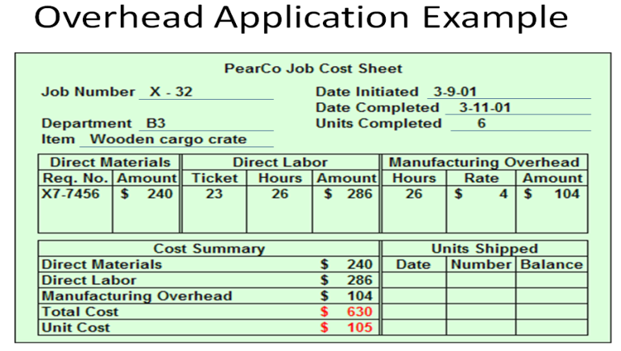
PearCo applies overhead based on direct labor hours. Total estimated overhead for the year is $640,000. Total estimated labor cost is $1,400,000 and total estimated labor hours are 160,000.
What is PearCo’s predetermined overhead rate per hour?

End of Lecture 11
Lecture 12
Exercise Questions

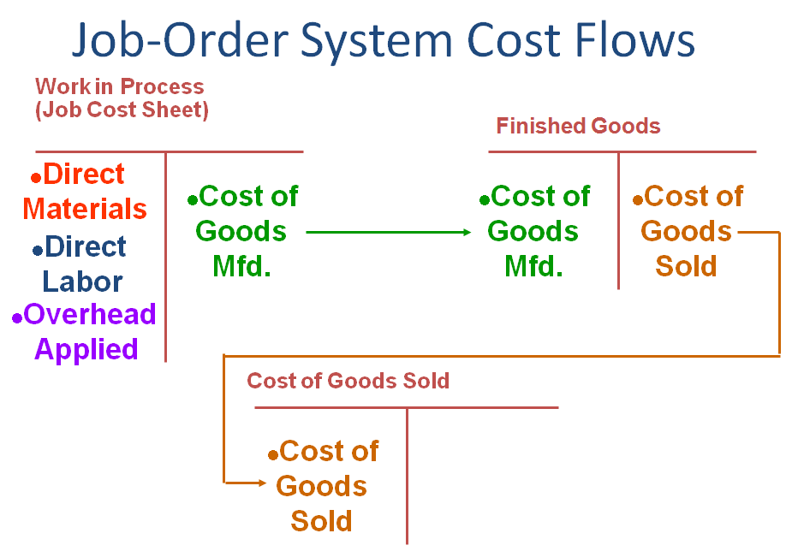

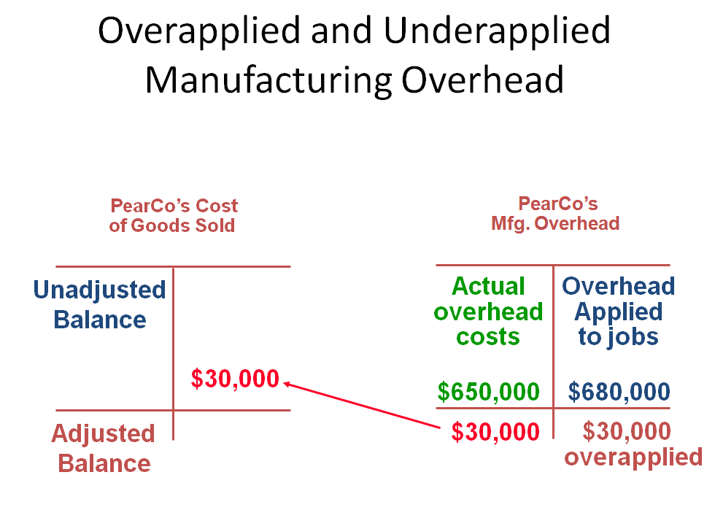
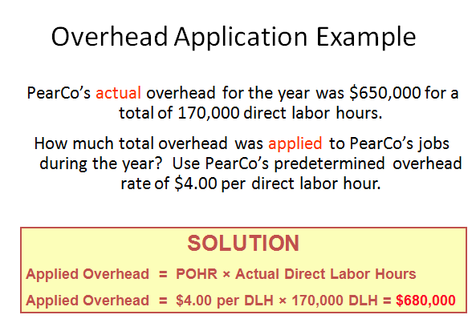
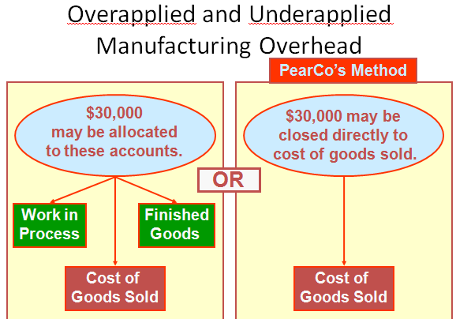

End of Lecture 12

Lecture 13
Cost Flows – Material Purchases
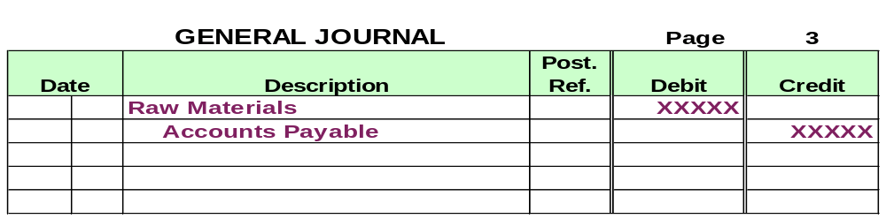Raw material purchases are recorded in an inventory account.

Cost Flows – Material Usage
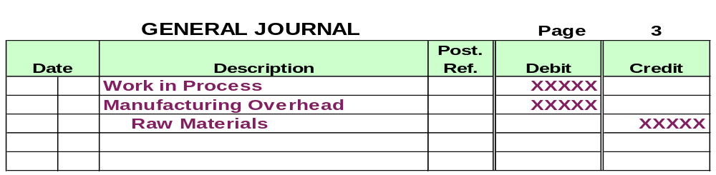Direct materials issued to a job increase Work in Process and decrease Raw Materials. Indirect materials used are charged to manufacturing Overhead and also decrease Raw Materials.

Cost Flows – Labor
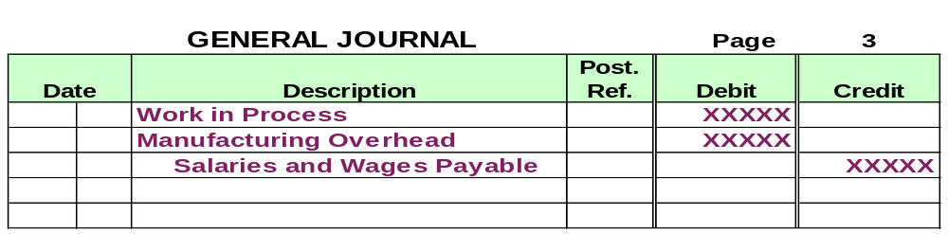The cost of direct labor incurred increases Work in Process and the cost of indirect labor increases manufacturing Overhead.

Cost Flows – Actual Overhead
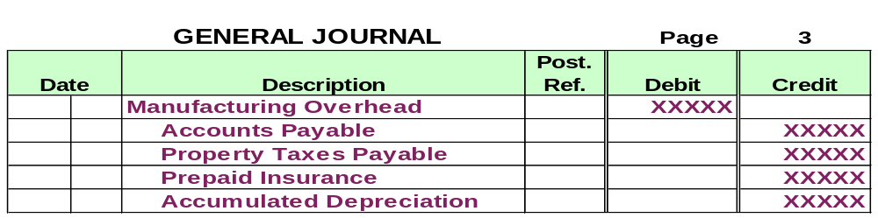 In addition to indirect materials and indirect labor, other manufacturing overhead costs are charged to the Manufacturing Overhead account as they are incurred.

Cost Flows – Overhead Applied
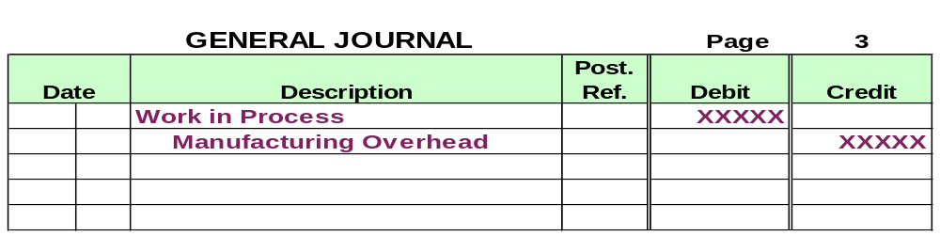Work in Process is increased when manufacturing Overhead is applied to jobs.

Cost Flows – Period Expenses
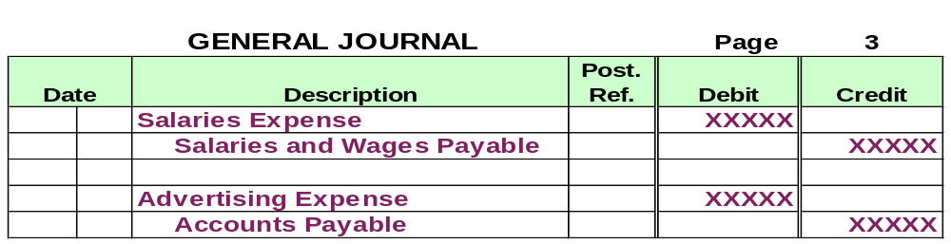 Nonmanufacturing costs (period expenses) are charged to expense as they are incurred.

Cost Flows – Cost of Goods Manufactured
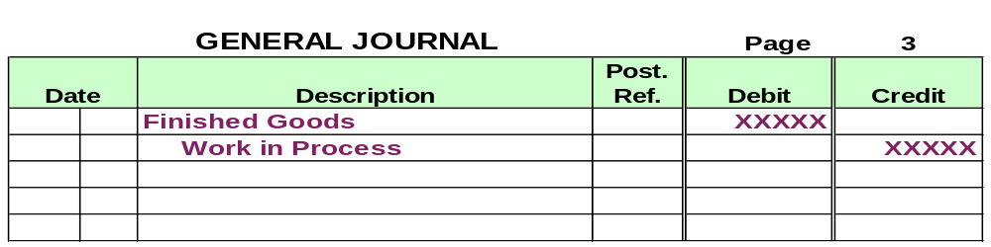As jobs are completed, the Cost of Goods Manufactured is transferred to Finished Goods from Work in Process.

Cost Flows – Sales
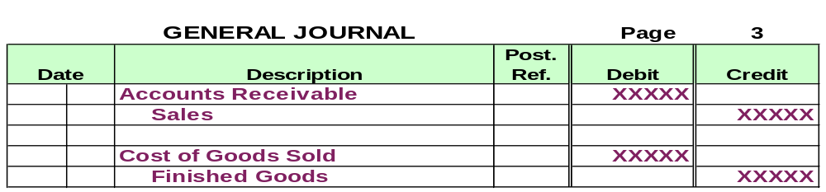When finished goods are sold, two entries are required: (1) to record the sale; and (2) to record Cost of Goods Sold and reduce Finished Goods.

End of Lecture 13

