Chapter 2
Lecture 06
Cost Classifications for Predicting Cost Behavior
How a cost will react to changes in the level of business activity.
  - Total variable costs change when activity changes.
  - Total fixed costs remain unchanged when activity changes.
Total Variable Cost
Your total long distance telephone bill is based on how many minutes you talk.
Variable Cost Per Unit
The cost per long distance minute talked is constant. For example, 1 Rupee per minute.
Total Fixed Cost
Your monthly basic telephone bill probably does not change when you make more local calls.
Fixed Cost Per Unit
The average cost per local call decreases as more local calls are made.
Cost Classifications for Predicting Cost Behavior
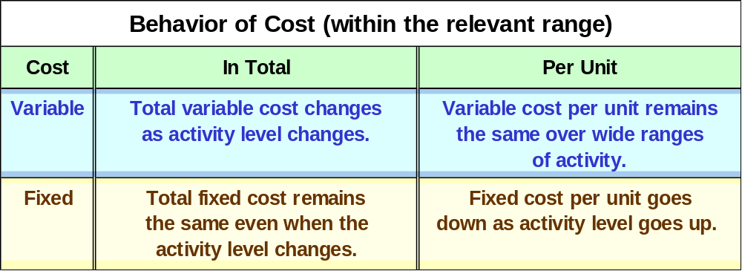

Direct Costs and Indirect Costs
Direct costs
- Costs that can be
easily and conveniently traced to a unit of product or other cost objective.
- Examples: direct material and direct labor
Indirect costs
- Costs cannot be easily and conveniently traced to a unit of product or other cost object.
- Example: manufacturing overhead
Differential Costs and Revenues
Costs and revenues that differ among alternatives
Example: You have a job paying $1,500 per month in your hometown. You have a job offer in a neighboring city that pays $2,000 per month. The Transportion cost to the city is $300 per month.
Opportunity Costs
The potential benefit that is given up when one alternative is selected over another. Example: If you were not attending college, you could be earning $15,000 per year. Your opportunity cost of attending college for one year is $15,000.
Sunk Costs
Sunk costs cannot be changed by any decision. They are not differential costs and should be ignored when making decisions.
Example: You bought an automobile that cost $10,000 two years ago. The $10,000 cost is sunk because whether you drive it, park it, trade it, or sell it, you cannot change the $10,000 cost.
End of Lecture 06

Lecture 06
Cost
Sacrifice made to achieve a particular purpose measured by the resources given up.
Product cost
A cost assigned to goods that were either purchased or manufactured for resale purpose
Cost of goods sold
In the period of sale, the product costs are recognized as an expense called cost of goods sold
Period cost
Costs are identified with the period of time in which they are incurred.
Manufacturing Costs
Direct Material
Raw Material, can be traced out in finished products
Direct Labor
Salaries, wages, fringe benefits for people directly working on production
Manufacturing Overheads
Indirect material
Insignificant to trace i.e. Cost of drill bits, glue, nails,
Indirect labor
Deptt supervisors, security guards etc
Manufacturing overheads.
Depreciation of plant and machinery, property taxes, insurance, electricity, gas etc.
Prime Cost
- This includes the material and direct labor
Conversion Cost
- This includes the direct material and factor overheads
Sample Income Statement of Manufacturing Company

Sample Income Statement of Bank

End of Lecture 07

Lecture 08
Exercise Questions
Sales revenue | Rs. 950000
Work-in-process inventory, December 31 | 30000
Work-in-process inventory, December 01 | 40000
Selling and administrative expenses | 150000
Income tax expense | 40%
Purchase of raw material | 180000
Raw-material inventory, December 31 | 25000
Raw-material inventory, December 01 | 40000
Direct labor | 200000
Utilities, plant | 40000
Depreciation: plant and equipment | 60000
Finished goods inventory, December 31 | 50000
Finished goods inventory, December 01 | 20000
Indirect material | 10000
Indirect labor | 15000
Other manufacturing overhead | 80000

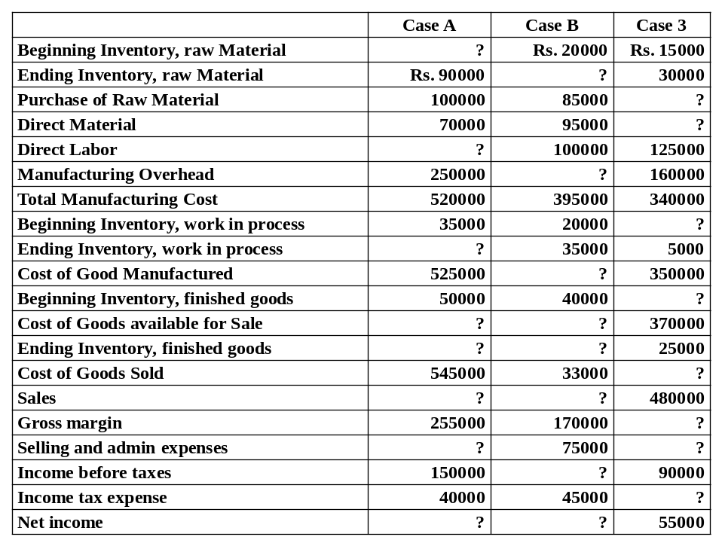

End of Lecture 08
Lecture 09
Exercise Questions
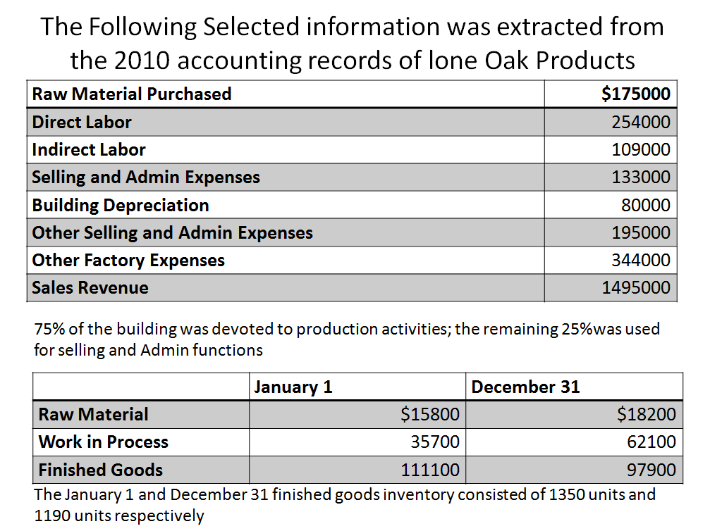
Q No. 1

Requirements
- Calculate Lone Oak’s manufacturing overhead for the year
- Calculate Lone Oak’s cost of goods manufactured
- Compute Cost of goods sold
- Determine net income. Assuming 30% income tax
- Determine number of completed units manufactured during the year.
Q No. 2
- On April 12, after the close of business, Unilever had a devastating fire that destroyed the company’s work in process and finished goods inventories.
- Fortunately, all raw materials escaped damage because material owned by the firm was stored in another warehouse.
- The Firms accountant determined that the cost of direct materials used normally averages 25 percent of prime costs. In addition, manufacturing overhead is 50 percent of the firm’s total production costs.
Sales revenue through April 12 | $330000
Income before taxes through April | 68000
Direct Labor Through April 12 | 120000
Cost of Goods Available for Sale, April 12 | 275000
Work in process inventory, January 1 | 21000
Finished goods inventory, January 1 | 37000
Gross Margin | 30% of Sales

Requirement: Unilever is in the process of negotiating a settlement with its insurance company. Prepare an estimate of the cost of work in process and finished goods inventories that were destroyed by the fire.
End of Lecture 09

