Supplement 6
Statistical Process Control

Background

Of all of the mathematical concepts presented in the text, SPC charts certainly rank among the most important to cover in an operations management course. Instructors who want to delve into some of the statistical background and who want to cover acceptance sampling could present Supplement 6 as rather challenging for business students. On the other hand, instructors who focus on the basics of the four SPC charts will find that most students can grasp the techniques rather handily.

It’s important to emphasize that control limits are not the same thing as engineering specification limits. Control limits are designed to monitor output over time to ensure that the system continues to produce consistent output. Output produced outside of control limits sends a signal that something extraordinary has occurred and the firm should investigate. One way to illustrate this in class is to bump into the projector in the middle of introducing control charts. Then point out that if you did not turn around periodically to look at the screen, you would never know that the slide is now projecting to the ceiling. So even though the equipment was set up perfectly at the beginning, we use control charts (turn around and look at our output) to periodically check to ensure that output still looks O.K. Spec limits, on the other hand, are fixed engineering measurements that define exactly what determines acceptable output or not. Any output produced outside of spec limits must be rejected. It is possible for output to exceed control limits and still be within spec limits. And, theoretically at least, it is possible for output that exceeds spec limits be appear to be within statistical control.

With SPC charts, students can get tripped up in several places. First, they must be able to choose the appropriate chart for the problem at hand. For variables (anything that can be measured along a number line such as length, temperature, volume, etc.), both and R-charts must be used. Figure S6.5 (and slides S6-35 and S6-36) show nicely why both are necessary. Choosing the correct chart for attributes (binary output such as percent defects) can be a bit tricky. The p-chart is used to monitor the percentage over time, while the c-chart is used to monitor the number of occurrences over time. But what if students are provided a set of number of errors over time as in Example S4, but without a “Fraction Defective” column? The answer is that they should convert those numbers to percentages and use a p-chart. What’s the difference? A p-chart is used for output that has a specific sample size. A c-chart, on the other hand, has no sample size. A c-chart looks at an “event,” which has no practical upper limit on the number of occurrences. For example, students could make a c-chart to monitor the number of mistakes in the instructor’s lectures over time. The instructor could have one mistake in a day, or five, or ten, or...there’s really no upper limit. Hence, there is no sample size and it is impossible to convert the numbers into a comparable fraction from day to day.

Another potential area of confusion for students is mixing up sample size and number of samples, particularly for and R-charts, and especially if the data are presented with output from each sample going down the columns of a table instead of across the rows. Students sometimes also do not fully realize that -charts examine sample averages. So it is perfectly acceptable to have an individual product with output that exceeds the control limits as long as the average for that entire sample still lies within the limits (assuming, of course, that the individual item was still produced within spec limits). With p-charts, students sometimes enter the number of samples for n instead of the sample size, and they sometimes round too much within the square root sign for σ_{p}. They should be told to generally use four decimal places, at least until after the square root function is applied. Finally, students sometimes are confused by the thought that a percent defects that is below the LCL is out of control. Here instructors can stress that control limits are pointing out the unusual, whether unusually good or unusually bad. If, say, a firm determined that no defects occurred on the day that the boss walked around the production floor, perhaps the boss should walk around the production floor more often.

If instructors cover process capability, this can be a place where the distinction between control limits and spec limits can be emphasized. It is probably worth covering the process capability ratio C_{p} in case students see it at their firms; however, the process capability index C_{pk} is the one that should be stressed. It is also easy to calculate but overcomes a major flaw with the C_{p} value.

Acceptance sampling calculations are rather complicated. They are skipped in this textbook and in most other introductory operations texts. Interested instructors can refer to Tutorial 2 on the website for more background.

Presentation Slides

INTRODUCTION (S6-1 through S6-5)
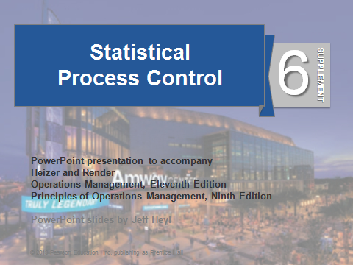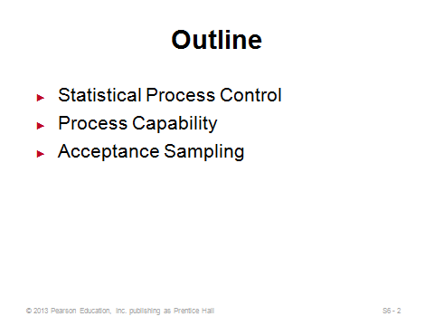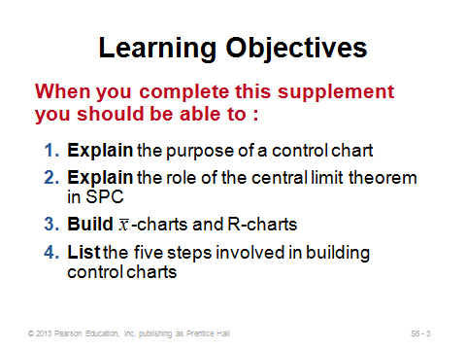
S6-1 S6-2 S6-3
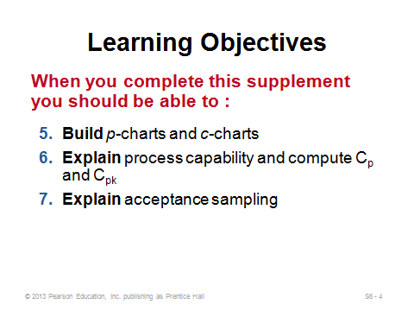
S6-4

STATISTICAL PROCESS CONTROL (SPC) (S6-5 through S6-53)
Introductory Subsection (S6-5 through S6-15)
Slides 5-8: Here instructors can discuss the idea that variation occurs all the time. We expect it and plan for it. A basketball player, for example, may have a good shooting percentage one night but a poor one the next night. We use control charts, however, to try to determine when the variation is so far beyond the norm that we think it is likely caused by something extraordinary. For example, the basketball player may have been sick on the day that she shot 10% from the floor, or she might have been eating a granola bar before the game on the day that she shot 90%. In the latter case, she might try to eat a granola bar prior to subsequent games to see if that should become her new pre-game routine.
Slides 9-13: These all come from Figure S6.1, which describes the important steps in determining process variation. Managers are trying to determine of the shape of the sample output over time remains stable (Slide 12) or varies (Slide 13). If it varies, we say that the process is out of control and investigate to take possible corrective action.
Slide 14: The book covers four different charts, but no matter which is being used, the concept is always the same. That is, output is monitored, and if it falls above or below the control limits, the firm investigates for assignable causes.
Slide 15: The difference between control limits and spec limits can be discussed here.

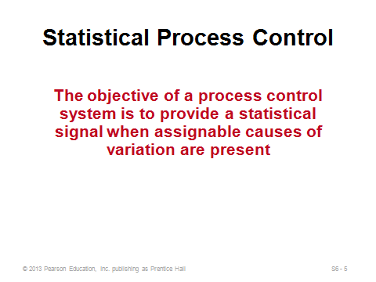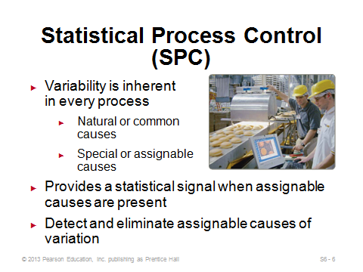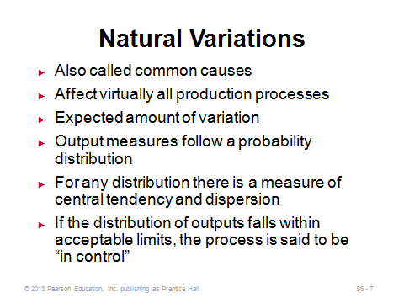
S6-5 S6-6 S6-7
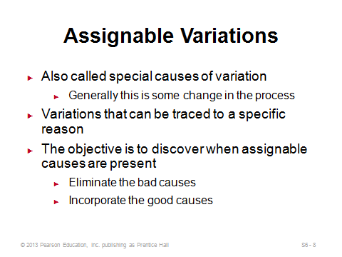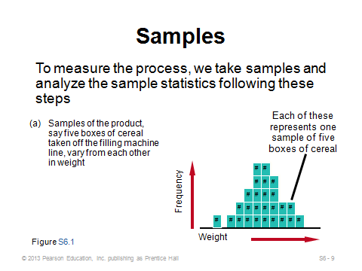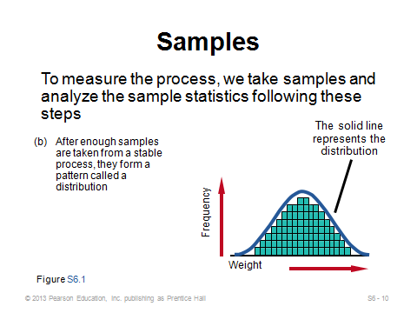
S6-8 S6-9 S6-10
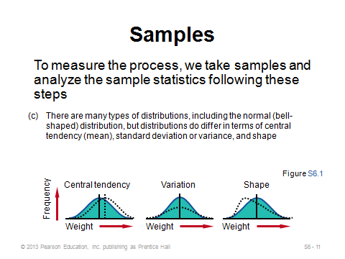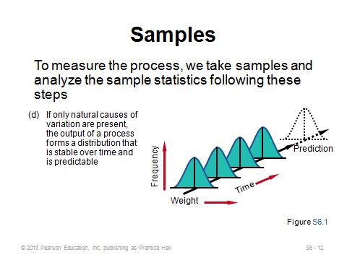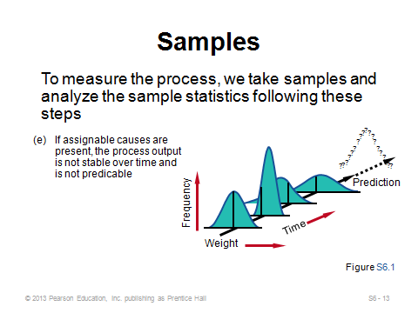
S6-11 S6-12 S6-13
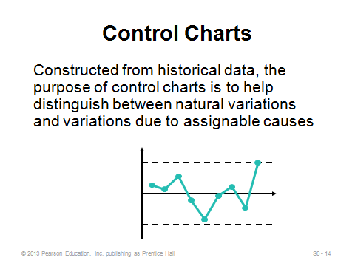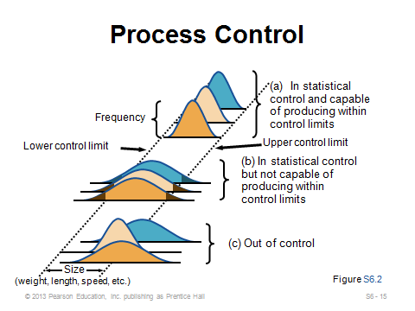
S6-14 S6-15

Control Charts for Variables (S6-16)
Slide 16: Variables are essentially characteristics that can be measured on a number line, such as length, width, weight, and temperature. The - and R-charts must be used together because it’s possible for the mean to remain constant while the dispersion significantly varies from sample to sample, or it's possible for the dispersion to remain constant but for the mean to be drifting up or down from sample to sample. Both need to be in control for the process to be considered in control.
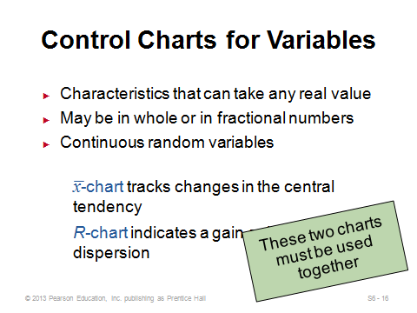
S6-16

The Central Limit Theorem (S6-17 through S6-19)
Slides 17-19: These provide the statistical foundation for control chart theory.
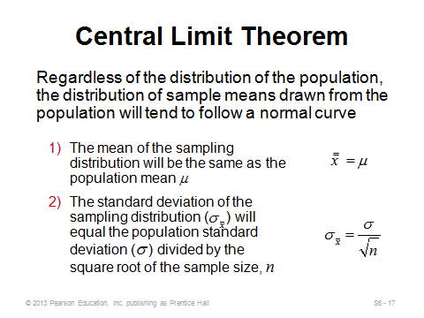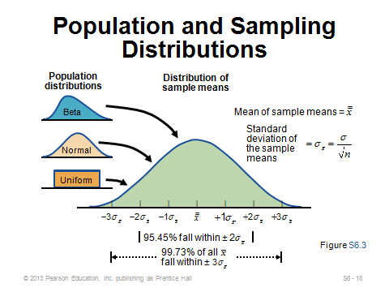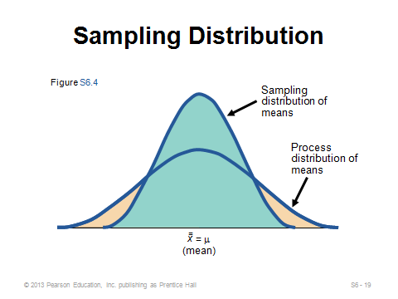
S6-17 S6-18 S6-19

Setting Mean Chart Limits (-Charts) (S6-20 through S6-27)
Slides 20-24: This is the first numerical example shown in the slides (Example S1), and it is applied for -charts when the process standard deviation is known. At this point, instructors should discuss the implementation of the z-value. The most common practice is to draw limits at three standard deviations from the mean (z = 3), but any other z-value is possible. The manager must make a trade-off between Type I and Type II errors. The higher the z-value, the more likely it is that assignable causes of variation will go undetected, while the lower the z-value, the more likely it is that natural causes will mistakenly be designated as assignable. Slide 24 nicely illustrates why the process in this example is out of control.
Slides 25-27: This example (Example S2) shows the formulas and an application for -charts when the process standard deviation is not known. Table S6.1 (Slide 26) is used in this case, and it is based on a z-value of three. Instructors could point out that the limits for -charts are equidistant from the mean.
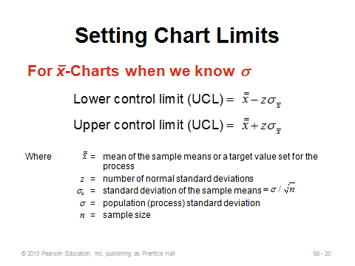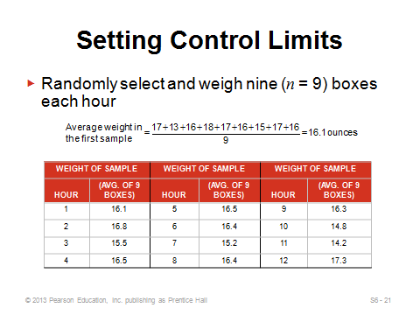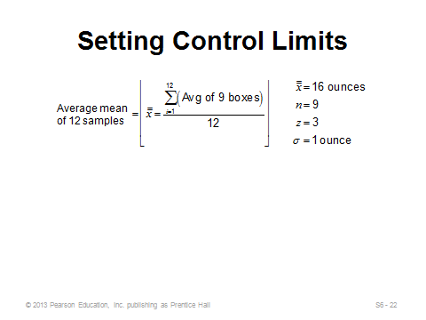
S6-20 S6-21 S6-22
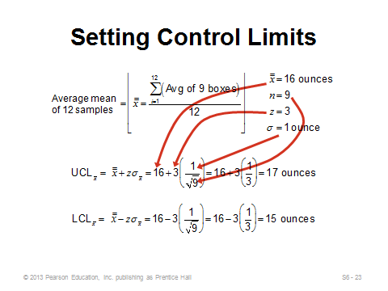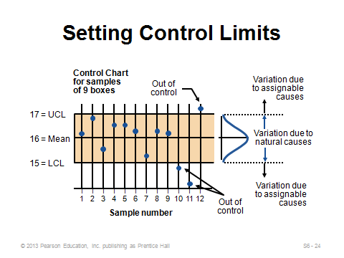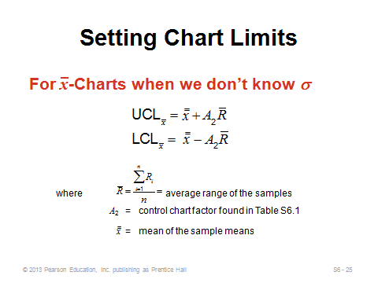
S6-23 S6-24 S6-25
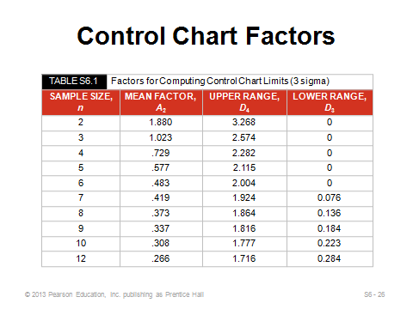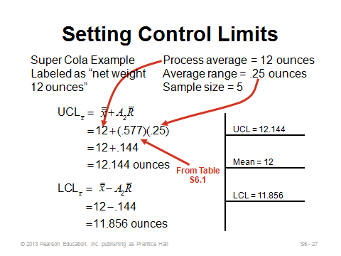
S6-26 S6-27

Setting Range Chart Limits (R-Charts) (S6-28 through S6-34)
Slide 28: This slide shows real SPC charts used by Darden restaurants. These also appear in the video case study.
Slides 29-31: This example (Example S3) shows the formulas and an application for R-charts. Once again Table S6.1 (Slide 26) is used. Instructors can point out that the range (highest value minus the lowest value in a sample) is used as a proxy for the standard deviation. Also, for small enough sample sizes, the LCL for the range chart will be zero, suggesting that it is impossible to have an unusually small amount of dispersion for samples that small.
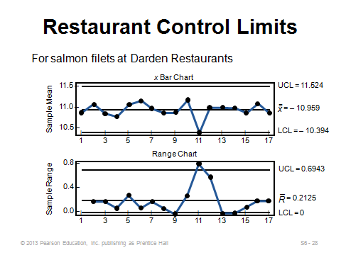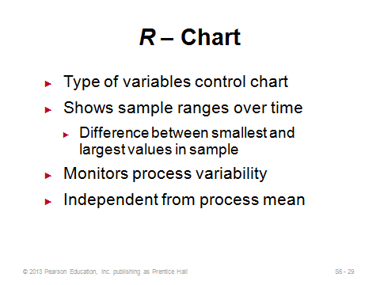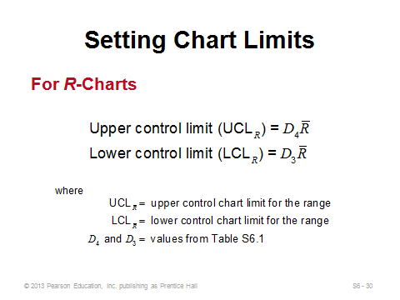
S6-28 S6-29 S6-30
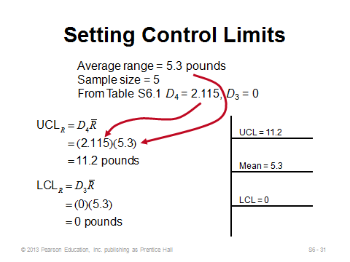
S6-31

Using Mean and Range Charts (S6-32 through S6-36)
Slides 32-33: These come from Figure S6.5. They nicely illustrate why firms must monitor both the - and R-charts when monitoring variables. (In fact, the R-chart should come first, because if the process variability is not in control, then the formulas are not valid because the formulas incorporate variability information.)
Slides 34-35: These two slides summarize the steps for creating - and R-charts.
Slide 36: Table S6.2 provides common z values. The most commonly used is z = 3.00.
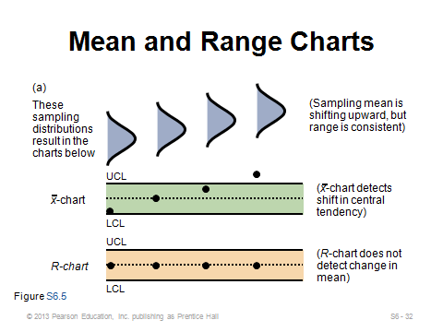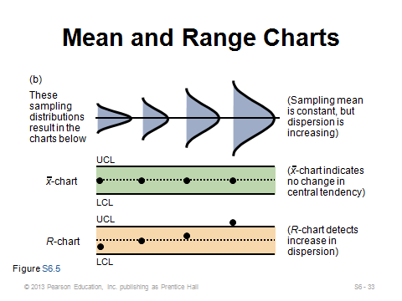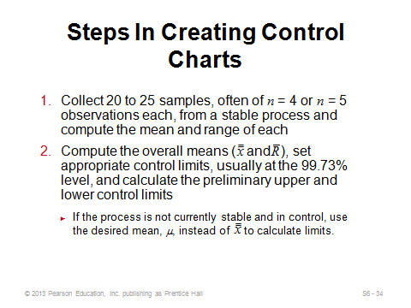
S6-32 S6-33 S6-34
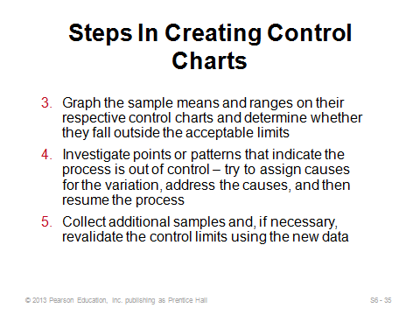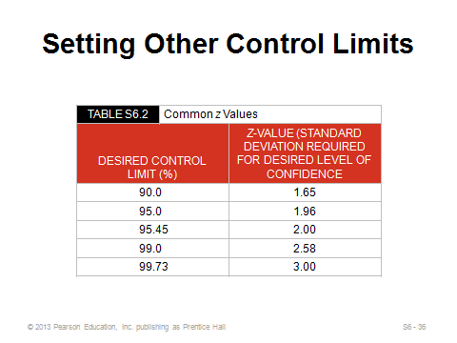
S6-35 S6-36

Control Charts for Attributes (S6-37 through S6-44)
Slide 37: Here is where the difference between p-charts and c-charts should be emphasized. As stated above in the “Background” section, the typical determining factor should be whether or not each sample has a sample size: if so, use a p-chart, if not, use a c-chart.
Slides 38-42: This example shows the formulas and an application for p-charts (Example S4). The default value for z should be 3, but that does not always have to be the case. Instructors should point out on Slide 39 that the sample size is 100, and n = 100 is not always the case. Also, is calculated in a streamlined way on Slide 40. Students should note that this approach is quicker and safer than summing up all of the p_{i} values with decimal points and then taking an average. Slide 40 shows the LCL limit as 0 for this example. Here, students should see that while a negative LCL calculation is possible, it is just rounded up to zero in practice. Slide 42 shows that the process in this example appears to be out of control.
Slides 43-44: This example shows the formula and an application (Example S5) for c-charts. The c-chart limits are the easiest to calculate and don’t require any sample size information. Here again, Slide 44 shows that a negative LCL should be rounded up to 0. For this example, the process appears to be in control.
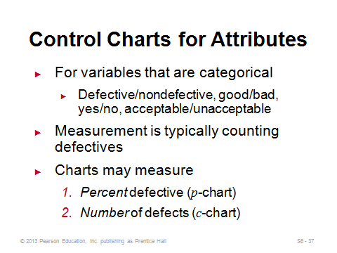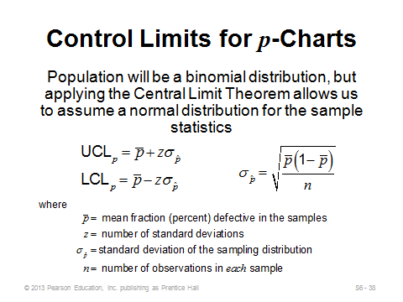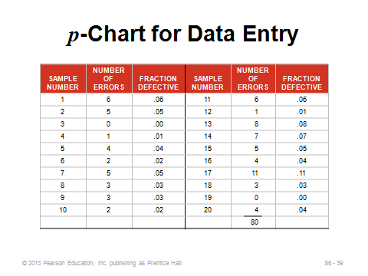
S6-37 S6-38 S6-39
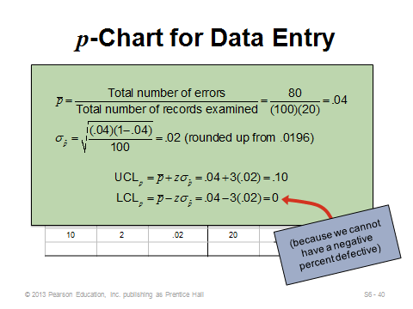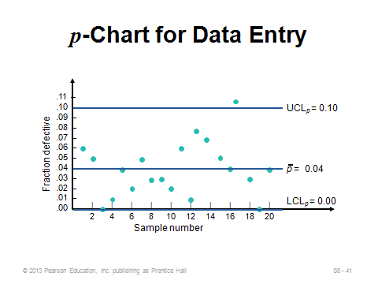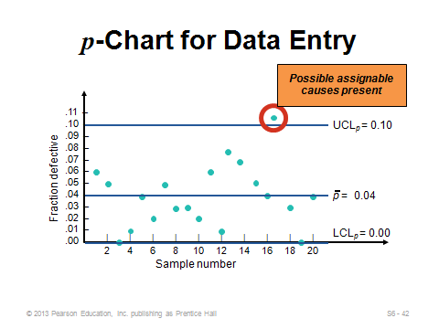
S6-40 S6-41 S6-42
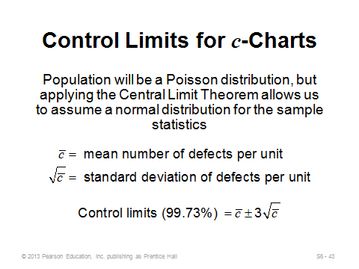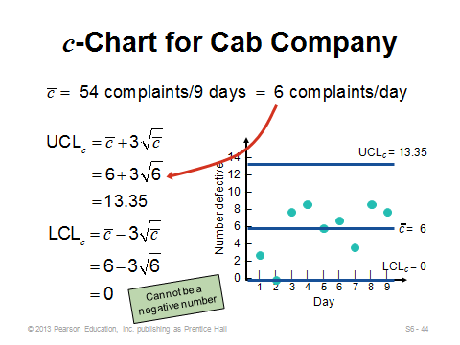
S6-43 S6-44

Managerial Issues and Control Charts (S6-45 through S6-53)
Slides 45-47: These summarize the control charting process, as well as determining which chart to use.
Slides 48-53: The basic control chart decision rule is to investigate for assignable cause once any point lies beyond the control limits. And, actually, this decision can easily be made by looking at the output data and comparing to the control limits—an actual chart does not have to be drawn. There are more subtle signaling techniques, however, that process control professionals recommend, and four of these are shown in Slides 50-53 (Figure S6.7). An actual graph of the output becomes particularly useful when looking for patterns like these.
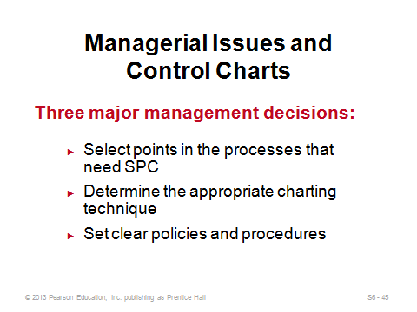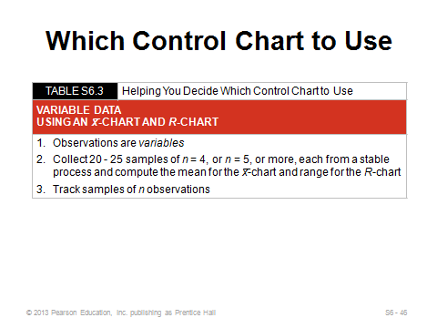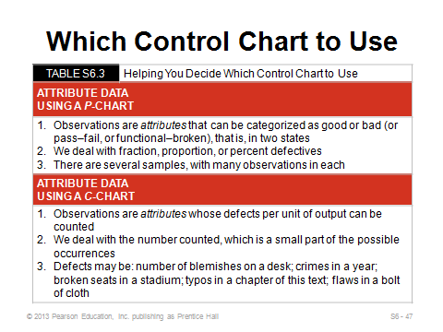
S6-45 S6-46 S6-47
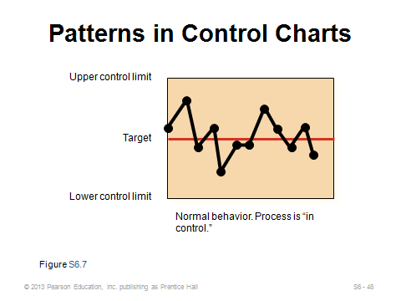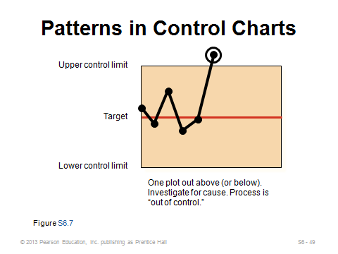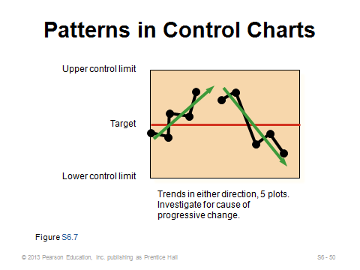
S6-48 S6-49 S6-50
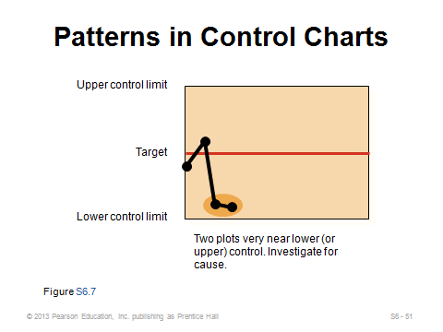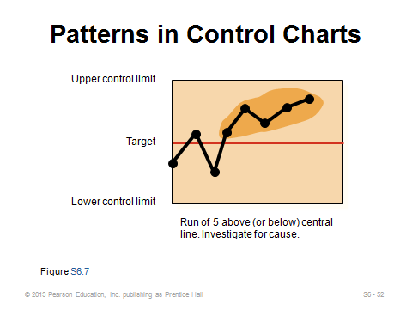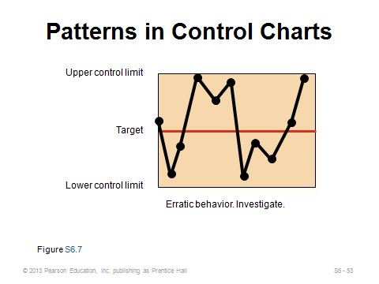
S6-51 S6-52 S6-53

PROCESS CAPABILITY (S6-54 through S6-64)
Slide 54: Capability charts deal with spec limits, not control limits, and they more commonly occur at the design stage to see if a process is “capable” of producing within limits most of the time (“most” usually means 99.73%). A process deemed “incapable” needs a design fix, which may be more severe than correcting an assignable cause as occurs with control chart violations.
Slides 55-58: These slides provide the formula and an example (Example S6) for the process capability ratio C_{p}. The biggest danger in making decisions based on C_{p} is that the ratio cannot detect a process that is not centered. Thus, it may signal a process as “capable” that is consistently producing output above or below the target.
Slides 59-63: These slides provide the formula and an example (Example S7) for the process capability index C_{pk}. This measure is generally preferable to C_{p} because it does a better job of signaling “capability” on both sides of the mean, thus better picking up the effects of a skewed distribution.
Slide 64: Figure S6.8 helps to visualize what different values of the process capability index imply.
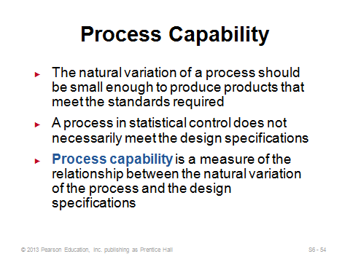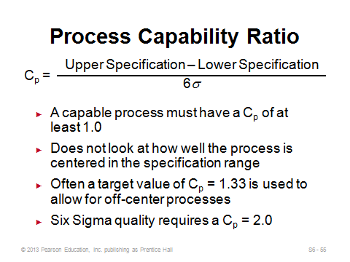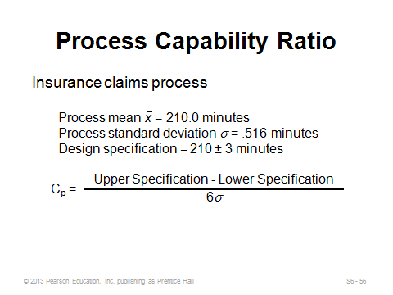
S6-54 S6-55 S6-56
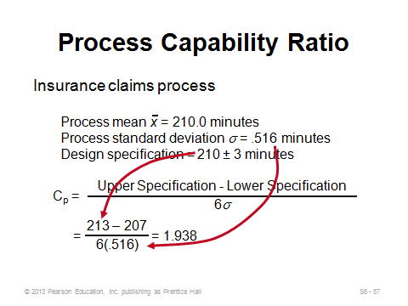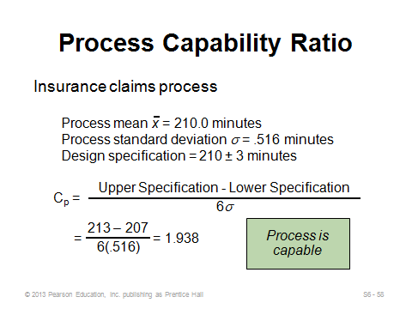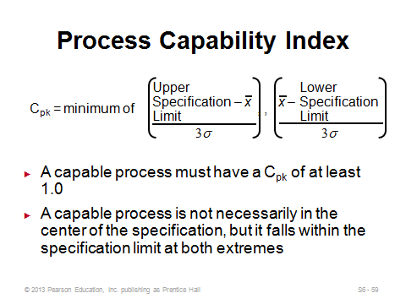
S6-57 S6-58 S6-59
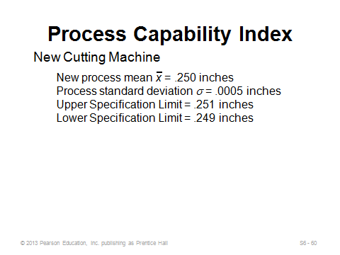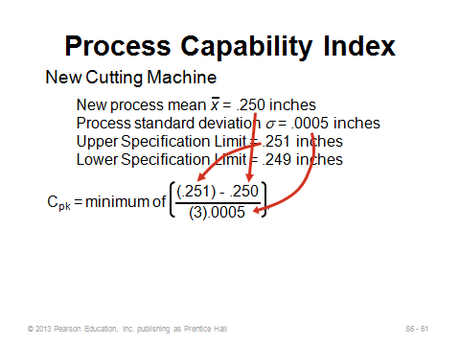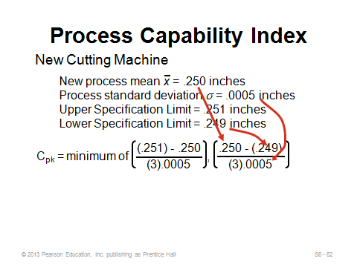
S6-60 S6-61 S6-62
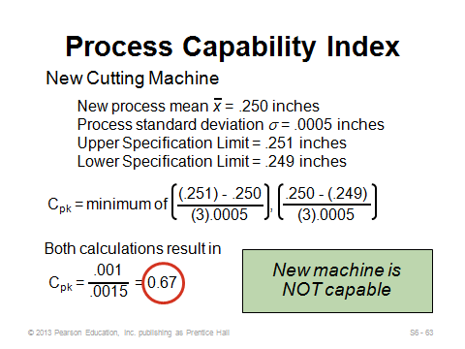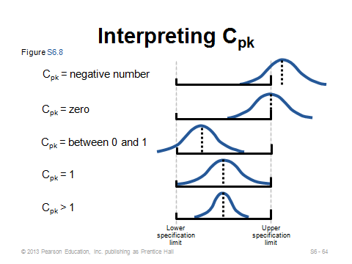
S6-63 S6-64

ACCEPTANCE SAMPLING (S6-65 through S6-76)

Slides 65-66: Capability studies focus on whether or not a process is capable of producing within specs under normal circumstances; control charts monitor output over time to make sure that something unusual hasn’t occurred; while inspection itself determines whether completed items themselves are acceptable or not. Firms practice acceptance sampling to avoid having to inspect every single incoming or finished goods item. It is assumed that the defect rate of the sample is reflective of the defective rate of the entire lot.
Slides 67-74: The text cannot devote enough space to show how to compute everything needed to draw an operating characteristic curve, so these slides just describe the concepts. The average outgoing quality can be computed (Slide 73) if (1) the sampling plan replaces all defective items encountered, and (2) the true incoming percent defective for the lot is known.
Slide 75: Certain automated inspection plans have eliminated the need for acceptance sampling.
Slide 76: The final slide (Figure S6.10) can be used to summarize the three major methods introduced in this supplement.
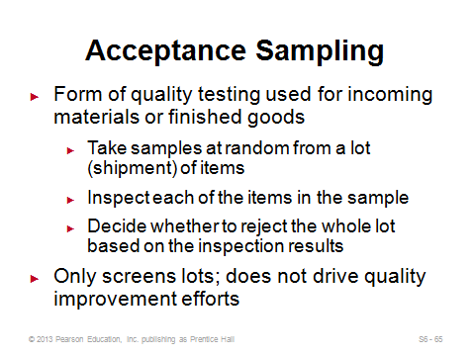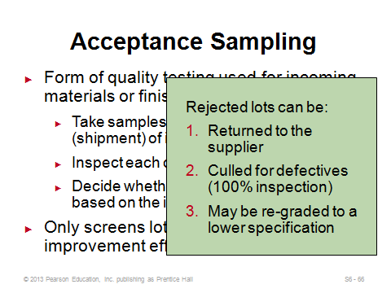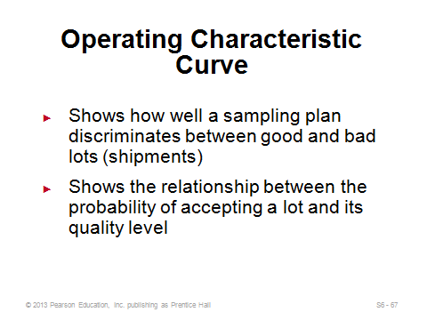
S6-65 S6-66 S6-67
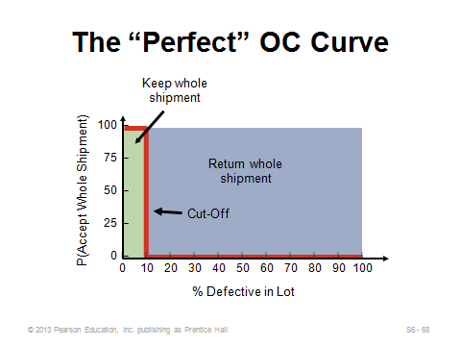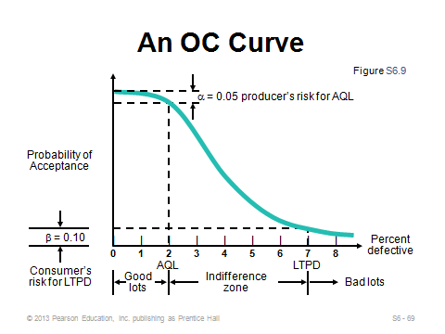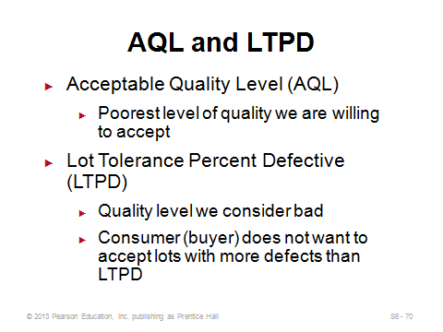
S6-68 S6-69 S6-70
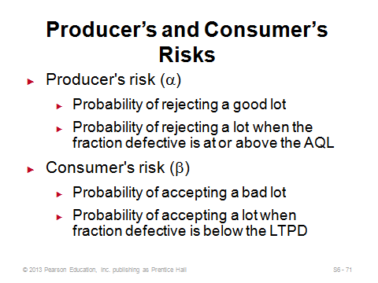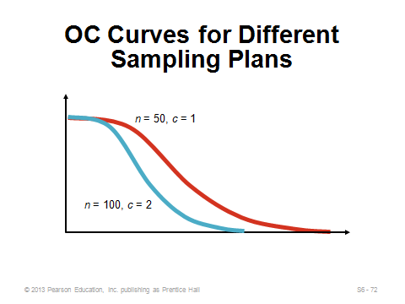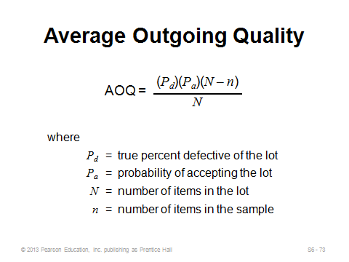
S6-71 S6-72 S6-73
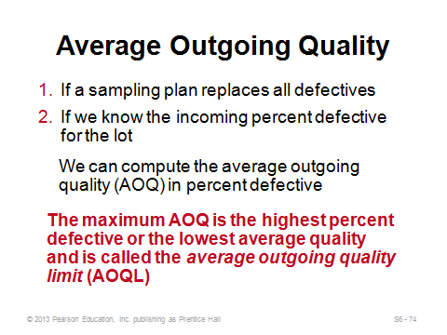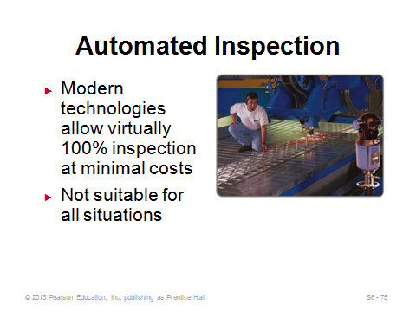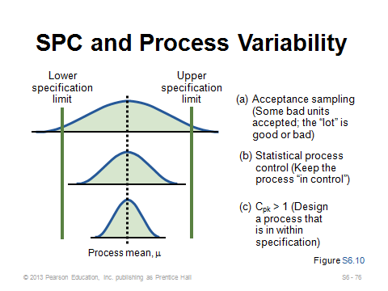
S6-74 S6-75 S6-76
Additional Case Studies

Internet Case Study (www.pearsonhighered.com/heizer)

- Green River Chemical Company: Involves a company that needs to set up a control chart to monitor sulfate content because of customer complaints.

Harvard Case Studies (http://harvardbusinessonline.hbsp.harvard.edu)

- Deutsche Allgemeinversicherung (#696084, © 1997)
- Process Control at Polaroid (A) (#693047, © 2002)

Ivey Case Studies (https://www.iveycases.com)

- Blount Canada Ltd., - Continuous Improvement (A) (#9A92D013, © 2010)
- Lake Erie Paper (#9B07E002, © 2007)
- Noram Foods (#9A82D022, © 2001)

Internet Resources

American Society for Quality | www.asq.org
American Statistical Association | www.amstat.org
BPI Consulting | www.spcforexcel.com
Institute of Statistics and Decision Sciences at Duke University | www.isds.duke.edu
Statistical Engineering Division of NIST | www.itl.nist.gov/div898
Total Quality Engineering | www.tqe.com

