Chapter 6
Managing Quality

Background

This chapter contains almost no quantitative material (most is reserved for Supplement 6). Nevertheless, any introductory operations management course absolutely must cover this content. Total quality management has become institutionalized in many firms around the world. If we quit teaching it, though, the perceived importance of the concepts will fade over time.

The evolution of quality management practices in business has a fascinating history. The ideas have been around since World War II, but western firms did not pay any attention to them at the beginning. In fact, there’s an old black and white British film called, “Right First Time,” that contains many of the concepts that still appear today in modern books about quality management. Having not had much luck with U.S. companies, W. Edwards Deming took his quality philosophies to Japan, which was devastated in the aftermath of World War II. Hungry for survival and growth, Japanese firms latched onto his ideas and added some of their own. By the 1970s, in relative obscurity, Japanese firms in numerous industries began producing products with higher quality than their western counterparts. Finally in the 1980s, western firms woke up to the fact that they were in trouble and finally started to look at the Japanese philosophies and the work of Deming and others. Now as we progress into the 21st century, high quality has become an order qualifier in many industries, and quality management programs have finally become ingrained in most top organizations around the world. The requirement of ISO 9000 certification to be even considered a supplier for numerous customers worldwide is one example of this quality evolution. Nowadays, buzzwords like “JIT,” “lean operations,” “six-sigma programs,” and “Toyota production system” (see Chapter 16)—have numerous similarities with, and roots derived, from the total quality management philosophies developed decades ago.

It seems important when discussing Chapter 6 to award due credit to the Japanese for essentially forcing the rest of the world to adopt total quality management programs to survive. There’s an old story from the Toronto Sun that can be summarized as follows: “IBM decided to have some parts manufactured in Japan as a trial project. In the specifications, they set the limit of defective parts at three units per 10,000. When the shipment arrived from Japan, it included this letter: ‘We Japanese have hard time understanding North American business practices. But the three defective parts per 10,000 have been included and are wrapped separately. Hope this pleases.’” Clearly, this story gets to the heart of the “zero defects” philosophy championed by the Japanese, as compared to an “acceptable quality level,” which has been historically common in U.S. firms. Another very important concept (which is easy to talk about but difficult to implement) attributable to the Japanese and Deming is the idea that defects, when they do exist, represent an opportunity for problem solving as opposed to a mistake that should be hidden. Deming believed that 80-85% of quality problems are caused by management, not the workers, so the identification of a defect is an opportunity for management to fool-proof that system in the future. A third concept attributable to the quality pioneers is the idea that it can be possible to have high quality and low cost at the same time. Spending more money on prevention is assumed to save even more than that on failure costs; therefore, “quality is free” (Crosby), and firms should strive to make it “right the first time.”

Presentation Slides

INTRODUCTION (6-1 through 6-4)
Slide 4: Arnold Palmer hospital does so much more than just “going through the motions” with these quality tools. The hospital really ingrains a culture of quality in all of its employees. Patient satisfaction is truly the number one priority. The results clearly reflect this culture: (1) the hospital typically scores in the top 10% nationally in benchmark patient satisfaction surveys, and (2) it boasts one of the highest neonatal intensive care survival rates in the U.S.
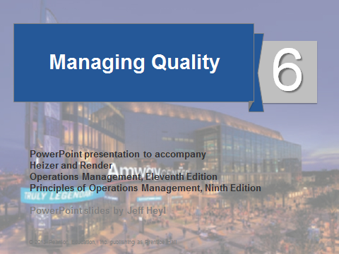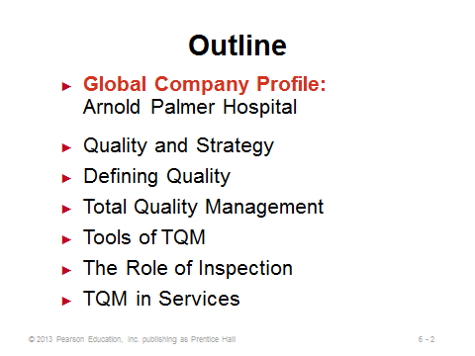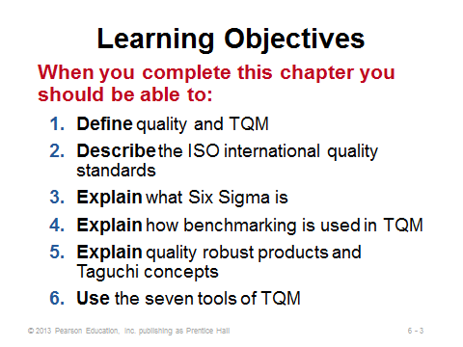
6-1 6-2 6-3

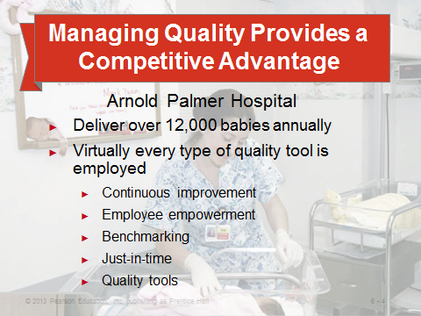
6-4

QUALITY AND STRATEGY (6-5 through 6-7)
Slide 5: Right away the instructor can emphasize that “high quality” is not an exclusive strategy unto itself. On the contrary, the pursuit of high quality can actually support other strategies discussed in Chapter 2 by satisfying customer needs or making things run more smoothly or cheaply. It is possible to have high quality and low cost at the same time! The third bullet on the slide is something that all of the quality gurus recognize. A successful quality management system must have top management support, and it involves so much more than implementing a tool or memorizing a list of concepts or Deming’s 14 points.
Slide 6: Studies have shown that high quality products are positively correlated with profitability, so the impacts illustrated in this slide (Figure 6.1) are really happening.
Slide 7: This flow of activities shown in this slide (Figure 6.2) will go nowhere without top management support and an organization that emphasizes a true culture of quality.
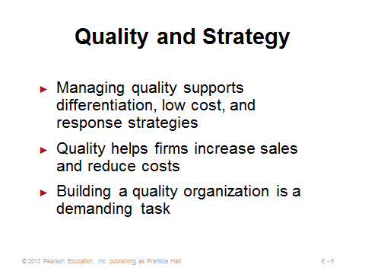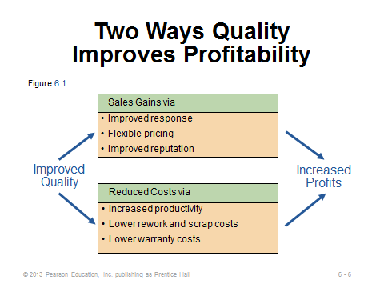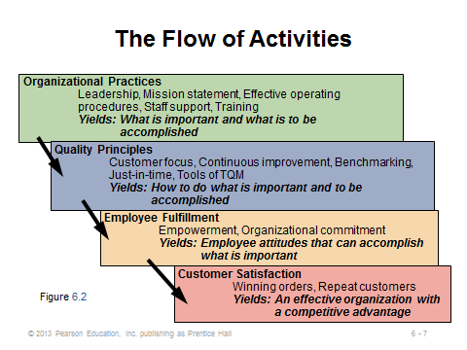
6-5 6-6 6-7

DEFINING QUALITY (6-8 through 6-21)
Slides 8-11: Quality means different things to different people for different products and services under different circumstances. It all begins with a good understanding of what the customers expect. Slide 11 is particularly important to emphasize. High quality does so much more than just reduce rework costs. The reputation implications can have a huge impact on profitability, and it is so difficult to recover from bad publicity about quality. Furthermore, several firms over the past few years have gone bankrupt due to liability stemming from product defects.
Slides 12-13: Instructors can spend several minutes on the Baldrige Award if they want to. Video clips of awards presentations can be shown, which usually include a U.S. President or Vice President. Also, the web site (http://www.nist.gov/baldrige/) contains a lot more information about the award, and it can be interesting to look at all the past winners—some are well known while many others are not. It can be useful to emphasize that some firms apply for the award with no intention of winning it—they want the comprehensive quality audit to identify needed areas of improvement.
Slides 14-15: ISO 9000 continues to be an important standard around the world, and increasingly in the United States. Many overseas companies will not purchase from suppliers who are not ISO 9000 certified. It used to be easier to make jokes about ISO 9000, because the original standards focused on documentation and consistency, with little stated about quality itself. However, recent updates to the standards have emphasized more features similar to the Baldrige criteria. An important advantage of a certification like ISO 9000 is that firms can rely on such a certification as an outside validation of quality—this frees firms from having to audit each potential supplier for themselves.
Slides 16-17: Here’s where the concept of making it “right the first time” can be emphasized. Spending more on prevention usually leads to bigger savings in failure costs and potentially even appraisal costs. In particular, external failure costs may exceed the price of the final product itself and can be devastating in terms of company reputation. The old carpenter’s quote applies here: “Measure twice and cut once.”
Slides 19-20: These slides describe some of the pioneers of quality management. Deming was probably the most influential. In fact, the Japanese honor Deming by naming their top national quality prize after him (an American). An interesting film about Deming was produced that shows him in action later in life. Both he and Juran were not particularly charismatic. Crosby, on the other hand, displayed his charisma like an infomercial professional (in a generally positive way). Crosby definitely focused less on the quantitative aspects of TQM than the other pioneers did. One important way that Juran differed was with the idea of choosing a defect level (which could be less than 1%) that minimized the “cost of quality” (finding the balance between prevention and failure costs). Deming and Crosby, on the other hand, preached about striving for and attaining zero defects.
Slide 21: The point about responding to problems is particularly important. Mistakes happen, but how does an ethical company respond and make it right?
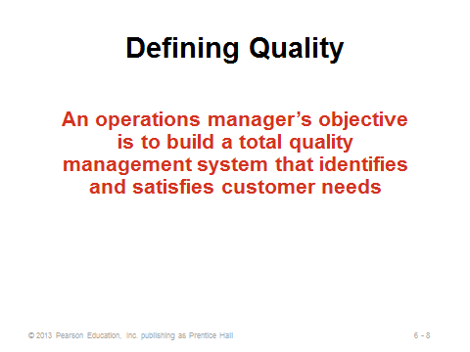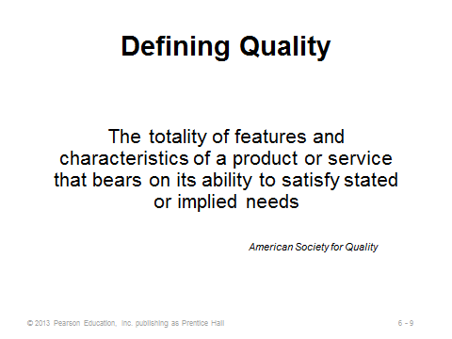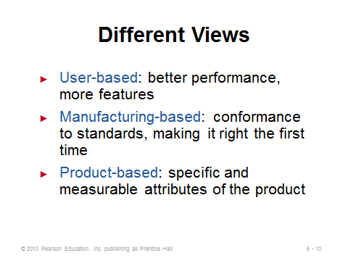
6-8 6-9 6-10
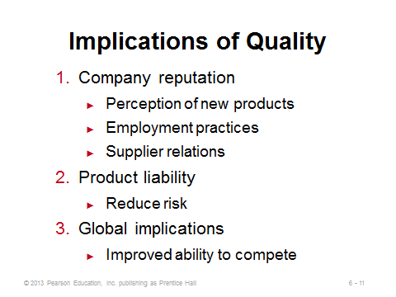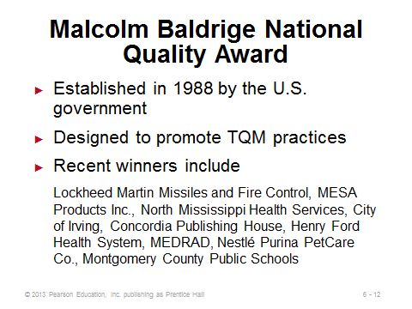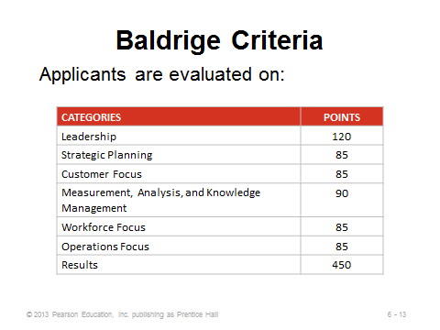
6-11 6-12 6-13
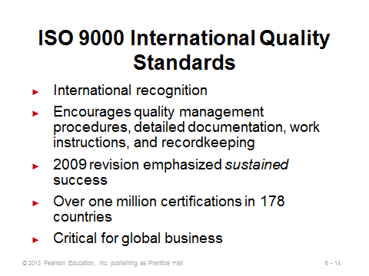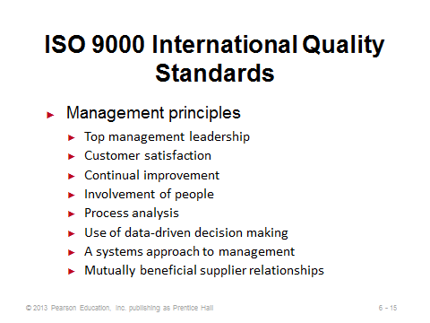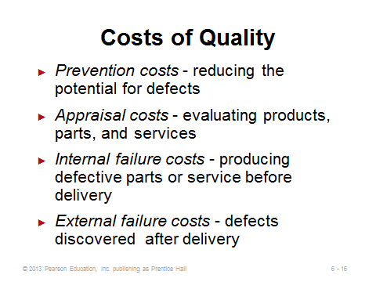
6-14 6-15 6-16
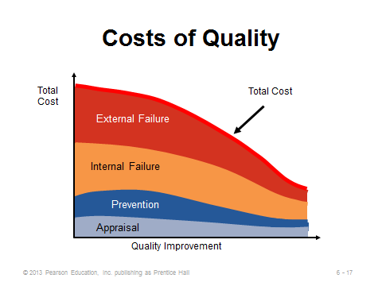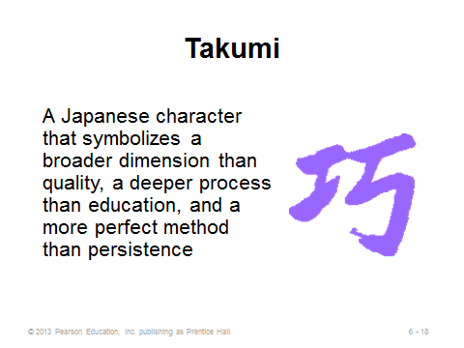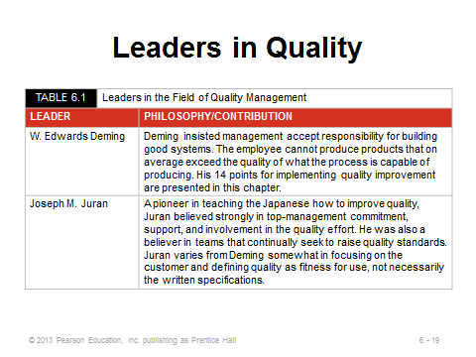
6-17 6-18 6-19
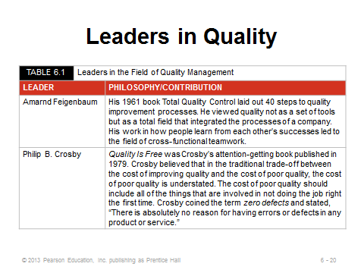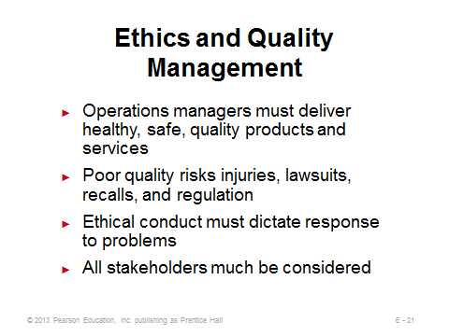
6-20 6-21

TOTAL QUALITY MANAGEMENT (6-22 through 6-44)
Slide 22: It can be re-emphasized here that TQM programs are difficult to implement and represent a cultural change that must be supported in words and actions by top management.
Slides 23-24: Deming’s points represent one framework to think about implementing a TQM program.
Slide 25: This slide identifies the seven major concepts of TQM.
Slides 26-28: Continuous improvement is like a race with no finish line. The runner can celebrate and take a break now and then, but then she needs to get back on that road and keep going further. The most important feature of the PDCA cycle (Slide 27—Figure 6.3) is the arrow on top—showing that the cycle does not end with implementation but starts again with a new set of improvements.
Slides 29-33: In some ways, Six Sigma is modern re-wording of old TQM concepts. The Six Sigma certification program (black belts and green belts) has become highly valued for those that attain the certification. In some ways, it is quality management’s equivalent to the CPA in accounting or the CFA in finance. A nice feature of the certifications is that they involve not only passing exams, but also real-world experience in managing quality improvement projects.
Slides 34-35: Arguably, employee empowerment represents the most powerful means to improve quality in an organization. Often the people closest to the actual work know best how to improve it. A key feature for success is to properly reward employees for helping to improve quality.
Slide 36: Note that benchmarking does not have to examine only other firms in the industry. World-class organizations from other industries lead to some great ideas—and those companies might be more willing to share information.
Slide 37: This is a very nice slide (Table 6.3) to cover point-by-point. Proper complaint resolution has such a huge impact on company reputation.
Slide 38: Internal benchmarking can be more effective than external benchmarking when the organization is large enough to have multiple divisions or business units.
Slides 39-40: JIT receives much fuller treatment in Chapter 16. The issues here are that JIT in the form of “procrastination” has two main benefits: less inventory and identification of errors early before they are applied to many products.
Slides 41-42: Genichi Taguchi created systematic methods to design experiments that identify the variables affecting product variation (these are fractional factorial experiments). He also has provided us with the three important concepts identified in Slide 41. Slide 42 focuses on quality robustness, i.e., products whose quality is not hampered by variations in conditions. Taguchi suggests that focusing on removing the effects of variations can often be cheaper than attempting to eliminate the causes.
Slides 43-44: A study found that U.S. consumers preferred Sony TVs made in Japan to those made in the U.S. Both factories used the same designs and specifications. But the difference in quality goals led to the difference in consumer preferences. Specifically, the U.S. factory had output that was uniformly distributed between the upper and lower specification limits. The Japanese factory, however, had output centered around the target in the shape of a normal distribution. Thus, much more of its output was near the target (or the center of the upper and lower limits). Clearly, this target-oriented approach led to higher quality final products. Why? Imagine many slightly large bolts fitting into slightly small nuts (connections that are too tight) and other slightly small bolts fitting into slightly large nuts (connections that are too loose). Add all those up over many components in a TV, and more things will go wrong. With the quality loss function, it’s important to emphasize that those are not actual costs. A component produced within specs may indeed cost nothing. However, the function is estimating the costs of not hitting the target exactly, using the important assumption that the costs increase according to a quadratic function, that is, doubling the distance from the target will quadruple the estimated cost. One application of the quality loss function could be in determining whether or not to buy a new machine that produces output closer to the target. Even if both the new and old machines always produce within spec limits, presumably the accuracy provided by the new machine has some benefits, which can be quantified by using quality loss function estimates.
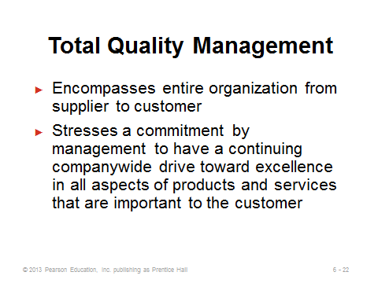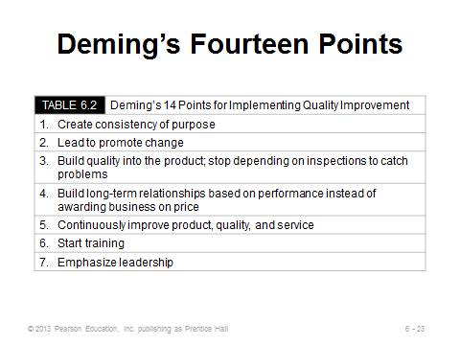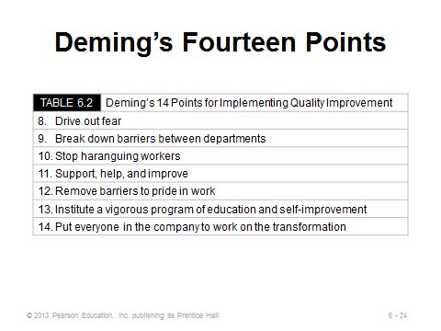
6-22 6-23 6-24
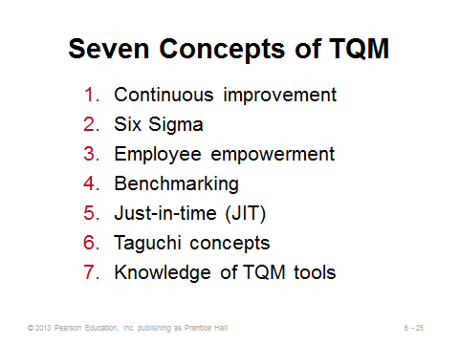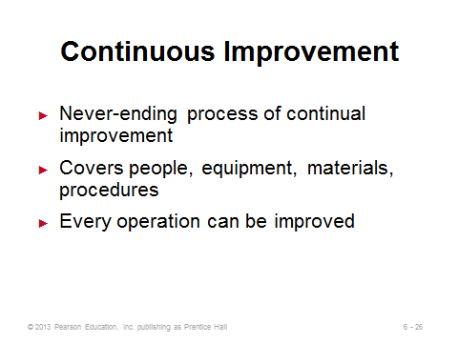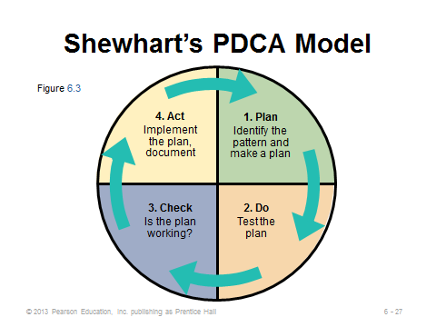
6-25 6-26 6-27
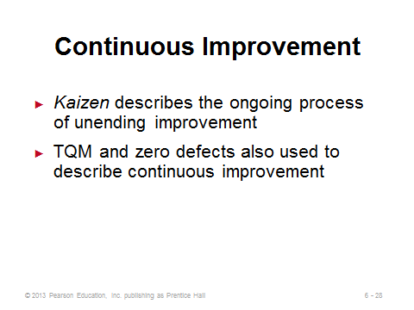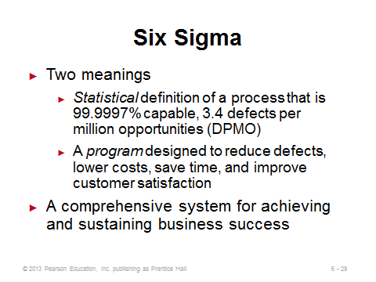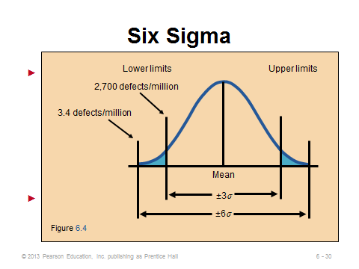
6-28 6-29 6-30
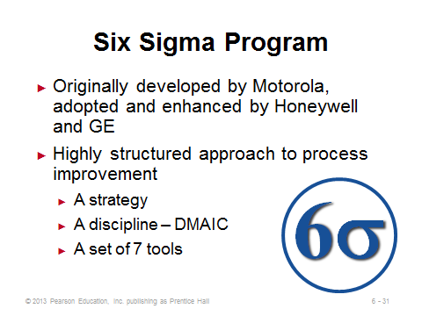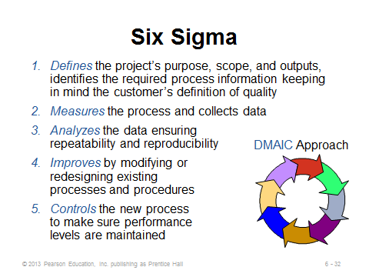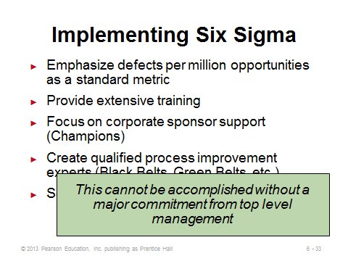
6-31 6-32 6-33

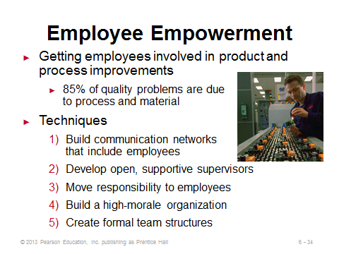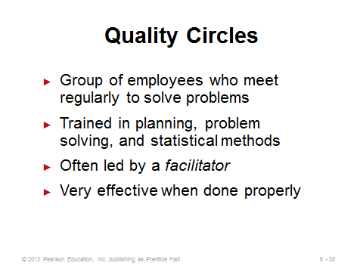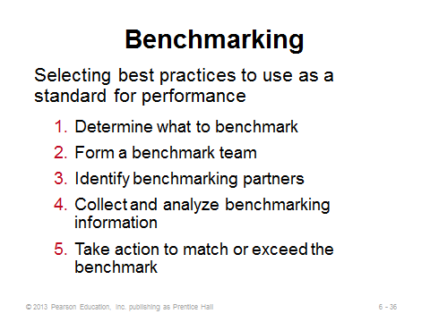
6-34 6-35 6-36
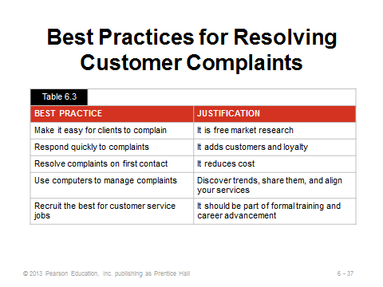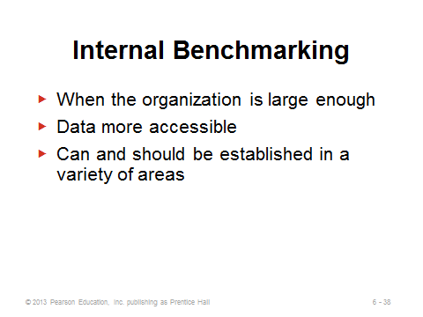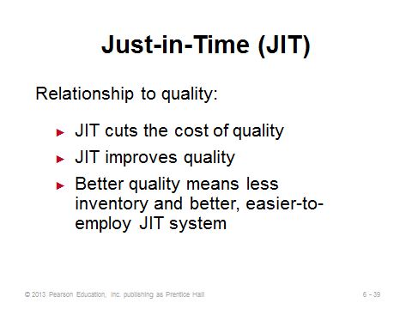
6-37 6-38 6-39
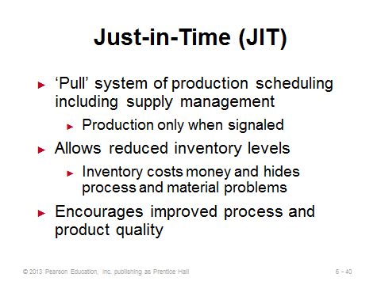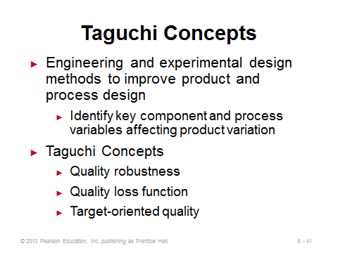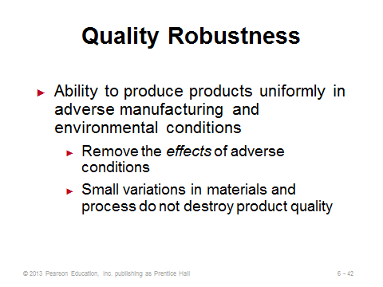
6-40 6-41 6-42
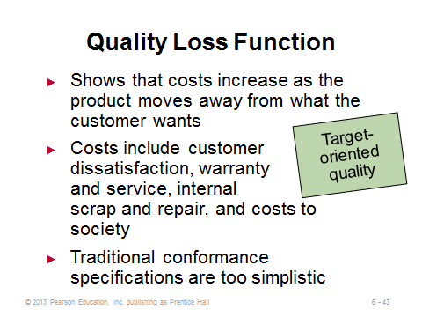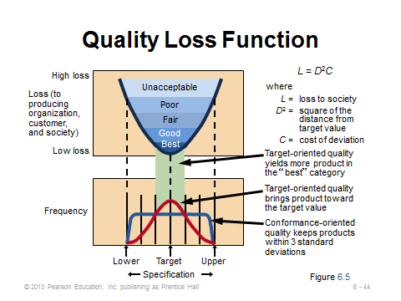
6-43 6-44

TOOLS OF TQM (6-45 through 6-58)
Slides 45-58: These are nice graphics that illustrate the seven tools. The full set can be covered relatively quickly. The first six, at least, are among the easier quantitative methods that operations managers employ; nevertheless, they can provide powerful insight.
Slide 47: A check sheet can have a variety of appearances. In many cases, patterns are easily seen while the data are being taken.
Slide 48: With a scatter diagram, if the two items are closely related, the data points will from a tight band. If a random pattern results, the items are unrelated.
Slide 49: The cause-and-effect diagram is also called a fishbone or Ishikawa diagram. The four Ms can be a good starting point for main causes. The lecture could break at this point with an example having students fill in the diagram with ideas for causes of some outcome.
Slide 50: A Pareto chart exhibits the natural phenomenon that, in general, 80% of problems are a result of only 20% of causes. The lecture could break here by asking the students about their experience managing things. Did the Pareto rule apply?
Slide 51: A picture can truly be worth 1000 words when attempting to analyze a process. A flowchart provides such a picture.
Slide 52: A histogram can help determine the potential actual underlying distribution of a variable. If it looks like a bell curve, the distribution might be Normal; if it looks like a rectangle, the distribution might be uniform, etc. More generally, a histogram provides a quick visual estimate of the mean, mode, skewness, etc.
Slide 53: SPC charts are the most “scientific” of the quality tools. They are covered in detail in Supplement 6. They are used to monitor a process over time. When output falls outside of the control limits, the process should be investigated to search for an unnatural (assignable) cause.
Slides 54-58: These provide further examples of some of the seven tools. They can be placed after each respective tool, if desired.
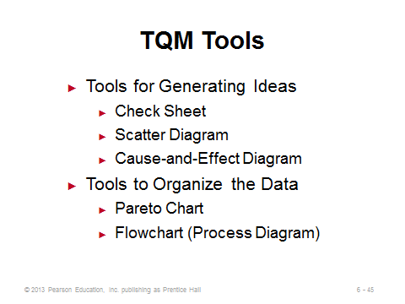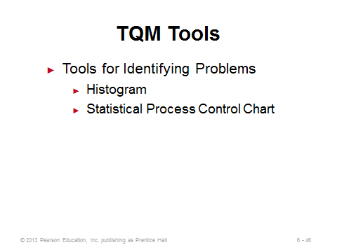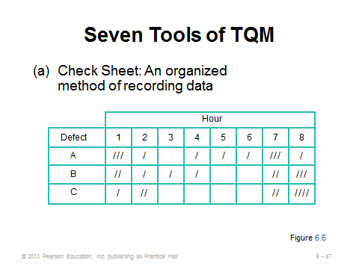
6-45 6-46 6-47
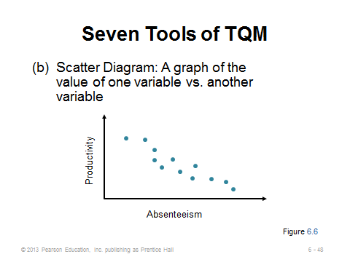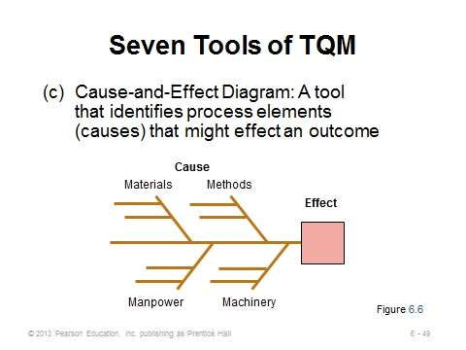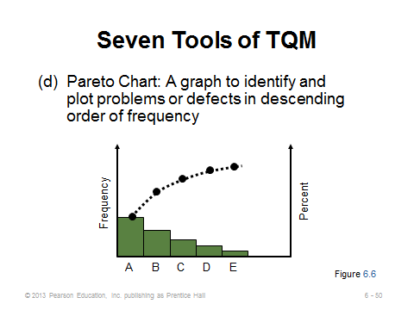
6-48 6-49 6-50
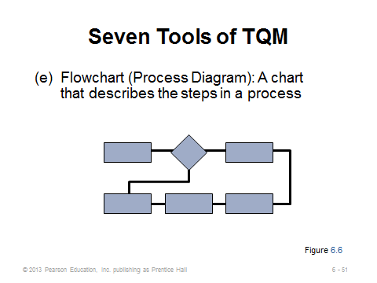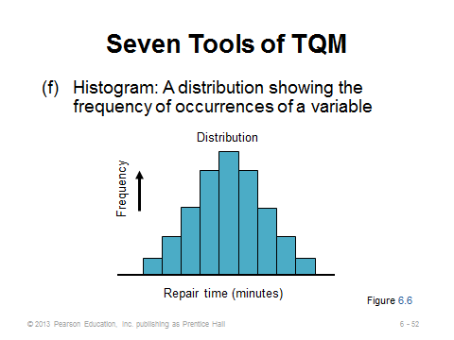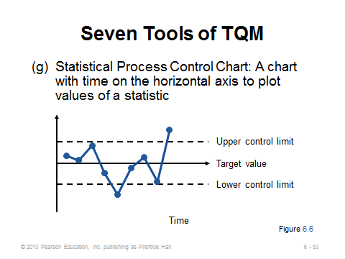
6-51 6-52 6-53
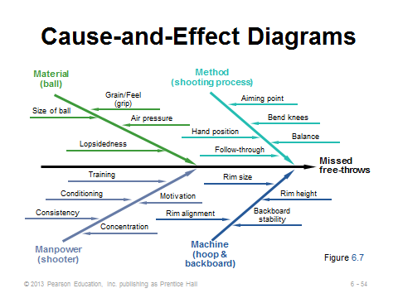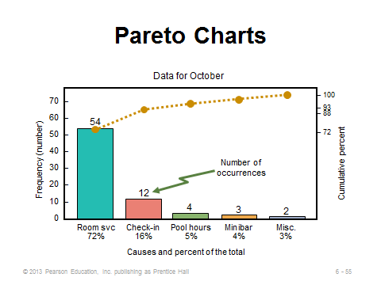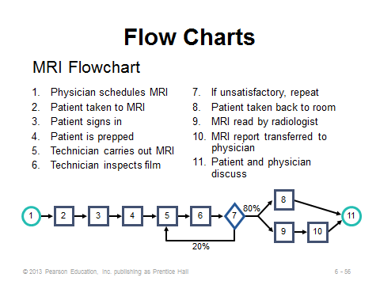
6-54 6-55 6-56
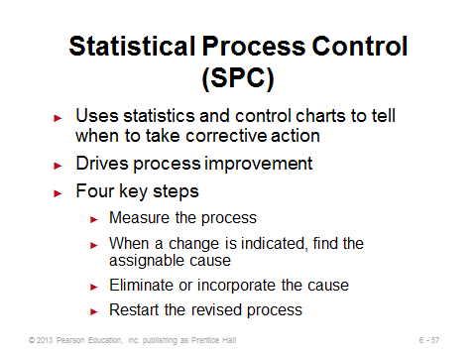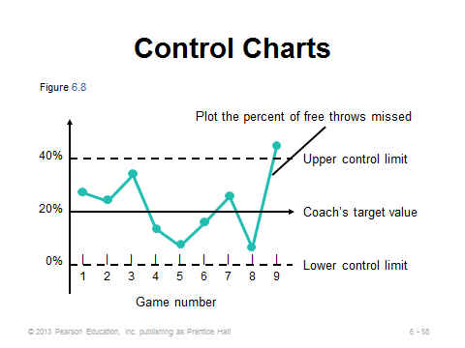
6-57 6-58

THE ROLE OF INSPECTION (6-59 through 6-67)
Slides 59-63: In the old days, the only form of quality management implemented by companies was the process of inspection. Inspection itself may not catch all errors, and it may be costly (Slide 61). Ideally, suppliers are delivering perfect materials and products that are made right the first time, which would minimize the need for a lot of inspection. Source inspection (Slide 62) is the concept of controlling or monitoring at the point of production or purchase. This is consistent with the idea of employee empowerment, where individual employees self-check their own work. Slide 63 describes two useful tools for source inspection: poka-yoke (foolproof devices or techniques) and checklists (surprisingly effective—see the book by Atul Gawande called The Checklist Manifesto: How to Get Things Right). If done correctly, source inspection would eliminate the need for extra inspections anywhere else. If inspections are needed, Slide 60 provides the common places. Point 3 is probably the most important because sending a defective product through the bottleneck process reduces the throughput for the entire operation.
Slides 64-66: These slides provide service industry inspection examples from Table 6.4 in the text. Clearly, inspection can be as important in services as in manufacturing.
Slide 67: This slide describes the differences between attribute and variable inspection. The differences determine which statistical process control techniques to use (Supplement 6).

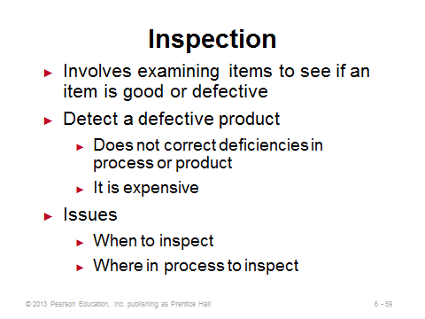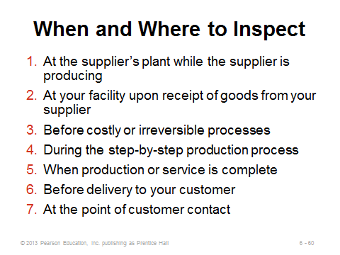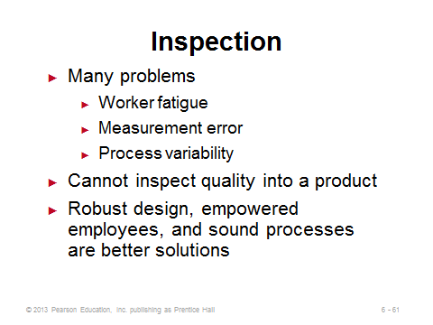
6-59 6-60 6-61
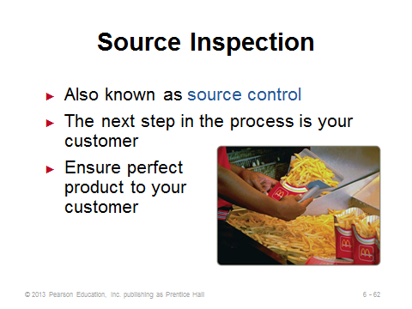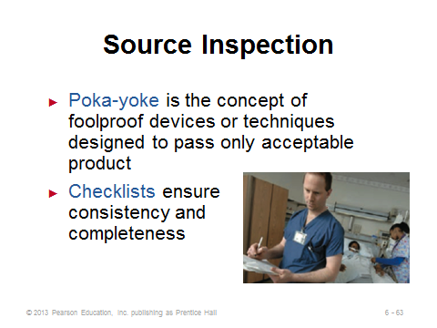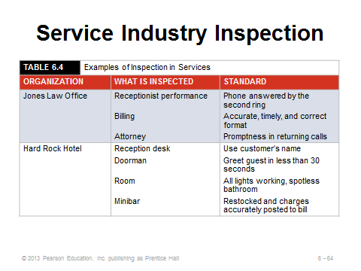
6-62 6-63 6-64
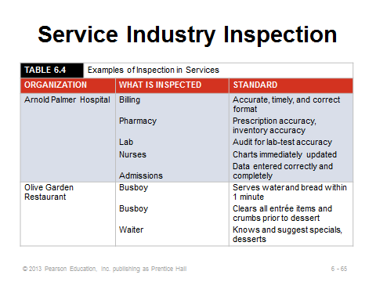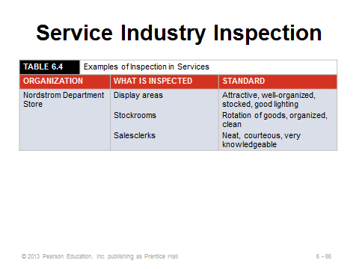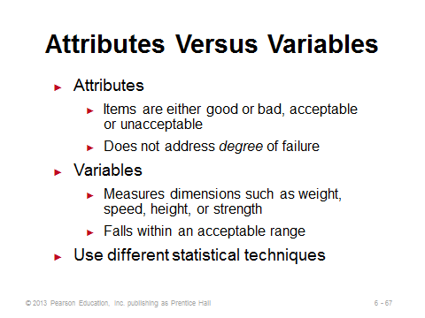
6-65 6-66 6-67

TQM IN SERVICES (6-68 through 6-72)
Slides 68-72: These slides focus on the special challenges and differences that attempting to implement TQM in services has. In addition to the quality checkpoints described in the Alaska Airlines example in Slide 70, the company sets quality standards in areas such as courtesy and appearance. Such standards are common in many service businesses, where employee appearance matters because there is customer contact. Disney World has similar standards for its student workers. You won’t find your ride operator sporting facial piercing and visible tattoos at Disney World. Slide 71 (Table 6.5) illustrates some of the different points of emphasis with respect to quality that service firms must adhere to. Finally, Slide 72 shows that Marriott’s LEARN routine is a nice way to think about service recovery. Each component is important, but the last one in particular notifies the system about the problem in the hopes that similar problems will not occur in the future.
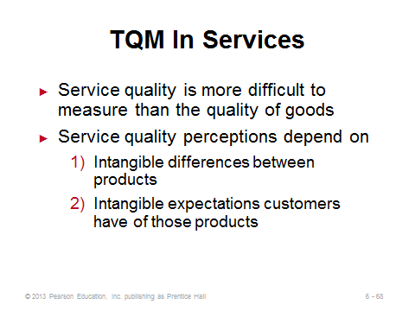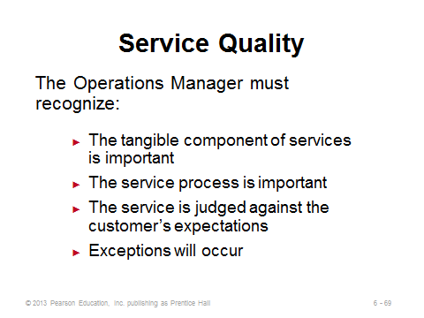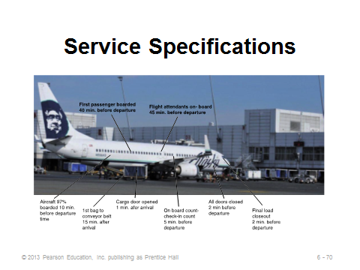
6-68 6-69 6-70

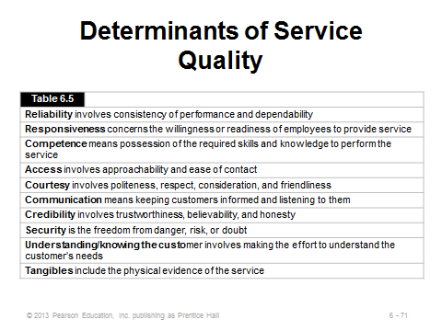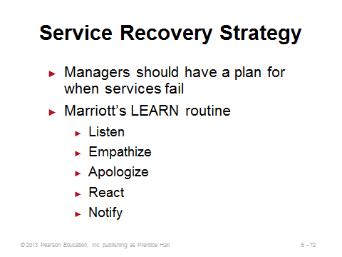
6-71 6-72

Additional Case Studies

Internet Case Study (www.pearsonhighered.com/heizer)

- Westover Electrical, Inc.: This electric motor manufacturer has a large log of defects in its writing process.

Harvard Case Studies (http://harvardbusinessonline.hbsp.harvard.edu)

- Bridges to Excellence: Bringing Quality Health Care to Life (#604030, © 2005)
- Collaborating to Improve (#608054, © 2007)
- Paul Chesler, Director, Quality Assurance (#607002, © 2006)

Ivey Case Studies (https://www.iveycases.com)

- Asterand: Learning from Failure (#9B12D018, © 2012)
- Benchmarking at Uljanik Shipyard (#9B05D011, © 2009)
- Quality Management in the Oil Industry: How BP Greases Its Machinery for Frictionless Sourcing (#9B12D006, © 2012)

Internet Resources

American Society for Quality | www.asq.org
ISO Central Secretariat | www.iso.ch
Juran Institute | www.juran.com
The Benchmarking Network | www.ebenchmarking.com
National Institute of Standards and Technology | www.quality.nist.gov
QAI Global Institute | www.qaiglobalinstitute.com
Quality Digest | www.qualitydigest.com
Quality Progress | http://asq.org/qualityprogress/index.html

