Chapter 4
Forecasting

Background

This chapter contains a lot of formulas and forecasting techniques. Depending upon preferences, instructors would typically either cover the whole thing or just cover the “basics.” The basics would likely consist of the qualitative techniques; the time series techniques of simple moving average, weighted moving average, and simple exponential smoothing; and the forecast error measurements of MAD, MSE, and possibly MAPE. Keep in mind that it is possible to present linear regression without worrying about the formulas. Excel not only can easily perform a regression analysis, but the Excel commands “SLOPE”, “INTERCEPT’, and “FORECAST” can be used to immediately calculate a single linear regression without even invoking the data analysis tool. Whichever set of techniques are presented, it is important to emphasize to the students the crucial need for accurate forecasts and how so many company decisions are driven by forecasted numbers.

Presentation Slides
INTRODUCTION (4-1 through 4-9)
Slides 6-9: The Global Company Profile for this chapter is Disney World, a place that many students will have visited or have wanted to visit. Disney has one of the more intricate forecasting systems in the world. The firm looks not only at historical data, but also a slew of inputs including vacation schedules of public schools, exchange rates, GDP data, and airline specials. The one-year forecasts are amazingly accurate. Such accuracy is crucial, as the forecasts drive many different management decisions, including park hours, number of characters to distribute, amount of food to buy, number of shows to put on, etc.
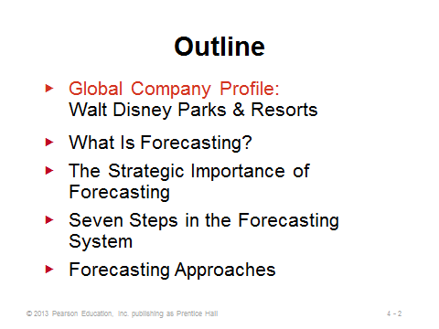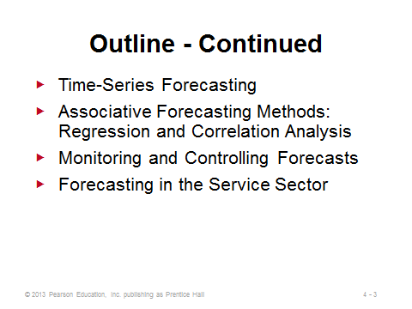
4-1 4-2 4-3
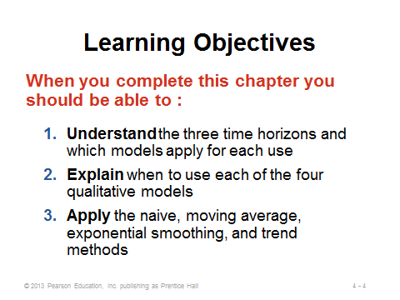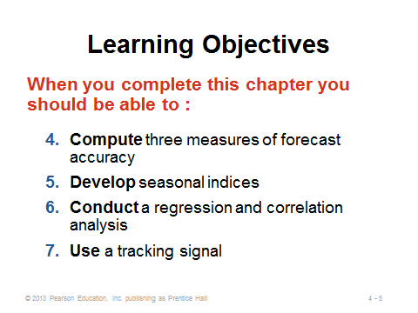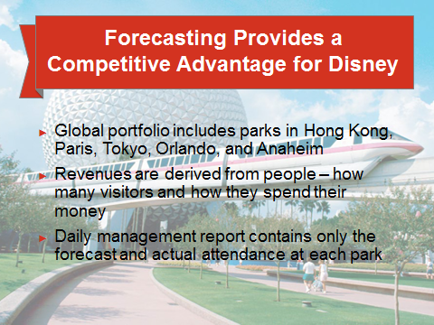
4-4 4-5 4-6
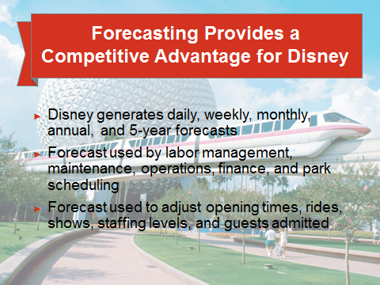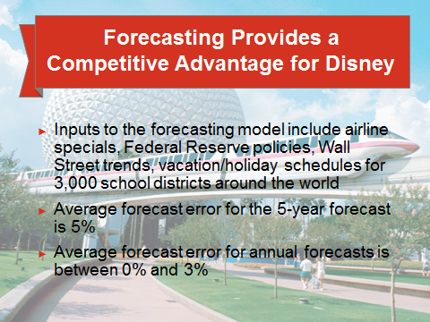
4-7 4-8 4-9

WHAT IS FORECASTING? (4-10 through 4-16)
Slide 10: Whether for gambling, deciding how thick of a coat to wear, or determining which career would be most interesting and lucrative, we all make or use forecasts regularly. All business decisions are ultimately driven by forecasts of the future. Thus, a poor forecast will likely lead to a poor decision, even if the decision methodology is sound (like “garbage-in, garbage-out” (GIGO) in computer programming).
Slides 11-12: These slides describe and differentiate the three categories of forecasting horizons. Clearly, forecasts from different horizons have different applications.
Slides 13-15: Students should be familiar with the product life cycle from Chapter 2. In fact, Slides 18 and 19 replicate Figure 2.5 from that chapter. Accurate forecasting for each stage is crucial for making quality decisions about the inevitable changes that must be made as a product moves through its life cycle.
Slide 16: Organizations use the three major types of forecasts identified in this slide for planning future operations. The operations manager typically focuses on demand forecasts.
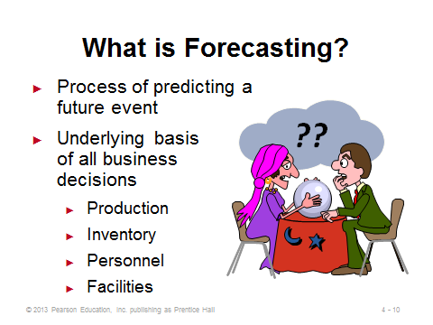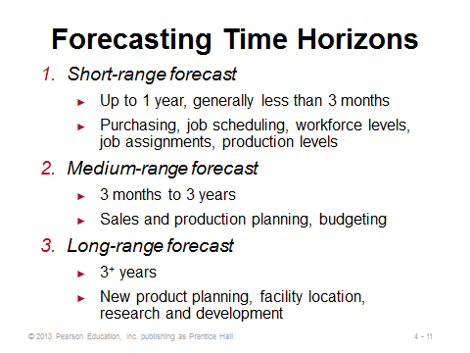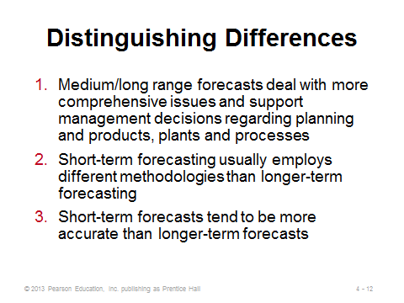
4-10 4-11 4-12
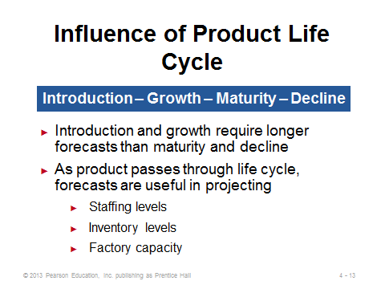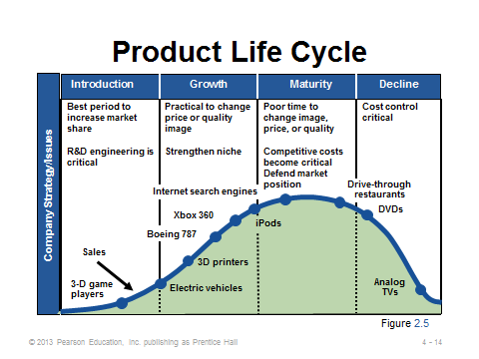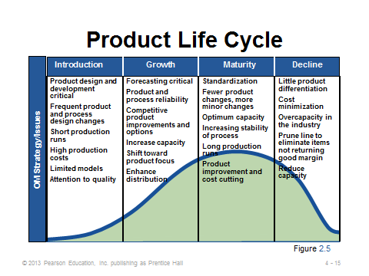
4-13 4-14 4-15
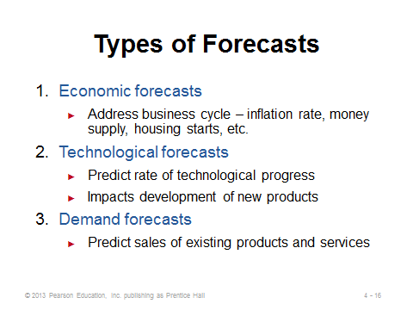
4-16

THE STRATEGIC IMPORTANCE OF FORECASTING (4-17)
Slide 17: Demand forecasts drive decisions in many areas, including the three described in this slide. For example, firms typically do not hire more workers when demand is falling, and vice-versa.
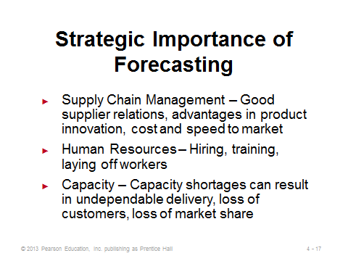
4-17

SEVEN STEPS IN THE FORECASTING SYSTEM (4-18 through 4-19)
Slide 18: The seven steps in forecasting are presented in this slide. The text uses Disney World to illustrate each step. Instructors could use that firm or choose one of their own. They could even pick an organization (possibly on campus) and have students try to describe how the organization might implement each step.
Slide 19: Every company must contend with several realities about forecasting, including those described on this slide. Forecasts need to be closely monitored to identify, for example, unusual circumstances or major shifts from historical trends. Also, when decisions can be based on aggregated rather than individual product forecasts, the aggregated forecasts should be used.
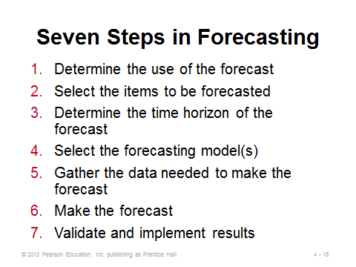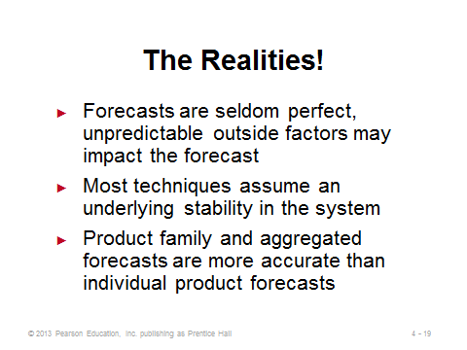
4-18 4-19

FORECASTING APPROACHES (4-20 through 4-28)
Slides 20-21: These slides compare when to use qualitative methods vs. quantitative methods. Sometimes a combination of both would be appropriate, particularly to incorporate new phenomena that were not part of the historical data.
Slides 22-27: Slides 22 and 23 identify the four primary qualitative forecasting methods, which are described further in the following four slides. Slide 25: An analogy that might help students understand the Delphi method is the college football coaches’ poll. At the beginning of the season, each voting coach submits his rankings of the top 25 football teams in the nation (essentially a forecast for which teams will do the best). Most likely, however, he will be familiar with only a subset of teams: schools from his region and perhaps some nationally ranked schools from the previous season that did not graduate many seniors. After the first poll comes out, other schools may be ranked of which he was not aware. After studying those teams, the coach may be convinced during the following week’s poll to vote for some of them. Over the season, the poll is dynamic as teams win and lose; nevertheless, information provided from other experts (other voting coaches) does add information that may alter a coach’s forecast the next time around.
Slide 28: This slide identifies the quantitative forecasting methods described in this chapter.
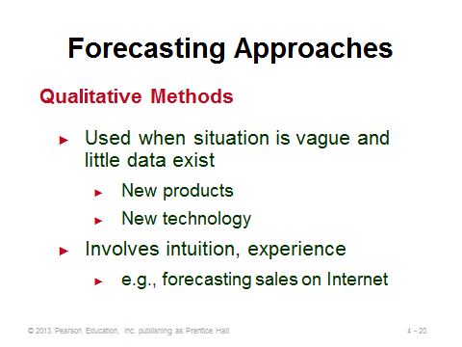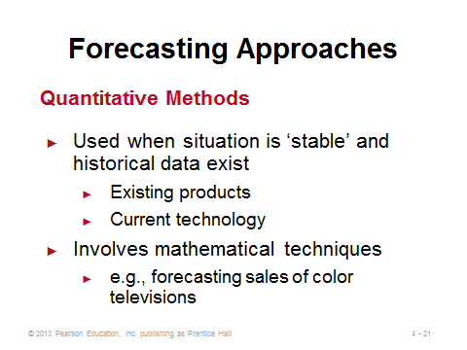
4-20 4-21 4-22

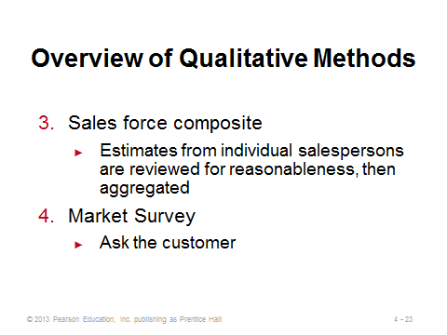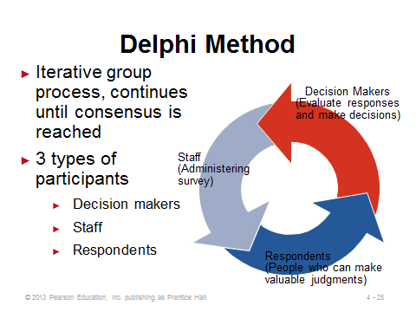
4-23 4-24 4-25
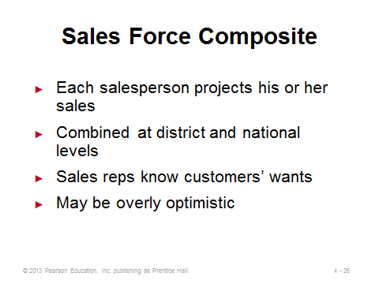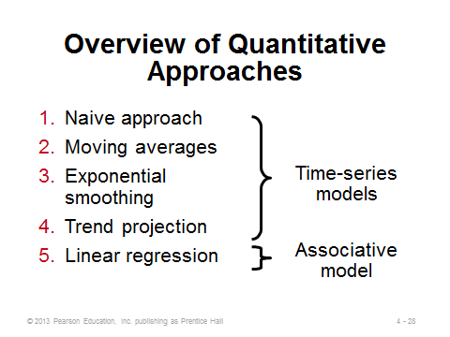
4-26 4-27 4-28

TIME-SERIES FORECASTING (4-29 through 4-95)
Introductory Paragraph (4-29)
Slide 29: This slide describes the basic assumptions of time series forecasting.
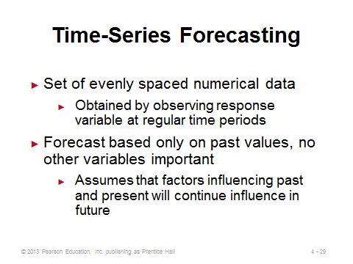
4-29

Decomposition of a Time Series (4-30 through 4-35)
Slides 30-35: Slide 30 identifies the four components of time series forecasting. Slide 31 (Figure 4.1) illustrates trend, seasonality, and random variation as compared to the average demand over that four-year time period. Slides 32-35 describe each of the four components in more detail.
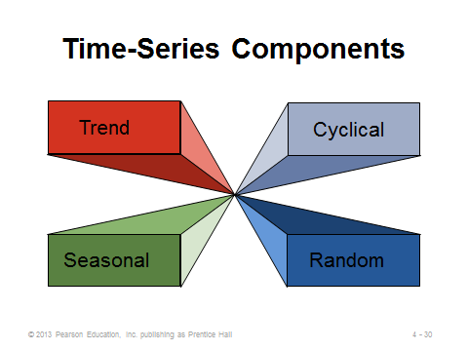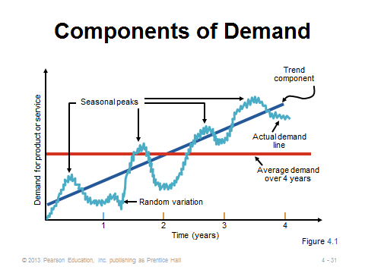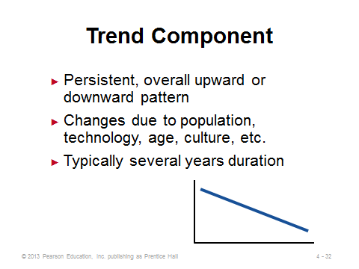
4-30 4-31 4-32 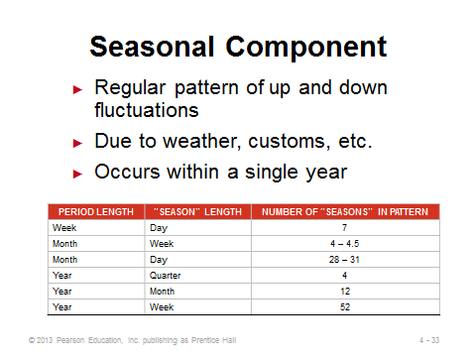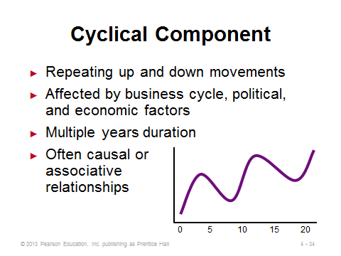 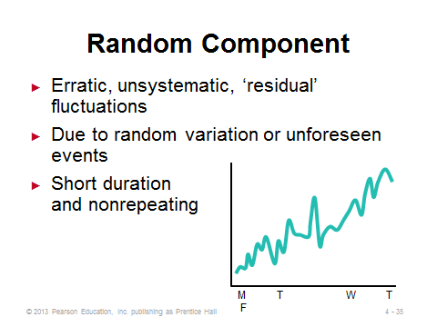
4-33 4-34 4-35

Naive Approach (4-36)
Slide 36: The naive approach is so simple that it could be considered to be a qualitative forecasting method. Numerous forecasts in the real world are made this way, especially for infrequent events. For example, with no additional information available, it would make sense to forecast attendance at this year’s sorority spring dance to be the same as last year’s.
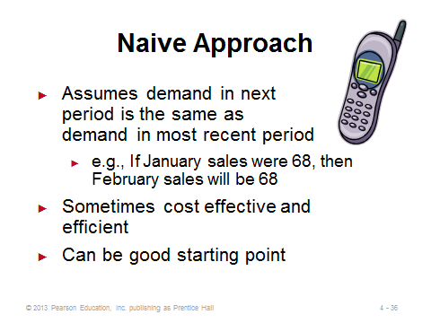
4-36

Moving Averages (4-37 through 4-43)
Slides 37-38: Slide 37 provides information about, and the formula for, the simple moving average forecast. It is applicable if we can assume that market demands will stay fairly steady over time. It can help to smooth out random fluctuations. Slide 38 provides a snapshot from Example 1 in the text. Each month, demand from the oldest month is discarded and replaced with the newest actual demand.
Slides 39-41: Slide 39 provides information about, and the formula for, the weighted moving average forecast. While this method still lags behind trends, it does a better job of catching them sooner than the simple moving average method does. The weights often sum to 100%, effectively eliminating the denominator in the formula. In fact, even when the weights sum to something else, students often forget to divide by that number. If significant seasonality exists, the weighted moving average could be a crude way to incorporate it by applying the largest weight to demand from that season’s last appearance. Slides 40 and 41 provide snapshots from Example 2 in the text. Like the simple moving average case, the oldest piece of data is replaced with the newest each month. In addition, all of the old data are moved back a month and have potentially different weights applied to them (often becoming smaller as in this example).
Slide 42: This slide identifies some potential downsides of using moving average forecasts.
Slide 43: This slide (Figure 4.2) illustrates how, if there are changes in demand, moving average forecasts will lag behind actual demand. Similar to a simple moving average, a weighted moving average forecast also lags behind actual sales when a trend exists, but it reacts slightly quicker.
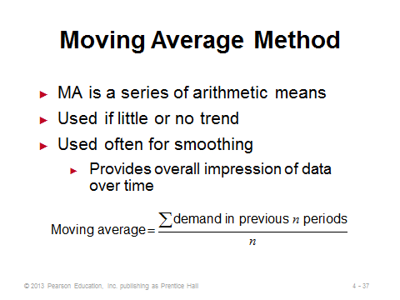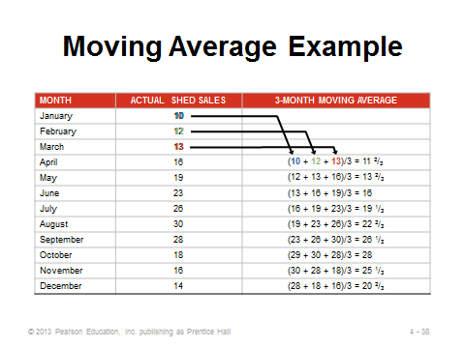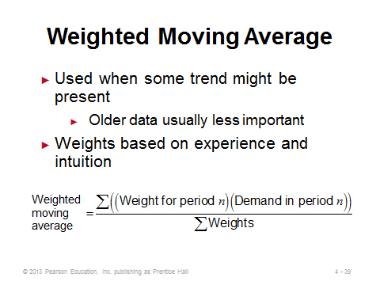
4-37 4-38 4-39
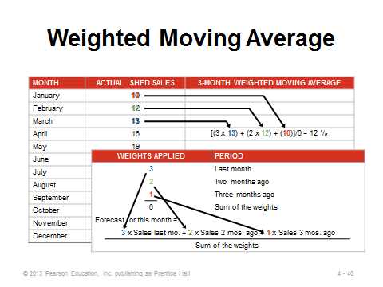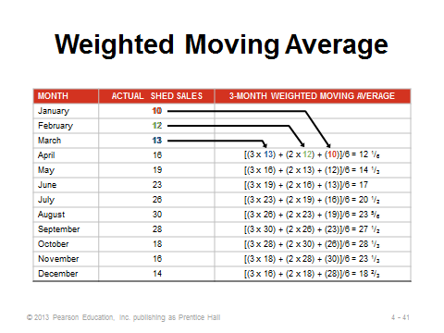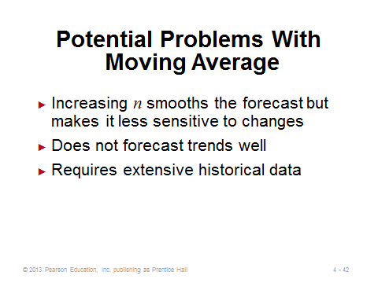
4-40 4-41 4-42
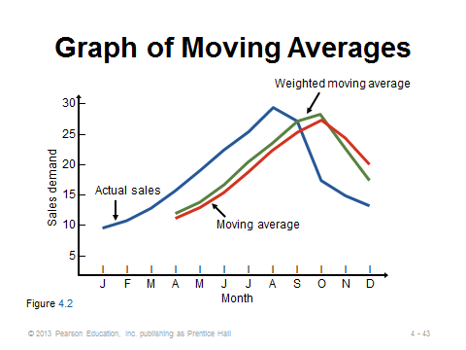
4-43

Exponential Smoothing (4-44 through 4-52)
Slides 44-45: Slide 44 describes the characteristics of the exponential smoothing forecasting method. Even though it is a form of weighted moving average, the special recursive formula means that less record keeping is necessary than for a regular weighted moving average forecast. If the weights are plotted on a graph, the curve drawn over them will be exponential in shape (hence the name). All old data remain part of the forecast, but the weights applied to very old data are extremely small. Slide 45 provides the formula. The only data needed are last period’s actual and forecasted demands. The method adjusts the forecast each period by a certain percentage (α) of the error in the previous period’s forecast. If the previous forecast was 40 units too high and α = 20%, then the new forecast will be 8 units (.20 × 40) lower.
Slides 46-48: These slides present Example 3 from the text. Here the new forecast was slightly higher because the previous forecast underestimated the true demand.
Slides 49-52: These slides examine the effect of the smoothing constant α. Note that there is no “optimal” value of α, and it should possibly be altered over time. Slide 49 shows that a high value of α places much more weight on the very recent periods, so the forecast can react much quicker to trends (displayed in Slide 50). In fact, when α = 1, exponential smoothing becomes the naive approach (this can be a good test question). In other words, the forecast is adjusted by the full error in the previous period’s forecast. When α = 0, the forecast never changes (note that this is not the naive approach). A good way to choose α is to test different values on old data (Slide 52). Whichever value yields the smallest errors might be a good choice for the future. Nevertheless, future conditions might change; therefore, forecast accuracy should continue to be monitored, and alpha values should be adjusted as needed over time.
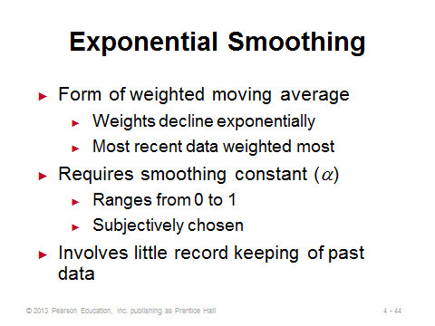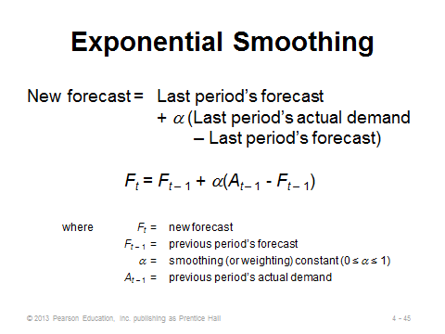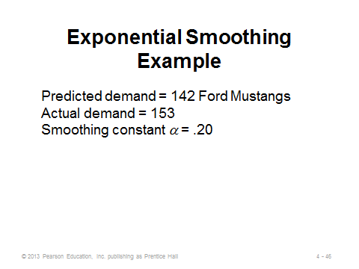
4-44 4-45 4-46
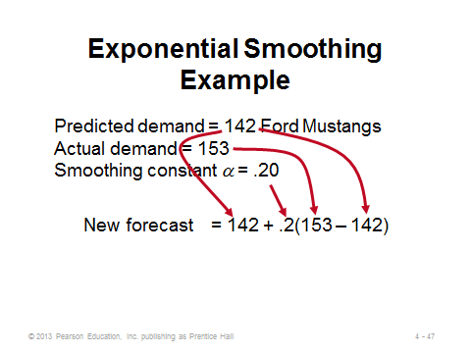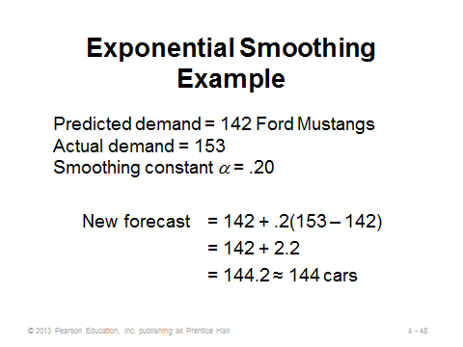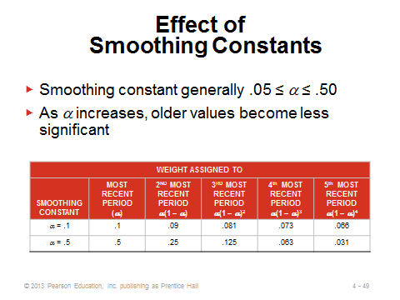
4-47 4-48 4-49
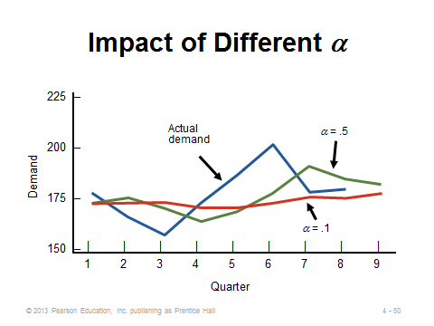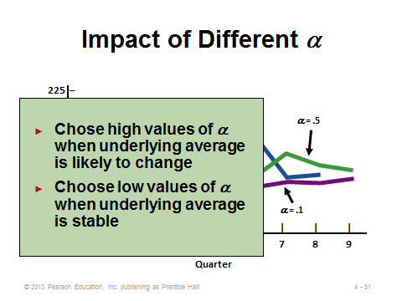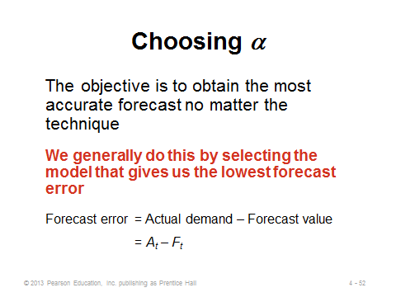
4-50 4-51 4-52

Measuring Forecast Error (4-53 through 4-64)
Slides 53-55: Slide 53 presents the formula for the mean absolute deviation (MAD). Note that “mean error” (without taking the absolute values) would not be proper because positive errors would cancel out negative errors, suggesting better performance than actually occurred. Slides 54 and 55 display the calculations from Example 4.
Slides 56-57: Mean squared error (MSE) is appropriate for protecting against particularly poor forecasts in any period, if that is of concern. Slide 56 presents the formula for MSE. Slide 57 displays the calculations from Example 5.
Slides 58-59: Mean absolute percent error (MAPE) has the advantage of defining errors in percentage terms, which can be easier to grasp than the large numbers produced by MAD and MSE. Slide 58 presents the formula for MAPE. Slide 59 displays the calculations from Example 6.
Slides 60-64: These slides (extending Examples 4, 5, and 6) compare forecasts using two different values of α by calculating MAD, MSE, and MAPE. For this example, the lower value of α (.10) performed best under all three measures. Note that the three measures of error do not always identify the same method as being the best.
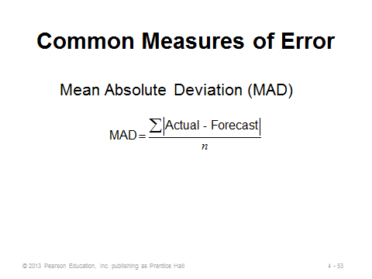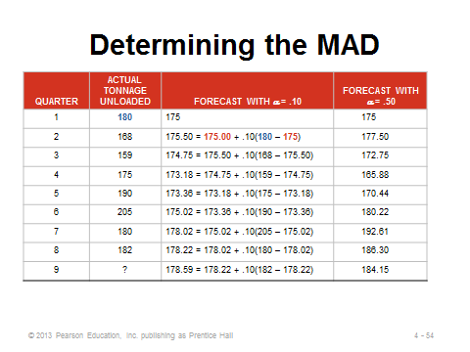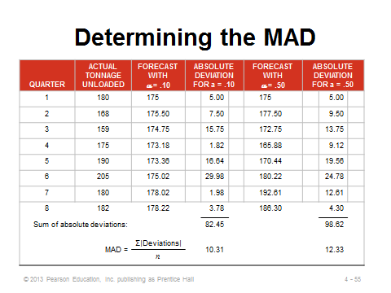
4-53 4-54 4-55
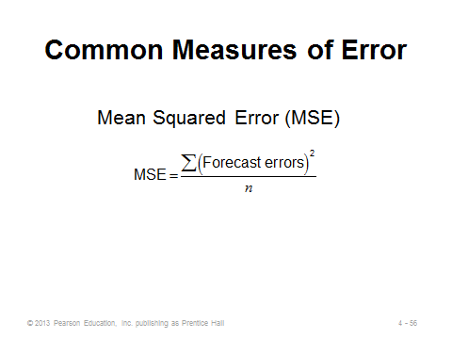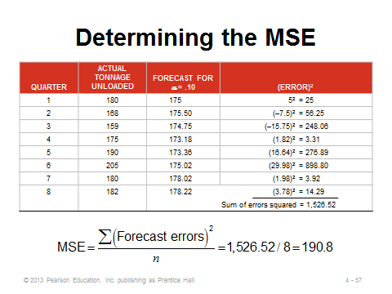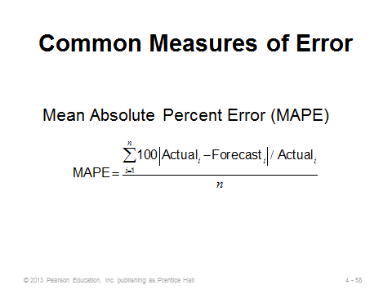
4-56 4-57 4-58
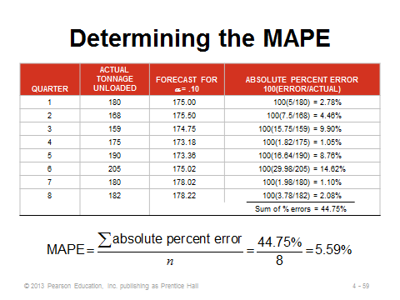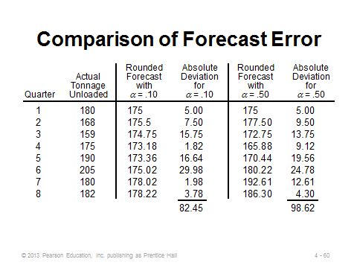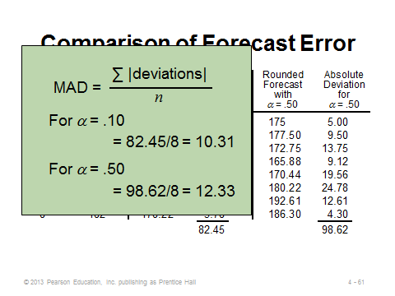
4-59 4-60 4-61
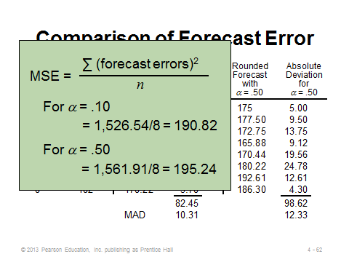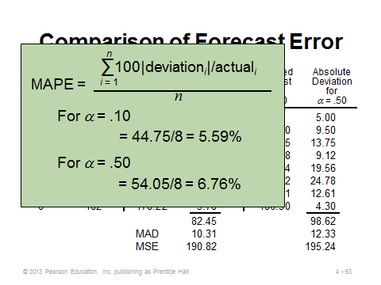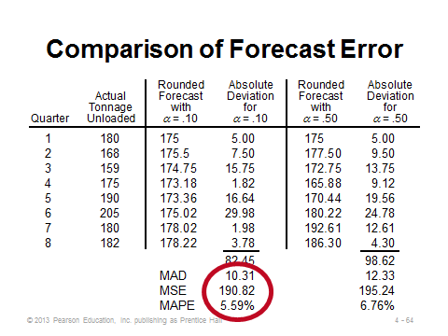
4-62 4-63 4-64

Exponential Smoothing with Trend Adjustment (4-65 through 4-73)
Slides 65-67: Exponential smoothing with trend adjustment is also called “double exponential smoothing” or “Holt’s method.” If it is known that a trend exists (for example, demand is rising or falling), this method can react more quickly than single exponential smoothing can. Slide 65 demonstrates how poorly standard (single) exponential smoothing can perform because it significantly lags behind a steep trend. Slide 66 shows that the overall forecast in double exponential smoothing is based on two pieces, a level (underlying) forecast and a forecast of the trend. Note that the forecast for n periods in the future would be F_{t} + nT_{t}. Slide 66 also presents the formulas for the two pieces of the overall forecast, where β (a fraction) is applicable to the trend component of the model and is a separate smoothing constant from α. Slide 67 details the three steps in forecasting with double exponential smoothing, which are illustrated in slides 69-71, respectively.
Slides 68-73: These slides present Example 7 from the text. The graph in Slide 73 (Figure 4.3) shows that this method can pick up the trend in actual demand very quickly.
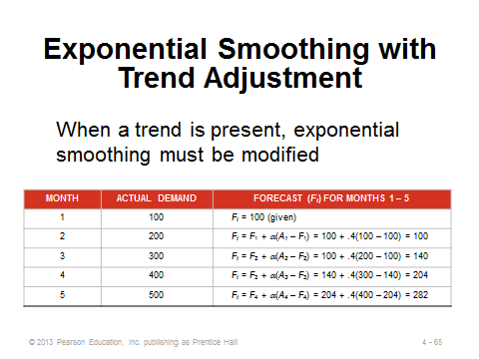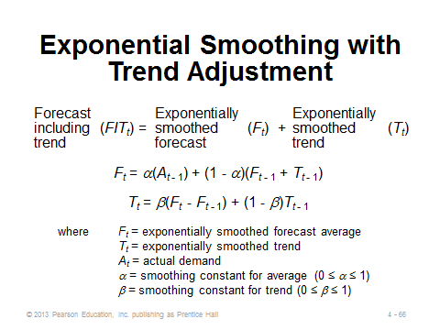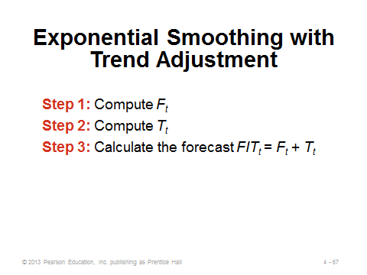
4-65 4-66 4-67
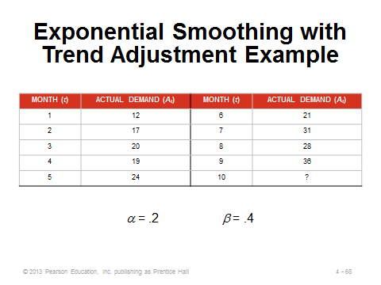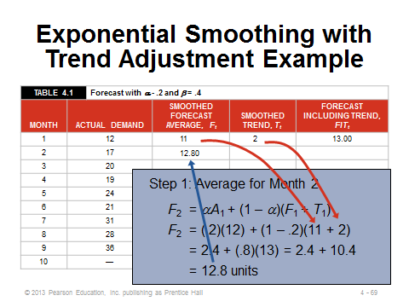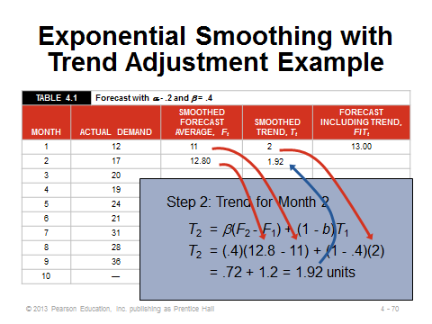
4-68 4-69 4-70
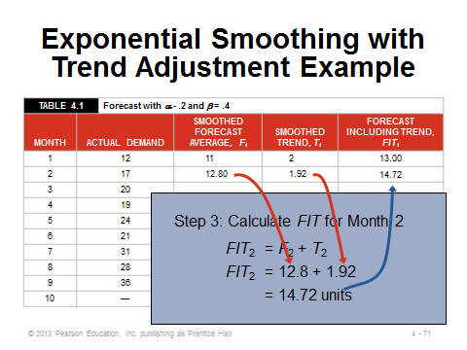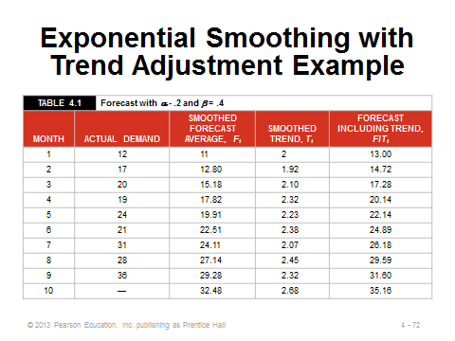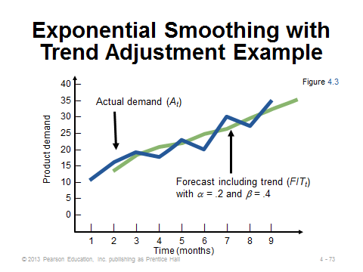
4-71 4-72 4-73

Trend Projections (4-74 through 4-81)
Slide 74: This slide presents the concept of a trend projection. The assumption is that the general trend seen in the past will continue into the future in a linear fashion. Least squares regression can be used to calculate the values for the equation.
Slides 75-76: Slide 75 (Figure 4.4) illustrates the concept behind the least squares method. Slide 76 provides the formulas for the slope and intercept terms.
Slides 77-80: These slides present Example 8 from the text. Alternatively, these calculations can be performed in Excel using the SLOPE and INTERCEPT functions. For example, put the numbers 1 through 7 in cells A1 through A7 respectively. Then insert the associated demands for those time periods in cells B1 through B7. The Excel formula =SLOPE(B1:B7,A1:A7) will compute the value of b, and the formula =INTERCEPT(B1:B7,A1:A7) will compute the value of a.
Slide 81: This slide identifies important requirements that must be met in order to effectively utilize the least squares trend projection method. In particular, the observations themselves should be rising or falling approximately linearly, and the deviations from the line should be approximately normally distributed, with most observations close to the line and only a small number farther out. And at some point in the future this linear growth will change slope or shape, so forecasts should not be made too far ahead.
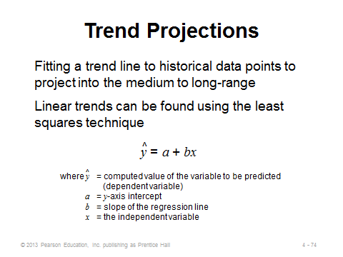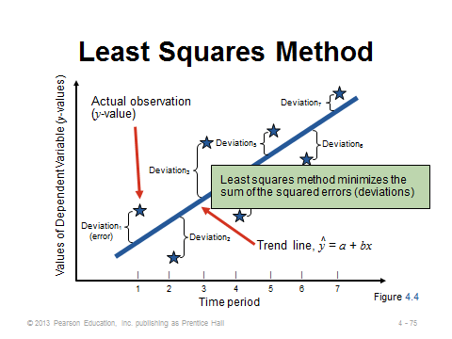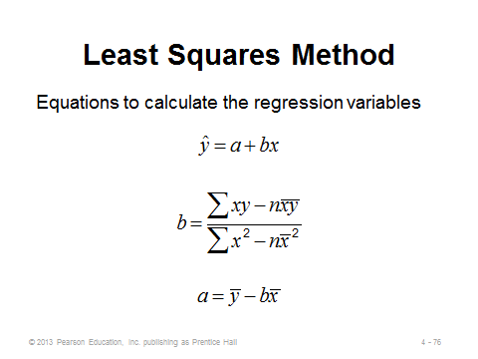
4-74 4-75 4-76
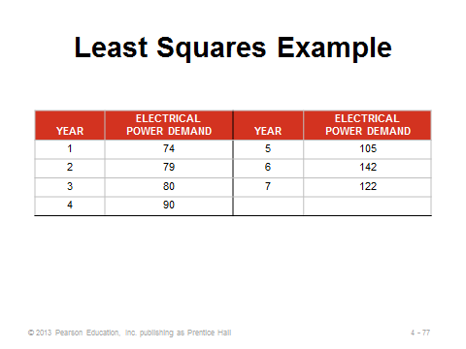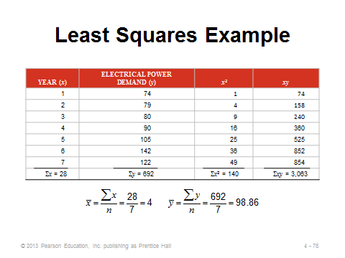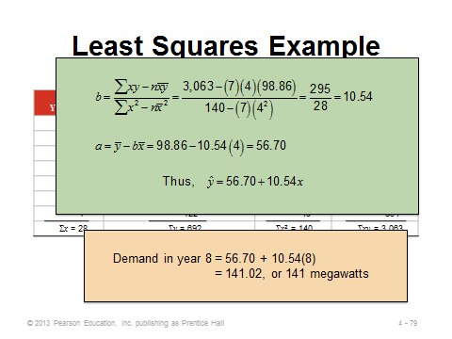
4-77 4-78 4-79
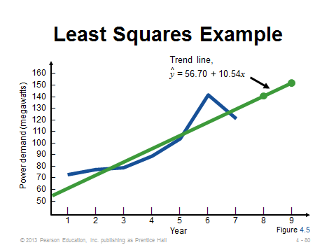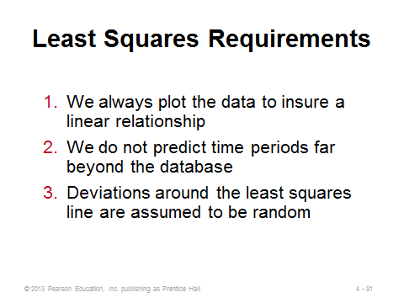
4-80 4-81

Seasonal Variations in Data (4-82 through 4-95)
Slides 82-83: Seasonal demand is common in many industries, so the associated forecasts should be adjusted to account for this major impact. Slide 83 identifies the steps for the multiplicative seasonal model. (The steps are not so obvious at first glance, so the follow-up example should definitely be presented to students.) Instructors might note that an alternative method for incorporating seasonality is to include it within an exponential smoothing framework. This is called “triple exponential smoothing,” or “Winter’s method,” and it introduces a third smoothing constant γ.
Slides 84-89: These slides present Example 9 from the text. In Slide 84, the fifth column calculates an average demand for each season (month) over the previous three years. In Slide 85, the average monthly demand in the sixth column equals the total average annual demand (the sum of column 5) divided by 12 months. Slides 86 and 87 show how to calculate the seasonal index for each month. In Slide 88, we start with a forecast (of 1200) for Year 4. This annual forecast is divided among the months by converting it into an average monthly forecast and multiplying that by the applicable seasonal index for each month. Slide 89 graphs the three years of actual demands as well as the demand forecasts for Year 4.
Slides 90-94: These slides present Example 10 from the text, which shows a way to incorporate both trend and seasonality into the same forecast. A trend line (least squares) is first created (Slide 90). Then seasonal indices are computed based on the same data (Slides 91-92). Finally, the trend-adjusted forecasts are multiplied by the associated monthly seasonal indices to produce the combined forecasts (Slides 93-94).
Slide 95: This slide provides calculations from Example 11—another case of making seasonal adjustments to forecasts, this time for quarterly data.
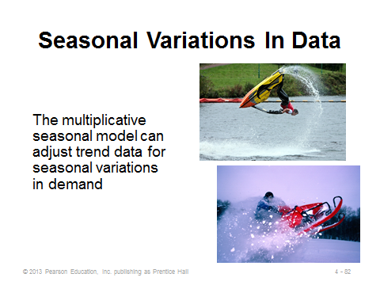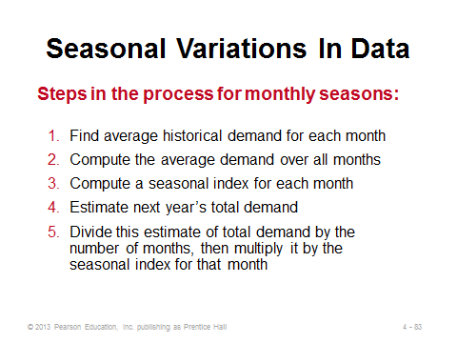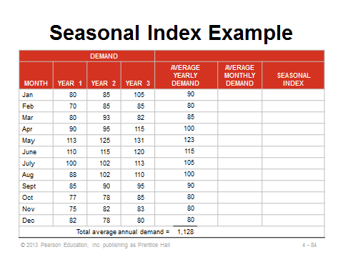
4-82 4-83 4-84
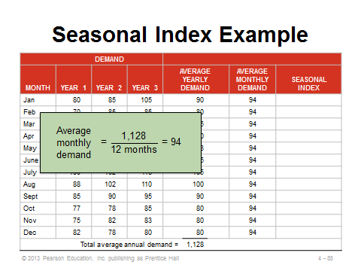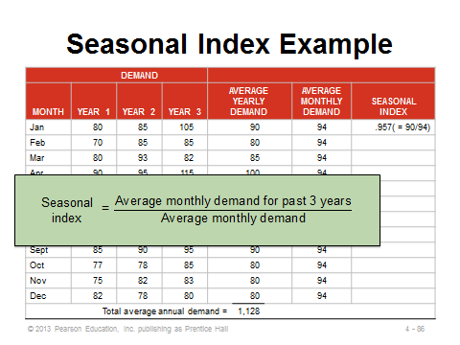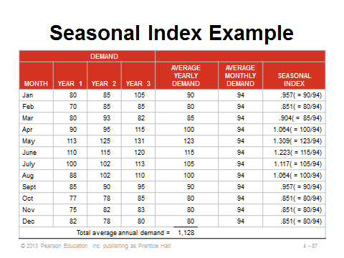
4-85 4-86 4-87
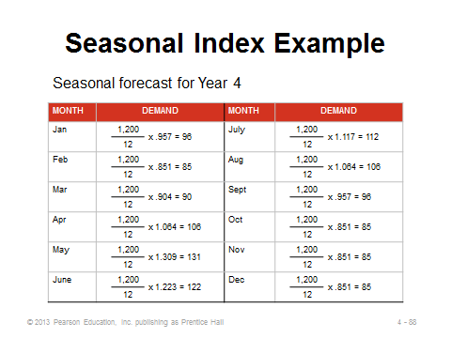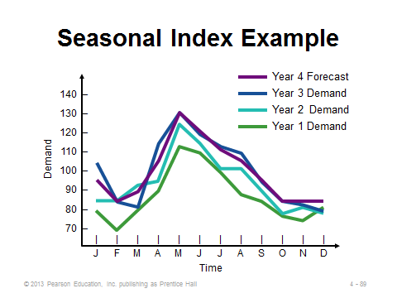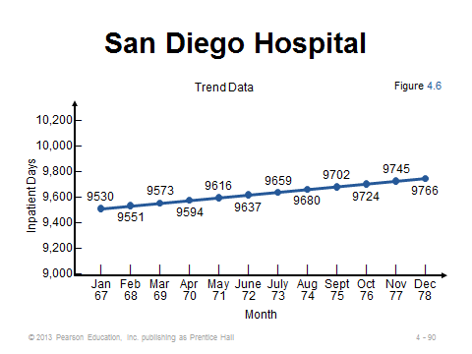
4-88 4-89 4-90
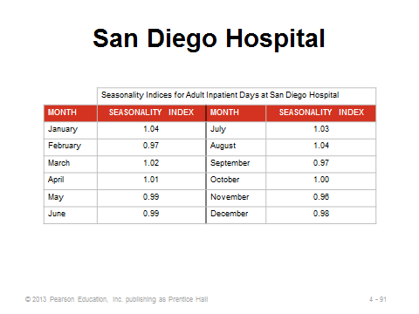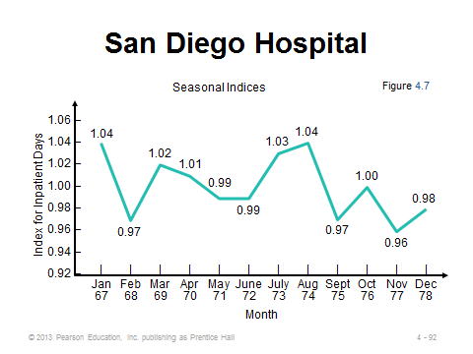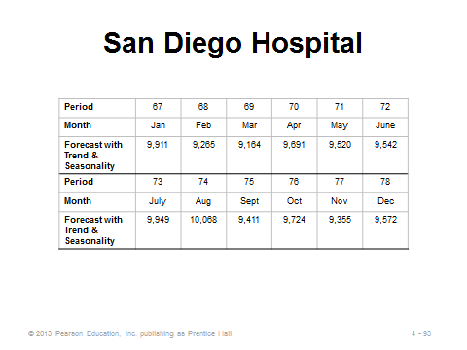
4-91 4-92 4-93
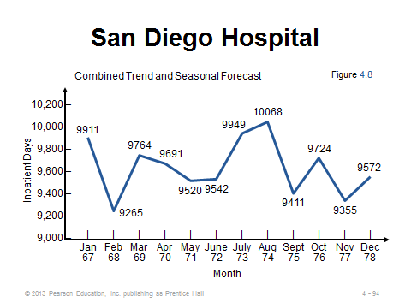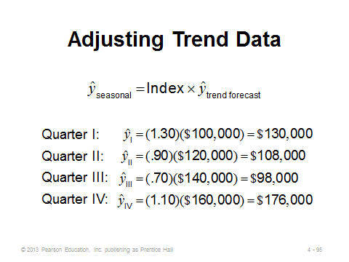
4-94 4-95

ASSOCIATIVE FORECASTING METHODS: REGRESSION AND CORRELATION ANALYSIS (4-96 through 4-114)
Slides 96-97: As opposed to basing forecasts on patterns of historical data, associative forecasting estimates the impact of certain predictors (independent variables) on the outcome (dependent variable). Predictors could include items such as the gross domestic product of the country, the level of advertising applied to a certain product, the weather for an outdoor event, etc. Simple linear regression assumes one independent variable and is the exact same technique as that used for time series trend projections. Slide 97 presents the formula.
Slides 98-103: These slides present Example 12 from the text, which assumes that sales volume is highly dependent upon payroll levels in the area. Slide 98 presents the raw data, and Slides 99 and 100 present the calculations. Slides 101-103 plot the regression line and show how to make a forecast based on a particular independent variable value ($6 billion).
Slides 104-106: The standard error of the estimate is a measure of variability around the regression line—its standard deviation. The formula in Slide 106 is the easier of the two to use.
Slide 107: This slide (Example 13) computes the standard error of the estimate for the regression line of Slide 103 (Example 12). The interpretation of the standard error of the estimate is similar to the standard deviation; namely, 1 standard deviation = .6827. So, in this example, there is a 68.27% chance of sales being within $306,000 from the point estimate of $3,250,000.
Slides 108-111: Slide 108 describes the concept of correlation, and Slide 109 presents the formula for the correlation coefficient. Slide 110 (Figure 4.10) presents a nice graphical demonstration of the concept of correlation. Slide 111 present the correlation coefficient calculations from Example 14.
Slide 112: This slide describes the concept of coefficient of determination (r²). It is the common measure that most of us think of when describing results from regressions. For Example 14, we see that 81% of changes in sales (the dependent variable) are predicted by changes in payroll (the independent variable).
Slides 113-114: Slide 113 introduces the notion of multiple regression analysis (more than one independent variable). Slide 114 presents the results from Example 15 in the text (solved via computer). The explanatory power of the model improved by adding a second independent variable.

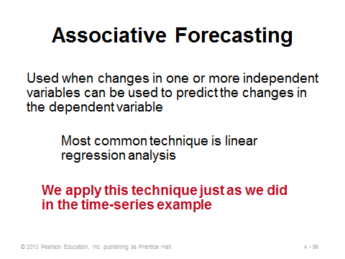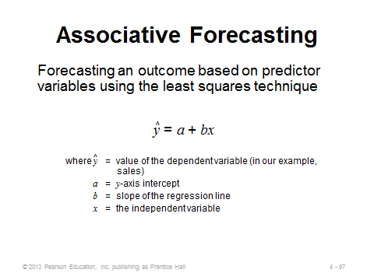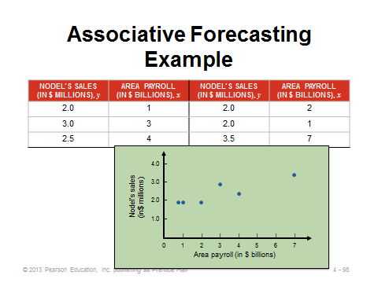
4-96 4-97 4-98
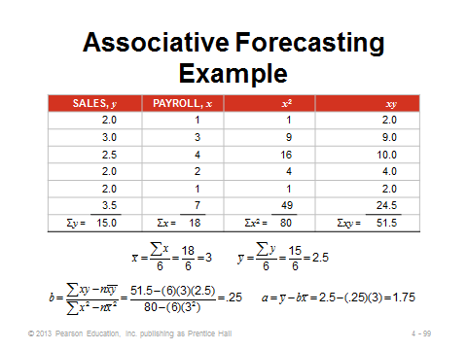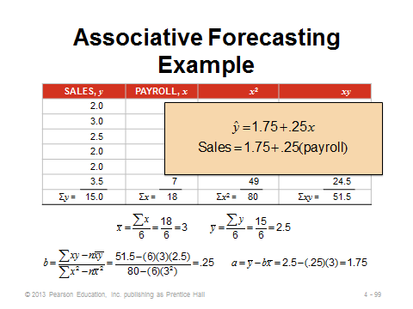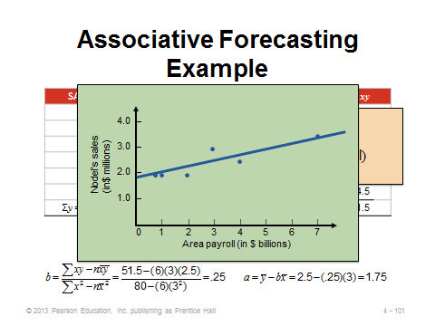
4-99 4-100 4-101
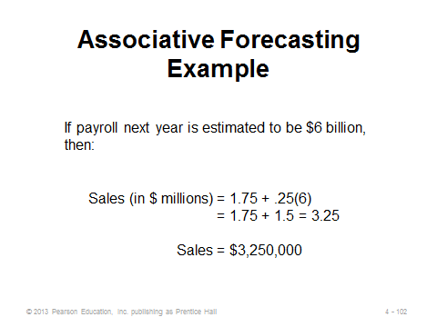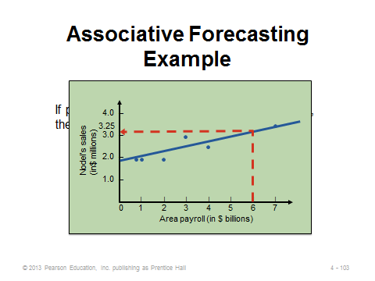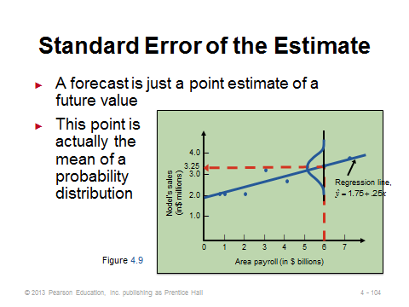
4-102 4-103 4-104
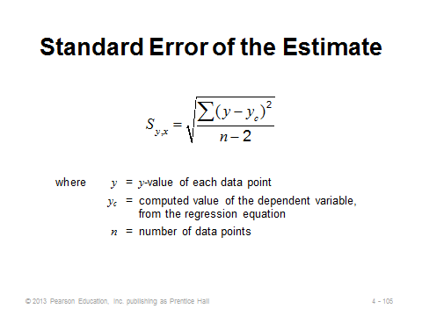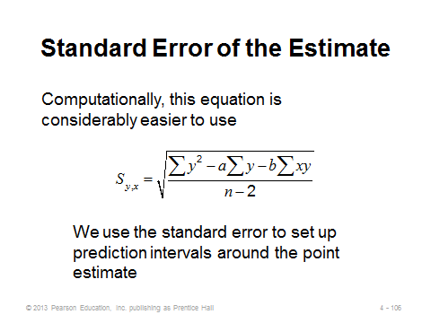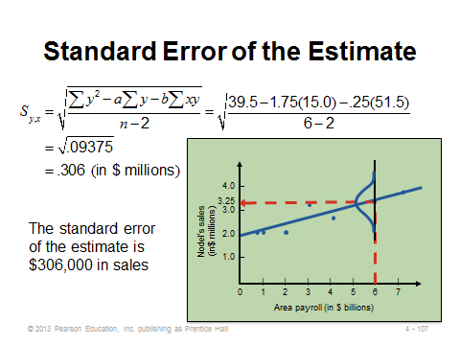
4-105 4-106 4-107
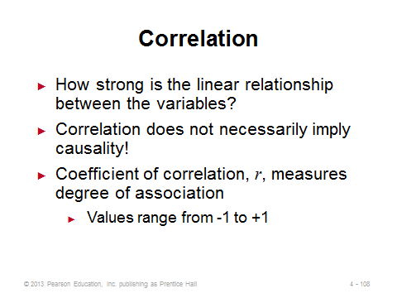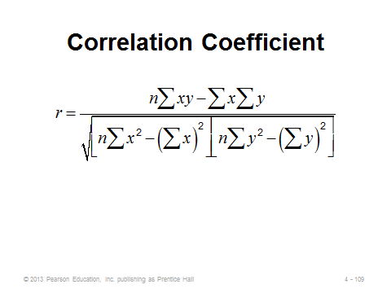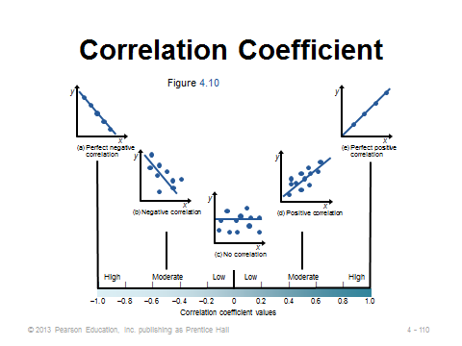
4-108 4-109 4-110
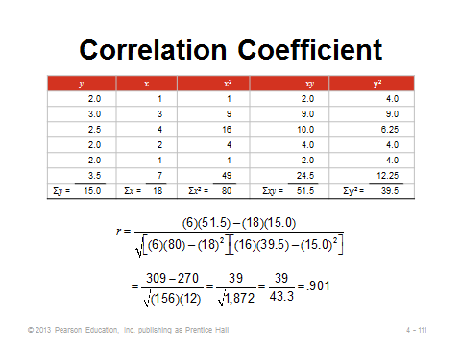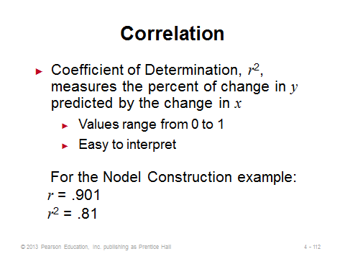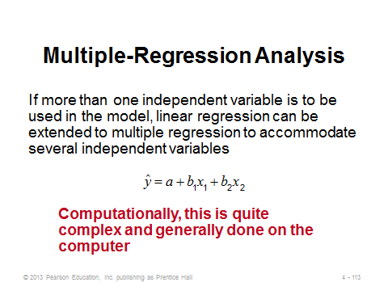
4-111 4-112 4-113
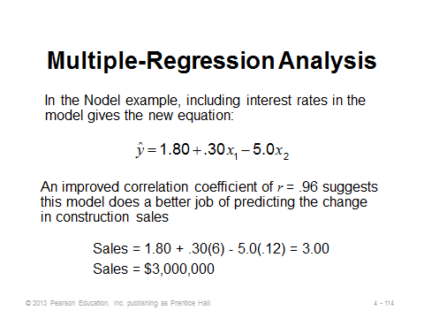
4-114

MONITORING AND CONTROLLING FORECASTS (4-115 through 4-120)
Slides 115-117: Slide 115 introduces the notion of a tracking signal, which is an effective way to make sure that the forecasting system is doing a good job. Slide 116 presents the formula. Slide 117 (Figure 4.11) illustrates the concept. If the tracking signal falls outside of the predetermined upper and lower control limits, the forecasting method should be examined for possible adjustment.
Slide 118: This slide presents Example 16 from the text. Management is using control limits of 4 MADs, so the variation is deemed acceptable.
Slides 119-120: These slides introduce the concepts of adaptive smoothing (Slide 119) and focus forecasting (Slide 120), both of which include an artificial intelligence component.
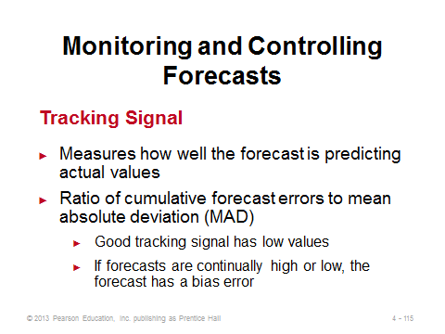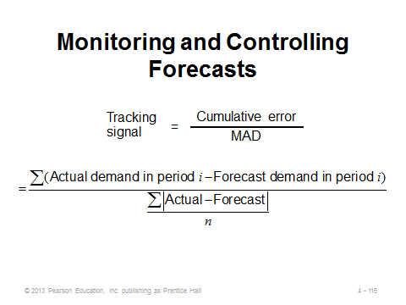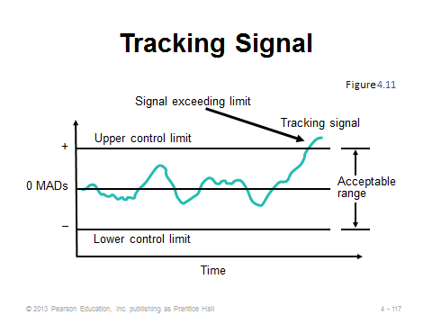
4-115 4-116 4-117
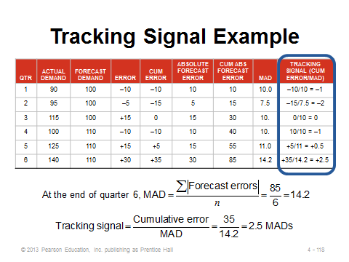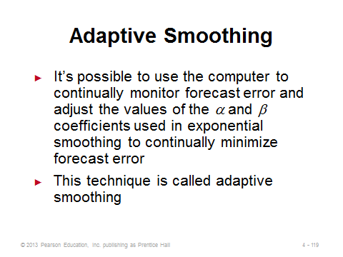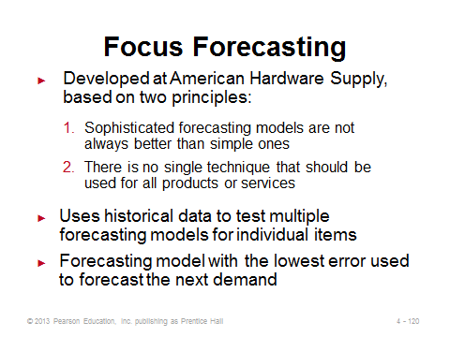
4-118 4-119 4-120

FORECASTING IN THE SERVICE SECTOR (4-121 through 4-123)
Slide 121: This slide identifies some of the unusual challenges faced when attempting to forecast in the service sector.
Slides 122-123: These slides (Figure 4.12) show the tremendous hourly variation in demand present at many typical services.
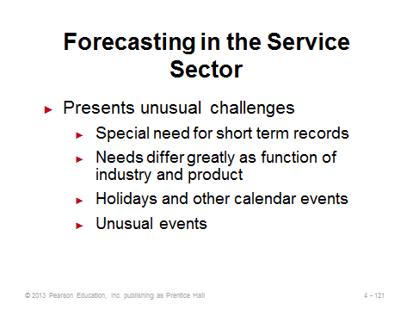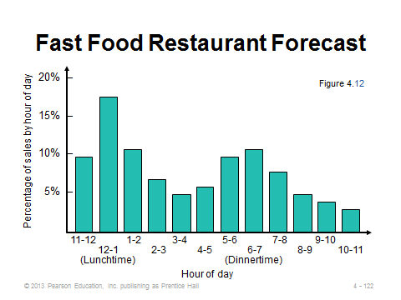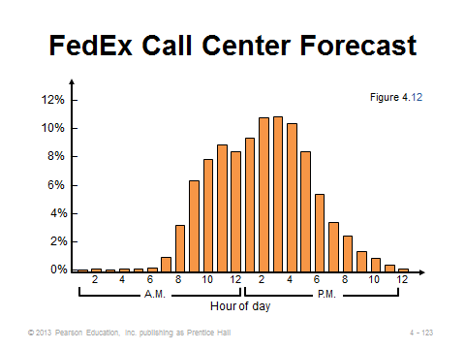
4-121 4-122 4-123

Additional Case Studies
Internet Case Study (www.pearsonhighered.com/heizer)

- Digital Cell Phone, Inc.: Uses regression analysis and seasonality to forecast demand at a cell phone manufacturer.
- North-South Airline: Reflects the merger of two airlines and addresses their maintenance costs.

Harvard Case Studies (http://harvardbusinessonline.hbsp.harvard.edu)

- Henkel Iberica (A) (#105023, © 2005)
- Leitax (A) (#606002, © 2007)
- Paper and More (A) (#606023, © 2009)

Ivey Case Studies (https://www.iveycases.com)

- Ontario Machinery Ring (C) – Data Analysis and Interpretation (#9B04A023, © 2009)
- Progistix-Solutions, Inc. – The Critical Parts Network (#9B05D002, © 2009)
- Wilkins, A Zurn Company: Demand Forecasting (#9B06D006, © 2009)

Internet Resources
American Statistical Association | www.amstat.org
Institute for Business Forecasters | http://www.ibf.org
Journal of Time Series Analysis | www.blackwellpublishers.co.uk
Royal Statistical Society | www.rss.org.uk

Other Supplementary Material

Steven S. Harrod provides a nice “Gas Data” forecasting exercise below in which students can examine a large data set in a spreadsheet or similar application.
“Gas Data” Forecast Exercise
Copyright 2013, Steven S. Harrod

This is a large data set forecasting exercise, suitable for an in class or computer lab activity. It typically requires about 40-50 minutes to present and supervise. The purpose of this exercise is to give students experience with larger data sets and applications in spreadsheets (or other tools). This exercise presumes that students have completed prior lectures and exercises on relevant forecasting methods.

Instructions
Provide the data to the students without explaining its origin. Ask the students to open the data in a new spreadsheet file. Direct the students to begin constructing a forecast for the data. You may ask the students to experiment with different forecast models, or you may create a more structured lesson and direct the students to implement specific models in sequence.

Give the students time to work independently (or at least in groups without you lecturing). One method would be to allow five minutes to work, and then pause to present your solution so far. In a typical lecture period, you should be able to progress through two or three forecast models, and then pick one of those for error statistics. Try to finish the lecture with a tracking signal chart for the data.

At the end of the class, ask the students to guess what the data is, and then reveal the data. This data is the recorded miles per gallon of a minivan at each fuel tank filling for a period of about two years.

These data provides an excellent opportunity to visual the significance of error statistics in more detail. In particular, this data provides a dramatic example of the tracking signal. The tracking signal fundamentally measures whether the underlying process of the series data is stable. When the tracking signal spikes, it is an indication that some fundamental change has occurred in the underlying process that the data is drawn from. Since a forecast is simply the generation of a trend from a series of data points, the methodology is dependent on the underlying process to be stable. If the underlying process is not stable, or experiencing a fundamental change in behavior, the forecast cannot accurately predict the trend.

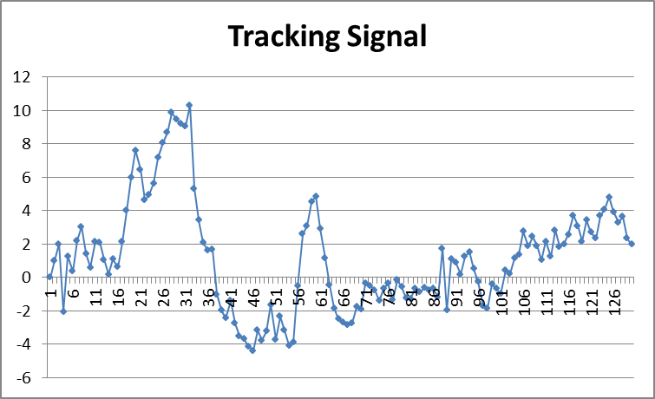
The tracking signal graphed above is derived from an exponential trend model of this data, alpha=0.25 and beta=0.05. The peaks in the tracking signal correspond with vacation trips (all highway mileage).

Data:
15.234198  15.282051  12.686447  18.695399  13.954545  19.231279  17.799736  13.591310  14.135649  19.202614  16.014406  14.235033  14.042553  17.370370  14.931946  18.944530  21.090248  23.291005  24.412429  18.026316  16.019608  19.819355  21.162651  24.569684  23.855634  23.426737  26.155689  22.651470  22.863933  23.152709  27.373936  14.441309 | 17.843575  17.931034  19.342641  20.459976  13.284175  16.012121  16.652174  20.418182  14.400000  15.131948  16.296080  15.273381  15.437382  18.800705  14.895259  17.348993  20.162805  11.452750  19.186296  14.144427  13.308824  15.594463  23.872367  26.097122  20.791855  24.127907  21.901999  16.138329  15.274262  14.397590  13.806888  14.915353 | 15.773259  15.662021  16.267725  18.551724  16.087209  20.626521  16.931818  16.573781  15.326152  18.526119  0.000000  17.922454  14.632063  19.676994  16.211632  15.231672  16.545894  18.125683  16.308915  17.402453  16.530963  16.978022  15.565928  23.812089  8.702398  23.951890  17.459494  15.894331  20.147453  18.852127  15.681159  15.594306 | 13.285199  15.876448  19.771198  16.241314  15.944233  20.194731  16.892193  19.659027  18.555490  21.658477  16.805556  20.036765  17.654742  16.533181  21.060695  16.672454  22.526920  17.066895  19.316290  20.611836  22.475904  18.825152  17.754386  22.829162  18.694158  19.205387  23.405535  21.848825  23.131774  19.709061  19.871279  22.000000  18.293255  19.797248

Note: This game has been developed by Steven S. Harrod for educational purposes. It may be used, disseminated, and modified for educational purposes, but it may not be sold. In all uses of the game, the original developer must be acknowledged (as has been done above).

