Chapter 3
Project Management

Background

This is the first chapter containing a significant amount of quantitative material. It also represents an opportunity for students to try out the popular Microsoft Project software. The concept of project crashing should be emphasized, because future managers need to know effective ways to speed up a project that has fallen behind. Note that if students will be learning about linear programming (Module B), the crashing problem can be effectively written as a linear program and solved in Excel.

Presentation Slides

INTRODUCTION (3-1 through 3-8)
Slides 7-8: From the Global Company Profile, the Bechtel group is the world’s premier manager of massive construction and engineering projects. The Bechtel projects are fascinating in their scope. The firm has clearly become a worldwide expert in successfully implementing project management concepts and techniques.
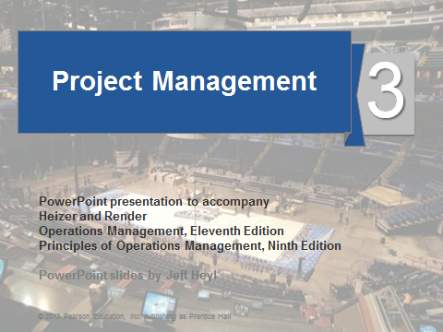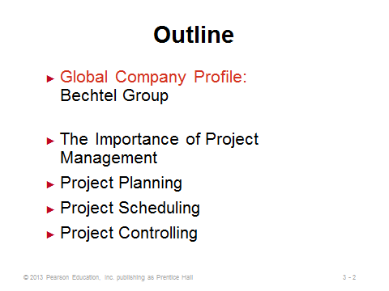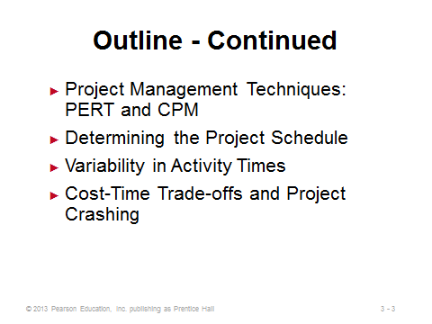
3-1 3-2 3-3
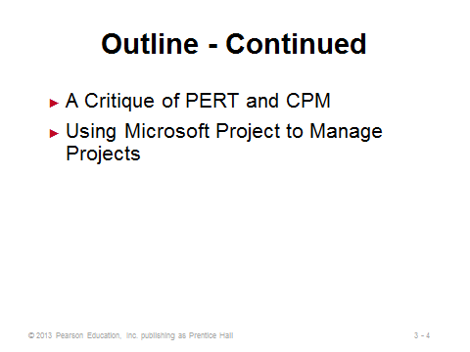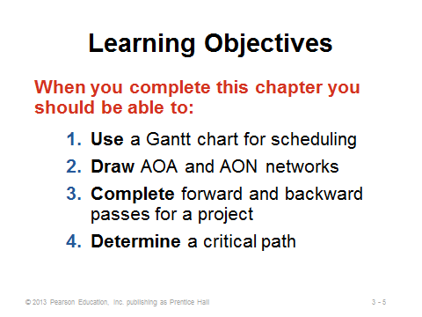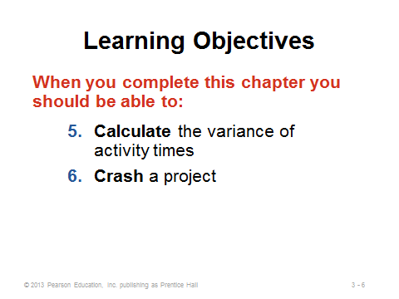
3-4 3-5 3-6

3-7 3-8

THE IMPORTANCE OF PROJECT MANAGEMENT (3-9 through 3-18)
Slide 9: This slide identifies important considerations involved when a company such as Bechtel tackles a large-scale project. Such efforts often require a significant amount of planning and control, and they are becoming more challenging due to growing project complexity and collapsing product/service life cycles. Techniques and concepts introduced in this chapter, along with software such as Microsoft Project, provide important assistance.
Slides 10-11: Slide 10 identifies typical characteristics that make up a project. These can be illustrated via the two examples in Slide 11.
Slides 12-18: Project management involves the three phases identified in Slide 12 and illustrated in Slides 13 and 14-18 (Figure 3.1). Slide 18 identifies some of the tools and reports applicable to each stage.
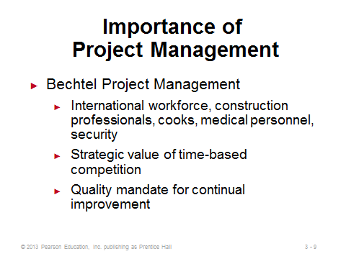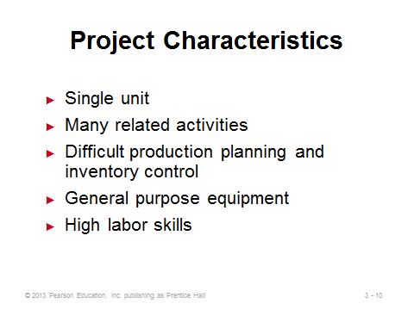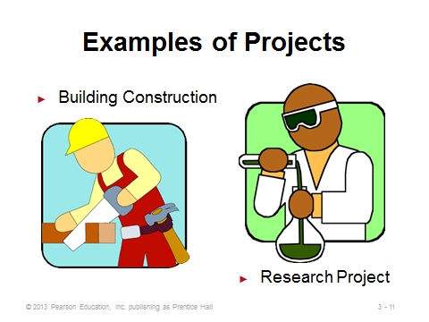
3-9 3-10 3-11
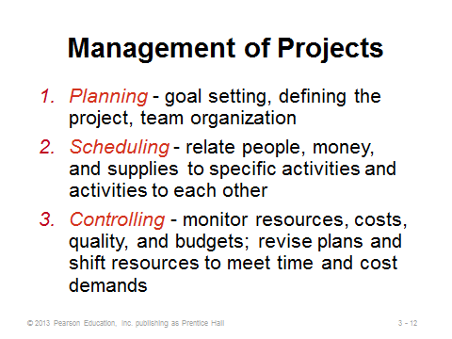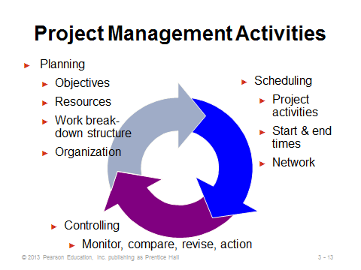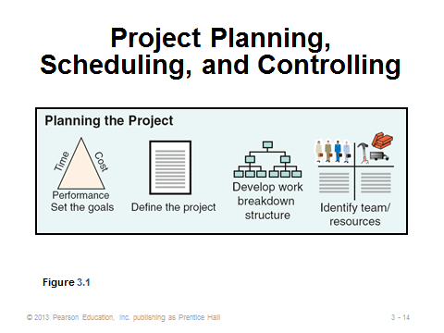
3-12 3-13 3-14
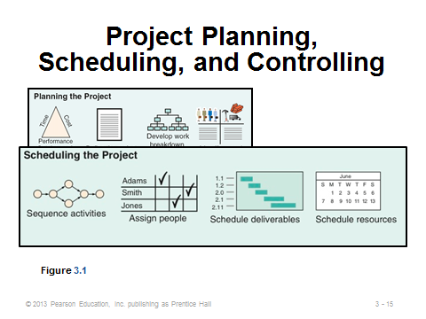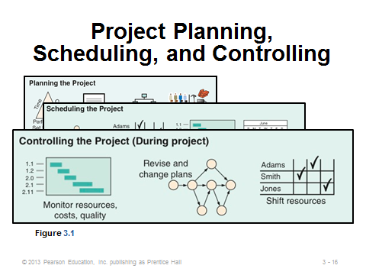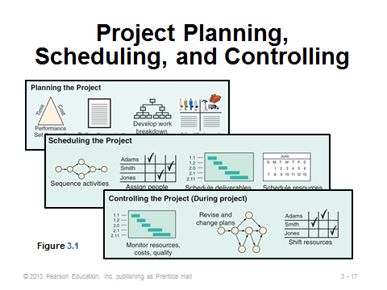
3-15 3-16 3-17
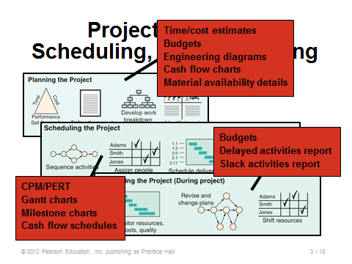
3-18

PROJECT PLANNING (3-19 through 3-28)
Slide 19: This slide identifies typical steps involved in project planning. A work breakdown structure defines the project by dividing it into its major subcomponents (or tasks), which are then subdivided into more detailed components, and finally into a set of activities and their related costs.
Slides 20-23: Slide 20 identifies typical characteristics of a project organization, which is an organization formed to ensure that programs (projects) receive the proper management and attention. A project organization often crosses departmental lines. The project manager’s job is often high-profile, and project success or failure is usually ultimately attributed to that person in a very public way (at least within the company). Firms managing multiple projects on a regular basis may set up a matrix organization. Slide 21 can be presented in reverse, that is, failed projects often lack one or more of the characteristics identified in this slide. Slide 22 (Figure 3.2) provides an example of a project organization, and Slide 23 provides an example of a matrix organization.
Slides 24-26: Good project managers need a wide variety of people, organizational, and technical skills. Slide 24 highlights the major responsibilities of a project manager, and Slide 25 follows up by identifying some of the requisite skills. This might be a good place to refer students to the OM in Action: “Rebuilding the Pentagon after 9/11.” Clearly the project manager for this monumental task called on his many project management skills to beat the deadline under cost. Slide 26 presents some of the important ethical issues that may arise in the course of a project. Research has shown that without good leadership and a strong organizational structure, most people follow their own set of ethical standards and values. The six-page Code of Ethics and Professional Conduct from the Project Management Institute can be found at the institute’s web site: http://www.pmi.org/~/media/PDF/Ethics/ap_pmicodeofethics.ashx. This is a good reference for any future project manager.
Slides 27-28: The work breakdown structure typically decreases in size from top to bottom as shown in Slide 27. Slide 28 (Figure 3.3) presents a work breakdown structure illustrating the development of Microsoft’s operating system Windows 8.
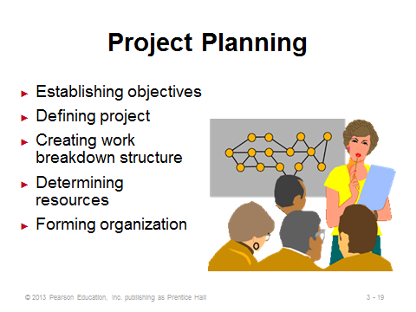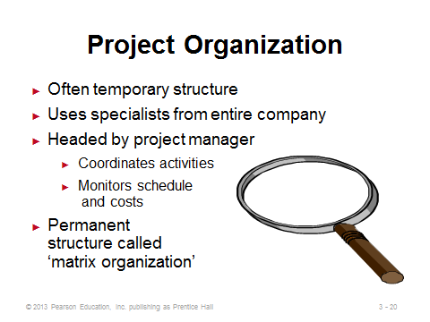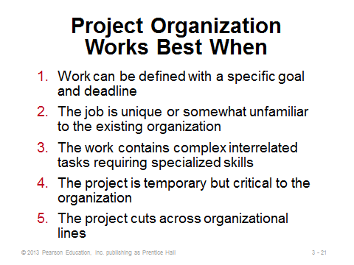
3-19 3-20 3-21
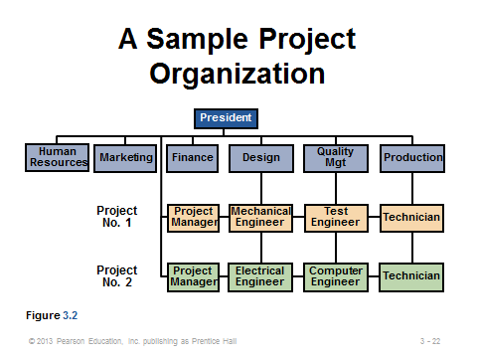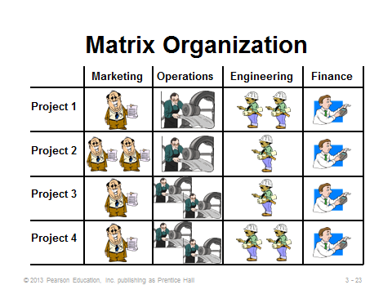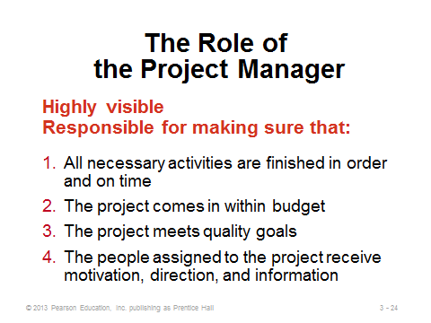
3-22 3-23 3-24
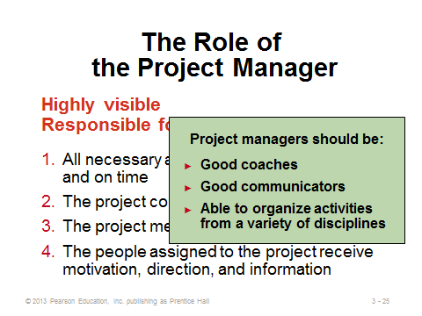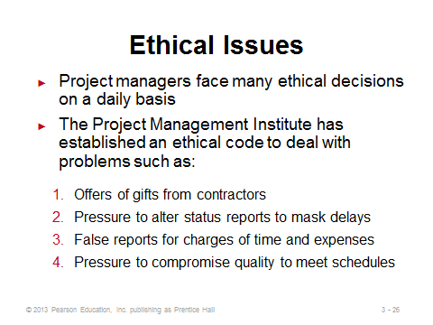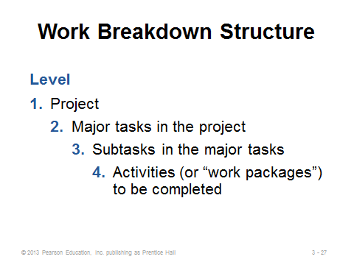
3-25 3-26 3-27
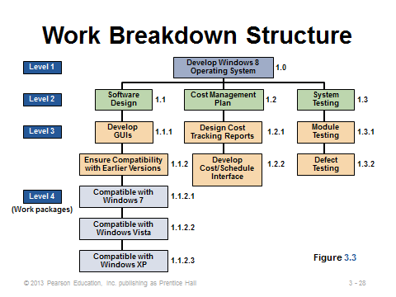
3-28

PROJECT SCHEDULING (3-29 through 3-33)
Slide 29: Gantt charts are low-cost means of helping managers make sure that the items identified on this slide are addressed.
Slide 30: Whatever approach is taken by a project manager, project scheduling serves the purposes identified on this slide.
Slides 31-33: While Gantt charts permit managers to observe the progress of each activity and to spot and tackle problem areas, they do not adequately illustrate the interrelationships between the activities and the resources. On the other hand, CPM and PERT do have the ability to consider precedence relationships and interdependency of activities. These techniques are widely used and are usually computerized. Slides 32 and 33 (Figure 3.4) present two different versions of a Gantt chart, the latter illustrating Delta’s efforts (OM in Action) to reduce its turnaround time from 60 minutes to 40.

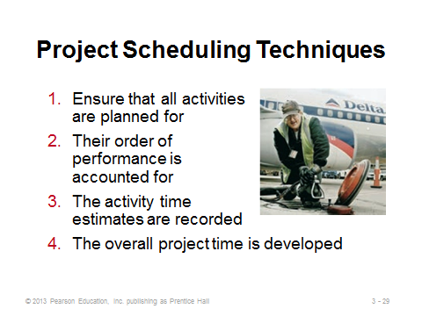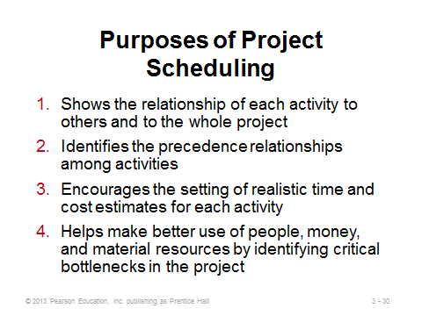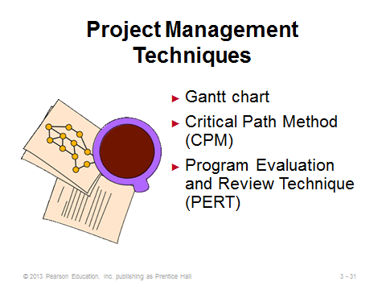
3-29 3-30 3-31
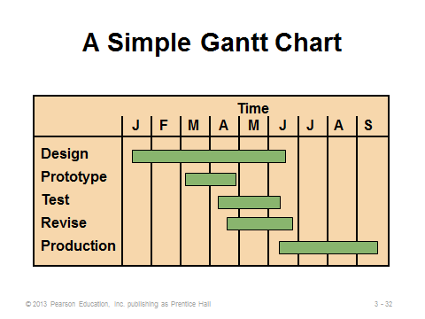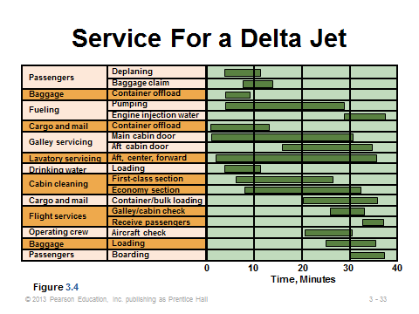
3-32 3-33

PROJECT CONTROLLING (3-34 through 3-36)
Slide 34: The control of projects involves close monitoring of resources, costs, quality, and budgets. Computerized software programs, such as Microsoft Project, produce a wide variety of reports, and information gleaned from them helps managers make adjustments.
Slide 35: This slide identifies several popular project management software packages.
Slide 36: This slide identifies several reports that typical software programs produce.
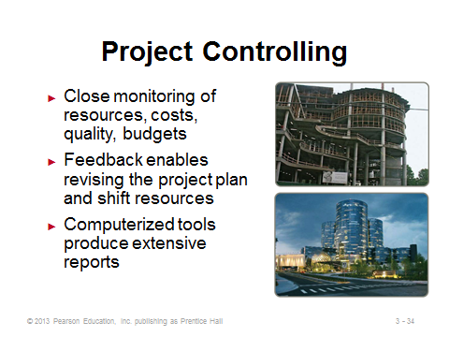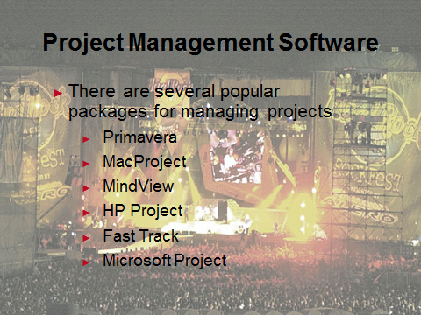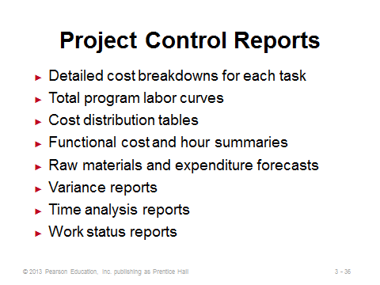
3-34 3-35 3-36

PROJECT MANAGEMENT TECHNIQUES: PERT AND CPM (3-37 through 3-49)
Slide 37: PERT and CPM were developed at around the same time, and most of their characteristics are the same. The major difference is that PERT incorporates uncertainty in task times by employing three time estimates for each activity (optimistic, pessimistic, and most likely). With PERT, project managers can estimate probabilities of completing the project within certain time frames.
Slides 38-39: These slides present the six basic steps of PERT/CPM. The critical path (Step 5) represents the expected time to complete the entire project. A delay in any activity on the critical path will delay the entire project.
Slides 40-41: Theses slides are nice because they identify eight questions that PERT and CPM can answer, even for projects with thousands of activities. This might be a good point for instructors to reference the Taco Bell example shown on page 84. Using PERT/CPM, Taco Bell built and opened a new fast-food restaurant in Compton, California, in just two days! (The process typically takes two months.)
Slides 42-44: Activity-on-node is a network diagram in which nodes designate activities, while activity-on-arrow is a network diagram in which arrows designate activities. These slides nicely illustrate how the two approaches compare under six different activity conditions. Many software packages use activity-on-node networks.
Slides 45-49: Slide 45 identifies the precedence relationships from Example 1 in the text. Slides 46-48 (Example 2) construct an activity-on-node diagram for those activities. Slide 49 (Example 3) presents an activity-on-arrow diagram for the same example.
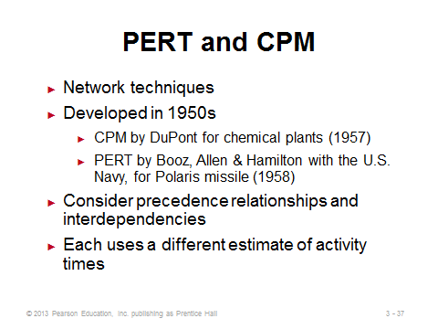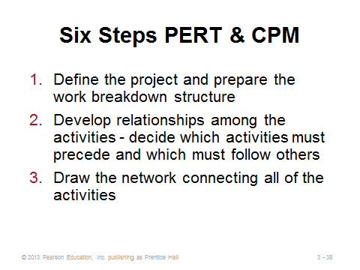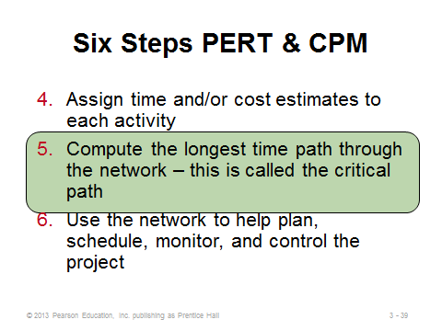
3-37 3-38 3-39
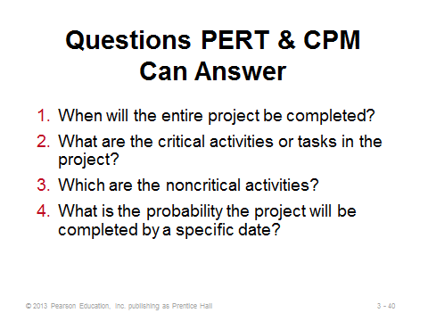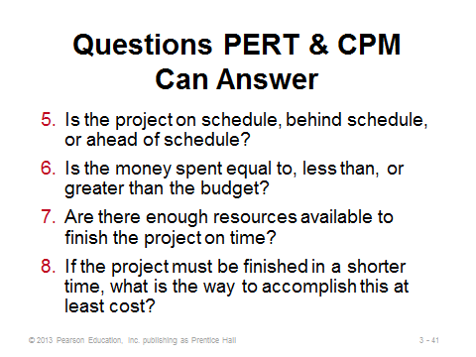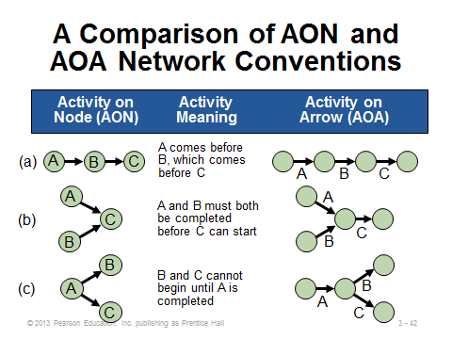
3-40 3-41 3-42
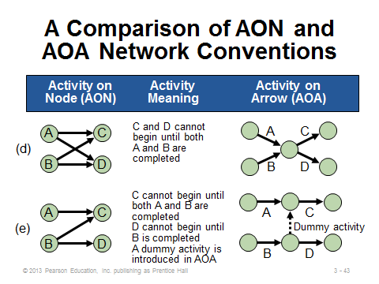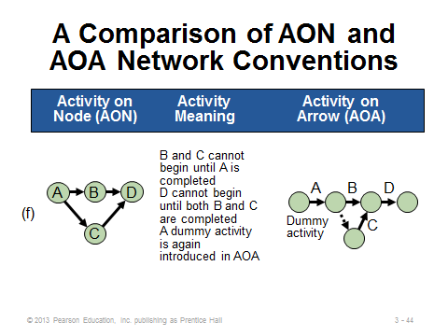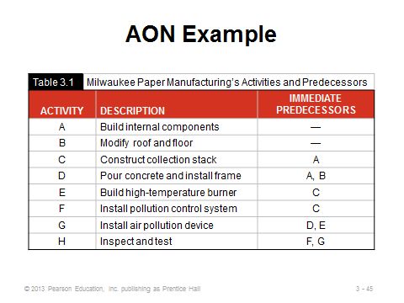
3-43 3-44 3-45
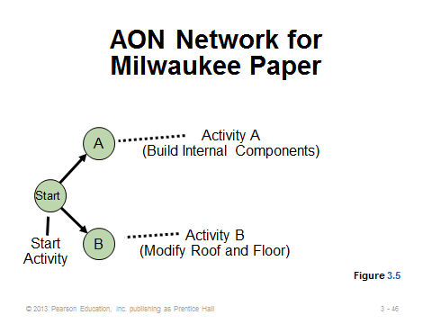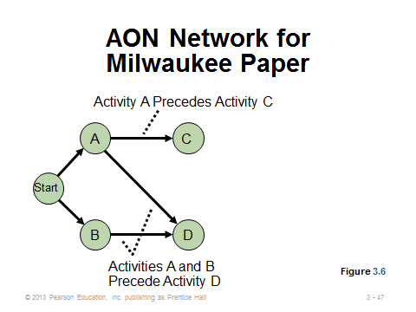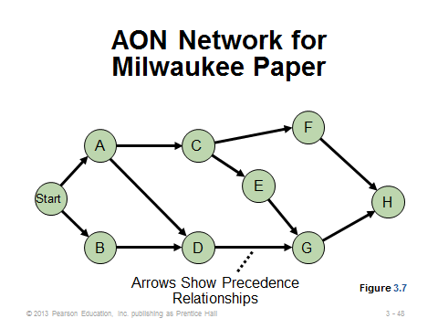
3-46 3-47 3-48
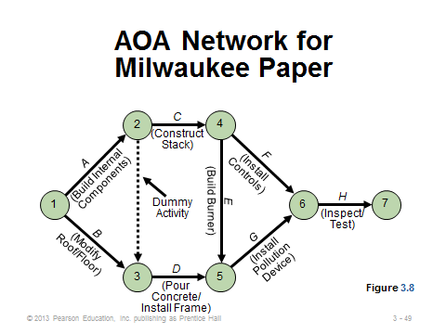
3-49

DETERMINING THE PROJECT SCHEDULE (3-50 through 3-73)
Slide 50: This slide describes characteristics of critical path analysis.
Slide 51: This slide contains the time estimates for the Milwaukee Paper example that will be used to illustrate critical path analysis in Slides 56-73. Note that the project will take less than 25 weeks to complete because some of the activities will be performed simultaneously.
Slides 52-53: To find the critical path, we calculate two distinct starting and ending times for each activity, as defined in Slide 52. Notation used in within nodes for the forward and backward passes is shown in Slide 53 (Figure 3.9).
Slides 54-55: These two slides present the calculations for the earliest start and earliest finish times, respectively.
Slides 56-62: For the Milwaukee Paper example, these slides (Example 4) take us through a forward pass, which computes all of the earliest start and earliest finish times.
Slides 63-64: These two slides present the calculations for the latest finish and latest start times, respectively.
Slides 65-68: For the Milwaukee Paper example, these slides (Example 5) take us through a backward pass, which computes all of the latest finish and latest start times.
Slide 69: This slide presents the calculation for slack time, i.e., the length of time an activity can be delayed without delaying the entire project. Activities with zero slack time are designated as critical and are on the critical path.
Slides 70-73: Slide 70 (Example 6) computes the slack for each activity in the ongoing Milwaukee Paper example. The activities with zero slack are marked as being on the critical path, and that path (Start-A-C-E-G-H) is identified on Slide 71. Slide 72 presents a Gantt chart for the earliest start and finish times (working on each step as soon as possible), while Slide 73 presents one for the latest start and finish times (more like a just-in-time approach).
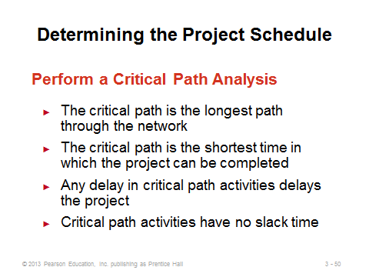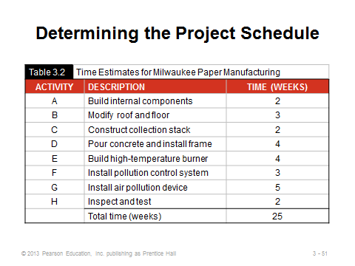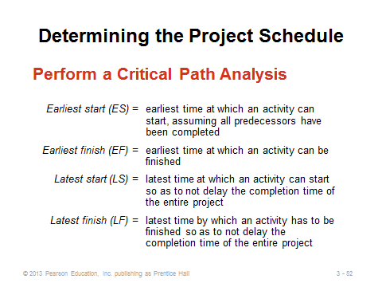
3-50 3-51 3-52
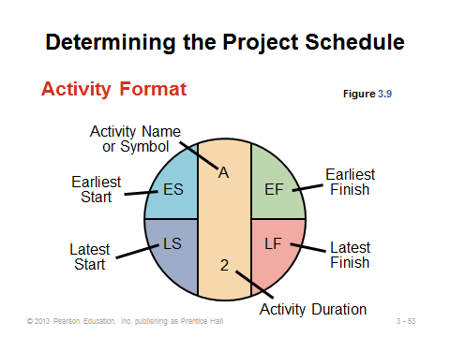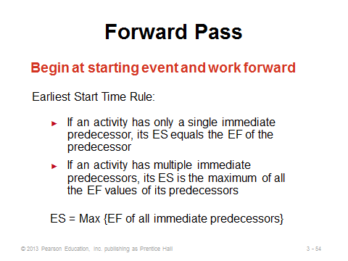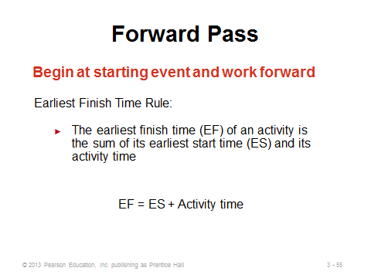
3-53 3-54 3-55
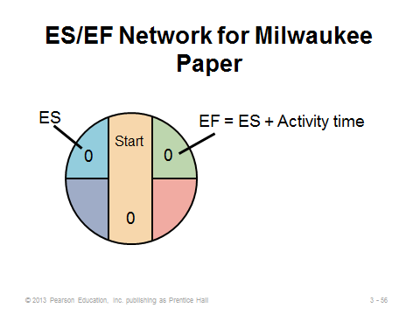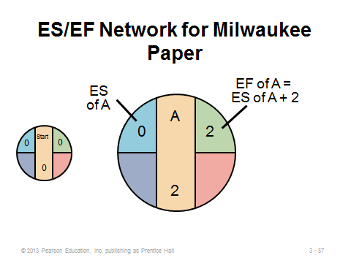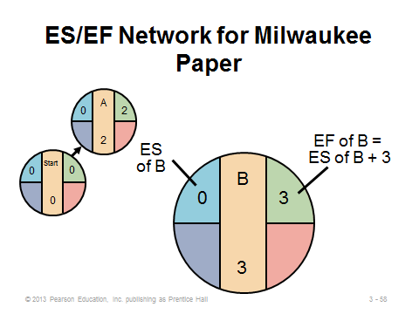
3-56 3-57 3-58

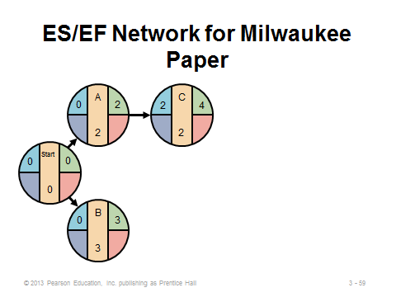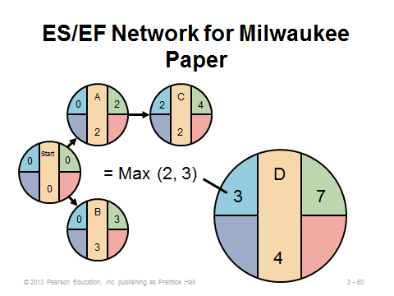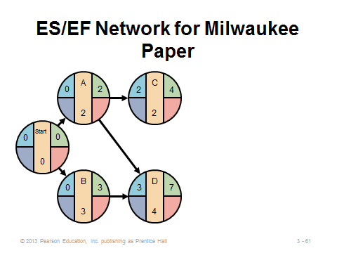
3-59 3-60 3-61

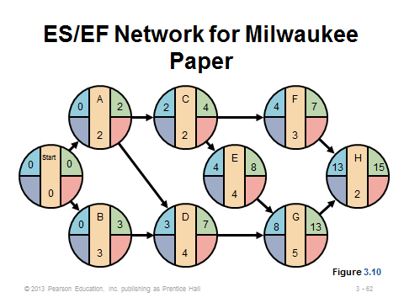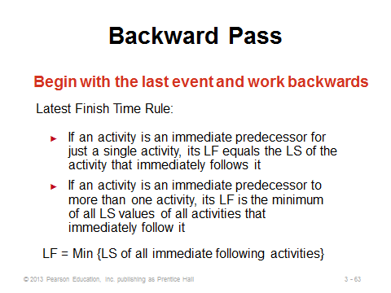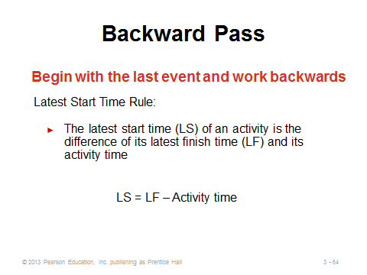
3-62 3-63 3-64

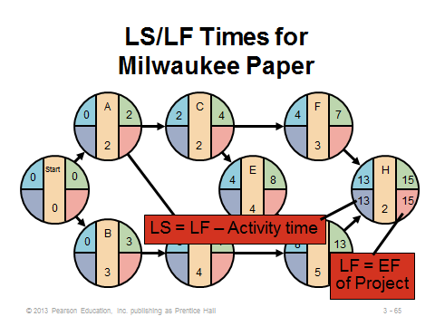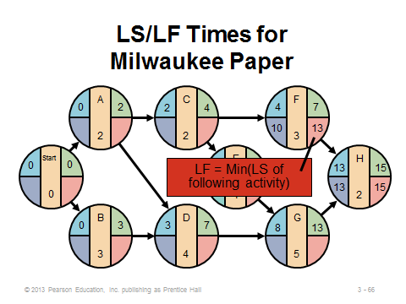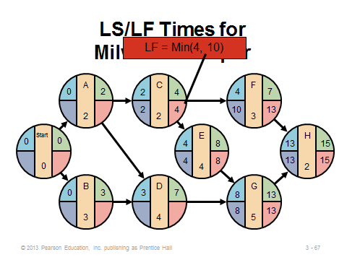
3-65 3-66 3-67

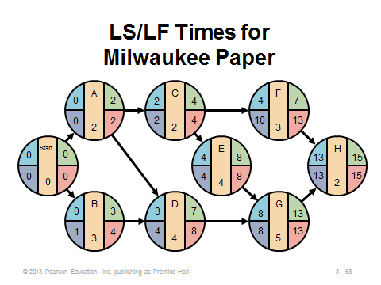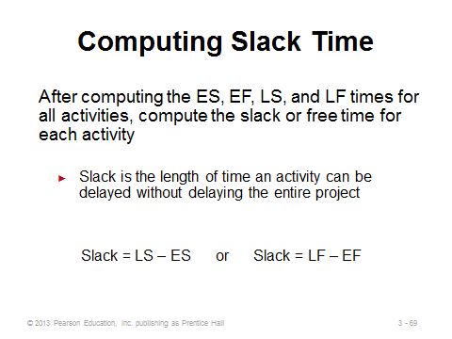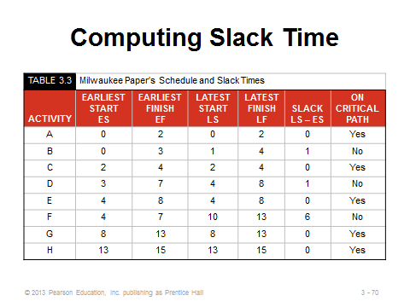
3-68 3-69 3-70
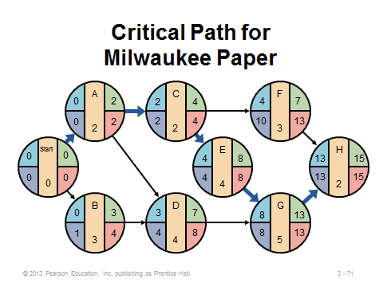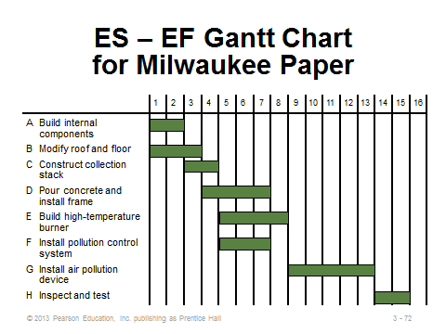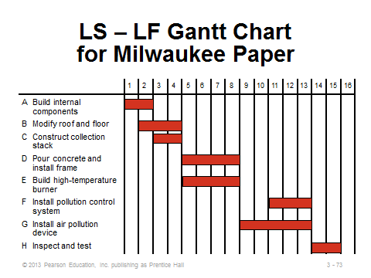
3-71 3-72 3-73

VARIABILITY IN ACTIVITY TIMES (3-74 through 3-88)
Slides 74-75: PERT introduces the common occurrence of activity time uncertainty, which may be particularly applicable for a new project incorporating new activities or personnel. The manager is asked to provide best-case, worst-case, and most likely time estimates for each activity.
Slides 76-77: We often assume that the PERT time estimates follow a beta probability distribution, as pictured in Slide 77 (Figure 3.11). Using the three time estimates, Slide 76 presents the calculations for the expected time and the variance of times. Note that the expected time will not equal the most likely time if the optimistic and pessimistic times are not equidistant from the most likely time. Slide 77 reminds us that the optimistic and pessimistic times should be chosen such that there should only be about a 1% chance of the activity actually taking shorter than or longer than those two times, respectively.
Slide 78: This slide (Example 8) applies PERT to the ongoing Milwaukee Paper example, computing an expected time and variance for each activity. Notice when the expected times are different from the most likely times and when they are the same. Also notice that the size of the variance is directly related to the spread between the optimistic and pessimistic times and has nothing to do with the most likely time.
Slides 79-80: Slide 79 presents the formula for the variance of the entire project. By assuming that the activities are independent, this value is simply the sum of the individual activities on the critical path. (In reality, the independence assumption may well not apply, and, importantly, ignoring the variance of noncritical activities may underestimate the true project variance.) Slide 80 (Example 9) computes the project variance for the ongoing Milwaukee Paper example.
Slides 81-82: The assumptions identified in Slide 81 can be used to help answer questions regarding the probability of finishing the project on time. For example, the probability distribution for project completion times for the ongoing Milwaukee Paper example is drawn in Slide 82 (Figure 3.12).
Slides 83-85: These slides (Example 10) show how to determine the probability of completing the ongoing Milwaukee Paper example by the 16-week deadline. The Standard Normal Distribution Table (Appendix I) converts the computed Z-value into the desired probability.
Slide 86: The probability calculation can be applied in reverse to determine the due date necessary to provide a given probability of completing the project on time. This slide from Example 11 in the text illustrates that idea for a 99% probability of completing the ongoing Milwaukee Paper example. From the Normal Table, the Z-value needs to be 2.33. With that value, the due date needs to be set no earlier than expected completion time + (Z × σ_{p}) = 15 + (2.33 × 1.76) = 19.1 weeks.
Slide 87: This slide reminds us that, especially when noncritical activities have a small slack, the variability of noncritical activities should be considered as well. It may be useful to compute the variability in completion times of noncritical paths (which is done in the same way as the variability computation for the critical path).
Slide 88: This slide summarizes the major results from the ongoing Milwaukee Paper example up to this point in the presentation.
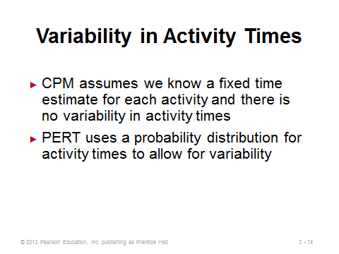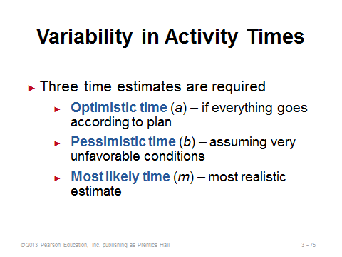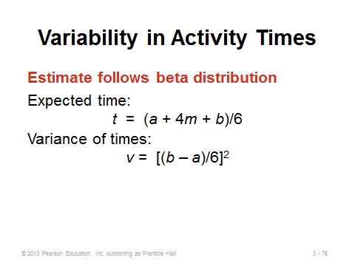
3-74 3-75 3-76
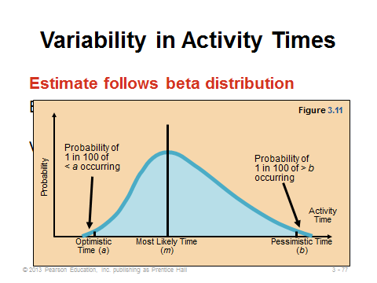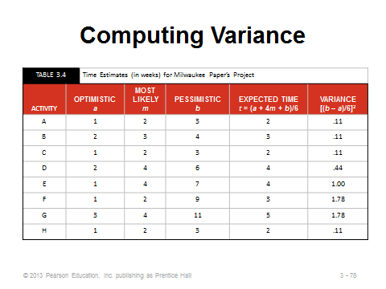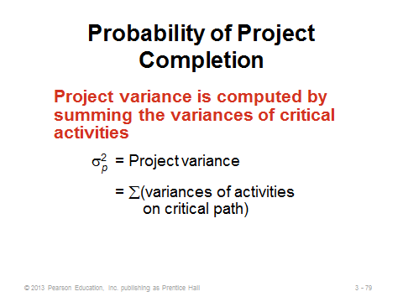
3-77 3-78 3-79
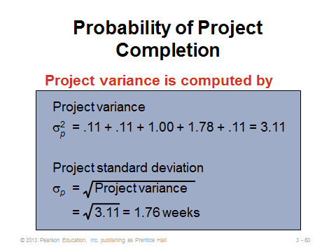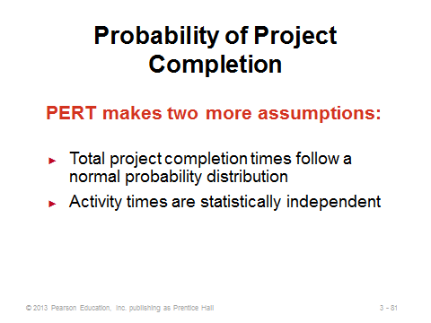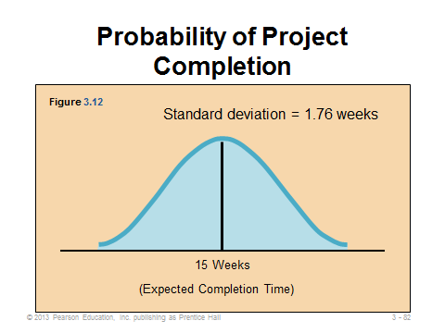
3-80 3-81 3-82
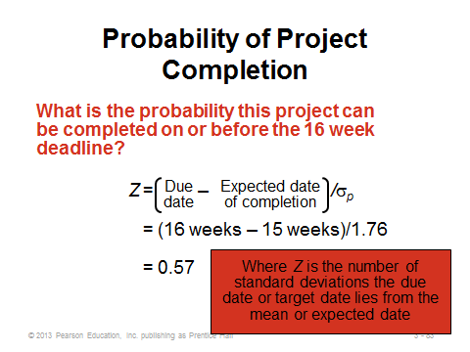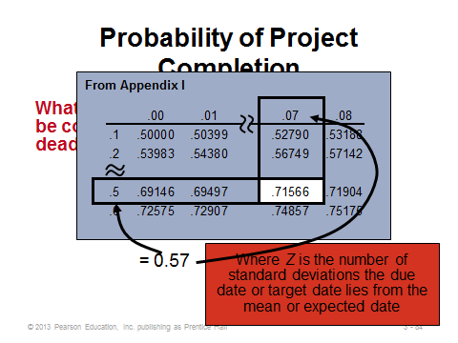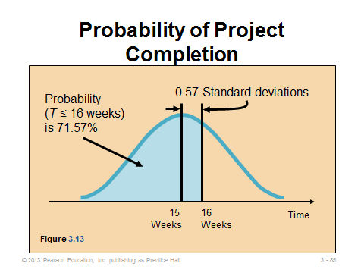
3-83 3-84 3-85

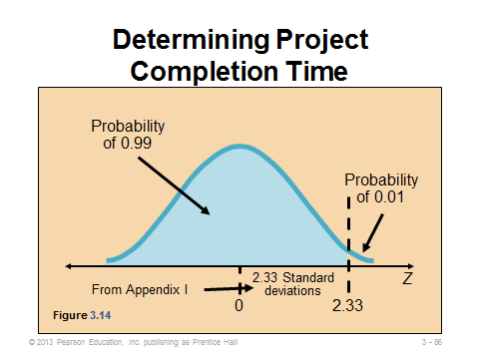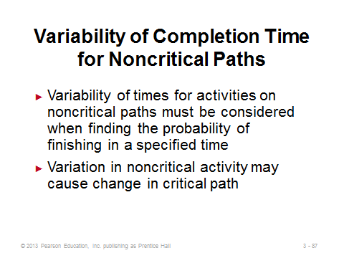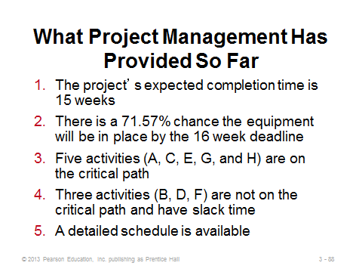
3-86 3-87 3-88

COST-TIME TRADE-OFFS AND PROJECT CRASHING (3-89 through 3-96)
Slide 89: Crashing involves finding ways to shorten project activity times to speed up the overall project completion time. Why is this important? Construction projects, in particular, often carry huge penalties for each day late (see the $10,000 penalty per day late in the Southwestern University: (A) case at the end of the chapter).
Slide 90: Managers are usually interested in speeding up a project at the least additional cost. Hence, when choosing which activities to crash and by how much, they need to consider the factors identified on this slide.
Slides 91-93: These slides describe the steps to take to crash a project. It should be noted that a new path may become critical during the solution algorithm. If so, it needs to be taken into consideration in future steps.
Slides 94-96: These slides (Example 12) show how to crash the ongoing Milwaukee Paper example by two weeks. Slide 94 presents the data. Slide 95 shows how to compute the crash time for Activity B. Slide 96 presents the original network for reference. In the example, Activity A should be crashed first at a cost of $750. This creates a second critical path: Start-B-D-G-H. The second activity to be crashed by a week should be Activity G at a cost of $1500. Even though its crash cost per period is larger than that of the smallest eligible activities on each of the two critical paths, Activity G is chosen because it lies on both paths; thus, both path times are reduced by one week when Activity G is reduced by one week.
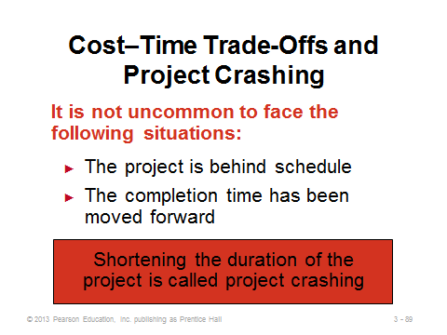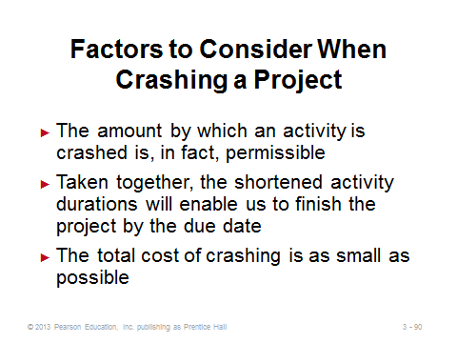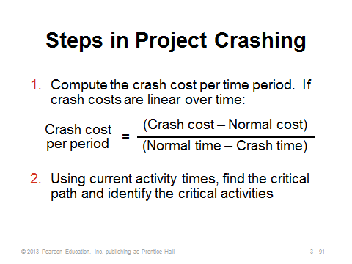
3-89 3-90 3-91
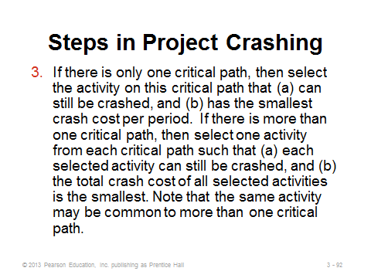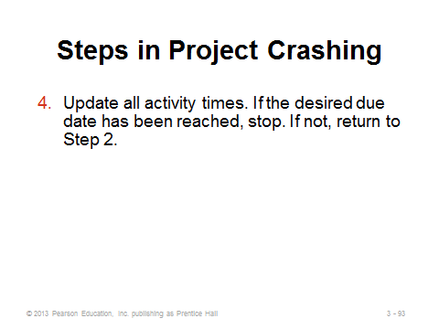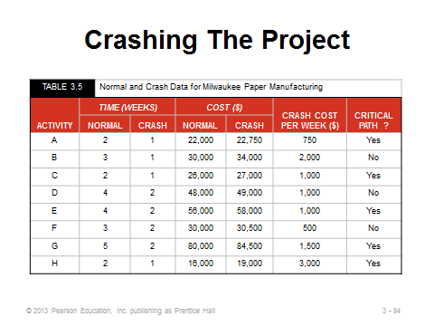
3-92 3-93 3-94
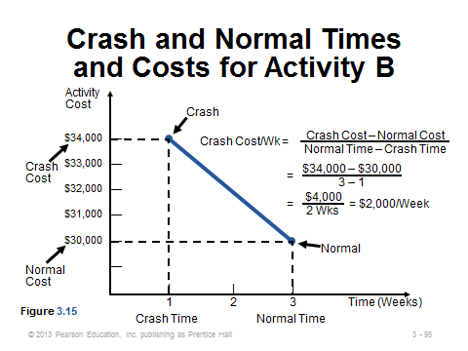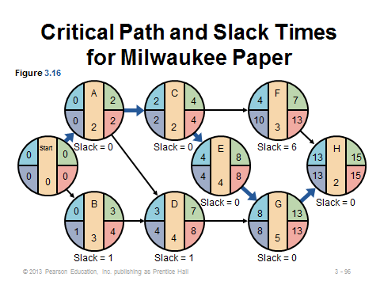
3-95 3-96

A CRITIQUE OF PERT AND CPM (3-97 through 3-99)
Slides 97-99: Slides 97 and 98 identify advantages of PERT/CPM, while Slide 99 provides important limitations. Clearly for projects involving hundreds or thousands of activities, it can be difficult to accurately identify the activities, their characteristics, and their precedence relationships.
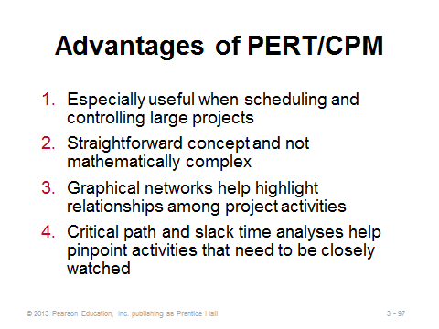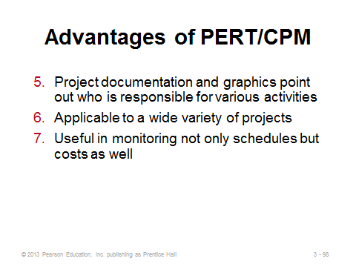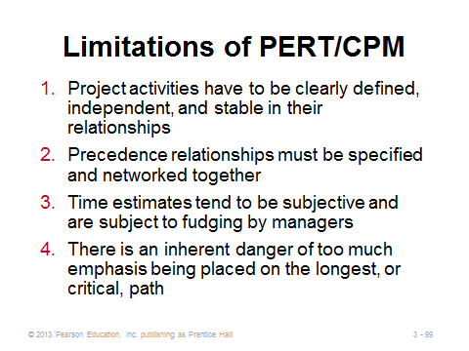
3-97 3-98 3-99

USING MICROSOFT PROJECT TO MANAGE PROJECTS (3-100 through 3-102)
Slides 100-102: These slides analyze the ongoing Milwaukee Paper example using Microsoft Project. Slide 100 (Program 3.1) shows a Gantt chart. Slide 101 (Program 3.2) shows the schedule as a project network, with the critical path identified in red. Clicking on an individual activity displays its details. Slide 102 shows the monitoring capabilities of the software. After about six weeks, three activities (A, B, and C) have been completed but three others (D, E, and F) are behind schedule.
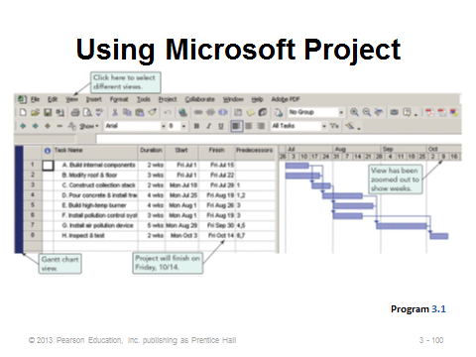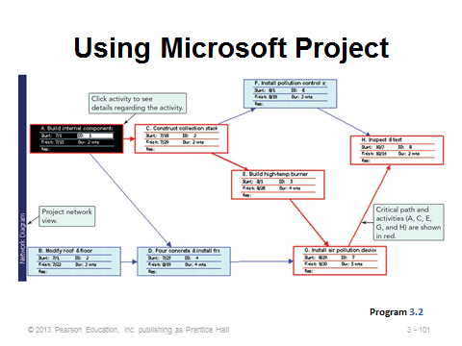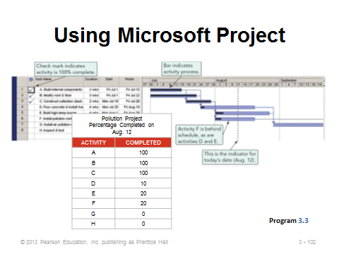
3-100 3-101 3-102

Additional Case Studies

Internet Case Study (www.pearsonhighered.com/heizer)

- Shale Oil Company: This oil refinery must shut down for maintenance of a major piece of equipment.

Harvard Case Studies (http://harvardbusinessonline.hbsp.harvard.edu)

- IBM Technology Group (#600010, © 2003)
- Merger Integration at Bank of America: The TrustWeb Project (#610054, © 2010)
- Teradyne Corp.: The Jaguar Project (#606042, © 2006)

Ivey Case Studies (https://www.iveycases.com)

- Project Management Analysis in the Internet Forecasting Industry (#9B12E006, © 2012)
- Toronto Sun and Caribana (#9B10D002, © 2010)
- Waterloo Regional Police Services: Reassessing the CIMS Project (#9B07E010, © 2007)

Internet Resources

E-Business Solutions for project management | www.eprojectcentral.com
PERT Chart EXPERT is an add-on product for Microsoft Project that adds extensive PERT charting | www.criticaltools.com
Project Management Institute, Inc. | www.pmi.org
Project Management Software | www.project-management-software.org
Project workspace for the construction industry | www.buzzsaw.com
Project time collection | www.journeyx.com

