Chapter 2
Operations Strategy in a Global Environment

Background

Of all the chapters in the book, this one has the most references to global operations. Depending on the instructor’s preferences, he or she could delve further into global issues and, for example, present some operations practices prevalent in different countries of the world. For the strategy sections of the chapter, it is important to emphasize that these are decisions that firms make that use operations to earn and keep business (as opposed to, say, an advertising campaign). Picking a strategy may seem trite to some students, but it important to emphasize that all 10 OM decisions will be geared toward the designated strategy.

Outsourcing is a growing trend in business with many success stories and many failures. It can be an emotional subject for some, so instructors need to be sensitive to potential student concerns and opinions about the subject. At the same time, the existence of strong opinions within the classroom can produce some lively class discussions. Instructors should try to present a balanced view of outsourcing, including the advantage, the risks and disadvantages, and the potential ethical dilemmas.

Jay and Barry’s OM Blog

1. OM in the News: Comparing Operations Strategies at Delta and Southwest
Southwest and Delta airlines have different OM strategies. A major part of Southwest’s approach to achieving low-cost competitive advantage is its standardized fleet of Boeing 737′s. In a bid to trim its highest operating cost, aviation fuel, Delta became the first airline to buy an oil refinery, and it also has focused on an asset most airlines avoid: older planes.

http://heizerrenderom.wordpress.com/2012/11/23/om-in-the-news-comparing-operations-strategies-at-delta-and-southwest/

2. OM in the News: Small Manufacturers Giving Up On “Made in China”
Although manufacturing in China can cost one-third of what it does in American factories, small companies are bringing production back to the U.S.

http://heizerrenderom.wordpress.com/2012/06/26/om-in-the-news-small-manufacturers-giving-up-on-made-in-china/
3. OM in the News: In the Race Between China and Mexico, Mexico Tries to Edge Ahead
China’s rising wages are providing Mexico an opportunity to wrestle back some of the business that chased cheap labor across the Pacific a decade ago.

http://heizerrenderom.wordpress.com/2012/09/18/om-in-the-news-in-the-race-between-china-and-mexico-mexico-tries-to-edge-ahead/

4. OM in the News: Walmart and the Bangladesh Factory Fire
After a garment factory fire in Bangladesh killed 112 workers, Walmart announced that the factory was no longer authorized to make clothes for the retailer. Furthermore, well aware of the reputational risks of sweatshop sourcing, Walmart is trying hard to monitor working conditions among its suppliers.

http://heizerrenderom.wordpress.com/2012/12/06/om-in-the-news-walmart-and-the-bangladesh-factory-fire/

Presentation Slides

INTRODUCTION (2-1 through 2-8)
Slides 6-8: These Boeing slides (Global Company Profile) can be presented to emphasize the truly global nature of the company’s supply network—as a precursor to the discussion about global issues.
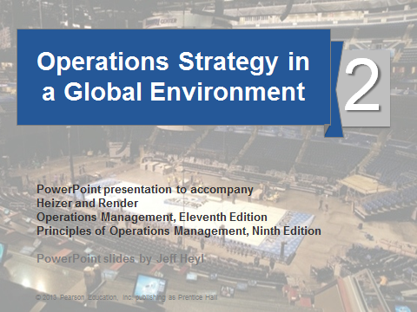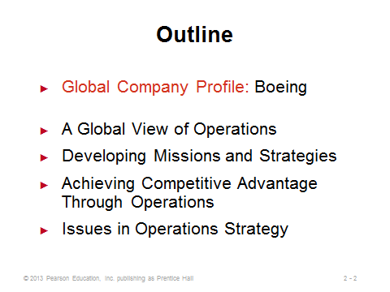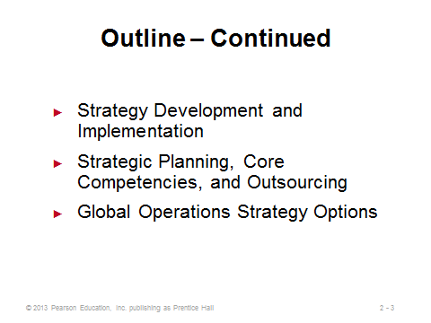
2-1 2-2 2-3
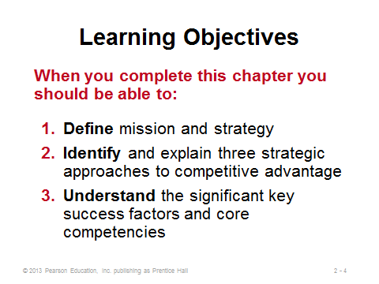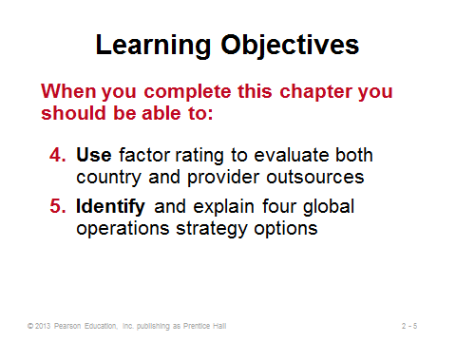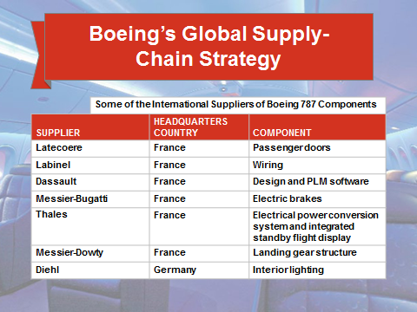
2-4 2-5 2-6
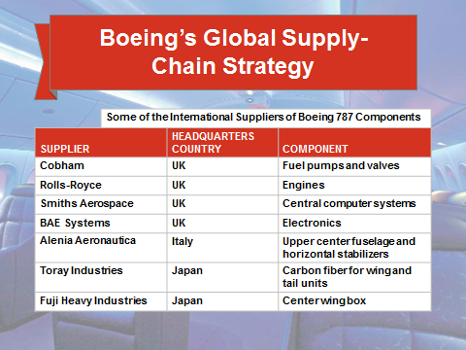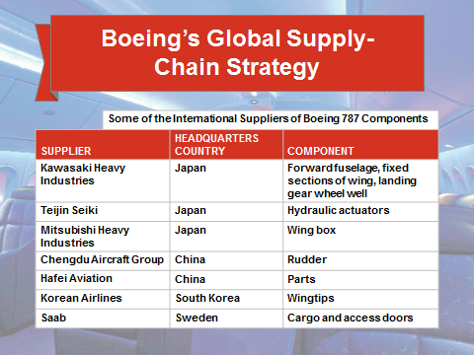
2-7 2-8

A GLOBAL VIEW OF OPERATIONS AND SUPPLY CHAINS (2-9 through 2-24)
Slides 9-10: These slides present five examples of companies that are hastily extending their operations globally with innovative strategies.
Slide 11: This slide (Figure 2.1) shows the steady growth of world trade over time.
Slides 12-18: The “Reasons to Globalize” slide (Slide 12) seems particularly important to cover in this chapter, and it is followed by specific discussion on each of the six reasons in Slides 13-18. Slide 13: Low labor cost is often, but not always, the primary draw as firms sometimes locate to areas containing particular expertise in whatever they are producing. Slide 14: A very common reason to globalize is to reduce costs, especially labor costs or tariff costs. The numbers can be hard to ignore: for example, saving $10 per hour per worker with 40-hour workweeks (52 weeks per year) and 1000 workers represents a savings in excess of $20 million annually. The agreements and organizations identified in Slide 14 represent ways in which firms can receive preferential tariff treatment. Slide 15: Not all great ideas come from one place—internationalization provides access to great ideas from around the world. Plus, locating overseas can provide better and quicker service to customers located in those countries. Slide 16: International firms inevitably learn about opportunities for new products and services; also, they may be able to sell maturing products longer in less developed countries. Slide 17: Firms can benefit by teaming up with a foreign partner to learn from each other and develop products and processes based on the unique knowledge of both firms. Slide 18: Great employees are attracted to firms that offer more worldwide employment opportunities, as well as better insulation from unemployment.
Slides 19-20: These slides are useful for discussing global location decisions. Slide 24 emphasizes that managers must become aware of cultural differences, and they should adjust their expectations and management styles accordingly. Slide 25 identifies some of the many factors that may need to be considered in global location decisions.
Slides 21-24: These slides represent a nice exercise in perhaps dispelling pre-conceived notions about parent companies and home countries of certain products. Student participation can be solicited here.
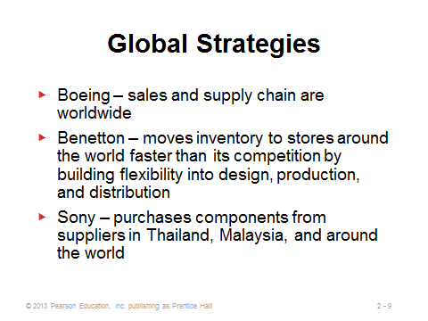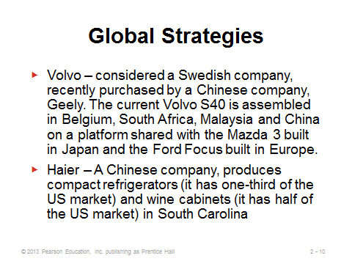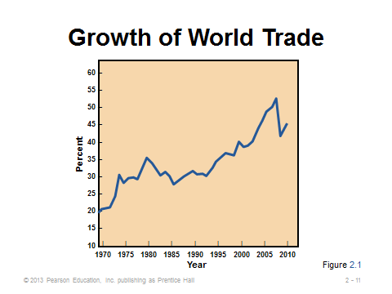
2-9 2-10 2-11
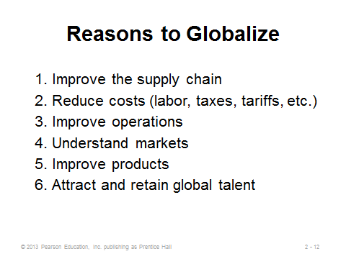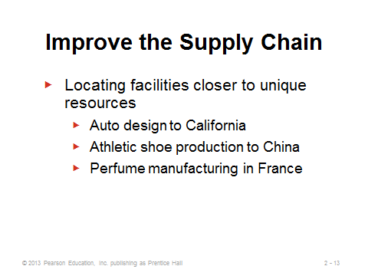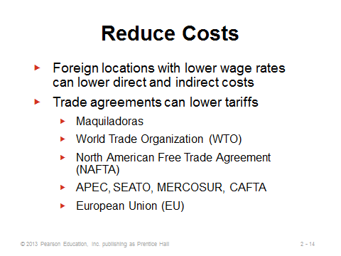
2-12 2-13 2-14
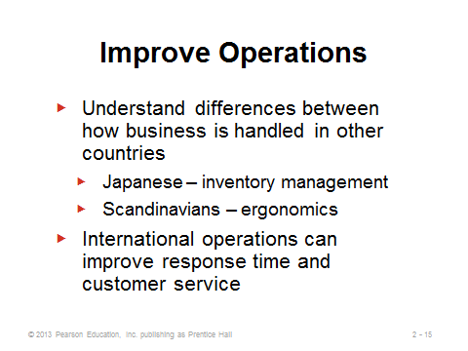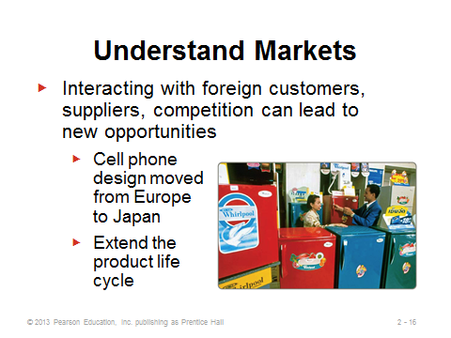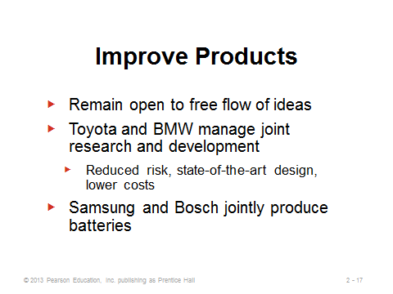
2-15 2-16 2-17
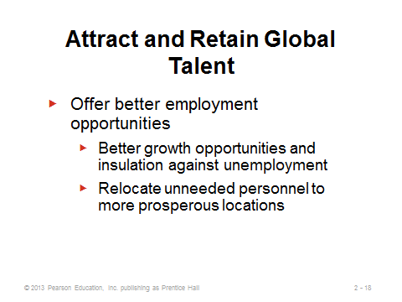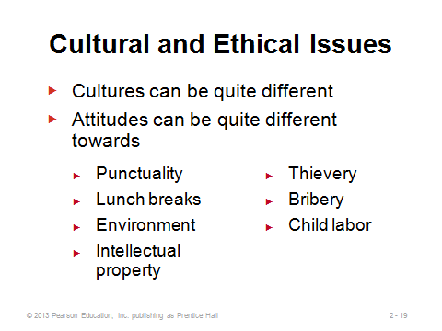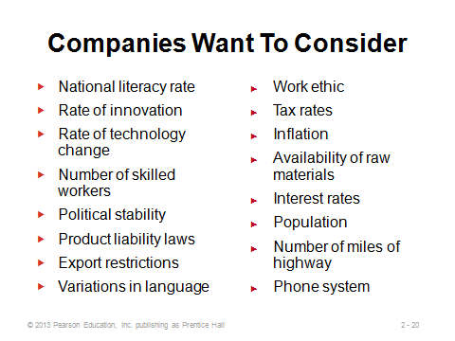
2-18 2-19 2-20
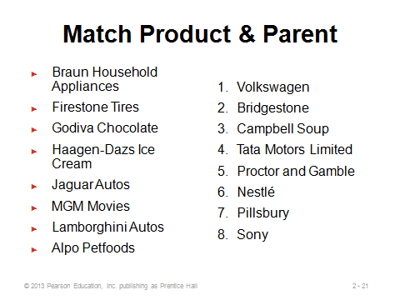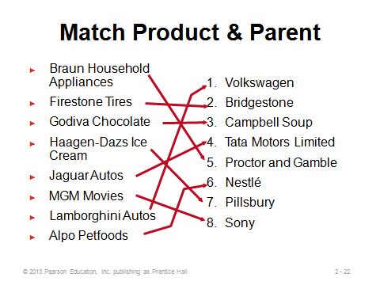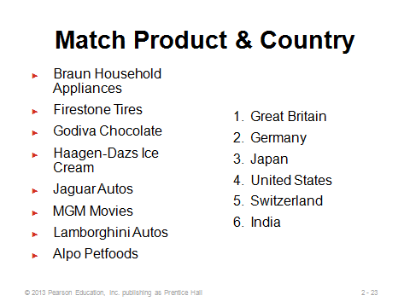
2-21 2-22 2-23
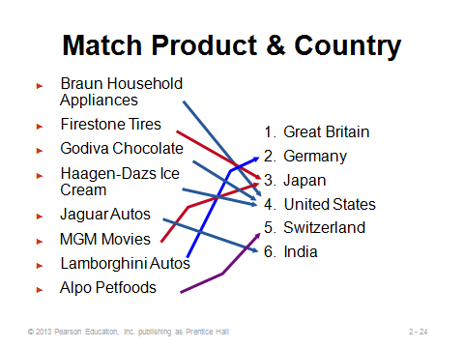
2-24

DEVELOPING MISSIONS AND STRATEGIES (2-25 through 2-36)
Slides 25-26: An organization’s mission is its purpose—what it will contribute to society. Its strategy is more specific—it represents an action plan to achieve the mission.
Slides 27-29: These slides (Figure 2.2) present examples of three corporate mission statements.
Slide 30: This slide suggests that several more considerations than profit maximization play a role in shaping a firm’s mission.
Slide 31: Functional areas have their own missions and strategies, which usually are based on higher-level missions and strategies in the organization.
Slides 32-35: These slides (Figure 2.3) present sample missions for a company, the operations function, and major OM departments.
Slide 36: A SWOT analysis can help managers identify strengths, weaknesses, opportunities, and threats to shape their strategies.

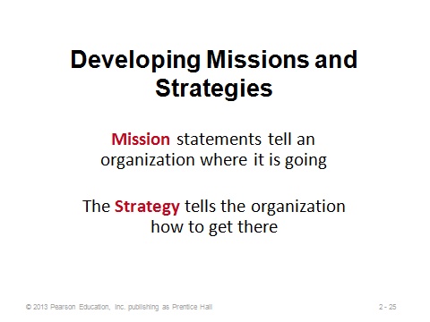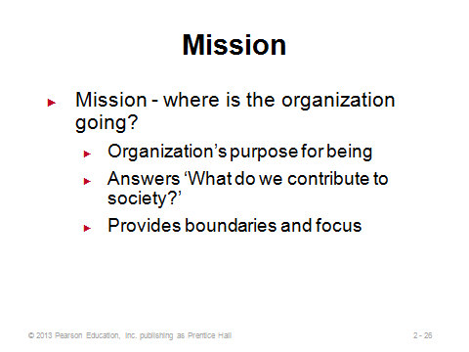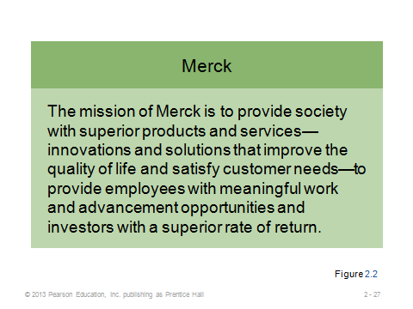
2-25 2-26 2-27

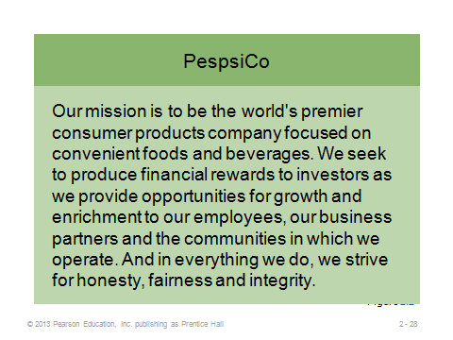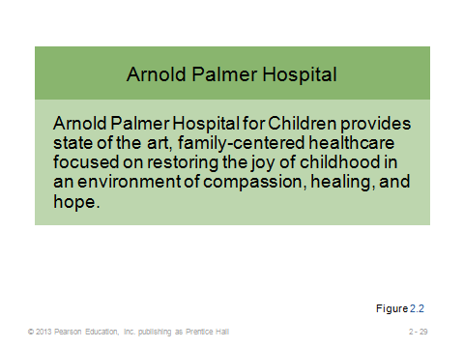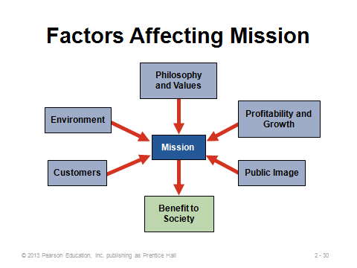
2-28 2-29 2-30
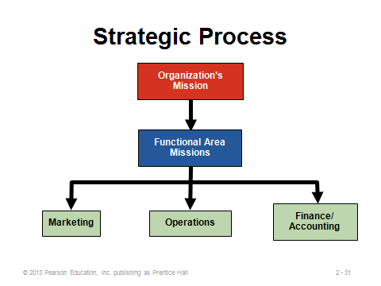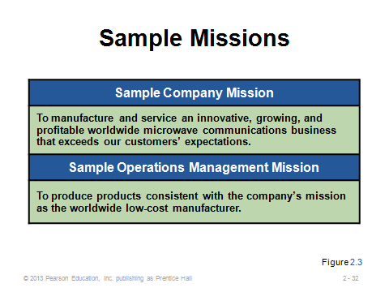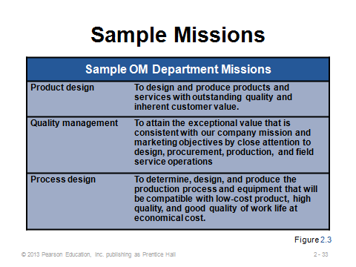
2-31 2-32 2-33
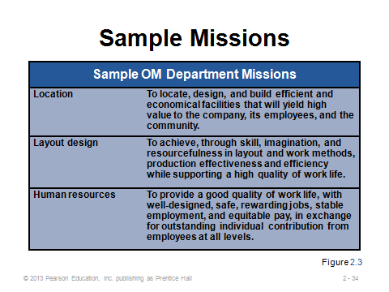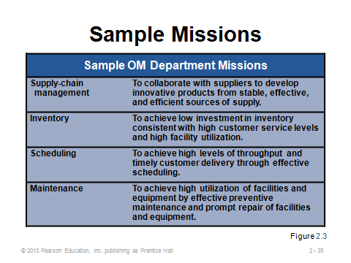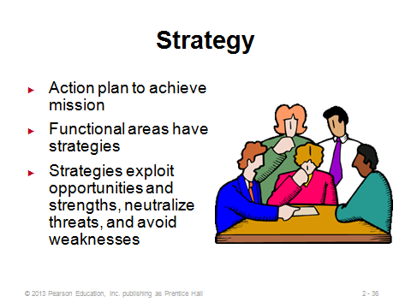
2-34 2-35 2-36

ACHIEVING COMPETITIVE ADVANTAGE THROUGH OPERATIONS (2-42 through 2-46)
Slides 37-41: The competitive strategies slides (37-41) are particularly important because an organization’s chosen strategy very much shapes how it approaches the 10 OM decisions. The three major strategies are differentiation, cost leadership, and response. While it may be possible to compete on all three at once, most firms focus on one of these major strategies. Slides 38-40 provide some specific examples of firms implementing these strategies. Slide 41 (Figure 2.4) provides some additional examples, and it emphasizes that firms can achieve competitive advantage via their operations function, by applying the 10 OM decisions to implement one or more of the competitive strategies.
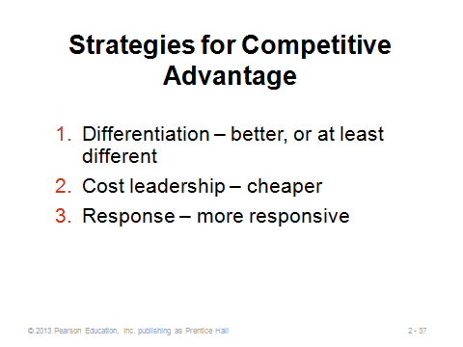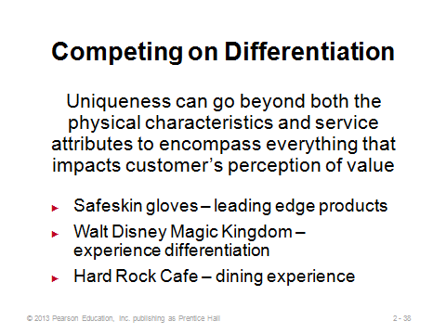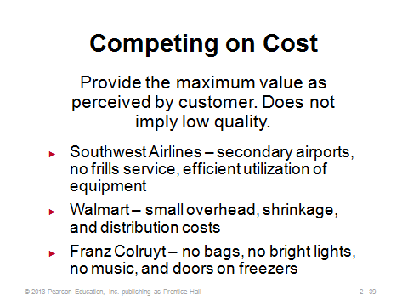
2-37 2-38 2-39
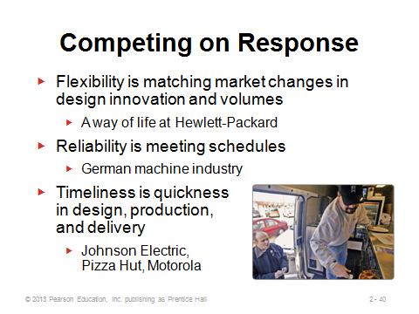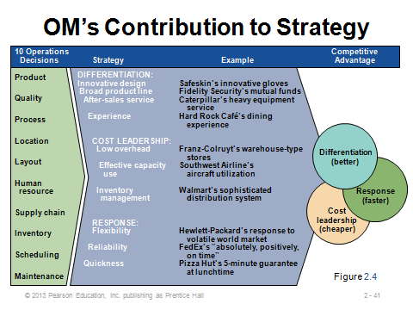
2-40 2-41

ISSUES IN OPERATIONS STRATEGY (2-42 through 2-44)
Slide 42: This slide identifies some alternative perspectives that may be helpful prior to establishing and attempting to implement a strategy. A resources view is a method that managers use to evaluate the resources at their disposal and manage or alter them to achieve competitive advantage. Value-chain analysis is a way to identify those elements in the production/service chain that uniquely add value. Porter’s five forces model is a method of analyzing the five forces in the competitive environment: immediate rivals, potential entrants, customers, suppliers, and substitute products. Because the firm operates in a system with many external factors, constant scanning of the environment is required. Finally, strategies need to be dynamic to deal with constant internal and external change.
Slides 43-44: These slides (from Figure 2.5) are valuable, especially to emphasize that the point in the product life cycle helps to determine the areas of emphasis for operations management.
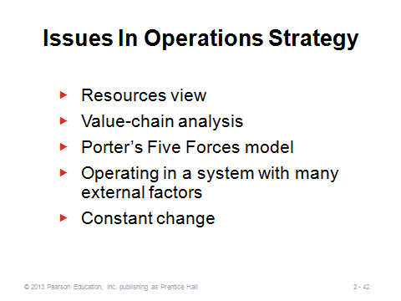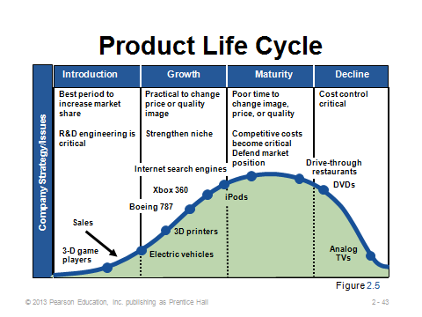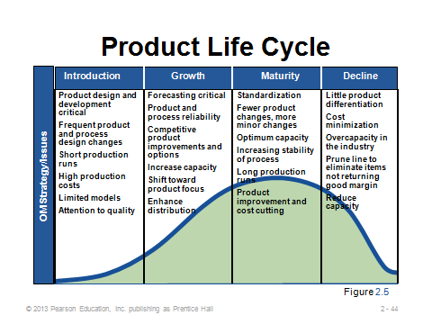
2-42 2-43 2-44

STRATEGY DEVELOPMENT AND IMPLEMENTATION (2-45 through 2-55)
Slide 45: A SWOT analysis is a formal review of the internal strengths and weaknesses and the external opportunities and threats. It represents an excellent model for evaluating a strategy.
Slide 46: This slide (Figure 2.6) illustrates the strategy development process, in which SWOT analysis plays a key role.
Slide 47: Key success factors are those activities that are necessary for a firm to achieve its goals. Once identified, the next step is to group the necessary activities into an organizational structure. That structure then needs to be staffed with personnel who will get the job done right. The operations function is most likely to be successful when the operations strategy is integrated with other functional areas of the firm, marketing, finance, HR, IT, etc.
Slide 48: The 10 OM decisions typically include the key success factors. This slide (Figure 2.7) identifies potential key success factors for marketing, finance, and operations. The 10 OM decisions provide an excellent initial checklist for determining key success factors and identifying core competencies within the operations function.
Slides 49-55: These slides present Figure 2.8 from the text in an eye-appealing, dynamic manner. An activity map is a graphical link of competitive advantage, key success factors, and supporting activities. This figure presents an example activity mapping of Southwest Airline’s low-cost competitive advantage.
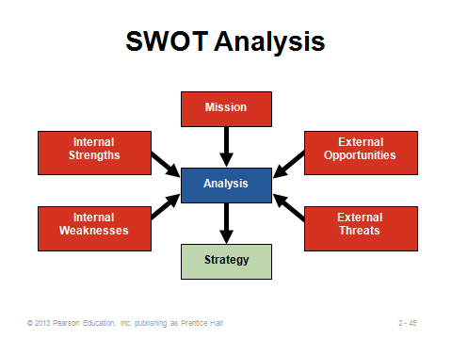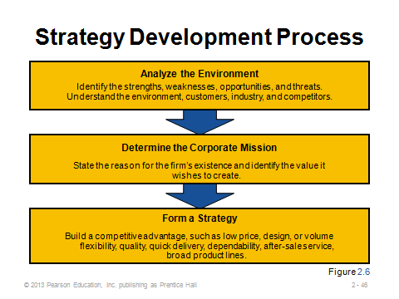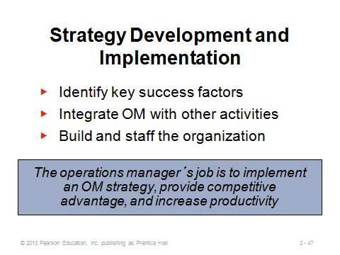
2-45 2-46 2-47
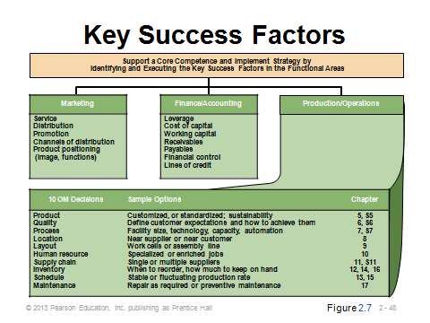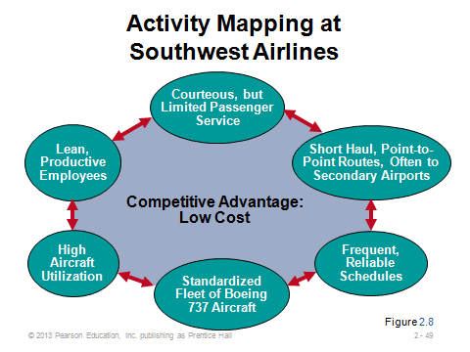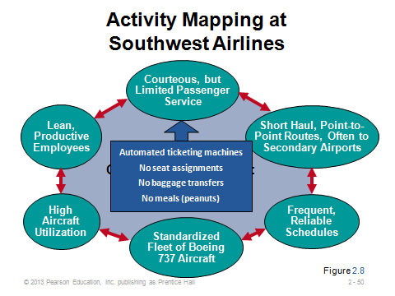
2-48 2-49 2-50
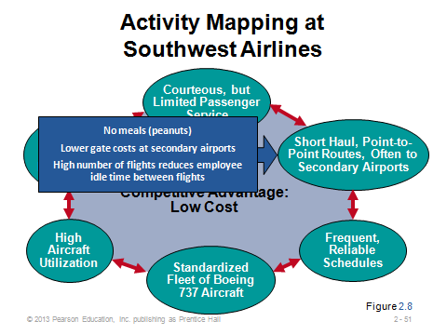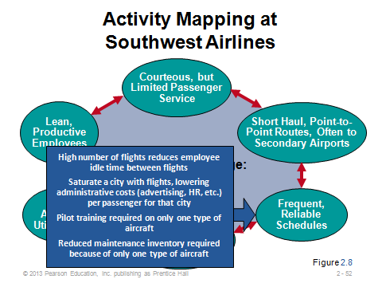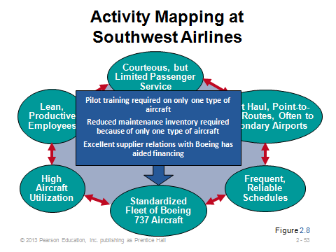
2-51 2-52 2-53

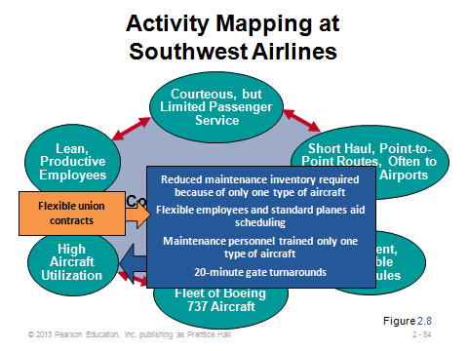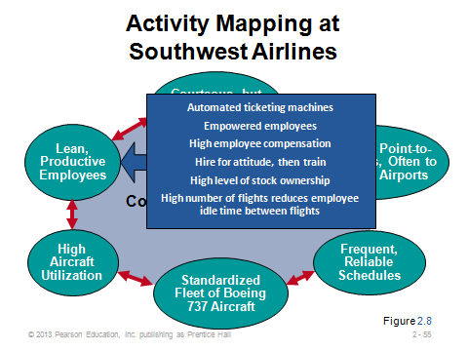
2-54 2-55

STRATEGIC PLANNING, CORE COMPETENCIES, AND OUTSOURCING (2-56 through 2-63)
Slides 56-57: From Table 2.1 in the text, notice how the 10 OM decisions are altered to build two distinct strategies within the same industry.
Slides 58-60: These slides introduce the concept of outsourcing, which transfers certain activities to specialty providers, allowing firms to focus on their core competencies. We often assume that outsourcing always implies that jobs are sent to other countries, but that is not always the case. Processes are often outsourced to domestic suppliers, as occurs when firms use 3rd-party logistics providers (see Chapter 11). The concept of outsourcing is not new, but Slide 58 shows why the use of outsourcing has been increasing in recent years. Slide 59 describes how the outsourcing of manufacturing represents an extension of the long-standing practice of subcontracting. When performed on a continuing basis, this becomes contract manufacturing. In addition, these days numerous non-core internal service functions, such as payroll and legal, are being outsourced to specialists. Slide 60 describes the theory of comparative advantage from economics, which provides the impetus behind international outsourcing.
Slide 61: This slide (Table 2.2) identifies potential advantages and disadvantages of outsourcing. Risks can be significant; roughly half of all outsourcing agreements fail due to inadequate planning and analysis. The final disadvantage identified on the slide refers to the phenomenon that many of the risks that firms run by outsourcing may not show up in profit statements until sometime in the future, encouraging short-run thinking fast-track managers to produce short-run profit increases that they can attribute to their outsourcing decisions.
Slides 62-63: The factor-rating method can be applied to outsourcing provider selection. Different factors are assigned difference importance weights, so a weighted average must be computed. Slide 63 is based on Example 1 from the book. In other real applications, managers can add factors and assign different weights as they deem fit. To keep things simple, all factors should move in the same direction, that is, either low scores are good for all factors or high scores are good for all factors.
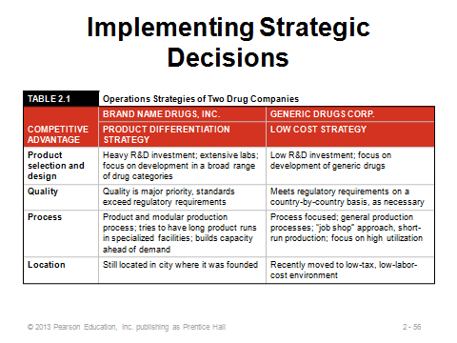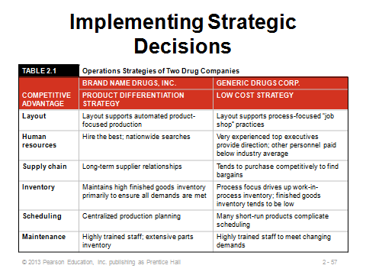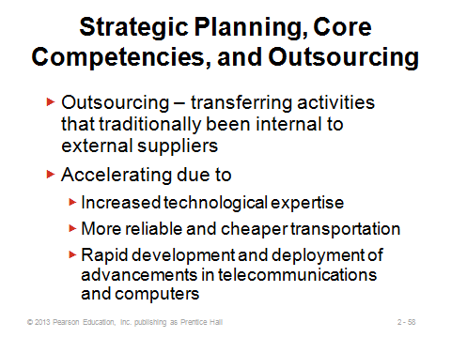
2-56 2-57 2-58
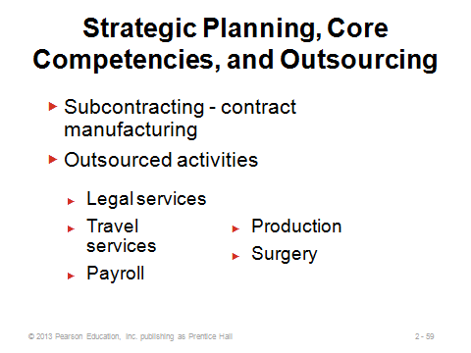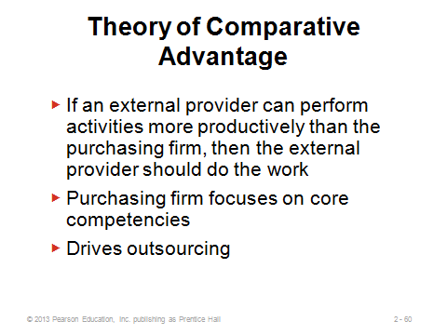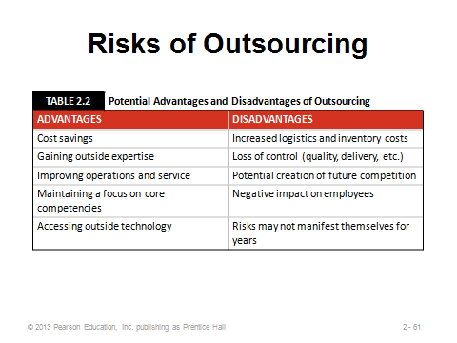
2-59 2-60 2-61
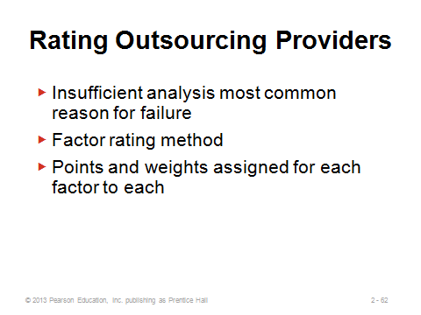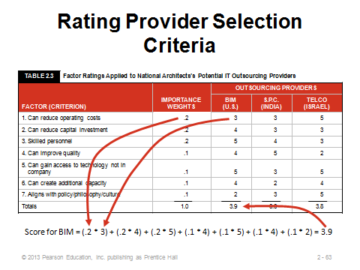
2-62 2-63

GLOBAL OPERATIONS STRATEGY OPTIONS (2-64 through 2-72)
Slides 64-71: These slides present Figure 2.9 from the text in an eye-appealing, dynamic manner. The figure places the four international operations strategies on a graph with local responsiveness on the x-axis and cost reduction on the y-axis. A transnational strategy has the potential to pursue all three operations strategies (differentiation, low cost, and response). Such firms can be thought of as “world companies,” whose country identity is not as important as its interdependent network of worldwide operations.
Slide 72: This slide is an interesting way to end the chapter discussion by presenting a ranking of the most corrupt countries.
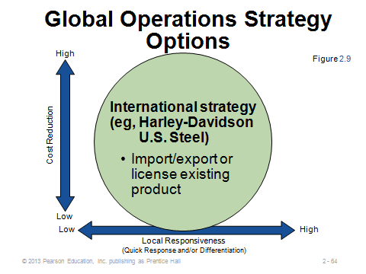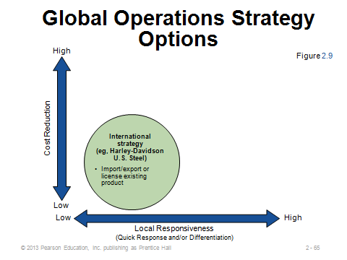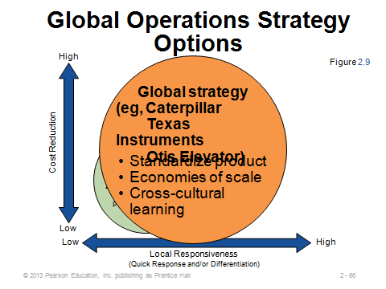
2-64 2-65 2-66
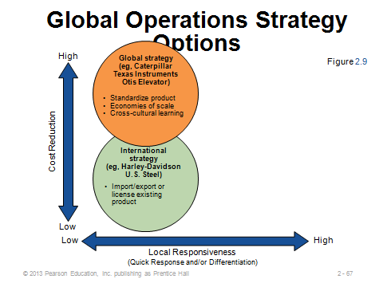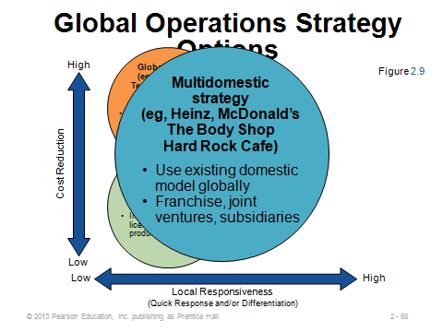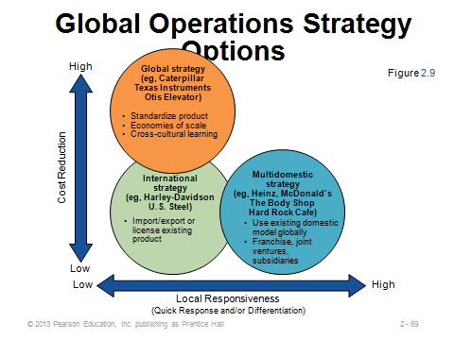
2-67 2-68 2-69
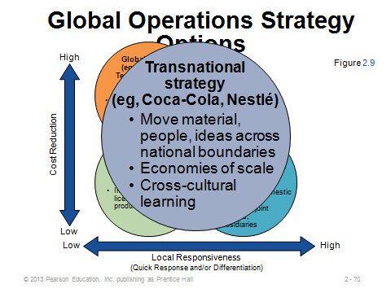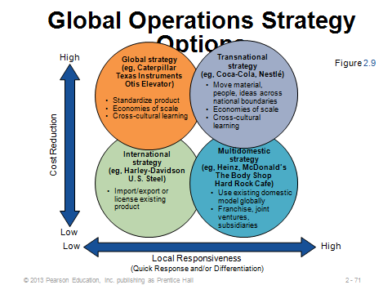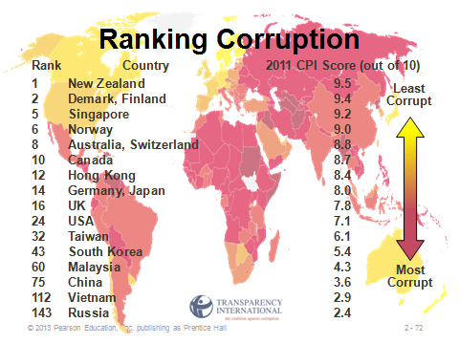
2-70 2-71 2-72

Additional Assignment Ideas

- Ask students to prepare for class by visiting several company web sites and, for each company, locating the company mission and printing a copy of the mission to bring to class. The students should also be asked to, if possible, determine the strategy used by the company to achieve its published mission.

- Look at the web sites for two different companies and determine how they operate in the global business environment. Students should try to address the following questions:

- How is a global strategy in evidence from their web site?
- What sort of global operations strategy do they seem to be adopting; international, multidomestic, global, or transnational?
- Does their facility location reflect their global strategy?
- How much of their business is done globally?
- How does their work force reflect their global strategy?

3. A number of opportunities and trends regarding outsourcing can be found at The Outsourcing Institute (www.outsourcing.com). Report on two outsourcing or offshoring opportunities/trends.

Additional Case Studies

Internet Case Study (www.pearsonhighered.com/heizer)

- Outsourcing to Tata: The Indian outsourcing firm is hired by New Mexico.

Harvard Case Studies (http://harvardbusinessonline.hbsp.harvard.edu)

- American Outsourcing (#705037, © 2007)
- Daewoo Shipbuilding and Marine Engineering (#609018, © 2009)
- Jamcracker: Pivot Path (#604052, © 2004)

Ivey Case Studies (https://www.iveycases.com)

- Managing Customer Relationships in Offshore Outsourcing: B2Bcs, and Israeli Consulting Firm (#W11081, © 2011)
- 7 Days Inn: Operations Strategy (#9B12D023, © 2012)
- Scotts Miracle-Gro: The Spreader Sourcing Decision (#9B08M078, © 2009)

Internet Resources

Center for Global Outsourcing | www.outsourceglobal.org
Council of Foreign Affairs | www.foreignaffairs.org
European Union | http://europa.eu/
International Trade Administration | www.ita.doc.gov
The Outsourcing Institute | www.outsourcing.com
Transparency International maintains a Bribe Payers Perception Index (PBI) | www.transparency.de
World Bank | www.worldbank.org
World Economic Forum | www.weforum.org
World Trade Organization | www.wto.org

