Chapter 1
Operations and Productivity

Background

Operations management has created industry giants. The Ritz-Carlton Hotel Company’s mission is to provide an outstanding customer experience through a complete focus on quality management. UPS operates trucks that run for 20 years because their drivers care. Disney has made a science of accurate forecasts and queuing theory. Darden restaurants (Red Lobster, Olive Garden, and others) view operations is their strategy for success. Frito-Lay dominates the snack market by keeping fresh snacks on the shelves with a production process that converts raw materials into a bag of chips sitting in a grocery store in as little as a day or two.

The importance of operations management can be highlighted early in the course with humorous videos or stories about “operations gone wrong.” Most people can share “disaster” stories about poor experiences that they have had dealing with companies.

It can be useful as well to spend some class time right away on the job market for operations management majors, showing starting salaries and job titles compared to other business majors. It can also be helpful to find an MBA program with a strong operations focus and display the starting salaries of those graduates (such data are available on many MBA program websites). Instructors can also share research results showing that (1) more CEOs “learn the ropes” by coming up through operations than any other functional area, and (2) Chief Operating Officer salaries tend to be approximately 10% higher than the salaries of the other “Chiefs” (CFO, CMO, and CIO).
Jay and Barry’s OM Blog

1. OM in the News: US Productivity Gains Make Manufacturing More Competitive
US manufacturing has become more competitive globally because of efficiency, flexible work standards, and increased automation. Factories have been producing more with fewer workers.

http://heizerrenderom.wordpress.com/2012/01/18/om-in-the-news-us-productivity-gains-make-manufacturing-more-competitive/

2. OM in the News: Flat US Wages and the Manufacturing Rebound
The wages for many manufacturing workers are not keeping up with inflation. This wage lag is a key factor contributing to the rebounding competitiveness of US industry.

http://heizerrenderom.wordpress.com/2012/06/04/om-in-the-news-flat-us-wages-and-the-manufacturing-rebound/

3. OM in the News: How to Recoup American Manufacturing Jobs
The US lost 34% of manufacturing jobs between 2000 and 2009, and the employment in manufacturing has risen only about 4% since. To Gene Sperling, director of the National Economic Council, the solution is to boost output.

http://heizerrenderom.wordpress.com/2012/04/18/om-in-the-news/

4. OM in the News: Fiat Threatens to Quit Italy
Fiat CEO Sergio Marchionne has recently threatened to cease manufacturing in Italy if he cannot bring down operating costs and increase productivity.

http://heizerrenderom.wordpress.com/2011/11/03/om-in-the-news-fiat-threatens-to-quit-italy/

Presentation Slides

INTRODUCTION (1-1 through 1-7)
Slide 7: This Global Company Profile from the first chapter helps to illustrate the wide variety of decisions that an operations manager must face. In the case of Hard Rock Cafe, the “product,” includes more than tasty meals—the layout, the memorabilia on display, and the service all encompass the dining package from Hard Rock that consumers now expect. The meals themselves are designed, tested, and then analyzed for the cost of ingredients, labor requirements, and customer satisfaction. Among other tasks, the operations manager must consider both the attractiveness and efficiency of restaurant layout, supplier quality and reliability, employee motivation and training, maintenance of tight schedules, and preparation of outstanding meals.
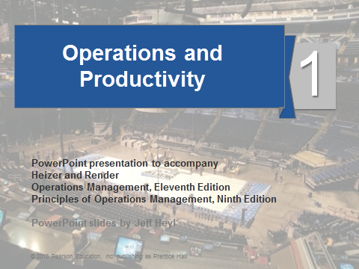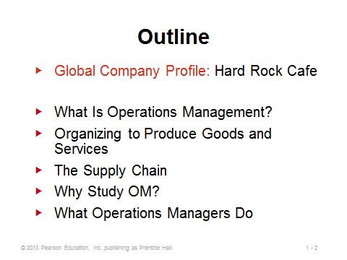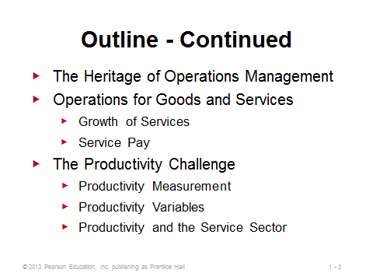
1-1 1-2 1-3
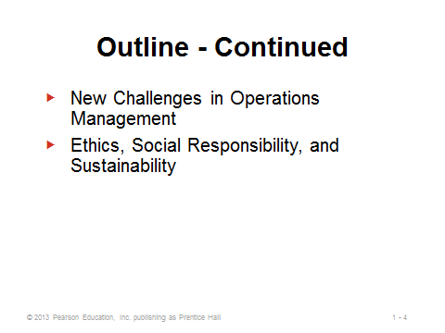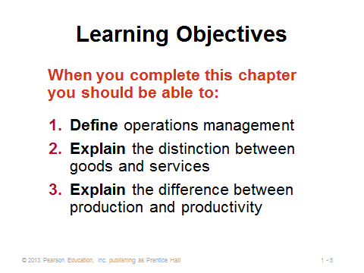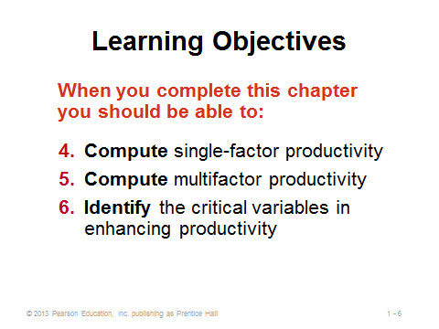
1-4 1-5 1-6
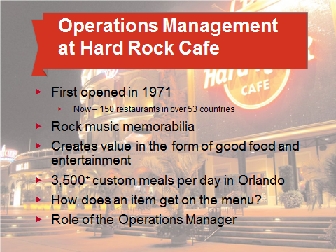
1-7

WHAT IS OPERATIONS MANAGEMENT? (1-8)
Slide 8: Starting with the Hard Rock Cafe example, it is important to stress from the very beginning of the course that operations management applies just as much to service businesses as to manufacturing businesses.
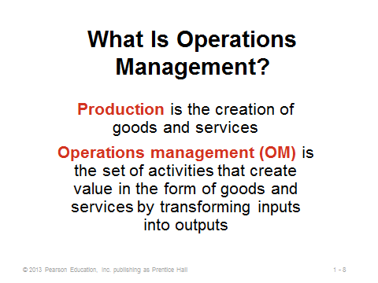
1-8

ORGANIZING TO PRODUCE GOODS AND SERVICES (1-9 through 1-12)
Slide 9: To create goods and services, all organizations must perform the three functions identified on this slide. Firms must create demand, satisfy that demand, and manage and monitor the financial flows associated with creating and satisfying that demand.
Slides 10-12: These slides (Figure 1.1) present example organization charts from three different companies. The areas in blue indicate the significant role that operations management plays in both manufacturing and service firms.
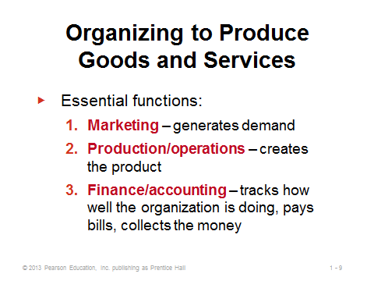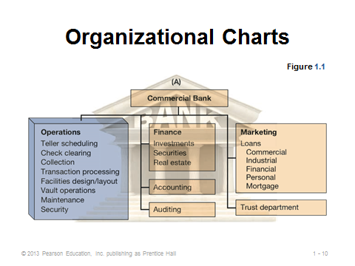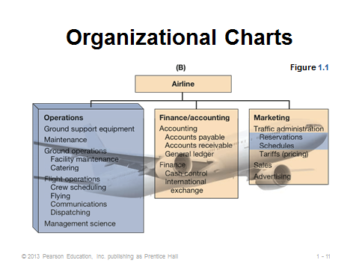
1-9 1-10 1-11
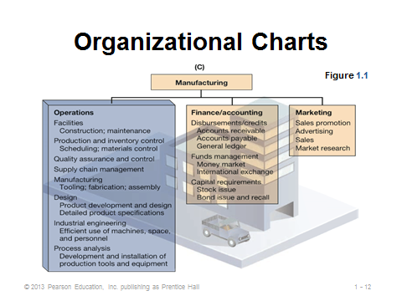
1-12

THE SUPPLY CHAIN (1-13)
Slide 8: The supply chain is described right at the beginning of the book to emphasize that competition in the 21st century is no longer between companies; it is between supply chains. Companies no longer try to do everything themselves. Rather, they outsource numerous functions and activities to specialized providers. Supply chains that have members who effectively collaborate foster an enormous competitive advantage. Chapter 11, supplement 11, and part of chapter 2 provide comprehensive coverage of this topic.
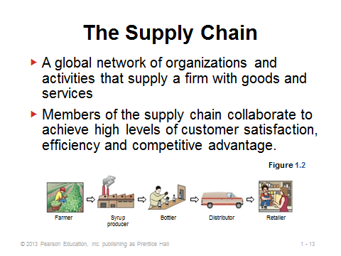
1-13

WHY STUDY OM? (1-14 through 1-15)
Slides 14-15: These slides can be used early on in the course to help “sell” the usefulness and importance of the class. In most cases, a large percentage of revenue is spent on the OM function. Slide 14 (Example 1) shows a common circumstance, that is, often the best and easiest way to meet improved contribution targets is through finding efficiencies in operations. In this particular example, the hefty requirements for the marketing and finance options might make them infeasible anyway.
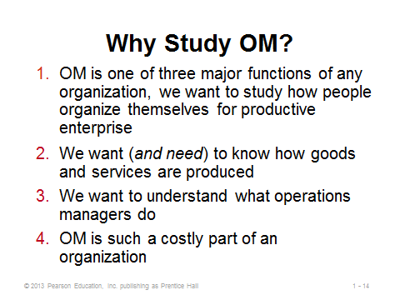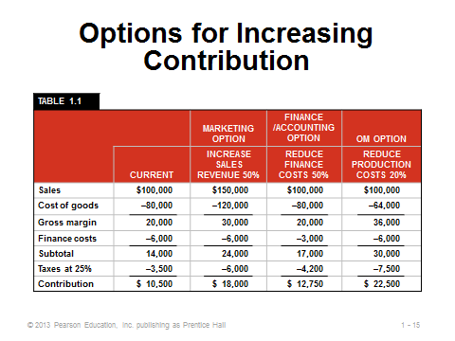
1-14 1-15

WHAT OPERATIONS MANAGERS DO (1-16 through 1-25)
Slide 16: All good managers, including operations managers, perform the basic management functions identified in this slide.
Slides 17-22: The 10 strategic OM decisions are useful to cover one-by-one, not only as a precursor to the rest of the text, but also to emphasize the wide array of responsibilities that are under an operation manager’s jurisdiction. Slide 17 maps them to the rest of the text, while Slides 18-22 provide examples for each decision of issues that the operations manager must address.
Slides 23-25: Salary information pertaining to local students (perhaps with help from the university’s career center) can be combined with Slides 23 through 25 to help sell the operations management field as a viable career option for students. A very common entry-level position for OM majors is in the purchasing area of organizations. Slide 24 (Figure 1.3) identifies several of the many types of career opportunities that exist for operations managers. The organizations identified in Slide 25 provide various certifications that may help forward students’ careers. The Six Sigma Green Belt and Black Belt certifications offered through the American Society for Quality represent relatively new and highly sought-after acknowledgements of professional expertise.
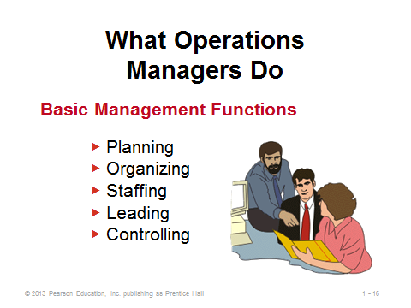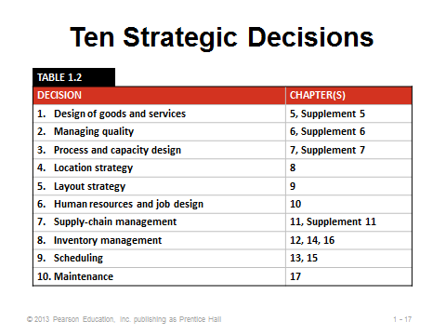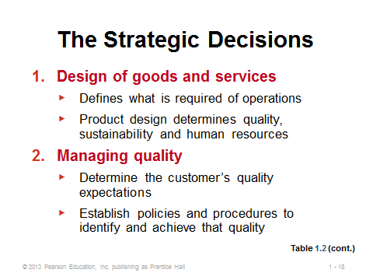
1-16 1-17 1-18
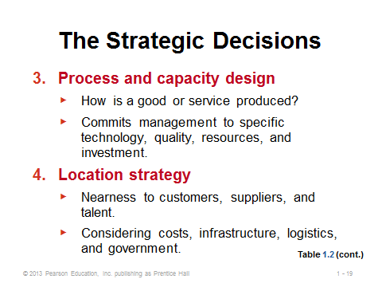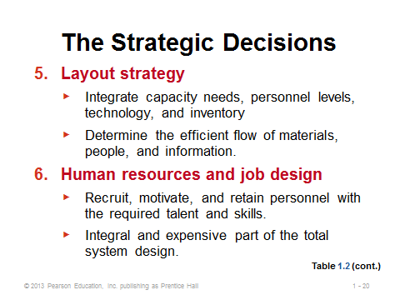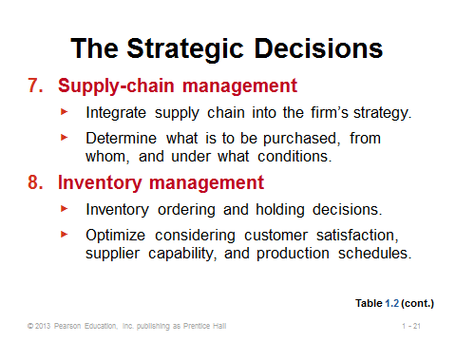
1-19 1-20 1-21
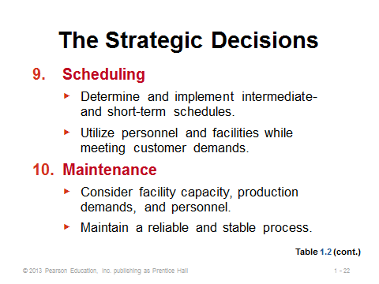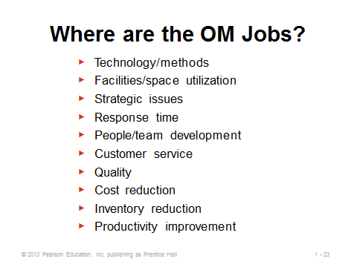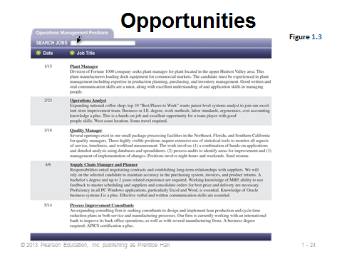
1-22 1-23 1-24
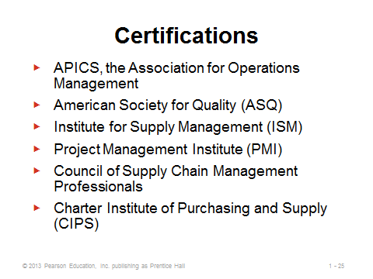
1-25

THE HERITAGE OF OPERATIONS MANAGEMENT (1-26 through 1-35)
Slide 26: This slide (Figure 1.4) presents a nice summary of the past and future of OM. Videos showing historical footage (see Other Supplementary Material below), can fit in well here.
Slides 27-34: Presenting students with a good historical context of the field is important. There is a lot of important history there that is directly tied to the economic growth of nations. Slides 27 and 28 supplement Slide 26 and provide more specific timing. Slides 29-34 provide information about some of the most important historical figures in the field.
Slide 35: Operations management continues to progress with innovations and contributions from other disciplines, particularly those identified on this slide.
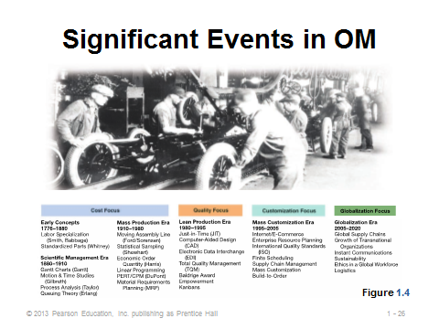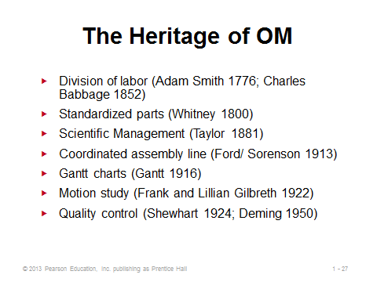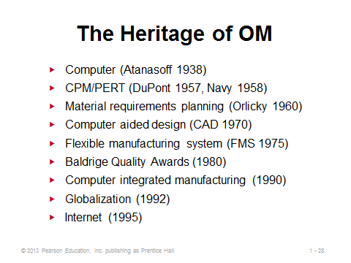
1-26 1-27 1-28
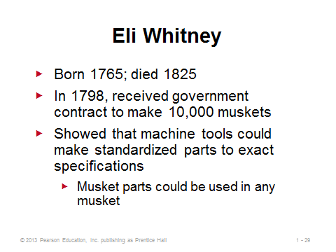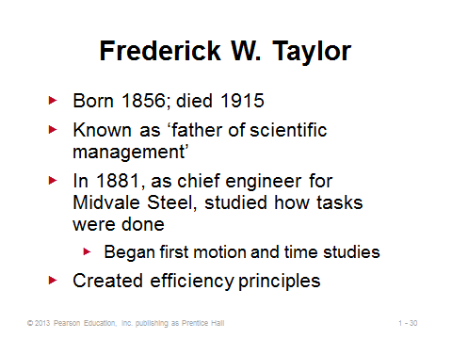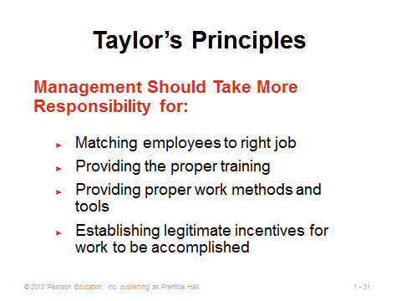
1-29 1-30 1-31
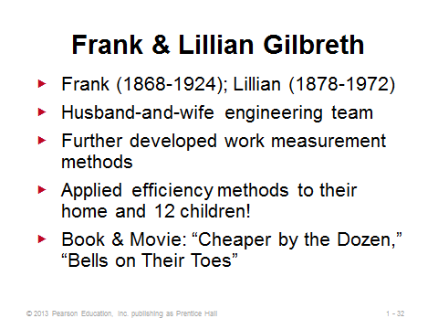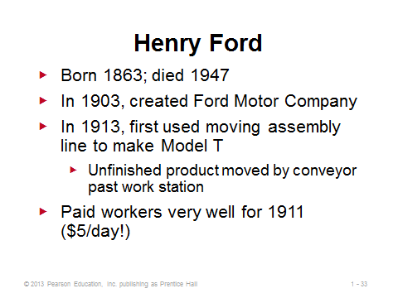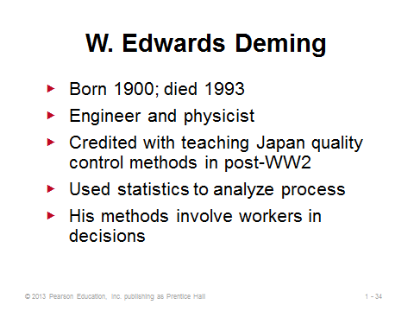
1-32 1-33 1-34
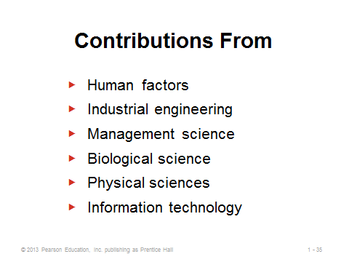
1-35

OPERATIONS FOR GOODS AND SERVICES (1-36 through 1-40)
Slide 36-37: The manufacturing-service distinction is more like a continuum, as most manufacturing companies provide some services (e.g., financing from an auto manufacturer) and most service companies provide some goods (e.g., shampoo at a hair salon). Nevertheless, the two extremes differ in important ways, which may impact how operations managers approach decision making in one case vs. another. Slide 37 identifies the major differences.
Slides 38-39: These slides illustrate the tremendous growth of services over time. Slide 38 (Figure 1.5) shows that, after peaking around 1950, the percentage of U.S. workers in manufacturing has declined steadily while service employment continues capture a larger and larger share of the jobs. The huge productivity increases in agriculture and manufacturing have allowed more of our economic resources to be devoted to services. Consequently, much of the world can now enjoy the pleasures of education, health services, entertainment, etc. Slide 39 (Table 1.4) provides examples of firms and percentages of employment in the U.S. in various sectors of the economy. More than half of the students taking this class will likely end up working for a firm in the service sector.
Slide 40: Salaries in services present a mixed bag. Some jobs, such as airline maintenance operations managers, pay very well, while others lag the national average. Not all jobs in services are low-paying, but some can be.
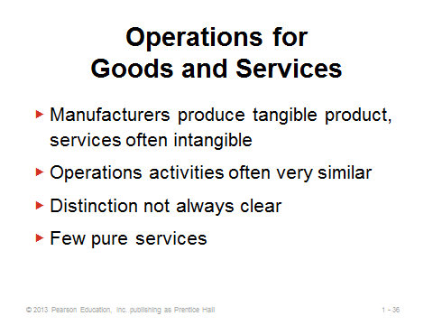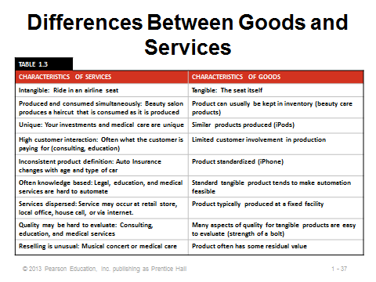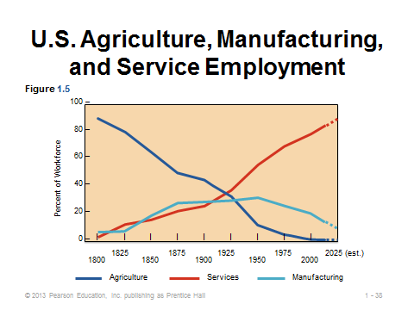
1-36 1-37 1-38
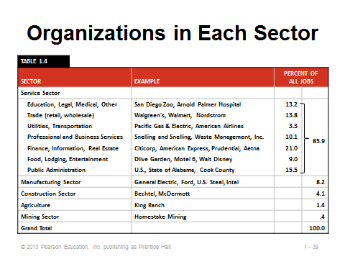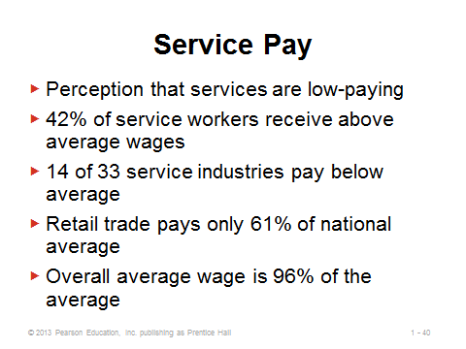
1-39 1-40

THE PRODUCTIVITY CHALLENGE (1-41 through 1-64)
Slide 41: The basic formula for productivity is simple: outputs ÷ inputs. This sometimes varies as interest focuses on a specific output or input, or a set of outputs or inputs. At the firm level, productivity improvement usually leads to greater profits. At a macro level, productivity improvement in an economy usually leads to a higher standard of living. Productivity improvement means getting more “bang for the buck:” either (1) reducing inputs while keeping output constant, or (2) increasing output while keeping inputs constant.
Slide 42: This slide (Figure 1.6) describes how productivity in the U.S. economy grows at about 2.5% per year, comprised of capital factors (0.95%), labor factors (0.25%), and management factors (1.3%). The picture also suggests that an effective feedback loop is an important component for continuous improvement.
Slides 43-44: These slides (OM in Action) describe how some relatively simple management and equipment changes improved Starbuck’s productivity significantly, which led to six-figure increases in revenue per outlet over a six-year time period.
Slides 45-47: The most common productivity formulas are presented in these slides. Slide 45 shows the basic formula. Slide 46 provides an example of a single-factor productivity measure, in this case the common measure of labor productivity. Slide 47 is a multifactor productivity measure. Note that a multifactor measure only makes sense if all of the inputs are expressed in the same units (usually a monetary unit such as dollars).
Slides 48-55: These slides illustrate Example 2 from the text, calculating both single-factor and multifactor productivity measures. Here, as in most cases, the multifactor measure makes more sense because it includes all costs connected with the increase in output. In fact, a situation that replaces workers with more expensive robots may appear to improve labor productivity but may actually be deceasing multifactor productivity (and firm profits) overall.
Slide 56: These potential measurements problems with productivity should be emphasized. If evaluating performance of a plant, a manager, a division, etc., it is important to compare “apples to apples” and to evaluate individuals on outcomes over which they have control.
Slide 57: The three factors identified in this slide are critical to achieving improved productivity. The percentages listed represent their respective historical contributions to productivity improvement.
Slide 58: As we see in this slide, sometimes training and education produce more productive workers, while in other cases, the workers’ general health along with environmental factors may determine their respective capabilities.
Slide 59: As unbelievable as it seems, a large number of U.S. high school students cannot solve very simple math problems, such as those shown in this slide (Figure 1.7). It has been suggested that perhaps up to 25% of U.S. workers lack the basic skills needed for their current job. The situation may be even worse in some other countries, particularly in some of the low-wage countries.
Slide 60: Historically, annual capital investment in the U.S. has increased at an annual rate of 1.5% after allowances for depreciation. In general, higher investment levels lead to higher productivity gains.
Slide 61: At 52%, management provides the biggest contribution towards productivity gains. Effective management is challenging, especially now that much of the labor force in postindustrial countries has migrated from manual work to work based on knowledge (knowledge societies) and requires ongoing education.
Slide 62: The items identified in this slide all contribute to the difficulty in improving productivity in the service sector.
Slides 63-64: The service firm Taco Bell (OM in Action) implemented several innovative productivity improvement measures (Slide 63), which produced impressive results (Slide 64).
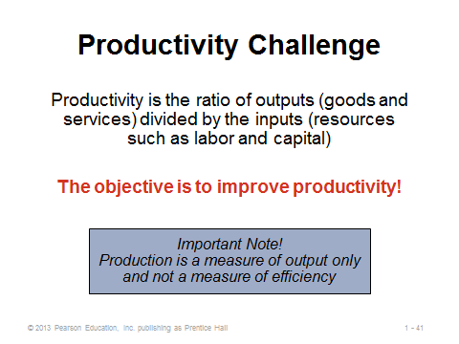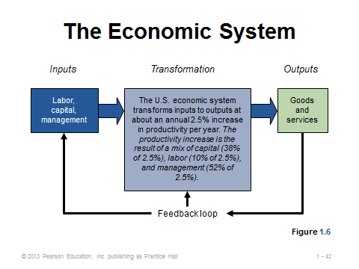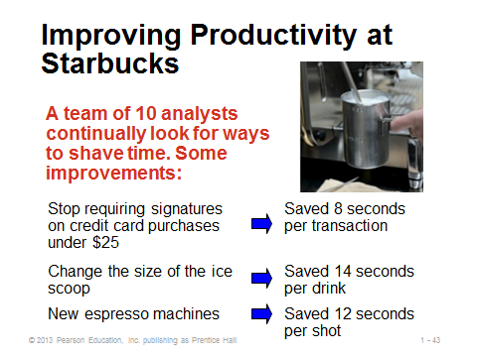
1-41 1-42 1-43
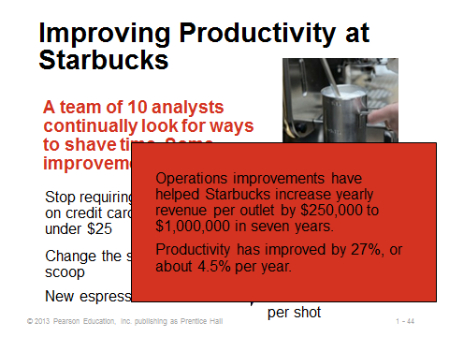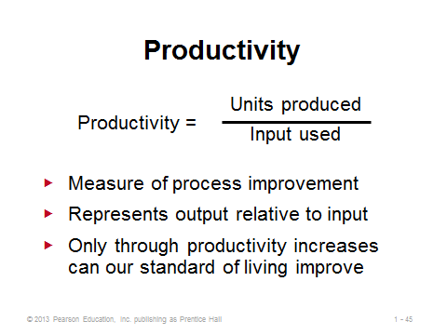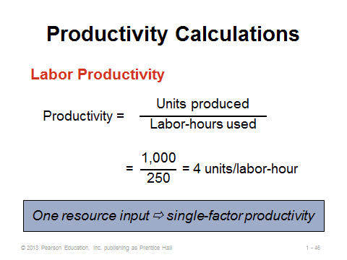
1-44 1-45 1-46
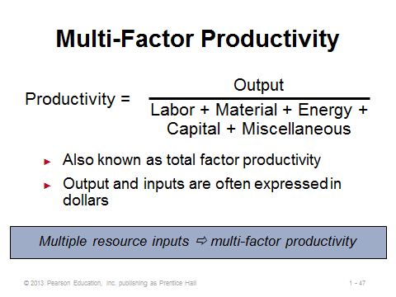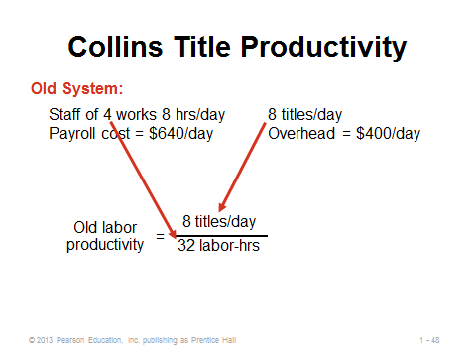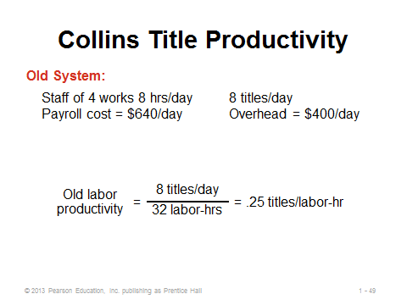
1-47 1-48 1-49
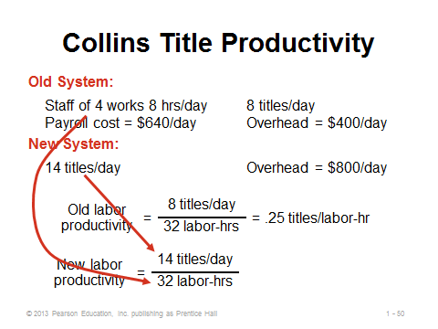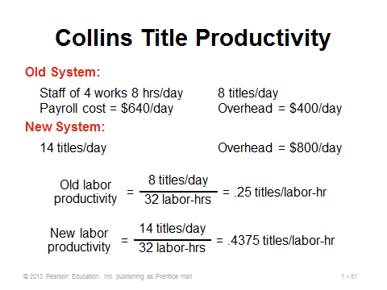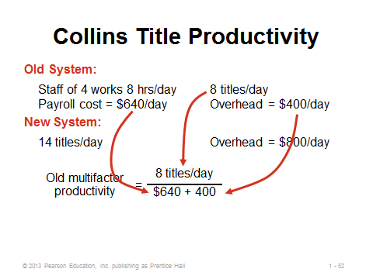
1-50 1-51 1-52
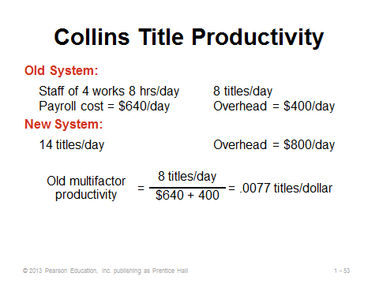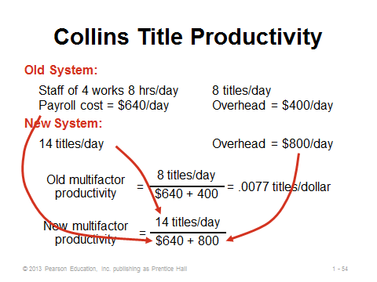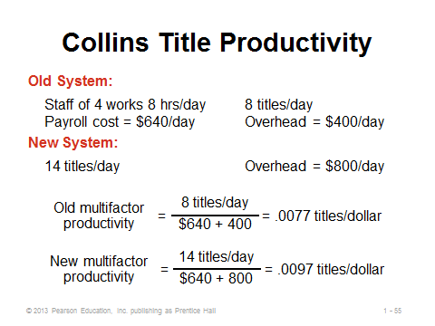
1-53 1-54 1-55
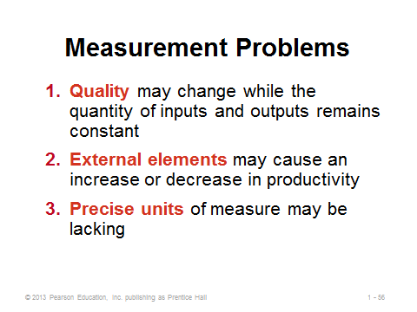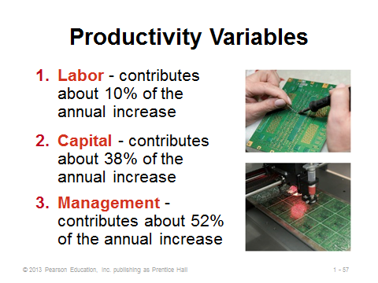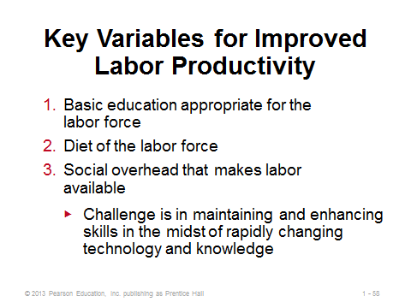
1-56 1-57 1-58
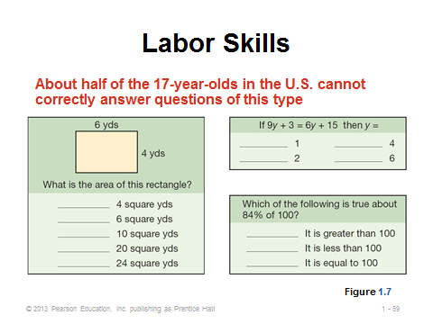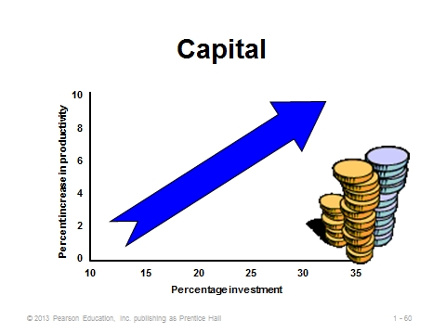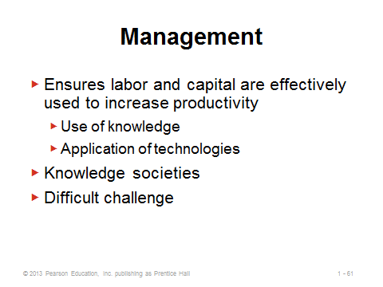
1-59 1-60 1-61
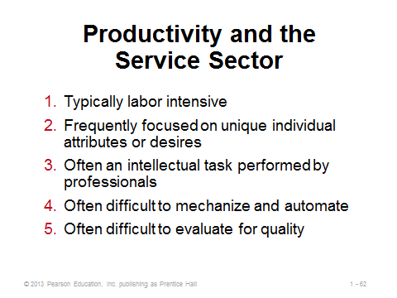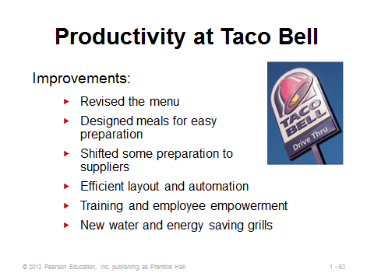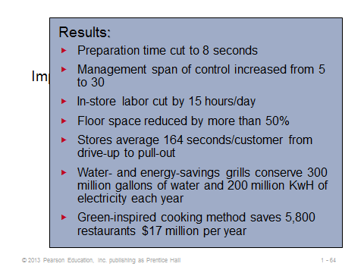
1-62 1-63 1-64

NEW CHALLENGES IN OPERATIONS MANAGEMENT (1-65)
Slide 65: Some traditional operations areas of emphasis are changing. New challenges based on these changes are identified on this slide. Each of these issues will be explored more fully later in the book.
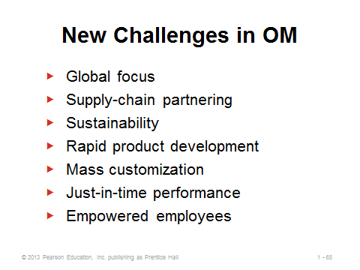
1-65

ETHICS, SOCIAL RESPONSIBILITY, AND SUSTAINABILITY (1-66)
Slide 66: Managers must address the challenges identified in the slide, along with many other challenges, in an ethical and socially responsible way while meeting demands of the marketplace.
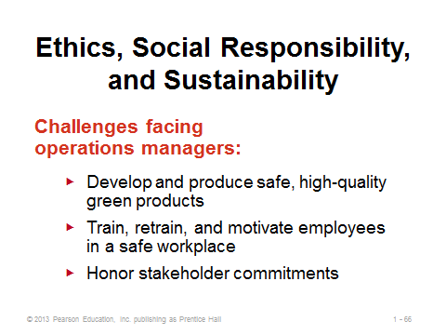
1-66
Additional Case Studies

Internet Case Study (www.pearsonhighered.com/heizer)

- Zychol Chemicals Corp.: The production manager must prepare a productivity report, which includes multi-factor analysis.

Harvard Case Study (http://harvardbusinessonline.hbsp.harvard.edu)
- Dynatrol Corp: Andover Assembly Division (#603050, © 2003)
- Wyeth Pharmaceutical: Spurring Scientific Creativity with Metrics (#607088, © 2010)
- Zara: Managing Stores for Fast Fashion (#610042, © 2010)

Ivey Case Studies (https://www.iveycases.com)

- ForeFront Manufacturing: Production Processes and Change Management in Mainland China (#9B06D020, © 2009)
- Jinjian Garment Factory: Motivating Go-slow Workers (#9B04M033, © 2009)
- Paediatric Orthopaedic Clinic at the Children’s Hospital of Western Ontario (B)
(#9B10D001, © 2010)

Internet Resources

American Productivity and Quality Center | www.apqc.org/
American Statistical Association (ASA) offers business and economics DataLinks, a searchable index of statistical data | www.econ-datalinks.org/
Economics and Statistics Administration | www.esa.doc.gov
Federal Statistics | www.fedstats.gov
National Bureau of Economic Research | www.nber.org
U.S. Bureau of Labor Statistics | stats.bls.gov
U.S. Census Bureau | www.census.gov

Other Supplementary Material

Videos
1. Modern Marvels, “The Assembly Line.”
The first part of this History Channel production shows Henry Ford and the Ford assembly line, with real historical footage. It describes the poor working conditions, as well as Ford’s response, which was to pay a very high hourly rate for the time.

2. Loose Bolts, Michael Keaton. Offers a more modern perspective on assembly lines and highlights the difficulties of making changes in existing organizations when implementing productivity improvement programs.

3. Ford Historic Model T, CarDataVideo (5:16), http://www.youtube.com/watch?v=S4KrIMZpwCY
This narrated video has a very detailed look at the first assembly lines at the original Ford auto plant, plus some driving scenes with the Model T.

