Chapter 12
Inventory Management

Background

This chapter is arguably the most important in the book. Some suggest that inventory management is the “heart and soul” of operations management. The chapter contains quite a few formulas. While none of the techniques are particularly difficult, the primary challenge for students is applying the correct technique to the problem at hand. Identifying the proper modeling environment is the key. The qualitative aspects of the lecture can be enhanced by relating some of these inventory issues to students’ personal lives. Everyone stores inventory in their homes and workplaces, so they should be able to see the connection to some of these issues. For example, driving to the price club involves a setup cost, storing winter clothes takes up much needed space, a sale on Ramon noodles may entice students to stock up, etc.

Presentation Slides
INTRODUCTION (12-1 through 12-8)
Slides 6-8: The Global Company Profile description of the Amazon.com order filling process is a nice one that includes some good detail. Note, in particular, Step 3, which represents a “pick-to-light” system. The lights direct workers to the exact bins to pick the proper items, doubling the picking speed while simultaneously eliminating almost all human errors stemming from matching products to numbers or descriptions. Throughout the system, computers, bar codes, and conveyor belts help to route products automatically to the appropriate boxes, which end up at the customers’ doorstep within about three days.
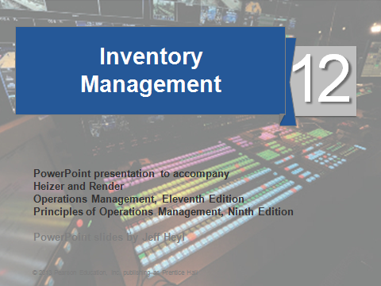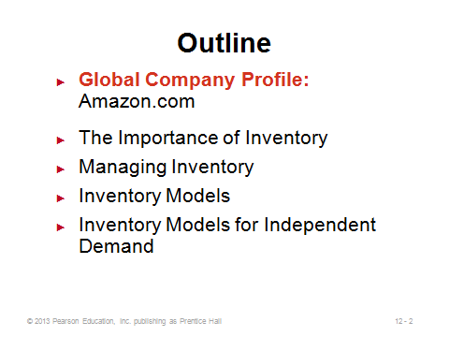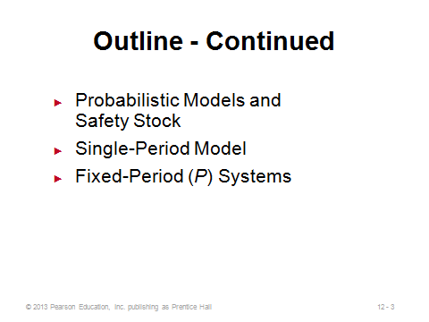
12-1 12-2 12-3
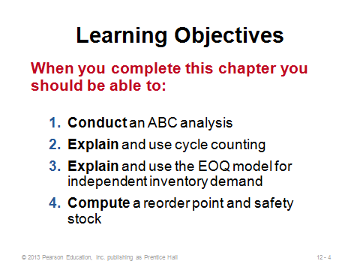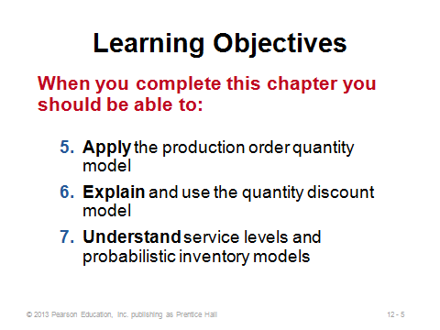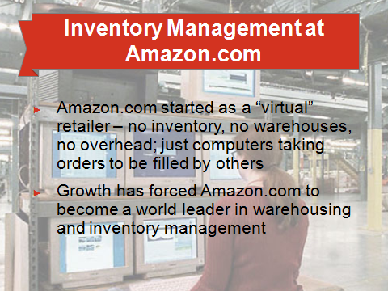
12-4 12-5 12-6
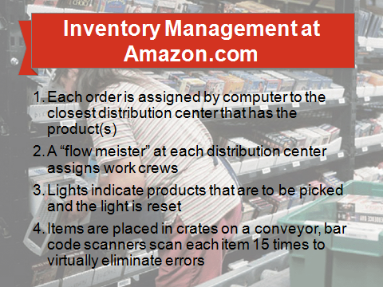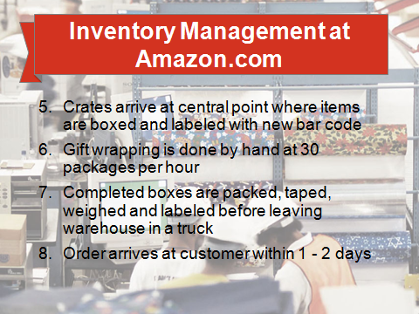
12-7 12-8

THE IMPORTANCE OF INVENTORY (12-9 through 12-13)
Slides 9-10: While the topic may not sound particularly “sexy” to students, inventory management is arguably the most important OM decision. OM researchers have written thousands of papers modeling every facet of inventory management imaginable. Companies tie up thousands or often millions of dollars in inventory, and the lost interest revenue alone on that money can represent a huge profit loss. On the other hand, companies that do not have the right goods at the right places at the right times may incur significant delays, backorder costs, or lost sales. Firms have had to go out of business due to poor inventory management.
Slide 11: These inventory functions can also be thought of as advantages of having inventory. Instructors can expand upon this list somewhat. For example, anticipatory inventory is built up during low- to medium-demand periods to get ready for an upcoming high-demand period (such as Christmas). This practice (level production policy—see Chapter 13) potentially avoids hiring and laying off workers, working extra overtime, etc. The decoupling (Function 2) allows operations to work at their own pace and permits constant production quantities. This use of buffer stock can occur between stations within a facility or between different companies in the supply chain. Finally, in addition to taking advantage of quantity discounts, firms may order or produce in large lots to exploit economies of scale in supply (spread a large setup cost over multiple items). This is also known as cycle inventory. While on Slide 11, instructors might take this opportunity to mention some of the disadvantages of having too much inventory. In addition to generating holding costs (described in detail later): (1) inventory can be difficult to control, store, and maintain, (2) handling inventory is a non-value added activity, (3) inventory reduces cash availability, which may be particularly troublesome for small firms, (4) having too much inventory runs the risk of product obsolescence or delays responsiveness to the market with new products, and (5) (as the Japanese remind us) having too much inventory may act as a bandage to help get around a problem, but in the long run this bandage may cover up the “wound” so that the firm cannot even identify the underlying problem (i.e., having no extra inventory exposes root problems in the system, which can then be corrected—creating a long-term competitive advantage).
Slide 12: This slide describes the four types of inventory. Raw material, WIP, and finished goods inventory represent what the firm will eventually sell to customers, while MRO inventory keeps the business running smoothly.
Slide 13: This is Figure 12.1 from the text, with the caption: “Most of the time that work is in-process (95% of the cycle time) is not productive time.”
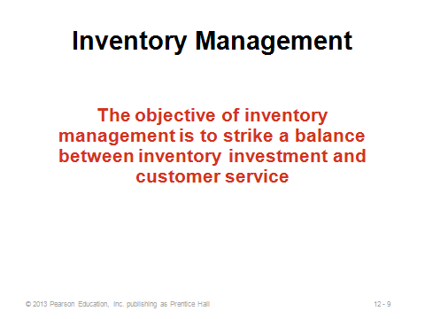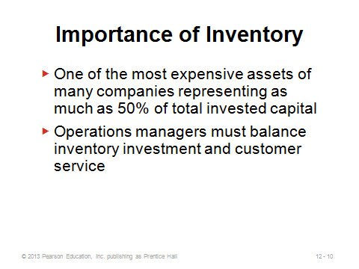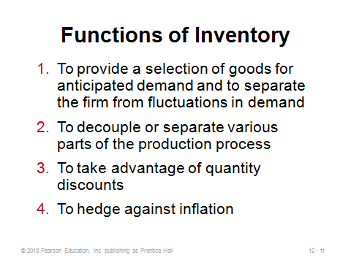
12-9 12-10 12-11
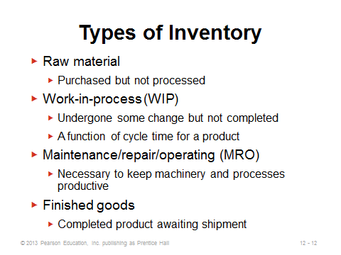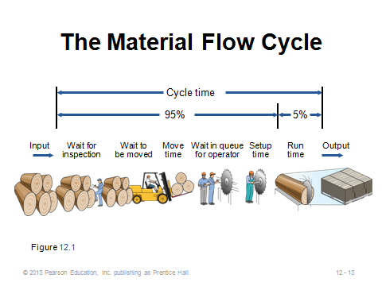
12-12 12-13

MANAGING INVENTORY (12-14 through 12-24)
Slides 15-19: These slides describe ABC analysis, which is often the first step in setting up an inventory control system. Based on the Pareto principle, the idea is to identify and then focus resources on the few critical parts, not the many trivial ones (such as paper clips). The cutoffs are not exact, but in general, Class A items represent about 15% of total inventory items and 70%-80% of total dollar usage. Class B items represent about 30% of total inventory items and 15%-25% of total dollar usage. Class C items represent about 55% of total inventory items but only 5% of total dollar usage. Slide 16 illustrates Example 1 from the text. Items are ranked in decreasing order of annual dollar volume (annual volume times unit cost), and the A-B-C cutoffs are made from there. Slide 17 (Figure 12.2) shows the typical graphical representation of ABC analysis. Slide 18 identifies other possible ways to rank items—the point being to help firms identify the items that need the most attention to address their particular issues. Slide 19 identifies some of the managerial actions to employ once the Class A (and to a lesser extent Class B) items have been identified.
Slides 20-21: Good inventory decisions rely on good data, so accurate record keeping of inventory is crucial. This process is challenging because inventory disappears for a variety of reasons: shoplifting, employee theft, breakage, spoilage, sales clerks/systems not correctly identifying sold items, etc.
Slides 22-23: Cycle counting is employed to more continuously count inventory and audit records than, say, an annual full physical count and reconciliation would entail. Slide 23 (Example 2) illustrates how such a system might be set up, based on ABC analysis. In this example, the Class A items are counted each month but through a rolling process, so some Class A items are counted every day to spread out the workload.
Slide 24: Service industries usually have inventory on hand, and in fact, a shortage of inventory in those environments (e.g., no shampoo at the salon or no coffee at the coffee shop) could even more readily result in lost sales. This slide identifies some techniques that can be employed to reduce the levels of shrinkage and pilferage.
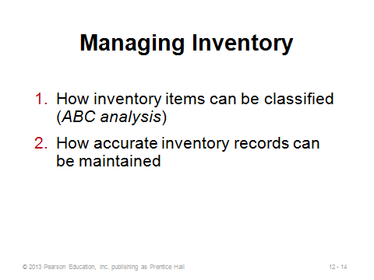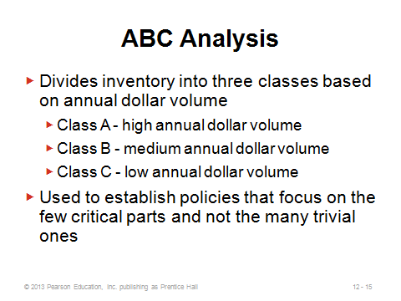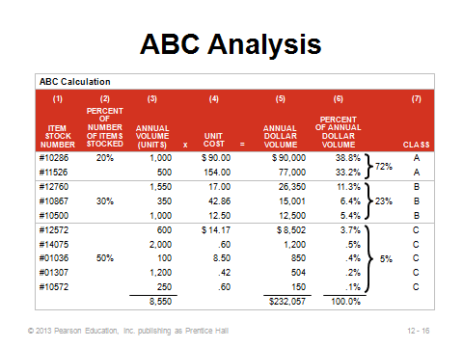
12-14 12-15 12-16
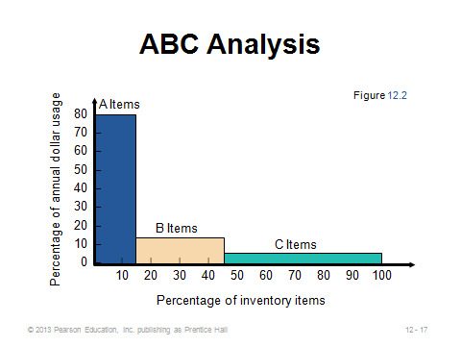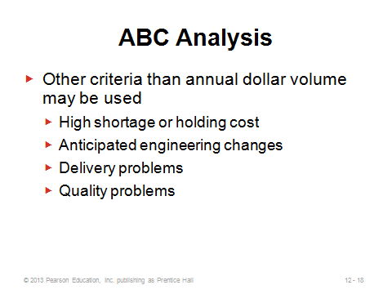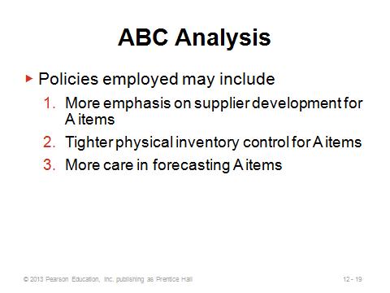
12-17 12-18 12-19
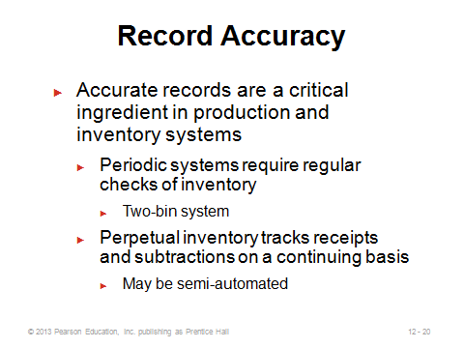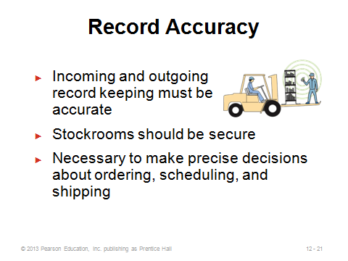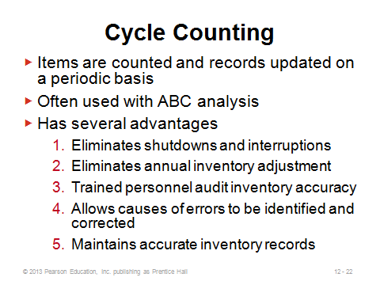
12-20 12-21 12-22
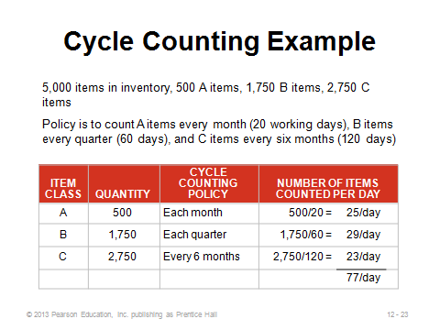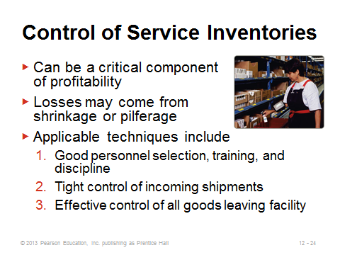
12-23 12-24

INVENTORY MODELS (12-25 through 12-28)
Slide 25: Demand characteristics determine which inventory models are appropriate. The models in Chapter 12 are applied to independent demand situations, while dependent demand is covered in Chapter 14. Two other demand distinctions include deterministic vs. stochastic and static (constant mean) vs. variable.
Slide 26: The primary tradeoff in lot-sizing decisions of basic inventory models involves balancing ordering/setup costs and holding (carrying) costs. Larger lot sizes imply lower ordering/setup costs but higher holding costs, and vice versa.
Slides 27-28: Slide 27 (Table 12.1) illustrates some of the possible components that may comprise the overall holding cost. Interest on tied-up money is an important part of holding cost that students sometimes have trouble grasping. Even though inventory is listed as an asset in the accounting books, if, say, a $100 item is purchased and left on the store shelf for one year, the firm has lost the opportunity cost on that money. The rate used is often the weighted average cost of capital for the firm, but even the bank savings account interest rate could apply. For example, if the firm earns 5% on its deposit accounts with the bank, then it would have had $105 at the end of one year if it had left the money in the bank instead of purchasing the inventory item. Thus, the annual holding cost of that $100 item should be at least $5. Another item that could be mentioned as part of Slide 27 is worker’s compensation costs because the most common worker’s compensation claims stem from back injuries due to moving inventory.
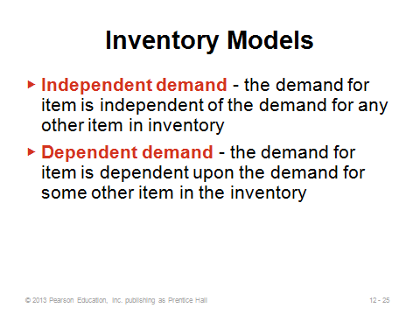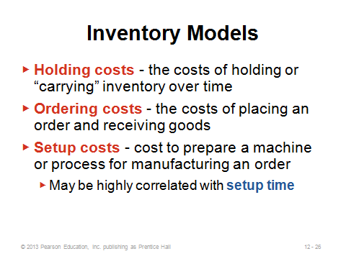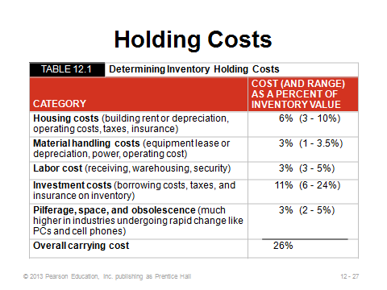
12-25 12-26 12-27
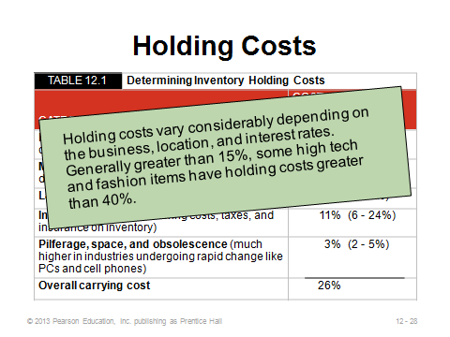
12-28

INVENTORY MODELS FOR INDEPENDENT DEMAND (12-29 through 12-59)
The Basic Economic Order Quantity (EOQ) Model (12-29 through 12-31)
Slide 30: It is important to cover the assumptions of the EOQ model. When any of these are relaxed, a more complicated model might apply better. There are actually a few other assumptions that can be mentioned as well: (1) the time horizon is infinite, (2) demand is not only constant period after period, but it is uniform (technically this implies that it is continuous and smooth, with no seasonality, large orders, or lumpiness—hence the straight declining lines in Slide 31), (3) there are no constraints on the order size, (4) decisions for one item are made independently of decisions for other items, and (5) there is no inflation. While these assumptions may seem restrictive and unrealistic, the EOQ is known to be a robust model and can at least provide a good base case or starting point decision.
Slide 31: Instructors should spend some time on this important graph (Figure 12.3). The EOQ assumption of instantaneous and complete receipt of inventory causes the line to shoot straight up when an order is placed. The assumption of constant (and uniform) demand causes the line to decline smoothly and continuously over time until the inventory level reaches zero, at which point another order must be placed. Since the time horizon is infinite and nothing about cost or demand conditions changes, this pattern repeats itself indefinitely. The graph also illustrates why we assume that average inventory on hand equals Q / 2.
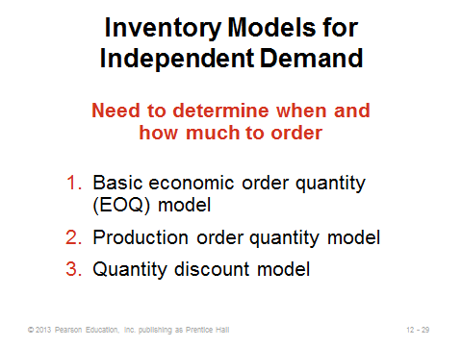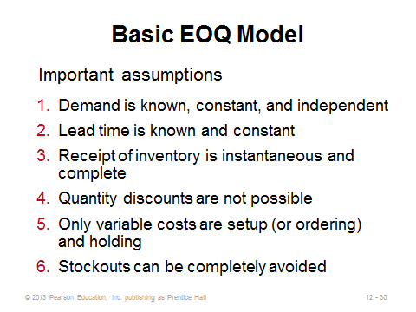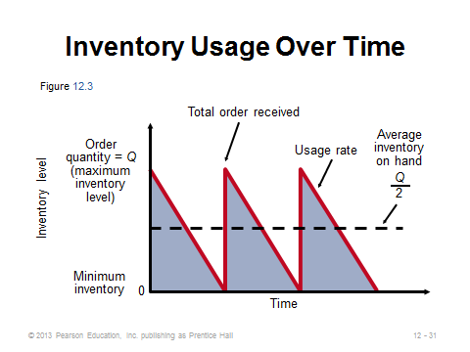
12-29 12-30 12-31

Minimizing Costs (12-32 through 12-43)
Slides 32-33: As the authors state, Slide 32 (Figure 12.4(c)) represents the heart of inventory modeling. It illustrates the essential tradeoff between ordering/setup cost and holding cost. With very small order sizes, ordering/setup cost is much higher than holding cost, and total cost would decrease by ordering more units each time. This continues, in fact, until ordering/setup cost exactly equals holding cost (Slide 33). At that point, the total cost curve reaches its minimum. (This can be shown analytically as well as graphically.)
Slides 34-36: These slides develop the EOQ formula. Keeping the notation at the top of each slide, we see the annual setup cost formula in Slide 34 and the annual holding cost formula in Slide 35. Slide 36 derives the optimal order quantity formula, knowing that annual setup and holding cost should be set equal to each other. For the more mathematically inclined students, the formula can also be derived by showing that the total cost formula is convex in Q, and the EOQ is the result of setting the first derivative equal to zero and solving for Q (see Footnote 3 in the text).
Slides 37-40: These slides present the continuing Examples 3 through 5 in the text. Slide 37 provides the order quantity. Slide 38 provides the expected number of orders per year for the same example (note that this value can be a fraction, implying that some years will be the rounded down integer while other years will be the rounded up integer). Slide 39 provides the expected time between orders (in days) for the same example. Slide 40 computes the total cost. Instructors may want to share that there is a shortcut formula for total cost of the EOQ model, which is based on the parameters only and not Q. If the EOQ is ordered, the total annual holding and setup cost will be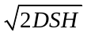. This can be derived by plugging Q* into the general total setup and holding cost formula as a function of Q.
Slide 41: This slide shows how to incorporate annual purchasing cost into the total cost formula for the EOQ model. Normally it’s not included because the order quantity does not affect purchase price in the basic EOQ model. It will be needed, however, for the quantity discount model.
Slides 42-43: Slide 42 notes that due to the flat shape of the total cost function (see Slide 32), the EOQ model is robust, i.e., it often provides satisfactory answers even with substantial variation in the parameters. Slide 43 illustrates Example 6 from the text, which looks at the previous example under the condition that demand was underestimated by a full 50%. The important issue is not that costs will increase (they obviously will be higher along with higher demand no matter which model is used), but that the total cost using the wrong EOQ is less than 2% higher in this example than the total cost using the right EOQ (if demand had been known correctly).
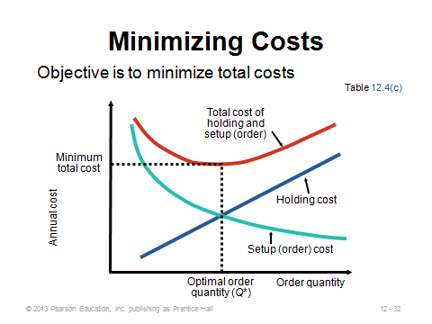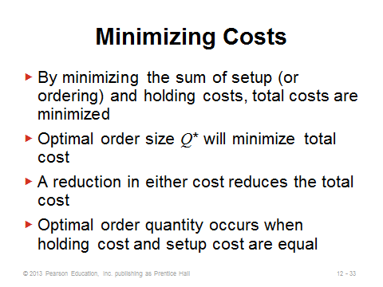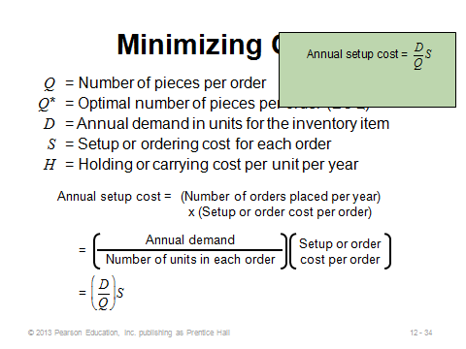

12-32 12-33 12-34
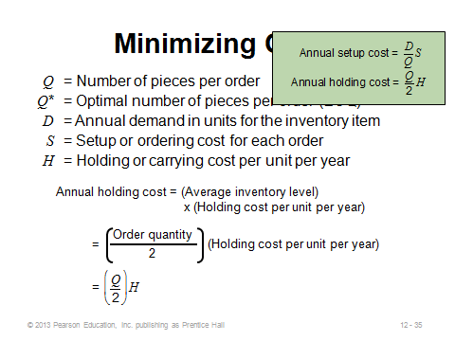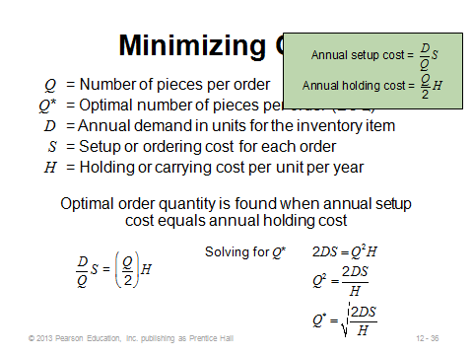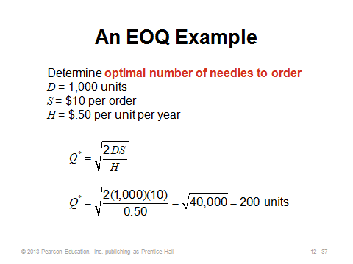
12-35 12-36 12-37
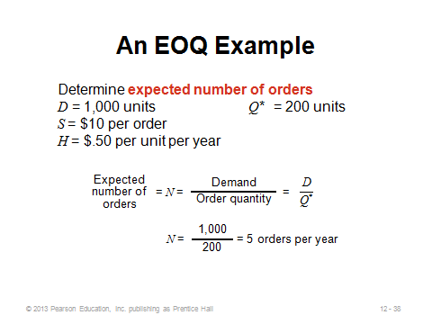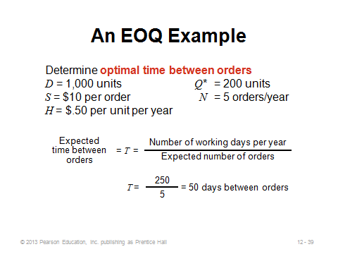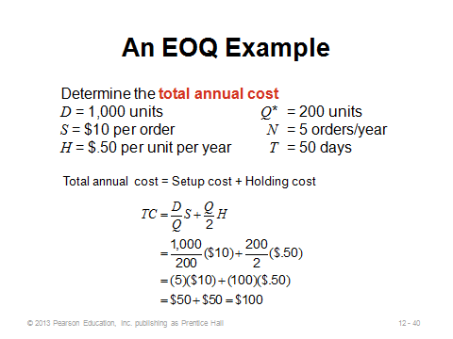
12-38 12-39 12-40
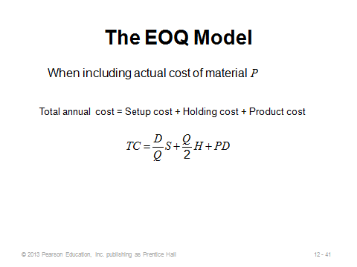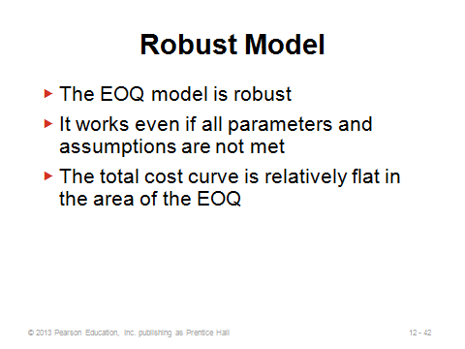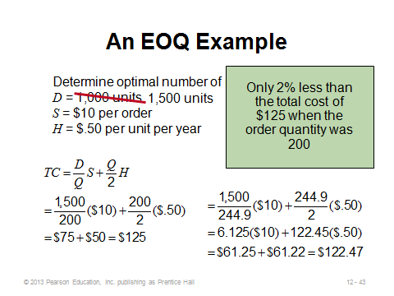
12-41 12-42 12-43

Reorder Points (12-44 through 12-46)
Slides 44-46: The basic EOQ model assumes that orders arrive instantaneously and completely. But when the (complete) orders take time to arrive, the timing of the order must account for this lead time. In other words, the firm must place the order before completely running out of inventory so that the new units have time to arrive before they are needed. Slide 44 provides the reorder point formula. Slide 45 (Figure 12.5) illustrates when (in units) the order should be placed. Slide 46 provides a reorder point calculation (Example 7).
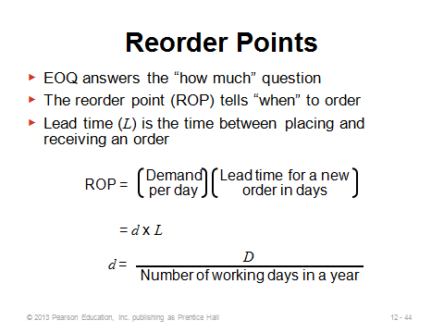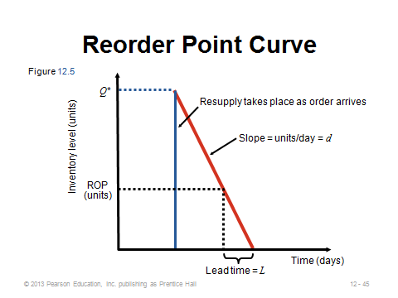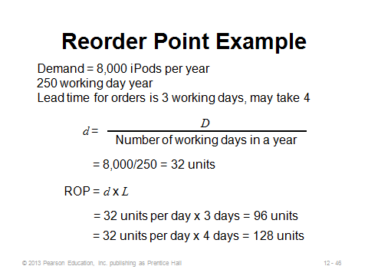
12-44 12-45 12-46

Production Order Quantity Model (12-47 through 12-52)
Slide 47: An important assumption of the basic EOQ model is that orders arrive instantaneously and completely (i.e., the production rate is infinite). While this assumption may be true for purchased parts, produced parts may take time to make. In particular, when units are produced and sold simultaneously, the EOQ graph changes to the one shown in this slide (Figure 12.6). This necessitates a different model, the Production Order Quantity (POQ) Model.
Slides 48-50: These slides derive the POQ formula. Note the addition of two new parameters: p = daily production rate and d = daily demand rate. Slide 50 also provides the formulas for annual setup cost and annual holding cost. Note what differs from the basic EOQ model. Due to the gradual inventory buildup, the holding cost parameter H is essentially reduced by (1 – d/p). Similarly, the maximum inventory level does not equal the order size but instead equals Q*(1 – d/p). This occurs because every day p units are added to inventory but d units are taken from inventory. As with the EOQ model, the POQ model has a shortcut formula for total annual holding and setup cost: 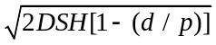. When p = ∞ (infinite production rate), the POQ formulas all collapse to the corresponding basic EOQ formulas. After students are shown the formulas, the instructor can ask the question: “If a firm can control its production pace, should it speed up or slow down?” The answer (slow down all the way to p = d) may sound counterintuitive to some students. Assuming no other use of the production resources (potentially a big assumption), from a holding and setup cost perspective, it is actually best to produce no faster than the demand rate (pure just-in-time production). In this way, inventory is never held (zero holding cost) and the single setup divided by an infinite time horizon implies an annual setup cost of zero. This zero cost can also be seen by looking directly at the shortcut total cost formula with p as a decision variable: .
Slide 51: This slide shows the POQ example (Example 8) from the text.
Slide 52: This slide shows how to modify the POQ formula when annual demand and production rates are used instead of daily demand and production rates.
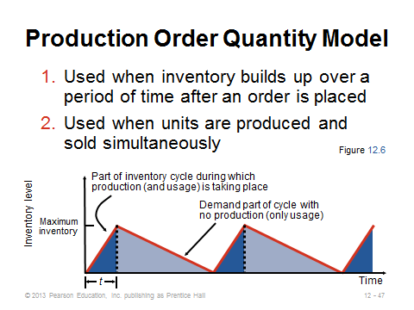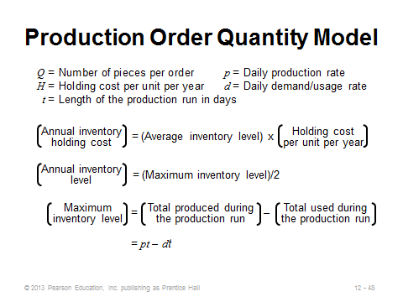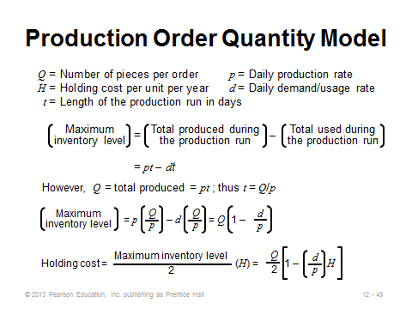
12-47 12-48 12-49
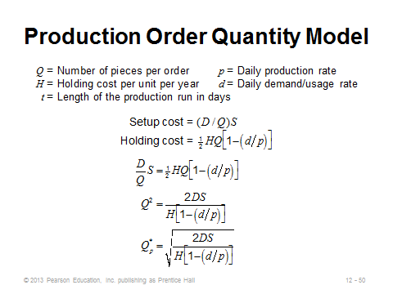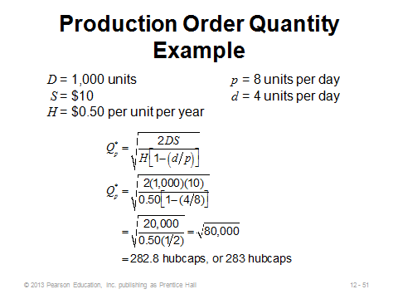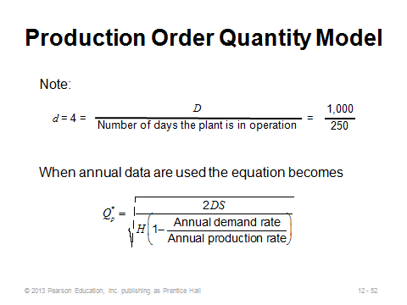
12-50 12-51 12-52

Quantity Discount Models (12-53 through 12-59)
Slides 53-54: Particularly with business-to-business transactions, quantity discounts are arguably more likely to exist than not. One study found that 95% of managers interviewed had all-units quantity discounts for some of the items that they either purchased or sold. Slide 53 (Table 12.2) illustrates a typical all-units quantity discount schedule. Whereas purchase cost can be ignored in the basic EOQ model, it must be considered when faced with a quantity discount price schedule. Importantly, note that annual purchase cost (not purchase cost per order) is added to the annual holding and setup cost formula (Slide 54). Also, annual holding cost per unit is now expressed as IP instead of H because it should be decreasing as the unit price decreases (at least the portion of holding cost due to the Investment costs from Table 12.1). As with going to the price club and buying much more toilet paper than necessary, the existence of quantity discounts may encourage buying a lot more and incurring a lot higher holding costs in order to take advantage of a great price break.
Slide 55: This slide identifies the four-step solution procedure for the all-units quantity discount problem. It is assumed that Q* will differ for each price discount because holding cost should be computed as an annual holding cost percentage I of unit cost P (which changes for each price interval). Note that this algorithm can be streamlined. Specifically, if EOQs are computed starting at the lowest price and working towards the highest price, once a feasible Q* is found (meaning that Q would be in the correct interval to qualify for the price P used in the formula to generate that Q), all higher price intervals can be ignored. That is because the holding and setup costs would be higher (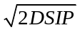), and the purchasing cost would also be higher.
Slide 56: This slide (Figure 12.7) illustrates why the upward adjustment may be necessary.
Slides 57-59: These slides illustrate Example 9 from the text. In this case, the quantities for two of the price intervals had to be adjusted upwards. The overall best quantity was 1000, which generated the second-lowest possible price. The lowest price had too large of a holding cost penalty to make the purchasing savings worthwhile.
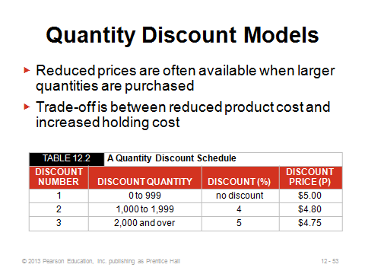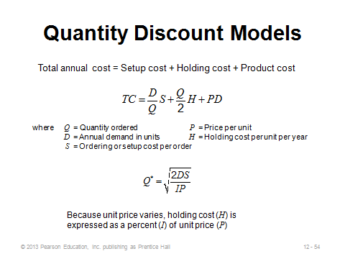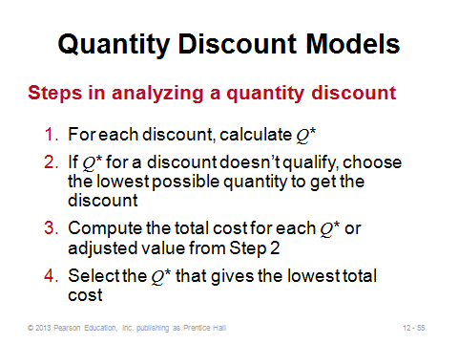
12-53 12-54 12-55
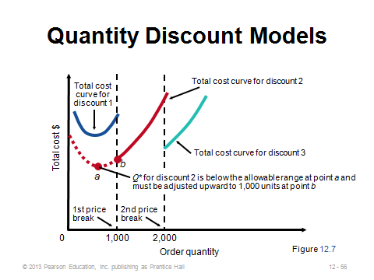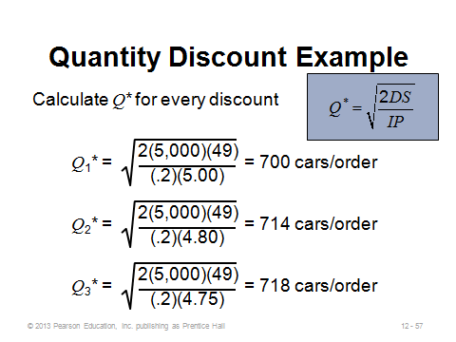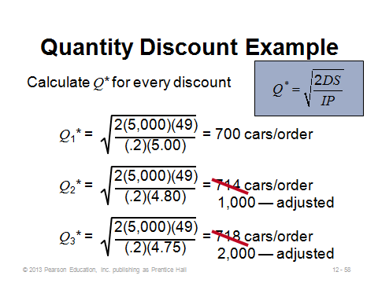
12-56 12-57 12-58
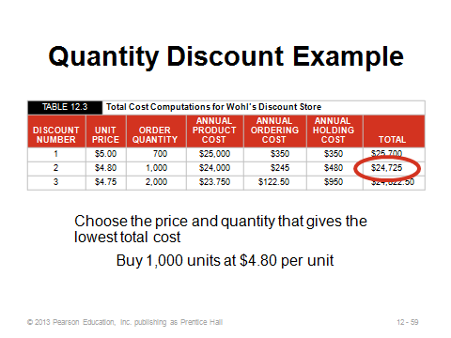
12-59

PROBABILISTIC MODELS AND SAFETY STOCK (12-60 through 12-73)
Slide 60: From a research perspective, stochastic inventory models can be quite complicated. Most real-world systems take a relatively straightforward approach to incorporating random demand. Clearly, in the real world most demand has a random component. Thus, most firms should be expected to keep on hand some level of safety stock in order to account for this demand uncertainty. This slide modifies the reorder point formula to incorporate this safety stock cushion, and it also provides the formula for annual stockout costs.
Slides 61-62: These slides illustrate Example 10 from the text, which illustrates the selection of the optimal reorder point if given a discrete demand distribution and a known stockout cost.
Slides 63-65: Because the actual cost of a stockout may be hard to identify, managers often base safety stock level on a desired cycle service level, defined as the probability of not running out of stock during demand lead time. (Other service levels may be considered, such as fill rate, but calculations for those are beyond the scope of this text.) Demand during lead time in these formulas is assumed to be normally distributed. Slides 63 (Figure 12.8) shows how the reorder point is increased to account for safety stock. Slide 64 provides the new ROP formula, where safety stock is computed as Z (based on desired service level applied to the standard normal distribution table) times the standard deviation of demand during lead time. Slide 65 illustrates the effect of safety stock. For a given standard deviation, safety stock increases as desired service level (Z-value) increases. Note that because we assume a normal distribution, half the time demand will be less than average. Thus, zero safety stock will still lead to a service level of 50%.
Slide 66: This slide (Example 11) calculates the safety stock and reorder point with normally distributed demand.
Slides 67-73: Several introductory texts only speak about safety stock for uncertain demand, but firms may need safety stock to cover uncertain supply as well. Slide 67 identifies three additional models that are provided in this text that incorporate uncertain supply and the case where standard deviation of lead time demand is not known. The following six slides provide the respective formulas and an example: Slide 68—variable demand and constant lead time, Slide 69—Example 12 illustrating Slide 68, Slide 70—variable lead time and constant demand, Slide 71—Example 13 illustrating Slide 70, Slide 72—variable demand and lead time, and Slide 73—Example 14 illustrating Slide 72. Students sometimes have difficulty grasping why standard deviation per day is multiplied by the square root of the lead time in days. In fact, demand is proportional in time, but standard deviation is not. This occurs because, according to probability theory, independent variances can be summed, but the standard deviation is the square root of the variance. Thus, for example, for a four-day lead time, if the standard deviation per day is 100, then the standard deviation over four days equals
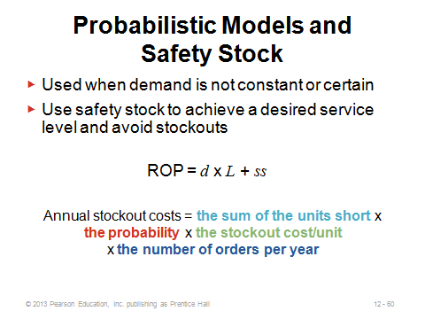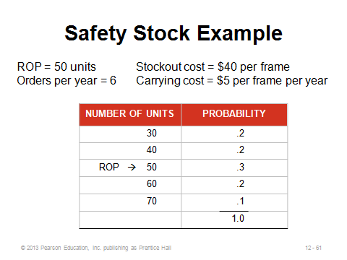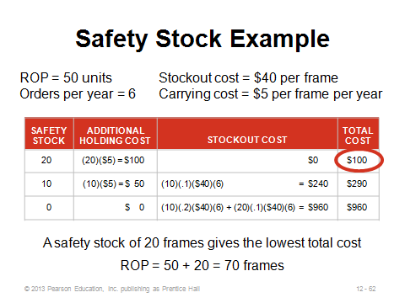
12-60 12-61 12-62
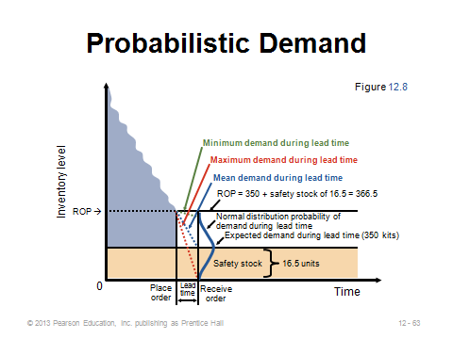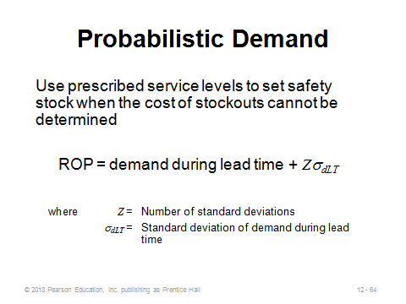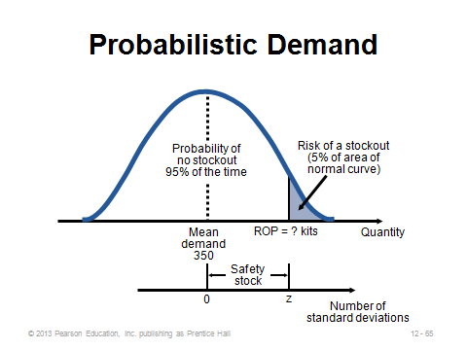
12-63 12-64 12-65
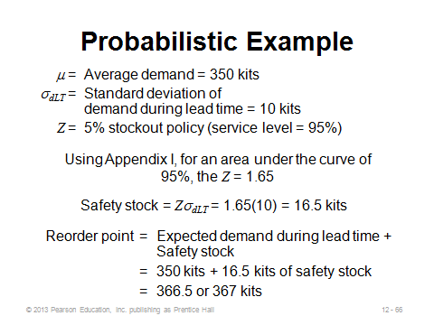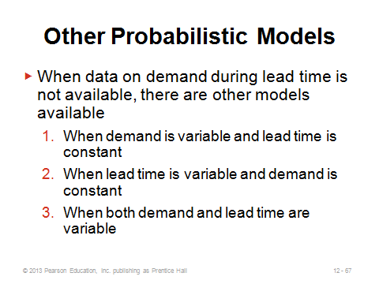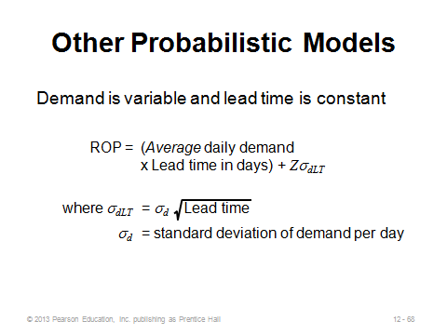
12-66 12-67 12-68
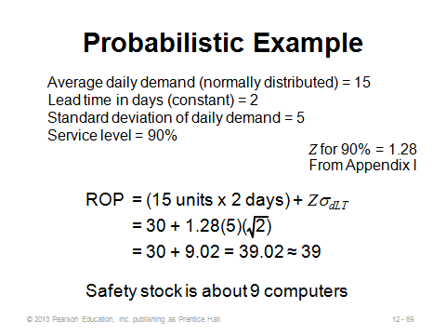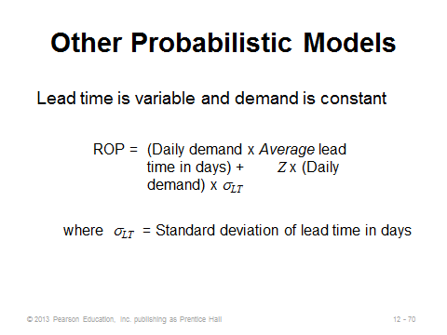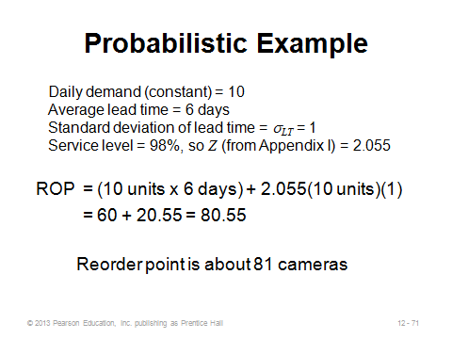
12-69 12-70 12-71
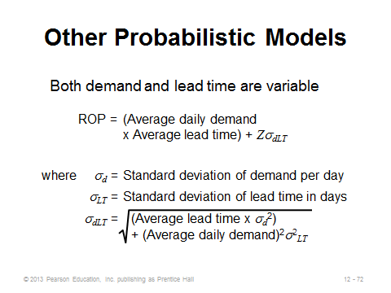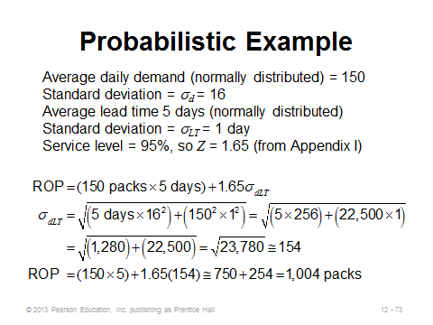
12-72 12-73

SINGLE-PERIOD MODEL (12-74 through 12-76)
Slide 74: Also known as the newsstand or newsvendor model, the single-period model forms the basis for much research conducted in operations management. Given a single selling season with only one chance to purchase, the interesting result is that the manager should not order the expected value of demand (in general). Instead, the optimal order quantity trades off the relative costs of shortage and overage. If it costs more to have too much than too little, then an amount less than the expected value should be ordered. On the other hand, if overage cost is less than shortage cost, then a quantity larger than the expected value should be ordered. The stockout cost is easier to estimate in the single-period model than in multi-period models because there is not a later chance to purchase the item (no backorders) and, with only one period, goodwill loss may be minimal—thus, stockout cost simply equals lost profit. Applications in addition to those listed in the text might include July 4th fireworks stands, new release videos, and ordering pizza for a large meeting. Example 15 in the text illustrates the method for solving the problem if demand is normally distributed (find the Z-value corresponding to the service level from (12-18) and set Q = μ + Zσ). Note that when the overage cost exceeds the shortage cost, Z will be negative and the firm should order less than expected demand. Finally, the newsstand problem can be solved for any distribution, not just the normal. In each case, order Q* such that the distribution function at that point equals the service level, i.e., F(Q*) = C_{s} / (C_{s} + C_{o}).
Slides 75-76: These slides illustrate Example 15 from the text. Note how the stockout risk equals 1 – service level.
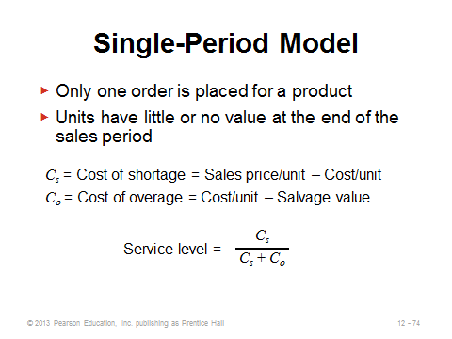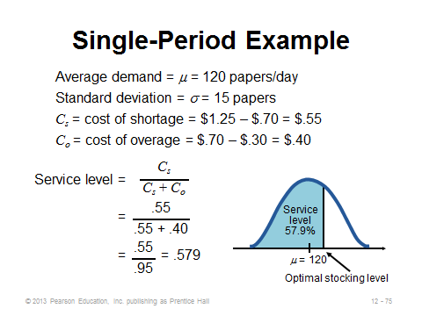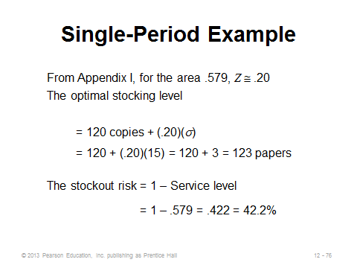
12-74 12-75 12-76

FIXED-PERIOD (P) SYSTEMS (12-77 through 12-79)
Slide 77: The inventory models considered up to the last section of the chapter are known as fixed-quantity (Q) systems, or continuous review systems. Another very popular system in practice is the fixed-period (P) system, otherwise known as periodic review. Instead of having a fixed order size every time and having a variable time between orders, a P system has a variable order size every time and a constant time between orders. For example, the purchaser might place an order every Friday afternoon (P = 1 week). The value of P can be determined by management, or it might be based on the average time between orders if the EOQ were ordered every time. When it is time to order, Q = T – IP, where T = the target quantity (average demand during (P + lead time) + safety stock (where σ covers (P + lead time)), and IP = on-hand inventory + scheduled receipts – backorders.
Slide 78: This slide (Figure 12.9) illustrates how a P system works. An effective analogy can be the process of filling water glasses in a restaurant. A server might be instructed to visit each table every five minutes (P). Once there, he or she fills each water glass to the top (T). Customers who drank a lot during the previous five minutes get a lot more water (Q), whereas those who drank little or no water are poured a small amount or even none.
Slide 79: This slide presents characteristics of P systems. The primary advantage of a P system is convenience, i.e., the purchaser does not have to monitor inventory continuously and place an order at a moment’s notice. The primary disadvantage is being less able to react quickly to large orders, implying either a lower service level or a higher cost in the form of more safety stock. Fixed-period systems do make it easier to combine orders from the same supplier, which could reduce overall ordering costs, allow for combined shipments, or allow for volume discounts based on total dollar volume purchased. On the other hand, the fixed lot sizes in fixed-quantity systems may help the firm obtain discounts each time when those discounts are based on amount purchased per item, or they may help when there are specific capacity limits or desired packaging/shipping sizes.
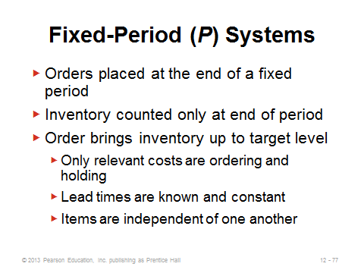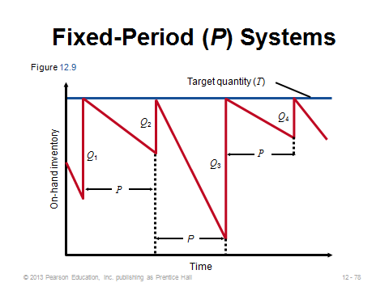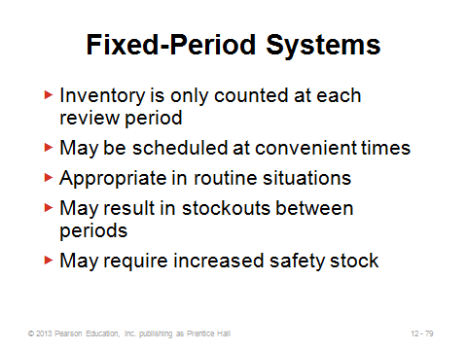
12-77 12-78 12-79

Additional Case Studies

Internet Case Studies (www.pearsonhighered.com/heizer)

- Southwestern University: F: The University must decide how many football day programs to order, and from whom.
- LaPlace Power and Light: This utility company is evaluating its current inventory policies.

Harvard Case Studies (http://harvardbusinessonline.hbsp.harvard.edu)
- Paper and More (A) (#606023, © 2009)
- Stonehaven, Inc. (#696048, © 2006)
- Supply Chain Optimization at Hugo Boss (A) (#609029, © 2009)

Ivey Case Studies (https://www.iveycases.com)

- CRP Products (#9B11D015, © 2012)
- Greaves Brewery: Bottle Replenishment (#9B04D017, © 2009)
- Progistix-Solutions Inc. – The Critical Parts Network (#9B05D002, © 2009)

Internet Resources

APICS: The Association for Operations Management | www.apics.org
Institute of Industrial Engineers | www.iienet.org
Inventory Management | www.inventorymanagement.com

