Chapter 9
Layout Strategies

Background

Layout can be a fun topic because students can easily relate to many of the concepts covered, particularly for retail and office layouts. Coverage of the job shop, work cell, and repetitive layouts, in particular, nicely ties back to previous sections of the book that touched on those as operations strategies. Layout also includes a significant human element (both employees and customers), which can lead to a host of creative and interesting design issues. The seven layout strategies covered in this chapter are all very different from each other, and they all have their unique characteristics that should be unveiled during the lecture.

Presentation Slides

INTRODUCTION (9-1 through 9-8)
Slides 6-8: McDonald’s is a nice example to cover because most students are intimately familiar with the restaurant. Slides 6 and 7 cover the seven major innovations that McDonald’s has implemented over the years, noting that six of these are layout decisions. The newest innovation (Slide 8) involves a hefty setup cost and, along with children’s play areas, takes the restaurant beyond a simple “grab food, eat quickly, and go” model. A short class discussion could gauge student reactions to, in particular, the “linger zone” and the “flexible zone.”
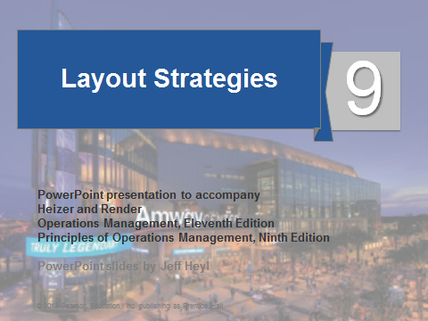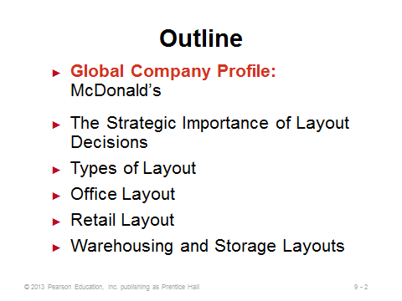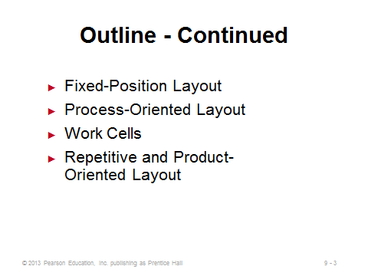
9-1 9-2 9-3
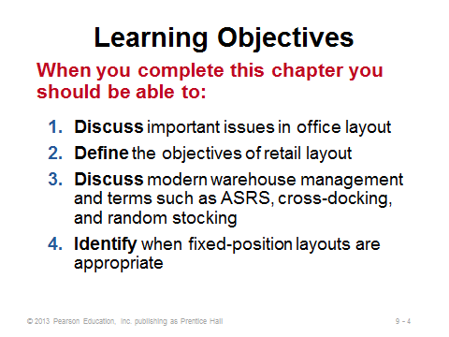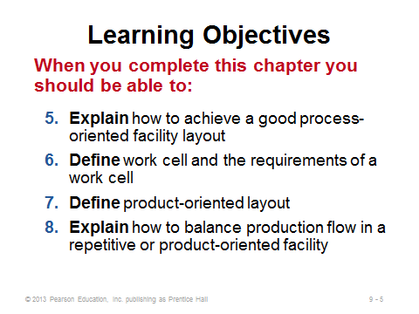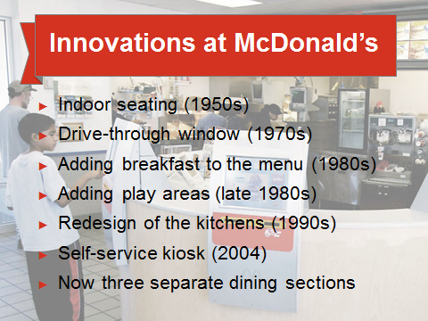
9-4 9-5 9-6
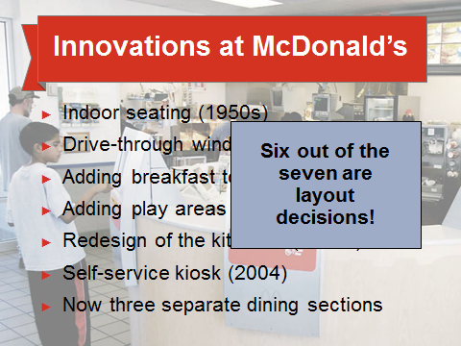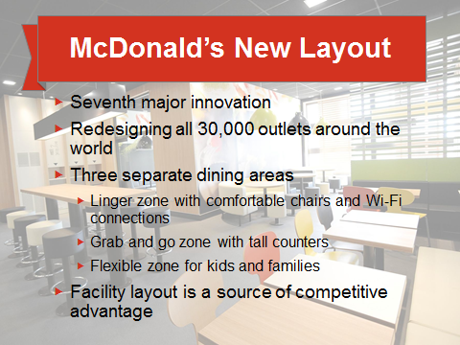
9-7 9-8

THE STRATEGIC IMPORTANCE OF LAYOUT DECISIONS (9-9 through 9-10)
Slide 10: Layout design is interesting because it sometimes balances very different objectives of efficiency vs. making humans (workers and/or customers) happy. Outstanding layout features can change employee or customer attitudes and perceptions, potentially producing more productive workers and/or happier customers who may purchase more and remain loyal.
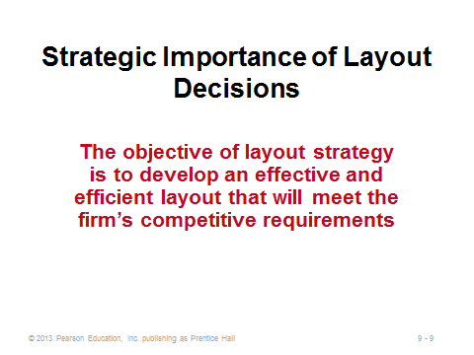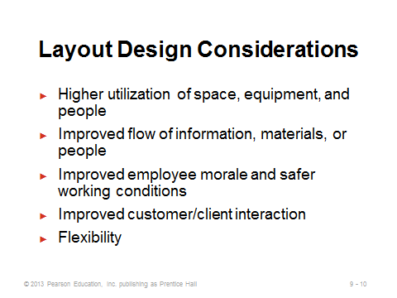
9-9 9-10

TYPES OF LAYOUT (9-11 through 9-17)
Slide 11: The seven layout types identified in this slide are all covered in detail in this chapter.
Slides 12-14: These slides provide a brief description of each type of layout.
Slides 15-16: These slides reproduce Table 9.1 from the text. The objectives are very different, and they drive the respective solution approaches involved. A short class discussion could go through the list, identifying features of some of the examples listed or instructors’/students’ own examples of each layout type. It can be interesting to record what students have noticed about layout decisions based on their own experiences as workers or customers and then to see, as the lecture continues, which features were identified and which were perhaps not.
Slide 17: This can be a good place to point out that, while mathematical models and software applications do exist for the facility layout problem, many actual implementations are based more on art than science. Regardless, good layouts typically consider all of the factors identified in this slide. Instructors might point out that a major reason why layouts have become more open (fewer offices, shorter cubical walls, etc.) over the years has been to increase information flow (communication) among workers (sometimes to the dismay of those who like to work in private).
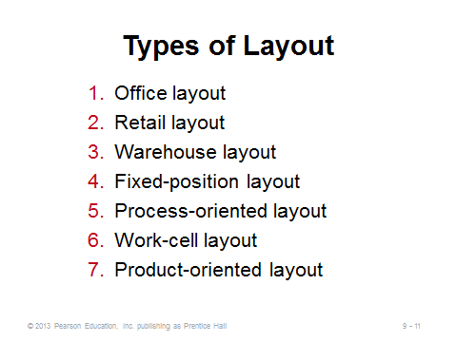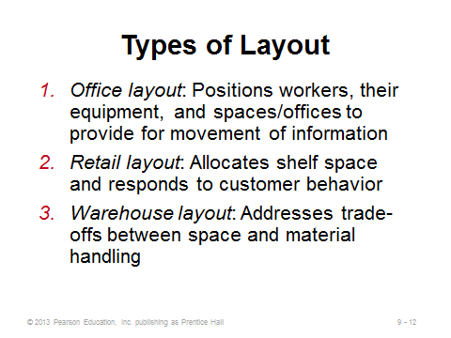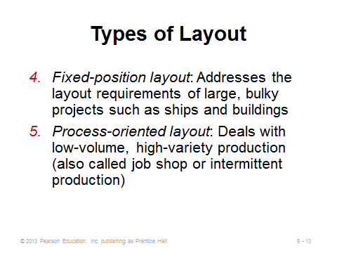
9-11 9-12 9-13
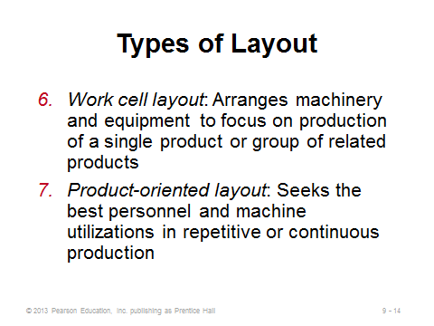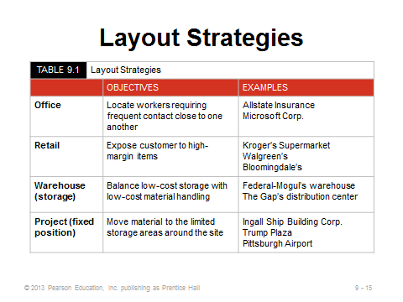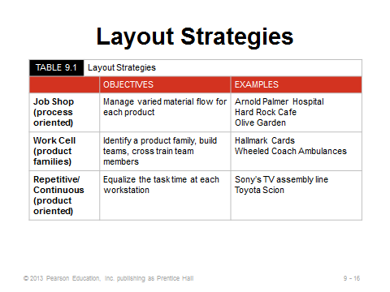
9-14 9-15 9-16
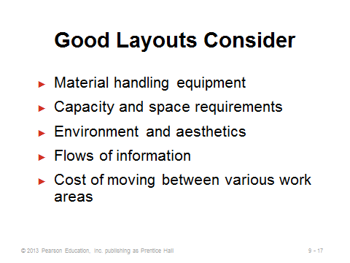
9-17

OFFICE LAYOUT (9-18 through 9-20)
Slide 18: The use of modular cubicles and flexible furniture allows office managers to rather easily alter layouts as conditions and personnel change.
Slide 19: When showing the relationship chart, instructors can add some examples such as the boss wanting to be near the bathroom, the senior manager wanting a lakeside view, or the couple who broke up wanting to be as far away from each other as possible. Software has existed for a long time that can provide good layouts based on a relationship chart—this is particularly useful for layout decisions involving many employees and/or departments. Instructors might point out that the development of a relationship chart can be a good way to involve employees in the design process. Let each employee provide input, at least concerning the departments or people relevant to them, and base the final chart on aggregate employee perceptions and desires.
Slide 20: Workspace can inspire informal and productive encounters if it balances the three physical and social aspects identified on this slide. In particular, spaces should naturally bring people together (proximity), people must be able to control access to their conversations (privacy), and the culture should signal that non-work interactions are encouraged (permission). People spend much of their lives at the office—most individuals would like it to be a social place! Finally, advances in information technology are leading to more offsite work resulting in lots of empty cubes. Firms are responding with flexible and shared workspaces. Class discussion could focus on how important it would be to students to have their “own” permanent work area at the office, even if they’re constantly on the road.
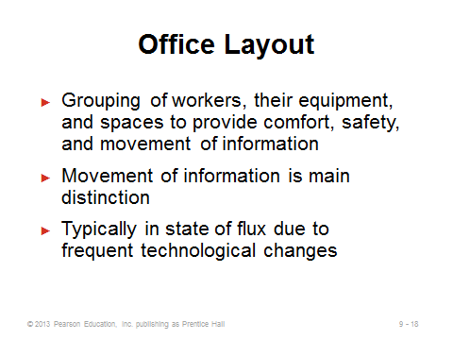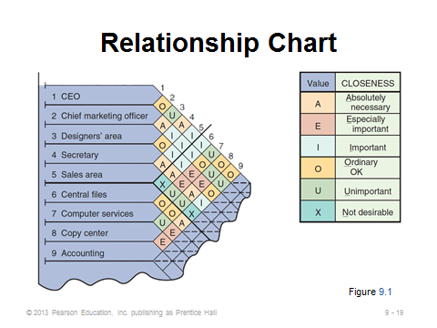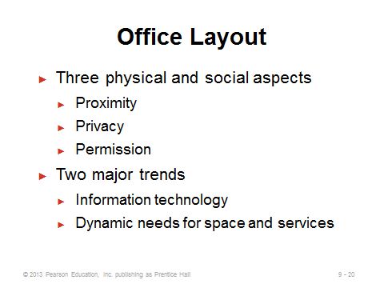
9-18 9-19 9-20

RETAIL LAYOUT (9-21 through 9-25)
Slides 21-22: Retail layout is fascinating due to the significant influence of consumer behavior. This represents one area of business where academic research has had a tremendous impact. As seen in the list on Slide 22, an important reason for the location of some items is to get consumers to look at other, perhaps less popular, items along the way. High-impulse items are sometimes located “front and center” in the store, and others are located in the checkout line, enticing customers to put them in their basket even though they had no intention of purchasing such products upon entering the store.
Slide 23: Figure 9.2 illustrates the intentional placing of dairy and bakery on opposite ends of the store to cause customers to pass by many other products on their way from one staple product area to the other.
Slide 24: Slotting fees are a somewhat controversial mechanism that retailers employ to allow manufacturers to put products on the store shelves. Retailer power has enabled this practice, but it provides a particular hindrance to small suppliers. Some suppliers may attempt direct selling through the Internet to avoid paying such a fee. Interestingly, despite its reputation of being tough on suppliers, the world’s biggest retailer Walmart does not demand slotting fees.
Slide 25: A servicescape describes the physical surroundings in which a service is delivered and how the surroundings have a humanistic effect on customers and employees. Firms should consider the elements identified in this slide in order to design a good service layout.
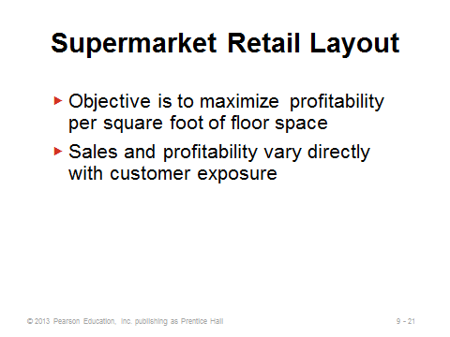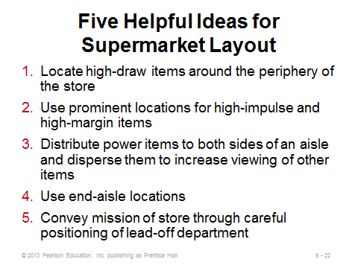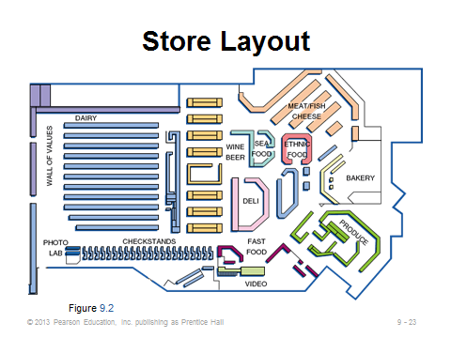
9-21 9-22 9-23
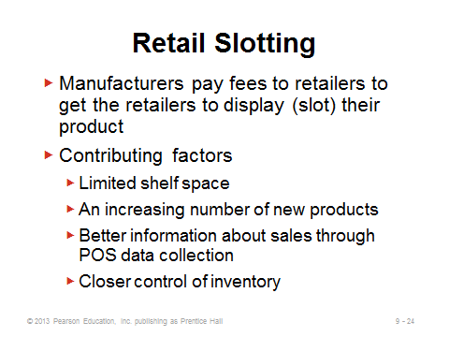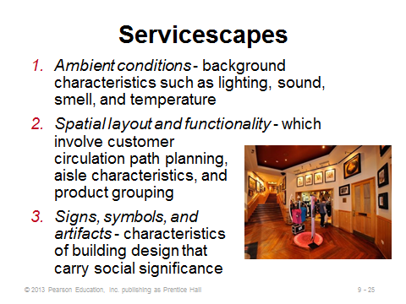
9-24 9-25

WAREHOUSING AND STORAGE LAYOUTS (9-26 through 9-31)
Slides 26-28: An interesting feature of warehouses is that most storage and space considerations are three-dimensional in nature (east-west, north-south, and up). There can be definite safety considerations about the vertical dimension, e.g., it’s better to put toilet paper than televisions on the top shelf. In general, high-volume items should be placed closest to the docks to minimize material handling costs; however, items that take up a lot of space should be placed further from the docks so that other items can be retrieved quicker (i.e., there is an opportunity cost for taking up a lot of space near the dock with only one type of item). (See Other Supplementary Material for the formulation of the one-dock warehouse problem along these lines.) The first bullet on Slide 28 demonstrates one of the benefits of component commonality. Essentially, more and more space is wasted when stocking more and more different items, as space needs to be allocated for each item type. The picture in this slide provides a dramatic demonstration of an ASRS implemented at a parking garage in Germany. This garage handles the same number of cars using only 20% of the space of a typical garage—and no drivers are needed (along with their associated driving accident risks)! The cars are all retrieved via a huge crane.
Slide 29: Cross-docking is considered to be an enlightened approach to distribution. The warehouse actually does not store anything for longer than a few hours, so it acts as a transfer point rather than as a traditional warehouse. Cross-docking may work particularly well for fast-moving items requiring daily deliveries.
Slide 30: Random stocking can save a significant amount of inventory space, particularly for firms storing many different items. The computer information systems requirements are significant.
Slide 31: In some sense the opposite of cross-docking, customizing suggests that warehouses should not only store goods but should also add some value to them. This slide identifies some of the value-added activities now performed at warehouses. Customizing may be an excellent way to implement postponement, as described in Chapters 7 and 11.
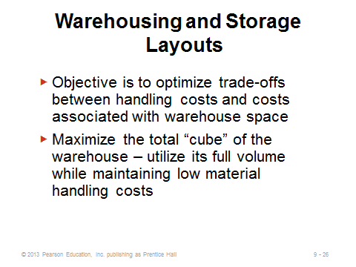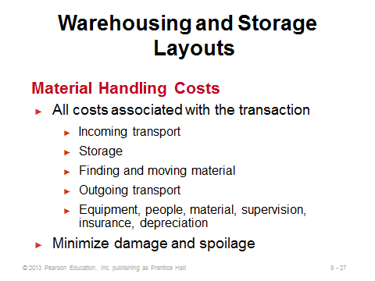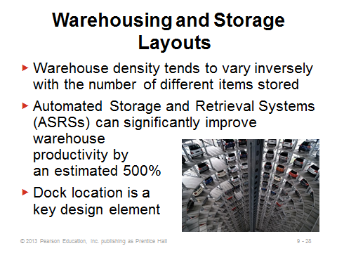
9-26 9-27 9-28
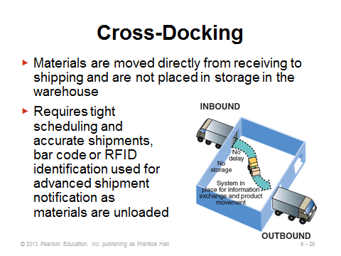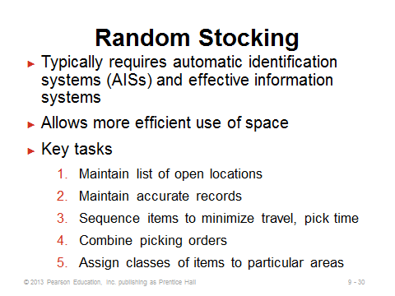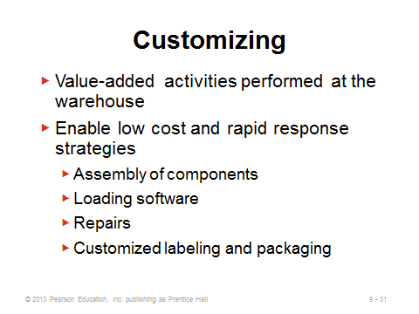
9-29 9-30 9-31

FIXED-POSITION LAYOUT (9-32 through 9-33)
Slides 32-33: These slides describe the fixed-position layout. It is the obvious choice for certain large products/projects, or for ones where the product itself would be very difficult to move (e.g., the land for a corn farm). For firms managing more than one of these, scheduling and moving workers, materials, and machines can be a challenging task, and it would be possible that more workers and machines would be needed than on a traditional assembly line. Slide 33 illustrates the concept of “manufactured homes,” where much of the structure is made ahead of time on an assembly line and the whole thing, despite its size, is shipped to and placed on its final location.
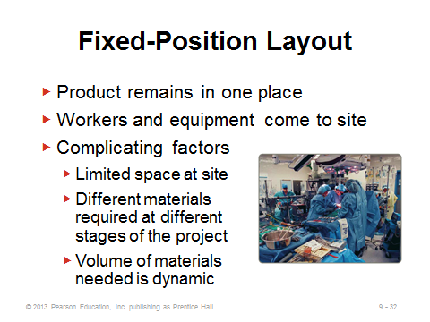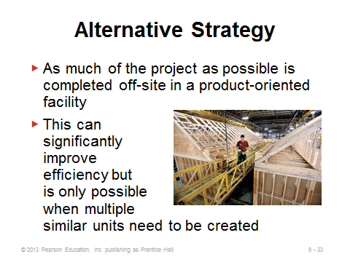
9-32 9-33

PROCESS-ORIENTED LAYOUT (9-34 through 9-48)
Slide 34: A process-oriented layout is the layout of choice for a typical job shop, as well as for many service industries (banks, cafeterias, hospitals, etc.). The machine investment costs are typically lower than those for a high-volume assembly line. But labor costs may be higher (due to the necessity for higher-skilled, flexible employees). Also, work-in-process inventory levels are typically higher than for an assembly line.
Slide 35: Figure 9.3 shows hospital layout, which makes much more sense than sending all patients past every department as an assembly line layout would.
Slides 36-45: These slides take us through Example 1 in the text, which utilizes the load-distance method to design a process-oriented layout. The objective is to arrange work centers in order to minimize total costs of material handling, defined here as load (the number of shipments per unit time) times distance (or cost to move between department i and department j). Slide 38 shows the steps to follow in designing a good layout. Slide 39 illustrates a from-to matrix (Figure 9.4), showing the loads between each station. Apparently, Department 3 should be placed near Departments 1 and 6 due to the high number of loads per week between Department 3 and those two departments. Slide 40 (Figure 9.5) shows an initial solution, which is hoped to be improved upon. Slide 41 shows the interdepartmental flow graph (Figure 9.6) of the layout shown in Figure 9.5. Placing the loads on the arrows provides a good visual picture of potential areas for change (for example, Assembly and Machine Shop should probably be closer together; meanwhile, Painting and Shipping do not have to be that close). Slides 42-45 show how the costs for the initial solution are improved by $90 (16%) after the switching to the second solution (Figure 9.7). Note that for just six departments, there are 6! = 720 possible arrangements to try. For 10 departments? The manager would have to explore 10! = 3,628,800 combinations to be certain of finding the very best!
Slides 46-48: These slides cover computer software, which is usually necessary for large applications. These programs tend to be interactive, and most claim to provide good but not necessarily optimal solutions. Slide 47 shows an application of Proplanner, which can manipulate layouts to show the cost savings from an improved layout. Slide 48 is a screen shot from Tecnomatix Plant Simulation software, providing very realistic images of potential layouts.
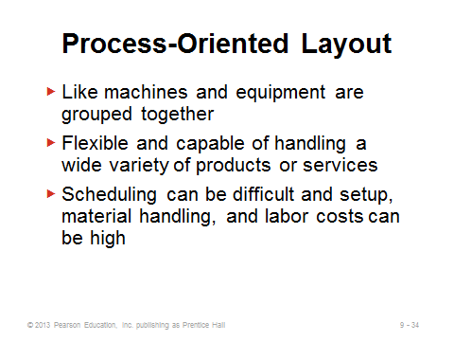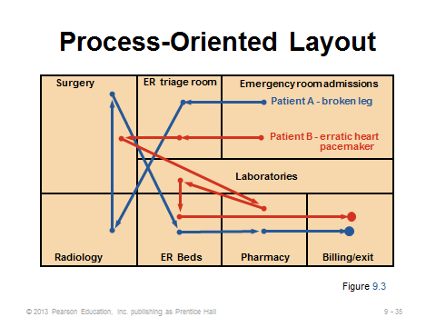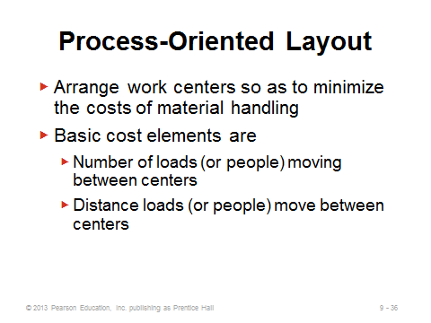
9-34 9-35 9-36
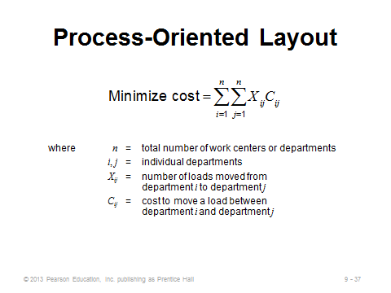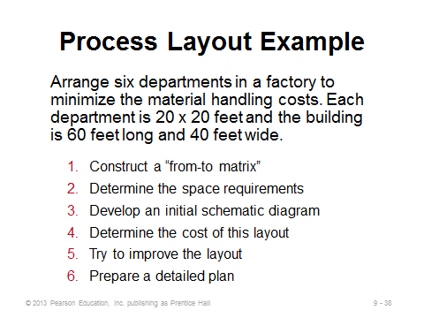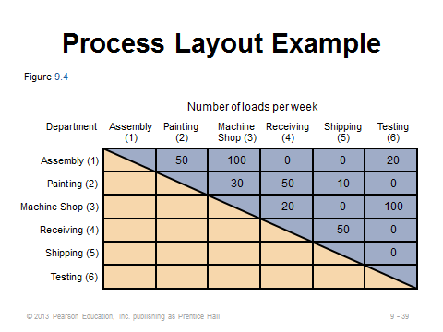
9-37 9-38 9-39

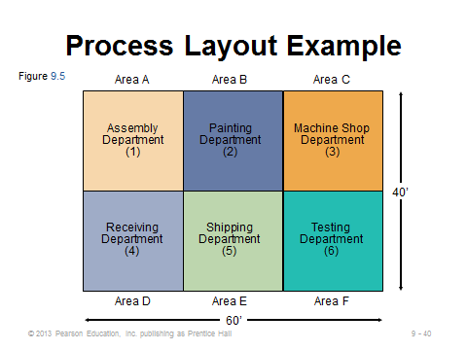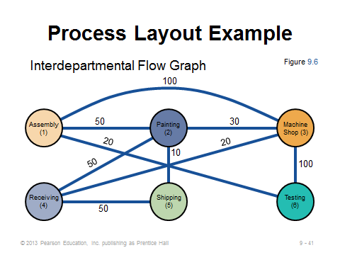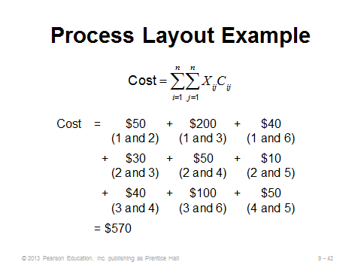
9-40 9-41 9-42
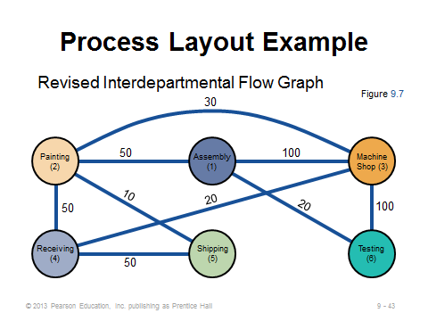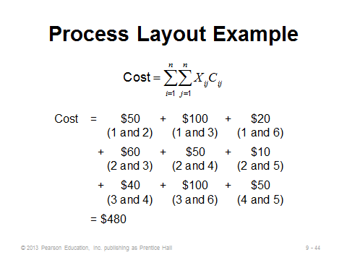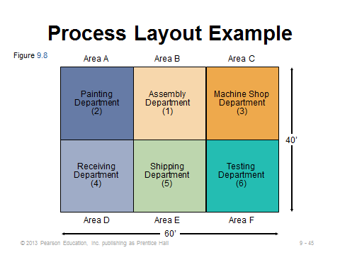
9-43 9-44 9-45
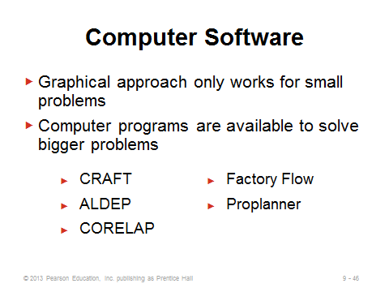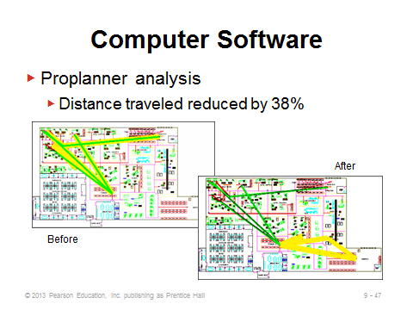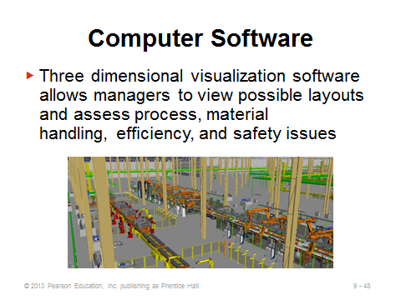
9-46 9-47 9-48

WORK CELLS (9-49 through 9-58)
Slides 49-51: Work cells can often be thought of as “mini-factories,” producing their own products or product groups. Slide 49 describes work cells, Slide 50 lists potential advantages stemming from focusing on one or few items as well as a sense of employee ownership, and Slide 51 identifies the requirements of cellular production.
Slides 52-53: These slides (Figure 9.9) illustrate two different instances where U-shaped layouts for work cells can be effective, particularly when the workers are cross-trained.
Slides 54-56: These slides address the issue of minimum staffing levels for work cells. Takt time is the pace of production units to meet customer demands. Slide 54 provides the takt time computation, and once that is known, the computation for the number of workers required. Slides 55-56 illustrate Example 2 from the text. Slide 55 shows the work balance chart (Figure 9.10), which delineates the various tasks and their times necessary for producing the product. The sum of these times equals the total operating time required for the product (the numerator of Equation (9-3)). Slide 56 shows that 2.92 (or 3) workers will be required. Note that this implies that one or more workers may work on more than one operation per product.
Slide 57: The staffing level calculation in Slide 54 (Equation (9-3)) assumes that either the time for the bottleneck operation is no more than the takt time or that more than one worker can help with the bottleneck operation. Cross-training of the workers, at least for manual operations, often overcomes minor imbalances in the work cell. However, if the bottleneck operation is machine-driven and has a larger time than the computed takt time, then the bottleneck’s time will determine the pace of production (see Supplement S7).
Slide 58: Slide 58 defines focused work center and focused factory.
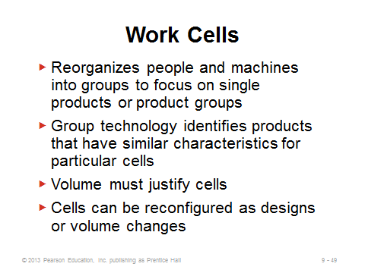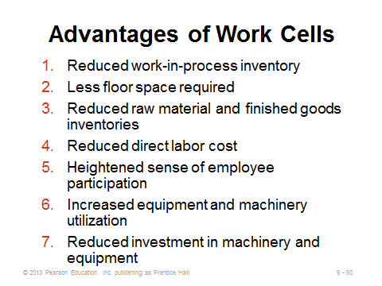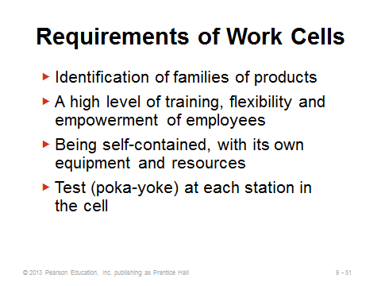
9-49 9-50 9-51
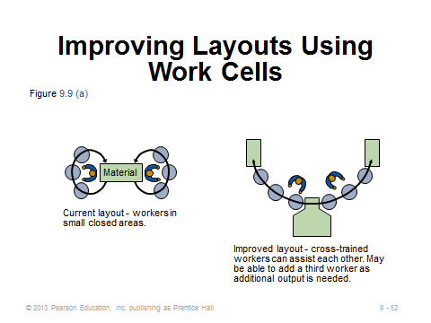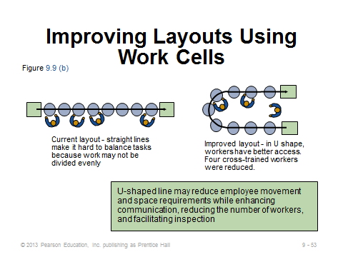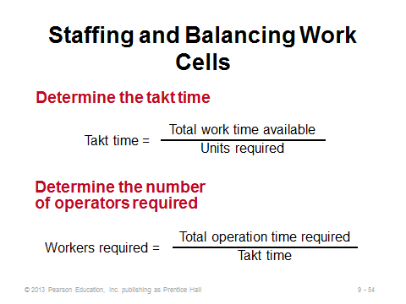
9-52 9-53 9-54
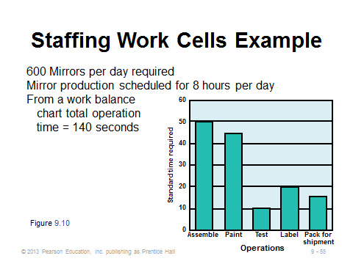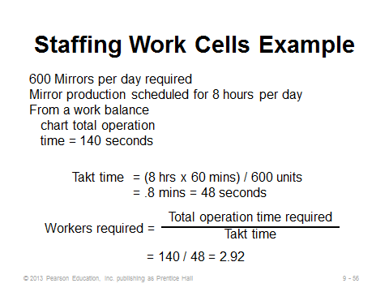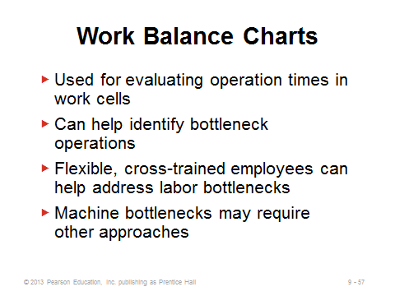
9-55 9-56 9-57
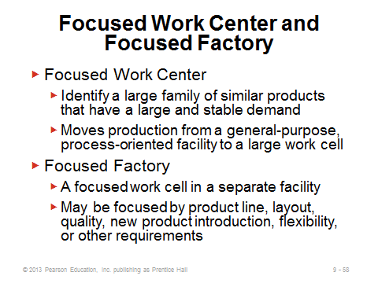
9-58

REPETITIVE AND PRODUCT-ORIENTED LAYOUT (9-59 through 9-68)
Slides 59-61: These slides describe product-oriented layouts, or what students imagine as traditional high-volume assembly lines. These often require a high level of capital investment for the specialized assembly line equipment. Less skilled labor is needed than for a process-oriented layout, implying potentially lower labor costs and less training. However, such jobs may be more boring for the workers, which could lead to morale and absenteeism issues. In terms of layout, the general placement of machines may be relatively straightforward as the order of machines must follow the progression of steps by which the product is made. Products often move down the line via automatic conveyor belts. Balancing the line becomes the major task in layout design.
Slide 62: This slide (Figure 9.11) illustrates the McDonald’s hamburger assembly line. Each hamburger goes through the same series of stations.
Slide 63: This slide identifies the steps in assembly-line balancing. Such an approach assigns multiple tasks to single workstations, in the hope that each workstation will then take approximately the same amount of time per product.
Slides 64-68: These slides cover Examples 3 through 5, which illustrate a line balancing application for Boeing. Slide 64 (Table 9.2) presents the time and precedence data for each task (similar to the project management tables of Chapter 3 but with times in minutes or seconds instead of days or weeks). Slide 65 presents the precedence diagram (Figure 9.12) and then overlays that with the cycle time and minimum number of workstations calculations. Slide 66 (based on Table 9.3) presents five of the most popular heuristics (rules) for assigning tasks to workstations. The Boeing example utilizes the most following tasks heuristic. Slide 67 (Figure 9.13) displays the solutions, and Slide 68 computes the efficiency of the line. A high efficiency value would imply little slack time in any of the workstations.
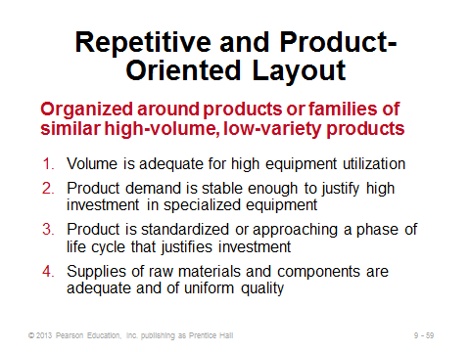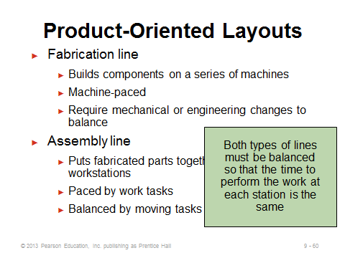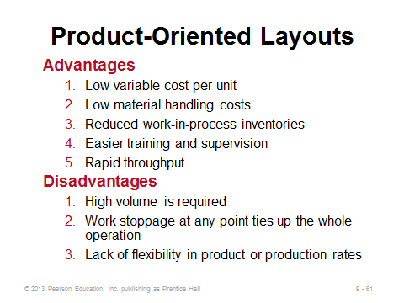
9-59 9-60 9-61
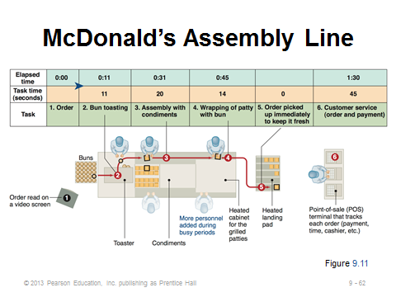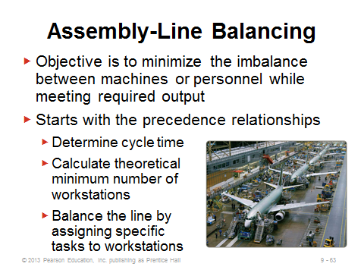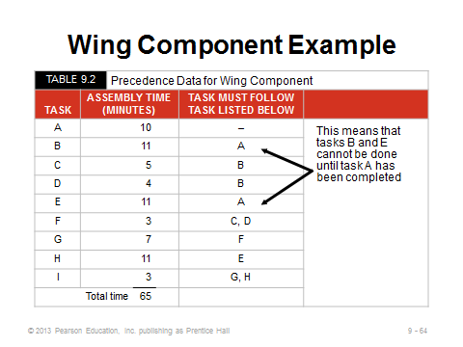
9-62 9-63 9-64
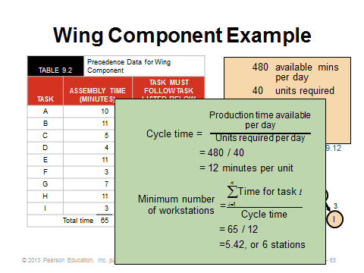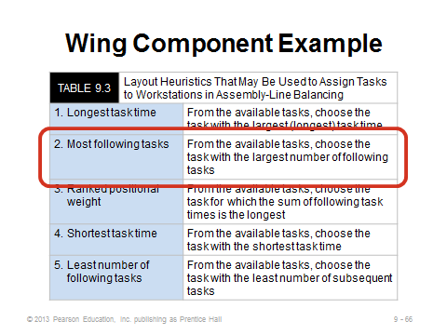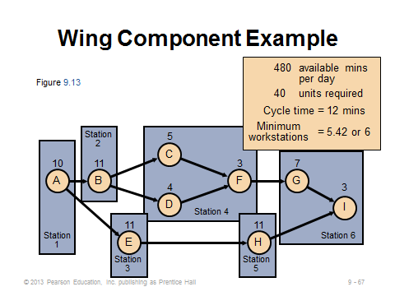
9-65 9-66 9-67
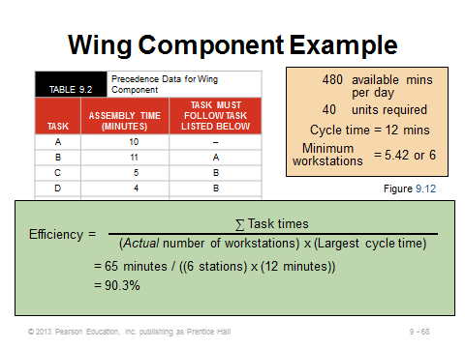
9-68

Additional Case Studies

Internet Case Studies (www.pearsonhighered.com/heizer)

- Microfix, Inc.: This company needs to balance its PC manufacturing assembly line and deal with sensitivity analysis of time estimates.

Harvard Case Studies (http://harvardbusinessonline.hbsp.harvard.edu)

- Assembling Smartphones: Takt Time ≠ Cycle Time? (#611012, © 2012)
- Delivery Problems at Arrow Electronics, Inc.(A), (#601131, © 2002)
- Toshiba: Ome Works (#696059, © 2008)

Ivey Case Studies (https://www.iveycases.com)

- Alara Agri: Fresh Cherry Production (#9B09D004, © 2009)
- Canadian Tire Check-out Configuration (#9B04D006, © 2009)
- Celestica, Inc. – Memory Business Unit (#9A97D005, © 2010)
Internet Resources

Commercial layout software from Cimtechnologies | www.cimtech.com
Layout: iQ | www.rapidmodeling.com
Proplanner’s Flow Planner calculator | www.proplanner.com/product/details/flowpath.aspx
Various facility design plans | www.manufacturing.net

