Chapter 8
Location Strategies

Background

Presenting location strategies can be fun because students have certain opinions and passions about geography. Being careful not to offend, the instructor can insert humor or quirky characteristics about locations (cities, states, countries) into the examples discussed. An easy target would be the home town of the rival sports team.

The two company videos associated with this chapter are particularly interesting when both are shown to the class because insightful comparisons can be drawn. The Red Lobster description of its graphical information system (GIS) might be especially eye-opening for students.

A lot of the location factors are interesting and potentially controversial. Discussion about any of those can carry on for some time.

Low labor costs often represent a major reason why companies (especially manufacturing firms) locate in particular countries. It may be useful to have a slide handy that compares hourly wage rates across certain countries, including the U.S., Germany, Japan, Mexico, and certain low-wage Asian countries.

Presentation Slides

INTRODUCTION (8-1 through 8-5)
Slide 8-5: Federal Express certainly represents a true American success story, beginning with an idea about overnight package delivery that few people thought that (1) would be feasible, and (2) customers would pay for. A key reason why it works is the use of a central hub system, and this slide describes the benefits. Instructors can expand on this slide in a couple of ways. First, why did FedEx choose Memphis instead of any other U.S. city? The firm was promising unprecedented speed, but that speed would be meaningless unless FedEx could deliver on its promise consistently. For speed, the firm needed a city in a central location in the U.S. For reliability, it needed a city with few weather delays, which eliminates other potential locations such as St. Louis, Chicago, Minneapolis, and Kansas City. Second, what are the alternatives to a central hub system? Presumably, the two most likely alternatives would be: (1) flying a separate plane from each source airport to each destination airport, or (2) flying one plane from each source airport but sending that plane to each destination airport. Assuming n sources and destinations and keeping in mind that packages must arrive at the addressee’s door the following day, compared to a central hub system option (1) would require n² planes vs. n planes, while option (2) would only require n planes but each would have to take off and land at all destinations before morning and the packages would have to be handled very carefully so they weren’t left at the wrong city. Such a discussion might be even more illuminating by picking, say five real cities and drawing plane routes on the board.
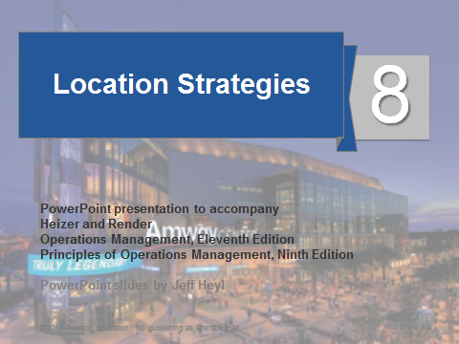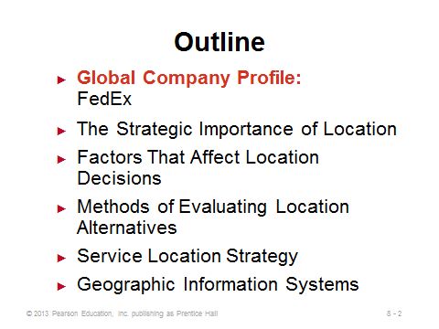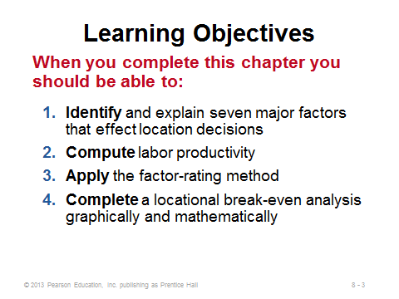
8-1 8-2 8-3
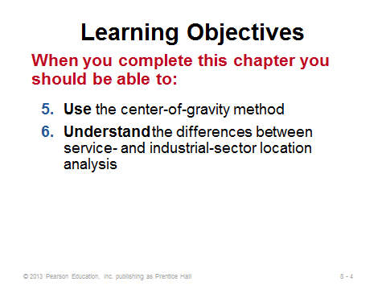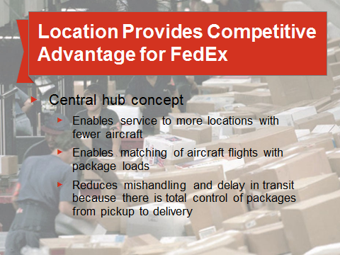
8-4 8-5

THE STRATEGIC IMPORTANCE OF LOCATION (8-6 through 8-9)
Slide 6: Instructors can use this slide to emphasize the importance of a quality location decision. Globalization has added options, but with more options comes a more complicated decision process. Location decisions are typically long-term in nature and can have a huge impact on both revenue and cost.
Slides 7-8: Most location decisions induce a long-term resource commitment from the firm (Slide 7), so those decisions need to be made with great care. Slide 8 identifies the three major location options. Each has certain pros and cons. For example, on-site expansion is generally cheapest and does not disperse the existing labor force; however, the layout may get de-optimized, and maintaining a single location maximizes disaster risk. Adding a new branch helps to diversify disaster risk, and the firm can design an optimal layout at the new facility; however, management now must deal with multi-site overhead, and any problems that exist at the current location will not be addressed. Relocating a facility may help to solve problems that exist at the current location, and the firm can design an optimal layout; however, there may be substantial moving and startup costs, the firm may lose good people who do not want to move, and maintaining a single location maximizes disaster risk.
Slide 9: Location-related costs, such as utility and local labor costs, are often out of the firm’s direct control, so it is somewhat locked into dealing with these cost levels once the location decision is made.
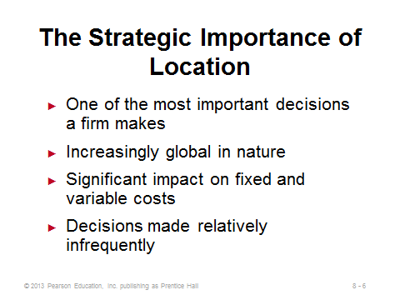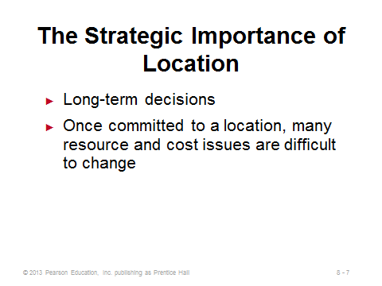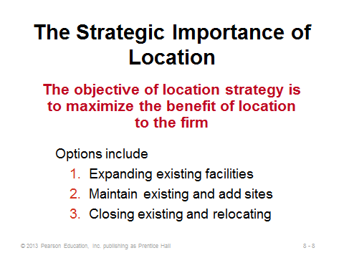
8-6 8-7 8-8
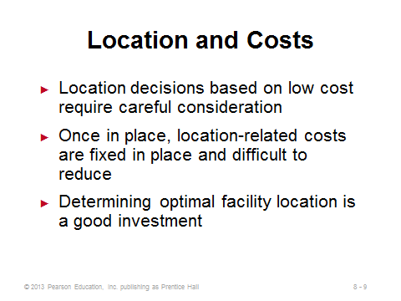
8-9

FACTORS THAT AFFECT LOCATION DECISIONS (8-10 through 8-24)
Slide 10: Selecting a facility location is becoming much more complex with globalization. This slide identifies five developments that have led to increased globalization. One approach to selecting a country is to identify what the parent organization believes are key success factors needed to achieve competitive advantage.
Slides 11-13: As exemplified by the Hard Rock Cafe video associated with Chapter 8, firms often divide their location decisions into three levels: first choosing a country, then a region, then finally a specific site. Slides 11-13 (Figure 8.1) identify key factors that may arise for each of the levels.
Slide 14: Based on country success factors such as those identified in Slide 11, as well as certain negative factors such as crime, the World Economic Forum biannually ranks the global competitiveness of 142 countries.
Slide 15: Productivity differences among locations (which may be due to system or infrastructure factors, or possibly differences in the workers themselves) need to be considered when comparing costs. This slide provides a simple example of a higher wage rate location actually being cheaper overall due to productivity differences.
Slides 16-21: These slides cover some of the key success factors in more detail. Exchange rates are mentioned in Slide 16. Students understand that these vary over time, but they are often mistaken in believing that exchange rate movements can be predicted with any accuracy. (If anyone could, then that person should be making millions of dollars speculating in the currency markets and not spending time reading this chapter.) For example, just because the dollar has been falling in value over the past several months compared to, say, the euro, gives no indication of what will happen next. Thus, it’s dangerous to make future cost predictions based on exchange rates that are any different than the current ones. Instructors could take time here to talk about managing exchange rate risk by using either financial hedging (options) or operational hedging (excess capacity in different locations that is called upon when exchange rates shift). Slide 17 is emphasizing, in particular, that when firms jump around the world chasing the lowest costs, they may create hardship on their most recent geographical “tenants.” Also, some locations are low cost because they have few environmental regulations, but should a firm intentionally go somewhere so that it can pollute more? When viewing Slide 18, instructors might mention that it is possible to purchase political risk insurance. Firms that wish to avoid the possibility of corruption might be interested in country corruption rankings such as those provided by Transparency International (Slide 19). Slides 20-21 illustrate that sometimes desired proximity (to markets, suppliers, or even competitors) drives the location decision. Access to a significant resource pool (labor, raw materials, etc.) often drives competitors to locate near one another (Slide 21). But competitors sometimes cluster for marketing purposes instead. For example, in the restaurant world, studies have shown that more total customers will visit restaurants that are located near each other than would if they are not. Presumably, all restaurants get a piece of this bigger customer pie.
Slides 22-24: These slides provide excellent examples of clustering of competitors, and they are clustered for some very different reasons.
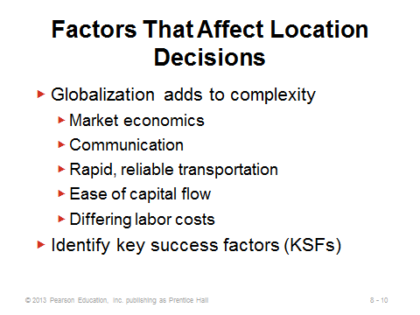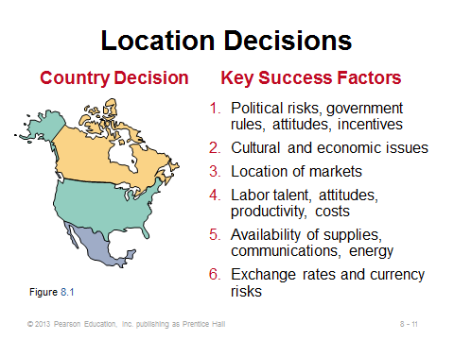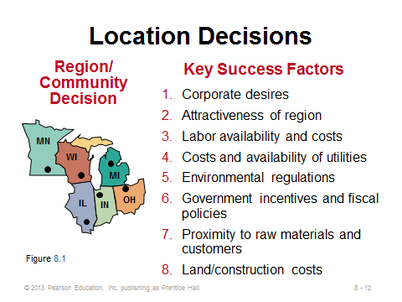
8-10 8-11 8-12
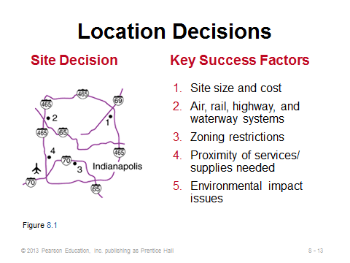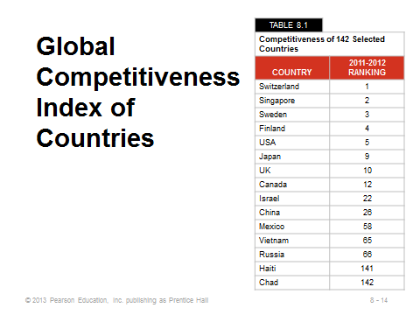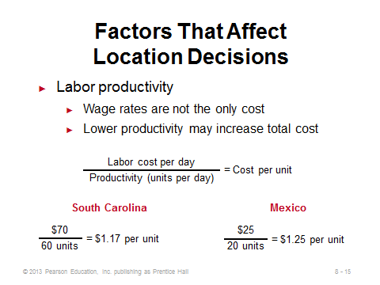
8-13 8-14 8-15

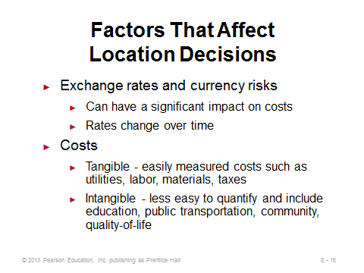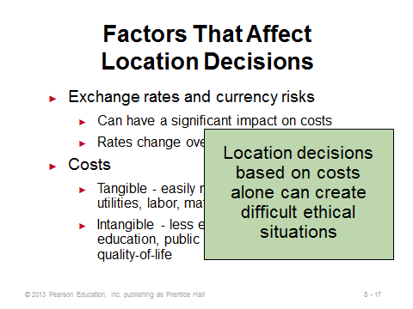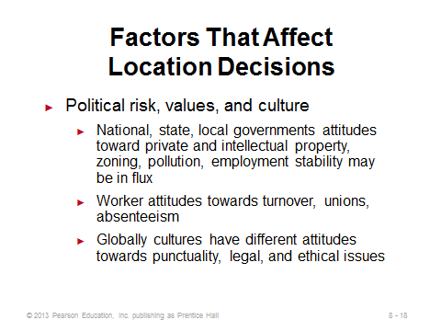
8-16 8-17 8-18
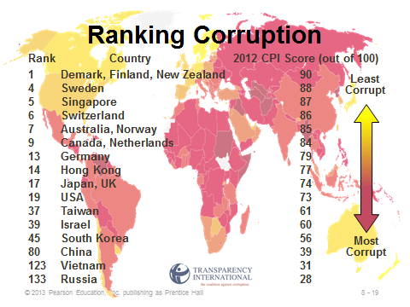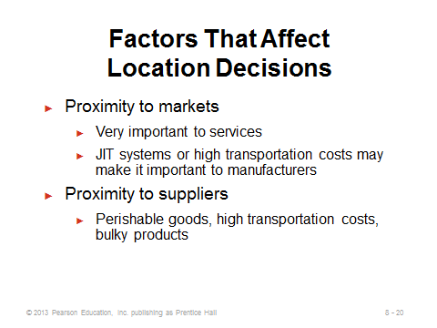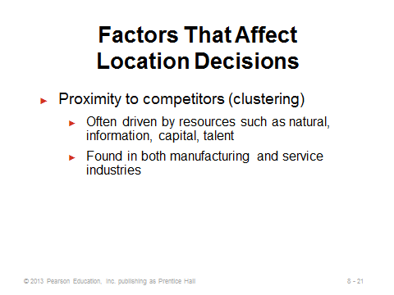
8-19 8-20 8-21
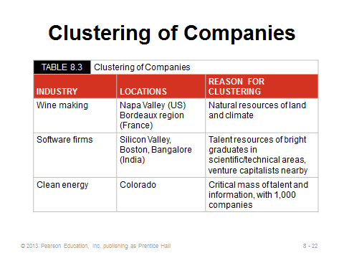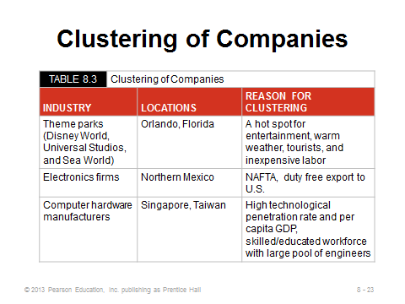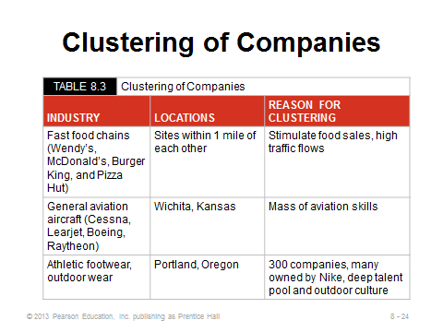
8-22 8-23 8-24
METHODS OF EVALUATING LOCATION ALTERNATIVES (8-25 through 8-39)
Slides 25-26: These slides describe the factor-rating method, which is used by many companies. It represents an attempt to convert qualitative factors into a numbers that can be analyzed. As the example (Example 1) in Slide 26 clearly shows, the method represents a simple weighted average approach. Instructors should point out some inherent dangers. While the approach appears to be objective in nature, it contains several subjective elements. For example, the weights themselves are subjectively chosen, and the actual location score for each factor may involve significant individual judgment as well. Raters should be careful—for example, when one location has a score of 80 and second has a score of 40, is the second location really 50% worse on that factor than the first location? And does 50% worse on one factor mean the same thing as 50% worse on another factor? Manipulators can play tricks with such methods by, for example, only including factors that are favorable for their favorite location or by including a bogus site that is so much worse on a particular factor (say, one that the manipulator’s favorite location performs poorly on) that the scores for all of the other locations end up being too close together in order to create the appropriate distance in score from the bogus location. Nevertheless, despite potential abuses and shortcomings, the factor-rating method can lead to thorough analysis and insight of many factors that should go into a proper location decision, and it can provide and objective-looking analysis to back up the final decision.
Slides 27-30: These slides describe and illustrate (Example 2) locational cost-volume analysis, which can be useful when comparing locations with clear fixed and linear variable production costs. The technique is the same idea as crossover analysis applied in Chapter 7 to process choice decisions.
Slides 31-37: These slides provide the formulas and a detailed example (Example 3) for the center-of-gravity method, used to find the weighted-average midpoint among a set of destinations to be served. Such methods are particularly useful for warehouses and distribution centers, or any locations either receiving from disperse sources or shipping to disperse customers. The method assumes Euclidean (straight-line) travel. Weights can be based on total volume shipped or shipping cost (total volume times each unit’s shipping cost per mile). Note that the actual center of gravity could place the facility in an undesirable location such as a volcano or the ocean. Typically, once the center of gravity is determined, a follow-up load-distance analysis of actual possible locations near the true center of gravity might be conducted. Two notes about the calculations: (1) the optimal x- and y-coordinates are computed separately, but they share the same denominator (the sum of the weights), and (2) calculations can be simplified by expressing weights, say, in thousands (for Slide 36)—since the numerator and the denominator can both be divided by 1000, the answers will be the same.
Slides 38-39: These slides examine the transportation model, which is described briefly in the text. This is also referred to as the allocation problem in the literature. Production-allocation decisions can change from period to period as production or transportation cost, plant capacity, and demand conditions change. The transportation model is one of the classic linear programming applications (see Module C). Relatively large problems can be solved using Excel’s Solver add-in. Interested instructors could even create some n ×m transportation model templates to provide to the students so all that the students would have to do is enter plant capacities, demands, and from-to costs, then invoke Solver to produce the optimal solution. Slide 39 (Figure 8.4) illustrates Volkswagen’s complex supply network. The transportation model can often be used to optimize distribution networks such as this one.
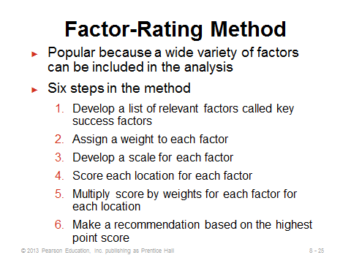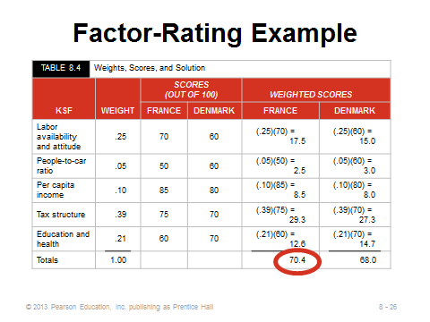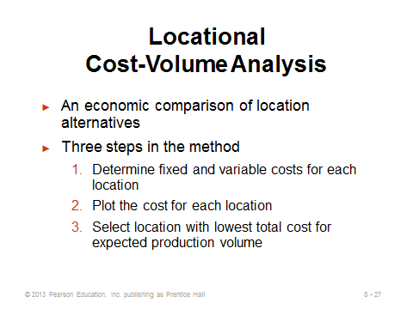
8-25 8-26 8-27
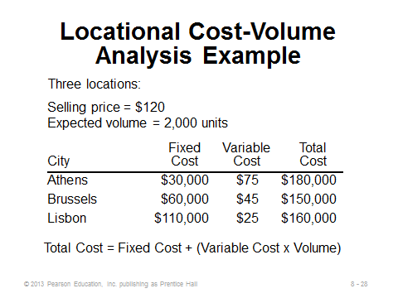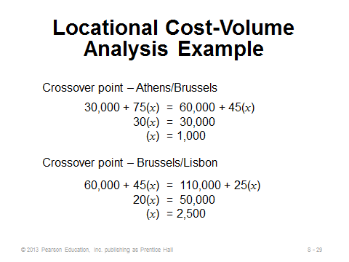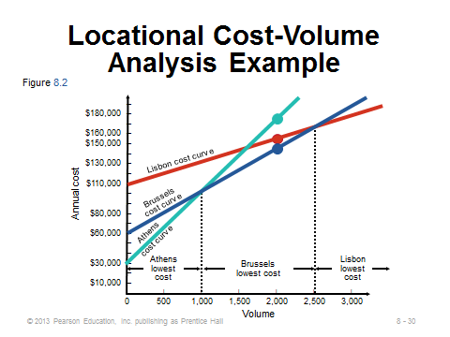
8-28 8-29 8-30
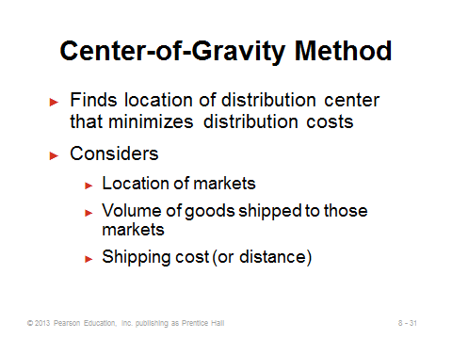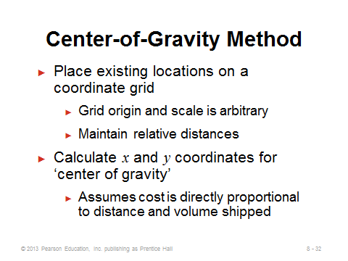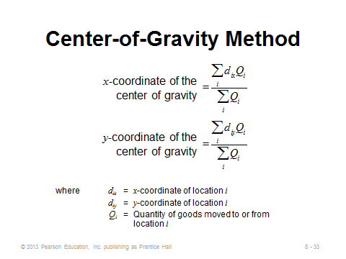
8-31 8-32 8-33
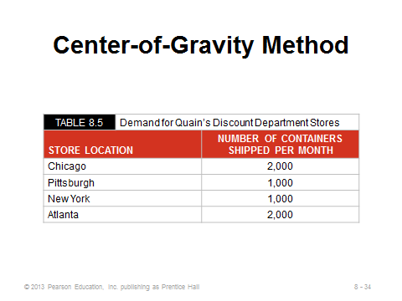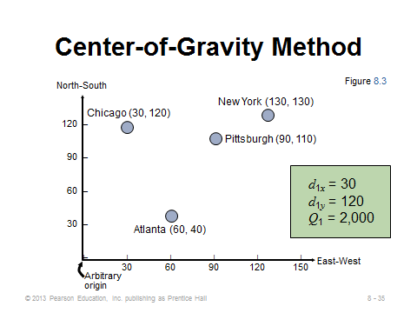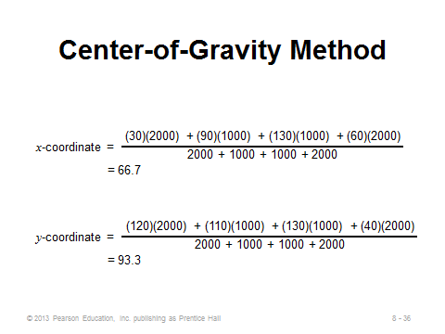
8-34 8-35 8-36
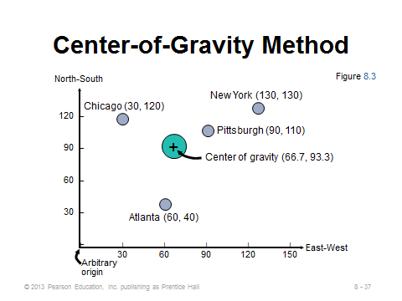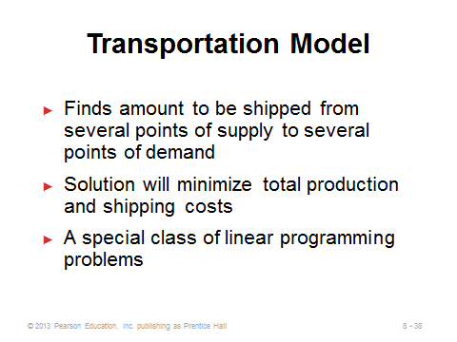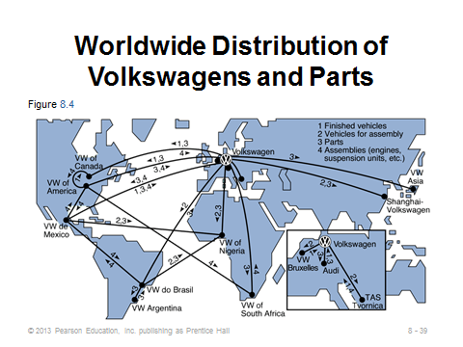
8-37 8-38 8-39

SERVICE LOCATION STRATEGY (8-40 through 8-43)
Slide 40: This slide identifies the eight major determinants of volume and revenue for the service firm.
Slides 41-42: These slides reproduce Table 8.6 from the text, which differentiates the location strategies and decisions between service and manufacturing firms. Almost every aspect of the decision is different.
Slide 43: This slide describes La Quinta’s regression model for location analysis (OM in Action: How La Quinta Selects Profitable Hotel Sites). Most of the predictive power of profitability (the dependent variable) is contained in just four variables: (1) price of the inn, (2) median income levels, (3) state population per inn, and (4) location of nearby colleges. La Quinta then used the regression model to predict profitability and developed a cutoff that gave the best results for predicting success or failure of a site. A spreadsheet is now used to implement the model, which applies the decision rule and suggests “build” or “don’t build.”
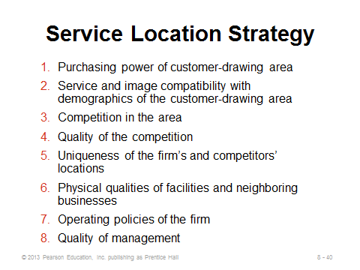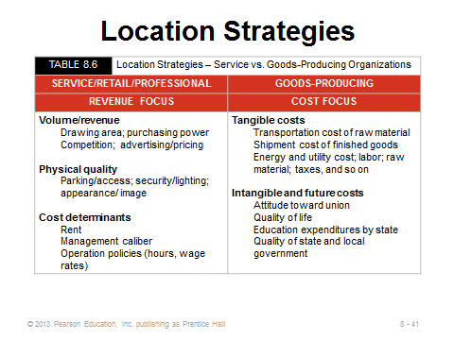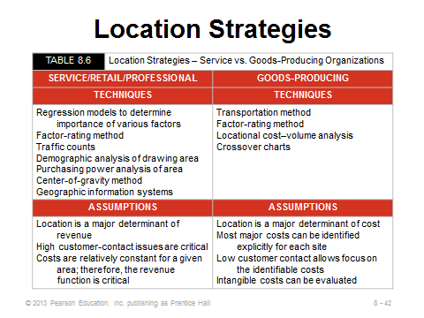
8-40 8-41 8-42
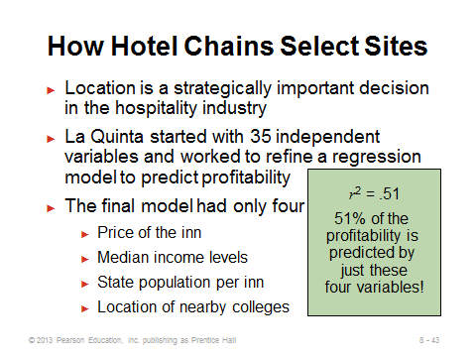
8-43

GEOGRAPHIC INFORMATION SYSTEMS (8-44 through 8-45)
Slides 44-45: These two slides describe and illustrate geographic information systems (GIS), which are marvelous detailed informational tools of particular use for companies in a constant growth mode. The text provides several interesting GIS applications, and the Chapter 8 video, “Locating the Next Red Lobster Restaurant,” provides an excellent description of how the firm makes regular use of GIS to aid its location decisions for new restaurants.
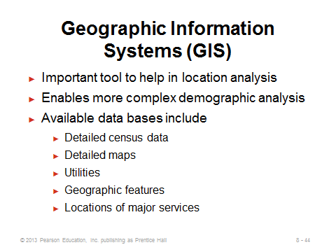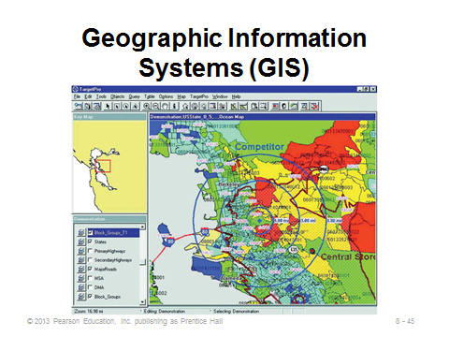
8-44 8-45

Additional Case Studies

Internet Case Study (www.pearsonhighered.com/heizer)

- Southwestern University's Location Decision (E): The University faces three choices in where to locate its football stadium.

Harvard Case Studies (http://harvardbusinessonline.hbsp.harvard.edu)

- AMD Dresden: Copy Inexactly! (#609004, © 2010)
- Intel: Strategic Decisions in Locating a New Assembly and Test Plant (A)
(#713406, © 2012)
- NEC: A New R&D Site in Princeton (#898027, © 2004)

Ivey Case Studies (https://www.iveycases.com)

- Are We Ready for an Automotive Plant? (#9B09D014, © 2010)
- Location Planning at A.B. Corp. (#9B12D008, © 2012)
- Whitewater West Industries Limited (#9A96D005, © 2010)

Internet Resources

Economic Development Service | www.sitelocationassistance.com
Location Strategies | locationstrategies.com
National Association of Manufacturers | www.nam.org
Site Selection Magazine | www.conway.com
Transparency International, which maintains a bribe payers perception index (BPI) and a corruption perception index. | www.transparency.org

