Supplement 7
Capacity and Constraint Management

Background
Even though this is a supplement, it contains enough information to be treated as an independent chapter. The bottleneck analysis material itself could easily be expanded to cover a full class session, particularly if the dice game simulation (see Active Classroom Learning Exercises) is played. Taken together, the tools and concepts in this chapter provide the future operations manager with an excellent starting point for thinking about capacity issues.

Class Discussion Ideas

1. One interesting way to demonstrate design and effective capacity is to use the school’s lecture halls as an example. While the design capacity is every seat full for all classes, the effective capacity is considerably less. This can be compared to other services such as airlines or restaurants.

2. A simple question that can generate a long list of ideas is to ask the students for ways in which firms can increase capacity in the short run and the long run. While the distinction between the short and long run is not always clear (and not necessarily that important anyway), the following types of answers might be provided. Short run: using longer production runs implying fewer setups, using overtime, subcontracting, adding shifts, hiring temporary workers, leasing equipment, renting more space, using better or faster workers, eliminating inefficiencies, increasing productivity, improving bottleneck capacity, and decreasing maintenance and/or eliminating inspections and/or eliminating/reducing employee breaks (these last three ideas may have detrimental long-run implications). Long run: purchase new equipment, automate processes, design new processes that are more product focused, expand the permanent workforce, expand facilities, enter into joint ventures, and purchase (merge with) the competition.

3. If the I Love Lucy video is shown (see Cinematic Ticklers below), 5-10 minutes of discussion can follow. This clip is as much about poor management techniques as it is about not matching the process time of a station with the speed of incoming product. Ask students what went wrong. They’ll likely identify some of the following. There was no training of the new employees. There was no supervision. We observe “management by threat.” The incentive was only to wrap every candy without letting any get through unwrapped, implying no quality control and encouraging the hiding of mistakes. There was no employee involvement. Communication was one way from the boss to the workers. Communication within the production line was non-existent—if the upstream station knew what was happening, it might have slowed down the line.

Active Classroom Learning Exercises

1. Hands-On Simulation of the Dice Game from The Goal
The dice game in Chapter 14 in The Goal (Goldratt and Cox, Third Revised Edition, North River Press, 2004) can be played in the classroom with groups of five people. The only supplies needed are dice and “products” (matches or pennies, for example). The game as described during the Boy Scout hike in The Goal demonstrates the detrimental effects of dependent events and statistical fluctuations on throughput.

The game places five players in a row. The first player has an unlimited supply of raw materials. During each round, player 1 rolls one die and moves that number of products into the raw materials bowl of player 2. Then player 2 rolls the die and moves the minimum of the roll and the number of products in the bowl into the raw materials bowl of player 3. This continues down the line. Player 5’s throughput (minimum of his/her raw materials or die roll) represents the system throughput for that round. The game continues for several rounds, with extra raw materials remaining in bowls in between rounds. The results: throughput will decrease from the start of the line to the end of the line.

The game can be played for several rounds with one group in front of everyone to demonstrate the effects. Then students can be asked to brainstorm ideas for changing the rules of the game to increase throughput. Ideas might include purchasing extra dice (more resources), replacing with bigger (e.g., 12-sided) dice (faster resources), introducing buffer inventory, or flipping a coin (Heads = 3, Tails = 4) (representing more accurate equipment)]. Afterwards, each group can be allowed to “purchase” an option or combination of options. Then let each group play the game for, say, 20 rounds and compare profit results. Revenue is based on throughput times a sales price, and cost depends upon the option purchased. This game can be automated in Excel and played for hundreds of rounds as well (see Additional Assignment Ideas below).

2. While the snowmobile/jet ski example clearly illustrates the concept of complementary demand, both markets already existed so entry was a relatively straightforward exercise. It can be a different proposition when there is no market and the organization has to create one. In the 1960’s Head had a successful business making metal snow skis. However, with no obvious complementary product, they had to create a market for metal tennis rackets in order to develop a complement to their ski production. Have the students investigate the product lines of a few local firms to see if they are using complementary products to balance demand. If they are not, have the students suggest possible complementary products that might be developed or adopted.

Company Videos
1. Capacity Planning at Arnold Palmer Hospital (8:39)
The Arnold Palmer Hospital was initially built to handle 6500 births per year, but demand soon began to run up against this limit. The hospital decided to build a brand new building across the street from the current one to eventually raise the birthing capacity to 15,000 babies per year. The first nine floors were built in the first phase, and later floors would be completed on an incremental basis as demand continued to rise. The video shows a break-even graph, as well as pictures from the text describing the four different ways to add capacity: (a) leading demand with incremental expansion, (b) leading demand with one-step expansion, (c) lagging demand with incremental expansion, and (d) attempts to have an average capacity with incremental expansion.

Prior to showing the video, instructors could ask students to think about different ways that a hospital might attempt to increase its capacity in terms of number of patients served per year. As the video itself describes several means of incremental and large expansion, discussion following the video could cover the various types. An interesting example is trying to reduce the time in the hospital for patients. What might be done to accomplish that? Are there ethical concerns with trying to move patients through faster? Other ideas could include things like having more shared rooms compared to private rooms, replacing certain hospital services and focus more on a few procedures (for example, eliminating certain surgical procedures that the hospital performs and replacing with more birthing space). Regarding major expansion, such as a new building, an interesting question becomes how large to make it. If the number of births is growing by 600 per year, will that growth continue beyond 10 years, and, if so, should building space (even if empty for the time being) be built at one time? Moreover, is bigger always better? How many births should this hospital perform before it begins to turn customers away?

Cinematic Ticklers
1. I Love Lucy, The Complete Second Season: “Job Switching” (Lucille Ball and Vivian Vance), Paramount, original airdate Sep. 15, 1952
This classic clip shows Lucy and Ethel wrapping candies on an automatic assembly line. The clip never fails to generate laughter in the classroom. Soon after the line starts up, the women fall behind and start to store, hide, and eat the product to avoid letting any get through unwrapped (because they’ll be fired if that happens). The situation only worsens when the supervisor returns to observe no problems (due to hidden and destroyed candy), so she yells out, “Speed it up a little!”

Jay and Barry’s OM Blog

1. OM in the News: Overcapacity Hits the European Auto Makers
European auto makers are now facing the dramatic issue of too much manufacturing capacity. About 30 of the 98 European auto-assembly plants are operating below 70% of their capacity.

http://heizerrenderom.wordpress.com/2012/06/23/om-in-the-news-overcapacity-hits-the-european-auto-makers/

2. OM in the News: How Airlines Match Capacity to Demand
Many fewer people fly in the winter than during school breaks, major holidays, and summer vacations. Here we see four suggested OM strategies that airlines can implement to break the cycle.

http://heizerrenderom.wordpress.com/2012/03/02/om-in-the-news-how-airlines-match-capacity-to-demand/

3. OM in the News: What Happens When Disney, Universal, and Legoland Reach Capacity
This is an interesting story of how different companies deal with capacity constraints. Universal and Disney’s tactics for managing operations at full capacity are described here.

http://heizerrenderom.wordpress.com/2012/01/01/om-in-the-news-what-happens-when-disney-universal-and-legoland-reach-capacity/

4. OM in the News: UPS Drivers Pick Up the Pace
The WSJ (Sept. 16, 2011) describes how UPS’s newest cost savings strategy will save $70 million per year. Drivers will use a digital remote fob to save time per stop while reducing motion and fatigue.

http://heizerrenderom.wordpress.com/2011/09/19/om-in-the-news-ups-drivers-pick-up-the-pace/

Presentation Slides

INTRODUCTION (S7-1 through S7-5)
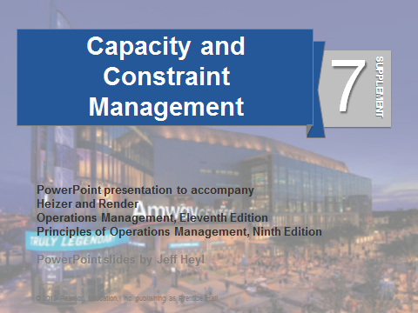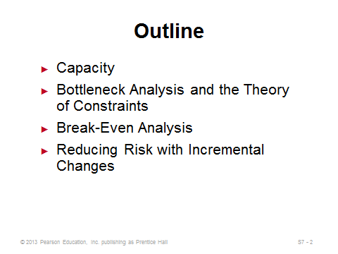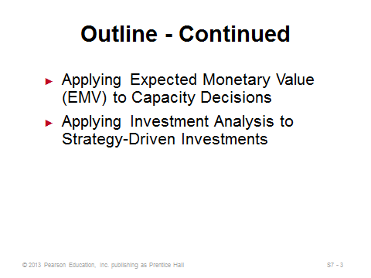
S7-1 S7-2 S7-3
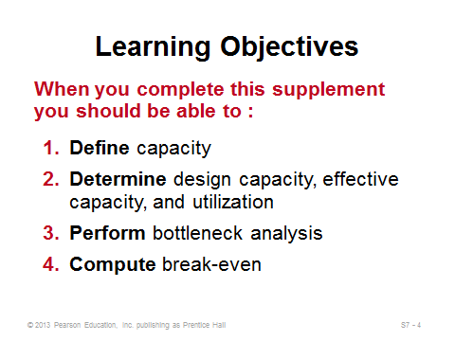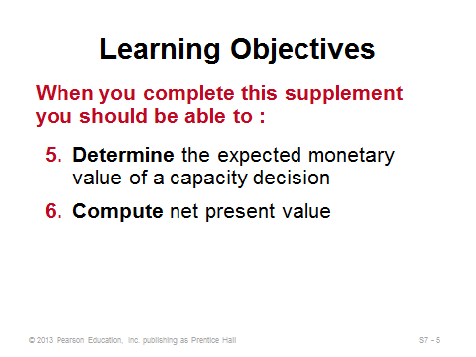
S7-4 S7-5

CAPACITY (S7-6 through S7-23)
Slides 6-7: These slides define capacity and illustrate how to modify or use capacity under each of the three planning horizons (short-range, intermediate-range, and long-range).
Slides 8-9: These slides define four common capacity-related terms: design capacity, effective capacity, utilization, and efficiency. Note that achieving 100% utilization or 100% efficiency may be difficult or even impossible. Operations managers tend to be evaluated on efficiency. The key to improving efficiency is often found in correcting quality problems and in effective scheduling, training, and maintenance.
Slides 10-14: These slides go through the steps of Example S1 from the text, the Sara James Bakery example. Slide 10 computes weekly design capacity. Slide 12 computes utilization. Slide 13 computes efficiency.
Slides 15-16: These slides go through the steps of Example S2 from the text, the Sara James Bakery (continued). Here we see the formula for actual (or expected) output.
Slides 17-19: The strategic importance of capacity decisions is emphasized in Slide 17. Slide 18 identifies four special considerations for a good capacity decision. One of these is find the optimum operating size (volume), which is illustrated in Slide 19 (Figure S7.2) showing economies and diseconomies of scale.
Slides 20-22: These slides cover issues in managing demand. Slide 20 identifies some options for handling situations of demand not matching capacity. Slide 21 (Figure S7.3) illustrates an example of producing products with complementary demand patterns (jet skis and snowmobiles). Other examples might include lawn mowers and snow blowers, basketballs and baseballs, or swimsuits and ski pants. Slide 22 identifies some options for adjusting capacity up or down to better match a fixed demand rate.
Slide 23: This slide touches on demand and capacity management levers commonly employed in the service sector. Appointments and reservations can allow service businesses more control over the timing of demand than a typical manufacturing firm might have. An additional demand management technique is to provide off-peak pricing to smooth out demand over a day (e.g., rush-hour movie specials), a month (e.g. Costco coupons only valid for a two-week period in the latter half of the month), or even a year (e.g., deep discounts at ski resorts during summertime).
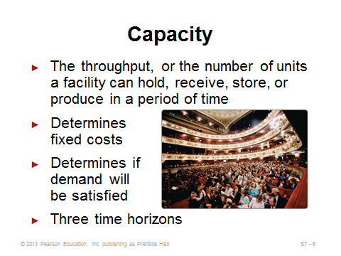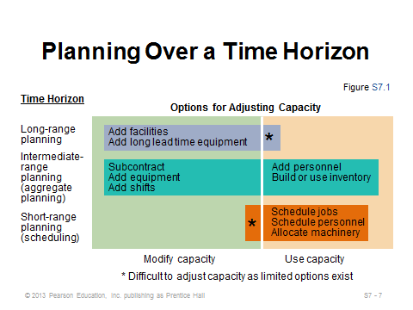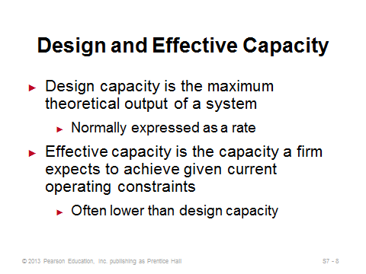
S7-6 S7-7 S7-8
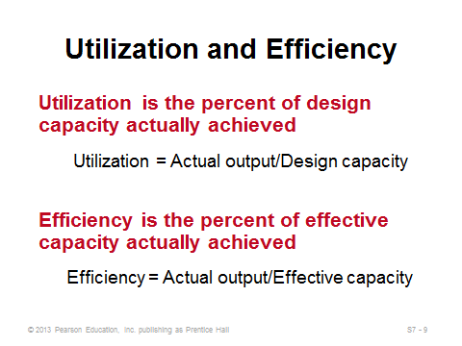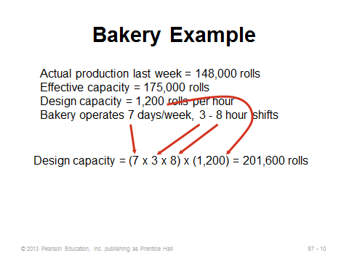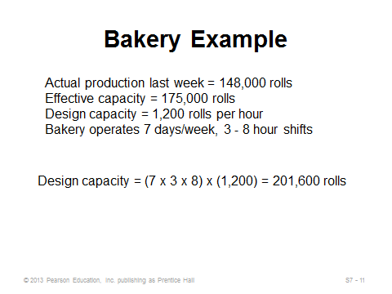
S7-9 S7-10 S7-11

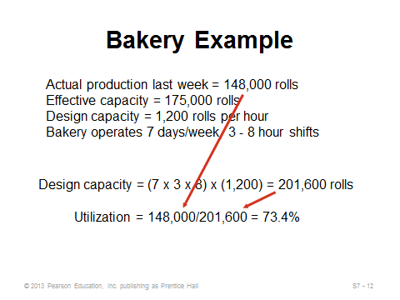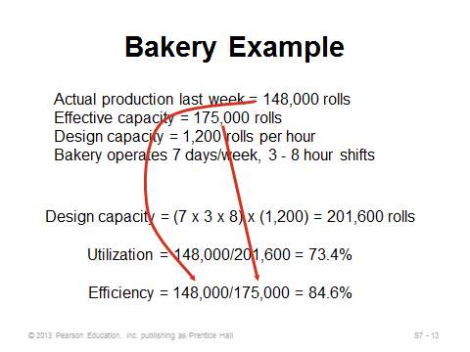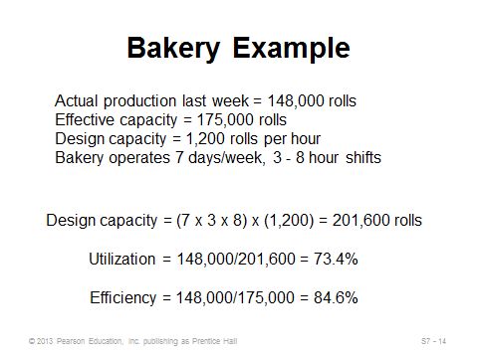
S7-12 S7-13 S7-14
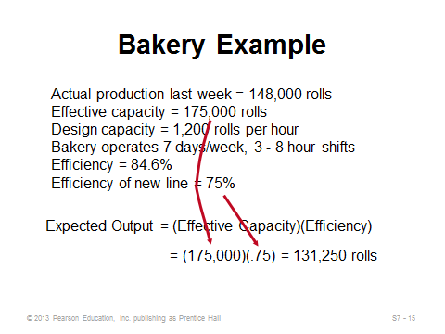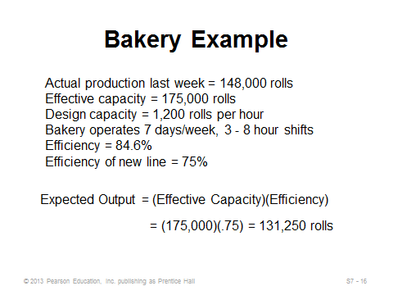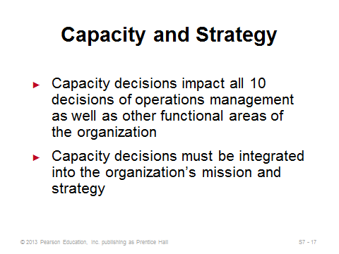
S7-15 S7-16 S7-17
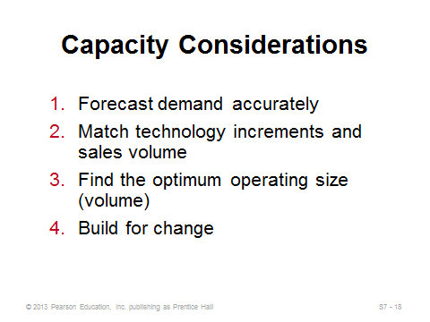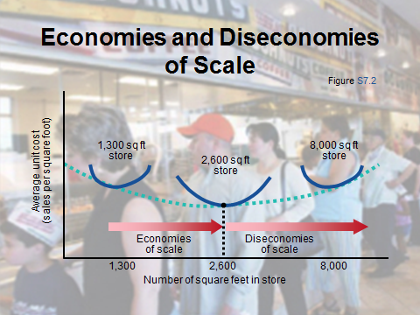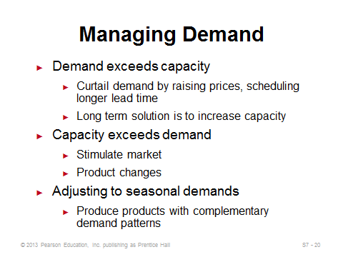
S7-18 S7-19 S7-20
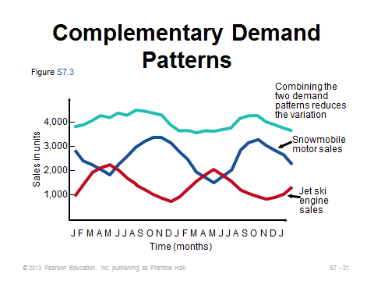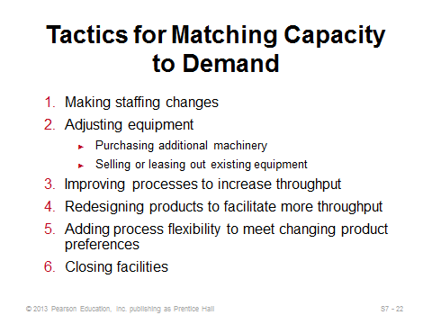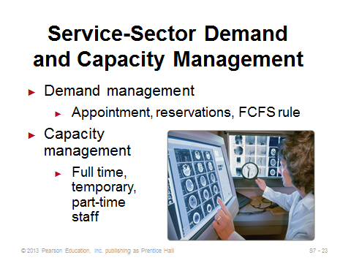
S7-21 S7-22 S7-23

BOTTLENECK ANALYSIS AND THE THEORY OF CONSTRAINTS (S7-24 through S7-31)
Slides 24-25: This section covers a topic often ignored in introductory operations management books but that is crucial for anyone analyzing processes—bottleneck analysis. Just as a chain is not stronger than its weakest link, a production system can produce no faster than its slowest station (bottleneck). Therefore, operations managers must learn to identify the bottleneck(s) in a process and focus on improving its (their) capacity to increase the throughput of the entire system. Goldratt’s and Cox’s popular book, The Goal: A Process of Ongoing Improvement, 3rd rev. ed. (Great Barrington, MA: North River Press, 2004) describes the bottleneck phenomenon very well; however, it leaves out the details of how to actually identify the bottleneck (which may not always be obvious). Many students have a surprisingly difficult time grasping the concepts illustrated in the examples in this section. Slide 24 provides the definition of bottleneck. Important process analysis definitions are provided in Slide 25. Students sometimes have a hard time understanding why the bottleneck time of a system may be so different from the throughput time. An automobile assembly line can be a good example to try to illustrate the difference. An efficient and balanced, conveyor-belt controlled, assembly line might have stations with 60-second cycle times; thus, a new car is produced on the line every 60 seconds (bottleneck time). However, a brand new car might take 30 hours to produce from scratch (throughput time). Therefore, the bottleneck time determines its capacity, while the throughput time determines potential lead time for new orders. The simple assembly line in Slide 25 (Figure S7.4) can be used to try to illustrate the basic concepts. The longest station in this assembly line is Station B at 4 minutes per unit. Thus, B is the bottleneck and the bottleneck time is 4 min./unit. It doesn’t matter how fast Stations A and C can produce—the system cannot pump out a product any faster than one every 4 minutes. (This can be illustrated by moving pennies (products) through the assembly line and recording the completion times of each product at each station.) A 4-minute bottleneck time implies a production capacity of (1 unit/4 min.)(60 min./hr.) = 15 units per hour. On the other hand, throughput time is computed by adding up the total time to send one unit through the system without any waiting. In this example, the throughput time is 2 + 4 + 3 = 9 minutes.
Slides 26-27: These slides summarize Example S3, which incorporates parallel operations. Slide 27 includes all of the calculations, and helpfully puts the process flow chart at the top of the slide. Instructors should point out that process times are divided by two when there is a parallel operation, but throughput times are not divided by two because one unit must still be processed for the full length of time at each station. It may help to explain why it makes sense to divide by 2 for the process times of the bread and fill operations. If start times were staggered, say, every 10 seconds, then a new sandwich would emerge from the fill operations every 10 seconds, even though it takes 20 seconds to fill any particular sandwich. If helpful, instructors can illustrate this point using pennies on the flow chart and recording completion times at each station.
Slides 28-29: These slides summarize Example S4, which incorporates simultaneous processes. Slide 29 includes all of the calculations, and helpfully puts the process flow chart at the top of the slide. The important point in this example is that the computation of throughput time does not involve simply adding all times in the system together. Due to simultaneous processing, the time of each path through the system must be computed—with the longest path representing the throughput time.
Slide 30: This slide identifies the five steps of the theory of constraints, popularized in The Goal. This approach applies to managing bottlenecks and more broadly to anything that limits or constrains an organization’s ability to achieve its goals.
Slide 31: This slide identifies four principles of bottleneck management. Principle 1 warns not to release orders into the system any faster than the bottleneck’s pace. Principle 2 implies that the bottleneck should always be kept busy with work (e.g., don’t let bottleneck workers take breaks without available replacement workers). Principle 3 warns not to produce faster than the bottleneck’s pace at non-bottleneck stations. Principle 4 implies that improvement efforts should focus on the bottleneck.
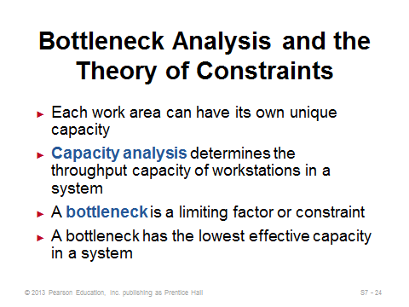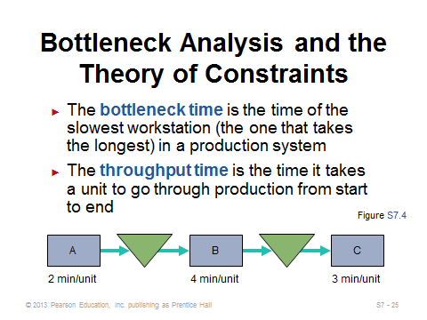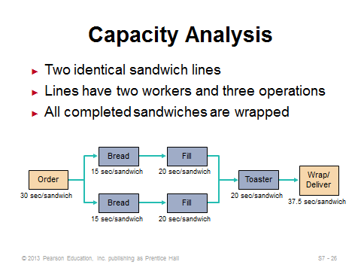
S7-24 S7-25 S7-26
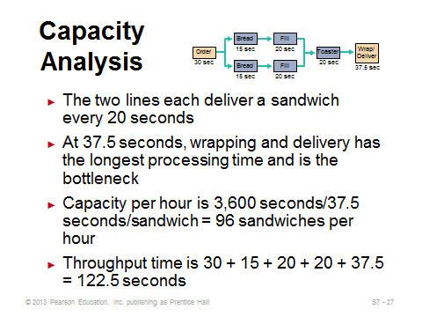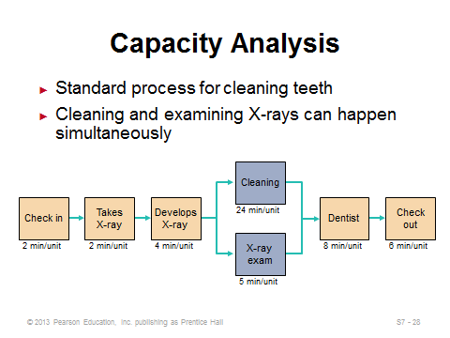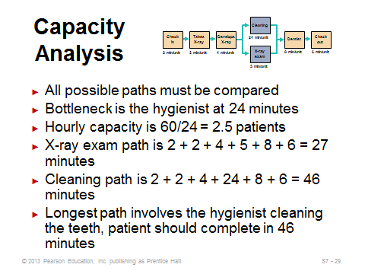
S7-27 S7-28 S7-29
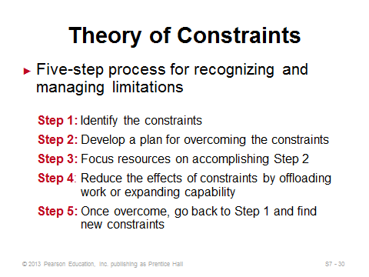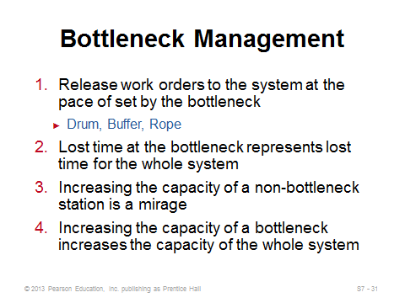
S7-30 S7-31

BREAK-EVEN ANALYSIS (S7-32 through S7-44)
Slides 32-38: These slides provide the foundation for break-even analysis, which is the critical tool for determining the capacity that a facility must have to achieve profitability. Slide 32 provides the definition, objective, and requirements. Slide 33 describes the two different types of costs considered: fixed and variable. Slide 34 describes the behavior of the revenue function. The graph in Slide 35 (Figure S7.5) suggests that approximately 475 units must be produced and sold in order to start making a profit. Slide 36 identifies limitations of using the simple linear break-even analysis approach. Slides 37 and 38 provide the necessary formulas, which can all be derived with some simple algebra.
Slides 39-41: These slides present Example S5. Note that the graph in Slide 41 is not presented in the text.
Slides 42-44: These slides present the multiproduct break-even analysis. Slide 42 presents the formula for the break-even point in dollars. Slides 43 and 44 present Examples S6 and S7 together.
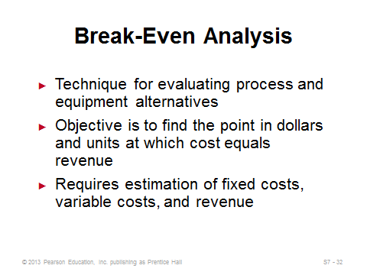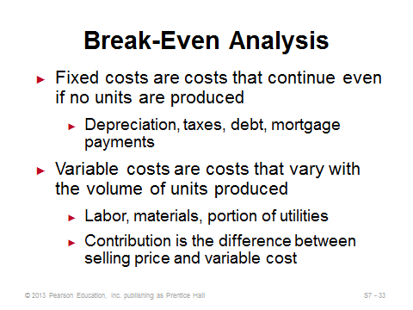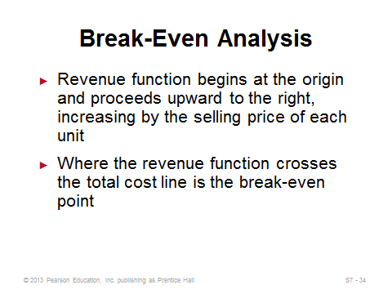
S7-32 S7-33 S7-34
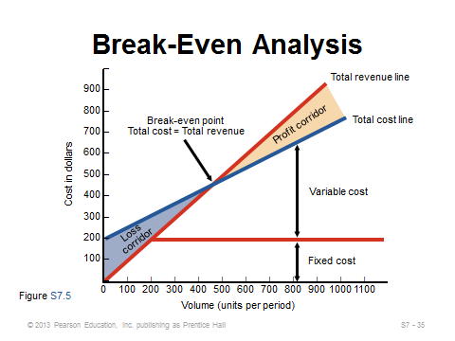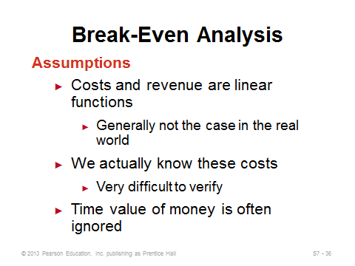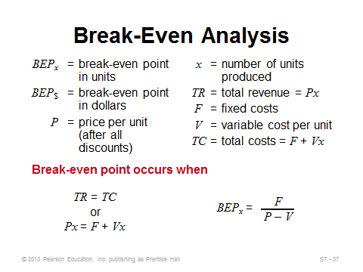
S7-35 S7-36 S7-37
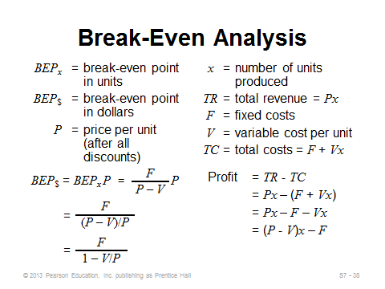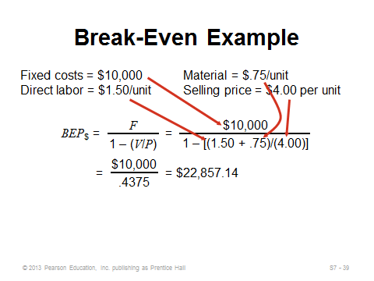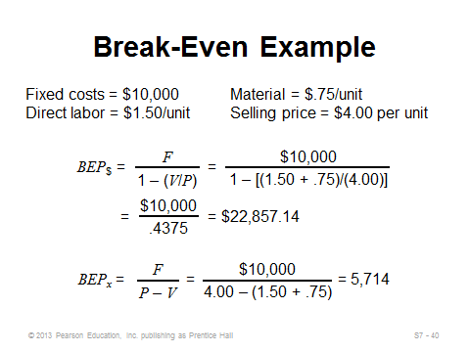
S7-38 S7-39 S7-40
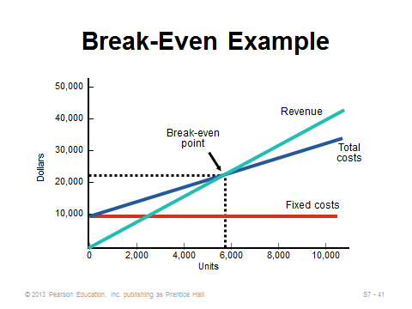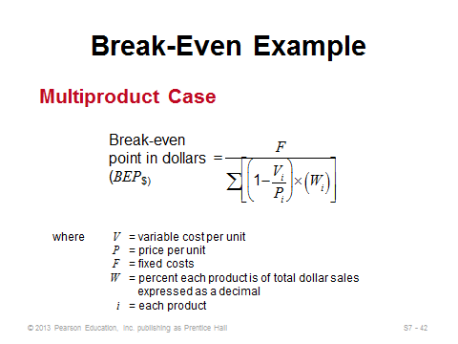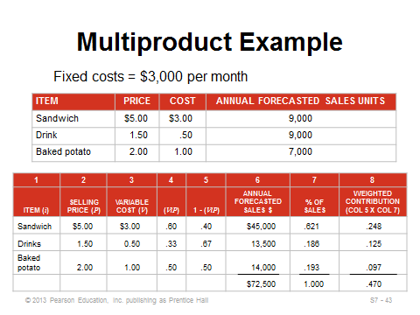
S7-41 S7-42 S7-43
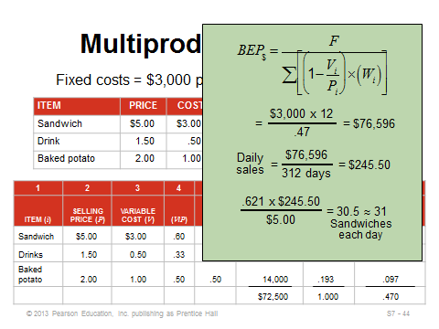
S7-44

REDUCING RISK WITH INCREMENTAL CHANGES (S7-52 through S7-55)
Slides 45-49: Slide 45 (Figure S7.6) displays the four approaches to adding new capacity: lead with incremental expansion, lead with one-step expansion, lag, and straddle. The next four slides focus on each approach individually. A leading strategy captures all demand, but at the cost of excess capacity for certain time periods. Leading with incremental expansion (Slide 46) involves less excess capacity and doesn’t tie up as much money compared to a one-step expansion (Slide 47); however, economies of scale in construction and equipment purchase may encourage expanding all at once. A one-time expansion also avoids the effects of inflation and maximizes flexibility in output rate. A lag strategy (Slide 48) never underutilizes capacity, but it may be unable to capture all demand. A straddle strategy (Slide 49) attempts to minimize the disadvantages of the two extreme strategies, while still retaining some of the advantages.

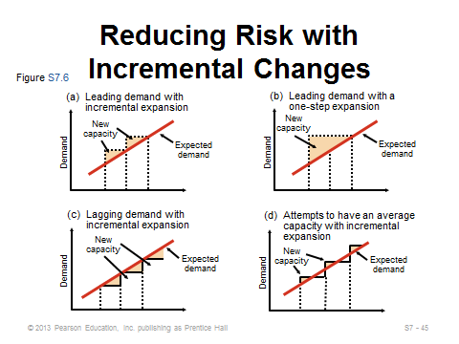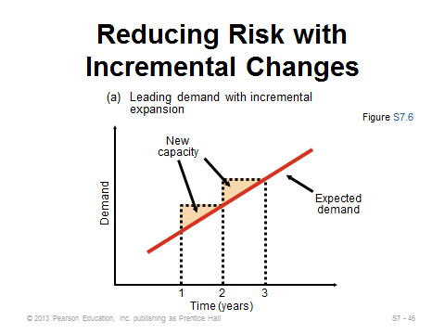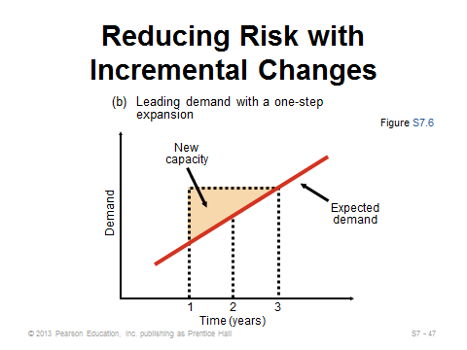
S7-45 S7-46 S7-47
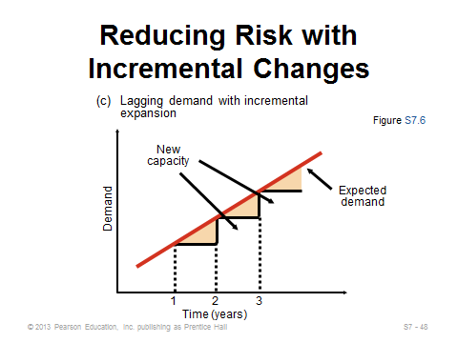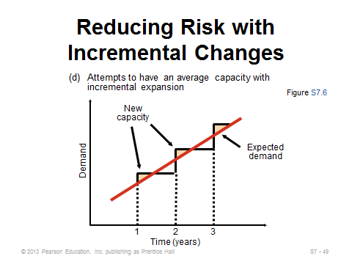
S7-48 S7-49

APPLYING EXPECTED MONETARY VALUE (EMV) TO CAPACITY DECISIONS
(S7-50 through S7-51)
Slides 50-51: Expected monetary value (EMV) computes the expected value of various alternatives, where the probabilities are assigned to various possible future states of nature. Slide 51 presents Example S8 from the text. Note that the text simply computes the EMV of each alternative and chooses the one with the highest EMV. For straightforward alternatives such as this with only one decision point, a decision tree (see Module A) could help visually but is not necessary to conduct the analysis.
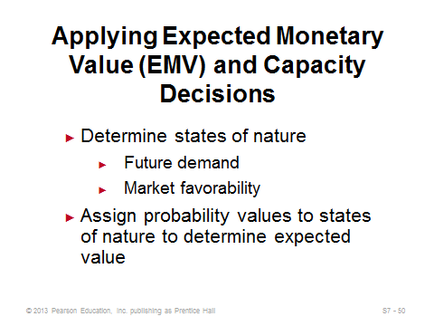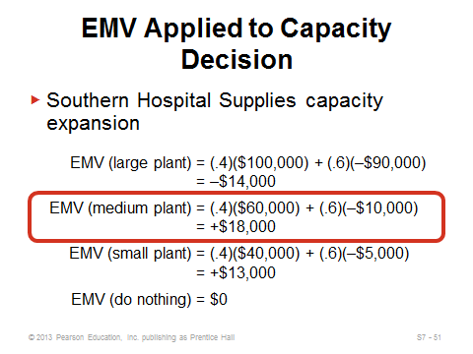
S7-50 S7-51

APPLYING INVESTMENT ANALYSIS TO STRATEGY-DRIVEN INVESTMENTS
(S7-52 through S7-59)
Slide 52: The discipline of finance provides us with the concept of net present value (NPV), which discounts future cash flows to be expressed in today’s dollars. When comparing investment alternatives, the one with the highest NPV is preferable. Although not covered in this short section of the text, it should be noted that taxes and depreciation are important elements in most NPV analyses.
Slides 53-55: Slide 53 presents the basic NPV formula, but Slide 54 warns that it can be cumbersome to implement. Slide 55 shows how to compute NPV using a table such as S7.1 from the text.
Slides 56-58: An annuity is a series of equal payments over time. The present value of an annuity can be easily computed using a table such as S7.2 in the text. These slides present the approach and illustrate it with Example S9.
Slide 59: This slide identifies some of the limitations of the NPV approach.
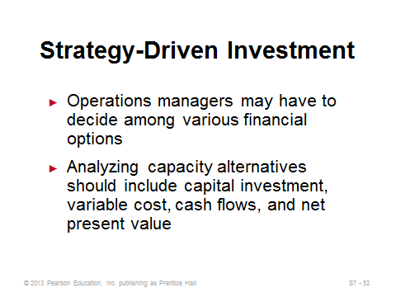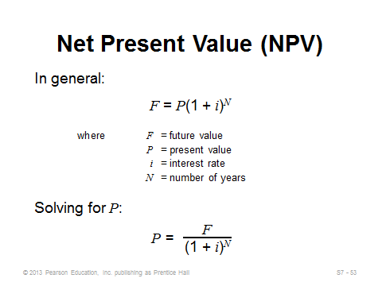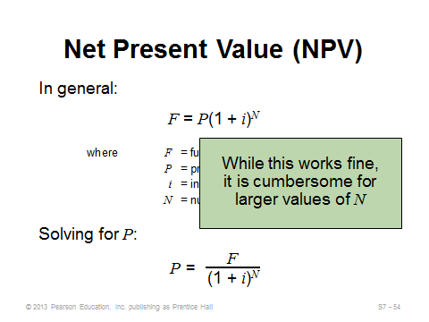
S7-52 S7-53 S7-54
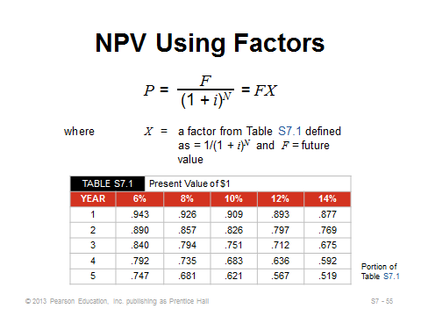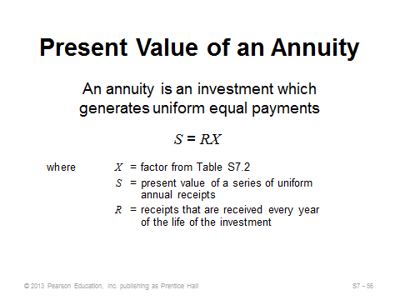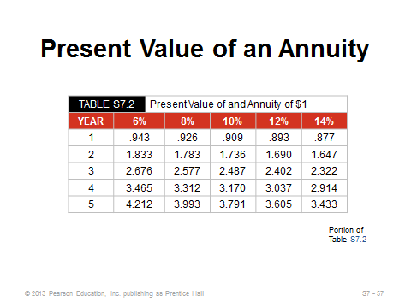
S7-55 S7-56 S7-57
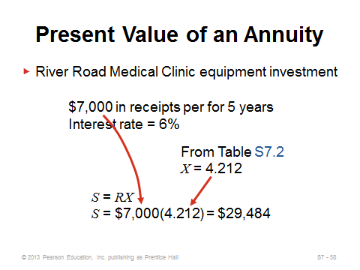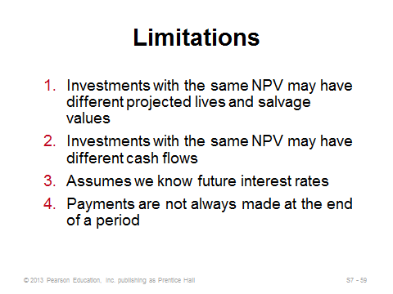
S7-58 S7-59

Additional Case Studies

Internet Case Study (www.pearsonhighered.com/heizer)

- Southwestern University's Food Service (D): Requires the development of a multi-product break-even solution.

Harvard Case Studies (http://harvardbusinessonline.hbsp.harvard.edu)
- Fresh Connections (#600022, © 2003)
- Kristen’s Cookie Co. (A) (Abridged) (#608037, © 2007)
- Scharffen Berger Chocolate Maker (A) (#606043, © 2010)

Ivey Case Studies (https://www.iveycases.com)

- Elizabeth’s Country Wares (#9B09D009, © 2010)
- Premanik Containers and the Bottleneck Challenge (#9B12E015, © 2013)
- Warehousing Strategy at Volkswagen Group Canada Inc. (VGCA) (#9B12D002, © 2012)

Internet Resources

American Council of Engineering Companies | www.acec.org
Association for Manufacturing Excellence | www.ame.org
DARPA: U.S. Defense Dept., Innovative Prototype Systems | www.DARPA.mil

