Chapter 7
Process Strategy and Sustainability

Background

Figure 7.1 represents a modification of the product-process matrix, championed by Hayes and Wheelwright. The new entry in recent years was not thought possible in the past, that is, mass customization. We should see more movement towards mass customization in the coming years, copying firms that have successfully implemented this approach.

This chapter is mostly conceptual, incorporating discussion of the four basic process strategies, the primary tools of process design, service process design issues, along with several different examples of technology. Sustainability issues have been increasing in importance in the past few years and are highlighted in this chapter. The chapter lends itself to creativity in the classroom. Students can brainstorm or work on exercises involving things like: (1) potential design of processes for products or services that have not even been invented yet, (2) redesign of processes that students think work poorly now, or (3) applying process analysis and design tools to any process that the instructor deems worthy.

Presentation Slides

INTRODUCTION (7-1 through 7-6)
Slides 5-6: These two slides feature Harley Davidson, which remains one of the very few U.S. motorcycle manufacturers. The firm owes much of its success to its loyal customer base, but also to a lean production system. Parts that feed the main assembly line are manufactured in work cells (process focus). The assembly line is a repetitive process, but actually contains features of mass customization because Harley can produce a wide variety of products at a rate of up to 600 units per day.

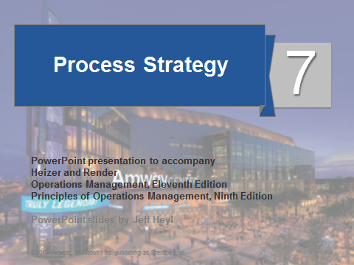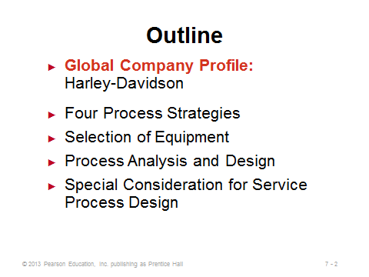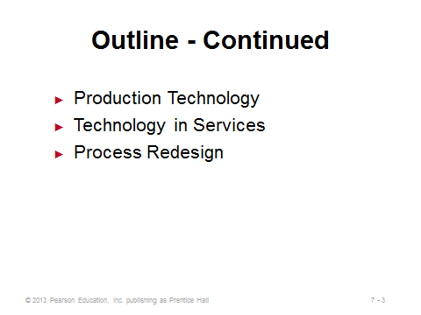
7-1 7-2 7-3
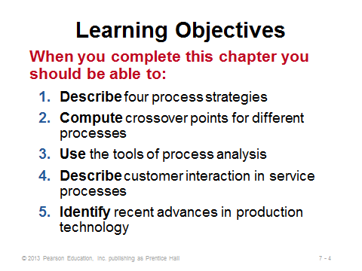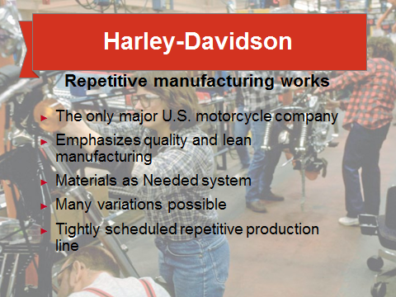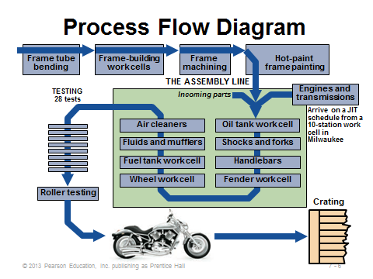
7-4 7-5 7-6

FOUR PROCESS STRATEGIES (7-7 through 7-28)
Slides 7-10: These slides identify the four basic strategies. Slide 9 reproduces Figure 7.1 from the text, showing where the four main process strategies fit along the matrix of product volume/product variety. Mass customization used to be thought of as unattainable, but technology and reduced changeover costs have opened the possibility for some firms.
Slides 11-12: These slides describe process focus and illustrate it with Arnold Palmer Hospital (Figure 7.2(a)). In general, the product or customer going through a process focus facility has no pre-defined flow. Any particular product or service may undertake a unique route through the system. Such systems, like job shops or banks, end up with certain processes having long waiting lines while other processes in the facility may be empty.
Slides 13-14: These slides describe repetitive focus and illustrate it with Harley Davidson (Figure 7.2(b)). A typical assembly line is a repetitive focus, as is a batch flow system. Repetitive processes have some flexibility in creating output variety but are limited by the variety of subassemblies that reach the assembly line.
Slides 15-16: These slides describe product focus and illustrate it with Frito-Lay (Figure 7.2(c)). Product-focused operations are often called continuous flow systems, and they may run 24 hours per day, not stopping for changeovers for weeks at a time. Product focus is all about creating very high volume in the most efficient way possible.
Slides 17-20: These slides describe mass customization and illustrate it with the Dell Computer model. Slide 18 (Table 7.1) provides some nice examples of how the number of choices for some products has skyrocketed in the past 30-40 years. Mass customization is designed to fulfill those increasingly varying customer needs while still producing large volumes at a reasonable cost. As Slide 19 suggests, the key to successful implementation of mass customization often rests in designing products and processes that incorporate common subassemblies. In this way, final customized assembly can occur very quickly to create a unique product, yet the firm does not have to produce and hold every product option in inventory. This technique is called postponement. Slide 20 identifies typical necessary conditions for successful mass customization.
Slides 21-24: These slides replicate Table 7.2 from the text, which arguably contains the most important conceptual information in the chapter. It is probably worth spending several minutes covering those comparisons, point-by-point. Characteristics in the repetitive process column typically represent a compromise or intermediate position between the two extremes of process focus and product focus. To achieve mass customization, the firm would have to ask itself what investments or changes might be required to move from its current strategy in column 1, 2, or 3 to column 4.
Slides 25-27: Crossover charts represent the only real math in Chapter 7. Slides 25 and 26 present the data and calculations, respectively, from Example 1. Slide 27 reproduces Figure 7.3 from the text, which illustrates the concepts from the example. If the fixed and variable costs of different production strategies can be accurately estimated, crossover charts help to determine the ranges of volume for which each strategy is cheapest.
Slide 28: Focusing on processes implies a move towards specialization, limiting the number of activities, products, and/or technologies. “Focus” is often a reason given why firms outsource so many activities. The concept of focused processes sounds like the opposite of the goal of mass customization. In fact, the instructor might want to ask the students why the book seems to be touting the benefits of both. Which is better to strive for? Is it possible to have “focused mass customization?”
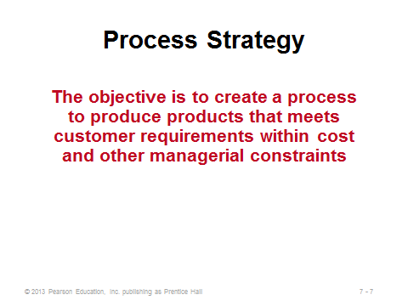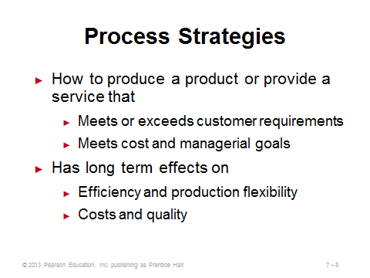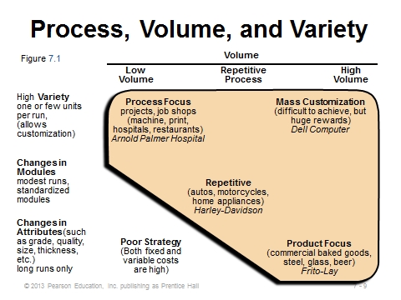
7-7 7-8 7-9

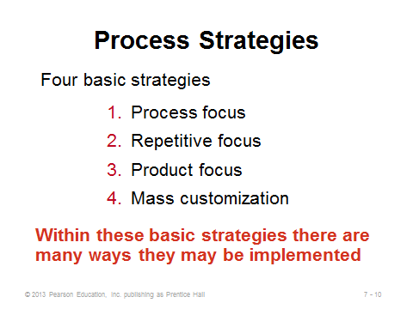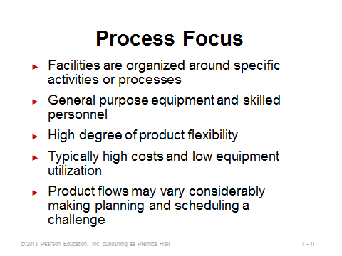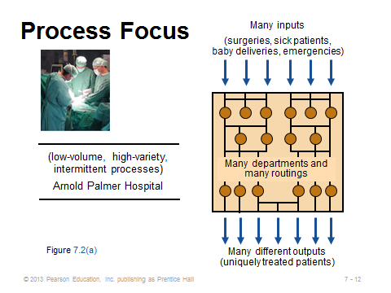
7-10 7-11 7-12
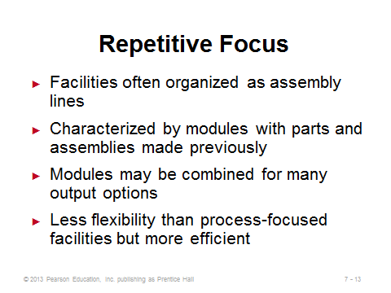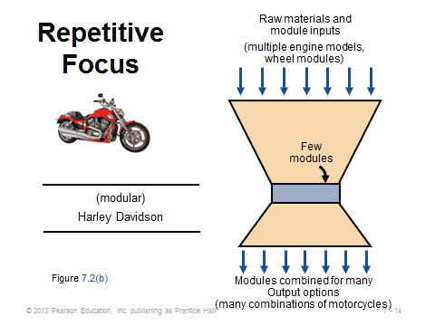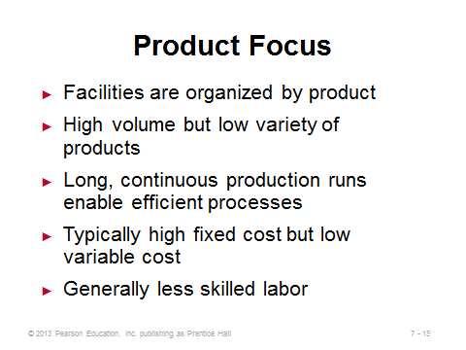
7-13 7-14 7-15
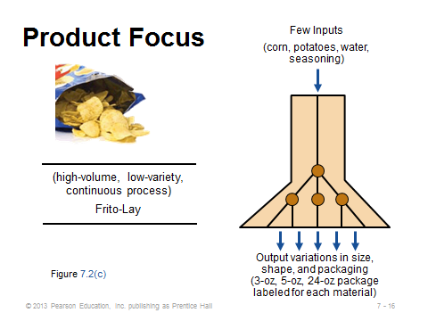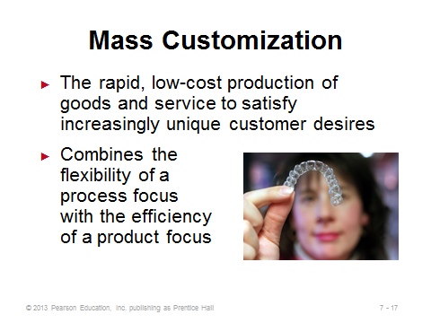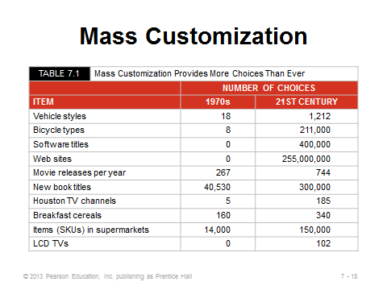
7-16 7-17 7-18
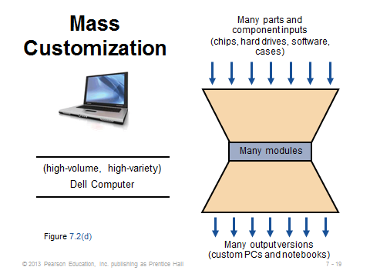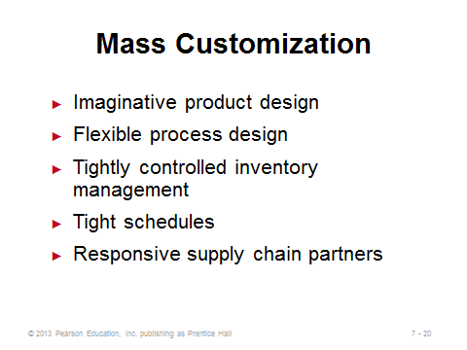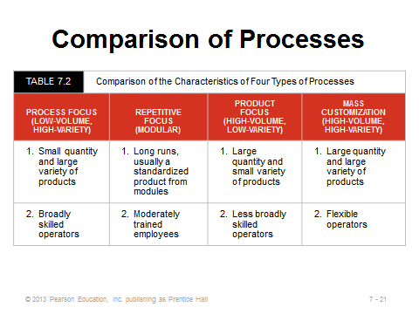
7-19 7-20 7-21
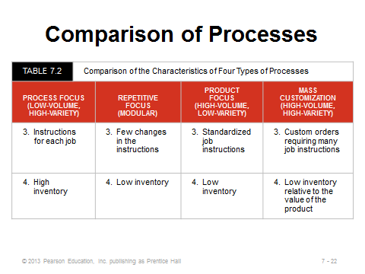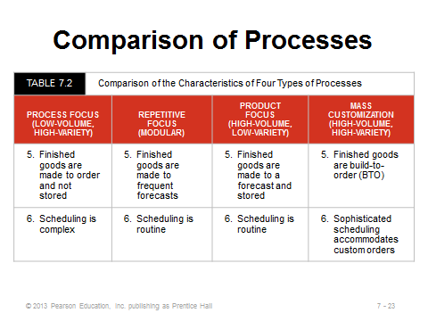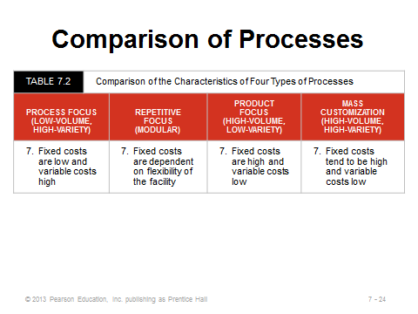
7-22 7-23 7-24
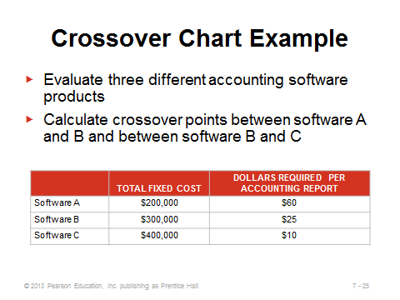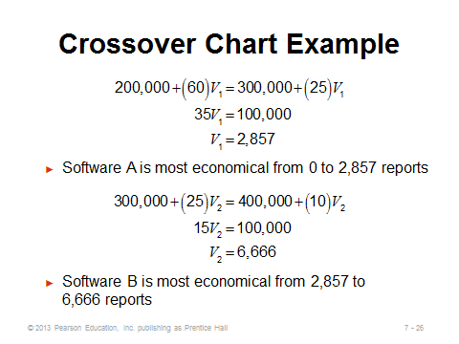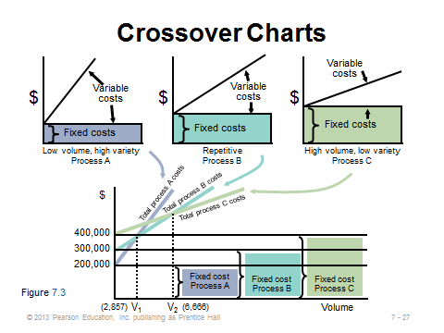
7-25 7-26 7-27
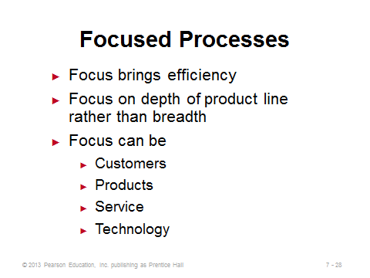
7-28

SELECTION OF EQUIPMENT (7-29 through 7-30)
Slides 29-30: It is important to emphasize that the technology decision is not always obvious, and it may involve a large capital expenditure. Numerous factors may need to be considered, particularly those identified on Slide 29. In addition, equipment that is more accurate or breaks down less often may lead to more stable processes. Slide 30 emphasizes the potential competitive advantage stemming from flexibility. Flexible equipment provides the ability to respond to new orders/make different products with little penalty in time, cost, or customer value. Flexible equipment may allow managers to enlarge the scope of their processes. Since changing processes or equipment can be difficult and expensive, it is best to get this critical decision right the first time.
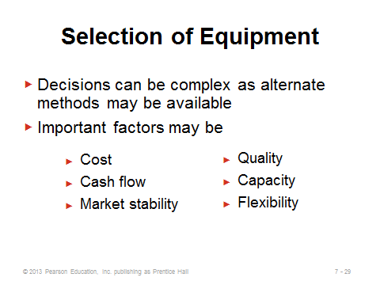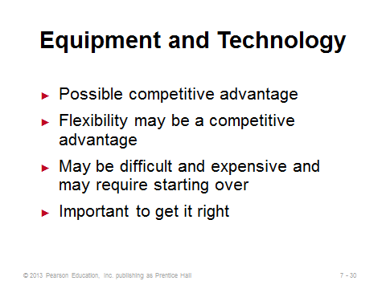
7-29 7-30

PROCESS ANALYSIS AND DESIGN (7-31 through 7-41)
Slide 31: These represent important questions to ask when analyzing and designing a process.
Slides 32-34: Flow charts and time-function mapping are introduced here—the difference in the two being that time-function mapping is a flowchart with time included on the x-axis. Drawing a flow chart should be the typical first step in any design or analysis effort. The two charts in Slides 33 and 34 come from Figure 7.4 of the text, illustrating a before and after time-function map used in process improvement at American National Can Company. The firm was able to eliminate the significant waiting that had slowed things down before improvement was implemented.
Slides 35-38: These slides describe value-stream mapping, which can appear complicated because the full supply chain is included in the picture. The nine steps to creating a value-stream map are shown in Slides 36-37. Slide 38 (Figure 7.5) displays the value-stream map created in Example 2. From this example, we see what looks like a significant amount of inventory, as well as a large percentage of non-value added time. As the text suggests, one way to reduce raw materials inventory might be to have deliveries twice per week instead of once per week.
Slide 39: A process chart, like the one shown in this slide (Figure 7.6), breaks down steps into detail and can provide a structured way to examine value-added vs. non-value added activities.
Slides 40-41: These slides illustrate service blueprinting, which is applicable for processes with a high amount of service content. Level 1 activities are under the control of the customer, level 2 activities represent interactions, and level 3 activities include activities not visible to the customer. The identification of potential failure points is particularly useful.
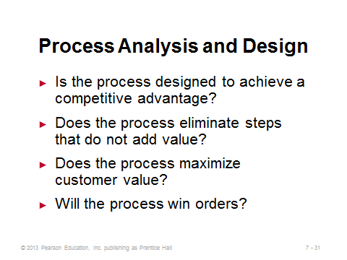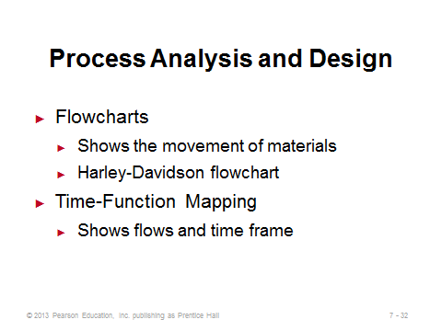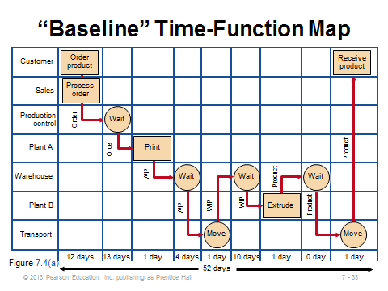
7-31 7-32 7-33
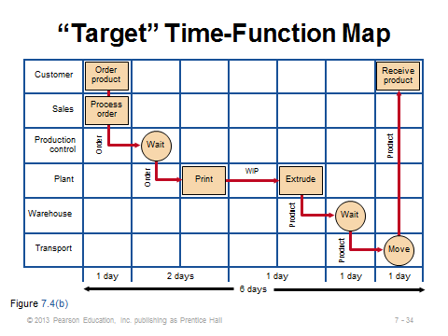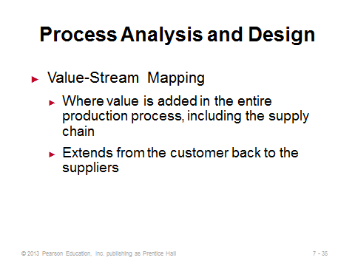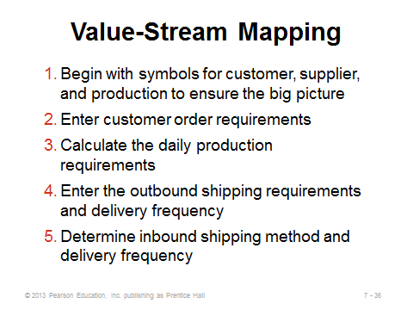
7-34 7-35 7-36
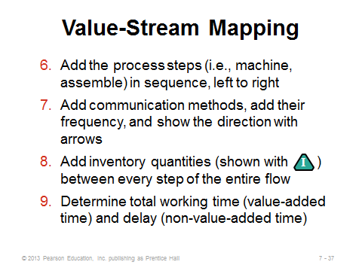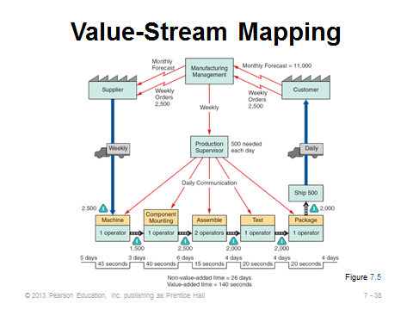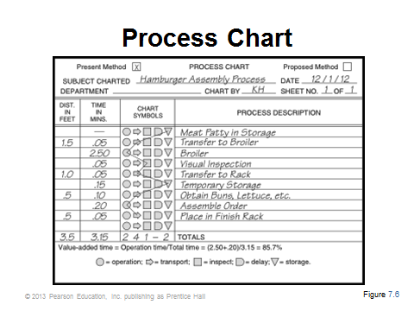
7-37 7-38 7-39

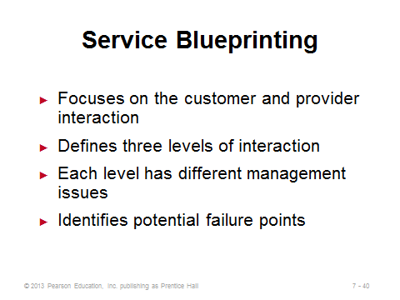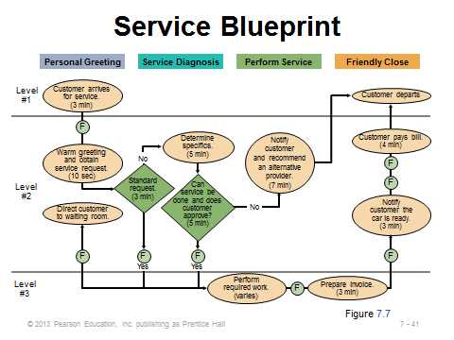
7-40 7-41

SPECIAL CONSIDERATIONS FOR SERVICE PROCESS DESIGN (7-42 through 7-47)
Slide 42: Customers are usually not involved in manufacturing operations. They often are involved in service operations, however, which is why service design can be particularly tricky.
Slides 43-45: These slides describe the service process matrix, where types of service are split into four quadrants based on degree of customization and degree of labor. The arrows in Slide 43 (Figure 7.8) represent how services in the rectangles can find a competitive opportunity by moving to the ovals.
Slides 46-47: These slides reproduce Table 7.3 from the text, which presents techniques for improving service productivity, including an example of each.
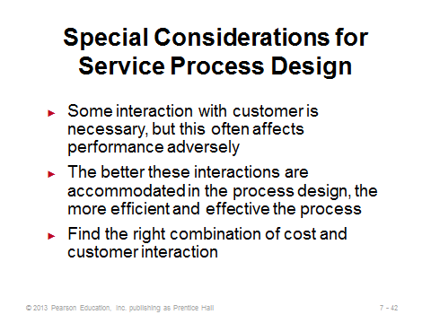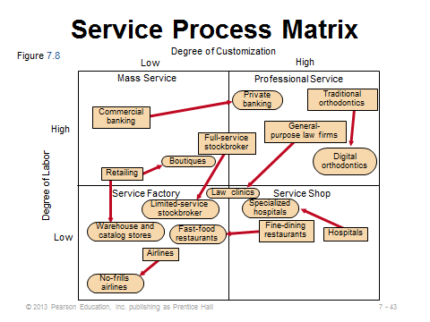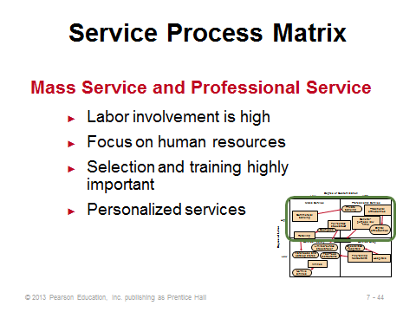
7-42 7-43 7-44
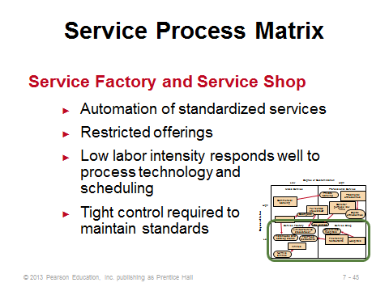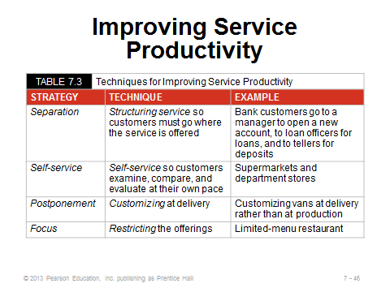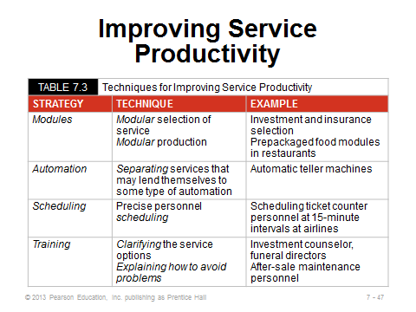
7-45 7-46 7-47

PRODUCTION TECHNOLOGY (7-48 through 7-58)
Slides 48: Slide 48 identifies nine types of production technology, which are then described in the next 10 slides.
Slide 49: This slide identifies the improvements that modern machine technology has introduced, especially when computer numerical control (CNC) machines are employed.
Slide 50: The AIS applications described in this slide refer to things like bar codes and RFID—anything that eliminates manual data entry. Bar codes allow warehouses to automatically sort hundreds of boxes per minute, and they significantly speed up the checkout process at retail stores, even allowing for the self-checkout stations that are becoming more and more prevalent. RFID has unlimited potential. As the picture in Slide 50 implies, RFID may someday allow customers to have all items in their cart totaled in an instant, without any physical handling. It could also act as an effective security devise against shoplifting.
Slides 51-52: Slide 51 describes process control, which automatically monitors output, signaling when a discrepancy exists. Vision systems (Slide 52) are similar to process control, but focus, in particular, on replacing human visual inspection with the aid of video cameras and computer technology.
Slide 53: We often think of robots when we think of the modern factory. Many robots have been around for decades, but they have hardly replaced all human manufacturing jobs. They are especially useful to replace monotonous or dangerous tasks. Preventive maintenance is crucial with robots, however, because a broken robot may shut down an entire assembly line, whereas a sick worker might more easily be replaced.
Slide 54: Interestingly, ASRSs have been employed for products as large as automobiles, using cranes that move in three dimensions. An additional advantage of ASRSs is that the warehouse, by not utilizing people, can remain in cold semi-darkness.
Slide 55: The army uses AGVs for particularly dangerous missions such as traversing across a mine field.
Slides 56-58: Flexible manufacturing systems (Slide 56) represent a possible way for firms to achieve mass customization. Computer-integrated manufacturing (Slide 57) extends a flexible manufacturing system backwards (into engineering and inventory control) and forwards (into warehousing and shipping). There is not a single standard CIM application, but the idea is to have computer-aided communication and control to help manage an entire production process. Slide 58 (Figure 7.9) provides a nice example of the possibilities of CIM.
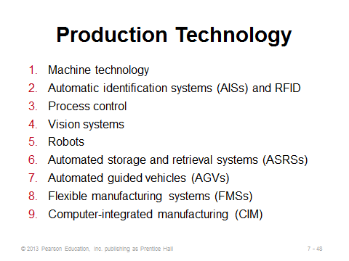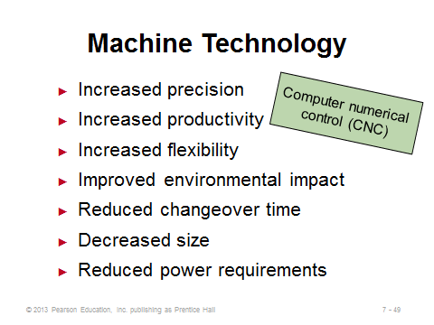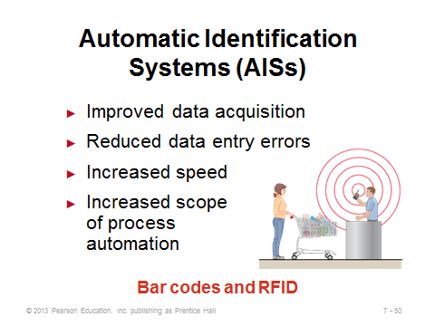
7-48 7-49 7-50
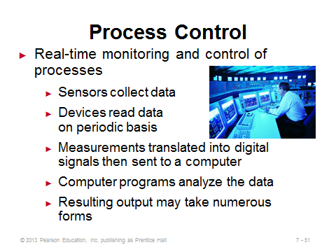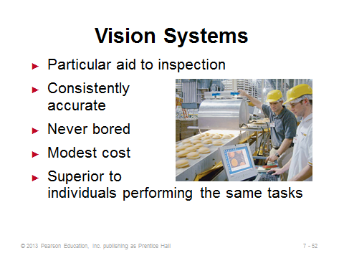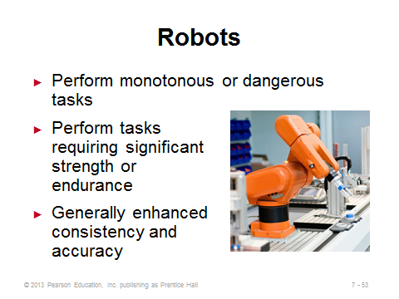
7-51 7-52 7-53

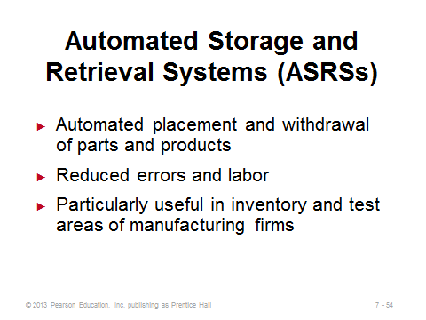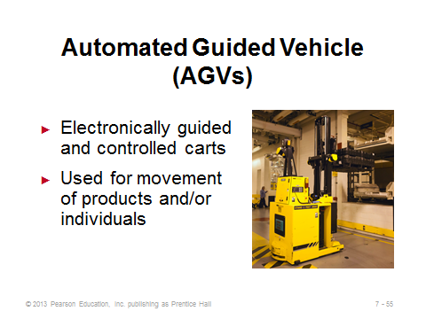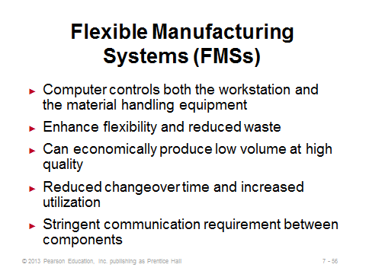
7-54 7-55 7-56
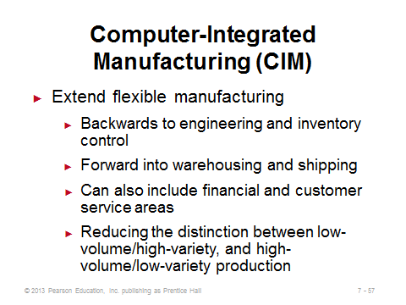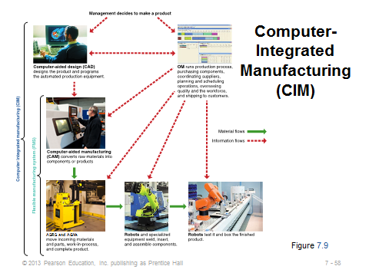
7-57 7-58

TECHNOLOGY IN SERVICES (7-59 through 7-60)
Slides 59-60: These slides reproduce Table 7.4 from the text. Here we see several examples of technology literally changing the way that service processes operate and the way in which customers obtain services. In some cases, such as online news outlets vs. physical newspapers, traditional service offerings have become endangered. In other cases, such as the ability to pre-order lunch at the ninth tee box on a golf course, technology may have opened new markets. Instructors can spend a fair amount of time on these two slides, even brainstorming with students about what might be coming next. For example, what else can be crammed into the next smart phone?
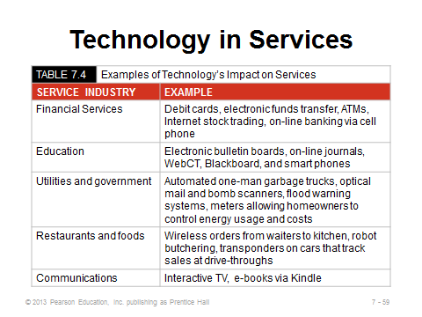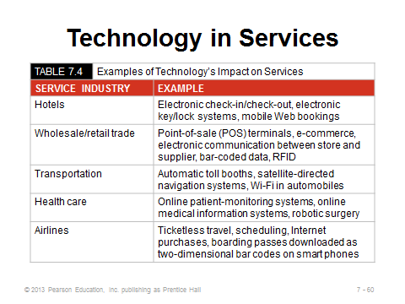
7-59 7-60

PROCESS REDESIGN (7-61)
Slide 61: A few years ago, the hot catch phrase for process redesign was “business process reengineering.” Whatever the term, every once and a while a process should be re-examined to see if it remains the appropriate vehicle for producing the product or providing the service. Such examination may be spurred by new products or product mixes, changes in competitive priorities of the company, changes in volume of demand, poor performance, new technology, changes in the cost or availability of inputs, or perhaps new legislation/regulation. As humans seem to get attached to the familiar, process redesign is often easier said than done. Sometimes a consultant or other objective set of eyes may be needed to break down certain assumptions that are presumed to be untouchable by the current workforce. Nevertheless, as with any organizational change, success usually follows those change efforts that include all employees in the fact-finding and decision-making processes.
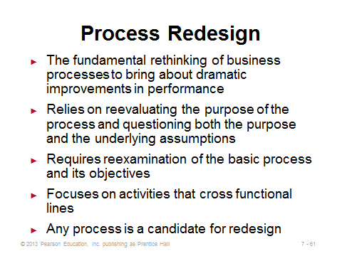
7-61

Additional Assignment Ideas

1. (BPR) Business Process Reengineering Online Learning Center. Here you will find lots of information; check out the tutorial section. Choose one tutorial and form a summary of that tutorial. http://www.prosci.com/bpr-homepage.htm

2. Think about a process that you participate in as a customer (e.g., a bank, a restaurant, a doctor’s office, the financial aid office, or an airport) that seems to operate inefficiently (i.e., that drives you crazy). Write up a short proposal that would suggest ways improve the efficiency of the organization.

Additional Case Studies

Internet Case Study (www.pearsonhighered.com/heizer)

- Matthew Yachts, Inc.: Examines a possible process change as the market for yachts changes.

Harvard Case Studies (http://harvardbusinessonline.hbsp.harvard.edu)

- Assembling Smartphones: Takt Time ≠ Cycle Time? (#611012, © 2012)
- Dore-Dore (#692028, © 2010)
- Stonehaven, Inc. (#696048, © 2006)

Ivey Case Studies (https://www.iveycases.com)

- Alara Agri: Fresh Cherry Production (#9B09D004, © 2009)
- Fisher & Paykel Limited (#9A97D015, © 2010)
- Introducing New Technologies at General Motors (#9A91J005, © 2001)

Internet Resources
American Council of Engineering Companies | www.acec.org
Association of Automatic Identification and Mobility | www.aimglobal.org
Association for Manufacturing Excellence | www.ame.org
Prosci: The world leader in change management research | www.prosci.com/index.html
DARPA: U.S. Defense Dept., Innovative Prototype Systems | www.DARPA.mil
Dassault Systems | www.3ds.com
Graham Process Improvement Methodology | www.worksimp.com
iGraphic’s approach to value-stream mapping | www.iGrafx.com
Strategos Inc.’s approach to value-stream mapping | www.strategosinc.com
BPM Focus | http://www.bpmfocus.org/default.aspx

