Lecture 1 Notes

The Accountant’s Role in the Organization

Overview

Welcome to the study of cost accounting. This introductory chapter explains the intertwining roles of managers and management accountants in choosing an organization’s strategy, and in planning and controlling its operations. Unlike the remainder of the textbook, this chapter has no “number crunching.” Its main purpose is to emphasize the management accountant’s role in providing information for managers.

Review Points

1. It is important to distinguish management accounting from financial accounting.

- Management accounting measures, analyzes, and reports financial and nonfinancial information that helps managers make decisions to fulfill the goals of an organization. Management accounting (a) emphasizes the future, (b) aims to influence the behavior of managers and employees in achieving the goals of an organization, and (c) is not particularly constrained by generally accepted accounting principles (GAAP).
- Financial accounting focuses on reporting to external parties, such as investors, government agencies, banks, and suppliers. It measures and records business transactions and provides financial statements—the balance sheet, income statement, statement of cash flows, and statement of retained earnings—based on GAAP.

2. Cost accounting measures and reports financial and nonfinancial information relating to the costs of acquiring or utilizing resources in an organization. Cost accounting provides information for both management accounting and financial accounting.

3. Cost management is the approaches and activities of managers in short-run and long-run planning and control decisions that increase value for customers and lower costs of products and services. For example, rearranging the production-floor layout might reduce manufacturing costs, or additional product design costs might be incurred in an effort to increase revenues and profits.

4. Strategy specifies how an organization matches its own capabilities with the opportunities in the marketplace to accomplish its objectives. In other words, strategy describes how an organization will compete and the opportunities its employees should seek and pursue. Companies follow one of two broad strategies:

- Sell quality products or services at low prices. An example is Southwest Airlines.
- Sell relatively unique products or services at higher prices than charged by competitors. An example is Ralph Lauren.

Choosing between these strategies is among the most important decisions that managers make. The term strategic cost management is often used to describe cost management that specifically focuses on strategic issues.

5. The value chain refers to the sequence of business functions in which usefulness (value to the customer) is added to the products or services of a company. These business functions are research and development (R&D); design of products, services, or processes; production; marketing; distribution; and customer service. Managers in each of these six business functions of the value chain are customers of management accounting information. Rather than proceeding sequentially through the value chain, companies can realize significant gains when various parts of the value chain work together. For example, additional spending on R&D and product design might be more than offset by lower costs of production and customer service.

6. The term supply chain describes the flow of goods, services, and information from the initial sources of materials and services to the delivery of products to customers, regardless of whether those activities occur in the same organization or in other organizations. Cost management emphasizes integrating and coordinating activities across all companies in the supply chain, as well as across each business function in an individual company’s value chain, to reduce costs.

7. Customers want companies to use the value chain and supply chain to deliver ever-improving levels of performance regarding four key success factors:

a. Cost and efficiency—Companies face continuous pressure to reduce the cost of the products or services they sell. Examples include eliminating the need for rework and outsourcing one or more business functions to foreign countries.
b. Quality—Customers expect high levels of quality. Total quality management (TQM) is a philosophy in which management improves operations throughout the value chain to deliver products and services that exceed customer expectations.
c. Time—Time has many components. Examples include the time to develop and bring new products to market and the speed at which an organization responds to customer requests.
d. Innovation—A constant flow of innovative products or services is the basis for ongoing company success. A main source of innovations is R&D.

Management accountants help managers track performance on the key success factors in comparison to the performance of competitors on the same factors. Tracking what is happening in other companies serves as a benchmark and alerts managers to the changes their own customers are observing and evaluating. The goal is for a company to continuously improve its critical operations.

8. Management accounting facilitates planning and control. Planning comprises (a) selecting organization goals, (b) predicting results under various alternative ways of achieving those goals, (c) deciding how to attain the desired goals, and (d) communicating the goals and how to attain them to the entire organization. Control comprises (a) taking actions that implement the planning decisions, (b) deciding how to evaluate performance, and (c) providing feedback that will help future decision making. Planning and control are linked by feedback. Managers use feedback to examine past performance (the control function) and systematically explore alternative ways of making better-informed decisions and plans in the future (the planning function).

9. Budgeting is essential for planning and control. A budget is the quantitative expression of a proposed plan of action by management for a specified period and is an aid to coordinating what needs to be done to implement that plan. The information used to develop budgets includes past financial and nonfinancial information routinely recorded in accounting systems.

10. Management accountants contribute to the company’s decisions about strategy, planning, and control by performing three important roles: problem solving, scorekeeping, and attention directing. Problem solving uses comparative analysis for decision making. Scorekeeping accumulates data and reports results—to all levels of management—describing how the organization is doing. Attention directing helps managers focus on opportunities and problems. Often these roles are simultaneously performed due to the ongoing interaction among strategic decisions, planning decisions, and control decisions.

11. Three guidelines help management accountants provide the most value to their companies in planning and control activities:

a. Employ the cost-benefit approach. This approach guides decision making: resources should be spent if they are expected to better attain company goals in relation to the expected costs of those resources. For example, consider budgeting systems as economic goods. The expected costs of a proposed budgeting system (such as personnel, software, and training) should be compared with its expected benefits, which are the collective decisions of managers that will better attain the company’s goals. In particular, measurement of the expected benefits is seldom easy.
b. Give full recognition to behavioral as well as technical considerations. A management accounting system should have two simultaneous missions for providing information: (i) to help managers make wise economic decisions by providing them with desired information (the technical mission), and (ii) to help motivate managers and other employees to aim for the goals of the organization (the behavioral mission). Management is primarily a human activity that should focus on how to help individuals do their jobs better.
c. Use different costs for different purposes. To illustrate this guideline, consider how to account for advertising. For the purpose of preparing financial statements under GAAP, advertising is an expense in the accounting period when it is incurred. For the purpose of determining a product’s selling price, its advertising costs, along with its other costs from all business functions of the value chain, should be taken into account.

12. Most organizations distinguish line management from staff management. Line management is directly responsible for attaining the goals of an organization. Staff management exists to provide advice and assistance to line management. When organizations rely on teams for attaining their goals, the traditional distinction between line and staff management is less clear-cut than it was a decade ago.

13. The chief financial officer (CFO), a staff management function, is the executive responsible for overseeing the financial operations of an organization, which typically include con-trollership, treasury, risk management, taxes, and internal audit. The controller, also a staff management function, is the financial executive primarily responsible for management accounting and financial accounting. In performing the problem-solving and attention-directing roles, the controller “controls” by exerting a force or influence that helps managers make better-informed decisions as they implement their strategies.

14. Professional accounting organizations promote high ethical standards. Professional accounting organizations such as the Institute of Management Accountants (IMA), the largest association of management accountants in the United States, play an important role in promoting high ethical standards. For example, the IMA has identified four standards of ethical conduct for management accountants: competence, confi-dentiality, integrity, and objectivity. EXHIBIT 1-7, text p. 16, provides the IMA’s guidance on issues relating to the four standards, and EXHIBIT 1-8, text p. 17, gives the IMA’s guidance on how to resolve ethical conflict.

Lecture Notes 2

An Introduction to Cost Terms and Purposes

Overview

This chapter introduces the basic terminology of cost accounting. Communication among managers and management accountants is greatly facilitated by having a common understanding of the meaning of cost terms and concepts. The chapter illustrates a major theme of the textbook: using different costs for different purposes. The chapter also provides a framework to help you understand cost accounting and cost management.

Review Points

1. Accountants define cost as a resource sacrificed (used) or forgone to achieve a specific objective. For example, it might cost $5,000 per month to rent retail space in a shopping center. To guide their decisions, managers often want to know how much a particular thing costs. This “thing” is called a cost object, anything for which a measurement of costs is desired. In the following questions, the cost object is in italics: How much does it cost to manufacture a 12-pack of Diet Pepsi? Which delivery truck is the least expensive to operate?

2. Costing systems account for costs in two basic stages. The first stage is cost accumulation, the collection of cost data in some organized way by means of an accounting system. The second stage is cost assignment, a general term that encompasses both (a) tracing accumulated costs that have a direct relationship to a cost object and (b) allocating accumulated costs that have an indirect relationship to a cost object.

3. A key question in cost assignment is whether costs have a direct or an indirect relationship to the particular cost object.

- The direct costs of a cost object are related to the particular cost object and can be traced to that cost object in an economically feasible (cost-effective) way. The term cost tracing describes the assignment of direct costs to the particular cost object.
- The indirect costs of a cost object are related to the particular cost object but cannot be traced to that cost object in an economically feasible way. The term cost allocation describes the assignment of indirect costs to the particular cost object.

Several factors affect the classification of a cost as direct or indirect: the materiality (relative importance) of the cost in question, available information-gathering technology, and design of operations.

4. Consider this question: Is a production department manager’s salary a direct cost or an indirect cost? The answer: It depends on the choice of the cost object. For example, if the cost object is the production department, the salary is a direct cost because it can be traced to the cost object. But if the cost object is one of the many products manufactured in the production department, the salary is an indirect cost because it can be allocated (but cannot be traced) to the cost object.

5. Two basic types of cost-behavior patterns are found in accounting systems.

- A variable cost changes in total in proportion to changes in the related level of total activity or volume. A variable cost does not change on a per unit basis when the related level of total activity or volume changes.
- A fixed cost remains unchanged in total for a given time period, despite wide changes in the related level of total activity or volume. A fixed cost increases (decreases) on a per unit basis when the related level of total activity or volume decreases (increases).

Costs are variable or fixed with respect to a specific cost object and for a given time period. A relevant range is the span of normal activity or volume level in which there is a specific relationship between the activity or volume level and the cost in question.

6. A cost driver is a variable, such as the level of activity or volume, that causes costs to increase or decrease over a given time period. In other words, a cause-and-effect relationship exists between a change in the level of activity or volume and a change in the level of total costs.

- The cost driver of variable costs is the level of activity or volume whose change causes these costs to change proportionately. For example, the number of trucks assembled is a cost driver of the cost of steering wheels for the trucks.
- Fixed costs have no cost driver in the short run but may have a cost driver in the long run. For example, the equipment and staff costs of product testing typically are fixed in the short run with respect to changes in the volume of production. In the long run, however, the company increases or decreases these costs to the levels needed to support future production levels.

7. Accounting systems typically report both total costs and unit costs (also called average costs). A unit cost is computed by dividing some amount of total costs by the related number of units. Unit costs are regularly used in financial reports. For many decisions, however, managers should think in terms of total costs rather than unit costs because fixed cost per unit changes when the related level of volume changes. Unit costs, therefore, should be interpreted with caution if they include a fixed-cost component. The Tennessee Products example, text p. 36, illustrates this important point.

8. Companies in the manufacturing, merchandising, and service sectors of the economy are frequently referred to in the study of cost accounting.

- Manufacturing-sector companies purchase materials and components and convert them into various finished goods. These companies typically have three types of inventory: direct materials inventory, work-in-process inventory, and finished goods inventory.
- Merchandise-sector companies purchase and then sell tangible products without changing their basic form. These companies have one type of inventory: merchandise inventory.
- Service-sector companies provide services (intangible products)—for example, legal advice, checking accounts, or audits—to their customers. These companies do not have an inventory of items for sale.

9. For companies with inventories, generally accepted accounting principles distinguish inventoriable costs from period costs.

- Inventoriable costs are all costs of a product that are considered as assets in the balance sheet when they are incurred and that become cost of goods sold when the product is sold. For manufacturing companies, all manufacturing costs are inventoriable costs. For merchandising companies, inventoriable costs are the acquisition costs of merchandise. Because service companies have no inventories, they have no inventoriable costs.
- Period costs are all costs in the income statement other than cost of goods sold. Period costs are treated as expenses of the accounting period in which they are incurred.

10. Three terms are widely used in describing manufacturing costs. In the following definitions, “the cost object” refers to “work in process and then finished goods.”

- Direct material costs are the acquisition costs of all materials that eventually become part of the cost object and that can be traced to the cost object in an economically feasible way.
- Direct manufacturing labor costs include the compensation of all manufacturing labor that can be traced to the cost object in an economically feasible way.
- Indirect manufacturing costs (also called manufacturing overhead costs or factory overhead costs) are all manufacturing costs that are related to the cost object but that cannot be traced to that cost object in an economically feasible way. Examples include power, indirect materials, indirect manu-facturing labor, plant insurance, plant depreciation, and compensation of plant managers.

11. In the income statement of a manufacturing company, cost of goods sold is computed as follows (figures assumed):

Beginning finished goods | $ 50,000
Add cost of goods manufactured | 800,000
Cost of goods available for sale | 850,000
Deduct ending finished goods | 60,000
Cost of goods sold | $790,000

The line item, cost of goods manufactured, refers to the cost of all goods brought to completion, whether they were started before or during the current accounting period. Cost of goods manufactured is often computed in a supporting schedule to the income statement as follows (figures assumed):

Beginning direct materials | $ 60,000
Add purchases of direct materials | 510,000
Direct materials available for use | 570,000
Deduct ending direct materials | 50,000
Direct materials used | 520,000
Add direct manufacturing labor | 100,000
Add indirect manufacturing costs | 230,000
Manufacturing costs incurred during the period | 850,000
Add beginning work in process | 120,000
Total manufacturing cost to account for | 970,000
Deduct ending work in process | 170,000
Cost of goods manufactured | $800,000

EXHIBIT 2-8, text p. 40, shows the flow of manufacturing costs in the general ledger accounts, from Work-in-Process Inventory to Finished Goods Inventory to Cost of Goods Sold.

12. Manufacturing costing systems use the terms prime costs and conversion costs.

- Prime costs are all direct manufacturing costs. Under the three-part classification of manufacturing costs in paragraph 10, prime costs are equal to direct material costs plus direct manufacturing labor costs. In cases where other direct manufacturing cost categories are used, they too are prime costs. For example, power costs could be classified as a direct cost if the power is metered to specific areas of a plant that are dedicated to manufacturing separate products.
- Conversion costs are all manufacturing costs other than direct material costs; they are incurred to convert direct materials into finished goods. Under the three-part classification of manufacturing costs, conversion costs are equal to direct manufacturing labor costs plus indirect manufacturing costs.

13. All manufacturing labor compensation, except for direct labor and managers’ salaries, is usually classified as indirect labor costs—a major component of manufacturing overhead. Two main categories of indirect labor in manufacturing and service companies are overtime premium and idle time. Overtime premium consists of the wage rate paid to workers (for both direct labor and indirect labor) in excess of their straight-time wage rates. Overtime premium is classified as overhead when the overtime is attributable to the heavy overall volume of work. When a particular job, such as a rush order, is the sole reason for the overtime, the overtime premium is classified as a direct cost of that job. Idle time is wages paid for unproductive time caused by lack of orders, machine breakdowns, material shortages, poor scheduling, and the like.

14. Some manufacturing companies classify payroll fringe benefit costs of direct labor as overhead cost, whereas others classify them as direct labor cost. The latter approach is preferable because these payroll fringe benefit costs are a fundamental aspect of acquiring the direct manufacturing labor services. To prevent disputes about cost items such as payroll fringe benefits, training time, overtime premium, idle time, vacations, and sick leave, contracts and laws should be as specific as feasible regarding definitions and measurements. The example, text p. 44, shows that the classification of payroll fringe benefits can be important for income tax purposes.

15. An important theme of the textbook is using different costs for different purposes. For example, managers can assign different costs to a product depending on their purpose. A product cost is the sum of costs assigned to a product for a specific purpose, such as (a) preparing financial statements for external reporting under generally accepted accounting principles (GAAP), (b) contracting with government agencies, or (c) pricing and product-mix decisions. For financial statements based on GAAP, a product cost includes only inventoriable costs. A product cost includes a broader set of costs for reimbursement under government contracts, or a still broader set of costs for pricing and product-mix decisions.

16. Three features of cost accounting and cost management across a wide range of applications are:

a. Calculating the cost of products, services, and other cost objects
b. Obtaining information for planning and control and performance evaluation
c. Analyzing the relevant information for decision making

Lecture Notes 3
Cost-Volume-Profit Analysis
Overview

This chapter explains a planning tool called cost-volume-profit (CVP) analysis. CVP analysis examines the behavior of total revenues, total costs, and operating income (profit) as changes occur in the output level, selling price, variable cost per unit, and/or fixed costs of a product or service. The reliability of the results from CVP analysis depends on the reasonableness of the assumptions. The Appendix to the chapter gives additional insights about CVP analysis; it illustrates decision models and uncertainty.

Review Points

1. CVP analysis is based on several assumptions including:
a. Changes in the level of revenues and costs arise only because of changes in the number of product (or service) units produced and sold (that is, the number of output units is the only driver of revenues and costs).
b. Total costs can be separated into a fixed component that does not vary with the output level and a component that is variable with respect to the output level.
c. When represented graphically, the behaviors of both total revenues and total costs are linear (straight lines) in relation to the output level within the relevant range (and time period).
d. The analysis either covers a single product or assumes that the proportion of different products when multiple products are sold will remain constant as the level of total units sold changes.

2. Even though CVP assumptions simplify real-world situations, many companies have found CVP relationships can be helpful in making decisions about strategic and long-range planning, as well as decisions about product features and pricing. Managers, however, must always assess whether the simplified CVP relationships generate sufficiently accurate predictions of how total revenues and total costs behave. If decisions can be significantly improved, managers should choose a more complex approach that, for example, uses multiple cost drivers and nonlinear cost functions.

3. Because managers want to avoid operating losses, they are interested in the breakeven point calculated using CVP analysis. The breakeven point is the quantity of output sold at which total revenues equal total costs. There is neither a profit nor a loss at the breakeven point. To illustrate, assume a company sells 2,000 units of its only product for $50 per unit, variable cost is $20 per unit, and fixed costs are $60,000 per month. Given these conditions, the company is operating at the breakeven point:

Revenues, 2,000 × $50 | $100,000
Deduct:
Variable costs, 2,000 × $20 | 40,000
Fixed costs | 60,000
Operating income | $ -0-

The breakeven point can be expressed two ways: 2,000 units and $100,000 of revenues.

4. Under CVP analysis, the income statement above is reformatted to show a key line item, contribution margin:

Revenues, 2,000 × $50 | $100,000
Variable costs, 2,000 × $20 | 40,000
Contribution margin | 60,000
Fixed costs | 60,000
Operating income | $ -0-

This format, called the contribution income statement, is used extensively in this chapter and throughout the textbook.

5. Contribution margin can be expressed three ways: in total, on a per unit basis, and as a percentage of revenues. In our example, total contribution margin is $60,000. Contribution margin per unit is the difference between selling price and variable cost per unit: $50 − $20 = $30. Contribution margin per unit is also equal to contribution margin divided by the number of units sold: $60,000 ÷ 2,000 = $30. Contribution margin percentage (also called contribution margin ratio) is contribution margin per unit divided by selling price: $30 ÷ $50 = 60%; it is also equal to contribution margin divided by revenues: $60,000 ÷ $100,000 = 60%. This contribution margin percentage means that 60 cents in contribution margin is gained for each $1 of revenues.

6. In our example, compute the breakeven point (BEP) in units and in revenues as follows:

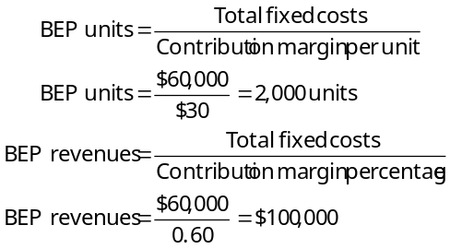

While the breakeven point is often of interest to managers, CVP analysis considers a broader question: What amount of sales in units or in revenues is needed to achieve a specified target operating income? The answer is easily obtained by adding target operating income to total fixed costs in the numerator of the formulas above. Assuming target operating income (TOI) is $15,000:

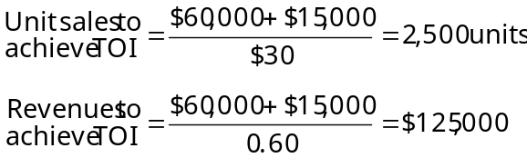
7. Because for-profit organizations are subject to income taxes, their CVP analyses must include this factor. For example, if a company earns $50,000 before income taxes and the tax rate is 40%, then:

Operating income | $50,000
Deduct income taxes (40%) | 20,000
Net income | $30,000

To state a target net income figure in terms of operating income, divide target net income by 1 − tax rate: $30,000 ÷ (1 − .40) = $50,000. Note, the income-tax factor does not change the breakeven point because no income taxes arise if operating income is $0.

8. Managers use CVP analysis to guide their decisions, many of which are strategic decisions. For example, CVP analysis helps managers decide how much to spend on advertising, whether or not to expand into new markets, and which features to add to existing products. Of course, different choices can affect fixed costs, variable cost per unit, selling prices, units sold, and operating income.

9. Single-number “best estimates” of input data for CVP analysis are subject to varying degrees of uncertainty, the possibility that an actual amount will deviate from an expected amount. One approach to deal with uncertainty is to use sensitivity analysis (discussed in paragraphs 10 through 12). Another approach is to compute expected values using probability distributions (discussed in paragraph 19).

10. Sensitivity analysis is a “what if” technique that managers use to examine how an outcome will change if the original predicted data are not achieved or if an underlying assumption changes. In the context of CVP analysis, sensitivity analysis examines how operating income (or the breakeven point) changes if the predicted data for selling price, variable cost per unit, fixed costs, or units sold are not achieved. The sensitivity to various possible outcomes broadens managers’ perspectives as to what might actually occur before they make cost commitments. Electronic spreadsheets, such as Excel, enable managers to conduct CVP-based sensitivity analyses in a systematic and efficient way.

11. An aspect of sensitivity analysis is margin of safety, the amount by which budgeted (or actual) revenues exceed breakeven revenues. The margin of safety answers the “what-if” question: If budgeted revenues are above breakeven and drop, how far can they fall below the budget before the breakeven point is reached?

12. CVP-based sensitivity analysis highlights the risks and returns that an existing cost structure holds for a company. This insight may lead managers to consider alternative cost structures. For example, compensating a salesperson on the basis of a sales commission (a variable cost) rather than a salary (a fixed cost) decreases the company’s downside risk if demand is low but decreases its return if demand is high. The risk-return tradeoff across alternative cost structures can be measured as operating leverage. Operating leverage describes the effects that fixed costs have on changes in operating income as changes occur in units sold and hence in contribution margin. Companies with a high proportion of fixed costs in their cost structures have high operating leverage. Consequently, small changes in units sold cause large changes in operating income. At any given level of sales:

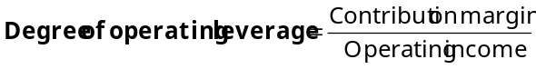
Knowing the degree of operating leverage at a given level of sales helps managers calculate the effect of changes in sales on operating income.

13. The time horizon being considered for a decision affects the classification of costs as variable or fixed. The shorter the time horizon, the greater the proportion of total costs that are fixed. For example, virtually all the costs of an airline flight are fixed one hour before takeoff. When the time horizon is lengthened to one year and then five years, more and more costs become variable. This example underscores the point: which costs are fixed in a specific decision situation depends on the length of the time horizon and the relevant range.

14. Sales mix is the quantities of various products (or services) that constitute total unit sales of a company. If the sales mix changes and the overall unit sales target is still achieved, however, the effect on the breakeven point and operating income depends on how the original proportions of lower or higher contribution margin products have shifted. Other things being equal, for any given total quantity of units sold, the breakeven point decreases and operating income increases if the sales mix shifts toward products with higher contribution margins.

15. Recall from paragraph 1d that, in multiple product situations, CVP analysis assumes a given sales mix of products remains constant as the level of total units sold changes. In this case, the breakeven point is some number of units of each product, depending on the sales mix. To illustrate, assume a company sells two products, A and B. The sales mix is 4 units of A and 3 units of B. The contribution margins per unit are $80 for A and $40 for B. Fixed costs are $308,000 per month. To compute the breakeven point:

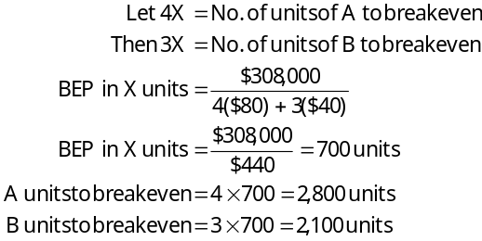
Proof of breakeven point:
A: 2,800 × $80 | $224,000
B: 2,100 × $40 | 84,000
Total contribution margin | 308,000
Fixed costs | 308,000
Operating income | $ -0-

16. CVP analysis can be applied to service organizations and nonprofit organizations. The key is measuring their output. Unlike manufacturing and merchandising companies that measure their output in units of product, the measure of output differs from one service industry (or nonprofit organization) to another. For example, airlines measure output in passenger-miles and hotels/motels use room-nights occupied. Government welfare agencies measure output in number of clients served and universities use student credit-hours.

17. Recall from paragraph 1a that CVP analysis assumes that the number of output units is the only revenue and cost driver. By relaxing this assumption, CVP analysis can be adapted to the more general case of multiple cost drivers but the simple formulas in paragraph 6 can no longer be used. Moreover, there is no unique breakeven point. The example, text p. 77, has two cost drivers—the number of software packages sold and the number of customers. One breakeven point is selling 26 packages to 8 customers. Another breakeven point is selling 27 packages to 16 customers.

18. Contribution margin, a key concept in this chapter, contrasts with gross margin discussed in Chapter 2. Gross margin is an important line item in the GAAP income statements of merchandising and manufacturing companies. Gross margin is total revenues minus cost of goods sold, whereas contribution margin is total revenues minus total variable costs (from the entire value chain). Gross margin and contribution margin will be different amounts (except in the highly unlikely case that cost of goods sold and variable costs are equal). For example, a manufacturing company deducts fixed manufacturing costs that become period costs from revenues in computing gross margin (but not contribution margin); it deducts sales commissions from revenues in computing contribution margin (but not gross margin).

Lecture Notes 4
Cost-Volume-Profit Analysis-Continued

THE BASICS OF COST-VOLUME-PROFIT (CVP) ANALYSIS
Relationship between these five elements:
-prices of products (i.e., sales),
-volume or level of activity (i.e., number of units sold),
-per unit variable costs,
-total fixed cost, and
-mix of products sold.

CONTRIBUTION MARGIN

Contribution Margin (CM) = Sales – Variable expenses
Unit Contribution Margin (Unit CM) = Sales price per unit – Variable expenses per unit
Contribution Margin Ratio (CM%) = CM/Sales or Unit CM/Sales price per unit

BREAK-EVEN ANALYSIS (B/E)

Sales = all costs + $0 profit

Breakeven is where total sales equal total expenses and profit is zero. Keep in mind, as sales increase so will total variable expenses.

Breakeven using the Contribution Margin method

B/E units sold = Fixed expenses / unit CM

B/E sales revenue = Fixed expenses / CM%

Target Profit Analysis

Sales = all costs + Profit

Units sold to attain the target profit = (Fixed expenses + target profit)/ unit CM

Sales revenue to attain the target profit = (Fixed expenses + target profit)/ CM%

Margin of Safety (M of S)
M of S, how much sales can decrease before net income goes to zero. M of S%, explains how much sales can decrease as a percent before net income goes to zero.

Margin of safety in dollars = Total current sales – breakeven sales
Margin of safety percentage = Margin of safety in dollars/total current sales

Operating Leverage

-Effect on NI with percentage change in sales

Degree of operating leverage = Total CM / Net Income

If the degree of operating leverage is 5 and sales increased by 10%, net income will increase 5 times faster than sales or 50% (5 x 10% = 50%).

-the degree of operating leverage is not constant
-at the breakeven point degree of operating leverage is infinite
-moving away from breakeven point the degree of operating leverage gets smaller

Using the degree of operating leverage, estimate the impact on net income of a 15% increase in sales.

Verify your estimate by constructing a new contribution format income statement for the company assuming a 15% increase in sales. Increased sales at 15% is $460,000 ($400,000 x (1 + .15) = $460,000)
 | Total | %
Sales |  | 100%
Less Variable Expenses |  | 64%
Contribution Margin |  | 36%
Less Fixed Expenses | 108,000
Net Operating Income | $

STRUCTURING SALES COMMISSIONS

Structure sales commissions on the CM rather than on Sales.
If a constraint exists, use the CM per constrained resource (see chapter 12).

MULTI-PRODUCT COMPANY
-Sales mix

Sales Mix and Breakeven Analysis
-Overall CM ratio = total contribution margin / total sales
-Breakeven sales = Fixed expenses / Overall CM%
-Sales to achieve target profits = (fixed expenses + target profit) / overall CM%

Lecture Notes 5
Job Costing

Absorption Costing
- the product absorbs all manufacturing costs (DM, DL, MOH)

JOB-ORDER COSTING—An Overview

Job order costing is used in situations where many different products are produced each period.
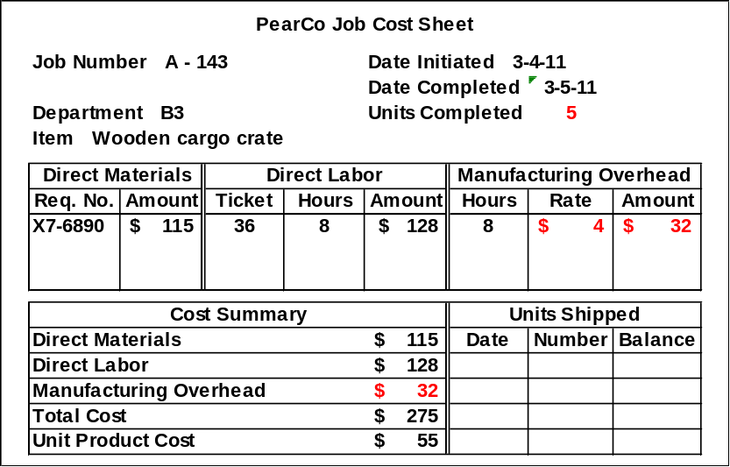

Job Cost Sheet
Exhibit 3-2 page 87

A job cost sheet includes:

Materials (DM)
+Labor (DL)
+*Applied MOH (MOH)
Total Cost

Cost per unit
Raw Material |  |  | WIP
+  Beginning bal.  + purchases | -  Materials used in production (either to WIP or MOH) |  | DM
+  Beginning bal.  + purchases | -  Materials used in production (either to WIP or MOH) |  | MOH
+  Beginning bal.  + purchases | -  Materials used in production (either to WIP or MOH) |  | IDM
Ending bal.

Computation of Unit Costs
-total job cost ÷ total units produced = average cost per unit (or cost per unit)
-basis for valuing COGS and EFG

THE FLOW OF COSTS

The Purchase and Issue of Materials

Purchases increase Raw Material (RM)

DMgoes to WIP (RM decreases)
IDMgoes to MOH (RM decreases)

WIP
DL
MOH
IDL

Labor Costs

--DLgoes to WIP
--IDLgoes to MOH

MOH
+  (actual costs)  IDM  IDL  Rent, Depreciation, etc. | -  (applied costs)  PDOR x allocation base used

Manufacturing Overhead Costs

-actual costs incurred for MOH during production (added into MOH)

-applied MOH is the amount of MOH taken out of MOH and added to WIP.

Computing Predetermined Overhead Rates
Predetermined overhead rate = | Estimated total manufacturing overhead cost  Estimated total units in the allocation base

Applying Manufacturing Overhead (p. 89)
-allocation base: is a measure that is used to apply overhead costs to products/services
-predetermined overhead rate (“PDOR”): rate used to allocate overhead cost to product/service.

Choice of an Allocation Base for Overhead Cost

- cost driver is a factor that causes overhead costs (i.e., machine-hours, direct labor hours, etc.); it is a factor that has a direct relationship with overhead costs.

- overhead application
Overhead applied to a particular job | = | Predetermined overhead rate | x | Amount of the allocation base incurred by the job
WIP
Beginning bal.
DM
DL
Applied MOH
Ending bal.

MOH
(clearing account)
(actual)  IDM  IDL  etc. | (applied)

Applied MOH = PDOR x allocation base

Practice
CHL makes snowboards and skateboards for specialty customers. The company uses a job-order cost system and computes a PDOR for the factory. CHL bases its rate on machine hours (MH). At the beginning of the year, the company made the following estimates for the factory:

Machine hours | 20,000
Manufacturing overhead cost | $500,000
Direct labor cost | $100,000

1. Compute the PDOR to be used by CHL:

2. The company uses $____ per MH to allocate costs to jobs. The job cost sheet for Job 203, which was started and completed during the year, showed the following:
Machine hours | 20
Materials requisitioned | $500
Direct labor cost | $100

Compute the total overhead cost applied to Job 203: _________ x __________ = $___________

3. What was the total cost for Job 203?
 | $
Total Cost | $

- Job 203 produced 100 units, what was the average cost per unit?

- CHL sold 75 units of Job 203, what was the total cost of the units sold (COGS)?

- How much cost remains on the balance sheet in finished goods inventory for Job 203?

Lecture Notes 6
Job Costing-Continued

Non-Manufacturing Costs
These costs are period costs and go directly to the income statement when incurred, (as discussed in chapter 2).

Cost of Goods Manufactured
-WIP to FG
WIP
Beginning bal.
DM
DL
Applied MOH
Ending bal.

Finished Goods
Beginning bal.
+ COGM
Ending bal.

Cost of goods manufactured

Cost of Goods Sold
Finished Goods
BFG  COGM | COGS
EFG
-FG to COGS

To income statement
Unit product cost x number of units sold
OR (BFG + COGM – EFG = COGS)

Summary
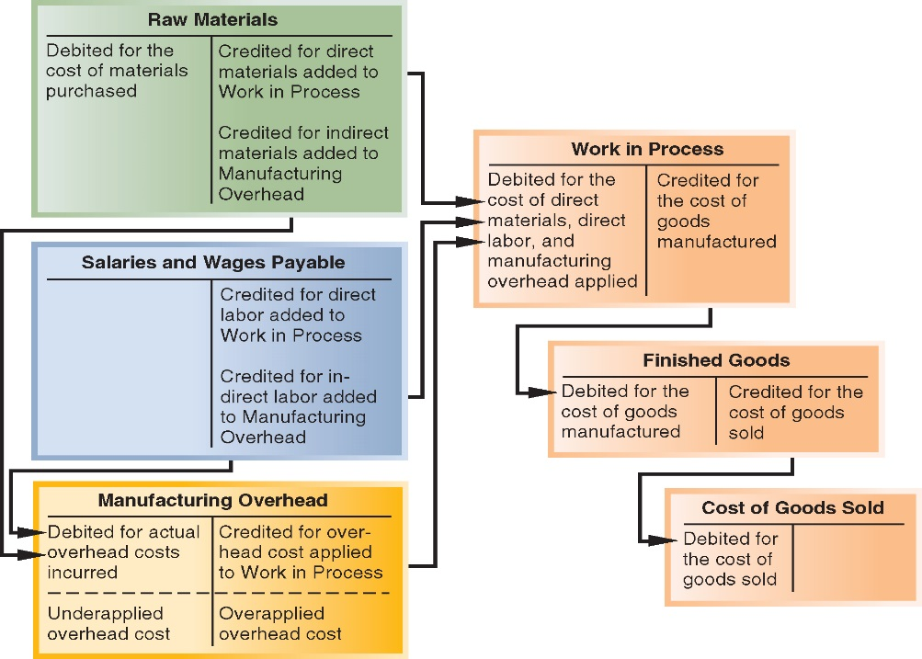
Of Cost Flows

Practice (continued from above)
CHL Manufacturing overhead costs incurred (including $25,000 of indirect materials) |  |  |  | $480,000
Other costs incurred:
Purchases of raw materials (both direct and indirect) |  |  |  | $425,000
Direct labor cost |  |  |  | 100,000
Inventories | Beginning | Ending
Raw materials | $20,000 | $30,000
WIP | $40,000 | $60,000
Finished Goods | $50,000 | $40,000

CHL used the PDOR calculated above to apply overhead to production during the year using MH as their allocation base. By year-end a total of 19,300 MH were used in production of snowboards and skateboards.
Compute the amount of applied overhead for the year.

Prepare a schedule of cost of goods manufactured for the year.

CHL Company
Schedule of Cost of Goods Manufactured
Direct materials
Raw materials inventory, beginning | $
Add purchases of raw materials
Raw materials available for use
Deduct raw materials inventory, ending
Raw materials used in production
Less indirect materials (already included in MOH) | 25,000 | $
Direct labor
Manufacturing overhead applied to WIP
Total manufacturing costs
Add beginning WIP
Less ending WIP
Cost of goods manufactured |  | $

Underapplied and Overapplied Overhead
MOH
(actual) | (applied)
underapplied | overapplied

(Debit) Left side (Actual) balance is due to underapplied MOH
-actual MOH was greater than MOH applied to production

(Credit) Right side (Applied) balance is due to overapplied MOH
-applied MOH was greater than actual MOH incurred in production

Review cost flows in T accounts
WIP
Bal. 40,000  390,000  100,000  (b) | (c)
Bal. 60,000

MOH
(a) 480,000 | (b) 482,500

Finished Goods
Bal. 50,000  (c) 952,500 | (d)
Bal. 40,000

COGS
(d)

$
By how much is MOH underaplied or overapplied?

Complete transactions (a) & (d) and identify (a) through (d).

Item (a):
Item (b):
Item (c):
Item (d):

MOH
(actual)  $ | (applied)  $

Disposition of Underapplied or Overapplied Overhead Balances

(Underapplied MOH) not enough MOH was applied in production during the year. Products are undercosted. MOH is closed out to COGS causing COGS to increase.

(Overapplied MOH) too much MOH was applied in production during the year. Products are overcosted. MOH is closed out to COGS causing COGS to decrease.

Practice (continued) Closing out MOH

Assume that the company closes any balances in the MOH account directly to COGS. Prepare the necessary journal entry.

(e)
To close MOH to COGS

A General Model of Product Cost Flows

Practice: comprehensive
SFTY Corporation provides the following annual data:

Manufacturing overhead costs:
Indirect material |  |  | $30,000
Property taxes |  |  | 15,000
Utilities, factory |  |  | 28,000
Indirect labor |  |  | 350,000
Depreciation, factory |  |  | 45,200
Insurance, factory |  |  | 17,800
Total |  |  | $486,000
Purchases of raw materials |  |  | $430,000
Direct labor cost |  |  | 490,000
Inventories: |  |  | Beginning | Ending
Raw materials |  |  | $15,000 | $7,500
Work in process |  |  | 23,500 | 17,500
Finished goods |  |  | 18,500 | 10,000

Based on SFTY’s analysis of past costs, their estimated manufacturing overhead cost was determined based on the cost equation Y = 277,200 + 20X. They use machine hours as their allocation base. Based on their forecast of production they expected to use 9,900 machine hours during the year. By the end of the year the company’s actual machine hour usage was 9,950 MH.

$
- Determine the predetermined overhead rate for the year:

$
- Determine the cost of raw materials used in production during the year:

$
- How much of the materials in (2) above consisted of direct materials?

$
- Determine the amount of MOH that was included in WIP inventory during the year:

$
- Determine the total manufacturing costs for the year:

$
- Determine the cost of goods manufactured for the year:

$
- What was the cost of goods sold for the year (before considering under or over-applied overhead).

$
- Was manufacturing overhead under- or overapplied? By how much?
MOH

- When MOH is closed; how will that impact cost of goods sold and Gross profit?

Lecture Notes 7
Activity Based Costing and Activity Based Management
A. General Introduction

In the costing systems we have examined so far, OH costs were allocated to individual products in the following simple way. One identified a rate base (activity measure) such as DLH or machine hours and determined a standard rate giving the charge in OH costs per unit of the rate base. If DLH is the rate base, then the OH cost charged to a product is directly proportional to the direct labor content of that product.

Critics of this traditional approach to product costing argue that it is too simplistic and that in many cases the resulting allocation of OH cost will distort the "true" cost of the different products. As a consequence, managers will be misled when they use product cost information to price products, bid on contracts and special orders, or drop products that are perceived unprofitable.

Activity based accounting (or simply activity costing) seeks to refine this procedure. The basic observation is that OH costs are caused by a variety of activities such as material handling, set-ups, maintenance, inspection, etc. However, different products may have different needs to have those activities performed. For example, product A may involve far more material components than product B and therefore a larger share of the material handling activity is caused by product A.

The overall goal of activity costing is to establish a better cause-effect relation between the different products and the overhead costs. This requires a detailed examination of the different activities which cause the OH costs, and an understanding of the activities that a particular product requires.

Example: Ajax Company
(taken from J. Shank and V. Govindarajan, "The Perils of Cost Allocation Based on Production Volumes" Accounting Horizons, December 1988).

BASIC PRODUCT INFORMATION:

THREE PRODUCTS | A | B | C
Production | 10,000 units  in 1 run | 15,000 units  in 3 runs | 5,000 units  in 10 runs
Shipments | 10,000 units  in 1 shipment | 15,000 units  in 5 shipments | 5,000 units  in 20 shipments
Selling Prices
Target | $162.61 | $134.09 | $ 81.31
Actual | $162.61 | $125.96 | $105.70
Manufacturing Cost
Raw Material | 5 components per unit  @$4.00 each = $20.00 | 6 components per unit  @$5.00 each=$30.00 | 10 components per unit  @$1.00 each = $10.00

Labor Usage |  |  |  | Total
Set-up Labor | 10 hrs per  Production run | 10 hrs. per  Production run | 11 hrs per  Production run | 150 hours
Run Labor |  hr. per unit | 1/3 hr. per unit |  hr. per unit | 11,250 hours
Machines Usage  (Machine cost = $70.00 per hour) |  hr. per unit | 1/3 hr. per unit |  hr. per unit | 10,000 hours

There is only one production department  machines  and it takes a little more than one labor hour for each machine hour (11,250/10,000) at the current product mix.

Labor wage rate is $20.00/hour including fringe benefits.
Other Overhead*
Receiving Department $300,000
Engineering Department 500,000
Packing Department 200,000
At the current production levels, Ajax then has to allocate the following OH cost:
Set-up 3,000
Receiving 300,000
Engineering 500,000
Packing 200,000
$1,003,000
Directly assignable overhead Machine costs $700,000
Total Overhead $1,703,000
If OH is applied on the basis of DL hours, the OH application rate becomes:
$1,703,000
-------------- = $151.40 per DLH.
11,250

This leads to the following product costs:
A B C
DM 20 30 10
DL 10 6.67 5.00
OH 75.70 56.49 37.85
Total $105.70 $93.16 $52.85

The following table shows the "burden" that the three products impose in terms of the activities: receiving, packing and engineering.
OVERHEAD TRANSACTIONS WORKLOAD
Products A B C

Receiving Orders:
(Receive each component 5(4%) 18(15%) 100(81%)
once per run i.e. a just
in time inventory policy)

Packing Orders:
One packing order 1(4%) 5(19%) 20(77%)
per shipment

Engineering Workload:
Distribution of workload in 25% 35% 40%
the Engineering Dept..is
based on subjective assessment
of long run trends in number
of engineering work orders
for each product.

Question: On what basis would you allocate set-up labor and machine usage costs?

The following table provides revised product costs when the individual OH items are allocated on the basis of the products' needs for the activities causing the OH expense.

Activity-Based Product Costs
A B C
DM 20.00 30.00 10.00

DL 10.00 6.67 5.00

Set-up labor .02 .04 .44

Machine OH 17.50 23.33 35.00

Receiving 1.20 3.00 48.60

Packing .80 2.53 30.80

Engineering 12.50 11.67 40.00

Total $62.02 $77.24 $169.84

Note: The two approaches lead to substantially different cost numbers.

B. The Mechanics of Activity Costing
For all direct costs the accounting is the same as before. However, OH costs are allocated in a two-step procedure. To perform this allocation one needs to identify:
OH line items, e.g. depreciation, rent, power, maintenance etc.
-cost pools, which typically evolve around activities such as machining operations or support activities
-allocation bases (or cost drivers) which reflect the cause-effect relation between OH line items, activities and products.
The number of cost pools is discretionary. In the above example cost pools were identified with the OH line items (i.e. receiving, packing engineering, set-up).
Step 1:For a given OH line item, pick a suitable allocation base and assign the OH cost accordingly to the different cost pools.
Example:The OH line item is rent. The allocation base is floor space and the cost pools are the machines. Then the rent expense is allocated to the individual machines in accordance to their share of the total floor space.
Step 2:For each cost pool choose an allocation base to assign the cost collected in the pool to the different products.
Example:The cost pool corresponds to a particular machine. The allocation base is machine hours. The cost is then assigned to an individual product in proportion to its running time on this machine.
Examples: HFD 5-24, 5-25, 5-26.
Note: Include two problems from prior edition of HFD.

Lecture Notes 8
Activity Based Costing and Activity Based Management-Continued

Objective of ABC
-understand overhead
-understand the profitability of products and customers

Cost Treatment under ABC
-Non-manufacturing Costs

-Manufacturing Costs

Plant-wide Overhead Rate
-traditional costing
-not used in ABC

Activity: any event that causes the consumption of overhead resources.

The Cost of Idle Capacity
-not assigned in ABC
-considered a period cost

Example: Fixed overhead costs are $900,000 and demand for the product is 80,000 units; the plant’s capacity is 100,000 units. What is the cost of idle capacity?

DESIGNING AN ACTIVITY-BASED COSTING (ABC) SYSTEM
Steps for Implementing Activity-Based Costing:
- Identify and define activities and activity pools.
- Prior to step 2. Wherever possible, directly trace costs to activities and cost objects; then… Step 2. Assign overhead costs to activity cost pools that couldn’t be directly traced.
- Calculate activity rates.
- Assign costs to cost objects using the activity rates and activity measures.
- Prepare management reports.

Step 1: Identifying Activities to Include in the ABC System
This step is the hardest part of implementing an ABC system. It requires a great deal of time and judgment.
Unit-level activities

Batch-level activities

Product-level activities

Customer-level activities

Organization-sustaining activities

Practice
The following activities occur at Greenwich Corp., a company that manufactures a variety of products. Classify each of the activities as either unit-level, batch-level, product level, or organization sustaining.

 | Unit | Batch | Product | Org. Sust.
Receive raw material from suppliers
Punch hole in product to attach logo
Interview & process new employees in the personnel department
Design new products
Insure the factory building
Issue purchase orders for a job.

Activity cost pool –the accumulated costs that relate to a single activity measure

Activity measure -an allocation base in an ABC system, (aka: cost driver)

-transaction driver: (typically the least accurate measure) simple counts of the number of times an activity occurs; easier to record (used more frequently).

-duration drivers: (more accurate measure of consumption) measures the amount of time required to perform an activity; takes more effort to record.

Practice
Listed below are activities that you have observed at Ming Corporation, a manufacturing company. Each activity has already been classified by cost hierarchy. Complete the table by providing examples of activity measures for each activity.

Activity | Level of Activity | Activity measure
Activity | Level of Activity | Transaction | Duration
a. Direct labor workers assemble a product | Unit
b. Products are designed by engineers | Product
c. Equipment is set-up | Batch
d. Machines are used to shape and cut material | Unit

Cost object is anything for which cost data are desired (products or customers)

Prior to Step 2: All costs are reviewed-trace costs that can be directly traced to a cost object…all remaining costs are overhead costs (both manufacturing and non-manufacturing).

Step 2: Assigning Overhead costs to Activity Cost Pools

First-stage allocation: The costs of departments are divided among the activity cost pools by the percentage of resources spent on each activity pool.

(Overhead cost by item) x (% used by activity) = cost to activity cost pool

Practice
SeeAll Windows (SAW) is a small company that builds specialty wooden windows for local builders. The company is implementing an activity-based costing system that has four activity cost pools and activity measures as seen below:

Activity Cost Pool | Activity Measure | Activity for the Year
Making windows | Direct labor hours | 100,000 DLH
Processing orders | Number of orders | 2,000 orders
Customer relations | # of customers hours | 2,500 customer contact hours (CH)
Other (idle capacity & org. sustaining) | None | N/A

Total overhead cost (both non-manufacturing and manufacturing) for the year includes the following:

 | Overhead cost
Indirect factory wages | $400,000
Production equipment depreciation | 300,000
Office expenses | 40,000
Marketing expenses | 250,000
Total cost | $990,000

Based largely on interviews with employees, the distribution of resource consumption across the activities has been estimated as follows:
 | Making windows | Processing orders | Customer relations | Other | Totals
Indirect factory wages | 30% | 40% | 10% | 20% | 100%
Production equipment depreciation | 90% | 0% | 0% | 10% | 100%
Office expenses | 0% | 30% | 10% | 60% | 100%
Marketing expenses | 0% | 0% | 60% | 40% | 100%

Carry out the first stage allocations of costs to activity cost pools.
 | Making windows | Processing orders | Customer relations | Other | Total
Indirect factory wages |  |  | $40,000 | $80,000 | 400,000
Production equipment depreciation |  | 0 | 0 | 30,000 | 300,000
Office expenses |  | 12,000 | 4,000 | 24,000 | 40,000
Marketing expenses |  | 0 | 150,000 | 100,000 | 250,000
Total |  | $172,000 | $194,000 | $234,000 | 990,000

Step 3: Calculate Activity Rates -- An activity rate is a very specific PDOR…cost per activity

Activity rates: Cost per activity = Total cost in activity pool/activity

Total cost in activity cost pool (from first stage allocation) ÷ Total activity for the cost pool

-OTHER cost pool

Practice (continued)
Compute the Activity Rate (STEP 3) for each activity cost pool for SAW Company. Use the data from the First Stage allocation completed above.
Activity Cost Pool | Total Cost | Activity for the year | Activity Rate
Making windows | $ | 100,000 DLH
Processing orders | $172,000 | 2,000 orders
Customer relations | $194,000 | 2,500 customers hours
Other | $234,000 | N/A | $0

Step 4: Assigning costs to cost objects
Second-stage allocation: Activity rates are used to apply costs to products and customers based on the amount of activity used.

Overhead Costs Assigned
Activity x activity rates = assigned cost

-Manufacturing overhead costs
-Non-manufacturing overhead costs
Practice (continued)
SAW management is interested in measuring the profitability of two customers. One of the customers, XYZ Builders, is a low-volume purchaser. The other, West Homes, is a relatively high-volume purchaser. Details of these two customers’ orders for the year appear below:
 | XYZ | West
Number of orders during year | 3 orders | 15 orders
Total DLH | 300 DLH | 2,500 DLH
Total customer hours | 15 CH | 45 CH
Total Sales | $12,300 | $83,000
Total direct materials | $4,300 | $29,500
Total direct labor cost | $5,400 | $36,500
Based on the activity rates calculated above, compute the amount of overhead cost assigned to XYZ Builders (STEP 4):
Activity Cost Pool | Activity Rate | Activity used | Assigned Cost
Making windows |  |  | $
Processing orders
Customer relations
Total overhead cost assigned: |  |  | $
Based on the activity rates calculated above, compute the amount of overhead cost assigned to West Homes (STEP 4):
Activity Cost Pool | Activity Rate | Activity used | Assigned Cost
Making windows | $3.90 per DLH | 2,500 DLH | $9,750.00
Processing orders | $86.00 per order | 15 orders | 1,290.00
Customer relations | $77.60 per CH | 45 CH | 3,492.00
Total overhead cost assigned: |  |  | $14,532.00

Step 5: Preparing management reports
Practice (continued)
SAW management would like an analysis of the profitability of XYZ Builders and West Homes
Customer Profitability Analysis
 | XYZ Builders |  |  | West Homes
Sales |  | $12,300 |  |  | $83,000
Costs:
Direct materials | $4,300 |  |  | $29,500
Direct labor | 5,400 |  |  | 36,500
Overhead cost assigned |  | 12,292 |  | 14,532 | 80,532
Customer margin |  | $ |  |  | $2,468

Comparison of Traditional and ABC Product Costs
Practice (continued)
Using the traditional approach, manufacturing overhead is estimated at $700,000 and estimated DLH is 100,000 hours. Compute the PDOR.

Using the traditional costing system, compute the customer margin:
Customer Profitability Analysis | 300 DLH |  |  |  | 2,500 DLH
 | XYZ Builders |  |  |  | West Homes
Sales |  |  | $12,300 |  |  |  | $83,000
Costs:
Direct materials | $4,300 |  |  |  | $29,500
Direct labor | 5,400 |  |  |  | 36,500
Overhead cost assigned (DLH x $7.00)
Customer margin |  |  | $ |  |  |  | $

What caused the change in the customer margin?

Unit level activity and volume
If batch level (i.e., machine set up) and/or product level (i.e., product redesign) activities cause the incurrence of overhead, using a unit level activity (DLH, MH) to assign costs will over cost high volume products/customers versus low volume products/customers.

ACTIVITY BASED COSTING AND EXTERNAL REPORTS
Most companies use ABC for internal reporting only and use a traditional costing system for external reporting. Some reasons are:
- External reports are not as detailed as internal reports.
- Difficult to change from traditional costing to ABC system.
- ABC (as described in this chapter) does not conform to GAAP.
- Auditors are uncomfortable with allocations based on interviews of company personnel.

Lecture Notes 9
Master Budgeting Responsibility Accounting
A. The Concept of Budgetary Control.

1. The use of budgets in controlling operations is known as budgetary control. Such control takes place by means of budget reports that compare actual results with planned objectives.

2. Budgetary control consists of:

a. Preparing periodic budget reports that compare actual results with planned objectives.

b. Analyzing the differences to determine their causes.
c. Taking appropriate corrective action.
d. Modifying future plans, if necessary.

3. Budgetary control works best when a company has a formalized reporting system. This system should do the following:

a. Identify the name of the budget report.

b. State the frequency of the report, such as weekly or monthly.
c. Specify the purpose of the report.
d. Indicate the primary recipient(s) of the report

ILLUSTRATION
BUDGETARY CONTROL REPORTING SYSTEM

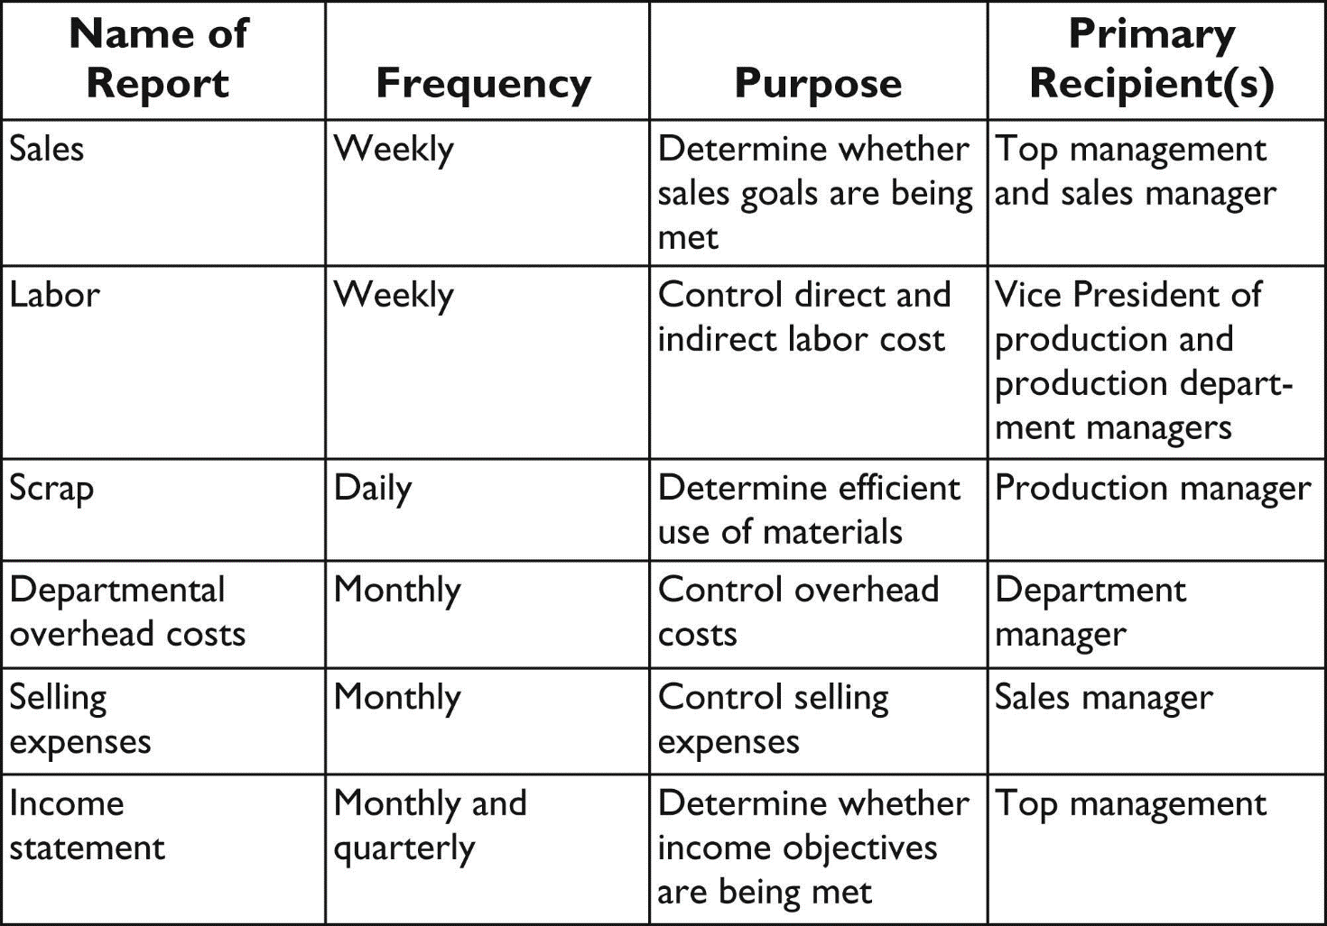

B. Static Budget Reports.

1. A static budget is a projection of budget data at one level of activity; data for different levels of activity are ignored. As a result, actual results are always compared with budget data at the activity level that was used in developing the master budget.

2. The static budget is appropriate in evaluating a manager’s effectiveness in controlling costs when
a. The actual level of activity closely approximates the master budget activity level, and/or

b. The behavior of the costs in response to changes in activity is fixed.

3. A static budget report is appropriate for fixed manufacturing costs and fixed selling and administrative expenses
C. Flexible Budgets.

1. A flexible budget projects budget data for various levels of activity. In essence, the flexible budget is a series of static budgets at different lev­ els of activity.

2. To develop the flexible budget, it is necessary to:

a. Identify the activity index and the relevant range of activity.

b. Identify the variable costs, and determine the budgeted variable cost per unit of activity for each cost.

c. Identify the fixed costs, and determine the budgeted amount for each cost.
d. Prepare the budget for selected increments of activity within the relevant range

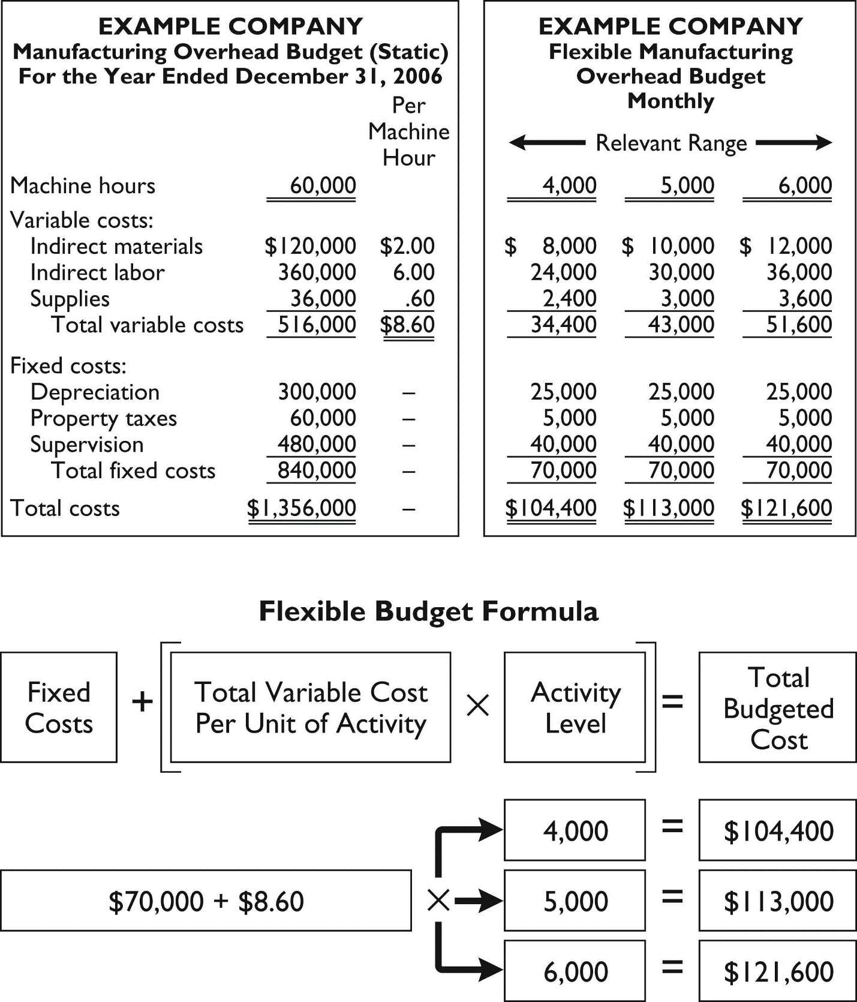

Lecture Notes 10
Master Budgeting Responsibility Accounting-Continued

3. Flexible budget reports are another type of internal report. The flexible budget report consists of two sections:

a. Production data for a selected activity index, such as direct labor hours.

b. Cost data for variable and fixed costs.

4. The flexible budget report provides a basis for evaluating a manager’s performance in two areas:

a. Production control.
b. Cost control.
5. Flexible budget reports are appropriate for evaluating performance since both actual and budgeted costs are based on the actual activity level achieved

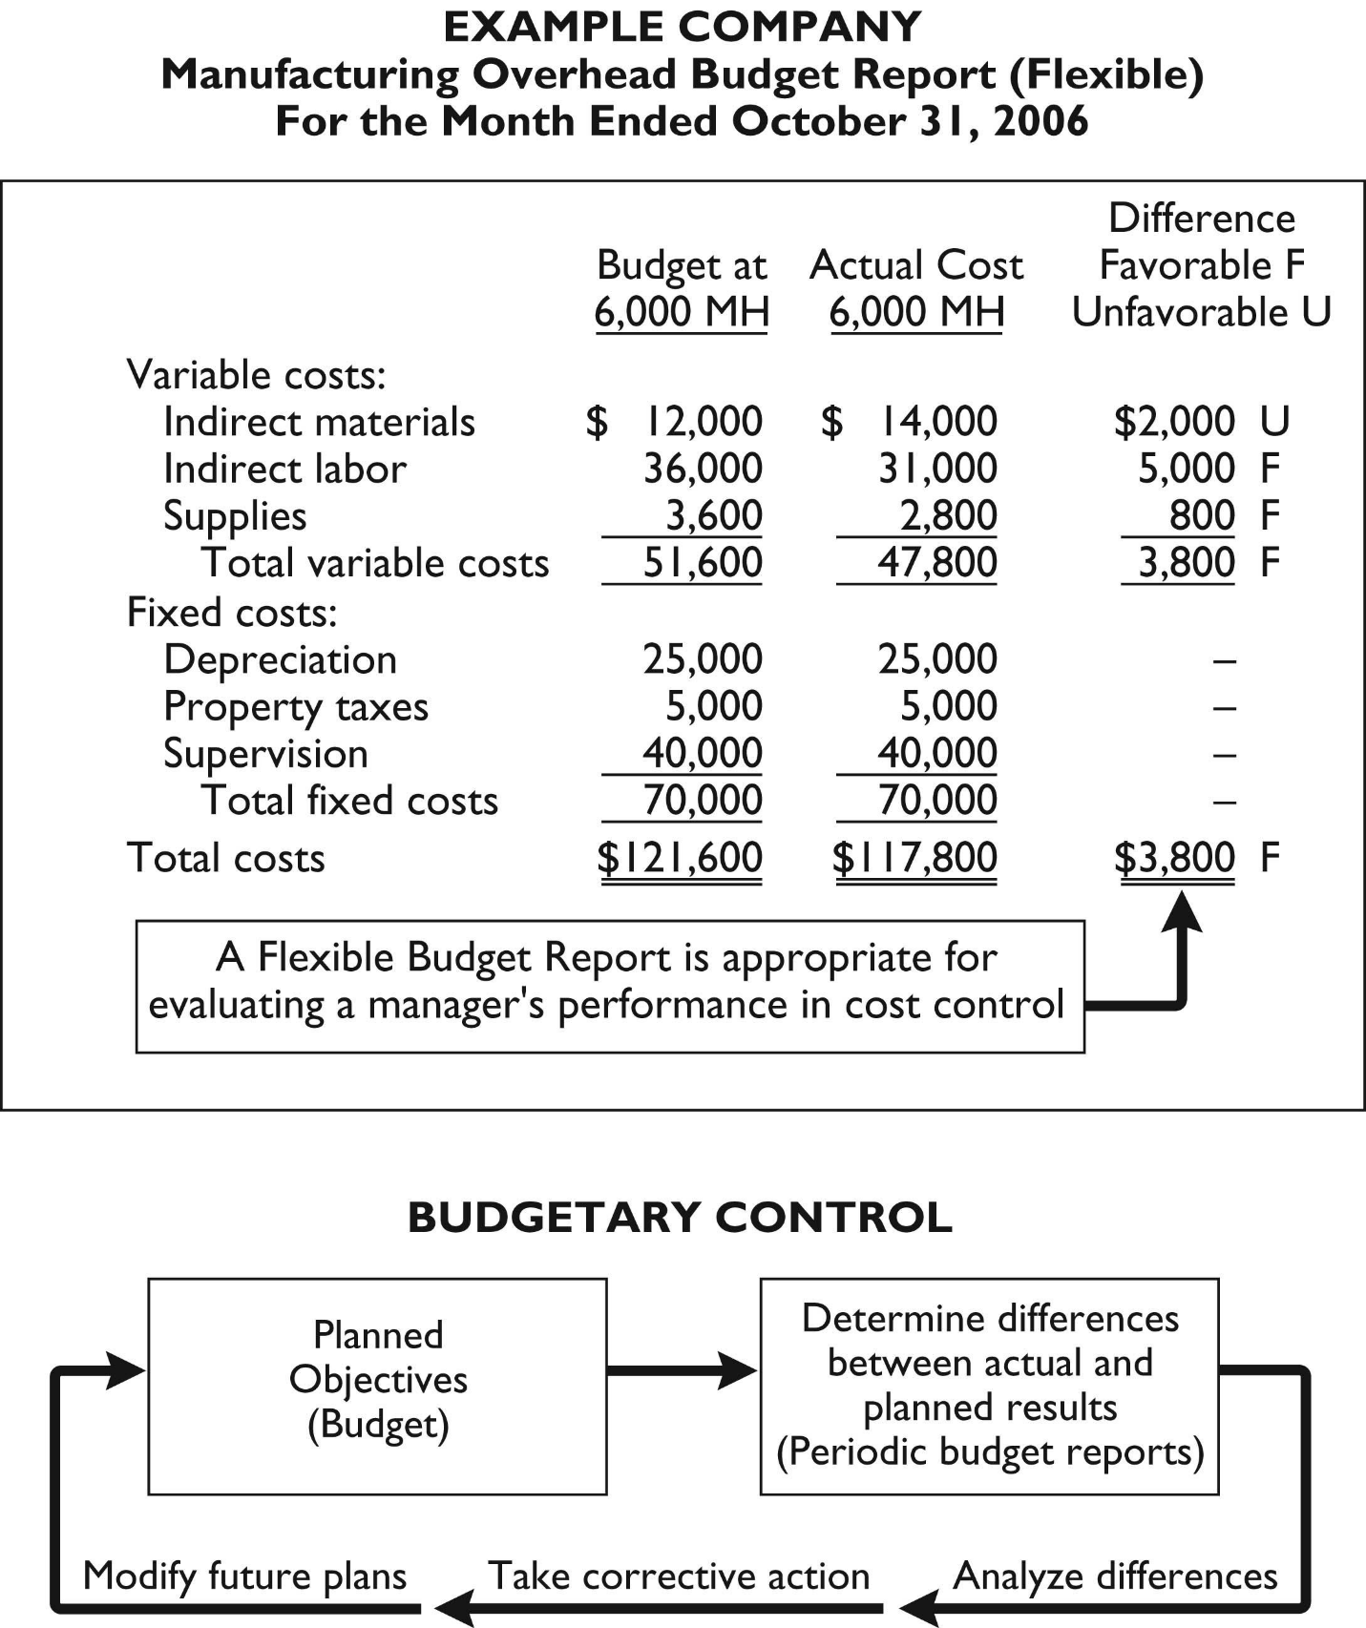
D. Management by Exception.

1. Management by exception means that top management’s review of a budget report is focused either entirely or primarily on differences be­ tween actual results and planned objectives.

2. For management by exception to be effective, there must be guidelines for identifying an exception. The usual criteria are:

a. Materiality—usually expressed as a percentage difference from budget.

b. Controllability of the item—exception guidelines are more restrictive for controllable items than for items that are not controllable by the manager

E. The Concept of Responsibility Accounting.

1. Responsibility accounting involves accumulating and reporting costs (and revenues) on the basis of the manager who has the authority to make the day­to­day decisions about the items.

2. Under responsibility accounting, a manager’s performance is evaluated on matters directly under that manager’s control.

3. Responsibility accounting can be used at every level of management in which the following conditions exist:

a. Costs and revenues can be directly associated with the specific level of management responsibility.

b. The costs and revenues are controllable at the level of responsibility with which they are associated.

c. Budget data can be developed for evaluating the manager’s effectiveness in controlling the costs and revenues.

- The reporting of costs and revenues under responsibility accounting differs from budgeting in two respects

a. A distinction is made between controllable and non-controllable costs.

b. Performance reports either emphasize or include only items controllable by the individual manager.

5. A cost is considered to be controllable at a given level of managerial responsibility if the manager has the power to incur it within a given period of time. It follows that:

a. All costs are controllable by top management because of the broad range of its activity.

b. Fewer costs are controllable as one moves down to each lower level of managerial responsibility because of the manager’s de­ creasing authority.

6. Noncontrollable costs are costs incurred indirectly and allocated to a responsibility level.

7. A responsibility reporting system involves the preparation of a report for each level of responsibility in the company’s organization chart.

8. Responsibility reports usually compare actual costs with flexible budget data. The reports show only controllable costs and no distinction is made between variable and fixed costs.

9. There are three basic types of responsibility centers: cost centers, profit centers, and investment centers.

a. A cost center incurs costs (and expenses) but does not directly generate revenues.

b. A profit center incurs costs (and expenses) and also generates revenues.

c. Like a profit center, an investment center incurs costs (and expenses) and generates revenues. In addition, an investment center has control over the investment funds available for use

10. Responsibility Reports.

a. The evaluation of a manager’s performance for cost centers is based on his or her ability to meet budgeted goals for controllable costs.

b. To evaluate the performance of a manager of a profit center, de­ tailed information is needed about both controllable revenues and controllable costs. The report is prepared using the cost­volume­ profit income statement. In the report:
(1) Controllable fixed costs are deducted from contribution margin.
(2) The excess of contribution margin over controllable fixed costs is identified as controllable margin.

(3) Noncontrollable fixed costs are not reported.

c. The primary basis for evaluating the performance of a manager of an investment center is return on investment (ROI).

d. Return on investment is computed by dividing controllable margin by average operating assets.

e. Judgmental factors in the ROI approach are (1) valuation of operating assets and (2) margin (income) measure

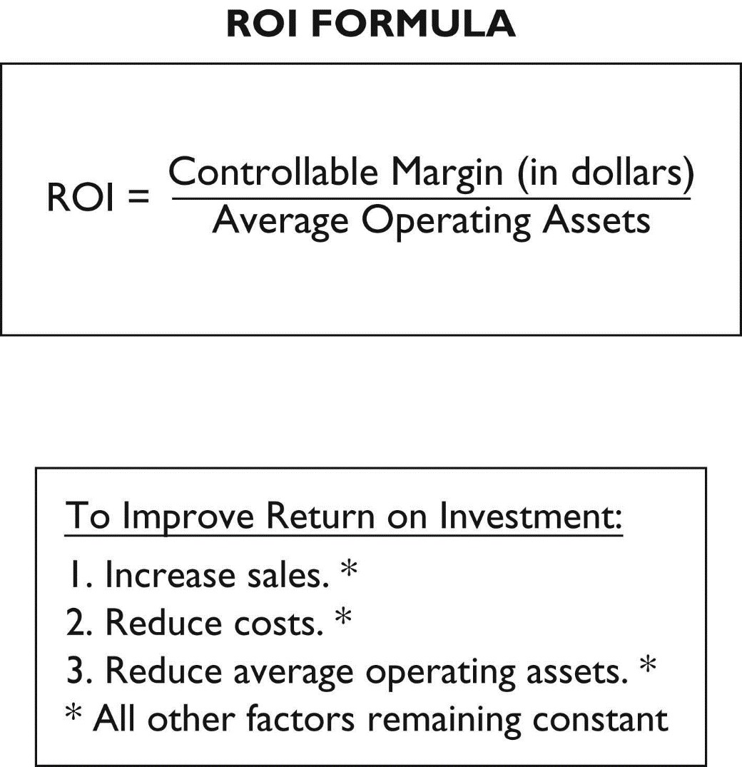

F. Principles of Performance Evaluation.

1. The human factor is critical in evaluating performance. Behavioral principles should include:

a. Managers of responsibility centers should have direct input into the process of establishing budget goals of their area of responsibility.

b. The evaluation of performance should be based entirely on matters that are controllable by the manager being evaluated.

c. Top management should support the evaluation process.

d. The evaluation process must allow managers to respond to their evaluations

e. The evaluation should identify both good and poor performance.

2. Performance evaluation under responsibility accounting should be based on certain reporting principles. Performance reports should:

a. Contain only data that are controllable by the manager of the responsibility center.

b. Provide accurate and reliable budget data to measure performance.

c. Highlight significant differences between actual results and budget goals.

d. Be tailor­made for the intended evaluation.
e. Be prepared at reasonable intervals.

*G. Residual Income Compared To ROI.

1. Residual income is the income that remains after subtracting from the controllable margin the minimum rate of return on a company’s average operating assets.

2. Residual income is computed as follows: Controllable Margin – (Minimum Rate of Return X Average Operating Assets).

3. ROI sometimes provides misleading results because profitable investments are often rejected when the investment reduces ROI but increases overall profitability

Lecture Notes 11
Determining How Cost behave
IDENTIFYING COST BEHAVIOR

Background
Managerial accountants play a large role in planning a company’s future activities. This involves forecasting future revenue volume, the costs expected with that revenue volume, and profits.

Why is this important?
A very important tool to help management forecast costs and profits is called cost-volume-profit (CVP) analysis. CVP starts with computing the break-even point. The break-even point is the sales level at which costs are equal to sales and no profit or loss is earned.

CVP is a very powerful tool, and can be used to answer questions such as:
- What sales volume is needed to break-even for a new business?
- What sales volume is required to earn a target profit?
- How would the break-even point change is a company acquires new machinery?
- How would the break-even point change if additional employees are hired, or existing employees terminated?

Identifying cost behavior
The first step in learning CVP is to understand how costs change when the volume of activity, such as units produced, changes. Costs may be classified as either fixed, variable, mixed, or step-wise.

Fixed costs:
The total amount of fixed costs remains unchanged when volume changes, within a relevant range of operations. The relevant range of operations is the normal operating range for a business, with existing machinery.

On a per unit basis, as the level of production changes the fixed cost per unit of output decreases as volume increases (and vice versa).

When production volume and costs are graphed, units of product are usually plotted on the horizontal axis and dollars of cost are plotted on the vertical axis.
- Fixed costs are represented by a horizontal line with no slope.
- The horizontal line starts on the vertical axis at the fixed cost amount.

Examples of fixed costs are factory rent, depreciation (straight-line method), and supervisors’ salaries.

Variable costs:

A variable cost increases or decreases as volume of activity increases or decreases.

On a per unit basis, a variable cost per unit remains constant but the total amount of variable cost changes with the level of production.

When production volume and variable costs are graphed,
- Variable cost is represented by a straight line starting at the zero cost level.
- The straight line is upward (positive) sloping. The line rises as volume increases.

Examples of variable costs include direct materials costs and sales commissions.

Mixed costs:

Mixed costs include both fixed and variable cost components.

When volume and mixed costs are graphed, mixed costs are represented by a straight line with an upward (positive) slope. The line starts at the fixed cost point on the vertical axis. As activity level increases, the mixed cost line increases at an amount equal to the variable cost per unit.

One example of a mixed cost is a telephone bill: there is a flat charge (fixed cost), even if no calls are made, but the total telephone expense increases as calls (variable costs) are made. Additionally, a salesperson compensated with a fixed monthly salary plus commissions on sales is a mixed cost.

Step-wise costs:

Step-wise costs are fixed within the relevant range of activity. If production volume expands significantly, total costs go up by a lump-sum amount (stair-step cost). An example is a factory expansion; with additional equipment and supervisors, fixed costs change.

Step-wise costs are treated as either fixed or variable cost in conventional CVP analysis depending on the width of the relevant range of activity.

Curvilinear Costs:

Curvilinear costs increase at a non-constant rate as volume increases.

When volume and costs are graphed, curvilinear costs appear as a curved line that starts at the graph origin (total cost is zero when volume is zero) and increases at different rates.

In summary, you should be VERY FAMILIAR with how costs behave IN TOTAL, on a PER UNIT basis, and how they would be graphed or charted.

Lecture Notes 12
Determining How Cost behave-Continued

Measuring cost behavior

CVP requires all costs be characterized as either fixed or variable. This means we must analyze mixed costs to determine their fixed and variable components. There are three methods commonly used to analyze these costs: scatter diagrams, the high-low method, and regression analysis (least-squares regression).

Scatter diagrams:

The scatter diagram displays data about past costs and units in graphical form. The unit volume is plotted on horizontal axis, and the costs on the vertical axis. Each point reflects the cost and volume levels for a prior period. The estimated line of cost behavior is drawn by fitting a line that best “fits” the points visually. The following summarizes the results from drawing a scatter diagram:
- Intersection point of line on cost axis is at fixed cost amount.
- The variable cost per unit of volume equals the slope of the line.
    - Select any two points on horizontal axis.
    - Draw a vertical line from each of these points to intersect the estimated line of cost behavior.
    - Compute the slope of the line, or variable cost, as the change in cost divided by the change in sales.
- Cost equation.
- Total Costs = Fixed costs plus (variable cost per unit times number of units of volume).
- Useful to predict future cost levels at different volumes.

A deficiency of the scatter diagram method is that estimates are based on “visual fit” of cost line, subject to interpretation.

High-low method:

The high-low method uses a two-step process to calculate variable and fixed costs. The formula to calculate variable cost per unit is:

Variable cost per unit = (Highest cost – lowest cost) / (Highest unit production – lowest unit production)

Once the variable cost per unit is known, the fixed costs are calculated. Pick either the high-cost point or low-cost point. Then, use the following formula:

Total costs = Fixed costs + Variable costs (# units * variable cost/unit)

The fixed costs are solved algebraically.

A deficiency of the high-low method is that it ignores all points except the highest and lowest, resulting in less precision.

Least-squares regression:

Least-Squares Regression is a statistical method of identifying cost behavior. Computation details are covered in advanced cost accounting courses. It is the most precise of the three methods discussed, as it uses all data points available.

USING BREAK-EVEN ANALYSIS

Break-even analysis requires knowing several basic formulas. A summary of these formulas follow.

Name | Formula
Contribution margin per unit | Sales price per unit – variable costs per unit
Contribution margin ratio | Contribution margin per unit / sales price per unit or Contribution margin/sales
Break-even point, in units | Fixed costs / Contribution margin per unit
Break-even point, in dollars | Fixed costs / Contribution margin ratio OR  BE Point in Units X Selling Price of Unit
Number of units needed to earn a target profit | (Fixed costs + Target Profit) / Contribution margin per unit
Number of sales dollars needed to earn a target profit | (Fixed costs + Target Profit) / Contribution margin ratio OR # units needed above X the selling price of a unit
Margin of safety, in dollars | Expected sales – Break-even sales
Margin of safety, in percent | (Expected sales – Break-even sales) / Expected sales

Preparing a cost-volume-profit chart

The following outline may help in preparing a cost-volume-profit chart, also called a break-even graph.

1. Horizontal axis⎯number of units sold.

2. Vertical axis⎯dollars of sales and costs.

3. Three steps:

(1) Plot fixed costs on vertical axis; draw horizontal line at this level to show that FC remains unchanged regardless of sales volume.

(2) Draw line reflecting total costs (variable costs plus fixed costs) for a relevant range of sales levels.
- Line starts at fixed costs on vertical axis.
- Slope equals variable cost per unit; compute total costs for any sales level, and connect this point with the vertical axis intercept.
- Stop line at productive capacity for the planning period.

(3) Draw sales line.
- Line starts at origin (zero units and zero dollars of sales).
- Slope of line is equal to selling price per unit; compute total revenues for any sales level, and connect this point with the origin.
- Stop line at productive capacity for the planning period.

4. Intersection of total cost line and sales line is the break-even point.

5. On either side of break-even point, the vertical distance between sales line and total cost line at any specific sales volume measures the profit or loss expected at that point.
    - Volume levels to left of break-even point⎯vertical distance is amount of loss expected because the total costs line is above the total sales line.
    - Volume levels to right of break-even point⎯vertical distance is amount of profit expected because the total sales line is above the total costs line.

Lecture Notes 13
Process Costing
COMPARISON OF JOB-ORDER COSTING AND PROCESS COSTING
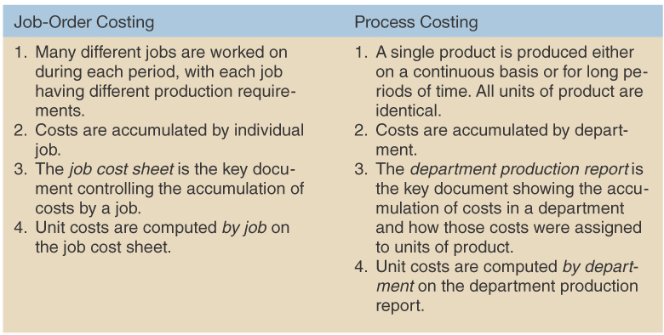

Similarities between Job-Order and Process Costing
-product costs (DM, DL, MOH)
-determine unit costs
-flow of costs

Differences between Job-Order and Process Costing
-department costs v. job costs
-department production report v. job cost sheet

Practice
Which method of determining product cost, job-order costing or process costing, would be more appropriate in each of the following situations?
 |  | Job-Order | Process
a. | A textbook publisher such as McGraw-Hill (many titles)
b. | An Exxon oil refinery
c. | A facility that only makes Minute Maid frozen orange juice
d. | A custom home builder
e. | A shop that customizes vans
f. | A chemical manufacturer

Processing Departments
Exhibit 4-2 page 143
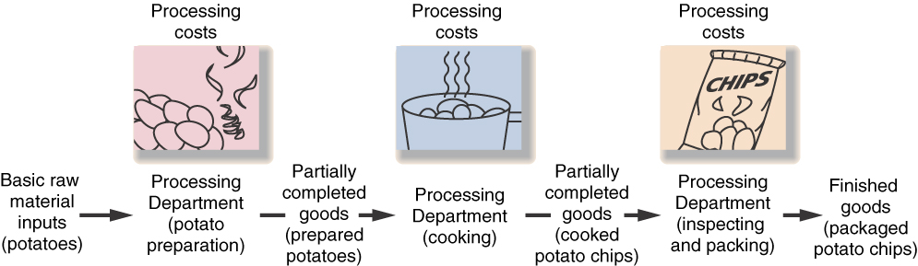

The Flow of Materials, Labor, and Overhead Costs (Exhibit 4-3 page 151)
Materials

Dept. 1 WIP
DM
CC

Dept. 2 WIP
Dept. 1
CC

Dept. 3 WIP
Dept. 2
DM
CC

Finished Goods
COGM | COGS

DL + MOH = CC
IDM

To income statement

Dept. 2 WIP
Dept. 1
DM
CC

-transferred-in costs
Cost transferred-in from all previous departments into this department
Transferred-in cost can be thought of as a type of material costs (however, it is not coming out of raw materials).
Transferred-in units is the same thing as “units started”
Costs added = transferred-in costs + material cost added + conversion costs added
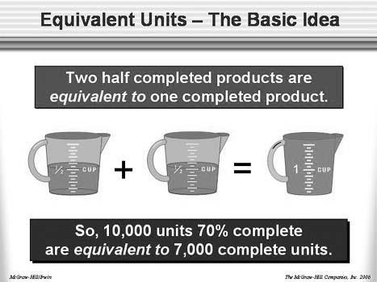
Overhead costs
-actual costs (could be used)
-applied cost (PDOR) – usually used

Equivalent Units of Production (EU)
“Pretend whole units”
“Amount of units that could have been completed if
they had worked on one unit at a time.”

Lecture Notes 14
Process Costing-Continued

OVERVIEW of the PRODUCTION REPORT—Weighted-Average Method
- A separate production report is prepared for each department.
You need to master the format of the production report; it will not be given on the exam

Step 1: Prepare a quantity schedule and compute the Equivalent Units
Units to be accounted for: | Quantity Schedule  (Units)
Beginning WIP (X% material; X% conversion)
Started production this period
Total units
 |  | Equivalent Units
Units accounted for as follows: |  | Materials | Conversion
Transferred out to next department
Ending WIP (____% material: ____% conversion)
Total units and equivalent units of production

Step 2: Compute costs per Equivalent Unit
Costs to be accounted for: | Total cost | Materials | Conversion | Whole unit
Beginning WIP
Costs added to this department
Total costs (a)
EU of production (from step 1) (b)
Cost per EU (a/b)

Step 3: Prepare a Cost Reconciliation
Cost accounted for as follows: | Total Cost
Transferred to next department |  | Units transferred x $ per whole unit
Ending WIP (materials) |  | EUs in EWIP for M x $ per EU for M
Ending WIP (conversion cost) |  | EUs in EWIP for CC x $ per EU for CC
Total ending WIP
Total cost

BWIP + costs added = EWIP + costs transferred out
Practice—Step 1
BT Company uses the weighted-average method in its process costing system. The Assembly Department started the month with 3,000 units in its beginning work in process inventory that were 50% complete with respect to material and 20% complete with respect to conversion costs. An additional 48,000 units were transferred in from the prior department during the month to begin processing in the Assembly Department. There were 8,000 units in the ending work in process inventory of the Assembly Department that were 100% complete with respect to material and 80% complete with respect to conversion costs.

- How many units transferred out of the Assembly department to the next department?

- What were the equivalent units (EU) for material in the Assembly Department for the month?

- What were the equivalent units (EU) for conversion costs in the Assembly Department for the month?

- What were the equivalent units (EU) in EWIP for material in the Assembly Department for the month?

- What were the equivalent units (EU) in EWIP for conversion costs in the Assembly Department for the month?

Lecture Notes 15
Process Costing-Continued
Practice—Step 1 & 2
Z Corp., uses the weighted-average method in its process costing system. The first processing department, the Welding Department, started the month with 10,000 units in its beginning work in process inventory that were 100% complete with respect to material and 40% complete with respect to conversion costs. Beginning work in process inventory consisted of $13,500 in material cost and $20,920 of conversion costs. An additional 62,000 units were started into production during the month and 67,000 units were completed in the Welding Department and transferred to the next processing department. There were 5,000 units in the ending work in process inventory of the Welding Department that were 100% complete to material and 80% complete with respect to conversion costs. A total of $130,500 in material was added into this department and $125,340 in conversion costs were incurred in the department during the month.

- The equivalent units (EU) for material in the Welding Department for the month:__________
- The equivalent units (EU) for conversion costs in the Department for the month: ___________
- The cost per equivalent unit ($/EU) for material for the month: $__________ per EU
- The cost per equivalent unit ($/EU) for conversion costs for the month: $__________ per EU
- The cost per whole unit for the month: $__________ per unit
- The cost transferred out of the Welding Department during the month: $_____________
- The cost in EWIP for material at the end of the month: $_____________
- The cost in EWIP for conversion cost at the end of the month: $_____________
Practice—Production Report
Builder Products, Inc., manufactures a caulking compound that goes through three processing stages prior to completion. Information on work in the first department, Cooking, is given below for May:
Production data
 |  | Units in process, May 1: materials 100%, conversion 80% | 10,000
 |  | Units started into production during May | 100,000
 |  | Units completed and transferred out | 95,000
 |  | Units in process, May 31: materials 60%, conversion 20% | ?
Cost data
 | Work in process inventory, May 1
 |  | Material cost | $1,500
 |  | Labor cost + overhead cost (conversion cost) | $7,200
 | Cost added during May
 |  | Material cost | $154,500
 |  | Labor cost + overhead cost (conversion cost) | $90,800

- Units transferred out of the Cooking department to the next department? _________ units
- How many units were in ending work in process at the end of May? ____________ units
- EU for material. ______________ EU
- EU for conversion costs. _______________EU
- The total cost to be accounted for in the Cooking department. $______________
- Cost per EU for material. $______________
- Cost per EU for conversion. $______________
- Cost per whole unit. $______________
- The cost transferred out of the Cooking department for the month. $______________
- Material cost remaining in the Cooking department at the end of the month. $_____________
- The conversion cost remaining in the department at the end of the month. $_____________
- The product cost remaining in the department at the end of the month? $______________
Practice—Step 3 and COGS
S Corporation uses the weighted-average method in its process costing system. The Fitting Department is the third and last department in its production process. The data below summarize the department's operations in March. All material (including transferred in units) are added at the beginning of production.
 | Units | Percentage complete
Beginning work in process inventory | 1,100 | 40%
Transferred in from the prior department during March | 46,000
Ending work in process inventory | 4,600 | 30%

The Fitting Department's production report indicates that the cost per equivalent unit for transferred in costs were $6.00 per unit, the cost per equivalent unit of material is $3.75 conversion cost for March was $9.25.

- How much product cost was assigned to the units transferred out of the Fitting Department during March? $_____________
- How much material & transferred in cost remains in the Fitting Department at the end of March? $____________
- How much conversion costs remain in the Fitting Department at the end of March? $__________
- If beginning finished goods contained $46,200 and ending finished goods contained $27,675 what was the company’s cost of goods sold? $_______________
- How many units did the company sell? ___________ units
Lecture Notes 16
Direct Cost Variance and Management Control
A Word on Flexible Budgets
Planning Budget—prepared before the period begins (Chapter 8)
Flexible Budget—takes into account how changes in activity affect budgeted revenue and budgeted costs.

STANDARD
A standard is a benchmark used for measuring performance.
-quantity of input
-cost of inputs

Management by Exception
-standard cost performance report is prepared showing variances
-focus attention on variances to determine why they occurred
-take corrective action to eliminate variance

Setting Standards
-Ideal standards
1. No machine breakdowns or other interruptions;
2. Expect skilled and efficient employees to work at 100%;
3. Large variances are normal since standards are difficult to achieve making “management by exception” difficult;
4. Causes issues with worker motivation.

-Practical standards
1. Tight but attainable;
2. Allow for normal machine breakdown and employee rest periods;
3. Should be achievable with highly efficient efforts of average worker;
4. Variances focus “management by exception;”
5. Used to forecast cash flow and inventory purchases/production.
Standard cost card
Input | (1) Standard  Quantity or Hours | (2) Standard  Price or Rate | (1) x (2)  Standard Cost
Direct materials | 3.0 pounds | $4.00 | $12.00
Direct labor | 0.5 hours | $22.00 | $11.00
Variable MOH | 0.5 hours | $6.00 | $3.00
Total Standard cost per unit |  |  | $26.00

DIRECT MATERIALS STANDARDS
Standard price (SP) for one unit of direct material; includes shipping and handling as well as reduction for purchase discounts.
Standard quantity per unit is the direct material used to produce one unit of final product; includes waste and spoilage as well as expectation for rejected units.
Standard Quantity (SQ) is the standard quantity of material allowed for the level of actual output.

DIRECT LABOR STANDARDS
Standard rate (SR) per hour includes the base hourly wage, plus taxes and fringe benefits.
Standard hours per unit, the direct labor hours needed to complete one unit of finished product. Standard hours (SH) are the standard hours allowed for the level of actual output.

VARIABLE MANUFACTURING OVERHEAD STANDARDS
Standard rate (SR) variable portion of the PDOR (similar to chapter 3),
Standard hours per unit, the allocation base used to allocate VOH to units on a per unit basis. Standard hours (SH) are the standard hours allowed for the level of actual output.

VARIANCES
Variance analysis
-compare actual v budget

Favorable variance (F): negative balances
Unfavorable variance (U): positive balances

Quantity and Price Variance
The general model used to determine a variance is: (Exhibit 10-4 page 425.)
SQ x SP | AQ x SP |  | AQ x AP
Quantity Variance = (AQ x SP) – (SQ x SP) |  | - Price Variance = (AQ x AP) – (AQ x SP)
Actual cost (AQxAP) - Flexible budget cost (SQxSP) = Spending Variance

where A = Actual, S = Standard, Q = Quantity and P = Price

Standard quantity allowed (SQ) or standard hours allowed (SH)
- Actual production x the standard quantity per unit = SQ or SH

DIRECT MATERIAL VARIANCES
AQ purchased MPV
AQ used MQV

Materials Quantity Variance (MQV)  MQV = What you used v. what you should have used  MQV = (SP x AQ used) – (SP x SQ)  MQV = SP (AQ- SQ)  -Responsibility  -Causes  -Calculate during production | Materials Price Variance (MPV)  MPV = What you paid v. what you should have paid  MPV = (AQ purchased x AP) - (AQ purchased x SP)  MPV = AQ (AP- SP)  -Responsibility  -Causes  -Calculate at time of purchase

Practice

Dawson Toys produces a toy called the Maze. The company has recently established a standard cost system to help control costs and has established the following standards for the Maze toy:
Direct material: | 6 microns per toy at $0.50 per micron

During July, the company produced 3,000 Maze toys. Production data for the month on the toy were:
Direct material: | 25,000 microns were purchased at a cost of $0.48 per micron, 5,000 of these microns were still in inventory at the end of the month

Determine the MQV and MPV

First identify the following:
AQ purchased | 25,000 given
AQ used | 20,000 (25,000 purchased – 5,000 in ending inventory)
SQ | 6 microns x 3,000 toys = 18,000 microns
AP | $0.48 given
SP | $0.50 given

Then solve:
MQV = | MPV =
MQV = | MPV =
MQV = | MPV =
MQV = | MPV =
MQV = | MPV =

Practice
Information on Rex Co.'s direct material costs for May follows:

Actual quantity of direct materials purchased | 30,000 | pounds
Actual cost of direct materials | $84,000
Actual quantity of direct material used | 29,500 | pounds
Standard price per pound | $3.00
Standard quantity per unit | 1.25 | Pounds
Units made during the month | 23,200 | Units

Determine the Material Quantity Variance

Determine the Material Price Variance

Lecture Notes 17
Direct Cost Variance and Management Control-Continued

DIRECT LABOR VARIANCES
-Replace Price (P) with Rate (R)
-Replace Quantity (Q) with Hours (H)

SH x SR | AH x SR |  | AH x AR
Efficiency Variance = (AH x SR) – (SH x SR) |  | - Rate Variance = (AH x AR) – (AH x SR)
Actual cost (AHxAR) - Flexible budget cost (SHxSR) = Spending Variance

Labor Efficiency Variance (LEV)  LEV = The hours that were worked v. the hours that should have been worked  LEV = (SR x AH) – (SR x SH)  LEV = SR (AH – SH)  -Responsibility  -Causes | Labor Rate Variance (LRV)  LRV = What you paid v. what you should have paid  LRV = (AH x AR) – (AH x SR)  LRV = AH (AR – SR)  -Responsibility  -Causes
Practice

Dawson Toys produces a toy called the Maze. The company has recently established a standard cost system to help control costs and has established the following standards for the Maze toy:
Direct labor: | 1.3 hours per toy at $8 per hour

During July, the company produced 3,000 Maze toys. Production data for the month on the toy were
Direct labor: | 4,000 direct labor-hours were worked at a cost of $36,000

Determine LEV and LRV

First identify the following:

AH

SH

AR

SR

Then solve:
LEV = SR (AH – SH) | LRV = AH (AR – SR)
LEV = | LRV =
LEV = | LRV=
LEV = | LRV =

What are some of the causes of the above variances?

Practice
The standards for product F88W specify 3.4 direct labor-hours per unit at $13.00 per direct labor-hour. Last month 800 units of product F88W were produced using 2,500 direct labor-hours at a total direct labor wage cost of $30,500.

What was the labor efficiency variance?

What was the labor rate variance?

What was the labor spending variance?

VARIABLE MANUFACTURING OVERHEAD VARIANCES
-If DLH is allocation base:
VOH Efficiency Variance (VoEV)  VoEV = Actual amount of the base that was used v. the amount of the base that should have been used  VoEV = (SR x AH) – (SR x SH)  VoEV = SR (AH – SH) | VOH Rate Variance (VoRV)  VoRV = Actual variable overhead v. what you should have spent for variable overhead  VoRV = (AH x AR) – (AH x SR)  VoRV = AH (AR – SR)  Where SR = Variable portion of PDOR

Practice
Shawl Corporation's variable manufacturing overhead is applied on the basis of direct labor-hours. The standard cost card for product F02E specifies 5.5 direct labor-hours per unit of F02E. The standard variable manufacturing overhead rate is $6.80 per direct labor-hour. During the most recent month, 1,560 units of product F02E were made and 8,700 direct labor-hours were worked. The actual variable manufacturing overhead incurred was $52,635.

What was the variable overhead efficiency variance for the month?

What was the variable overhead rate variance for the month?
What was the variable overhead spending variance?

Evaluation of Controls Based on Standard Costs

Advantages (page 439)
- Management by exception
- Benchmark
- Simplify bookkeeping
- “Responsibility accounting”

Potential Problems (page 440)
- Reports may not be timely
- Potential to use negative reports to punish employees
- Efficiency variance assumes labor is variable
- Favorable variances can be interpreted good when it is not
- Too much focus on meeting the standard may make quality suffer
- Just meeting the standard is not sufficient the goal is “constant improvement.”

Lecture Notes 18
Flexible Budget, Overhead Variances and Management Control

A. Static Budgets. (Exercise 11-8.) The term static budget refers to the budget that is set at the beginning of a budgeting period and that is geared to only one level of activity—the budgeted level of activity.

1. What Is Wrong with a Static Budget? The static budget is appropriate for the budgeted level of activity but is not realistic for other levels of activity—particularly if variable costs are significant. If activity is 10% higher than budgeted, then some costs are likely to be 10% higher than budgeted as well.

2. Static Budgets and Performance Reports. Unfortunately, managers are commonly held responsible for deviations of actual from budgeted costs. This approach confuses two different aspects of control—control over the level of activity and control over the effective use of resources.

3. Why Do Actual Costs Deviate from Budgeted Costs? Actual costs deviate from budgeted costs for many reasons. The two most important are: i) the actual level of activity differs from the budgeted level of activity and ii) the manager’s use of resources was more or less effective than assumed in the budget. That is, a variance between actual and budgeted costs can be due to a change in activity level or to effective or ineffective cost control.

4. Static Budget Comparisons Commingle Effects. If the actual level of activity differs greatly from the budgeted level, most of the variance for variable costs will almost certainly be due to the change in activity level. The variance would then be an extremely noisy indicator of how well a manager controlled costs. And at any rate, the variance between actual and budgeted costs commingles effects due to changes in activity levels and due to how well costs were controlled given the level of activity. If a manager is responsible for the level of activity, control over that aspect of the manager’s responsibility should be separated from control over costs. And if a manager is not responsible for the level of activity, it is even clearer that the two effects must be disentangled to have a meaningful report. The key to resolving this problem is the use of flexible budgets.

B. Flexible Budgets. (Exercises 11-1, 11-7, 11-8.) A flexible budget is geared to all levels of activity within the relevant range and is used to plan and control spending. The flexible budget will show the cost formula for each variable cost and total cost (possibly including fixed costs) at various levels of activity.

C. Overhead Performance Report. (Exercises 11-2, 11-3, 11-4, 11-9, 11-10, 11-11.) When the actual level of activity differs from what had been assumed in the static budget at the beginning of the period, we would expect the spending to differ as well. A good overhead performance report compares actual costs to the flexible budget for the actual level of activity. Since spending in at least some categories should vary with activity, this is the only way to build a reasonable benchmark for what the spending should be.

D. Complications when Activity Is Measured In Hours. When a company makes a number of different products, a unit of one product may require different overhead resources than a unit of another product. In that situation, adding together units of output from different products is like adding apples and oranges. Some other measure of activity should be used.

1. The measure of activity. Three factors should be considered in selecting an activity base for a flexible budget.

a. The activity base and overhead costs should be causally related. The activity measure should actually drive the overhead costs. Direct labor-hours is often used as the measure of activity, but this practice has come under increasing criticism. As discussed in conjunction with activity-based costing, the links between direct labor-hours and overhead seem to be getting more tenuous.

b. The activity measure should not be stated in dollars. If the activity measure is stated in dollars, then changes in prices may be interpreted as changes in activity.

c. The activity base should be simple and easily understood.

2. Actual versus standard hours allowed and variable overhead variances. When an input such as direct labor-hours or machine-hours is used as the measure of activity, the question arises whether actual hours or the standard hours allowed for the actual output should be used as the measure of activity in performance reports. The following discussion assumes that overhead spending is highly correlated with actual hours; that is, actual hours drives overhead costs.

a. Actual Hours. When actual hours are used as the basis for the flexible budget allowance, only a spending variance can be computed for variable overhead. The variable overhead spending variance is the difference between the actual variable overhead cost and the budget allowance that is determined by multiplying the actual hours by the variable overhead rate per hour. A spending variance occurs because prices differ from those assumed in the flexible budget, because of effective or ineffective control of overhead resources, or because of inaccuracies in the flexible budgets themselves. The variable overhead spending variance basically combines price and quantity variances in one variance. Exhibit YY-6 in the text presents an example of a variable overhead performance report where the budget is based on actual hours.

b. Standard Hours Allowed. The standard hours allowed could also be used as a measure of activity in a performance report. However, in this case it is best to compute two variances rather than just one. The first variance is the variable overhead spending variance based on the actual hours. The second variance is the variable overhead efficiency variance based on the difference between the actual hours and the standard hours allowed for the actual output of the period. The mechanics of these two variances were covered in Chapter 10.
The variable overhead efficiency variance attempts to estimate the indirect effects on variable overhead costs of efficient or inefficient use of the activity base. If too many hours are used to produce the actual output, then presumably this results in additional variable overhead costs. (Remember the assumption that variable overhead costs are really proportional to actual hours.) Exhibit YY-7 in the text presents an example of a variable overhead performance report where both spending and efficiency variances are computed for variable overhead.

Lecture Notes 19
Flexible Budget, Overhead Variances and Management Control

E. Predetermined Overhead Rates (Exercises 11-5, 11-12, 11-14, 11-15.) Predetermined overhead rates were discussed in earlier chapters, so this is largely a review. The formula for the predetermined overhead rate used in this chapter is:

Separate predetermined rates can be computed for variable and fixed overhead by including only variable or fixed overhead costs in the numerator. When overhead is fixed, the predetermined overhead rate will depend on the denominator level of activity. The higher the level of activity is, the lower the rate will be.

F. Applying Overhead in a Standard Cost System. Overhead can be applied to units based on actual hours or on standard hours allowed for the actual output. In a standard cost system overhead is applied on the basis of the standard hours allowed for the actual output. This results in each unit being assigned the same overhead cost—regardless of how many hours were actually required to make the unit.

G. Fixed Overhead Variances in a Standard Cost System. (Exercises 11-6, 11-13, 11-14, 11-15, 11-16.) Two variances are computed for fixed overhead—a budget variance and a volume variance. These variances are quite different from the variances computed for variable overhead.

1. Budget Variance. The budget variance is the difference between the actual fixed overhead costs incurred during the period and the budgeted fixed overhead costs contained in the flexible budget. This variance is very useful in that it indicates how well spending on fixed items was controlled.
Students are often confused about the controllability of fixed costs. Contrary to intuition, fixed costs are often far easier to control than variable costs. For example, it is usually much easier to control spending on convention travel (a fixed cost) than on direct materials. The term fixed does not mean the cost can’t change. A fixed cost can change and it may depend on a number of factors; however, it does not depend on the level of activity during the period.

2. Volume Variance. The volume variance is the difference between the total budgeted fixed overhead and the fixed overhead applied to production. Alternatively, it can be expressed as follows:

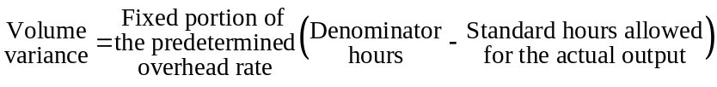

The volume variance occurs because the denominator level of activity differs from the standard hours allowed for production. Thus, an unfavorable variance means that the company operated at an activity level below the denominator level of activity. Conversely, a favorable variance means that the company operated at an activity level greater than the denominator level of activity. Some would call the volume variance a measure of the utilization of plant facilities relative to the planned utilization. Others who are less charitable would call it the error that is induced in the costing system by assuming that fixed costs are variable.

H. Under- and Overapplied Overhead. The sum of the four manufacturing overhead variances—variable overhead spending, variable overhead efficiency, fixed overhead budget, and fixed overhead volume—equals the under- or overapplied overhead for the period.

1. The sum of the variances equals under- or overapplied overhead. The four overhead variances measure the difference between actual overhead costs incurred and the standard overhead cost for the actual output. The under- or overapplied overhead measures the difference between actual overhead costs incurred and the overhead applied to inventory. In a standard cost system the amount of overhead cost applied to inventory is the standard cost, so the variances and the under- or overapplied inventory measure the same thing. Therefore, they must sum to the same number.

2. Underapplied overhead is equivalent to an unfavorable variance. If overhead is underapplied, more overhead cost was incurred than was applied to inventory. The amount applied to inventory is the standard cost allowed for the actual output. Therefore, if overhead is underapplied, more overhead cost was incurred than was allowed for the actual output—hence, the overall variance is unfavorable. Similar reasoning leads to the conclusion that overapplied overhead is equivalent to a favorable variance.

- Variable overhead variances – a closer look

  - Actual versus standard hours

    - When the flexible budget is based on hours of activity, the quantity of hours chosen can be based on actual hours or the standard hours allowed for the actual output.
33

        - If the actual hours are used, only a spending variance can be computed.
      - If both the actual and standard hours are used, both a spending and an efficiency variance can be computed.

  - ColaCo – an example

    - Assume the following:
ColaCo’s actual production for the period required 3,200 standard machine hours.
      - Actual variable costs incurred during the period was $6,740.
34
      - 3,300 machine-hours were actually worked during the period.
      - The standard variable overhead cost per machine hour is $2.00.

35 | 36 | 37
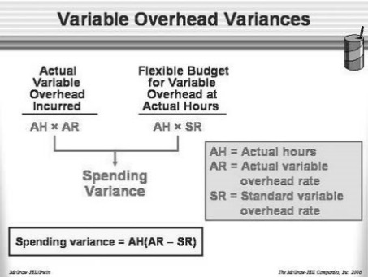 | 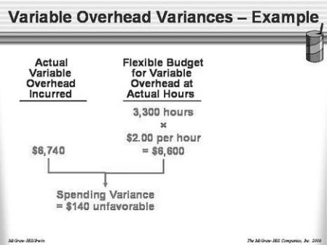 | 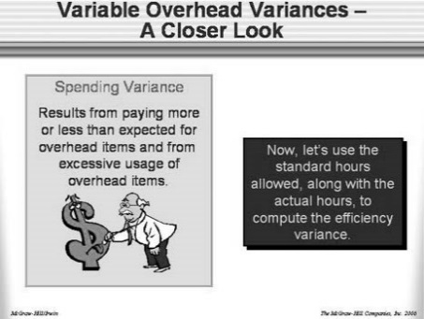
38 | 39
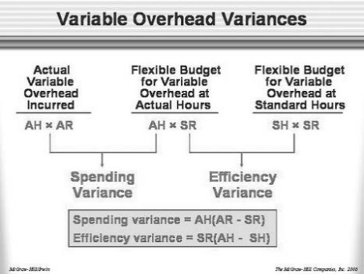 | 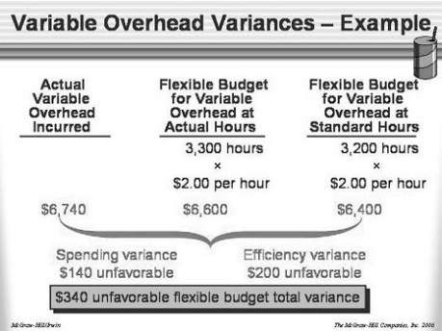

Lecture Notes 20
Decision Making and relevant Information
Learning Objectives

LO1. Identify relevant and irrelevant costs and benefits in a decision situation.
LO2. Prepare an analysis showing whether a product line or other organizational segment should be dropped or retained.
LO3. Prepare a make or buy analysis.
LO4. Prepare an analysis showing whether a special order should be accepted.
LO5. Determine the most profitable use of a constrained resource and the value of obtaining more of the constrained resource.
LO6. Prepare an analysis showing whether joint products should be sold at the split-off point or processed further.

A. Cost Concepts for Decision-Making. (Exercises 13-1, 13-7, and 13-13.) Every decision involves

1. Identifying relevant costs. Only those costs and benefits that differ between alternatives are relevant in a decision. Any cost or benefit that does not differ between the alternatives is irrelevant and can be ignored. This is a tremendously powerful concept that allows us to ignore mounds of data when making decisions since most things are not affected by any given decision.

a. All sunk costs (i.e., costs already irrevocably incurred) are irrelevant since they will be the same for any alternative. All future costs that do not differ between alternatives are irrelevant.

b. Any cost that is avoidable is potentially relevant. An avoidable cost is a cost that can be eliminated (in whole or in part) as a result of choosing one alternative over another.

2. Different costs for different purposes. Costs that are relevant in one decision are not necessarily relevant in another. In each situation the manager must examine the data and isolate the relevant costs.
3. Human frailties. Most of us have a great deal of difficulty ignoring irrelevant costs when making decisions. We are especially reluctant to ignore sunk costs when the sunk costs are a consequence of a past decision that in retrospect was unwise. We have a tendency to become committed to courses of action that have not worked out.
B. Adding or Dropping a Segment. (Exercises 13-2, 13-8, and 13-14.) Decisions related to dropping old products (or segments) and adding new products (or segments) are among the most difficult that a manager makes. Two basic approaches can be used to analyze data in this type of decision.

1. Compare contribution margins and fixed costs. A segment should be added only if the increase in total contribution margin is greater than the increase in fixed cost. A segment should be dropped only if the decrease in total contribution margin is less than the decrease in fixed cost.

2. Compare net operating incomes. A second approach is to calculate the total net operating income under each alternative. The alternative with the highest net operating income is preferred. This approach requires more information than the first approach since costs and revenues that don’t differ between the alternatives must be included in the analysis in order to compute net operating incomes.

3. Beware of allocated common costs. Allocated common costs can make a profitable segment look unprofitable. Allocated common costs that would not be affected by a decision are irrelevant and should be ignored.

Cost concepts for decision making

Identifying relevant costs and benefits

A relevant cost is a cost that differs between alternatives.

An avoidable cost is a cost that can be eliminated in whole or in part by choosing one alternative over another. Avoidable costs are relevant costs. Unavoidable costs are irrelevant costs.

Two broad categories of costs are never relevant in any decision:

A sunk cost is a cost that has already been incurred and cannot be avoided regardless of what a manager decides to do.
A future cost that does not differ between alternatives is never a relevant cost.
Spending variance alone – using actual hours
The general model for calculating the variable overhead spending variance is as shown. Notice, actual hours are used instead of standard hours allowed.
In the case of ColaCo, the variable overhead spending variance is $140 U.
1. This variance is useful only to the extent that the cost driver for variable overhead really is the actual machine hours worked.
2. This variance contains price and quantity components.
The unfavorable variance may be due to the variable overhead items costing more to purchase than the standards allow.
The unfavorable variance may be due to using more of the variable overhead items than the standards allow.

Lecture Notes 21
Decision Making and relevant Information-Continued

B. Adding or Dropping a Segment. (Exercises 13-2, 13-8, and 13-14.) Decisions related to dropping old products (or segments) and adding new products (or segments) are among the most difficult that a manager makes. Two basic approaches can be used to analyze data in this type of decision.

1. Compare contribution margins and fixed costs. A segment should be added only if the increase in total contribution margin is greater than the increase in fixed cost. A segment should be dropped only if the decrease in total contribution margin is less than the decrease in fixed cost.

2. Compare net operating incomes. A second approach is to calculate the total net operating income under each alternative. The alternative with the highest net operating income is preferred. This approach requires more information than the first approach since costs and revenues that don’t differ between the alternatives must be included in the analysis in order to compute net operating incomes.

3. Beware of allocated common costs. Allocated common costs can make a profitable segment look unprofitable. Allocated common costs that would not be affected by a decision are irrelevant and should be ignored.

C. The Make or Buy Decision. (Exercises 13-3, 13-9, and 13-15.) A make or buy decision is concerned with whether an item should be made internally or purchased from an external supplier.

1. Advantages of making an item internally.

a. Producing a part internally reduces dependence on suppliers and may ensure a smoother flow of parts and material for production.

b. Quality control may be easier when parts are produced internally.

c. Profits can be realized on the parts and materials.

2. Advantages of buying an item from an external supplier.

a. By pooling the requirements of a number of users, a supplier can realize economies of scale and may be able to move more quickly up the learning curve.

b. A specialized supplier may be able to respond more quickly and at less cost to changing future needs.

c. Changing technology may make producing one’s own parts riskier than purchasing from the outside.

3. Opportunity Cost. Opportunity costs should be considered in decisions. The opportunity cost of using a resource that has excess capacity is zero. However, using a resource that has no idle capacity (i.e., that is a constraint) does involve an opportunity cost. The opportunity costs may be far larger than the costs typically recorded in accounting systems.

D. Special Order. (Exercises 13-4 and 13-10.) Special orders are one-time orders that do not affect a company’s normal sales. As long as the incremental revenue from the order exceeds its incremental costs, the order should be accepted. If the special order requires a constrained resource, opportunity costs should be included as part of the incremental costs.

E. Utilization of a Constrained Resource. (Exercises 13-5 and 13-11.) A constraint is whatever prevents an individual or organization from getting more of what it wants. There is always a constraint as long as desires are unsatisfied. The chapter focuses on one particular kind of constraint—a production constraint. A production constraint can be a raw material, a part, a machine, or a workstation. If the constraint is a machine or workstation, it is called a bottleneck.

1. Contribution Margin per Unit of the Constrained Resource. Whenever demand exceeds productive capacity, a production constraint exists. The company is unable to fill all orders and some choices have to be made concerning which orders are filled and which are not filled. The problem is how to most effectively use the constrained resource.

a. Regardless of which orders are filled, the fixed costs will usually be the same. Therefore, maximizing the total contribution margin will also maximize profit.

b. To maximize contribution margin, rank products on the basis of their contribution margins per unit of the constrained resource. Starting at the top of the list, produce up to demand or to the point where the constrained resource is exhausted—whichever comes first. (This idea is generalized in the new Profitability Appendix.)

2. Managing constraints. Ordinarily, a system has only one constraint. The capacity of any complete process is determined by the capacity of the constraint, which could be a single machine or work center. In addition to making sure that the best product mix is chosen by ranking products based on the contribution margin per unit of the constrained resource, managers should seek ways to increase the effective capacity of the constraint.

a. Increasing the capacity of the constraint or bottleneck is called “relaxing the constraint” or “elevating the constraint.” Conceptually, the capacity of the bottleneck can be increased by increasing the rate of output at the bottleneck or increasing the time available at the bottleneck. Some specific examples of ways to elevate the constraint follow:
• Pay workers overtime to keep the bottleneck running after normal working hours. As discussed below, the potential payoff from taking such an action is often well worth the additional expense. In contrast, paying workers overtime to keep non-bottleneck processes running after normal working hours is a waste of money.
• Shift workers from non-bottleneck areas to the bottleneck.
• Hire more workers or acquire more machines specifically to augment the bottleneck.
• Subcontract some of the production that would use the bottleneck. If an unimportant part requires a lot of time on the bottleneck and can be purchased cheaply from an external supplier, this is a great way to increase profits. The bottleneck can be shifted to more profitable uses.
• Streamline the production process at the bottleneck to eliminate wasted time. Improvement programs such as TQM and Business Process Reengineering should focus on bottlenecks. A decrease in processing time at the bottleneck can have an immediate and dramatic effect on profits. A decrease in processing time at a non-bottleneck is likely to have no immediate impact on profits; it just creates more excess capacity.
• Reduce defects. A part that is processed on the bottleneck and later rejected because it is defective uses valuable bottleneck processing time.

b. The benefits from effectively managing constraints (i.e., bottlenecks) can be enormous. Managers should be given information that signals this potential. Decide how additional processing capacity at the bottleneck would be used if it were available. In other words, what product or order would be produced that otherwise could not be produced? This is the marginal job. The contribution margin per unit of the constrained resource for this marginal job is the value of elevating the constraint by one unit. (It is also the opportunity cost of using the constrained resource.) Quite often these calculations reveal that the value of additional time is so valuable that some decisions can be made very easily—such as adding a shift on the bottleneck.

F. Joint Costs and the Contribution Approach. (Exercises 13-6 and 13-12.) In some manufacturing processes, several end products are produced from a single input. Such end products are known as joint products. The costs associated with making these products up to the point where they can be recognized as separate products (the split-off point) are called joint costs.

1. The pitfalls of allocation. Joint costs are really common costs that are incurred to simultaneously produce a variety of end products. Unfortunately, these common costs are routinely allocated to the joint products. Allocated joint costs are often misinterpreted as costs that could be avoided by producing less of one of the joint products. However, joint costs can only be avoided by producing less of all of the joint products simultaneously. If any of the joint products is made, then all of the joint costs up to the split-off point will have to be incurred.

2. Sell or process further decisions. A decision may need to be made concerning whether to sell a joint product as is or process it further for a higher price. (This type of decision is not confined to joint products. Any time a product could be sold as is or processed further for additional revenue, this kind of analysis is pertinent.)

a. It is profitable to continue processing a joint product after the split-off point so long as the incremental revenue from such processing exceeds the incremental processing costs.

b. In such decisions, the joint costs incurred before the split-off point are not relevant. They would be relevant in a decision to shut down the joint process, but they are irrelevant in any decision about what to do with the joint products once they have reached the split-off point.

G. Activity-Based Costing and Relevant Costs. Activity-based costing is a resource consumption model, not a spending model. Activity-based costing gives an idea of the magnitude of resources involved in carrying out activities, but it should be used with a great deal of caution in making particular decisions. The costs assigned to products and other cost objects are only potentially relevant costs. Whether they are relevant or not in any particular situation should be carefully considered.
For example, in most activity-based costing systems the fixed depreciation costs of a sophisticated milling machine would be allocated to products based on their usage of that resource. Suppose you are trying to decide whether to drop a product that uses the milling machine. The fact that the product uses the milling machine is relevant only if the milling machine is a bottleneck (and opportunity costs are involved in its use) or somehow future cash flows associated with the machine will be affected by how much it is used. If the machine is not a bottleneck and using some of its excess capacity has no effect on future spending, then using the machine costs nothing. In this case, the costs assigned by the activity-based costing system to the product would not be relevant.

Lecture Notes 22
Inventory Costing and Capacity Analysis
Learning Objectives

LO1. Explain how variable costing differs from absorption costing and compute unit product costs under each method.
LO2. Prepare income statements using both variable and absorption costing.
LO3. Reconcile variable costing and absorption costing net operating incomes and explain why the two amounts differ.
LO4. Understand the advantages and disadvantages of both variable and absorption costing.

A. Overview of Variable and Absorption Costing. At least two methods can be used in manufacturing companies to value units of product for accounting purposes—absorption costing and variable costing. These methods differ only in how they treat fixed manufacturing overhead costs.

1. Variable Costing. Variable costing includes only variable production costs in product costs. Direct materials, direct labor and variable manufacturing overhead costs would ordinarily be included in product costs under variable costing. Fixed manufacturing overhead is not treated as a product cost under this method. Rather, fixed manufacturing overhead is treated as a period cost and is charged against income each period.

2. Absorption Costing. Absorption costing treats all production costs as product costs, regardless of whether they are variable or fixed. Under absorption costing, a portion of fixed manufacturing overhead is allocated to each unit of product.

B. Comparison of Absorption and Variable Costing. (Exercises 7-3, 7-5, 7-6, 7-8, and 7-9.) When comparing absorption costing and variable costing income statements, a number of points should be noted:

1. Deferral of fixed manufacturing costs under absorption costing. Under absorption costing, if inventories increase then a portion of the fixed manufacturing overhead costs of the current period is deferred to future periods in the inventory account. When the units are later taken out of inventory and sold, the deferred fixed costs flow through to the income statement as part of cost of goods sold.

2. Differences in inventories under the two methods. The ending inventory figures under the variable costing and absorption costing methods are different. Under variable costing, only the variable manufacturing costs are included in inventory. Under absorption costing, both variable and fixed manufacturing costs are included in inventory.

3. Suitability for CVP analysis. An absorption costing income statement is not well suited for providing data for CVP computations since it makes no distinction between fixed and variable costs. In contrast, the variable costing method classifies costs by behavior and is very useful in setting-up CVP computations.

C. Extended Comparison of Income Data. (Exercises 7-2 and 7-6.) Exhibit 7-3 in the text presents a comparison of absorption costing and variable costing income statements over three years in which production is constant but sales vary. Exhibit 7-6 in the text also presents comparative income statements over three years but holds annual sales constant and varies annual production. From these Exhibits, several generalizations can be drawn. (All of these generalizations assume the LIFO inventory flow assumption is being used. The generalizations may not hold in some rare cases if a company uses an inventory flow assumption other than LIFO.)

1. Production equals sales (no change in inventories). When production equals sales, inventories do not change. If inventories do not change, then there is no change in the fixed manufacturing overhead costs in inventories under absorption costing. Therefore, under both costing methods all of the current fixed manufacturing overhead will flow through to the income statement as an expense. In the case of absorption costing it will be part of cost of goods sold. In the case of variable costing, it will be a period expense.

2. Production exceeds sales (inventories increase). When production exceeds sales, inventories grow. If inventories grow, then some of the current fixed manufacturing overhead costs will be deferred in inventories under absorption costing. Since all of the current fixed manufacturing overhead costs are expensed under variable costing, the net operating income reported under absorption costing will be greater than the net operating income reported under variable costing.

3. Sales exceed production (inventories decrease). When sales exceed production, inventories shrink. If inventories decrease, then some of the fixed manufacturing overhead costs that had been deferred in inventories in previous periods will be released to the income statement as part of cost of goods sold as well as all of the current fixed manufacturing overhead costs. Since only the current fixed manufacturing overhead costs are expensed under variable costing, the net operating income reported under absorption costing will be less than the net operating income reported under variable costing.

4. Long-term differences in income. Over an extended period of time, the cumulative net operating income figures reported under absorption costing and variable costing will be about the same; they will differ only by the amount of fixed manufacturing overhead cost in ending inventories under absorption costing. Cumulative net operating income figures will be identical whenever ending inventories are reduced to zero.

5. Changes in production volume. Variable costing net operating income is not affected by changes in production volume. On the other hand, absorption costing net operating income is affected by changes in production volume. For any given level of sales, net operating income under absorption costing will increase as the level of output increases and hence inventories increase.

D. The Matching Principle. Accountants and managers have been arguing for decades concerning the relative merits of absorption and variable costing. In practice, absorption costing is used far more than variable costing even for internal reports. The reasons for this are not entirely clear, although the perception that absorption costing is required for external reporting undoubtedly plays a key role. The argument for using absorption costing in external reports seems to be based on the matching principle.

1. Argument for absorption costing. Advocates of absorption costing argue that all manufacturing costs must be assigned to units of product so as to properly match costs with revenues. They argue that fixed manufacturing overhead costs are essential to the production process and must be included when costing units of product, regardless of how the cost behaves.

2. Argument for variable costing. Advocates of variable costing argue that fixed manufacturing overhead costs are incurred in order to have the capacity to produce. Moreover, they will be incurred regardless of whether anything is actually produced. Since these costs are not caused by any particular unit of product and are incurred to provide capacity for a particular period, the matching principle would dictate that fixed manufacturing overhead costs must be expensed in the current period.

E. Advantages of the Contribution Approach. (Exercises 7-4 and 7-7.) There are a number of advantages to using variable costing (and the contribution approach) in internal reports and analysis.

1. More useful for CVP analysis. Variable costing statements provide data that are immediately useful for CVP analysis since they categorize costs on the basis of their behavior. In contrast, it is often difficult to rework absorption costing data so that they can be used in CVP analysis and in decisions.

2. Income is not affected by changes in production volume. Under absorption costing, reported net operating income is affected by changes in production since fixed costs are spread across more or fewer units. This can distort income and may even result in income moving in an opposite direction from sales. This does not occur under variable costing.

3. Avoids misunderstandings concerning unit product costs. Absorption costing unit product costs can be easily misinterpreted as variable costs since they are stated on a per unit basis. Such a misperception can lead to serious errors in making decisions. Variable costing avoids this problem since unit costs include only variable costs.

4. Fixed costs are more visible. The impact of fixed costs on profits is emphasized because the total amount of such costs for the period appears separately and is highlighted in the income statement rather than being buried in cost of goods sold and ending inventory.

5. Understandability. Managers should find it easier to understand variable costing reports because data are organized by behavior and because variable costing is much closer to cash flow.

6. Control is facilitated. Variable costing ties in with cost control methods such as flexible budgets.

7. Incremental analysis is more straight-forward. Variable cost corresponds closely with the current out-of-pocket expenditure necessary to produce and sell products and services and can therefore be used more readily in incremental analysis than absorption costing data. And since variable costing net operating income is closer to net cash flow than absorption costing net operating income, it is likely to be more useful to companies that have cash flow problems.

However, variable costing is not generally accepted by auditors for external financial reports and is not permitted by the IRS in the United States and by tax authorities in many other countries for income tax calculations. There is some question about whether variable costing is actually prohibited in the United States by official pronouncements and some companies do use some form of variable costing in their external reports, but absorption costing must be considered the most generally accepted practice.

F. Impact of JIT Inventory Methods. When companies use JIT methods for controlling their operations, the distortions of income that can occur under absorption costing largely (or completely) disappear.

1. The cause of distortions in net operating income. Erratic movements in net operating income under absorption costing and the differences in net operating income between absorption and variable costing can be traced to changing levels of inventory. When inventory levels are constant or negligible, absorption costing and variable costing methods yield the essentially same net operating income.

2. The JIT solution. Under an ideally functioning JIT system, goods are produced strictly to customers’ orders. Finished goods inventories almost disappear and work in process inventories are kept to a minimum. With little or no inventories, fixed manufacturing overhead costs cannot be shifted between periods under absorption costing. As a result, both variable and absorption costing will show essentially the same net operating income figure, and the net operating income under absorption costing will move in the same direction as movements in sales.

Lecture Notes 23
Fixed Overhead Variance, Spoilage, Rework and Scrap
Predetermined Overhead Rates (Exercises 11-5, 11-12, 11-14, 11-15.) Predetermined overhead rates were discussed in earlier chapters, so this is largely a review. The formula for the predetermined overhead rate used in this chapter is:

Separate predetermined rates can be computed for variable and fixed overhead by including only variable or fixed overhead costs in the numerator. When overhead is fixed, the predetermined overhead rate will depend on the denominator level of activity. The higher the level of activity is, the lower the rate will be.

Applying Overhead in a Standard Cost System. Overhead can be applied to units based on actual hours or on standard hours allowed for the actual output. In a standard cost system overhead is applied on the basis of the standard hours allowed for the actual output. This results in each unit being assigned the same overhead cost—regardless of how many hours were actually required to make the unit.

Fixed Overhead Variances in a Standard Cost System. (Exercises 11-6, 11-13, 11-14, 11-15, 11-16.) Two variances are computed for fixed overhead—a budget variance and a volume variance. These variances are quite different from the variances computed for variable overhead.

1. Budget Variance. The budget variance is the difference between the actual fixed overhead costs incurred during the period and the budgeted fixed overhead costs contained in the flexible budget. This variance is very useful in that it indicates how well spending on fixed items was controlled.
Students are often confused about the controllability of fixed costs. Contrary to intuition, fixed costs are often far easier to control than variable costs. For example, it is usually much easier to control spending on convention travel (a fixed cost) than on direct materials. The term fixed does not mean the cost can’t change. A fixed cost can change and it may depend on a number of factors; however, it does not depend on the level of activity during the period.

2. Volume Variance. The volume variance is the difference between the total budgeted fixed overhead and the fixed overhead applied to production. Alternatively, it can be expressed as follows:

The volume variance occurs because the denominator level of activity differs from the standard hours allowed for production. Thus, an unfavorable variance means that the company operated at an activity level below the denominator level of activity. Conversely, a favorable variance means that the company operated at an activity level greater than the denominator level of activity. Some would call the volume variance a measure of the utilization of plant facilities relative to the planned utilization. Others who are less charitable would call it the error that is induced in the costing system by assuming that fixed costs are variable.

Under- and Overapplied Overhead. The sum of the four manufacturing overhead variances—variable overhead spending, variable overhead efficiency, fixed overhead budget, and fixed overhead volume—equals the under- or overapplied overhead for the period.

1. The sum of the variances equals under- or overapplied overhead. The four overhead variances measure the difference between actual overhead costs incurred and the standard overhead cost for the actual output. The under- or overapplied overhead measures the difference between actual overhead costs incurred and the overhead applied to inventory. In a standard cost system the amount of overhead cost applied to inventory is the standard cost, so the variances and the under- or overapplied inventory measure the same thing. Therefore, they must sum to the same number.

2. Underapplied overhead is equivalent to an unfavorable variance. If overhead is underapplied, more overhead cost was incurred than was applied to inventory. The amount applied to inventory is the standard cost allowed for the actual output. Therefore, if overhead is underapplied, more overhead cost was incurred than was allowed for the actual output—hence, the overall variance is unfavorable. Similar reasoning leads to the conclusion that overapplied overhead is equivalent to a favorable variance.

- Variable overhead variances – a closer look

  - Actual versus standard hours

    - When the flexible budget is based on hours of activity, the quantity of hours chosen can be based on actual hours or the standard hours allowed for the actual output.

        - If the actual hours are used, only a spending variance can be computed.
      - If both the actual and standard hours are used, both a spending and an efficiency variance can be computed.

  - ColaCo – an example

    - Assume the following:
ColaCo’s actual production for the period required 3,200 standard machine hours.
      - Actual variable costs incurred during the period was $6,740.
      - 3,300 machine-hours were actually worked during the period.
      - The standard variable overhead cost per machine hour is $2.00.

Lecture Notes 24
Spoilage, Rework and Scrap

Spoilage, defective units, rework and scrap are common in the typical manufacturing environment and should be accounted for and monitored. The purpose of this section is to define these cost categories and to illustrate some of the applicable accounting techniques. This section also includes a comparison of the statistical and accounting control concepts from the perspective of monitoring spoilage costs.
CONCEPTUAL DEFINITIONS
The following conceptual definitions are commonly used for spoilage, normal spoilage, abnormal spoilage, defective units, rework and scrap.
Spoilage: Spoilage refers to units that do not meet product specifications because of damage or other reasons, and that cannot be reworked into good units.
Normal Spoilage: Spoilage up to an acceptable level defined by management is referred to as normal spoilage. Statistically, normal spoilage falls within the control limits on a control chart, although the statistical process control methodology is not always used for this purpose. It is assumed however, that normal spoilage results from common causes. Therefore, normal spoilage is considered to be unavoidable, uncontrollable and part of the cost of producing, i.e., a product or inventoriable cost. These concepts are illustrated in Exhibit 4-17.
Abnormal Spoilage: Spoilage above an acceptable level is referred to as abnormal spoilage. Statistically, it is outside the control limits and interpreted as an out of control condition. Thus, abnormal spoilage is considered to be controllable. Management should be able to keep the amount of spoilage within the control limits. As a result, spoilage cost above the upper limit is charged to a loss account.

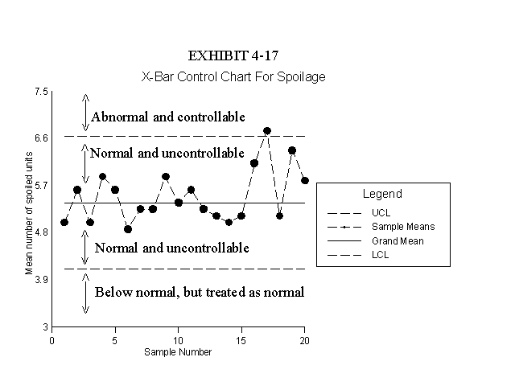
Spoilage within the control limits on the chart is considered to be uncontrollable because it is caused by the normal variations within the system. Spoilage above the upper control limit is considered to be controllable because it is caused by a special, or abnormal event or situation that does not occur when the process is stable. Spoilage below the lower control limit is treated as normal spoilage and does not represent a problem.
Defective Units: A defective unit is a term used to indicate a unit that does not originally meet product specifications, although it can be reworked into a good unit of product.
Rework: Rework refers to the costs associated with reworking the defective units to convert them into good products.
Scrap: Raw material fragments such as wood shavings, sawdust, metal filings, cloth cuttings, and other leftover, but unusable, pieces of material are defined as scrap.
METHODS OF ACCOUNTING FOR SPOILAGE
Normal Spoilage
There are two methods of accounting for normal spoilage that are applicable in different situations. When spoilage is common to all jobs, i.e., when it is just as likely to occur on one job as another, spoilage costs are treated like any other overhead cost. The second method is used where the spoilage is caused by the customer's exact specifications. Then the spoilage cost is charged to the customer’s job where it occurred. More specific explanations for these two methods are provided below.
1. Normal Spoilage Common To All Jobs
When spoilage is common to all jobs (i.e., caused by the system) an estimate of spoilage cost (excluding any estimated disposal value) is included in the numerator when the factory overhead rate is calculated. Then some spoilage costs will be charged to each job when overhead is applied to work in process and to each job. The normal spoilage that occurs during the period is charged to factory overhead, less any estimated disposal value. The estimated disposal value is charged to an account for spoilage inventory. For example, assume spoilage in the amount of $500 was detected during the period. The disposal value is estimated to be $100 and the spoilage was caused by defects in the raw materials within control limits. The entry to record the spoilage is:
Factory Overhead 400
Spoilage Inventory 100
Work in Process 500
Note that in this method, actual spoilage is charged to factory overhead and applied spoilage is charged to each job, just like any other type of factory overhead costs. When the spoilage is sold, an entry is made to debit cash and credit spoilage inventory for the $100 disposal value. If accurate estimates of the disposal values cannot be made at the time the spoilage is detected, the following entries will accomplish the same purpose.
The entry when the spoilage is detected is:
Factory Overhead 500
Work in Process 500
The entry when the spoilage is sold is:
Cash 100
Factory Overhead 100
2. Normal Spoilage Caused by Job Specifications
This method is used only in cases where the customer's specifications causes the spoilage. The idea is that the customer's requirements are rather unusual, or more precise than the normal product specifications. The spoilage costs that occur as a result of a particular customer's special requirements should not be shared by other customers. Therefore, this method simply leaves the spoilage cost in work in process and on the job where it has already been charged. Any disposal value would be charged to the spoilage inventory account. Using the example above, the entry is:
Spoilage Inventory 100
Work in Process 100
This entry leaves the unrecovered costs, i.e., $400, in Work in Process and on the job cost sheet where it has already been charged. To be fair to this customer, the manufacturer might eliminate the spoilage charge from the overhead rate when applying overhead to this job to avoid overcharging the customer for spoilage.
Abnormal Spoilage
Spoilage above an acceptable level (statistically above the upper control limit) should be charged to a loss account. Assuming the spoiled units in the example above were classified as abnormal spoilage, the applicable entry is:
Loss From Abnormal Spoilage 400
Spoilage Inventory 100
Work In Process 500
Abnormal spoilage results from a special cause other than a customer’s precise or unusual specifications. For example, abnormal spoilage can occur when production line equipment is not adjusted properly, when inferior raw materials are purchased, or by fire, explosion, or other unusual events.
METHODS OF ACCOUNTING FOR REWORK
Normal Rework
The two methods of accounting for normal rework are based on the same logic used to account for spoilage. Normal rework that is common to all jobs is treated like any other factory overhead cost. Rework caused by a customer's specifications is charged to that particular customer's job.
1. Normal Rework Common To All Jobs
When rework is as likely to occur on one job as another, an estimate of the rework (cost) that is expected to occur during the period under normal conditions is included in the numerator when the factory overhead rate is calculated. Then, each job is charged with some rework cost when overhead is applied. Actual rework cost is charged to factory overhead. For example, assume various jobs had to be reworked during the period that required $1,000 of additional direct material, and $800 of direct labor for 80 additional hours. Also assume that overhead is applied at a rate of $20 per direct labor hour. The entry to record these costs is as follows.
Factory Overhead 3,400
Materials Control 1,000
Factory Payroll 800
Factory Overhead* 1,600
* Factory overhead applied = (80)($20)
2. Rework Caused by Job Specifications
In cases where the rework is caused by the customer's specifications, the costs of reworking the units is charged to the job where it occurred. Using the amounts in the example above, the entry is as follows:
Work in Process 3,400
Materials Control 1,000
Factory Payroll 800
Factory Overhead 1,600
The $3,400 is also charged to the specific job cost sheet where it occurred. It would be appropriate to eliminate the rework charge from the overhead rate when applying overhead to this job to avoid overcharging the customer for rework.
Abnormal Rework
Rework costs that exceed the control limits are charged to a loss account. Conceptually, the approach is the same as that used for abnormal spoilage. Assuming the rework in the example above is considered to be abnormal, the following entry is appropriate.
Loss From Abnormal Rework 3,400
Materials Control 1,000
Factory Payroll 800
Factory Overhead 1,600
METHODS OF ACCOUNTING FOR SCRAP
There are many ways to account for scrap. The estimated disposal value of scrap may be charged to a scrap inventory account if the value is significant. However, if the value of the scrap is relatively minor, an inventory account for scrap is not needed. Two methods are illustrated below that are variations of an approach referred to as the cost reduction method.
Cost Reduction Method Where Normal Scrap Is Common To All Jobs
Scrap frequently has a disposal value. When scrap is common to all jobs produced, an estimate of the revenue expected from the sale of normal scrap is subtracted from the numerator in the overhead rate calculation. This causes the overhead rate to be lower than it would be otherwise. Then overhead applied to work in process is somewhat less than it would be without the benefit of this cost reduction. If an inventory account is not used, no entry is made until the scrap is sold. Then the actual amount received when the scrap is sold is treated as an overhead cost reduction. For example, assume scrap that accumulated during the period is sold for $300. The appropriate entry is:
Cash 300
Factory Overhead 300
Cost Reduction Method Where Normal Scrap Is Caused by Job Specifications
When scrap is caused by the customer's requirements, the credit for scrap revenue is given to the customer. The entry is as follows:
Cash 300
Work in Process 300
The $300 credit is also made on the appropriate job cost sheet. When overhead is applied to the job involved, the estimate of scrap revenue that was subtracted in the overhead rate calculation should be added back to the rate. This avoids giving the customer an extra cost reduction for scrap.
Alternative Methods of Accounting For Scrap
If an inventory account is used for scrap, an additional entry is required in both of the previous illustrations. An estimate of the disposal value of the scrap is charged to the Scrap inventory account. The credits are made to the same accounts as above, depending on whether the scrap is common to all jobs or caused by specific job specifications. When the scrap is sold, the entry includes a debit to cash and a credit to the Scrap inventory account.
Another method of accounting for scrap treats the revenue from scrap sales as other revenue, rather than as a cost reduction. The credit in the entry to record the sale is to an account called "Other Revenue" or "Revenue From the Sale of Scrap". This method is conceptually different from the cost reduction method because the revenue from disposal is sometimes recorded before the sale. This unorthodox entry is made in cases where the value of scrap is significant, and an inventory account is used for control purposes. Then when the revenue method is used, the disposal value is recorded with a debit to the scrap inventory account and a credit to revenue from the sale of scrap. The method is unorthodox from a GAAP perspective because the credit to the revenue account is recorded before the sale takes place. This is not only confusing, it violates the concept of revenue recognition. For this reason, the revenue method is not recommended.

Lecture Notes 25
Pricing Decision and Cost Management
One of the most difficult managerial decisions is to select the price for a particular product. The "right" price must take into consideration the following factors: relevant costs, market data and "competitors" actions.

Three Major Influences on Pricing (The Three C’s):

A. Customers

B. Competitors

C. Costs

1. Microeconomic Approach

(Customers and Competition)

Microeconomics typically distinguishes the following market situations.

- Perfect competition: firm’s act as price takers

- Monopoly: price and production volume are set such that
Marginal revenue = Marginal cost. Monopolist may seek to price discriminate.

- Oligopoly - strategic game between competing firms. Difficult to predict market price in oligopolistic industries. Issues of price leadership and collusion.

Problems with Microeconomic Approach

- Knowledge of demand curve (particularly complex with differentiated products).

- Constructing the appropriate cost curve. The cost curve represents economic cost and not accounting cost; allocations made in cost accounting may distort the economic cost of a product.

- Competitors' costs and capacity constraints

In spite of these problems, economic analysis of pricing is helpful in focusing the attention of managers on factors external to the firm such as market behavior and the role of competitors.

2. Cost Based Pricing

2.a. Full Cost-Mark-up Pricing

We start with the cost of manufactured goods (standard cost calculated under the absorption costing method- This will be discussed in later lectures). Add the variable S&A expenses per unit. Then we assign the fixed S&A to the units to be sold in a manner similar to the treatment of fixed OH under absorption costing. Finally, we set the price at a specified percentage above full cost.

Question: What determines the mark-up factor?

- Advantage - the method is simple.

- Problems - leads to non-optimal decisions;
- the projected sales volume may not be achieved, and thus the desired profit will
not be achieved;
- no attention is given to external considerations.

2.b. Variable Cost-Mark-up Pricing

Here, one includes the variable costs (including S&A expenses) and adds the avoidable fixed costs (that is, fixed costs which could be escaped if the product was not produced/sold). This approach is useful in determining a lower bound for the price and is frequently helpful in special order situations.

When considering the relationship of price to cost, what is the relevant cost to choose?
- variable cost plus a portion of the fixed cost?
- variable cost only?
- something else?
Is it even appropriate to relate prices to cost?

Example
1 2 3
────────────────────────────────────────────────────────────> Time
Decide on Choose Sales Choose Sales
fixed costs production (for 3 production
$100 gives level for months) level
capacity of 9 months
120 units) (VC = $5)

Consider 3 distinct points in time and see how the implicit pricing rule changes.

1. Before Fixed Costs Incurred

Suppose there are three alternatives envisioned at this stage.
(a) Do not start production at all.
(b) Incur fixed costs and sell 55 units at $7.00.
(c) Incur fixed costs and sell 60 units at $6.25.

Which course of action maximizes profit?

What pricing rule is implicitly being used? Price > Full Cost? Price > Variable Cost?.....?

│ Alternative (a) │ Alternative (b) │ Alternative (c)
│ │
Revenue │ │ │
│ │ │
-Total VC │ │ │
│ │ │
Contribution │ │ │
│ │ │
-FC │ │ │
│ │ │
Profit │ │ │

The profit maximizing course of action is . . . . .
What pricing rule does this reflect?

Definition The full cost of an item is the sum of its variable cost and a share of the fixed costs. (Also called absorption cost.)
Full Costa = $0
Full Costb = VC + 100/55 = 5 + 1.82 = $6.82
Full Costc = VC + 100/60 = 5 + 1.67 = $6.67

Compare these with the prices in each case:

Pricea = $0 = Full Costa
Priceb = $7.00 > $6.82 = Full Costb
Pricec = $6.25 < $6.67 = Full Costc

At this stage in the decision tree all costs (variable and fixed) should be recovered by the price, i.e. on a per unit basis, the pricing rule is Price > Full Cost.

As we shall see in the next example using a per unit pricing rule can sometimes lead to the wrong decision.
2. Before Units Are Produced

Here we shall consider two different scenarios.

Scenario One

Suppose there are three alternatives at this stage.
(a) Produce 60 units and sell for $6.25.
(b) Produce 80 units: sell 60 at $6.25 and 20 at $5.50.
(The extra 20 are not sold under the brand name.)
(c) Produce zero units.

│ Alternative (a) │ Alternative (b) │ Alternative (c)
Revenue │ │ │
│ │ │
-Total VC │ │ │
│ │ │
Contribution │ │ │
│ │ │
-FC │ │ │
│ │ │
Profit │ │ │

Our best choice is to take strategy . . . . . thereby maximizing our contribution to the fixed costs.

Our pricing rule is in effect one which says, given that the fixed costs have already been incurred, choose Price > VC, or strictly speaking CM > 0.

Note: In the choice between (a) and (b) the only RELEVANT items are those that differ between the two alternatives:

- the extra quantity demanded of 20 units and
- their CM of $0.50.

(Here it was OK to use a per unit pricing rule.)

Scenario Two

Again suppose there are three alternatives.
(a) Produce 60 units and sell for $6.25.
(b) Produce 70 units: sell 50 at $6.25 and 20 at $5.50.
(c) Produce zero units.

In this scenario the extra unbrand-named production alters the demand for the brand name items.

│ Alternative (a) │ Alternative (b) │ Alternative (c)
Revenue │ │ │
│ │ │
-Total VC │ │ │
│ │ │
Contribution │ │ │
│ │ │
-FC │ │ │
│ │ │
Profit │ │ │

This time profit is maximized if strategy . . . . . . . . . . . . is followed.
This is because although the extra 20 units each earn a contribution of $0.50, the company forgoes the contribution of $1.25 on each of 10 brand named units, i.e. there are more relevant items in this scenario.
Change in CM = + 20(0.5) - 10(1.25)
= 10 - 12.5
= -$2.50

In this instance the per unit pricing rule Price > VC would lead us to take the wrong action.

The best action should be determined by looking at total contribution arising from each of the alternatives.

3. After Units Are Produced

At this point both FC and VC are sunk costs and are therefore irrelevant.
Suppose that 60 units have already been sold at $6.25.
Our alternatives are:
(a) sell all the remaining units at $4.50
(b) sell 5 more units at $6.00 and hold the remaining units till next season when they
can be sold at $2 per unit.

│ Alternative (a) │ Alternative (b)
Revenue │ │
│ │
-Total VC │ │
│ │
Contribution │ │
│ │
-FC │ │
│ │
Profit │ │

The optimal action in this case is to choose option . . . . .

In other words to maximize profit we implicitly adopt a pricing rule which says sell at a price < VC, but > 0.

The moral of this section on Pricing Decisions is

Considerations Other than Costs in Pricing Decisions

A. Price discrimination is the practice of charging some customers a higher price than is charged other customers. This can be used to increase profits when some customers are price insensitive (business travelers).

B. Peak-load pricing is the practice of charging a higher price for the same product or service when demand approaches physical capacity limits. This practice is used in telephone, hotel, electric utility, and car rental industries.

Life Cycle Product Budgeting and Costing

A. Product life cycle spans from R & D activity until end of sales and customer support: Life-cycle budgeting focuses on revenues and expenses for each product from initial R&D to final customer service and support - "cradle to grave", "womb-to-tomb".

B. Pricing decisions using life-cycle cost must incorporate all costs throughout the product's life cycle.

C. Developing life-cycle reports requires tracking costs and revenues on a product-by-product basis over several calendar periods.

D. Environmental costs should be considered during the product life-cycle.

Effects of Antitrust Laws on Pricing

A. Price discrimination - Robinson-Patman Act

3 key features of the price discrimination laws:

- apply to manufacturers, not service providers.
- is permissible if price differences can be justified by differences in costs.
- illegal only if intent is to destroy competition.

B. Predatory pricing is the deliberate pricing below costs in an effort to drive out competitors and restrict supply and then to raise prices rather than enlarge demand or meet competition.

C. It is important to collect and maintain variable product cost data to fend off accusations of predatory pricing.

Lecture Notes 26
Pricing Decision and Cost Management-Continued
Overview
The essential feature of decentralization in large firms is the creation of responsibility centers (e.g. cost, profit, or investment centers). The performance of these responsibility centers is evaluated on the basis of various accounting numbers, such as standard and actual cost, divisional profit or return on investment. A central role of the management accounting system therefore is to evaluate (i.e. attach a dollar figure to) the transactions between the different responsibility centers. Under the subject cost allocation we studied alternative methods to charge user departments for the services rendered by service departments (frequently cost centers). Transfer prices are used to evaluate the goods and services exchanged between profit centers (divisions) of a decentralized firm. Hence, the transfer price is the price that one division of a company charges another division of the same company for a product transferred between the two divisions.
- There are no cash flows between the divisions. The transfer price is used only for accounting purposes.
- The transfer price becomes an expense for the receiving manager and a revenue for the supplying manager.
- If intra-company transfers are accounted for at prices in excess of cost, appropriate elimination entries have to be made for external reporting purposes. Examples of items to be eliminated for consolidated financial statements include:
- Intra-company receivables and payables.
- Intra-company sales and costs of goods sold
- Intra-company profits in inventories.

Purposes of Transfer Pricing
There are two major reasons to operate a transfer pricing system:
- Appropriate transfer prices help to coordinate the production, sales and pricing decisions of the different divisions. Transfer prices make managers aware of the value that the goods and services have to other segments of the firm.
- The use of transfer prices allows the company to generate separate profit figures for each divisions and thereby to evaluate the performance of each division separately.
Alternative Methods of Transfer Pricing
Transfer pricing policies specify the rules that are being used to calculate the TP. In addition, a TP policy has to be specific about the sourcing question, i.e., are divisions free to buy/sell externally or is it the case that internal transfers are mandated.
1. Market-based Transfer Pricing
In the presence of competitive and stable external markets, many firms take the external market price as a benchmark for their internal transfer price. Generally, the external market price provides a ceiling not to be exceeded by the internal transfer price.
Question: How would you argue that market price is the "correct" TP if the external market is perfectly competitive?
Issues with market-based TP:
- Imperfect Competition
- Distress Prices
-Protecting "infant" segments
2. Negotiated Transfer Pricing
Here, the firm does not specify rules for the determination of transfer prices. Divisional managers are encouraged to negotiate a mutually agreeable transfer price. Negotiated transfer pricing is typically combined with free sourcing. In some companies, though, H.Q. reserves the right to interfere in the negotiation process and impose an "arbitrated" solution.
Question: What do you perceive to be the major advantages/disadvantages of negotiated transfer pricing?

3. Cost-based Transfer Pricing
In the absence of an established market price many companies base the TP on the production cost of the supplying division.
Full (absorption) cost; either standard or actual. Popular because of its simplicity and clarity.
Cost-plus For transfers at full cost the buying division takes all the gains from trade while the supplying division receives none. To overcome this problem the supplying division is frequently allowed to add a mark-up in order to make a "reasonable" profit. The transfer price may then be viewed as an approximate market price.

EXAMPLE: The following example, however, illustrates potential problems with this TP method. The ABC company consists of two divisions: A and B. Division A's output is an intermediate product that is completed and marketed by the B division. The following cost and revenue information applies:
Division A: Fixed Cost : $4000
Variable Cost : $2 per unit
Division B: Fixed Cost : $3,000
Variable Cost : $10 per unit
Each unit of the final product requires one unit of the intermediate product plus certain other inputs (provided by Division B) leading to a variable cost of 10. For the final product y Division B estimates that the market demand curve is given by: P = 19 B .001 * y. Suppose that the supplying division is entitled to a mark-up of 25% above full cost. Verify that transferring 2000 units of x (the intermediate product) at a transfer price of $5 is "desirable" for both divisions.
Is it optimal from ABC's perspective if 2000 units are transferred?
Variable Cost plus Lump Sum Charge: In order to motivate the buying division to make appropriate purchasing decisions, the transfer price could be set to (standard) variable cost plus a lump-sum periodical charge covering the supplying division's related fixed costs.

Question: Apply this method to the setting in the above Example.

Variable Cost plus Opportunity Cost: Our text book advocates what is known as the Horngren-Foster rule. According to this rule the minimum TP is the sum of two elements:
i) Incremental costs incurred to the point of transfer: cash outflows that are directly associated with the production of the transferred goods.
ii) Opportunity costs for the firm: the contribution margin foregone by the firm as a whole if the goods are transferred internally.

Question: In the example above, suppose that the supplying division (A) can sell the intermediate
product externally at a price of $8 per unit after incurring additional variable cost of $4 per unit.
What transfer price would you advocate in this situation? (HINT: Depends whether there is a
Capacity constraint or not.)

Question: For the setting considered in the above example, suppose there are now two internal buying divisions, i.e., there is also a division C for which the intermediate product x is a component of its marketable product. Suppose also that the supplying division A is subject to capacity constraints. In what way can the approach of the Horngren-Foster-Datar rule be used to arrive at an optimal transfer price?

Transfer Pricing Practices

Method Used United
Statesª Canada^{b} Japan^{c}
Cost based 45% 47% 47%
Market based 33 35 34
Negotiated 22 18 19

TOTAL 100% 100% 100%

Tax Considerations in the Choice of Transfer Prices
If the divisions involved belong to different tax jurisdictions, the choice of transfer price will be partly affected by tax considerations. Consider the following example.
Example - Tax implication of transfers across countries.
A and B are divisions of the ABC company. The A division is located in the U.S. where the marginal tax rate is 35%. The B division is located in Golanjia where the marginal tax rate is 15%. The A division produces an intermediate product at a cost of $100 per unit and then transfers this product to the B division where it is finished at an additional cost of $100 and sold for $500. Assume 1,000 units are transferred annually and that the minimum transfer price is the variable cost.

Question: What transfer price should be charged in order to minimize taxes?

Lecture Notes 27
Budgetary Planning, Customer Profitability Analysis and Sales Variance Analysis

LEARNING OBJECTIVES

- Identify four purposes for allocating costs to cost objects

- Guide cost-allocation decisions using appropriate criteria

- Discuss decisions faced when collecting costs in indirect-cost pools

- Discuss why a company’s revenues can differ across customers purchasing the same product

- Apply the concept of cost hierarchy to customer costing

- Discuss why customer profitability differs across customers

- Provide additional information about the sales-volume variance by calculating the sales-mix variance and the sales-quantity variances

- Provide additional information about the sales-quantity variance by calculating the market-share variance and the market-size variances

Chapter 14 emphasizes the subject described by one successful business owner as the purpose of cost accounting—cost allocation. If all costs were traceable to the cost object, cost accounting texts would be much smaller. The difficulty of assigning indirect costs to the cost object is the subject of much study but necessary for providing information needed for strategic and operating decisions. In this chapter the customer is the cost object and the approach is on macro issues in cost allocation—allocation of costs to divisions, plants, and customers.

Combining an analysis of revenues and of costs by customer provides the manager insight into why differences in customer profitability exist. Revenues are primarily analyzed through volume of units of product purchased and magnitude of price discounting. An illustration of an activity-based costing system on customer rather than products is used to describe customer cost analysis. The costs are defined through the use of a cost hierarchy. Several factors are described as useful in deciding how to allocate resources across customers.

In the second section of the chapter, actual amounts of revenue are compared to those budgeted through variance analysis. Revenue price variance or flexible budget variance was covered in Chapter 7. Volume variance for sales is reviewed and then subdivided into the sales mix variance and sales quantity variance. If reliable data about market size and share are available, the sales quantity variance can be separated for those—market-size variance and market-share variance. The appendix gives explanation for subdividing the cost variances introduced in Chapter 7. The mix and yield variances for substitutable inputs are similar in concept and computation to the mix and quantity variances for revenue.

- Cost allocation

- Problem for organizations and accounting but necessary for decisions, both strategic and operating

- Purposes of cost allocation

- Costs related to cost object cannot be traced in cost-effective way—indirect costs

- Costs that cannot be traced must be allocated

- Such costs often comprise a large percentage of overall costs

- Different costs are appropriate for different purposes

- To provide information for economic purposes

- To motivate managers and other employees

- To justify costs or compute reimbursement

- To measure income and assets for reporting to external parties

- Criteria to guide cost-allocation decisions

- Choose the purpose, then select criteria, implement allocation

- Cause-and-effect criterion – superior for economic decisions or motivation; used for activity-based costing applications

- Benefits-received criterion – superior for economic decisions or motivation

- Fairness criterion – especially difficult to obtain agreement

- Ability-to-bear criterion – raises issues related to cross-subsidization

- Use cost-benefit approach when designing and implementing cost-allocation systems

- Cost of collecting data and educating managers about cost-allocation system

- Benefit of making better-informed decisions derived from well-designed system

- Advances in technology reduce costs and allow for more detailed cost allocations

- Cost allocation and costing systems: costs incurred in different parts of a company assigned, and then reassigned, for costing products, services, customers, or contracts with illustration

- Allocating corporate costs to divisions and products [Surveys of Company Practice]

- All corporate costs to divisions

- Incurred to support activities of the divisions

- Motivates division managers to examine how corporate costs planned and controlled

- Used to determine full cost of product

- No corporate costs to divisions: costs not controllable by division managers

- Only some corporate costs to divisions

- Costs widely perceived as causally related to division activities

- Cost widely perceived that provide explicit benefits to divisions

- Choosing cost pools to use in allocation: key decision of number of indirect cost pools

- Use of a single cost pool

- Use of homogeneous cost pool

- Similar cause-and-effect or benefits-received relationship with cost-allocation base

- More accurate costs of a given cost object: same allocation results for pool as if each individual activity allocated separately

- Fewer cost pools required to accurately explain differences in how divisions or products use company resources

- Use of numerous individual corporate cost pools

- Costs not homogeneous with current pools

- Resources used differently by divisions

- Information technology reduces cost/increases benefit of using multiple pools

- View of managers

- Improvements in information-gathering technology

- Choosing cost-allocation base to use in allocation: ones that have best cause-and-effect relationships with costs

- Customer profitability analysis

- Purpose

- The reporting and analysis of revenues earned from customers and costs incurred to earn those revenues

- Ensuring that customers making large contributions to operating income of a company receive a level of attention from the organization matching their contribution to company’s profitability

- Customer revenue analysis

- Variable of volume sold

- Variable of magnitude of price discounting (reduction of selling price below list selling prices to encourage increases in customer purchasing)

- Records needed of pricing history

- Reasons for discounting

i. Volume discounts

ii. Desire to sell to customer who might help promote other sales

iii. Poor negotiating by salesperson or unwanted effect of incentive plan based only on revenues

- Customer cost analysis

- Customer cost hierarchy: categorizes costs related to customers into different cost pools on the basis of different types of cost drivers (cost-allocation bases) or different degrees of difficulty in determining cause-and-effect (benefits received) relationships

- Some costs can be reliably assigned to individual customers

- Some costs can be reliably assigned only to distribution channels or to corporatewide efforts

- Customer-level costs

- Customer output unit-level costs: resources sacrificed on activities performed to deliver each unit to a customer

- Customer batch level costs: resources sacrificed on activities that are related to a group of units delivered to a customer

- Customer-sustaining costs: resources sacrificed on activities undertaken to support individual customers, regardless of the number of units or batches of product delivered to customers

d. Cost reduction of each activity highlighted by use of activity-based costing

3. Customer-level operating income analysis

- Distribution-channel costs—not allocated to customers

- Changes in customer behavior does not affect distribution-channel costs

ii. Salespersons responsible for managing individual customer accounts demotivated if bonuses affected by costs over which they had minimal influence

- Corporate-sustaining costs—no cause-and-effect or benefits-received relationship for individual customers and distribution channels

- Some argue allocation of all costs for pricing decisions that use full costs

- Not allocating has value in distinguishing between various degrees of objectivity and different levels at which decisions made and performance evaluated

- Customer-profitability profiles

- Highlights how vital a small set of customers is to retail profitability

- Focuses on ways to make future business with customer more profitable

- Assesses customer value

- Likelihood of customer retention

- Potential for customer growth

- Long-run customer profitability

- Increases in overall demand from having well-known customers

- Ability to learn from a customer

- Deserves cautious approach when deciding to drop customers—concern for long-run profitability may provide misleading signals about customer’s short-run profitability

- Sales variances

- Static-budget variance: difference between an actual result and a budgeted amount in the static budget

- Flexible-budget variance: difference, based on level of output actually achieved (sold), between actual result and the flexible-budget amount—budgeted contribution margin times actual unit volume sold

2. Sales-volume variance: effect on budgeted contribution margin of the difference between actual quantity and budgeted quantity of units sold

- Subdivisions of sales-volume variance

- Sales-mix variance: difference between budgeted contribution margin for actual sales mix and budgeted contribution margin for budgeted sales mix

- Trade-off between products with greater contribution margin and those with smaller contribution margins—and effect on profitability

- Composite unit: hypothetical unit with weights based on mix of individual units

- Reason for variance should be investigated

- Sales-quantity variance: difference between (1) budgeted contribution margin based on actual units sold of all products and the budgeted-mix and (2) contribution margin in the static budget [budgeted units of all products to be sold and the budgeted mix]

- Market-share variance: difference in budgeted contribution margin for actual market size in units caused solely by the actual market share being different from the budgeted market share

- Market-size variance: difference in budgeted contribution margin at the budgeted market share caused solely by the actual market size in units being different from budgeted market size in units

- Necessary to obtain reliable market share and size data to calculate the variances

- Appendix: Mix and yield variances for substitutable inputs

- Substitutable inputs

- Efficiency variance—Direct materials or direct labor

- Mix variance (inputs)

- Yield variance

Lecture Notes 28
Budgetary Planning, Customer Profitability Analysis and Sales Variance Analysis
II. Preparing the Operating Budget

The first part of the master budget is the operating budget. The components of the operating budget include the following:
A. The sales budget is the projection approved by the budget committee that describes expected sales for each product in units and dollars for the coming period.
The sales budget may reveal seasonal fluctuations in sales.
Sales = Units × Unit selling price
B. The production budget describes how many units must be produced to meet sales needs and satisfy ending inventory requirements.
The production budget must consider the company’s inventory policy and, thus, the beginning inventory and desirable ending inventory levels.
Units to be produced =
Ending inventory units + Units sales – Beginning inventory units
C. The direct materials purchases budget outlines the expected usage of materials for production, inventories, and purchases of the direct materials required.
The direct materials usage is determined by the input-output relationship of each product as follows:
Expected DM usage = DM units needed per unit of output × Units of output
Budgeted DM purchases in units =
Desired ending DM units + Expected DM usage – Beginning DM units
DM purchase costs = Budgeted DM purchases in units × Unit price
Note that a separate schedule is prepared for each kind of direct material.
D. The direct labor budget shows the total direct labor hours needed and the associated cost based on the input-output relationship of each product.
Expected DL hours = DL hours needed per unit of output × Units of output
DL costs = Expected DL hours × Wage rate
E. The overhead budget shows the expected cost of all indirect manufacturing items.
The estimated overhead is divided into variable and fixed components:
Total overhead = (Variable overhead rate × Activity level per chosen cost driver)
+ Budgeted total fixed overhead
F. The ending finished goods inventory budget supplies information needed for the balance sheet and serves as input for the preparation of the cost of goods sold budget.
It provides information for the unit cost of a finished product and the cost of the expected inventories.
G. The cost of goods sold budget provides the information needed for the pro forma income statement.
H. The marketing expense budget outlines planned expenditures for selling and distribution activities.
The estimated marketing expense is divided into variable and fixed components:
Total marketing expense = (Variable marketing rate × Sales activity level)
+ Budgeted total fixed marketing expenses
I. The research and development expense budget outlines the estimated expenditures of research and development activities for the coming year.
J. The administrative expense budget consists of estimated expenditures for the overall organization and operation of the company.
Most of the administrative expenses are fixed costs with respect to sales.
K. The budgeted income statement is based on all of the component budgets.

III. Preparing the Financial Budget

The financial budgets are the second part of the master budget. The financial budgets usually include the cash budget, the budgeted balance sheet, the budgeted statement of cash flows, and the budget for capital expenditures.
Note that the master budget and the associated financial budget are plans for one year.
The capital expenditures budget is a financial plan outlining the expected acquisition of long-term assets, typically over a number of years.
A. The Cash Budget
The cash budget is a detailed plan that shows all expected sources and uses of cash. Much of the information needed to prepare the cash budget comes from the operating budgets.
The cash budget includes five main sections:
1. The total cash available section shows that:
Total cash available = Beginning balance + Cash receipts
Cash receipts include primarily:
a. Cash sales.
b. Collection from sales on account (credit sales).
The collection pattern of credit sales can be determined by past experience using an accounts receivable aging schedule.
2. The total cash disbursements section includes all planned cash outlays for the
period, including the purchase of materials, payment of wages, and payment of other
expenses.
The cash disbursements section does not include:
a. Interest payment on short-term loans (these appear in the financing section).
b. Noncash expenses such as depreciation.
3. The cash excess or deficiency section compares the cash available with the cash needed.
Total cash needed = Total cash disbursements + Minimum cash balance
The minimum cash balance is the lowest amount of cash on hand that the firm finds acceptable.
4. The financing section of the cash budget consists of:
a. Borrowings.
b. Planned repayments, including interest.
5. The planned ending cash balance section reflects the inclusion of the minimum cash balance, which was subtracted to find the cash excess or deficiency.
B. Budgeted Balance Sheet
The preparation of the budgeted balance sheet depends on information from the current balance sheet and the information in the other budgets in the master budget.

IV. Operating Budgets for Merchandising and Service Firms

- A merchandising firm has a merchandise purchases budget to identify the quantity of each item that must be purchased for resale, the unit cost of the item, and the total purchase cost.
- In a for-profit service firm, the sales budget identifies each service and the quantity that will be sold.
The sales budget is also the production budget because the service produced will be identical to the service sold.
- In a not-for-profit service firm, the sales budget identifies the level of various services that will be offered for the coming year and the associated funds that will be assigned to the services.

Lecture Notes 29
Capital Budgeting and Cost Analysis
CAPITAL BUDGETING—PLANNING INVESTMENTS

Screening decisions
-Project must meet a minimum requirement to be acceptable
-Required rate of return is the minimum rate of return (hurdle rate, cut-off rate, or cost of capital) the project must yield.
-The minimum rate of return is used as the discount rate in NPV to determine if the project passes the screening decision.

Preference decisions
-Best choice of all alternatives

The Time Value of Money
“A dollar today is worth more than a dollar a year from now.”
DISCOUNTED CASH FLOWS—THE NET PRESENT VALUE METHOD (p. 581.)
- The length of time of the investment.
- When cash flows occur.
- Amount of cash flows.
- The discount rate.
Positive NPV | return is greater than the discount rate
Zero NPV | return is equal to the discount rate
Negative NPV | return is less than the discount rate

Emphasis on Cash Flows

Typical cash outflows:
-Investment required (is the total net cash outflow at the investment inception--cash paid for initial investment reduced by salvage value of old equipment sold plus any increased need for working capital, see next),
-Increased need for working capital (CA – CL), and
-Increased operating costs (including repairs and maintenance).

Typical cash inflows:
-Increased revenue or decreased costs,
-Salvage value at the end of the useful life of the asset, and
-Working capital released at the end of the investment.
NPV method automatically provides for return of the original investment.

Simplifying Assumptions
- All cash flows occur at the end of a period (except for the original investment which occurs at the beginning).
- All cash inflows from the investment are immediately reinvested at the discount rate.

Lecture Notes 30
Capital Budgeting and Cost Analysis

DISCOUNTED CASH FLOWS—THE NET PRESENT VALUE METHOD (p. 581.)
- The length of time of the investment.
- When cash flows occur.
- Amount of cash flows.
- The discount rate.
Positive NPV | return is greater than the discount rate
Zero NPV | return is equal to the discount rate
Negative NPV | return is less than the discount rate

Emphasis on Cash Flows

Typical cash outflows:
-Investment required (is the total net cash outflow at the investment inception--cash paid for initial investment reduced by salvage value of old equipment sold plus any increased need for working capital, see next),
-Increased need for working capital (CA – CL), and
-Increased operating costs (including repairs and maintenance).

Typical cash inflows:
-Increased revenue or decreased costs,
-Salvage value at the end of the useful life of the asset, and
-Working capital released at the end of the investment.
NPV method automatically provides for return of the original investment.

Simplifying Assumptions
- All cash flows occur at the end of a period (except for the original investment which occurs at the beginning).
- All cash inflows from the investment are immediately reinvested at the discount rate.

Choosing a Discount Rate
-Cost of capital
Format for NPV
Using Present Value Factor Tables
Time | Cash flow | PV Factor (@ discount %) | Present Value
Now ‘0’ | (investment, cash outflow) | 1.000 | ($ investment)
n | Single cash flow | PV$1 @ (n, %) | Cash flow x PV factor
n | Annual cash flow | PVA @ (n, %) | Cash flow x PVA factor
NPV = |  |  | Summation of PV of (investment) + PV of cash flow

Or with the TI BAII+ Financial Calculator
Use the manual that came with your Texas Instrument BAII Plus to understand how to use the NPV program.

CF key, is used to enter the cash flows. Key CF (to clear old CF, press 2nd CLR Work)
CF₀ is the initial investment, key in (amount)(±), then press (enter), and (↓) down arrow
C01 is the first occurring cash flow: amount (enter) (↓) F01 is the number of times the cash flow will occur in a row: amount (enter) (↓)
C02 is the second occurring cash flow…follow the steps for C01. Enter all cash flows in order of receipt. If a cash flow is a single cash flow, then the F is 1.
Once all cash flows have been entered press the NPV key.
“I” Is the interest rate, input the rate; i.e., if the rate is 15% put 15 then (enter) (↓)
NPV = key CPT and NPV will be calculated

NOTE: if two cash flows occur at the same time, add them together and enter them as one cash flow. If an annuity and a single sum occur at the same time, you need to adjust the frequency of the annuity and treat the last annuity payment as a single sum.

Using a financial calculator will yield a different answer than the factor tables due to rounding issues with the Factor Tables.
Practice
AR Paving Company is considering an investment in a curb-forming machine. The machine will cost $240,000, will last 10 years, and will have a $40,000 salvage value at the end of 10 years. The machine is expected to generate net cash inflows of $60,000 per year in each of the 10 years. AR's discount rate is 18%. Is the project acceptable?

What is the net present value of this machine?

Practice
Allen Company's required rate of return is 12%. The company is considering the purchase of a Machine. The machine will cost $15,000 and have a life of 8 years. Its salvage value will be $1,000 and cost savings are projected at $3,000 per year.

Compute the machine's net present value.

DISCOUNTED CASH FLOWS—THE INTERNAL RATE OF RETURN METHOD (IRR)

The internal rate of return (yield of the project) is the rate of return provided from the investment. The internal rate of return is calculated by finding the discount rate that causes the net present value of the investment to be equal to zero.

When NPV = 0; the discount rate used equals the IRR

Finding IRR with even cash flows using the factor tables:
IRR factor = | Investment required  Net annual cash inflow

When looking in the PV tables (look at the annuity tables if there are annual cash flows) for the IRR factor one must look at the factor where “n” is the number of years of the project. Only the PV factors associated with the appropriate ‘n’ can be used. When you find the factor, the interest rate associated with the factor is the IRR.

Practice
The following data pertain to an investment project:

 | Investment required | $86,994
 | Annual savings | $18,000
 | Life of the project | 10 years

What is the projects internal rate of return?

If the company’s required rate of return is 15% would this investment be acceptable?

IRR w/Financial Calculator: same steps as NPV on page 13-2 except press IRR key instead of NPV key…and you don’t enter “I” because it is calculated.

NPV versus IRR

NPV assumes the cash flows are reinvested at the discount rate

IRR assumes the cash flows are reinvested at the IRR

PREFERENCE DECISIONS—THE RANKING OF INVESTMENT PROJECTS (p. 595)

IRR Method
-the alternative with the highest IRR is more desirable.

NPV Method

- Profitability Index = | Net present value
- Profitability Index = | Investment required

The alternative with the highest profitability index is the project that is more desirable.

Practice
Bowen Company is considering two investment proposals, as shown below:

 | Investment Proposal
 | A | B
Investment required | $185,000 | $120,000
Present value of future net cash flows | $197,000 | $130,000

What is the profitability index for project A?

What is the profitability index for project B?

If the company could only invest in one investment, which would they invest in?

Consider the difference in investment required between the two projects…what can be done with the $65,000 difference?

Lecture Notes 31
Capital Budgeting and Cost Analysis

OTHER APPROACHES TO CAPITAL BUDGETING DECISIONS (p. 597)
These methods DO NOT consider the time value of money.

Payback Method
- Payback period = | Investment required
- Payback period = | Net annual cash inflow

The alternative with the shorter payback period is more desirable.

Evaluation of the Payback Method
-Does not consider cash flow beyond payback
-Does not consider time value of money
-Makes a good screening tool for companies with cash flow shortages
-Easier to understand

Practice
years
An investment project requires an investment (investment required) of $100,000. The project is expected to generate net cash inflows of $28,000 per year for the next 10 years. Assuming a 12% discount rate, what is the project's payback period?

If management requires a payback period in 3 years or less, is this project acceptable?

%
What is the project’s Internal Rate of Return (IRR)?

Compare the payback results with the IRR results…what does it tell you?

Payback and Uneven Cash Flows
-Once inflows exceed outflows, payback has been achieved
-Assume cash flow is received evenly across the year.

Practice
Time (Year) | Cash Flow | Unrecovered investment
Now | (20,000) | (20,000)
End of 1 | 5,000 | (15,000)
End of 2 | 10,000
End of 3 | 12,000
End of 4 | 14,000
End of 5 | 12,000
Original investment was $20,000. The company requires their investments to payback within 3 years. Is this investment acceptable?

Simple Rate of Return Method

- Simple Rate of Return = | Annual incremental net operating income
- Simple Rate of Return = | Investment Required
or
- Simple Rate of Return = | Annual cost savings – depreciation on new equip.
- Simple Rate of Return = | Investment Required

-Only method that takes depreciation into calculation.
-Does not use the time value of money (does not involve discounting cash flows)
-Does not focus on cash flow; it focuses on accounting net operating income.
- Depreciation expense = | Cost – residual value
- Depreciation expense = | Useful Life

Straight-line depreciation:

Practice
Mercer Corporation is considering replacing a technologically obsolete machine with a new state-of-the-art numerically controlled machine. The new machine would cost $250,000 and would have a ten-year useful life. Unfortunately, the new machine would have no salvage value. The new machine would cost $12,000 per year to operate and maintain, but would save $55,000 per year in labor and other costs. The old machine can be sold now for scrap for $10,000.

What is the depreciation expense on the new machine?

What is the annual cost savings of the new machine?

What is the investment required for the new machine?

What is the simple rate of return on the new machine?

Lecture Notes 32
Revision

- Pricing
- Variances
- Budgeting

