Lecture 1: Introduction to Sociology
Dr. Sadaf Sajjad
Introduction to Sociology
Requirement and Expectation in Sociology class
- The number one requirement is going to be a flexible and open mind.
- It absolutely changes how you see the world you live in.
- You will learn how sociologists gather data and perform research. You may learn about institutions, inequality, religion, etc.
There is sometimes a great deal of focus on understanding the experiences of different groups within their social contexts.
- Sociology is the study of human social relationships and institutions.
- Sociology's subject matter is diverse, ranging from crime to religion, from the family to the state, from the divisions of race and social class to the shared beliefs of a common culture, and from social stability to radical change in whole societies.
- Unifying the study of these diverse subjects of study is sociology's purpose of understanding how human action and consciousness both shape and are shaped by surrounding cultural and social structures.
- Sociologists are employed by research institutes, the criminal justice system, public health and welfare organizations, private businesses, law firms, international agencies, medical centers, educational institutions, advertising firms, survey and polling organizations, and beyond.
- Students with a bachelor's degree in sociology often secure employment as social researchers, case workers, paralegals, public relations workers, administrators, community organizers, public policy researchers, and data analysts.
- Sociology also provides great preparation for going on to law school, medical school, business school, and for graduate degree programs in social work, education, public policy, religious ministry, mass communications, public health, non-profit administration, and international affairs.
- Sociology is the study of group life and those parts of our individual lives that are affected by social interaction.
- we are social animals from birth, that is, that we are powerfully influenced by other people's expectations.
- we can't function effectively either as individuals or as citizens unless we develop the capacity to understand social forces.
- Whether it's the prospects for the safety of your neighborhood, the likelihood of success in your chosen occupation, or the future of your planet, these outcomes depend as much on world-historical changes taking place in society as on issues of ability and character at the individual level.
- To provide scientific contributions to society. Many sociologists are involved in scientific research and are able to solve large-scale problems that affect the world around us.
- To study the roles of institutions, organizations and individuals. Sociologists study how social institutions such as family, education, religion and governmental control affect human behavior.
- To use scientific knowledge and sociology theories to solve social problems. Sociologists can draw upon data and scientific studies to draw conclusions about certain situations and solve social problems.
- To enrich human culture. Sociologists have made great contributions throughout history, and these have provided us with in-depth knowledge about human culture, norms and behaviors.
- To improve international relations. Some sociologists work for government agencies where they can reduce the effects of political unrest and conflict between nations, and work towards solving common problems.
Course Goals
Our purpose in this course is to provide you with the tools of the sociological imagination. By the end of this course, you should be able:
- To understand the basic concepts, language, and theories of sociology.
- To become familiar with the strategies sociologists use to study human society.
- To describe and explain major features of society, beginning with the institutions that are closest to your own experience.
- To understand the social dimensions of inequality and difference.
Part 1. Sociological Perspective
- Sociology as a Point of View
- Sociological Imagination
- Sociology and Science
- Sociology as a Social science: Cultural Anthropology, Psychology, Economics, History, Political science and Social Work.
- Development of Sociology
- Doing Sociology
Part 2: The Individual In Society
- Culture
- Socialization and Development
- Social organizations and Groups
- Deviance and Social Control
Part 3: Social Inequalities
- Social Class
- Race and Ethnicity
- Gender
- Age
Part 4: Institutions
- Marriage
- Religion
- Education
- Political and Economic System
- Media
- Health
Part 5: Social Change
- Population and Environment
- Human Ecology
- Collective Behavior
- Social Movements
- Consequences of Social Change
Sociology and Behavior
- Behavior is learned and can be unlearned
- Social learning perspectives are used in practice (social-skills, modeling, etc)
- Behavior Modification is done according to condition
Behavior is Shaped by Culture
Literacy Rate
Social Interaction
Personal Space
Sociology and Science
- Psychology is Empirical
- Knowledge acquired through observation
- It is a systematic approach to the understanding of people, their thoughts, emotions and behavior. The application of this understanding helps to solve
human problems
Types of Sociology
- Sociology is a fairly broad realm of scientific study and is divided into several different types of sociology, or branches of sociology. All in all, sociologists study human behavior and interactions, and how different events, institutions and influences make certain people behave in a certain way.
Sociology is made of three main branches and then breaks down further into different types of sociology. The three main branches of sociology are:
1. Social morphology - a study of geographical data and settings
2. Social physiology - the study of religion, law, economics, politics and other influences of society
3. General sociology - the study of how different social laws are derived from various processes

Social Organization Sociology
The study of different institutions, such as educational institutions, the institution of marriage, social stratification and even the economy, and how these influence society and create different groups
Social disorganization and social change
The study of deviant behavior in society and sociologists in this field try to make sense of why some people are involved with crime, drug addiction and other problems that plague society.
Population or demographic sociology –
- this is the study of the population and changes in the population, and sociologists in this field review statistics and data to forecast population growth and trace its root causes.
Sociology theory and methods
- this is one of the types of sociology that is more scientific in nature. Sociologists in this field test various methods and make attempts to prove different theories.
Human ecology
- deals with some of the social problems affecting society, and tries to identify what types of institutions are prompting these problems.
Applied sociology –
- makes use of existing research data to solve social problems and apply sociological concepts in fields such as family counseling, industrial relations and economic development.
The Four Primary Goals Of Sociology
- Describing and Explaining Behavior in Society
  - Differentiating between normal, healthy and unhealthy behaviors is the cornerstone of sociology, so it is important that sociologists have a keen sense of observation.
  - the second goal of sociology, explaining. The attempt to explain behavior based on observation is actually rather difficult due to many factors. For instance, behavior of society varies among culture and can change over time
- Predicting and Influencing Behavior
  - Sociologists try to determine if a person is likely to make healthy or unhealthy decisions when confronted with certain situations. Most of the time, they will use experiments to make their predictions.
  - The last of the goals of sociology is to influence social behavior. This can be to change un accepted behavior as well as encourage already existing desirable behavior. There are many methods used to influence behavior such as positive reinforcement or rewarding good behavior.
Behavioral Sociology
- Behavioral psychology is a branch of psychology
that focuses on observable behaviors.
- Conditioning, reinforcement and punishment are key concepts used by behaviorists.
Social-Cultural Sociology
- Baron, Byrne & Suls (1989) define social psychology as .......“the scientific field that seeks to understand the nature and causes of individual behavior in social situations”
- It is about understanding individual behavior in a social context
- Socio cultural sociology focuses on the fact that our interactions with others in society affect not only our thought process, but also our perception, and the manner in which we make decisions.
- Our socio cultural thought process begins in childhood and steadily gains momentum as we grow older.
- This branch of sociology explains how we create our identity or self-image, and shape our perception.

The importance of Sociology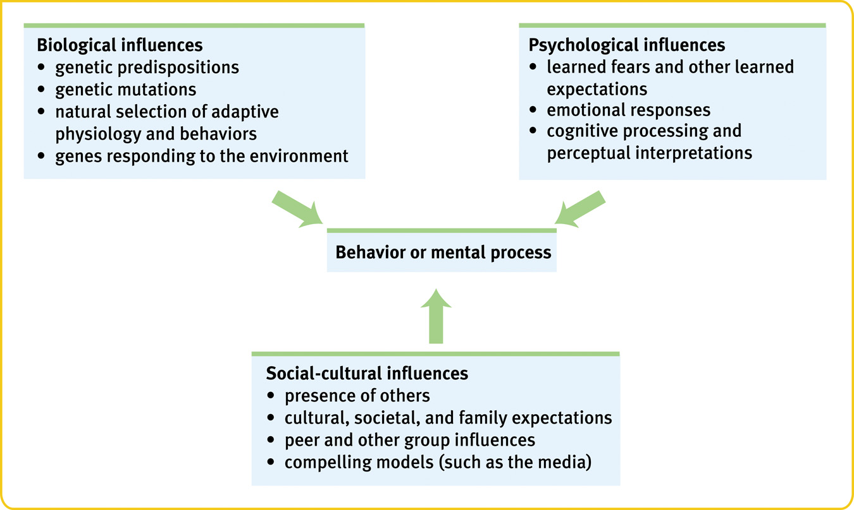

The importance of Sociology
- Self-Knowledge
Learning can be viewed as one purpose of life, and self-knowledge can be viewed as an important element of learning.
- Learning About Others
learning about oneself, the field of sociology allows us to learn about others.
- Solving Important Problems
Theories and findings in sociology may help us to solve important problems.

Development of Sociology
- Development describes the growth of humans throughout the lifespan, from conception to death.
- The scientific study of human development seeks to understand and explain how and why people change throughout life.
- This includes all aspects of human growth, including physical, emotional, intellectual, social, perceptual, and personality development.

