Lecture 20. RELIGION

Dr. Sadaf Sajjad

Religion

religions is a universal found in every culture.

Religion was defined by Emile Durkheim as a “unified system of beliefs and practices relative to sacred things”

Durkheim stressed the social impact of religion

Durkheim and the Sociological Approach to Religion

Sacred: Elements beyond everyday life that inspire awe, respect, and even fear

Profane: Includes the ordinary
and common place

Define and understand the different types of religious organisation

Look at how functionalists, Marxists, phenomenologists, feminists and others have understood religion

Examine new religious movements

Look at how religion influences society

Weigh up the arguments of those who insist that religion is dead – or at the very least terminally ill (the secularisation debates

We won’t…

Debate the truth of any religious expression

Engage in a formal comparative study of religion

Examine supernatural elements of religion

Argue the merits of ‘faith’

‘faith’ or ‘religion’ ?

Faith is ‘an orientation of the self’ - faith relates to the internal conviction, associated beliefs, attitudes;

‘Religion’ relates to the formal expression of the internal conviction (normally socially expressed)

Sociologically speaking, what is religion?

A social institution that develops in history and relates in some way to the supernatural, religion is a group phenomenon that is concerned with responses to existential questions (i.e big questions!).

These questions are mediated by class, gender and age and along with the responses, are expressed in a body of beliefs, celebrated in a set of practices / rites, and advocate certain behavior (moral codes).

WHAT IS A SOCIAL INSTITUTION?

Penny Jaffray summed social institutions up as
‘holding society together…by providing ordered and structured ways of doing things that continue over long periods of time…[and tend to] perpetuate social inequality’
‘Stable sets of statuses, roles, groups and organisations…[that] provide the foundation for addressing fundamental social needs’
(Newman, D. M. (2000) Sociology. Exploring the architecture of everyday life.

That Develops In History

Simply, as with any institution, religion grows out of, and within, specific social contexts. Just as religion moulds individual action, so it is in turn developed by events. It develops over time.

Relates In Some Way To The Supernatural

As Haralambros and Holborn point out (5th Edition, 431) many definitions of religion include reference to ‘supernatural beings’. This is a problem with, for example, Buddhism, which as a religion, pays no attention to such.

Is A Group Phenomenon

Seek to recruit or regulate procreation in order to both grow and continue

Involve a process of socialization (training, of new members)

“Provides the goods” – members seek some form of benefit from membership

Preserves order – motivates members to pursue groups goals and abide by group norms

Maintains a sense of purpose

Concerned With Existential Questions (The Big Ones)

Religion seeks responses to ultimate questions (Why are we here? What does it all mean?)

Religion seeks to respond to aspects of life that threaten meaningful order and to rob life of its sense, not purely intellectually but also materially (How do we address suffering? Who am I?)

Which Are Mediated By Class, Gender And Age

Questions of ultimate concern differ from community to community – if you are starving and poor then you are less likely to be interested in questions of the purpose of life, and more likely to be concerned with material questions.

Women have been largely marginalized or at least subordinated by men’s use of religion; therefore women’s questions would often differ from men’s

Religious meaning for a 6 year old / 16 year old, 40 year old and 70 year old could all differ substantially

Expressed In A Body Of Beliefs

In attempt to respond to questions religion tends to develop explanations and ‘work out rationales, and discover “facts” that are eventually systematized into a body of beliefs

Rites And Practices

Performance of ritual generated by beliefs

An act becomes religious only when group defines it as such

Advocate (Promote) Certain Behaviour

Judgement that certain thoughts, actions are worthwhile and others are discouraged/rejected

Often claims a higher source of authority (invokes the sacred and / or supernatural)

Functionalism

Functions of Religion

Manifest functions

Religion defines the spiritual world and gives meaning to the divine

Religion also provides an explanation for events that are difficult to understand

the purpose of life,

why people suffer, and

the existence of an afterlife

Religion - Functionalism

Those answers give people a sense of purpose

Strengthened by such beliefs, people are less likely to collapse in despair when confronted by life’s calamities

The Integrative Function of Religion
- Durkheim viewed religion as an integrative force in human society
- Gives meaning and purpose to people’s lives
- Gives people ultimate values and ends to hold in common
- Strengthens social integration within specific faiths and denominations
- In some instances, religious loyalties are dysfunctional

Religion and Social Control: The Marxist Approach

Marx was an atheist who believed that the existence of God was an impossibility

Marx recognized that religion promoted stability within society, but it also perpetuated patterns of social inequality

According to Marx, religion serves elites, by legitimizing the status quo and diverting people’s attention from social inequities

Marxist Approach

In his view religion often drugged the masses into submission by offering a consolation for their harsh lives on earth: the hope for salvation in an ideal after life

Marx described religion as "the opiate of the people".

Gender and Religion

Women have played fundamental role in religious socialization, but generally take subordinate role in religious leadership

Most religions are patriarchal, and reinforce men’s dominance in secular and spiritual matters

Women compose 12.8 percent of U.S. clergy, but account for 51 percent of theology students

Components Of Religion

Religious rituals: practices required or expected of members of a faith

Religious experience: feeling or perception of being in direct contact with ultimate reality or of being overcome with religious emotion

Community

Ecclesia: religious organization claiming to include most or all of the members of a society; is recognized as the national or official religion

Denomination: large, organized religion not officially linked to the state or government

Community

Sect: relatively small religious group that has broken away from some other religious organization to renew what it considers the original vision of the faith

Sects are at odds with society and do not seek to become established national religions

Established sect: religious group that is the outgrowth of a sect, yet remains isolated from society

Community

Cult or new religious movement (NRM): small, alternative faith community that represents either a new religion or a major innovation in an existing faith.

Similar to sects since they tend to be small and are often viewed as less respectable than more established faiths

Unlike sects, may be totally unrelated to existing faiths

Comparing Forms of Religious Organization

Ecclesiae, denominations, sects, and new religious movements have different relationships to society

Best viewed as types along a continuum

Table 13-3: Sociological Perspectives on Religion
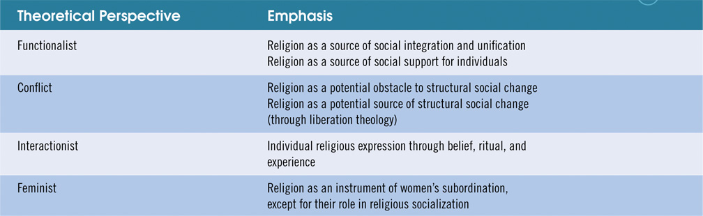

World Religions

Diversity in World Religions

85 percent of the world’s population adheres to some religion

Christianity is the largest faith around the world with about 34 percent of the population.

it includes the Roman Catholic Church, the numerous Protestant denominations, and the Eastern Orthodox Church with over 1.9 billion faithful

the second largest is Islam with about 19 percent, and is the fastest growing of the major religions.

Table 13-2: Major World Religions
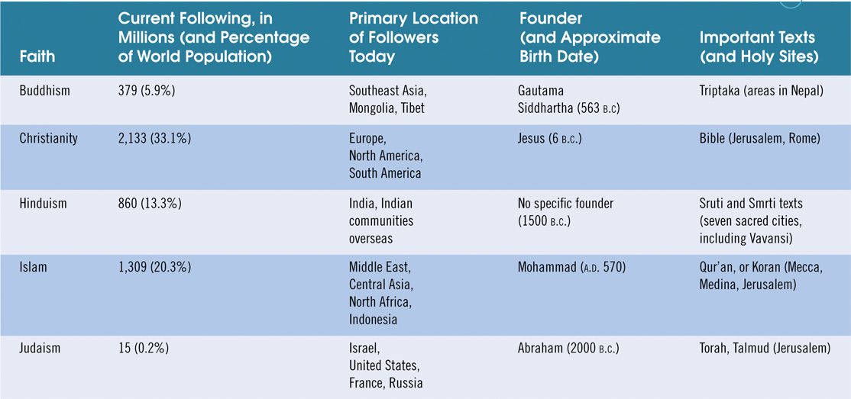

Organization of Religious Behavior

An ecclesia is a religious organization claiming to include most or all of the members of a society and is recognized as the national or official religion

Ecclesiae are conservative, in general, and do not challenge the leaders of a secular government

Denominations

A denomination is a large, organized religion not officially linked with the state or government

A denomination tends to have an explicit set of beliefs, a defined system of authority, and a generally respected position in society

The United States has the most denominations in the world. It is a result of the immigrant heritage

Eighty-seven percent of the population identify themselves as Christian, and the largest Christian denominations is the Roman Catholic Church, with about 57 million members.

About 80 million people, or 60 percent of the religious population are Protestant, but they are divided into hundreds of denominations

The Southern Baptist Convention, with about 15 million members is currently the largest Protestant denomination

Sects

A sect can be defined as a relatively small religious group that has broken away from some other religious organization to renew what it considers the original vision of the faith

Sect formation is very common in the U.S.

Sects usually exhibit a higher degree of fervor and loyalty than more established religious groups do

To sustain their membership, sects rely on active recruitment, of new members

New Religious Movements or Cults Religious Behavior

The Secularization of Culture

Sociologists use the term secularization of culture to refer to a culture that, once heavily influenced by religion, has lost much of its religious influence

The only sphere of influence that religion retains in advanced societies is the family

It is no longer the primary cohesive force in societies, having been replaced by nationalism and other secular and political ideologies

Religion in the Schools
- The Setting
  - First Amendment protects religious freedom
  - In 1987, Supreme Court ruled states could not compel the teaching of creationism in public schools
    - Creationists want Bible’s version of creation of world taught as the only theory of evolution or as an alternative theory
- Sociological Insights
  - Supporters of school prayer and creationism feel there is too much separation in schools between the
sacred and the profane
  - Opponents argue a religious majority
in a community might impose viewpoints specific to its faith at the expense of religious minorities

Key Beliefs Among Today’s Youth

Smith: Moralistic Therapeutic Deism (MTD)

A god exists who created and ordered the world and watches over human life

God wants people to be good to each other, as taught in the Bible and by most religions
The central goal of life is to be happy and to feel good about oneself

God does not need to be particularly involved in one’s life except when God is needed to solve a problem

Good people go to heaven when they die

Sociological Understanding of Religion

Comte: Religion of humanity

Weber: Ascetic form of 19th Protestantism critical in development of capitalism

Durkheim: God basically represented community or society

Major religions of the world

Christianity

Islam

Hinduism

Chinese Syncretism

Nonreligion

What is the function of the religious social institution?

Promotion of social order

Central mechanism for social control over behavior of people

What role do denominations and congregations play in organizing religious activity?

Denominations

Organized religious group with at least a few distinguishing religious doctrines

Frequently provide “correct” doctrine and model liturgies

Congregations

Specific church or temple or mosque that people actually attend

Most important level of organization

Religiosity by Gender and Age

Why are women more religious than men?

Women more likely to take up new religions; treated badly by old religions

Across societies, women are still treated differentially

Religion and motherhood are the key bases of self-validation available to most traditional women, including those in the developed world

Why is it difficult to distinguish religious conflict from ethnic or class conflict?

History replete with religious wars

Many “religious” wars have ethnic or tribal conflict more central to the problem

Hindu and Muslim conflict in India (“Hindutva”)

The Social Functions of Religion

Religion articulates a culture’s “beliefs” and conception of “the beyond.”

Durkheim saw religion as worship of society, not as worship of a deity:

“…rites are a means through which a group reaffirms itself.”

Religious rites strengthen commonly-held attitudes.

Function #1: Providing Emotional Support and Security
for Believers

Religion provides meaning in a natural world in which humans have little or no control over certain phenomena. Humans use religion to deal with:

Dependence

Powerlessness

Scarcity

Religion offers a transcendental relationship with “the beyond,” which provides people with

New security

A firmer identity in this world (believers and priests) and the next

Function #2: Religion Provides Social Control

As Durkheim implied, religion sacralizes the norms and values of established society, maintaining the dominance of group goals over individual wishes: Religion is a means of social control.

Function #3: Religion Provides Mechanisms for Social Change.

Religion has served a “prophetic” function in which absolute standards take precedence over “earthly” ones.

Religious belief is thus used as justification for social protests, social movements, political revolutions, etc.

Function #4: Religion Contributes to Individuals’ Identities

Religion is an aspect of heritage, like ethnicity.

Religion furnishes part of individuals’ understanding of who and what they are: eg, “I am Catholic” or “I am Muslim.”

Function #5: Religion is a Factor in directing the Individual’s Lifecourse

Religion contributes to the developing identity of the individual: This is the maturation function of religion.

Religions prescribe rites, privileges and responsibilities that are associated with life stages, as with the identity of “elder,” ceremonies for entry into “adulthood,” marriage, etc.

Religion and Secular Society

Generally, religion concerns the “sacred,” and secular society comprises the “profane.”

However, there are important and enduring relationships between these two separate spheres.

The religion-society link is expressed differently in different religious organizations.

Religions as Organizations

A church is a formal organization that shares features with all formal organizations: it is bureaucratic in nature and integrated into the larger society.

A sect is a form of religious organization that is non-bureaucratic and clearly distinct from the larger society.

A cult is distinct not only from the larger society but from other religions as well- it does not emerge from pre-existing religious forms; it is completely new.

Brief Summary

Defining Religion

Religion is institutionalized.

Religion is a feature of groups.

Religions are based on beliefs that are considered sacred, as distinguished from profane.

Defining Religion

Religion establishes values for behavior.

Religion establishes norms for behavior.

Religion provides answers to questions of ultimate meaning.

Exclusive and Inclusive Religious Groups

Exclusive religious groups have an easily identifiable religion and culture, including distinctive beliefs and strong moral teachings.

Inclusive religious groups have a more moderate and liberal religious orientation.

Polling Question

How important would you say religion is in your own life?

A.) Very important

B.) Fairly important

C.) Not very important

D.) No opinion

Durkheim: The Functions of Religion

Reaffirms social bonds between people.

Creates social cohesion through religious rituals.

Binds individuals to society by establishing a collective consciousness.

Weber: Protestant Ethic and Spirit of Capitalism

Material wealth meant one was favored by God motivating Protestants to work to confirm their salvation.

Value judgments about those who haven’t succeeded can be traced to influence of religion.

Marx: Religion, Social Conflict, and Oppression

Religion:

Legitimates the social order and supports the ideas of the ruling class.

Soothes the oppressed and prevents them from rising against oppression.

Can be the basis for social change or social continuity.

Theories of Religion

Theories of Religion

Theories of Religion

The World’s Religions

Polling Question

What is your current religious affiliation?

A.) Protestant

B.) Catholic

C.) Jewish

D.) None

E.) Other

Christianity

Christianity developed in the Mediterranean region of Europe.

It grew rapidly from the years 40 to 350 A.D. to encompass about 56% of the Roman empire.

Christianity is a belief in the Holy Trinity: God, the creator; Jesus, the son of God; Holy Spirit, the personal experience of the presence of God.

Christianity is the dominant religion in the U.S., although there is great diversity in forms of Christianity.

Judaism

The Jewish faith is more than 4000 years old.

Under Egyptian rule in ancient history, Jewish people endured centuries of slavery.

Led from Egypt by Moses in the thirteenth century B.C., Jewish people were liberated and celebrate this freedom in the annual ritual of Passover—one of the holiest holidays.

The Jews see themselves as “chosen people,” meant to recognize their duty to obey God’s laws as revealed in the Ten Commandments.

Jewish teachings are the source of both Christian beliefs and Islamic beliefs.

More than 40% of the world’s Jewish population lives in the United States, creating the largest community of Jewish people in the world.

The state of Israel, founded in 1948 as a homeland for all Jews following the Holocaust of World War II, has given Jewish people a high profile in international politics.

Islam

Islamic people are found in northern Africa, southeastern Asia, and increasingly, in North America and Europe.

Estimates are that there are now somewhere between 6 and 7 million Islamic people in the United States, one-third of whom are South Asian in origin, one-third African American, and one-quarter Arab American; the remainder are from diverse origins.

Followers of Islamic religion are called Muslims.

They believe that Islam is the word of God (Allah), revealed in the prophet of Muhammad, born in Mecca in the year 570 A.D.

The Koran is the holy book of Islam.

Many practicing Muslims in the United States are African Americans who observe the strict dietary habits and prohibitions against many activities, such as consuming pork, alcohol use, drug use, and gambling.

Hinduism

In this religion, god is not a specific entity.

Instead, people are called upon to see a moral force in the world and to live in a way that contributes to spiritual and moral development.

Karma is the principle in Hindu that sees all human action as having spiritual consequences leading to a higher state of spiritual consciousness, perhaps found in reincarnation

Hinduism is linked to the social system of India, because the caste system is seen as stemming from people’s commitment to Hindu principles.

Those who live the most ideal forms of life are seen as part of the higher caste, with the lower caste as spiritually bereft.

Gandhi, a great world leader, used Hindu principles to guide one of the most important independence movements in the world.

Buddhism

The Buddha in Buddhism is Siddhartha Gautama, born of the highest caste in India in the year 563 B.C.

As a young man, he sought a path of enlightenment, based on travel and meditation.

Buddhism thus encourages its followers to pursue spiritual transformation.

Through seeking spiritual enlightenment, Buddhists see people as relieving themselves of their worldly suffering.

Confucianism

Confucians follow the principles of Confucius, a Chinese philosopher who promoted certain moral practices.

Confucianism promotes a disciplined way of life, more of a moral code than a sacred religion as there is not a particular god or set of religious disciples whom Confucians follow.

The expression of goodness and social unity is an important principle in Confucian thought.

Religions Organizations

Churches -Formal organizations that see themselves, and are seen by society, as the primary and legitimate religious institutions.

Sects - Groups that have broken off from an established church, when a faction questions its legitimacy.

Cults - Religious groups devoted to a specific cause or a leader with charisma.

Religious Conversion: Social Drift Theory

People move into religious groups gradually, particularly if they have become disenchanted with their prior affiliations.

Conversion is linked to shifting patterns of association, not mind control.

People are active participants in the process of their own conversion, not passive creatures “programmed” with new ideas.

Religious Conversion: Phases

An experience that leads a potential convert to perceive disruption in their previous life, allowing them to be open to a serious change in the social environment.

An emotional bond is created between the initiate and one or more group members.

A period of intense interaction with the new group.

Religion and Social/Political Attitudes

Religiosity is related to a wide array of social and political attitudes.

Racial prejudice, homophobia, and anti-Semitism are all linked to patterns of religious affiliation.

Religious extremism develops in particular social contexts and can fuel dangerous behaviors, such as terrorism.

Changes in Religious Behavior

There has been an enormous growth in conservative religious groups.

Evangelical groups have been highly influential, particularly through their use of the electronic media as a means of communication and their affiliation with conservative political causes.

Secularization is the process in society by which religious institutions, action, and consciousness lose their social significance.

Quick Quiz

1. The institutionalized system of symbols, beliefs, values, and practices by which a group of people interprets and responds to what they feel is sacred and that provides answers to questions of ultimate meanings is known as:

a. Religion

b. Totenism

c. Judeo-prescription

d. Proscription

Answer: a

The institutionalized system of symbols, beliefs, values, and practices by which a group of people interprets and responds to what they feel is sacred and that provides answers to questions of ultimate meanings is known as religion.

2. The majority of people in the U.S. identify themselves as:

a. Jewish

b. Catholic

c. Muslim

d. Protestant

Answer: d

The majority of people in the U.S. identify themselves as protestant.

3. To Marx, religion is a form of:

a. spiritual oppression

b. spiritual flaw

c. collective consciousness

d. false consciousness

Answer: d

To Marx, religion is a form of false consciousness.

4. "Religion is an integrative force in society." This statement is most closely related to:

a. conflict theory

b. symbolic interaction

c. evolutionary theory

d. functionalism

Answer: d

"Religion is an integrative force in society." This statement is most closely related to functionalism.

5. The Koran is the holy book of:

a. Buddhism

b. Islam

c. Catholicism

d. Hinduism

Answer: b

The Koran is the holy book of Islam.

