Memory
Lecture no: 7
Clinical Psychologist SadafSajjad
_____________________________________________________________________________
Memory
“Memory is the process of maintaining information over time.” (Matlin, 2005)
“Memory is the means by which we draw on our past experiences in order to use this information in the present.’ (Sternberg, 1999)
The Phenomena of Memory
Memory is the persistence of learning over time. It is our ability to store and retrieve information.
Human memory can be pretty amazing. E.g. People who were shown the whole image 17 years before were more likely to identify the fragment.
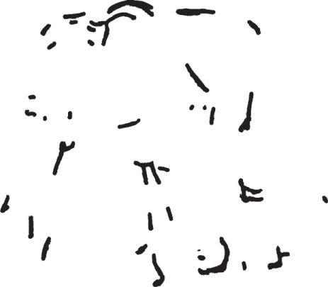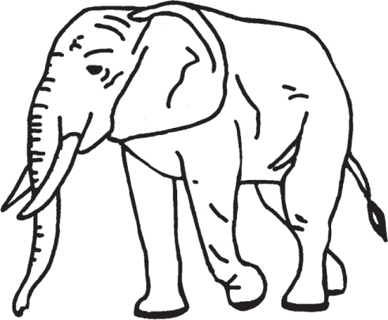

How Memory works?
Psychologists think of memory as involving three processes
Encoding
The set of mental operations that people perform on sensory information to convert that information into a form that is usable in the brain’s storage systems.
Storage
Holding onto information for some period of time.
Retrieval
Getting information that is in storage into a form that can be used

Models of Memory
- Atkinson-Shiffrin Model
Atkinson-Shiffrin Model also known as, Multi-stage Model. It consists of three different, interacting memory systems.
Sensory Memory
Stimuli are recorded by our senses and held briefly in sensory memory.
Short-term Memory
Some of this information is processed into short-term memory and encoded through rehearsal .
Long-term Memory
Information then moves into long-term memory where it can be retrieved later.
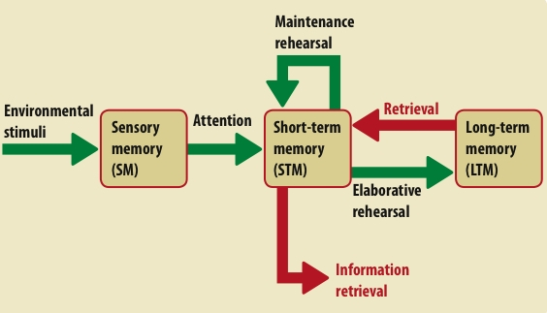
Atkinson-Shiffrin Model
- Working Memory Model
Instead of all information going into one single store, there are different systems for different types of information. It Consists of three different systems
Central Executive: Drives the whole system (e.g. the boss of working memory) and allocates data to the subsystems (VSS & PL). It also deals with cognitive tasks such as mental arithmetic and problem solving.
Visuo-Spatial Sketch Pad (inner eye): Stores and processes information in a visual or spatial form. The VSS is used for navigation.
The phonological loop is the part of working memory that deals with spoken and written material. It can be used to remember a phone number.
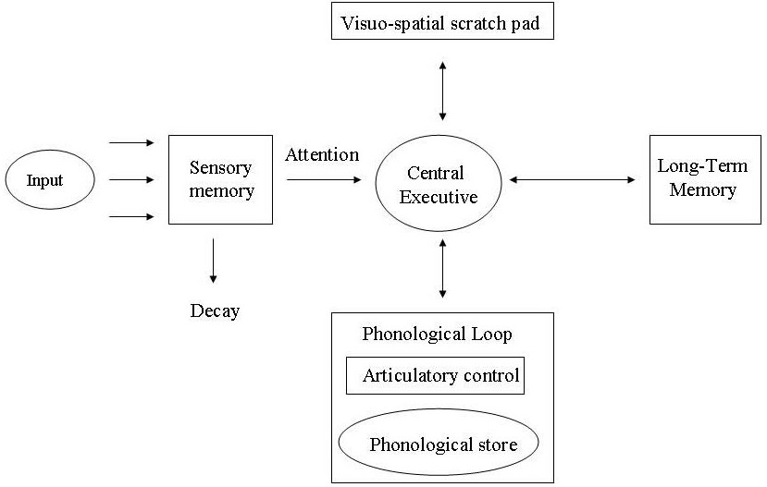
Working Memory Model
Types of Memory
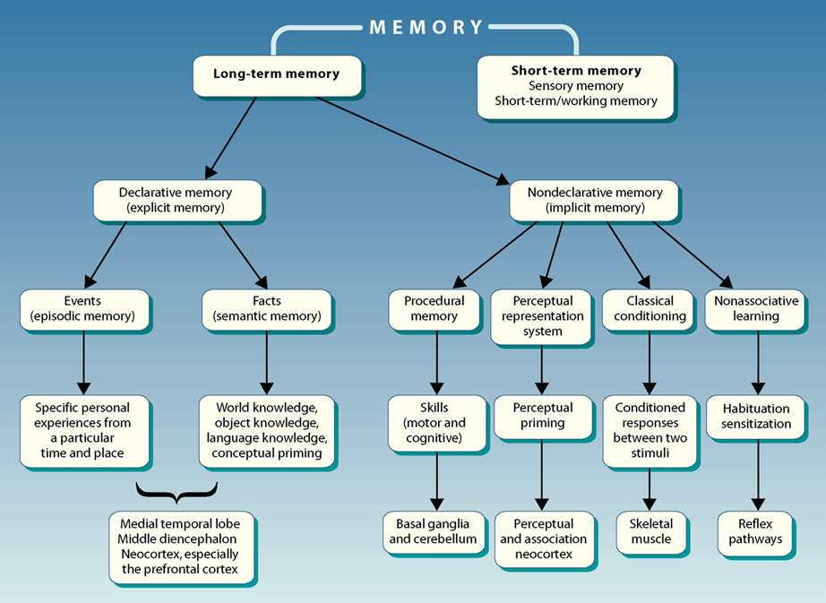
- Sensory Memory
The immediate, initial recording of sensory information held in sensory memory. It has large capacity, but rapid decay. Actual length of time a stimulus exist in sensory storage depends on the modality:
Iconic memory - a visual image in sensory storage - they last approximately 1/4 of a second.
Echoic memory - auditory image. These (as well as other senses) seem to last up to 3 seconds.
Sensory Memory to Short-term Memory
After getting the information in the form of Iconic and Echoic Memories, data need to be transferred to short term memory otherwise it can be lost.
Two processes are required to get information from sensory memory to short term memory
  - Pattern recognition - when new information comes into sensory storage, we actively search through long term memory in an effort to find a match for this new raw data.
  - Attention - this is pretty obvious. The more we pay attention to a stimulus, the more likely it will continue onto the next memory store (short term memory)
- Short-term Memory
The stuff we encode from the sensory goes to STM. Events are encoded visually, acoustically or semantically. A limited capacity store that can maintain information for approximately 20 seconds. E.g. we recall digits better than letters.
Ways to Extend duration of STM
Maintenance Rehearsal
  - The process of repeatedly verbalizing or thinking about the information.
Slots/Chunking
  - bits of information are combined into meaningful units, or chunks, so that more information can be held in STM
Primacy and Recency
  - Primacy - when you are receiving information, the information perceived first is more likely to be remembered. This more recent information may simply get to long term memory more easily, and thus be remembered or we may just rehearse the early information more.
  - Recency - information perceived toward the end of an event is also more likely to be remembered. So, information in the "middle" seems to get pushed out and is less likely to be remembered.
Elaborative Rehearsal
  - the only way to bring information into long-term memory
  - connecting new information with previously stored, already existing associative structures
- Long-term Memory
An unlimited capacity store that can hold information over lengthy periods of time. Suggested encoding modes are semantic (meaning) and visual (pictorial) in the main but can be acoustic also.
Types of Long-term Memory
- Declarative LTM
Semantic memory - containing general knowledge, such as knowledge of language and information learned in formal education.
Episodic memory - containing personal information not readily available to others, such as daily activities and events.
Semantic and episodic memories are forms of explicit memory - memory that is consciously known.
- Non-declarative LTM
It includes skills that people know how to do. Also include emotional associations, habits, and simple conditioned reflexes that may or may not be in conscious awareness.
Non-declarative memory often called implicit memory - memory that is not easily brought into conscious awareness.
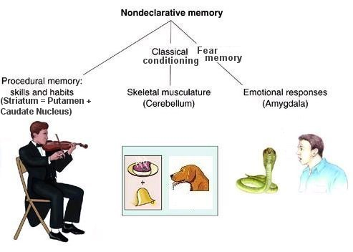
Non-declarative LTM
Level of Processing Model
A model of memory as a single system in which retention depends on how deeply information is processed
  - With the shallowest levels of processing, a person is merely aware of the incoming sensory information
  - Deeper processing (elaboration) takes place only when the person does something more with the information, such as forming relationships, making associations, attaching meaning to a sensory impression, or otherwise engaging in active elaboration on new material
Craik and Tulving Experiment:
They had participants answer yes or no to questions asked about words just before the words were flashed to them for 1/5 of a second. Participants had to process the words visually, acoustically, or semantically. The test required shallow processing for the first question, deeper processing for the second question, and still deeper processing for the third question. Later retention tests showed that the deeper the level of processing, the higher the accuracy rate of memory.
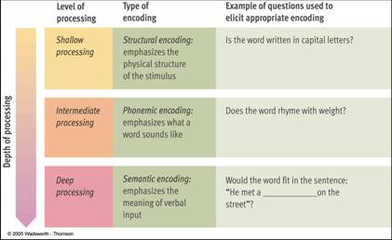
Level of Processing Model
Remembering
Remembering involves three kinds of memory tasks
Recall
  - A measure of retention that requires a person to remember material with few or no retrieval cues, as in an essay test
  - Trying to remember someone’s name, recalling items on a shopping list, memorizing a speech or a poem word for word, and remembering
  - May be made a little easier if cues are provided to jog memory
  - Sometimes serial recall is required; that is, information must be recalled in a specific order
  - Research suggests that, in free recall tasks, order associations are more resistant to distractions than meaningful associations
Recognition
- A measure of retention that requires a person to identify material as familiar, or as having been encountered before
- Multiple-choice, matching, and true/false questions are examples of recognition test items
- The main difference between recall and recognition is that a recognition task does not require you to supply the information but only to recognize it when you see it
- Recent brain-imaging studies have discovered that the hippocampus plays an extensive role in memory tasks involving recognition, and the degree of hippocampal activity varies with the exact nature of the task
Relearning
- Measuring retention in terms of the percentage of time or learning trials saved in relearning material compared with the time required to learn it originally; also called the savings method
- Savings score
- The percentage of time or learning trials saved in relearning material over the amount of time or number of learning trials required for the original learning
- College students demonstrate the relearning method each semester when they study for comprehensive final exams
Example of Recall:
The process of storing information in memory is called ______________.
Example of Recognition:
The process of storing information in memory is called:
a. rehearsal b. deep processing
c. encoding d. retrieval
Forgetting
Curve of forgetting - a graph showing a distinct pattern in which forgetting is very fast within the first hour after learning a list and then tapers off gradually.
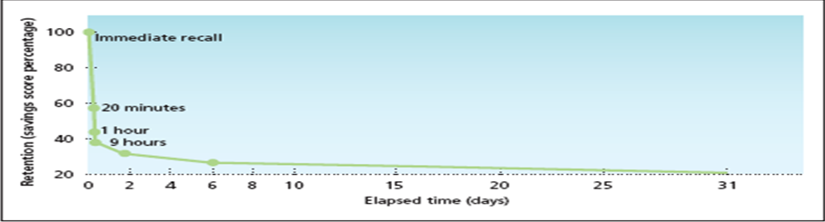
Curve of Forgetting
Forgetting due to Encoding Failure
Failure to process information into memory.
Forgetting due to Memory Trace Theory
Physical change in the brain that occurs when a memory is formed.
  - Decay - loss of memory due to the passage of time, during which the memory trace is not used.
  - Disuse - another name for decay, assuming that memories that are not used will eventually decay and disappear.
Forgetting due to Interference Theory
  - Proactive interference : memory retrieval problem that occurs when older information prevents or interferes with the retrieval of newer information.
  - Retroactive interference: memory retrieval problem that occurs when newer information prevents or interferes with the retrieval of older information.
Some Ways to Improve Memory
Knowledge of Results: Feedback allowing you to check your progress
Recitation: Summarizing aloud while you are learning
Rehearsal: Reviewing information mentally (silently)
Selection: Selecting most important concepts to memorize
Organization: Organizing difficult items into chunks; a type of reordering

