Biological Basis of behavior
Lecture no: 4
Clinical Psychologist SadafSajjad
_____________________________________________________________________________
What we are going to learn?
- How biology effects behavior
- Neural Structure and synaptic transmission
- Structure and functions of nervous system
- Endocrine system
Why study biology in a psychology class?
“Everything psychological is simultaneously biological.”
- Every thought, behavior, emotion, perception, etc. is rooted in our biology, particularly our brain
- The brain is a “psychological organ” as well as a biological one.
- Biology is the science of living things ---it plays an integral role in supporting psychology.
How biology effect behavior?
Brain, nerves and hormones are responsible for your thoughts feelings and actions.
Example:
Biological processes are involved in every human action:
- You feel hungry
- You remember your favorite restaurant
- You smell the food
- Or take a bite
Biology Effects Behavior:
Psychology determines what people perceive to feel and behave - while determining the way we act, feel and behave is biology. Psychologists study biological psychology to establish a bridge between:
- Psychology and Biology
- Brain activity and mental states
Biological psychology:
Definition: The branch of psychology that studies the biological foundations of behavior, emotions, and mental processes. Biological psychology is about finding biological causes of how we: think, feel, & act.
Biological systems that effect behavior are:
- Endocrine system
- Nervous system
Neural structure and synaptic transmission:
Neuron is a nerve cell --- the basic unit of the nervous system. That is constantly sending signals to your brain muscles and glands.
Signals: help different parts of body to communicate with each other
Neuron Structure:
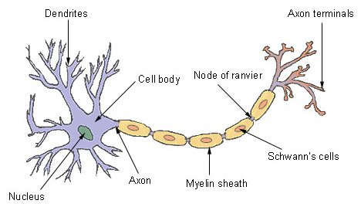
- Cell body (soma): the central part of the neuron, contains the nucleus
      - Function: regulates cell functioning
- Dendrites: the branching part of the neuron
      - Function: receives messages from other neurons and relays them to the cell body
      - The word DENDRITE comes from the Greek word for tree. This may serve as a useful analogy in discussing the dendrites for several reasons:
      - The dendrites branch repeatedly from the cell body (to increase the surface area of the cell to better allow the cell to receive incoming information). These radiations from the cell body are often referred to as a dendrite tree.
      - In terms of function, the dendrites function similarly to the roots of a tree. Just as the roots take water and other nutrients from the soil and carry them to other parts of the tree, the dendrites collect information and spread it to other parts of the neuron.
- Axon (A nerve fiber): a single process extending from the cell body of a neuron
        - Function: caries nerve impulses away from it.
- Synapse: the point of connection between two neurons or between a neuron and a muscle or gland.
        - Function: Electrochemical communication between neurons takes place at these junctions.
Interesting facts:
- The diameter of an axon may vary from approximately 1mm-20mm.
- An axon may travel long distances to reach its destination (longest axon is approximately 3 feet in humans and 10 feet in giraffes).
Types of Neuron:
- Sensory neurons -receive information from environment.
- Motor neurons – send signals to muscles and glands to ready organism for action.
- Interneuron – receives & sends information to other neurons.
Signal propagation in neurons:
The neural impulse:
The electrochemical properties of the neuron allow it to transmit signals.
The electric charge of a neuron can be measured with a pair of electrodes connected to an oscilloscope
- Nerves propagate signals in the form of action potentials.
- Resting potential: the negative charge maintained within neurons that are at rest.
    - It is due to more sodium ions outside neuron than inside, and more potassium inside neuron than outside
- Action potential: a neural impulse-- the shifting change in charge that moves down the axon to terminal buttons
Signal Propagation in neuron:
When the action potential passes sodium channel open and response to membrane depolarization. Sodium ion rushes into the axon, further depolarizing its membrane. Sodium channel then switch into a new inactivated state in which they are closed. Sodium channel is then ready to get open if next action potential takes place. Action potential is propagated in only one direction in an axon.
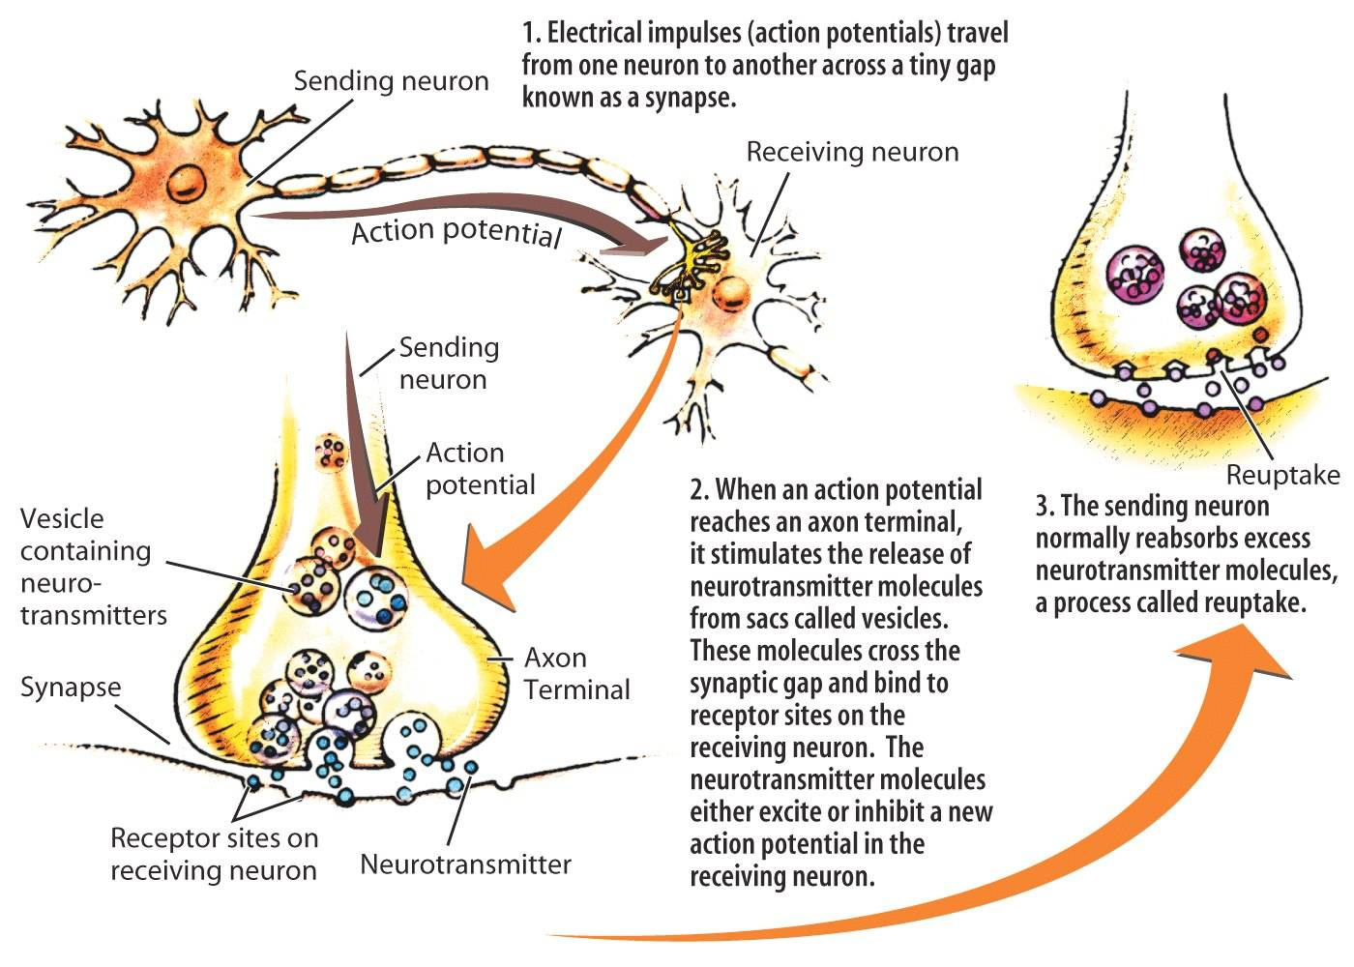
All or None Law:
The all-or-none law is a principle that states that the strength of a response of a nerve cell or muscle fiber is not dependent upon the strength of the stimulus. If a stimulus is above a certain threshold, a nerve or muscle fiber will fire. Essentially, there will either be a full response or there will be no response at all.

The all-or-none law was first described in 1871 by physiologist Henry Pickering Bowditch. In his descriptions of the contraction of the heart muscle, he explained, "An induction shock produces a contraction or fails to do so according to its strength; if it does so at all, it produces the greatest contraction that can be produced by any strength of stimulus in the condition of the muscle at the time."
While the all-or-none law was initially applied to the muscles of the heart, it was later found that nerves and other muscles also respond to stimuli according to this principle.
Authors Levitan and Kaczmarek explain, "The all-or-none law guarantees that once an action potential is generated it is always full size, minimizing the possibility that information will be lost along the way."
Synaptic Transmission:
  - Synapse: the place where an axon of one neuron meets with the dendrite/cell body of another neuron. When a neural impulse reaches an axon’s terminal buttons, it triggers the release of chemical messengers called neurotransmitters. The neurotransmitter molecules diffuse across the synaptic cleft and bind to receptor sites on the postsynaptic neuron. A specific neurotransmitter can bind only to receptor sites that its molecular structure will fit into, much like a key must fit a lock.
  - Synaptic cleft: the gap between the axon and the dendrite/cell body across which neural transmission occurs
  - Neurotransmitters: a chemical that sends signals from one neuron to another over the synaptic cleft
The Nervous System:
It affects the human behavior. It is comprised of the central nervous system and the peripheral nervous system. Central nervous system comprises of brain and spinal cord. 31 pairs of spinal nerves radiate from the spinal cord
Reflex is an automatic response to an event. The Reflex arc is the main functional unit of the nervous system that helps a person reacts to a stimulus.
Example: sensory neuron detects pain/hot, send signal to spinal cord, spinal cord signal to motor neurons.
Peripheral Nervous System links central nervous system to organs. It is comprised of the skeletal nervous system and the autonomic nervous system. Skeletal nervous system controls voluntary movements of our skeletal muscles.
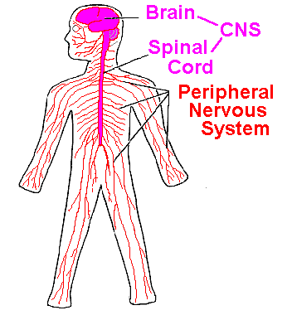
Structure of brain:
- Brainstem: the set of neural structures at the base of the brain, including the medulla, the reticular formation, and the Pons
- Medulla: controls heartbeat, breathing, and swallowing
- Reticular formation: regulates alertness and autonomic nervous system activity
- Pons: bridge from brainstem to cerebellum; controls a variety of functions, including sleep and control of facial muscles
- little brain: extending from rear of brainstem-- coordinates physical movement
- The cerebellum: is the area of the hindbrain that controls motor movement coordination, balance, equilibrium and muscle tone.
- Thalamus: the brain’s sensory switchboard; receives signals from the sensory and motor systems
Our brain is divided into two halves; the two hemispheres continually work together on most tasks.
  - left brain: written language, spoken language, number skills, reasoning (analytical and verbal)
  - Right brain: insight, art awareness, imagination/creativity, music awareness (intuitive and perceptual)
Left brain and right brain theory:
Have you ever heard people say that they tend to be more of a right-brain or left-brain thinker?
- According to the theory of left-brain or right-brain dominance, each side of the brain controls different types of thinking.
- Example:
    - A person who is "left-brained" is often said to be more logical, analytical and objective,
    - While a person who is "right-brained" is said to be more intuitive, thoughtful and subjective.
The theory grew out of the work of Roger W. Sperry, who was awarded the Nobel Prize in 1981. While studying the effects of epilepsy, Sperry discovered that cutting the corpus collosum (the structure that connects the two hemispheres of the brain) could reduce or eliminate epilepsy. These patients also experienced other symptoms after the experiment; many split-brain patients found themselves unable to name objects that were processed by the right side of the brain, but were able to name objects that were processed by the left-side of the brain. Based on this information, Sperry suggested that language was controlled by the left-side of the brain.
The Endocrine System:
- Communication from the brain is sent to the rest of the body by the endocrine system as well as by the nervous system.
- The endocrine system is a series of glands throughout the body that secrete chemicals (hormones) into the bloodstream.
- Hormones are transferred to the target tissues via ducts and affect body functions.
- Not all hormones are proteins.
- The endocrine system links the brain to the organs that control body metabolism, growth and development, and reproduction.
Hormones:
Hormones producing glands make up your endocrine system. Hormones are chemicals that your body produces to tell your cells how to behave. Some common hormone glands are:
- Hypothalamus: Produces hormones that stimulate or inhibit secretion of hormones by the pituitary.
- Thyroid glands: regulates your metabolism, or how fast your body uses energy.
- Pancreas: regulates how much energy your body gets.
- Adrenal glands: pumps out adrenaline hormones when you’re faced with stress or excited.
- Pituitary gland: a master gland that secretes hormones that trigger your other gland.
- Parathyroid: Produce parathyroid hormone that helps maintain calcium ion level in blood necessary for normal functioning of neurons.
- Pineal gland: Produces melatonin that helps regulate circadian rhythms and is associated with seasonal affective disorder.

