Learning and Behavior
Lecture no: 3
Clinical Psychologist SadafSajjad
_____________________________________________________________________________
Learning:
Learning became a major focus of study in psychology during the early part of the twentieth century as behaviorism rose to become a major school of thought. Today, learning remains an important concept in numerous areas of psychology, including cognitive, educational, social, and developmental psychology.
Learning is defined as:
“Learning is often defined as a relatively lasting change in behavior that is the result of experience”.
Learning is a relatively permanent change in behavior that is the result of experience. Learning is the most hopeful of the fields of psychology. Opposed to short term changes in behavior potential (caused e.g. by fatigue) learning implies long term changes.
During the first half of the twentieth century, the school of thought known as BEHAVIORISM rose to dominate psychology and sought to explain the learning process.
Behavior:
Founded by John B. Watson, Behavior is
“the school of thought in psychology that sought to measure only observable actions”.
Behaviorism is primarily concerned with observable behavior, as opposed to internal events like thinking and emotion. Observable (i.e. external) behavior can be objectively and scientifically measured. Internal events, such as thinking should be explained through behavioral terms (or eliminated altogether).
Learning and Behavior
It is:
“The process by which a relatively lasting change in potential behavior occurs as a result of practice or experience”.
Learning occurs throughout life in animals, and learned behavior accounts for a large proportion of all behavior in the higher animals, especially in Humans.
Types of Learning
- Classical Conditioning
- Operant Conditioning
- Cognitive Learning
- Observational Learning
Classical Conditioning
First described by Ivan Pavlov, a Russian physiologist as:
“It’s a type of learning in which a stimulus acquires the capacity to evoke a reflexive response that was originally evoked by a different stimulus”.
It is s a four-step learning procedure involving reflexes. It involves placing a neutral signal before a reflex. It focuses on involuntary, automatic behaviors.
Experiment on Classical Conditioning
Pavlov became curious about the fact that some of his laboratory dogs began salivating before food actually was in their mouths. He then found that if he used the appropriate sequence of events, a dog would salivate at the sound of a buzzer or the appearance of a light. Further experimentation established the conditions essential in producing such a phenomenon.
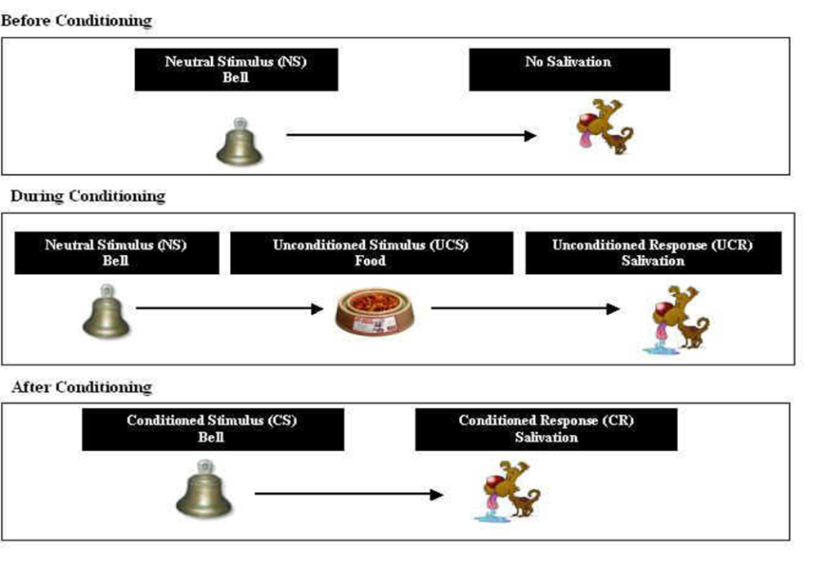
The reflexive behaviors in classical conditioning are described as:
Unconditioned Stimulus (US) - a stimulus that evokes an unconditioned response without any prior conditioning
Unconditioned Response (UR) - an unlearned reaction/response to an unconditioned stimulus that occurs without prior conditioning.
Conditioned Stimulus (CS) - a previously neutral stimulus that has, through conditioning, acquired the capacity to evoke a conditioned response.
Conditioned Response (CR) - a learned reaction to a conditioned stimulus that occurs because of prior conditioning.
Conditioned Fear & Anxiety - many phobias that people experience are the results of conditioning.
For Example - "fear of bridges”.
Operant Conditioning
First studied by Edward Thorndike and later by B.F. Skinner, states:
“Operant conditioning is a learning process in which the probability of response occurring is increased or decreased due to reinforcement or punishment”.
The underlying idea behind operant conditioning is that the consequences of our actions shape voluntary behavior. It occurs through rewards and punishments for behavior.
Skinner (1953), used the term operant to refer to any
“The Active behavior that operates upon the environment to generate consequences“.
For example, consider the case of children completing homework to earn a reward from a parent or teacher, or employees finishing projects to receive praise or promotions. In these examples, the promise or possibility of rewards causes an increase in behavior, but operant conditioning can also be used to decrease a behavior. The removal of an undesirable outcome or the use of punishment can be used to decrease or prevent undesirable behaviors.
Skinner’s Experiment on Operant Conditioning
Skinner wanted a better control over the learning situation, which allowed the organism (to be experimented on), to freely operate in its environment. To do all this, he invented Skinner box, which is also called the operant chamber. There is a device in the box, which can deliver food pellets into a tray at random. Inside the box, there is a lever which when pressed activates the device for delivering food pellets. A hungry pigeon is left inside the box. The rat exhibits random activities while exploring the box. Accidentally the pigeon presses the lever and a pellet of food is delivered. The first time it happens, the pigeon does not learn the connection between the response of lever pressing and food pellets. Sooner or later, the pegion learns that the consequence of lever pressing is positive; lever pressing brings food. Skinner counted the number of lever presses. The number of responses within a particular unit of time is called the rate of response. Skinner used rate of response as a measure of learning.

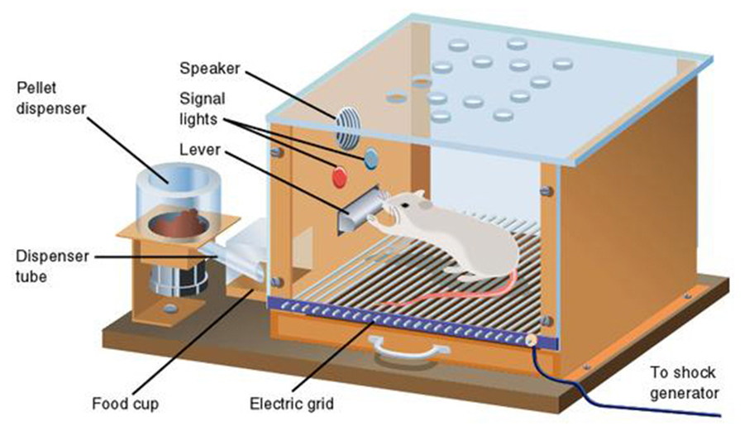

Components of Operant Conditioning
Some key concepts in operant conditioning are,

1) Reinforcement is any event that strengthens or increases the behavior it follows. There are two kinds of rein forcers:
Positive rein forcers, are favorable events or outcomes that are presented after the behavior. In situations that reflect positive reinforcement, a response or behavior is strengthened by the addition of something, such as praise or a direct reward.
Negative rein forcers, involve the removal of an unfavorable events or outcomes after the display of a behavior. In these situations, a response is strengthened by the removal of something considered unpleasant.
In both of these cases of reinforcement, the behavior increases.
2) Punishment, on the other hand, is the presentation of an adverse event or outcome that causes a decrease in the behavior it follows. There are two kinds of punishment:
Positive punishment, sometimes referred to as punishment by application, involves the presentation of an unfavorable event or outcome in order to weaken the response it follows.
Negative punishment, also known as punishment by removal, occurs when an favorable event or outcome is removed after a behavior occurs.
In both of these cases of punishment, the behavior decreases.
Cognitive Learning
Cognitive learning comprises of,
“learning a relationship between two stimuli and thus is also called S-S learning. Types of cognitive learning include latent learning and the formation of insights”.
Cognitive learning is the result of listening, watching, touching or experiencing.
Cognitive learning is a powerful mechanism that provides the means of knowledge. It goes well beyond simple imitation of others. Is the procedures we have for manipulating information “in our heads”. It includes creating mental representations of physical objects and events. Also includes other forms of information processing.
Types of Cognitive Learning
Types of cognitive learning include latent learning and the formation of insights.
1) Latent learning, sometimes called incidental learning is learning without reinforcement and is not immediately demonstrated when it occurs.
For example, if a student wants a coffee break, wonders where to go, and suddenly remembers a new coffee shop near campus, the student is demonstrating latent learning.
E. C. Tolman, a well-known investigator of cognitive learning, suggested that organisms form cognitive maps of their environments, maps that can be used when needed.
2) Insight, is a new way to organize stimuli or a new approach to solving a problem.
For example, A student struggling with a mathematical problem who suddenly sees how to solve it without having been taught additional methods has had an insight.
Experiment on Chimpanzee's
Wolfgang Köhler, a famous Gestalt psychologist, demonstrated that chimpanzees can solve problems using insight. Chimps placed in a cage, with bananas beyond their reach, learned that they could pile up boxes or attach one stick to another to reach and obtain the food. The chimps had not been reinforced for these specific behaviors but learned how to get the food through insight. Once insight has occurred, no further instruction or training is required.
Results of Kohler’s Experiment
The details of the chimps' solutions to Kohler's food-gathering puzzle varied. One chimp tried to shinny up a toppling pole it had poised under the bananas,
several succeeded by stacking crates underneath, but were hampered by difficulties in getting their centers of gravity right.
Another chimp had good luck moving a crate under the bananas and using a pole to knock them down.
The theme common to each of these attempts is that, to all appearances, the chimps were solving the problem by a kind of cognitive trial and error, as if they were experimenting in their minds before manipulating the tools.
The pattern of these behaviors--failure, pause, looking at the potential tools, and then the attempt--would seem to involve insight and planning, at least on the first occasion.
Observational Learning
Was 1st proposed by Albery Bandura,
“Replicating others’ novel behavior through observation and imitation; also known as vicarious learning, modeling, or social learning”.
In Observational Learning, someone must notice something someone else is doing, remember it or record it in their mind, and finally replicate the behavior. It is mostly seen in children who model their actions on those of their parents.
The only things that limit this type of learning is the intelligence level, And the level of ability to copy the person well that the learner possesses. Observational learning, is also known as modeling. Modeling is said to have two components, Observation and Imitation. You watch somebody do something and then you attempt to copy it.
The Modeling Process
The following steps are involved in the observational learning and modeling process:
Attention: In order to learn, you need to be paying attention. Anything that detracts your attention is going to have a negative effect on observational learning. If the model interests you or there is a novel aspect to the situation, you are far more likely to dedicate your full attention to learning.
Retention: The ability to store information is also an important part of the learning process. Retention can be affected by a number of factors, but the ability to pull up information later and act on it is vital to observational learning.
Reproduction: Once you have paid attention to the model and retained the information, it is time to actually perform the behavior you observed. Further practice of the learned behavior leads to improvement and skill advancement.
Motivation: Finally, in order for observational learning to be successful, you have to be motivated to imitate the behavior that has been modeled. Reinforcement and punishment play an important role in motivation. While experiencing these motivators can be highly effective, so can observing other experience some type of reinforcement or punishment. For example, if you see another student rewarded with extra credit for being to class on time, you might start to show up a few minutes early each day.
“Bobo” doll Experiment
Bandura had children witness a model (man who was working for Bandura) aggressively attacking a plastic clown called the Bobo doll. The children would watch a video where the man would aggressively hit a doll and pummel it on the head with a hammer, hurls it down, sits on it and punch it on the nose repeatedly, kick it across the room, flings it in the air, and bombard it with balls. After the video, the children were placed in a room with attractive toys, but they could not touch them. Therefore, the children became angry and frustrated. Then the children were led to another room where there were identical toys used in the Bobo video (with Bobo dolls).Bandura and many other researchers founded that 88% of the children imitated the aggressive behavior. Eight months later, 40% of the same children reproduce the violent behavior observed in the Bobo doll experiment.

