Aptitude
Lecture No: 25
Clinical Psychologist Sadaf Sajjad
____________________________________________________________________________
What is Aptitude?
Aptitude is a suitability, natural ability, or capacity to learn; especially (in psychology) potential rather than existing capacity to perform some function, whether physical, mental, or a combination of the two, given the necessary education or training.
An aptitude is an innate inborn ability or capacity to learn to do a certain kind of work. The innate nature of aptitude is in contrast to achievement, which represents knowledge or ability that is gained. Aptitudes may be physical or mental. Aptitude refers to those qualities characterizing a person’s way of behavior which serve to indicate how well he can learn to meet & solve a certain specified kinds of problem. Individual possess certain specific aptitude or ability in addition to intellectual abilities or intelligence, which helps them to achieve success in some specific occupations or activities. Thus aptitude means specific ability or capacity distinct from general intellectual ability that helps to acquire proficiency or achievement in specific field.
Aptitude can be defined as individual differences that are related to subsequent learning during a fixed time frame. The learning or acquisition of knowledge or skills can occur in a formal intervention (training or education) or in an informal setting (experience or mentoring). This definition can be fruitfully narrowed by specifying the domain of individual differences (cognitive, non-cognitive) and the type of relationship (i.e., rate, accuracy) with learning.
Numerous individual differences are related to learning, including cognitive abilities, personality traits, interests, and values. All of these can be considered aptitudes, and all can be evaluated in work, school, or vocational contexts. Aptitudes are discussed most commonly in reference to cognitive abilities within a formal educational or training context where the learning is labeled achievement.
Aptitudes are Natural Abilities
Aptitudes are natural talents, special abilities for doing, or learning to do, certain kinds of things easily and quickly. They have little to do with knowledge or culture, or education, or even interests. They have to do with heredity. Musical talent and artistic talent are examples of such aptitudes. Some people can paint beautifully but cannot carry a tune. Others are good at talking to people but slow at paperwork. Still others can easily repair a car but find writing difficult. These basic differences among people are important factors in making one person satisfied as a banker, another satisfied as an engineer, and still another satisfied working as an editor.
Skills, Abilities and Aptitudes
Skills, abilities, and aptitudes are similarly related but distinct, descriptions of what a person can do, and should not be conflated.
Skills are a backward looking description. Skills describe what a person has learned to do in the past.
Abilities are a present description. Abilities describe what a person can do now.
Aptitudes are a forward looking description. Aptitudes describe what a person has the ability to do in the future. They describe what a person can learn to do.
Aptitude and Intelligence
Aptitude and intelligence quotient are related, and in some ways opposite views of human mental ability. Whereas intelligence quotient sees intelligence as being a single measurable characteristic affecting all mental ability, aptitude refers to one of many different characteristics which can be independent of each other, such as aptitude for military flight, air traffic control, or computer programming.
Aptitude and Motivation
Aptitudes have an important impact on motivation as it feels good to use a high aptitude, thus reinforcing operating that way. Feeling good about using yourself in a particular way is almost certainly related to the production of endorphins. Not only pain killers, endorphins are also known to be mood regulators. There are probably as many endorphin types as there are aptitudes.
Some of the feelings associated with strong talents are negative. An unused aptitude is a source of frustration and restlessness. Ongoing in its functioning, an unused aptitude must either be stifled or ignored. It takes energy to stifle a part of yourself and to neutralize or ignore a natural and ongoing tendency. It also doesn't feel good. This takes its toll in the long run. Motivational energy seems to be finite--the extra effort needed to stifle a part of you is an important factor in burnout.
Low-Aptitude
Low-aptitudes are also important. Almost anyone can learn to do a task or pass a class by rote, but if the gut level "knowing" is lacking, performance is inferior to those who have the knack (other factors being equal). Without that deep level of knowing or understanding, self-confidence is lower. If people don't have a gut-level feel for a situation, they are never really comfortable there. It is anxiety producing and energy draining to operate in low-talent areas. Without the inherent rewards associated with high aptitude, motivation is lower.
Low-Aptitude people make more errors and achieve less in that area or work a lot harder to achieve the same results. This can lead to burnout, accidents, and a high level of stress-related illness. It is possible to learn to be better at anything, whatever the level of aptitude. However, with the same effort, people with the right talents for that activity stay ahead and enjoy what they're doing. For them, operating in a particular way is cost-effective on many levels.

Aptitude Testing
True aptitude testing consists of a series of independent work samples or tasks, each one tapping a different aptitude. The tests are designed to measure your natural talents, those inborn abilities that make it easier for you to learn or to do certain things.
Testable Aptitudes
Many of Aptitudes have been identified and are testable.
- General Learning Ability
It an aptitude, commonly referred to as the "G" score, defined as the ability to "catch on" or understand instructions and underlying principles; ability to reason and make judgments. Closely related to doing well in school. It is related to the use of logic or scientific facts to define problems and draw conclusions; make decisions and judgments; or plan and supervise the work of others. Specific job tasks that might require high General Learning Ability include: diagnose and treat illnesses or injuries; use facts to solve a crime; plan the layout of a computer network; inspect and test engine parts.
- Verbal Aptitude
This is important in all academic and most non-academic subjects in high school. It measures how well you see relationships among words. If you were to take only one test, this would be the best all-around predictor of how well you can do in academic subjects. This area is important for careers requiring written and oral communication, such as business, law, education, journalism, and the sciences.
- Numerical Aptitude
It measures how well you perform mathematical reasoning tasks. Scores on this test predict, to some extent, success in nearly all high school and college courses. Numerical ability is one element of all-around ability to master academic work. It is important for careers in engineering, mathematics, bookkeeping, carpentry, and computer technology.
- Form Perception
Form perception is an ability to perceive pertinent detail in objects and in pictorial and graphic material; to make visual comparisons and discriminations and to see slight differences in shapes and shadings of figures and widths and lengths of lines.

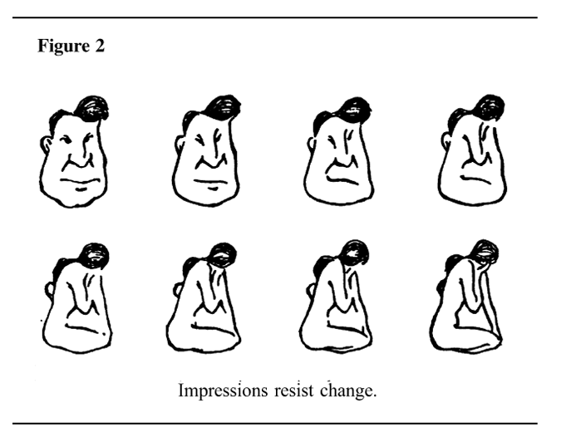
Figure 1: Example of Form Perception
- Clerical Perception
It is an ability to perceive pertinent detail in verbal or tabular material; to observe differences in copy, to proofread words and numbers, and to avoid perceptual errors in arithmetical computation.
- Language Learning Aptitude
It does not refer to whether or not an individual can or cannot learn a foreign language. It is assumed that virtually everybody can learn a language given adequate opportunity. According to John B. Carroll and Stanley Sapon, the authors of the Modern Language Aptitude Test, language learning aptitude does refer to the “prediction of how well, relative to other individuals, an individual can learn a foreign language in a given amount of time and under given conditions.” As with many measures of aptitude, language learning aptitude is thought to be relatively stable throughout an individual’s lifetime.
- Inductive Reasoning Aptitude
Inductive reasoning is a measurable aptitude for how well a person can identify a pattern within a large amount of data. Measurement is generally done in a timed test by showing four pictures or words and asking the test taker to identify which of the pictures or words does not belong in the set. The test taker is shown a large number of sets of various degrees of difficulty. The measurement is made by timing how many of these a person can properly identify in a set period of time.
Here is an example question: Find the set of letters that doesn’t belong with the other sets.
1. a) cdef b) mnpo c) hikj d) vwyx
- Spatial-temporal reasoning
Spatial-temporal reasoning is the ability to visualize spatial patterns and mentally manipulate them over a time-ordered sequence of spatial transformations. This ability, often referred to as "thinking in pictures", is important for generating and conceptualizing solutions to multi-step problems that arise in areas such as architecture, engineering, science, mathematics, art, games (e.g. chess), and everyday life.
- Abstract Reasoning
This measures how well you can reason when problems are shown in terms of size or shape or position or quality, or other geometric figures or shapes. It is important in courses and occupations requiring use of diagrams, such as drafting, mathematics, computer technology, and automobile repair.

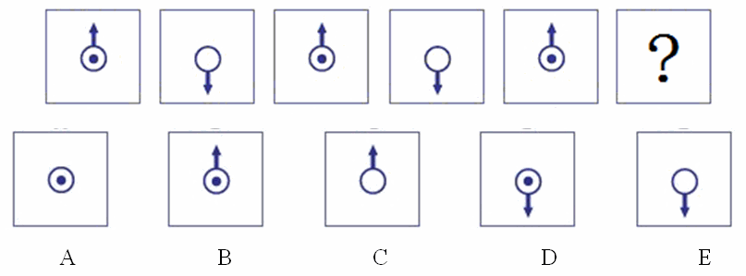
Figure 2: Example of Abstract reasoning
- Mechanical Reasoning
This measures your ability to understand mechanical principles and devices. People; who do well on this test usually like to find out how things work; they often are better than average at learning how to construct, operate, or repair complicated equipment. Some careers where this ability is important are carpentry, engineering, machine operations, electrical trades.
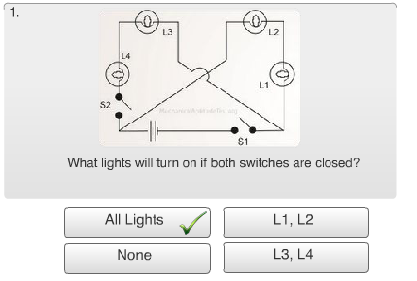
Figure 3: Example of Mechanical Reasoning
- Finger Dexterity
It is an ability to move the fingers and manipulate small objects with the fingers rapidly and/or accurately.
- Manual Dexterity
It is an ability to move the hands easily and skillfully; to work with the hands in placing and turning motions.
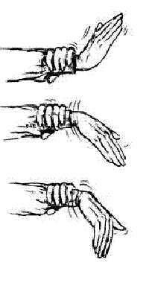
Figure 4: Manual Dexterity
Aptitude Batteries
Aptitudes are generally tested in the form of an Aptitude Battery which tests a large number of aptitudes at one time with a series of small tests for each aptitude. Aptitude batteries may lean more toward innate aptitudes or more toward learned skills. Batteries that lean toward learned skills are frequently called Aptitude Tests. An example that leans both ways is the Armed Services Vocational Aptitude Battery (ASVAB). Aptitude batteries that lean toward aptitudes are often useful in selecting a career
Measuring Aptitudes: The 48-minute aptitude battery consists of the following tests:
- Aptitude - Clerical Perception: 5 minutes, 240 questions
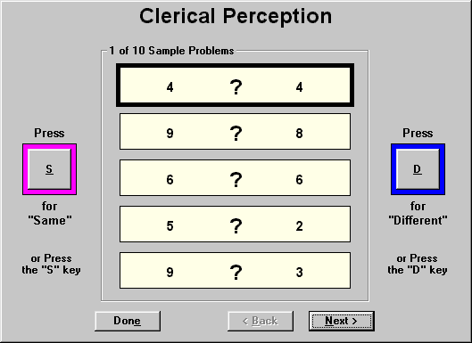

- Aptitude – Vocabulary: 5.5 minutes, 20 questions
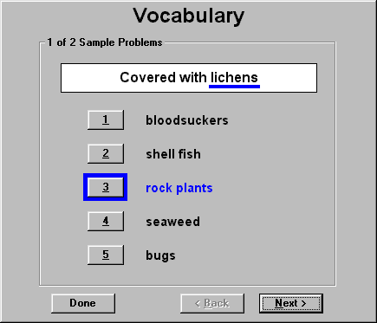
- Aptitude - Numerical Computation: 8.5 minutes, 10 questions
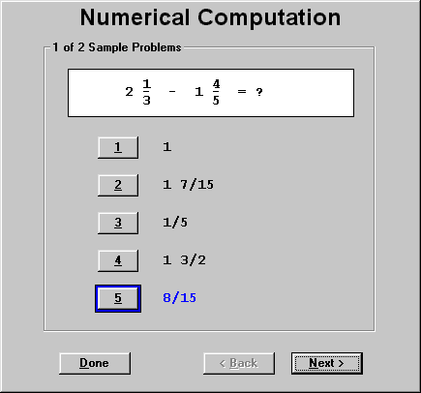
- Aptitude - Numerical Reasoning: 13 minutes, 12 questions
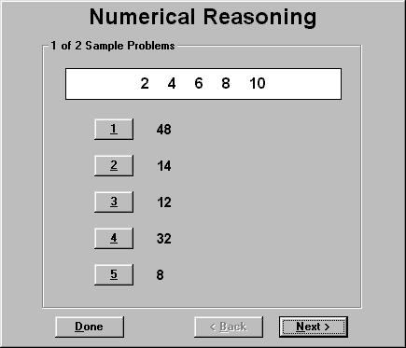
- Aptitude - Spatial Visualization: 7 minutes, 14 questions
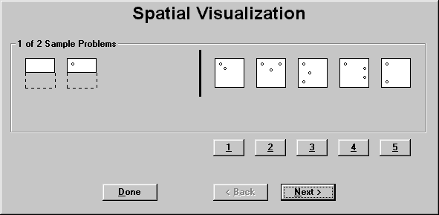
- Aptitude - Inductive Reasoning: 6.5 minutes, 15 questions
