Altruism
Lecture no: 18
Clinical Psychologist SadafSajjad
_____________________________________________________________________________
Why do people help?
Altruism: Rooted in the Latin word alter – meaning other. Altruism – means “living for others”. The key component of this behavior is selflessness – an unselfish regard for the welfare of others.
Altruism refers to an individual acting in a way that will decrease its own survival chances, but improve the survival chances of another individual. The Darwinian perspective emphasising ‘survival of the fittest’ gave the impression that selfishness was the norm. Pioneering work involving the study of animals living in social groups in fact revealed that co-operation and altruism are just as ‘natural’ as selfishness.
History of Altruism
The French philosopher named August Comte coined the word altruism in 1851 and it was added to the English dictionary two years later. However, all human kind has been demonstrating altruism since the world’s beginning. Altruism is studied today by psychologists, biologists, theologians, anthropologists, political scientists, economists, sociologists, mathematicians and more. Most societies acknowledge the importance of altruism in that it benefits a community as a whole. Societies also understand that it is imperative to cooperate with one another rather than strive on conflict. Thus, it helps avoid war and instead, instills peace.
Examples of Animal Altruism
Vampire bats will regurgitate and feed blood that they have collected from their prey to a hungry conspecific.
Ground squirrels will warn others of the presence of a predator, even though making such a call may draw the attention of the predator to itself
Three Characteristics of Altruistic Behavior
- Perceiving the need of another person
- Being motivated by empathy to help the other person
- Addressing the need by taking action without expecting a reward or recognition in return

Theories of Altruism
Psychologists believe there are two types of altruism:
- Biological altruism (with its roots in evolutionary psychology)
- Psychological altruism (based more on cognitive psychology)
Biological Altruism
It based on Instinct and Genes. Evolutionary Psychology is the attempt to explain social behavior in terms of genetic factors that evolved over time, according to the principles of natural selection. Darwin recognized that altruistic behavior posed a problem for his theory: if an organism acts altruistically, it may decrease its own reproductive fitness.
- Kin Selection Theory
Kin selection theory predicts that the extent of altruism depends on genetic relatedness. By helping relatives to reproduce (even at the cost to your own reproductive success) then your shared genes can spread. Assisting a close relative thereby increases one’s ‘Inclusive Fitness’. Using mathematical modelling, Hamilton showed that an altruistic gene can spread through the population if it causes an individual to help a relative, whenever the cost to the individual is offset by the reproductive benefit gained by the receiver. ‘Hamilton’s Rule’ = r B>c where r=coefficient of relatedness, B = benefit to the recipient, c = cost to the giver.
Example: In a house fire, who would you save first, your brother/sister or your neighbor?
Kin Selection in Humans
Food sharing is more common amongst close relatives. Political alliances between kin are more stable than those formed between distantly related, or unrelated individuals and involve less preconditions. The passing on of wealth to lineal descendants (excluding spouses) is far more common than giving to less closely related or unrelated individuals. Close relatives are preferentially sought out in times of need and such help is less likely to be reciprocal. Relatives typically receive more expensive presents. One reason we help people is that we assume it will make them more likely to help us in the future. This is so strong it may have become genetically based.
- Reciprocal Altruism Theory
It is proposed by Trivers (1971). Natural Selection may create psychological mechanisms designed to deliver benefits even to non-relatives, provided that such actions lead to reciprocal beneficial actions in the future. This is not necessarily limited to the same species e.g. cleaner fish. If the benefit received is larger than the cost incurred, then individuals who engage in such behaviour will out-reproduce those who do not. E.g, in vampire bats, an individual will share food with a conspecific (whether related or not) if the other has shared food with that individual in the past.
Conditions Under Which Reciprocation Flourishes
Individuals must associate for long-enough periods of time to develop reciprocal interactions. The likelihood of one individual performing some social exchange with another should be predicted on the basis of their past associations. The roles of giver and receiver should reverse at least once. The short-term benefits to the recipient are greater than the costs to the donor. Givers should be able to recognise and expel cheaters from the system.
Reciprocal Altruism: Prisoner’s Dilemma
Criminals A and B commit a crime together. They are caught by the police and are interviewed separately. They both know that without the testimony of the other, there is not enough evidence to imprison them for more than a year. However, they also know that if they collaborate with the police and blame the other one, the other would go to prison for 20 years, but they would go free.
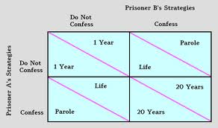
Prisoner’s Dilemma

Psychological Altruism
Where biological explanations of altruism can be seen in many animals, psychological explanations of altruism are witnessed only in higher-level mammals. While biological explanations of altruism occur almost automatically, psychological explanations of altruism arise as a result of cognition. That is, this type of altruism relies on the ‘helper’ understanding the situation. This kind of altruism is not innate.
- Negative-state relief model
When encountering a homeless person asking for money, we can either give them some money or walk away. Schaller and Cialdini (1988) proposed the negative-state relief model. Pro-social behavior results from egoism rather than altruism. We help others in order to relieve the stress we feel when encountering a bad situation. This model also explains why people walk away. Walking away also alleviates distress.
- Empathy-altruism model
Batson disagrees with the notion that we only help to relieve negative feelings. Batson et al (1981) suggests that people experience two kinds of emotion when they see suffering. According to Batson, if you feel empathy towards a person, you will help, regardless of what you may gain from it. Relieving suffering becomes the most important thing. If a person feels no empathy, then they would consider the costs and benefits before making the decision to help. The empathy-altruism hypothesis has been tested empirically many times, in order to distinguish it from egoist hypotheses (e.g. Schaller and Cialdini’s ‘negative-state relief’ model). It is, however, very difficult to determine from observed behavior, whether someone is acting out of empathy or to relieve distress.
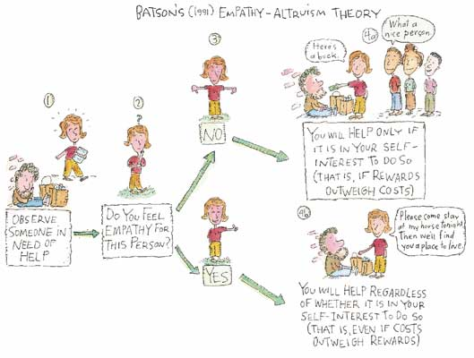
Empathy- altruism Model
Process of Helping

Factors that Influence Helping
Number of bystanders
How does a large crowd influence noticing an emergency, interpreting something as an emergency, and assuming responsibility? This leads to the bystander effect. Factors exist that reduce bystander effect.
  - Clear emergencies vs. ambiguous.
  - Cohesive groups vs. strangers.
Presence of Prosocial models.
Salvation Army contributions increase if person has just seen someone else give.
Time pressure
You are less likely to receive aid from someone in a hurry. They are less likely to notice an emergency and less likely to interpret a situation correctly.
Emotions
Guilt: Increases helping behavior. In one study, those who had not lied volunteered to help an experimenter for an average of 2 minutes, those who had lied helped for approximately 63 minutes! More likely to help if our guilt is public knowledge.
Negative mood: For adults, not children, a bad mood increases the likelihood of helping behavior. It appears that adults have learned that helping is a self-gratifying behavior. Exceptions to this tendency include feelings of anger and grief.
Positive mood: Happy people are helpful people. Parking ticket study: fear turning to relief increases helping behavior significantly.
Personality Traits
No one trait predicts altruism. However, There are individual differences in helpfulness over time. Network of traits (emotionality, empathy, self-efficacy) are linked to helping. High self-monitors help if they believe it will be socially rewarded (interaction of personality and situation). Men more likely to help in dangerous situations; women in safer situations.
How do we teach altruism?
Teach moral inclusion: If we are more likely to help those who are like us, expand that group.
Model altruism: Even television can be helpful here!
Attributing behavior to altruistic motives: Avoid over justification effect. That is, don’t coerce people into altruism, don’t reward them too much, etc.

