Conformity
Lecture No: 17
Clinical Psychologist Sadaf Sajjad
____________________________________________________________________________
What is Conformity?
Conformity is a type of social influence involving a change in belief or behavior in order to fit in with a group. This change is in response to real (involving the physical presence of others) or imagined (involving the pressure of social norms / expectations) group pressure.
- “Yielding to group pressures” (Crutchfield, 1955).
- Group pressure may take different forms, for example bullying, persuasion, teasing, criticism etc.
- Conformity is also known as majority influence (or group pressure).
- An agreement to the majority position, brought about either by a desire to ‘fit in’ or be liked (normative) or because of a desire to be correct (informational), or simply to conform to a social role (identification).
Solomon Asch Experiment

Solomon Asch (1952) perceptual judgment of line lengths: Which of 3 lines is closest in length to this line? In this type of experiment the consequences of non-conformity are unclear - there are no stated sanctions against non-conformity. An experiment to investigate the extent to which social pressure from a majority group could affect a person to conform. People conform for two main reasons: because they want to fit in with the group (normative influence) and because they believe the group is better informed than they are (informational influence).
Asch believed that the main problem with Sherif's (1935) conformity experiment was that there was no correct answer to the ambiguous auto kinetic experiment. How could we be sure that a person conformed when there was no correct answer? Asch (1951) devised what is now regarded as a classic experiment in social psychology, whereby there was an obvious answer to a line judgment task. If the participant gave an incorrect answer it would be clear that this was due to group pressure.
Aim: Solomon Asch (1951) conducted an experiment to investigate the extent to which social pressure from a majority group could affect a person to conform.

Procedure: Asch used a lab experiment to study conformity, whereby 123 male students from Swarthmore College in the USA participated in a ‘vision test’. Using the line judgment task, Asch put a naive participant in a room with four to six confederates. The confederates had agreed in advance what their responses would be when presented with the line task. The real participant did not know this and was led to believe that the other seven participants were also real participants like themselves. Each person in the room had to state aloud which comparison line (A, B or C) was most like the target line. The answer was always obvious. The real participant sat at the end of the row and gave his or her answer last. In some trials, the seven confederates gave the wrong answer. There were 18 trials in total and the confederates gave the wrong answer on 12 trails (called the critical trials). Asch was interested to see if the real participant would conform to the majority view.
What Predicts Conformity?
- Group cohesiveness - when group members are attracted to each other.
- Commitment to the initial judgment where there is no prior commitment.
- Self-aware people (private vs. public) when people are privately self-aware they are less likely to conform; social standards are more influential if the person is publicly self-aware.
- Self-presentation if one is trying to present himself as intelligent, he will be perceived as more intelligent if he does not conform.
- Need for individuation the desire to maintain one’s uniqueness.
- Desire for personal control - the theory of psychological reactance - people will react against attempts to control their behavioral freedom.
- Makeup of group exerting the pressure experts; members are important to the individual; members are comparable to the individual; feelings of insecurity in the relationship
- Rewards and punishments (normative pressure) wish to avoid punishment (rejection, ridicule, embarrassment); wish to gain acceptance or love
- Information (behavioral modeling) sometimes the behavior of others serves as a guide to how we should behave.
Forms of Conformity
- Compliance:
- Motivated by rewards and the avoidance of punishment.
- Lasts as long as the rewards last or as long as the threat lasts.
- Going along with the group behaviorally without being persuaded that the group is correct.
- Power is the major component.
The concept of compliance is similar to conformity, yet slightly different. For compliance to occur within groups, one must adapt his/her actions to another's wishes or rules. A person that conforms must have a disposition that allows him/her to yield to others. Requests for and acts of compliance occur in everyone's lives. Simply asking someone to perform a task is a request for compliance. The most effective method to gain compliance is through rational persuasion and inspiration. The central aspect of conformity is that the person being influenced by the group change his/her attitudes and/or beliefs while the main point of compliance is the achievement of some specified task.
- Identification
- Desire to be like the influencer.
- We adopt an opinion or a behavior because it puts us into a satisfying relationship with the influencer.
- The major component of this type of conformity is the attractiveness of the influencer.
- Internalization
- Most permanent, most deeply rooted response to social influence.
- The desire to be right is the motive.
- Once accepted the behavior or the opinion becomes a part of our belief system separate from the source.
- Credibility of the influencer is important (expert and trustworthy).
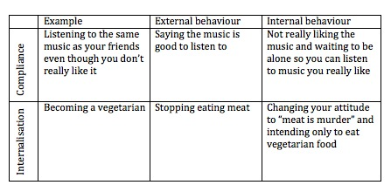
- Ingratiational Conformity
- Where a person conforms to impress or gain favor/acceptance from other people.
- It is similar to normative influence but is motivated by the need for social rewards rather than the threat of rejection, i.e., group pressure does not enter the decision to conform.
Types of Social Conformity
- Man (1969) states that “the essence of conformity is yielding to group pressure”. He identified three types of conformity: Normative, informational and ingratiational.
- Kelman (1958) distinguished between three different types of conformity: Compliance, Internalization and identification.
Comparison of the three:
- Compliance is the least enduring and has the least effect on the individual, because people comply merely to gain reward or to avoid punishment. Rewards and punishments are very important means to get people to learn and to perform specific activities but are limited as techniques of social influence because they must be ever present to be effective.
- Continuous reward or punishment is not necessary for identification. All that is needed is the individual's desire to be like that person. You will continue to hold beliefs similar to the SO as long as he remains important to you, he still holds the same beliefs, and those beliefs are not challenged by counter-opinions that are more convincing.
- Internalization is the most permanent response to social influence because your motivation to be right is a powerful and self-sustaining force.
- In compliance, the important component is power -the power of the influencer to dole out rewards and punishments. In identification, the crucial component is attractiveness - the attractiveness of the person with whom we identify.
- Any of the three can determine behavior. In the Asch studies, it seems obvious the subjects were complying with the unanimous opinion of the group in order to avoid the punishment of ridicule or rejection.
- Circumstances can increase the permanence of conformity produced by compliance or identification.
Informational influence

Informational social influence occurs when one turns to the members of one's group to obtain and accept accurate information about reality. Sometimes you may need to seek out experts, conform to the way others or a group are behaving, or look to some other source of information.One other way is to use informational social influence; you look to the behaviors of others who are also in the same or similar situation to see how they behave.
When Will People Conform to Informational Social Influence?
- When the Situation Is Ambiguous.
Ambiguity is the most crucial variable in determining whether people use each other as a source of information.
- When the Situation Is a Crisis.
Crisis situations leave us limited time to act, which may make us scared and panicky. If we turn to others who are also panicked for information, our own panic and irrationality may be intensified.
- When Other People Are Experts.
The more expertise or knowledge someone has, the more people will turn to them as a guide in an ambiguous situation. Unfortunately experts are not always reliable sources of information.
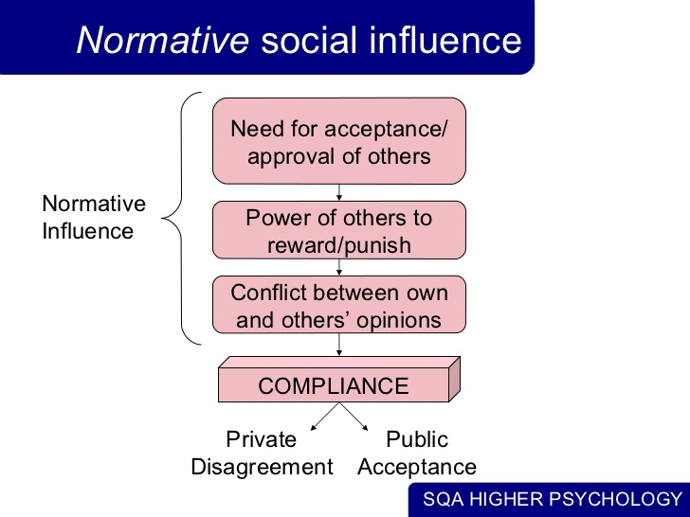
Normative influence
Normative social influence occurs when one conforms to be liked or accepted by the members of the group. This need of social approval and acceptance is part of our state of humans. In addition to this, we know that when people do not conform to their group and therefore are deviants, they are less liked and even punished by the group. Normative influence usually results in public compliance, doing or saying something without believing in it.
Mindless conformity
Using others as cues to behavior without thinking or dealing with the dilemma of perception/ thoughts and others’ perceptions and thoughts.
Sherif’s Study
Sherif (1935) made use of the autokinetic effect to perform a classic conformity study. If you look at a stationary light in an otherwise dark room the light will appear to move, because your eyes have no other reference point. Sherif found that a subject's reports of movement were highly influenced by other people's estimates.
Sherif conducted two versions of this experiment:
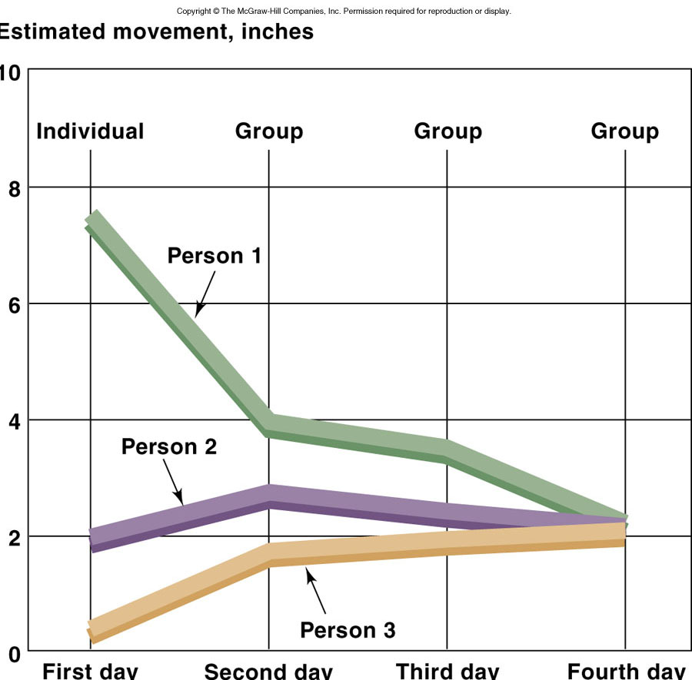Individuals were asked to estimate how far they thought the light moved, then tested them together in a group. Estimates in the group converged as they established a 'group norm'. This was close to the average of estimates they gave individually.
A group was asked to give estimates of how far they thought the light moved then they were asked to give individual estimates, these were very close to the group estimate.
Sherif claimed that he had shown conformity. The individuals were experiencing informational social influence.
Difference between Asch & Sherif studies
Asch (parallel lines)  Participants knew there was a correct answer  - Conformity does not lead to internalization | Sherif (moving light)  Subject didn’t know wasn’t correct answer  - Reasonable to consider other’s views  - Participants later adopted social norms  - Conformity leads to internalization

Obedience
Act of compliance to someone or a group or institution with power over us. Although acts of compliance may be impermanent this does not mean they are trivial.
Stanley Milgram: Obedience to Authority
Obedience is a form of social influence where an individual acts in response to a direct order from another individual, who is usually an authority figure. It is assumed that without such an order the person would not have acted in this way. Obedience occurs when you are told to do something (authority), whereas conformity happens through social pressure (the norms of the majority). Obedience involves a hierarchy of power / status. Therefore, the person giving the order has a higher status than the person receiving the order.
Milgram’s Study
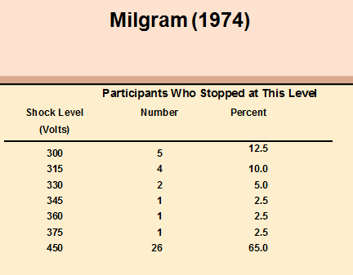
He assigned each of the subjects to the role of teacher. Each subject was told that his task was to help another subject like himself learn a list of word pairs. Each time the learner made a mistake, the teacher was to give the learner an electric shock by flipping a switch. The teacher was told to increase the shock level each time the learner made a mistake, until a dangerous shock level was reached.
Milgram (1963) wanted to investigate whether Germans were particularly obedient to authority figures as this was a common explanation for the Nazi killings in World War II.
Milgram selected participants for his experiment by advertising for male participants to take part in a study of learning at Yale University. The procedure was that the participant was paired with another person and they drew lots to find out who would be the ‘learner’ and who would be the ‘teacher’. The draw was fixed so that the participant was always the teacher, and the learner was one of Milgram’s confederates (pretending to be a real participant).
The learner (a confederate called Mr. Wallace) was taken into a room and had electrodes attached to his arms, and the teacher and researcher went into a room next door that contained an electric shock generator and a row of switches marked from 15 volts (Slight Shock) to 375 volts (Danger: Severe Shock) to 450 volts (XXX).
Factors cause people to carry obedience to extremes
- People justify their behavior by assigning responsibility to the authority rather than themselves.
- People define the behavior that’s expected of them as routine.
- People don’t want to be rude or offend the authority.
- People obey easy commands first and then feel compelled to obey more and more difficult commands. This process is called entrapment, and it illustrates the foot-in-the-door phenomenon.
Zimbardo experiment
Study on obedience was conducted at Stanford University during the 1970s. Phillip Zimbardo was the main psychologist responsible for the experiment. In the Stanford Prison Experiment, college age students were put into a pseudo prison environment in order to study the impacts of "social forces" on participant’s behavior. Unlike the Milgram study in which each participant underwent the same experimental conditions, here using random assignment half the participants were prison guards and the other half were prisoners. The experimental setting was made to physically resemble a prison while simultaneously inducing "a psychological state of imprisonment”. People will readily conform to the social roles they are expected to play, especially if the roles are as strongly stereotyped as those of the prison guards. The “prison” environment was an important factor in creating the guards’ brutal behavior (none of the participants who acted as guards showed sadistic tendencies before the study). Therefore, the roles that people play can shape their behavior and attitudes.
Experiment
Aim: To investigate how readily people would conform to the roles of guard and prisoner in a role-playing exercise that simulated prison life.
Procedure: Participants were randomly assigned to either the role of prisoner or guard in a simulated prison environment. The prison simulation was kept as “real life” as possible. Prisoners were arrested at their own homes, without warning, and taken to the local police station.

Guards were also issued a khaki uniform, together with whistles, handcuffs and dark glasses, to make eye contact with prisoners impossible. No physical violence was permitted. Zimbardo observed the behavior of the prisoners and guards. Here they were treated like every other criminal. They were fingerprinted, photographed and ‘booked’. Then they were blindfolded and driven to the psychology department of Stanford University, where Zimbardo had had the basement set out as a prison, with barred doors and windows, bare walls and small cells. Here the deindividuation process began. When the prisoners arrived at the prison they were stripped naked, deloused, had all their personal possessions removed and locked away, and were given prison clothes and bedding. They were issued a uniform, and referred to by their number only. Their clothes comprised a smock with their number written on it, but no underclothes. They also had a tight nylon cap, and a chain around one ankle. There were 3 guards to the 9 prisoners, taking shifts of eight hours each (the other guards remained on call).
Findings: Within a very short time both guards and prisoners were settling into their new roles, the guards adopting theirs quickly and easily. Within hours of beginning the experiment some guards began to harass prisoners. They behaved in a brutal and sadistic manner, apparently enjoying it. Other guards joined in, and other prisoners were also tormented.
Conformity in the Workplace
Conformity in the workplace refers to following workplace rules as well as adhering to traditional or socially expected methods of doing business and using familiar processes.
- Dress Code
- Regulations
- Employee Initiative
- Socially Expected Behavior
Non Conformity
Not everyone conform to social pressure. Indeed, there are many factors that contribute to an individual's desire to remain independent of the group. For example, Smith and Bond (1998) discovered cultural differences in conformity between western and eastern countries. People from western cultures (such as America and the UK) are more likely to be individualistic and don't want to be seen as being the same as everyone else.

