Industrial Psychology
Lecture No: 14
Clinical Psychologist Sadaf Sajjad
____________________________________________________________________________
Definition
The branch of applied psychology that is concerned with efficient management of an industrial labor force and especially with problems encountered by workers in a mechanized environment. Industrial psychology looks at behavior that occurs within the workplace. Also called industrial-organizational (I/O) psychology, people who work in this field might study worker personalities and performances, or the interactions between the individuals within a business or organization.
The Basics
The Society for Industrial and Organizational Psychology (SIOP) as "the scientific study of the workplace”. When employed to advise a company, the psychologist will draw on his or her knowledge about psychological areas and theories particularly important in the workplace. It is the study of employees, workplaces, and organizations. Industrial and organizational psychologists contribute to an organization's success by improving the workplace and the performance, satisfaction and well-being of its people.
It majors study psychology as it applies to the workplace: attitudes of employees and employers, organizational behavior, workplace environment and its effects, and much, much more. You’ll study such things as personality, cognition, perception, and human development. You’ll learn about the biological side of behavior (which means you’ll also really know what chemicals aren’t at proper levels in a person with a chemical imbalance). You might be given the option to take relevant business courses, such as management, since you will focus on organizational settings.
Importance of Industrial Psychology
- It looks about the biological side of behavior (which means it really discovers what chemicals aren't at proper levels in a person with a chemical imbalance).
- Psychology plays major role in improving human relations and also in solving industrial dispute.
- Psychology also helps in explaining difference in individuals relating to interests, aptitudes, specialties, intelligence etc.
- Psychological also helps an individual in dealing with particular conditions or environment while working and so helps in better adjustment and so relief of tension. Psychology also helps in personal adjustment for prevailing environment.

History of Industrial Psychology
Industrial Psychology is almost as old as Psychology itself. Psychology came about in 1879 in the laboratory of Wilhelm Wundt in Germany and William James at Harvard. Both of them were philosophers and physicians fascinated with the mind-body debate. The older discipline of philosophy could not alone deal with this debate, more room and new tools were needed, giving way to Psychology. Texts applying psychology to business first appeared in 1903; the first Industrial-Organizational (I/O) psychology text appeared in 1910 (Landy, 1997). It is believed that four men developed the ‘tone’ and ‘structure’ of I/O psychology: Hugo Munsterberg, James Cattell, Walter Dill Scott, and Walter Bingham (Landy, 1997).
It was primarily an outgrowth of the Industrial Revolution. When factories and assembly lines began coming into existence, the people who ran the factories wanted to try to get as much money as possible out of their workers.
The older discipline of philosophy could not alone deal with this debate, more room and new tools were needed, giving way to Psychology. Texts applying psychology to business first appeared in 1903; the first Industrial-Organizational (I/O) psychology text appeared in 1910 (Landy, 1997).
Scope of Industrial Psychology
Industrial psychology was eventually renamed "industrial and organizational psychology." Traditional industrial psychology deals with the entry and movement of employees within organizations, while organizational psychology studies individual and group dynamics that affect workplaces. As of 2012, the field of industrial and organizational psychology covers a huge range of workplace issues, including employee recruitment, hiring, training and retention, as well as workplace diversity, reducing absenteeism, eliminating harassment and discrimination, encouraging teamwork, and increasing worker motivation.
- Personnel Selection: Selection of employees, executives. Developing instruments of personnel selection.
- Personnel Development: Developing means of appraisal of performance for all, measurement of attitudes, employee counseling for better adjustment with the environment.
- Human Engineering: Suggesting changes, innovations in machines/ technology / operations/equipment for greater ease in operation in least possible human energy.
- Productivity Study: Activities of lessening worker fatigue, improving work environmental conditions, light, ventilation, work arrangements etc to maximize efficiency.
- Management: Activities involving development of managerial skills.
- Accident Prevention and Safety Measures
- Labor Relations

Work Behavior
The psychology of work behavior is one form of industrial psychology. Attitudes of employees as related to their performance is a main theme. Variables in employee personalities and abilities are listed and situational and background differences are studied. The industrial psychologist also studies human mental and physical abilities, administering tests and assessing values and establishing job-related criteria. Human-error factors also are monitored, as are costs and causes of accidents.
It is essential that all employees accept personal responsibility for maintaining high standards of conduct and job performance, including observance of WPI rules and policies. Violations of these standards will result in disciplinary action. Disciplinary action is considered a dimension of performance evaluation. It is a corrective process to help employees overcome work-related shortcomings, strengthen work performance and achieve success.
Management
Many management skills fall under the umbrella of industrial psychology. Managers must be educated concerning the area of employee supervision. Expertise in perception and assessment is required in order to make proper decisions as to whether to promote or admonish. Determination of training needs and abilities to resolve conflict are skills that managers would learn in their study of industrial psychology. Motivational tactics are imperative to the success of industry, thus the industrial psychologist also may devise financial or other incentives.
An industrial psychologist works in a business or corporate setting. They primarily deal with organizations and their employees, potential employees, and their existing personnel. He often helps employees with career planning and development, and conducts management assessments and employee attitude surveys. You may work for the company or may be hired as a consultant for a company. Your goal as an industrial psychologist is to improve productivity.
Workplace Interactions
Industrial psychology often focuses on worker interaction and satisfaction. Employees who work together well and are happy in their jobs can significantly strengthen a business or organization.Common workplace issues might include disruptive employee behavior, lack of teamwork, or personality clashes between employees.
- Take the point of view of others. Science has shown us that mirror neurons work to create empathy among individuals. By taking the point of view of the people we work with we can better understand their motivations.
- Value the many sources of knowledge that exist. Sometimes we tend to think that our view is the correct one, because it’s all we know. But there are many sources of knowledge that exist within the workplace and all we have to do is take the time to explore them. Learn about that new co-worker or have lunch with someone in another department.
- Look for places to agree, connect or support. When we interact with others in the workplace, it’s easier to conquer our differences by finding ways to connect first. Does that co-worker with the different political beliefs also value family as much as you? This allows you to create a connection with the person based on commonality.
- Acknowledge that I don’t have to be right all the time. Often when we assume we are right, we reduce the amount of new information that we take in, because obviously we know it all already! A better approach would be to accept that you may not be right all the time and allow yourself to learn from your co-workers’ differences.
- Act in ways that edify the self-esteem of others. Discussions of difference or diversity in the workplace can sometimes get ugly with people hurling personal insults at one another. Instead, try to boost the self-esteem of others when discussing such hotly contested topics. Building self-esteem is a major step toward creating a respectful workplace
Motivation
Motivation is an area of psychology that has gotten a great deal of attention, especially in the recent years.Motivated employees are happy, productive and loyal, and that's what companies want. Motivation at work can be used as a basis for creating practices, procedures and processes to affect employee motivation.
Motivation in the workplace is obviously very important. Creating a motivating environment in your workplace produces happy employees; therefore low staff turnover and absenteeism, enhanced productivity, satisfied customers and better financial performance.
- Take time to communicate the importance of the role and importance of each employee contribution in the achievement of the goals of your organization.
- Clearly indicate job expectations.
- In a clearly defined organizational structure, each employee know how they relate to each other and who the person to whom they report to and they go to for solving problems they cannot handle on their own.
- Employees are better motivated when they are given opportunities to learn to do more and more complex tasks, which help build their self-esteem and enable them to climb the social ladder.
- A healthy working relationship with others is brought about by perceived fairness in tasks distribution-load and complexity-and remuneration/benefits. Perceived fairness in the exercise of rewarding and punishing is another important factor in bringing motivation in the workplace.
- The perception of good ethos and values in the treatment of your employees and the practices of business.
Theories
- Expectancy Theory
The Expectancy theory states that employee’s motivation is an outcome of how much an individual wants a reward (Valence), the assessment that the likelihood that the effort will lead to expected performance (Expectancy) and the belief that the performance will lead to reward (Instrumentality). In short, Valence is the significance associated by an individual about the expected outcome. It is an expected and not the actual satisfaction that an employee expects to receive after achieving the goals.

Instrumentality is a personality trait associated with the ability to be focused in a competitive way, objective and to make decisions easily. The instrumentality is the belief that if one does meet performance expectations, he or she will receive a greater reward. This reward may come in the form of a pay increase, promotion, recognition or sense of accomplishment. It is important to note that when it is perceived that valued rewards follow all levels of performance, then instrumentality is low. For example, if a professor is known to give everyone in the class an "A" regardless of performance level, then instrumentality is low.
The valance refers the value the individual personally places on the rewards. This is a function of his or her needs, goals, values and Sources of Motivation.

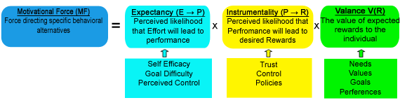
- Goal Settings Theory
Goal-setting theory refers to the effects of setting goals on subsequent performance.
Researcher Edwin Locke found that individuals who set specific, difficult goals performed better than those who set general, easy goals. Locke proposed five basic principles of goal-setting: clarity, challenge, commitment, feedback, and task complexity.One of the most effective ways to stay motivated is to set goals for yourself. However, the type and quality of goals you set affects how well they will work.
Goal setting involves establishing specific, measurable, achievable, realistic and time-targeted (S.M.A.R.T ) goals. Work on the theory of goal-setting suggests that an effective tool for making progress is to ensure that participants in a group with a common goal are clearly aware of what is expected from them.[citation needed] On a personal level, setting goals helps people work towards their own objectives—most commonly with financial or career-based goals.[citation needed] Goal setting features as a major component of personal development literature.Goal mechanisms affect performance by increasing motivation to reach set goals (Latham, 2004). These mechanisms are inputs that affect behavior in groups or individuals, which serve to increase attention to a goal, energy in pursuing a goal, persistence in achieving a goal, and ability to strategize to reach a goal. When an individual or team can focus attention on behaviors that will accomplish a goal, they also divert attention away from behaviors that will not achieve the goal.
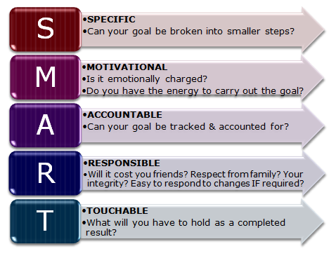
Effective goal-setting principles
- Clarity: A clear, measurable goal is more achievable than one that is poorly defined. In other words, be specific! The most effective goals have a specific timeline for completion.
- Challenge: The goal must have a decent level of difficulty in order to motivate you to strive toward the goal.
- Commitment: Put deliberate effort into meeting this goal. Share your goal with someone else in order to increase your accountability to meet that goal.
- Feedback: Set up a method to receive information on your progress toward a goal. If losing 30 pounds in four months turns out to be too hard, it is better to adjust the difficulty of your goal mid-way through the timeline than to give up entirely.
- Task complexity: If a goal is especially complex, make sure you give yourself enough time to overcome the learning curve involved in completing the task. In other words, if a goal is really tough, make sure you give yourself some padding to give you the best chance at succeeding.

- Equity theory
Equity theory is a theory that attempts to explain relational satisfaction in terms of perceptions of fair/unfair distributions of resources within interpersonal relationships.
The core of the equity theory is the principle of balance or equity. As per this motivation theory, an individual’s motivation level is correlated to his perception of equity, fairness and justice practiced by the management. Higher is individual’s perception of fairness, greater is the motivation level and vice versa.
People are happiest in relationships where the give and take are about equal. If one person is getting too little from the relationship, then not only are they going to be unhappy with this—the person getting the lion’s share will also be feeling rather guilty about this imbalance. This is reinforced by strong social norms about fairness.
In short-term relationships we tend to trade in things, such as loaning small sums or buying beers. In longer-term relationships the trade is more emotional.
Overall, though, it is still better to be getting more than less—although you could feel better about the relationship, the benefits you get from it can buy you compensatory happiness elsewhere.
Adams' Equity Theory calls for a fair balance to be struck between an employee's inputs (hard work, skill level, tolerance, enthusiasm, and so on) and an employee's outputs (salary, benefits, intangibles such as recognition,and so on). According to the theory, finding this fair balance serves to ensure a strong and productive relationship is achieved with the employee, with the overall result being contented, motivated employees.Equity, and thereby the motivational situation we might seek to assess using the model, is not dependent on the extent to which a person believes reward exceeds effort, nor even necessarily on the belief that reward exceeds effort at all. Rather, Equity, and the sense of fairness which commonly underpins motivation, is dependent on the comparison a person makes between his or here reward/investment ratio with the ratio enjoyed (or suffered) by others considered to be in a similar situation.
Equity Theory is also called Inequity Theory as it is the unequal difference that is often the area of interest.
Industries and Organizations
Psychology of Workplace
Positive psychology in the workplace is about shifting attention away from negative aspects such as work violence, stress, burnout, and job insecurity. Positive psychology can help create a working environment goal of promoting positive affect in its employees.Employers who understand the link between employee well-being and organizational performance strived to maintain a work environment characterized by openness, fairness, trust, and respect, even when difficult actions were required.
These employers are positioned for success in the economic recovery and will have a distinct competitive advantage in their ability to attract and retain the very best employees.
- Employee Involvement
Efforts to increase employee involvement empower workers, involve them in decision-making and give them increased job autonomy. Employee involvement programs can increase job satisfaction, employee morale, and commitment to the organization as well as increase productivity, reduce turnover and absenteeism and enhance the quality of products and services.
- Work-Life Balance
Programs and policies that facilitate work-life balance generally fall into two categories: flexible work arrangements and resources to help employees manage their non-work demands. Conflict between work and other life responsibilities can diminish the quality of both work and home life for employees, which in turn can affect organizational outcomes such as productivity, absenteeism and turnover. Efforts to help employees improve work-life balance can improve morale, increase job satisfaction and strengthen employees’ commitment to the organization.
- Employee Recognition
Employee recognition efforts reward employees both individually and collectively for their contributions to the organization. Recognition can take various forms: formal and informal, monetary and non-monetary. By acknowledging employee efforts and making them feel valued and appreciated, organizations can increase employee satisfaction, morale and self-esteem. Additionally, the organization itself may benefit from greater employee engagement and productivity, lower turnover and the ability to attract and retain top-quality employees.
- Human resources
Human resources is the set of individuals who make up the workforce of an organization, business sector or an economy. "Human capital" is sometimes used synonymously with human resources, although human capital typically refers to a more narrow view; i.e., the knowledge the individuals embody and can contribute to an organization.
Prison Psychology
Prison psychology relates to the application of psychology within a correctional setting.
Writing in his article "Ethical Concerns Within the Practice of Correctional Psychology", Michael Decaire notes that "The correctional psychologist’s primary mission is to assist in offender rehabilitation and reintegration. The psychologist enhances staff and inmate safety by promoting a healthy institutional environment."
Psychology in Schools
Treatment of children's and adolescents' behavioral and learning problems, to teachers, politicians and other responsible persons in the institutionalized education systems with pedagogic, didactic or systemic-organizational problems, sometimes also integrating parents of school children to find common solutions.
Job Satisfaction
Job satisfaction is how content an individual is with his or her job. Scholars and human resource professionals generally make a distinction between affective job satisfaction and cognitive job satisfaction. Affective job satisfaction is the extent of pleasurable emotional feelings individuals have about their jobs overall, and is different to cognitive job satisfaction which is the extent of individuals’ satisfaction with particular facets of their jobs, such as pay, pension arrangements, working hours, and numerous other aspects of their jobs.
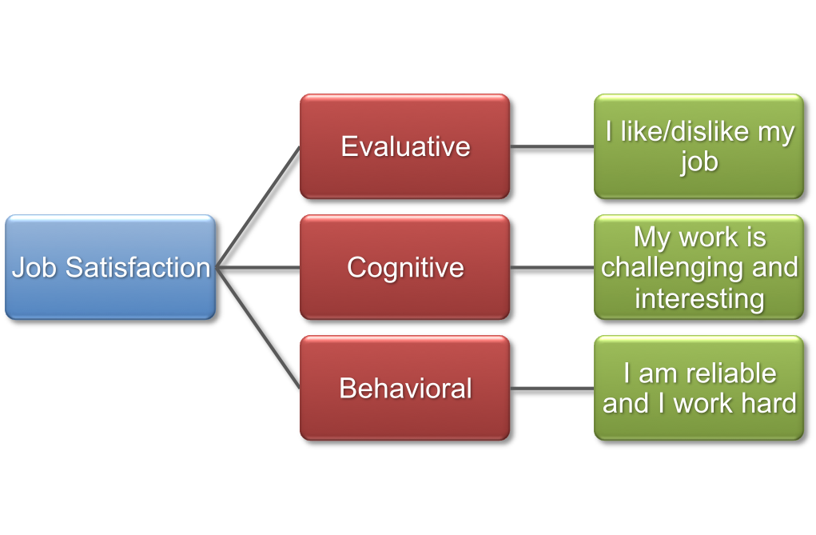
Influence on Employees
- Psychology of industry also play role in promotions by considers various parameters of an individual that affects his behaviour and so capability.
- Helps an individual in dealing with particular conditions or environment while working and so helps in better adjustment and so relief of tension.
- Helping to give businesses and organizations a more efficient structure.
- Primitive and sometimes deadly attacks on the strikers would usually just increase the workers' resolve to struggle.
- Industrial Psychology makes workers interchangeable and therefore expendable, as a problematic worker may easily be replaced with a more docile one.
Muchinsky’s key areas of I/O Psychology
According to Muchinsky (2000), most industrial organizational psychologists work in one of six major subject areas:
- Training and development: Professional in this area often determine what type of skills are necessary to perform specific jobs as well as develop and evaluate employee training programs.
- Employee Selection: This area involves developing employee selection assessments, such as screening tests to determine if job applicants are qualified for a particular position.
- Ergonomics: The field of ergonomics involves designing procedures and equipment designed to maximize performance and minimize injury.
- Performance Management: I/O psychologists who work in this area develop assessments and techniques to determine if employees are doing their jobs well.
- Work Life: This area focuses on improving employee satisfaction and maximizing the productivity of the workforce. I/O psychologists in this area might work to find ways to make jobs more rewarding or design programs that improve the quality of life in the workplace.
- Organizational Development: I/O psychologists who work in this area help improve organizations, often through increasing profits, redesigning products, and improving the organizational structure.

