Cognitive Processes
Lecture: 10
Clinical Psychologist Sadaf Sajjad
____________________________________________________________________________
Cognition
Group of mental processes that includes attention, memory, producing and understanding language, learning, reasoning, problem solving, and decision making.
The collection of mental processes and activities used in perceiving, thinking and understanding, as well as the act of using these processes.Cognition literally means “to know”. Knowledge can be thought of as memories formed from the manipulation and assimilation of raw input, perceived via our senses of sight, hearing, taste, touch and smell.Using knowledge to direct and adapt action towards goals is the foundation of the cognitive process. Past experiences and trends inform our sense of what the future might hold and help us to act accordingly.The words perception, attention, memory and executive function are one way of divvying up the processes involved in how we think.
Psychology and Cognition
- There is a relationship between how people think about themselves and how they behave. (Carol Dweck’s Mindset)
- Fixed ideas about other people – Stereotyping
- The term "cognition" is also used in a wider sense to mean the act of knowing or knowledge, and may be interpreted in a social or cultural sense to describe the emergent development of knowledge and concepts within a group that culminate in both thought and action.
Approach to human behavior that focuses on how we think, with the belief that such thought processes affect the way in which we behave (other approaches take other factors into account, such as the biological approach, which acknowledges the influences of genetics and chemical imbalances on our behavior).Cognitive (meaning "knowing") psychologists attempt to create rules and explanations of human behavior and eventually generalize them to everyone's behavior. The Humanist approach opposes this, taking into account individual differences that make us each behave differently. The cognitive approach attempts to apply a scientific approach to human behavior, which is reductionist in that it doesn't necessarily take into account such differences.
Cognitive categories
- Processing Speed
This is the speed at which your brain processes information. Faster processing speed means more efficient thinking and learning. Processing speed declines consistently across the adult lifespan, thus compromising higher cognitive performance. It is possible that by challenging your cognitive abilities and pushing the limits of your processing speed, you may allay these age-related changes.
- Auditory Processing
This is the ability to analyze, blend and segment sounds. It's also known as phonemic awareness. Auditory processing is crucial not just for speaking, but also for reading and spelling. This is because when you read, you need to be able to identify the individual and blended sounds that make each word unique and recognizable.
- Visual Processing
This is the ability to perceive, analyze and think in visual images. Visual processing is imperative for reading, remembering, walking, driving, and playing sports and literally thousands of other tasks you do every day. Visual perception is an ongoing process involving selecting, grouping, and interpreting visual information.
- Logic and Reasoning
This is the ability to reason, form concepts, and solve problems using unfamiliar information or new procedures. It enables you to create correlations, solve problems, plan ahead and draw conclusions. Deductive reasoning determines whether the truth of a conclusion can be determined for that rule, based solely on the truth of the premises. Inductive reasoning attempts to support a determination of the rule.
- Attention Skills
There are three types of attention skills. Sustained Attentionis the ability to stay focused and on-task for a period of time. Selective Attention is the ability to quickly sort through incoming information and stay focused on one thing in spite of distractions. Divided Attention is the ability to multi-task.
- Memory
Memory is the process by which information is encoded, stored, and retrieved. Encoding allows information that is from the outside world to reach our senses in the forms of chemical and physical stimuli. In this first stage we must change the information so that we may put the memory into the encoding process. Storage is the second memory stage or process. This entails that we maintain information over periods of time. Finally the third process is the retrieval of information that we have stored. We must locate it and return it to our consciousness. Some retrieval attempts may be effortless due to the type of information.
There are three major processes involved in memory: encoding, storage and retrieval. In order to form new memories, information must be changed into a usable form, which occurs through the process known as encoding. Once information has been successfully encoded, it must be stored in memory for later use. Much of this stored memory lies outside of our awareness most of the time, except when we actually need to use it. The retrieval process allows us to bring stored memories into conscious awareness.

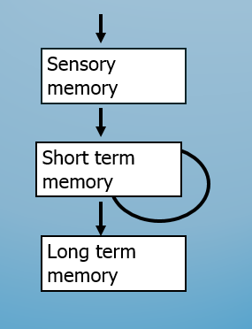
- Memory Model
Three memory stores
- sensory memory
- input buffer
- visual or acoustic
Short term memory
- ‘scratchpad’ store
- visual or acoustic
Long term memory
- stores facts and meanings
- semantically organized

- Short-Term Memory
Short-term memory, also known as primary or active memory, is the information we are currently aware of or thinking about. In Freudian psychology, this memory would be referred to as the conscious mind. The information found in short term memory comes from paying attention to sensory memories.Most of the information kept in short-term memory will be stored for approximately 20 to 30 seconds, but it can be just seconds if rehearsal or active maintenance of the information is prevented.
This skill handles the dynamic job of keeping at the forefront of your mind the information you need to complete immediate and short-term tasks. In short-term/working memory, we encode information from the sensory registers for transfer into long-term memory.
Example
212348278493202 (difficult)
0121 414 2626 (easy)
Short-term characteristics
Short-term/ working memory characteristics, important for the design of human-to-system interfaces as well as training/learning programs, are:
Capacity - Very limited and in some models considered a "bottleneck" in human information processing. The classic work of Miller (1956) determined the number of units that can be processed at any one time as 7 + 2. Subsequent studies have indicated that 5 + 2 may apply to most of the items we wish to remember.
Duration - About 15 to 30 seconds, however, it can be indefinite if one continues to concentrate on, attend to, and rehearse the information in its store.
- Long-Term Memory
This is the "library" of facts and knowledge you have accumulated in the past. Its size is considered to be infinite for practical purposes. In other words, we will not run out of memory in our lifetimes. Long-term memory has a relatively slow access time of 100 milliseconds.
Long-term memory refers to the continuing storage of information. In Freudian psychology, long-term memory would be call the preconscious and unconscious. This information is largely outside of our awareness, but can be called into working memory to be used when needed. Some of this information is fairly easy to recall, while other memories are much more difficult to access.Through the process of association and rehearsal, the content of short-term memory can become long-term memory. While long-term memory is also susceptible to the forgetting process, long-term memories can last for a matter of days to as long as many decades.
Long-Term Memory Characteristics
Declarative or Explicit Knowledge - Static knowledge about things in the world such as facts and experiences that we can recall under conscious control.
Semantic Memory - This is information that has lost its time reference. That is, we know the information, facts, and concepts, but we cannot remember where or when the information was acquired. This is our generic knowledge of the world.
Episodic Memory - These memories are associated with a specific time or episode in our life and is in serial form. These are specific incidents from our past that we can "relive" by remembering incidental details of an event.
Some of this information is fairly easy to recall, while other memories are much more difficult to access. Through the process of association and rehearsal, the content of short-term memory can become long-term memory. While long-term memory is also susceptible to the forgetting process, long-term memories can last for a matter of days to as long as many decades.
- Comparison of Short- & Long Term Memory
Short Term Memory | Long Term Memory
- Very fast input  - Limited capacity  - 5 – 20 seconds duration  - Contains words, images, ideas, sentences  - Immediate retrieval | - Relatively slow input  - Practically unlimited capacity  - Practically unlimited duration  - Contains networks, schemata  - Retrieval depends on connections

- Memory Retrieval
Long-term memory (LTM) includes both recent information, which can be fragile, and information that has been consolidated and in store for some time. The process of consolidation is thought to take place in the hippocampus which creates the memory traces and transfers the memories to other parts of the cerebral cortex for long-term store.
Recognition - Recognition is the identification of items based on prior learning and LTM storage. It can be thought of as a "pattern" match of the item (or person) with a pattern in memory. We are much better at recognition than recall.
Recall - Recall is more difficult than recognition because the item (or person) must first be recognized and then specific, associated information found and retrieved from long-term memory. Recall is more like a fill-in-the-blank test.
- Memories & the Self
In one sense, we have our memories. If we had no long-term memory, we would be locked in a world of immediate sensory experience with no means by which to interpret our environment or determine our actions within it. Our learning, encoded in memory, determines our belief systems, influences our perceptions, and defines "the self." Cognition, learning, and memory are inexorably linked.
Language in Cognition
Language accumulates cultural wisdom; cognition develops mental representations modeling surrounding world and adapts cultural knowledge to concrete circumstances of life. Language is acquired from surrounding language “ready-made” and therefore can be acquired early in life. This early acquisition of language in childhood encompasses the entire hierarchy from sounds to words, to phrases, and to highest concepts existing in culture. Cognition is developed from experience. Language and cognition use similar mechanisms. It is embodied and situated in the environment.
Language structure and processing within cognitive psychology
Phonemes - phonetics which is the study how speech sounds are produced. These phonemes such as an a that can be used in different ways like using the word back and baby. Each word is said differently but the a does double duty in this case. This is not the only letter in the alphabet that does this double duty.
Words - are the phonemes that fit together to produce the some 600,000 words in the English language. While much of the English language may make sense to us here in the United States; this same idea in foreign languages such as bdat is not allowed in the United States but used elsewhere in the world.
Sentences-are the grammatical arrangements of words that help us construct thoughts when trying to speak or write.
Text- is when one uses a group of related sentences to form a paragraph that explains a subject.
Visual Cognition
Visual cognition covers many aspects such as face, scene and object recognition, visual attention and search, visual word recognition and reading, eye movement control and active vision, short-term and long-term visual memory and visual imagery. Cognition refers to the way an individual acquires and processes information and those who veer toward a visual cognitive style prefer to process visual information rather than, for example, acoustic or verbal information. There are several strategies one can use when processing visual information.Visual cognition refers to the way the brain responds to visual stimuli; in other words, the subjective process where the seeing becomes, through an objective process, an object, word or memory.
Visual cognition can be conveniently divided into two subtopics.
The first is the representation of information concerning the visual world currently. Before a person. When we behave in certain ways or change our knowledge about the world in response to visual input, what guides our behavior or thought is rarely some simple physical property of the input such as overall brightness or contrast. The second subtopic is the process of remembering or reasoning about shapes or 9bjects that are not currently before us but must be retrieved from memory or constructed from a description. This is usually associated with the topic of 'visual imagery’.
Problem Solving
Problem-solving is a mental process that involves discovering, analyzing and solving problems. The ultimate goal of problem-solving is to overcome obstacles and find a solution that best resolves the issue. The best strategy for solving a problem depends largely on the unique situation. In some cases, people are better off learning everything they can about the issue and then using factual knowledge to come up with a solution. In other instances, creativity and insight are the best options.
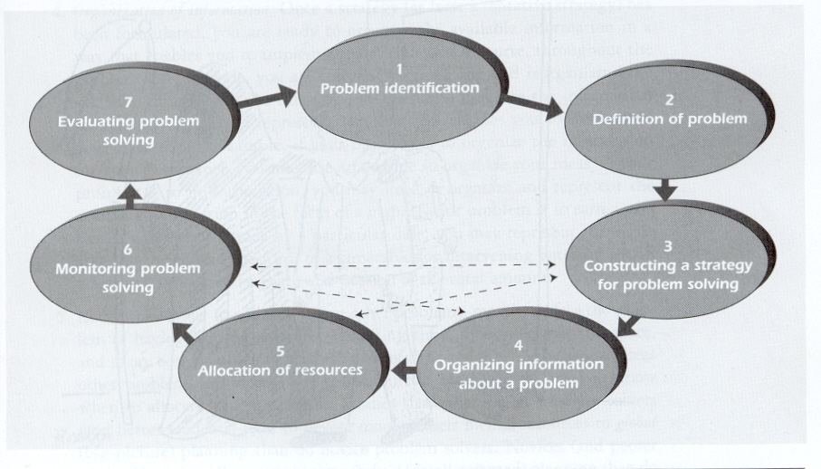
- The behaviorist approach
Behaviorist researchers argued that problem solving was a reproductive process; that is, organisms faced with a problem applied behavior that had been successful on a previous occasion.
Successful behavior was itself believed to have been arrived at through a process of trial-and-error.Behaviorism is primarily concerned with observable behavior, as opposed to internal events like thinking and emotion. Observable (i.e. external) behavior can be objectively and scientifically measured. Internal events, such as thinking should be explained through behavioral terms (or eliminated altogether).The influence of the behaviorist approach, with its emphasis on the manipulation of behavior through patterns of reinforcement and punishment, can be seen in many practical situations. Below is a brief account of how the behaviorist approach has been applied in psychotherapy.
Therapeutic techniques based on conditioning processes are usually referred to as either behavior modification or behavior therapy. Techniques based on operant conditioning are usually referred to as behavior modification and techniques which rely upon the principles of classical conditioning are usually known as behavior therapy.
- Al behavior is learnt from experience
- All behavior occurs via learning from experiences of the environment
- The theory of classical conditioning assumes that we learn by association
- The theory of operant conditioning assumes that the law of effect explains why if behavior is reinforced i.e. rewarded it will be repeated
- General laws derived from the animal experiments can be extrapolated and applied to humans
- The scientific experimental method is the most appropriate method for studying behavior
- We are born with ‘clean slates’ and learning is not instinctive
- Cognitive mental processes cannot be observed or measure, so it is assumed they are not relevant to the scientific study of human behavior
- Unconscious mental processes are no relevant to the study of human behavior.

- The Gestalt approach
Gestalt psychologists argued that problem solving was a productive process. In particular, in the process of thinking about a problem individuals sometimes "restructured" their representation of the problem, leading to a flash of insight that enabled them to reach a solution.
The Gestalt psychologists described several aspects of thought that acted as barriers to successful problem solving. One of these was called the Einstellung effect, now more commonly referred to as mental set or entrenchment. This occurs when a problem solver becomes fixated on applying a strategy that has previously worked, but is less helpful for the current problem.
The Gestalt psychologists described several aspects of thought that acted as barriers to successful problem solving. One of these was called the Einstellung effect, now more commonly referred to as mental set or entrenchment. This occurs when a problem solver becomes fixated on applying a strategy that has previously worked, but is less helpful for the current problem.
- The cognitive approach to problem solving
Problem space theory
In this theory, people solve problems by searching in a problem space. The problem space consists of the initial (current) state, the goal state, and all possible states in between. The actions that people take in order to move from one state to another are known as operators.
- Solving a problem involves negotiating alternative paths to a solution
- Initial state is linked to goal state by a path
- Knowledge states are produced by the application of mental operators
- Algorithms vs. heuristics are used to move along the path
- Limited processing resources provide constraints on the degree to which multiple moves can be considered.
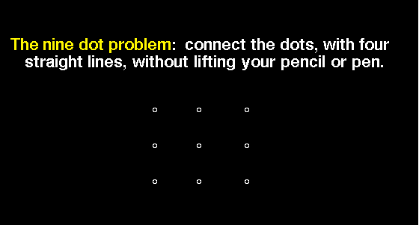
Reasoning
The set of mental processes used to derive inferences or conclusions from premises. Reasoning helps to generate new knowledge and to organize existing knowledge, rendering it more usable for future mental work. Reasoning is therefore central to many forms of thought such as scientific, critical, and creative thinking, argumentation, problem solving, and decision making.
- Inductive reasoning
Inductive reasoning is implicative; it generates new knowledge. Inductive reasoning supports inferences but does not guarantee that the inferences are true.There are many forms of inductive reasoning such as enumerative induction and analogical reasoning. The best known form is enumerative induction in which the general properties of a class are inferred from a specific set of empirical observations. For example, upon observing that all the birds in the neighborhood have wings and fly, a person infers that all birds have wings and fly.
When a child uses inductive thinking or reasoning, he or she engages in the evaluation and comparison of facts to reach a conclusion. Inductive reasoning progresses from observations of individual cases to the development of a generality.
Inductive reasoning would work in the opposite order. The specific observation would be that a particular wasp has a stinger. One could then induce that all wasps have stingers. Inducing that all cats have orange fur because one cat has orange fur, for example, could be easily disproved by observing cats that do not have orange fur.
- Deductive Reasoning
Deduction refers to processes of inference which guarantee logically valid conclusions from a set of premises. In other words, assuming that the premises are correct, the conclusions deduced from these premises must also be correct.Deduction also plays an important role in categorical reasoning. One of the main cognitive functions of deductive reasoning is to organize knowledge in ways that allow one to derive parsimonious conclusions from sets of premises.
Deductive reasoning is a form of reasoning where two or more facts or assumptions are applied to a specific event. An example of this is concluding that the sparrow lays eggs, based on knowing that all birds lay eggs, and that sparrows are a form of bird.
Deductive reasoning is one of the two basic forms of valid reasoning. It begins with a general hypothesis or known fact and creates a specific conclusion from that generalization.The basic idea of deductive reasoning is that if something is true of a class of things in general, this truth applies to all members of that class. One of the keys for sound deductive reasoning, then, is to be able to properly identify members of the class, because incorrect categorizations will result in unsound conclusions.
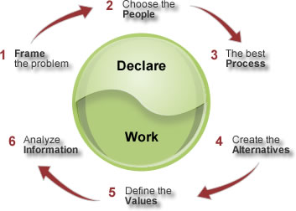
Judgment and Decision
Decision making is one of the basic cognitive processes of human behaviors by which a preferred option or a course of actions is chosen from among a set of alternatives based on certain criteria. Decision making process depends upon the amount of time and information available. The psychology involves careful planning, thin slicing and extra sensory perception.
There are many theories which deal with decision making process. Some of them are explained below with their merits and demerits. These three methods of decision making are consciously or unconsciously considered by the human brain during the decision making process.

