Introduction to psychology
Lecture No: 1
Clinical Psychologist Sadaf Sajjad
____________________________________________________________________________
Myths of Psychology
- Psychologists read faces, they mix their own preconceived ideas with their training.
- They are like magicians.
- Like Psychiatric patients, Psychologists are crazy people too.
- Going to visit Psychologists means you have something abnormal, or you are considered mad.
Facts about Psychology
Psychology emerged from biology and philosophy and is closely linked to other disciplines including sociology, medicine, linguistics and anthropology.
- Psychology is an organized body of knowledge.
- It collects and analyze knowledge.
- Psychologist are trained in living a balanced life
- Anyone can visit a psychologist starting from a counseling session to a major disorder.
What is Psychology- Definition
Psychology is the science of the mind and behavior. The word "psychology" comes from the Greek word psyche meaning "breath, spirit, soul", and the Greek word logia meaning the study of something. Psychology is both an applied and academic field that studies the human mind and behavior. Research in psychology seeks to understand and explain how we think, act and feel. The emergence of psychology as a separate and independent field of study was truly born when Wilhelm Wundt established the first experimental psychology lab in Leipzig, Germany in 1879.
Throughout psychology's history, a number of different schools of thought have thought have formed to explain human thought and behavior. These schools of thought often rise to dominance for a period of time. While these schools of thought are sometimes perceived as competing forces, each perspective has contributed to our understanding of psychology.
Psychology and Behavior
When many people think about psychology, they immediately think about the diagnosis and treatment of abnormal behavior. However, it is important to remember that psychology studies normal behavior as well.
The mind is highly complex and enigmatic. Many wonder how psychologists can study such an intricate, seemingly abstract and extremely sophisticated thing. Even if scientists look inside the brain, as in an autopsy or during a surgical operation, all they see is gray matter (the brain). Thoughts, cognition, emotions, memories, dreams, perceptions, etc. cannot be seen physically, like a skin rash or heart defect.
- To describe human thought and behavior
- To explain why these behaviors occur
- To predict how, why and when these behaviors will occur again in the future
- To modify and improve behaviors to better the lives of individuals and society as a whole
- Behavior is learned and can be unlearned
- Social learning perspectives are used in practice (social-skills, modeling, etc)
- Behavior Modification is done according to condition
- Behavior is shaped by culture
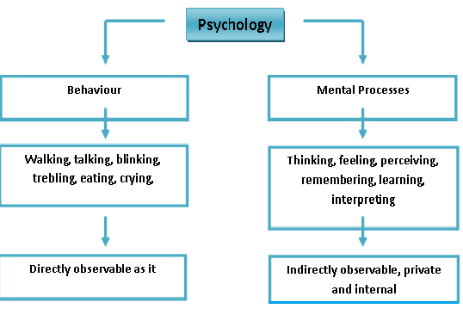
Psychology as a Science
Psychology is Empirical. The idea that knowledge should be gained through experience, i.e. empirically, turned into a method of enquiry that used careful observation and experiments to gather facts and evidence. Psychology is a discipline which seeks to study the thoughts and actions of man (as well as the behavior of animals) in a scientific way. If one is to understand exactly what this means a clear definition of science is required. Science is a marvelous development in the history of human thought. It has wrought amazing benefits and wonders for the modern world.
It is a systematic approach to the understanding of people, their thoughts, emotions and behavior. The application of this understanding helps to solve
human problems.
Branches of Psychology
It has two main branches:
- Pure Psychology:It deals with the psychological research and data which helps to formulate the principles of activity
- Applied Psychology:It applies the information given by Pure Psychology, to the problems of actual life.
Pure Psychology
Psychology is the scientific study of human and animal behavior with the object of understanding why living beings behave as they do. It deals with the psychological research and data which helps to formulate the principles of acvtivity
- Experimental Psychology
- Social Psychology
- Abnormal Psychology
- Developmental Psychology
- Comparative Psychology
- Physiological Psychology
Applied Psychology
The basic premise of applied psychology is the use of psychological principles and theories to overcome problems in other areas, such as mental health, business management, education, health, product design, ergonomics, and law.
- Clinical Psychology
- Industrial Psychology
- Educational Psychology
- Application of Psychology in Medicine
- Application of Psychology in Law
Goals Of Psychology
- Describing and Explaining Behavior
Differentiating between normal, healthy and unhealthy behaviors is the cornerstone of psychology, so it is important that psychologists have a keen sense of observation. Psychologists are interested in explaining behavior in addition to merely describing it. Why do people do the things they do? What factors contribute to development, personality, social behavior, and mental health problems? Throughout psychology's history, many different theories have emerged to help explain various aspects of human behavior.The second goal of psychology, explaining. The attempt to explain behavior based on observation is actually rather difficult due to many factors. For instance, behavior varies among culture and can change over time. Psychologists' attempts to explain behavior reflect the fundamental goal of all science--understanding our universe and our place in it. Several theorists, from Freud and Jung to Skinner and Rogers, have offered various theories to explain personality, development and motivation. Explanations are limited, of course, because they often are culturally restricted; that is, one explanation might not explain similar behavior in another culture or society. Explanation is often determined through qualitative and quantitative observation, including experimentation.
- Predicting and Influencing Behavior
Psychologists try to determine if a person is likely to make healthy or unhealthy decisions when confronted with certain situations. Most of the time, they will use experiments to make their predictions. Psychology also attempts to predict behavior. The purpose of prediction is to determine when an individual will make healthy or unhealthy choices or how an individual will perform within environment and stimuli. Consider the advantages of predicting whether a student will be successful at a certain college, based on past behavior in a similar environment. Though prediction is not foolproof, it can permit institutions and individuals to make more informed decisions choices about their futures.
The last of the goals of psychology is to influence behavior. This can be to change unhealthy behavior as well as encourage already existing healthy behavior. There are many methods used to influence behavior such as positive reinforcement or rewarding good behavior. Modifying behavior can be healthy or unhealthy, but within ethical constraints, psychology attempts to voluntarily encourage individuals and groups to modify behavior for long-term healthy gain. Personality and development theories differ as to how best to encourage behavior changes. Some behaviorists believe in repetitive reinforcement, while positivists believe in honest cognitive discourse. Psychology can be used in education, social correction and organizational structures to elicit preferred behavior and attitudes.
Different Perspectives in Psychology
- Biological Psychology
- Behavioral/Clinical Psychology
- Cognitive Psychology
- Social-Cultural Psychology
- Personality Psychology
- Experimental Psychology
- Educational Psychology
- Industrial Psychology
- Criminal Psychology
- Computational Psychology

Biological psychology
Biology is defined as the study of life (from the Greek bios meaning ‘life’ and logos meaning ‘study’). A biological perspective is relevant to the study of psychology in three ways:
  - Comparative method: different species of animal can be studied and compared. This can help in the search to understand human behavior.
  - Physiology: how the nervous system and hormones work, how the brain functions, how changes in structure and/or function can affect behavior. For example, we could ask how prescribed drugs to treat depression affect behavior through their interaction with the nervous system.
Biological psychology, also called physiological psychology or behavioral neuroscience, the study of the physiological bases of behaviour. Biological psychology is concerned primarily with the relationship between psychological processes and the underlying physiological events—or, in other words, the mind-body phenomenon. Its focus is the function of the brain and the rest of the nervous system in activities (e.g., thinking, learning, feeling, sensing, and perceiving) recognized as characteristic of humans and other animals. Biological psychology has continually been involved in studying the physical basis for the reception of internal and external stimuli by the nervous system, particularly the visual and auditory.
Biological psychology looks at the link between biology and psychological events such as how information travels though out our bodies (neural impulses, axons, dendrites, etc.), how different neurotransmitters effect sleep, dreams, and other behaviors, just to name a few. It is the study of how all body processes function, including the electrical and chemical processes necessary for nervous system communication.
Behavioral Psychology
Behavioral psychology is a branch of psychology that focuses on observable behaviors. Conditioning, reinforcement and punishment are key concepts used by behaviorists. Learn more about classical conditioning and operant conditioning as well as some of the major behaviorist thinkers.
Behavioral psychology maintains that
- Behavior is both conditioned and determined by its own outcomes or consequences (rewards and punishments);
- Human behavior can be understood by investigating animal behavior;
- Only the observable and measurable aspects of a behavior are worth investigating;
- Repetition alone brings mastery which is the same as understanding;
- Knowledge is something given by an instructor and taken (acquired) by a learner;
- An instructor should focus on changing the learner's behavior and not his or her thinking patterns; and
- Mind (and thus consciousness) does not exist as far as scientific investigation is concerned.
Behavioral psychology, also known as behaviorism, is a theory of learning based upon the idea that all behaviors are acquired through conditioning. Advocated by famous psychologists such as John B. Watson and B.F. Skinner, behavioral theories dominated psychology during the early half of the twentieth century. Today, behavioral techniques are still widely used in therapeutic settings to help clients learn new skills and behaviors.
1. Conditioning
- Classical conditioning is a behavioral-intervention technique by which two stimuli that are paired together repetitively elicit the same behavioral response separately.
- Operant conditioning, is a technique that focuses on the association between voluntary behavior and consequence.
2. Reinforcement
Reinforcement is a psychology term that refers to the way behaviors increase or decrease according to whether people associate it with a positive experience (a "reward") or a negative experience (a "punishment").
3. Punishment
Negative punishment is an important concept.In behavioral psychology, the goal of punishment is to decrease the behavior that precedes it. In the case of negative punishment,it involves taking something goodor desirable away in order to reduce the occurrence of a particular behavior.

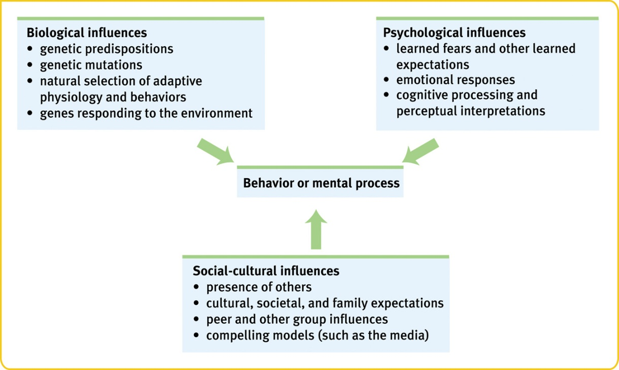

Cognitive Psychology
Cognitive Psychology is the study of human thought processes and cognitions. Cognitive psychologists study topics such as attention, memory, perception, decision-making, and problem solving and language acquisition.
This branch investigates internal mental processes, such as problem solving, memory, learning, and language (how people think, perceive, communicate, remember and learn). This branch of psychology is closely related to other disciplines, such as neuroscience, philosophy and linguistics. Cognitive psychology focuses on the way humans process information, looking at how we treat information that comes in to the person (what behaviorists would call stimuli), and how this treatment leads to responses. In other words, they are interested in the variables that mediate between stimulus/input and response/output. Cognitive psychologists study internal processes including perception, attention, language, memory and thinking. At the center of cognitive psychology is how people acquire, process and store information. Many say that cognitive psychology is the study of intelligence. Practical applications for cognitive research may include how to improve memory, increase the accuracy of decision-making, or how to set up educational programs to boost learning. Unlike behaviorism, which focuses only on observable behaviors, cognitive psychology is concerned with internal mental states. Unlike psychoanalysis, which relies heavily on subjective perceptions, cognitive psychology uses scientific research methods to study mental.
Social-Cultural Psychology
Baron, Byrne &Suls (1989) define social psychology as .......“the scientific field that seeks to understand the nature and causes of individual behavior in social situations”. Social psychology is about understanding individual behavior in a social context. Socio cultural psychology focuses on the fact that our interactions with others in society affect not only our thought process, but also our perception, and the manner in which we make decisions.
Our socio cultural thought process begins in childhood and steadily gains momentum as we grow older. This branch of psychology explains how we create our identity or self-image, and shape our perception.
It uses scientific methods to understand and explain how feeling, behavior and thoughts of people are influenced by the actual, imagined or implied presence of other people. A social psychologist will look at group behavior, social perception, non-verbal behavior, conformity, aggression, prejudice, and leadership. Social perception and social interaction are seen as key to understanding social behavior. Simply, social psychology studies the impact of social influences on human behavior.
Personality Psychology
Personality psychology is a branch of psychology that studies personality and its individual differences. It studies personality and individual different processes - that which makes us into a person.
Its areas of focus include:
- Construction of a coherent picture of the individual and his or her major psychological processes
- Investigation of individual differences
- Investigating human nature and human's similarities
The study of personality has a broad and varied history in psychology with an abundance of theoretical traditions. The major theories include dispositional (trait) perspective, psychodynamic, humanistic, biological, behaviorist, and social learning perspective. However, many researchers and psychologists do not explicitly identify themselves with a certain perspective and instead take an eclectic approach.
Experimental Psychology
Experimental psychology is an area of psychology that utilizes scientific methods to research the mind and behavior. Experimental psychologists work in a wide variety of settings including colleges, universities, research centers, government and private businesses. Experimental psychologists work in a wide variety of settings including colleges, universities, research centers, government and private businesses. Some of these professionals may focus on teaching experimental methods to students, while others conduct research on cognitive processes, animal behavior, neuroscience, personality and many other subject areas.
The experimental method in psychology attempts to account for the activities of animals (including humans) and the functional organization of mental processes by manipulating variables that may give rise to behaviour; it is primarily concerned with discovering laws that describe manipulable relationships. The term generally connotes all areas of psychology that use the experimental method.
Educational Psychology
Educational psychology is the study of how humans learn in educational settings, the effectiveness of educational interventions, the psychology of teaching, and the social psychology of schools as organizations. It involves learning process of early childhood and adolescence, includes the social, emotional and cognitive processes. Educational psychology is concerned with how students learn and develop, often focusing on subgroups such as gifted children and those subject to specific disabilities. Educational psychology can in part be understood through its relationship with other disciplines. It is informed primarily by psychology, bearing a relationship to that discipline analogous to the relationship between medicine and biology. Educational psychology in turn informs a wide range of specialities within educational studies, including instructional design, educational technology, curriculum development, organizational learning, special education and classroom management. Educational psychology both draws from and contributes to cognitive science and the learning sciences.
This branch of psychology involves not just the learning process of early childhood and adolescence, but includes the social, emotional and cognitive processes that are involved in learning throughout the entire lifespan.
Industrial Psychology
Industrial organizational psychology is an applied area of psychology that involves using psychological theories and principles to solve problems related to the workplace and organizations.Concerned with efficient management of an industrial labor force and especially with problems encountered by workers in a mechanized environment.
It is also known as industrial-organizational psychology, I-O psychology, work psychology, organizational psychology, work and organizational psychology, occupational psychology, personnel psychology or talent assessment) - studies the performance of people at work and in training, develops an understanding of how organizations function and how people and groups behave at work. The occupational psychologist aims to increase effectiveness, efficiency, and satisfaction at work.
Criminal Psychology
Criminal psychology is the study of the wills, thoughts, intentions and reactions of criminals, all that partakes in the criminal behavior. This psychology is particularly uneasy with tests of social structure that are based on assessments of age, race, ethnicity, and gender at the personal level.
Computational Psychology
It is concerned with building computer models of human cognitive processes and is based on an analogy between the human mind and computer programs. The brain and computer are viewed as general-purpose symbol-manipulation systems, capable of supporting software processes.
The importance of psychology
- Self-Knowledge
- Learning can be viewed as one purpose of life, and self-knowledge can be viewed as an important element of learning.
- Learning About Others
- learning about oneself, the field of psychology allows us to learn about others.
- Solving Important Problems
- Theories and findings in psychology may help us to solve important problems.

Development of psychology
- Development describes the growth of humans throughout the lifespan, from conception to death.
- The scientific study of human development seeks to understand and explain how and why people change throughout life.
- This includes all aspects of human growth, including physical, emotional, intellectual, social, perceptual, and personality development.

