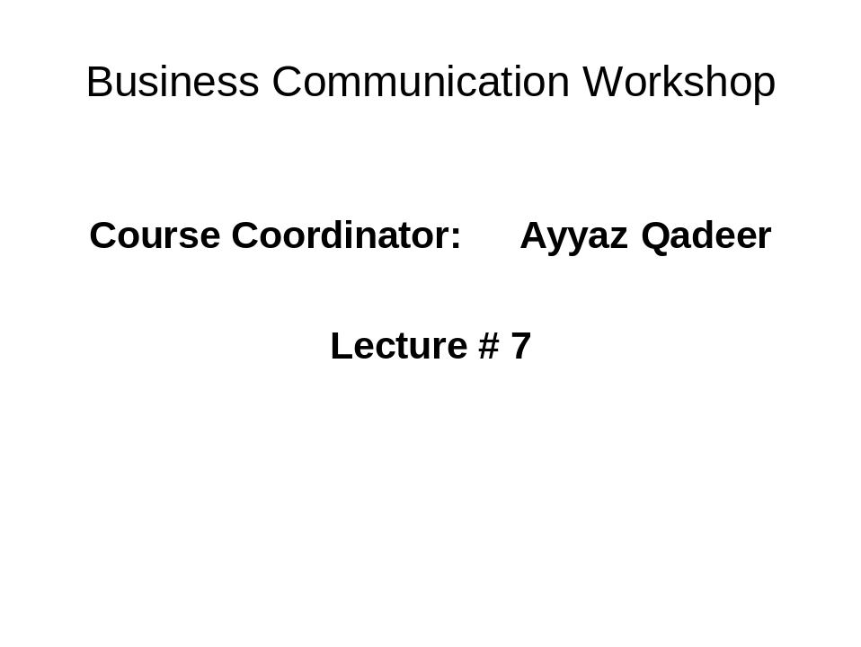
The Three-Step Writing Process

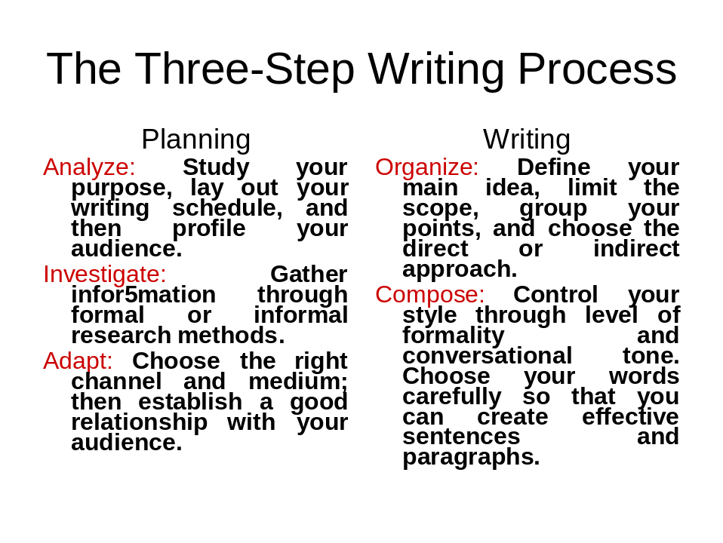
Completing
Revise: Evaluate content and review readability, editing and rewriting for conciseness and clarity.
Produce: Use effective design elements and suitable delivery methods.
Proofread: Review for errors in layout, spelling and mechanics.

Define Your Purpose
- What is the difference between a general purpose and a specific purpose?
- What is credibility?
- What four questions should you ask yourself when trying to decide whether to proceed with the message?
Analyze Your Audience
See your message from your receivers’ point of view: their needs, interests, attitudes, even their culture.
- Views, mental, filters, needs, and culture
One person, member of group, laborer, superior, colleague, subordinate, woman or man, longtime or new customer, young, middle-aged, ….
- You audience even affects the choice of medium…
Develop an Audience Profile
Identify your primary audience
Determine audience size
Determine audience composition
Gauge your audience’s level of understanding
Estimate your audience’s probable reaction
Collecting Information Informally
- Consider others’ viewpoints
- Browse through files
- Chat with supervisors or colleagues
- Ask your audience for input
What Does Your Audience Need?
- Have you provided all the required information? (Ask who, what, when, where, why, and how.)
- Is the information accurate?
- Is the information ethical?
- Is the information pertinent?
Select Appropriate Channel and Medium
- What should you consider when deciding upon a channel and medium?
- What is meant by media richness?
- Verbal, vocal, visual
- Feed back and personal interaction
- When would you choose a rich medium?
- Think of instances when you would use each of the following:
  - Video broadcast
  - Memo
Face-to-face meeting
Oral Media
- Oral communication includes face-to-face conversations, phone calls, speeches, presentations, and meetings.
Your choice of medium would depend on audience, location, message importance, and the need for nonverbal feedback.
Written Media
- Written communication includes letters, memos, and reports.
- A form letter, memo, or boilerplate message is often used for routine communication.
- Reports and proposals are factual documents distributed to insiders and outsiders.
Audience: Establishing a Good Relationship
- Think about who you are and who your audience is. (Be yourself.)
- Use the “you” attitude in all your messages.
- Always emphasize the positive.
- Establish your credibility.
- Be polite.
- Use bias-free language.
- Project the company’s image.
Biases in Language
- Gender
- Racial and ethnic
- Disability
- Age

-----------------------------------Best of Luck---------------------------------------------------

