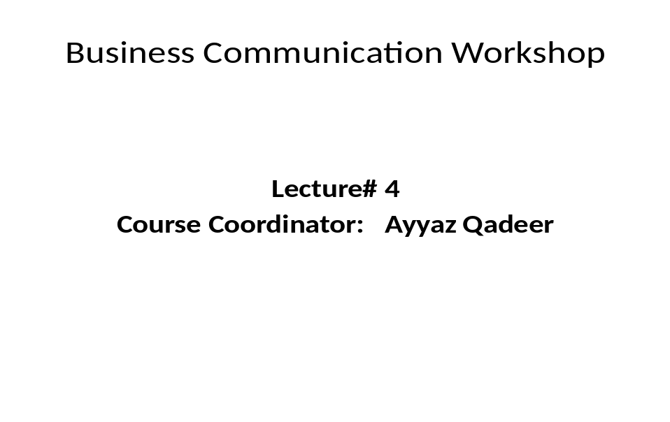
Concreteness
- Misunderstandings of words have produced tragedies in both war and peace, in business and non-business situations.
- Were you precise in using facts and figure wherever possible?
- Did you use the active voice more than the passive?
- Is there action in verbs rather than in nouns or infinitives?
- Did you try to occasionally use vivid, image-building words? But in business writing, use them sparingly.
Concreteness (Use specific facts and figures)
Vague, General, Indefinite
- Student GMAT scores are higher.
- Eastern Europe is making progress in obtaining investments.
Concrete, Precise
- In 2007 the GMAT scores averaged 600; by 2008 they had risen to 610.
- In 2000 investments in Eastern Europe were about US $ 30 millions; today that figure has increased by 10%.
Concreteness (Put actions into your verbs)
- Active verbs help make your sentences:
- Specific The dean decided
- Personal You will notice instead of “it will be noted”
- Concise Passive slows both reading and writing
- Emphatic Passive verbs dull action: the students held a contest or “ a contest was held by the students”
Concreteness (Put actions into your verbs)
Active
- Tests were administered by the professors.
- Professor A. will give consideration to the report.
Passive
- Professors administered the tests.
- Prof. A. will consider the report.

Clarity
- Choose as precise or as concrete a word as possible.
- Select words that have a high sense of appropriateness for the reader.
- Opt for the familiar word, the one that is not pretentious.
- Limit average sentence length to 17 to 25 words.
- Insert no more than one main idea into a sentence.
- Arrange words so that the main idea occurs early in a sentence.
Clarity (choose precise, concrete, and familiar words)
Unfamiliar
After our perusal of pertinent data, the conclusion is that a lucrative market exists for the subject property.
Familiar
The data we studied show that your property is profitable and in high demand.
Courtesy
- Ask yourself: Does the communication have a sincere you-attitude?
- Not only politeness like “Please” or “Thank you” but also socially accepted manners.
- Be sincerely tactful, thoughtful and appreciative.
2. Have someone else look at your statement if you have doubts about whether it is tactful. Another opinion may cause you to reconsider making a statement.
- Be careful about being dishonest
- Other opinion should be of some expert.
- Be cautious in using humor in communication. Here too it pays to have someone else review your words.
- Most of the humor is culturally specific.
- Maintain a line between humor and irony
4. Be careful in using discriminatory language; this means being aware of gender, race, age, color, creed, sexual preferences, or ethnic origins.
Courtesy (be sincerely tactful, thoughtful, and appreciative)
Tactless, blunt, Irritating Tactful, Courteous
- Stupid letter; I can’t understand any of it. It’s my understanding.
- You are delinquent Contrary to you inference
- You did not tell us I’m sure you must realize
- Your complaint We find it difficult to believe that
- Your stubborn silence Why have you ignored
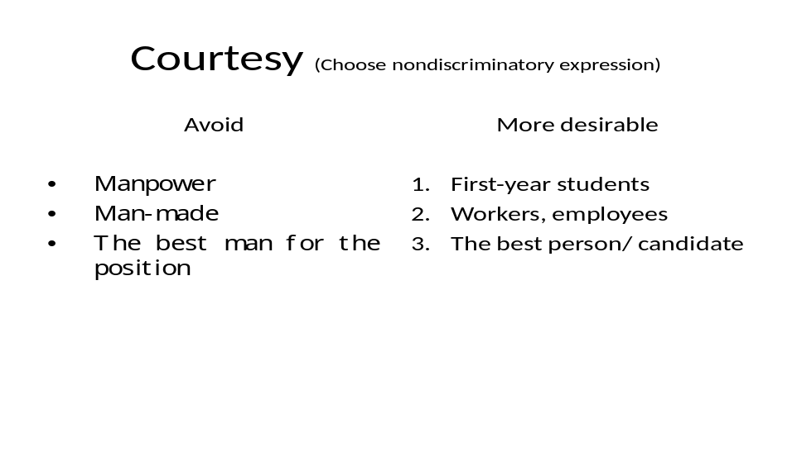
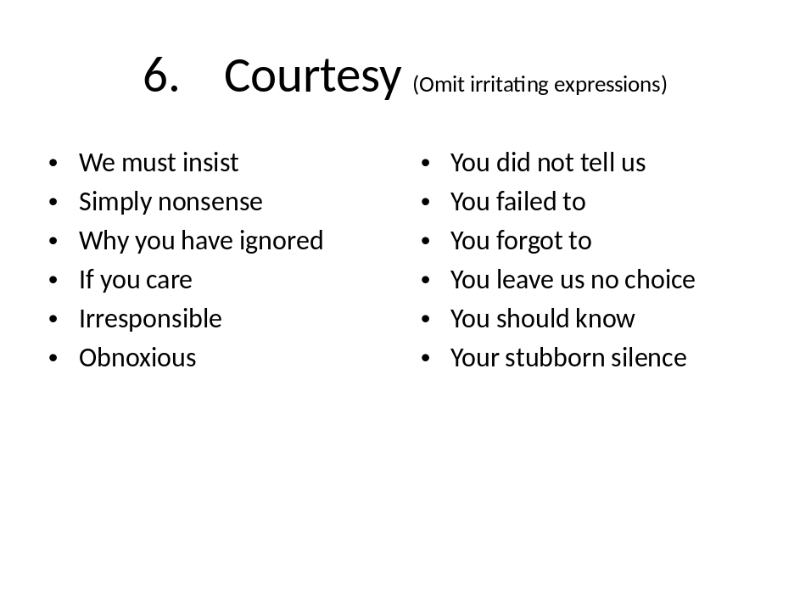
Correctness
- Select the right level of language for your communication: either formal or informal
- Formal: scholarly writing like doctoral dissertations, article, legal documents etc.
- Informal: characteristic of business writing where words are short, well-known and conversational. e.g.
- Formal Less Formal
Participate join
Procure get
Endeavor try
Edifice building
Interrogate question
Correctness
- Realize that informal language is also used in business communication.
- Check –often by letting another person read your material – for correct figures, facts, and words.
- Verify your statistical data,
- Double check your total,
- Determine whether a “fact” has changed over time
- Apply the principles of accepted mechanics to your writing.
- Spelling. grammar, sentence construction, sentence fragment, run-on sentences, punctuation, consistency in tenses etc.

-----------------------------------Best of Luck---------------------------------------------------

