COMSATS Institute of Information Technology
Course Title: Business Communication Workshop
Instructor: Ayyaz Qadeer
Course Code: HUM 200
Credit Hours: 3
Semester: Fall 2013 (BBA-3)

Introduction

Business Communication Workshop is a compulsory 3 credit hour course of BBA program at CIIT. It is an essential course because effective communication skills are indispensable for business professionals in the highly globalized world of today.
All the time, they are required to communicate in various professional capacities through written, electronic, oral and non-verbal means. As such, strong communication and interpersonal skills are the hallmarks of successful business entrepreneurs
Objective
- This course focuses on the ability of students to communicate, with an emphasis on the ability to communicate successfully across cultural boundaries.

- Effective communication is a skill, and hence it can be learned. Students will be exposed to theories and concepts that underlie effective oral and written communication skills.
- They will learn to collect, organize, analyze and present information in an understandable and logical order; understand the nature of non verbal communication and be able to use it effectively in oral and written presentations.
Course Outcome
- After completion of this course, students are expected to be able to:
- Know the meaning, forms and process of communication
- Understand intercultural communication
- Understand the importance of non-verbal communication
- Read & understand a passage, report, news item etc efficiently
- Use appropriate sentence structure
- Write paragraphs with proper topic sentences
- Listen and understand lectures
- Work in pair/group with peers
- Write Resume’ & letter
- Write informational & analytical reports
- Brainstorm on a topic and make its outline
- Get familiar with researching
Develop presentation skills
Course Outline
- Understanding Business Communication,
- Communicating in Teams,
- Communicating Interculturally,
- 7 Cs of Effective Communication,
- Effective Sentence structure, Paragraph writing,
- Resume’ & Application Letter,
- Planning Business Messages,
- Composing Business Messages,
- Completing Business Messages,
- Planning Reports, Writing Business Reports, Completing formal Business Reports,
- Writing Good News & Neutral Messages,
- Bad News Messages,
- Persuasive Written Messages,
- Oral Presentations,
- Writing emails
Recommended Course Text
- Excellence in Business Communication (8th Edition), by John V. Thill, Courtland L. Bovee
- Effective Business Communication by Herta Murphy, Herbert W. Hildebrandt, Jane. P. Thomas
- Essentials of Business Communication by Mary Ellen Guffey
Evaluation Criteria
- 1st sessional 10 % Marks
- 2nd sessional 15% Marks
- Final Exams 50% Marks
- Quizzes/Assignment/presentations 25%Marks

Lecture # 1

What is Effective Communication? Its Importance and Benefits. Introduction to Business Communication

“If all my possessions were taken from me with one exception, I would hope to keep my power of communication --- for by it I would regain all the rest.” (Daniel Webster)
What is communication?
In plain words “just to convey the message”, To give signals or messages through sounds, gesture or written symbols

Communication is to Understand….
- The intended meaning from the actual words
- The intended listening (hearer wants to hear) from the actual listening (hearer actually hears)
Business Communication
- Life blood of every organization
- Achieving Career Success through Effective Communication
- Effective Communication enables organizations to function successfully.
- It helps you anticipate problems, make decisions, coordinate work flow, supervise others, develop relationships, and promote products
Adapting to the changing Workplace
- Communicating at internet speed
- Communicating with culturally diverse Work Force
- Communicating in the age of information Technology
- Communicating in team-based organizations
- Course/training for Effective Communication
Communicating in Organizations
- Organizations make sure that communication inside and outside the company are open, honest and clear.
- Ability to communicate increases productivity, both individual and organization’s
- Shapes impression you make on colleagues, employees, supervisors, investors, and customers
- Helps you to perceive the needs of the stakeholders, and it helps you to respond to those needs
- Your communication skills determine your success whether you:
  - Run your own business
  - Work for an employer
  - invest in a company
  - raise money for charities
- Every member of an organization is a link in the information chain.
- Flow of information inside the organization:
  - Staff meetings
  - progress reports
  - project proposals
  - research results
- or outside the organization:
  - loan applications
  - purchasing agreements
  - help-wanted ads
  - distribution contracts
  - product advertisements
  - sales calls
- within company you & your coworkers use the information you obtain from one another to guide your activities
- a manager coordinates these activities & efforts
- constant flow of information up, down & across the organization
- As manager, you carry out decision by collecting facts, analyzing them, and transmitting directions to lower-level employees.
- Employees serve as the eyes and ears of an organization
- You are a contact point in both the external & internal communication networks.
Internal Communication
- Formal Communication Channels
- Information may travel up, down or across an organization’s formal hierarchy.
- Tall narrow structure of organization with many levels risk distortion of information
- One way to reduce distortion is to reduce number of levels
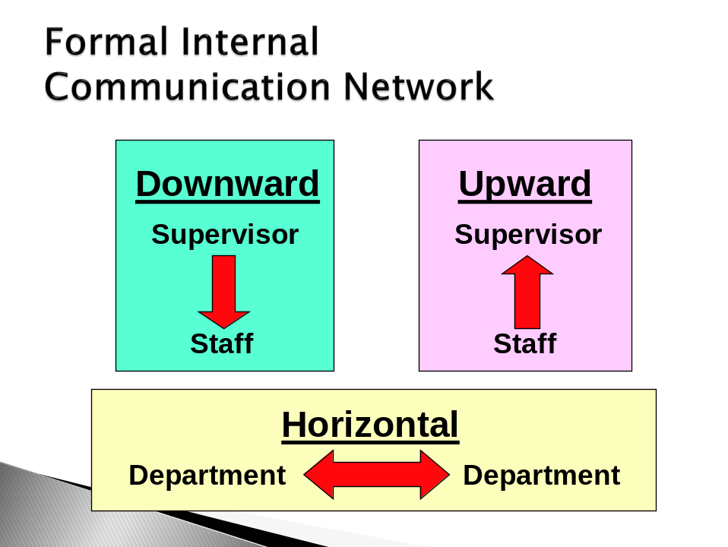
Downward information flow
- At most organizations, decisions made at top flow down to people who will carry them out
- Downward messages might take the form of a casual conversation, or formal interview between a supervisor and an individual employee, or communicated orally, through workshop or on videotape.
- Typical messages include:
  - Briefings on the organization’s mission & strategies
  - Instructions on how to perform various jobs
  - Explanations of policies and procedures
  - Feedback on employee performance
Motivational pep talk
Upward information flow
- To solve problems and make decisions managers must know what’s going on in the organization
- Since they cant be everywhere at once, executives depend on lower level employees to furnish them with information like: reports on problems, emerging trends, opportunities for improvement, grievances & performance
- The danger is that employees will report only the good news.
- Methods for channeling information upwards: group meetings, interviews with employees who are leaving company, employee surveys, etc
- Many companies have set up suggestions systems that encourages employees to submit ideas for improving business
Horizontal information flow
- Communication flows from one dept. to another either laterally or diagonally
- Bypasses bureaucratic barriers
- Efficiency of the company enhances
- Horizontal information through Computer networks, and teamwork
- Without it co-workers aren’t able to share information, resulting in missed deadlines, duplicated efforts, increased cost, extra time, decreased product quality & deteriorating employee relationship.
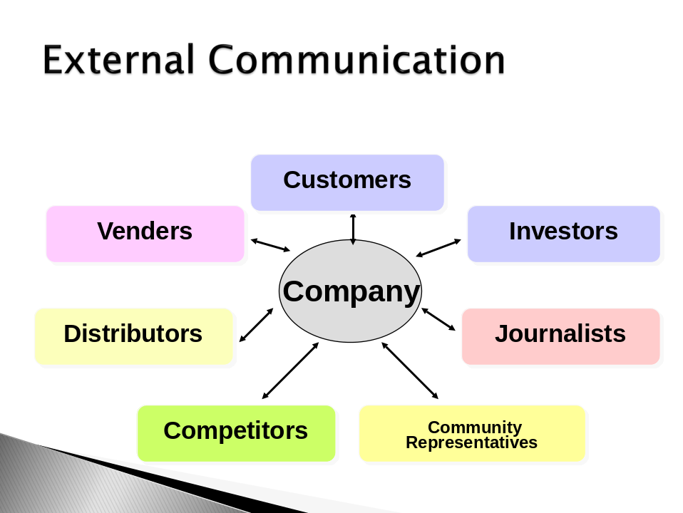
Goals of communication
- To inform
- To request
- To persuade
- To motivate
- To build relationships.
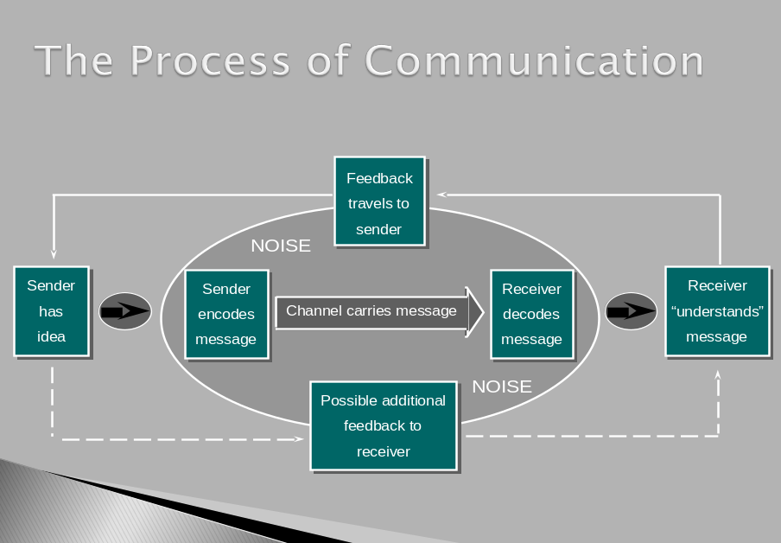
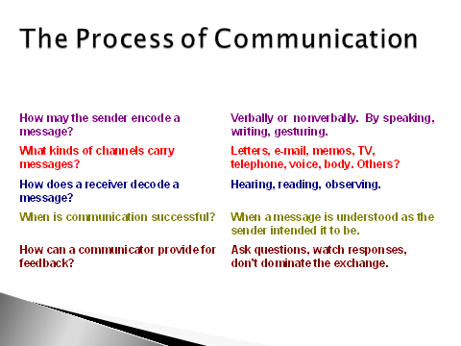

Medium of Communication
    - Oral or Written
Oral  - Immediate feedback  - Shorter sentence; shorter words  - Conversational  - Focus on interpersonal relations  - Prompt action  - Less detailed technical information  - More personal pronouns  - More colloquial language  - Simpler constructions  - More imperative, interrogative, and exclamatory sentences | Written  - Delayed feedback  - Longer sentences; longer words  - More formal  - Focus on content  - Delayed action  - More detailed technical information  - Fewer personal pronouns  - More complex constructions  - Useful for permanent record; detailed documentations  - Possibility of review

Elements in Communication (5 W’s and H)
- Who Communicator
- Whom Receiver
- Why Reason
- What Contents
- Where Place
- How Method

-----------------Best of Luck-------------------------

