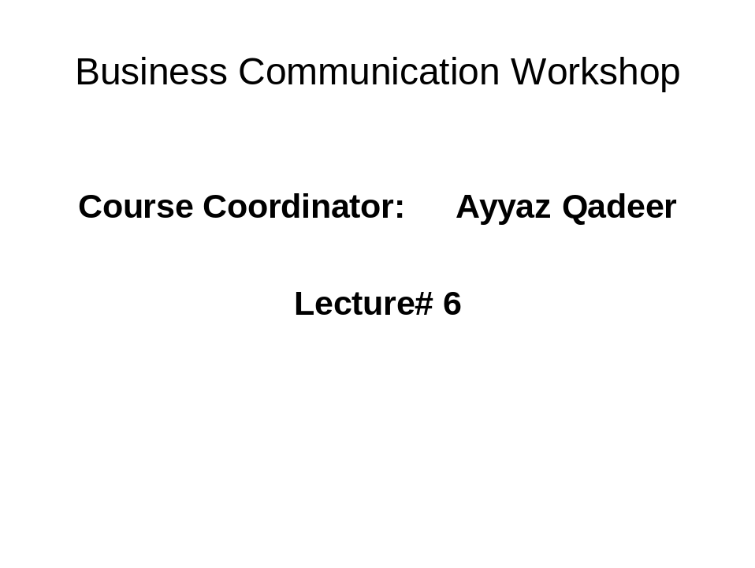

Communicating Interculturally

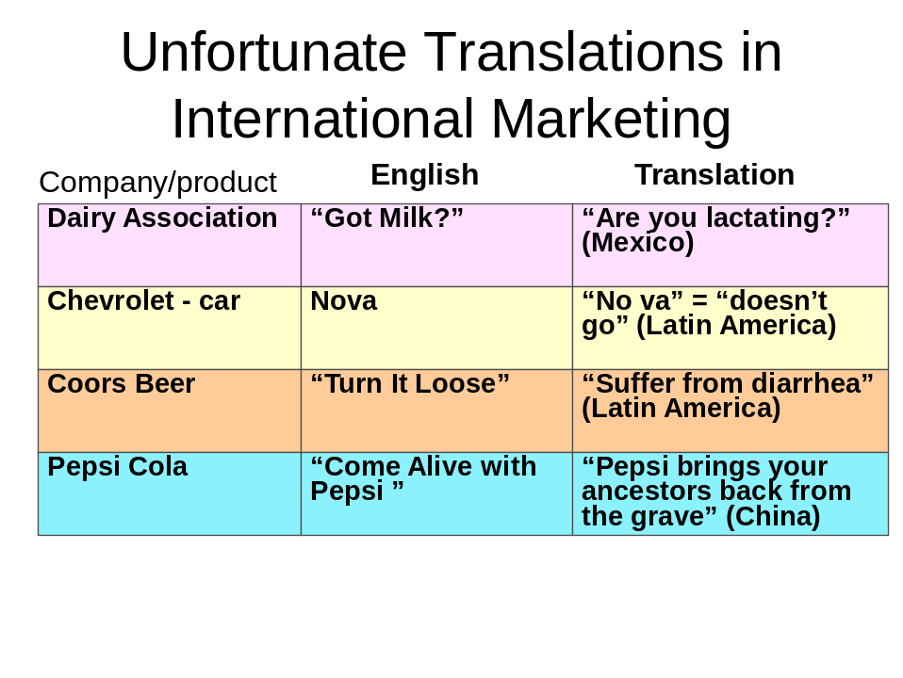
Overcoming Language Barriers
Breaking Through ESL Barriers
- Avoid using slang and idioms.
- Pay attention to local accents and pronunciation.
- Be aware of vocal variations.
Breaking Through Foreign Language Barriers
- Learn a foreign language.
- Use an intermediary or translator.
- Offer language training programs.
- Study other cultures.
Developing Intercultural Communication Skills
- Assume differences.
- Take responsibility.
- Withhold judgment.
- Show respect.
- Empathize.
- Tolerate ambiguity.
- Recognize bias.
- Learn patience and persistence.
- Be flexible.
- Emphasize some common ground.
- Send clear messages.
- Deal with the individual.
- Know when to be direct.
- Avoid the superficial.
- Evaluate feedback to assess your hypothesis.
Writing Effective Messages to International Audiences
- Use plain English.
- Be clear.
- Avoid slang and idioms.
- Be brief.
- Use short paragraphs.
- Use transitional elements
Improve Your Oral Skills
- Try to eliminate noise.
- Look for feedback.
- Rephrase sentences when necessary.
- Clarify your true intent with repetition and examples.
- Don’t talk down to the other person.
- Use objective, accurate language.
- Listen carefully and patiently.
- Adapt your conversation style to the other person’s.
- Clarify what will happen next.

-----------------------------------Best of Luck---------------------------------------------------

