Business Communication Workshop

Course Coordinator: Ayyaz Qadeer
Lecture # 30

Ethics in Business Communication

Importance of Ethical Communication
Learning Ethical models
- Helps you discover and make explicit your ethical positions and standards
- Enables you to diagnose the ethical position of your interlocutors.
- Provides you with a conceptual framework that will guide you towards becoming a consistent ethical business communicator.

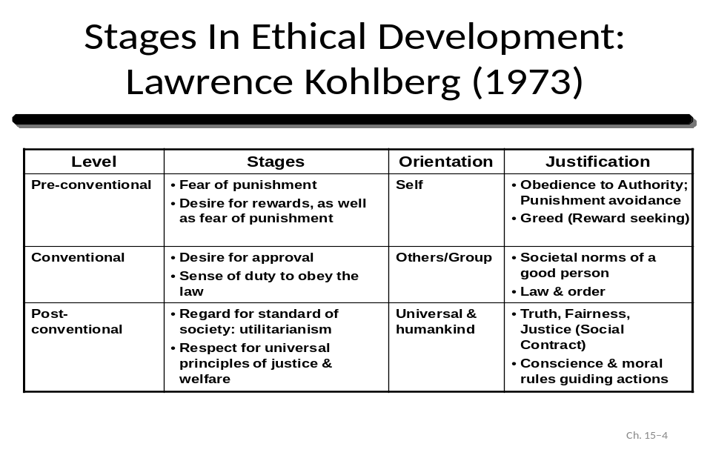
Individual Ethical Frameworks
- Utilitarian Approach
- Focuses on whether the decision made will deliver the greatest good to the greatest number of people affected.
- Recognizes that decisions made by people can have both positives and negative consequences.
B. Moral Rights Approach
- Recognizes that human beings are born with fundamental rights and privileges.
- Stresses the importance of respecting and protecting the fundamental rights of all human beings.
C. Justice Approach
- Focuses on how the costs and benefits of an action are distributed and whether the distribution is fair and equitable.
Three types of justice approach are: distributive, procedural, and compensatory justice.
- Distributive Justice Approach
- Rewards and punishments should be fairly distributed based on how much individuals contribute towards, or deviate from the given organizational goals.
- Discrimination (e.g., race, gender) is an example of the lack of distributive justice.
- Procedural Justice Approach
- The policies, rules, and procedures relating to decisions and behaviors should be applied fairly and consistently.
- The criterion is whether the rules and processes governing the distribution of the rewards and punishments are fair.
- Compensatory Justice Approach
- Involves compensating someone for a past wrong decision or action.
- Requires that hurt parties be compensated for past injustice.
When adopting Justice Approach, the decision maker should consider whether:
- the costs and benefits are fairly distributed and how;
- the procedures for distributing costs and benefits are fair and clear;
the individuals who are unfairly affected by this course of action are fairly compensated.

Cultural Issues in Ethical Behavior
Two ways of dealing with cultural issues in ethical decision making: universal and relative approaches.
Universalism states that:
- Individuals should choose a course of action that can be applied to all people under all circumstances.
Relativism argues that:
- Behavior in foreign settings should be guided by local laws and customs.
Corporate Social Responsibility (CRS)
Corporate social responsibility refers to:
- Obligations of a corporation.
- How it acts in terms of its own corporate interests and profits in relation to the interests of its external stakeholders.
Corporate social responsibility includes concerns about:
- Green and environmental protection issues
- Community service
- Employment practices
- General corporate philanthropy
Ethically Based Communication Style
A. Utilitarian Communication Style
- Believes that the decision should benefit the majority.
- Utilitarians compare alternative options and are open and receptive to exploring different viewpoints.
- Moral Rights Communicating Style
- The advocates believe that decisions and actions are either right or wrong.
- People holding a moral rights perspective focus on analyzing or explaining why a decision or action is either right or wrong, rather than the consequences of the decision or action.
- Justice Communication Style
- Justice advocates are interested in how and whether the costs and benefits of decisions and actions are distributed equitably.
- Universalist Communication Style
- Ethical universalism believes that ethical principles are universal and should be applied to all cultures.
- Universalists stress on conveying universal values.
. Relativist Communication Style
- Believes that ethical behavior is influenced by the cultural context.
- When in Rome, do as Romans do.
- Relativists focus on the different values between cultures.

Possible Ethical Communication Conflict
Utilitarian versus Moral Rights Communication Conflicts
- The utilitarians may not be interested in the rights or wrongs of a decision, whereas the moral rights adherent is not interested in the pros and cons of the proposed actions.
Universalistic versus Relativistic Communication Conflicts
- While universalists do not recognize that certain rights and traditions of a culture need to be respected, relativists fail to recognize that certain fundamental rights are applicable to all cultures.
Justice Communication Conflicts
- Communicators taking the justice approach have a shared perspective and a basis for successful communication.
- Communication conflicts can still arise among individuals holding differing views about what constitutes justice (e.g. distributive, procedural, compensatory justice)
Ethics and Decision Models
Rational or Classical Model
- The decision maker selects the best option among alternatives to reach an optimal goal.
- It encourages ethical communication by promoting extensive information flow and promotes an open process of communication.
- This method is most costly and time consuming.
- Behavioral Model
- The decision maker identifies one alternative at a time and selects the first satisfactory alternative identified.
- It is often adopted by managers who are constrained by information, costs and time.
- This model may carry with it a greater possibility of unethical decision making and unequal communication.
- Retroactive Model
- The decision maker chooses a favorable alternative early in the decision making process but carries it through the sequential steps of the rational decision making process with other alternatives.
- A favorable option is considered along with other alternatives, but a change of intention is lacking.
- Dealing with Ethical Dilemmas
When encountering ethical dilemmas in dealing with “borderline” or “gray” area situations, individuals tend to rationalize their inappropriate behavior. The individual may believe that:
- their misconduct is not really illegal; or
- the result is in everyone’s best interests.

