Business Communication Workshop

Course Coordinator: Ayyaz Qadeer
Lecture # 26

Making Oral Presentations

Three-Step Process for Oral Presentations
- Plan your speech or presentation
- Write your speech or presentation
- Complete your speech or presentation
Reasons for Giving a Speech
- To inform
- To persuade
- To motivate
- To entertain
Writing Speeches and Presentations
- Define your idea
- Limit your scope
- Choose your approach
- Prepare an outline
- Choose an appropriate style
Preparing an Oral Presentation
- Identify your purpose.

  - Decide what you want your audience to believe, remember, or do when you finish.
  - Aim all parts of your talk toward your purpose.
- Organize the introduction.
  - Get the audience involved.
  - Capture attention by opening with a promise, story, startling fact, question, quotation, relevant problem, or self-effacing story.
  - Establish your credibility by identifying your position, expertise, knowledge, or qualifications.
  - Introduce your topic.
  - Preview the main points.
- Organize the body of your presentation.
- Develop two to four main points. Streamline your topic and summarize its principal parts.
- Arrange the points logically: chronologically, from most important to least, by comparison and contrast, or by some other strategy.
- Prepare transitions. Use "bridge" statements between major points. (I've just discussed three reasons for X; now I want to move to Y.) Use verbal signposts: however, for example, etc.
  - Have extra material ready. Be prepared with more information and visuals if needed.
- Captivate your audience by
  - Relating your subject to audience’s needs
  - Using clear, vivid language
  - Explaining the relationship between your subject and familiar ideas
- Organize the conclusion.
  - Review your main points.
  - Provide a final focus. Tell how listeners can use this information, why you have spoken, or what you want them to do.
  - Describe the next steps if the speech requires action of others.
  - End on a positive note.
  - Provide for a question-and-answer period, if appropriate.
Delivering Your Message
- Memorizing
- Reading
- Speaking from notes
- Impromptu speaking
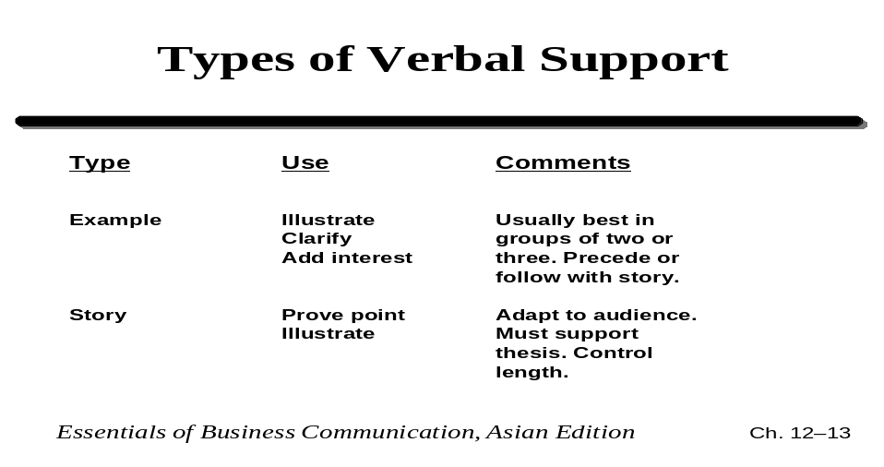
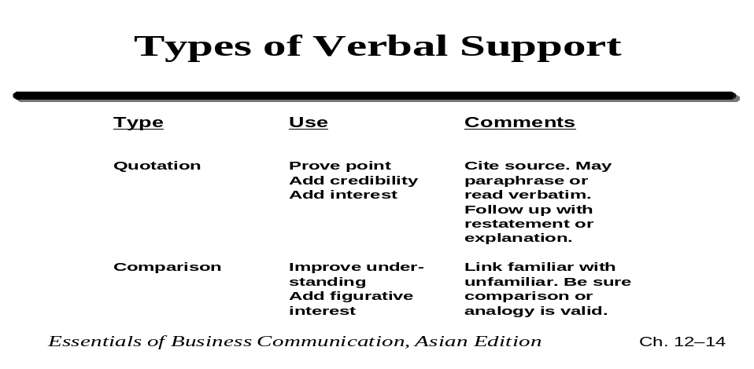
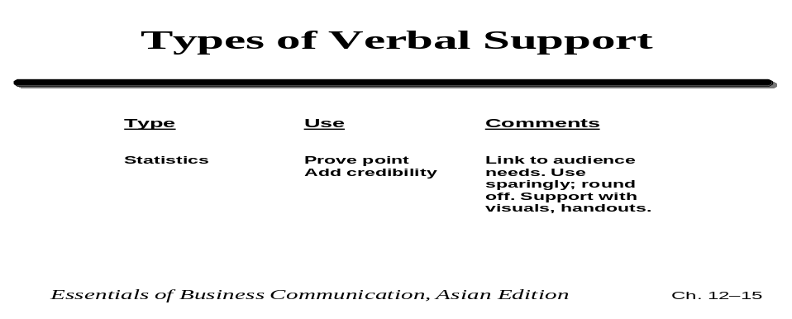
Nine Techniques for Getting Your Audience’s Attention
- A Promise
  - “By the end of my talk, you will . . . .”
- Drama
  - Tell a moving story; describe a problem.
- Eye contact
- Command attention by making eye contact with as many people as possible.
- Movement
  - Leave the lectern area. Move toward the audience.
- A question
  - Ask for a show of hands. Use a rhetorical question.
- A demonstration
  - Include a member of the audience.
- Samples, gimmicks
  - Award prizes to volunteer participants; pass out samples.
- Visuals
  - Use graphics and other visual aids.
- Appeal to the audience’s self-interest
  - Audience members want to know, “What's in it for me?”

