Business Communication Workshop

Course Coordinator: Ayyaz Qadeer
Lecture # 25

Proposal Writing

What is a Proposal?
A proposal is a document that request support-usually money- for work a proposer wants to do. What makes a proposal a proposal is that it asks the audience to approve, fund, or grant permission to do the proposed project.
Proposals: Types
- Internal proposal:
You write a proposal to someone within your organization, it is an internal proposal. With internal proposals, you may not have to include certain sections (such as qualifications), or you may not have to include as much information in them.
- External proposal:
It is one written from one separate, independent organization or individual to another such entity.
- Solicited proposal:
If the recipient of the proposal in some way requested the proposal, it a solicited proposal. Typically, a company will send out requests for proposals.
- Unsolicited proposals:
Unsolicited proposals are those in which the recipient has not requested proposals. With unsolicited proposals, you sometimes must convince the recipient that a problem or need exists before you can begin the main part of the proposal.
Things to remember
- The proposer has a particular interests and goals, and that's why he/she writes the proposal.
- The recipient of the proposal, be it an organization, a person, or a group, has its own interests and goals which may or may not coincide with those of the proposer.
- So, the proposal should be convincing to the potential funder, and it should show that the proposed activity will be a good investment.
- This is especially important when there is a competition between you and other proposers.
- Always make sure that your proposal meets the expectations of the funder.
- In order to write a proposal that meets the expectations of a given funder, you should try to know the funder`s goals and interests.
- If you are writing an unsolicited proposal to a private company, a good source of information might be the company's published reviews and annual reports.
- Requests for proposals are usually the best source of information when you are writing a solicited proposal.
- If your proposed activity and the request for proposal (RFP) don't match, try to look for another funding agency.
Some common parts of Proposal
- The general outline of the proposal should be adapted and modified according to the needs of the readers and the demand of the topic proposed. For example, long complicated proposals might contain all the following sections. In contrast, shorter or simpler proposals might contain only some of the sections or the main ones.
Title page
- Specific formats for title pages vary from one proposal to another but most include the following:
    - The title of the proposal ( as short as informative as possible)
    - A reference number for the proposal
    - The name of the potential funder ( the recipient of the proposal)
    - The proposal's date of submission
    - The signature of the project director and responsible administrator(s ) in the proposer`s institution or company
Abstract
- The Abstract is a very important part of the proposal because it provides a short overview and summary of the entire proposal.
- The Abstract of the proposal is short, often 200 words or less.
- In a short proposal addressed to someone within the writer's institution, the Abstract may be located on the title page.
- In a long proposal, the Abstract will usually occupy a page by itself following the Title page.
- The Abstract should briefly define the problem and its importance, the objectives of the project, the method of evaluation, and the potential impact of the project.
Table of contents
The table of contents lists the sections and subsections of the proposal and their page numbers.
Introduction
Plan the introduction to your proposal carefully. Make sure it does all of the following things (but not necessarily in this order) that apply to your particular proposal:
  - Indicate that the document to follow is a proposal.
  - Refer to some previous contact with the recipient of the proposal or to your source of information about the project.
  - Find one brief motivating statement that will encourage the recipient to read on and to consider doing the project.
  - Give an overview of the contents of the proposal.
Background
Often occurring just after the introduction. The background section discusses what has brought about the need for the project—what problem, what opportunity there is for improving things, what the basic situation is.
It's true that the audience of the proposal may know the problem very well, in which case this section might not be needed. Writing the background section still might be useful, however, in demonstrating your particular view of the problem. And, if the proposal is unsolicited, a background section is almost a requirement—you will probably need to convince the audience that the problem or opportunity exists and that it should be addressed.
Benefits and feasibility of the proposed project
Most proposals discuss the advantages or benefits of doing the proposed project. This acts as an argument in favor of approving the project. Also, some proposals discuss the likelihood of the project's success. In the unsolicited proposal, this section is particularly important.
Description of the proposed work
Most proposals must describe the finished product of the proposed project. In this course, that means describing the written document you propose to write, its audience and purpose; providing an outline; and discussing such things as its length, graphics, and so on.
Method, procedure, theory
In most proposals, you'll want to explain how you'll go about doing the proposed work, if approved to do it. This acts as an additional persuasive element; it shows the audience you have a sound, well-thought-out approach to the project. Also, it serves as the other form of background some proposals need. Remember that the background section (the one discussed above) focused on the problem or need that brings about the proposal. However, in this section, you discuss the technical background relating to the procedures or technology you plan to use in the proposed work.
Schedule
Most proposals contain a section that shows not only the projected completion date but also key milestones for the project. If you are doing a large project spreading over many months, the timeline would also show dates on which you would deliver progress reports. And if you can't cite specific dates, cite amounts of time or time spans for each phase of the project.
Qualifications
Most proposals contain a summary of the proposing individual's or organization's qualifications to do the proposed work. It's like a mini-resume contained in the proposal. The proposal audience uses it to decide whether you are suited for the project. Therefore, this section lists work experience, similar projects, references, training, and education that shows familiarity with the project.
Costs, resources required
Most proposals also contain a section detailing the costs of the project, whether internal or external. With external projects, you may need to list your hourly rates, projected hours, costs of equipment and supplies, and so forth, and then calculate the total cost of the complete project. With internal projects, there probably won't be a fee, but you should still list the project costs: for example, hours you will need to complete the project, equipment and supplies you'll be using, assistance from other people in the organization, and so on.
Conclusions
The final paragraph or section of the proposal should bring readers back to a focus on the positive aspects of the project (you've just showed them the costs). In the final section, you can end by urging them to get in touch to work out the details of the project, to remind them of the benefits of doing the project, and maybe to put in one last plug for you or your organization as the right choice for the project.
Appendices
Appendices (supplementary material that is collected and appended at the end of a proposal)should be devoted to those aspects of your project that are of secondary interest to the reader. Begin by assuming that the reader will only have a short time to read your proposal and it will only be the main body of your proposal (not the Appendices). Then, assume that you have gotten the attention of the reader who would now like some additional information. This is the purpose of the Appendices.
Organization of Proposals
- As for the organization of the content of a proposal, remember that it is essentially a sales, or promotional kind of thing. Here are the basic steps it goes through:
- You introduce the proposal, telling the readers its purpose and contents.
- You present the background—the problem, opportunity, or situation that brings about the proposed project. Get the reader concerned about the problem, excited about the opportunity, or interested in the situation in some way.
- State what you propose to do about the problem, how you plan to help the readers take advantage of the opportunity, how you intend to help them with the situation.
- Discuss the benefits of doing the proposed project, the advantages that come from approving it.
- Describe exactly what the completed project would consist of, what it would look like, how it would work—describe the results of the project.
- Discuss the method and theory or approach behind that method—enable readers to understand how you'll go about the proposed work.
- Provide a schedule, including major milestones or checkpoints in the project.
- Briefly list your qualifications for the project; provide a mini-resume of the background you have that makes you right for the project.
- Now (and only now), list the costs of the project, the resources you'll need to do the project.
- Conclude with a review of the benefits of doing the project (in case the shock from the costs section was too much), and urge the audience to get in touch or to accept the proposal.
Format of Proposals
You have the following options for the format and packaging of your proposal. It does not matter which you use as long as you use the memorandum format for internal proposals and the business-letter format for external proposals
- Cover letter with proposal:
In this format, you write a brief "cover" letter and attach the proposal proper after it. The cover letter briefly announces that a proposal follows and outlines the contents of it. In fact, the contents of the cover letter are pretty much the same as the introduction
- Cover memo with separate proposal:
In this format, you write a brief "cover" memo and attach the proposal proper after it. The cover memo briefly announces that a proposal follows and outlines the contents of it. In fact, the contents of the cover memo are pretty much the same as the introduction. The proposal proper that repeats much of what's in the cover memo. This is because the memo may get detached from the proposal or the reader may not even bother to look at the memo and just dive right into the proposal itself.
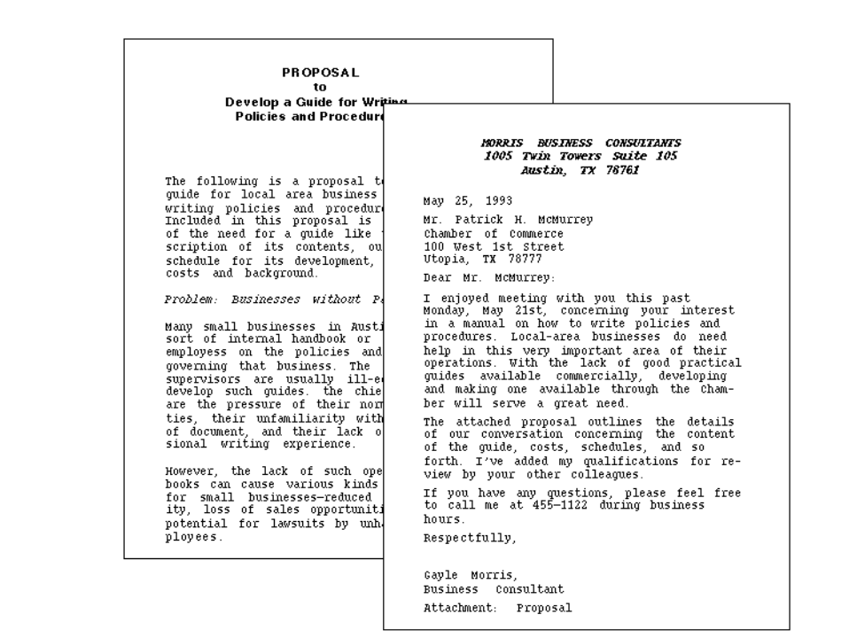

Business-letter proposal: Put the entire proposal within a standard business letter. You include headings and other special formatting elements as if it were a report
4. Memo proposal: put the entire proposal within a standard office memorandum. You include headings and other special formatting elements as if it were a report.
