Course: PAKISTAN STUDIES

Instructor: Mrs. AQEELA ASIF
Assistant Professor

Mrs. Aqeela Asif did her Bachelors in political Science & history from University of the Punjab. She did her Masters in History from the University of the Punjab with specialization of Modern Islamic World. She joined Allama Iqbal Open University in the same year as tutor for undergraduate and post graduate level in 1989. She did her B.Ed from Allama Iqnal Open University with English and Pakistan Studies. She joined Fatima Jinnah Women University as internee and Teaching Assistant in 1999. From the same year she started teaching at FJWU of different course as lecturer, at Master’s level in department of Education and Islamic Studies. She did Advance Diploma Course of English Language from National University of Modern Languages, Islamabad in 2001. In 2002, she Joined Sir Syed Institute of Technology as lecturer and was also the member of Academic Council and performed the duties of Controller of Examination. She joined COMSATS IIT in January 2004, as a Lecture. She completed Certificate level course from Institute of Peace studies (online) from USA in 2005. In the same year, she was promoted Assistant Professor. She has participated in many regional and international conferences, seminars and workshops and represented her institute and country. She is freelancing writer for print and electronic media and participated in different TV talk shows as an educationist. Her columns and articles regularly published in international and national level newspapers on different social, economic, moral and educational topics. Her research interest includes media studies, Pakistan’s current affairs & Social policy, study of life history & philosophy / teachings of celebrities of ancient and present Islamic world.

______________________________________________________________________________

Lecture # 1
Topic: Importance of Social Sciences & What is an Ideology?

- Social sciences promote social sense among students
- Creates awareness among youth about social and political issues
- Promotes sense of responsibility and patriotism

Course Objectives

- To sensitize students about the importance of Pakistan’s geographical and strategic position in South Asia.
- To promote the knowledge of Pakistani culture and civilization.
- To aware new generation about the current affairs and important pillars of Pakistan’s political system.
- To aware the students with the meaning and significance of Pakistan’s foreign policy.
- Pakistan Studies as a compulsory subject.
- To develop the qualities of patriot Pakistani for understanding and full filling their duties and responsibilities.
- To develop the sense of belongingness to their motherland. To develop strong faith in the basic concepts of Pakistan’s ideology and introduction of Pakistan’s historical background.

Text Book
Pakistan Studies by M. Ikram Rabbani

- Course outline

Tentative List of Lectures
Lecture 01 Introduction to Pakistan Studies and Ideology of Pakistan
Lecture 02 Muslim Nationalism
Lecture 03 Aims and objectives of the establishment of Pakistan
Lecture 04 Land and the People of Pakistan I
Lecture 05 Land and the People of Pakistan II
Lecture 06 Land and the People of Pakistan III
Lecture 07 History of Pakistan I (2500BC-712AD)
Lecture 08 History of Pakistan II (712AD- 1526AD)
Lecture 09 History of Pakistan III (1526- 1900AD)
Lecture 10 Evolution of Muslim Nationalism in India
Lecture 11 Emergence of Pakistan Movement
Lecture 12 Pakistan Movement – Historical events
Lecture 13 Creation of Pakistan and Role of Muslim Leadership
Lecture 14 Establishment of Pakistan I from 1947-77
Lecture 15 Establishment of Pakistan I from 1978 - 2008
Lecture 16 Different ruler from 1947-2008
Lecture 17 Constitutional Developments in Pakistan I.
Lecture 18 Constitutions of 1956
Lecture 19 Constitutions of 1962, 1973.
Lecture 20 Neighboring Countries China & Iran
Lecture 21 Neighboring Countries India & Afghanistan
Lecture 22 Pakistan’s Role in Regional & Inter. Organizations I: UNO, OIC, NAM
Lecture 23 Pakistan’s Role in Regional & Inter. Organizations II: SAARC, ECO
Lecture 24 Pakistan and the Muslim world I
Lecture 25 Pakistan and the Muslim world II
Lecture 26 Pakistan’s Foreign policy I
Lecture 27 Pakistan’s Foreign policy II
Lecture 28 Current Issues and problems of Pakistan I
Lecture 29 Current Issues and problems of Pakistan II
Lecture 30 Economy of Pakistan
Lecture 31 Industrial Sector: Problems & Solutions
Lecture 32 Agriculture Sector: Problems & Solutions

- What is an Ideology?
- Definitions of an Ideology:
“A political ideology is a system of beliefs that explain and justifies a preferred political order, either existing or proposed and offers a strategy ( institutions, processes programmers) for its attainment.” (ref. Ideologies & Modern Politics, Reo M.Christenson)
“An ideology offers an interpretation of the past, and an explanation of the present and a vision of the future.” (ref. Ibid.,p.4.)

- How an ideology emerges?
“An ideology emerges when people feel strongly that are being mistreated under an existing order, when their status is threatened by fundamental changes occurring in the society, and when the prevailing ideology no longer satisfies them” . (ref. Ibid.,p.7.)
How an ideology emerges?
1. Rejected social position
2. Time of crisis
3. Social group
4. Social stress

- Importance of an Ideology
Ideology is a motivating force for a nation which is striving hard to bring stability to its nationhood. It provides the cement binding base to the scattered groups in a society and bring them closer to each other on a common platform.

- Basis of Ideology of Pakistan
1. A balanced political system based on Islamic philosophy
2. Two Nation Concept
3. Historical background
4. Culture and civilization

- What are the aims and objectives of the creation of Pakistan?

1. Enforcement of the Sovereignty of the Allah Almighty
2. Establishment of the Islamic Democracy
3. Revival of Muslim image and Identity
4. Protection of Muslim Culture and Civilization
5. Two Nation Theory
6. To get rid of the prejudicial Hindu majority
7. Establishment of the balanced Economic System

1-Enforcement of the Sovereignty of Allah Almighty
Quaid i Azam said:
“We did not demand Pakistan to acquire a piece of land but we wanted a homeland we could introduce Islamic principles”

2-Establishment of the Islamic Democracy:
“It is my firm belief that our salvation lies in following the golden rules of conduct as given by our great law-giver, the Prophet of Islam. Let us lay the foundation of our democratic system on Islamic ideals and principles. The Almighty has taught us that our decisions in the state affairs shall be guided by mutual consultation.” (Ref. 14 February 1948. Sibi)

3-Revival of Muslim image and Identity: Hindus domination was prominent in social, economic, education and government services. United India was not the permanent solution of these problems.

4- Protection of Muslim Culture and Civilization: Distinctive cultural values, Social behavior, Culture, Civilization, Literature, Hindi- Urdu controversy, Muslims were not prepared to accept Hindu Supremacy.

5-Two nation Theory: Reference of Albruni , Shah Wali Ullah, Syed Ahmed Shaheed Barelvi, Haji Shariat Ullah, Sir Syed Ahmed Khan.

6-To get rid of the Hindu majority: Muslims came to India as conqueror, Muslims were dominated in all spheres of social life during their rule, Muslim domination aroused Hindu jealousy, British rule Muslims lost their empire & political supremacy, British extended favors to Hindus, British and the Hindu adopted a cruel policy against Muslims.

7- Establishment of the balanced Economic System: In Commerce and trade Hinds were dominated in India. After War of 1857 the British government had banned Muslim entry into government service, All high level civil and military position were reserved for the Hindus, Muslims were considered eligible only for low ranking jobs, Muslims were behind in the field of education, Muslims of Subcontinent demand for Pakistan to establish stable economic system for every individual.

______________________________________________________________________________

Lecture # 02
Topic: Muslim Nationalism and Two Nation Theory

- What is Nationalism?

- Nationalism is a political ideology that involves a strong identification of a group of individuals with a nation.
- A nation may refer to a community of people who share a common language, culture, ethnicity or history. There are two main perspectives on the origins and basis of nationalism, one is the primordialist perspective that describes nationalism as a reflection of the ancient and perceived evolutionary tendency of humans to organize into distinct grouping based on an affinity of birth;
- The other is the modernist perspective that describes nationalism as a recent phenomenon that requires the structural conditions of modern society.

- Evolution of Two-Nation theory and Nationalism

Quaid i Azam once said:

“Pakistan was established the day when the first Indian national embraced Islam”
Al-Beruni came to India in 1001 A.D with Mahmud of Ghazni and written his famous book “Kitab-ul-Hind”. He wrote that:
“The two societies the Hindu and Muslim, like two streams, have sometimes touched but never merged, each following its separate course.”

- Differences between Hindus and Muslims
1. Religious difference
2. Cultural and Social differences
3. Economic & Educational differences
4. Political differences

- Religious Differences:
According to Panikar, “two parallel societies were established on the same soil. At all steps they were different and hardly any social communication and inter mangling of life existed between them.”
Hindu Nationalism: Dr. Ashoke, the son of the well-known Indian historian writes in “Advent of Independence” that it were the Hindus who took lead in Hindu-Muslim separatism by launching the nationalist moments; Brahmo-samaj, Ariya-samaj, Shudi movement. The founders of Ariya-samaj and Brahmo-smaj were Hindu nationalist leaders and they totally ignored the great contribution made by Muslims in the Indian society and they promoted only the concept of Hindu nationalism.

- Cultural and Social Differences:
The two communities inherited cultural background with glaring contrast of outlook, history, religion and civilization, their beliefs, thinking and approach towards various aspects of life were different form each other. Hindus and Muslims followed different social customs and traditions, the Hindus burnt their dead bodies while Muslims buried them. Difference of language and communication styles; Hindus worshiped mother cow while Muslims slaughtered it for eating and sacrificial purposes. The Hindus and Muslims did not intermarry. The Muslims were taken as Maleecha (impure) and anything touched by a Muslim was polluted and extensively washed with the sacred water of Ganga.
“Hindu Muslim families which lived in the same neighborhood for generations could be distinguished at a glance from each other. The cloths, the food, the household utensils, the layout of homes, the words of salutation, the gestures and everything about them will be different and will immediately point to their distinctive origin.” (ref.CH Muhammad Ali, Emergence of Pakistan ,Pg1)
Muslims were not even allowed to enter in their kitchens and if it happens by any Muslim than the same was taken as polluted and to be washed and to shed away the impurity caused by a Muslim.

- Economic and Educational Differences:
With the fall of Mughal Empire in 1857 Muslims completely lost hold from political power in south-Asia. The British blamed Muslims for the war and put them under great stress. British had snatched power from the Muslims, they were very keen to ensure that the Muslims should not be in a position to regain their lost political power. Therefore British adopted harsh policy against Muslims. The outcome of the war of 1857 closed all doors of economic prosperity among the Muslims. But British rulers extraordinarily favored Hindus and allowed them a free access to prosper and to progress economically. Therefore the Hindus with the blessings of the British government tried their best to crush the Muslims in their economic field. The Hindus quickly monopolized the economic resources due to the opportunities provided by the British rulers. That was the real economic decline of Muslims. The Hindus had also advanced in the educational field because they quickly and readily took to the English education. Muslims were reluctant to receive modern education, which heavily affected their economic condition. At that time Muslims were dependent on Hindu money lenders for pursuing their trade and business and fell an easy prey to the cruelest exploitation by the Hindus.

- Political differences:
Political differences between Hindus and Muslims have played an important role in the development of two nation theory. Hindi-Urdu controversy in 1864 was the first political tussle between the two communities. The Hindus agitation against Urdu intensified Muslims apprehensions. All India national congress was established in 1885 by a retired civil servant A.O.Hume. At first Congress claimed that it would for the safeguards of the interest of all the communities in India, irrespective of their religion. But with the time it turned into a pure Hindu body working for the interests of the Hindus only. Congress demanded the introduction of representative democracy on British pattern; the representative democracy stands for majority rule and places a minority under the mandate of the majority for all political matters. Congress made another demand that all appointments on high civil posts should made through competitive examinations because Muslims were not highly qualified and it was difficult for them to clear competitive examinations. The acceptance of this demand would have rendered the Muslims economically destroyed. In 1905 the province of Bengal was divided on totally administrative grounds. This partition insured a number of political benefits for the Muslims but the entire Hindu community and the congress itself, erupted into volcanic agitation against the partition. So the partition of Bengal was reverted in 1911. Therefore Muslims demanded for separate electorate as a first step to provide safeguards to their political interests. In 1930’s when congress assumed the government in 8 provinces it adopted prejudice attitude with the Muslims.

That attitude leads the Muslims to the final conclusion and they started demand for a separate homeland. Muslim leadership represented the Muslims of Subcontinent at all levels effectively. Presidential address of Allama Iqbal in 1930 was very important turning and that was based on the concept of Muslim Nationalism.

- Nationalism and Allama Iqbal

Allama Iqbal preached an idea of nationalism through his poetry based on Islamic unity and brotherhood. He believed that the individual is not linked with the geographical boundaries but with a spiritual relationship. He negated the concept of territorial nationalism and supported the concept of universal Islamic unity and brotherhood.

- Conclusion:
There was an unbridgeable gulf between the Hindus and the Muslims the two communities were distinct from each other, ideologically, culturally, politically, socially and economically. In the presence of such deep rooted contrast of thinking and approach how the Muslims and Hindus, would the common nationality as claimed by Gandhi. These differences are infect, the two nation theory which became the basis of the nationalism among the Muslims which led them to the establishment of Pakistan.
______________________________________________________________________________

Lecture #3
Topic: Aims and Objectives of the Establishment of Pakistan- As Welfare State

- What is the concept of welfare state?

Definitions:
‘A welfare state is a system of government run organizations that helps everyone to have a good quality of life.’

‘A welfare state is a government that provides for the prosperity or the wellbeing of the citizens completely.’

‘It is a state in which the government assumes responsibility for minimum standards of living for every citizen.’

The term welfare state usually refers to an ideal model of provision, where the state accepts responsibility for the facility of comprehensive and universal welfare for its citizens. A welfare state is a government that involved in citizens’ lives at every level. It provides for physical, material, and social needs rather than the people providing for their own.

- History of the concept of Welfare State
It is started from the First Islamic State of Medina in 622 A.D. The concept of welfare and support to the needy was introduced in early Islamic law as forms of Zakat (charity), one of the five Pillars of Islam. It continued, developed and more refined during Pious Caliphate in the 8th century. The taxes (including Zakat and Jizya) collected in the treasury of an Islamic government were used to provide income for the needy, including the poor, elderly, orphans, widows, and the disabled. According to famous scholar Al-Ghazali 1058-1111), the government was also expected to store up food supplies in every region in case a disaster or famine occurred.

- Resolution of Welfare State
The resolution of the welfare state is to generate economic and social equality. A welfare state is to assure reasonable standards of living for all, access to justice, freedom of faith, freedom of speech and transparency in decisions of executive. The welfare state is responsible to provides education, housing, rations, healthcare, pensions, unemployment insurance, sick leave or time off due to injury, health facilities , and equal opportunities for employment. It is also delivers public transportation, childcare, social wellbeing such as public parks and libraries, as well as many other services. An ideal welfare state is responsible for human rights such as rights of non-Muslims, rights of women, rights of equal opportunities for earning and work, rights of expression and speech etc.

- Quaid e Azam and the concept of welfare state

- “It is not our purpose to make the rich richer and to accelerate the process of accumulation in the hands of few individuals. We should aim at leveling up the general standard of living amongst the masses, our ideal should not be capitalistic but Islamic and the interests and welfare of the people as a whole should be kept constantly in mind.” Quaid-e-Azam Muhammad Ali Jinnah wanted Pakistan to be a welfare state where there was justice, equality and fair play.
- In his July 1, 1948 State Bank Address he set a clear direction on the future economy of Pakistan. He said that “we must evolve banking practices compatible with Islamic ideas of social and economic life.”
- Quaid-e-Azam wanted Pakistan to be a welfare state. On March 12, 1949, the Constituent Assembly of Pakistan adopted Objective Resolution, which contained principles for framing of the Constitution based on Islamic principles including welfare state.
“Pakistan should not blindly follow Western economic theory and practice and should develop its own economic system based on true Islamic concept of equality of manhood and social justice.”
- Outlining the purpose of the creation of Pakistan the Quaid said in a speech to the officers of the Defense Services on 11th October 1947, that:
“The establishment of Pakistan was only a means to an end and not an end in itself. The idea was that we should have a state in which we could live and breathe as free men and which we could develop according to our own lights and culture and where principals of Islamic social justice could find free play.”
- Discussing the aims and objects of creation of Pakistan, in a message to the Frontier Muslim Students Federation dated June 1945, the Quaid declared:
“Pakistan not only means freedom and independence but the Muslim ideology which has to be preserved which has come to us as precious gift treasure and which we hope others will share with us.”
- In his presidential address at the Special Pakistan session of the Punjab Muslim Students Federation on 2nd March 1941, the Quaid said:
“We are a nation. And a nation must have a territory. What is the use of merely saying that we are a nation? Nation does not live in the air. It lives on the land, it must govern land, and it must have territorial state and that is what you want to get.”
- Discussing the philosophical difference between Islam and Hindustan the Quaid-i-Azam declared at the All India Muslim League Lahore Session on 23rd March, 1940: It is extremely difficult to appreciate why our Hindu friends fail to understand the real nature of Islam and Hinduism. They are not religions in the strict sense of the word, but are, in fact, different and distinct social orders, and it is a dream that the Hindus and Muslims can ever evolve a common nationality, and this misconception of one Indian nation has gone far beyond the limits and is the cause of most of your troubles and will lead India to destruction if we fail to revise our notions in time. The Hindus and Muslims belong to two different religious philosophies, social customs, and literatures. The Quaid further explained:
“They neither intermarry nor interline together and, indeed they belong to two different civilizations which are based mainly on conflicting ideas and conceptions. Their concepts on life and of life are different. It is quite clear the Hindus and Mussalmans derive their inspiration from different sources of history.”
- They have different epics, different heroes, and different episodes. Very often the hero of one is foe of the other and, likewise, their victories and defeats overlap. To yoke together two such nations under a single state, one as a numerical minority and the other as a majority, must lead to growing discontent and final destruction of any fabric that may be built up for the government of such a state.

Infect the Quaid’s concept of Pakistan was that it would be an Islamic Welfare State where no one would be exploited. Also in the Islamic Welfare State it is the duty of the state to see that there is no one without food and clothes and every individual is at least provided with basic necessities of life.

- Islamic state’s welfare Responsibilities:

- Food, Health, Shelter & Security: As per the Qur'anic teachings the Islamic state should guarantee equal rights and provision of basic necessities to all ethnic, regional, cultural, tribal and religious groups.
- Education: The Prophet Muhammad (peace be upon him) said: “One who treads a path in search of knowledge has his path to Paradise made easy by God…” – (ref. Riyadh-us-Saleheen,245) So Provision of education is the responsibility of Islamic state Gender Equality, Freedom of Thought & Expression, Protection of Religious Sentiments, Equality before Law: The Prophet says that, the life and blood of Muslims are equally precious . (ref. Abu Dawud; Ibn Majjah).
- Rights of Non-Muslims: Islam has also laid down rights for non-Muslims who may be living within the boundaries of an Islamic state. So the Holy Qur’an has referred to the basic human needs in these words : “There is therein (enough provision) for thee not to go hungry nor to go naked; nor to suffer from thirst, nor from the sun’s heat”
(ref. Al- Quran 20 : 118-119)
- The Right to Basic Necessities of Life: “The government is the guardian of anyone who has no other guardian. -(Abu Daud, Tirmizi)
The above mentioned saying of Prophet Muhammad (PBUH) establishes beyond any doubt that the responsibility of providing basic needs to its citizens lies on the Islamic state. In this matter, Islam has made no distinction between the Muslims and non-Muslims. Currently Pakistan does not resemble with the ideal Islamic Welfare State which the Quaid had envisioned and would have tried to exercise had he lived longer. Be responsible, now it’s our duty to develop Pakistan as welfare state.

A Dutch proverb says:
Money is lost nothing is lost;
Courage is lost much is lost;
Honour is lost most is lost;
Soul is lost all is lost.

______________________________________________________________________________

Lecture 4
Topic: Land & the People of Pakistan I

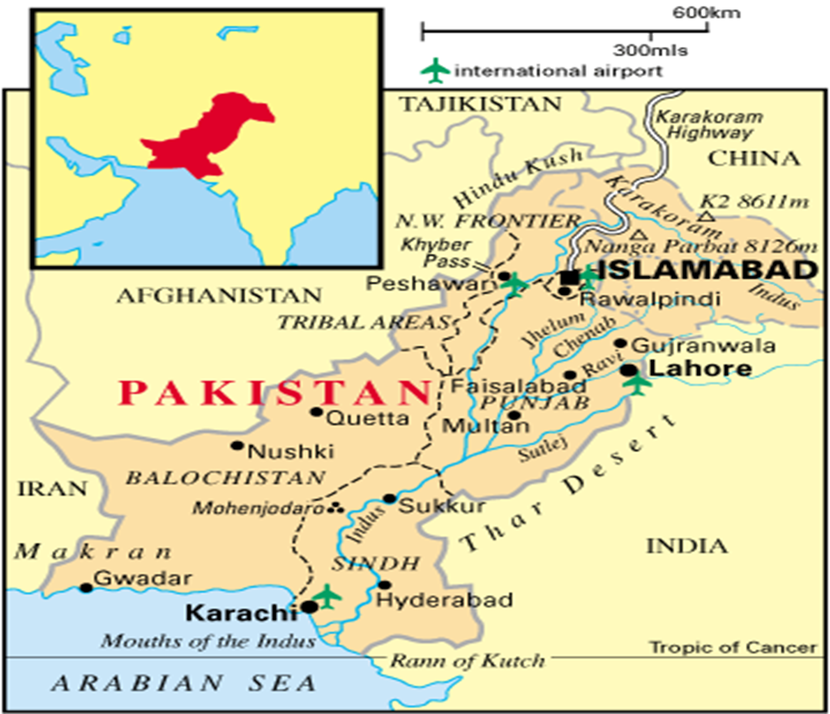
Map of Pakistan

- What is Geography?
Geography is the study of the earth’s landscapes, peoples, places and environments. It is, quite simply, about the world in which we live. Geography is unique in bridging the social sciences (human geography) with the natural sciences (physical geography).Human geography concerns the understanding of the dynamics of cultures, societies and economies, and physical geography concerns the understanding of the dynamics of physical landscapes and the environment.

- Geography informs us about:
The places and communities in which we live and work, Our natural environments and the pressures they face, The interconnectedness of the world and our communities within it, How and why the world is changing, globally and locally, How our individual and societal actions contribute to those change, The choices that exist in managing our world for the future, The importance of location in business and decision-making.

- What are Important Geographical Features:

A) Physical Environment and natural resources:
- water Sources, Rivers, Glaciers, Ground Water;
- Land Forms :Mountain, Valleys, Plateaus, Plains, Deserts;
- Climate: Temperature, Rainfall, Pressure, Humidity;
- Minerals: Metallic, Non-Metallic;
- Natural Vegetation: Forests

B) Uses of the physical environment creates “Human Environment”
Human Resources are:
- Industry;
- Agriculture;
- Mining;
- Settlement;
- Transport;
- Trade

- Importance of Pakistan’s Location:
Air Links, Sea ports, Land route/ links

- Location of Pakistan:
Pakistan is located between latitudes 24 35’ north and 37 05’ and extends from longitude 61 east to 78’ east. (approx.), The total area of Pakistan is 706,096 sq km. Stretching over 1600 km from north to south and about 885 km from east to west. (approx.)

- Boundaries of Pakistan:
- China: in the extreme north-east;
- Afghanistan: in the west, known as Durand line;
- Iran: in South-West;
- India: in East;
- Arabian Sea: South;
- Tajikistan: Wakhan is the narrow strip of Afghan territory which separates Pakistan from Tajikistan. The map shows that Pakistan’s borders with Afghanistan and India are longer than those with Iran and China; it was discovered after the disintegration of USSR in 1991that Central Asian States Republics possesses untouched power resources such as mineral oil and natural gas. This can easily be transported through Pakistan and Iran to the South Asian and South East Asian countries by constructing pipelines. These projects could bring huge economic benefits to Pakistan such as transit revenue, power resources for various industrial, commercial and domestic uses etc. Land links to the North and North West because of the large mountain ranges and the climate. Karakoram Highway makes communication with China. Khyber Pass provides a route to Afghanistan. North and north-west are land locked: thus Pakistan’s seaport of Karachi and Gwader can also serve these areas. Feasibility of Natural Gas Pipeline Project from the CAS countries and Iran to India and South East Asian countries after passing through Pakistan. Easy access to CAS Republics via Afghanistan. Inflow of Chinese industrial products to Pakistan through common border. Jinnah Terminal connects the West with Asia by Air. Karachi, a natural harbor and an important warm water port also serves as a refueling stop for ships.

- Pakistan: The Natural Topography:
- Mountains:
- The Northern Mountains and North-Western Mountains: Himalayas-Hindukush, Karakorm, Safed Koh range, waziristan hills, sulaiman range, kirthar range, The Siwaliks , salt range etc.

- Valleys of Himalayas: Murree and gallies, kaghan
Valleys of Hindukash range: Sawat, Chitral, Dir
Valleys of karakuram range: Gilgit, Haunza, Baltistan

- Glaciers: Baltoro, Batura and Siachin in the karakuram range.

- Passes through the western mountains: Khyber, Kurram, Tuchi, Gomal, Bolan.
Passes through the northern mountains: Khunjerab, Shandur, Babusar.

- Plateau: Potwar, Salt range, Baluchistan plateau

- Plains: Upper Indus Plain, Lower Indus Plain, Labella Plain

- Deserts: Cholistan(Punjab), Nara (Sindh), Therparkar(Sindh), Thal(Punjab), Kharan (Balochistan)

- Administrative Division of Pakistan
Punjab, Sindh, KPK, Baluchistan, Azad Kashmir, FANA, FATA

Quotation

“Geography has made us neighbors,
History has made us friends,
Economics has made us partners,
and necessity has made us allies.”

______________________________________________________________________________
Lecture 5
Topic: Land & the People of Pakistan II

- Background: Separation in 1947 of British India into the Muslim state of Pakistan (with two sections West and East). The dispute over the state of Kashmir is ongoing.

- Location: Southern Asia, bordering the Arabian Sea, between India on the east and Iran and Afghanistan on the west and China in the north.30 00 N, 70 00 E, Area: total: 803,940 sq km (approx.), Iran

- Coast line: 1,046 km (approx.)

- Climate: mostly hot and dry

- Natural resources: land, extensive natural gas reserves, limited petroleum, coal, iron ore, copper, salt, limestone

- Population:

The population of the country is a double faced phenomenon is a vital factor in the development process on one hand while rapid population growth can impede development on the other.
Two aspects of population: (A) Quantitative, (B) Qualitative:

(A)Quantitative population: the quantitative aspects of population include statistics of total population, density of population, birth and death rates and migration.

(B) Qualitative population: The qualitative aspects refer to the ability and capability of the people.

Total Population:170 million (approx.)
Nationality: Pakistani
Ethnic groups: Punjabi, Sindhi, Pashtun, Baloch, Muhajir etc
Religions: Muslim 97%(Sunni 77%, Shi’s 20%), Christian, Hindu and others 3%

- Languages: Punjabi 48%, Sindhi 12%, Siraiki 10 %; Pashtu 8%, Urdu (National) 8%, Balochi 3%, Hindko 2% Brahui 1%, English (official), Burushaski and others 8%

- Literacy rate: age 15 and over can read and write
Total literate population: 48.7% (approx.)
Male: 61.7% and Female: 35.2% , (approx.)

- Punjab is the most populous province with the population density of 333.5pesons per sq. Km followed by KPK 253.6 persons per sq. Km and Sindh 212.8 person per sq. Km. Baluchistan has the least population density where only 18.8 persons live in a sq. Km.
- Most Urbanized Areas, Islamabad, Sindh, Punjab, Baluchistan, KPK, Lahore and Karachi are the thickly populated areas of Pakistan. Punjab and Sindh are very hot in summer and winters are pleasant.

- Climate divisions of Pakistan are:
- Highland: Northern areas (cold winters, mild summers and rainfall in all seasons)
- Lowland: Punjab (cool winters, hot summers, monsoon rainfall)
- Coastal: Makran and Surrounding areas (mild winters and warm summers.
- Arid: Desert areas (Mild winter, hot summers and extreme aridity)

- Current Environmental Issues:
Water pollution from raw sewage, industrial wastes, and agricultural runoff;
Limited natural fresh water resources, a majority of the population does not have access to portable water, Deforestation, Soil erosion, Desertification, Natural Hazards, Frequent Earthquakes, Occasionally severe especially in north and west, Flooding along the Indus after heavy rains (July to August)

- Government:
Country name: Islamic Republic of Pakistan
Government type: Federal Republic
Administrative division: Four provinces, one capital territory, Federally Administrated Tribal Areas, Federally Administrated Northern Areas, the Pakistani-administered portion of the disputed Jammu and Kashmir region include Azad Kashmir.
Pillars of the Government System: Legislation, Administration, Judiciary, Defense and Media.

- Political Pressure groups:
Military, ulema, landowners, industrialists and small merchants also influential

- Export commodities: garments, bed linen, cotton cloth and yarn, rice, leather goods, sports goods, chemicals, carpets and rugs
- Imports commodities: petroleum, petroleum products, machinery, plastics, transportation equipment, edible oils, paper and paperboard, iron and steel, tea.
- Currency code: PKR
- Internet country code: .pk
- Radio broadcast stations: AM, 31 and FM,68 (approx.)
- T.V stations: 27 (approx.)
- International Air ports: 08
- Airports: 50 (approx.)
- Sea ports: 05 (Baluchistan),03 (Sind)
- Dry ports: 11
- Railway Stations: 34

- Agriculture in Pakistan:
About 57% of Pakistan's total land area is under cultivation and is watered by one of the largest irrigation systems in the world. The most important crops are cotton, wheat, rice, sugarcane, corn, pulses, oil seeds, barley, fruits and vegetables.

- Fishing in Pakistan:
Fishery and fishing industry plays an important role in the national economy of Pakistan. With a coastline of about 1046 km, Pakistan has enough fishery resources that remain to be fully developed. It is also a major source of export earnings.

- Forestry in Pakistan:
About only 4% of land in Pakistan is covered with forests. The forests of Pakistan are a main source of food, wood for domestic use, paper, fuel wood, rubber, medicine as well as used for purposes of wildlife conservation and tourism.

- Mining in Pakistan:
The Salt Range in the Potwar Plateau has large deposits of rock salt. Pakistan has extensive mineral resources, including fairly sizable reserves of gypsum, limestone, chromite, iron ore, rock salt, silver, gold, precious stones, gems, marbles, tiles, copper, sulfur, fire clay, silica sand.

- International Agreements

Pakistan is a party to several international agreements related to environment and climate, the most prominent among them is:
1) Specific Regions and Seas , Law of the Sea, Ship Pollution (MARPOL 73/78)
2) Atmosphere and Climate, Climate Change, Ozone Layer Protection
3) Biodiversity, Environment, and Forest: Desertification, Endangered Species, Environmental Modification, Marine Life Conservation
4) Wastes: Dangerous Wastes
5) Rivers: Indus Waters Treaty

- Conclusion:
The geography of Pakistan is a profound blend of landscapes varying from plains to deserts, forests, hills, and plateaus ranging from the coastal areas of the Arabian Sea in the south to the mountains of the Karakoram Range in the north.
______________________________________________________________________________

Lecture # 6
Topic: Land & the People of Pakistan III
- Annual Rainfall- Its Distribution and types
Rainfall in Pakistan is mostly brought by the following Types of winds in different periods during the year:
Convectional rain in early summer
Monsoonal or relief rain in summer from south west monsoon
Cyclonic rain caused by depressions brought along the prevailing westerly winds in the cool seasons.
- Seasons
Hot Season – April to June
Rainy Season – July to September
Cool Season – October to March
- Rural and Urban Areas
Pakistan is an agricultural country and 80 % of its people form the rural population of the country,
The villages, towns and small cities form the rural areas of Pakistan
Their main profession is cultivation and ploughing

- Differences between Rural and Urban Way of Life
The rural and urban life differs in a number of ways. For an agricultural country like Pakistan, it is essential to understand how and why life in rural and urban areas differs.

1. Function
Villages and towns differ in function. Villages are usually engaged in primary activities, including farming, animal keeping, loading, fishing etc. Towns are engaged in secondary activities, like manufacturing, trade, transport, telecommunications, education, medical treatment and other activities. However, these two sets of activities are not exclusively confined to rural and urban areas. Shops, transportation services, educational and medical facilities are found in rural areas, too. But less facilities of modern life are available in villages as compare to town and cities. In urban areas, on the other hand, relationships tend to be impersonal; urban areas are thickly populated that most people do not even know who their neighbors are. This is case in large urban centers like Karachi and Islamabad.

2. Lifestyle
Some specialists believe that lifestyle is a distinguishing feature of villages and towns. According to them, close contact with other members of the community is a distinctive feature of rural life. The inhabitants of a village, for example, usually know each other personally. However, even in modern cities, there are pockets in the city where people who belong to the same community or village live. In such areas people know each other and have closer contact with their neighbors.
In small towns, which are in reality overgrown villages, most people know one another as well.

It is also argued that while village life is traditional, urban life is rational. This is not entirely the case in Pakistan. Most of the urban population in Pakistan has a strong rural background. Although the use of urban facilities changes their way of living, it does not change their way of thinking much. In Pakistan, the lifestyles of the rich and poor differ far more than the lifestyles of city and village dwellers. The objective application of lifestyle as a factor for distinguishing between villages and towns is therefore difficult.

3. Population
Another factor used to distinguish between villages and towns is population. Although this opinion is applied in many countries, there is no agreement on size. In Canada, for example, a settlement with a population of more than 1,000 is considered urban, in Japan more than 30,000 and in Pakistan, 5,000. Pakistan, a settlement can also call itself a town if it has a two committee or cantonment that controls electricity, the water supply and drainage. For example, Ziarat in Baluchistan had a population of 619 in 1998, but it was still classified as a town because it had these services. However, there are only ten towns with populations of less than 5,000 out of a total 478 urban centers in Pakistan.

- Important Cities of Pakistan
Rawalpindi-Islamabad
Famous for: General Headquarters of the Pakistan Army, Air and Naval Headquarters
Cotton and textile mills, steel mills and oil refineries.
Quality educational Institutions
Only hill resort in Punjab-Murree
Beautiful place (Margallah hills)and pleasant climate

- Karachi is famous for:
Capital city of the province Sind and the largest city of Pakistan
Coast line & Sea ports
Trade, Industry, education and other fields of life
Beautiful beaches- hawks Bay
International Airport
Quaid –i- Azam was born in Karachi
Steel Mill

2. Lahore is famous for:
Capital city of the province of Punjab
Historical city
Lahore resolution 1940 & Minar-i-Pakistan
City of Colleges
City of Gardens
Commercial and trade center
Number of Newspapers, journals and magazines published from Lahore

3. Peshawar is famous for:
Peshawar is the capital city of Khyber Pakhtunkhawa.
Khyber pass
Historical city
Qissa Khawani Bazar
Famous educational Institutions

4. Quetta is famous for:
Quetta is the provincial capital of Baluchistan
Bolan Pass, Hanna lake and Urak valley
Staff College
Important center of Baluchistan
Educational Institutions
Strategic importance
Fruit producing city

- Provincial Setup of Pakistan
History: In 1947 Pakistan was consist on two provinces, East Pakistan and West Pakistan. The Eastern part was separated from the rest of the country in 1971.The Present Pakistan which consists of the western part of the country, comprises of four provinces and a number of Tribal areas. The tribal areas are situated in the extreme north of the country.

These provinces are further sub-divided into divisions and divisions into districts and sub-divisions for administrative purposes. Every district is divided into tehsil while the tehsils consist on several villages. Before partition Punjab, East and west Punjab, consist of 28 districts, eleven districts fell in Eastern Punjab, which declared as part of India, and 17 districts were included in the Western Punjab which fell in Pakistan. This distribution of districts remained unchanged till 1956 when scheme of One Unit was introduced in Pakistan. One Unit was dissolved by President Yahya Khan in 1969 and Punjab once again got the status of a province.

At that time three new districts were announced and after this many new districts announced till 1991. Baluchistan & KPK there are 29 districts in Baluchistan. Baluchistan has the lowest population density. Quetta is the biggest city of Baluchistan. KPK has 24 districts the urban population in the province has increased. Peshawar is the biggest city of KPK. Sind is called the gift of the Indus. It is known as Babul Islam because of Muhammad bin Qasim. It is the land of sufis, saints and poets. The province has 27 districts. The word Punjab means the land of the five rivers. It is the biggest province of the country. Punjab has 35 districts. Northern Areas
Northern Areas or Gilgit –Baltistan is the northernmost region of Pakistan. It has six districts.
Five peaks of the world are in the northern areas of Pakistan. World’s largest glaciers are in Northern areas such as Baltoro & Hipsar. K-2, 2nd highest mountain of the world is in Northern areas.

- Social life in Pakistan
And above all, we boost of a strong social unit.Our family system is strongest in the world where we respect our elders and do not abandon them to old homes. We in Pakistan, have a social setup where a father/grandfather is usually considered a figure of authority and this helps keeps things balanced at home. Pakistan is the best place to be when you are in your old age. We have a country that makes us, Pakistanis, everywhere proud. So stand up and tell the world,
“We are proud to be a Pakistani”.

Lecture # 07
Topic: History of Pakistan I (2500BC-712AD)

- It is fascinating to learn about how people lived in the past. History teaches us to learn from past. ‘People who do not learn from history have to repeat it’. History teaches us to understand the modern world.

- How to learn history?
To look at sun, Sun dial, Water clock, Important event, BC (Before Christ), AD (Anna Domini which is Latin word for ‘year of our Lord’)

Years BC are counted backwards and year AD in the normal way. Muslims calendar start from the event of ‘Hijrah’ and based on the movement of moon. Concept of stone age, metal age, fertile crescent empires, modern age etc.

- Historical Background of Pakistan

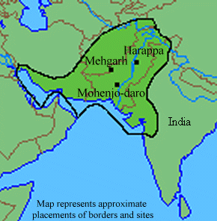

- Indus Valley Civilization 2500-1500 BC
2500-1500BC: The Indus Valley Civilization or Harappian Civilization was at its peak and was possibly the largest of all ancient civilizations in terms of population. Mohenjo-Daro and Harappa were two of the many urban parts of this civilization that had trade connections with various places in Iran, Afghanistan, Mesopotamia/Iraq, and many parts of India including Bombay and New Delhi. Following are the Special features of Indus valley Civilization:
Agriculture: wheat, cotton, corn, pluses.
Industry: Tools of copper, bronze, and stone.
Textile: cotton and silk cloth
Sophisticated pottery and other kinds of cooking and serving utensils
Architecture: Three-story brick houses were built in Mohenjo-Daro& Harappa
Trade and Business: They had trade relations with various places in Iran, Afghanistan, Mesopotamia/Iraq, and many parts of India including Bombay and New Delhi.

- The Aryan Civilization: 2000- 1,500 BC

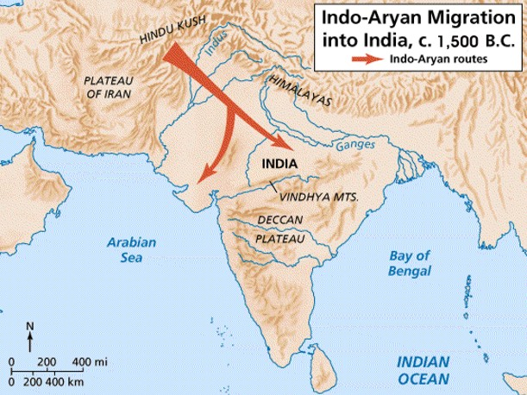
A group of warrior nomads, the Aryans, began to migrate into the Indus Valley region around the time that the Harappan Civilization began to decline. The nomadic Aryans were a cattle-breeding society, and they learned how to live as settled agriculturists from the remaining Harappan people.

- The Persian Empire: 520 BC

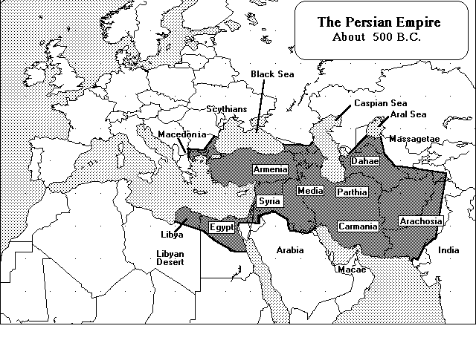
From 539 BC to 331 BC, the Persian Empire was the most powerful state in the world. Ruled from Persia (now Iran), it stretched from Egypt to India. It had rich resources of water, fertile farmland, and gold. The Persians worshiped a fire god, Zoroaster. They employed special spies, known as “the king’s ears,” But some spies became powerful, and joined with enemies of the empire, such as Alexander the Great, the Greek leader who conquered the Persian Empire in 331 BC.

- Alexander- the great: 336 -323 BC

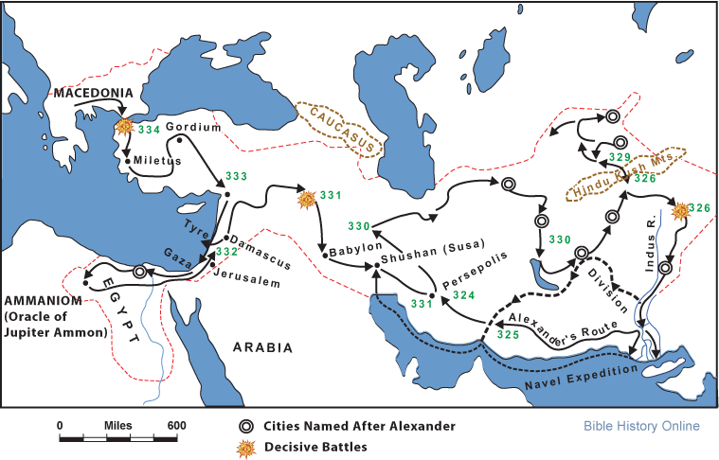
Aged twenty-five, Alexander the Great defeated the combined might of the Persian Empire and became the richest ruler in the world but he died at the age of 32.That brief but systematic empire-building campaign changed the world. It spread Greek ideas and culture from the Eastern Mediterranean to Asia. Historians call this era the "Hellenistic period."

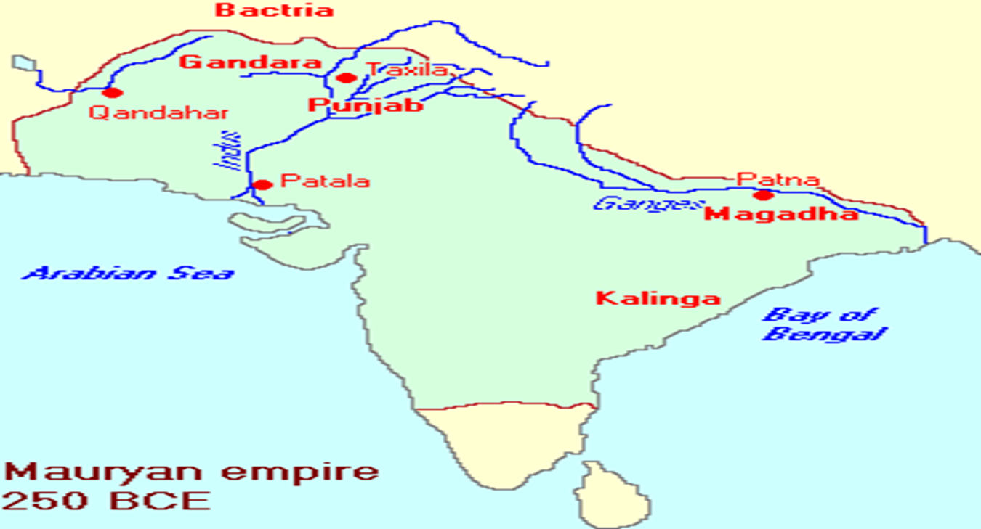
- The Mauryan Empire & Asoka: 269 -233

Greek control over the area along the Indus weakened after the withdrawal of Alexander and certainly after his death in 323 B.C. This unstable state of affairs must have provided Chandragupta with an opportunity to conquer and annex the territories. Ashoka was the third emperor of the Mauryan Empire; he ruled from 269-233 BC and promoted Buddhism.

- The Greeks & Ghandhara Civilization: 175 - 160 BC

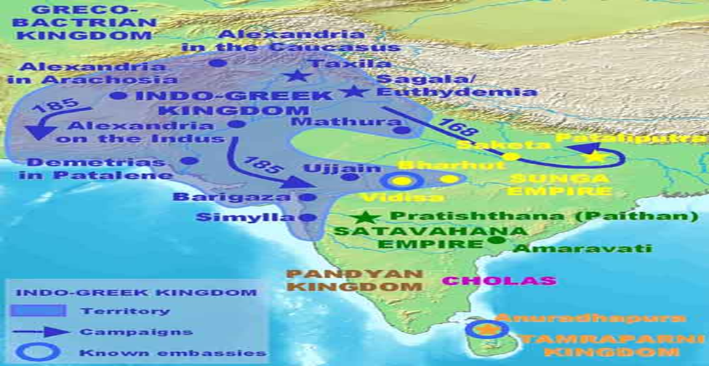

The Greek king , conquered the Kabul River Valley around 175 BC. & re-built Taxila and Pushkalavati as their twin capital cities in Gandhara.

- They were followed in 75 BC by Iranian nomads from Central Asia, and in about 50 BC by the powerful Parthians. After defeating the Greeks in 53 BC, the Parthians ruled the northern Pakistan area. During their era of trade and economic prosperity, the Parthians promoted art and religion. The Gandhara School of art developed, which reflected the glory of Greek, Syrian, Persian and Indian art traditions.

- The Kushans: (the next wave of invaders from central Asia): 50 AD

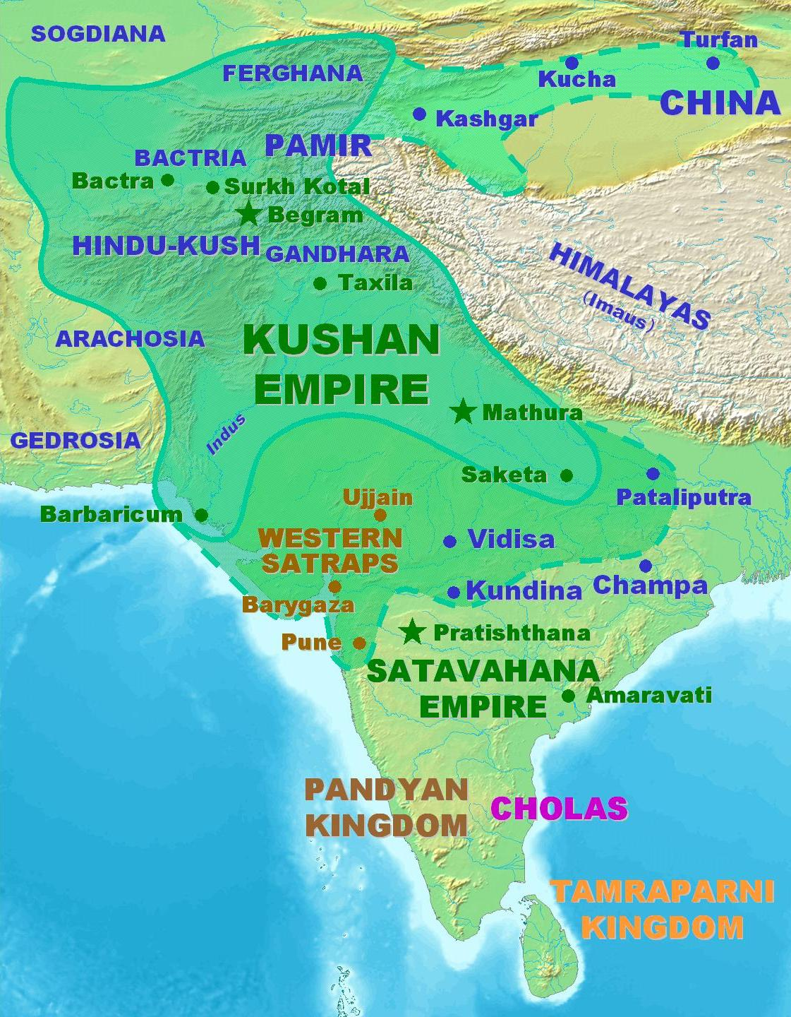
The Kushana king, ruler of nomad tribes from Central Asia, overthrew the Parthians in 64 AD and took over Gandhara. The Kushans further extended their rule into northwest India and Bay of Bengal, south into Bahawalpur. They made their winter capital at Purushapura, the City of Flowers, now called Peshawar, and their summer capital north of Kabul. The Kushans, made the northwest frontier of subcontinent part of their empire around 50 AD. The empire was wealthy, gaining substantial revenue by controlling most of the major Asian land trade routes. Very high quality coins made from gold earned by trading with the Roman Empire was used to pay for luxury goods such as spices, silk and metalwork.

- Gupta Empire (320-720 AD)

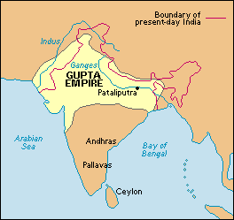

In the later part of the third century, Kushan power declined. Chandragupta I was a princely ruler in one of the kingdom. He established one of the most fertile and richest kingdoms in the heartland of the former Mauryan Empire. During the time of the Gupta Empire , Indians enjoyed a Golden Age in the arts, sciences and religion. Hinduism flowered and expanded throughout India. The Hindu epic writings of the Ramayana and the Mahabbarata were completed and spread to all in the Empire. Hindu temples and shrines were built throughout the lands ruled by the Guptas. Sanskrit poetry, drama and art grew in importance, resulting in the Gupta period to be known as the classical age of Indian culture and arts.

- HUNS Invasion

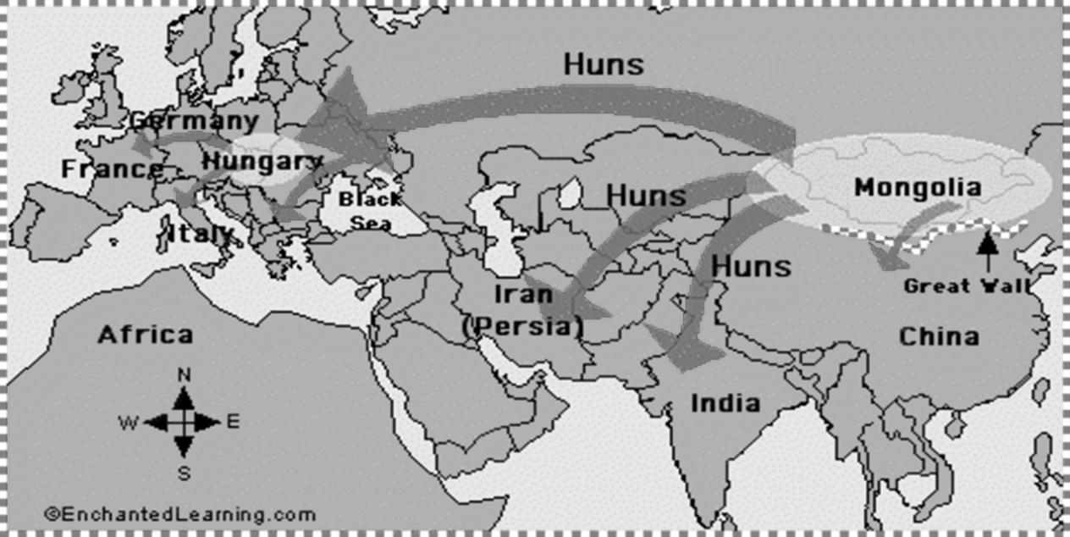

Wars of succession and invasions from the Huns resulted in the gradual decline of the Gupta Empire. The Empire split up but Gupta rulers continued to rule Magadha in a minor capacity until 720. HUNS terrorized the Chinese for years before many migrated to the banks of the Volga River in Central Asia. It is debatable if these affects were good or bad, but it is impossible to deny the Huns shaped the world we live in today.

K . Muslims arrival in Subcontinent.

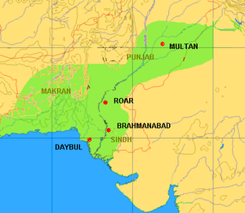

Muhammad bin Qasim 712 AD. Muhammad bin Qasim Al-Thaqafi (Arabic: محمد بن قاسم‎) (c. 31 December 695–18 July 715) was an Umayyad general who, at the age of 17, began the conquest of the Sindh and Punjab regions along the Indus River for the Umayyad Caliphate. He was born & raised in the city of Taif (in modern day Saudi Arabia). Qasim's conquest of Sindh and Punjab laid the foundations of Islamic rule in the Indian subcontinent.

Quotes about history:

If you want to understand today, you have to search yesterday. Pearl Buck
The challenge of history is to recover the past and introduce it to the present.
David Thelen
______________________________________________________________________________

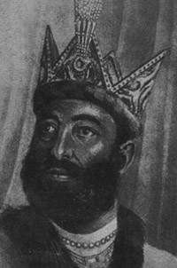
Lecture # 08
Topic: History of Pakistan II (712AD- 1526AD)
- Mahmud Ghaznwi: 998 – 1030 AD
Sultan Mahmud Ghaznawi at the age of 27 announced his claim to the throne of Afghanistan. He was the son of Turkish slave named Sebktigin. In 1001 Sultan Mahmud captured Peshawer and in 1005 make it center for his forces. He expanded his kingdom through some 17 invasions of the Punjab and northeastern India.
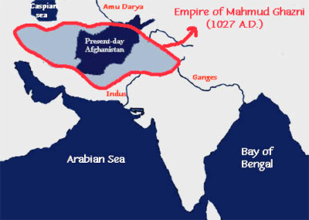
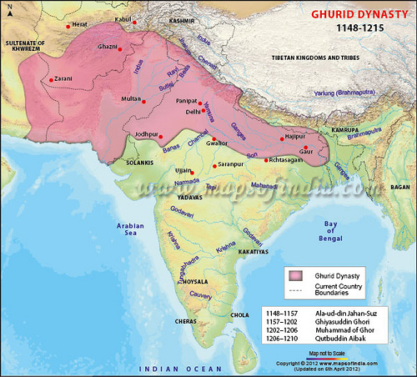
Muhammad Ghori: 1185-1206 AD After Mahmud along this historic high road came Shahabuddin Muhammad Ghori (1185) who established Muslim rule in Delhi for the first time by defeating Prithvi Raj. He had has the credit to establish the first Muslim in Delhi. In 1206, he was killed while offering his evening prayer.

- Slave Dynasty 1206-1290 AD
Qutub-ud- Deen Aybak (1192-1210). Qutbuddin was born somewhere in the area near Afghanistan. Qutbuddin rose through the ranks to become the Emperor Muhammad Ghauri's most trusted general. Qutbuddin Aibek was patron of art and architecture. One of the most prominent is "Qutib Minar" started by Qutbudin Aibek but completed by his successor Shamsuddin Iltutmish. He died while playing polo in Lahore
- Khalji Dynasty:(1290–1320)

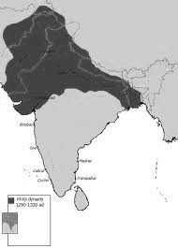

- Sayyd Dynasty (1414 to 1451)
Delhi Sultanate has been controlled by several ruling powers over the period of Indian history. Sayyd and Lodhi Dynasty are two of the major rulers of Delhi, which have played significant role in the history of Delhi Sultanate before Mughal empires started ruling over India. Sayyd Dynasty empowered India for about 37 years. Khizar Khan was the founder of the Sayyd Dynasty.
- Lodhi Dynasty (1451-1526)
Compared to Sayyd, the Lodhi Dynasty was a better ruling empire who was in power for about 75 years. Established by Buhlul Lodhi in 1451, Lodhis ruled Delhi till 1526. Buhlul Lodhi was one of the successful rulers of his time. He expanded his dynasty by invading the neighboring states.
- End of Salateen, Mughal Empire and European Entrance
Muhammad bin Qasim: 712AD, Mahmud Ghaznwi: 998 – 1030 AD, Muhammad Ghori: 1185-1206 AD, Qutub-ud- Deen Aybak (founder of Dehli Sultanate. Sultanate starched from Punjab in the west to the Bihar region in the East) 1192-1526 AD. Vas Code Gama, a Portuguese navigator entered in subcontinent in 1498 AD.
- Mughal Empire 1526-1857
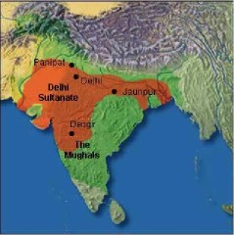

Founder : Zaheer-ud-Deen Baber 1526 AD
Effective rulers were: Humayun,Akbar,Jahangir, Shsh Jhan, Aurangzab 1707 AD
Ineffective rulers were remained on the throne at Dehli till 1857 AD
- Challenges for Mughals
- Afghans: (Sher Shah Suri, 1530– Humayun)
2- Ahmed Shah Durrni, 1747- Aurangzeb
3- Hindus: (Shiveji & Marhats 1646 – Aurangzeb)
4- Persians: (Nadir Shah 1738 – Auranzeb Alamgir)
5- Sikhs: (Ranjeet Singh,1799-1849 – Shah Alam)
6- British: ( Since the time of Jahngeer EIC was trying to capture the power and wealth)
- Impact of Islam- Cultural & Religious Influence
Islam gained quick and unmatched popularity throughout the Sub-continent and by the end of 14th century Islam had entered in all parts of India.
Cultural Influence: (Why it was attractive for local natives?) Because:
- No concept of cast system in Islam
- Simple, easy and understandable
- Introduced a new social system
- Promoted tolerance and acceptance
- Challenged Hindu society
- Stressed on the doings of the individual rather than the superiority or inferiority
- Islam became for the blessing for lower classes of India
- Islam showed them a new way of life
- Islam introduced a respectable way of life
- Languages like Sanskrit were influenced by Arabic, Persian and Turkish by interaction and a new language Urdu or Hindi developed

- Religious Influence
- Islam and Hinduism differ in their attitude towards life
- Concept of Tawheed in Islam
- Concept of equality in society in Islam
- Islam also left its impact on the religious sphere of India and important developments occurred in the Hindu temples and their architectures began reflecting the Islamic way of constructions
- Hindu religious leaders started preaching of brotherhood ,equality and peace
- Baba Guru Nank was highly influenced by Islamic teachings
- Muslim sufis and mystics presented a liberal view of Islam by the personal examples of piety and humanitarian approach
- Hindu reformers gave a serious thinking on eliminating unethical social principles of Hinduism in order to make it more tolerable and acceptable faith
- Bhagti Movement was lunched in the 14th century to bridge the gap between two religions from Hindu reformers

- Din-I-Illahi
Akbar occupied the throne of Delhi in 1566, he wanted to promote collaboration with Rajput chiefs for this purpose he married a number of Rajput women and he also appointed Hindus on high level government posts. The Hindu courtiers of Akbar encouraged him to introduce a new religious faith by combining the Hinduism and Islam so he introduced Din-I-Illahi in 1582. The immediate result of announcement of Din-i-illhi was the loss of Muslim political loyalty in the Indian society so Akbar’s attempt to merge the different religious faiths bitterly failed. Din-I-illahi and its effect quickly disappeared with Akbar’s death.
- Start of Different Religious and Educational Movements from Muslims
- Hazrat Mujadid Alfsani challenged the might of Akbar the great Mughal emperor to reestablish the glory of Islam.He firmly believed in two nation theory.
- Hazrat Shah Waliullah was a great saint scholar and reformer of eighteenth centenary he adopted a balanced approach and understanding towards religious matters, he introduced the basic beliefs of Islam to the people and promoted Quranic education. He removed misunderstandings between Shias and Sunnis. Shah Wali Ullah’s Services:
ShahWaliullah provided leadership in the political field against Marhatas and Sikhs who had created serious problems to the Mughal rulers. He translated Holy Quran into simple Persian language afterward his two sons Shah Rafi uddin and Shah Abdul Quadir prepared Urdu versions of the Holy Quran.
- Syed Ahmed Shaheed Barailvi : Syed Ahmed Shaheed was born in 1786 and begin his carrier as a Sawar in service of Nawab Amir Khan the ruler of Tonk. At that time Punjab was ruled by the Sikh ruler Ranjit Singh who treated Muslims harshly and there was no freedom for Muslims to practice their religion so Syed Ahmed decided to launch jihad movement against the Sikh rule. Syed Ahmed occupied Peshawar in 1830. Syed Ahmed shifted to Balakot and faced another attack by the Sikh army the Muslims were defeated in the battle in which Syed Ahmed was martyred in 1831.
- Next movement was ‘Farizi Movement’: Haji Shriat ullah started this movement in 1820. The fraizi movement stressed on the performing the fraiz, religious duties imposed by God and His Prophet. One hand zamindars who were mostly non-muslims were exploiting the Muslims and on other hand EIC was crushing the Muslim rulers and people. He preached and revived basic Islamic teachings of social life and basic beliefs, till his death in 1840.
- Aligarh Movement and Sir Syed Ahmed Khan: The war of 1857 had ended in disaster the British blamed Muslims and therefore took severe actions against the Muslims to eliminate them from the society. At that time all high government civil and military positions were reserved for the Hindus and non-Muslims. Since the social position of the Muslims heavily depended on their government employment this measure clearly effects the economic and social position of the Muslims at that time some dedicated leaders and reformers appeared on the scene to pull the Muslims out of this depression. Among those leaders Sir Syed was the prominent leader who launched movements for the Muslim revival.
Quotation:
If you would understand anything, observe its beginning and its development.
(Aristotle)

Lecture # 09
History of Pakistan III (1526- 1900AD)
- Mughals

In 1526 in his fifth attempt, Babur defeated the last of the Delhi Sultans, Ibrahim Shah Lodi, at the First Battle of Panipat. The Mughal emperors were Muslims and direct descendants of Genghis Khan through Chagatai Khan and Timur. At the height of their power in the late 17th and early 18th centuries, they controlled most of the subcontinent—extending from Bengal in the East to Baluchistan in the West, Kashmir in the North to the Bay of Bengal in the South.
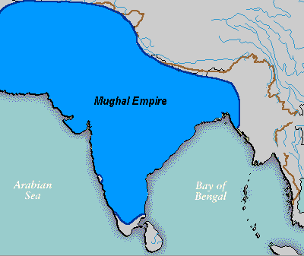
Mughal Empire was started by Zaheer-ud-Deen Baber in 1526-1530 and effective rulers were: Nasir-ud-Din Humayun:1530-56, with a break from 1540 to 1555, Jalal-ud-Din Akbar (1556-1605), Nur-ud-Din Jahangir (1605-27), Shihab-ud-Din Shah Jahan (1627-58) and Muhayyi-ud-Din Aurangzeb (1658-1707) . Ineffective rulers were remained on the throne at Dehli till 1857. Last ruler was Bahadur Shah Zafar. 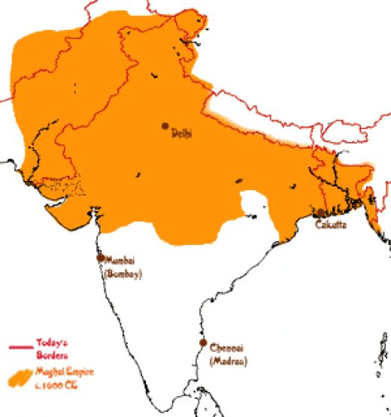

The "classic period" of the empire started in 1556 with the accession of Akbar the Great. Under his rule, India enjoyed much cultural and economic progress as well as religious harmony Akbar was a successful warrior; he also forged martial alliances with several Hindu Rajput kingdoms. The rule of Shah Jahan, the fifth emperor, was the golden age of Mughal architecture and the arts. He built many splendid monuments, the most famous of which is the legendary Taj Mahal at Agra, as well as the Pearl Mosque, the Red Fort, Jama Masjid (Mosque), and the Lahore Fort.
The Mughal Empire reached the peak of its territorial expansion during the rule of Aurangzeb. During his lifetime, victories in the south expanded the Mughal Empire to more than 1.25 million square miles, ruling over more than 150 million subjects, nearly 1/4th of the world's population, with a combined GDP of over $90 billion. 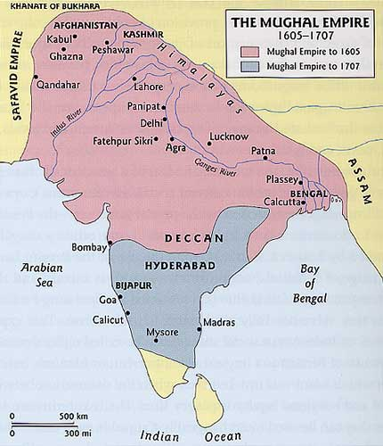
By the mid-18th century, the Marathas had captured many Mughal provinces from the Deccan to Bengal, and internal dissatisfaction (as well as separatist agendas from the Rajputs, Sikhs, and Jats) arose due to the weakness of the Mughal Empire's administrative and economic systems.
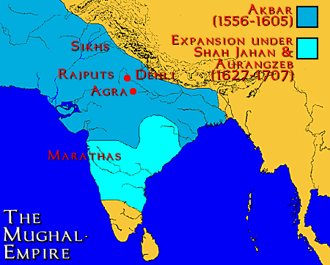

In 1739, a weakened Mughal Empire was defeated in the Battle of Karnal by the forces of Nader Shah of Iran. Mughal power was severely limited. The last emperor, Bahadur Shah II had authority over only the city of Shah-jahan-abad. He supported the Indian Rebellion of 1857 and was overthrown by the British. Rivals of Mughals in Subcontinent were Afghans: (Sher Shah Suri, 1530– Humayun), Ahmed Shah Durrni, 1747- Aurangzeb, Hindus: (Shiveji & Marhats 1646 – Aurangzeb), Persians: ( Nadir Shah 1738 – Auranzeb Alamgir), Sikhs: (Ranjeet Singh,1799-1849 – Shah Alam), British: ( since the time of Jahngeer EIC was trying to capture the power and wealth)
- European Influence
Vas Code Gama, a Portuguese navigator entered in subcontinent in 1498. East India Company was founded in 1600 which governed with the consent of Parliament until 1858.Company bought a strip of sandy beach at Madras in 1639,required a lease to part of Bombay. At that time Akbar and Jahangir (1605) was ruling in Subcontinent. King Charles II in 1668 & in 1690 got permission of settlement in Calcutta- the company built a fort known as factory from which the British conducted trade/business activities. The French got off to a slow start in their attempt to build a trading empire in India and East India Company French in 1664 but never succeeded in fostering a trade volume comparable to that of British. In 1746, under the aggressive leadership of Joseph Francis Duplex French army clutched Madras however during the seven years’ war, the French surrendered & peace treaty was concluded in 1763. East India Company in the 1740’s, Clive’s greatest triumph came at the Battle of Plassy. In 1757, British also defected Maysour’s ruler, Hyder Ali and his son Tippu Sultan in 1780s. Different British Governor Generals ruled over India from 1780 to 1947.
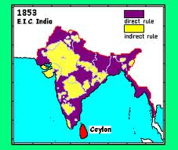
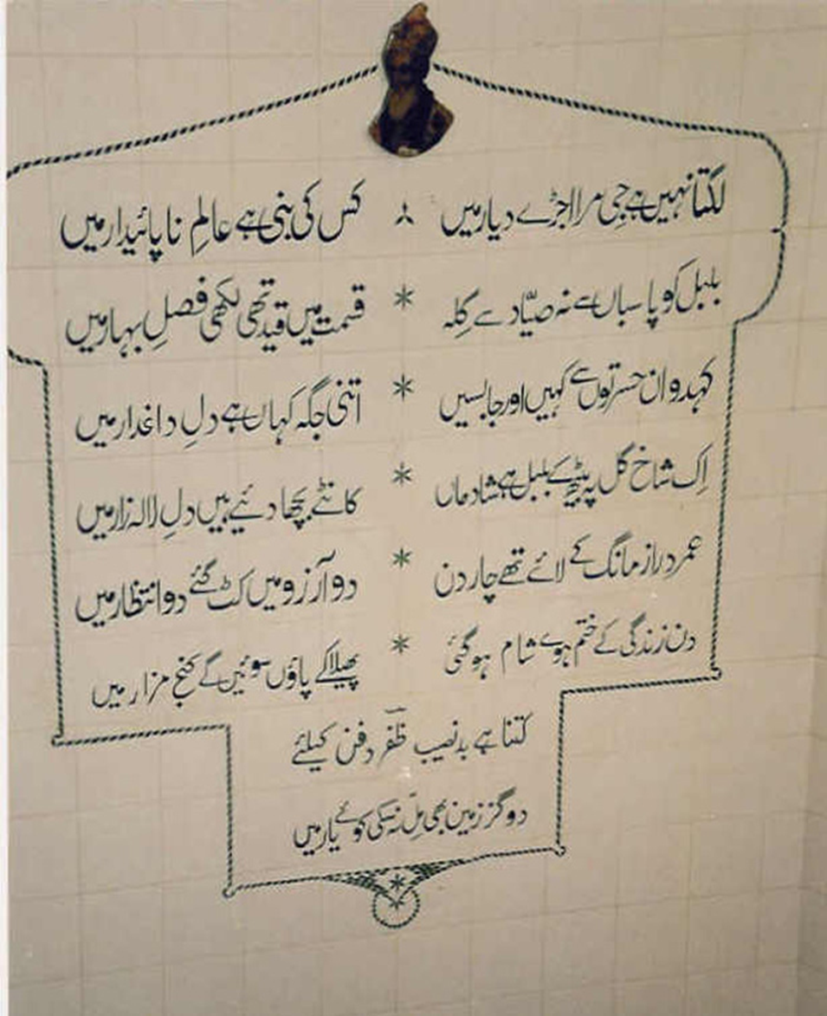
In 1857 many traditional groups largely in north revolted. British army defused & crushed revolts one by one in different areas and also captured rule in center Delhi and that was the complete down fall of Mughal era.
- Start of Muslim Political Struggle
Shah Wali Ullah against Marhts invited Ahmed Shah Abdli in 1761at 3rd Battle of Panipat. Syed Ahmed Shaheed Baralvi against Ranjeet Singh in 1826 from Akora (N.W.F.P). Haji Shariat Ullah from Bengal in 1820 against British. Sir Syed Ahmed Khan played a vital role in restoring relations between the British & Muslim after war of Independence and in helping Muslims to appreciate the value of modern education.
- Start of Pakistan Movement
Legislative Councils Act, 1861: Sir Syed Ahmed Khan indicated in the ‘Causes of Indian Revolt’, several weakness of the British government and advised the government:
i- to give the representation to the local people in the Legislative Council to create sentiments of loyalty
ii- enforcement of Legislative Council Act of 1861 was the first step taken for the constitutional reforms in Subcontinent in spite of its limited scope an opportunity to the Indian people to safeguard their political interests.
iii- Sir Syed Ahmd Khan was nominated as the member of the legislative council under the Act of 1861
- Different Educational/Reforms Movements
- Aligarh Movement (western education)
- Tehrik-i-Deoband, Saharnpur(Islamic education & traditions)
- Anjumn-i-Himyat-i-Islam Lahore(modern education according to Islamic principles)
- Nadva-tul-Ulema Luckhnow (gereral reformation of muslim society and to remove sectarian differences among different groups of Ulema)
1. Aligarh Movement: It was based on two fold program:
i) Muslims revival
ii) Cooperation with British government
Different institutions of Aligarh
1)School of Muradabadin, 1859 (Persian & English)
2)School of Ghaziabad, 1864 (Translated work from English to Urdu)
3)Scientific Society,1866. published a journal, Aligarh Institute Gazette
4)M.A.O high school was established in 1874
5) M.A.O College at Aligarh in 1877
6) The college upgraded to the level of university in 1920
- Political aspect of the Aligarh Movement
Sir Syed contended that his political vision gave an independent political expression to the Muslim community, which aided its goal of securing political power in India. His philosophy guided the creation of the All India Muslim League in 1906, as a political party separate from the Congress. Sir Syed's ideas inspired both the liberal, pro-British politicians of the Muslim League and the religious ideologues of the Khilafat struggle. In the 1940s, the student body of Aligarh committed itself to the establishment of Pakistan and contributed in large measure to the activities of the Muslim League. Sir Syed's patronage of Urdu led to its widespread use amongst Indian Muslim communities and following the Partition of India its adoption as the official language of Pakistan, even though Bengali and Punjabi were more prevalent at the time.
Quotation:
Acquisition of knowledge of science and technology is the only solution for the problems of Muslims.
Sir Syed Ahmed Khan

Lecture # 10
Evolution of Muslim Nationalism in India
- Evolution of Muslim Nationalism in India
The EIC which came to India for trade purposes, soon over powered the political system which resulted in the end of glorious Muslim rule over India. Muslims had come to India as conquerors and settle down to dominate every walk of life. Naturally new development in politics did not suit them and they were not happy over the turn of affairs. The Muslims began their revival struggle under Syed Ahmed Shaheed Barailvi which unfortunately failed.They again put up a bold struggle to throw off the British slavery when the war of Independence was fought against the British. In this hour of despair and distress Sir Syed Ahmed Khan came forward to pull the Muslims out of the position of hopelessness.
- Indian Councils Act of 1861
With the passage of time the British Government decided to associate the people of the subcontinent with the law making process. For this purpose the Indian Councils Act was passed on 1st August 1861.
- The Indian Councils Act of 1892
The political climate of the subcontinent underwent a big change due to the formation of Indian National Congress in 1885. With growing political awareness the educated class started demanding representative institutions in India. The Bill was introduced in the House of Lords in 1890 and after a delay of two years, it was passed in 1892
- Urdu-Hindi Controversy 1867
During the last days of the Muslim rule, Urdu emerged as the most common language of the northwestern provinces of India. It was declared the official language, and all official records were written in this language. In 1867, some prominent Hindus started a movement in Banaras in which they demanded the replacement of Urdu with Hindi, and the Persian script with the Deva Nagri script, as the court language in the northwestern provinces. The reason for opposing Urdu was that the language was written in Persian script, which was similar to the Arabic script, and Arabic was the language of the Quran, the Holy Book of the Muslims. The Urdu-Hindi controversy had a great effect on the life of Sir Syed Ahmad Khan. Before this event he had been a great advocate of Hindu-Muslim unity and was of the opinion that the “two nations are like two eyes of the beautiful bride, India”.
- Change in Sir Syed's thought
But this movement completely altered his point of view. He put forward the Two-Nation Theory, predicting that the differences between the two groups would increase with the passage of time and the two communities would not join together in anything totally. That was the main turning in Indian politics towards ‘Two-Nation Theory’
- Partition of Bengal 1905
Finding the Bengal Presidency too large for one governor to administer, in 1905 the English decided to redraw its boundaries and divided it into two parts. Incidentally, the partition went in favor of the Muslims. The Muslims of India welcomed the partition of Bengal, but the Hindu community strongly opposed it.
Analysis
Three factors had kept Muslims away from the Congress, Sir Syed’s advice to the Muslims to give it a wide berth, Hindu agitation against the partition of Bengal and the Hindu religious revivalism’s hostility towards the Muslims.
- Formation of All India Muslim League 1906
On December 30 1906, the annual meeting of Muhammadan Educational Conference was held at Dhaka under the chairmanship of Nawab Viqar-ul-Mulk. Almost 3,000 delegates attended the session making it the largest-ever representative gathering of Muslim in India. For the first time the conference lifted its ban on political discussion, when Nawab Salim Ullah Khan presented a proposal for establish a political party to safeguard the interests of the Muslims; the All India Muslim League.This way All India Muslim League was established in Dhaka in 1906. Maulana Muhammad Ali Jouhar wrote the constitution of the League, known as the “Green Book”. Branches were also setup in other provinces. Syed Ameer Ali established a branch of the League in London in 1908, supporting the same objectives.
- Minto-Morley Reforms 1909
In 1906, Lord Morley, the Secretary of State for Indian Affairs, announced in the British parliament that his government wanted to introduce new reforms for India, in which the locals were to be given more powers in legislative affairs. After the approval of Lord Minto and Lord Morley, the Act of 1909 was passed by the British parliament. The Act of 1909 is commonly known as the Minto-Morley Reforms. Right of separate electorate was given to the Muslims.
- The Lucknow Pact 1916
In 1913, a new group of Muslim leaders entered the folds of the Muslim League with the aim of bridging the gulf between the Muslims and the Hindus. The most prominent amongst them was Muhammad Ali Jinnah. The Muslim League changed its major objective and decided to join hands with the Congress in order to put pressure on the British government. Quaid-e-Azam Muhammad Ali Jinnah titled: An Ambassador of Hindu-Muslim Unity and was also written by prominent Indian politician, after Lakhnow pact. When the All-India Muslim League came into being, it was a moderate organization with its basic aim to establish friendly relations with the Crown. However, due to the decision of the British government to annul the partition of Bengal, the Muslim leadership decided to change its goals, in 1913, and they decided to start Joint independence struggle with Congress.
Analysis
Although, that Hindu-Muslim Unity was not for more than eight years and collapsed after the Khilafat Movement but it was the first time when Congress recognized Muslim League as the political party, representing the Muslims of the region. As Congress agreed to separate electorates, it infact agreed to consider the Muslims as a separate nation. They thus accepted the concept of the Two-Nation Theory.
- Khalafat Movement 1919
The general impression among the Muslims of India was that the western powers were waging a war against Islam throughout the world in order to rob it of all its power and influence. The Ottoman Empire was the only Muslim power that had maintained a impression of authority and the Muslims of India wanted to save the Islamic political power from destruction. Muhammad Ali argued that for Muslims to accept mandates over Iraq, Syria and Palestine would amount to a total disregard of the wishes of the Holy Prophet (S. A. W.). Thus the Muslims of India launched the Tehrik-i-Khilafat. The objectives were as follows:
- To maintain the Turkish Caliphate.
- To protect the holy places of the Muslims.
- To maintain the unity of the Ottoman Empire.
Analysis
Although the Khilafat Movement failed to achieve its declared objectives, it carried political awakening to large masses of Muslims. It was during the Khilafat days that representatives of Indian Muslims came into contact with eminent notables from other Muslim countries to save the unity in Islamic world. The Khilafat Movement was an asset for the struggle of Pakistan. It made clear to the Indian Muslims to trust neither the British nor the Hindus, but to look to their own strengths for self-preservation.
- Analysis: Change in Muslim politics
Muslim Politics in British India: 1924-1935
Under this theme we will be discussing 6 major developments:
- Delhi Muslim Proposals
- Simon Commission
- Nehru Report
- Quaid-e-Azam,s Fourteen Points
- Round Table Conference
- Allama Iqbal’s Presidential address 1930
One significant development was the end of the Khilafat Movement that had come to an end, and then the efforts to promote Hindu Muslim unity had also suffered but the Muslim leaders were still trying if somehow some kind of understanding can be developed with the Congress leadership. Delhi Muslim Proposals 1927 was major move in this regard.
- Delhi Muslim Proposals 1927
Considering separate electorates to be the main hindrance in improving Hindu-Muslim relations, Quaid-i-Azam proposed that if the Hindus agreed to provide certain safeguards, the Muslims would give up this demand . So, in effect, the Muslims agreed to give up the separate electorates in form of the reservation of seats. Unfortunately, the Congress first accepted but later rejected the proposals. Simon Commission (The Government of India Act 1919 was essentially transitional in character. Under Section 84). Simon Commission was sent to the Sub-continent under the command of Sir John Simon. All members of the commission were British. That was regarded as highly insulting to the Indians and immediate protest was raised from all the important political parties. When the Simon Commission arrived, the local masses welcomed it by with slogans of “Go back Simon!”.

- Nehru Report 1928
After the failure of Simon Commission, there was no alternative for the British government but to ask the local people to frame a constitution for themselves. In 1928,an All Parties Conference was arranged to solve the constitutional problems of India.A committee was set up under Pandit Moti Lal Nehru. That committee prepared a report which is known as "Nehru Report".Thus the Nehru Report was nothing else than a Congress document and thus totally opposed by Muslims of the Sub-continent. The recommendations of the Nehru Report went against the interests of the Muslim community. Two Muslim members of the Nehru Committee, Syed Ali Imam could attend only one meeting due to his illness and Shoaib Qureshi did not endorse views of the Committee on the issue of Muslim representation in legislature.

c) Jinnah’s 14 Points 1929
1. Federal System
2. Provincial Autonomy
3. Representation of Minorities
4. Number of Muslim Representative
5. Separate Electorates
6. Muslim Majority Provinces
7. Religious Liberty
8. Three-Fourth Representation
9. Separation of Sind
10. Introduction of Reforms in N.W.F.P and Baluchistan
11. Government Services
12. Protection of Muslim's culture and Language
13. One-Third Muslim Ministers
14. Constitution

- Comparison between Jinnah’s 14 points with Nehru Report
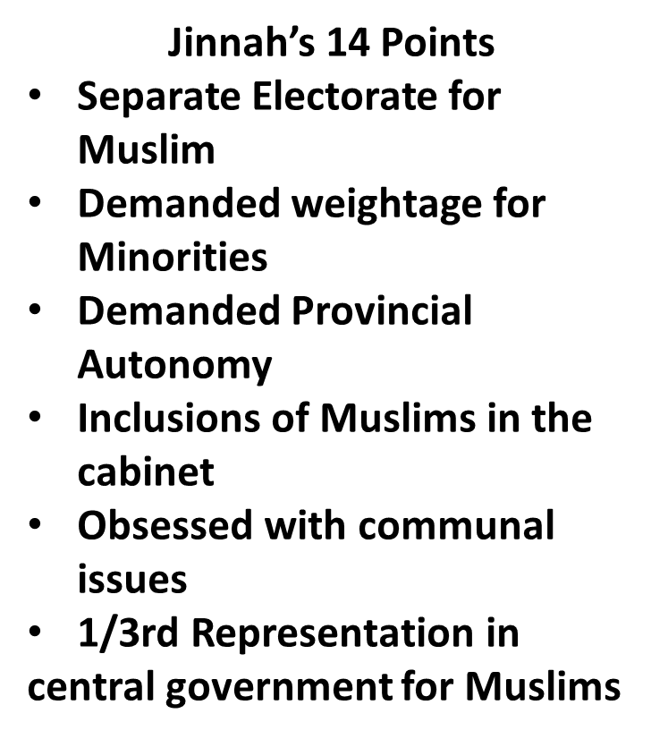
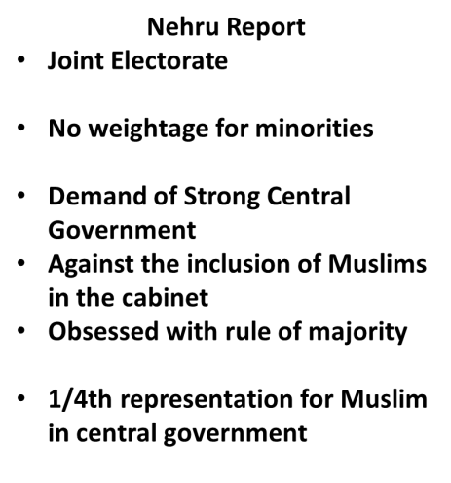

- Round Table Conferences 1930-32
The first session of the conference opened in London on November 12, 1930. All parties were present except for the Congress, whose leaders were in jail due to the Civil Disobedience Movement. The second conference was held in London on September 7, 1931. The main task of the conference was done through the two committees on federal structure and minorities Gandhi was a member of both but he adopted a very unreasonable attitude. He claimed that he represented all India and dismissed all other Indian delegates as non-representative. The third session began on November 17, 1932. It was short and unimportant. The Congress was once again absent. In those days Quaid-i-Azam did not participate in the session of the Second Round Table Conference as he had decided to keep himself aloof from the Indian politics and to practice as a professional lawyer in England.
Analysis
The result of these deliberations was the Government of India Act, 1935, establishing provincial autonomy and also a federal system but that was never implemented.
- Allama Iqbal’s Presidential address 1930
As a permanent solution to the Muslim-Hindu problem, Iqbal proposed that Punjab, North West Frontier Province, Baluchistan and Sindh should be converted into one province.
He declared that the northwestern part of the country was destined to unite as a self-governed unit, within the British Empire or without it. This, he suggested, was the only way to do away with communal riots and bring peace in the Sub-continent.
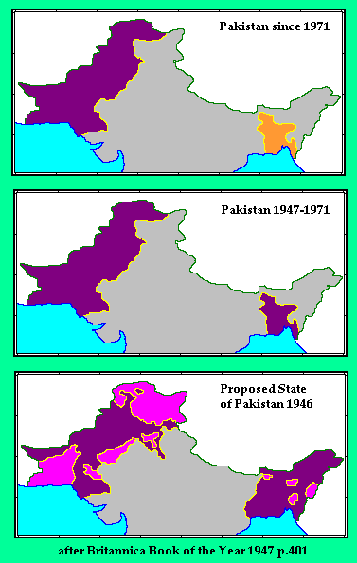
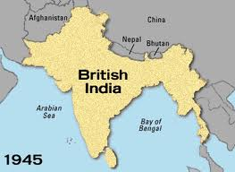
Analysis
The greatest historical significance of Allama Iqbal’s Allahabad address was that it ended all political confusion from the minds of the Muslims, thus enabled them to determine their new destination. The national spirit that Iqbal fused amongst the Muslims of India later on developed into the ideological basis of Pakistan.
Quotation:
The Story of Pakistan, its struggle and its achievement, is the very story of great human ideals, struggling to survive in the face of odds and difficulties.
Quaid-i-Azam Muhammad Ali Jinnah (Chittagong, March 1948)
Lecture # 11
Emergence of Pakistan Movement
- Government of India Act 1935
After the failure of the Third Round Table Conference, the British government gave the Joint Select Committee the task of formulating the new Act for India. The Committee comprised of 16 members each from the House of Commons and House of Lords, 20 representatives from British India and seven from the princely states. The Bill was discussed in the House of Commons for 43 days and in the House of Lords for 13 days and finally, after being signed by the King, was enforced as the Government of India Act, 1935, in July 1935.When Quaid-i-Azam Mohammad Ali Jinnah had returned from England in 1934-35, the Muslim League was almost dead and Muslims in India as a community lacked direction, objective, a leader and a platform.
Analysis
Both the Indian National Congress and the Muslim League opposed the Act, but participated in the provincial elections of winter 1936-37, conducted under provisos of the Act. At the time of independence, both India and Pakistan accepted the Act of 1935, with few amendments, as their provisional constitution. Government of India Act of 1935 was practically implemented in 1937.
- Elections 1935-36
There were two major political parties in the Sub-continent, the Congress and the Muslim League. Both parties did their best to motivate the masses before these elections and put before them their manifesto. The political manifestos of both parties were almost identical, although there were two major differences. Congress stood for joint electorate and the League for separate electorates; Congress wanted Hindi as official language with Deva Nagri script of writing while the League wanted Urdu with Persian script. The results of the elections were shocking for the Muslims of India and Muslim League as well, which could not get mentionable support from the voters. Congress achieved a big victory and managed to get clear majority in five provinces. After four-month delay, Congress formed their ministries in July 1937.
- Congress Ministries 1937
The Congress proved to be a pure Hindu party and worked during its rule only for the betterment of the Hindus. Twenty-seven months of the Congress rule were like a nightmare for the Muslims of South Asia. Some of the Congress leaders even stated that they would take revenge from the Muslims for the last 700 years of their slavery.
- Bande Matram
- Wardha Scheme
- Raising of three- colored flag
- Widdia Mander Scheme
- Hindi Muslim riots Muslim Mass contract Campaign
At the outbreak of the World War II, the Viceroy proclaimed India’s involvement without prior consultations with the main political parties. When Congress demanded an immediate transfer of power in return for cooperation of the war efforts, the British government refused. As a result Congress resigned from power. Muslim League remained very active during the terrible rule of the Congress. It continued drawing attention of the masses, through it resolutions, to anti-Muslim polices of the Congress and appealed to the congress to change its biased attitude towards the Muslims. With the resignation of the Congress ministers the Muslims of India observed the Day of Deliverance on 22nd December, 1939.
- Pakistan Resolution 1940
From March 22-24, 1940, the All India Muslim League held its annual session at Minto Park, Lahore. This session proved to be historical. Having passed the Pakistan Resolution, the Muslims of India changed their ultimate goal. Instead of seeking alliance with the Hindu community, they set out on a path whose destination was a separate homeland for the Muslims of India.
- Cripps Mission 1942
The British government wanted to get the cooperation of the Indian people in order to deal with the war situation. The divergence between the two major representative parties of the country harassed the British government. It found it difficult to make the war a success without the cooperation of both the Hindus and the Muslims. On March 22, 1942, Britain sent Sir Stafford Cripps with constitutional proposals.The important points of the declaration were as follows:
- General elections in the provinces would be arranged as soon as the war ended.
- A new Indian dominion, associated with the United Kingdom would be created.
- Those provinces not joining the power could form their own separate union.
- Minorities were to be protected.
However, both the Congress and the Muslim League rejected these proposals. Jinnah opposed the plan, as it did not acknowledge Pakistan. Thus the plan came to nothing.
- Wavell Plan and Simla Conference 1943-45
In May 1945, Lord Wavell, the Viceroy of India, went to London and discussed his ideas about the future of India with the British administration. To discuss these proposals with the leadership of major Indian parties, Wavell called for a conference at Simla on June 25, 1945. Leaders of both the Congress and the Muslim League attended the conference, which is known as the Simla Conference. However, differences arose between the leadership of the two parties on the issue of representation of the Muslim community. The Muslim League claimed that it was the only representative party of the Muslims in India. Congress, which had sent Maulana Azad as the leader of their delegation, tried to prove that their party represented all the communities living in India
- Elections 1945
All this resulted in a deadlock. Finally, Wavell announced the failure of his efforts on July 14. Thus the Simla Conference couldn’t provide any hope of proceeding further. With the failure of the Simla Conference, Lord Wavell announced that the Central and Provincial Legislature elections would be held in the winter of 1945, after which a constitution-making body would be set up. He also announced that after the elections, the Viceroy would set an Executive Council that would have the support of the main Indian political parties. Both the Muslim League and the Congress opposed the proposal. Quaid-i-Azam declared that Muslims were not ready to accept any settlement less than a separate homeland. The WWII finally came to an end in1945. Jinnah declared on behalf of the Muslim League that no settlement would be acceptable except on the basis of Pakistan.While the All Indian Congress Committee considered the proposals as “unsatisfactory”. The elections were held in two stages. In December 1945 the central legislative assembly was elected and Provincial elections were held in early 1946. Congress won a total of 930 seats, gaining an absolute majority in eight provinces. The Muslim League captured 428 out of the possible 492 Muslim seats.
The elections of 1945-46 proved that Muslim League alone represented the Muslims of India. The sweeping majority of ML increased Congress hostility towards the ML.
- Cabinet Mission Plan 1946
All of the British Government’s attempts to establish peace between the Congress and the Muslim League had failed.
The results of the general elections held in 1945-46 served to underline the urgency to find a solution to the political deadlock. Which was the result of non-cooperation between the two major parties. To end this, the British government sent a special mission of cabinet ministers to India. The mission consisted of Lord Pethic Lawrence, the Secretary of State for India, Sir Stafford Cripps, President of the Board of Trade, and A. V. Alexander, the First Lord of the Admiralty.
The purpose of the mission was: Preparatory discussions with elected representatives of British India and the Indian states in order to secure agreement as to the method of framing the constitution.
- Setting up of a constitution body.
- Setting up an Executive Council with the support of the main Indian parties.
The mission arrived on March 24, 1946. After extensive discussions with Congress and the Muslim League, the Cabinet Mission put forward its own proposals on May 16, 1946. The Muslim League accepted the plan on June 6 1946. Earlier, the Congress had accepted the plan on May 24, 1946, though it rejected the interim setup. The Viceroy should now have invited the Muslim League to form Government as it had accepted the interim setup; but he did not do so.
Meanwhile Jawaharlal Nehru, addressing a press conference on July 10, said that the Congress had agreed to join the constituent assembly, but saying it would be free to make changes in the Cabinet Mission Plan. Under these circumstances, the Muslim League disassociated itself from the Cabinet Plan and resorted to “Direct Action” to achieve Pakistan. As a result, Viceroy Wavell invited the Congress to join the interim government, although it had practically rejected the plan.
However, the Viceroy soon realized the ineffectiveness of the scheme without the participation of the League. Therefore, on October 14, 1946, he extended an invitation to them as well. On March 22, 1947, Lord Mountbatten arrived as the last Viceroy. It was announced that power would be transferred from British to Indian hands by June 1948.
- Arrival of Lord Mountbatten & Partition Plan 1947
Lord Mountbatten entered into a series of talks with the Congress and the Muslim League leaders. Quaid-i-Azam made it clear that the demand for Pakistan had the support of all the Muslims of India and that he could not withdraw from it. With reliable activists as Patel agreeing to the Muslim demand for a separate homeland, Mountbatten now prepared for the partition of the Sub-continent and announced it on June 3, 1947.
- June 3rd Plan 1947
When all of Mountbatten’s efforts to keep India united failed, he asked to chalk out a plan for the transfer of power and the division of the country. It was decided that none of the Indian parties would view it before the plan was finalized. The plan was finalized in the Governor’s Conference in April 1947, and was then sent to Britain in May where the British Government approved it. The plan was made public on June 3, and is thus known as the June 3rd Plan. June 3 Plan (1947) was comprised of the following main points on the basis of which Britain, after dividing it, was to quit India:
1. Two separate states will be established in India.
2. The present constitution assembly will to act but its constitution will not be applicable on the areas which will not accept it.
3. The power will be transferred the same year (1947) to the representatives of India.
4. The Muslim majority areas and the Hindu majority distinct of Bengal and Punjab will decide in separate meeting to accept or not to accept the division of the provinces. If anyone of the two groups will opt division, the province will be divided.
5. The Muslim majority areas which will not opt to join present constituent assembly, will create their separate constituent assembly.
- Radcliffe Award 1947
It was provided in the June 3 plan that as soon as the legislatures of Punjab and Bengal decided in favor of partition, a boundary commission should be set up to demarcate the boundaries. The legislatures of Bengal and Punjab voted in favor of partition. Boundary commissions were set up for Punjab and Bengal under the chairmanship of Sir Radcliffe. Each commission was to consist of an equal number of representatives of India and Pakistan and one or more impartial members. The final award was announced on 17 August, 1947. The Radcliffe Award was unfair to Pakistan because it awarded many Muslim majority areas in Punjab and Bengal to India. Calcutta was given to India. Muslim majority tehsils of Gurdaspur and Batala were given to India along with Pathankot tehsil. The Muslim majority tehsil Ajnalain in Amritsar district was also handed over to India. In Jullundur district the Muslim majority areas in Ferozpur district were also given to India. All of these areas were attached to western Punjab. This unfair award resulted in India's occupation of Kashmir and snatching from Pakistan important head works and giving them to India.
- Quotation:
“Come forward as servants of Islam, organize the people economically, socially, educationally and politically and I am sure that you will be a power that will be accepted by everybody.”
Quaid-i- Azam
Presidential Address at the All India Muslim League, Lahore
March 23, 1940
______________________________________________________________________________
Lecture # 12
Topic: Pakistan Movement Important Events
- Analysis :Radcliffe Award
Jinnah told the people of Pakistan that the awards were ‘Wrong, unjust and perverse’. However partition had taken place two days earlier and there was little to be done. Besides that there were many other problems which were pressing for the new country. It was time to establish Pakistan as a viable member of the world community. The two self-governing countries of India and Pakistan legally came into existence at the stroke of midnight on 15 August 1947. The ceremonies for the transfer of power were held a day earlier in Karachi, at the time the capital of the new state of Pakistan, so that the last British Viceroy, Lord Mountbatten of Burma, could attend both the ceremony in Karachi and the ceremony in Delhi. This is why Pakistan's Independence Day is celebrated on 14 August and India's on 15 August. The partition of India was set forth in the Indian Independence Act 1947 and resulted in the dissolution of the Indian Empire and the end of the British Raj.
It resulted in a struggle between the new states of India and Pakistan and displaced up to 12.5 million people in the former British Indian Empire, with estimates of loss of life varying from several hundred thousand to a million. The violent nature of the partition created an atmosphere of mutual hostility and distrust between India and Pakistan that effects their relationship to this day.
The partition included the geographical division of the Bengal province of British India into East Bengal, which became part of the State of Pakistan (from 1956, East Pakistan). People migrated from these areas to Pakistan and Hindus and Sikhs to India
Same happened in West Bengal which became part of India, and a similar partition of the Punjab province became West Punjab (later the Pakistani Punjab and Islamabad Capital Territory) and East Punjab (later the Indian Punjab, as well as Haryana and Himachal Pradesh).
- Major Issues due to unfair partition
The main problems for Pakistan were:
- Refugees
- Accession of Princely States
- Indus Water
- Administrative issues
Pakistan came into existence with horrible loss of life and property, and the migration of millions of stunned and poor men, women, and children. The cost was heavy in terms of human suffering. But what the Muslims wanted and what they achieved was a homeland of their own. They now had the freedom to worship, practice their religious faith and develop their culture. The majority of refugees who migrated after the independence were settled in the port city of Karachi in southern Sindh and in the cities of Hyderabad, Sukkhur, Nawabshah and Mirpurkhas. As well the above many settled in the cities of Punjab mainly in Lahore, Multan, Bahawalpur and Rawalpindi. The number of migrants in Sindh was placed at over 540,000 of whom two-third were urban. In case of Karachi, from a population of around 400,000 in 1947, it turned into more than 1.3 million in 1953. Refugees settled in Pakistan and they were welcomed by the local people and set many examples of the Islamic concept of Muslim brotherhood e.g., Former President of Pakistan, General Pervez Musharraf, was born in the Nahar Vali Haveli in Daryaganj, Delhi, India. Several previous Pakistani leaders were also born in different regions of India. Pakistan's first prime minister, Liaquat Ali Khan was born in Karnal (now in Haryana). The 7-year longest-serving Governor and martial law administrator of Pakistan's largest province, Balochistan, General Rahimuddin Khan, was born in the city near Uttar Pradesh. General Muhammad Zia-ul-Haq, who came to power in a military coup in 1977, was born in Jalandhar, East Punjab. The families of all four men opted for Pakistan at the time of Partition.
Moreover, independence had opened up a bright future for the Muslims, who hoped for a better standard of living, economic development, prosperity and a fuller life. The partition agreement also included the division of Indian government assets, including the Indian Civil Service, the Indian Army, the Royal Indian Navy, the Indian railways and the central treasury, and other administrative services.
- Issues of Princely States
In the outcome of the partition, the princely states of India, that had been left alone by the Indian Independence Act 1947 to choose whether to join India or to Pakistan or to remain outside them. The British ruled India with two administrative systems. One was ‘Provinces’ and the other ‘Princely States’. About 60% of the Indian sub-continent's territory were Provinces and 40% were Princely States. Provinces were British territories completely under British control. Princely States were the states in British India with local ruler or king with honorary titles like Maharaja, Raja, Maharana, Rana, Nizam, Badshah and other such titles meaning king or ruler in different Indian languages. These rulers were subjected to the British Empire. These two types of administrative systems were the result of the British East India Company's attempt to annex the whole of Indian sub-continent and make it into a British territory. When the British gave the Indian sub-continent independence in 1947 there were 562 Princely States. Some of them like Kashmir, Mysore and Hyderabad were as large as England.
- Jammu & Kashmir
The Princely state of Kashmir and Jammu had a majority of Muslim population; Muslims were 80 percent of the whole state. Kashmir, the bold states, was the reverse of Hyderabad. It had a Hindu ruler, Maharaja Hari Singh, but his subjects were mostly Muslims, accounting to 78 percent of the total population. The Maharaja was reluctant to join either India or Pakistan. But Lord Mountbatten urged him to take a decision to join either of the states before August 15, 1947.The Maharaja asked for more time to consider his decision. In the meantime he asked the Indian and the Pakistani government to sign a “standstill agreement” with him. Pakistan consented but India refused. The Maharaja of Jammu and Kashmir consented to India at the outbreak of violence. This Kashmir conflict led to the 1947 war between India and Pakistan in that region.The choice between India and Pakistan made by the ruler of Jammu and Kashmir led to the Indo-Pakistani War of 1947 some two months after the partition and they became disputed territory. All states were merged into one or another of the new states, whether voluntarily or by force, in all cases by the ruler signing an agreement. Other wars and conflicts between India and Pakistan have continued since then. As a result of the Bangladesh Liberation War and the Indo-Pakistani War of 1971, East Pakistan became the independent state of Bangladesh in 1971.
- Issue of Hyderabad
Hyderabad, the second of the bold states was the largest and richest in India. Its population was 85 percent Hindu but the ruler (Nizam) was a Muslim. He was reluctant to accede either to India or Pakistan but was dismissed by Mountbatten for adopting this course. The Nizam was forced by the Indian government and Lord Mountbatten to join India. A standstill agreement was concluded between India and Hyderabad. The Hindu subjects were encouraged to revolt against the Nizam’s desire to be independent. The whole province suffered chaos and violence. Hyderabad filed a complaint with the Security Council of the United Nations. Before the hearing could be started, Indian troops entered Hyderabad to “restore order”, and under the pretext of “police action” Hyderabad was forced to join India. The Hyderabad army surrendered on September 17, 1948, and finally Hyderabad was annexed into the Indian Union.
- Issue of Junagadh
Nawab Mohammad Mahabat of Junagadh, a princely state located on the south-western end of India decided to join Pakistan. India stated that Junagadh was not nearby to Pakistan and refused to accept the Nawab's choice of accession to Pakistan. Nawab argued that Junagadh could access Pakistan by sea. India cut off supplies of fuel and coal to Junagadh, detached air and postal links, sent troops to the frontier, and occupied the principalities and acceded to India. Pakistan agreed to discuss a referendum, subject to the withdrawal of Indian troops, that condition India rejected and occupied rest of Junagadh by 9 Nov 1947. The Nawab and his family fled to Pakistan and appealed United Nations.
- Issue of Jodhpur
Yet another prince, the Maharaja of Jodhpur, expressed a wish to join Pakistan but Mountbatten warned him that his subjects were mostly Hindus and his accession to Pakistan would create problems. As a result Jodhpur, too, acceded to India.
- Ten other states
Apart from the Kashmir issue, the issue of accession of 10 states within the boundaries of Pakistan was causing tension especially the Khan of Kalat. They needed to be convinced about the details of joining. These states were: Chitral, Amb, Swat, Dir, Makran, Kharan, Lasbella, Kalat, Khairpur, and Bahawalpur. Largest of these states was Bahawalpur.
The Quaid played very important role in convincing the Rulers of these states to accede to Pakistan. These states acceded to Pakisan between 3 October 1947 and 31 March 1948. Thus this issue of great importance was settled during the life-time of Quaid-i-Azam.
- The Indus Water
The most explosive of Indo-Pakistan disputes was the question of sharing the waters of the Indus basin. On April 1, 1948, India cut off the supply of water from the two headworks under her control. Fortunately, Mr. E. Black, President of the International Bank for Reconstruction and Development offered the offices of the Bank for the solution of the water problem in 1952. A solution acceptable to both governments was agreed upon in 1960 at the Indus Basin Development Fund Agreement at Karachi. This treaty is commonly known as the “Indus Water Treaty”. The treaty allowed for a provisional period of 10 to 13 years, after which the three eastern rivers would fall exclusively to India’s share and the three western rivers to Pakistan.
During the provisional period, Pakistan would construct a system of replacement works consisting of two dams, five barrages and seven link canals financed by the Indus Development Fund.
Quotation:
The only way in which these people can be put on their feet again is the rapid industrialization of the country which would provide new avenues of employment for them. Nature has blessed us with plenty of raw materials and it is now up to us to harness our resources to the best advantage of our State and its people.
Quaid-i-Azam
Speech on the Opening Ceremony of the Bengal Oil Mills on 2nd February, 1948.

Lecture # 13
Creation of Pakistan and Role of Muslim Leadership
- Creation of Pakistan and Role of Muslim Leadership
Pakistan emerged in 1947 as a homeland of the Muslim Nation of the South Asian subcontinent, a nation which was denied the right of respectable existence by the Hindu majority under the British Raj. This emergence took place through division of the subcontinent under unique circumstances.
The Congress leaders were initially opposed to this division but they had to acknowledged under pressure from the united political demand of the Muslims, skillfully guided by Quaid-i-Azam Muhammad Ali Jinnah. Although they agreed to the establishment of Pakistan, yet they had a hope that the partition would soon be undone.
With this start, the Congress leaders could never accept the existence of Pakistan from the core of their hearts.
- Role of Quaid-i-Azam
This legacy continued even after Independence; rather, the Indian leaders were bent upon creating hurdles in the way of proper functioning of the new state. The best example of this is the Indian intervention in East Pakistan in 1971, which led to the establishment of Bangladesh.
The Quaid demanded that India should recognize the reality of Pakistan’s existence. This was not a new thing in his view, the Muslim in South Asia always had “a place in India”. Explaining this he said on 19 February 1948.
‘We have had a place in India for many centuries. At one time it was supreme place. This was when the edict of the Mughals ran from shore to shore. We look back on that period simply from historical point of view. Now we have got a comparatively small place – comparatively small although four times the size of England. It is ours and we are contented with it.’
Pakistan had emerged against the background of tussle between the Hindus and the Muslims. After its creation there was strong probability of the continuity of the same rivalry between them as two countries. He desired that the Muslims of Hindustan should try to live in India by developing close and harmonious relations with the Hindus and other non-Muslim communities.
“My advice to my Muslim brethren in India is”, said the Quaid, “to give unflinching loyalty to the State in which they happen to be.
As the Indian Muslims had supported that cause of Pakistan, the Indian Government ‘victimized and oppressed’ them. The Quaid called upon the Indian Government not to penalize them
“for their help and sympathy for the establishment of Pakistan”.
The same attitude of cordiality towards the Hindu and other non-Muslim population in Pakistan was expected by him from the Government of Pakistan, which he himself was heading. In this policy he sought cooperation from both the Muslims and the Hindus of Pakistan. In a message, he called upon both communities to forget their past of mutual rivalry and try to build good relations with each other
‘On can quite understand the feeling that exists between the two communities wherever one community is in majority and the other is in minority. But the question is whether it is possible or practicable to act otherwise than what has been done’.
‘ A division had to take place. On both sides, in Hindustan and Pakistan, there are sections of people who may not agree with it, who may not like it, but in my judgment there was no other solution and I am sure future history will record its verdict in favor of it. And what is more it will be proved by actual experience as we go on that was the only solution of India’s constitutional problem.’
Quaid i Azam said:
‘Any idea of a United India could never have worked and in my judgment it would have led us to terrific disaster. May be that view is correct; may be it is not; that remains to be seen.’
‘All the same, in this division it was impossible to avoid the question of minorities being in one Dominion or their other. Now that was unavoidable. There is no other solution. Now what shall we do? Now, if we want to make this great State of Pakistan happy and prosperous we should wholly and solely concentrate on the well-being of the people, and especially of the masses and the poor.’
- Analysis
That is what was desired by the Quaid, who was keenly interested in strengthening human relations between the peoples of both countries. Thus Quaid-i-Azam guided Pakistan, both in terms of framing powers in various fields. Though Quaid live for a short period, but it was his guidance that made Pakistan as a living state, despite its weakness. It strengthened Pakistan in all of its spheres.
Reference: Pakistan Journal of History & Culture (Quaid-i-Azam Number)
Vol. XXII, No. 2, July - Dec, 2001
- Iqbal and Pakistan Movement
Allama Muhammad Iqbal was one of the greatest thinkers and poets of the Muslim world. He was not only a learned leader, a revolutionary poet-philosopher, an extraordinary scholar and harbinger of Islamic revival but also a political thinker and a sincere leader of Pakistan. From the outset he took keen interest in the political situation of India and in 1908 while he was still in England, he was selected as a member of the executive council of the newly-established British branch of the Indian Muslim League. In 1931 and 1932 he represented the Muslims of India in the Round Table Conferences held in England to discuss the issue of the political future of the Indian Muslims.
Iqbal was greatly inspired with political wisdom and divinely insight. He was deadly against atheism and materialism and discarded the European concept of religion as the private faith of an individual having nothing to do with his temporal life. In his view, the biggest blunder made by Europe was the separation of Church and State.
This proved to be a wonderful foresight as in a Presidential Address delivered at the annual session of the All-India Muslim League on December 29, 1930, Iqbal demanded in the best interests of India as well as Islam the creation of a separate homeland for the Indian Muslims.
He maintained: Islam does not bifurcate the unity of man into an irreconcilable duality of spirit and matter.
In Islam, God and the Universe, spirit and matter, church and state are organic to each other. For such a group of people, the concept of an Indian nationhood and the construction of a state on national lines amounted to a negation of the Islamic principles of solidarity and, therefore, not acceptable to Muslims.
Iqbal had no hesitation in saying if the principle that the Indian Muslims is entitled to full and free development on the lines of his own culture and tradition in his own Indian homeland is recognized as the basis of a permanent communal settlement, he will be ready to stake all for the freedom of India.
He added: The life of Islam in this country very largely depends on its centralization in a specific territory and thereby posed a question: Is it possible to retain Islam as an ethical ideal and reject it as a state in favor of national politics in which religious attitude is not permitted to play any part. If the answer to this question was in the negative, it was impossible for the Muslims of India to stay within a secularized and unified political structure.
‘jalal-E-Padshahi Ho K Jamhoori Tamasha Ho
Juda Ho Deen Siasat Se To Reh Jati Hai Changaizi’
Translation:
‘Statecraft divorced from Faith to reign of terror leads,
Though it be a monarch’s rule or Commoners’ Show.’

It is apparent from the above that the purpose for the creation of a separate Muslim state was two-fold. It was to end the Hindu-Muslim conflict and also to enable Islam to play its vital role as a cultural force. In the context of the Indian sub-continent commitment to Islam could only be fulfilled by the creation of a separate Muslim state.
Therefore, according to Allama Iqbal the future of Islam as a moral and political force not only in India but in the whole of Asia restored on the organization of the Muslims of India led by the Quaid-i Azam.
- Analysis
Iqbal was singularly the major influence in sharpening and defining the feeling of Muslim identity and separateness on the basis of religion, history, tradition and culture. He gave his community a message of faith, hope and struggle. He believed in a dynamic rather than static view of life. Self-awareness, which was the corner stone of Iqbal’s philosophical thinking, profoundly motivated the rising middle class of the Muslim Community. In Iqbal’s poetry, we find a significant symbol, “Deeda-war” (visionary), who may be deemed as Iqbal himself. He could foresee what others could not. A visionary sees the problems or critical phenomena in a long term perspective and develops some sort of cosmic sense. Such individuals, although very rare, change the course of history forever, as indeed Iqbal did. Pakistan owes its existence to Allama Iqbal and the people of Pakistan owe a great deal of gratitude to his extraordinary vision. After the disaster following the Balkan War of 1912, the fall of the caliphate in Turkey, and many anti-Muslim nonstop actions against Muslims in India and elsewhere by the intellectuals and so called secular minded leaders, Allama Iqbal suggested a separate state for the Muslims of the Indian subcontinent so that they can express the strength and truth of Islam to the utmost. He was keenly aware of the deep-seated Hindu and Sikh prejudice and unaccommodating attitude. He had observed the mind of the British Government. Hence he reiterated his apprehensions and suggested safeguards in respect of the Indian Muslims.
During the final stages of the Round-Table Conference. He said ‘ I shall try, according to my lights to show how far it is desirable to construct a fresh policy now that the Premier’s announcement at the last London Conference has again necessitated a careful survey of the whole situation.’ It was Allama Iqbal who called upon Quaid-i Azam Muhammad Ali Jinnah to lead the Muslims of India to their memorable goal. He preferred the Quaid to other more experienced and well-known Muslim leaders such as Sir Aga Khan, Maulana Hasrat Mohani, Nawab Muhammad Ismail Khan, Maulana Shaukat Ali, Nawab Hamid Ullah Khan of Bhopal, Sir Ali Imam, Maulvi Tameez ud-Din Khan, Allama al-Mashriqi and others.
After the Lahore Resolution was passed on March 23, 1940, the Quaid-i Azam said to him: ‘Iqbal is no more amongst us, but had he been alive he would have been happy to know that we did exactly what he wanted us to do.’

In short, Iqbal was the man behind the idea of Pakistan. His contributions to the Muslim world as one of the greatest thinkers of Islam also stand unparalleled. In his writings, he urged people, particularly the youth, to stand up and face the various challenges bravely like an eagle. The central theme and main source of his message was the Qur’an that is a source of foundational principles upon which the infrastructure of an organization must be built as a logical system of life. It will remain an inspiration for us and for generations after us.
- Choudhry Rahmat Ali
He was born in Balachaur, Punjab, British India on November 16, 1895 and died in Cambridge, Cambridgeshire, United Kingdom on 12 February 1951. His notable work was an historical pamphlet titled ‘Now or Never’ which was published in 1933. He participated in Pakistan Movement and Pakistan National Movement.
He was Muslim nationalist and one of the earliest followers of the creation of the state of Pakistan. He got recognition with creating the name "Pakistan" for a separate Muslim homeland in South Asia and is generally known as the founder of the movement for its creation. Ali discussed the etymology in further detail: 'Pakistan' is both a Persian and an Urdu word. It is composed of letters taken from the names of all our South Asia homelands; that is, Punjab, Afghania, Kashmir, Sindh and Balochistan. It means the land of the Paks - the spiritually pure and clean.’
‘At this solemn hour in the history of India, when British and Indian statesmen are laying the foundations of a Federal Constitution for that land, we address this appeal to you, in the name of our common heritage, on behalf of our thirty million Muslim brethren who live in PAKSTAN - by which we mean the five Northern units of India, Viz: Punjab, North-West Frontier Province (Afghan Province), Kashmir, Sind and Baluchistan.’
In 1934, Choudhry Rahmat Ali and his friends met Muhammad Ali Jinnah and appealed for his support of the Pakistan idea. He replied; "My dear boys, don’t be in a hurry; let the waters flow and they will find their own level.”
After the creation of Pakistan: Choudhry Rahmat Ali was a leading figure for the conception of Pakistan, he lived most of his life in England. He had been voicing his dissatisfaction with the creation of Pakistan ever since his arrival in Lahore on April 6, 1948. The Continent of DINIA by Choudhry Rahmat Ali, Since he was unhappy over a smaller Pakistan than the one he had conceived in his 1933 pamphlet ‘Now Or Never’. Because of political difference with other leaders of that time he did not stay in Pakistan and left for England in October 1948. He died in February 1951 and was buried in Cambridge, UK.
- Prominent Leaders of the Pakistan Movement
Mohammad Ali Jouhar, Ibrahim Ismail Chundrigar, Syed Shamsul Hasan, Jan Muhammad Junejo, Chaudhry Khaliquzzaman, Abdul Qayyum Khan, Shaukat Hayat Khan, Liaquat Ali Khan, Muhammad Zafarullah Khan, Sikandar Hayat Khan, Nawab Waqar-ul-Mulk and many others.
- Prominent Women of the Pakistan Movement
Bi Amman, Begum Maulana Muhammad Ali Jauhar, Ms. Fatima Jinnah, LadyNusrat Abdullah Haroon, Begum Jahan Ara Shah Nawaz, Begum Rana Liaqat Ali Khan, Begum Salma Tasadduque Hussain, Begum Shista Ikram Ullah
- Prominent Ulema and Mushaikh
Allama Shabbir Ahmed Usmani, Mulana Ashrah Ali Thanvi, Pir Syed Jammat Ali Shah, Pir Shah Manki Sharif, Mulana Abdul Hamid Badayuni and many others.
Quotation:
Thou did’t create the night, but I made the lamp.
Thou did’t create clay, but I made the cup.
Thou did’t create the deserts, mountains and forests,
I produced the orchards, gardens and groves
It is I who made the glass out of stone,
And it is I who turn a poison into an antidote
Allama Muhammad Iqbal

Lecture # 14
Establishment of Pakistan I from 1947-71

- Early Problems of Pakistan
The emergence of Pakistan, after a long and difficult freedom movement, was actually a great victory of the democratic idea of life. The Indian Muslims happily and boldly laid down their lives and properties to achieve a destination in which they saw the fulfillment of their dreams of living an independent life free from Hindu and British dominance. From its very beginning, Pakistan faced a large number of problems. Some of the initial difficulties were:
- Choice of Capital and Establishment of Government
The first problem that Pakistan had to face was to choose a capital to form a Government and to establish a secretariat. Karachi was chosen as the capital of Pakistan. Quaid-e-Azam took the office of the Governor General, Liaquat Ali Khan was appointed as Prime Minister and a Cabinet of experienced persons was selected. Arrangements were to be made to bring the officials who had opted for Pakistan from Delhi to Karachi.
- Unfair Boundary Distribution
A boundary commission was set up under a British Chairman, Sir Cyril Redcliff. He misused his powers and handed over Muslims majority areas like Gurdaspur, Ferozpur and Junagadh to India hence providing them a gateway to Kashmir. Quaid-e-Azam called it an unjust, incomprehensible and even perverse award.
- The Massacre of Muslim Refugees in India
On the birth of Pakistan, Hindus and Sikhs became more violent. In a planned move, Muslims properties were set on fire and they were compelled to leave India for Pakistan with nothing but their lives. Millions of refugees were killed before they reached Pakistan. Many migrants were looted and had to be provided boarding immediately as they reached Pakistan.
- Division of Military and Financial Assets
In order to embarrass Pakistan financially, India did a lot of enmity in the matters of Pakistan which were concerned with its benefits. Pakistan was promised to get Rs. 750 million but the Indian Government refused to give. Pakistan received only 200 million. Pakistan also did not receive the due share of the military assets. This dishonest attitude put Pakistan into great difficulties.
- Canal Water Dispute
Most of the rivers flowing in Pakistan have their origin in India. In 1948, India stopped water supply to Pakistani canals to damage the Pakistani agriculture. However on 9th September, 1960 an agreement called Indus Basin Treaty was signed between the two countries.
- Kashmir Dispute
Kashmir dispute is the most important and unsolved problem. Kashmir is the natural part of Pakistan because at the time of partition 85% of the Kashmir's total population was Muslim.
The Hindu Dogra Rule, who was secretly with the Government of India, declared Kashmir as a part of India. Pakistan has continuously insisted that Kashmir must get their right of self-determination but due to non-cooperation of India, Kashmir issue still remain unsolved.

- Annexation of Princely States
All Indian princely states were given the right to link up with either of states. However, the fate of some states remained undecided. The Muslim Nawab governing Junagadh favoured in acceding to Pakistan. But Indian Government sent Army troops towards Junagadh and occupied the State by force in November, 1947.
Hyderabad Deccan was the largest and richest state ruled by Muslim leader Nizam who decided to remain independent. But pressure tactics began to the applied by Indian Government and Mountbatten. India attacked Hyderabad on 13th September 1948 and forcibly annexed this state to India.
- Economic Problems
When Pakistan came into existence, it mostly consisted of economically backward and underdeveloped areas. The agricultural system was obsolete and outdated which added to the economic backwardness of the areas forming part of Pakistan. Before partition the Hindus, with the blessings of the British Government, had acquired complete monopoly in trade and commerce. The entire capital was in the hands of the Hindus. Unfortunately, the banks and other financial institutions were located in Indian Territory. The major industries were also in those areas which were part of India. Besides these factors the technical experts and laborers, who operated the industries, were all Hindus because the Muslims extremely lagged behind in education and financial capabilities.
The insufficient system of transportation and communication also made its adverse affect on economic development of the country. The railway system and river transportation in East Pakistan was in depleted condition.
The roads were in shabby and irreparable condition. The communication and transportation system in West Pakistan, comparatively, was in better position. The power resources in the two wings were rare and small which were insufficient to meet the national requirement.
- Administrative Problems
Pakistan came into being under the most terrible conditions. The Government of Pakistan could not get enough time to set up workable administrative machinery because of the great difficulties created by Congress. The Indian Government adopted delaying strategies in transferring the Government servants and official record which aggravated the situation.
Therefore the immediate task before the nation was to establish a workable administrative and Government machinery to run the affairs of the newly born state. The biggest administrative problem facing Pakistan was the acute shortage of competent and experienced employees in the Central and Provincial Governments.
Furthermore, there weren't enough chairs, tables or even stationary and paper pins for administrative purposes. However, Quaid-e-Azam paid his immediate attention towards setting up of administrative machinery and took a number of steps to overcome the administrative problems of the new state.
- Constitutional Problem
At the time of establishment of Pakistan the Government of India Act 1935 became the working constitution of Pakistan with certain adaptions. But the need of a constitution framed by the elected representatives of the people was necessary for free people. So the first constituent assembly was formed and was given the task to frame the constitution for the country. But the constituent assembly failed to frame a constitution even in eight years. Lack of a permanent constitution created chances of corrupt interference in democratic progress of Pakistan.
On the other hand, the constituent assembly conferred extra ordinary powers on Governor General which afterwards led to future constitutional crisis.
- Power Problem
Due to transfer of Muslim majority areas to India and of unfair demarcation, electricity system of West Punjab was disrupted, because all power stations were at Mundi, a predominantly Muslim majority area, gifted to Bharat.
- First democratic era (1947–1958)
The first government of Pakistan was headed by Prime Minister Liaquat Ali Khan and it chose the seaport of Karāchi as its capital. Jinnah, considered the founder of Pakistan and welcomed as the Quaid-i-Azam (Great Leader), became head of state as Governor-General.
The government faced many challenges in setting up new economic, judicial, and political structures. It tried to organize the bureaucracy and the armed forces, resettle the Mohajirs (Muslim refugees from India), and establish the distribution and balance of power in the provincial and central governments. Before the government could overcome these difficulties, Jinnah died in September 1948. In foreign policy, Liaquat Ali Khan established friendly relations with the United States and visited USA in 1950.
Pakistan’s early foreign policy was one of nonalignment, with no formal commitment to either the United States or the Union of Soviet Socialist Republics (USSR), the two major adversaries in the Cold War. In 1953, however, Pakistan aligned itself with the United States and accepted military and economic assistance.
- From 1948-54
Liaquat Ali Khan was assassinated in 1951. Khwaja Nazimuddin, an East Pakistani who had succeeded Jinnah as governor-general, became Prime Minister. Ghulam Muhammad became Governor-General. Nazimuddin tried to limit the powers of the governor-general through amendments to the Government of India Act of 1935, under which Pakistan was governed pending the adoption of a constitution. Ghulam Muhammad dismissed Nazimuddin and replaced him with Muhammad Ali Bogra, Pakistan’s ambassador to the United States, who subsequently was elected president of the Muslim League.
In the 1954 provincial elections in East Pakistan, the Muslim League was routed by the United Front coalition, which supported provincial autonomy. The coalition was dominated by the Awami League. However, Ghulam Muhammad imposed governor’s rule in the province, preventing the United Front from taking power in the provincial legislature. After the constituent assembly tried to control the Governor-General’s power, Ghulam Muhammad declared a state of emergency and dissolved the assembly.
- From 1955-58
A new constituent assembly was indirectly elected in mid-1955 by the various provincial legislatures. The Muslim League, although still the largest party, was no longer dominant as more parties, including those of the United Front coalition, gained representation. Bogra, who had little support in the new assembly, was replaced by Chaudhri Muhammad Ali, a former civil servant in West Pakistan and a member of the Muslim League. At the same time, General Iskander Mirza became Governor-General.
The new constituent assembly enacted a bill, which became effective in October 1955, integrating the four West Pakistani provinces into one political and administrative unit, known as the One Unit. This change was considered to give West Pakistan parity with the more populous East Pakistan in the national legislature. The assembly also produced Pakistan’s first constitution, which was adopted on March 23, 1956. It provided for a unicameral (single-chamber) National Assembly with 300 seats, evenly divided between East and West Pakistan.
It also officially designated Pakistan an Islamic republic. According to its provisions, Mirza’s title changed from Governor-General to President.
- Unstable Parliamentary Democracy
The new charter not bearing political instability continued because no stable majority party emerged in the National Assembly. Prime Minister Ali remained in office only until September 1956, when he was unable to retain his majority in the National Assembly and was succeeded by Hussain Shaheed Suhrawardy, founder of the Awami League of East Pakistan. He formed a coalition cabinet that included the Awami League and the Republican Party of the West Wing, a new party that was formed by rebel members of the Muslim League.
However, President Mirza forced Suhrawardy to resign after he discovered that the prime minister was planning to support Firoz Khan Noon, leader of the Republican Party, for the presidency in the country’s first general elections, scheduled for January 1959. The succeeding coalition government, headed by Ismail Ibrahim Chundrigar of the Muslim League, lasted only two months before it was replaced by a Republican Party cabinet under Noon. President Mirza, realizing he had no chance of being reelected president and openly dissatisfied with parliamentary democracy, proclaimed martial law on October 7, 1958. He dismissed Noon’s government, dissolved the National Assembly, and canceled the scheduled general elections. Mirza was supported by General Muhammad Ayub Khan, commander in chief of the army, who was named chief martial-law administrator. Twenty days later Ayub forced the president to resign and assumed the presidency himself.
- First military era (1958–1971):The Ayub Years 1958-69
President Ayub ruled Pakistan almost absolutely for a little more than ten years. Although his regime made some notable achievements, it did not eliminate the basic problems of Pakistani society. Ayub’s regime increased developmental funds to East Pakistan more than threefold. This had a noticeable effect on the economy of the province, but the disparity between the two wings of Pakistan was not eliminated. His regime also initiated land reforms designed to reduce the political power of the landed aristocracy. Ayub also publicized a progressive Islamic law, the Muslim Family Laws Ordinance of 1961, imposing restrictions on polygamy and divorce and reinforcing the inheritance rights of women and minors. He also implemented constitution of 1962.
- Presidential Republic (1962-1969)
In 1959, soon after taking office, Ayub ordered the planning and construction of a new national capital, to replace Karachi. The chosen location of the new capital in the province of Punjab was close to the military headquarters of Rawalpindi which served as an interim capital. Islamabad officially became the new capital in 1967, although construction continued into the 1970s. Perhaps the most important of Ayub’s changes, was his introduction of a new political system, known as the Basic Democracies, in 1959. A new constitution promulgated by Ayub in 1962 ended the period of martial law. The new, 156-member National Assembly was elected that year by an electoral college of 120,000 Basic Democrats from the union councils.
The presidential election of January 1965, also determined by electoral college rather than direct vote, resulted in a victory for Ayub, although opposition parties were allowed to participate. Ayub was skillful in maintaining cordial relations with the United States, stimulating substantial economic and military aid to Pakistan. This relationship declined in 1965, when another war with India broke out over Kashmīr. The United States then suspended military and economic aid to both countries. The USSR interfered to mediate the conflict, inviting Ayub Khan and Prime Minister Lal Bahadur Shastri of India to meet in Tashkent. By the terms of the so-called Tashkent Agreement of January 1966, the two countries pull out their forces to prewar positions and restored diplomatic, economic, and trade relations.
The Tashkent Agreement and the Kashmīr war, however, generated frustration among the people and resentment against President Ayub. Foreign Minister Zulfikar Ali Bhutto, who opposed Pakistan’s policy regarding war, resigned his position and founded the Pakistan People’s Party (PPP) in opposition to the Ayub regime. Ayub tried unsuccessfully to make compensations, But public protests started and he declared martial law and resigned in March 1969.
- Martial law in Pakistan : Yahya Regime from 1969 -1971
Instead of transferring power to the speaker of the National Assembly, as the constitution dictated, he handed it over to the commander in chief of the army, General Agha Muhammad Yahya Khan, who was the designated martial-law administrator. Yahya then assumed the presidency.
This way Ayub period ended and Yahya regime started in 1969. In an attempt to make his martial-law regime more acceptable, Yahya dismissed almost 300 senior civil servants and identified 32 families that were said to control about half of Pakistan’s gross national product.
To control their power Yahya issued an ordinance against monopolies and restrictive trade practices in 1970. He also committed to the return of constitutional government and announced the country would hold its first general election on the basis of universal adult franchise in late 1970.(Every adult rich or poor irrespective of their religion caste or education , religion , color , race , economic conditions is free to vote. Universal Adult Franchise is based on the concept of equality.)
Yahya determined that representation in the National Assembly would be based on population. In July 1970 he abolished the One Unit, thereby restoring the original four provinces in West Pakistan. As a result, East Pakistan emerged as the largest province of the country, while in West Pakistan the province of Punjab emerged as the dominant province. East Pakistan was allocated 162 seats in the 300-seat National Assembly, and the provinces of West Pakistan were allocated a total of 138.
- Civil War
Yahya opened negotiations with Mujib in Dhaka in mid-March, but the effort soon failed. Meanwhile Pakistan’s army went into action against Mujib’s civilian followers, who demanded that East Pakistan become independent as the nation of Bangladesh.
The Awami League leaders took refuge in Calcutta (now Kolkata) and established a government in exile. India finally intervened on December 3, 1971, and the Pakistani army surrendered 13 days later. East Pakistan declared its independence as Bangladesh.

Quotation
All that is valuable in human society depends upon the opportunity for development accorded the individual.
Albert Einstein

Lecture 15
Establishment of Pakistan II from 1972- 2008
- Second democratic era (1971–1977) Zulfikar Ali Bhutto
On December 20, 1971, Zulfikar Ali Bhutto became President and Chief Martial Law Administrator. The army had ‘Shock’ defeat in war against India, East Pakistan had appeared on the map of the world and the Country was still under Martial Law. In 1970 elections, however, had PPP an overwhelming majority in the National Assembly. Under Bhutto’s leadership Pakistan began to rearrange its national life from 1971.
- The Bhutto Government
Bhutto nationalized the basic industries, insurance companies, domestically owned banks, and schools and colleges. He also instituted land reforms that benefited tenants and middle-class farmers. He removed the armed forces from the process of decision making, but to conciliate the generals he allocated about 6 percent of the gross national product to defense. In July 1972 Bhutto negotiated the Simla Agreement, which confirmed a line of control dividing Kashmīr and prompted the withdrawal of Indian troops from Pakistani territory. In April 1972 Bhutto lifted martial law and organized the National Assembly, which consisted of members elected from West Pakistan in 1970. After much political debate, the legislature drafted the country’s third constitution, which was implemented on August 14, 1973.
It changed the National Assembly into a two-chamber legislature, with a Senate as the upper house and a National Assembly as the lower house. It designated the Prime Minister as the most powerful government official, but it also set up a formal parliamentary system in which the executive was responsible to the legislature. Bhutto became Prime Minister, and Fazal Elahi Chaudry replaced him as president.
Bhutto embarked on ambitious nationalization programs and land reforms, which he called “Islamic socialism.” His reforms achieved some success but earned him the enmity of the powerful and capitalist class.
In addition, religious leaders considered them to be un-Islamic. Unable to deal constructively with the opposition, he became heavy-handed in his rule. In the general elections of 1977, nine opposition parties united in the Pakistan National Alliance (PNA) to run against Bhutto’s PPP. Losing in three of the four provinces, the PNA accused that Bhutto had rigged the vote. The PNA boycotted the provincial elections a few days later and organized demonstrations throughout the country that lasted for six weeks. The PPP and PNA leadership proved incapable of resolving the deadlock, and the army chief of staff, General Muhammad Zia ul-Haq, staged a coup on July 5, 1977, and imposed another martial-law regime.
Bhutto was tried for authorizing the murder of a political opponent and found guilty; he was hanged on April 4, 1979. The PPP was reorganized under the leadership of his daughter, Benazir Bhutto.
- Second military era (1977–1988)Zia Rule
Zia formally assumed the presidency in 1978 and embarked on an Islamization program. Through various ordinances between 1978 and 1985, he instituted the Islamization of Pakistan’s legal and economic systems and social order. In 1979 a federal Sharia (Islamic law) court was established to exercise Islamic judicial review. Other ordinances established interest-free banking and provided maximum penalties for defamation, theft, and consumption of alcohol. On March 24, 1981, Zia issued a Provisional Constitutional Order that served as a substitute for the suspended 1973 constitution. The order provided for the formation of a Federal Advisory Council (Majlis-e-Shoora) to take the place of the National Assembly.
In early 1982 Zia appointed the 228 members of the new council. This effectively restricted the political parties, which already had been constrained by the banning of political activity, from organizing resistance to the Zia regime through the election process. The Soviet intervention in Afghanistan in December 1979 heightened Pakistan’s insecurity and changed the fortunes of General Zia’s military regime. Afghan refugees began to pour into Pakistan. After about a year, the United States responded to the crisis. In September 1981 Zia accepted a six-year economic and military aid package worth $3.2 billion from the United States.
The United States approved a second aid package worth $4.0 billion in 1986 but then suspended its disbursement in 1989 due to Pakistan’s nuclear-weapons program. That nuclear program was started during the rule of Zufikar Ali Bhutto. After a referendum in December 1984 endorsed Zia’s Islamization policies and the extension of his presidency until 1990, Zia permitted elections for parliament in February 1985. A civilian cabinet took office in April, and martial law ended in December. Muhammad Khan Jonejo was PM and elections were conducted on non-party basis.
However, Zia was dissatisfied, and in May 1988 he dissolved the government and ordered new elections. Three months later he was killed in an airplane crash and a caretaker regime took power until elections could be held.
- Third democratic era (1988–1999): Benazir-Nawaz period
Benazir Bhutto became Prime Minister after her PPP won the general elections in November 1988. She was the first woman to head a modern Islamic state. A civil servant, Ghulam Ishaq Khan, was appointed president. In August 1990 he dismissed Bhutto’s government, charging misconduct, and declared a state of emergency. Bhutto and the PPP lost the October elections after she was arrested for corruption and abuse of power.
- Nawaz Sharif rule - I
The new prime minister, Nawaz Sharif, head of the Islamic Democratic Alliance (a coalition of Islamic parties including the Pakistan Muslim League), introduced a program of privatizing state enterprises and encouraging foreign investment.
Fulfilling Sharif’s election promise to make Sharia (Islamic law) the supreme law of Pakistan, the national legislature passed an amended Shariat Bill in 1991. Sharif also promised to ease continuing tensions with India over Kashmīr. The charges against Bhutto were resolved, and she returned to lead the opposition. In early 1993 Sharif was appointed the leader of the Pakistan Muslim League.
In April 1993 Ishaq Khan once again used his presidential power, this time to dismiss Sharif and to dissolve parliament. However, Sharif appealed to the Supreme Court of Pakistan, and in May the court stated that Khan’s actions were unconstitutional, and the court reinstated Sharif as prime minister.
Sharif and Khan subsequently became embroiled in a power struggle that paralyzed the Pakistani government. In an agreement designed to end the stalemate, Sharif and Khan resigned together in July 1993, and elections were held in October of that year.
- Benazir Bhutto period - II
Bhutto’s PPP won a plurality in the parliamentary elections, and Bhutto was again named prime minister. However in 1996, the popularity of Benazir Bhutto decreased after the controversial death of Murtaza Bhutto, Benazir Bhutto's younger brother. Many public figures and officials suspected even Benazir Bhutto's involvement in the murder, although there were no proves. In 1996, seven weeks passed this incident, Benazir Bhutto's government was dismissed by her own hand-picked president on charges of Murtaza Bhutto's death.
So in 1996 Bhutto’s government was dismissed by President Farooq Leghari amid allegations of corruption. New elections in February 1997 brought Nawaz Sharif back to power in a clear victory for the Pakistan Muslim League.
- Nawaz Shrif period - II
In the 1997 election that returned Nawaz Sharif as Prime Minister, his party received a heavy majority of the vote, obtaining enough seats in parliament to change the constitution, which Prime minister Sharif amended to eliminate the formal checks and balances that restrained the Prime Minister's power. One of Sharif’s first actions as prime minister was to lead the National Assembly in passing a constitutional amendment stripping the president of the authority to dismiss parliament. The action triggered a power struggle between Sharif, Leghari, and Supreme Court Chief Justice Sajjad Ali Shah. When the military threw its support behind Sharif, Leghari resigned and Shah was removed. Sharif’s nominee, Rafiq Tarar, was then elected as president. Pakistan was affected by domestic unrest beginning in the mid-1990s. Violence between rival political, religious, and ethnic groups erupted frequently in Sind Province, particularly in Karāchi. Federal rule was imposed on the province in late 1998 due to increasing violence.
Under Nawaz Sharif's leadership, Pakistan became the seventh nuclear power country of the world, the first country in the Muslim world, on May 28,1998, as well as a declared nuclear-weapon state. However, Pakistan conducted these nuclear tests in response to Indian nuclear test conducted on May 11, 1998 in the same month. Economic growth declined towards the end of nineties period, hurt by the Asian financial crisis and economic sanctions imposed on Pakistan after its first tests of nuclear devices in 1998. The next year, Kargil war started between India and Pakistan and increased fears of a nuclear war in South Asia. That war was internationally condemned and Sharif's mandate had no longer a hold on the country as the public support for him had collapsed in 1999.
- Third military era (1999–2007): Musharraf Period
Musharraf declared himself the chief executive of Pakistan, suspended the constitution, and dissolved the legislature. He appointed an eight-member National Security Council to function as the country’s supreme governing body.
Sharif was arrested, and in April 2000 he was convicted of abuse of power and other charges and sentenced to life imprisonment; his sentence was subsequently commuted and he was allowed to live in exile in Saudi Arabia. Meanwhile, the Supreme Court of Pakistan set a deadline of October 2002 for holding national elections to restore civilian rule. After assuming power, Musharraf’s military government adopted a reorganizer policy. It identified economic reform as the most urgent measure needed to restore the confidence of foreign and local investors. As part of this strategy, Musharraf initiated an ambitious program based on accountability, improved governance, and widening of the tax net.
However, in the wake of the coup new international sanctions were imposed to oppose the military regime. Donor agencies such as the International Monetary Fund (IMF) were unwilling to provide new loans or reschedule Pakistan’s foreign debt.
After the incident of 9/11, Musharraf’s cooperation with the United States evoked hostility from hardline Islamic fundamentalist groups within Pakistan. In December 2003 the Pakistani president survived two assassination attempts.
The attacks appeared to encourage Musharraf to crack down on the militant fundamentalists and to strengthen Pakistan’s cooperation with the United States in pursuing al-Qaeda and Taliban forces along the Pakistani border with Afghanistan.
- Fourth democratic era (2008)
Constitutional Amendments and Elections
Musharraf pledged to hold provincial and parliamentary elections in October 2002. In a attempt to secure his position as president, a title he had adopted in 2001, Musharraf called a referendum in April 2002 on extending his presidency for five years. The referendum returned a majority of votes in favor of the proposal, although low voter turnout, loose voting rules, and the absence of poll monitors infected the results.
In addition, political parties denounced the referendum because under the constitution, the president is to be selected by members of the national and provincial legislatures. Musharraf granted himself extensive new powers in August, when he decreed different amendments to Pakistan’s constitution. Among other powers, the amendments allow him to dissolve the parliament, force the resignation of the prime minister, and appoint military chiefs and Supreme Court justices.
In December 2003 the parliament approved the 17th Constitutional Amendment, which ratified most of the powers Musharraf sought, including the power to dissolve parliament and dismiss the prime minister. In exchange General Musharraf agreed to step down as the chief of army staff by the end of 2004.
He also promised that the parliament would serve out its five-year term. Parliament agreed to extend Musharraf’s term to 2007. Meanwhile, Britain announced that in restoring an elected civilian government, Pakistan qualified for readmission to the Commonwealth of Nations.
In December 2003 the parliament approved the 17th Constitutional Amendment, which indorsed most of the powers Musharraf sought, including the power to dissolve parliament and dismiss the prime minister. In exchange General Musharraf agreed to step down as the chief of Army Staff by the end of 2004. Prior to the legislative elections, Musharraf banned former prime ministers Sharif and Bhutto (who were both living in exile) from running as candidates. In the elections, no single party or coalition of parties won a majority of seats in the National Assembly (lower house).
The Pakistan Muslim League (Quaid-e-Azam), a new PML group formed as a pro-Musharraf party, won the largest number of seats. In November the National Assembly chose Mir Zafarullah Jamali as 20th prime minister of Pakistan. In January 2004 Musharraf sought and received an record vote of confidence from the parliamentary. In August Shaukat Aziz, a former banker and minister of finance, became the 21PM of Pakistan.
The country continued to be subject to increasing incidents of sectarian violence, including suicide bombings at mosques and other public places. Adding to this human-generated calamity, Pakistan suffered a devastating earthquake in October 2005 in the Kashmir region that killed tens of thousands of people and left hundreds of thousands homeless.
In early 2007 Musharraf began seeking reelection to the presidency. However, because he remained head of the military, opposition parties and then the Pakistan Supreme Court objected on constitutional grounds. In March Musharraf dismissed Chief Justice Iftikhar Mohammad Chaudhry, which sparked a general strike of Pakistani lawyers and outbreaks of violent protest in various parts of the country; the Supreme Court overturned the dismissal in July, and Chaudhry was restored. In October an electoral college consisting of the parliament and four provincial legislatures voted to give Musharraf another five-year term, although opposition members refused to participate in the proceedings. After the Supreme Court delayed the pronouncement of this outcome (in order to review its constitutionality),
Musharraf declared a state of emergency in early November. The constitution was once again suspended, members of the Supreme Court (including Chaudhry) were dismissed, and the activities of independent news media organizations were reduced. Later in the month, the Supreme Court, reconstituted with Musharraf appointees, upheld his reelection; Musharraf subsequently resigned his military commission and was sworn into the presidency as a civilian.

In the fall of 2007 Nawaz Sharif and Benazir Bhutto—who had also been living in exile—were permitted to return to Pakistan, and each began campaigning for upcoming parliamentary elections scheduled for early January 2008. At the end of December, however, Bhutto was assassinated at a political rally in Rawalpindi, an act that stunned Pakistanis and set off riots and in different parts of the country. Musharraf, having only just lifted the state of emergency, had to again place the armed forces on special alert, and he was forced to postpone the election until mid-February.
The outcome of the voting was seen as a rejection of Musharraf and his rule; his PML-Q party finished a distant third behind the PPP (now led by Asif Ali Zardari, Bhutto’s widower), which captured about one-third of the parliamentary seats up for election, and Sharif’s party, the PML-N, with about one-fourth of the seats. In March the PPP and PML-N formed a coalition government. Yousaf Raza Gilani, a prominent member of the PPP and a former National Assembly speaker, was elected prime minister.
- Pakistan under President Zardari
Disputes over Musharraf’s successor, Sharif subsequently removed the PML-N from the governing coalition and indicated that his party would put forth its own candidate in the presidential elections announced for early September; however, neither the PML-N nor the PML-Q candidate won enough support to pose a challenge to Zardari, the PPP’s candidate, and on Sept. 6, 2008, he was elected president.

Quotation:
Change is the law of life. And those who look only to the past or present are certain to miss the future.
John Fitzgerald Kennedy

Lecture # 16
Topic: Different Rulers from 1947-2012
Governor Generals of Pakistan:
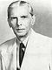
1:Name: Muhammad Ali Jinnah (1876–1948)
Start of term: 15 August 1947
End of term: 11 September 1948
Political party: Muslim League
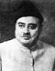
- 2: Sir Khawaja Nazimuddin (1894–1964)
Start of term: 14 September 1948
End of term: 17 October 1951
Political party: Muslim League

- 3: Malik Ghulam Muhammad(1894–1964)
Start of term: 14 September 1948
End of term: 17 October 1951
Political party: Muslim League
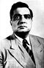
- 4:Iskander Mirza (1899–1969)
Start of term: 6 October 1955
End of term: 23 March 1956
Political party: Republican Party

Total: 04 Govern Generals of Pakistan

Presidents of Pakistan (1947-2012)

- 1- Iskander Mirza (1895–1956)
Start of term: 23 March 1956
End of term: 27 October 1958
Political party: Republican Party

- 2-Ayub Khan (1907–1974)
Start of term: 27 October 1958
End of term: 25 March 1969
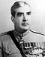
Political party: Martial Law
- 3-Yahya Khan (1917–1980)
Start of term: 25 March 1969
End of term:20 December 1971
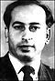
Political party: Martial Law
- 4-Zulfikar Ali Bhutto (1928–1979)
Start of term: 20 December 1971
End of term:13 August 1973
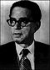
Political Party:Pakistan Peoples Party
- 5-Fazal Ilahi Chaudhry (1904–1982)
Start of term: 13 August 1973
End of term:16 September 1978
Political party: Pakistan Peoples Party
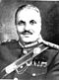
- 6-Muhammad Zia-ul-Haq(1924–1988)
Start of term:16 September 1978
End of term:17 August 1988
Political Party: Martial law
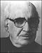
- 7-Ghulam Ishaq Khan (1915–2006
Start of term:17 August 1988
End of term:18 July 1993
Political party: Independent
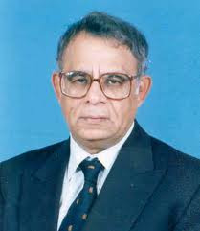
- 8-Wasim Sajjad (Care taker) (1941–)
Start of term: 18 July 1993
End of term: 14 November 1993
Political Party: Pakistan Muslim League (N)
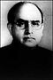
- Farooq Leghari(1940–2010)
Start of term: 14 November 1993
End of term:2 December 1997
Political party: Pakistan People’s Party
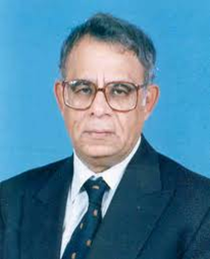
- 10-Wasim Sajjad (Care taker) (1941–)
Start of term:2 December 1997
End of term:1 January 1998
Political Party: Pakistan Muslim League (N)
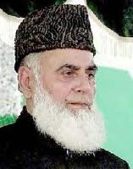
- 11- Muhammad Rafiq Tarar (1929–)
Start of term:1 January 1998
End of term:20 June 2001
Political party: Pakistan Muslim League (N)

- Pervez Musharraf (1943–)
Start of term:20 June 2001
End of term:18 August 2008
Political Party: Martial Law/Pakistan Muslim League (Q)
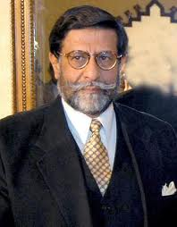
- 13- M.Mian Soomro (Care taker) (1950–)
Start of term: 18 August 2008
End of term: 9 September 2008
Political party: Pakistan Muslim League (Q)

- 14- Asif Ali Zardari (1955–)
Start of term:9 September 2008
End of term: Current
Political Party: Pakistan Peoples Party
Total: 11 Elected Presidents and 03 Caretaker


Prime Ministers of Pakistan (1947-2011)
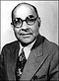
- 1-Liaquat Ali Khan (1896–1951)
Start of term: 14 August 1947
End of term: 16 October 1951

Political party: Muslim League
- 2-Sir Khawaja Nazimuddin (1894–1964)
Start of term:17 October 1951
End of term: 17 April 1953
Political party: Muslim League
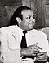
- 3-Muhammad Ali Bogra(1909–1963)
Start of term: 17 April 1953
End of term: 12 August 1955
Political party: Muslim League
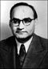
- 4-Chaudhry Muhammad Ali(1905–1980)
Start of term: 12 August 1955
End of term: 12 September 1956
Political party: Muslim League
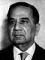
- 5-Huseyn Shaheed Suhrawardy(1892–1963)
Start of term: 12 September 1956
End of term: 17 October 1957
Political party: Awami League
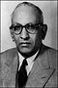
- 6-Ibrahim Ismail Chundrigar(1898–1968)
Start of term: 17 October 1957
End of term: 16 December 1957
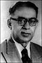
Political party: Muslim League
- 7-Sir Feroz Khan Noon(1893–1970)
Start of term: 16 December 1957
End of term: 7 October 1958
Political party: Republican Party
Post Abolished : 7 Oct 1958 - 7 Dec 1971

- 8-Nurul Amin (1893–1974)
Start of term: 7 December 1971
End of term: 20 December 1971
Political party: Pakistan Muslim League

Post Abolished: 20 Dec.1971 - 14 Aug.1973

- 9-Zulfikar Ali Bhutto (1928–1979)
Start of term: 14 August 1973
End of term: 5 July 1977
Political party: Pakistan Peoples Party
Post Abolished :5 Jul.1977 24 – Mar.1985

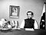
- 10-Muhammad Khan Junejo(1932–1993)
Start of term: 24 March 1985
End of term: 29 May 1988
Political party: Independent, P. M. League

Post Abolished: 29 May 1988 - 2 Dec, 1988
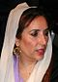
- 11-Benazir Bhutto (1953–2007)
Start of term:2 December 1988
End of term: 6 August 1990
Political party: Pakistan People’s Party
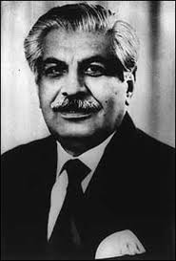
- 12-Ghulam Mustafa Jatoi(1931–2009 )
Start of term: 6 August 1990
End of term: 6 November 1990
Political party: Caretaker

- 13- Nawaz Sharif(1949– )
Start of term: 6 November 1990
End of term: 18 April 1993
Political party: I.J.I and P.M.L(N)
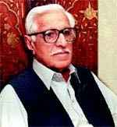
- 14- Balakh Sher Mazari(1928– )
Start of term: 18 April 1993
End of term: 26 May 1993
Political party: Caretaker

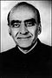
- 15- Moeenuddin Ahmad Qureshi(1930– )
Start of term: 18 July 1993
End of term: 19 October 1993
Political party: Caretaker
- 16- Benazir Bhutto(1953–2007)
Start of term: 19 October 1993
End of term: 5 November 1996
Political party: Pakistan People’s Party
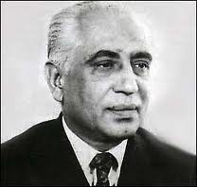
- 17- Malik Meraj Khalid(1916–2003)
Start of term: 5 November 1996
End of term: 17 February 1997
Political party: Caretaker
- 18- Nawaz Sharif (1949– )
Start of term: 17 February 1997
End of term: 12 October 1999
Political party: Pakistan Muslim League (N)

Post Abolished: 12 Oct.1999 - 21 Nov. 2002

- 19- Zafarullah Khan Jamali (1944– )
Start of term: 23 November 2002
End of term: 26 June 2004
Political party: Pakistan Muslim League (Q)

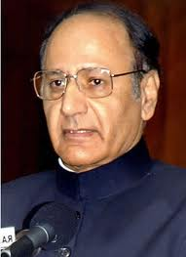
- 20- Chaudhry Shujaat Hussain(1946– )
Start of term: 30 June 2004
End of term: 20 August 2004

Political party: Pakistan Muslim League (Q)
- 21- Shaukat Aziz(1949– )
Start of term: 20 August 2004
End of term: 16 November 2007
Political party: Pakistan Muslim League (Q)
- 22- Muhammad Mian Soomro(1950– )
Start of term: 16 November 2007
End of term: 25 March 2008
Political party: Pakistan Muslim League (Q)

- 23- Yousaf Raza Gillani (1952– )
Start of term: 25 March 2008
End of term:19 June 2012
Political party: Pakistan People’s Party
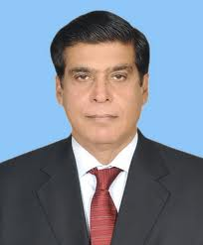
- 24-Raja Pervaiz Ashraf(1950-)
Start of term: 22 June 2012
End of Term: Current
Political party: Pakistan People’s Party
Summary : Governors-General
- Mohammad Ali Jinnah
- Khwaja Nazimuddin
- Ghulam Mohammad
- Major General Iskander Mirza
Presidents
- Major-General Iskander Mirza
- General Mohammad Ayub Khan
- General Agha Mohammad Yahya Khan
- Zulfikar Ali Bhutto
- Fazal Elahi Chaudhri
- General Mohammad Ziaul Haq
- Ghulam Ishaq Khan
- Wasim Sajjad (interim)
- Farooq Ahmad Khan Leghari
- Wasim Sajjad (interim)
- Mohammad Rafiq Tarar
- General Pervez Musharraf
- M.Mian Soomro (Care taker)
- Asif Ali Zardari
Total: 11 Elected Presidents and 03 Caretakers
Prime Ministers of Pakistan
- Liaquat Ali Khan
- Khawaja Nazimuddin
- Muhammad Ali Bogra
- Chaudhry Muhammad Ali
- Huseyn Shaheed Suhrawardy
- Ibrahim Ismail Chundrigar
- Feroz Khan Noon
- Nurul Amin
- Zulfikar Ali Bhutto
- Muhammad Khan Junejo
- Benazir Bhutto
- Nawaz Sharif
- Miraj Khalid
- Zafarullah Khan Jamali
- Shujaat Hussain
- Shaukat Aziz
- Syed Yousaf Raza Gilani
- Raja Pervaiz Ashraf

Quotation
"A good leader is not the person who does things right, but the person who finds the right things to do."
Anthony T. Dadovano

Lecture # 17
Topic: Constitutional Developments in Pakistan I.

- Background
One of the most uphill tasks for the newly created Pakistan was the framing of its comprehensive Constitution. Both India and Pakistan at their birth adopted Government of India Act of 1935 with essential amendments as the interim constitution i.e. Parliamentary and Federal in nature. Quaid-e-Azam with his vast and strong background of handling legal matters took up this problem with urgency however gravity of other issues compelled him to pay his attention to other matters which delayed this important process of constitution making.
- Definition
Constitution is a basic document which sets out the framework for governance and exercise of power. It defines the powers of the institutions and sets out the relationship that exists between different state institutions. It also describes the powers within which these institutions have to work and what would be the nature of relationship of the individual with the state. A constitution is a set of fundamental principles or established patterns according to which a state or other organization is ruled. The term constitution comes through French from the Latin word constitution, used for regulations and orders.
- Sources of Constitution
Culture, Society, Civilization, History, Religion, Traditions and Political System
- Constitution of Pakistan
Constitution of Pakistan is the supreme law of Pakistan. There have been several documents known as the Constitution of Pakistan. The Constitution of 1973 is the existing constitution, which provides for a parliamentary system with a President as head of state and popularly elected Prime Minister as head of government. Pakistan has bicameral legislature that consists of the Senate(upper house) and the National Assembly(lower house). It was drafted by the government of Zulfikar Ali Bhutto and, following additions by the opposition parties, was approved by the legislative assembly on April 10, 1973. It was Pakistan's first ever constitution by consensus unlike two earlier constitutions, the Constitution of 1956 and the Constitution of 1962.
- Reasons of Delay
It took almost nine years for the two constituent assemblies to make a constitution for the country. Following are the main reasons of delay:
- Two wings of Pakistan – East Pakistan and West Pakistan
- Inexperienced politicians
- Clash of Interests between two wings
- Debate on 'State’ and ‘Islam’
- Federal State System
- Cultural and linguistic differences
- Lack of homogeneity between two wings
- Language issue
- Administrative problems
- Influx of refugees
- Politicians personal clashes and differences
- Lack of quality leadership
- Illiteracy
- Lack of mutual understanding & Tolerance

- History of Constitution Making
Government of India Act, 1935& 1945 with amendments: Pakistan became independent from British India in 1947, following its partition. The first document that served as a constitution for Pakistan was the Government of India Act, 1935 with amendments.
- Measures Taken by Jinnah
Appointed the first constituent assembly of Pakistan in August 1947: 69 members elected in 1945-46 election and 10 members were included from princely states. Dual responsibility of acting as the federal legislature and constituent assembly.
The members however lacked the essential requirements of high competence, commitment and political experience. Even though Jinnah wanted to improve this situation but his early demise in 1948 struck another shock to inexperienced Pakistan.
- The Objectives Resolution
The first big step in the framing of a constitution for Pakistan was taken by the Constituent Assembly on 12 March 1949, when it passed a resolution on the 'Aims and Objectives of the Constitution', popularly known as the Objectives Resolution. It laid the foundation of the constitution and indicated the broad outline of its structure. The resolution was moved by Liaquat Ali Khan, the first Prime Minister of Pakistan.[
Main Features of Objective Resolution
- Sovereignty of Allah
- Democracy: Elected representation
- Federal Republic based on Islamic Principles, justice, equality and tolerance with an independent judiciary plus protection of minorities
- Muslim way of life according to teachings of Quran and Sunnah

- Basic Principles Committee [1949-1952]
After the Objectives Resolution was passed in 1949, the Constitution Assembly set up a number of committees to draw the future constitution on the basis of the principles given in the Objectives resolution. The committee presented its interim report to the Legislative Assembly in1950. This was a short document presenting the guidelines and principles of the future Constitution of Pakistan.
After sharp criticism by religious scholars a basic principles committee was setup to review the recommendations however the report was subject to widespread criticism over its recommendations in East and West Pakistan. Political crisis developed as the Prime Minister Liaquat Ali Khan was assassinated in 1952, after a three year delay general elections were held on 21st June 1955. Assembly met on 7th July 1955. Finally the first constitution was promulgated by the second constituent assembly on 23rd March 1956.
- Parity Proposal (2nd Draft of Constitution) and Khawaja Nazinuddin presented second draft of constitution in 1952. However the parity proposal was rejected.
- Muhammad Ali Formula 1953: Muhammad Ali claimed that his formula was acceptable to both wings.
After ten days of the adoption of the final draft of constitution, the first constituent assembly , was dissolved by the Governor –General. 2nd Constituent assembly was set up in 1955 and fourth draft was presented and approved in 1956. Pakistan came into being as a free Muslim state in quite unfavorable circumstances, it had no resources, it had to build up its administrative machinery from a scratch. But Supreme efforts were made by the Quiad-e-Azam and his colleagues to contend with the situation. His golden principles "Unity Faith and Discipline” gave way to Pakistan for a bright future of a strong and well developed country.
Quotation
"The foundation of your state have been laid and it is now for you to build and build as quickly as you can."
Quaid i Azam
In his last message to the nation on 14th August 1948

Lecture # 18
Topic: Constitution of 1956,II
- Origins of the Constitution of 1956
Pakistan became independent of the United Kingdom in 1947. Under Section 8 of the Indian Independence Act, 1947, the Government of India Act, 1935 became, with certain adaptations, the working constitution of Pakistan. But the need of a constitution to be framed by the elected representatives of the people, was all the more necessary for the free citizens of a sovereign state. Therefore the first Constituent Assembly was formed under the Independence Act and was entrusted with two separate functions.
- To frame a Constitution for the country, and
- To set as a Federal Legislative Assembly or Parliament until that Constitution came into effect. The powers and functions of the central legislature under the Government of India Act were conferred on the Constituent Assembly.
- The Constituent Assembly could, however, amend the Government of India Act, 1935, and no Act of the British Parliament could be extended to Pakistan without legislation by the Constituent Assembly.
- The first Constituent Assembly originally consisted of 69 members; subsequently the number of members was increased to 79
Provisions
- The Constitution of 1956 was lengthy and detailed; it contained 234 articles divided into thirteen parts and six schedules.
- The Constitution of 1956 provided for federal system with the principle of parity between East Pakistan and West Pakistan.
- The Federal Legislature was to perform like the British Parliament. The Centre was invested with such powers as to take unilateral action in emergency and it could influence the provincial autonomy.
- The Constitution of 1956 provided for the parliamentary form of government, where real executive authority was vested in a cabinet, collectively responsible to the legislature.
- The cabinet was presided over by the Prime Minister. The Constitution declared that there would be only one house of parliament known as the National Assembly and equality between the two Wings (i.e. East Pakistan and West Pakistan) was maintained in it.
- The Governor General was replaced by a President, who was to be elected by the Electoral College of Pakistan composed of members of the National Assembly and Provincial Assembly.
- With regards to civil rights, familiar rights such as rights of life, liberty and property were granted, again with the usual qualifications and safeguards.
- Familiar democratic rights and freedoms such as freedom of speech and expression, of assembly and association, of movement and of profession were all provided in the Constitution, with the usual qualifications.
- As per the Constitution, Urdu and Bengali were made national languages.
- The judiciary was given power to enforce the fundamental rights and the courts were to decide if a law was repugnant to any provisions of the fundamental rights.

- What are the Salient Features of the constitution of 1956?
Salient Features
- Written Constitution - This is a written and lengthy document.
- Rigid Constitution - The constitution could only be amended through a process requiring the amendment to be passed by at least a two-thirds majority of the parliament and authentication by the President.
- Islamic Republic of Pakistan - The name of the country was adopted as the Islamic Republic of Pakistan.
- Objectives Resolution - The objective resolution was included as permeable by the constitution.
- Federal System - The constitution provides for a federal system in the country. Powers was divided between the center and the provinces. The subjects were divided into three lists; The Federal List, The Provincial List, and the Concurrent List.
(Concurrency means simultaneous authority of the two autonomous orders of government over subjects of mutual importance). All federal constitutions recognize some areas of exclusive jurisdiction for each order of the government e.g defense and currency are widely accepted to be federal subjects.

However, it is difficult to categorize certain subjects as exclusive domain of one order of the government within a federation e.g Health and Education at different levels. Even in federations like Switzerland, Canada and Belgium, where most powers are assigned to one level of the government, it is virtually impossible to define water-tight compartments of jurisdiction.)
- Unicameral Legislature - The legislature would consist of a single house. Both the wings of the country were given representation in the National Assembly. The National Assembly consisted of 300 members. 150 members were drawn from each wing.
- Parliamentary System - a parliamentary system was adopted, according to it the president was the head of state and the Prime Minister the head of government.
The President - required to be a Muslim of at least forty years of age. The tenure of his office was five years. In case of internal or external danger he could declare a state of emergency in the country. He was authorized to appoint the Governors, the Judges of the Supreme Court, Auditor General and the Advocate General.
The Prime Minister - He was to be the leader of the Parliamentary group and was thus indirectly elected by the people. He could choose his cabinet from the members of the National Assembly; the cabinet was answerable to the Assembly.
Provincial Autonomy - Curtailed in the constitution to a great extent.
Islamic Law - no law would be passed against the teachings of the Quran and Sunnah.
Free Judiciary - An independent judiciary in the country. A Supreme Court interpreted the constitution, advised the state whenever required, and decided the issues whenever required.

- What are the Islamic provisions of the constitution of Pakistan?
Islamic provisions
- Islamic Republic of Pakistan - The name of the country was adopted as the Islamic Republic of Pakistan.
- Objectives Resolution - Included as preamble to the constitution.
- Islamic Law - No Law would be passed against the teachings of the Quran and Sunnah, and existing laws would be made Islamic in character.
- Muslim President - a requirement.
- Religious Freedom - Freedom to profess, practice and propagate any religion and the right to establish, maintain and manage religious institutions.
- Life According to the Holy Quran and Sunnah- According to the directive principles, steps were to be taken to enable the Muslims of Pakistan individually and collectively to order their lives in accordance with the Holy Quran and Sunnah.
- Teachings of the Holy Quran - Were to be made compulsory for all Muslims.
- Slavery and forced labour were prohibited.
- Alcohol and narcotics - sale was banned and were prohibited. Prostitution - was prohibited.
- Special tax - No person should be compelled to pay any special tax whose proceeds were to be spent on the propagation of any religion other than the person's own.
- Unity among Muslim countries - States were required to strengthen the bonds of Muslims.
- Organization for Islamic Research and Instructions - The president was required to set up an organization for Islamic Research and Instruction in advanced studies to assist in the reconstruction of Muslim society on a true Islamic basis.

- Drawbacks of the Constitution of 1956
- A far-reaching devolution of power already a political reality was not given a constitutional recognition and accepted as the basis of the stale.
- The federal list was greatly reduced and the provincial list greatly enlarged, transferring to the provinces, among other things, control over mineral resources, recruitment of services, industries, internal communications and the tribal areas in the North West Frontier. This was conflicting to the practice of advanced countries where the deferral principle has been used in building up a common nationhood through a strong center.
- The constitution in Pakistan instead of being an instrument for unity a country already divided by geography, sought to create two distinct political entities with maximum autonomy in the management of their affairs.
- Regional loyalties were further combined by the introduction of parity of representation the National Assembly.
- The constitution was concerned in the belief that the political life of the country would always be tied to provincial berths and will never rise a higher plane of nationalism in which party affiliations would cut across the physical barriers.
- Parity was certain to foster narrow-minded feeling equally in the region in whose favor it was to operate and in the region whose interests were adversely affected by it.
Expiry
On 7 October 1958, President Iskander Mirza staged a coup d'état. He abrogated the constitution, imposed martial law and appointed General Muhammad Ayub Khan as the Chief Martial Law Administrator and Aziz Ahmad as Secretary General and Deputy Chief Martial Law Administrator.
However, three weeks later General Ayub—who had been openly questioning the authority of the government prior to the imposition of martial law—deposed Iskandar Mirza on 27 October 1958 and assumed the presidency.
Four years later a new document, Constitution of 1962 was adopted. This was eventually succeeded by the Constitution of 1973, current as of 2012.

Quotation
Don't interfere with anything in the Constitution. That must be maintained, for it is the only safeguard of our liberties.
Abraham Lincoln

Lecture # 19
Topic: Constitution 1962, 1973, III
- Constitution of 1962
Origins:
- General Ayub Khan wanted to introduce a controlled and limited democracy as he believed that western style democracy did not suit Pakistan. Therefore he introduced the constitution of1962 on 1st March thereby abrogating the previous constitution.
- On 17 February 1960 Ayub Khan appointed a commission to report on the future political framework for the country. The Commission was headed by the former Chief Justice of Pakistan, Muhammad Shahabuddin, and had ten other members, five each from East Pakistan and West Pakistan, composed of retired judges, lawyers, industrialists and landlords.
- The report of the Constitution Commission was presented to President Ayub on 6 May 1961 and thoroughly examined by the President and his Cabinet.
- In January 1962, the Cabinet finally approved the text of the new constitution. It was promulgated by President Ayub on 1 March 1962 and finally came into effect on 8 June 1962. The Constitution contained 250 articles divided into twelve parts and three schedules.

Provisions
- The Constitution of 1962 provided for a presidential form of government, as opposed to the parliamentary form of government under the 1956 Constitution. The President, who must be a Muslim not less than 35 years of age and qualified for election as a member of the National Assembly was to be elected indirectly by an electoral college in accordance with the provisions outlined in the Constitution itself.
- The Electoral College formed by not less than 120,000 Basic Democrats (B.D.), equally distributed between the two provinces.
- The term of the President was five years to act as Head of State as well as Chief Executive—solely responsible for country's administration. Governor and Minister were appointed and removed by him.
- He was eligible to issue Ordinances and veto against legislated laws by two-thirds of the National Assembly. However, the President was not empowered to dissolve the Assembly except at the cost of his office also.
- On a charge of violating the Constitution or gross misconduct the President might be impeached by the National Assembly for which one-third of the total members of the National Assembly must give written notice to the Speaker for the removal of the President.
- The President was to be removed from office if the resolution for impeachment was passed by votes of not less than three-fourths of the total members of the Assembly.
- A significant feature of the impeachment procedure was that if the resolution for removal of the President fails to obtain one-half of the total number of members of the National Assembly the movers of the resolution would cease to be members of the Assembly.
- There was no restriction of religion for a person holding the office of the Speaker of the National Assembly. Secondly, if the President resigns from his office or vote of no-confidence passes against him, then according to the Constitution the Speaker would act as the President of the State till the election of new President.
- Under these special circumstances, a non-Muslim might get the chance to be an acting President of Pakistan.
- The Constitution of 1962 provided for elections of the Central and Provincial Legislatures for a term of five years. The members of the Assemblies were elected by the Basic Democrats.
- The National Assembly was exclusively empowered to legislate for the central subjects. However, it could legislate on matters falling under provincial jurisdiction. The power to impose taxes was laid with the central legislature.
- The Assembly had to serve as a court in the cases of impeachment, conviction or declaring the President as undermined. It could amend the Constitution, but with two-thirds majority.
- However, if the President's veto was over-ridden, he had the right to ask for the assent of the Electoral College. The procedure of the Provincial Assemblies was identical with that of the National Assembly.
- Urdu and Bengali were recognized as national languages.

Salient Features
1) Written Constitution: The Constitution of 1962 was a written document. It consisted of five schedules and 250 articles.
2) Rigid Constitution: This is a rigid constitution. This is a rigid constitution can only be amended through a particular process. If an amendment to the constitution is passed by at least two-third majority of the parliament then it becomes a part of law after authentication by the President.
3) Federal System: A federal system was introduced in the country. It consisted of a central government and two provincial government comprising East and West Pakistan.
4) Presidential forum of Government: President was the head Executive of the nation. He was empowered to nominate the ministers of his cabinet.
5) Unicameral Legislature
6) Indirect Method of Election: The President was elected by an Electoral College comprising 80,000 Basic Democrats, equally distributed between the two provinces.
7) Provincial Governments: There were two provincial governments. Each of them was headed by a governor. He enjoyed powers in the province which the President enjoyed in the center. The Governor was empowered to appoint provincial ministers with the sanction of the President of Pakistan.
8) Provincial Legislature: Each province was provided with a legislature. It originally consisted of 150 members. However, later on this number was increased to 218.
President:
- According to the 1962 Constitution the President should be a Muslim with the term of 5 years. He was eligible to promulgate Ordinances and veto against legislated laws only override-able by two/thirds of the National Assembly. However, the President was not empowered to dissolve the Assembly except the cost of his office also.
- Restrictions to the President: The President was not allowed to hold any office of profit in the service of Pakistan but was not prevented from holding a managing private property.
- Islamic Law: No Law would be passed against the teaching of Quran and Sunnah and the existing laws would be made Islamic in character.
- Fundamental Rights: The constitution of 1962 laid down fundamental rights of speech and expression, freedom to choose profession and freedom to profess religion. With Regards to civil rights, familiar right such as the rights of life, livery and property were granted.
- Role of Judiciary: The Judiciary was responsible for the interpretation of laws and executive orders in the light of the principles emboided in a written constitution.
- Language: Urdu and Bengali were recognized as National Languages.
Islamic provisions
- The preamble of the Constitution of 1962 was based on the Objectives Resolution.
- The Constitution laid down simply that the state of Pakistan shall be an Islamic republic under the name of Islamic Republic of Pakistan'.
- According to the principles of policy, steps were to be taken to enable the Muslims of Pakistan individually and collectively, to order their lives in accordance with the fundamental principles and basic concepts of Islam, and should be provided with facilities whereby they may be enabled to understand the meaning of life according to those principles and concepts.
- No law shall be enacted which is unacceptable to the teachings and requirements of Islam as set out in the Qur'an and Sunnah and all existing laws shall be brought in conformity with the Qur'an and Sunnah.
- Only a Muslim could be qualified for the election as President.
- Teaching of the Quran and Islamiyat to the Muslims of Pakistan was made compulsory.
- Proper organization of Zakat, waqf, and mosques was ensured.
- Practical steps were to be taken to eliminate what were seen as social evils by Islam, such as the use of alcohol, gambling, etc.
- A novel Islamic provision in the 1962 Constitution had introduced an 'Advisory Council of Islamic Ideology' to be appointed by the President. The functions of the Council was to make recommendations to the Government as to encourage the Muslims of Pakistan to order their lives in accordance with the principles and concepts of Islam.
- There shall be an organization to be known as Islamic Research Institute, which shall be established by the President. The function of the Institute was to undertake Islamic Research and Instruction in Islam for the purpose of assisting in the reconstruction of Muslim society on a truly Islamic basis.
- The state should work to strengthen the bonds of unity among Muslim countries.

Drawbacks of the Constitution of 1962
- Moreover, the Constitution gave overwhelming powers the President who dominated the entire constitutional system.
- Ayub's Constitution lasted as long as he survived in office. With his departure his system was also folded
Expiry
The second martial law was imposed on 25 March 1969, when President Ayub Khan abrogated the Constitution of 1962 and handed over power to the Army Commander-in-Chief, General Agha Mohammad Yahya Khan.
On assuming the presidency, General Yahya Khan agreed to popular demands by abolishing the one-unit system in West Pakistan and ordered general elections on the principle of one man one vote.
Analysis: Main Features of 1962 Constitution
It was Presidential form of Government. It introduced the Basic Democracy system first time in the country. Principles of maximum provincial autonomy, equality of mankind, independence of judiciary, rights of minorities were also highlighted in it. Islamic advisory council was constituted to advise govt. over Islamic law making. Legal Framework Order (LFO) highlighting the principles on which the future elections had to be held. The LFO brought an end to parity between East and West Pakistan, accepting the numerical majority of the eastern wing. After taking control of the government in 1971 Z.A. Bhutto started work on a democratic constitution for the country.

Constitution of 1973
- On 17th April 1972 the National Assembly constituted a committee to prepare a draft constitution. The Committee worked hard and prepared the draft of the constitution which was presented to the leaders of all parliamentary leaders on 20th October 1972.
- All the leaders signed the draft. After that it was discussed and debated n the National Assembly which gave its approval on 10th April 1973. The President gave his assent on 12th April 1973. Finally the Senate approved the constitution in August 1973.
- Consequently the constitution was enforced in the country on 14th August 1973. According to the Constitution of 1973 Mr. Z.A. Bhutto looks over as the tenth Prime Minister and Mr. Fazl-e-Elahi was sworn in as the President of Pakistan.

Salient Features of 1973 Constitution
The Constitution of 1973 is extremely different from the earlier Constitution of 1956 and 1962. It has the following salient features.
1. Written Constitution: Like the previous constitutions of 1956 and 1962 the Constitution of 1973 is a written document. It is very comprehensive and consists of twelve parts consisting of 280 articles.
2. Introductory and the Objectives Resolution: It commences with an introductory which interpret the Islam shall be state religion. The principles and provisions set out in the Objectives Resolution have been made essential part of the constitution.
3. Islamic System: The inclusion of Islamic Provisions has given the 1973 Constitution an unprecedented Islamic character. It ensures an Islamic system in the country.
4. Rigid Constitution: It is a rigid constitution. No Government can change it at will. It is not easy to make amendments in it. Two-third majority of both the Houses is required for this purpose.
5. Federal System: The Constitution of 1973 has introduced a Federal system in the country. The federation of Pakistan consists of a Central Government and four Provincial Governments. The Federal Government is headed by a President elected by members of Parliament.
6. Parliamentary form of Government: The 1973 Constitution proposes a Parliamentary form of Government in the country. The PM is elected by the NA after 30 days of the general elections. The President calls the session of the NA for the election of the PM. Prime minister is the head of the Parliamentary system. He is leader of the Parliament. The Prime Minister selects a cabinet of central ministers from the members of Parliament which conducts the affairs of the country. According to 1973 Constitution the Prime Minister enjoys wide powers.
7. Bicameral Legislature: The Constitution provides for the establishment of a bicameral legislature in Pakistan. The Parliament consists of two Houses named Senate and National Assembly. The Senate or the Upper House consists of 100 members The National Assembly consists of 342 members (60 Seats for women).
8. Distribution of seats based on general, women in NA.Distribution of seats among general, women, technocrats & ulema in Senate. In Provincial Assemblies distribution is among general, women & minorities in all provinces. Province-wise Distribution of NA Seats (342)
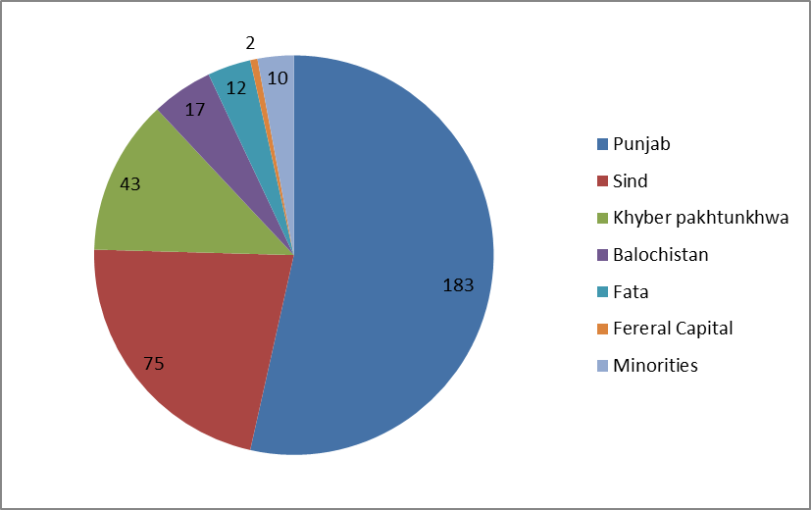
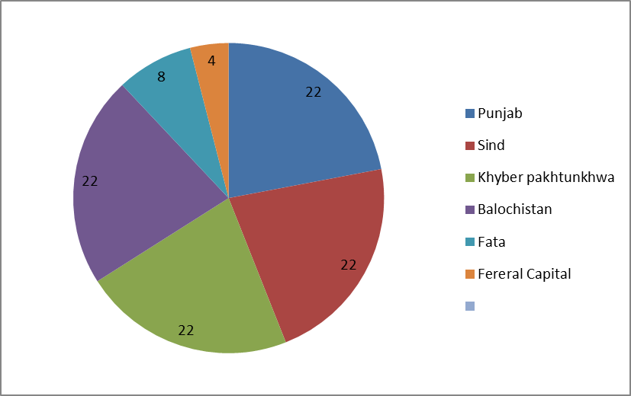
Distribution of seats in Senate (100)

Provincial Assemblies
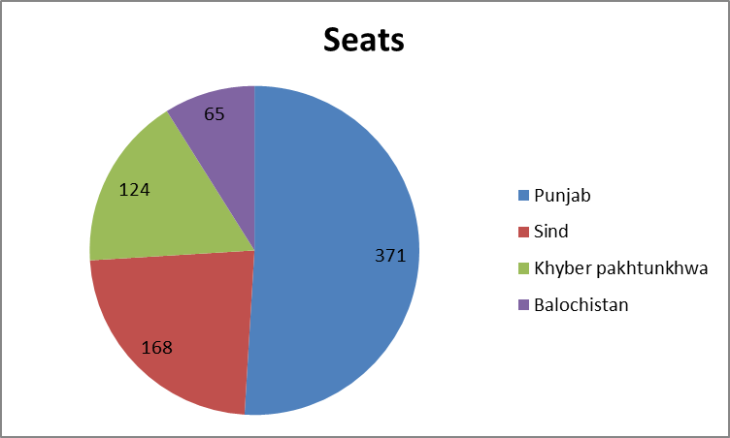

8. Direct Method of Election:
The Constitution of 1973 gives a direct method of election. The members of the National Assembly, the Provincial Assemblies are directly elected by the people.
9. Fundamental Rights:
The 1973 Constitution ensures the following fundamental rights to the citizens of Pakistan: Security of person, Safeguard against unlawful arrest, Prohibition of slavery and forced labor. Freedom of movement, assembly, association, business, speech, religion, Right to hold property, Equality before law, Right to preserve language, script and culture, Safeguard against discrimination in services.
10. Principles of Policy:
The Constitution of 1973 has set the following principles of policy: Local electoral bodies will be set up for solving local problems.The prejudices shall be discouraged. The women shall be given full representation in all spheres of national life. Social justice shall be promoted. Bonds with Muslim world shall be strengthened.
11. Independence of Judiciary:
Constitution of 1973 stresses upon the establishment of an independent judiciary. Full job security has been provided. The judges are appointed by the President. They cannot be removed from service before the end of their term except on the recommendation of the Supreme Judicial Council. In addition the Judges are paid respectable salaries.
12. National Language:
The 1973 Constitution has declared Urdu as the national language of Pakistan. However English has been retained as the official language.

Analysis
It introduced a Parliamentary form of Govt. Prime Minister as the head and real executive of government, Ordinances to be counter signed by the Prime Minister. Bicameral legislature, Independence of judiciary, Urdu as national language, Provincial autonomy guaranteed residuary powers given to the provinces. A clear and definite definition for Muslim was given. An Islamic ideology council was set up for framing of Laws for Islamic injunctions.

Quotation:
Come forward as servants of Islam, organize the people economically, socially, educationally and politically and I am sure that you will be a power that will be accepted by everybody.
Muhammad Ali Jinnah

Lecture # 20
Topic: Pakistan's Relations with Neighboring Countries Part I: China & Iran
- Steps for the Process of Islamization ( Remaining part of the previous topic)
Pakistan is an ideological state that was founded on the principle that Muslims would lead their lives according to Islam. All the laws made and implemented in this country have been designed keeping in view the teachings of Holy Quran and Sunnah. Quaid-e-Azam Muhammad Ali Jinnah said:
“Let us lay the foundation of our democracy on the basis of truly Islamic ideals and principles. Almighty Allah taught us that the decisions in the affairs shall be guided by discussion and consultation.”
All the constitutions that have been implemented in our country (1956, 1965 and 1973) have Islamic Provisions. The Government of Pakistan has taken the following steps to introduce Islamic Laws in Pakistan:
1. Hudood Ordinance: Hudood Ordinance was introduced in the country in 1977. In the light of Hudood Ordinance, various punishments were prescribed for different crimes. The word Hudood means the punishment which has been prescribed in the light of Holy Quran. According to the Hudood Ordinance manufacture, export, import and use of alcohols has been prohibited. Any person found guilty is liable of punishment of 30 lashes and 5 years imprisonment.The second Hadood Law is concerned with the crime of theft.The third Hadood law is meant for adultery (Zina-bil-Raza) and rape (Zina-bil-Jabar), whose punishment is stoning the adulter to death.
2. Establishment of Federal Sharia Courts
3. Zakat and Ushr Ordinance: Zakat and Ushr Ordinance was promulgated in the country on June 20, 1980. According to the ordinance, Zakat Fund was established to collect zakat donations. It was made compulsory for every Sahib-e-Nisab Muslim to pay Zakat by depositing 10 percent of money in one’s bank account.Ushr is the tax levied on yield of agricultural land in cash or kind. According to Ushr Ordinance, every owner who ploughs and cultivates land was made bound to deposit 10 percent of his earnings in cash or kind, as Ushr.
4. Teaching of Islamic and Pakistan Studies
5. Interest Free Banking: In January 1981, interest free banking was introduced in Pakistan. According to this system, the account holder partners with the bank in profit and loss and shares risk according to one’s investment in the bank.
6. Establishment of Islamic University: Sharia faculties have been established in various universities for the promotion of Islamic teachings. The function of Jamia-e-Bahawalpur was streamlined and an Islamic University was established in Islamabad.
7.Nizam-e-Salat and Azan
Characteristics of an Islamic society. (Ref. Text book)

- Pak- China Relations
People's Republic of China–Pakistan relations began in 1950 when Pakistan was among the first countries to recognized and started relations with the Republic of China.
- Following the 1962 China-Indian War, both countries have placed considerable importance on the maintenance of an extremely close and supportive relationship. Since then, the two countries have regularly exchanged high-level visits resulting in a variety of agreements. China has provided economic, military and technical assistance to Pakistan.
- Bilateral relations: Importance of China for Pakistan
Militarily Power: Bilateral relations have evolved from an initial Chinese policy of neutrality to a partnership that links a smaller but militarily powerful Pakistan, partially dependent on China for its military strength.
- Diplomatic relations were established in 1950, military assistance began in 1966. A strategic alliance was formed in 1972.
- Economic co-operation began in 1979. China has become Pakistan’s largest sup­plier of arms and its third-largest trad­ing partner.
- Recently, both nations have decided to cooperate in improving Pakistan's civilian nuclear program.
- Favorable relations with China is a pillar of Pakistan's foreign policy. China supported Pakistan's opposition to the Soviet Union's intervention in Afghanistan and is perceived by Pakistan as a regional counterweight to NATO and the United States.
- China and Pakistan also share close military relations, with China supplying a range of modern armaments to the Pakistani defense forces.
- China supports Pakistan's stand on Kashmir while Pakistan supports China on the issues of Tibet and Taiwan.
- Lately. military cooperation has deepened with joint projects producing armaments ranging from fighter jets to guided missile frigates.
- Gwadar port project Chinese cooperation with Pakistan has reached economic high points, with substantial Chinese investment in Pakistani deep-water port at Gwadar. Both countries have an ongoing free trade agreement.
- Pakistan has served as China's main bridge between Muslim countries.
- Pakistan also played an important role in bridging the communication gap between China and the West by facilitating the 1972 Nixon visit to China.
- China is emerging economic power of the world.
- China has Strongest , well trained and well equipped army
- China is a Nuclear power
- China is the prominent country among Communist bloc and have say in an international forums
- Pakistan is seeking support from China in education, trade, and telecommunication, technical, nuclear and defense sectors.
Background
A close identity of views and mutual interests remain the hallmark of bilateral ties. Since the 1962 Sino-Indian War, Pakistan has supported China on most important issues like Taiwan and Tibet and other sensitive issues such as human rights.
China also has a reliable record of supporting Pakistan in regional issues. During the Pakistan-Indian tensions in 1965, 1971, and 2008, it declared that it would support Pakistan in the event of a war. Pakistan's military depends heavily on Chinese armaments, and joint economic projects.

- History of Diplomatic Relations
Diplomatic relations between Pakistan and China were established on 21 May 1951, shortly after the independence of the Republic of China in 1949. Pakistan hoped that China would serve as a counterweight to Indian influence. India had recognized China a year before, and Indian Prime Minister Nehru also hoped for closer relations with the Chinese. However, with escalating border tensions leading to the 1962 Sino-Indian war, China and Pakistan aligned with each other in a joint effort to counter perceived Indian encroachment. China also fully supported Pakistan in 1965 war against India. Chinese pressure on India enabled Pakistan to accept ceasefire in a better position than it would have been. China also supported Pakistan in the 1971 war. Soon after the war China wrote off some loans and it had given to Pakistan.
Since 1962, China has been a source of military equipment to the Pakistani Army, helping establish ammunition factories, providing technological assistance and modernizing existing facilities. With the war in Afghanistan there is a general sentiment in Pakistan to adopt a foreign policy which favors China. As Pakistan sees China a more reliable ally over the long term as compare to any other country of the world. Consequently, the primarily geopolitical alliance between Pakistan and China has since 1990 branched out into military and economic cooperation.
Since 9/11, Pakistan has increased the scope of Chinese influence and support by agreeing to a number of military projects, combined with extensive economic support and investment from the Chinese.
- Joint Ventures of Pak-China
Defense Projects :Pak- China are involved in the joint venture of several projects which include collaborating in the development of JF-17 Thunder fighter aircraft, K-8 Karakorum advance training aircraft, space technology, AWACS systems, Al-Khalid tanks and the Babur cruise missile. The armies have a schedule for organizing joint military exercises. Silk route was completed in 1971. Heavy Mechanical complex Texila. Chashma power project and Gawadr port project etc.
China has become increasing concerned about al-Qaeda linked terrorism creating in Pakistan and is seeking to setup military bases on Pakistani soil to deal with the problem.
China – Pakistan Free Trade Agreement: Economic trade between Pakistan and China is increasing at a rapid pace and a free trade agreement has recently been signed.
China has pledged to increase their investment in Pakistan's economy and infrastructure. China has been helping to develop Pakistan's infrastructure through the building of power plants, roads and also promoting communication sector. Current trade between both countries is at $9 billion, making China the second largest trade partner of Pakistan.
- A quick review of Pak-China relations
1950 – Pakistan becomes the third non-communist country, and first Muslim one, to recognize the People's Republic of China.
1951 – Beijing and Karachi establish diplomatic relations.
1963 – Pakistan and china resolved border disputes.
1970 – Pakistan helps the U.S. arrange the 1972 Nixon visit to China.
1978 – The Karakoram Highway linking the mountainous Northern Pakistan with Western China officially opens.

1980s – China and the U.S. provide support through Pakistan to the Afghan guerrillas fighting Soviet occupational forces.
1986 – China and Pakistan reach a comprehensive nuclear co-operation agreement.
1996 – Chinese President Jiang Zemin pays a state visit to Pakistan.
1999 – A 300-megawatt nuclear power plant, built with Chinese help in Punjab province, is completed.
2001 – A joint-ventured Chinese-Pakistani tank, (Al-Khalid) is completed.
2002 – The building of the Gwadar deep sea port begins, with China as the primary investor.
2003 – Pakistan and China signed a $110 million contract for the construction of a housing project on Multan Road in Lahore
2007 – The Sino-Pakistani joint-ventured fighter aircraft – the JF-17 Thunder is formally rolled out.
2008 – Pakistan welcomes the Chinese Olympic Torch in an Islamabad sports stadium, under heavy guard amidst security concerns.
2008 – China and Pakistan sign a free trade agreement.
2008 – Pakistan and China to build a railway through the Karakoram Highway, in order to link China's rail network to Gwadar Port.
2008 – The F-22P frigate, comes into service with the Pakistani Navy.
2009 – The ISI arrest several suspected Uyghur terrorists seeking refuge in Pakistan.
2010 – Pakistan and China conduct a joint anti-terrorism drill.
2010 – Wen Jiabao visits Pakistan. More than 30 billion dollars worth of deals were signed.
2011 – Pakistan is expected to buy air to air SD 10 missiles from China for its 250 JF 17 thunder fighter fleet.
The relations between Pakistan and China have been described as "higher than mountains deeper than oceans stronger than steel and sweeter than honey.

- Pakistan – Iran Relations

Background
Relations between Pakistan and Iran date back to the common prehistoric Indo-Iranian heritage (which connects all of Greater Persia with the Indo-Aryan Civilization of the Indus Valley) from 3000-2000 BC and Islamic empires in South-central Asia and the Greater Middle East in the 13th to 19th centuries. There is a long history of contact and mutual influence between the two nations, with significant aspects of Pakistani culture and traditions are influenced from Iranian cultures.
- Important of Iran for Pakistan
Iran is the largest Muslim country sharing its boundaries with Pakistan. Strategic position of Iran is very important. Iran is emerging nuclear power. Pakistan and Iran both countries are sharing common history and culture. Pakistan was also part of Greater Persia and both Pakistan and Iran are part of the Iranian Cultural Continent. Iran is blessed with oil wealth. Islamic brotherhood. Politically, Iran was the first country to officially acknowledge the newly formed state of Pakistan in 1947 as well. Raza Shah Pahlivi was the first foreign ruler who visited Pakistan. During the rule of 1970s, Iran's relations with Pakistan were at their peak. However, During the 1980s foreign policy of both countries experiences major shifts however both countries had good relations. Pakistan and Iran also supported different sides during the Afghan Civil War and improved relations significantly since 1999.
Proposed Gas pipeline project: Pakistan and Iran have a number of areas of mutual interest on fighting drug trade along their common border as well as defeating Afghan supported tribal insurgency along their border. They are both members of the Developing 8 Countries group of countries as well as the Economic Cooperation Organization. Iran and Pakistan are also both observers of the Shanghai Cooperation Organization.
Baghdad pact, which was milestone in Pak-Iran geo-political geo- strategic relations, was signed. Both Pakistan and Iran joined CENTO and SECTO in 1955. Iran's moral, political and diplomatic support to Pakistan during two Indo - Pak wars is recorded in history. The Regional Cooperation for Development, an agreement among Turkey, Iran and Pakistan for non-political cooperation was signed in 1964.
Iran support for Pakistan in the post war (1971 war) period was very important. Iran supported Pakistan whole heartedly in the 93000 prisoners of war dispute. Iran assured Pakistan security and territorial integrity. Iran welcomed the conclusion of Simla Agreement between India and Pakistan. The Shah of Iran appreciated Zulfiqar Ali Bhotto.
Zia accession to power opened a new chapter in Pak-Iran relations during Iran – Iraq war.
Pakistan welcomed Islamic Revolution in Iran which opened a new chapter in Pak-Iran relations. Iran always acts as a mediator between India and Pakistan over the Kashmir issue but the tilt was clearly in Pakistan's favor.
The real test of Iran- Pakistan friendship, however, the first instance of military assistance from Iran to Pakistan was the 1965 and 1971 Indo-Pak Wars. Iran considered the defense of Pakistan as its own defense.
- Conclusion
The two Muslim countries have shown remarkable consistency in their relations with each other despite certain minor ups and downs. Their bilateral relations made them important for the other regional powers-specially India. Their individual strategic locations made them important for the superpowers for keeping their hold on the oil-rich region of Asia.
Today relations between Islamabad and Tehran are based on bilateral relations among the Islamic Republic of Pakistan and the Islamic Republic of Iran.

Quotation
A diplomatic peace is not yet the real peace. It is an essential step in the peace process leading towards a real peace.
Yitzhak Rabin

Lecture # 21
Topic: Pakistan's relations with Neighboring Countries Part II: India & Afghanistan
- Importance of India for Pakistan
India is the biggest country (area vise and population vise) in the region. Pakistan is sharing its longest boundaries with India. India is growing economy in the region. India is atomic power and has strategic importance in South Asian region. Pakistan has promoted trade relations with India for livestock and food items etc. River heads located in India. Pak- India, both countries are sharing common history, culture & civilization and has very strong ‘People to People’ contact.

- Pakistan's relations with India
Relations between India and Pakistan have been stressed by a number of historical and political issues, and are defined by the violent partition of British India in 1947, the Kashmir dispute and the numerous military conflicts fought between the two nations. Therefore, even though the two South Asian nations share historic, cultural, geographic, and economic links, their relationship has been plagued by hostility and mistrust.
Soon after their independence, India and Pakistan established diplomatic relations but the violent partition and numerous territorial disputes would overshadow their relationship. Since their independence, the two countries have fought three major wars, one undeclared war and have been involved in numerous armed clashes and military standoffs.
The Kashmir dispute is the main center-point of all of these conflicts with the exception of the Indo-Pakistan War of 1971, which resulted in the secession of East Pakistan (now Bangladesh). There have been numerous attempts to improve the relationship—notably, the Shimla summit, the Agra summit and the Lahore summit. Since the early 1980s, relations between the two nations soured particularly after the Siachen conflict, the rise of Kashmir insurgency in 1989, Indian and Pakistani nuclear tests in 1998 and the 1999 Kargil war. Certain confidence-building measures — such as the 2003 ceasefire agreement and the Delhi–Lahore Bus service — were successful in deescalating tensions. However, these efforts have been impeded by periodic terrorist attacks. The 2001 Indian Parliament attack almost brought the two nations on the brink of a nuclear war.
The 2007 Samjhauta Express bombings, which killed 68 civilians (most of whom were Pakistani), was also a crucial point in relations. Additionally, the 2008 Mumbai attacks carried out by Pakistani militants resulted in a severe blow to the ongoing India-Pakistan peace talks.
- Important current issue
- Water disputes: The Indus Waters Treaty governs the rivers that flow from India into Pakistan. Water is referring as one possible cause for a conflict between the two nations. Water disputes, for example, could place the Indus Waters Treaty (IWT) of 1960, which has successfully regulated the distribution of a precious resource between the two countries for over five decades, under greater strain.
- India, with its larger population and mushrooming energy requirements, uses much more of the shared waters, and its domestic needs are rising, while Pakistan depends increasingly on them for its agriculture. Wile India is constructing several dams in the Indus River Basin, the Pakistani military and jihadi groups now identify water disputes as a core issue, along with Kashmir, that must be resolved if relations are to be normalized.

- History of relations
1947 - Britain divides its Indian empire into secular but mainly Hindu India and Muslim Pakistan, triggering one of the greatest and bloodiest migrations of modern history.
1947/48 - India and Pakistan go to their first war over the disputed Himalayan region of Kashmir. The war ended with a U.N.-ordered ceasefire and resolution seeking a referendum for the people of Jammu and Kashmir to decide whether to become part of India or Pakistan.
1965 - India and Pakistan go to war over Kashmir. Fighting ended after United Nations calls for ceasefire.
1971 - Pakistan and India go to war a third time over East Pakistan, which became independent Bangladesh.
1972 - Pakistani Prime Minister Zulfikar Ali Bhutto and Indian prime minister Indira Gandhi sign agreement in Indian town of Simla to lay principles meant to govern relations.
1974 - India detonates its first nuclear device.
1990 - Indian army opens fire in Kashmir's summer capital Srinagar during protest against crackdown on separatism, killing 38 and urging a revolt. India accuses Pakistan of arming and sending Islamist militants into Indian Kashmir. Pakistan denies that, saying it gives political, moral and diplomatic support to what it calls a Kashmiri freedom movement
1998, May - India carries out five underground nuclear tests and announces plans to build a nuclear arsenal. Pakistan conducts six tests of its own in response.
1999, Feb - Indian Prime Minister Atal Behari Vajpayee makes a historic bus ride to Pakistan for summit with Pakistani counterpart Nawaz Sharif.
May - The two countries stand on the brink of their fourth war after India launches major counter-strike against Pakistani intruders dug in on mountains in Kargil in Indian Kashmir.
2000,July - Summit between Pakistani leader and army chief General Pervez Musharraf and Vajpayee in the Indian city of Agra ends in failure.
2001,Dec - Militants attack Indian parliament. Fourteen people, including the five assailants, are killed. India blames Pakistan-based Kashmiri separatist groups Lashkar-e-Taiba and Jaish-e-Mohammad and demands action against them. Hundreds of thousands of soldiers confront each other on the border
2003 - Pakistan announces ceasefire along the Line of Control, the de facto border in Kashmir. India welcomes the move.
2004 - The two countries launch a peace process that brings an improvement in diplomatic, sporting and trade links but no progress on Kashmir. Peace process comes under strain from occasional bomb attacks in India.
2008,July - India says Pakistan's ISI intelligence agency was behind a bomb attack on the Indian embassy in Kabul that killed 58 people.
- Analysis of Pak – India relations
For over six decades, bilateral relations have been overshadowed by the Kashmir dispute. With political will on both sides to normalize relations, however, the dialogue process has resulted in some promising achievements. Broader economic ties would provide a more conducive environment to address longstanding disputes like Kashmir. Numerous challenges still threaten the chance for peace and stability.
There are other some other barriers as India is constructing several dams in the Indus River Basin, the Pakistani policy makers now identify water disputes as a core issue, along with Kashmir, that must be resolved if relations are to be normalized.
Pakistan’s relations with Afghanistan
Pakistan and Afghanistan is immediate neighbors’ having 2240 km common border formally known as Durand Line. Despite shared geography, ethnicity and faith, relations with Afghanistan have never been smooth. Rather, they have been a painful. With the Indian threat looming from the East, Afghanistan’s hostile attitude has added further in the fragile security environment challenging the very existence of Pakistan.
- Importance of Afghanistan for Pakistan
Afghanistan is brother Islamic country and sharing common history and religion. Pakistan is sharing its second longest boundary with Afghanistan. Historical trade routes like Khyber Pass & Bolan Pass are very important land routes. Presence of NATO forces is making Afghanistan strategically very important for Pakistan. Islamic brotherhood and blood relations of many families living in common border areas is very obvious. Trade route for land lock Central Asian States through Afghanistan is very vital for both countries.
- History of relations
It is regrettable fact of the history that from the time of Pakistan’s birth, Afghanistan has maintained an attitude of hostile neighbor and Pakistan has to live with it because neighbors cannot be changed. Issues of Durand Line and Pakhtoonistan: Referendum results held for the future of NWFP, 289244 votes in favor and 2874 against clearly demonstrate the desire of the inhabitants of the area in absolute term. People of the Tribal Agencies, without exception, stated that they were part of Pakistan and wished to preserve same relations with Pakistan as they had with the previous government. Afghanistan was the only country around the world that opposed Pakistan’s entry in United Nation in September 1947.
The Bilateral Journey (1947-1963): The phase marks the ill-fated beginning of the bilateral relations, commencing from the establishment of Pakistan in 1947 and continues till 1963. The phase describes how the seeds of conflict and discord were sown and promoted between the two brotherly neighbors by the vested interests.
In 1950, the tension reached to its climax when Afghan king Zahir Shah made an anti-Pakistan speech at a celebration in Kabul. In 1955, Afghan Pakistani embassy in Kabul was sacked, consulates in Kandahar and Jalalabad were attacked. President Iskandar Mirza visited Afghanistan in August 1956 and Hussain Shaheed Suharwardy Prime Minister of Pakistan toured Afghanistan in 1957.Afghan ruler King Zahir Shah visted Pakistan in 1958 and Prime Minister Sardar Daud Khan in 1959. These visits helped in cultivating attitude of reconciliation on both sides.
Following Iran’s successful mediation which resulted in the 1963 Tehran Accord, Afghanistan and Pakistan agreed to restore diplomatic relations, re-open their closed borders and resume trade and commercial ties to create an atmosphere of good understanding, friendship, and mutual trust.
The relations were improved to such an extent that during the 1965 India -Pakistan war, Afghanistan sided with Pakistan which enabled Pakistan to fully concentrate on its war with India and worry less about the security of its western border. King Zahir Shah, in his state visit of 1968, was given a very warm welcome by Pakistan.
In 1973 Daud abolished the monarchy and inaugurated a republic under his own presidency. Leaders like Gulbaddin Hekmat Yar, Ahmad Shah Masood, and Burhan-ud-din Rabbani escaped to Pakistan and continued controlling their armed resistance against Communists. In July 1977, and removal of Daud by communist forces.
In 1978 Kabul was taken over by the People's Democratic Party of Afghanistan (PDPA) designating Noor Mohammed Taraki as President, Hafiz Ullah Amin as Prime Minister, and Babrak Karmal as deputy Prime Minister. On September 16th 1979, Hafizullah Amin staged another coup against own government, killing Taraki, and took over as President of Afghanistan and War of Independence started against Soviet’s Occupation (1979-1992).
1979 Soviet invasion of Afghanistan, which killed Hafizullah Amin and appointed Babrak Karmal as the country’s president, created a frightening situation for Pakistan till 1988. Hence the Soviet military move into Afghanistan was posing a direct strategic threat to the security of Pakistan, Iran and the Persian Gulf. Finally, the Peace Accord between Pakistan and Afghanistan was signed in Geneva on April 1988, with the two superpowers as its co-guarantors.

However, the Accord did not cater for any post withdrawal interim government in Afghanistan thereby leaving the country in state of civil war.
Disintegration of Soviet Union in 1991 triggered the collapse of Najeeb Ullah in April 1992 and setting up of Sibghatullah Mojadedi’s and other broad-based Interim Government till the dawn of Taliban in1996. Pakistan that was eagerly looking for revival for peace and stability in Afghanistan because it was a mandatory condition for voluntarily return of over 3 million Afghan refugees to their homes.
However, the situation changed with the 9/11 world trade center attacks that brought Americans as symbols of economic and military might, brought Afghanistan under brutal attacks in search of Osama bin laden.
Since 2001 till to date, NATO forces are conducting military operations against terrorist groups to establish peace and stability in Afghanistan. Hamad Karzi is the Head of the State and the blame game between Pakistan and Afghanistan is on again.

Analysis
Afghanistan is accusing openly regarding flow of militants infiltrating from Pakistani side of the border to Afghanistan. Afghanistan has no regard of Pakistan’s troops deployment along the border to prevent any infiltration across and its successful operations in Swat, South Waziristan and elsewhere.
However, people to people contact is very strong and has cordial relations among families. Recently governments of the both countries are trying to establish friendly relations with each other and high officials of the states exchanged friendly visits.
- Importance of Peaceful relations with neighboring countries
- Strong defense
- Peace and stability in the region
- To focus on development
- To promote trade activities with neighboring countries
- To control crime, drug, smuggling and human trafficking
- To safe transportation charges
- To promote cultural and education activities
- To promote tourism and business activities
- To provide access to Central Asian States to warm water ports.
- To work for the welfare of the poor people of the region specially against poverty and diseases.
- To reduce defense budget
- To focus on research and advance technology activities.
- To promote development activities like European Union

Quotation
Nothing is more precious than peace. Peace is the most basic starting point for the advancement of humankind.
Daisaku Ikeda


Lecture # 22
Topic: Pakistan’s Role in Regional & Inter.Organizations. Part I: UNO, OIC, NAM
- United Nations Organizations
Aims & Objectives
The United Nations is an international organization whose stated aims are facilitating cooperation in international law, international security, economic development, social progress, human rights, and achievement of world peace. The UN was founded in 1945 after World War II to replace the League of Nations, to stop wars between countries, and to provide a platform for dialogue. It contains multiple secondary organizations to carry out its missions.
- Organs of UNO
The UN has six principle organs:
- The General Assembly (the main deliberative assembly)
- The Security Council (decides certain resolutions for peace and security)
- The Economic and Social Council (assists in promoting international economic and social cooperation and development)
- The Secretariat (provides studies, information, and facilities needed by the UN)
- The International Court of Justice (the primary judicial organ)
- The United Nations Trusteeship Council (currently inactive)
There are 193 member states, including every internationally recognized sovereign state in the world but Vatican City. From its offices around the world, the UN and its specialized agencies decide on functional and administrative issues in regular meetings held throughout the year. The organization has different principal organs: the General Assembly, the Security Council (for deciding certain resolutions for peace and security). The Economic and Social Council (for assisting in promoting international economic and social cooperation and development); the Secretariat (for providing studies, information, and facilities needed by the UN); the International Court of Justice (the primary judicial organ); and the United Nations Trusteeship Council (which is currently inactive). Other prominent UN System agencies include the World Health Organization (WHO) the World Food Program (WFP) and United Nations Children's Fund (UNICEF).
- The UN's most prominent position is Secretary-General which has been held by Ban Ki-moon of South Korea since 2007.
- The United Nations Headquarters is in New York City, with further main offices at Geneva, Nairobi, and Vienna.
- The organization is financed from voluntary contributions from its member states, and has six official languages: Arabic, Chinese, English, French, Russian, and Spanish.

Pakistan’s role in UNO
- Peacekeeping: United Nations peacekeeping missions involving Pakistan. The Pakistani military has made major contributions to peacekeeping missions in different parts of the world, the most prominent of which included Somalia, Sierra Leone, Bosnia, Congo and Liberia. As of present, Pakistan stands as the largest contributor of troops to United Nations peacekeeping missions in the world.
- Security Council: In 1954 Mr. Zafarullah represented Pakistan at the Security Council UNO and fairly advocated the cases of liberation of Kashmir, Libya, North Ireland, Eritrea, Somalia, Sudan, Tunisia, Morocco and Indonesia, Malaya, Nigeria and Algeria.
- Zafarullah skillfully concentrated his focus upon freedom, strength, prosperity and unity of the Muslim world. The same year he was elected as the member of International Court of Justice and served in this capacity till 1961.
- Pakistan’s earlier terms on the Council were in 2003-04, 1993-94, 1983-84, 1976-77, 1968-69 and 1952-53.
- Recently Pakistan elected as the temporary United Nations Security Council seat for a term that was started on January 2012 and will end in December 2013.
- Pakistan’s election to the Security Council is the acknowledgement by the international community of its services and its capabilities to contribute to the maintenance of international peace and security which is the main function of the Security Council.
- The United Nations has conferred the Prestigious United Nations Prize in the Field of Human Rights for 2008 on Mohtarma Benazir Bhutto Shaheed.
- In 2008 some 867 Pakistani soldiers serving with the UN Mission in the Democratic Republic of the Congo have been decorated with UN peacekeeping medals.



- The Organization of Islamic Cooperation
The Organization of Islamic Cooperation (OIC) (formerly Organization of the Islamic Conference) is the second largest inter-governmental organization after the United Nations. Which has membership of 57 states spread over four continents. The Organization is the collective voice of the Muslim world and ensuring to safeguard and protect the interests of the Muslim world. The Organization was established upon a decision of the historical summit which took place in Rabat, Kingdom of Morocco on 12th Rajab 1389 Hijra (25 September 1969) as a result of criminal burning of Al-Aqsa Mosque in occupied Jerusalem.

Member States and Observer States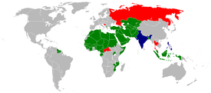
In 1970 the first ever meeting of Islamic Conference of Foreign Minister (ICFM) was held in Jeddah which decided to establish a permanent secretariat in Jeddah headed by the organization’s secretary general.
The present Charter of the Organization was adopted by the Eleventh Islamic Summit held in Dakar on 13-14 March 2008 which laid down the objectives and principles of the organization and fundamental purposes to strengthen the solidarity and cooperation among the Member States. Over the last 40 years, the membership has grown from its founding members of 25 to 57 states.
The Organization is representing over1.5 billion Muslims of the world. The Organization has consultative and cooperative relations with the UN and other inter-governmental organizations to protect the vital interests of the Muslims. Under the Charter, the Organization aims to enhance and consolidate the bonds of solidarity among the Member States.
- Objectives:

- Respect the right of self-determination and non-interference in the domestic affairs and to respect sovereignty, independence and territorial integrity of each Member State;
- Ensure active participation of the Member States in the global political, economic and social decision-making processes to secure their common interests;
- Reaffirm its support for the rights of peoples as specified in the UN Charter and international law;
- Strengthen intra-Islamic economic and trade cooperation; in order to achieve economic integration leading to the establishment of an Islamic Common Market;
- Utilize efforts to achieve sustainable and comprehensive human development and economic well-being in Member States;
- Protect and defend the true image of Islam, to combat defamation of Islam and encourage dialogue among civilizations and religions;
- Enhance and develop science and technology and encourage research and cooperation among Member States in these fields;

OIC Organs:

- The Islamic Summit, composed of Kings and Heads of State and Government of Member States, is the supreme authority of the Organization.
- It convenes once every three years to deliberate, take policy decisions and provide guidance on all issues pertaining to the realization of the objectives and consider other issues of concern to the Member States and the Ummah.
- The Council of Foreign Ministers, which meets once a year, considers the means for the implementation of the general policy of the Organization by, inter alia: Adopting decisions and resolutions on matters of common interest in the implementation of the objectives and the general policy of the Organization; Reviewing progress of the implementation of the decisions and resolutions adopted at the previous Summits and Councils of Foreign Ministers;
- The General Secretariat, which is the executive organ of the Organization, entrusted with the implementation of the decisions of the two preceding bodies. In order to coordinate and boost its action, align its view points and stands, and with concrete results in various fields of cooperation -political, economic, cultural, social, spiritual and scientific- among Member States, the Organization has created different committees, nearly all, at ministerial level, a number of which are chaired by Heads of State.
- The Al-Quds Committee, the Standing Committee for Information and Cultural Affairs (COMIAC), the Standing Committee for Economic and Trade Cooperation (COMCEC), and the Standing Committee for Scientific and Technological Cooperation (COMSTECH) are the ones Chaired by Heads of State.

- Conferences
Number Date Country Place
1st September 22–25, 1969 Morocco Rabat
2nd February 22–24, 1974 Pakistan Lahore
3rd January 25–29, 1981 Saudi Arabia Mecca and Ta’if
4th January 16–19, 1984 Morocco Casablanca
5th January 26–29, 1987 Kuwait Kuwait City
6th December 9–11, 1991 Senegal Dakar
7th December 13–15, 1994 Morocco Casablanca
March 23-24, 1997 Pakistan Islamabad
(1st Extraordinary)
8th December 9–11, 1997 Iran Tehran
9th November 12–13, 2000 Qatar Doha
March 4-5, 2003 Qatar Doha
(2nd Extraordinary)
10th October 16–17, 2003 Malaysia Putrajaya
December 7–8, 2005 Saudi Arabia Mecca
3rd Extraordinary

11thMarch 13–14, 2008 Senegal Dakar

August 14–15, 2012 Saudi Arabia Mecca
4th Extraordinary

- Pakistan's Role In the OIC

- Pakistan with its Islamic faith and support for Muslim causes, as well as in response to the overwhelming public support for the cause of liberation of Al-Quds Al-Sharif, was a founding member of the OIC in 1969.
- Relations with the Islamic world are the corner stone of foreign policy of Pakistan. As a founding member of the OIC Pakistan has an abiding commitment to the purposes, principles and objectives of its Charter.
- Pakistan has played an important role in strengthening cooperation among Muslim States by its active participation in the programs and activities of the OIC. The efforts by Pakistan have received due acknowledgment in the OIC signified by its membership of all key OIC's Specialized Committees and Contact Groups on critical issues of the Islamic world - Palestine, Afghanistan, Jammu & Kashmir, Bosnia and Kosovo.
- Pakistan is the Chairman of the OIC Standing Committee on Scientific and Technological Cooperation (COMSTECH) which has its Headquarters in Islamabad. Pakistan also host the Secretariat of the Islamic Chamber of Commerce and Industry( ICCI). The Office of the OIC's Secretary General's Special Representative on Afghanistan is based in Islamabad.
- The Headquarters of the Islamic Telecommunication Union would also be established in Islamabad. Pakistan is the Chairman of the Council and the Executive Committee of the Parliamentary Union of the OIC Member States (PUOICM).
- Mr. Sharif-ud-Din Pirzada a noted Lawyer and a former Foreign Minister of Pakistan served as the Secretary General of the OIC from 1984 to 1988. Pakistan is a member of all OIC subsidiaries, affiliated and specialized Organs.
- Pakistan hosted the second Islamic Summit Conference in Lahore on 22nd to 24th February 1974. Pakistan also hosted the Second Conference of the OIC Foreign Ministers (ICFM) held in Karachi from 26th to 28 December 1970, Eleventh ICFM in Islamabad from 17th to 22nd May 1980 and the Twenty-first ICFM held in Karachi on 25th to 29th April 1993. The Special Sessions of the OIC Foreign Ministers Conference in 1980 and in 1994 were also held in Pakistan.
- To commemorate Fifty years of the Independence of Pakistan an Extra-ordinary Session of the Islamic Summit was held in Islamabad on 23rd March 1997.
- A large number of the Islamic Heads of State and Government, in a grand gesture of solidarity with Pakistan attended the Summit meeting and conveyed their full support to the sovereignty, political independence and territorial integrity of Pakistan on this auspicious occasion.


- Non-Aligned Movement

The first Conference of Non-Aligned Heads of State or Government, at which 25 countries were represented, was convened at Belgrade in September 1961, largely through the initiative of Yugoslavian President Tito. At that stage his biggest concern was that an accelerating arms race might result in war between the Soviet Union and the USA.
The Non-Aligned Movement is a Movement of 115 members representing the interests and priorities of developing countries. The Movement has its origin in the Asia-Africa Conference held in Bandung, Indonesia in 1955. The meeting was convened upon the invitation of the Prime Ministers of Burma, Ceylon, India, Indonesia and Pakistan and brought together leaders of 29 states, mostly former colonies, from the two continents of Africa and Asia, to discuss common concerns and to develop joint policies in international relations. Prime Minister Nehru, the acknowledged senior statesman, along with Prime Ministers Soekarno and Nasser, led the conference. At the meeting Third World leaders shared their similar problems of resisting the pressures of the major powers, maintaining their independence and opposing colonialism and neo-colonialism, specially western domination.
- NAM Structure and Organization
- Coordination
- Coordinating Bureau
- Coordination of the Coordinating Bureau and role of the Chair
- Working Groups, Contact Groups, Task Forces and Committees
- Non-Aligned Security Council Caucus
- Joint Coordinating Committee

- Coordination of Non-Aligned countries in other UN centers
The Troika, Group of past, present and future Chairs (Group of Ten), Panel of Economists
Documentation, Decision making by consensus
(ref.http://www.nam.gov.za/background/background.htm)
- NAM Summits at a glance
First Conference - Belgrade, September 1-6, 1961
Second Conference - Cairo, October 5-10, 1964
Third Conference - Lusaka, September 8-10, 1970
Fourth Conference - Algiers, September 5-9, 1973
Fifth Conference - Colombo, August 16-19, 1976
Sixth Conference - Havana, September 3-9, 1979
Seventh Conference - New Delhi, march 7-12, 1983
Eighth Conference - Harare, September 1-6, 1986
Ninth Conference - Belgrade, September 4-7, 1989
Tenth Conference - Jakarta, September 1-7, 1992
Eleventh Conference - Cartagena de Indias, October 18-20, 1995
- Pakistan’s role in NAM
- PEACEFUL SETTLEMENT OF DISPUTES: In view of the unresolved Kashmir issue, it has been our efforts that the NAM decisions reflect an emphasis on peaceful settlement of disputes. Therefore, urged the Movement consistently to evolve a mechanism for conflict resolution. In this context, the Final Document of the 12th NAM Summit, held in Durban, had reiterated the need to secure a peaceful settlement of all outstanding issues in South Asia.
- NUCLEAR ISSUE: Pakistan has fully supported NAM’s principled position on the issue of global nuclear disarmament within a time-bound framework. On the question of the South Asian nuclear tests, the 12th NAM Summit affirmed “the need for bilateral dialogue to secure peaceful solutions to all outstanding issues and the promotion of confidence and security building measures and mutual trust”. This is a clear endorsement of Pakistan’s position that a solution to the situation arising from the nuclear tests cannot be promoted in an atmosphere of pressure.
- SELF-DETERMINATION : NAM has constantly working for the fundamental right of all peoples to self-determination, the exercise of which, in the case of peoples under colonial or alien domination and foreign occupation, is essential to ensure the eradication of all these situations and to guarantee universal respect for human rights and fundamental freedoms. In this regard, the Movement has strongly condemned ongoing brutal repression of the legitimate aspirations for self-determination of peoples under colonial, alien domination and foreign occupation in various regions of the world.
- TERRORISM: The 12th NAM Summit had stressed the need to combat terrorism in all its forms and manifestations, regardless of race, religion or nationality of the victims or perpetrators of terrorism. The Summit, however, endorsed, in principle, the call for the definition of terrorism and to differentiate it from the legitimate struggle of peoples under colonial or alien domination and foreign occupation, for self-determination and national liberation.
- EXPANSION OF THE SECURITY COUNCIL: Since NAM predominantly comprises developing countries, it has reliably paid considerable attention on economic issues. The Movement has maintained its long-standing position on the need for conscious steps to regulate the market measures as a means of ensuring that growth in the world economy and trade is both dynamic as well as unbiased.
- Pakistan desires to see NAM play an increasingly effective role in all international forums, particularly in the United Nations. It is important that the Movement safeguards and preserves the principled positions evolved by it on a wide range of international issues.
Analysis
Pakistan's participation in international organizations, including UNO, OIC and the NAM, reflect its desire to be an influential player in the geographic region of which it is a part.
In addition, Pakistan has played a leading role in the OIC, and President Zia was instrumental in energizing the OIC as a forum for periodic meetings of the heads of Islamic states. Pakistan thus appears firmly committed to the utility of broad-based international cooperation.
Quotation
The five separate fingers are five independent units. Close them and the fist multiplies strength. This is organization.
James Cash Penney

Lecture # 23
Pakistan’s Role in Regional & International Organizations, Part II: SAARC, ECO
- Definition and Types of Organizations
An international organization is an organization with an international membership, scope, or presence. There are four main types:
- International nongovernmental organizations (NGOs): non-governmental organizations (NGOs) that operate internationally. There are two types:
- International non-profit organizations. Examples include the World Organization of the Scout Movement, International Committee of the Red Cross.
- International corporations, referred to as multinational corporations. Examples include The Coca-Cola Company and Toyota.
- Intergovernmental organizations, also known as international governmental organizations (IGOs): the type of organization most closely associated with the term 'international organization', these are organizations that are made up primarily of sovereign states (referred to as member states).
Notable examples include the United Nations (UN), Organization for Security and Co-operation in Europe (OSCE), Council of Europe (CoE), European Union (EU; which is a prime example of a supranational organization), and World Trade Organization (WTO). The UN has used the term "intergovernmental organization" instead of "international organization" for clarity.
Regional integration is a process in which states enter into a regional agreement in order to enhance regional cooperation through regional institutions and rules. The objectives of the agreement could range from economic to political, although it has generally become a political economy initiative where commercial purposes are the means to achieve broader socio-political and security objectives.
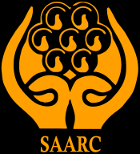
- South Asian Association for Regional Cooperation

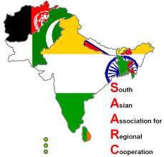
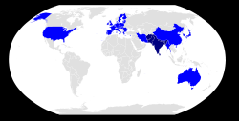

Observers State Member-States
The South Asian Association for Regional Cooperation (SAARC) is an organization of South Asian nations, which was established on 8 December 1985. The government of Bangladesh, Bhutan, India, Maldives, Nepal, Pakistan, and Sri Lanka formally adopted its charter. It was establish to promote economic and social progress, cultural development within the South Asia region and also for friendship and cooperation with other developing countries.
It is dedicated to economic, technological, social, and cultural development emphasizing collective self-reliance. Its seven founding members are Sri Lanka, Bhutan, India, Maldives, Nepal, Pakistan, and Bangladesh. Afghanistan joined the organization in 2007. Meetings of heads of state are usually scheduled annually; meetings of foreign secretaries, twice annually. It is headquartered in Kathmandu, Nepal.
History: The first concrete proposal for establishing a framework for regional cooperation in South Asia was made by the late president of Bangladesh, Ziaur Rahman, on May 2, 1980. Afghanistan, Bangladesh, Bhutan, India, Maldives, Nepal, Pakistan, Sri Lanka are the founder member states. 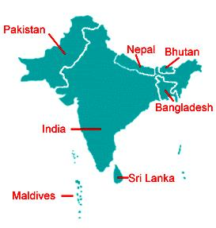
- Objectives
- to promote the welfare of the people of South Asia and to improve their quality of life;
- to accelerate economic growth, social progress and cultural development in the region and to provide all individuals the opportunity to live in dignity and to realize their full potential;
- to promote and strengthen selective self-reliance among the countries of South Asia;
- to contribute to mutual trust, understanding and appreciation of one another's problems;
- to promote active collaboration and mutual assistance in the economic, social, cultural, technical and scientific fields;
- to strengthen cooperation with other developing countries;
- to strengthen cooperation among themselves in international forums on matters of common interest; and
- to cooperate with international and regional organizations with similar aims and purposes.

- Organs
- Secretariat: The SAARC Secretariat was established in Kathmandu on 16 January 1987 and was inaugurated by Late King Birendra of Nepal. It is headed by a Secretary General appointed by the Council of Ministers from Member Countries in alphabetical order for a three-year term. The Secretariat coordinates and monitors implementation of activities, prepares for and services meetings, and serves as a channel of communication between the Association and its Member States as well as other regional organizations. In several recent meetings the heads of state or government of member states of SAARC have taken some important decisions and bold initiatives to strengthen the organization and to widen and deepen regional co-operation.
- The SAARC Secretariat and Member States observe 8 December as the SAARC Charter Day.
- Regional Centers: The SAARC Secretariat has established various regional centers in member states. Each regional center is managed by a governing board. SAARC has intentionally laid more stress on "core issues" rather than political issues like the Kashmir dispute and the Sri Lankan civil war. However, political dialogue is often conducted on the margins of SAARC meetings. During the 12th and 13th SAARC summits, extreme emphasis was laid upon greater cooperation between the SAARC members to fight terrorism.
- South Asian Free Trade Area: Over the years, the SAARC members have expressed their unwillingness on signing a free trade agreement. Though India has several trade pacts with Maldives, Nepal, Bhutan and Sri Lanka, similar trade agreements with Pakistan and Bangladesh have been delayed due to political and economic concerns on both sides.
- In 1993, SAARC countries signed an agreement to gradually lower tariffs within the region, in Dhaka. Eleven years later, at the 12th SAARC Summit at Islamabad, SAARC countries devised the South Asia Free Trade Agreement which went into force on January 1, 2006. Under this agreement, SAARC members will bring their duties down to 20 per cent by 2009.

- Role of Pakistan

- Since the Association's start, Pakistan has been a supporter of SAARC objectives and has remained an active player on the SAARC platform.
- It has contributed meaningfully to the establishment institutions and progress of the Association.
- Pakistan supported a step by step approach for enhancing cooperation and stresses the need for better coordination of programs and consolidation of the progress made so far

- Economic Cooperation Organization (ECO)
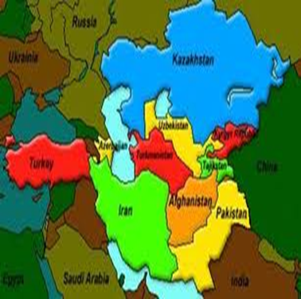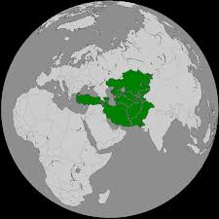
The Economic Cooperation Organization (ECO) is an inter-governmental organization involving seven Asian and three Eurasian nations part of the South-central Asian Union. It provides a platform to discuss ways to improve development and promote trade, and investment opportunities. The common objective is to establish a single market for goods and services, much like the European Union.
- History
ECO's secretariat and cultural department are located in Tehran, its economic bureau is in Turkey and its scientific bureau is situated in Pakistan. The organization was founded by Turkey, Iran and Pakistan. Economic Cooperation Organization is an inter-governmental regional organization established in 1985 by Iran, Pakistan and Turkey for the purpose of promoting economic, technical and cultural cooperation among the member states.
- Background
It was the successor organization of what was the Regional Cooperation for Development (RCD), founded in 1964, which ended activities in 1979. In the fall of 1992, the ECO expanded to include seven new members, namely Afghanistan, Azerbaijan, Kazakhstan, Kyrgyzstan, Tajikistan, Turkmenistan and Uzbekistan. The status and power of the ECO is growing. However, the organization faces many challenges. Most importantly, the member states are lacking appropriate infrastructure and institutions which the Organization is primarily seeking to develop, to make full use of the available resources in the region and provide sustainable development for the member nations.
The Economic Cooperation Organization Trade Agreement (ECOTA) was signed on 17 July 2003 in Islamabad. ECO Trade Promotion Organization (TPO) is a new organization for trade promotion among member states located in Iran (2009). Under the agreement reached between ECO members, the common trade market should be established by 2015
- Sustainable Economic Development of Member States
Progressive removal of trade barriers and promotion of intra- regional trade; Greater role of ECO region in the growth of world trade; Gradual integration of the economies of the Member States with the world economy; Development of transport & communications infrastructure linking the Member States with each other and with the outside world; Economic liberalization and privatization; Mobilization and utilization of ECO region's material resources; Effective utilization of the agricultural and industrial potentials of ECO region; Regional cooperation for drug abuse control, ecological and environmental protection and strengthening of historical and cultural ties among the peoples of the ECO region; and Mutually beneficial cooperation with regional and international organizations.

- Activities
Activities of ECO are conducted through Directorates under the supervision of Secretary General and his Deputies which considered and evolve projects and programs of mutual benefit in the fields of:
- Trade and Investment
- Transport and Telecommunications
- Energy, Minerals and Environment
- Agriculture, Industry and Tourism
- Human Resources & Sustainable Development
- Project & Economic Research and Statistics

- Pakistan’s role in ECO
ECO currently is engaged in energy crisis resolution and meetings are being held in Tehran. And by resolving this problem all the members will facilitated by it specially Pakistan. Because besides the potentiality of the country in many a sectors still they are not operating at an efficient level which is required according to the current need of the scenario.
Pakistan’s potential in telecommunication, agriculture, food, industry, trade and many other sectors made it significant as it can play its role for the betterment of rest of the member nations by providing them with assistance financially and technically both.
Quotation

Without courage, wisdom bears no fruit.
Baltasar Gracian

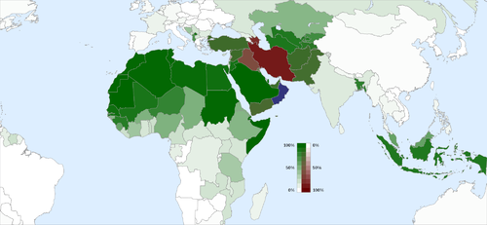
Lecture # 24
Pakistan and the Muslim world I
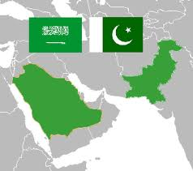
- Pakistan- Saudi Arabia: Historical background
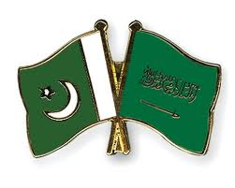

Arab traders were the main supplier for chain of silk, spices, cotton and other goods between Pakistan and Europe through the silk route, over centuries of history exist in relations between the two lands.
- Importance of KSA
- Two Holy Cities Makkah & Madina
- 1965 & 1971 Wars Domestic and Financial help
- Golden Era of Shah Faisal
- Saudi support to Pakistan in all internal and external affairs and at all international forums.

- Role of Pakistan in development of Saudi Arabia.
- Pakistan has provided assistance in the field of Science & Technology , infrastructure development and many more fields .
- Pakistan is providing training facilities to Saudi Armed forces.
- In Gulf War some 5,000 Pakistani troops were stationed in Saudi Arabia and the United Arab Emirates as part of the U.S.-led Persian Gulf War efforts in 1990.
- Pakistan has provided military aid and expertise to the kingdom for decades-close ties between militaries.
- Saudi Arabia is one of the supporter of Afghan Mujahedeen during Afghan war against USSR and European and US arms suppliers, all were supporting Taliban however in 2001 Saudi broke ties with Taliban.
- SA also supported Afghan Muhajreen during that War.
- In 2005 earthquake -Saudi Arabia topped the list of donor countries. Official aid followed by large investments from Saudi princes and from religious institutions.
- Pakistani madrassa educational system, for instance, is Saudi funded by private donors.
- The two countries Pakistan and Saudi Arabia shared views on major international and regional issues. Both countries consult each other on regional and international issues from time to time.
- They work together on Organization of Islamic Conference. Saudi Arabia supported Pakistan in all its wars with India and its position on Kashmir is supportive of Pakistan.
- Saudi Arabia and Pakistan have an extensive economic relationship that expanded rapidly after 1972. SA had always provided economic assistance and loans to Pakistan and it had also invested capital in Pakistan in various projects. An important aspect of relationship is oil supply to Pakistan from Saudi Arabia.
- Since 1998 SA had been supplying crude oil to Pakistan on deferred payment bases which mean that to get the oil now but make the payment later on gradually.
- This has help to ease economic pressure on Pakistan and Pakistan has been able to obtain oil.
- SA is the biggest oil supplier to Pakistan at the moment. This relationship is going to expand over the years because both have been expanding the area of cooperation for example latest addition to this cooperation is counter terrorism and both countries are cooperating to contain terrorism in the region.

- Pakistan and Turkey
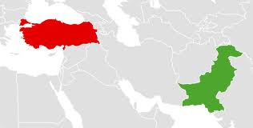
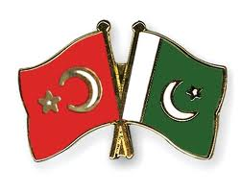
Turkey is another Muslim country with a long history of close and cordial relations with Pakistan. Turkey had stood by Pakistan in all kinds of situations in wars or in peace. Turkey has always supported Pakistan. Turkey established diplomatic relations soon after the independence of Pakistan in 1947 and bilateral relations became increasingly close owing to cultural, religious and geopolitical links between the two countries.
Pakistan's founder Muhammad Ali Jinnah expressed admiration for Turkey's founding leader Mustafa Kemal Atatürk and also a desire to develop Pakistan on the Turkish model of modernism. Pakistan, Turkey and Iran established the RCD in 1964. Turkey supports Pakistan on the Kashmir dispute and Pakistan supports them on the Cyprus conflict. There have been high level civil and military visits, in fact their top military leaders visited Pakistan and Pakistani top military leaders responded to that and go back to Turkey for similar visits. Both have great contribution in the multilateral arrangements of CENTO, RCD, ECO, etc.
In 80’s the RCD was replaced by ECO (economic cooperation organization) in 1985. It was initiated by Pakistan, Iran and Turkey but now it has 10 members which includes 7 Asian and 3 Eurasian nations and it is an ad-hoc organization to UN.
In 90’s, present ECO cultural institute was signed at Islamabad in 1995 to foster rich culture heritage of Turkey, Iran and 10 other Asian states mid 1990’s. The hero of the nation, Dr. A Q Khan visited turkey for technological cooperation.
In 2004, President Gen Pervez Musharraf visited Turkey. In 2005 Kashmir earthquake, Turkey stepped up its efforts to help the Pakistani people of the affected areas. President Zardari visited Turkey in 2008. Turkish PM, Mr. Erdogan addressed a joint session of two houses of the parliament of Pakistan during his visit 2012. Turkey and Pakistan are founding members of the Economic Cooperation Organization and part of the Developing 8 Countries (D-8) organization. Both nations have worked to negotiate on trading agreement, aiming to increase trade and investments, especially in transport, telecommunications, manufacturing, tourism and other industries. Pakistani exports include rice, sesame seeds, leather, textiles, fabrics, sports goods, and medical equipment.

- Pakistan and Egypt
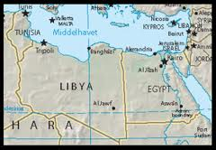
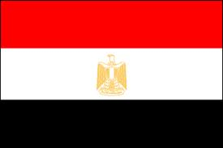
Pakistan’s relations with Egypt
Egypt Pakistan relations are normal and cordial. currently they exchanged views on regional and international issues. However in the past in the 50s and 60s there was a problem in Pakistan’s relation with the Egypt. Egypt under Nasser had some reservations due to Pakistan’s ties with the West. The relations began to improve and the cordiality has increased since 1967 and especially after the death of Nasser in 1970. Pakistan supported Egypt when it was attacked by Israel in 1956, 1967, 1973. Pakistan and Egypt both are members of OIC. During Arab-Israel wars Anwar Saddat recognized Pakistan’s services in OIC in 1974.
Egypt also played a vital role in Soviet war in Afghanistan where Egypt widely provided manpower (see Afghan Arabs) and military equipment to Afghan mujahedeen in their fight against the Soviets.
Al-AZHAR University is one of the first preferences of Pakistani student for the education of Islamic Law, Sharia and Jurisprudence. Al-Azhar University continues to offer its 30 scholarships to the Pakistani students each year; this number will rise to 50 soon. Since 2001, Egypt continues to support Pakistan in its war against terrorism. In May 2009, Egyptian Assistant Foreign Minister visited Islamabad to show Egypt’s support and solidarity with the people and government of Pakistan.
Pakistan Prime Minister, Yusuf Raza Gilani, on assuming his office, made his first trip abroad to Egypt, within a year time, Gilani visited Egypt again in July 2009.

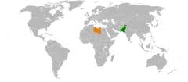
- Pakistan and Libya

The early 1970s were the first time the Pakistani populace began to notice Muammar Gaddafi. Gaddafi gave a speech at the Organization of the Islamic Conference meeting, where he declared support for Pakistan to pursue development of nuclear Power. When he came to Pakistan to attend the second Islamic Summit Conference in 1974, he stated, "Pakistan is the fort of Islam." Because of Gaddafi's support for Pakistan's nuclear deterrence program, he became a popular figure within the country. Gaddafi cricket stadium in Lahore, the largest in the country, was named after him.
Libya-Pakistan relations refer to the bilateral and diplomatic relations between Libya and Pakistan. The relationship has been friendly throughout its history. Both countries share religious and cultural links, particularly their Islamic heritage. Libya’s head of state Col. Qazzafi was one of the great well-wisher and supporter of Pakistan. He and his govt. extended valuable support to Pakistan in the 70s, this support was not only diplomatic support but also economic support and in the 70s Libya invested in Pakistan. When in 1986 American army launched air raids on Libya Pakistan despite its close ties with America condemned American air raids on Libya.
After the removal of Zulfikar Ali Bhutto, the bonds with Pakistan became weak. General Zia hated and distrusted Colonel Gaddafi, therefore he immediately cut all the military aid to Libya. Now the Libya is overcoming its problems with the United States Libya Pakistan relations are becoming friendly and activated.

- Pakistan and Jordan

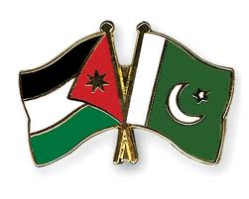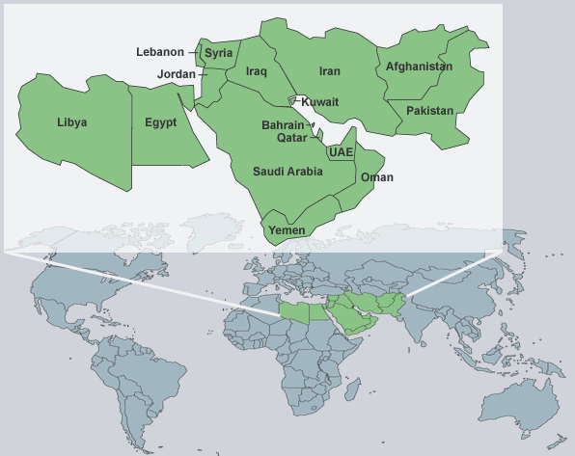

Pakistan-Jordan contacts began in the 1970s and 1980s, growing stronger since the mid-1990s. In 2001, Pakistani leaders visited Amman to discuss full-scale cooperation. The King of Jordan lauded what he called "deep, strong and historical relations" between the two countries. Jordan, as the custodian of the Masjid-i-Aqsa, has always occupied a place of great affection in the hearts of Muslims of Pakistan and has attracted Pakistani pilgrims by the thousand. Pakistan’s relations with Jordan have always been very cordial and a large measure of political co-operation has existed between the two countries. Hussein paid a State visit to Pakistan in 1955. His second visit to Pakistan.
In the joint Pakistan-Jordan communiqué issued after the Pakistan Prime Minister’s visit to Jordan in August 1957, the two countries pledged themselves to cooperate with each other in pursuance of their common policies and interests. The suggestion of Ch. Mohammad Zafrullah Khan, while he was Pakistan’s Foreign Minister, to convene a conference of Muslim countries at Jerusalem to evolve some positive policy for united action for countering the threat of the State of Israel is a manifestation of the keen interest of Pakistan in the welfare and security of Jordan.
Quotation
Observe good faith and justice toward all nations. Cultivate peace and harmony with all.
George Washington

Lecture # 25
Pakistan and the Muslim world II
- Pakistan & Syria
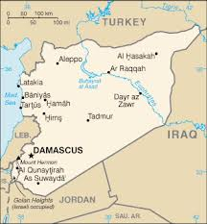

Pakistan–Syria relations are the relations between Syria and Pakistan are historic where the two have ancient civilizational ties. Both countries were on the silk route through which civilizational exchanges took place for centuries. Damascus has been one of the great power centers of the Muslim world. It is a matter of satisfaction to Pakistan that its relations with Syria have always been cordial.
In 2005 Syria and Pakistan agreed on mutual cooperation in the fields of science and technology.

- Pakistan & Lebanon
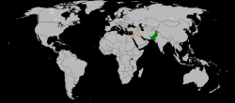


Historically, Lebanon has been a meeting place of the empires and civilizations of Asia and Europe. The Lebanese have been a great sense of business. Their ancestors demonstrated a remarkable genius for trade & commerce.
Contacts between Pakistan and Lebanon have greatly expanded in recent years with the introduction of direct air service. Now the exchange of visits between scholars, businessmen and others will prove mutually beneficial. Lebanon–Pakistan relations are the relations between Lebanon and Pakistan. Pakistan and Lebanon are bound by deep ties of amity and friendship and relations between the two brotherly countries have always been close and friendly.[1] Pakistan has an embassy in Beirut. Lebanon has an embassy in Islamabad.
Bilateral trade between the two nations currently stands at $35.4 million in 2005-06.
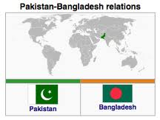
- Pakistan & Bangladesh
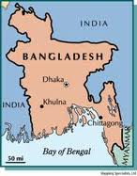
Bangladesh came into existence in December 1971 in a situation which created a lot of bitterness in Bangladesh against Pakistan and in Pakistan against Bangladesh. So in the initial years there was a lot of bitterness between the two countries. Bangladesh was East Pakistan but the internal instability and external conspiracies gave birth to Bangladesh. Pakistan had initially bitter relations but recognized it in February 1974 and from that time its relation with Bangladesh have gradually improved.
Despite the fact that in the initial years both the countries have complaints against each other. In the present day context countries have cordial relations, trade has improved and the visits of senior official and political leaders have been there. Both worked together within the framework of SAARC, OIC. With the passage of time the relations of both these countries are going to expand.
An issue of continuing controversy is the status and return of Biharis, also called Stranded Pakistanis to Pakistan. Numbered around 540,000, these communities had migrated to what became East Pakistan from the Indian state of Bihar after the partition of India in 1947.
During the liberation war, these communities supported the Pakistani government and later wanted to immigrate to Pakistan. Relations improved considerably under the military regimes of Ziaur Rahman and Hossain Mohammad Ershad in Bangladesh, which had grown more distant from its war ally, India. Five Pakistani heads of government made official visits to Bangladesh since the 1980s and numerous trade and cultural agreements have been signed. Common concerns over India's regional power have influenced strategic cooperation leading to a gift of several squadrons of F-6 fighter aircraft to the Bangladesh Air Force in the late 1980s.

- Indonesia & Pakistan
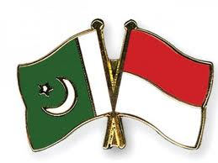
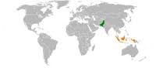
Pakistan-Indonesia relationship is particularly special, founded on common mutual religious outlook. Indonesia is the world largest Muslim country in terms of its population, whereas Pakistan is the world second largest Muslim country.
Both countries are members of the Organization of Islamic Cooperation. Pakistan has an embassy in Jakarta, whereas Indonesia has a embassy in Islamabad, and a Consulate General in Karachi. Pakistan’s policy of good relations and friendship has extended eastwards to the islands of Indonesia. The history of Pakistan’s relations with Indonesia is also based on the unfailing support of the Muslims of this sub-continent for their brothers in other countries. The people of Indonesia in their struggle for freedom had all the sympathy and support of the people of Pakistan.
Pakistan residents in Indonesia fought side by side with their Indonesian brethren in their war of liberation. The newborn State of Pakistan in those days extended its whole-hearted support to their cause both within and outside the United Nations and rejoiced when their struggle came to a successful end with the establishment of Indonesia.
During the Indonesian National Revolution, Muhammad Ali Jinnah encouraged Muslim soldiers serving in British Indian army to join hands with Indonesians against their fight against the Dutch Empire colonization of Indonesia.
As a result 600-Muslim soldiers of the British Indian Army deserted the colonial forces putting their lot at stake, allied with Indonesians. Out of these 600 soldiers, 500 of them died in war; while the remaining returned to Pakistan or continued to live in Indonesia.
As a recognition of Muslim soldiers from Pakistan, during Indonesia Golden Jubilee celebration on August 17, 1995, Indonesia grants Independence War Awards to the living ex Pakistan soldiers and awarded the highest honor Adipura to the Founding Father of Pakistan Mohammad All Jinnah and the Government of Pakistan.
Pakistan's relationship with Indonesia greatly developed under Gen Ayub Khan. During the 1965 war with India, Indonesia offered to provide Pakistan with military help.Indonesia’s President Megawati Sukarnoputri paid a 3-days official visit to Islamabad in Dec 2003.
Indonesian president Susilo Bambang Yudhoyono visited Pakistan in 2005. Former Pakistani President Pervez Musharraf visited Indonesia in Jan 2007. In Nov 2010, Pakistan Foreign Minister Shah Mehmood Qureshi visited Indonesia and held bilateral talks on trade, terrorism and current situation in Afghanistan and Middle East. It was in the context of our mutual support for just causes and the dedication of the two countries to the implementation of the right of self-determination of all peoples that Indonesia extended its unequivocal support to Pakistan with regard to the Jammu and Kashmir dispute.
In the development of even closer relations between Indonesia and Pakistan, a historic event took place when at a conference held in Karachi in March, 1965 “IPECC” (Indonesia-Pakistan Economic and Cultural Cooperation) was established. This provided for RCD-type Co-operation between the two countries in order to maximize trade and promote joint ventures in industry and cooperation in communications for their mutual benefit. It also provided for development of cultural contacts to cement existing ties between peoples of the two countries.
There has been significant economic cooperation between the two countries with the largest Muslim populations in the World. Co-operation between Pakistan and Indonesia has extended to various fields, particularly in international affairs.

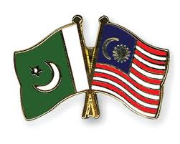
- Pakistan & Malaysia
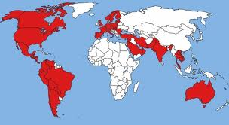

Pakistan has brotherly relations with Malaysia. Both are members of Organization of Islamic Conference (O.I.C) and the Commonwealth of Nations. There is a trade and cultural pact between the two countries, under which the import and export of various goods is done on fairly large scale. The President and the Prime Minister of Pakistan along with other high officials visited Malaysia many times and Malaysian officials also paid a good will visit to Pakistan. Both the countries enjoy close relations and links of mutual friendship and the cooperation has further strengthened.
Even before the independence of Malaya there was contact between the leaders of Pakistan and Malaya. In 1955 Tunku Abdur Rahman on his way to the independence talks in London broke journey in Karachi for consultations with the Pakistani Prime Minister. The most notable were the visits to Pakistan of the Chief Ruler of Malaya in December, 1961, and Prime Minister Tunku Abdur Rahman’s visit in October, 1962. These visits have helped to maintain close political, commercial and cultural relations between the two countries. Indonesia, Malaysia and the Philippines, expressed their concerns. Again in April, 1964, the President offered to the three parties’ facilities for holding a Conference in Pakistan.1964, the President gave a statement in London expressing the hope that Indonesia and Malaysia would continue to explore possibilities of an cordial settlement. Malaysia and Pakistan have signed a Free Trade Agreement known as Malaysia-Pakistan Closer Economic Partnership Agreement (MPCEPA) in Jan 2008. In a very short span of time, relations between the two countries established as a useful platform, dedicated to the promotion of bilateral relationship and friendship. This relationship is not restricted to any one area or field, but it covers every aspect of bilateral cooperation i.e. trade, commerce, industry, tourism, culture, education, health, etc.
Analysis
- Muslim countries are not based on desire for gain or for gratitude. It is based on much more fundamental considerations and compulsions. Even before the beginning of the Pakistan movement, the leaders of Muslim revival in the sub-continent had identified themselves with the greater cause of an awakening of the Islamic world as a whole.
- The ideology of Pakistan was not only confined to the need for the freedom of the Muslims of the sub-continent. It was extremely concerned with the display in the twenty first century of Islamic values of social Justice and universal brotherhood.
- The promotion of harmony, peace and justice in international affairs has, therefore, been an important principle with Pakistan in the conduct of its foreign policy.
- Its ideological basis, its dedication to the cause of freedom, solidarity and progress of Islam in the twentieth century, and its keen mission for peace with justice and equity and for the fulfillment of its purpose in the scheme of things in the Muslim world were critical factors.
- Pakistan has a role of the greatest importance to play in this evolutionary phase. Its situation on the edges of the Middle East on the one hand and the Far East on the other is in itself a compelling factor.
- Its ideological basis provides the motive power. It is the particular heritage of Pakistan, however, which remains the most strong factor in the determination of both the nature and scope of its role.
- The Muslims of Pakistan have inherited, along with their Islamic zeal an admixture of all the other great civilizations that have helped to shape human destiny.
- Pakistan will carry for the world the lifeblood of its future generations with all the promise of peace, brotherhood, progress and enlightenment—in fact the true ingredients of a better world. If mankind is to avoid the many drawbacks which lie in its path, many a bridge will have to be established in the world of the future. A simple glance at the human, political and physical geography of the world will show the importance of the situation of Pakistan.
- Then there are other Muslim countries with which Pakistan has good and friendly relations. There are Muslim countries in Africa like Algeria, Tunis, Morocco and Sudan. With all these countries Pakistan has close and cordial relations. This reflects Pakistan’s effort to maintain close relations with the Muslim World which is an important feature of Pakistan’s foreign policy.
All this reflects the aspiration of the people of Pakistan who have been great supporter of Pakistan’s relations with the Muslim countries. Whenever there is a problem in the Muslim World the people of Pakistan have always stood by them and supported them in all respects therefore the govt. of Pakistan has always been doing the same thing because this is motto of the govt. from the constitution. This is also part of Pakistan’s political heritage; this also fits in Pakistani identity derived, forms and based on Islam that it must reflect these values in its foreign policy and relations with Islamic world.

Quotation
Peace and friendship with all mankind is our wisest policy, and I wish we may be permitted to pursue it.
Thomas Jefferson

Lecture # 26
Pakistan’s Foreign policy, Part I
- Introduction
Definitely, like men, states also require neighbors and friends in order to fulfill their social, economic, and political needs.
Foreign Policy can be defined as:
- "Relations between sovereign states: it is reflection of domestic politics and an interaction among sovereign states”.
- “It indicates the principles and preferences on which a country desire to establish relations with another country."
- “General objectives that guide the activities and relationships of one state in its interactions with other states.”

- What is the meaning of Foreign Policy?
A foreign policy is the dealing with the external environment; it is the collection of official document and formal records of action and public statements.
A foreign policy is the approach to establish foreign relations, consists on state-interest and to safeguard national interests and to achieve its goals.
The development of foreign policy is influenced by domestic considerations, the policies or behavior of other states, or plans to advance specific geopolitical designs.
Leopold von Ranke emphasized the primacy of geography and external threats in shaping foreign policy. But other writers emphasized domestic factors. Diplomacy is the tool of foreign policy, and war, alliances, and international trade may all be manifestations of it.

- Pakistan’s foreign policy in light of Quaid i Azam’s words
The father of the nation, Quaid-e-Azam defined Foreign Policy towards other countries of the world in 1948, as follows:
“Our Foreign Policy is one of friendliness and good-will towards all the nations of the world. We do not cherish aggressive designs against any country or nation. We believe in the policy of honesty and fair play in national and international dealings and are prepared to make our outmost contribution to the promotion of peace and prosperity among the nations of the world. Pakistan will never be found lacking in extending its material and moral support to the oppressed and suppressed of the United Nations Charter."
It was not possible for such an ideological state to set aside its ideology while framing its foreign policy. Thus Pakistan from the very first day started working for good relations with the Muslim world. Unity of Ummah, from the outset has been a corner stone of the foreign policy of Pakistan. As early as in 1948, while delivering a message on the occasion of Eid-ul-Fitr, Quaid-i-Azam advised:
“My Eid message to our brother Muslim states is one of friendship and goodwill. We are all passing through perilous times. The drama of power politics that is being staged in Palestine, Indonesia and Kashmir should serve an eye opener to us. It is only by putting up a united front that we can make our voice felt in the council of the world.”
- History of the formation of Foreign policy of Pakistan
- Soon after independence, Pakistan appointed six representatives abroad out of, which three were sent to the Muslim countries, i.e. Afghanistan, Iran and Egypt. The first foreign policy issue which engaged the attention of the newly born dominion of Pakistan was the Palestine question which had come before the UN General Assembly in April 1947. By the end of 1948, Pakistan had established diplomatic relations with almost all the Muslim countries of the world. Pakistan also gave complete moral support to the Muslims who were struggling for their independence in different parts of the world.
- Pakistan took the position that the Balfour Declaration and the mandate of the League of Nations were contrary to the wishes of the Palestinians and in disregard of the pledges of independence given to the Arabs. Pakistan suggested that the UN should strive to find a solution, which would be in accordance with the freely expressed wishes of the people concerned. Pakistan opposed the partition of Palestine and warned the UN that, the partition of Palestine might provoke a conflict which the UN might find difficult to contain.
- Pakistan supported Libya, Tunisia, Morocco and Algeria in their struggle for independence and gave them all possible support in the United Nations.Pakistan tried to develop good relations with Iran, Turkey and Indonesia. But, in spite of its efforts to remove the misunderstanding on the issue of Durand line, Pakistan failed to develop cordial relations with the Muslim neighboring state of Afghanistan.
- Later in 1951, a resolution was adopted that declared aggression against any Muslim country to be treated as aggression against the entire world of Islam. During 1950s Pakistan took many initiatives at the UN in favor of independence of those Muslim countries which were still under European colonial domination. Pakistan supported the cause of Indonesia at the UN. In early 1950 Pakistan decided to join the Western camp because the other option, as USSR, was not ready to supply arms to any non-communist country.
- Moreover Pakistan emphasis on religion was indirect ideological conflict with the anti-religion policy of the Soviet Union. Hence Pakistan gradually drifted towards the West and became the most allied ally of USA.
- Baghdad Pact and CENTO was opposed by the Arab countries and Pakistan by joining the pact tense its relations particularly with Egypt. The mishandling of the situation during the Suez Canal crises adversely affected the credibility of Pakistan in the Arab World. However by joining the Baghdad Pact Pakistan got the required military assistance and came closer to Turkey and Iran. The two countries proved to be the best of the friends of Pakistan and helped it in the times of peace as well as war.
- During the days of Ayub Khan, Pakistan adopted a policy of developing good relations with the Muslim countries on bilateral basis. Pakistan made efforts to remove its differences with the Arab countries. The relations between Pakistan and Egypt normalized. During the 1967 Arab-Israel war, Pakistan succeeded in removing misunderstandings and imparting the feeling of solidarity. Pakistan strongly condemned the Israeli aggression. Apart from the public sympathy in Pakistan, the country gave diplomatic support to the Arabs and played a positive role in UN. Two resolutions, condemning Israel, submitted by Pakistan were adopted on July 4 and July 14, by a vast majority in the General Assembly of the United Nations. Pakistan also condemned the 1969 Israeli aggressive design to damage Masjid Al-Aqsa and offered the Arab Muslims its complete support.
- Pakistan made attempts to develop close relations with Iran and Turkey in the Socio-economic field. On the initiative of the president of Pakistan the three Muslim members of the CENTO decided to form a new organization. The Presidents of Pakistan and Turkey and the Shah of Iran met at Istanbul and Regional Co-operation for Development (RCD) was launched on July 22, 1964.
- Pakistan tried to involve Afghanistan in the organization but all its efforts failed. The main aim of the organization was to develop cultural and economic ties between the three Muslim countries of the same geographical region.
- In spite of its limitations, RCD brought Pakistan closer to Turkey and Iran and it was considered a step forward towards the unity of the Muslim world.
- Pakistan also developed good ties with Indonesia. In September 1964, the two Islamic countries signed a pact for economic and cultural co-operation. The basic purpose of this pact was to promote co-operation in the economic and cultural fields on the lines of RCD pact. Apart from the ideological factor, the reasons for the promotion of relations between the two countries were the beginning of Indonesia tension with India and the start of Pakistan good relations with China. Indonesia and China were already good friends.
- The policies adopted by the foreign policy makers of Pakistan towards the Muslim countries in 1960 paid its dividends.
- During the Indo-Pakistan war of 1965, all the Arab countries gave moral support to Pakistan. Egypt was the only exception, who remained neutral. Brotherly countries like Indonesia, Turkey and Iran also gave material support to Pakistan during the war.
- The burning of Al-Aqsa Masjid on August 21, 1969 sent a wave of irritation throughout the Muslim world including Pakistan. On the initiative of King Faisal of Saudi Arabia, Muslim countries of the world decided to hold a Summit. Thus the idea of holding a conference of the Muslim heads of the states, which was proposed by Pakistan in 1952 was finally implemented after the delay of seventeen years.
- After the separation of East Pakistan in 1971, Pakistan tried to cultivate close relations with the Islamic World and China and tried to maintain an equidistant relationship with the superpowers. Zulfiqar Ali Bhutto, the president of Pakistan made a whirlwind tour of twenty countries, including many Muslim countries of the Middle East and Africa and tried to develop cordial relations with them. Pakistan tried to strengthen ties with the countries of the Arab World. New avenues were explored for economic and technical co-operation between Pakistan and the Arab countries. On the outbreak of the Arab-Israel War in October 1973, Pakistan openly sided with the Arabs and condemned Israel.
- Holding of the Second Islamic Summit Conference under the sponsorship of the Organization of Islamic Conference at Lahore from February 22, to February 24, 1974 was a landmark in the history of Pakistan relations with the Muslim countries. Not only all the 30 invited states attended the conference but some new members also joined it, bringing the total number of participants to thirty-eight. The Lahore summit recognized P.L.O. as the sole legitimate representative of the Palestine nation. P.L.O was admitted as a full member of the OIC.
- When Soviet Union attacked Afghanistan, Pakistan forgot its old tense relations with the neighboring Muslim country. Motivated by security needs coupled with ideological sympathy, Pakistan decided to support the Mujahideen, who had declared Jihad against the Soviets. Pakistan had two options i.e. either to fight a war by proxy in Afghanistan or to face the Soviet forces directly in the years to come. Pakistan opted for the former.Pakistan provided military assistance to the Mujahideen fighting in Afghanistan and gave refuge to the thousands of Afghan brothers and sister who were passing through the worst period in their history. Some Pakistanis, voluntarily fought shoulder by shoulder with their Afghan brothers in the Jihad. Some of them lost their lives and many others lost their limbs.
- The 1979, revolution in Iran greatly affected the relations between the two brethren Islamic states. Although Pakistan was the first county who recognized the revolutionary government in Iran yet the relations between the two countries suffered a setback during the early phase of the post-revolutionary Iran. They took divergent stands on various issues. Both states faced a variety of actual and potential friction points. The foreign policy of both underwent a tremendous change in the post revolution period. Pakistan was apprehensive of the Iranian intention to export revolution to Pakistan and the Muslim world in general. Iran considered Pakistan as the ally of the US, which was conceived by Iran as their greatest enemy.
- During the Gulf war, Pakistan was in a dilemma. While the public sympathies were with Iraq, the government followed a pro West policy. However, Pakistan did not involve itself directly in the conflict and remained contented with sending troops to Saudi Arabia which remained away from the main theater of the war. On the other hand, Pakistan government has practically stopped military assistance to Kashmiri Mujahideen and has limited itself to diplomatic and verbal support.
- The Kashmir problem has been presented more as an issue of the violation of Human Rights rather than the incomplete agenda of the partition of the sub-continent and denial of the right of self-determination to the people of Jammu and Kashmir.

- Foreign policy and Constitution of Pakistan
All the three constitutions of Pakistan stressed on the good relations with the Muslim world. Article 24 of the 1956 Constitution provided that the State should try to strengthen the bond of unity among Muslim countries. Article 21 of the 1962 Constitution provided that the bonds of unity among Muslim countries should be ensured. In the 1973 constitution, Article 40 among other things lays down a principle of policy that the state shall try to preserve and strengthen brotherly relations among Muslim countries based on Islamic unity.
A study of the 65 years of Pakistan’s foreign policy shows that its ideological aspect has been an integral part of the political culture of Pakistan. Since the demise of the U.S.S.R, a new-world order is emerging which has given the United States immense influence in international politics.
The United States is trying to impose its own brand of new-world order and Pakistan like most of the third world countries is under pressure to accept it. The political instability since mid-eighties has further weakened the position of Pakistan.
- Diplomatic Dynamics
Diplomatic dynamics is dependent upon foreign policy in structural and functional context. Foreign policy is the process of regulating state behavior in the global community according to specific objectives. Henery Kissinger is of the opinion that foreign policy is state relations to achieve well defined objectives.
The foreign policy is formulated on two points as follows:
- The objectives the countries want to achieve.
- Variables that contribute to shape external relations.
Pakistan being no exception, has clearly spelled out objectives. Pakistan stands for peace, cooperation, and interdependence. Similarly, three conspicuous variables have helped in developing and shaping its foreign policy. These are:
  - National Security,
  - Economic interest and
  - Ideology.

- Basic Goals of Pakistan’s Foreign Policy
- Maintenance of territorial integrity.
- Maintenance of its political independence.
- Acceleration of social and economic development.
- Strengthening Pakistan’s status on the globe.
- Keeping cordial and friendly relations with all countries and especially with the Muslim countries.
Quotation
“A country that demands moral perfection in its foreign policy will achieve neither perfection nor security”
Henry Kissinger
____________________________________________________________________________
Lecture # 27
Pakistan’s Foreign policy, Part II
- Guiding Principles of Pakistan‘s Foreign Policy
1. Protection of freedom and sovereignty
Pakistan came into being after great sacrifices of millions of Muslims ,like any other country, she also considers with deep regard the need for preservation of its independence and does not allow any country to harm its freedom .Therefore, the principle of protection of independence and sovereignty is the corner stone of Pakistan's Foreign Policy.
2. Cordial Relations with Muslim Countries:
Pakistan always tries to establish cordial and friendly relations with Muslim countries. It has always moved its concern against Israel, India and U.S.S.R capturing Palestine, Kashmir and Afghanistan respectively. She has shouldered high responsibilities and used her influence for safeguarding the rights of the Muslims. Pakistan is also an active member of the Islamic Conference.
3. Non Interference in Internal Affairs of Other countries:
Pakistan has sought to establish normal and friendly relations with all countries especially its neighboring countries, on the basis of universally acknowledge the principle of national sovereignty, no use of force, no-interference in the internal affairs of state.
4. Implementation of U.N Charter:
Pakistan's policy is to act upon UN Charter and to support all moves by the UN to implement it. Pakistan has been the member of UN since the year of its birth.
5. Promotion of World Peace:
Pakistan policy is to promote peace among nations. It has no aggressive designs against any country. Neither does it support any such action. Pakistan has always held that the international disputes should be settled through negotiations rather than non-battlefield.
6. Non-Alignment:
Pakistan follows the policy of Non-Alignment that is to keep away from alignment with any big power bloc and avoids taking sides in the cold war. It has also given up its association with SEATO and CENTO and was included in NAM in 1979.
- Support for Self-Determination and Condemnation of Racial Discrimination:
Pakistan is a staunch supporter of the right of self-determination and has been in the fore front of efforts to eliminate colonialism. It has advocated the right of self-determination of Kashmir.
- Analysis of Guiding Principles
The guiding principles of Pakistan's Foreign Policy are rooted in the country's Islamic ideology, its rich cultural heritage and historical experience. As an Islamic and non-aligned country, Pakistan supports Islamic values and firmly upholds the above mentioned principles, which hold out the promotion of a just and unbiased world order in which nations can live in peace and security.
- Important Factors of Foreign policy
Internal factors and External factors
Internal factors included:
- Geographical location.
- Size of the State
- Natural capacity.
External factors included:
- Alliances.
- Power structure.
- World opinion

- Current Focusing points
- The major focus of Pakistan's foreign policy is security against external and internal challenges to its national identity, territorial, integrity and independence. Another foreign policy interest is the cultivation of close and brotherly relations with the Muslim states.
- Pakistan highlights sovereign equality of states, bilateralism, mutuality of interests, and non-interference in each other's domestic affairs as the cardinal features of its foreign policy.
- Pakistan firmly believes that it has to work within the norms and institutions of the international system but it supports their restructuring for bringing them in line with the realities currently obtaining in the International system.
- Pakistan also identifies with the political and economic concerns of the developing countries. Pakistan, therefore, maintains a strong faith in the principles enunciated in the United Nations Charter and takes an active part in the deliberations of the UN and other International and regional organizations.
- Other leading foreign policy goals include support to the right of self-determination for the subjugated nations, oppositions to colonialism, peaceful resolution of inter-state disputes, arms control and nuclear non-proliferation, and promotion of peace and stability through international and regional cooperation.
- Pakistan is the second largest Muslim country in terms of percentage of population (after Indonesia), and its status as a declared nuclear power, being the only Islamic nation to have that status, plays a part in its international role.
- Pakistan has a violent independent foreign policy, especially when it comes to issues such as development of nuclear weapons, construction of nuclear reactors, foreign military purchases and other issues that are vital to its national interests.
- Pakistan has a strategic geo-political location at the corridor of world major maritime oil supply lines, and has close proximity to the resource and oil rich central Asian countries.
- Pakistan is an important member of the Organization of Islamic Cooperation (OIC), a major non-NATO ally of the war against terrorism, and has a highly disciplined military, which is the world's eighth-largest standing military force.
- Historically, Pakistan's foreign policy has encompassed difficult relations with the Republic of India; especially on the core-issue of Kashmir, over which it has fought three wars. However it has had long-standing close relations with its other neighbors Afghanistan, Iran and China, extensive security and economic interests in the Persian Gulf and wide-ranging bilateral relations with the United States and other Western countries.
- Due to intention of Soviet expansion, Pakistan has strong relations with the People's Republic of China during much of the Cold War and good relations with the United States of America. Today, the People's Republic of China remains Pakistan's closest ally.

- Major Alliance
Pakistan has historically maintained brotherly and friendly relations with all the Arab and Muslim countries under the banner of OIC. Apart from friendly relations with Muslim countries, China and USA are also seen as major partners.
- Major Rivalries
Pakistan and India have fought 3 wars in the past. The continuing dispute over the status of Kashmir inflames opinion in both nations and makes friendly relations difficult. Also, Pakistan and Israel maintain no diplomatic relations.
- International Organization & Foreign policy
Pakistan is an active member of the United Nations. It was a member of the CENTO and SEATO military alliances. Its alliance with the United States was especially close after the Soviets invaded the neighboring country of Afghanistan. In 1964, Pakistan signed the Regional Cooperation for Development (RCD) Pact with Turkey and Iran, when all three countries were closely allied with the U.S., and as neighbors of the Soviet Union, worried about the expansion policy of USSR. To this day, Pakistan has a close relationship with Turkey. RCD became obsolete after the Iranian Revolution, and a Pakistani-Turkish initiative led to the founding of the Economic Cooperation Organization (ECO) in 1985. Pakistan is the leading member of the Coffee Club to oppose Indian membership in the United Nations Security Council.
Pakistan began with an independent foreign policy in 1947. However, it tilted towards the West in a period of 7 years due to serious economic and security pressures. It pursued independent to non-aligned foreign policy from mid-60s to the end of the 1970s and assigned a great importance to its interaction with the Muslim states and the issues and problems of the developing world.
It maintained a policy of close interaction in the security and economic fields with the West in general and the U.S. in particular in the mid and late 1950s, the 1980s, and now since 2012.
Pakistan is currently an active player in the global efforts for combating religious extremism and terrorism with a policy that extremism and terrorism pose serious threats to global security as well as to Pakistan's internal peace, stability and economic development.
Pakistan has made some difficult decisions in pursuing counter terrorism and for ensuring peace and stability in the immediate neighborhood in order to boost its image at the international level, restore international confidence in the ability of the Pakistani state and government to put their socio-economic house in order. And shape up as a democratically oriented, modern and enlightened Muslim state that does not allow its territory to be used by extremist groups.
- Overview of different phases of Pakistan’s Foreign Policy
From 1947-1960
As we got independence there was Indian threat on our Eastern borders. Pakistan opted non-aligned and independent foreign policy. At that time other Muslim countries were not strong enough to extend any military help. It was cold war era and the big power’s rivalry made the country territorially unprotected. However Pakistani political leaders visited USA in search of ties to have guarantees of borders, but of no use. Pakistan lived on developing with meager resources till 1955 and 1959 when Pakistan entered into a multilateral alliance system initiated by USA to contain communism. They were South-East Asian Treaty Organization (SEATO-1955) and Central Treaty Organization (CENTO-1959). Pakistan felt secure because one of the clauses of both the agreements was, “attack on one will be considered attack on all”. These agreements turned out to be useless when Pakistan-India clashed in 1965 and 1971. No country came to Pakistan’s rescue. After its defeat in 1971 Pakistan instead on depending on any one power began a massive venture of arms shopping. Due to this defense policy, expenditure raised and socio-economic needs of the country suffered. The nuclear and missile system program was started to maintain the balance of power in the region.
Pak-China relations were promoted due to unsafe borders and to counter the power imbalance of South-Asia. During the past three decades the Afghanistan issue, Kashmir struggle for freedom and Pakistan’s nuclear policy has made the borders of the country more open to problems.
Recent development in the world has put the country in the hot water. Due to continue political disturbance and wars in Afghanistan has created serious socio-economic issues for Pakistan. Pakistan has been over burdened by unnecessary foreign aid which has only turned out to be a trap. Consequently, Pakistan is included among the poor countries of the world therefore the country still requires to design its foreign policy to fulfill its economic needs and to ensure stable economy and cultivate capabilities by which the country comes out of the un kind clutches of loans.
- Pak-US Relations
Pak-US relations are based on two-dimensions:
1) Historical prospective 2) Issue related context.
1947- 1953 Explanations of friendship with all
1953-1962 Alignment with the west
1962-1971 transition
1972-1979 Bilateralism and non-alignment
1980-1988 Afghanistan and tilted non-alignment
1989-1998 the search of alternatives
1998-2002 re-strengthening ties
- Pak-China Relations and foreign policy
Both countries are interested to promote development and progress in their economies. China’s great achievements and its rich experience in all spheres of economic and technical developments provide a good example for Pakistan to follow. Since our progress have been less impressive on account of internal and external factors so we need to reshape our foreign policy according to our finical requirements and social developments.
Quotation
Let us more and more insist on raising funds of love, of kindness, of understanding, of peace. Money will come if we seek first the Kingdom of God - the rest will be given.
Mother Teresa
_____________________________________________________________________________
Lecture # 28
Current Issues and Social problems of Pakistan, Part I
- Difference between Issues & Social Problems
In general terms a ‘Social problem’ describe as it is moral and ethical in nature - for example: Inner-city homelessness, poverty, Child labor etc. ‘Issue’ can be defined as a point or matter of discussion, debate, or dispute on legal and moral basis and a matter of public concern.
- Effects of issues and Social Problems
Social problems and issues very adversely affect our society. One of the major effects is that our harmony is distributed and it creates hostility and distrust in the society. These also result in large-scale social dissatisfaction and create suffering and misery. On the whole social problems & issues do not help at all in solving any problem but create problems of serious magnitude, which is disadvantageous to the whole society.
Social Problem can be defined as:
“A social problem is any different behavior in a disapproved direction of such a degree that it exceeds the tolerance limit of the community”.
It may also be defined as a condition, which effects large number of people in an adverse manner. But in this connection it may be pointed out that ‘problem’ or ‘issue’ is not an absolute term. It is only a relative term because what is problem for one society may not be problem for the other. Similarly ‘problem’ is not permanent and universal. What may appear problem today may not remain so tomorrow. We find that in Pakistan child marriage was problem till yesterday but today it has received universal criticism and as such is no problem at all.
- List of Current issues & Problems of Pakistan
- Image of Pakistan
- Human Rights violation
- Social problems
- Environmental Issues
- Health Issues/Poor health facilities
- Electricity load shedding
- Educational Issues & low literacy rate
- Political Issues/lack of quality leadership
- Poverty
- Terrorism
- Food and water crisis
- Population growth
- Internal and international migration
- Gender discrimination
- Foreign loans
- Child labor
- Inflation
- Injustice
- Smuggling
- Drug abuse
- Increase in suicide attempts
- Street crime
- Ethnic conflicts etc.

- Issue: Image of Pakistan
Pakistan has occupied the center place in world politics not only because of its geographical location but also its historical background and relationship with the four other nuclear powers in the world - India, Israel, England and America. Currently Pakistan is experiencing major crisis in different fields of life. The present government seems to be extremely passionate of the idea of marketing a soft image of Pakistan at the global level.
Solution: This image building exercise cannot be undertaken overnight. It has to be a sustained projection over a prolonged period.
- Issue: Human Rights violation
Pakistan’s human rights record is generally regarded as poor by domestic and international observers. Many observers contend that the country’s legal code is largely concerned with crime, national security and domestic quietness, and less with the protection of individual rights. Pakistan have suffered for decades because here human rights have not been protected in the communities. Whether they are women or children and sometimes the rights of minorities are threatened. The Pakistani Constitution ensures equal rights and freedoms to all citizens. Pakistan still struggles between the laws and traditions.
Solution: Today we have an urgent need to eradicate human rights violations for the sovereignty and prosperity of Pakistan.
- Poverty
According to an analysis which shows that the poverty has increased roughly from 30% to 40% during the past decade. Consider that if 40%of a country’s population is earning their lives below the poverty-line in which the people are deprived of basic necessities of life such as clothing, shelter, food, education and medication, such families and their children will be forced to think of their survival only. Even after decades of existence there is no equal distribution of wealth and resources. Pakistan remains a feudal society where 90% of its wealth is owned by 10% of people. Industrialization has suffered because of the unpredictable economy and politics. None of the governments, military or civil, had any effective plan of action to decrease the gap between the rich and the poor. Those Pakistanis who went to work in the Middle East in 1970s and 80s, and brought back foreign currency, have also created an economic imbalance and uneven social growth in the country.
Solution: The problem has now reached a critical decision-making stage. There should be population control according to resources. State and people should seriously plan to resolve this issue without any delay.
- Educational Problems
Rather than increasing, in the last sixty-five years, the literacy rate has decreased as the schools have not kept up with the population explosion. Literacy is defined as persons aged 15 or above who can “read” and “write". According to this definition, Pakistanis officially reported to have 50% literacy rate. Which means half of its population is illiterate. With such family backgrounds, inflation, poverty and child labor this rate is expected to increase in future. Even for those who are termed as “Literate” are only able to read and write, which in today’s technology oriented world is still considered as illiteracy. Majority of the people forming the top controlling tier is almost unaware of technologies and technical mindset. Thus, it causing in the country to adopt the new technologies at a snail’s speed. Sadly, most people in the villages cannot read or write. There is no national standardized educational system. Because of the large number of children, many poor parents, who do not practice family planning cannot provide their children proper food , education and other basic facilities. Education is considered as the cheapest defense of a nation The Constitution of Islamic Republic of Pakistan says, “The state of Pakistan shall remove illiteracy and provide free and compulsory secondary education within minimum possible period.” Unequal education system Different medium of instruction in Public and private sector Regional disparity (standard of education varies in different provinces of Pakistan) In FATA, the literacy rate is deplorable constituting 29.5% in males and 3% in females. Pakistan is the only country where many children do not get their primary education in their native language. Rather than studying in Punjabi, Pushto, Balochi and Sindhi, many children are taught in Urdu, English and Arabic which are not their mother tongues.
Solution: A uniform educational policy needs to introduce at national level addressing all the population of Pakistan and need to promote primary education in regional languages.
- Health care problems
Many Pakistanis suffer from physical and emotional problems, there is no sufficient health care system in place. Children still suffer from malnourishment because of prevalent poverty. Many patients with emotional problems only see a psychiatrist when they get violent and have a nervous breakdown. Mental illness is still surrounded by visible stigma. Because of lack of health education there is less emphasis on prevention. Pakistan is facing a health crisis with rising rates of heart disease, diabetes, and other non-communicable diseases (NCDs) which unduly affect poor families, with possible side effects of disability and premature death and worsening poverty people pay for medical treatment out of their own pockets. Furthermore, dreaded diseases such as Dengue and Congo fevers have been reported from the field, along with measles and neonatal tetanus. World Health Organization has reported about consultations for pneumonia, diarrhea, and suspected malaria. The World Health Organization (WHO) reported 4 million cases of diarrhea, pneumonia, malaria, and skin illnesses that had largely resulted from the flood conditions. Cholera outbreaks have also been reported from flood-affected areas.
Solution: At public level to create awareness about diseases and prevention measures while at government level seek consultation to other countries that have successfully implemented health polices and provided health services to their public.
- Energy Crisis
Electricity is the major Problem Pakistan facing today. Electricity in Pakistan is generated, transmitted, distributed and retail supplied by two vertically integrated public sector utilities: Water and Power Development Authority (WAPDA) for all of Pakistan (except Karachi), and the Karachi Electric Supply Corporation (KESC) for the City of Karachi and its surrounding areas. There are around 16 independent power producers that contributes significantly in electricity generation in Pakistan. For years, the matter of balancing Pakistan’s supply against the demand for electricity has remained a largely unresolved matter. Pakistan faces a significant challenge in restoring its network responsible for the supply of electricity. Pakistan suffers from a massive electricity shortage. Electricity generation in Pakistan has shrunk by 50% in recent years due to an over-reliance on hydroelectric power. In 2008, availability of power in Pakistan falls short of the population’s needs by 15% Pakistan was hit by its worst power crisis in 2007. Load Shedding have become constant problem in Pakistan in recent years. The main problem with Pakistan’s poor power generation is raising political instability, together with rising demands for power and lack of efficiency.
Solution: To improve efficiency and to conclude advantageous and favorable contracts with power generation companies.
- Corruption
Corruption although can be classified into a thousands of categories depends on how good people manipulate things. However the basic and most common type is "bribe" which has far reaching implications towards the destruction of complete system. Any system would be declared as a complete failure once the corruption starts appearing even on the grass root level. Corruption in Pakistan is widespread at all levels .The country has had a constantly poor ranking at the Transparency International's Corruption Perceptions Index. The Transparency International reveals an increase in corruption in Pakistan, making the country to stand at 42nd position among the most corrupt countries in the world.
Solution: First, by planning institutional checks and next by ensuring greater transparency in government and private sector as well. To begin with the standard of legislative responsibility must be raised. Ministers are trustees of public money and poverty and should be made accountable as trustees. Two more safeguards are essential. One is a right to information law. The other is a partnership between a vigilant press and an assertive public opinion.
- Political Instability
Democracy is the product of wishes of the people and not of the desires of an elite few. But political system of Pakistan could not resulted implementing the democratic values. Illiterate voters, family ties among politicians and feudalism has constrained in application of democratic system in Pakistan. Democracy can be revived in Pakistan by taking following steps:
Solution: Reforms in judiciary, Creation of an independent election commission, Internal party elections, Strengthen the free press, Division of provinces, Don’t neglect provincial and local government, Implementation of the constitutions, Continuity of fair elections and Protection of minorities and civil liberties
- International Interference
Interference in Pakistan is not new; it can be divided into different phases, mostly cold war period, Afghan Soviet Union war and current phase which started after 9/11 when America firmly believed that Al Qaida is responsible for 9/11 attacks and they are located under the security of Taliban in Afghanistan. Pakistan is ally of America in the war against Afghanistan as well as the victim of drone attacks. It is really necessary because they have a very odd relationship. India is typically termed as a conventional enemy to Pakistan. Pakistan lost its one wing due to Indian interference.
Solution: In India with a billion plus population have a million problems to handle. Yet the focus of India has been right and it shows in its 8% economic growth. Its time, Pakistan learns this lesson and corrects its focus.

Quotation
Fear is the path to the Dark Side... Fear leads to anger... anger leads to hate... hate leads to suffering...
Yoda, Star Wars, Episode 1, the Phantom Menace

Lecture # 29
Current Issues and problems of Pakistan II
- Terrorism
Terrorism: Pakistan plays a key and highly conflicted-role in the global war on terror. Today terrorism is threatening the very roots and fabric of Pakistan’s nationhood. More tragically, terrorism in Pakistan draws its justification from the very faith which provides the country its ideological bases. The major causes of Terrorism in Pakistan are: 1- Political Instability 2- Economic Conditions 3- Standard of Living 4- Religious Extremism. Terrorism is the direct outcome of poverty. Terrorism in Pakistan has become a major and highly destructive occurrence in recent years. The whole world looks at Pakistan, as a victim of terrorist’s activities. The main reason is, being exploitation through the religious leaders and reaction of the military operations both internally as well as externally. The post-9/11 War on Terrorism in Pakistan has had two principal elements: the government’s battle with jihadi groups banned after the attacks in New York, and the U.S. quest of Al-Qaeda, usually (but not always) in co-operation with Pakistani forces. In 2004, the Pakistani army launched a chase of Al-Qaeda members in the mountainous area of Waziristan on the Afghan border. Clashes there erupted into a low-level conflict with Islamic militants and local tribesmen, sparking the Waziristan War. Terrorist attacks staged in Pakistan have killed over 35,000 people. Preventing and resolving conflicts with Taliban and other religious groups. The government should enter into serious negotiations with Washington on the issues of drone attacks so that our sovereignty should be preserved as we reserve the right to undertake actions on our own land. A solid time-table of withdrawal from Afghanistan needs to be announced by the U.S led forces.
Solution: The real solution is to kill the root of Terrorism and systematically change the attitude of those peoples who are involved in terrorism - Military operations against terrorists are also required tactful planning. Education, Justice, and strong political system can stop the Terrorism.

- Gender discrimination
Gender discrimination represents an important social problem in Pakistan as well as throughout the world. Girls face discrimination everywhere in the world. They often receive less food than boys do, have less entrée to schooling and work long hours. In societies where a male child is regarded as more valuable to the family, girls often are denied the right of life, denied the right to name and nationality. Primary school ratio of boys & girls is, 10:4 respectively. Lack of technical education and allocation of funds for education are very low. It is only 1.5 to 2.0 percent of the total GDP. Untrained and non-professional teachers are another reason of enhancing this issue. Girls, by being married off early or forced to stay at home and help in domestic chores, girls are often denied the right to education and all the advantages that go with it, the right to associate freely and the rights accompanying unjustified deprivation of liberty. These all are basic humiliation from family to girls when boys are regarded as the pillars of tomorrow. Girls, the world over are less likely than their brothers to be attending primary school. Pakistan has for decades grossly underinvested in education, and in particular, girls’ education. Girls' education also means comprehensive change for a society. Educated women are essential to ending gender bias, starting by reducing the poverty that makes discrimination even worse in the developing world.
Solution: Govt. should take following measures: Increase education budget and establish more schools and appoint qualified and trained teachers. Technical education must be given to all the classes. Primary education should be promoted in the country.
- Overpopulation
According to official news Pakistani has an estimated 2% growth rate which for a country of official population of 160 Million turns out to be roughly around3.2 Million every year. This alarming growth rate is causing huge pressure on head of the families who are to support them.The root cause of overpopulation is the unbalanced growth rate. In third world countries the basic awareness among the common people is lacking, which is the fundamental reason of overpopulation. Governments have very few budgets to educate the people all over the country about the disadvantages of extra ordinary birth rate. In this way majority of the people remain uneducated regarding the adequate methods of birth control. Given that about 40% of the population is already living under poverty line and 5.6% (official figures) of the population is unemployed, the ever growing population of Pakistan is just adding to the problems of the already under pressure nation. Overpopulation is a great danger for economic development as it swallows up the progress made by the economic sector. With the increase in population, there is low capital income in the country which badly affects the economy of the country. There per capita income of Pakistan is 479 dollars compared to 27000 dollars in Japan and 14000 dollars in Singapore
Solution: To create awareness among public and provide population control facilities in all regions and at levels.
- Inflation
High inflation is contributing to– Increasing vulnerability and fall in real income of lower, middle and fixed income segments of the society. The major reasons are : uncertainty about future scenario of the business, environment and instability of the financial system, Loss of business and investors’ confidence, Slowing down of real economic activities.
Solution: To control wastages of resources and reduce inflation and improve monetary policies & coordination, to set short term targets, Choice of Appropriate Monetary Policy Instrument, Strengthen regulatory bodies to break down monopoly, elements and other arrangements hindering prices to adjust.
- Unemployment
Unemployment is one of the biggest problems of Pakistan. A person is who has ability to do work and is willing to do work, is unable to get job opportunity. In the current situation more than 30 lac people are unemployed in Pakistan and unemployment ratio is more than 12%. The biggest reason of unemployment in Pakistan is concerned with the backwardness of agriculture sector. Industrial sector is the second largest sector of our economy and contributes 19% to national income. This sector should employ a large number of labors. Due to electricity breakdown already established industry is deteriorating, resulting in the prevailing unemployment ratio. High cost and low quality are responsible for less demand for our agricultural and industrial items. Because of less demand of such kinds of goods both the domestic and international producers are losing their interest in production.
Solution: we should create protected enviourment for the investor and regular supply of electricity and gas may improve our industrial sector.
- Economy Crisis
In 1947, Pakistan had 40 million people with per capita income of 100$. Agriculture accounted for almost 50% of economic output with hardly any manufacturing, as all industries were located in India. Therefore, it was unable to feed 30 million people and was dependent on imports from the USA. From thereon, Pakistan has come a long way. Today with 170 million people, our per capita income in 2008 reduced out of every hundred rupees of our national income, we consume 85 rupees and save only 15 rupees, which means that the amount of money which is available to invest for economic growth and advancement is too little.
Solution: to generate income resources and opportunities for the people.
- Food Crisis
The increasing food crisis has affected millions of people in Africa and now it is rapidly moving towards South-East Asian countries including Pakistan. The global food crisis has affected hundreds of millions of people worldwide, causing a flow of socio-political unrest in many countries as families struggle to find ways to survive against rising food and fuel prices. The world’s financial experts have placed Pakistan on a list of 36 countries that face a serious food crisis it has two sides; one is unavailability of edibles and second is raising prices due to gap in demand and supply of edibles.
Solution: It is time the government reconsidered its priorities and, keeping aside its history of neglect and indifference, made concerted efforts to refresh the farming sector to ensure food security for all citizens. What we need is nothing short of a model shift that views hunger as a national security threat.
- Political Problems
Due to political instability, Pakistan’s economic and social growth has been reduced. The root cause of Pakistan political distresses lies in its feudal and the winner-take-all approach to governing that has been practiced by successive leadership. Social, political and religious intolerance has increased over the decades. In 1500 years of history Muslims have not developed any unique political system that can be considered democratic. Illiterate voters, family ties among politicians and feudalism has constrained democracy in Pakistan.
Solution: Democracy can be revived in Pakistan by taking following steps: Reform the judiciary, Creation of an independent election commission, Internal party elections, Strengthen the free press, Division of provinces, Don’t neglect provincial and local government, Implementation of the constitutions, Continuity of fair elections and Protection of minorities and civil liberties
- Water Crisis
Pakistan is facing the crisis of water nowadays. The increase in demand due to population growth, and infrequent rainfall, is aggravating the situation day by day . Insufficient no. of reservoir is also one of the causes of water crisis. Continuous silting of water reservoirs, lakes, canals, rivers and waterways is one of the major reasons of shrinking water storage capacity.
Solution: The problem has now reached a critical decision-making stage. There are two obvious solutions to the problem: Firstly, Make new water reservoirs to make up for the reducing capacity of old reservoirs, as well as to cater for increase in demand. Secondly, Maintain the storage capacity of old reservoirs. Make new reservoirs only to meet the requirement of additional demand.
- Future of Pakistan
In the next few years Pakistan is need to make many significant choices otherwise international powers might dictate certain decisions as they see Pakistan as a failed state that is victim of terrorists and having nuclear weapons, has become a threat to world peace.
If the British Empire can lose her colonies, the Berlin wall can come down and the Communist World can disintegrate, Pakistan can also divide further and the map of the Middle East can change in the next decade.
(ref:http://www.chowk.com/Views/Pakistan-Crisis-Seven-Problem-Seven-Solutions)
- Possible Solutions
For Pakistanis to make sure that Pakistan not only survives but also grows and thrives and joins the modern world by becoming a progressive and democratic state, they need to take following steps:
1. The gap between the rich and the poor has to decrease.
2. The curriculum of schools need to be reviewed so that children can receive scientific and balanced education in their mother tongue. In addition, they need to develop critical and creative thinking.
3. Health care education and free health care needs to be provided to all citizens.
4. The Pakistani Constitution has to fully implement so that all citizens, especially women and minorities are to be given equal rights.
5. Pakistan needs to become aware of their own cultural traditions and identity.
6. All political parties need to present their 5 to 10 year plan to deal with serious economic, religious and social problems so that people know which party will serve them the best.
Quotation
I believe that if you show people the problems and you show them the solutions they will be moved to act.
Bill Gates

Lecture # 30
Economy of Pakistan

- Introduction to Economy of Pakistan
The economy of Pakistan is the 47th largest in the world in nominal terms and 27th largest in the world in terms of purchasing power parity (PPP). Pakistan has a semi-industrialized economy, which mainly encompasses textiles, chemicals, food processing, agriculture and other industries. Growth poles of Pakistan's economy are situated along the Indus River; diversified economies of Karachi and Punjab's urban centers coexist with lesser developed areas in other parts of the country. The economy has suffered in the past from decades of internal political disputes, a fast growing population, mixed levels of foreign investment, and a costly, ongoing confrontation with neighboring India.

- Economic history of Pakistan
When Pakistan gained independence in 1947 from UK, Pakistan's average economic growth rate since independence has been higher than the average growth rate of the world economy during the period. Average annual real GDP growth rates were 6.8% in the 1960s, 4.8% in the 1970s, and 6.5% in the 1980s. Average annual growth fell to 4.6% in the 1990s with significantly lower growth in the second half of that decade. During the 1960s, Pakistan was seen as a model of economic development around the world, and there was much praise for its economic progression. Karachi was seen as an economic role model around the world, and there was much praise for the way its economy was progressing. Many countries sought to opt Pakistan's economic planning strategy and one of them, South Korea, copied the city's second "Five-Year Plan" and World Financial Center in Seoul is designed and modeled after Karachi.
Later, economic mismanagement in general and economic policies in particular, caused a large increase in the country's public debt and led to slower growth in the 1970s and 1990s. The economy recovered during the 1980s via a policy of deregulation, as well as an increased inflow of foreign aid and remittances from foreign Pakistani workers.

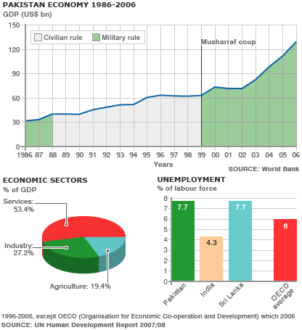
- Recent decades: This is a chart of trend of gross domestic product of Pakistan recent decades:

Historically, Pakistan's overall economic output (GDP) has grown every year since a 1951 recession. Despite this record of sustained growth, Pakistan's economy had, until a few years ago, been considered as unstable and highly vulnerable to external and internal shocks. However, the economy proved to be unexpectedly resilient in the face of multiple adverse events concentrated into a four-year (1998–2002) period.
- The Asian financial crisis;
- Economic sanctions – according to Colin Powell, Pakistan was "sanctioned to the eyeballs";
- The global recession of 2001–2002;
- A severe drought – the worst in Pakistan's history, lasting about four years;
- Heightened perceptions of risk as a result of military tensions with India – with as many as 1 million troops on the border, and predictions of impending (potentially nuclear) war;
- The post-9/11 military action in neighboring Afghanistan, with a massive influx of refugees from that country;
Despite these adverse events, Pakistan's economy kept growing, and economic growth accelerated towards the end of this period. This flexibility has led to a change in perceptions of the economy, with leading international institutions such as the IMF, World Bank, and the ADB praising Pakistan's performance in the phase of adversity.

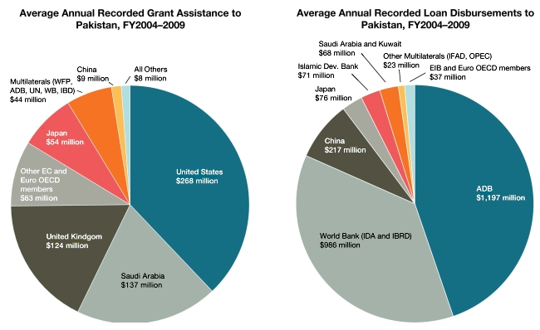
- Structure of Economy
The economy of the Islamic Republic of Pakistan is suffering with high inflation rates. Agriculture accounted for about 53% of GDP in 1947. While per-capita agricultural output has grown since then, it has been outpaced by the growth of the non-agricultural sectors, and the share of agriculture has dropped to roughly one-fifth of Pakistan's economy. In recent years, the country has seen rapid growth in industries (such as ready-made garments, textiles, and cement) and services (such as telecommunications, transportation, advertising, and finance).
- Sectors: Agriculture, Industry
Agriculture
Pakistan is one of the world's largest producers of the following commodities according to FAOSTAT, the statistical arm of the Food and Agriculture Organization of The United Nations, given here with the 2008 ranking:
- Apricot (3rd)
- Buffalo Milk (2nd)\
- Chickpea (3rd)
- Cotton, lint (4th)
- Cotton, Seed (3rd)
- Dates (5th)
- Mango (6th)
- Onion, dry (4th)
- Oranges (11th)
- Rice (11th)
- Sugarcane (5th)
- Orange (9th)
- Wheat (10th)
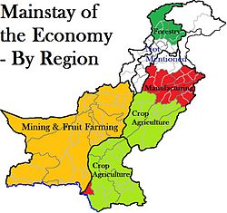
Pakistan's principal natural resources are fertile land and water. About 25% of Pakistan's total land area is under cultivation and is watered by one of the largest irrigation systems in the world. Pakistan irrigates three times more acres than Russia. Agriculture accounts for about 23% of GDP and employs about 44% of the labor force. Zarai Taraqiati Bank Limited is the largest financial institution geared towards the development of agriculture sector through provision of financial services and technical expertise.

- Industries
Industries: textiles (8.5% of the GDP), fertilizer, cement, oil refineries, dairy products, food processing, beverages, construction materials, SME Sector, Automotive industry, CNG industry, Cement industry, IT industry, Textiles, Mining, Communication, Banking, finance and insurance, property sector, Public administration and defense, Social, community and personal services, Electricity, Chemicals and pharmaceuticals.
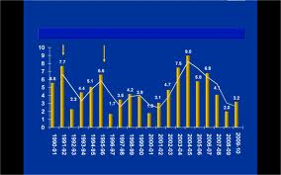
- Economic growth
- Prerequisites of Economic Development
Economic growth is dependent upon a number or factors such as natural resources, capital human resources, technology, attitude of the people, political condition in the country. All the factors which have a strong bearing on economic growth are divided into two categories:
- Economics factors
- Non-economic factors
Economic Factors: Natural Resources: If a country is not rich in natural resources, it is then not in a position to develop rapidly. As for as Pakistan is concerned, Pakistan is blessed with a plenty of natural resources, yet it is underdeveloped due to the fact that these resource have not been properly utilized.Capital accumulation capital formation refers to the process of adding to the stock of capital over time.
Stock of capital: The stock of capital can be built up and increased through three different resources which are as under:
- Role of capital: Capital plays a vital tile in the process of development a country. Capital accumulation increases the efficiency of labor. Capital accumulations encourage the introduction of new technology. Capital accumulation can make capital developing possible.
- Capital formation: Capital formation in Pakistan is very low because saving rate is not satisfactory.

- Labor and Manpower
Labor and Manpower: Labor is a key factor of production. In low income countries, the capital is the infrequent input, but the labor is plentiful. We can say the developing countries are capital poor and labor rich. Investment in human capital may take the following form:
- Spread of education from literacy training to the university level.
- The job training to workers. To provide information of job vacancies to potential candidates.
- To increase expenditure on health and nutrition for raising the productive capacity of the workers.

- Power: Power resources are the foundation of economic development. They are derived mainly from two types of sources:
- Commercial
- Non- commercial. Role of power in development: Giving an initial push to the raising of production in all sectors of the economy.
- Quickly bridging the development gap.
- Providing economies of scale.
- Ensuring high quality standard.
- Reducing material wastages in all sectors of the economy.
Power in Pakistan: Pakistan is still running short of its energy resources. Govt. of Pakistan is trying to develop new energy resources to overcome the problem.
- Transport and Communications
The availability of an efficient transport and communications network is a prerequisite for a meaningful economic cooperation amongst nations, particularly in the areas of trade and tourism for attracting foreign investment and realizing the potential gains from an outward oriented trade strategy. Besides human capital (skill and education) a strong efficient and affordable means of transport and communications of the country contributes to the national economic growth by lowering domestic production cost, integrating markets, promoting economic opportunities and establishing links among the people.
National Highway & road links
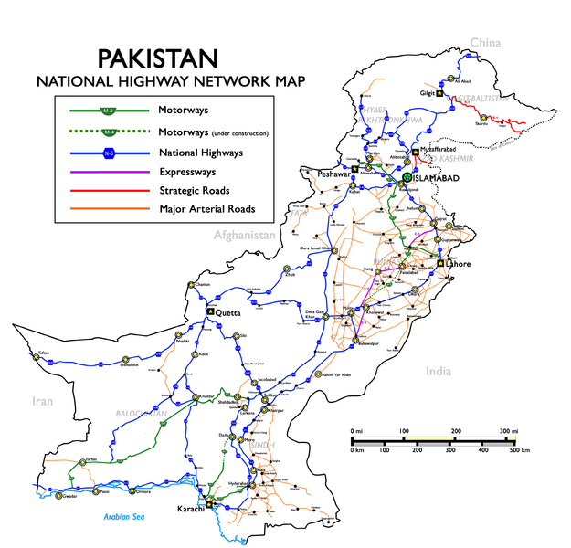

The transport and communications sector generates a large number of employment opportunities, and acts as a significant tool in the fight against poverty.
The sector is also a major contributor to government’s revenue through taxes and duties on its production and imports, fees on ownership and operation of vehicles and licensing of modern communications facilities.
Railway Tracks map of Pakistan
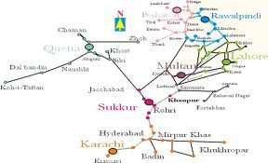

- Education & Training
There is certainly a close relationship between the volume of transport and communication and the level of growth. Its bearing on economic growth can be considered from economic, social and political point of view. Human capital formation: "Human capital refers to the level of education, skills, health and nutrition of the labor force”.
- Non-Economic Factors: Social Culture Factor
Non- economic factors are as much important as economic factors in economic development. According to Nurkse:“Economic development has much to do with human endowments, social attitudes, political conditions and historical accidents".
- Social Culture Factor: Social attitudes, values and institutions strongly influence economic development of a country. People in LDC’s are mostly conservative in their habits. They feel pride in their native culture and are generally not receptive to new methods of production. Joint family system has also killed the sense of initiative and the incentive to work.
- Political Factor: Peace and stable policies are necessary for eco-development. Trade and commerce activities would hurt in case of majority of the people are against t the policies of the government. Rapid change of government means change of policies and priorities, which create an uncertain state in the economy. A country can’t attract foreign investment in case of political disturbances.
- Administrative Factors: The administrative factor has an important bearing on the economic progress of a country. If the administration of a country is efficient, honest and strong, it can give a big push to the economic development. In less developed countries, the administration is generally weak, inefficient and corrupt. The weak administration has failed to perform its duties and thus has considered delaying the economic growth.

Quotation
There can be Economy only where there is efficiency.
Benjamin Disraeli

Lecture # 31
Industrial Sector: Problems & Solutions
- Pakistan Economic Structure: Primary Sector
Primary Sector: Pakistan’s primary sector plays a major role in the country’s economy. Primarily an agrarian economy, Pakistan produces a range of agricultural products. Around 43% of the country’s labor is engaged in the primary sector, which in turn contributes 20.8% to the country’s economy in 2009. Pakistan is the second largest producer of Chickpea and the third largest producer of mango in the world according to the 2005 Food and Agriculture Organization of the United Nations.
Some other major agricultural products of Pakistan include onion, cotton, rice, tangerines, oranges, apricot, sugarcane, date palm, Clementine and wheat. Dairy farming is also a large industry in Pakistan. In fact, Pakistan is the fifth largest milk producer in the world. Although Pakistan has a considerable livestock population, it spends around $40 million a year on formula milk import. Categorized as semi-industrialized, Pakistan’s economy has grown tremendously since its independence in 1947. Punjab and Karachi states constitute the major share in the economic growth of the country. The first decade of the 21st century has experienced wide-ranging economic reforms particularly in manufacturing and financial services sector, leading to improvement in the country’s economic outlook.
- Pakistan Economic Structure: Secondary Sector
Secondary Sector: Pakistan’s manufacturing sector provides employment to 20.3% of the country’s labor force (est. 2005). Some major manufacturing industries include cotton textile and apparel manufacturing, carpets, rugs, rice, chemicals, sports goods and leather goods.
Some other popular industries are construction materials, mineral, paper products, food processing and beverages. Around 51.4% of country’s exports include textile and apparel. The secondary sector experienced a growth of 5.4% in 2007-08. However, electricity shortage remains the biggest challenge in ensuring development of Pakistan’s secondary sector.
- Pakistan Economic Structure: Services Sector
Services Sector: The services sector of Pakistan mainly includes industries such as finance, insurance, transport, communications and storage that account for 24% of the country’s GDP. Wholesale and retail trade has 30% share in the GDP. With increase in the country’s software exports, the IT industry is emerging as a flourishing service industry. Despite union unrest, the Pakistani government is actively engaged in privatization of banking, telecommunications and utilities to produce more jobs in the country.
- Problems of Industrial Sector
British Policy at the time of Partition, only 34 units given to Pakistan out of 921.
- Controversial Industrial Strategy
- Shortage of Capital
- Limited Markets
- Lack of Technical Know-How
- Lack of Infrastructure
- Lack of Industrial Research
- Unbalanced Industrial Structure
- Labor Unrest
- Nationalization
- Lack of Specialization
- Controversial Industrial Strategy
The slow growth in industrial sector is mainly due to rapid changes in the industrial development strategies. The planners have not yet been able to solve the central issues such as:
- Sectorial balance between agricultural and industrial sector
- Balanced regional development
- Growth versus distribution strategy
- Small scale verses large scale
- Capital intensive verses labor intensive
- Public sector versus private sector
- Rural versus urban
- Nationalization of industries
- Import substitution versus export promotion
- Lack of Capital: In Pakistan, the saving and investment is very low. Private foreign investment and foreign aid has other adverse effects. There is inadequate facility of industrial credit in the country and the expansion of industries is handicapped.
- Limited Markets: Limited domestic market ad increasing foreign competition is another obstacle in the way of industrial development. The purchasing of the common man in the country is low, due to low wages and unemployment. Therefore, the demand for industrial goods in the country is not conducive to industrial growth. Market is also limited due to low quality and lack of standardization.
- Lack of Technical Know-How: Another problem in the way of rapid industrialization is the lack of skilled labor. Modern machinery needs trained technical men and laborers. Our labor is uneducated and untrained and does not work hard.
- Lack of Infrastructure: The transport system of Pakistan is still under development. The existing system does not cope with the industrial and commercial requirements. Sources of power like electricity, coal, gas, and oil have not yet been fully developed. The power capacity available is not sufficient to cover the need of growing industrial sector.
- Lack of Industrial Research: Lack of industrial research is also a problem. Which is responsible for high production cost? Industrial research discovers new techniques of production and introduces new varieties of products. Due to lack of industrial research, improvement in production techniques has not been made possible and as such production costs of our industrial products are high and we are unable to compete with producers from other countries.
- Unbalanced Industrial Structure: There is no balance in consumer goods and capital goods industry. The taxation system favors the consumer goods industries. It gives no protection to intermediate and capital goods industries. The result is that capital goods industries are still underdeveloped.
- Labor Unrest: The rapid growth of the large-scale manufacturing sector in Pakistan led to the existence of a substantial labor force employed in this sector. However, the standard of living of the labor force and the real wage did not increase. This led to trade union movements and strikes. This resulted in tension between entrepreneurs and laborers which disturbed industrial production and efficiency.
- Nationalization: The nationalization of industries in 1972 inflicted heavy damages to private industrial sector in Pakistan. The total investment in private sector dropped from Rs.1358 million in 1970-71 to Rs.650 million in 1976-77. The pace of industrialization is still slow. The privatization, decontrol, and other fiscal and monetary concessions.
- Lack of Specialization: A very peculiar feature of industries in Pakistan is that all the process of production are done on a single unit with a result that the benefit of specialization is not available to reduce the cost and improve the quality. For example, the motor car industry must be split into spare-parts industry, assembling industry, tire and tube industry, etc. All these industries are called subsidiary to the car industry.

- Solution of Industrial Problems
- Clear strategy for industrial sector
- Provision of industrial finance
- Provision of infrastructure
- Development of capital goods industry
- Industrial research
- Fiscal incentives
- Technical education and training
1. Clear Strategy for Industrial Sector: For revival and growth of industrial sector, the controversial issues have to be solved once for all. Unless the danger of nationalization of industries is removed and the lost confidence is restored, the progress in the industrial field will remain slow.
2. Provision of Industrial Finance: Establishing a well-organized capital and money market in the country can solve the problem of lack of capital for the industrial sector. The Government of Pakistan established Pakistan Industrial Credit and Investment corporation (PICIC) in 1957 to provide loans to the private sector. Moreover, an Industrial Development Bank of Pakistan (IDBP) was established in 1961. Recently, Investment Corporation of Pakistan (ICP), National Development Finance Corporation (NDFC) Equity Participation Fund (EPF) and Bankers Equity Limited (BEL) are also helping in the industrial development.
3. Provision of Infrastructure: Industrialization requires adequate amount of transportation, communication, and energy facilities to be provided by the government. The government of Pakistan should issue open route permits to transporting agencies so that their number may increase and a competition ensues among them. This will improve the quality of service and reduce the fare. Roads should be constructed in the rural areas so that the villages may be linked with national highways and the railway stations. Railway services should be provided to the maximum possible areas and their rolling stock should be enhanced to increase their capacity of handling a large volume of goods. Speedy development of hydro-electricity is required to increase the power capacity of the country. In the meantime, steps should be taken distribute the existing capacity on the basis of requirement of industrial units and their important in the economy.
4. Development of Capital Goods Industry: It is required to establish well-equipped workshops in large number so that the idle period of machines may be reduced to the minimum. It is also necessary to establish a number of tools and machine manufacturing plants to meet the demand of spare parts industry.
5. Industrial Research: Industrial research discovers new techniques of production and introduces new varieties of products. This results in lower cost of production. More laboratories must be established in the country for industrial research in order to improve production techniques and invent new varieties of products. The government of Pakistan in 1953 established Pakistan Council of Scientific and Industrial Research (PCSIR) at Lahore, Karachi and Peshawar.
6. Fiscal Incentives: Taxes of various types increases the production cost and in many cases discourages production. Tax holidays may be given to infant industries and those established in undeveloped areas.
7. Technical Education and Training: To improve the productivity in the industrial sector, it is essential to establish technical training institutions to give training to the laborers. The government made necessary arrangements and helped in the establishment of Pakistan Industrial Technical Assistant Centre (PITAC), other vocational and commercial institutions including Pak-German and Pak-Swedish Institutes of Technology. This is going to provide technical assistance to industrialists, to helping the dissemination of modern knowledge and improved techniques among artisans and craftsmen.

- Pakistan Economic Review
Pakistan economic review projects that because of strong economic policies taken up by Pakistan government manufacturing and financial services sectors have flourished since fiscal 2008. Export of goods is a major concern for Pakistan economy. From 1999, exports of Pakistan have increased from $7.5 billion to $18 billion in financial year 2007-2008. Major items for exports include cotton fiber, vegetables, rice, electrical appliances, furniture, cement, tiles, marble, textiles, clothing, sports goods, powdered milk, livestock meat, software, seafood, leather goods, surgical instruments, carpets, rugs, ice cream, chicken, wheat, processed food items, Pakistani assembled Suzuki cars, salt, defense equipment, onyx (gemstons), marble and engineering goods to mention a few. Some important import items of Pakistan are petroleum and petroleum products, automobiles, medicines, industrial machinery, construction machinery, trucks, electronics, civilian aircraft, computers, pharmaceutical products, computer parts, food items, toys, defense equipment, iron and steel. Economic review of Pakistan has been focusing in recent times on how to deal with economic recession.
Government of Pakistan has initiated a number of procedures to address regional economic imbalances. Economic indicators look positive in present situation. Discount rate of central bank has been improved to 1.5 percentage points. This will help in dealing with high inflation rate in Pakistan. Pakistan economic review projects that government encourages foreign investments in various fields of real estate, telecommunications, software, energy, fertilizer, aerospace, textiles, steel, ship building, arms manufacturing, cement and automotive.

Quotation
If we wish our state's growth to continue, then our future will increasingly be with industries that require a highly skilled and technically proficient workforce.
Jay Weatherill

Lecture 32
Agriculture Sector: Problems & Solutions
- History of Agriculture in Pakistan
Agriculture and irrigation system was developed in the Indus Valley Civilization (Mohenjo-daro) by around 4500 BCE. The size and prosperity of the Indus civilization grew as a result of this innovation, which eventually led to more planned settlements making use of drainage and sewers. Sophisticated irrigation and water storage systems were developed by the Indus Valley Civilization, including artificial reservoirs at Girnar dated to 3000 BCE, and an early canal irrigation system from circa 2600 BCE. Archeological evidence of an animal-drawn plough dates back to 2500 BC in the Indus Valley Civilization. All agricultural affairs and activities in Pakistan are overseen and regulated by the Ministry of Agriculture.
- Introduction: Agricultural of Pakistan
Economy of every state depends on three sectors that is agriculture, industry and commerce. These three are interrelated with each other as the progress or revert of one sector effects the other two. Pakistan is an agricultural state thus agriculture gains are of much importance than any other sector. Importance of this sector is manifold as it feeds people, provides raw material for industry and is a base for foreign trade.
It contributes 26% of GDP and 52% of the total populace is getting its livelihood from it. 67.5% people are living in the rural areas of Pakistan and are directly involved in it.
- There are two crops in Pakistan: Rabi & Kharif.
Crop | Sowing season | Harvesting season
Kharif | April – June | Oct – Dec
Rabi | Oct – Dec | April – May

- Agricultural Reforms in Pakistan
First Agricultural Reforms in Pakistan were introduced by General Ayub Khan in Jan 24, 1959. According to these reforms an individual was not allowed to own 500 irrigated and 1000 of non-irrigated land in Pakistan. The remaining lands were given freely to the landless farmers. It was also narrated that no surcharge or extra money will be taken from any landless person in return for the transfer of land. The total geographical area of Pakistan is 79.6 million hectares. About 27 percent of the area is currently under cultivation. Of this area, 80 percent is irrigated. In this regard, Pakistan has one of the highest proportions of irrigated cropped area in the world.
The cultivable waste lands offering good possibilities of crop production amount to 8.9 million hectares. Growth in cropped area is very impressive: from 11.6 million hectares in 1947 to 22.6 million hectares in 1997.
- Land use, farming systems and institutions
Most of Pakistan is classified as arid to semi-arid because rainfall is not sufficient to grow agricultural crops, forest and fruit plants and pastures. About 68 percent of the geographical area has annual rainfall of 250 mm, whereas about 24 percent has annual rainfall of 251 to 500 mm. Only 8 percent of the geographical area has annual rainfall exceeding 500 mm. Thus supplemental water is required for profitable agricultural production, either from irrigation or through water harvesting. Though the agricultural sector is facing problems in Pakistan yet the major chunk of money comes from this sector. Following are the major causes of agricultural problems in Pakistan which disturb the agricultural growth or development in Pakistan. Agriculture is the important sector of Pakistan’s economy. It importance has reduced due to following reasons:
- Problems of Agriculture Sector in Pakistan
- Under Utilization of Land
- Under Utilization of Manpower
- Uneconomic Holdings
- Water-logging and Salinity
- Lack of Water Supply\
- Low per Acre Yield
- Insufficient Use of Inputs
- Poor Rural Infrastructure
- Insufficient Agricultural Research
- Lack of Extension Service
- Defective Land Tenure System
- Insufficient Facilities

- Under Utilization of Land: The resources in the agricultural sector are not properly utilized. There is a huge wastage of land which is evident from the fact that out of about 90 million acres of cultivable land, only 44 million acres have so for been brought under plough. This wastage comes to 60 % of the area. Further, the land is divided into many small units. The area is used to provide passage (due to small land holding) in form of strips summed up runs into hundreds of acres that are wasted.
- Under Utilization of Manpower: The total labor force in the rural sector is about 16 million out of which only 15% are paid workers while the rest are self-employed. The employment picture in the agriculture is complicated. This had resulted due to abundance of self-employed and unpaid family workers and the seasonal nature of work in agriculture. Disguised unemployment is difficult to estimate. However, an estimate put it at about two million workers, which is a severe wastage.
- Uneconomic Holdings: The term uneconomic holding refer to the cultivating units which are small in size and the cultivation processes cannot be properly and effectively applied to them. As a result there input-output ration is low compare to bigger farms. According to agriculture census 1980, there are 4.7 million formers and almost half of them own only three acres or less of land. The main cause of this is Islamic law of inheritance and lack of alternative occupations.
- Water-logging and Salinity: Due to leakage of water from the canals, the water table has come closer to the surface of the soil and the plants are unable to get air and grow. This is called water logging. When this water evaporates the salts contained in the water spread on the surface. This makes the surface hot and destroys the plants. This is known as salinity. These problems are found in the irrigated areas Punjab and Sind. According to an estimate above 15 lakh acres have been made unfit for cultivation due to water logging and salinity.
- Lack of Water Supply: The agriculture output depends upon the water supply at different stages of cultivation. If the water supply is not sufficient, the crop is damaged and the yield is reduced. In Pakistan, the agricultural output depends on irrigation facility, which is defective in the sense that the supply of water is either delayed or is less than the requirement.
- Low per Acre Yield: This is a problem to be solved as well as the result of various problems. Per acre yield in Pakistan is among the lowest in the world. It is about one third of what is produced in other countries. For examples, in case of rice , Japan and Egypt production is more than three times in Pakistan. Similar is the case of sugarcane, cotton and wheat.
- Insufficient Use of Inputs: To increase agricultural output, it is essential to expand the use of agricultural inputs which includes chemical fertilizers, improve seeds, plant protection and mechanization. At present, seeds are used by formers are generally defective and of inferior quality. Similarly, lack of use of fertilizers like urea and pesticides result in less production.
- Poor Rural Infrastructure: Poor rural infrastructure is another basic problem of agriculture in Pakistan. Due to lack of transport and communication facilities, the rural population has restricted mobility. There is less flow of credit in rural areas due to lack of credit institutions. There are no organized marketing facilities so the poor farmers are exploited by the traders.
- Insufficient Agricultural Research: Research and education is a continuing requirement for the agricultural development not only in developing better seeds, improving cultivation methods and better use of other inputs, but also for finding out there best combination for our conditions. Unfortunately, it has not received due attention and suffers from financial and personal constraints.
- Lack of Extension Service: Lack of extension services in Pakistan, the agricultural extension service has not been active. An agricultural extension service aims at providing the formers with systemic excess to knowledge about farming practices, multiple cropping and use of physical inputs and ensuring that the knowledge provided is appropriate to the farming being practice. In Pakistan, the coverage of extension services is extremely limited. Mainly, due to poor service conditions and the insufficient provision of extension aids.
- Defective Land Tenure System: The phrase “Land tenure system” signifies the rights and obligations associated with the arrangement of ownership and the use of land. It is obvious that a number of problems can arise in a system dominated by land owners. It results in absolute landlordism in which the landlord obtains a substantial share of the produce of the land without making any effort. The land is cultivated by tenants who suffer not only from social subordination but also from different types of exploitation. All this leads to low production.
- Insufficient Facilities: In Pakistan rural credit supplied both through institutional and non-institutional sources. Institutional sources include ADBP, commercial banks, and cooperative institutions. Non institutional sources are the private money lenders like commission agents, village traders, and landlords and well-to-do farmers. “ Friends and relatives” is also an informal source of credit. These sources are generally regarded as exploitative and undesirable. Any attempts to drive them out by lowering the interest rates have not been successful.
- Current Status of Agriculture Sector: Over the past 20 years some important structural changes have taken place in the sector. In particular, livestock has emerged as an important subsector, today contributing more than one-third of agricultural GDP, compared with about 28 percent 20 years ago. Similarly, fisheries and forestry, while still minor contributors to agricultural GDP, have grown rapidly. Structural changes have also taken place within the produce sector. Cotton is now as important as wheat in terms of value added with a one-fifth share of total earnings. Rice and sugar have, however, fallen from a 20 percent share in the early 1970s to 15 percent today.

- Solutions to Problems
- Increase in Irrigation Facilities
- Farm Mechanization
- Agricultural Research
- Reclamation Program
- Agricultural Price Policy
- Land Reforms
- Credit Policy
- Cooperative Movement
- Increase in Irrigation Facilities
1. The availability of water has to be increased by construction of small dams, installation of tube-wells, etc., for bringing in more land under cultivation and increasing the output. There will, thus, be less dependence on rain for the supply of timely water. The government of Pakistan established Water and Power Development Authority (WAPDA) in 1959 to build dams for storage and supply of irrigation water.
2. Farm Mechanization: There is unanimity of opinion that farm mechanization increases agricultural productivity and income of the farmers. Spray machines are applied to spray the standing crops. The threshers and harvesters replace the manual harvesting. Tractors, bulldozers and attached implements are being increasingly use. In Pakistan, there are at present five tractor manufacturing plants producing its various parts. Until 1990, the total numbers of tractors use were about three lakh. ADPB is providing loans to farmer for the purchase of tractors and installation of tube-wells in the different areas of the country.
3. Agricultural Research: In order to rise the potential of agricultural production, there should continuous improvement in the research for agricultural growth. The specific areas of research includes the development of high yielding, short duration , disease and drought resistant varieties of major food and cash crops of Pakistan according to the situation prevailing in different areas of the country.
4. Reclamation Program: Vigorous efforts should be made to protect and reclaim the areas effected by water logging, salinity and soil erosion in the country. The government of Pakistan started salinity control and reclamation project (SCARP) in 1959. Under this scheme, about 12,500 tube-wells were installed and other derange schemes were introduced the result is about 3 million acres have been reclaimed.
5. Agricultural Price Policy: An agricultural price policy refers to the government’s role in defining or inducing the prices of agricultural outputs and inputs. The price mechanism can, if used carefully and systematically, prove to be effective supplement efforts towards the revival of agriculture and increase agricultural productivity. The policy regarding output is also called price support policy.
6. Land Reforms: Land reforms refer to the concept of redistribution of land ownership in excess of certain ceiling. Pakistan inherited of feudalistic land tenure system. At the time of partition 7% of the land owners owned 53% of the total land. These big landlords had little incentive to cultivate all the land or to rise the productivity of their lands. Thus in 1959, individual ownership was restricted to 500 acres of irrigated and 1000 acres of irrigated land. In 1972, this was further reduced to 150 irrigated and 300 irrigated acres. The resume land was distributed among the landless farmers.
7. Credit Policy: Agriculture is a backward and a poor sector. The farmers need loans to purchase various types of inputs like seeds, fertilizers, pesticides, tractor, tube-wells, etc. The Agricultural Development Bank of Pakistan (ADBP) was established in 1961.The ADBP is the largest source of credit to agriculture sector of Pakistan. The bank provides short, medium and long term loans for farm and off farm activities. The bank has five following windows of investment:
- Development loans
- Production loans
- Agri-Business loans
- Cottage industry loans
- Off farm income generating activities loans
The ADBP advance loans based on land, mortgage, or on personal security. Till 1996, the ADBP has provided credit for about Rs. 100 billion to 4million farmers. Most of it was given for purchase of tractors and tube-wells.
8. Cooperative Movement: Cooperative farming is a voluntary organization in which the farmers poll their resources in order to carry out various agriculture operations by helping each other for the protection of their common interest. The farmers may be motivated to farms cooperative societies for production of crops, purchase of inputs and for sale of output. Cooperative farming, if adopted, can solve the problems of disintegration of holding, mechanization, and middlemen.
______________________________________________________________________________
- Essential Readings
Text Book: Pakistan Studies (compulsory) for B.A & B.Sc Engineering by M.D. Zafar and Ikram Rabbani.
- Indicative Bibliography:
1- Ishatiaq Hussain Qureshi, The Struggle For Pakistan.
2- Javid Iqbal, Ideology of Pakistan.
3- M. Ikram Rabbani, Pakistan Affairs.
4- Shaid Javed Burki, “State & Society in Pakistan,” The Macmillan Press Ltd 1980 (reprint 1997).
5-Wayne Wilcox, “The Emergence of Bangladesh,” Washington, American Enterprise, Institute of Public Policy Research, 1972.
6-Safdar Mehmood, “Pakistan Kayyun Toota,” Idara-e-Saqafat-e-Islamaia, Club Road, Lahore.
7-Tahir Amin, “National Movement of Pakistan,” Institute of Policy Studies, Islamabad.
8-Lawrence Ziring, “Enigma of Political Development,” WmDawson & sons Ltd. Canon House Folkstone, Kent England, 1980.
9-Waseem Ahmad, “Pakistan Under Marshal Law,” Lahore 2002.
10-Ansar Zahid, “History & Culture of Sindh,” Karachi Royal Book Company, 1980.
11-Phamplets and booklets published by Nazra-i-Pakistan Council.
- Internet (valid web sites) and inter. level newspapers and journals
http://www.storyofpakistan.com/
- http://www.pakistan.gov.pk/
- http://www.pak.gov.pk/public/govt/ministry_table.htm
- http://www.pakissan.com http://www.paktrade.org/
- http://www.caapakistan.com/ http://www.parc.gov.pk/
- http://www.pakistan.gov.pk/ministries/index.jsp?MinID=6&cPath=59
- http://www.pakistan.gov.pk/ministries/index.jsp?MinID=15&cPath=162
- http://www.sbp.org.pk
Quotation
“We must work our destiny in our own way and present to the world an economic system based on true Islamic concept of equality of manhood and social justice. We will thereby be fulfilling our mission as Muslims and giving to humanity the message of peace which alone can save it and secure the welfare, happiness and prosperity of mankind.”
(Quaid i Azam’s Speech at the opening ceremony of State Bank of Pakistan, Karachi. July 1, 1948)

The End

